SmartDots Summary for event 160

Executive summary
The Planning Group on Commercial Catch, Discards and Biological Sampling (PGCCDBS) meeting in Vienna in March 2011, identified Megrim as one of the species requiring confirmation of the ages being assigned by Fisheries Institutes. The last workshop on megrim otoliths was in 2004.

The planning group indicated that Marine Scotland Science (Aberdeen, Scotland) should be responsible for organising an otolith exchange in the summer of 2014, but for several reasons it was not possible to proceed with the exchange until 2018. The exchange was initially started by Gordon Henderson sending round the hard otoliths to participating countries. However before the exchange could be completed the coordinator retired and the remaining aspects of collating the data and uploading images to SmartDots was taken up by his colleague.

Agreement between readers of megrim is poor, as the otolith thickens with increasing age and annual rings become difficult to distinguish, particularly, on the otolith edge. PGCCDBS suggested in 2014 that a trial of breaking and burning otoliths older than 6 years should comprise part of the exchange, but this will not be possible on this occasion.

The objectives of the exchange are:

To investigate the levels of agreement on age readings.
To analyse the relative differences between reader ages

Overview of samples and advanced readers

Table 1: Overview of samples used for the xxx exchange. The modal age range for all samples is 3-13.
Year | ICES area | Quarter | Number of samples | Modal age range | Length range
2013 | 27.4.a | 1 | 30 | 3-9 | 280-550 mm
2013 | 27.4.a | 2 | 30 | 4-10 | 290-580 mm
2013 | 27.4.a | 3 | 15 | 4-10 | 400-570 mm
2013 | 27.4.a | 4 | 29 | 3-9 | 300-500 mm
2013 | 27.6.a | 1 | 15 | 6-10 | 390-530 mm
2013 | 27.6.a | 2 | 15 | 6-9 | 330-470 mm
2013 | 27.6.a | 3 | 30 | 5-13 | 370-540 mm
2013 | 27.6.a | 4 | 15 | 6-11 | 410-550 mm

Table 2: Overview of advanced readers.
Reader code | Expertise
R02 FR | Advanced
R04 FR | Advanced
R06 IS | Advanced
R08 BE | Advanced

Results overview

Age readings
Table 3: Age reading table presents the number of readings made per expert reader for each modal age.
Modal age | R02 FR | R04 FR | R06 IS | R08 BE | total
3 | 7 | 6 | 7 | 8 | 28
4 | 11 | 9 | 12 | 12 | 44
5 | 35 | 34 | 37 | 39 | 145
6 | 61 | 55 | 61 | 64 | 241
7 | 31 | 28 | 32 | 33 | 124
8 | 11 | 11 | 12 | 12 | 46
9 | 6 | 6 | 6 | 6 | 24
10 | 1 | 1 | 1 | 1 | 4
11 | 1 | 1 | 3 | 2 | 7
12 | 0 | 0 | 0 | 0 | 0
13 | 0 | 0 | 0 | 0 | 0
Total | 164 | 151 | 171 | 177 | 663

CV table
Table 4: Coefficient of Variation (CV) table presents the CV per modal age and advanced reader, the CV of all advanced readers combined per modal age and a weighted mean of the CV per reader.
Modal age | R02 FR | R04 FR | R06 IS | R08 BE | all
3 | 13 % | 21 % | 30 % | 22 % | 25 %
4 | 23 % | 12 % | 33 % | 37 % | 34 %
5 | 11 % | 9 % | 24 % | 25 % | 24 %
6 | 12 % | 9 % | 18 % | 22 % | 21 %
7 | 11 % | 15 % | 17 % | 19 % | 20 %
8 | 5 % | 7 % | 16 % | 18 % | 17 %
9 | 12 % | 18 % | 0 % | 12 % | 15 %
10 | - | - | - | - | 13 %
11 | - | - | 0 % | 0 % | 23 %
12 | - | - | - | - | -
13 | - | - | - | - | -
Weighted Mean | 12 % | 11 % | 19 % | 22 % | 22 %

PA table
Table 5: Percentage agreement (PA) table represents the PA per modal age and reader, advanced the PA of all advanced readers combined per modal age and a weighted mean of the PA per reader.
Modal age | R02 FR | R04 FR | R06 IS | R08 BE | all
3 | 86 % | 67 % | 57 % | 75 % | 71 %
4 | 82 % | 78 % | 33 % | 50 % | 59 %
5 | 83 % | 88 % | 35 % | 23 % | 56 %
6 | 70 % | 82 % | 41 % | 34 % | 56 %
7 | 61 % | 64 % | 53 % | 36 % | 53 %
8 | 82 % | 73 % | 42 % | 17 % | 52 %
9 | 67 % | 33 % | 100 % | 50 % | 62 %
10 | 100 % | 0 % | 0 % | 100 % | 50 %
11 | 0 % | 0 % | 100 % | 100 % | 71 %
12 | - | - | - | - | -
13 | - | - | - | - | -
Weighted Mean | 73 % | 75 % | 45 % | 36 % | 56 %

Relative bias table
Table 6: Relative bias table represents the relative bias per modal age and advanced reader, the relative bias of all advanced readers combined per modal age and a weighted mean of the relative bias per reader.
Modal age | R02 FR | R04 FR | R06 IS | R08 BE | all
3 | -0.14 | 0.00 | 0.71 | 0.38 | 0.24
4 | 0.45 | -0.22 | 1.75 | 1.00 | 0.75
5 | 0.17 | 0.03 | 1.51 | 1.72 | 0.86
6 | -0.16 | 0.00 | 1.25 | 1.52 | 0.65
7 | -0.32 | -0.29 | 1.03 | 1.67 | 0.52
8 | -0.18 | -0.09 | 1.00 | 2.08 | 0.70
9 | -0.67 | -1.50 | 0.00 | 0.83 | -0.33
10 | 0.00 | -2.00 | 1.00 | 0.00 | -0.25
11 | -5.00 | -4.00 | 0.00 | 0.00 | -2.25
12 | - | - | - | - | -
13 | - | - | - | - | -
Weighted Mean | -0.13 | -0.17 | 1.19 | 1.49 | 0.59

Bias plot
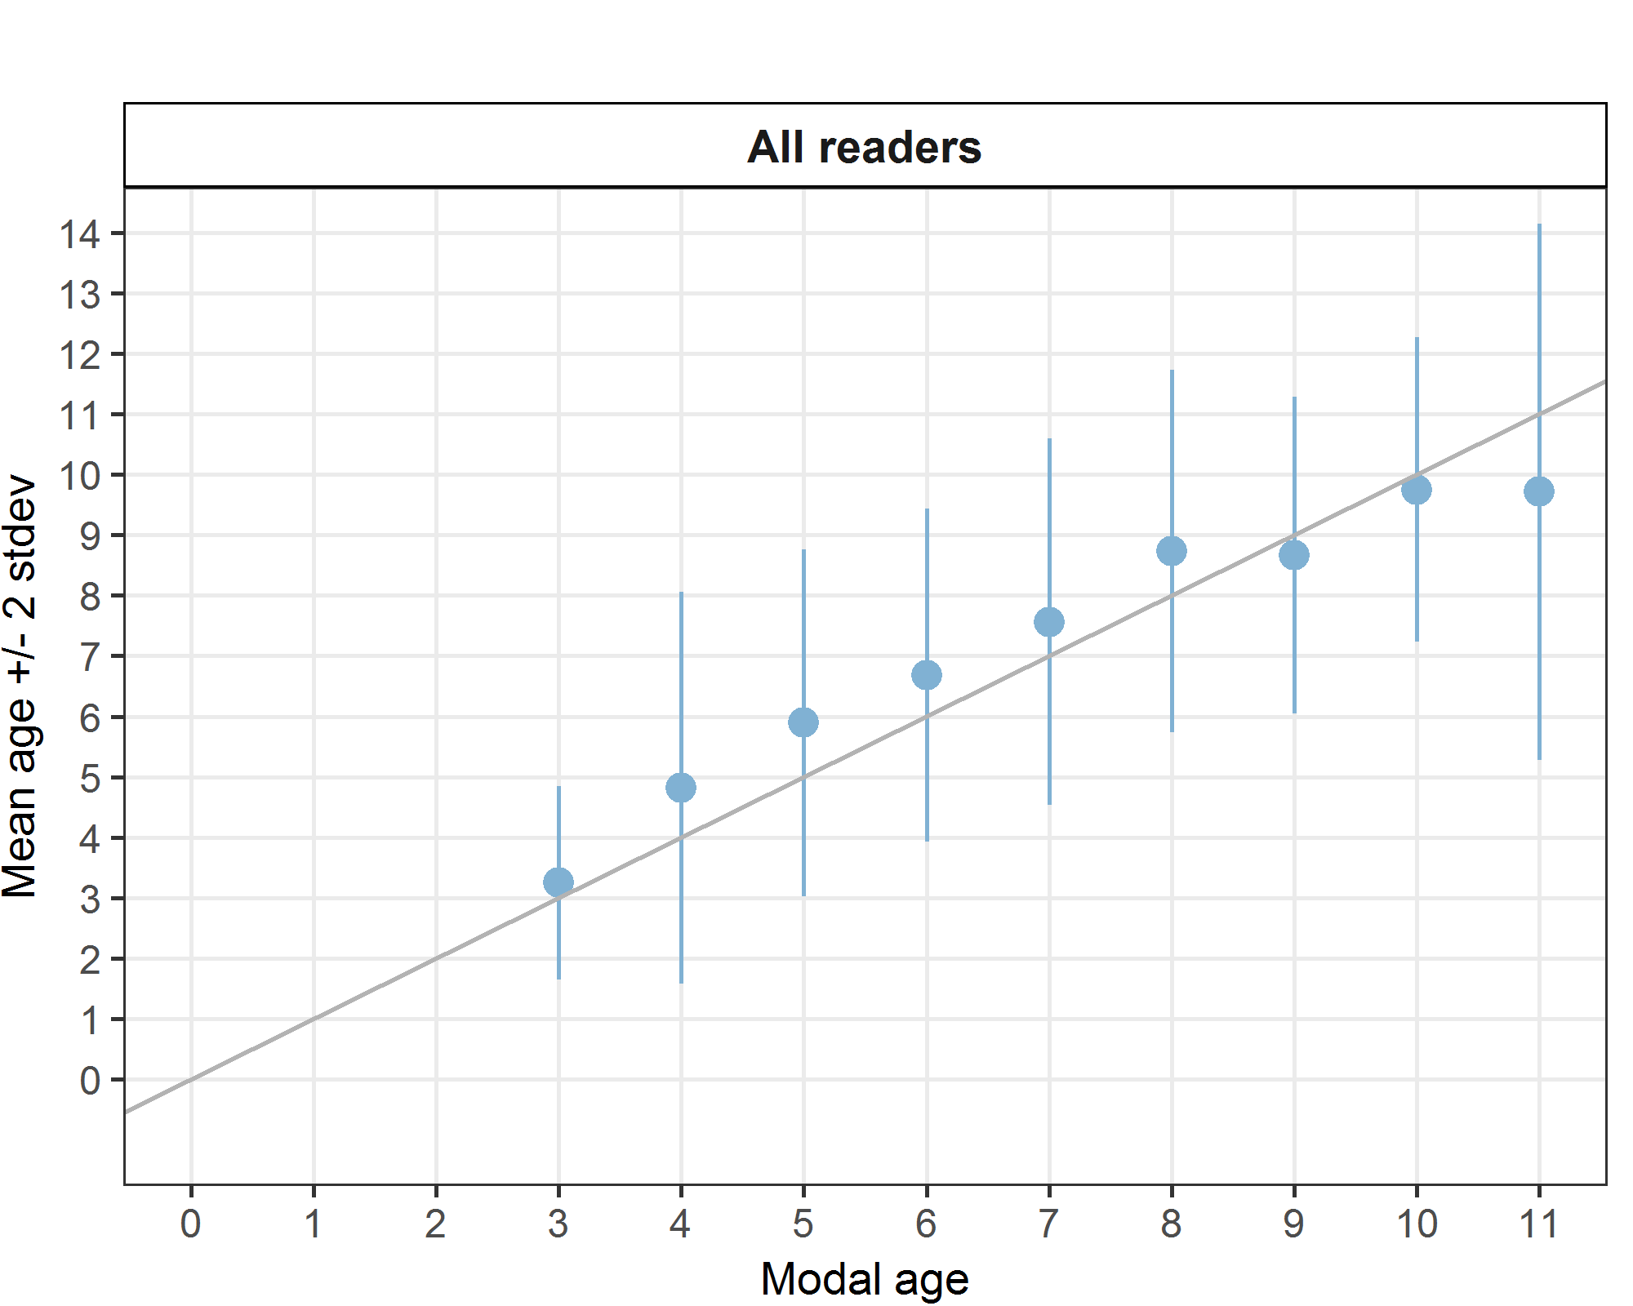
Figure 1: Age bias plot for advanced readers.

Age error matrices
Table 6: Age error matrix (AEM) for .
Modal age | 3 | 4 | 5 | 6 | 7 | 8 | 9 | 10 | 11
Age 2 | 0.07143 | 0.02273 | - | - | - | - | - | - | -
Age 3 | 0.71429 | 0.04545 | - | - | - | - | - | - | -
Age 4 | 0.14286 | 0.59091 | 0.027586 | 0.020747 | 0.008065 | - | - | - | -
Age 5 | 0.03571 | 0.06818 | 0.558621 | 0.053942 | 0.040323 | - | - | - | -
Age 6 | 0.03571 | 0.11364 | 0.165517 | 0.560166 | 0.088710 | - | 0.08333 | - | 0.1429
Age 7 | - | 0.09091 | 0.110345 | 0.145228 | 0.532258 | 0.08696 | 0.12500 | - | 0.1429
Age 8 | - | 0.02273 | 0.055172 | 0.107884 | 0.112903 | 0.52174 | 0.04167 | 0.25 | -
Age 9 | - | 0.02273 | 0.048276 | 0.070539 | 0.096774 | 0.21739 | 0.62500 | - | -
Age 10 | - | 0.02273 | 0.027586 | 0.020747 | 0.064516 | 0.06522 | 0.08333 | 0.50 | -
Age 11 | - | - | 0.006897 | 0.012448 | 0.024194 | 0.02174 | - | 0.25 | 0.7143
Age 12 | - | - | - | 0.004149 | 0.032258 | 0.02174 | 0.04167 | - | -
Age 13 | - | - | - | 0.004149 | - | 0.06522 | - | - | -

