Report of Otolith Exchange Analysis for Brill

Coordinated by Karen Bekaert
Institute for Agricultural and Fisheries Research (ILVO)
Ankerstraat 1, 8400 Oostende, Belgium

Participants (in alphabetical order): Chantre, C., Devries, M., Dussuel, A., Elleboode, R., Hoek, R., Maertens, I., Moerman, M.

May 2019
Table of Contents
1 Executive summary 3
2 Terms of reference 4
3 Participant list 5
4 Introduction 6
5 Methods 7
5.1 Statistical analyses 8
6 Analysis of age calibration exercise 10
6.1 Overview of samples and readers 11
6.2 Results 12
6.2.1 All readers – Sectioned and stained otoliths 12
6.2.2 Advanced readers 14
6.2.3 All readers – whole otoliths 16
6.2.4 Advanced readers – whole otoliths 19
6.2.5 Comparison between whole and stained sectioned otoliths 21
6.3 Discussion 22
6.4 Conclusion 23
7 References 24
8 Annex 1. List of participants 25
9 Annex 2. Additional results 26
9.1 Results all readers – sectioned and stained 27
9.2 Results Advanced readers – sectioned and stained 41
9.3 Results all readers – whole 50
9.4 Results Advanced readers – whole otoliths 63

Executive summary

The last brill (Scophthalmus rhombus) exchange took place in 2005. A small scale exchange was recommended in 2009 by PGCCDBS for brill in the North Sea and English Channel (Subarea 4 and 7.d-e). Unfortunately, a full report from the 2005 exchange is missing, so few background is known. Brill is a category 3 stock (no ages used is the assessment). Nevertheless, several countries collect age samples for brill, partly under obligation by the EU Data Collection Regulation. A scoping meeting for brill is planned in 2020.
The objectives of the exchange were:
- Estimate the accuracy and precision of the age readings for whole otoliths and sectioned and stained otoliths.
- Detect any potential age reading problems.
- Compare the results between whole and sectioned & stained otoliths

Two otolith sets were included in the exchange: a North Sea brill set (N=71) and a set from the English Channel (N = 53). A total of 8 participants from 3 countries (Belgium, France and the Netherlands) participated in the exchange. Only 3 advanced readers participated, which are all used to reading stained sectioned otoliths. Whole otoliths are only read in France, but these readers are all basic (not providing data for assessment).
The statistics were better for stained sectioned otoliths than for whole otoliths. The average percentage agreement of 84 %, CV of 15 % and APE of 8 % was reached by all readers annotating stained sectioned otoliths. There was an important improvement when only advanced readers were combined: PA=95%, CV = 8%, APE = 1%. For whole otoliths, the statistical results were not satisfactory. The average percentage agreement of 63 %, CV of 29 % and APE of 22 % was obtained by all readers, while for advanced readers, the results were slightly better: PA=71%, CV = 29%, APE = 23%.
When comparing whole and stained sectioned otoliths, fish are generally assigned an older age when otoliths are sectioned and stained. This has also been confirmed in other flatfish species. For young fish (aged 0 to 2), the differences in ageing between whole and stained sectioned otoliths is small. In 80 % of the cases, fishes are aged the same.
From the 2005 exchange, we only know that the PA was high (90%) and that no bias between the readers was evident. In this exchange, the PA for stained sectioned otoliths of the advanced readers was very high (95%) and was still satisfactory for all readers (84 %).
No major issues were detected for advanced readers when ageing stained sectioned brill otoliths. Stained sections appear to be the best way to age brill.

Terms of reference

- To evaluate the accuracy and precision in otolith age reading of brill in subarea 4 (North Sea) and division 7.d-e (English Channel)
- To identify issues related to age reading of brill in subarea 4 and division 7.d-e
- To report results to WGBIOP that will take place in October 2019.

Participant list
A total of 7 participants from 3 different countries were involved in the brill otoliths exchange. A list of the participants with a summary of their experience in age estimation of brill is shown in Table 3.1. Age estimation of brill is based on sectioned and stained otoliths with the exception of France where whole otoliths are used.

Table 3.1: overview table of participants
Country | Reader name | Reader code | Expertise* | Provides data for assessment | Preparation method used for ageing brill
Netherlands | Devries Marcel | R02 NL | Advanced | Yes | Sectioned & Stained
Belgium | Maertens Ilse | R04 BE | Advanced | Yes | Sectioned & Stained
Belgium | Moerman Martine | R06 BE | Advanced | Yes | Sectioned & Stained
France | Celina Chantre | R08 FR | Basic | No | Whole
France | Antoine Dussuel | R10 FR | Basic | No | Whole
France | Romain Elleboode | R12 FR | Basic | No | Whole
Netherlands | Ruben Hoek | R14 NL | Basic | No | Sectioned & Stained

* level of expertise in Smartdots: advanced=provides data for assessment; basic=does not provide data for assessment

Introduction
The last brill (Scophthalmus rhombus) exchange took place in 2005. A small scale exchange was recommended in 2009 by PGCCDBS for brill in the North Sea and English Channel (Subarea 4 and 7.d-e). Unfortunately, a full report from the 2005 exchange is missing. Few background is thus known about the results, except that the agreement was high (90%) and that no bias between the readers was evident. Brill is a category 3 stock (no ages used in the assessment), nevertheless, several countries collect age samples for brill, partly under obligation by the EU Data Collection Regulation. A scoping meeting for brill is planned in 2020.

Methods

Statistical analyses

This report contains statistical analyses and comparisons of age readings in the form of tables and graphical plots based on Guus Eltink Excel sheet ‘Age Reading Comparisons’ (Eltink, A.T.G.W. 2000) and R scripts specifically developed for SmartDots. For each individual fish the Coefficient of Variation (CV), percentage agreement (PA) and Average Percentage Error (APE) to modal age was calculated. Additionally, age error matrices (AEM) were produced for advanced age readers separately for whole and sectioned otoliths.
All statistical analyses were produced separately for whole and sectioned otoliths and for all and then for only advanced age readers who provide data for stock assessment.
Percentage Agreement
The percentage agreement per reader per modal age tells how large is the part of readings that are equal to the modal age. The weighted mean included at the bottom of the table is weighted according to number of age readings. A rank is also assigned to each reader.
PA = ( no. of readings agreeing with modal age/total no. of readings) x 100%.
Co-efficient of Variation (CV)
The table presents the CV per modal age and reader. The CV’s are calculated as the ratio between the standard deviation (σ) and mean value (μ) per reader and modal age:
$$CV=\frac{σ}{μ}⋅100\%$$
To the table is also added the CV of all readers combined per modal age and a weighted mean of the CV per reader. Finally a rank value is added per reader, where the reader with the lowest weighted mean is assigned with a rank and so forth (in the situation of ties between two weighted means will every tied element be assigned to the lowest rank. This is the procedure for all ties methods when assigning ranks).
Average Percentage Error (APE)
APE was calculated based on the method outlined by Beamish & Fournier (1981). This method is not independent of fish age and thus provides a better estimate of precision. As the calculations of both CV and APE pose problems if the mean age is close to 0, all observations for which modal age was 0 were omitted from the CV and APE calculations.
The average percentage error is calculated per image as:
$$APE=\frac{100\%}{n}\sum_{i=1}^{n}{|}\frac{a_{i}-\overline{a}}{\overline{a}}|$$
where $a_{i}$ is the age reading of reader $i$ and $\overline{a}$ is the mean of all readings from 1 to $n$.

Age error matrix (AEM)
Age error matrices (AEM) were produced following procedures outlined by WKSABCAL (2014) where the matrix shows the proportion of each modal age miss-aged as other ages. The sum of each row is 1, which equals 100%. The age data was analysed twice, the first time all readers were included and the second time only the “advanced” readers were included. If a reader is “advanced” then they are considered well trained and they provide ages for stock assessment or similar purposes. When the AEM is compiled for assessment purposes it uses only those readers who provide age data for the stock assessment in that specific area.
Otolith Growth Analysis
SmartDots provides a measure of distance between the annotations made by the readers and thus provides a measure of growth increment width. This data is used to establish growth curves for each fish and for each reader.

Analysis of age calibration exercise

Overview of samples and readers
Following WGBIOP Guidelines for Otoliths Exchanges (2018) a set of brill otoliths were selected and uploaded for analysing using the SmartDots application (http://ices.dk/marine-data/tools/Pages/smartdots.aspx).
A total of 124 whole and sectioned & stained otoliths were used in the exchange. The images of the whole and the sectioned & stained otolith were originating from the same otolith. First, an image was taken from the whole otoliths, which was afterwards sectioned, stained and photographed. The otoliths were from ICES areas 4.b (42), 4.c (29) and 7.d (53), they were stratified by quarter and age.
Table 6.1: Overview of samples used for the brill exchange.
Year | ICES area | Quarter | Number of samples | Modal age range | Length range
2005 | 27.4.b | 4 | 8 | 2-5 | 310-570 mm
2011 | 27.4.b | 3 | 2 | 1 | 250-260 mm
2014 | 27.4.c | 3 | 6 | 1-6 | 240-560 mm
2015 | 27.4.c | 4 | 6 | 1-4 | 285-370 mm
2016 | 27.4.c | 4 | 2 | 3-8 | 325-365 mm
2017 | 27.4.b | 3 | 19 | 2-10 | 260-570 mm
2017 | 27.4.b | 4 | 13 | 0-7 | 190-580 mm
2017 | 27.4.c | 2 | 5 | 3-5 | 365-445 mm
2017 | 27.4.c | 3 | 10 | 0-3 | 135-435 mm
2017 | 27.7.d | 1 | 14 | 2-8 | 325-630 mm
2017 | 27.7.d | 2 | 10 | 1-7 | 220-535 mm
2017 | 27.7.d | 3 | 18 | 1-8 | 280-615 mm
2017 | 27.7.d | 4 | 11 | 0-5 | 270-520 mm

Table 6.2: Reader overview
Reader code | Expertise
R02 NL | Advanced
R04 BE | Advanced
R06 BE | Advanced
R08 FR | Basic
R10 FR | Basic
R12 FR | Basic
R14 NL | Basic

Results

All readers – Sectioned and stained otoliths
All samples included, except AQ3 otoliths
The weighted average percentage agreement based on modal ages for all readers is 84 %, with the weighted average CV of 15 % and APE of 8 %.
The percentage agreement per reader per modal age tells how large is the part of readings that are equal to the modal age. The weighted mean including at the bottom of the table is weighted according to number of age readings. A rank is also assigned to each reader.
Table 6.3: Percentage agreement (PA) table represents the PA per modal age and reader, the PA of all readers combined per modal age and a weighted mean of the PA per reader.
Modal age | R02 NL | R04 BE | R06 BE | R08 FR | R10 FR | R12 FR | R14 NL | all
0 | 100 % | 100 % | 100 % | 71 % | 100 % | 100 % | 100 % | 96 %
1 | 94 % | 100 % | 100 % | 71 % | 94 % | 65 % | 100 % | 89 %
2 | 90 % | 90 % | 100 % | 85 % | 80 % | 75 % | 90 % | 87 %
3 | 95 % | 90 % | 95 % | 81 % | 76 % | 71 % | 90 % | 86 %
4 | 81 % | 100 % | 100 % | 82 % | 88 % | 59 % | 88 % | 86 %
5 | 100 % | 86 % | 100 % | 93 % | 79 % | 57 % | 92 % | 86 %
6 | 92 % | 93 % | 93 % | 93 % | 57 % | 36 % | 93 % | 79 %
7 | 100 % | 100 % | 71 % | 100 % | 71 % | 14 % | 86 % | 78 %
8 | 60 % | 80 % | 80 % | 40 % | 20 % | 0 % | 100 % | 54 %
9 | - | - | - | - | - | - | - | -
10 | 0 % | 100 % | 100 % | 100 % | 0 % | 0 % | 100 % | 57 %
Weighted Mean | 91 % | 94 % | 96 % | 82 % | 77 % | 58 % | 93 % | 84 %
The CV is a measure for the precision of the readings.
Table 6.4: Coefficient of Variation (CV) table presents the CV per modal age and reader, the CV of all readers combined per modal age and a weighted mean of the CV per reader.
Modal age | R02 NL | R04 BE | R06 BE | R08 FR | R10 FR | R12 FR | R14 NL | all
0 | - | - | - | - | - | - | - | -
1 | 26 % | 0 % | 0 % | 36 % | 25 % | 36 % | 0 % | 30 %
2 | 26 % | 16 % | 0 % | 17 % | 23 % | 32 % | 16 % | 21 %
3 | 7 % | 10 % | 7 % | 14 % | 16 % | 17 % | 11 % | 13 %
4 | 11 % | 0 % | 0 % | 15 % | 9 % | 14 % | 9 % | 10 %
5 | 0 % | 8 % | 0 % | 10 % | 10 % | 14 % | 6 % | 9 %
6 | 5 % | 4 % | 5 % | 4 % | 12 % | 18 % | 5 % | 10 %
7 | 0 % | 0 % | 8 % | 0 % | 7 % | 12 % | 5 % | 7 %
8 | 7 % | 5 % | 5 % | 10 % | 10 % | 7 % | 0 % | 10 %
9 | - | - | - | - | - | - | - | -
10 | - | - | - | - | - | - | - | 10 %
Weighted Mean | 12 % | 6 % | 3 % | 15 % | 15 % | 21 % | 8 % | 15 %
The relative bias is the difference between the mean age (per modal age per reader) and modal age and measures the accuracy of the readings. As for the previous tables, a combined bias for all readers and weighted means are calculated and finally a rank is assigned to each reader.
Table 6.5: Relative bias table represents the relative bias per modal age per reader, the relative bias of all readers combined per modal age and a weighted mean of the relative bias per reader.
Modal age | R02 NL | R04 BE | R06 BE | R08 FR | R10 FR | R12 FR | R14 NL | all
0 | 0.00 | 0.00 | 0.00 | 0.29 | 0.00 | 0.00 | 0.00 | 0.04
1 | -0.06 | 0.00 | 0.00 | 0.29 | -0.06 | 0.35 | 0.00 | 0.08
2 | -0.15 | -0.10 | 0.00 | 0.15 | -0.20 | 0.00 | -0.10 | -0.06
3 | 0.05 | 0.10 | 0.05 | 0.10 | -0.24 | -0.29 | 0.00 | -0.03
4 | -0.06 | 0.00 | 0.00 | 0.12 | -0.12 | -0.41 | -0.12 | -0.08
5 | 0.00 | 0.00 | 0.00 | 0.14 | -0.07 | -0.50 | -0.08 | -0.07
6 | -0.08 | 0.07 | -0.07 | 0.07 | -0.50 | -1.00 | -0.07 | -0.23
7 | 0.00 | 0.00 | 0.00 | 0.00 | -0.29 | -0.57 | 0.14 | -0.10
8 | 0.40 | 0.20 | 0.20 | 0.20 | -1.00 | -1.20 | 0.00 | -0.17
9 | - | - | - | - | - | - | - | -
10 | -1.00 | 0.00 | 0.00 | 0.00 | -2.00 | -2.00 | 0.00 | -0.71
Weighted Mean | -0.03 | 0.02 | 0.01 | 0.15 | -0.23 | -0.33 | -0.04 | -0.07

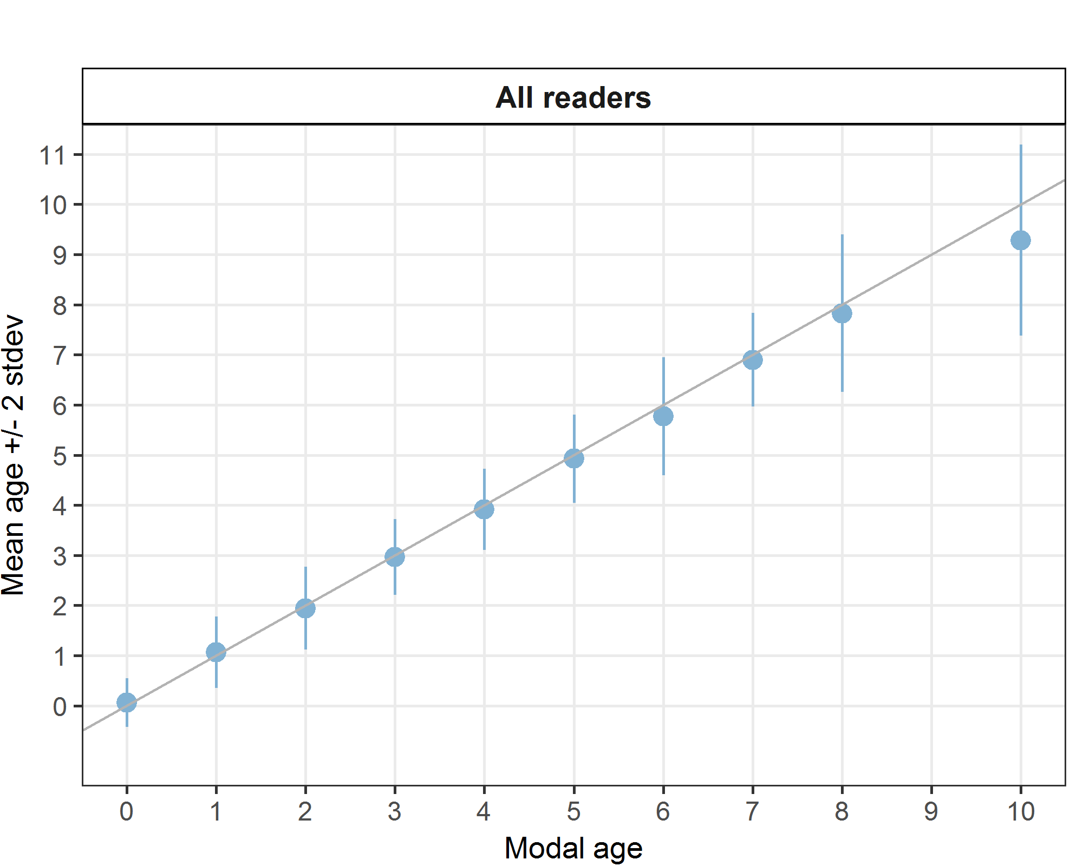
Figure 6.1: Age bias plot for all readers. Mean age recorded +/- 2 stdev of all readers combined are plotted against modal age. The estimated mean age corresponds to modal age if the estimated mean age is on the 1:1 equilibrium line (solid line). Relative bias is the age difference between estimated mean age and modal age.

Table 6.6: Inter reader bias test. The Inter-reader bias test gives probability of bias between readers and with modal age. - = no sign of bias (p>0.05), * = possibility of bias (0.01<p<0.05), ** = certainty of bias (p<0.01)
Comparison | R02 NL | R04 BE | R06 BE | R08 FR | R10 FR | R12 FR | R14 NL
R02 NL | - | - | - | ** | ** | ** | -
R04 BE | - | - | - | ** | ** | ** | -
R06 BE | - | - | - | * | ** | ** | -
R08 FR | ** | ** | * | . | ** | ** | **
R10 FR | ** | ** | ** | ** | - | - | **
R12 FR | ** | ** | ** | ** | - | - | **
R14 NL | - | - | - | ** | ** | ** | -
Modal age | - | - | - | ** | ** | ** | -

Advanced readers
All samples included (except AQ3 samples)
The weighted average percentage agreement based on modal ages for advanced readers is 95 %, with the weighted average CV of 8 % and APE of 1 %.
Table 6.7: Percentage agreement (PA) table represents the PA per modal age and reader, advanced the PA of all advanced readers combined per modal age and a weighted mean of the PA per reader.
Modal age | R02 NL | R04 BE | R06 BE | all
0 | 100 % | 88 % | 100 % | 95 %
1 | 94 % | 100 % | 100 % | 98 %
2 | 95 % | 89 % | 100 % | 95 %
3 | 95 % | 95 % | 100 % | 97 %
4 | 76 % | 100 % | 100 % | 92 %
5 | 100 % | 80 % | 100 % | 93 %
6 | 100 % | 92 % | 100 % | 97 %
7 | 100 % | 100 % | 71 % | 90 %
8 | 100 % | 100 % | 100 % | 100 %
9 | 100 % | 50 % | 50 % | 67 %
10 | 0 % | 100 % | 100 % | 67 %
Weighted Mean | 93 % | 93 % | 98 % | 95 %

Table 6.8: Coefficient of Variation (CV) table presents the CV per modal age and advanced reader, the CV of all advanced readers combined per modal age and a weighted mean of the CV per reader.
Modal age | R02 NL | R04 BE | R06 BE | all
0 | - | - | - | -
1 | 26 % | 0 % | 0 % | 14 %
2 | 12 % | 17 % | 0 % | 12 %
3 | 7 % | 7 % | 0 % | 6 %
4 | 12 % | 0 % | 0 % | 7 %
5 | 0 % | 9 % | 0 % | 5 %
6 | 0 % | 5 % | 0 % | 3 %
7 | 0 % | 0 % | 8 % | 5 %
8 | 0 % | 0 % | 0 % | 0 %
9 | 0 % | 8 % | 8 % | 6 %
10 | - | - | - | 6 %
Weighted Mean | 9 % | 6 % | 1 % | 8 %
Table 6.9: Relative bias table represents the relative bias per modal age and advanced reader, the relative bias of all advanced readers combined per modal age and a weighted mean of the relative bias per reader.
Modal age | R02 NL | R04 BE | R06 BE | all
0 | 0.00 | 0.25 | 0.00 | 0.08
1 | -0.06 | 0.00 | 0.00 | -0.02
2 | -0.05 | -0.11 | 0.00 | -0.05
3 | 0.05 | 0.05 | 0.00 | 0.03
4 | -0.12 | 0.00 | 0.00 | -0.04
5 | 0.00 | 0.07 | 0.00 | 0.02
6 | 0.00 | 0.08 | 0.00 | 0.03
7 | 0.00 | 0.00 | 0.00 | 0.00
8 | 0.00 | 0.00 | 0.00 | 0.00
9 | 0.00 | -0.50 | -0.50 | -0.33
10 | -1.00 | 0.00 | 0.00 | -0.33
Weighted Mean | -0.03 | 0.02 | -0.01 | -0.01
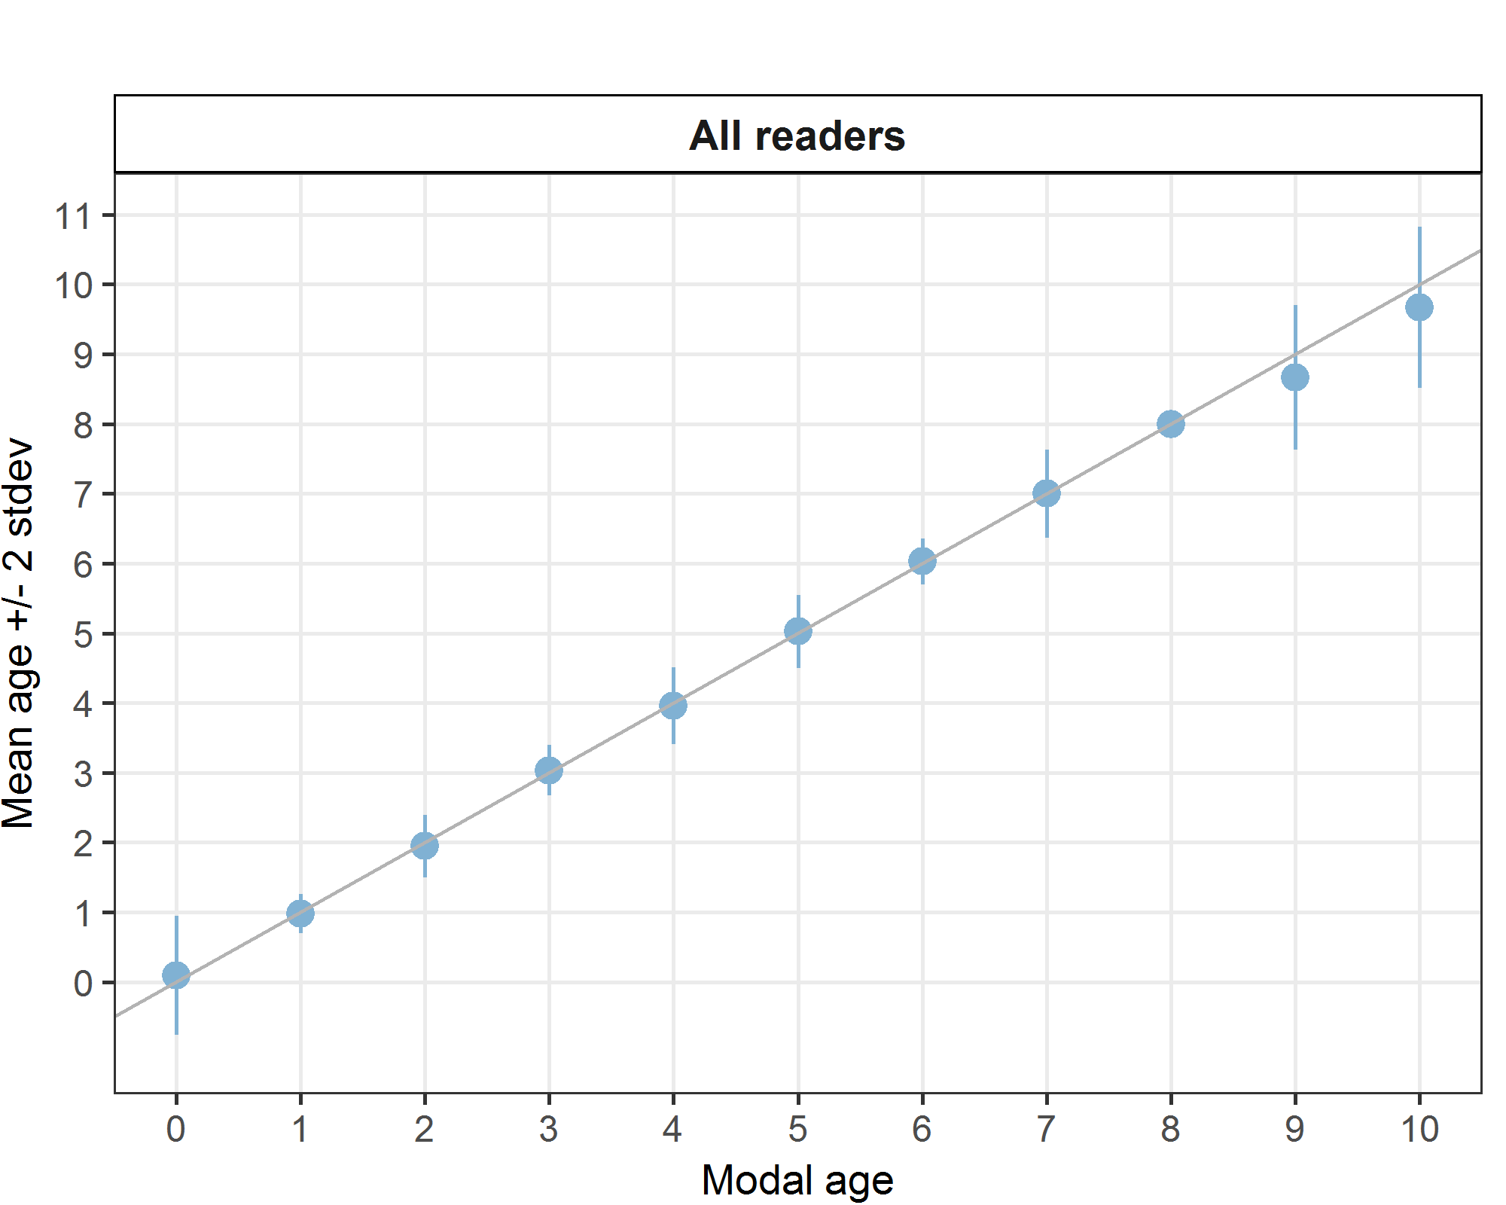
Figure 6.2: Age bias plot for advanced readers.

The age error matrix was calculated for the area and is only based on the age readings of the advanced readers because only these results go into the assessment.
Table 6.10: Age error matrix (AEM) for brill. The AEM shows the proportional distribution of age readings for each modal age. Age column should sum to one but due to rounding there might be small deviations in some cases. Only advanced readers are used for calculating the AEM.
Modal age | 0 | 1 | 2 | 3 | 4 | 5 | 6 | 7 | 8 | 9 | 10
Age 0 | 0.95455 | 0.01923 | - | - | - | - | - | - | - | - | -
Age 1 | - | 0.98077 | 0.05263 | - | - | - | - | - | - | - | -
Age 2 | 0.04545 | - | 0.94737 | - | - | - | - | - | - | - | -
Age 3 | - | - | - | 0.96667 | 0.05660 | - | - | - | - | - | -
Age 4 | - | - | - | 0.03333 | 0.92453 | 0.02273 | - | - | - | - | -
Age 5 | - | - | - | - | 0.01887 | 0.93182 | - | - | - | - | -
Age 6 | - | - | - | - | - | 0.04545 | 0.97368 | 0.04762 | - | - | -
Age 7 | - | - | - | - | - | - | 0.02632 | 0.90476 | - | - | -
Age 8 | - | - | - | - | - | - | - | 0.04762 | 1 | 0.3333 | -
Age 9 | - | - | - | - | - | - | - | - | - | 0.6667 | 0.3333
Age 10 | - | - | - | - | - | - | - | - | - | - | 0.6667

All readers – whole otoliths
All samples included, except AQ3 samples
The weighted average percentage agreement based on modal ages for all readers is 63 %, with the weighted average CV of 29 % and APE of 22 %.
The percentage agreement per reader per modal age tells how large part of the readings that are equal to the modal age. The weighted mean including at the bottom of the table is weighted according to number of age readings. A rank is also assigned to each reader.
Table 6.11: Percentage agreement (PA) table represents the PA per modal age and reader, the PA of all readers combined per modal age and a weighted mean of the PA per reader. A rank is also assigned to each reader.
Modal age | R02 NL | R04 BE | R06 BE | R08 FR | R10 FR | R12 FR | R14 NL | all
0 | 83 % | 71 % | 100 % | 14 % | 100 % | 100 % | 86 % | 79 %
1 | 65 % | 59 % | 64 % | 0 % | 91 % | 60 % | 90 % | 62 %
2 | 67 % | 91 % | 45 % | 14 % | 52 % | 79 % | 68 % | 59 %
3 | 65 % | 69 % | 50 % | 48 % | 65 % | 65 % | 73 % | 63 %
4 | 85 % | 80 % | 50 % | 60 % | 80 % | 75 % | 56 % | 70 %
5 | 38 % | 54 % | 31 % | 54 % | 62 % | 64 % | 75 % | 53 %
6 | 83 % | 86 % | 67 % | 57 % | 71 % | 57 % | 57 % | 68 %
7 | 60 % | 100 % | 40 % | 80 % | 80 % | 20 % | 20 % | 57 %
Weighted Mean | 68 % | 74 % | 53 % | 36 % | 73 % | 68 % | 70 % | 63 %

Table 6.12: Coefficient of Variation (CV) table presents the CV per modal age and reader, the CV of all readers combined per modal age and a weighted mean of the CV per reader. A rank is also assigned to each reader.
Modal age | R02 NL | R04 BE | R06 BE | R08 FR | R10 FR | R12 FR | R14 NL | all
0 | - | - | - | - | - | - | - | -
1 | 36 % | 36 % | 36 % | 25 % | 32 % | 36 % | 27 % | 52 %
2 | 35 % | 15 % | 28 % | 26 % | 37 % | 19 % | 36 % | 37 %
3 | 24 % | 16 % | 29 % | 18 % | 25 % | 20 % | 24 % | 25 %
4 | 10 % | 11 % | 17 % | 15 % | 14 % | 12 % | 20 % | 17 %
5 | 19 % | 18 % | 15 % | 12 % | 18 % | 13 % | 14 % | 18 %
6 | 7 % | 6 % | 13 % | 12 % | 8 % | 18 % | 10 % | 12 %
7 | 14 % | 0 % | 7 % | 14 % | 6 % | 17 % | 12 % | 14 %
Weighted Mean | 24 % | 18 % | 24 % | 19 % | 24 % | 20 % | 24 % | 29 %
The relative bias is the difference between the mean age (per modal age per reader) and modal age. As for the previous tables, a combined bias for all readers and weighted means are calculated and finally a rank is assigned to each reader.
Table 6.13: Relative bias table represents the relative bias per modal age per reader, the relative bias of all readers combined per modal age and a weighted mean of the relative bias per reader. A rank is also assigned to each reader.
Modal age | R02 NL | R04 BE | R06 BE | R08 FR | R10 FR | R12 FR | R14 NL | all
0 | 0.17 | 0.29 | 0.00 | 0.86 | 0.00 | 0.00 | 0.14 | 0.21
1 | 0.35 | 0.41 | 0.36 | 1.90 | -0.09 | 0.40 | 0.10 | 0.49
2 | 0.00 | 0.00 | 0.50 | 1.45 | -0.10 | 0.21 | -0.09 | 0.28
3 | -0.23 | 0.23 | 0.79 | 0.60 | 0.31 | 0.04 | -0.27 | 0.21
4 | -0.05 | 0.10 | 0.70 | 0.35 | 0.15 | -0.25 | -0.56 | 0.06
5 | -0.23 | 0.31 | 1.00 | 0.54 | 0.23 | -0.18 | -0.33 | 0.19
6 | -0.17 | 0.14 | 0.50 | -0.14 | 0.29 | -0.71 | -0.43 | -0.07
7 | -0.60 | 0.00 | 0.60 | -0.40 | 0.20 | -1.60 | -1.00 | -0.40
Weighted Mean | -0.05 | 0.20 | 0.60 | 0.86 | 0.11 | -0.06 | -0.24 | 0.20

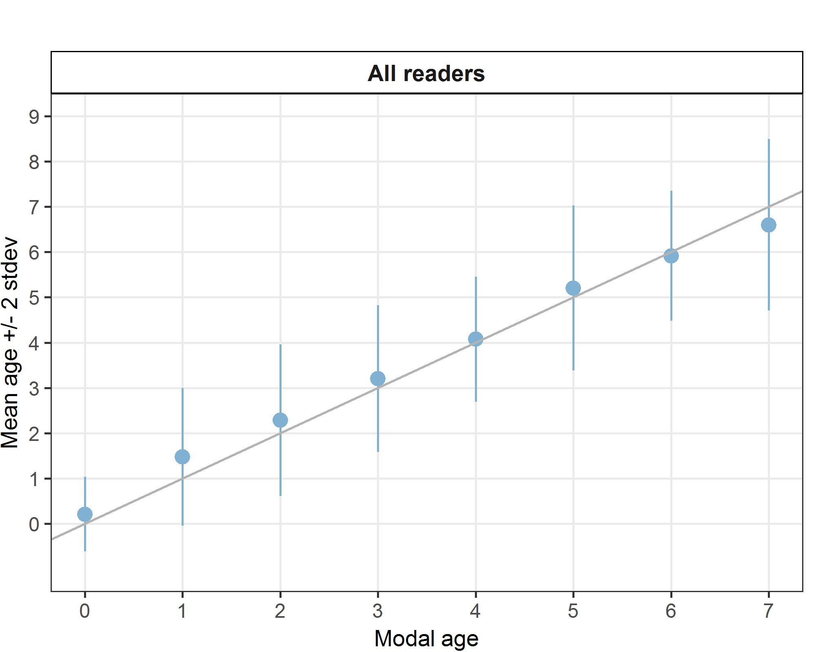
Figure 6.3: Age bias plot for all readers. Mean age recorded +/- 2 stdev for all readers combined are plotted against modal age. The estimated mean age corresponds to modal age, if the estimated mean age is on the 1:1 equilibrium line (solid line). Relative bias is the age difference between estimated mean age and modal age.

Table 6.14: Inter reader bias test. The Inter-reader bias test gives probability of bias between readers and with modal age. - = no sign of bias (p>0.05), * = possibility of bias (0.01<p<0.05), ** = certainty of bias (p<0.01)
Comparison | R02 NL | R04 BE | R06 BE | R08 FR | R10 FR | R12 FR | R14 NL
R02 NL | - | ** | ** | ** | - | - | *
R04 BE | ** | - | ** | ** | - | ** | **
R06 BE | ** | ** | - | * | ** | ** | **
R08 FR | ** | ** | * | - | ** | ** | **
R10 FR | - | - | ** | ** | - | - | **
R12 FR | - | ** | ** | ** | - | - | *
R14 NL | * | ** | ** | ** | ** | * | -
Modal age | - | ** | ** | ** | - | - | **

Advanced readers – whole otoliths
All samples included, except AQ3 samples
The weighted average percentage agreement based on modal ages for all readers is 71 %, with the weighted average CV of 29 % and APE of 23 %.
Table 6.15: Percentage agreement (PA) table represents the PA per modal age and reader, advanced the PA of all advanced readers combined per modal age and a weighted mean of the PA per reader.
Modal age | R02 NL | R04 BE | R06 BE | all
0 | 100 % | 83 % | 100 % | 94 %
1 | 76 % | 83 % | 56 % | 72 %
2 | 73 % | 84 % | 43 % | 67 %
3 | 90 % | 67 % | 58 % | 72 %
4 | 86 % | 82 % | 45 % | 71 %
5 | 57 % | 86 % | 43 % | 62 %
6 | 80 % | 73 % | 70 % | 74 %
7 | 60 % | 100 % | 60 % | 73 %
Weighted Mean | 79 % | 80 % | 54 % | 71 %

Table 6.16: Coefficient of Variation (CV) table presents the CV per modal age and advanced reader, the CV of all advanced readers combined per modal age and a weighted mean of the CV per reader. A rank is also assigned to each reader.
Modal age | R02 NL | R04 BE | R06 BE | all
0 | - | - | - | -
1 | 35 % | 45 % | 70 % | 57 %
2 | 32 % | 22 % | 45 % | 36 %
3 | 11 % | 17 % | 27 % | 22 %
4 | 9 % | 10 % | 19 % | 16 %
5 | 12 % | 14 % | 19 % | 19 %
6 | 7 % | 9 % | 13 % | 11 %
7 | 14 % | 0 % | 7 % | 10 %
Weighted Mean | 20 % | 20 % | 35 % | 29 %

Table 6.17: Relative bias table represents the relative bias per modal age and advanced reader, the relative bias of all advanced readers combined per modal age and a weighted mean of the relative bias per reader. A rank is also assigned to each reader.
Modal age | R02 NL | R04 BE | R06 BE | all
0 | 0.00 | 0.17 | 0.00 | 0.06
1 | 0.24 | 0.22 | 0.56 | 0.34
2 | -0.10 | 0.19 | 0.43 | 0.17
3 | 0.00 | 0.24 | 0.79 | 0.34
4 | -0.05 | 0.09 | 0.68 | 0.24
5 | -0.43 | 0.29 | 1.00 | 0.29
6 | -0.20 | 0.09 | 0.50 | 0.13
7 | -0.60 | 0.00 | 0.40 | -0.07
Weighted Mean | -0.07 | 0.17 | 0.57 | 0.23
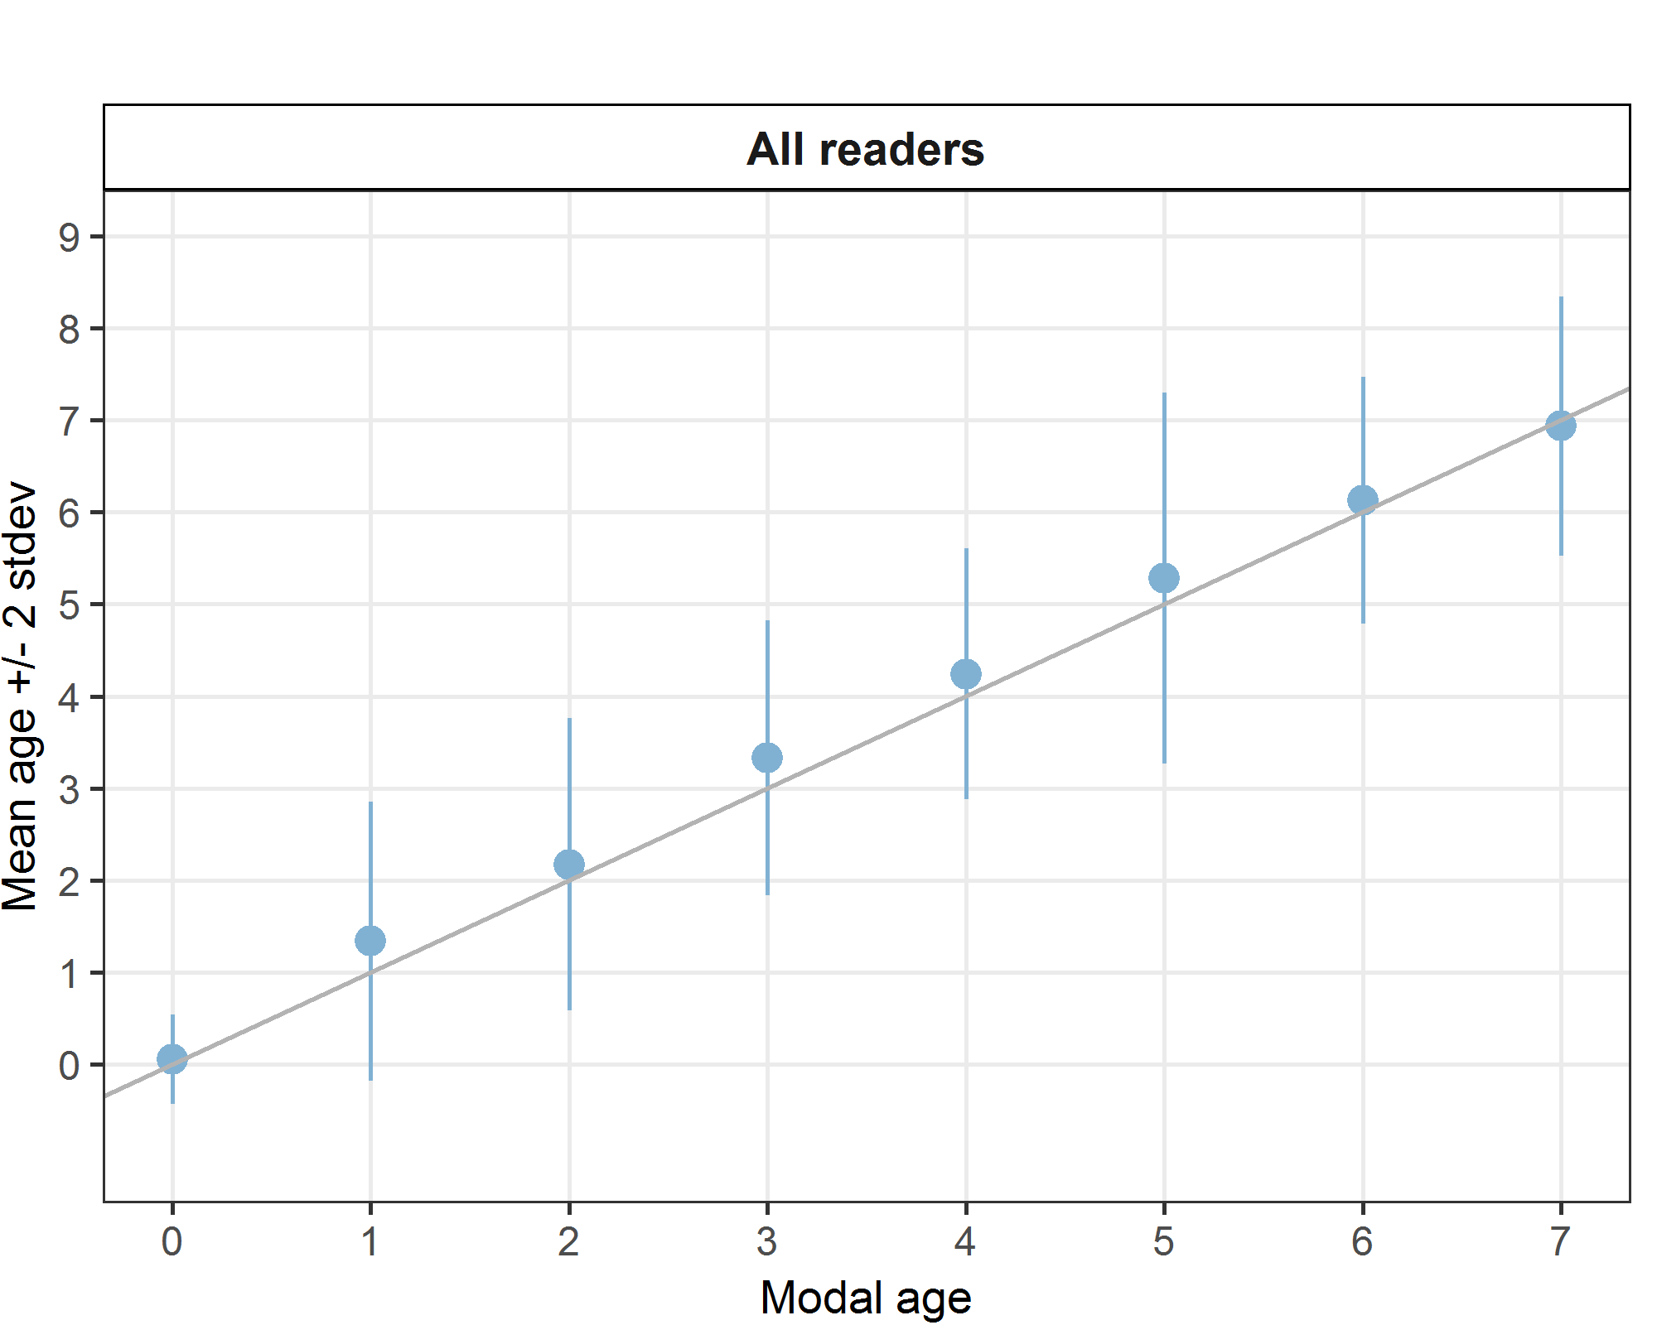
Figure 6.4: Age bias plot for advanced readers.

Age error matrices are calculated per area and only based on the age readings of the advanced readers.
Table 6.18: Age error matrix (AEM) for brill for whole otoliths. The AEM shows the proportional distribution of age readings for each modal age. Age column should sum to one but due to rounding there might be small deviations in some cases. Only advanced readers are used for calculating the AEM.
Modal age | 0 | 1 | 2 | 3 | 4 | 5 | 6 | 7
Age 0 | 0.94118 | 0.01887 | - | - | - | - | - | -
Age 1 | 0.05882 | 0.71698 | 0.11957 | - | - | - | - | -
Age 2 | - | 0.20755 | 0.67391 | 0.03279 | - | - | - | -
Age 3 | - | 0.03774 | 0.14130 | 0.72131 | 0.06061 | - | - | -
Age 4 | - | - | 0.05435 | 0.14754 | 0.71212 | 0.14286 | - | -
Age 5 | - | 0.01887 | - | 0.08197 | 0.15152 | 0.61905 | 0.09677 | 0.06667
Age 6 | - | - | 0.01087 | 0.01639 | 0.07576 | 0.09524 | 0.74194 | 0.06667
Age 7 | - | - | - | - | - | 0.09524 | 0.09677 | 0.73333
Age 8 | - | - | - | - | - | 0.04762 | 0.06452 | 0.13333

Comparison between whole and stained sectioned otoliths

Figure 6.5: Comparison of age determinations based on whole and sectioned otoliths from the same fish. The y=x line indicates when both methods give the same result.
The same age is given in 55% of the cases for whole and stained sectioned otoliths (fig. 6.5), 4% are above the line (older age for section) and 41% are below the line (older age for whole). The outcome of the age readings clearly differed depending on the method, indicating that one of the methods is less accurate. Fish are generally assigned an older age when using sectioned otoliths compared to whole otoliths. This was evident for all readers combined. The deviation becomes clearer in older fish, as for fish aged from 0 to 2, 80% was given the same age for the two methods.

Discussion
The statistics representing age reading performance were calculated for all readers combined and for experienced readers only. All areas were included and calculations were carried separately for each preparation method. There were 3 advanced readers, used to reading S&S otoliths. No advanced readers were used to reading whole otoliths. As expected, percentage agreement was higher and coefficient of variation was lower for advanced readers compared to all readers regardless of preparation method.
In all cases, the statistics were better for stained sectioned otoliths than for whole otoliths. The average percentage agreement of 84 %, CV of 15 % and APE of 8 % was reached by all readers annotating stained sectioned otoliths. There was an important improvement when only advanced readers were combined: PA=95%, CV = 8%, APE = 1%. For whole otoliths, the statistical results were not satisfactory. The average percentage agreement of 63 %, CV of 29 % and APE of 22 % was obtained by all readers, while for advanced readers, the results were slightly better: PA=71%, CV = 29%, APE = 23%. We should stress here that the advanced readers were used to reading stained sectioned otoliths, and not whole otoliths, although they were used to reading whole otoliths of other flatfish species. Only the French readers read whole otoliths, but they are all basic, not reporting data for assessments.
When comparing whole and stained sectioned otoliths, fish are generally assigned an older age when otoliths are sectioned and stained. This has also been confirmed in other flatfish species. Question is whether age is underestimated when using whole otoliths or overestimated when using sections. In a validation study on two other flatfish species (plaice Pleuronectes platessa and sole Solea solea) it was concluded that age will be underestimated when using whole otoliths (Etherton, 2015).
From the 2005 exchange, we only know that the PA was high (90%) and that no bias between the readers was evident. In this exchange, the PA for stained sectioned otoliths of the advanced readers was very high (95%) and was still satisfactory for all readers (84 %). No bias was evident between the advanced readers for S&S otoliths, but bias was evident with basic readers. In the case of whole otoliths, the bias was evident between almost all readers and the percentage agreement was unsatisfactory.

Conclusion
Overall agreement between advanced readers of stained sectioned brill otoliths is good with average percentage agreement (PA) of 95% and variance CV=8% and APE=1%

Overall agreement between advanced readers of whole brill otoliths is significantly lower with average percentage agreement (PA) of 71 % and variance CV=29% and APE=23%.
No major issues were detected for advanced readers when ageing stained sectioned brill otoliths. Stained sections appear to be the best way to age brill. For young fish (aged 0 to 2), the differences in ageing between whole and stained sectioned otoliths is small. In 80 % of the cases, fishes are aged the same.

References

Etherton M. (2015) European plaice (Pleuronectes platessa) and sole (Solea solea) indirect age validation using otoliths from mark-recapture experiments from the North Sea. Fisheries Research 170: 76–81.

Annex 1. List of participants
Table 8.1: Participants list.
Reader code | Expertise
R02 NL | Advanced
R04 BE | Advanced
R06 BE | Advanced
R08 FR | Basic
R10 FR | Basic
R12 FR | Basic
R14 NL | Basic

Annex 2. Additional results

Results all readers – sectioned and stained
Data Overview
Table 9.1: Summary of statistics; PA (%), CV (%) and APE (%).
CV | PA | APE
15 % | 84 % | 8 %
Table 9.2: Data overview including modal age and statistics per sample.
Fish ID | Event ID | Image ID | length | Catch date | ICES area | R02 NL | R04 BE | R06 BE | R08 FR | R10 FR | R12 FR | R14 NL | Modal age | PA % | CV % | APE %
001_PTCT07_BLL_7D_2017071510364 | 200 | 15029 | 325 | 15/07/2017 00:00:00 | 27.7.d | 2 | 2 | 2 | 2 | 1 | 1 | 2 | 2 | 71 | 28 | 24
002_PTCT07_BLL_7D_2017071510365 | 200 | 15031 | 480 | 15/07/2017 00:00:00 | 27.7.d | 5 | 4 | 5 | 5 | 4 | 4 | 5 | 5 | 57 | 12 | 11
003_BTS01_BLL_4B_2017082811204 | 200 | 15033 | 303 | 28/08/2017 00:00:00 | 27.4.b | 2 | 2 | 2 | 2 | 2 | 2 | 2 | 2 | 100 | 0 | 0
004_BTS01_BLL_4C_2014002 | 200 | 15035 | 240 | 25/08/2014 00:00:00 | 27.4.c | 1 | 1 | 1 | 1 | 1 | 1 | 1 | 1 | 100 | 0 | 0
005_BTS01_BLL_4C_2014003 | 200 | 15037 | 305 | 25/08/2014 00:00:00 | 27.4.c | 1 | 1 | 1 | 1 | 1 | 1 | 1 | 1 | 100 | 0 | 0
006_BTS01_BLL_4C_2014004 | 200 | 15039 | 435 | 25/08/2014 00:00:00 | 27.4.c | - | 6 | 6 | 6 | 6 | 4 | 6 | 6 | 83 | 14 | 10
007_BTS01_BLL_4C_2014006 | 200 | 15041 | 390 | 25/08/2014 00:00:00 | 27.4.c | 5 | 5 | 5 | 5 | 5 | 5 | 5 | 5 | 100 | 0 | 0
008_BTS01_BLL_4C_2014008 | 200 | 15043 | 510 | 25/08/2014 00:00:00 | 27.4.c | 5 | 5 | 5 | 5 | 5 | 5 | - | 5 | 100 | 0 | 0
009_BTS01_BLL_4C_2014015 | 200 | 15045 | 560 | 25/08/2014 00:00:00 | 27.4.c | 5 | 5 | 5 | 5 | 5 | 5 | 5 | 5 | 100 | 0 | 0
010_BTS01_BLL_4C_2015053385 | 200 | 15047 | 290 | 23/10/2015 00:00:00 | 27.4.c | 1 | 1 | 1 | 1 | 1 | 1 | 1 | 1 | 100 | 0 | 0
011_BTS01_BLL_4C_2015053386 | 200 | 15049 | 285 | 23/10/2015 00:00:00 | 27.4.c | 1 | 1 | 1 | 1 | 1 | 1 | 1 | 1 | 100 | 0 | 0
012_BTS01_BLL_4C_2015053387 | 200 | 15050 | 315 | 23/10/2015 00:00:00 | 27.4.c | 2 | 2 | 2 | 2 | 2 | 3 | 2 | 2 | 86 | 18 | 11
013_BTS01_BLL_4C_2015053388 | 200 | 15052 | 370 | 23/10/2015 00:00:00 | 27.4.c | 2 | 2 | 2 | 3 | 2 | 4 | 2 | 2 | 71 | 32 | 25
014_BTS01_BLL_4C_2015053390 | 200 | 15054 | 360 | 23/10/2015 00:00:00 | 27.4.c | 4 | 4 | 4 | 4 | 4 | 3 | 4 | 4 | 86 | 10 | 6
015_BTS01_BLL_4C_2015053391 | 200 | 15056 | 325 | 23/10/2015 00:00:00 | 27.4.c | 3 | 3 | 3 | 2 | 2 | 2 | 3 | 3 | 57 | 21 | 19
016_BTS01_BLL_4C_2016219500 | 200 | 15058 | 325 | 04/10/2016 00:00:00 | 27.4.c | 3 | 3 | 3 | 3 | 3 | 3 | 3 | 3 | 100 | 0 | 0
017_BTS01_BLL_4C_2016219501 | 200 | 15060 | 365 | 04/10/2016 00:00:00 | 27.4.c | 9 | 9 | 8 | 8 | 6 | 7 | 8 | 8 | 43 | 14 | 10
018_BTS01_BLL_4C_2017082811007 | 200 | 15062 | 301 | 28/08/2017 00:00:00 | 27.4.c | 2 | 2 | 2 | 2 | 2 | 2 | 2 | 2 | 100 | 0 | 0
019_BTS01_BLL_4C_2017082811008 | 200 | 15064 | 320 | 28/08/2017 00:00:00 | 27.4.c | 2 | 2 | 2 | 2 | 2 | 2 | 2 | 2 | 100 | 0 | 0
020_BTS01_BLL_4C_2017082811010 | 200 | 15066 | 257 | 28/08/2017 00:00:00 | 27.4.c | 1 | 1 | 1 | 1 | 1 | 1 | 1 | 1 | 100 | 0 | 0
021_BTS01_BLL_4C_2017082811011 | 200 | 15068 | 284 | 28/08/2017 00:00:00 | 27.4.c | 1 | 1 | 1 | 1 | 1 | 1 | 1 | 1 | 100 | 0 | 0
022_BTS01_BLL_4C_2017082811017 | 200 | 15070 | 433 | 28/08/2017 00:00:00 | 27.4.c | 3 | 3 | 3 | 3 | 3 | 3 | 3 | 3 | 100 | 0 | 0
023_BYDR05_BLL_4B_2017071410271 | 200 | 15072 | 270 | 14/07/2017 00:00:00 | 27.4.b | 2 | 1 | 2 | 2 | 2 | 2 | 1 | 2 | 71 | 28 | 24
024_BYDR05_BLL_4B_2017071410272 | 200 | 15074 | 270 | 14/07/2017 00:00:00 | 27.4.b | 2 | 1 | 2 | 2 | 2 | 2 | 1 | 2 | 71 | 28 | 24
025_BYDR05_BLL_4B_2017071410273 | 200 | 15076 | 290 | 14/07/2017 00:00:00 | 27.4.b | 2 | 2 | 2 | 2 | 2 | 2 | 2 | 2 | 100 | 0 | 0
026_BYDR05_BLL_4B_2017071410274 | 200 | 15078 | 260 | 14/07/2017 00:00:00 | 27.4.b | 2 | 2 | 2 | 2 | 2 | 1 | 2 | 2 | 86 | 20 | 13
027_BYDR05_BLL_4B_2017071410527 | 200 | 15080 | 520 | 14/07/2017 00:00:00 | 27.4.b | 4 | 4 | 4 | 4 | 4 | 3 | 4 | 4 | 86 | 10 | 6
028_BYDR05_BLL_4B_2017071410535 | 200 | 15082 | 525 | 14/07/2017 00:00:00 | 27.4.b | 4 | 4 | 4 | 4 | 4 | 4 | 4 | 4 | 100 | 0 | 0
029_BYDR06_BLL_4B_2011001 | 200 | 15084 | 250 | 29/09/2011 00:00:00 | 27.4.b | 1 | 1 | 1 | 2 | 1 | 2 | 1 | 1 | 71 | 38 | 32
030_BYDR06_BLL_4B_2011002 | 200 | 15122 | 260 | 29/09/2011 00:00:00 | 27.4.b | 1 | 1 | 1 | 2 | 1 | 1 | 1 | 1 | 86 | 33 | 21
031_BYDR07_BLL_4B_2017110910270 | 200 | 15088 | 280 | 09/11/2017 00:00:00 | 27.4.b | 1 | 1 | 1 | 1 | 1 | 1 | 1 | 1 | 100 | 0 | 0
032_BYDR07_BLL_4B_2017110910271 | 200 | 15090 | 290 | 09/11/2017 00:00:00 | 27.4.b | 1 | 1 | 1 | 2 | 1 | 2 | 1 | 1 | 71 | 38 | 32
033_BYDR07_BLL_4B_2017110910276 | 200 | 15092 | 300 | 09/11/2017 00:00:00 | 27.4.b | 1 | 1 | 1 | 1 | 1 | 2 | 1 | 1 | 86 | 33 | 21
034_BYDR07_BLL_4B_2017110910277 | 200 | 15094 | 300 | 09/11/2017 00:00:00 | 27.4.b | - | 1 | 1 | 1 | 1 | - | 1 | 1 | 100 | 0 | 0
035_BYDR07_BLL_4B_2017110910297 | 200 | 15096 | 190 | 09/11/2017 00:00:00 | 27.4.b | 0 | 0 | 0 | 0 | 0 | - | 0 | 0 | 100 | - | -
036_BYDR07_BLL_4B_2017110910298 | 200 | 15098 | 200 | 09/11/2017 00:00:00 | 27.4.b | 0 | 0 | 0 | 1 | 0 | - | 0 | 0 | 83 | - | -
037_BYDR05_BLL_4B_2017071410528 | 200 | 15100 | 335 | 14/07/2017 00:00:00 | 27.4.b | 3 | 4 | 4 | 4 | 3 | 3 | 3 | 3 | 57 | 16 | 14
038_BYDR07_BLL_4B_2017110910533 | 200 | 15102 | 380 | 09/11/2017 00:00:00 | 27.4.b | 4 | 4 | 4 | 4 | 4 | 4 | 4 | 4 | 100 | 0 | 0
039_BYDR05_BLL_4B_2017071410534 | 200 | 15104 | 450 | 14/07/2017 00:00:00 | 27.4.b | 3 | 4 | 3 | 4 | 3 | 3 | 3 | 3 | 71 | 15 | 12
040_BYDR07_BLL_4B_2017110910541 | 200 | 15105 | 535 | 09/11/2017 00:00:00 | 27.4.b | 4 | 4 | 4 | 4 | 4 | 4 | 4 | 4 | 100 | 0 | 0
041_BYDR07_BLL_4B_2017110910542 | 200 | 15107 | 520 | 09/11/2017 00:00:00 | 27.4.b | 6 | 6 | 6 | 6 | 6 | 6 | 6 | 6 | 100 | 0 | 0
042_BYDR07_BLL_4B_2017110910549 | 200 | 15109 | 560 | 09/11/2017 00:00:00 | 27.4.b | 5 | 5 | 5 | 5 | 5 | 5 | 5 | 5 | 100 | 0 | 0
043_BYDR07_BLL_4B_2017110910550 | 200 | 15111 | 555 | 09/11/2017 00:00:00 | 27.4.b | 7 | 7 | 7 | 7 | 7 | 8 | 7 | 7 | 86 | 5 | 3
044_BYDR07_BLL_4B_2017110910552 | 200 | 15113 | 580 | 09/11/2017 00:00:00 | 27.4.b | 7 | 7 | 7 | 7 | 7 | 6 | 7 | 7 | 86 | 6 | 4
045_BYDR08_BLL_7D_2017121510064 | 200 | 15115 | 270 | 15/12/2017 00:00:00 | 27.7.d | - | 0 | 0 | 0 | 0 | - | 0 | 0 | 100 | - | -
046_BYDR08_BLL_7D_017121510211 | 200 | 15124 | 455 | 15/12/2017 00:00:00 | 27.7.d | 3 | 3 | 3 | 3 | 3 | 3 | 3 | 3 | 100 | 0 | 0
047_BYDR08_BLL_7D_2017121510206 | 200 | 15117 | 430 | 15/12/2017 00:00:00 | 27.7.d | 2 | 2 | 2 | 2 | 2 | 2 | 2 | 2 | 100 | 0 | 0
048_BYDR08_BLL_7D_2017121510207 | 200 | 15118 | 435 | 15/12/2017 00:00:00 | 27.7.d | 1 | 2 | 2 | 2 | 2 | 2 | 2 | 2 | 86 | 20 | 13
049_BYDR08_BLL_7D_2017121510208 | 200 | 15119 | 465 | 15/12/2017 00:00:00 | 27.7.d | 3 | 4 | 4 | 5 | 4 | 4 | 3 | 4 | 57 | 18 | 13
050_BYDR08_BLL_7D_2017121510213 | 200 | 15120 | 475 | 15/12/2017 00:00:00 | 27.7.d | 4 | 4 | 4 | 4 | 4 | 4 | 4 | 4 | 100 | 0 | 0
051_BYDR08_BLL_7D_2017121510219 | 200 | 15129 | 320 | 15/12/2017 00:00:00 | 27.7.d | 0 | 1 | 1 | 1 | 1 | 2 | 1 | 1 | 71 | 58 | 29
052_BYDR08_BLL_7D_2017121510220 | 200 | 15131 | 320 | 15/12/2017 00:00:00 | 27.7.d | 1 | 1 | 1 | 1 | 1 | 2 | 1 | 1 | 86 | 33 | 21
053_CDDR02_BLL_7D_2017002255 | 200 | 15133 | 495 | 09/03/2017 00:00:00 | 27.7.d | - | 4 | 4 | 4 | 4 | 4 | 3 | 4 | 83 | 11 | 7
054_CDDR02_BLL_7D_2017002256 | 200 | 15135 | 570 | 09/03/2017 00:00:00 | 27.7.d | 5 | 5 | 5 | 5 | 5 | 5 | 5 | 5 | 100 | 0 | 0
055_CDDR02_BLL_7D_2017002257 | 200 | 15137 | 500 | 09/03/2017 00:00:00 | 27.7.d | 4 | 4 | 4 | 4 | 4 | 3 | 4 | 4 | 86 | 10 | 6
056_CDDR02_BLL_7D_2017002260 | 200 | 15139 | 470 | 09/03/2017 00:00:00 | 27.7.d | 4 | 4 | 4 | 4 | 4 | 4 | 4 | 4 | 100 | 0 | 0
057_CDDR02_BLL_7D_2017002261 | 200 | 15141 | 580 | 09/03/2017 00:00:00 | 27.7.d | 6 | 6 | 6 | 6 | 6 | 6 | 6 | 6 | 100 | 0 | 0
058_CDDR02_BLL_7D_2017002263 | 200 | 15143 | 520 | 09/03/2017 00:00:00 | 27.7.d | 6 | 6 | 6 | 6 | 6 | 6 | 6 | 6 | 100 | 0 | 0
059_CDDR02_BLL_7D_2017002264 | 200 | 15145 | 495 | 09/03/2017 00:00:00 | 27.7.d | 5 | 5 | 5 | 5 | 5 | 5 | 5 | 5 | 100 | 0 | 0
060_CDDR02_BLL_7D_2017002271 | 200 | 15147 | 335 | 09/03/2017 00:00:00 | 27.7.d | 2 | 2 | 2 | 2 | 2 | 2 | 2 | 2 | 100 | 0 | 0
061_CDDR02_BLL_7D_2017002274 | 200 | 15149 | 325 | 09/03/2017 00:00:00 | 27.7.d | 2 | 2 | 2 | 2 | 2 | 2 | 2 | 2 | 100 | 0 | 0
062_CDDR06_BLL_4B_2017073110641 | 200 | 15151 | 535 | 31/07/2017 00:00:00 | 27.4.b | 7 | 7 | 7 | 7 | 6 | 6 | 7 | 7 | 71 | 7 | 6
063_CDDR06_BLL_4B_2017073110642 | 200 | 15152 | 560 | 31/07/2017 00:00:00 | 27.4.b | 9 | 10 | 10 | 10 | 8 | 8 | 10 | 10 | 57 | 10 | 9
064_CDDR06_BLL_4B_2017073110643 | 200 | 15153 | 535 | 31/07/2017 00:00:00 | 27.4.b | 6 | 6 | 6 | 6 | 5 | 4 | 6 | 6 | 71 | 14 | 11
065_CDDR06_BLL_4B_2017073110645 | 200 | 15154 | 445 | 31/07/2017 00:00:00 | 27.4.b | 3 | 4 | 4 | 4 | 4 | 3 | 4 | 4 | 71 | 13 | 11
066_CDDR06_BLL_4B_2017073110646 | 200 | 15028 | 470 | 31/07/2017 00:00:00 | 27.4.b | 6 | 7 | 6 | 6 | 5 | 4 | 6 | 6 | 57 | 17 | 12
067_CDDR06_BLL_4B_2017073110654 | 200 | 15155 | 570 | 31/07/2017 00:00:00 | 27.4.b | 9 | 8 | 9 | 9 | 8 | 7 | 8 | 8 | 43 | 9 | 7
068_CDDR06_BLL_4B_2017073110659 | 200 | 15156 | 490 | 31/07/2017 00:00:00 | 27.4.b | 5 | 5 | 5 | 5 | 5 | 4 | 4 | 5 | 71 | 10 | 9
069_CDDR06_BLL_4B_2017073110644 | 200 | 15157 | 490 | 31/07/2017 00:00:00 | 27.4.b | 3 | 3 | 3 | 3 | 3 | 2 | 3 | 3 | 86 | 13 | 9
070_CDDR06_BLL_4B_2017073110648 | 200 | 15158 | 355 | 31/07/2017 00:00:00 | 27.4.b | 2 | 2 | 2 | 2 | 1 | 1 | 2 | 2 | 71 | 28 | 24
071_CDDR06_BLL_4B_2017073110649 | 200 | 15160 | 400 | 31/07/2017 00:00:00 | 27.4.b | 3 | 3 | 3 | 3 | 2 | 2 | 3 | 3 | 71 | 18 | 15
072_CDDR07_BLL_4B_2017102010285 | 200 | 15161 | 415 | 20/10/2017 00:00:00 | 27.4.b | 6 | 6 | 6 | 6 | 6 | 5 | 6 | 6 | 86 | 6 | 4
073_CDDR08_BLL_7D_2017112110277 | 200 | 15163 | 370 | 21/11/2017 00:00:00 | 27.7.d | 3 | 3 | 3 | 3 | 2 | 3 | 2 | 3 | 71 | 18 | 15
074_CDDR08_BLL_7D_2017112110280 | 200 | 15165 | 420 | 21/11/2017 00:00:00 | 27.7.d | 3 | 3 | 3 | 3 | 3 | 3 | 3 | 3 | 100 | 0 | 0
075_CDDR08_BLL_7D_2017112110283 | 200 | 15167 | 520 | 21/11/2017 00:00:00 | 27.7.d | 5 | 6 | 5 | 5 | 6 | 5 | - | 5 | 67 | 10 | 8
076_EXNL_BLL_4100007_130918_004 | 200 | 15169 | 233 | 18/09/2017 00:00:00 | 27.4.c | 1 | 1 | 1 | 1 | 1 | 2 | 1 | 1 | 86 | 33 | 21
077_EXNL_BLL_4100014_130918_005 | 200 | 15171 | 152 | 18/09/2017 00:00:00 | 27.4.c | 0 | 0 | 0 | 0 | 0 | 0 | 0 | 0 | 100 | - | -
078_EXNL_BLL_4100022_180918_006 | 200 | 15173 | 138 | 18/09/2017 00:00:00 | 27.4.c | 0 | 0 | 0 | 1 | 0 | 0 | 0 | 0 | 86 | - | -
079_EXNL_BLL_4100023_180918_007 | 200 | 15175 | 143 | 18/09/2017 00:00:00 | 27.4.c | 0 | 0 | 0 | 0 | 0 | 0 | 0 | 0 | 100 | - | -
080_EXNL_BLL_4100024_180918_008 | 200 | 15177 | 133 | 18/09/2017 00:00:00 | 27.4.c | 0 | 0 | 0 | 0 | 0 | 0 | 0 | 0 | 100 | - | -
081_GNKT02_BLL_7D_2017002518 | 200 | 15179 | 540 | 07/03/2017 00:00:00 | 27.7.d | 5 | 5 | 5 | 5 | 5 | 4 | 5 | 5 | 86 | 8 | 5
082_GNKT02_BLL_7D_2017002524 | 200 | 15181 | 565 | 07/03/2017 00:00:00 | 27.7.d | 7 | 7 | 7 | 7 | 7 | 7 | 7 | 7 | 100 | 0 | 0
083_NDGP05_BLL_4B_2005004 | 200 | 15258 | 310 | 07/11/2005 00:00:00 | 27.4.b | 2 | 2 | 2 | 2 | 2 | 2 | 2 | 2 | 100 | 0 | 0
084_NDGP05_BLL_4B_2005005 | 200 | 15260 | 340 | 07/11/2005 00:00:00 | 27.4.b | 2 | 2 | 2 | 2 | 2 | 2 | 2 | 2 | 100 | 0 | 0
085_NDGP05_BLL_4B_2005001 | 200 | 15183 | 330 | 07/11/2005 00:00:00 | 27.4.b | 3 | 3 | 3 | 3 | 3 | 2 | 3 | 3 | 86 | 13 | 9
086_NDGP05_BLL_4B_2005041 | 200 | 15185 | 420 | 07/11/2005 00:00:00 | 27.4.b | 3 | 3 | 3 | 3 | 3 | 3 | 3 | 3 | 100 | 0 | 0
087_NDGP05_BLL_4B_2005045 | 200 | 15187 | 470 | 07/11/2005 00:00:00 | 27.4.b | 3 | 3 | 3 | 3 | 3 | 3 | 3 | 3 | 100 | 0 | 0
088_NDGP05_BLL_4B_2005060 | 200 | 15189 | 490 | 07/11/2005 00:00:00 | 27.4.b | 5 | 5 | 5 | 5 | 5 | 4 | 5 | 5 | 86 | 8 | 5
089_NDGP05_BLL_4B_2005066 | 200 | 15191 | 570 | 07/11/2005 00:00:00 | 27.4.b | 4 | 4 | 4 | 4 | 4 | 4 | 4 | 4 | 100 | 0 | 0
090_NDGP05_BLL_4B_2005071 | 200 | 15193 | 540 | 07/11/2005 00:00:00 | 27.4.b | 5 | 5 | 5 | 5 | 5 | 3 | 5 | 5 | 86 | 16 | 10
092_PTCT02_BLL_7D_2017002749 | 200 | 15195 | 495 | 07/03/2017 00:00:00 | 27.7.d | 8 | 8 | 8 | 7 | 7 | 6 | 8 | 8 | 57 | 11 | 9
093_PTCT02_BLL_7D_2017002750 | 200 | 15197 | 630 | 07/03/2017 00:00:00 | 27.7.d | 7 | 7 | 8 | 7 | 7 | 6 | 8 | 7 | 57 | 10 | 7
094_PTCT02_BLL_7D_2017002752 | 200 | 15199 | 440 | 07/03/2017 00:00:00 | 27.7.d | 3 | 3 | 3 | 3 | 3 | 3 | 3 | 3 | 100 | 0 | 0
095_PTCT03_BLL_4C_2017040310575 | 200 | 15201 | 425 | 03/04/2017 00:00:00 | 27.4.c | 3 | 3 | 3 | 3 | 3 | 3 | 3 | 3 | 100 | 0 | 0
096_PTCT03_BLL_4C_2017040310576 | 200 | 15202 | 445 | 03/04/2017 00:00:00 | 27.4.c | 4 | 3 | 3 | 3 | 3 | 3 | 3 | 3 | 86 | 12 | 8
097_PTCT03_BLL_4C_2017040310577 | 200 | 15203 | 425 | 03/04/2017 00:00:00 | 27.4.c | 3 | 3 | 3 | 3 | 3 | 3 | 3 | 3 | 100 | 0 | 0
098_PTCT03_BLL_4C_2017040310583 | 200 | 15204 | 365 | 03/04/2017 00:00:00 | 27.4.c | 4 | 4 | 4 | 3 | 3 | 3 | 4 | 4 | 57 | 15 | 14
099_PTCT03_BLL_4C_2017040310584 | 200 | 15205 | 390 | 03/04/2017 00:00:00 | 27.4.c | 5 | 5 | 5 | 5 | 5 | 5 | 5 | 5 | 100 | 0 | 0
100_PTCT03_BLL_7D_2017040310167 | 200 | 15206 | 220 | 03/04/2017 00:00:00 | 27.7.d | 1 | 1 | 1 | 2 | 0 | 1 | 1 | 1 | 71 | 58 | 29
101_PTCT03_BLL_7D_2017040310347 | 200 | 15208 | 535 | 03/04/2017 00:00:00 | 27.7.d | 6 | 6 | 6 | 6 | 6 | 5 | 6 | 6 | 86 | 6 | 4
102_PTCT03_BLL_7D_2017040310350 | 200 | 15210 | 425 | 03/04/2017 00:00:00 | 27.7.d | 6 | 6 | 6 | 6 | 5 | 6 | 6 | 6 | 86 | 6 | 4
103_PTCT06_BLL_7D_2017062610220 | 200 | 15212 | 400 | 26/06/2017 00:00:00 | 27.7.d | 4 | 4 | 4 | 4 | 4 | 4 | 4 | 4 | 100 | 0 | 0
104_PTCT06_BLL_7D_2017062610221 | 200 | 15214 | 495 | 26/06/2017 00:00:00 | 27.7.d | 3 | 3 | 3 | 3 | 3 | 3 | 4 | 3 | 86 | 12 | 8
105_PTCT06_BLL_7D_2017062610222 | 200 | 15216 | 535 | 26/06/2017 00:00:00 | 27.7.d | 7 | 7 | 6 | 7 | 6 | 6 | 7 | 7 | 57 | 8 | 7
106_PTCT06_BLL_7D_2017062610224 | 200 | 15218 | 390 | 26/06/2017 00:00:00 | 27.7.d | 3 | 3 | 3 | 3 | 2 | 3 | 3 | 3 | 86 | 13 | 9
107_PTCT06_BLL_7D_2017062610225 | 200 | 15220 | 445 | 26/06/2017 00:00:00 | 27.7.d | 5 | 4 | 4 | 6 | 4 | 4 | 4 | 4 | 71 | 18 | 14
108_PTCT06_BLL_7D_2017062610236 | 200 | 15222 | 340 | 26/06/2017 00:00:00 | 27.7.d | 0 | 2 | - | 3 | 1 | 2 | 2 | 2 | 50 | 62 | 47
109_PTCT06_BLL_7D_2017062610238 | 200 | 15224 | 325 | 26/06/2017 00:00:00 | 27.7.d | 2 | 2 | 2 | 3 | 1 | 2 | 2 | 2 | 71 | 29 | 14
110_PTCT07_BLL_7D_2017071510148 | 200 | 15226 | 280 | 15/07/2017 00:00:00 | 27.7.d | 1 | 1 | 1 | 2 | 1 | 1 | 1 | 1 | 86 | 33 | 21
111_PTCT07_BLL_7D_2017071510150 | 200 | 15228 | 280 | 15/07/2017 00:00:00 | 27.7.d | 1 | 1 | - | - | 1 | 1 | - | 1 | 100 | 0 | 0
112_PTCT07_BLL_7D_2017071510363 | 200 | 15230 | 500 | 15/07/2017 00:00:00 | 27.7.d | 3 | 3 | 3 | 4 | 2 | 2 | 3 | 3 | 57 | 24 | 17
113_PTCT07_BLL_7D_2017071510366 | 200 | 15232 | 570 | 15/07/2017 00:00:00 | 27.7.d | 8 | 8 | 8 | 8 | 7 | 7 | 8 | 8 | 71 | 6 | 5
114_PTCT07_BLL_7D_2017071510368 | 200 | 15234 | 565 | 15/07/2017 00:00:00 | 27.7.d | 6 | 6 | 6 | 7 | 6 | 6 | 6 | 6 | 86 | 6 | 4
115_PTCT07_BLL_7D_2017071510369 | 200 | 15236 | 580 | 15/07/2017 00:00:00 | 27.7.d | 8 | 8 | 8 | 9 | 7 | 7 | 8 | 8 | 57 | 9 | 6
116_PTCT07_BLL_7D_2017071510370 | 200 | 15238 | 475 | 15/07/2017 00:00:00 | 27.7.d | 5 | 5 | - | 7 | 4 | 4 | 5 | 5 | 50 | 22 | 13
117_PTCT07_BLL_7D_2017071510371 | 200 | 15240 | 530 | 15/07/2017 00:00:00 | 27.7.d | 5 | 6 | 5 | 6 | 4 | 4 | 6 | 6 | 43 | 17 | 14
118_PTCT07_BLL_7D_2017071510372 | 200 | 15242 | 615 | 15/07/2017 00:00:00 | 27.7.d | 6 | 6 | 6 | 6 | 5 | 5 | 6 | 6 | 71 | 9 | 7
119_PTCT07_BLL_7D_2017071510374 | 200 | 15244 | 460 | 15/07/2017 00:00:00 | 27.7.d | 6 | 6 | 6 | 6 | 5 | 5 | 6 | 6 | 71 | 9 | 7
120_PTCT07_BLL_7D_2017071510375 | 200 | 15246 | 460 | 15/07/2017 00:00:00 | 27.7.d | 4 | 4 | 4 | 4 | 3 | 3 | 4 | 4 | 71 | 13 | 11
121_PTCT07_BLL_7D_2017071510376 | 200 | 15248 | 560 | 15/07/2017 00:00:00 | 27.7.d | 7 | 7 | 7 | 7 | 7 | 6 | 7 | 7 | 86 | 6 | 4
122_PTCT07_BLL_7D_2017071510377 | 200 | 15250 | 395 | 15/07/2017 00:00:00 | 27.7.d | 4 | 4 | 4 | 4 | 4 | 3 | 4 | 4 | 86 | 10 | 6
123_PTCT07_BLL_7D_2017071510379 | 200 | 15252 | 500 | 15/07/2017 00:00:00 | 27.7.d | 6 | 6 | 6 | 6 | 6 | 4 | 5 | 6 | 71 | 14 | 11
124_PTCT07_BLL_7D_2017071510381 | 200 | 15254 | 370 | 15/07/2017 00:00:00 | 27.7.d | 2 | 2 | 2 | 2 | 2 | 2 | 2 | 2 | 100 | 0 | 0
125_PTCT07_BLL_7D_2017071510362 | 200 | 15256 | 395 | 15/07/2017 00:00:00 | 27.7.d | 3 | 3 | 3 | 3 | 3 | 2 | 3 | 3 | 86 | 13 | 9
Table 9.3: Number of age readings table gives an overview of number of readings per reader and modal age. The total numbers of readings per reader and per modal age are summarized at the end of the table.
Modal age | R02 NL | R04 BE | R06 BE | R08 FR | R10 FR | R12 FR | R14 NL | total
0 | 6 | 7 | 7 | 7 | 7 | 4 | 7 | 45
1 | 17 | 18 | 17 | 17 | 18 | 17 | 17 | 121
2 | 20 | 20 | 19 | 20 | 20 | 20 | 20 | 139
3 | 21 | 21 | 21 | 21 | 21 | 21 | 21 | 147
4 | 16 | 17 | 17 | 17 | 17 | 17 | 17 | 118
5 | 14 | 14 | 13 | 14 | 14 | 14 | 12 | 95
6 | 13 | 14 | 14 | 14 | 14 | 14 | 14 | 97
7 | 7 | 7 | 7 | 7 | 7 | 7 | 7 | 49
8 | 5 | 5 | 5 | 5 | 5 | 5 | 5 | 35
9 | 0 | 0 | 0 | 0 | 0 | 0 | 0 | 0
10 | 1 | 1 | 1 | 1 | 1 | 1 | 1 | 7
Total | 120 | 124 | 121 | 123 | 124 | 120 | 121 | 853
Table 9.4: Age composition by reader gives a summary of number of readings per reader.
Modal age | R02 NL | R04 BE | R06 BE | R08 FR | R10 FR | R12 FR | R14 NL
0 | 8 | 7 | 7 | 5 | 8 | 4 | 7
1 | 17 | 20 | 17 | 14 | 21 | 14 | 19
2 | 18 | 18 | 19 | 23 | 21 | 27 | 19
3 | 22 | 19 | 20 | 21 | 18 | 24 | 21
4 | 14 | 20 | 18 | 17 | 18 | 21 | 17
5 | 16 | 12 | 14 | 14 | 16 | 12 | 12
6 | 12 | 14 | 14 | 14 | 12 | 11 | 13
7 | 7 | 8 | 5 | 10 | 8 | 5 | 6
8 | 3 | 4 | 5 | 2 | 2 | 2 | 6
9 | 3 | 1 | 1 | 2 | 0 | 0 | 0
10 | 0 | 1 | 1 | 1 | 0 | 0 | 1
Total | 120 | 124 | 121 | 123 | 124 | 120 | 121
Table 9.5: Mean length at age per reader is calculated per reader and age (not modal age) and for all readers combined per age. A weighted mean is also given.
Age | R02 NL | R04 BE | R06 BE | R08 FR | R10 FR | R12 FR | R14 NL
0 | 202 mm | 175 mm | 175 mm | 178 mm | 181 mm | 142 mm | 175 mm
1 | 283 mm | 277 mm | 277 mm | 268 mm | 291 mm | 280 mm | 277 mm
2 | 323 mm | 336 mm | 329 mm | 312 mm | 344 mm | 338 mm | 338 mm
3 | 418 mm | 419 mm | 420 mm | 406 mm | 421 mm | 425 mm | 421 mm
4 | 457 mm | 454 mm | 452 mm | 460 mm | 470 mm | 480 mm | 461 mm
5 | 499 mm | 501 mm | 505 mm | 500 mm | 502 mm | 502 mm | 499 mm
6 | 512 mm | 511 mm | 508 mm | 499 mm | 502 mm | 540 mm | 508 mm
7 | 566 mm | 554 mm | 559 mm | 550 mm | 567 mm | 530 mm | 555 mm
8 | 548 mm | 554 mm | 528 mm | 468 mm | 565 mm | 558 mm | 535 mm
9 | 498 mm | 365 mm | 570 mm | 575 mm | - | - | -
10 | - | 560 mm | 560 mm | 560 mm | - | - | 560 mm
Weighted Mean | 409 mm | 408 mm | 409 mm | 409 mm | 408 mm | 413 mm | 407 mm
[[1]] 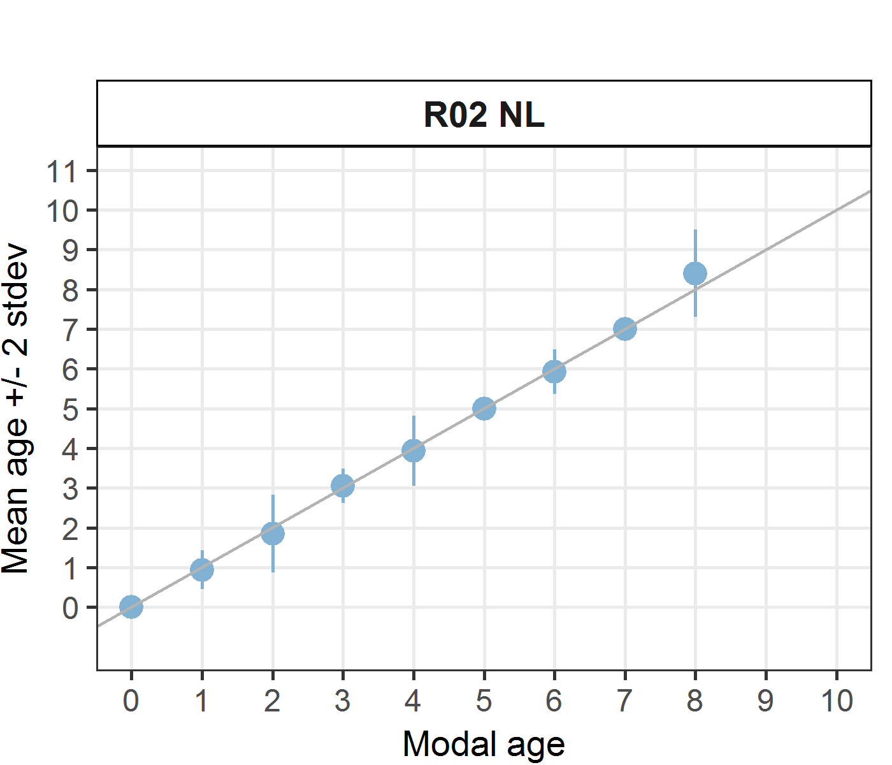 [[2]] 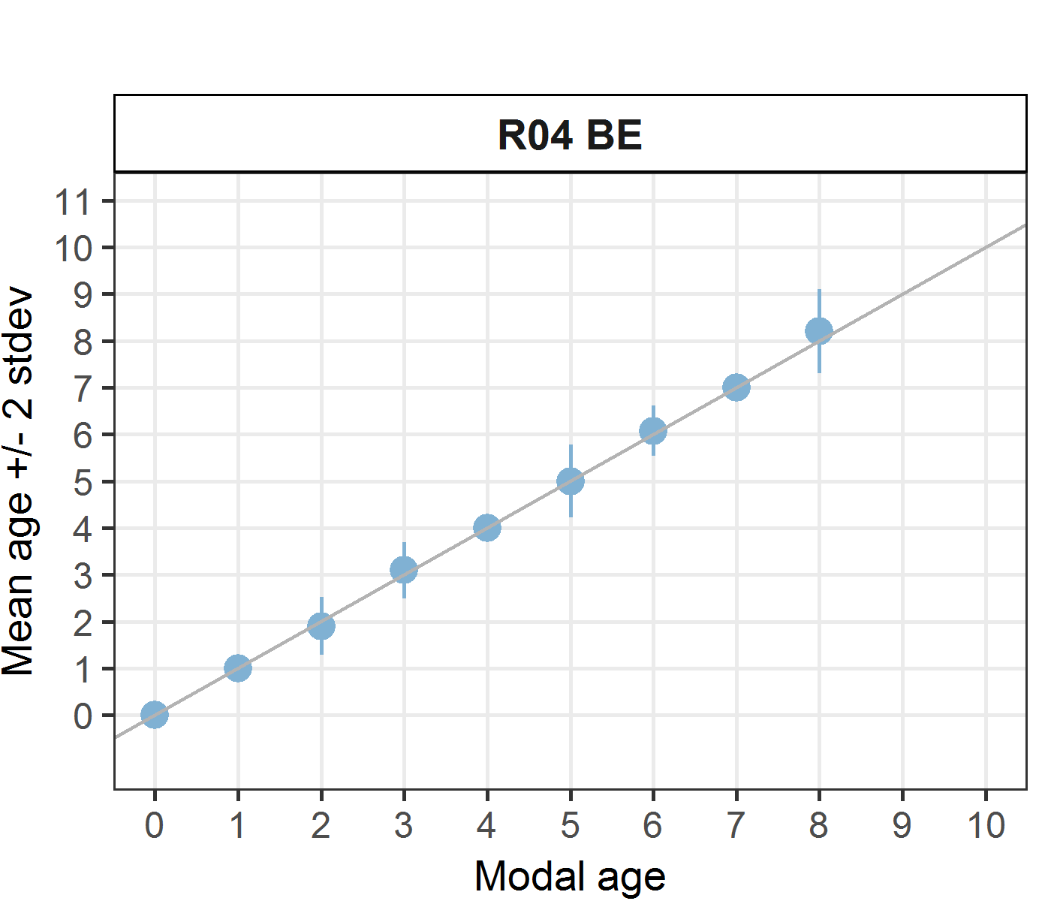 [[3]] 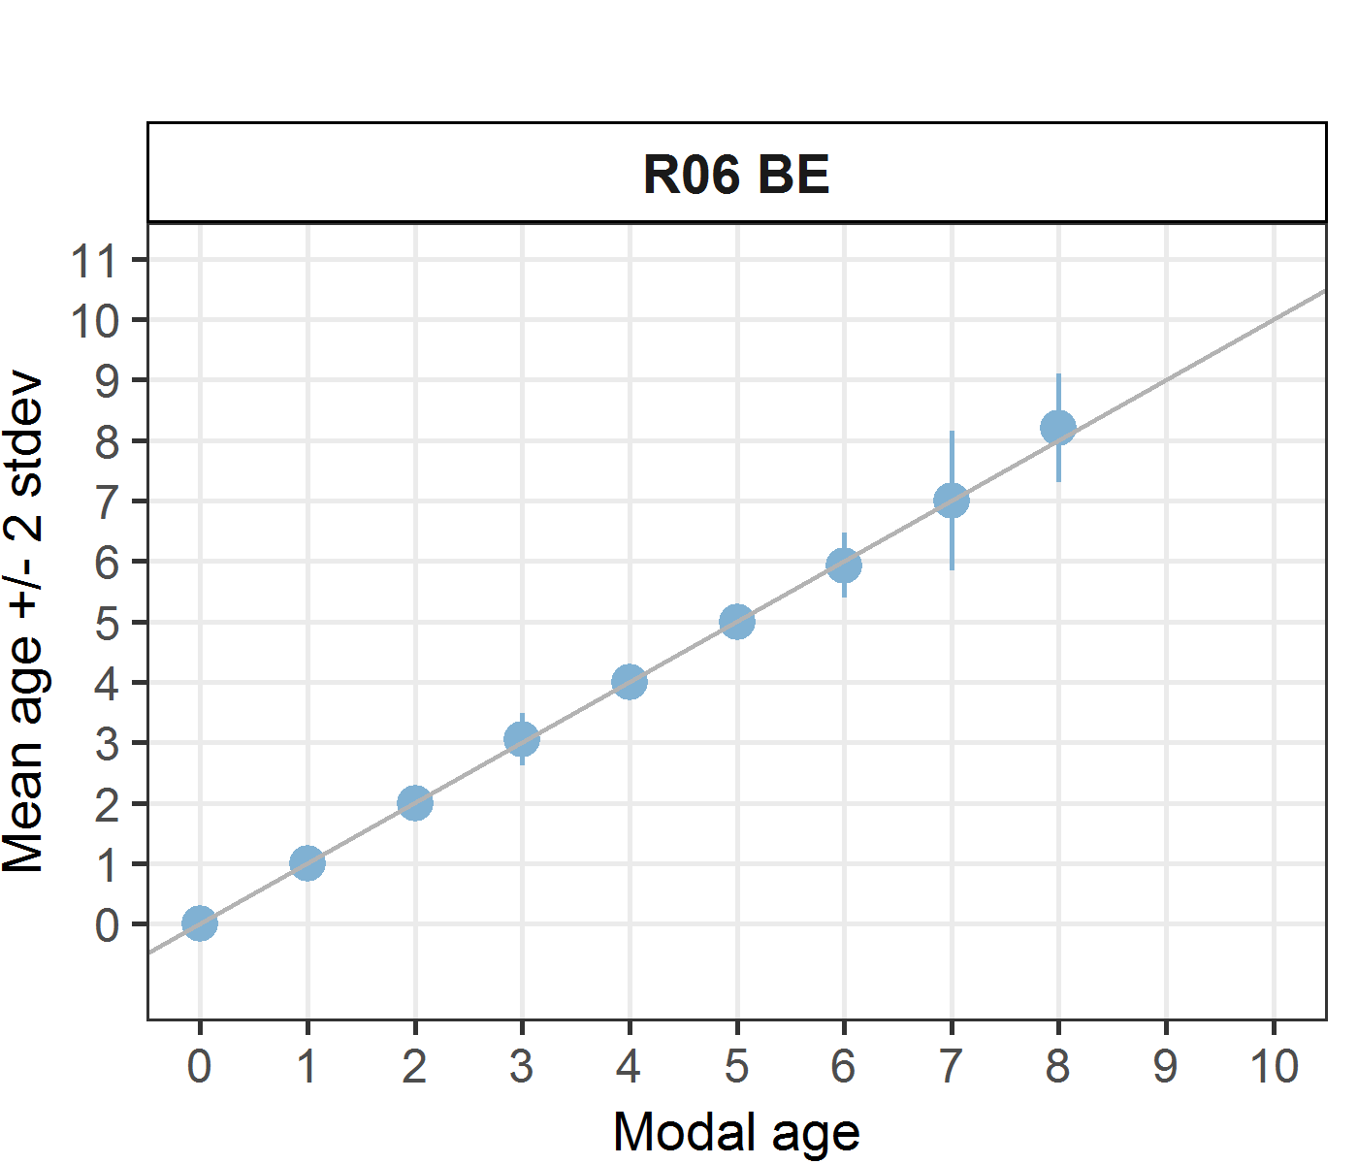 [[4]] 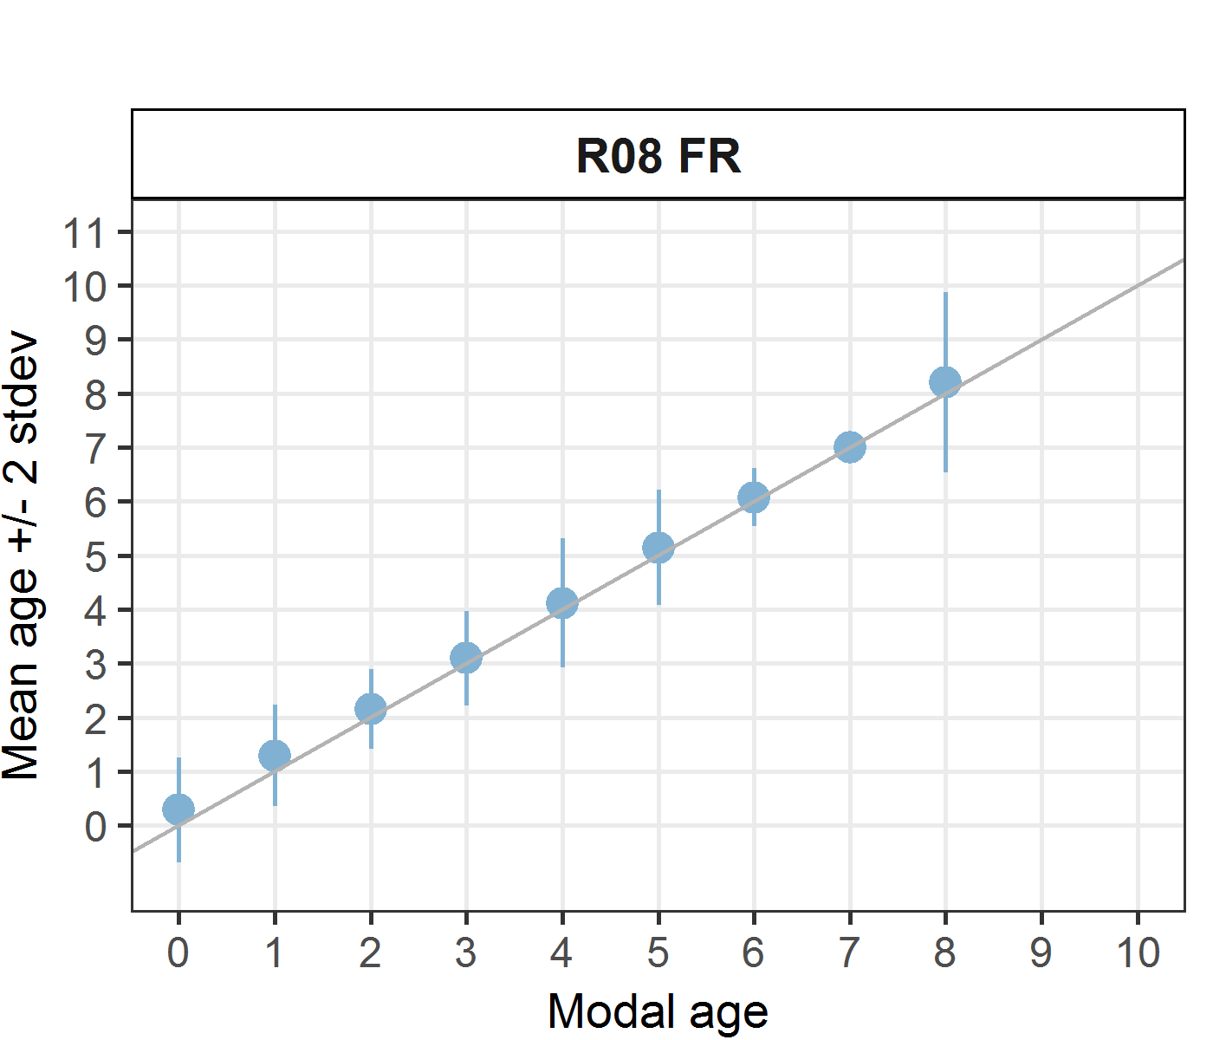 [[5]] 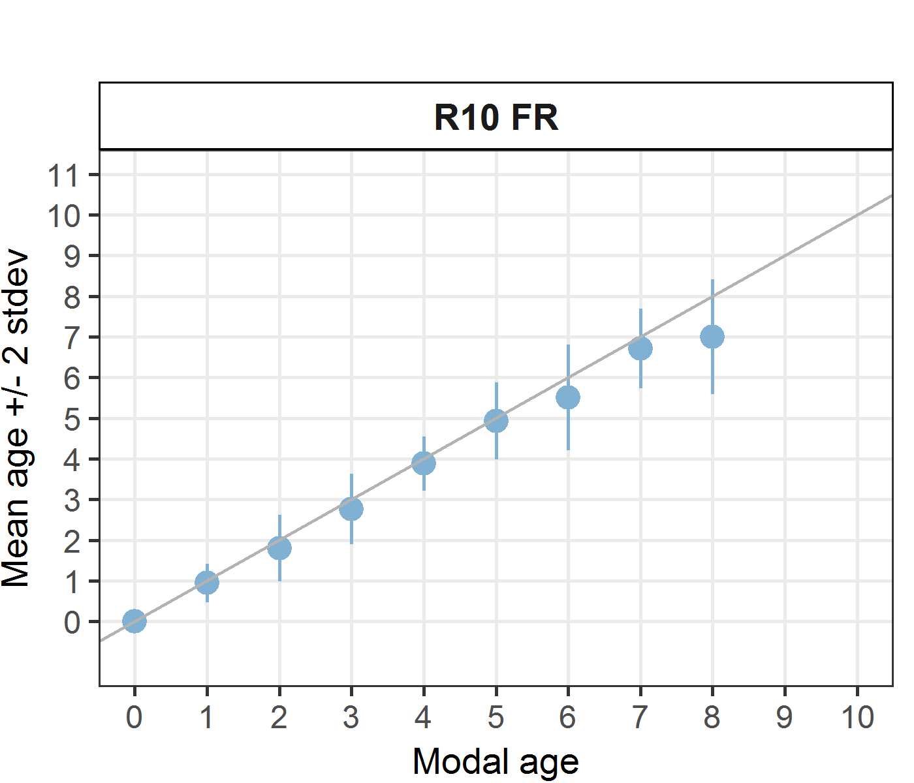 [[6]] 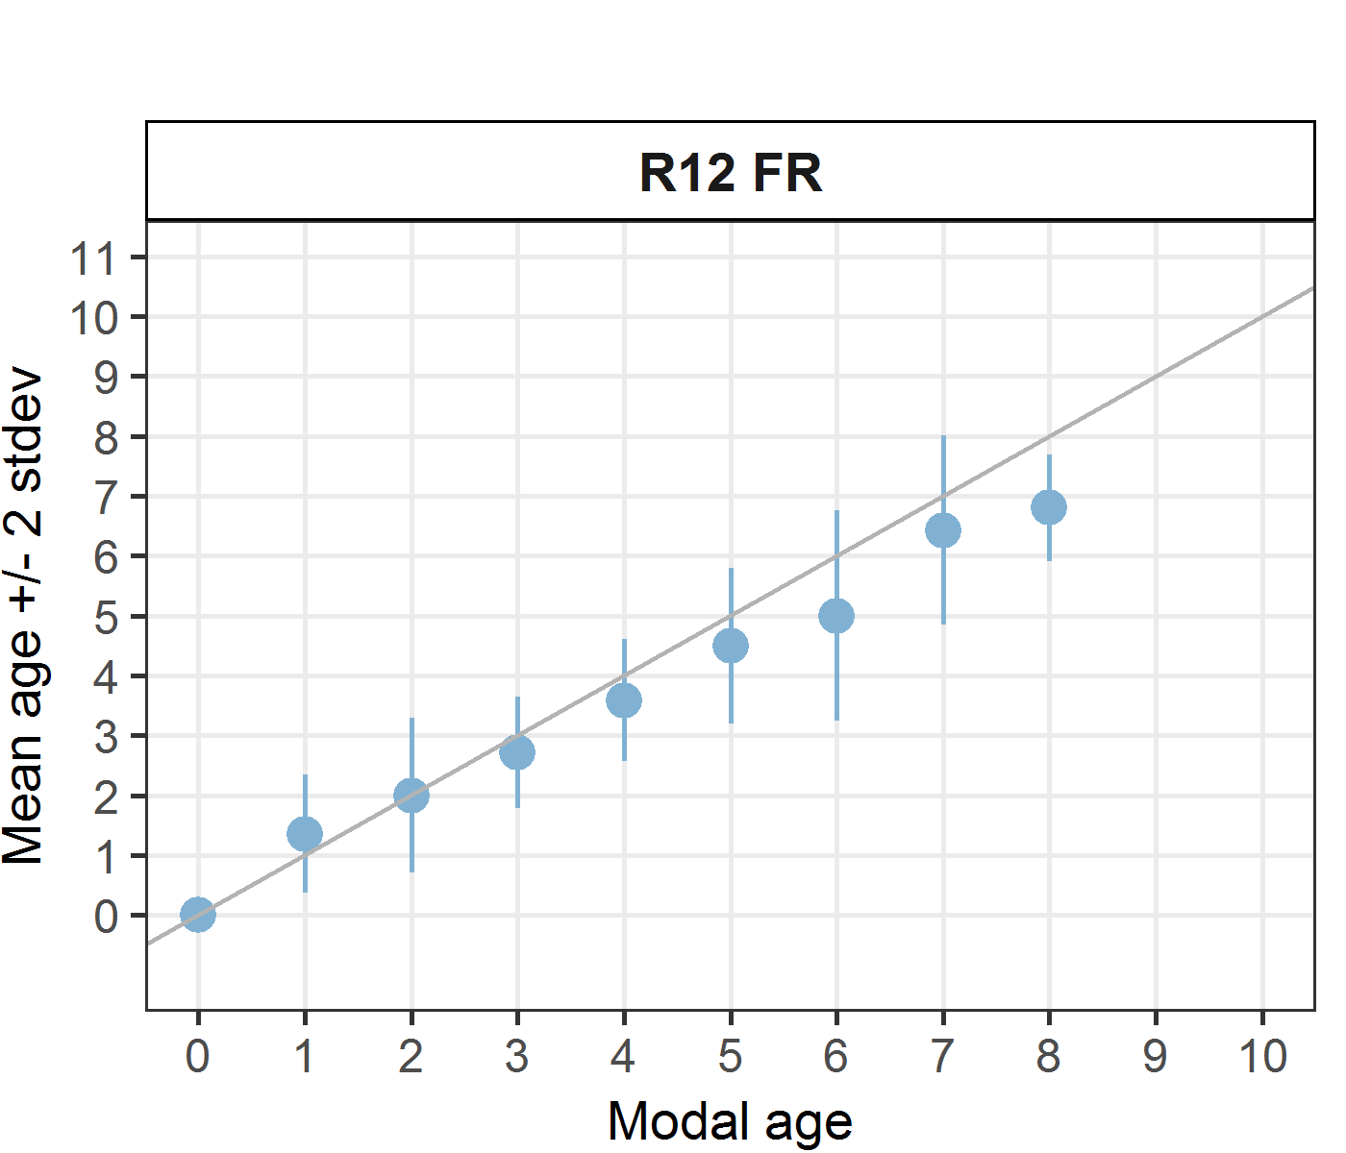 [[7]] 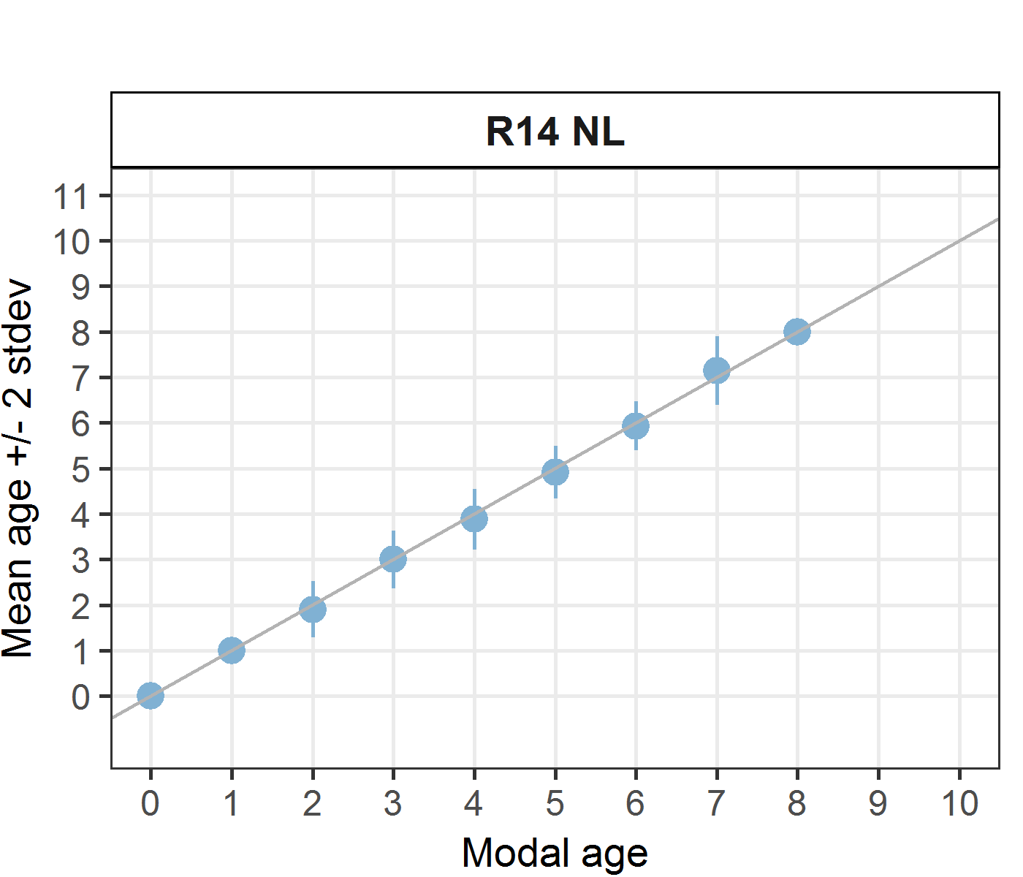
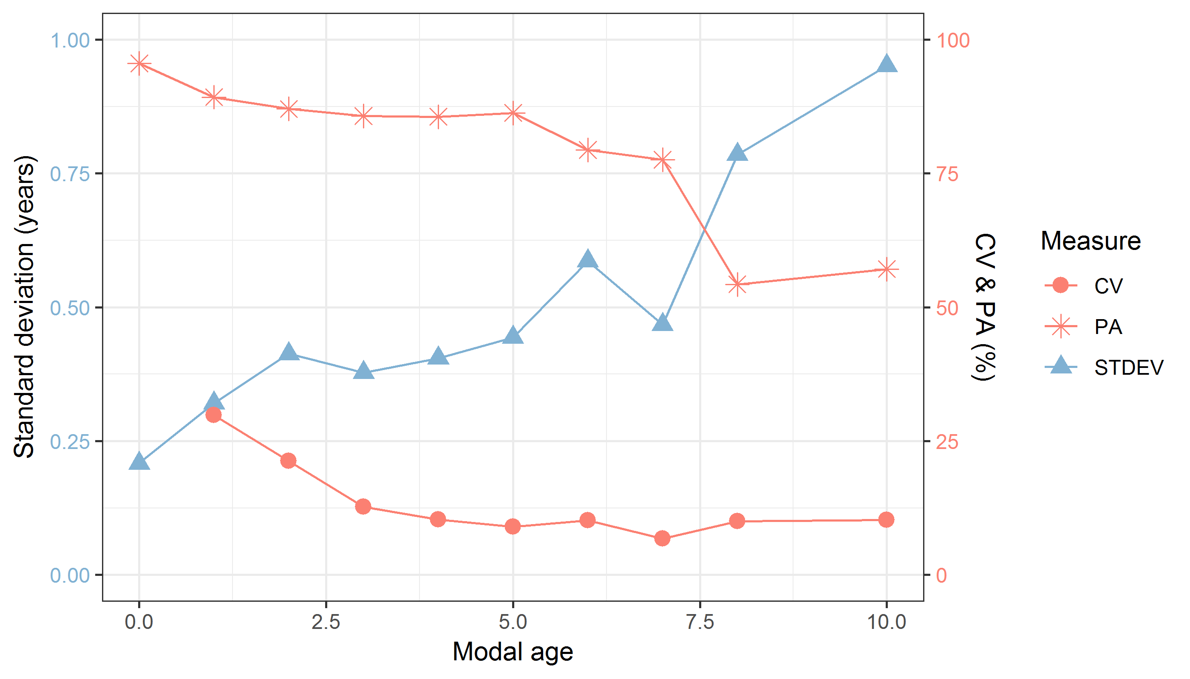
Figure 9.1: CV, PA and (STDEV (standard deviation) are plotted against modal age
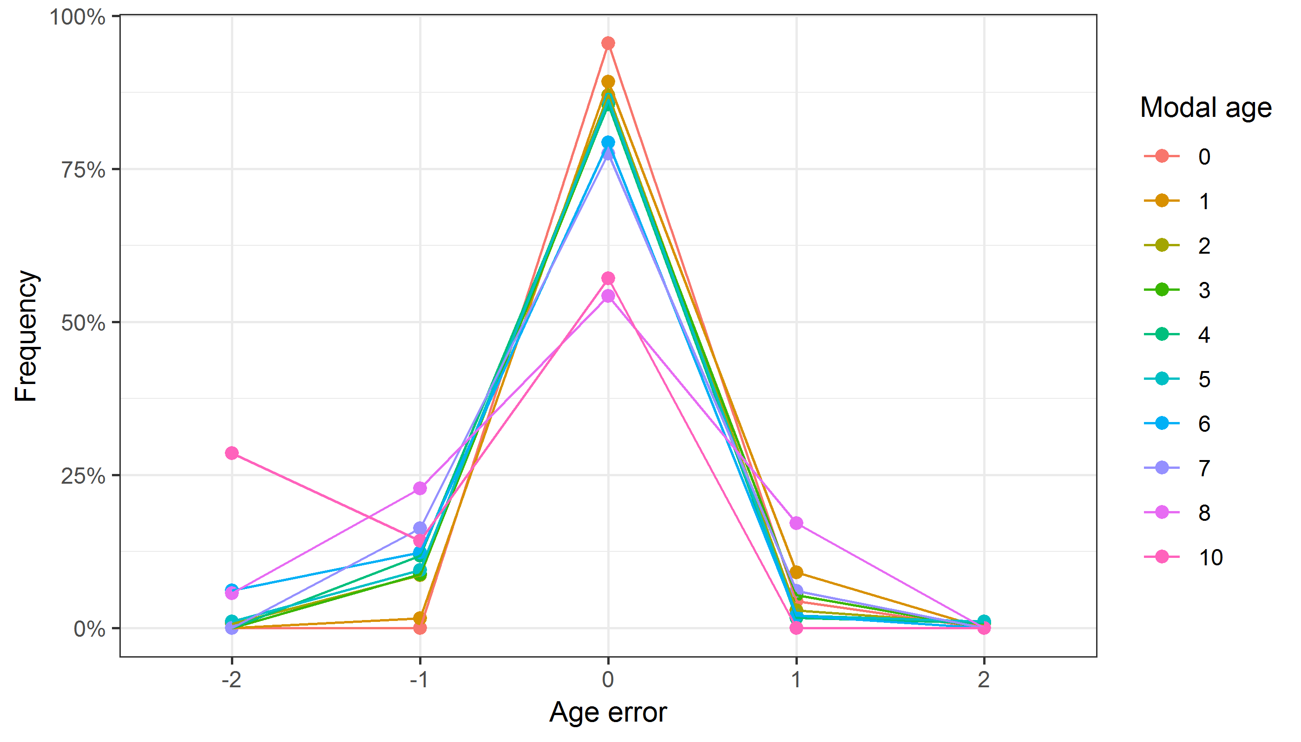
Figure 9.2: The distribution of the age reading errors in percentage by modal age as observed from the whole group of age readers in an age reading comparison to modal age. The achieved precision in age reading by MODAL age group is shown by the spread of the age readings errors. There appears to be no relative bias, if the age reading errors are normally distributed. The distributions are skewed, if relative bias occurs.

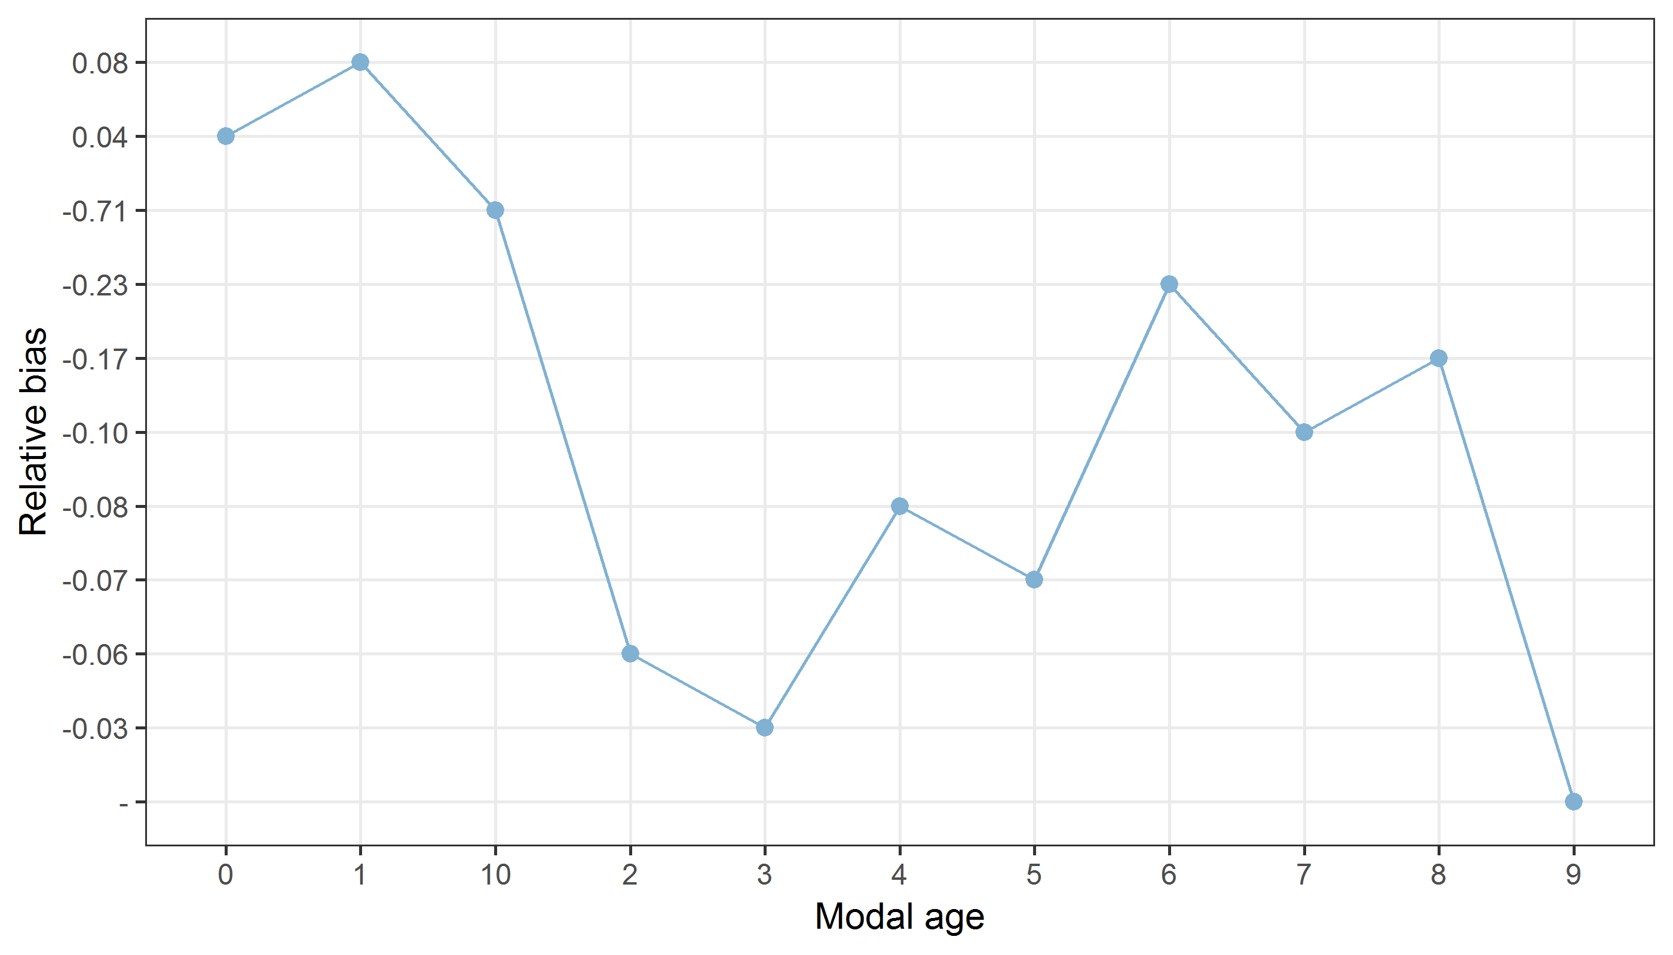
Figure 9.3: The relative bias by modal age as estimated by all age readers combined.
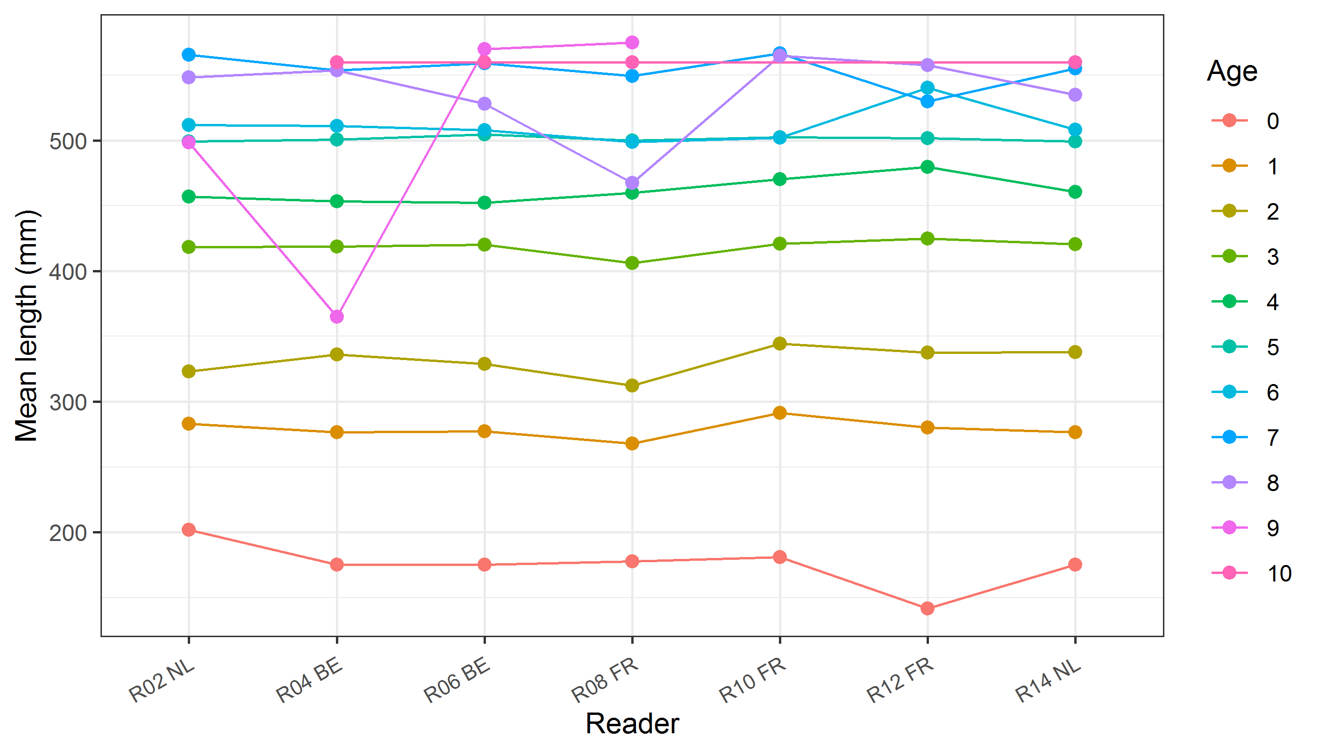
Figure 9.4: The mean length at age as estimated by each age reader.

Results Advanced readers – sectioned and stained
All samples included
Data Overview
Table 9.6: Data overview including modal age and statistics per sample.
Fish ID | Event ID | Image ID | length | sex | Catch date | ICES area | R02 NL | R04 BE | R06 BE | Modal age | PA % | CV % | APE %
001_PTCT07_BLL_7D_2017071510364 | 200 | 15029 | 325 | - | 15/07/2017 00:00:00 | 27.7.d | 2 | 2 | 2 | 2 | 100 | 0 | 0
002_PTCT07_BLL_7D_2017071510365 | 200 | 15031 | 480 | - | 15/07/2017 00:00:00 | 27.7.d | 5 | 4 | 5 | 5 | 67 | 12 | 10
003_BTS01_BLL_4B_2017082811204 | 200 | 15033 | 303 | - | 28/08/2017 00:00:00 | 27.4.b | 2 | 2 | 2 | 2 | 100 | 0 | 0
004_BTS01_BLL_4C_2014002 | 200 | 15035 | 240 | - | 25/08/2014 00:00:00 | 27.4.c | 1 | 1 | 1 | 1 | 100 | 0 | 0
005_BTS01_BLL_4C_2014003 | 200 | 15037 | 305 | - | 25/08/2014 00:00:00 | 27.4.c | 1 | 1 | 1 | 1 | 100 | 0 | 0
006_BTS01_BLL_4C_2014004 | 200 | 15039 | 435 | - | 25/08/2014 00:00:00 | 27.4.c | - | 6 | 6 | 6 | 100 | 0 | 0
007_BTS01_BLL_4C_2014006 | 200 | 15041 | 390 | - | 25/08/2014 00:00:00 | 27.4.c | 5 | 5 | 5 | 5 | 100 | 0 | 0
008_BTS01_BLL_4C_2014008 | 200 | 15043 | 510 | - | 25/08/2014 00:00:00 | 27.4.c | 5 | 5 | 5 | 5 | 100 | 0 | 0
009_BTS01_BLL_4C_2014015 | 200 | 15045 | 560 | - | 25/08/2014 00:00:00 | 27.4.c | 5 | 5 | 5 | 5 | 100 | 0 | 0
010_BTS01_BLL_4C_2015053385 | 200 | 15047 | 290 | - | 23/10/2015 00:00:00 | 27.4.c | 1 | 1 | 1 | 1 | 100 | 0 | 0
011_BTS01_BLL_4C_2015053386 | 200 | 15049 | 285 | - | 23/10/2015 00:00:00 | 27.4.c | 1 | 1 | 1 | 1 | 100 | 0 | 0
012_BTS01_BLL_4C_2015053387 | 200 | 15050 | 315 | - | 23/10/2015 00:00:00 | 27.4.c | 2 | 2 | 2 | 2 | 100 | 0 | 0
013_BTS01_BLL_4C_2015053388 | 200 | 15052 | 370 | - | 23/10/2015 00:00:00 | 27.4.c | 2 | 2 | 2 | 2 | 100 | 0 | 0
014_BTS01_BLL_4C_2015053390 | 200 | 15054 | 360 | - | 23/10/2015 00:00:00 | 27.4.c | 4 | 4 | 4 | 4 | 100 | 0 | 0
015_BTS01_BLL_4C_2015053391 | 200 | 15056 | 325 | - | 23/10/2015 00:00:00 | 27.4.c | 3 | 3 | 3 | 3 | 100 | 0 | 0
016_BTS01_BLL_4C_2016219500 | 200 | 15058 | 325 | - | 04/10/2016 00:00:00 | 27.4.c | 3 | 3 | 3 | 3 | 100 | 0 | 0
017_BTS01_BLL_4C_2016219501 | 200 | 15060 | 365 | - | 04/10/2016 00:00:00 | 27.4.c | 9 | 9 | 8 | 9 | 67 | 7 | 5
018_BTS01_BLL_4C_2017082811007 | 200 | 15062 | 301 | - | 28/08/2017 00:00:00 | 27.4.c | 2 | 2 | 2 | 2 | 100 | 0 | 0
019_BTS01_BLL_4C_2017082811008 | 200 | 15064 | 320 | - | 28/08/2017 00:00:00 | 27.4.c | 2 | 2 | 2 | 2 | 100 | 0 | 0
020_BTS01_BLL_4C_2017082811010 | 200 | 15066 | 257 | - | 28/08/2017 00:00:00 | 27.4.c | 1 | 1 | 1 | 1 | 100 | 0 | 0
021_BTS01_BLL_4C_2017082811011 | 200 | 15068 | 284 | - | 28/08/2017 00:00:00 | 27.4.c | 1 | 1 | 1 | 1 | 100 | 0 | 0
022_BTS01_BLL_4C_2017082811017 | 200 | 15070 | 433 | - | 28/08/2017 00:00:00 | 27.4.c | 3 | 3 | 3 | 3 | 100 | 0 | 0
023_BYDR05_BLL_4B_2017071410271 | 200 | 15072 | 270 | - | 14/07/2017 00:00:00 | 27.4.b | 2 | 1 | 2 | 2 | 67 | 35 | 27
024_BYDR05_BLL_4B_2017071410272 | 200 | 15074 | 270 | - | 14/07/2017 00:00:00 | 27.4.b | 2 | 1 | 2 | 2 | 67 | 35 | 27
025_BYDR05_BLL_4B_2017071410273 | 200 | 15076 | 290 | - | 14/07/2017 00:00:00 | 27.4.b | 2 | 2 | 2 | 2 | 100 | 0 | 0
026_BYDR05_BLL_4B_2017071410274 | 200 | 15078 | 260 | - | 14/07/2017 00:00:00 | 27.4.b | 2 | 2 | 2 | 2 | 100 | 0 | 0
027_BYDR05_BLL_4B_2017071410527 | 200 | 15080 | 520 | - | 14/07/2017 00:00:00 | 27.4.b | 4 | 4 | 4 | 4 | 100 | 0 | 0
028_BYDR05_BLL_4B_2017071410535 | 200 | 15082 | 525 | - | 14/07/2017 00:00:00 | 27.4.b | 4 | 4 | 4 | 4 | 100 | 0 | 0
029_BYDR06_BLL_4B_2011001 | 200 | 15084 | 250 | - | 29/09/2011 00:00:00 | 27.4.b | 1 | 1 | 1 | 1 | 100 | 0 | 0
030_BYDR06_BLL_4B_2011002 | 200 | 15122 | 260 | - | 29/09/2011 00:00:00 | 27.4.b | 1 | 1 | 1 | 1 | 100 | 0 | 0
031_BYDR07_BLL_4B_2017110910270 | 200 | 15088 | 280 | - | 09/11/2017 00:00:00 | 27.4.b | 1 | 1 | 1 | 1 | 100 | 0 | 0
032_BYDR07_BLL_4B_2017110910271 | 200 | 15090 | 290 | - | 09/11/2017 00:00:00 | 27.4.b | 1 | 1 | 1 | 1 | 100 | 0 | 0
033_BYDR07_BLL_4B_2017110910276 | 200 | 15092 | 300 | - | 09/11/2017 00:00:00 | 27.4.b | 1 | 1 | 1 | 1 | 100 | 0 | 0
034_BYDR07_BLL_4B_2017110910277 | 200 | 15094 | 300 | - | 09/11/2017 00:00:00 | 27.4.b | - | 1 | 1 | 1 | 100 | 0 | 0
035_BYDR07_BLL_4B_2017110910297 | 200 | 15096 | 190 | - | 09/11/2017 00:00:00 | 27.4.b | 0 | 0 | 0 | 0 | 100 | - | -
036_BYDR07_BLL_4B_2017110910298 | 200 | 15098 | 200 | - | 09/11/2017 00:00:00 | 27.4.b | 0 | 0 | 0 | 0 | 100 | - | -
037_BYDR05_BLL_4B_2017071410528 | 200 | 15100 | 335 | - | 14/07/2017 00:00:00 | 27.4.b | 3 | 4 | 4 | 4 | 67 | 16 | 12
038_BYDR07_BLL_4B_2017110910533 | 200 | 15102 | 380 | - | 09/11/2017 00:00:00 | 27.4.b | 4 | 4 | 4 | 4 | 100 | 0 | 0
039_BYDR05_BLL_4B_2017071410534 | 200 | 15104 | 450 | - | 14/07/2017 00:00:00 | 27.4.b | 3 | 4 | 3 | 3 | 67 | 17 | 13
040_BYDR07_BLL_4B_2017110910541 | 200 | 15105 | 535 | - | 09/11/2017 00:00:00 | 27.4.b | 4 | 4 | 4 | 4 | 100 | 0 | 0
041_BYDR07_BLL_4B_2017110910542 | 200 | 15107 | 520 | - | 09/11/2017 00:00:00 | 27.4.b | 6 | 6 | 6 | 6 | 100 | 0 | 0
042_BYDR07_BLL_4B_2017110910549 | 200 | 15109 | 560 | - | 09/11/2017 00:00:00 | 27.4.b | 5 | 5 | 5 | 5 | 100 | 0 | 0
043_BYDR07_BLL_4B_2017110910550 | 200 | 15111 | 555 | - | 09/11/2017 00:00:00 | 27.4.b | 7 | 7 | 7 | 7 | 100 | 0 | 0
044_BYDR07_BLL_4B_2017110910552 | 200 | 15113 | 580 | - | 09/11/2017 00:00:00 | 27.4.b | 7 | 7 | 7 | 7 | 100 | 0 | 0
045_BYDR08_BLL_7D_2017121510064 | 200 | 15115 | 270 | - | 15/12/2017 00:00:00 | 27.7.d | - | 0 | 0 | 0 | 100 | - | -
046_BYDR08_BLL_7D_017121510211 | 200 | 15124 | 455 | - | 15/12/2017 00:00:00 | 27.7.d | 3 | 3 | 3 | 3 | 100 | 0 | 0
047_BYDR08_BLL_7D_2017121510206 | 200 | 15117 | 430 | - | 15/12/2017 00:00:00 | 27.7.d | 2 | 2 | 2 | 2 | 100 | 0 | 0
048_BYDR08_BLL_7D_2017121510207 | 200 | 15118 | 435 | - | 15/12/2017 00:00:00 | 27.7.d | 1 | 2 | 2 | 2 | 67 | 35 | 27
049_BYDR08_BLL_7D_2017121510208 | 200 | 15119 | 465 | - | 15/12/2017 00:00:00 | 27.7.d | 3 | 4 | 4 | 4 | 67 | 16 | 12
050_BYDR08_BLL_7D_2017121510213 | 200 | 15120 | 475 | - | 15/12/2017 00:00:00 | 27.7.d | 4 | 4 | 4 | 4 | 100 | 0 | 0
051_BYDR08_BLL_7D_2017121510219 | 200 | 15129 | 320 | - | 15/12/2017 00:00:00 | 27.7.d | 0 | 1 | 1 | 1 | 67 | 87 | 67
052_BYDR08_BLL_7D_2017121510220 | 200 | 15131 | 320 | - | 15/12/2017 00:00:00 | 27.7.d | 1 | 1 | 1 | 1 | 100 | 0 | 0
053_CDDR02_BLL_7D_2017002255 | 200 | 15133 | 495 | - | 09/03/2017 00:00:00 | 27.7.d | - | 4 | 4 | 4 | 100 | 0 | 0
054_CDDR02_BLL_7D_2017002256 | 200 | 15135 | 570 | - | 09/03/2017 00:00:00 | 27.7.d | 5 | 5 | 5 | 5 | 100 | 0 | 0
055_CDDR02_BLL_7D_2017002257 | 200 | 15137 | 500 | - | 09/03/2017 00:00:00 | 27.7.d | 4 | 4 | 4 | 4 | 100 | 0 | 0
056_CDDR02_BLL_7D_2017002260 | 200 | 15139 | 470 | - | 09/03/2017 00:00:00 | 27.7.d | 4 | 4 | 4 | 4 | 100 | 0 | 0
057_CDDR02_BLL_7D_2017002261 | 200 | 15141 | 580 | - | 09/03/2017 00:00:00 | 27.7.d | 6 | 6 | 6 | 6 | 100 | 0 | 0
058_CDDR02_BLL_7D_2017002263 | 200 | 15143 | 520 | - | 09/03/2017 00:00:00 | 27.7.d | 6 | 6 | 6 | 6 | 100 | 0 | 0
059_CDDR02_BLL_7D_2017002264 | 200 | 15145 | 495 | - | 09/03/2017 00:00:00 | 27.7.d | 5 | 5 | 5 | 5 | 100 | 0 | 0
060_CDDR02_BLL_7D_2017002271 | 200 | 15147 | 335 | - | 09/03/2017 00:00:00 | 27.7.d | 2 | 2 | 2 | 2 | 100 | 0 | 0
061_CDDR02_BLL_7D_2017002274 | 200 | 15149 | 325 | - | 09/03/2017 00:00:00 | 27.7.d | 2 | 2 | 2 | 2 | 100 | 0 | 0
062_CDDR06_BLL_4B_2017073110641 | 200 | 15151 | 535 | - | 31/07/2017 00:00:00 | 27.4.b | 7 | 7 | 7 | 7 | 100 | 0 | 0
063_CDDR06_BLL_4B_2017073110642 | 200 | 15152 | 560 | - | 31/07/2017 00:00:00 | 27.4.b | 9 | 10 | 10 | 10 | 67 | 6 | 5
064_CDDR06_BLL_4B_2017073110643 | 200 | 15153 | 535 | - | 31/07/2017 00:00:00 | 27.4.b | 6 | 6 | 6 | 6 | 100 | 0 | 0
065_CDDR06_BLL_4B_2017073110645 | 200 | 15154 | 445 | - | 31/07/2017 00:00:00 | 27.4.b | 3 | 4 | 4 | 4 | 67 | 16 | 12
066_CDDR06_BLL_4B_2017073110646 | 200 | 15028 | 470 | - | 31/07/2017 00:00:00 | 27.4.b | 6 | 7 | 6 | 6 | 67 | 9 | 7
067_CDDR06_BLL_4B_2017073110654 | 200 | 15155 | 570 | - | 31/07/2017 00:00:00 | 27.4.b | 9 | 8 | 9 | 9 | 67 | 7 | 5
068_CDDR06_BLL_4B_2017073110659 | 200 | 15156 | 490 | - | 31/07/2017 00:00:00 | 27.4.b | 5 | 5 | 5 | 5 | 100 | 0 | 0
069_CDDR06_BLL_4B_2017073110644 | 200 | 15157 | 490 | - | 31/07/2017 00:00:00 | 27.4.b | 3 | 3 | 3 | 3 | 100 | 0 | 0
070_CDDR06_BLL_4B_2017073110648 | 200 | 15158 | 355 | - | 31/07/2017 00:00:00 | 27.4.b | 2 | 2 | 2 | 2 | 100 | 0 | 0
071_CDDR06_BLL_4B_2017073110649 | 200 | 15160 | 400 | - | 31/07/2017 00:00:00 | 27.4.b | 3 | 3 | 3 | 3 | 100 | 0 | 0
072_CDDR07_BLL_4B_2017102010285 | 200 | 15161 | 415 | - | 20/10/2017 00:00:00 | 27.4.b | 6 | 6 | 6 | 6 | 100 | 0 | 0
073_CDDR08_BLL_7D_2017112110277 | 200 | 15163 | 370 | - | 21/11/2017 00:00:00 | 27.7.d | 3 | 3 | 3 | 3 | 100 | 0 | 0
074_CDDR08_BLL_7D_2017112110280 | 200 | 15165 | 420 | - | 21/11/2017 00:00:00 | 27.7.d | 3 | 3 | 3 | 3 | 100 | 0 | 0
075_CDDR08_BLL_7D_2017112110283 | 200 | 15167 | 520 | - | 21/11/2017 00:00:00 | 27.7.d | 5 | 6 | 5 | 5 | 67 | 11 | 8
076_EXNL_BLL_4100007_130918_004 | 200 | 15169 | 233 | - | 18/09/2017 00:00:00 | 27.4.c | 1 | 1 | 1 | 1 | 100 | 0 | 0
077_EXNL_BLL_4100014_130918_005 | 200 | 15171 | 152 | - | 18/09/2017 00:00:00 | 27.4.c | 0 | 0 | 0 | 0 | 100 | - | -
078_EXNL_BLL_4100022_180918_006 | 200 | 15173 | 138 | - | 18/09/2017 00:00:00 | 27.4.c | 0 | 0 | 0 | 0 | 100 | - | -
079_EXNL_BLL_4100023_180918_007 | 200 | 15175 | 143 | - | 18/09/2017 00:00:00 | 27.4.c | 0 | 0 | 0 | 0 | 100 | - | -
080_EXNL_BLL_4100024_180918_008 | 200 | 15177 | 133 | - | 18/09/2017 00:00:00 | 27.4.c | 0 | 0 | 0 | 0 | 100 | - | -
081_GNKT02_BLL_7D_2017002518 | 200 | 15179 | 540 | - | 07/03/2017 00:00:00 | 27.7.d | 5 | 5 | 5 | 5 | 100 | 0 | 0
082_GNKT02_BLL_7D_2017002524 | 200 | 15181 | 565 | - | 07/03/2017 00:00:00 | 27.7.d | 7 | 7 | 7 | 7 | 100 | 0 | 0
083_NDGP05_BLL_4B_2005004 | 200 | 15258 | 310 | - | 07/11/2005 00:00:00 | 27.4.b | 2 | 2 | 2 | 2 | 100 | 0 | 0
084_NDGP05_BLL_4B_2005005 | 200 | 15260 | 340 | - | 07/11/2005 00:00:00 | 27.4.b | 2 | 2 | 2 | 2 | 100 | 0 | 0
085_NDGP05_BLL_4B_2005001 | 200 | 15183 | 330 | - | 07/11/2005 00:00:00 | 27.4.b | 3 | 3 | 3 | 3 | 100 | 0 | 0
086_NDGP05_BLL_4B_2005041 | 200 | 15185 | 420 | - | 07/11/2005 00:00:00 | 27.4.b | 3 | 3 | 3 | 3 | 100 | 0 | 0
087_NDGP05_BLL_4B_2005045 | 200 | 15187 | 470 | - | 07/11/2005 00:00:00 | 27.4.b | 3 | 3 | 3 | 3 | 100 | 0 | 0
088_NDGP05_BLL_4B_2005060 | 200 | 15189 | 490 | - | 07/11/2005 00:00:00 | 27.4.b | 5 | 5 | 5 | 5 | 100 | 0 | 0
089_NDGP05_BLL_4B_2005066 | 200 | 15191 | 570 | - | 07/11/2005 00:00:00 | 27.4.b | 4 | 4 | 4 | 4 | 100 | 0 | 0
090_NDGP05_BLL_4B_2005071 | 200 | 15193 | 540 | - | 07/11/2005 00:00:00 | 27.4.b | 5 | 5 | 5 | 5 | 100 | 0 | 0
092_PTCT02_BLL_7D_2017002749 | 200 | 15195 | 495 | - | 07/03/2017 00:00:00 | 27.7.d | 8 | 8 | 8 | 8 | 100 | 0 | 0
093_PTCT02_BLL_7D_2017002750 | 200 | 15197 | 630 | - | 07/03/2017 00:00:00 | 27.7.d | 7 | 7 | 8 | 7 | 67 | 8 | 6
094_PTCT02_BLL_7D_2017002752 | 200 | 15199 | 440 | - | 07/03/2017 00:00:00 | 27.7.d | 3 | 3 | 3 | 3 | 100 | 0 | 0
095_PTCT03_BLL_4C_2017040310575 | 200 | 15201 | 425 | - | 03/04/2017 00:00:00 | 27.4.c | 3 | 3 | 3 | 3 | 100 | 0 | 0
096_PTCT03_BLL_4C_2017040310576 | 200 | 15202 | 445 | - | 03/04/2017 00:00:00 | 27.4.c | 4 | 3 | 3 | 3 | 67 | 17 | 13
097_PTCT03_BLL_4C_2017040310577 | 200 | 15203 | 425 | - | 03/04/2017 00:00:00 | 27.4.c | 3 | 3 | 3 | 3 | 100 | 0 | 0
098_PTCT03_BLL_4C_2017040310583 | 200 | 15204 | 365 | - | 03/04/2017 00:00:00 | 27.4.c | 4 | 4 | 4 | 4 | 100 | 0 | 0
099_PTCT03_BLL_4C_2017040310584 | 200 | 15205 | 390 | - | 03/04/2017 00:00:00 | 27.4.c | 5 | 5 | 5 | 5 | 100 | 0 | 0
100_PTCT03_BLL_7D_2017040310167 | 200 | 15206 | 220 | - | 03/04/2017 00:00:00 | 27.7.d | 1 | 1 | 1 | 1 | 100 | 0 | 0
101_PTCT03_BLL_7D_2017040310347 | 200 | 15208 | 535 | - | 03/04/2017 00:00:00 | 27.7.d | 6 | 6 | 6 | 6 | 100 | 0 | 0
102_PTCT03_BLL_7D_2017040310350 | 200 | 15210 | 425 | - | 03/04/2017 00:00:00 | 27.7.d | 6 | 6 | 6 | 6 | 100 | 0 | 0
103_PTCT06_BLL_7D_2017062610220 | 200 | 15212 | 400 | - | 26/06/2017 00:00:00 | 27.7.d | 4 | 4 | 4 | 4 | 100 | 0 | 0
104_PTCT06_BLL_7D_2017062610221 | 200 | 15214 | 495 | - | 26/06/2017 00:00:00 | 27.7.d | 3 | 3 | 3 | 3 | 100 | 0 | 0
105_PTCT06_BLL_7D_2017062610222 | 200 | 15216 | 535 | - | 26/06/2017 00:00:00 | 27.7.d | 7 | 7 | 6 | 7 | 67 | 9 | 7
106_PTCT06_BLL_7D_2017062610224 | 200 | 15218 | 390 | - | 26/06/2017 00:00:00 | 27.7.d | 3 | 3 | 3 | 3 | 100 | 0 | 0
107_PTCT06_BLL_7D_2017062610225 | 200 | 15220 | 445 | - | 26/06/2017 00:00:00 | 27.7.d | 5 | 4 | 4 | 4 | 67 | 13 | 10
108_PTCT06_BLL_7D_2017062610236 | 200 | 15222 | 340 | - | 26/06/2017 00:00:00 | 27.7.d | 0 | 2 | - | 0 | 50 | - | -
109_PTCT06_BLL_7D_2017062610238 | 200 | 15224 | 325 | - | 26/06/2017 00:00:00 | 27.7.d | 2 | 2 | 2 | 2 | 100 | 0 | 0
110_PTCT07_BLL_7D_2017071510148 | 200 | 15226 | 280 | - | 15/07/2017 00:00:00 | 27.7.d | 1 | 1 | 1 | 1 | 100 | 0 | 0
111_PTCT07_BLL_7D_2017071510150 | 200 | 15228 | 280 | - | 15/07/2017 00:00:00 | 27.7.d | 1 | 1 | - | 1 | 100 | 0 | 0
112_PTCT07_BLL_7D_2017071510363 | 200 | 15230 | 500 | - | 15/07/2017 00:00:00 | 27.7.d | 3 | 3 | 3 | 3 | 100 | 0 | 0
113_PTCT07_BLL_7D_2017071510366 | 200 | 15232 | 570 | - | 15/07/2017 00:00:00 | 27.7.d | 8 | 8 | 8 | 8 | 100 | 0 | 0
114_PTCT07_BLL_7D_2017071510368 | 200 | 15234 | 565 | - | 15/07/2017 00:00:00 | 27.7.d | 6 | 6 | 6 | 6 | 100 | 0 | 0
115_PTCT07_BLL_7D_2017071510369 | 200 | 15236 | 580 | - | 15/07/2017 00:00:00 | 27.7.d | 8 | 8 | 8 | 8 | 100 | 0 | 0
116_PTCT07_BLL_7D_2017071510370 | 200 | 15238 | 475 | - | 15/07/2017 00:00:00 | 27.7.d | 5 | 5 | - | 5 | 100 | 0 | 0
117_PTCT07_BLL_7D_2017071510371 | 200 | 15240 | 530 | - | 15/07/2017 00:00:00 | 27.7.d | 5 | 6 | 5 | 5 | 67 | 11 | 8
118_PTCT07_BLL_7D_2017071510372 | 200 | 15242 | 615 | - | 15/07/2017 00:00:00 | 27.7.d | 6 | 6 | 6 | 6 | 100 | 0 | 0
119_PTCT07_BLL_7D_2017071510374 | 200 | 15244 | 460 | - | 15/07/2017 00:00:00 | 27.7.d | 6 | 6 | 6 | 6 | 100 | 0 | 0
120_PTCT07_BLL_7D_2017071510375 | 200 | 15246 | 460 | - | 15/07/2017 00:00:00 | 27.7.d | 4 | 4 | 4 | 4 | 100 | 0 | 0
121_PTCT07_BLL_7D_2017071510376 | 200 | 15248 | 560 | - | 15/07/2017 00:00:00 | 27.7.d | 7 | 7 | 7 | 7 | 100 | 0 | 0
122_PTCT07_BLL_7D_2017071510377 | 200 | 15250 | 395 | - | 15/07/2017 00:00:00 | 27.7.d | 4 | 4 | 4 | 4 | 100 | 0 | 0
123_PTCT07_BLL_7D_2017071510379 | 200 | 15252 | 500 | - | 15/07/2017 00:00:00 | 27.7.d | 6 | 6 | 6 | 6 | 100 | 0 | 0
124_PTCT07_BLL_7D_2017071510381 | 200 | 15254 | 370 | - | 15/07/2017 00:00:00 | 27.7.d | 2 | 2 | 2 | 2 | 100 | 0 | 0
125_PTCT07_BLL_7D_2017071510362 | 200 | 15256 | 395 | - | 15/07/2017 00:00:00 | 27.7.d | 3 | 3 | 3 | 3 | 100 | 0 | 0
Table 9.7: Number of age readings table gives an overview of number of readings per reader and modal age. The total numbers of readings per reader and per modal age are summarized at the end of the table.
Modal age | R02 NL | R04 BE | R06 BE | total
0 | 7 | 8 | 7 | 22
1 | 17 | 18 | 17 | 52
2 | 19 | 19 | 19 | 57
3 | 20 | 20 | 20 | 60
4 | 17 | 18 | 18 | 53
5 | 15 | 15 | 14 | 44
6 | 12 | 13 | 13 | 38
7 | 7 | 7 | 7 | 21
8 | 3 | 3 | 3 | 9
9 | 2 | 2 | 2 | 6
10 | 1 | 1 | 1 | 3
Total | 120 | 124 | 121 | 365
Table 9.8: Age composition by reader gives a summary of number of readings per reader.
Modal age | R02 NL | R04 BE | R06 BE
0 | 8 | 7 | 7
1 | 17 | 20 | 17
2 | 18 | 18 | 19
3 | 22 | 19 | 20
4 | 14 | 20 | 18
5 | 16 | 12 | 14
6 | 12 | 14 | 14
7 | 7 | 8 | 5
8 | 3 | 4 | 5
9 | 3 | 1 | 1
10 | 0 | 1 | 1
Total | 120 | 124 | 121
Table 9.9: Mean length at age per reader is calculated per reader and age (not modal age) and for all readers combined per age. A weighted mean is also given.
Age | R02 NL | R04 BE | R06 BE
0 | 202 mm | 175 mm | 175 mm
1 | 283 mm | 277 mm | 277 mm
2 | 323 mm | 336 mm | 329 mm
3 | 418 mm | 419 mm | 420 mm
4 | 457 mm | 454 mm | 452 mm
5 | 499 mm | 501 mm | 505 mm
6 | 512 mm | 511 mm | 508 mm
7 | 566 mm | 554 mm | 559 mm
8 | 548 mm | 554 mm | 528 mm
9 | 498 mm | 365 mm | 570 mm
10 | - | 560 mm | 560 mm
Weighted Mean | 409 mm | 408 mm | 409 mm
[[1]] 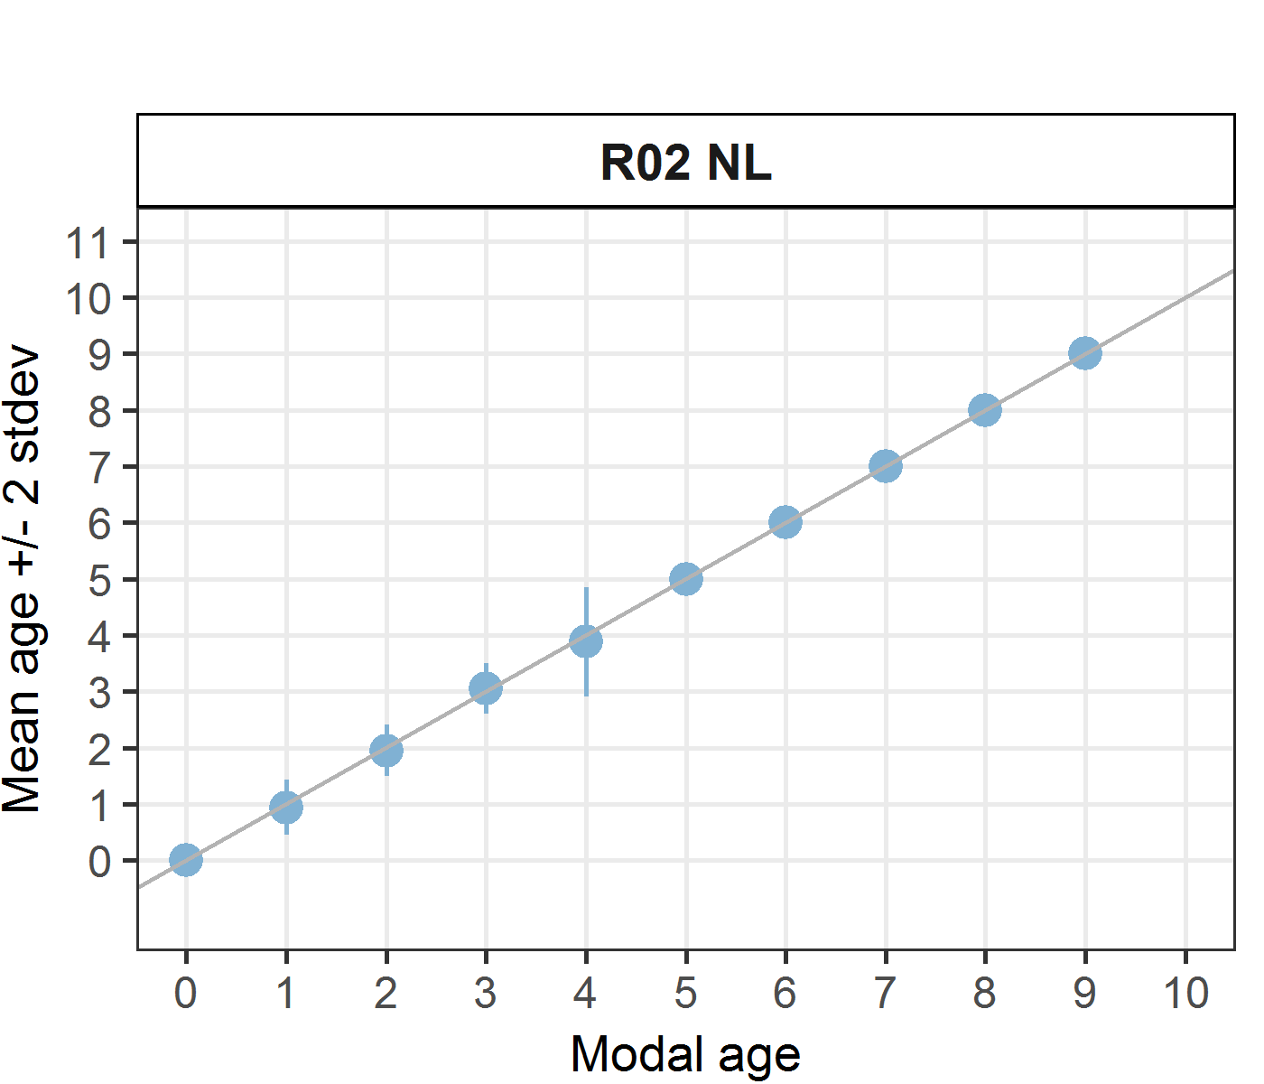 [[2]] 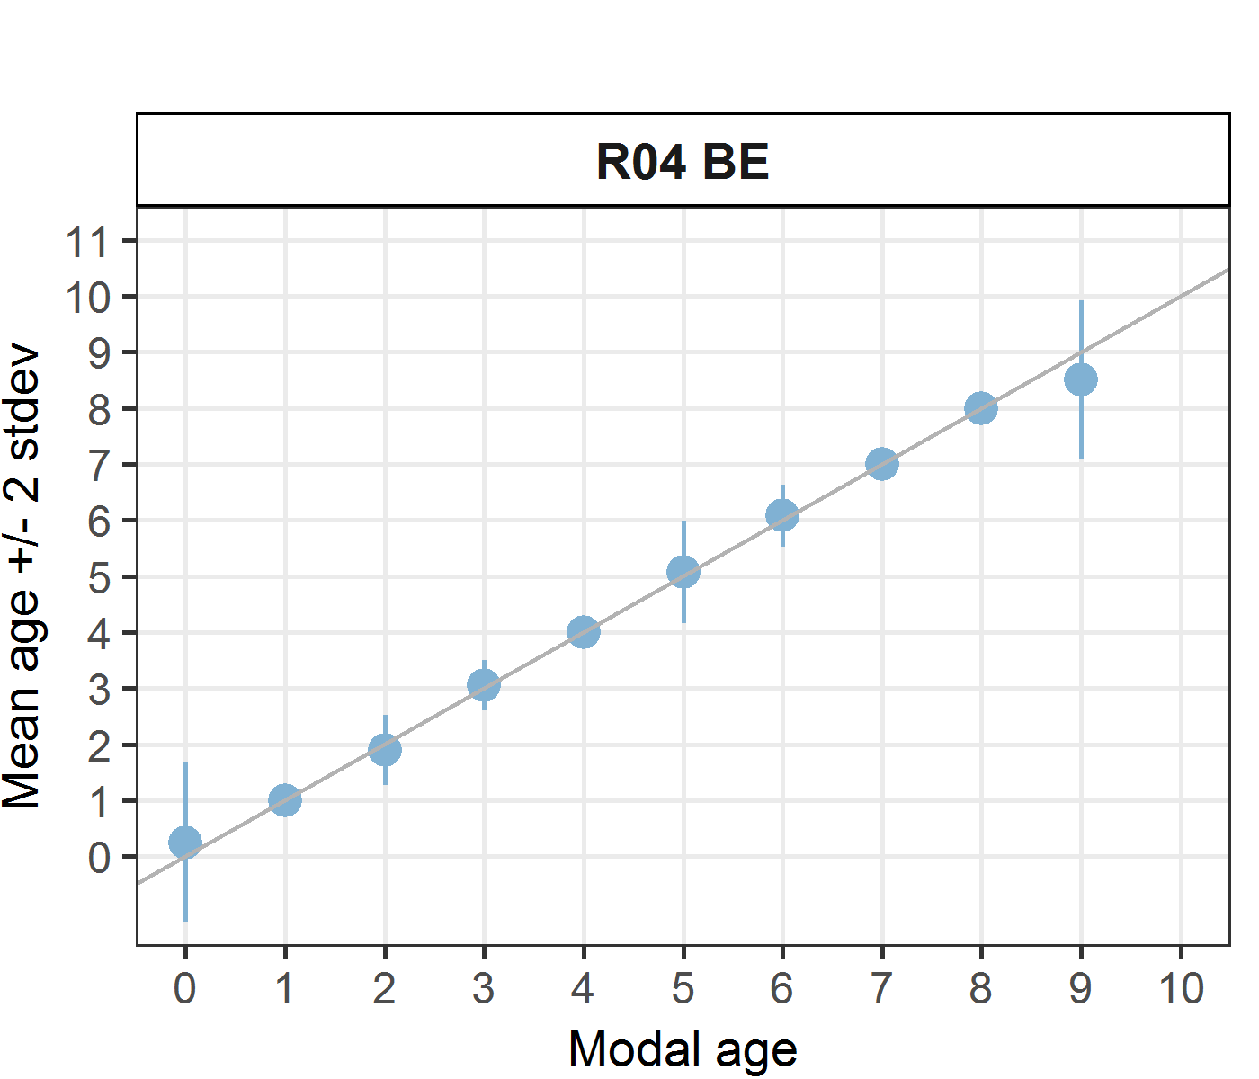 [[3]] 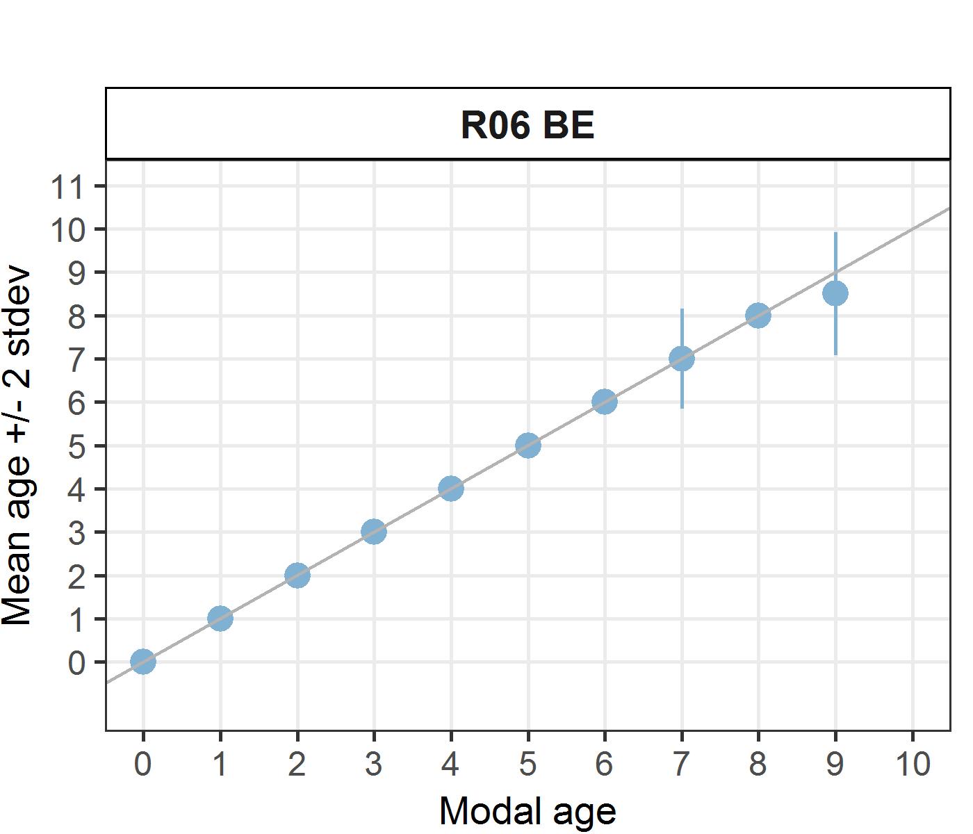
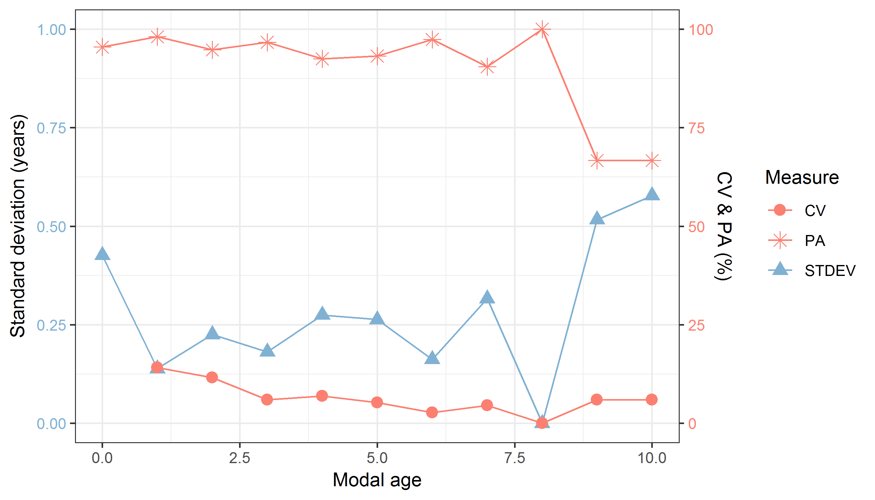
Figure 9.6: CV, PA and (STDEV (standard deviation) are plotted against modal age
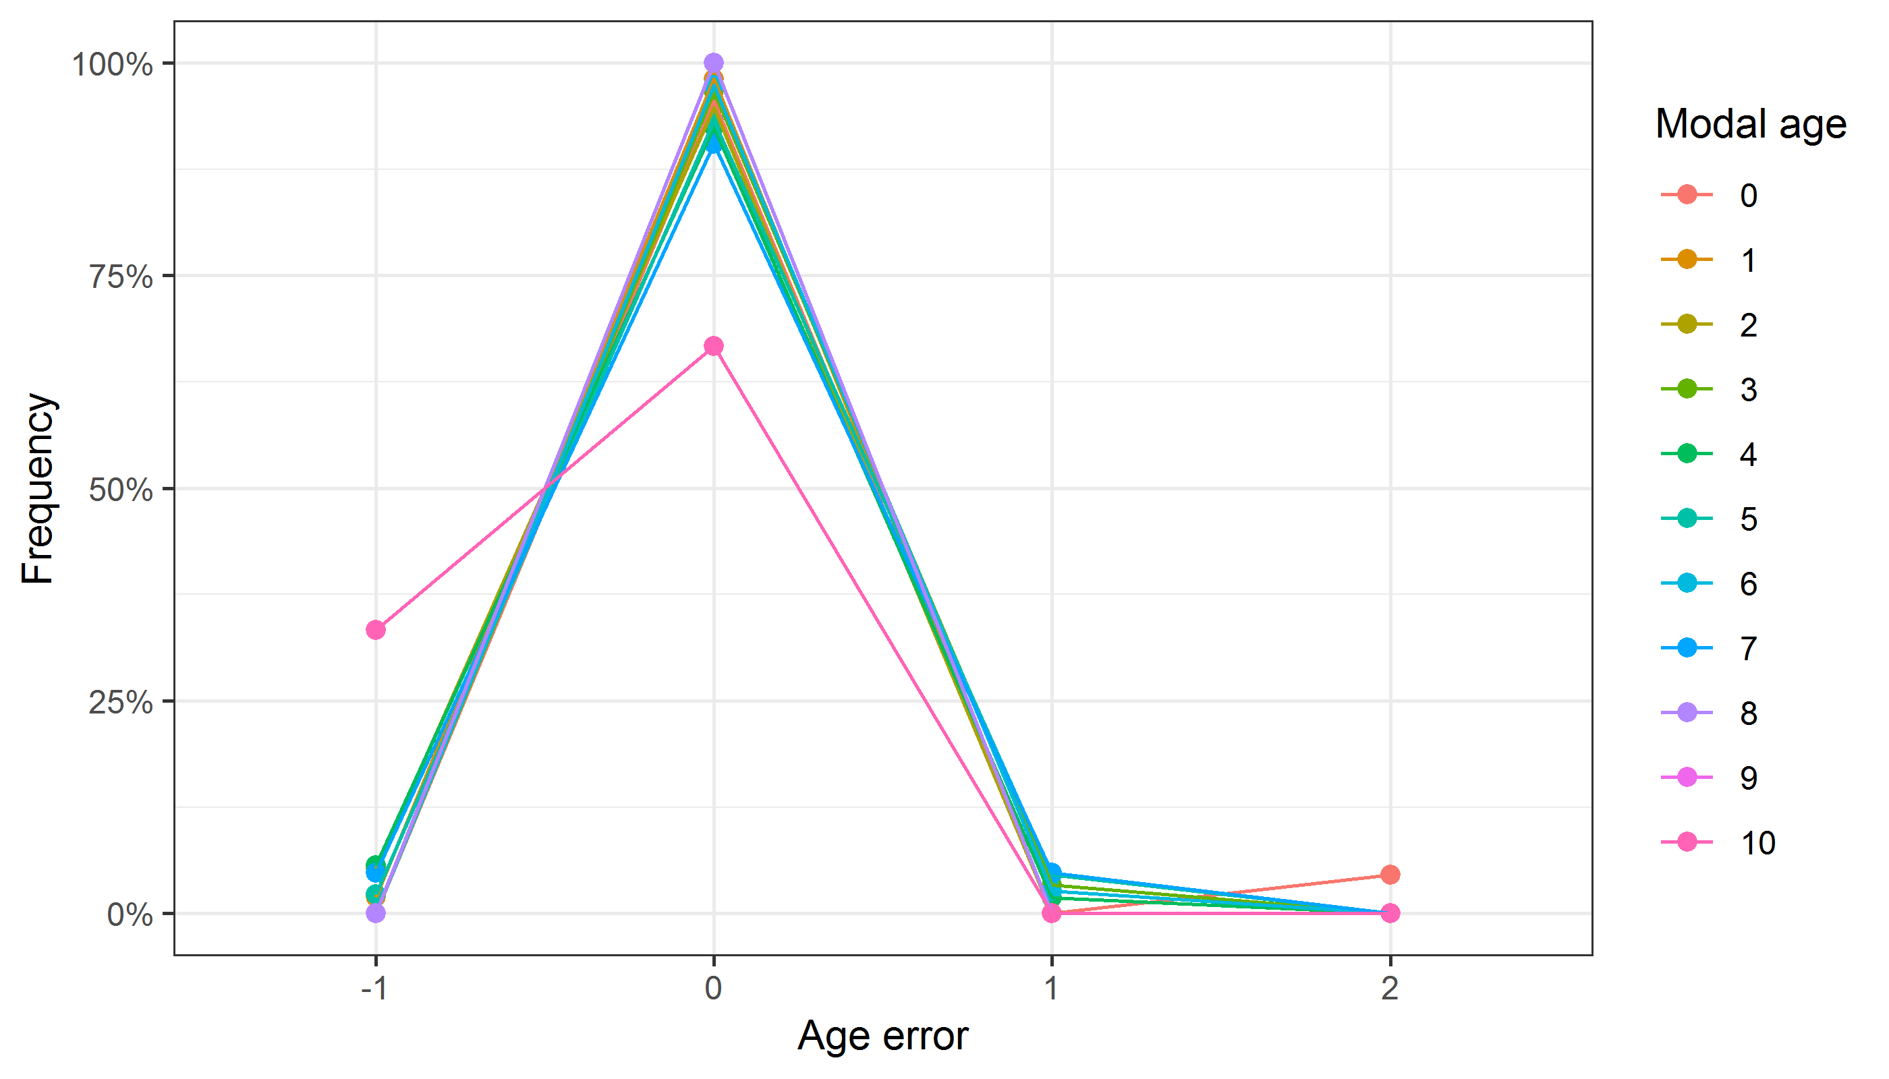
Figure 9.7: The distribution of the age reading errors in percentage by modal age as observed from the whole group of age readers in an age reading comparison to modal age. The achieved precision in age reading by MODAL age group is shown by the spread of the age readings errors. There appears to be no relative bias, if the age reading errors are normally distributed. The distributions are skewed, if relative bias occurs.
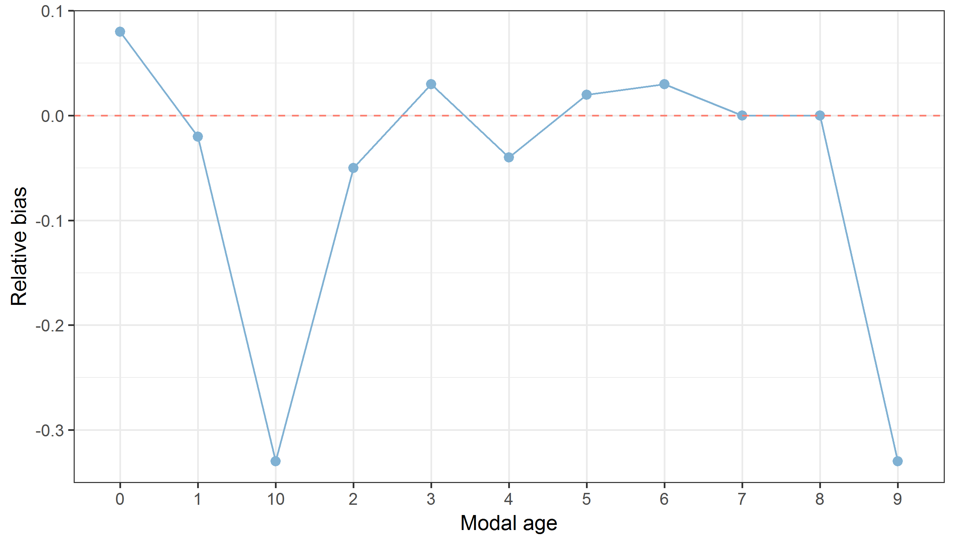
Figure 9.8: The relative bias by modal age as estimated by all age readers combined.
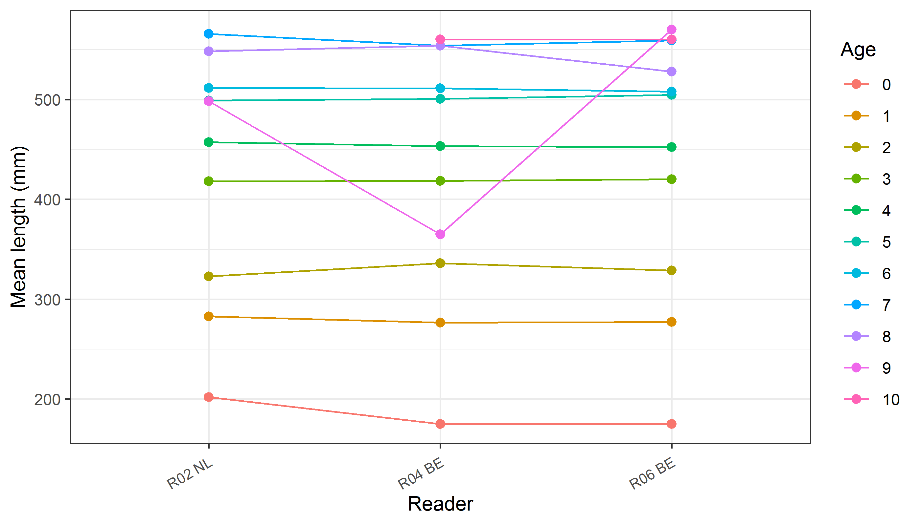
Figure 9.10: The mean length at age as estimated by each age reader.

Results all readers – whole
Data Overview
Table 9.10: Summary of statistics; PA (%), CV (%) and APE (%).
CV | PA | APE
29 % | 63 % | 22 %
Table 9.11: Data overview including modal age and statistics per sample.
Fish ID | Event ID | Image ID | length | sex | Catch date | ICES area | R02 NL | R04 BE | R06 BE | R08 FR | R10 FR | R12 FR | R14 NL | Modal age | PA % | CV % | APE %
001_PTCT07_BLL_7D_2017071510364 | 200 | 15030 | 325 | - | 15/07/2017 00:00:00 | 27.7.d | 1 | 2 | 2 | 3 | 1 | 2 | 1 | 1 | 43 | 44 | 36
002_PTCT07_BLL_7D_2017071510365 | 200 | 15032 | 480 | - | 15/07/2017 00:00:00 | 27.7.d | 4 | 4 | 5 | 4 | 4 | 3 | 3 | 4 | 57 | 18 | 13
003_BTS01_BLL_4B_2017082811204 | 200 | 15034 | 303 | - | 28/08/2017 00:00:00 | 27.4.b | 2 | 2 | 2 | 3 | 1 | 2 | 1 | 2 | 57 | 37 | 26
004_BTS01_BLL_4C_2014002 | 200 | 15036 | 240 | - | 25/08/2014 00:00:00 | 27.4.c | 1 | 1 | 1 | - | 0 | 1 | 1 | 1 | 83 | 49 | 33
005_BTS01_BLL_4C_2014003 | 200 | 15038 | 305 | - | 25/08/2014 00:00:00 | 27.4.c | 1 | 1 | 2 | 4 | 1 | 2 | 1 | 1 | 57 | 65 | 48
006_BTS01_BLL_4C_2014004 | 200 | 15040 | 435 | - | 25/08/2014 00:00:00 | 27.4.c | 2 | 4 | 6 | 4 | 3 | 3 | 3 | 3 | 43 | 36 | 26
007_BTS01_BLL_4C_2014006 | 200 | 15042 | 390 | - | 25/08/2014 00:00:00 | 27.4.c | 1 | 3 | 5 | 4 | 3 | 3 | 2 | 3 | 43 | 43 | 29
008_BTS01_BLL_4C_2014008 | 200 | 15044 | 510 | - | 25/08/2014 00:00:00 | 27.4.c | 3 | 4 | 5 | 5 | 6 | 3 | 4 | 3 | 29 | 26 | 21
009_BTS01_BLL_4C_2014015 | 200 | 15046 | 560 | - | 25/08/2014 00:00:00 | 27.4.c | 4 | 4 | 5 | 5 | 4 | 4 | 4 | 4 | 71 | 11 | 10
010_BTS01_BLL_4C_2015053385 | 200 | 15048 | 290 | - | 23/10/2015 00:00:00 | 27.4.c | 2 | 1 | 1 | 2 | 0 | 1 | 1 | 1 | 57 | 60 | 43
011_BTS01_BLL_4C_2015053386 | 200 | 15087 | 285 | - | 23/10/2015 00:00:00 | 27.4.c | 2 | 2 | 1 | 2 | 1 | 1 | 1 | 1 | 57 | 37 | 34
012_BTS01_BLL_4C_2015053387 | 200 | 15051 | 315 | - | 23/10/2015 00:00:00 | 27.4.c | 2 | 2 | 2 | 3 | 1 | 2 | 1 | 2 | 57 | 37 | 26
013_BTS01_BLL_4C_2015053388 | 200 | 15053 | 370 | - | 23/10/2015 00:00:00 | 27.4.c | 1 | 2 | 2 | 4 | 3 | 3 | 2 | 2 | 43 | 40 | 32
014_BTS01_BLL_4C_2015053390 | 200 | 15055 | 360 | - | 23/10/2015 00:00:00 | 27.4.c | 4 | 4 | 4 | 4 | 4 | 3 | 2 | 4 | 71 | 22 | 17
015_BTS01_BLL_4C_2015053391 | 200 | 15057 | 325 | - | 23/10/2015 00:00:00 | 27.4.c | - | 2 | 3 | 4 | 2 | - | 1 | 2 | 40 | 48 | 37
016_BTS01_BLL_4C_2016219500 | 200 | 15059 | 325 | - | 04/10/2016 00:00:00 | 27.4.c | 3 | 4 | 3 | 3 | 4 | 2 | 1 | 3 | 43 | 37 | 27
017_BTS01_BLL_4C_2016219501 | 200 | 15061 | 365 | - | 04/10/2016 00:00:00 | 27.4.c | 3 | 4 | 6 | 3 | 3 | 2 | 1 | 3 | 43 | 50 | 34
018_BTS01_BLL_4C_2017082811007 | 200 | 15063 | 301 | - | 28/08/2017 00:00:00 | 27.4.c | - | 2 | 2 | 4 | 1 | - | 1 | 1 | 40 | 61 | 40
019_BTS01_BLL_4C_2017082811008 | 200 | 15065 | 320 | - | 28/08/2017 00:00:00 | 27.4.c | 1 | 1 | 2 | 3 | 1 | 1 | 1 | 1 | 71 | 55 | 43
020_BTS01_BLL_4C_2017082811010 | 200 | 15067 | 257 | - | 28/08/2017 00:00:00 | 27.4.c | 1 | 1 | 1 | 2 | 1 | 1 | 1 | 1 | 86 | 33 | 21
021_BTS01_BLL_4C_2017082811011 | 200 | 15069 | 284 | - | 28/08/2017 00:00:00 | 27.4.c | - | 1 | 1 | - | 1 | - | - | 1 | 100 | 0 | 0
022_BTS01_BLL_4C_2017082811017 | 200 | 15071 | 433 | - | 28/08/2017 00:00:00 | 27.4.c | 4 | 2 | 3 | 4 | 3 | - | 2 | 2 | 33 | 30 | 22
023_BYDR05_BLL_4B_2017071410271 | 200 | 15073 | 270 | - | 14/07/2017 00:00:00 | 27.4.b | 1 | 1 | 1 | 2 | 1 | 1 | 1 | 1 | 86 | 33 | 21
024_BYDR05_BLL_4B_2017071410272 | 200 | 15075 | 270 | - | 14/07/2017 00:00:00 | 27.4.b | 1 | 1 | 2 | 3 | 1 | 1 | 1 | 1 | 71 | 55 | 43
025_BYDR05_BLL_4B_2017071410273 | 200 | 15077 | 290 | - | 14/07/2017 00:00:00 | 27.4.b | 1 | 2 | 2 | 3 | 1 | 1 | 1 | 1 | 57 | 50 | 42
026_BYDR05_BLL_4B_2017071410274 | 200 | 15079 | 260 | - | 14/07/2017 00:00:00 | 27.4.b | 1 | 2 | 2 | 2 | 1 | 2 | 1 | 2 | 57 | 34 | 31
027_BYDR05_BLL_4B_2017071410527 | 200 | 15081 | 520 | - | 14/07/2017 00:00:00 | 27.4.b | 4 | 4 | 4 | 5 | 4 | 4 | 3 | 4 | 71 | 14 | 7
028_BYDR05_BLL_4B_2017071410535 | 200 | 15083 | 525 | - | 14/07/2017 00:00:00 | 27.4.b | - | 5 | - | 7 | - | - | - | 5 | 50 | 24 | 17
029_BYDR06_BLL_4B_2011001 | 200 | 15085 | 250 | - | 29/09/2011 00:00:00 | 27.4.b | 1 | 1 | 1 | 2 | 1 | 1 | 1 | 1 | 86 | 33 | 21
030_BYDR06_BLL_4B_2011002 | 200 | 15086 | 260 | - | 29/09/2011 00:00:00 | 27.4.b | 1 | 2 | 1 | 3 | 1 | 2 | 1 | 1 | 57 | 50 | 42
031_BYDR07_BLL_4B_2017110910270 | 200 | 15089 | 280 | - | 09/11/2017 00:00:00 | 27.4.b | 2 | 2 | 1 | 3 | 1 | 1 | 1 | 1 | 57 | 50 | 42
032_BYDR07_BLL_4B_2017110910271 | 200 | 15091 | 290 | - | 09/11/2017 00:00:00 | 27.4.b | 2 | 2 | 1 | 3 | 1 | 2 | 1 | 1 | 43 | 44 | 36
033_BYDR07_BLL_4B_2017110910276 | 200 | 15093 | 300 | - | 09/11/2017 00:00:00 | 27.4.b | 2 | 1 | 1 | 4 | 1 | 2 | 1 | 1 | 57 | 65 | 48
034_BYDR07_BLL_4B_2017110910277 | 200 | 15095 | 300 | - | 09/11/2017 00:00:00 | 27.4.b | 1 | 2 | 1 | 4 | 1 | 2 | 1 | 1 | 57 | 65 | 48
035_BYDR07_BLL_4B_2017110910297 | 200 | 15097 | 190 | - | 09/11/2017 00:00:00 | 27.4.b | 0 | 0 | 0 | 1 | 0 | 0 | 0 | 0 | 86 | - | -
036_BYDR07_BLL_4B_2017110910298 | 200 | 15099 | 200 | - | 09/11/2017 00:00:00 | 27.4.b | 0 | 0 | 0 | 1 | 0 | 0 | 0 | 0 | 86 | - | -
037_BYDR05_BLL_4B_2017071410528 | 200 | 15101 | 335 | - | 14/07/2017 00:00:00 | 27.4.b | 2 | 3 | 3 | 3 | 2 | 3 | 2 | 3 | 57 | 21 | 19
038_BYDR07_BLL_4B_2017110910533 | 200 | 15103 | 380 | - | 09/11/2017 00:00:00 | 27.4.b | 3 | 4 | 4 | 4 | 4 | 4 | 3 | 4 | 71 | 13 | 11
039_BYDR05_BLL_4B_20170714910534 | 200 | 15123 | 450 | - | 14/07/2017 00:00:00 | 27.4.b | 4 | 4 | 3 | 5 | 5 | 3 | 3 | 3 | 43 | 23 | 19
040_BYDR07_BLL_4B_2017110910541 | 200 | 15106 | 535 | - | 09/11/2017 00:00:00 | 27.4.b | 4 | 4 | 4 | 4 | 3 | 3 | - | 4 | 67 | 14 | 12
041_BYDR07_BLL_4B_2017110910542 | 200 | 15108 | 520 | - | 09/11/2017 00:00:00 | 27.4.b | 5 | 6 | 6 | 5 | 6 | 5 | 6 | 6 | 57 | 10 | 9
042_BYDR07_BLL_4B_2017110910549 | 200 | 15110 | 560 | - | 09/11/2017 00:00:00 | 27.4.b | 4 | 5 | 5 | 5 | 4 | 4 | 4 | 4 | 57 | 12 | 11
043_BYDR07_BLL_4B_2017110910550 | 200 | 15112 | 555 | - | 09/11/2017 00:00:00 | 27.4.b | 6 | 6 | 7 | 6 | 6 | 4 | 5 | 6 | 57 | 17 | 12
044_BYDR07_BLL_4B_2017110910552 | 200 | 15114 | 580 | - | 09/11/2017 00:00:00 | 27.4.b | 6 | 6 | 6 | 5 | 5 | - | 5 | 5 | 50 | 10 | 9
045_BYDR08_BLL_7D_2017121510064 | 200 | 15116 | 270 | - | 15/12/2017 00:00:00 | 27.7.d | - | 0 | 0 | 0 | 0 | - | 1 | 0 | 80 | - | -
046_BYDR08_BLL_7D_017121510211 | 200 | 15125 | 455 | - | 15/12/2017 00:00:00 | 27.7.d | 3 | 3 | 3 | 4 | 3 | 3 | 2 | 3 | 71 | 19 | 10
047_BYDR08_BLL_7D_2017121510206 | 200 | 15126 | 430 | - | 15/12/2017 00:00:00 | 27.7.d | 2 | 3 | 2 | 5 | 3 | 3 | 2 | 2 | 43 | 37 | 26
048_BYDR08_BLL_7D_2017121510207 | 200 | 15127 | 435 | - | 15/12/2017 00:00:00 | 27.7.d | 2 | 2 | 2 | 4 | 2 | 2 | 2 | 2 | 86 | 33 | 21
049_BYDR08_BLL_7D_2017121510208 | 200 | 15128 | 465 | - | 15/12/2017 00:00:00 | 27.7.d | 3 | 3 | 4 | 4 | 3 | 4 | 3 | 3 | 57 | 16 | 14
050_BYDR08_BLL_7D_2017121510213 | 200 | 15121 | 475 | - | 15/12/2017 00:00:00 | 27.7.d | 4 | 3 | 4 | 4 | 4 | 4 | 3 | 4 | 71 | 13 | 11
051_BYDR08_BLL_7D_2017121510219 | 200 | 15130 | 320 | - | 15/12/2017 00:00:00 | 27.7.d | 2 | 1 | 1 | 3 | 1 | 2 | 1 | 1 | 57 | 50 | 42
052_BYDR08_BLL_7D_2017121510220 | 200 | 15132 | 320 | - | 15/12/2017 00:00:00 | 27.7.d | 2 | 2 | 1 | 3 | 1 | 2 | 1 | 1 | 43 | 44 | 36
053_CDDR02_BLL_7D_2017002255 | 200 | 15134 | 495 | - | 09/03/2017 00:00:00 | 27.7.d | 2 | 3 | 4 | 4 | 4 | 3 | 3 | 3 | 43 | 23 | 19
054_CDDR02_BLL_7D_2017002256 | 200 | 15136 | 570 | - | 09/03/2017 00:00:00 | 27.7.d | 4 | 4 | 5 | 5 | 5 | 5 | 4 | 5 | 57 | 12 | 11
055_CDDR02_BLL_7D_2017002257 | 200 | 15138 | 500 | - | 09/03/2017 00:00:00 | 27.7.d | 4 | 3 | 5 | - | 4 | 3 | 3 | 3 | 50 | 22 | 18
056_CDDR02_BLL_7D_2017002260 | 200 | 15140 | 470 | - | 09/03/2017 00:00:00 | 27.7.d | 2 | 3 | 4 | 4 | 4 | 3 | 3 | 3 | 43 | 23 | 19
057_CDDR02_BLL_7D_2017002261 | 200 | 15142 | 580 | - | 09/03/2017 00:00:00 | 27.7.d | - | 6 | 6 | 6 | 6 | 6 | 5 | 6 | 83 | 7 | 5
058_CDDR02_BLL_7D_2017002263 | 200 | 15144 | 520 | - | 09/03/2017 00:00:00 | 27.7.d | 5 | 5 | 6 | 6 | 5 | 6 | 5 | 5 | 57 | 10 | 9
059_CDDR02_BLL_7D_2017002264 | 200 | 15146 | 495 | - | 09/03/2017 00:00:00 | 27.7.d | 3 | 4 | 5 | 4 | 3 | 4 | 3 | 3 | 43 | 20 | 16
060_CDDR02_BLL_7D_2017002271 | 200 | 15148 | 335 | - | 09/03/2017 00:00:00 | 27.7.d | 2 | 2 | 3 | 4 | 3 | 3 | 2 | 2 | 43 | 28 | 23
061_CDDR02_BLL_7D_2017002274 | 200 | 15150 | 325 | - | 09/03/2017 00:00:00 | 27.7.d | 2 | 2 | 3 | 3 | 2 | 2 | 2 | 2 | 71 | 21 | 18
062_CDDR06_BLL_4B_2017073110641 | 200 | 15262 | 535 | - | 31/07/2017 00:00:00 | 27.4.b | 5 | 5 | 7 | - | 6 | 4 | 5 | 5 | 50 | 19 | 15
063_CDDR06_BLL_4B_2017073110642 | 200 | 15263 | 560 | - | 31/07/2017 00:00:00 | 27.4.b | 6 | 7 | - | 6 | 7 | 6 | 6 | 6 | 67 | 8 | 7
064_CDDR06_BLL_4B_2017073110643 | 200 | 15264 | 535 | - | 31/07/2017 00:00:00 | 27.4.b | 4 | 4 | 6 | 6 | 6 | 4 | 4 | 4 | 57 | 22 | 20
065_CDDR06_BLL_4B_2017073110645 | 200 | 15265 | 445 | - | 31/07/2017 00:00:00 | 27.4.b | 3 | 3 | - | 4 | 3 | 2 | 3 | 3 | 67 | 21 | 11
066_CDDR06_BLL_4B_2017073110646 | 200 | 15266 | 470 | - | 31/07/2017 00:00:00 | 27.4.b | 4 | 4 | 6 | 4 | 4 | 4 | 4 | 4 | 86 | 18 | 11
067_CDDR06_BLL_4B_2017073110654 | 200 | 15267 | 570 | - | 31/07/2017 00:00:00 | 27.4.b | 5 | 7 | 8 | 7 | 7 | 5 | 6 | 7 | 43 | 18 | 15
068_CDDR06_BLL_4B_2017073110659 | 200 | 15268 | 490 | - | 31/07/2017 00:00:00 | 27.4.b | 3 | 3 | 5 | 3 | 3 | 3 | 3 | 3 | 86 | 23 | 15
069_CDDR06_BLL_4B_2017073110644 | 200 | 15269 | 490 | - | 31/07/2017 00:00:00 | 27.4.b | 3 | 3 | - | 3 | 3 | 3 | 3 | 3 | 100 | 0 | 0
070_CDDR06_BLL_4B_2017073110648 | 200 | 15271 | 355 | - | 31/07/2017 00:00:00 | 27.4.b | 2 | 2 | - | 3 | 2 | 2 | 2 | 2 | 83 | 19 | 13
071_CDDR06_BLL_4B_2017073110649 | 200 | 15270 | 400 | - | 31/07/2017 00:00:00 | 27.4.b | 3 | 2 | 3 | 5 | 2 | 2 | 4 | 2 | 43 | 38 | 29
072_CDDR07_BLL_4B_2017102010285 | 200 | 15162 | 415 | - | 20/10/2017 00:00:00 | 27.4.b | 4 | 5 | 6 | 5 | 4 | 4 | - | 4 | 50 | 17 | 14
073_CDDR08_BLL_7D_2017112110277 | 200 | 15164 | 370 | - | 21/11/2017 00:00:00 | 27.7.d | 2 | 1 | 3 | 2 | 2 | 2 | 2 | 2 | 71 | 29 | 14
074_CDDR08_BLL_7D_2017112110280 | 200 | 15166 | 420 | - | 21/11/2017 00:00:00 | 27.7.d | 3 | 3 | 3 | 3 | 3 | 3 | 3 | 3 | 100 | 0 | 0
075_CDDR08_BLL_7D_2017112110283 | 200 | 15168 | 520 | - | 21/11/2017 00:00:00 | 27.7.d | 4 | 4 | 5 | 5 | 4 | 4 | 4 | 4 | 71 | 11 | 10
076_EXNL_BLL_4100007_130918_004 | 200 | 15170 | 233 | - | 18/09/2017 00:00:00 | 27.4.c | 1 | 2 | 2 | 5 | 2 | 2 | 2 | 2 | 71 | 55 | 34
077_EXNL_BLL_4100014_130918_005 | 200 | 15172 | 152 | - | 18/09/2017 00:00:00 | 27.4.c | 1 | 1 | 0 | 1 | 0 | 0 | 0 | 0 | 57 | - | -
078_EXNL_BLL_4100022_180918_006 | 200 | 15174 | 138 | - | 18/09/2017 00:00:00 | 27.4.c | 0 | 0 | 0 | 1 | 0 | 0 | 0 | 0 | 86 | - | -
079_EXNL_BLL_4100023_180918_007 | 200 | 15176 | 143 | - | 18/09/2017 00:00:00 | 27.4.c | 0 | 0 | 0 | 1 | 0 | 0 | 0 | 0 | 86 | - | -
080_EXNL_BLL_4100024_180918_008 | 200 | 15178 | 133 | - | 18/09/2017 00:00:00 | 27.4.c | 0 | 1 | 0 | 1 | 0 | 0 | 0 | 0 | 71 | - | -
081_GNKT02_BLL_7D_2017002518 | 200 | 15180 | 540 | - | 07/03/2017 00:00:00 | 27.7.d | 4 | 4 | 5 | 4 | 4 | 4 | 4 | 4 | 86 | 9 | 6
082_GNKT02_BLL_7D_2017002524 | 200 | 15182 | 565 | - | 07/03/2017 00:00:00 | 27.7.d | 6 | 7 | 7 | 7 | 7 | 5 | 6 | 7 | 57 | 12 | 10
083_NDGP05_BLL_4B_2005004 | 200 | 15259 | 310 | - | 07/11/2005 00:00:00 | 27.4.b | 2 | 2 | 3 | 3 | 2 | 2 | 2 | 2 | 71 | 21 | 18
084_NDGP05_BLL_4B_2005005 | 200 | 15261 | 340 | - | 07/11/2005 00:00:00 | 27.4.b | 3 | 2 | 4 | 4 | 2 | 3 | 2 | 2 | 43 | 31 | 26
085_NDGP05_BLL_4B_2005001 | 200 | 15184 | 330 | - | 07/11/2005 00:00:00 | 27.4.b | 2 | 2 | - | 4 | 2 | 2 | 2 | 2 | 83 | 35 | 24
086_NDGP05_BLL_4B_2005041 | 200 | 15186 | 420 | - | 07/11/2005 00:00:00 | 27.4.b | 3 | 3 | 3 | 3 | 3 | 3 | 3 | 3 | 100 | 0 | 0
087_NDGP05_BLL_4B_2005045 | 200 | 15188 | 470 | - | 07/11/2005 00:00:00 | 27.4.b | 2 | 2 | 3 | 3 | 2 | 2 | 3 | 2 | 57 | 22 | 20
088_NDGP05_BLL_4B_2005060 | 200 | 15190 | 490 | - | 07/11/2005 00:00:00 | 27.4.b | 4 | 4 | 4 | 4 | 4 | 3 | 3 | 4 | 71 | 13 | 11
089_NDGP05_BLL_4B_2005066 | 200 | 15192 | 570 | - | 07/11/2005 00:00:00 | 27.4.b | 4 | 4 | 4 | 4 | 4 | 4 | 4 | 4 | 100 | 0 | 0
090_NDGP05_BLL_4B_2005071 | 200 | 15194 | 540 | - | 07/11/2005 00:00:00 | 27.4.b | 4 | 5 | 6 | 5 | 5 | 5 | 4 | 5 | 57 | 14 | 10
092_PTCT02_BLL_7D_2017002749 | 200 | 15196 | 495 | - | 07/03/2017 00:00:00 | 27.7.d | 6 | 6 | 8 | 7 | 7 | 6 | 6 | 6 | 57 | 12 | 10
093_PTCT02_BLL_7D_2017002750 | 200 | 15198 | 630 | - | 07/03/2017 00:00:00 | 27.7.d | 7 | 7 | 8 | 7 | 7 | 5 | 6 | 7 | 57 | 14 | 10
094_PTCT02_BLL_7D_2017002752 | 200 | 15200 | 440 | - | 07/03/2017 00:00:00 | 27.7.d | 3 | 3 | 3 | 4 | 3 | 4 | 3 | 3 | 71 | 15 | 12
095_PTCT03_BLL_4C_2017040310575 | 200 | 15272 | 425 | - | 03/04/2017 00:00:00 | 27.4.c | 3 | 3 | 3 | 3 | 3 | 3 | 3 | 3 | 100 | 0 | 0
096_PTCT03_BLL_4C_2017040310576 | 200 | 15273 | 445 | - | 03/04/2017 00:00:00 | 27.4.c | 2 | 2 | 3 | 3 | - | - | 2 | 2 | 60 | 23 | 20
097_PTCT03_BLL_4C_2017040310577 | 200 | 15274 | 425 | - | 03/04/2017 00:00:00 | 27.4.c | 2 | 2 | 3 | 3 | 2 | 3 | 3 | 3 | 57 | 21 | 19
098_PTCT03_BLL_4C_2017040310583 | 200 | 15275 | 365 | - | 03/04/2017 00:00:00 | 27.4.c | 3 | 4 | 4 | 4 | 4 | 4 | 2 | 4 | 71 | 22 | 17
099_PTCT03_BLL_4C_2017040310584 | 200 | 15276 | 390 | - | 03/04/2017 00:00:00 | 27.4.c | 3 | 4 | 5 | 5 | 5 | 4 | 3 | 5 | 43 | 22 | 18
100_PTCT03_BLL_7D_2017040310167 | 200 | 15207 | 220 | - | 03/04/2017 00:00:00 | 27.7.d | 2 | 2 | 1 | 2 | 1 | 2 | 1 | 2 | 57 | 34 | 31
101_PTCT03_BLL_7D_2017040310347 | 200 | 15209 | 535 | - | 03/04/2017 00:00:00 | 27.7.d | 6 | 5 | 6 | 6 | 5 | 5 | 5 | 5 | 57 | 10 | 9
102_PTCT03_BLL_7D_2017040310350 | 200 | 15211 | 425 | - | 03/04/2017 00:00:00 | 27.7.d | 5 | 6 | 6 | 5 | 6 | 5 | 5 | 5 | 57 | 10 | 9
103_PTCT06_BLL_7D_2017062610220 | 200 | 15213 | 400 | - | 26/06/2017 00:00:00 | 27.7.d | 4 | 5 | 5 | 5 | 3 | 4 | 5 | 5 | 57 | 18 | 15
104_PTCT06_BLL_7D_2017062610221 | 200 | 15215 | 495 | - | 26/06/2017 00:00:00 | 27.7.d | 3 | 4 | 3 | 4 | 3 | 4 | 3 | 3 | 57 | 16 | 14
105_PTCT06_BLL_7D_2017062610222 | 200 | 15217 | 535 | - | 26/06/2017 00:00:00 | 27.7.d | 5 | 7 | 7 | 6 | 6 | 5 | 5 | 5 | 43 | 15 | 13
106_PTCT06_BLL_7D_2017062610224 | 200 | 15219 | 390 | - | 26/06/2017 00:00:00 | 27.7.d | 3 | 3 | 3 | 3 | 3 | 2 | 2 | 3 | 71 | 18 | 15
107_PTCT06_BLL_7D_2017062610225 | 200 | 15221 | 445 | - | 26/06/2017 00:00:00 | 27.7.d | 3 | 3 | 4 | 4 | 3 | 3 | 3 | 3 | 71 | 15 | 12
108_PTCT06_BLL_7D_2017062610236 | 200 | 15223 | 340 | - | 26/06/2017 00:00:00 | 27.7.d | 2 | 2 | 2 | 3 | 1 | 2 | 2 | 2 | 71 | 29 | 14
109_PTCT06_BLL_7D_2017062610238 | 200 | 15225 | 325 | - | 26/06/2017 00:00:00 | 27.7.d | 1 | 2 | 2 | 3 | 1 | 2 | 2 | 2 | 57 | 37 | 26
110_PTCT07_BLL_7D_2017071510148 | 200 | 15227 | 280 | - | 15/07/2017 00:00:00 | 27.7.d | 1 | 1 | 2 | 2 | 1 | 1 | 2 | 1 | 57 | 37 | 34
111_PTCT07_BLL_7D_2017071510150 | 200 | 15229 | 280 | - | 15/07/2017 00:00:00 | 27.7.d | 1 | 1 | 2 | 3 | 1 | 1 | 2 | 1 | 57 | 50 | 42
113_PTCT07_BLL_7D_2017071510366 | 200 | 15233 | 570 | - | 15/07/2017 00:00:00 | 27.7.d | 6 | 7 | 8 | 6 | 7 | 5 | 5 | 5 | 29 | 18 | 14
114_PTCT07_BLL_7D_2017071510368 | 200 | 15235 | 565 | - | 15/07/2017 00:00:00 | 27.7.d | 5 | - | 6 | 6 | 5 | - | - | 5 | 50 | 10 | 9
115_PTCT07_BLL_7D_2017071510369 | 200 | 15237 | 580 | - | 15/07/2017 00:00:00 | 27.7.d | 7 | 7 | 8 | 5 | 8 | 5 | 7 | 7 | 43 | 19 | 15
116_PTCT07_BLL_7D_2017071510370 | 200 | 15239 | 475 | - | 15/07/2017 00:00:00 | 27.7.d | 4 | 4 | 5 | 3 | 4 | 4 | 4 | 4 | 71 | 14 | 7
117_PTCT07_BLL_7D_2017071510371 | 200 | 15241 | 530 | - | 15/07/2017 00:00:00 | 27.7.d | 4 | 5 | 5 | 5 | 5 | 5 | 5 | 5 | 86 | 8 | 5
118_PTCT07_BLL_7D_2017071510372 | 200 | 15243 | 615 | - | 15/07/2017 00:00:00 | 27.7.d | 6 | 6 | 6 | 6 | 6 | 6 | 6 | 6 | 100 | 0 | 0
119_PTCT07_BLL_7D_2017071510374 | 200 | 15245 | 460 | - | 15/07/2017 00:00:00 | 27.7.d | 4 | 5 | 6 | 5 | 5 | 4 | 4 | 4 | 43 | 16 | 13
120_PTCT07_BLL_7D_2017071510375 | 200 | 15247 | 460 | - | 15/07/2017 00:00:00 | 27.7.d | 4 | 4 | 4 | 4 | 4 | 3 | 4 | 4 | 86 | 10 | 6
121_PTCT07_BLL_7D_2017071510376 | 200 | 15249 | 560 | - | 15/07/2017 00:00:00 | 27.7.d | 7 | 7 | 7 | 7 | 7 | 7 | 5 | 7 | 86 | 11 | 7
122_PTCT07_BLL_7D_2017071510377 | 200 | 15251 | 395 | - | 15/07/2017 00:00:00 | 27.7.d | 5 | 4 | 4 | 4 | 5 | 4 | 3 | 4 | 57 | 17 | 12
123_PTCT07_BLL_7D_2017071510379 | 200 | 15253 | 500 | - | 15/07/2017 00:00:00 | 27.7.d | 6 | 6 | 6 | 5 | 6 | 4 | 5 | 6 | 57 | 14 | 12
124_PTCT07_BLL_7D_2017071510381 | 200 | 15255 | 370 | - | 15/07/2017 00:00:00 | 27.7.d | 2 | 3 | 2 | 3 | 4 | 4 | 3 | 3 | 43 | 27 | 19
125_PTCT07_BLL_7D_2017071510362 | 200 | 15257 | 395 | - | 15/07/2017 00:00:00 | 27.7.d | 3 | 3 | 3 | 3 | 3 | 3 | 3 | 3 | 100 | 0 | 0
Table 9.12: Number of age readings table gives an overview of number of readings per reader and modal age. The total numbers of readings per reader and per modal age are summarized at the end of the table.
Modal age | R02 NL | R04 BE | R06 BE | R08 FR | R10 FR | R12 FR | R14 NL | total
0 | 6 | 7 | 7 | 7 | 7 | 6 | 7 | 47
1 | 20 | 22 | 22 | 20 | 22 | 20 | 21 | 147
2 | 21 | 22 | 20 | 22 | 21 | 19 | 22 | 147
3 | 26 | 26 | 24 | 25 | 26 | 26 | 26 | 179
4 | 20 | 20 | 20 | 20 | 20 | 20 | 18 | 138
5 | 13 | 13 | 13 | 13 | 13 | 11 | 12 | 88
6 | 6 | 7 | 6 | 7 | 7 | 7 | 7 | 47
7 | 5 | 5 | 5 | 5 | 5 | 5 | 5 | 35
Total | 117 | 122 | 117 | 119 | 121 | 114 | 118 | 828
Table 9.13: Age composition by reader gives a summary of number of readings per reader.
Modal age | R02 NL | R04 BE | R06 BE | R08 FR | R10 FR | R12 FR | R14 NL
0 | 5 | 5 | 7 | 1 | 9 | 6 | 6
1 | 19 | 16 | 15 | 6 | 26 | 12 | 27
2 | 27 | 30 | 18 | 9 | 13 | 27 | 23
3 | 22 | 20 | 21 | 32 | 23 | 26 | 27
4 | 24 | 25 | 15 | 34 | 21 | 25 | 14
5 | 8 | 10 | 15 | 21 | 11 | 12 | 13
6 | 9 | 8 | 16 | 10 | 10 | 5 | 7
7 | 3 | 8 | 5 | 6 | 7 | 1 | 1
8 | 0 | 0 | 5 | 0 | 1 | 0 | 0
Total | 117 | 122 | 117 | 119 | 121 | 114 | 118
Table 9.14: Mean length at age per reader is calculated per reader and age (not modal age) and for all readers combined per age. A weighted mean is also given.
Age | R02 NL | R04 BE | R06 BE | R08 FR | R10 FR | R12 FR | R14 NL
0 | 161 mm | 188 mm | 175 mm | 270 mm | 195 mm | 159 mm | 159 mm
1 | 283 mm | 270 mm | 278 mm | 159 mm | 290 mm | 276 mm | 291 mm
2 | 355 mm | 332 mm | 320 mm | 276 mm | 358 mm | 331 mm | 358 mm
3 | 425 mm | 437 mm | 399 mm | 358 mm | 433 mm | 437 mm | 451 mm
4 | 494 mm | 468 mm | 451 mm | 421 mm | 467 mm | 475 mm | 512 mm
5 | 508 mm | 502 mm | 494 mm | 481 mm | 503 mm | 548 mm | 525 mm
6 | 553 mm | 534 mm | 504 mm | 557 mm | 531 mm | 554 mm | 565 mm
7 | 590 mm | 571 mm | 550 mm | 558 mm | 564 mm | 560 mm | 580 mm
8 | - | - | 569 mm | - | 580 mm | - | -
Weighted Mean | 408 mm | 406 mm | 405 mm | 408 mm | 406 mm | 406 mm | 405 mm
[[1]] 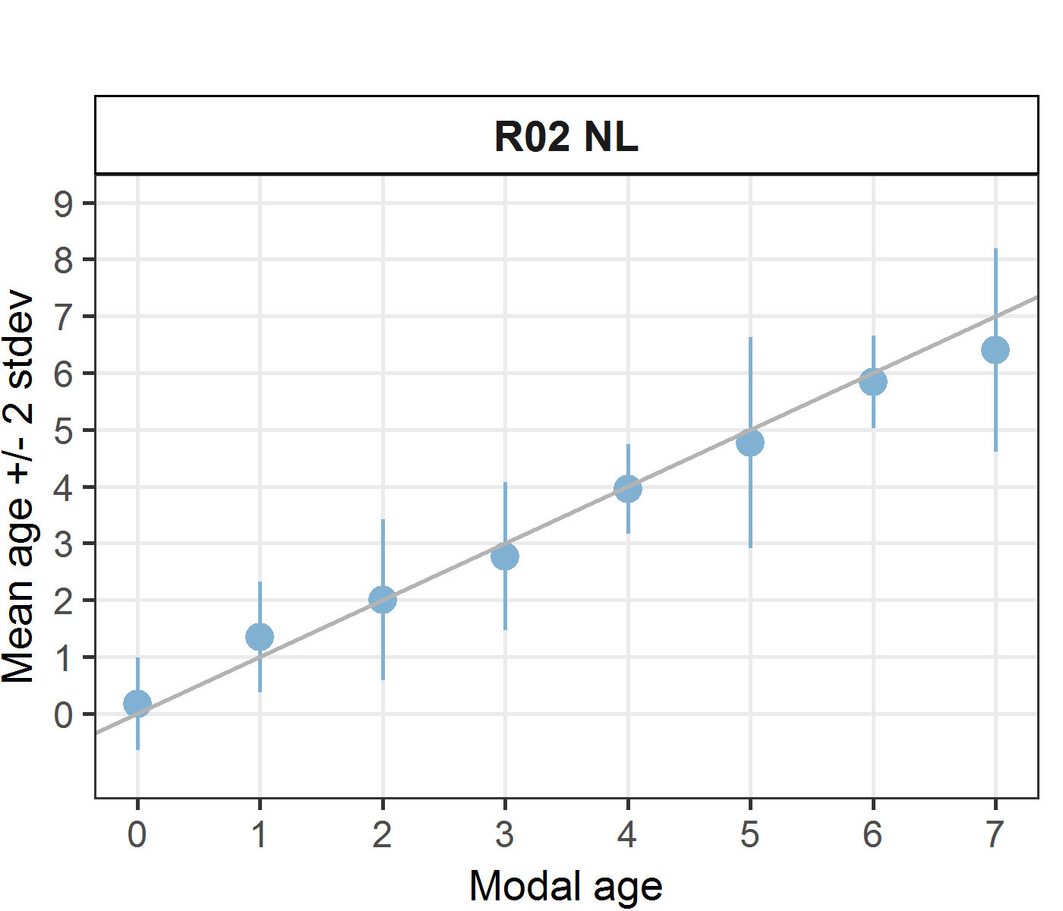 [[2]] 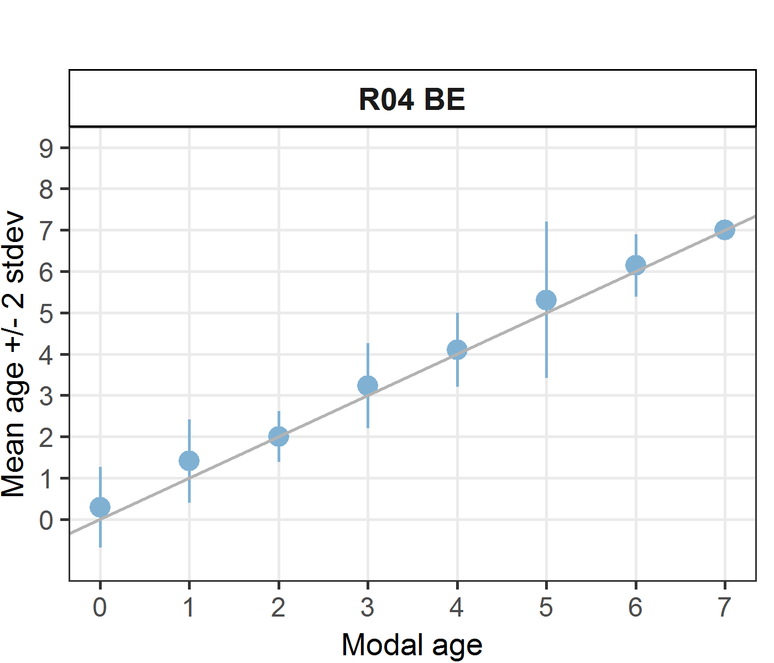 [[3]] 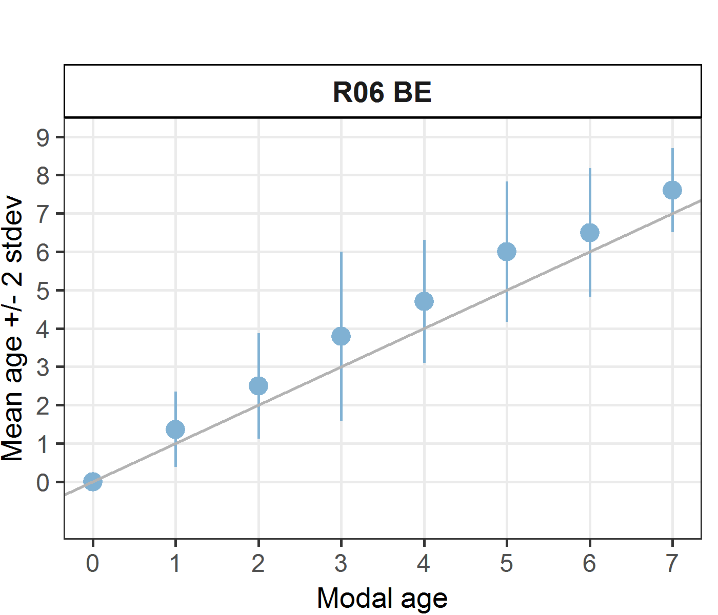 [[4]] 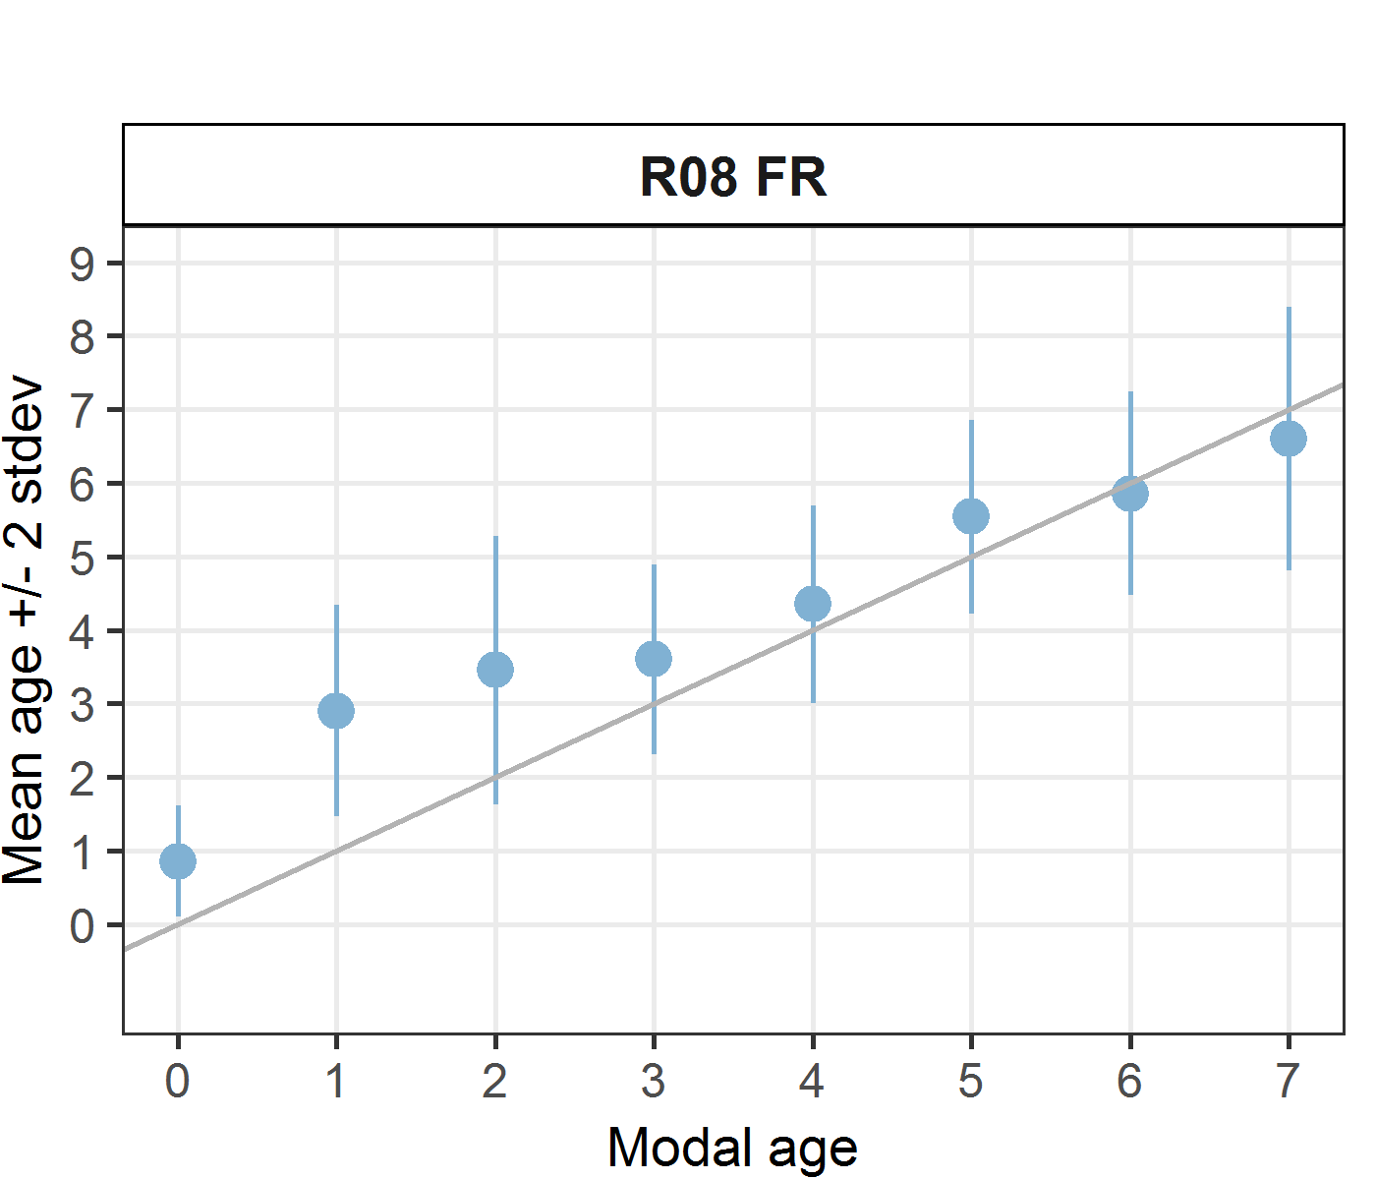 [[5]] 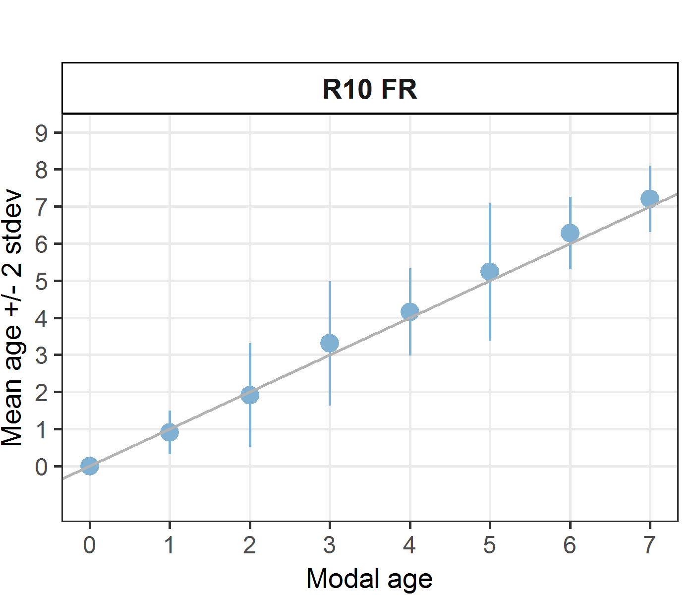 [[6]] 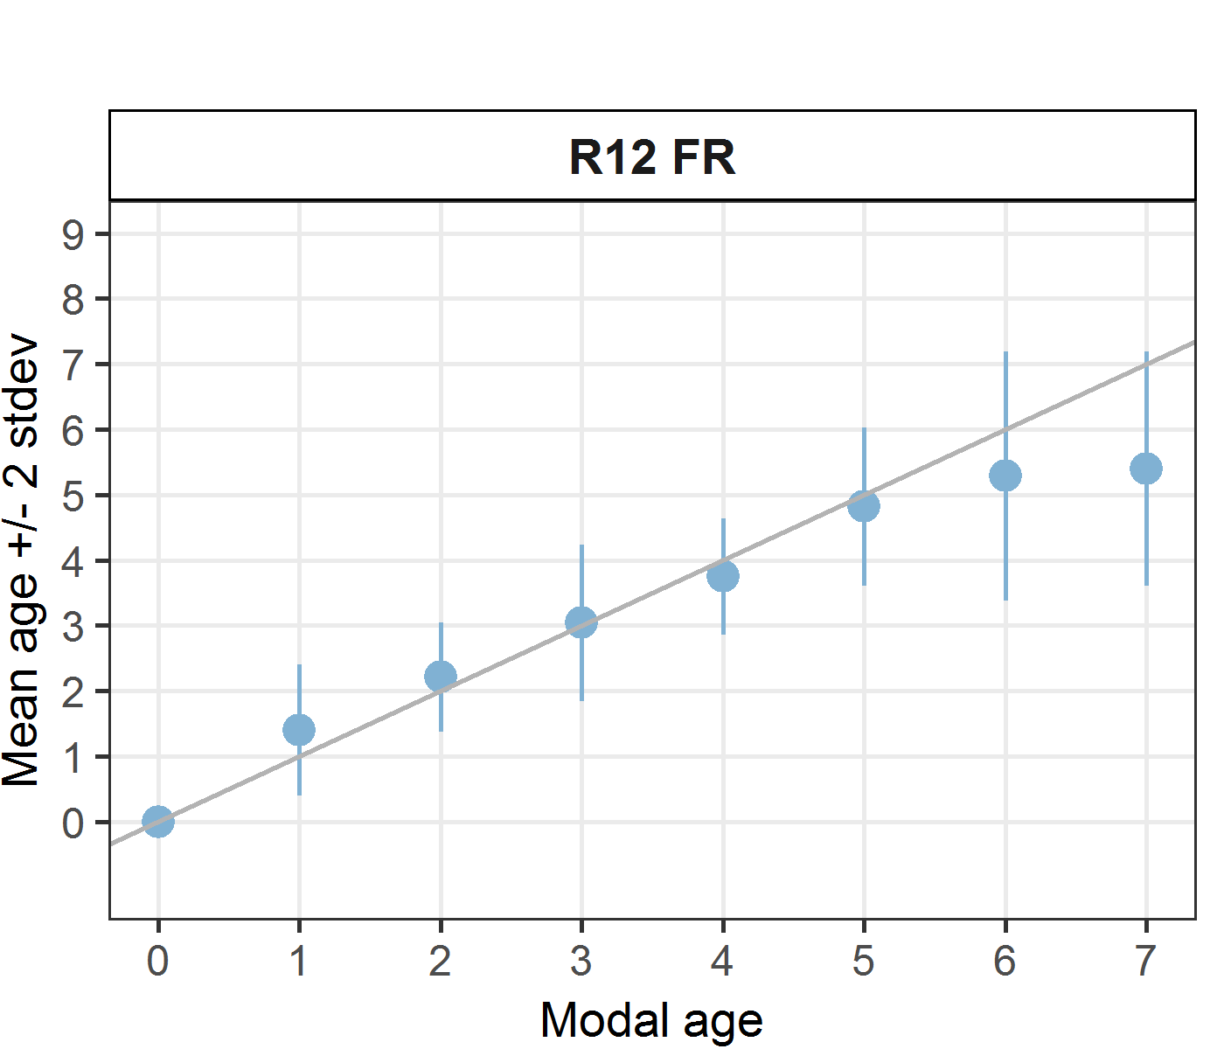 [[7]] 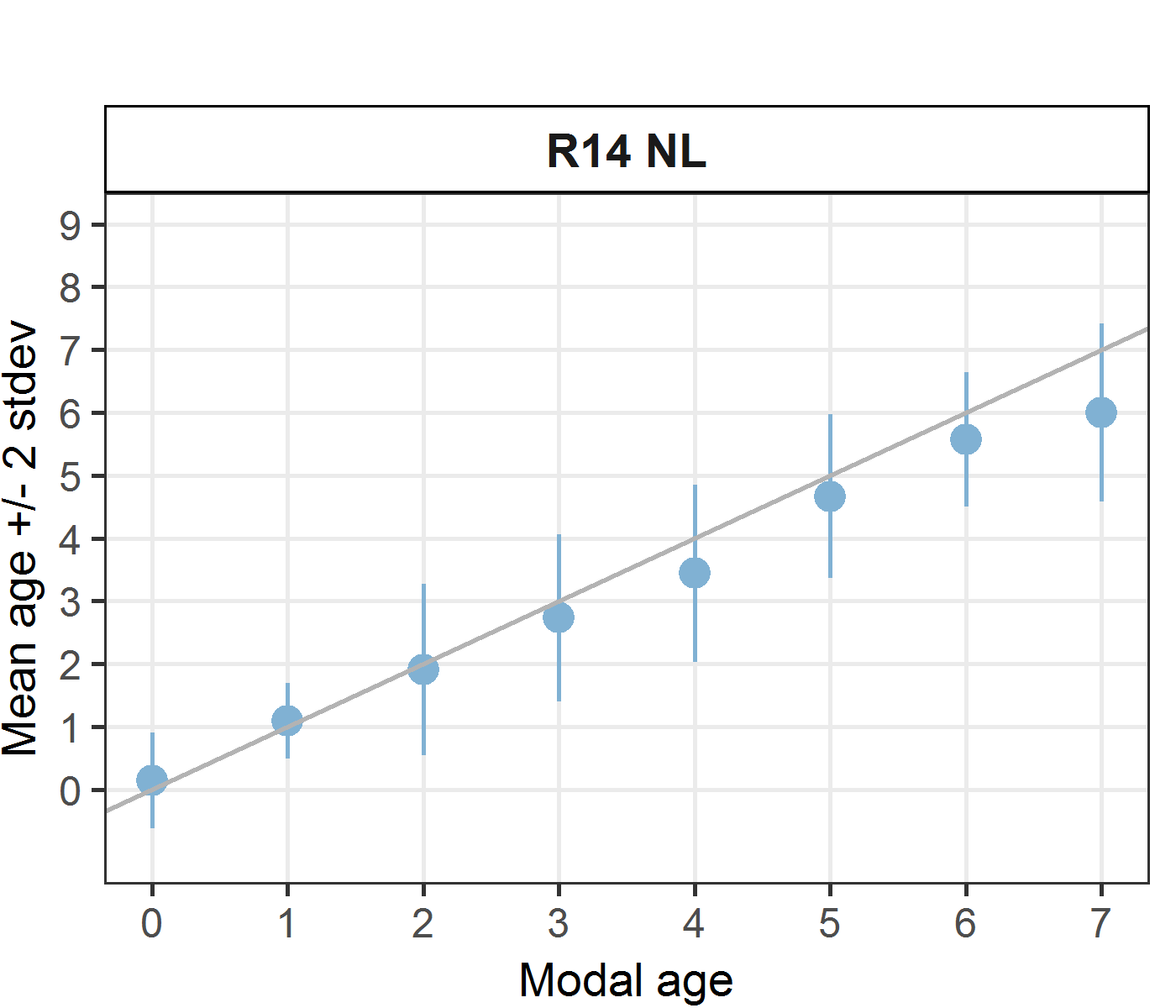
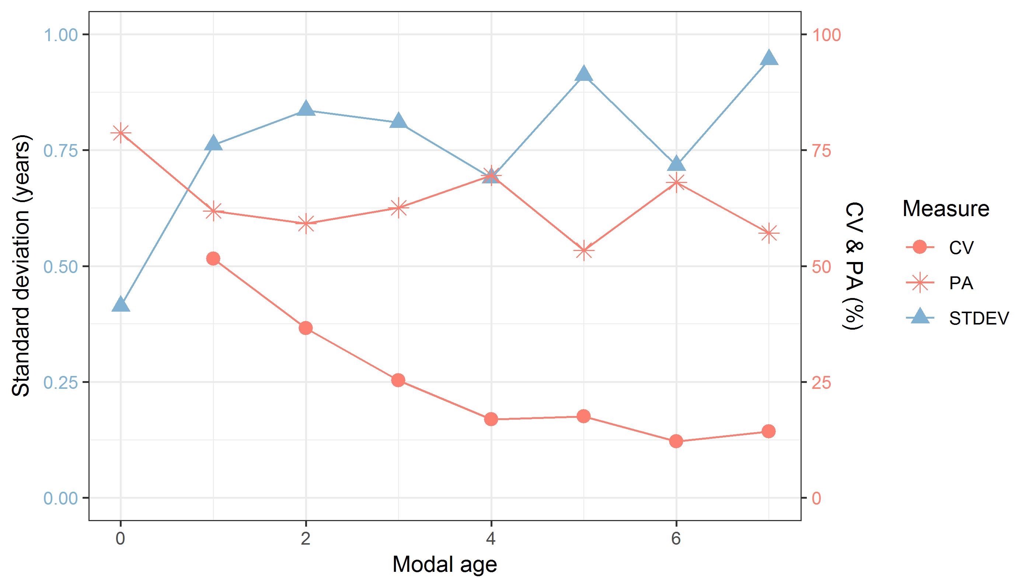
Figure 9.11: CV, PA and (STDEV (standard deviation) are plotted against modal age
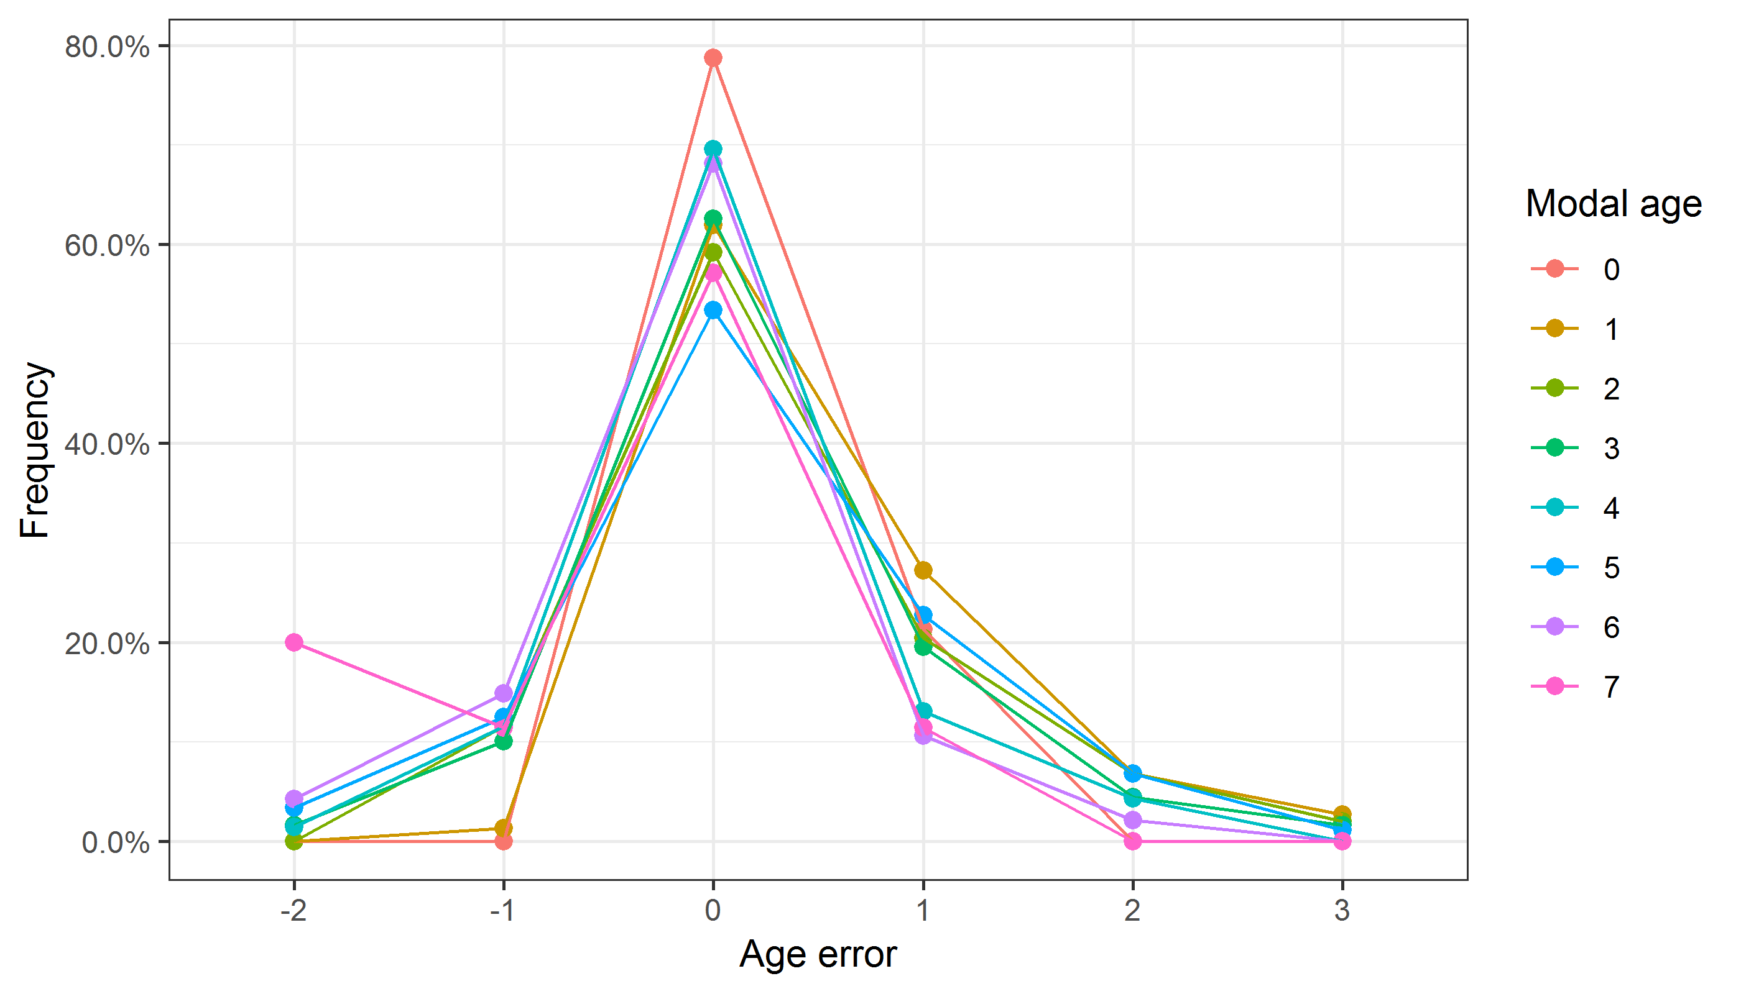
Figure 9.12: The distribution of the age reading errors in percentage by modal age as observed from the whole group of age readers in an age reading comparison to modal age. The achieved precision in age reading by MODAL age group is shown by the spread of the age readings errors. There appears to be no relative bias, if the age reading errors are normally distributed. The distributions are skewed, if relative bias occurs.
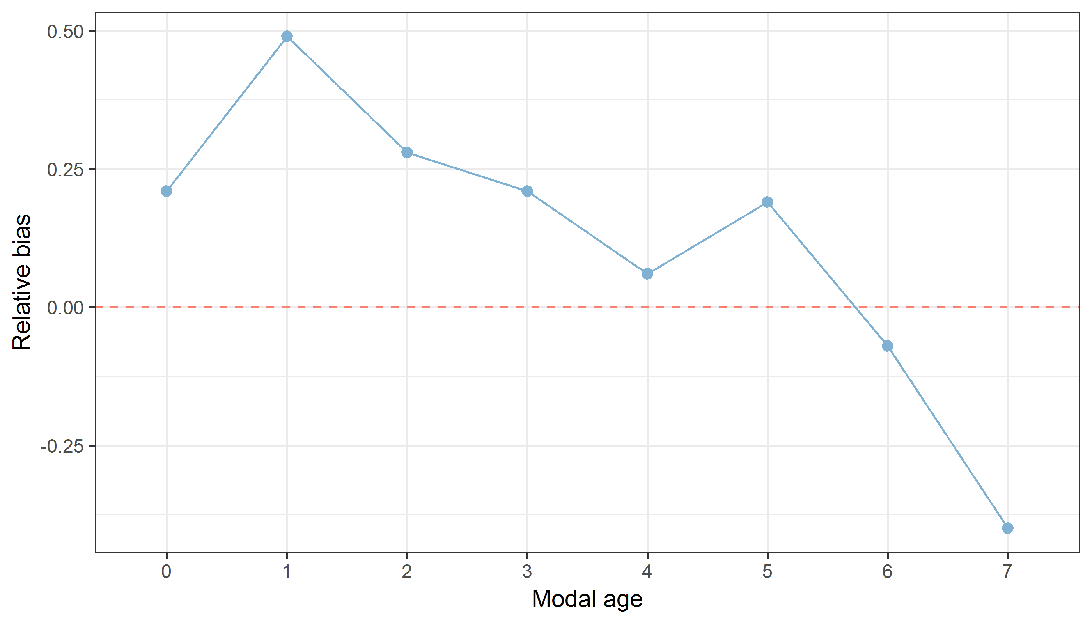
Figure 9.13: The relative bias by modal age as estimated by all age readers combined.
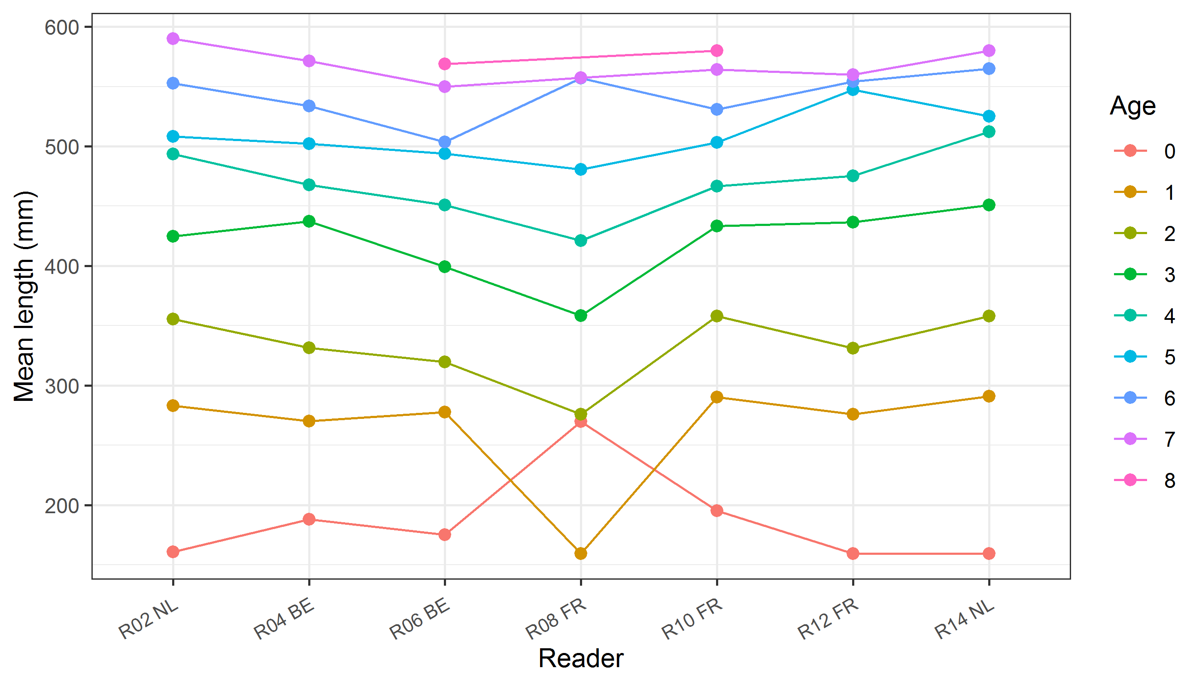
Figure 9.14: The mean length at age as estimated by each age reader.

Results Advanced readers – whole otoliths
All samples included
Data Overview
Table 9.15: Data overview including modal age and statistics per sample.
Fish ID | Event ID | Image ID | length | sex | Catch date | ICES area | R02 NL | R04 BE | R06 BE | Modal age | PA % | CV % | APE %
001_PTCT07_BLL_7D_2017071510364 | 200 | 15030 | 325 | - | 15/07/2017 00:00:00 | 27.7.d | 1 | 2 | 2 | 2 | 67 | 35 | 27
002_PTCT07_BLL_7D_2017071510365 | 200 | 15032 | 480 | - | 15/07/2017 00:00:00 | 27.7.d | 4 | 4 | 5 | 4 | 67 | 13 | 10
003_BTS01_BLL_4B_2017082811204 | 200 | 15034 | 303 | - | 28/08/2017 00:00:00 | 27.4.b | 2 | 2 | 2 | 2 | 100 | 0 | 0
004_BTS01_BLL_4C_2014002 | 200 | 15036 | 240 | - | 25/08/2014 00:00:00 | 27.4.c | 1 | 1 | 1 | 1 | 100 | 0 | 0
005_BTS01_BLL_4C_2014003 | 200 | 15038 | 305 | - | 25/08/2014 00:00:00 | 27.4.c | 1 | 1 | 2 | 1 | 67 | 43 | 33
006_BTS01_BLL_4C_2014004 | 200 | 15040 | 435 | - | 25/08/2014 00:00:00 | 27.4.c | 2 | 4 | 6 | 2 | 33 | 50 | 33
007_BTS01_BLL_4C_2014006 | 200 | 15042 | 390 | - | 25/08/2014 00:00:00 | 27.4.c | 1 | 3 | 5 | 1 | 33 | 67 | 44
008_BTS01_BLL_4C_2014008 | 200 | 15044 | 510 | - | 25/08/2014 00:00:00 | 27.4.c | 3 | 4 | 5 | 3 | 33 | 25 | 17
009_BTS01_BLL_4C_2014015 | 200 | 15046 | 560 | - | 25/08/2014 00:00:00 | 27.4.c | 4 | 4 | 5 | 4 | 67 | 13 | 10
010_BTS01_BLL_4C_2015053385 | 200 | 15048 | 290 | - | 23/10/2015 00:00:00 | 27.4.c | 2 | 1 | 1 | 1 | 67 | 43 | 33
011_BTS01_BLL_4C_2015053386 | 200 | 15087 | 285 | - | 23/10/2015 00:00:00 | 27.4.c | 2 | 2 | 1 | 2 | 67 | 35 | 27
012_BTS01_BLL_4C_2015053387 | 200 | 15051 | 315 | - | 23/10/2015 00:00:00 | 27.4.c | 2 | 2 | 2 | 2 | 100 | 0 | 0
013_BTS01_BLL_4C_2015053388 | 200 | 15053 | 370 | - | 23/10/2015 00:00:00 | 27.4.c | 1 | 2 | 2 | 2 | 67 | 35 | 27
014_BTS01_BLL_4C_2015053390 | 200 | 15055 | 360 | - | 23/10/2015 00:00:00 | 27.4.c | 4 | 4 | 4 | 4 | 100 | 0 | 0
015_BTS01_BLL_4C_2015053391 | 200 | 15057 | 325 | - | 23/10/2015 00:00:00 | 27.4.c | - | 2 | 3 | 2 | 50 | 28 | 20
016_BTS01_BLL_4C_2016219500 | 200 | 15059 | 325 | - | 04/10/2016 00:00:00 | 27.4.c | 3 | 4 | 3 | 3 | 67 | 17 | 13
017_BTS01_BLL_4C_2016219501 | 200 | 15061 | 365 | - | 04/10/2016 00:00:00 | 27.4.c | 3 | 4 | 6 | 3 | 33 | 35 | 26
018_BTS01_BLL_4C_2017082811007 | 200 | 15063 | 301 | - | 28/08/2017 00:00:00 | 27.4.c | - | 2 | 2 | 2 | 100 | 0 | 0
019_BTS01_BLL_4C_2017082811008 | 200 | 15065 | 320 | - | 28/08/2017 00:00:00 | 27.4.c | 1 | 1 | 2 | 1 | 67 | 43 | 33
020_BTS01_BLL_4C_2017082811010 | 200 | 15067 | 257 | - | 28/08/2017 00:00:00 | 27.4.c | 1 | 1 | 1 | 1 | 100 | 0 | 0
021_BTS01_BLL_4C_2017082811011 | 200 | 15069 | 284 | - | 28/08/2017 00:00:00 | 27.4.c | - | 1 | 1 | 1 | 100 | 0 | 0
022_BTS01_BLL_4C_2017082811017 | 200 | 15071 | 433 | - | 28/08/2017 00:00:00 | 27.4.c | 4 | 2 | 3 | 2 | 33 | 33 | 22
023_BYDR05_BLL_4B_2017071410271 | 200 | 15073 | 270 | - | 14/07/2017 00:00:00 | 27.4.b | 1 | 1 | 1 | 1 | 100 | 0 | 0
024_BYDR05_BLL_4B_2017071410272 | 200 | 15075 | 270 | - | 14/07/2017 00:00:00 | 27.4.b | 1 | 1 | 2 | 1 | 67 | 43 | 33
025_BYDR05_BLL_4B_2017071410273 | 200 | 15077 | 290 | - | 14/07/2017 00:00:00 | 27.4.b | 1 | 2 | 2 | 2 | 67 | 35 | 27
026_BYDR05_BLL_4B_2017071410274 | 200 | 15079 | 260 | - | 14/07/2017 00:00:00 | 27.4.b | 1 | 2 | 2 | 2 | 67 | 35 | 27
027_BYDR05_BLL_4B_2017071410527 | 200 | 15081 | 520 | - | 14/07/2017 00:00:00 | 27.4.b | 4 | 4 | 4 | 4 | 100 | 0 | 0
028_BYDR05_BLL_4B_2017071410535 | 200 | 15083 | 525 | - | 14/07/2017 00:00:00 | 27.4.b | - | 5 | - | 5 | 100 | - | 0
029_BYDR06_BLL_4B_2011001 | 200 | 15085 | 250 | - | 29/09/2011 00:00:00 | 27.4.b | 1 | 1 | 1 | 1 | 100 | 0 | 0
030_BYDR06_BLL_4B_2011002 | 200 | 15086 | 260 | - | 29/09/2011 00:00:00 | 27.4.b | 1 | 2 | 1 | 1 | 67 | 43 | 33
031_BYDR07_BLL_4B_2017110910270 | 200 | 15089 | 280 | - | 09/11/2017 00:00:00 | 27.4.b | 2 | 2 | 1 | 2 | 67 | 35 | 27
032_BYDR07_BLL_4B_2017110910271 | 200 | 15091 | 290 | - | 09/11/2017 00:00:00 | 27.4.b | 2 | 2 | 1 | 2 | 67 | 35 | 27
033_BYDR07_BLL_4B_2017110910276 | 200 | 15093 | 300 | - | 09/11/2017 00:00:00 | 27.4.b | 2 | 1 | 1 | 1 | 67 | 43 | 33
034_BYDR07_BLL_4B_2017110910277 | 200 | 15095 | 300 | - | 09/11/2017 00:00:00 | 27.4.b | 1 | 2 | 1 | 1 | 67 | 43 | 33
035_BYDR07_BLL_4B_2017110910297 | 200 | 15097 | 190 | - | 09/11/2017 00:00:00 | 27.4.b | 0 | 0 | 0 | 0 | 100 | - | -
036_BYDR07_BLL_4B_2017110910298 | 200 | 15099 | 200 | - | 09/11/2017 00:00:00 | 27.4.b | 0 | 0 | 0 | 0 | 100 | - | -
037_BYDR05_BLL_4B_2017071410528 | 200 | 15101 | 335 | - | 14/07/2017 00:00:00 | 27.4.b | 2 | 3 | 3 | 3 | 67 | 22 | 17
038_BYDR07_BLL_4B_2017110910533 | 200 | 15103 | 380 | - | 09/11/2017 00:00:00 | 27.4.b | 3 | 4 | 4 | 4 | 67 | 16 | 12
039_BYDR05_BLL_4B_20170714910534 | 200 | 15123 | 450 | - | 14/07/2017 00:00:00 | 27.4.b | 4 | 4 | 3 | 4 | 67 | 16 | 12
040_BYDR07_BLL_4B_2017110910541 | 200 | 15106 | 535 | - | 09/11/2017 00:00:00 | 27.4.b | 4 | 4 | 4 | 4 | 100 | 0 | 0
041_BYDR07_BLL_4B_2017110910542 | 200 | 15108 | 520 | - | 09/11/2017 00:00:00 | 27.4.b | 5 | 6 | 6 | 6 | 67 | 10 | 8
042_BYDR07_BLL_4B_2017110910549 | 200 | 15110 | 560 | - | 09/11/2017 00:00:00 | 27.4.b | 4 | 5 | 5 | 5 | 67 | 12 | 10
043_BYDR07_BLL_4B_2017110910550 | 200 | 15112 | 555 | - | 09/11/2017 00:00:00 | 27.4.b | 6 | 6 | 7 | 6 | 67 | 9 | 7
044_BYDR07_BLL_4B_2017110910552 | 200 | 15114 | 580 | - | 09/11/2017 00:00:00 | 27.4.b | 6 | 6 | 6 | 6 | 100 | 0 | 0
045_BYDR08_BLL_7D_2017121510064 | 200 | 15116 | 270 | - | 15/12/2017 00:00:00 | 27.7.d | - | 0 | 0 | 0 | 100 | - | -
046_BYDR08_BLL_7D_017121510211 | 200 | 15125 | 455 | - | 15/12/2017 00:00:00 | 27.7.d | 3 | 3 | 3 | 3 | 100 | 0 | 0
047_BYDR08_BLL_7D_2017121510206 | 200 | 15126 | 430 | - | 15/12/2017 00:00:00 | 27.7.d | 2 | 3 | 2 | 2 | 67 | 25 | 19
048_BYDR08_BLL_7D_2017121510207 | 200 | 15127 | 435 | - | 15/12/2017 00:00:00 | 27.7.d | 2 | 2 | 2 | 2 | 100 | 0 | 0
049_BYDR08_BLL_7D_2017121510208 | 200 | 15128 | 465 | - | 15/12/2017 00:00:00 | 27.7.d | 3 | 3 | 4 | 3 | 67 | 17 | 13
050_BYDR08_BLL_7D_2017121510213 | 200 | 15121 | 475 | - | 15/12/2017 00:00:00 | 27.7.d | 4 | 3 | 4 | 4 | 67 | 16 | 12
051_BYDR08_BLL_7D_2017121510219 | 200 | 15130 | 320 | - | 15/12/2017 00:00:00 | 27.7.d | 2 | 1 | 1 | 1 | 67 | 43 | 33
052_BYDR08_BLL_7D_2017121510220 | 200 | 15132 | 320 | - | 15/12/2017 00:00:00 | 27.7.d | 2 | 2 | 1 | 2 | 67 | 35 | 27
053_CDDR02_BLL_7D_2017002255 | 200 | 15134 | 495 | - | 09/03/2017 00:00:00 | 27.7.d | 2 | 3 | 4 | 2 | 33 | 33 | 22
054_CDDR02_BLL_7D_2017002256 | 200 | 15136 | 570 | - | 09/03/2017 00:00:00 | 27.7.d | 4 | 4 | 5 | 4 | 67 | 13 | 10
055_CDDR02_BLL_7D_2017002257 | 200 | 15138 | 500 | - | 09/03/2017 00:00:00 | 27.7.d | 4 | 3 | 5 | 3 | 33 | 25 | 17
056_CDDR02_BLL_7D_2017002260 | 200 | 15140 | 470 | - | 09/03/2017 00:00:00 | 27.7.d | 2 | 3 | 4 | 2 | 33 | 33 | 22
057_CDDR02_BLL_7D_2017002261 | 200 | 15142 | 580 | - | 09/03/2017 00:00:00 | 27.7.d | - | 6 | 6 | 6 | 100 | 0 | 0
058_CDDR02_BLL_7D_2017002263 | 200 | 15144 | 520 | - | 09/03/2017 00:00:00 | 27.7.d | 5 | 5 | 6 | 5 | 67 | 11 | 8
059_CDDR02_BLL_7D_2017002264 | 200 | 15146 | 495 | - | 09/03/2017 00:00:00 | 27.7.d | 3 | 4 | 5 | 3 | 33 | 25 | 17
060_CDDR02_BLL_7D_2017002271 | 200 | 15148 | 335 | - | 09/03/2017 00:00:00 | 27.7.d | 2 | 2 | 3 | 2 | 67 | 25 | 19
061_CDDR02_BLL_7D_2017002274 | 200 | 15150 | 325 | - | 09/03/2017 00:00:00 | 27.7.d | 2 | 2 | 3 | 2 | 67 | 25 | 19
062_CDDR06_BLL_4B_2017073110641 | 200 | 15262 | 535 | - | 31/07/2017 00:00:00 | 27.4.b | 5 | 5 | 7 | 5 | 67 | 20 | 16
063_CDDR06_BLL_4B_2017073110642 | 200 | 15263 | 560 | - | 31/07/2017 00:00:00 | 27.4.b | 6 | 7 | - | 6 | 50 | 11 | 8
064_CDDR06_BLL_4B_2017073110643 | 200 | 15264 | 535 | - | 31/07/2017 00:00:00 | 27.4.b | 4 | 4 | 6 | 4 | 67 | 25 | 19
065_CDDR06_BLL_4B_2017073110645 | 200 | 15265 | 445 | - | 31/07/2017 00:00:00 | 27.4.b | 3 | 3 | - | 3 | 100 | 0 | 0
066_CDDR06_BLL_4B_2017073110646 | 200 | 15266 | 470 | - | 31/07/2017 00:00:00 | 27.4.b | 4 | 4 | 6 | 4 | 67 | 25 | 19
067_CDDR06_BLL_4B_2017073110654 | 200 | 15267 | 570 | - | 31/07/2017 00:00:00 | 27.4.b | 5 | 7 | 8 | 5 | 33 | 23 | 17
068_CDDR06_BLL_4B_2017073110659 | 200 | 15268 | 490 | - | 31/07/2017 00:00:00 | 27.4.b | 3 | 3 | 5 | 3 | 67 | 31 | 24
069_CDDR06_BLL_4B_2017073110644 | 200 | 15269 | 490 | - | 31/07/2017 00:00:00 | 27.4.b | 3 | 3 | - | 3 | 100 | 0 | 0
070_CDDR06_BLL_4B_2017073110648 | 200 | 15271 | 355 | - | 31/07/2017 00:00:00 | 27.4.b | 2 | 2 | - | 2 | 100 | 0 | 0
071_CDDR06_BLL_4B_2017073110649 | 200 | 15270 | 400 | - | 31/07/2017 00:00:00 | 27.4.b | 3 | 2 | 3 | 3 | 67 | 22 | 17
072_CDDR07_BLL_4B_2017102010285 | 200 | 15162 | 415 | - | 20/10/2017 00:00:00 | 27.4.b | 4 | 5 | 6 | 4 | 33 | 20 | 13
073_CDDR08_BLL_7D_2017112110277 | 200 | 15164 | 370 | - | 21/11/2017 00:00:00 | 27.7.d | 2 | 1 | 3 | 1 | 33 | 50 | 33
074_CDDR08_BLL_7D_2017112110280 | 200 | 15166 | 420 | - | 21/11/2017 00:00:00 | 27.7.d | 3 | 3 | 3 | 3 | 100 | 0 | 0
075_CDDR08_BLL_7D_2017112110283 | 200 | 15168 | 520 | - | 21/11/2017 00:00:00 | 27.7.d | 4 | 4 | 5 | 4 | 67 | 13 | 10
076_EXNL_BLL_4100007_130918_004 | 200 | 15170 | 233 | - | 18/09/2017 00:00:00 | 27.4.c | 1 | 2 | 2 | 2 | 67 | 35 | 27
077_EXNL_BLL_4100014_130918_005 | 200 | 15172 | 152 | - | 18/09/2017 00:00:00 | 27.4.c | 1 | 1 | 0 | 1 | 67 | 87 | 67
078_EXNL_BLL_4100022_180918_006 | 200 | 15174 | 138 | - | 18/09/2017 00:00:00 | 27.4.c | 0 | 0 | 0 | 0 | 100 | - | -
079_EXNL_BLL_4100023_180918_007 | 200 | 15176 | 143 | - | 18/09/2017 00:00:00 | 27.4.c | 0 | 0 | 0 | 0 | 100 | - | -
080_EXNL_BLL_4100024_180918_008 | 200 | 15178 | 133 | - | 18/09/2017 00:00:00 | 27.4.c | 0 | 1 | 0 | 0 | 67 | - | -
081_GNKT02_BLL_7D_2017002518 | 200 | 15180 | 540 | - | 07/03/2017 00:00:00 | 27.7.d | 4 | 4 | 5 | 4 | 67 | 13 | 10
082_GNKT02_BLL_7D_2017002524 | 200 | 15182 | 565 | - | 07/03/2017 00:00:00 | 27.7.d | 6 | 7 | 7 | 7 | 67 | 9 | 7
083_NDGP05_BLL_4B_2005004 | 200 | 15259 | 310 | - | 07/11/2005 00:00:00 | 27.4.b | 2 | 2 | 3 | 2 | 67 | 25 | 19
084_NDGP05_BLL_4B_2005005 | 200 | 15261 | 340 | - | 07/11/2005 00:00:00 | 27.4.b | 3 | 2 | 4 | 2 | 33 | 33 | 22
085_NDGP05_BLL_4B_2005001 | 200 | 15184 | 330 | - | 07/11/2005 00:00:00 | 27.4.b | 2 | 2 | - | 2 | 100 | 0 | 0
086_NDGP05_BLL_4B_2005041 | 200 | 15186 | 420 | - | 07/11/2005 00:00:00 | 27.4.b | 3 | 3 | 3 | 3 | 100 | 0 | 0
087_NDGP05_BLL_4B_2005045 | 200 | 15188 | 470 | - | 07/11/2005 00:00:00 | 27.4.b | 2 | 2 | 3 | 2 | 67 | 25 | 19
088_NDGP05_BLL_4B_2005060 | 200 | 15190 | 490 | - | 07/11/2005 00:00:00 | 27.4.b | 4 | 4 | 4 | 4 | 100 | 0 | 0
089_NDGP05_BLL_4B_2005066 | 200 | 15192 | 570 | - | 07/11/2005 00:00:00 | 27.4.b | 4 | 4 | 4 | 4 | 100 | 0 | 0
090_NDGP05_BLL_4B_2005071 | 200 | 15194 | 540 | - | 07/11/2005 00:00:00 | 27.4.b | 4 | 5 | 6 | 4 | 33 | 20 | 13
092_PTCT02_BLL_7D_2017002749 | 200 | 15196 | 495 | - | 07/03/2017 00:00:00 | 27.7.d | 6 | 6 | 8 | 6 | 67 | 17 | 13
093_PTCT02_BLL_7D_2017002750 | 200 | 15198 | 630 | - | 07/03/2017 00:00:00 | 27.7.d | 7 | 7 | 8 | 7 | 67 | 8 | 6
094_PTCT02_BLL_7D_2017002752 | 200 | 15200 | 440 | - | 07/03/2017 00:00:00 | 27.7.d | 3 | 3 | 3 | 3 | 100 | 0 | 0
095_PTCT03_BLL_4C_2017040310575 | 200 | 15272 | 425 | - | 03/04/2017 00:00:00 | 27.4.c | 3 | 3 | 3 | 3 | 100 | 0 | 0
096_PTCT03_BLL_4C_2017040310576 | 200 | 15273 | 445 | - | 03/04/2017 00:00:00 | 27.4.c | 2 | 2 | 3 | 2 | 67 | 25 | 19
097_PTCT03_BLL_4C_2017040310577 | 200 | 15274 | 425 | - | 03/04/2017 00:00:00 | 27.4.c | 2 | 2 | 3 | 2 | 67 | 25 | 19
098_PTCT03_BLL_4C_2017040310583 | 200 | 15275 | 365 | - | 03/04/2017 00:00:00 | 27.4.c | 3 | 4 | 4 | 4 | 67 | 16 | 12
099_PTCT03_BLL_4C_2017040310584 | 200 | 15276 | 390 | - | 03/04/2017 00:00:00 | 27.4.c | 3 | 4 | 5 | 3 | 33 | 25 | 17
100_PTCT03_BLL_7D_2017040310167 | 200 | 15207 | 220 | - | 03/04/2017 00:00:00 | 27.7.d | 2 | 2 | 1 | 2 | 67 | 35 | 27
101_PTCT03_BLL_7D_2017040310347 | 200 | 15209 | 535 | - | 03/04/2017 00:00:00 | 27.7.d | 6 | 5 | 6 | 6 | 67 | 10 | 8
102_PTCT03_BLL_7D_2017040310350 | 200 | 15211 | 425 | - | 03/04/2017 00:00:00 | 27.7.d | 5 | 6 | 6 | 6 | 67 | 10 | 8
103_PTCT06_BLL_7D_2017062610220 | 200 | 15213 | 400 | - | 26/06/2017 00:00:00 | 27.7.d | 4 | 5 | 5 | 5 | 67 | 12 | 10
104_PTCT06_BLL_7D_2017062610221 | 200 | 15215 | 495 | - | 26/06/2017 00:00:00 | 27.7.d | 3 | 4 | 3 | 3 | 67 | 17 | 13
105_PTCT06_BLL_7D_2017062610222 | 200 | 15217 | 535 | - | 26/06/2017 00:00:00 | 27.7.d | 5 | 7 | 7 | 7 | 67 | 18 | 14
106_PTCT06_BLL_7D_2017062610224 | 200 | 15219 | 390 | - | 26/06/2017 00:00:00 | 27.7.d | 3 | 3 | 3 | 3 | 100 | 0 | 0
107_PTCT06_BLL_7D_2017062610225 | 200 | 15221 | 445 | - | 26/06/2017 00:00:00 | 27.7.d | 3 | 3 | 4 | 3 | 67 | 17 | 13
108_PTCT06_BLL_7D_2017062610236 | 200 | 15223 | 340 | - | 26/06/2017 00:00:00 | 27.7.d | 2 | 2 | 2 | 2 | 100 | 0 | 0
109_PTCT06_BLL_7D_2017062610238 | 200 | 15225 | 325 | - | 26/06/2017 00:00:00 | 27.7.d | 1 | 2 | 2 | 2 | 67 | 35 | 27
110_PTCT07_BLL_7D_2017071510148 | 200 | 15227 | 280 | - | 15/07/2017 00:00:00 | 27.7.d | 1 | 1 | 2 | 1 | 67 | 43 | 33
111_PTCT07_BLL_7D_2017071510150 | 200 | 15229 | 280 | - | 15/07/2017 00:00:00 | 27.7.d | 1 | 1 | 2 | 1 | 67 | 43 | 33
113_PTCT07_BLL_7D_2017071510366 | 200 | 15233 | 570 | - | 15/07/2017 00:00:00 | 27.7.d | 6 | 7 | 8 | 6 | 33 | 14 | 10
114_PTCT07_BLL_7D_2017071510368 | 200 | 15235 | 565 | - | 15/07/2017 00:00:00 | 27.7.d | 5 | - | 6 | 5 | 50 | 13 | 9
115_PTCT07_BLL_7D_2017071510369 | 200 | 15237 | 580 | - | 15/07/2017 00:00:00 | 27.7.d | 7 | 7 | 8 | 7 | 67 | 8 | 6
116_PTCT07_BLL_7D_2017071510370 | 200 | 15239 | 475 | - | 15/07/2017 00:00:00 | 27.7.d | 4 | 4 | 5 | 4 | 67 | 13 | 10
117_PTCT07_BLL_7D_2017071510371 | 200 | 15241 | 530 | - | 15/07/2017 00:00:00 | 27.7.d | 4 | 5 | 5 | 5 | 67 | 12 | 10
118_PTCT07_BLL_7D_2017071510372 | 200 | 15243 | 615 | - | 15/07/2017 00:00:00 | 27.7.d | 6 | 6 | 6 | 6 | 100 | 0 | 0
119_PTCT07_BLL_7D_2017071510374 | 200 | 15245 | 460 | - | 15/07/2017 00:00:00 | 27.7.d | 4 | 5 | 6 | 4 | 33 | 20 | 13
120_PTCT07_BLL_7D_2017071510375 | 200 | 15247 | 460 | - | 15/07/2017 00:00:00 | 27.7.d | 4 | 4 | 4 | 4 | 100 | 0 | 0
121_PTCT07_BLL_7D_2017071510376 | 200 | 15249 | 560 | - | 15/07/2017 00:00:00 | 27.7.d | 7 | 7 | 7 | 7 | 100 | 0 | 0
122_PTCT07_BLL_7D_2017071510377 | 200 | 15251 | 395 | - | 15/07/2017 00:00:00 | 27.7.d | 5 | 4 | 4 | 4 | 67 | 13 | 10
123_PTCT07_BLL_7D_2017071510379 | 200 | 15253 | 500 | - | 15/07/2017 00:00:00 | 27.7.d | 6 | 6 | 6 | 6 | 100 | 0 | 0
124_PTCT07_BLL_7D_2017071510381 | 200 | 15255 | 370 | - | 15/07/2017 00:00:00 | 27.7.d | 2 | 3 | 2 | 2 | 67 | 25 | 19
125_PTCT07_BLL_7D_2017071510362 | 200 | 15257 | 395 | - | 15/07/2017 00:00:00 | 27.7.d | 3 | 3 | 3 | 3 | 100 | 0 | 0
Table 9.16: Number of age readings table gives an overview of number of readings per reader and modal age. The total numbers of readings per reader and per modal age are summarized at the end of the table.
Modal age | R02 NL | R04 BE | R06 BE | total
0 | 5 | 6 | 6 | 17
1 | 17 | 18 | 18 | 53
2 | 30 | 32 | 30 | 92
3 | 21 | 21 | 19 | 61
4 | 22 | 22 | 22 | 66
5 | 7 | 7 | 7 | 21
6 | 10 | 11 | 10 | 31
7 | 5 | 5 | 5 | 15
Total | 117 | 122 | 117 | 356
Table 9.17: Age composition by reader gives a summary of number of readings per reader.
Modal age | R02 NL | R04 BE | R06 BE
0 | 5 | 5 | 7
1 | 19 | 16 | 15
2 | 27 | 30 | 18
3 | 22 | 20 | 21
4 | 24 | 25 | 15
5 | 8 | 10 | 15
6 | 9 | 8 | 16
7 | 3 | 8 | 5
8 | 0 | 0 | 5
Total | 117 | 122 | 117
Table 9.18: Mean length at age per reader is calculated per reader and age (not modal age) and for all readers combined per age. A weighted mean is also given.
Age | R02 NL | R04 BE | R06 BE
0 | 161 mm | 188 mm | 175 mm
1 | 283 mm | 270 mm | 278 mm
2 | 355 mm | 332 mm | 320 mm
3 | 425 mm | 437 mm | 399 mm
4 | 494 mm | 468 mm | 451 mm
5 | 508 mm | 502 mm | 494 mm
6 | 553 mm | 534 mm | 504 mm
7 | 590 mm | 571 mm | 550 mm
8 | - | - | 569 mm
Weighted Mean | 408 mm | 406 mm | 405 mm
[[1]] 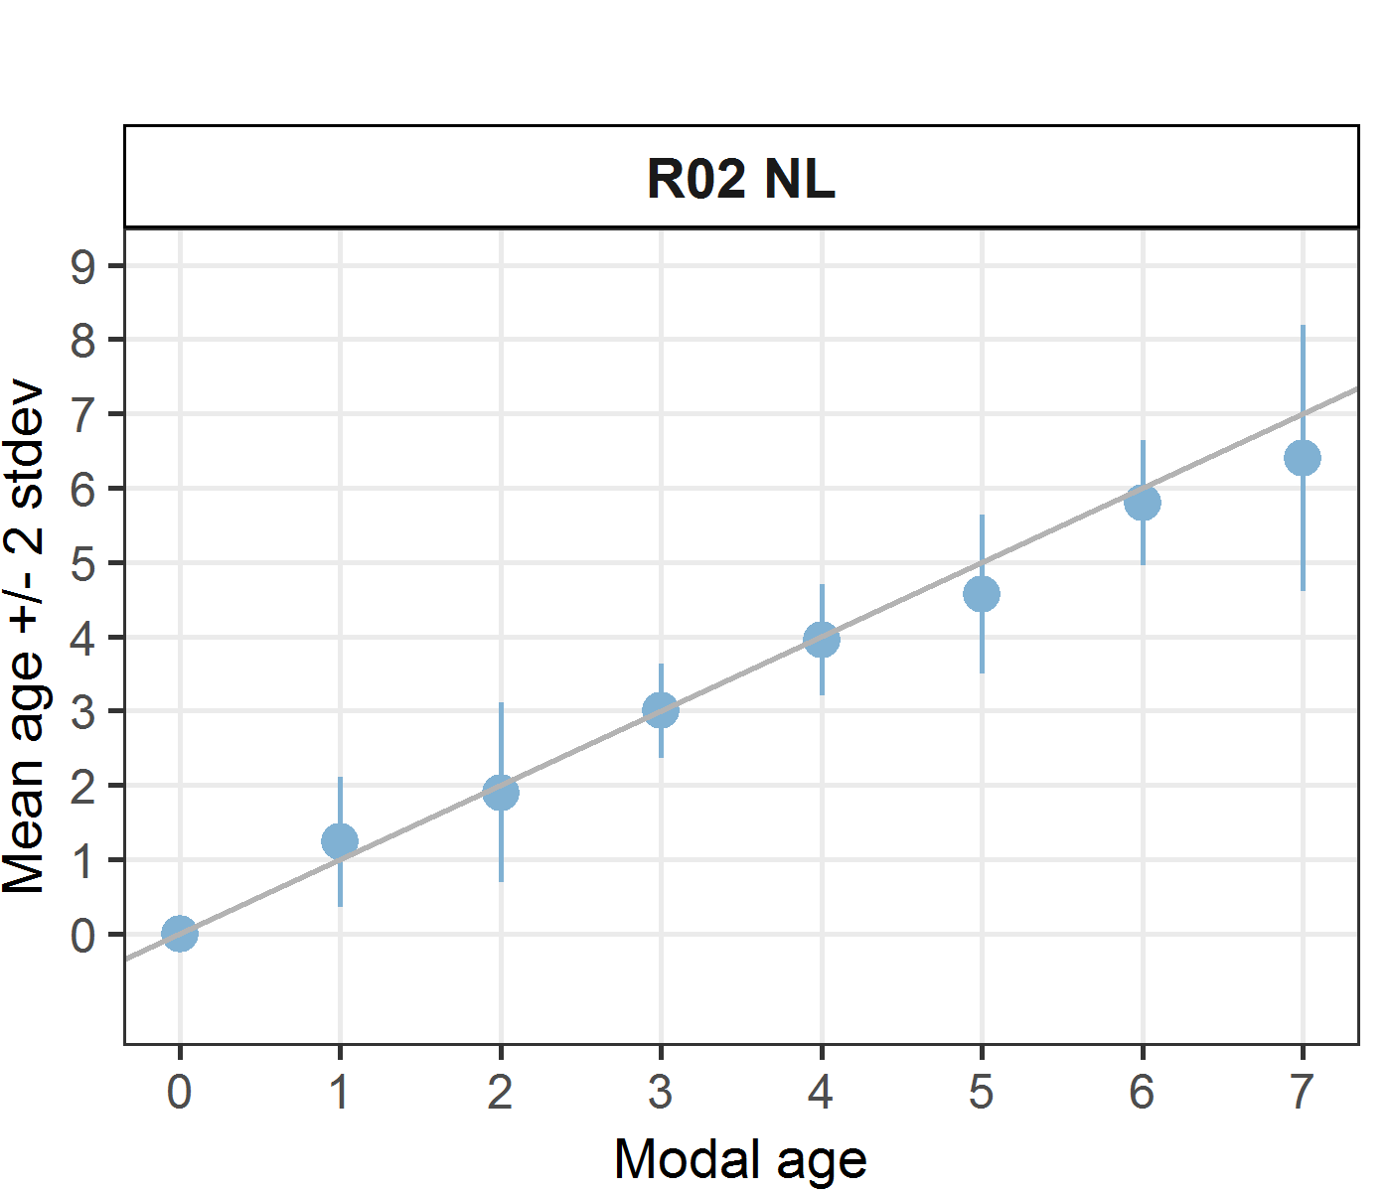 [[2]] 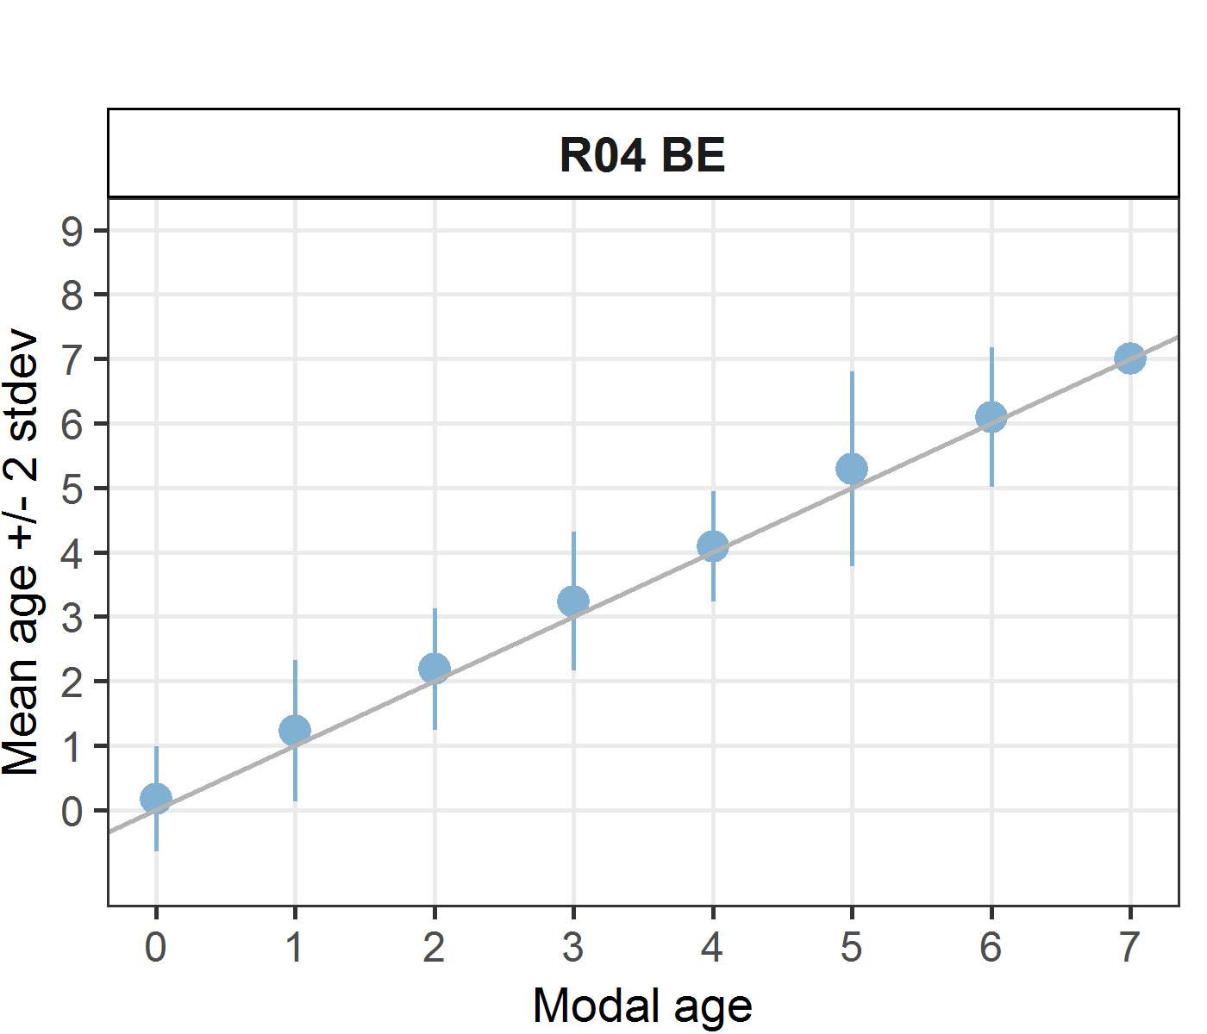 [[3]] 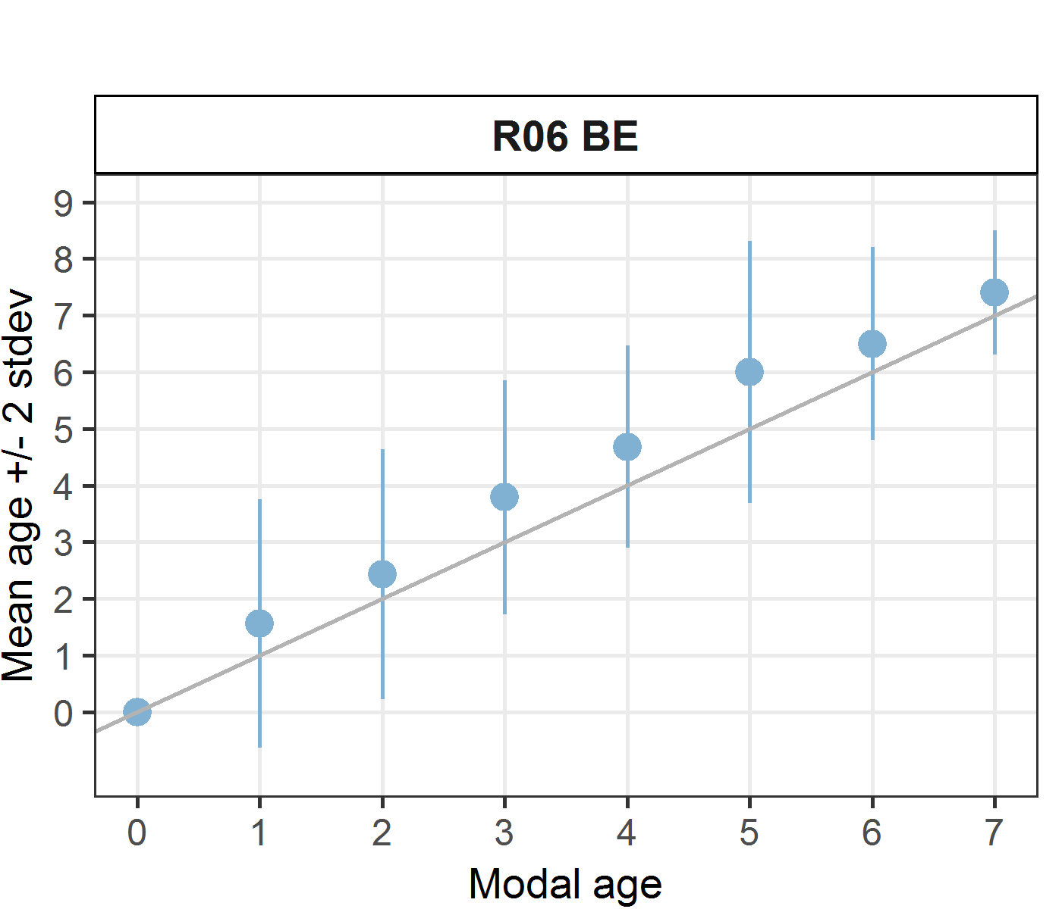
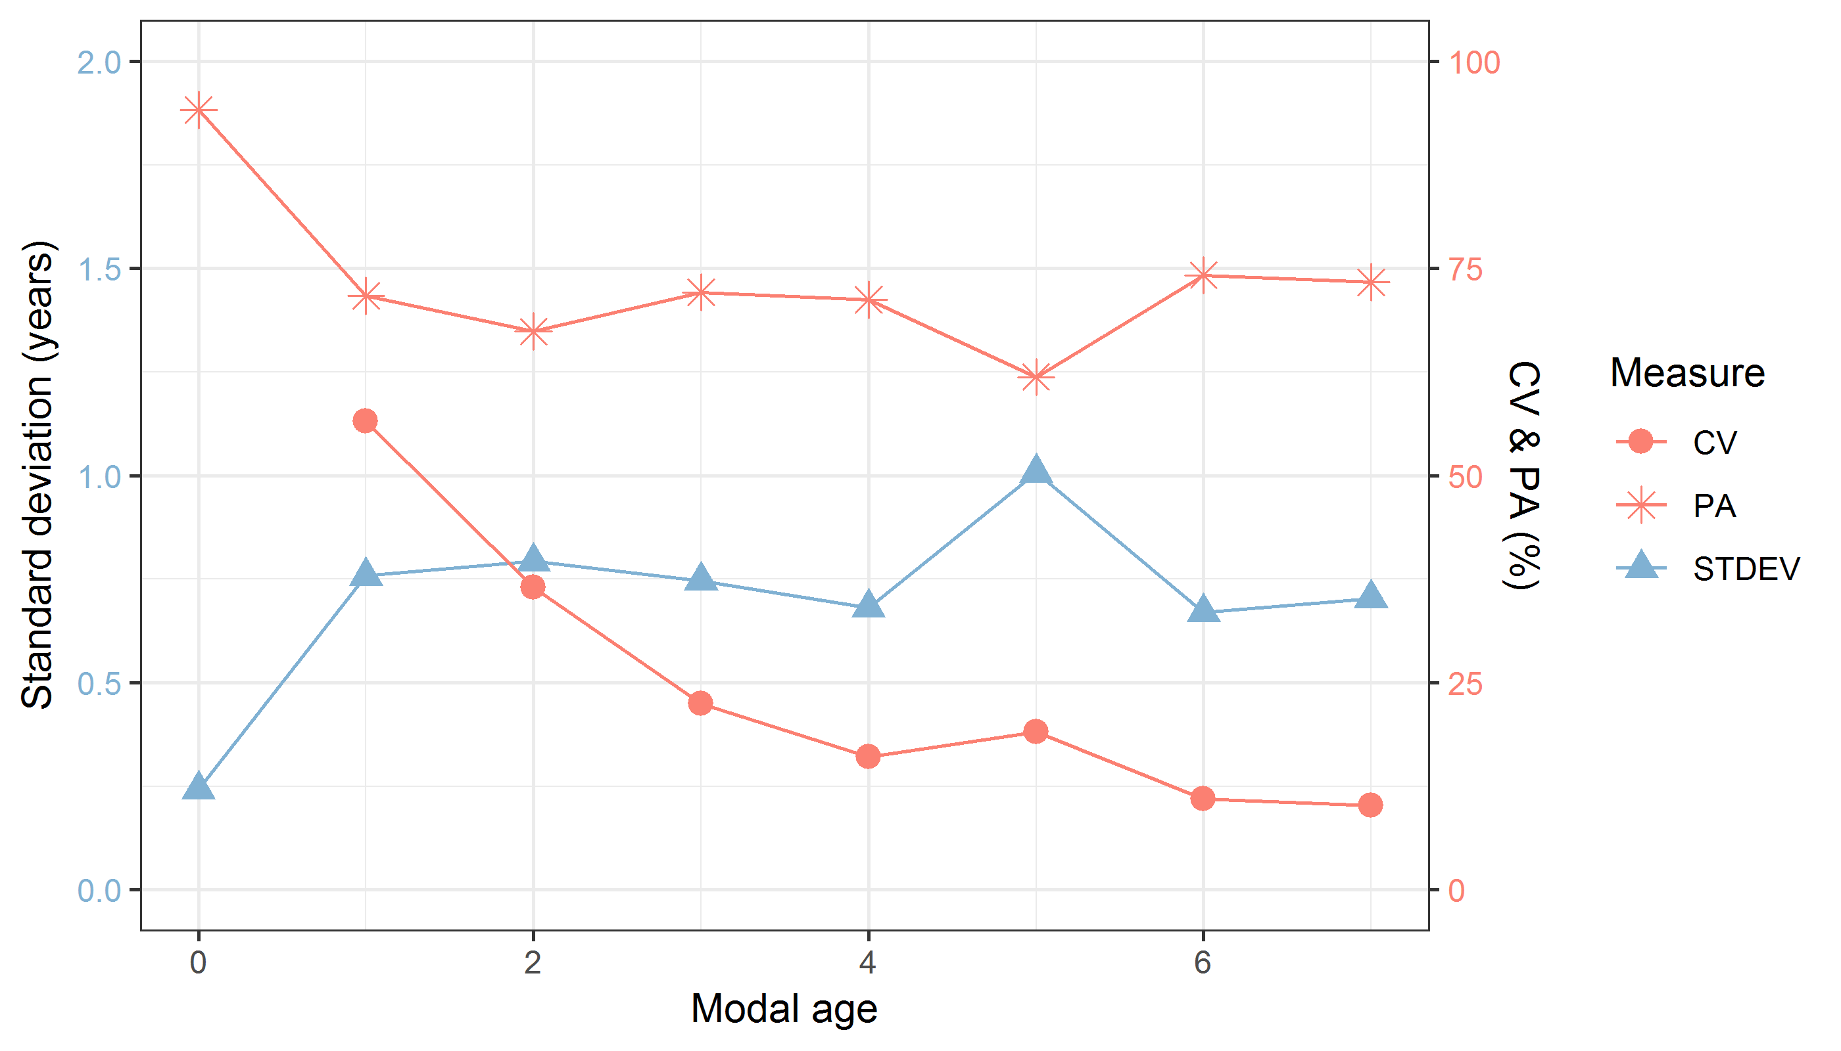
Figure 9.15: CV, PA and (STDEV (standard deviation) are plotted against modal age
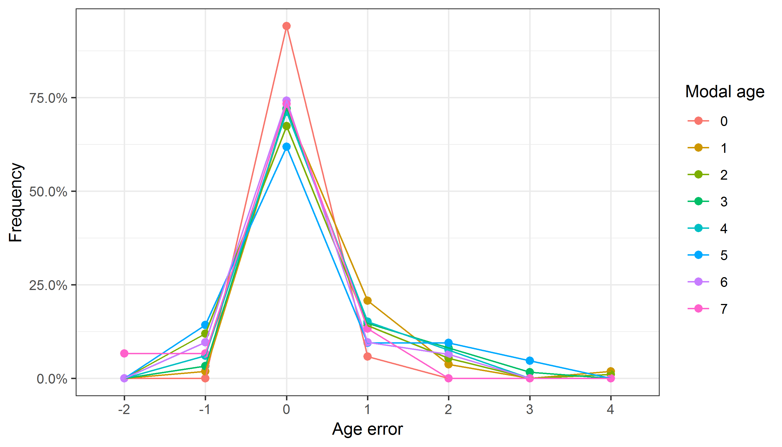
Figure 9.16: The distribution of the age reading errors in percentage by modal age as observed from the whole group of age readers in an age reading comparison to modal age. The achieved precision in age reading by MODAL age group is shown by the spread of the age readings errors. There appears to be no relative bias, if the age reading errors are normally distributed. The distributions are skewed, if relative bias occurs.
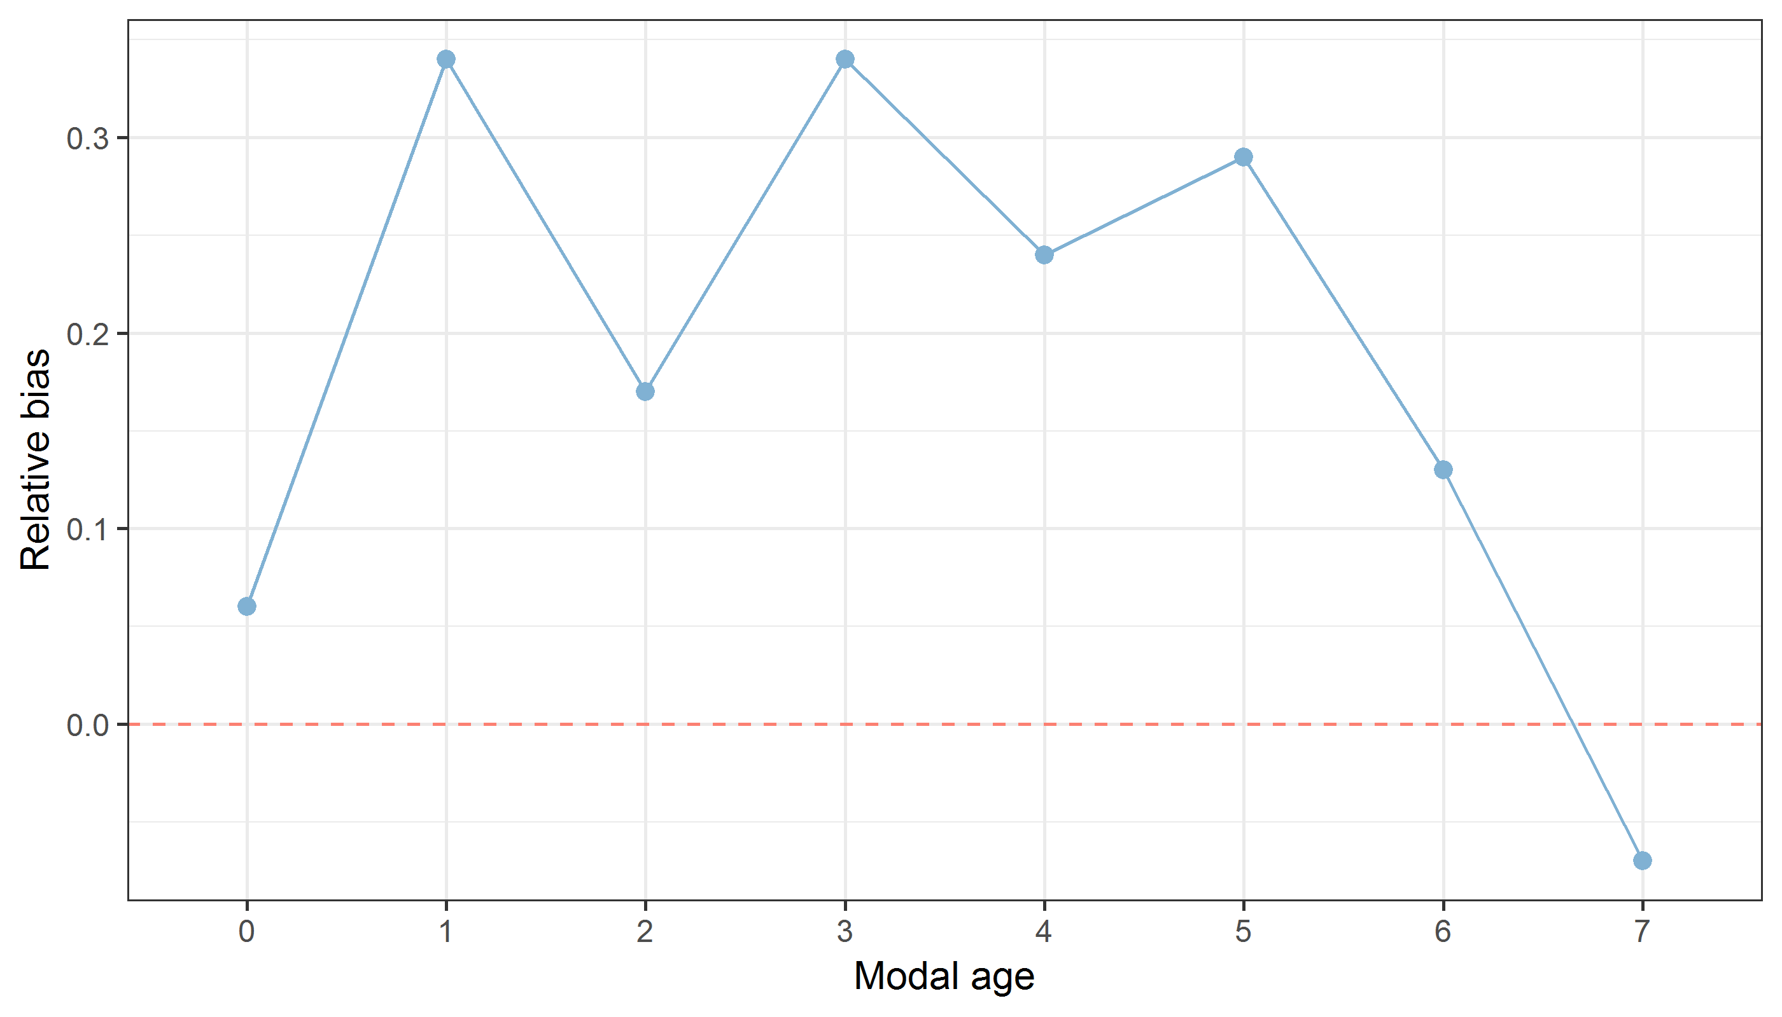
Figure 9.17: The relative bias by modal age as estimated by all age readers combined.
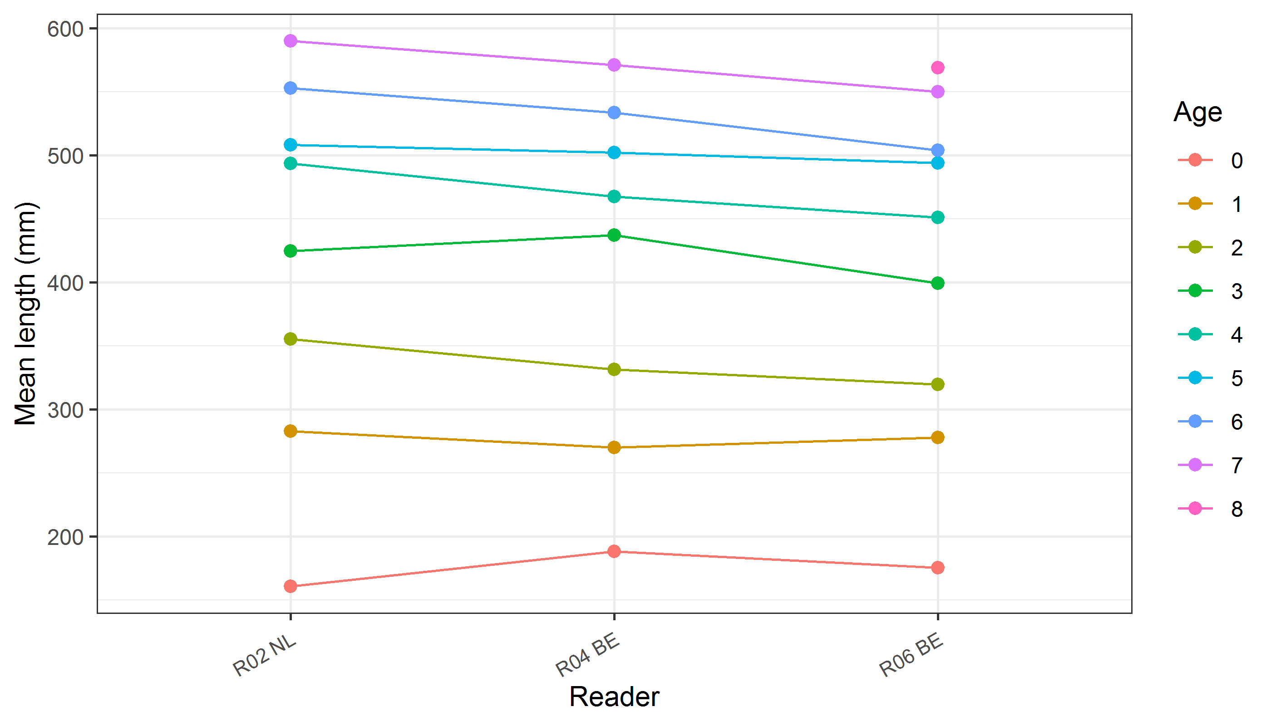
Figure 9.18: The mean length at age

