SmartDots Summary for event 200 – brill exchange in area 27.4.b, 27.4.c, 27.7.d

Executive summary

The last brill (Scophthalmus rhombus) exchange took place in 2005. A small scale exchange was recommended in 2009 by PGCCDBS for brill in the North Sea and English Channel (Subarea 4 and 7.d-e). Unfortunately, a full report from the 2005 exchange is missing, so few background is known. Brill is a category 3 stock (no ages used is the assessment). Nevertheless, several countries collect age samples for brill, partly under obligation by the EU Data Collection Regulation. A scoping meeting for brill is planned in 2020.
The objectives of the exchange were:
- Estimate the accuracy and precision of the age readings for whole otoliths and sectioned and stained otoliths.
- Detect any potential age reading problems.
- Compare the results between whole and sectioned & stained (SS) otoliths

In this report, you will only find the results of the advanced age readers for stained sectioned otoliths as these are the data used in the assessments. A more detailed view of all data of the exchange can be found in the “Report of Otolith Exchange Analysis of Brill, 2019”.
Two otolith sets were included in the exchange: a North Sea brill set (N=71) and a set from the English Channel (N = 53). A total of 8 participants from 3 countries (Belgium, France and the Netherlands) participated in the exchange. Only 3 advanced readers participated, which are all used to reading stained sectioned otoliths.
The age reading performance of the advanced readers was very good: the percentage agreement (PA) was 95%, variation coefficient (CV) was 8% and the average percentage error was only 1%.
From the 2005 exchange, we only know that the PA was high (90%) and that no bias between the readers was evident. In this exchange, the PA for stained sectioned otoliths of the advanced readers was very high (95%) and was still satisfactory for all readers (84 %). No bias was evident between the advanced readers for stained sectioned otoliths.
No major issues were detected for advanced readers when ageing stained sectioned brill otoliths.

Overview of samples and advanced readers

Table 2.1: Overview of samples used for the brill exchange in area 27.4.b, 27.4.c, 27.7.d. The modal age range for all samples is 0-10.
Year | ICES area | Quarter | Number of samples | Modal age range | Length range
2005 | 27.4.b | 4 | 8 | 2-5 | 310-570 mm
2011 | 27.4.b | 3 | 2 | 1 | 250-260 mm
2014 | 27.4.c | 3 | 6 | 1-6 | 240-560 mm
2015 | 27.4.c | 4 | 6 | 1-4 | 285-370 mm
2016 | 27.4.c | 4 | 2 | 3-8 | 325-365 mm
2017 | 27.4.b | 3 | 19 | 2-10 | 260-570 mm
2017 | 27.4.b | 4 | 13 | 0-7 | 190-580 mm
2017 | 27.4.c | 2 | 5 | 3-5 | 365-445 mm
2017 | 27.4.c | 3 | 10 | 0-3 | 135-435 mm
2017 | 27.7.d | 1 | 14 | 2-8 | 325-630 mm
2017 | 27.7.d | 2 | 10 | 1-7 | 220-535 mm
2017 | 27.7.d | 3 | 18 | 1-8 | 280-615 mm
2017 | 27.7.d | 4 | 11 | 0-5 | 270-520 mm

Table 2.2: Overview of advanced readers.
Reader code | Expertise
R02 NL | Advanced
R04 BE | Advanced
R06 BE | Advanced

Results overview

Age readings
Table 3.1: Age reading table presents the number of readings made per expert reader for each modal age.
Modal age | R02 NL | R04 BE | R06 BE | total
0 | 7 | 8 | 7 | 22
1 | 17 | 18 | 17 | 52
2 | 19 | 19 | 19 | 57
3 | 20 | 20 | 20 | 60
4 | 17 | 18 | 18 | 53
5 | 15 | 15 | 14 | 44
6 | 12 | 13 | 13 | 38
7 | 7 | 7 | 7 | 21
8 | 3 | 3 | 3 | 9
9 | 2 | 2 | 2 | 6
10 | 1 | 1 | 1 | 3
Total | 120 | 124 | 121 | 365

CV table

Table 3.2: Coefficient of Variation (CV) table presents the CV per modal age and advanced reader, the CV of all advanced readers combined per modal age and a weighted mean of the CV per reader.
Modal age | R02 NL | R04 BE | R06 BE | all
0 | - | - | - | -
1 | 26 % | 0 % | 0 % | 14 %
2 | 12 % | 17 % | 0 % | 12 %
3 | 7 % | 7 % | 0 % | 6 %
4 | 12 % | 0 % | 0 % | 7 %
5 | 0 % | 9 % | 0 % | 5 %
6 | 0 % | 5 % | 0 % | 3 %
7 | 0 % | 0 % | 8 % | 5 %
8 | 0 % | 0 % | 0 % | 0 %
9 | 0 % | 8 % | 8 % | 6 %
10 | - | - | - | 6 %
Weighted Mean | 9 % | 6 % | 1 % | 8 %

PA table
Table 3.3: Percentage agreement (PA) table represents the PA per modal age and reader, advanced the PA of all advanced readers combined per modal age and a weighted mean of the PA per reader.
Modal age | R02 NL | R04 BE | R06 BE | all
0 | 100 % | 88 % | 100 % | 95 %
1 | 94 % | 100 % | 100 % | 98 %
2 | 95 % | 89 % | 100 % | 95 %
3 | 95 % | 95 % | 100 % | 97 %
4 | 76 % | 100 % | 100 % | 92 %
5 | 100 % | 80 % | 100 % | 93 %
6 | 100 % | 92 % | 100 % | 97 %
7 | 100 % | 100 % | 71 % | 90 %
8 | 100 % | 100 % | 100 % | 100 %
9 | 100 % | 50 % | 50 % | 67 %
10 | 0 % | 100 % | 100 % | 67 %
Weighted Mean | 93 % | 93 % | 98 % | 95 %

Relative bias table
Table 3.4: Relative bias table represents the relative bias per modal age and advanced reader, the relative bias of all advanced readers combined per modal age and a weighted mean of the relative bias per reader.
Modal age | R02 NL | R04 BE | R06 BE | all
0 | 0.00 | 0.25 | 0.00 | 0.08
1 | -0.06 | 0.00 | 0.00 | -0.02
2 | -0.05 | -0.11 | 0.00 | -0.05
3 | 0.05 | 0.05 | 0.00 | 0.03
4 | -0.12 | 0.00 | 0.00 | -0.04
5 | 0.00 | 0.07 | 0.00 | 0.02
6 | 0.00 | 0.08 | 0.00 | 0.03
7 | 0.00 | 0.00 | 0.00 | 0.00
8 | 0.00 | 0.00 | 0.00 | 0.00
9 | 0.00 | -0.50 | -0.50 | -0.33
10 | -1.00 | 0.00 | 0.00 | -0.33
Weighted Mean | -0.03 | 0.02 | -0.01 | -0.01

Bias plot
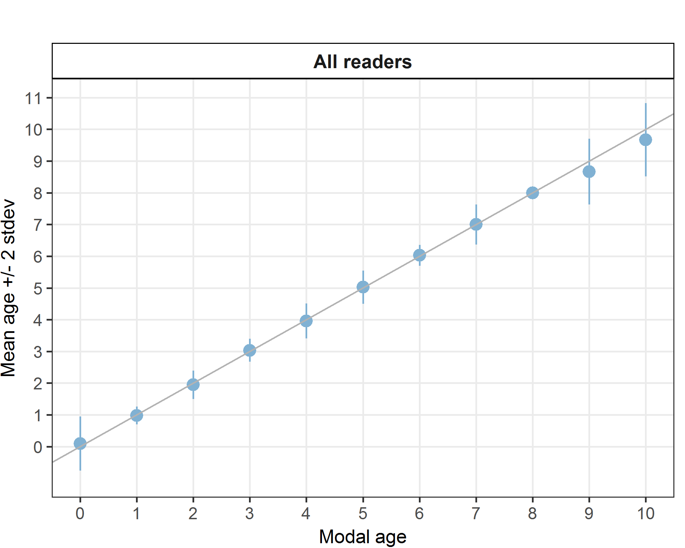
Figure 3.1: Age bias plot for advanced readers.

Age error matrices
Table 3.5: Age error matrix (AEM) for brill in areas 27.4.b, 27.4.c, 27.7.d.
Modal age | 0 | 1 | 2 | 3 | 4 | 5 | 6 | 7 | 8 | 9 | 10
Age 0 | 0.95455 | 0.01923 | - | - | - | - | - | - | - | - | -
Age 1 | - | 0.98077 | 0.05263 | - | - | - | - | - | - | - | -
Age 2 | 0.04545 | - | 0.94737 | - | - | - | - | - | - | - | -
Age 3 | - | - | - | 0.96667 | 0.05660 | - | - | - | - | - | -
Age 4 | - | - | - | 0.03333 | 0.92453 | 0.02273 | - | - | - | - | -
Age 5 | - | - | - | - | 0.01887 | 0.93182 | - | - | - | - | -
Age 6 | - | - | - | - | - | 0.04545 | 0.97368 | 0.04762 | - | - | -
Age 7 | - | - | - | - | - | - | 0.02632 | 0.90476 | - | - | -
Age 8 | - | - | - | - | - | - | - | 0.04762 | 1 | 0.3333 | -
Age 9 | - | - | - | - | - | - | - | - | - | 0.6667 | 0.3333
Age 10 | - | - | - | - | - | - | - | - | - | - | 0.6667

Conclusion

The age reading performance of the advanced readers was very good: the percentage agreement (PA) was 95%, variation coefficient (CV) was 8% and the average percentage error was only 1%.
No major issues were detected for advanced readers when ageing stained sectioned brill otoliths in areas 27.4.b, 27.4.c, 27.7.d.

