SmartDots Summary for event 216 – turbot exchange in area 27.7.d, 27.4.a, 27.4.b, 27.4.c

Executive summary
The last turbot (Scophthalmus maximus) exchange took place in Ostend in 2008 (WKART, 2008) for North Sea and Baltic turbot. A new small scale exchange for North Sea turbot was then recommended. Moreover, turbot became a category 1 stock in 2019 (ages are used for assessment) and the first advice will be given for 2020 using age data from 2018.
The objectives of this new exchange were:
- Estimate the accuracy and precision of the age readings for whole otoliths and sectioned and stained otoliths.
- Detect any potential age reading problems.
- Compare the results between whole and sectioned & stained otoliths

In this report, you will only find the results of the advanced age readers for stained sectioned otoliths as these are the data used in the assessments. A more detailed view of all data of the exchange can be found in the “Report of Otolith Exchange Analysis of Turbot, 2019”.
Two otolith sets were included in the exchange: a North Sea (27.4.a, 27.4.b, 27.4.c) turbot set (N=126) and a set from the English Channel (27.7.d) (N = 52). A total of 8 participants from 3 countries (Belgium, France and the Netherlands) participated in the exchange. Only 3 advanced readers participated, which are all used to reading stained sectioned otoliths. Whole otoliths are only read in France, but these readers are all basic (not providing data for assessment).
The age reading performance of the advanced readers was satisfactory: the percentage agreement (PA) was 78%, variation coefficient (CV) was 19% and the average percentage error was 7%.
During the 2008 workshop, the overall agreement rate for the North Sea sample was high 82.8%. In this exchange, the percentage agreement for stained sectioned otoliths of the advanced readers was satisfactory (78 %), but some age reading issues were detected. The main issue between advanced readers was the analysis of the first small ring and whether or not this is a true annulus. In 2008, agreements were made for the interpretation of the first ring, but the agreements were not specified in the report. It seems that the readers are not aware any more about the agreements concerning the first ring. It will be necessary to find the specifics on the agreements and to inform the readers about it. If it turns out to be impossible to retrieve the needed information, a small workshop on this issue will be necessary. Moreover a validation study on whether this first ring should be counted as first annulus is recommended.

Overview of samples and advanced readers
Table 2.1: Overview of samples used for the xxx exchange. The modal age range for all samples is 0-20.
Year | ICES area | Strata | Quarter | Number of samples | Modal age range | Length range
2014 | 27.7.d | SS | 3 | 2 | 2 | 240-340 mm
2015 | 27.4.a | SS | 1 | 4 | 9-13 | 400-450 mm
2015 | 27.4.b | SS | 3 | 1 | 12 | 560 mm
2015 | 27.4.b | SS | 4 | 2 | 9-10 | 380-650 mm
2015 | 27.4.c | SS | 3 | 9 | 1-5 | 215-575 mm
2015 | 27.7.d | SS | 1 | 25 | 2-20 | 245-350 mm
2015 | 27.7.d | SS | 4 | 11 | 1-13 | 180-370 mm
2016 | 27.4.b | SS | 3 | 2 | 8 | 540-590 mm
2016 | 27.4.c | SS | 4 | 2 | 2-3 | 360-415 mm
2016 | 27.7.d | SS | 4 | 14 | 2-15 | 240-470 mm
2017 | 27.4.a | SS | 1 | 6 | 2-4 | 260-450 mm
2017 | 27.4.a | SS | 2 | 1 | 5 | 520 mm
2017 | 27.4.a | SS | 3 | 7 | 1-5 | 390-550 mm
2017 | 27.4.b | SS | 1 | 5 | 3-7 | 390-520 mm
2017 | 27.4.b | SS | 2 | 7 | 3-9 | 430-590 mm
2017 | 27.4.b | SS | 3 | 26 | 2-13 | 250-610 mm
2017 | 27.4.b | SS | 4 | 25 | 1-12 | 190-675 mm
2017 | 27.4.c | SS | 2 | 4 | 3-6 | 325-400 mm
2017 | 27.4.c | SS | 3 | 15 | 1-4 | 200-540 mm
2018 | 27.4.c | SS | 3 | 10 | 0-1 | 100-250 mm

Table 2.2: Overview of advanced readers.
Reader code | Expertise
R02 NL | Advanced
R04 BE | Advanced
R06 BE | Advanced

Results overview

Age readings
Table 3.1: Age reading table presents the number of readings made per expert reader for each modal age.
Modal age | R02 NL | R04 BE | R06 BE | total
0 | 4 | 4 | 4 | 12
1 | 23 | 21 | 24 | 68
2 | 18 | 17 | 18 | 53
3 | 21 | 22 | 22 | 65
4 | 20 | 20 | 20 | 60
5 | 18 | 17 | 17 | 52
6 | 12 | 12 | 12 | 36
7 | 11 | 13 | 12 | 36
8 | 8 | 8 | 8 | 24
9 | 7 | 7 | 5 | 19
10 | 10 | 11 | 10 | 31
11 | 3 | 3 | 3 | 9
12 | 4 | 4 | 3 | 11
13 | 8 | 8 | 7 | 23
14 | 0 | 0 | 0 | 0
15 | 3 | 3 | 3 | 9
16 | 0 | 0 | 0 | 0
17 | 1 | 1 | 1 | 3
18 | 0 | 0 | 0 | 0
19 | 1 | 1 | 0 | 2
20 | 1 | 1 | 1 | 3
Total | 173 | 173 | 170 | 516

CV table
Table 3.2: Coefficient of Variation (CV) table presents the CV per modal age and advanced reader, the CV of all advanced readers combined per modal age and a weighted mean of the CV per reader.
Modal age | R02 NL | R04 BE | R06 BE | all
0 | - | - | - | -
1 | 81 % | 40 % | 42 % | 57 %
2 | 21 % | 33 % | 25 % | 30 %
3 | 20 % | 14 % | 10 % | 16 %
4 | 17 % | 8 % | 6 % | 12 %
5 | 22 % | 9 % | 15 % | 16 %
6 | 16 % | 5 % | 5 % | 10 %
7 | 11 % | 4 % | 0 % | 7 %
8 | 13 % | 0 % | 17 % | 12 %
9 | 9 % | 5 % | 0 % | 7 %
10 | 4 % | 11 % | 17 % | 13 %
11 | 5 % | 0 % | 5 % | 5 %
12 | 0 % | 0 % | 5 % | 2 %
13 | 6 % | 3 % | 9 % | 7 %
14 | - | - | - | -
15 | 0 % | 0 % | 4 % | 3 %
16 | - | - | - | -
17 | - | - | - | 3 %
18 | - | - | - | -
19 | - | - | - | 7 %
20 | - | - | - | 3 %
Weighted Mean | 24 % | 14 % | 15 % | 19 %

PA table
Table 3.3: Percentage agreement (PA) table represents the PA per modal age and reader, advanced the PA of all advanced readers combined per modal age and a weighted mean of the PA per reader.
Modal age | R02 NL | R04 BE | R06 BE | all
0 | 100 % | 100 % | 100 % | 100 %
1 | 83 % | 95 % | 83 % | 87 %
2 | 83 % | 82 % | 72 % | 79 %
3 | 57 % | 95 % | 91 % | 82 %
4 | 40 % | 90 % | 95 % | 75 %
5 | 72 % | 94 % | 76 % | 81 %
6 | 42 % | 92 % | 92 % | 75 %
7 | 36 % | 92 % | 100 % | 78 %
8 | 38 % | 100 % | 88 % | 75 %
9 | 57 % | 71 % | 100 % | 74 %
10 | 80 % | 45 % | 70 % | 65 %
11 | 67 % | 100 % | 67 % | 78 %
12 | 100 % | 100 % | 67 % | 91 %
13 | 75 % | 75 % | 43 % | 65 %
14 | - | - | - | -
15 | 100 % | 100 % | 33 % | 78 %
16 | - | - | - | -
17 | 100 % | 100 % | 0 % | 67 %
18 | - | - | - | -
19 | 100 % | 0 % | - | 50 %
20 | 100 % | 0 % | 100 % | 67 %
Weighted Mean | 65 % | 87 % | 82 % | 78 %

Relative bias table
Table 3.4: Relative bias table represents the relative bias per modal age and advanced reader, the relative bias of all advanced readers combined per modal age and a weighted mean of the relative bias per reader.
Modal age | R02 NL | R04 BE | R06 BE | all
0 | 0.00 | 0.00 | 0.00 | 0.00
1 | 0.13 | 0.10 | 0.21 | 0.14
2 | -0.17 | 0.35 | 0.33 | 0.17
3 | -0.43 | 0.09 | 0.09 | -0.08
4 | -0.50 | 0.00 | 0.05 | -0.15
5 | 0.00 | 0.12 | 0.35 | 0.16
6 | -0.33 | 0.08 | 0.08 | -0.06
7 | -0.45 | 0.08 | 0.00 | -0.13
8 | 0.00 | 0.00 | 0.50 | 0.17
9 | -0.57 | 0.29 | 0.00 | -0.10
10 | 0.20 | 0.45 | 1.20 | 0.62
11 | -0.33 | 0.00 | 0.33 | 0.00
12 | 0.00 | 0.00 | 0.33 | 0.11
13 | 0.38 | 0.25 | 1.14 | 0.59
14 | - | - | - | -
15 | 0.00 | 0.00 | 0.67 | 0.22
16 | - | - | - | -
17 | 0.00 | 0.00 | -1.00 | -0.33
18 | - | - | - | -
19 | 0.00 | 2.00 | - | -
20 | 0.00 | 1.00 | 0.00 | 0.33
Weighted Mean | -0.16 | 0.15 | 0.28 | 0.09

Bias plot
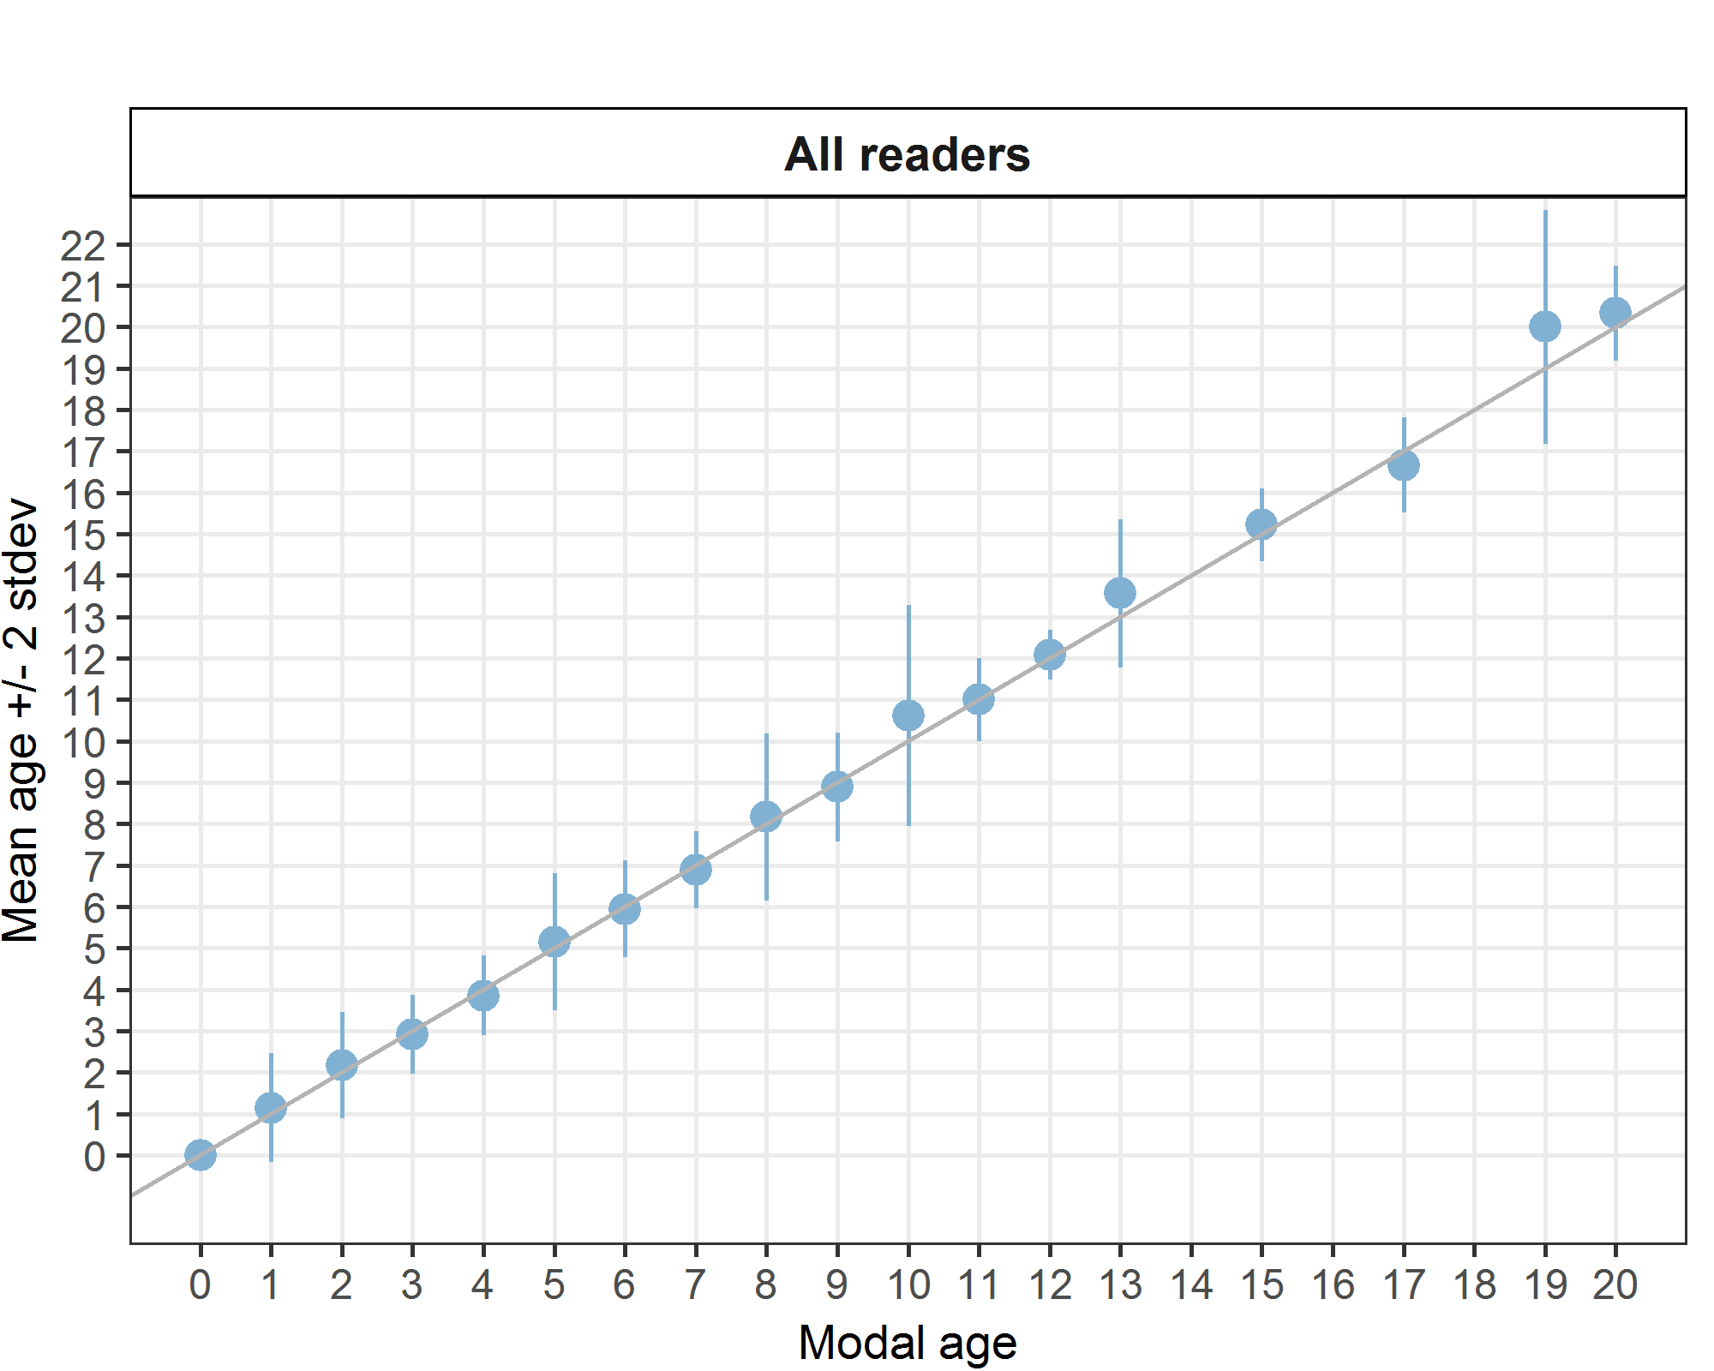
Figure 3.1: Age bias plot for advanced readers.

Age error matrices
Table 3.6: Age error matrix (AEM) for SS.
strata | Modal age | 0 | 1 | 2 | 3 | 4 | 5 | 6 | 7 | 8 | 9 | 10 | 11 | 12 | 13 | 15 | 17 | 19 | 20
SS | Age 0 | 1 | 0.02941 | - | - | - | - | - | - | - | - | - | - | - | - | - | - | - | -
SS | Age 1 | - | 0.86765 | 0.05660 | - | - | - | - | - | - | - | - | - | - | - | - | - | - | -
SS | Age 2 | - | 0.05882 | 0.79245 | 0.13846 | - | - | - | - | - | - | - | - | - | - | - | - | - | -
SS | Age 3 | - | 0.02941 | 0.07547 | 0.81538 | 0.20 | - | - | - | - | - | - | - | - | - | - | - | - | -
SS | Age 4 | - | - | 0.07547 | 0.03077 | 0.75 | 0.07692 | - | - | - | - | - | - | - | - | - | - | - | -
SS | Age 5 | - | 0.01471 | - | 0.01538 | 0.05 | 0.80769 | 0.16667 | - | - | - | - | - | - | - | - | - | - | -
SS | Age 6 | - | - | - | - | - | 0.05769 | 0.75000 | 0.16667 | - | - | - | - | - | - | - | - | - | -
SS | Age 7 | - | - | - | - | - | 0.01923 | 0.05556 | 0.77778 | 0.12500 | 0.05263 | - | - | - | - | - | - | - | -
SS | Age 8 | - | - | - | - | - | 0.01923 | 0.02778 | 0.05556 | 0.75000 | 0.10526 | 0.03226 | - | - | - | - | - | - | -
SS | Age 9 | - | - | - | - | - | 0.01923 | - | - | 0.04167 | 0.73684 | - | - | - | - | - | - | - | -
SS | Age 10 | - | - | - | - | - | - | - | - | 0.04167 | 0.10526 | 0.64516 | 0.1111 | - | - | - | - | - | -
SS | Age 11 | - | - | - | - | - | - | - | - | - | - | 0.16129 | 0.7778 | - | - | - | - | - | -
SS | Age 12 | - | - | - | - | - | - | - | - | 0.04167 | - | 0.06452 | 0.1111 | 0.90909 | - | - | - | - | -
SS | Age 13 | - | - | - | - | - | - | - | - | - | - | - | - | 0.09091 | 0.65217 | - | - | - | -
SS | Age 14 | - | - | - | - | - | - | - | - | - | - | 0.09677 | - | - | 0.17391 | - | - | - | -
SS | Age 15 | - | - | - | - | - | - | - | - | - | - | - | - | - | 0.13043 | 0.7778 | - | - | -
SS | Age 16 | - | - | - | - | - | - | - | - | - | - | - | - | - | 0.04348 | 0.2222 | 0.3333 | - | -
SS | Age 17 | - | - | - | - | - | - | - | - | - | - | - | - | - | - | - | 0.6667 | - | -
SS | Age 19 | - | - | - | - | - | - | - | - | - | - | - | - | - | - | - | - | 0.5 | -
SS | Age 20 | - | - | - | - | - | - | - | - | - | - | - | - | - | - | - | - | - | 0.6667
SS | Age 21 | - | - | - | - | - | - | - | - | - | - | - | - | - | - | - | - | 0.5 | 0.3333

Conclusion

The age reading performance of the advanced readers was satisfactory: the percentage agreement (PA) was 78%, variation coefficient (CV) was 19% and the average percentage error was 7%.
During the 2008 workshop, the overall agreement rate for the North Sea sample was high 82.8%. In this exchange, the percentage agreement for stained sectioned otoliths of the advanced readers was satisfactory (78 %), but some age reading issues were detected. The main issue between advanced readers was the analysis of the first small ring and whether or not this is a true annulus. In 2008, agreements were made for the interpretation of the first ring, but the agreements were not specified in the report. It seems that the readers are not aware any more about the agreements concerning the first ring. It will be necessary to find the specifics on the agreements and to inform the readers about it. If it turns out to be impossible to retrieve the needed information, a small workshop on this issue will be necessary. Moreover a validation study on whether this first ring should be counted as first annulus is recommended.

