Workshop 2 on the identification of clupeoid larvae (WKIDCLUP2)

By WebEx, 1-2 September 2020

Executive summary
The Workshop 2 on the Identification of Clupeoid larvae (WKIDCLUP2) was scheduled to meet from 31 August to 4 September 2020 in Bremerhaven, Germany, to calibrate clupeoid larvae identification. Because of the Covid19 pandemic and associated travel and meeting restrictions, the workshop had to be postponed to 2021. However, and as an add on, in order to provide potential participants with urgently needed advice for clupeid larvae identification, a video conference was scheduled instead for 1 – 2 September 2020 with a shortened terms of reference list. This was also done in order to test this format for future workshops on ichthyoplankton identification. The meeting was chaired by Matthias Kloppmann, Germany. In total 27 persons representing 13 institutes from 11 countries participated in the video workshop .
The majority of the time at the workshop was spent identifying fish larvae. For this, prior to the workshop, the WebApp SmartDots was adapted to be utilized for ichthyoplankton identification based on images. The results from the identification trials were analysed in the traditional way using modified Excel tables built by Guus Eltink. Overall agreement in identifying clupeid and discriminating them from other, non-clupeid larvae among all participants was 81.7 %. Agreement for herring larvae was 86 %, for sprat 80 %, for sardine 86 % and for anchovy 71 %. Subsequent analysis of the myotome counts, which was also facilitated through the SmartDots WebApp, showed that particularly in those specimens that showed low agreement in correct identification, variation of counts was high.
The dates for the postponed workshop WKIDCLUP2 were agreed as 30 August – 3 September 2021.

Opening of the meeting
The meeting started on Tuesday 1 September 2020. Altogether, 13 institutes were represented from 11 countries (see Table 1.1), 27 participants joined the meeting, and 3 more participated only in the SmartDots identification trial (Annex 1).
Table 1.1. Represented countries and institutes during WKIDCLUP2 2020
Country | Institute
Denmark | DTU-Aqua
France | IFREMER
Germany | TISF and TIOF
Latvia | BIOR
Netherlands | WMR
Portugal | IPMA
Sweden | SLU
Spain | AZTI and IEO
Norway | HI
UK-England | CEFAS
UK-Scotland | MS

Adoption of the agenda
The original terms of reference for this meeting were:
- Conduct comparative identification trials focusing on clupeoid and clupeid-like larvae evaluating suitable criteria for the identification using the trial – analysis – retrial methodology (Science Plan codes: 3.1, 3.2);
- Review available information on the identification of clupeoid larvae on the Northeast Atlantic Shelf, with special consideration of the larval appearance and morphology through development (Science Plan codes 3.1, 3.2);
- Identify and evaluate sources of misidentification of larvae by preparing an uncertainty matrix of clupeid larvae identification (Science Plan codes: 3.1, 3.2);
- Standardize sample processing and data reporting of clupeid larvae surveys (Science Plan codes: 3.1, 3.2)..
After postponing the originally planned physical meeting, and deciding on carrying out a shortened video conference instead, the agenda was adapted to working only on parts of ToRs a) and c). The shortened ToR list looked as follows
- Conduct one comparative identification trial focusing on clupeoid and clupeid-like larvae evaluating suitable criteria for the identification utilizing the SmartDots WebApp. (Science Plan codes: 3.1, 3.2);
- Identify sources of misidentification of (Science Plan codes: 3.1, 3.2);

An agenda was sent round prior to the workshop. The adopted agenda can be found in Annex 2.

SmartDots WebApp for ichthyoplankton identification workshops
The SmartDots web application was originally designed by cooperation of ICES, ILVO, DTU-Aqua and IMR to aid maturity and age reading exchange, training and workshop events. Currently, its further development is facilitated through WGBIOP. When it became clear, that a video conference was planned to partly replace this year’s physical WKIDCLUP2 meeting, it became desirable that SmartDots would be adapted to also aid ichthyoplankton identification events based on microscopic images of fish eggs and/or larvae. Scientists from DTU-Aqua, Denmark, WMR, the Netherlands, and in particular the ICES datacentre were involved to adapt SmartDots to the WKIDCLUP2 event. The following modifications were made to the application
For the organizer of an event:
- The organizer was enabled to set a scale to each of the microscopic images enabling participants to undertake direct measurements on the larvae, e.g. of total length, standard length or head length
For the participants the following annotations were enabled
- Select the species name from a dropdown menu
- Counting myotomes of either the trunk or between pylorus and pelvic fin directly in an image by setting dots.
- Measuring total, standard or head length of a larvae by creating poly-lines in an image.
- Making a comment
Prior to the meeting, 131 images of 60 larvae were uploaded to the SmartDots server and a scale was set to each of the images.
Species composition of the 60 larval samples was as follows
Herring, Clupea harengus: 13 larvae
Sprat, Sprattus sprattus: 12 larvae
Sardine, Sardina pilchardus: 14 larvae
Anchovy, Engraulis encrasicolus: 14 larvae
Other species with similar appearance to clupeid larvae, 7 specimens: 1 Argentine, Argentina sphyraena, 1 Crystal goby, Crystallogobius linearis, 5 Sandeel, Ammodytidae gen. sp.
With the images, information was given on time and area of catch of the larvae.
All participants had at least to make an annotation in the species identification field, i.e. determine the species, either specifically one of the 4 clupeoid species or “other” for non-clupeoid larvae.
See also Annex 3 for a short report on the SmartDots beta for ichthyoplankton identification.

Larvae identification results

Results of the larvae identification trial on SmartDots.
The original assessment of species identification for each larva, by each participant, was put into a primary result table (not presented here). Once the results were available from every participant from the SmartDots site, these were analysed. The results were compared with pre-determined (identifications done by experts) species. These were considered to be correct.
A summary of the results from the one round on clupeoid larval species determination is presented in Table 4.1. The table is divided into four sub-tables labelled A-D, where the performance of each participant is judged against the actual correct species identification.
Sub-table A shows the number of larvae of each species that were assessed by each participant (i.e., the number of larvae which the participant should actually have found per species). The numbers of each species will therefore be the same for all participants that read all the larvae.
Sub-table B shows the numbers of larvae of each species as actually annotated by each participant to the different larval image samples.
Sub-table C shows the over- or underestimation of each participant per species.
Sub-table D shows the percentage agreement in species identification between the assessment of each participant and the actual species.
The results show, compared to those of the 2014 workshop (ICES 2014) considerable improvement in the allocation of larvae to the correctly determined species. The agreement among all participants for all species was 81.7 %, an increase of more the 25 %-points compared to 2014. The agreement for herring larvae was 86 %, for sprat 80 %, for sardine 86 % and for anchovy 71 %. All values are higher than observed in 2014. Except for two participants, all readers achieved agreement rates of more than 70 % with the actual species. Agreement rates of at least 90 % was reached by six participants, contrasting to the 2014 workshop, where none of the participants reached 80 % agreement.

In only 3 specimens, less than 50 % of readers misidentified the species. Two thirds (40 larvae, 66.7 %) of all specimens were correctly identified by at least 80 % of all readers. Since no self-evaluation was done by the different readers on whether they were experienced or unexperienced, results were not analysed with respect to this characteristic.
The results were presented to the participants and the features which aided clupeoid larvae identification were discussed. From the SmartDots Server, images of larvae of all clupeoid species were shown on the shared screen and identification characteristics were discussed. Larval features change with size and after the discussion as well as the analysis of the SmartDots results, it became clear that only very few of the participants were measuring the larval length. Also, not all did myotome counts, even though this is a crucial technique for identification in many specimens of clupeoid larvae. Both, measuring and myotome counting, was possible with SmartDots, and participants were instructed how to do this on their screens.

Table 4.1.1 Species identification 1st round. The species compositions based on actual species reflecting the best estimates based on only those larvae that were used for species identification by the participant (A), the species compositions as obtained per participant (B), the percentage over- or underestimation (C) and the percentages agreement with actual species (D) are shown per species by participant and for the whole group that took part in the species identification exercise on fish larvae. A weighted mean percent agreement is given by person and all persons combined.

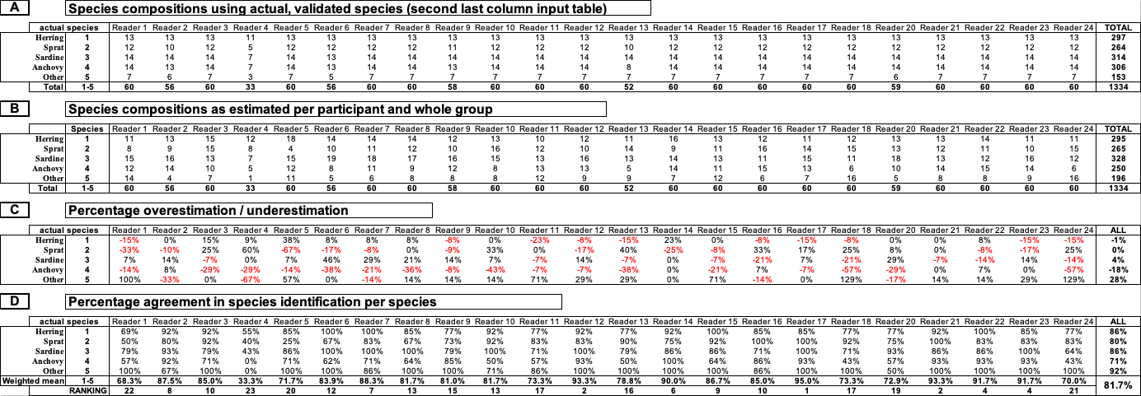

Sources of misidentification
SmartDots allows for extracting not only identification results, but also of results of measuring and counting. Especially the myotome counting results show that this is a prominent source of misidentification in clupeid (herring, sprat or sardine) larvae (Figure 4.1.1). The specimens with some of the lowest agreements in correct identification also had the highest variability in myotome counts.
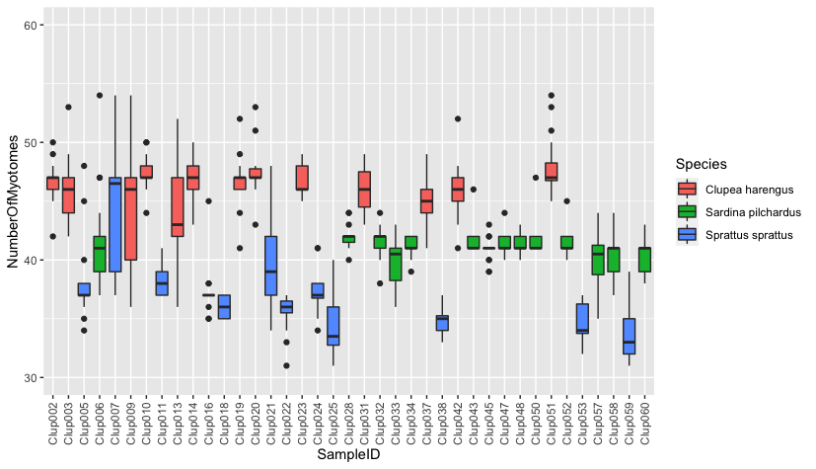
Figure 4.2.1 Box Plot on the variability of myotome counts in the different specimens of clupeid (herring, sprat and sardine) larvae. Anchovy and other larvae were excluded from the analysis.

Specimens with the IDs Clup007, Clup009, Clup013 and Clup021 had myotome count results between 34 and > 50, which would match meristics of all possible clupeid species (Figure 4.2.1). Consequently, annotations by participants contained all 3 possible clupeid species, herring, sprat and sardine, as well as anchovy. Herring and sprat would have been the 2 only correct results for the 4 specimens. These results clearly illustrate the major confounding issues in mytome counting, which could lead to erroneous identification results: where to start and end counting, and how to discriminate between true and false myosepts in order to distinguish between two adjoining myotomes. These issues will be thoroughly discussed and standardized methods prepared at the postponed 2021 full workshop.

Reference

ICES 2014. Report of the Workshop on the identification of clupeoid larvae (WKIDCLUP), 1-5 September 2014, Hamburg, Germany. ICES CM 2014/SSGESST:04. 36 pp.

Annex 1: List of participants
Participants WKIDCLUP2 – video workshop
01 Carolina Giraldo, IFREMER, France, Carolina.Giraldo@ifremer.fr
02 Isabel Riveiro, IEO, Spain, Isabel.Riveiro@ieo.es
03 Malin Werner, SLU, Sweden, Malin.Werner@slu.se
04 Maik Tiedmann, HI, Norway, Maik.Tiedemann@hi.no
05 Andrejs Makarčuks, BIOR, Latvia, Andrejs.Makarcuks@bior.lv
06 Bastian Huwer, DTU-aqua, Denmark, bhu@aqua.dtu.dk
07 Svend-Erik Levinsky, DTU-aqua, Denmark, sel@aqua.dtu.dk
08 Louise Scherffenberg Lundgaard, DTU-aqua, Denmark, lslu@aqua.dtu.dk
09 Alexander Neil Holdgate, DTU-aqua, Denmark, s190061@student.dtu.dk
10 Paula Alvarez, AZTI, Spain, palvarez@azti.es
11 Cindy van Damme, WUR, The Netherlands, cindy.vandamme@wur.nl
12 Ewout Blom, WUR, The Netherlands, ewout.blom@wur.nl
13 Erika Koelemij, WUR, The Netherlands, erika.koelemij@wur.nl
14 Maria Manuel Angelico, IPMA, Portugal, mmangelico@ipma.pt
15 Elisabete Henriques, IPMA, Portugal, ehenriques@ipma.pt
16 Birgit Suer, TISF, Germany, birgit.suer@thuenen.de
17 Matthias Kloppmann, chair, TISF, Germany, matthias.kloppmann@thuenen.de
18 Isabel Lee-Elliott, UK, isabellee_elliott@hotmail.com
19 Daniela Carriço, IPMA, Portugal, danielacarrico22@gmail.com
20 Anne Georgi, TIOF, Germany, anne.georgi@thuenen.de
21 Annegret Finke, TIOF, Germany, annegret.finke@thuenen.de
22 Lina Livdane, TIOF, Germany, lina.livdane@thuenen.de
23 Dagmar Stephan, TIOF, Gemany, dagmar.stephan@thuenen.de
24 Hannah Holah, Marine Scotland, Scotland, Hannah.Holah@gov.scot
25 Norbert Rohlf, TISF, Germany, norbert.rohlf@thuenen.de
26 Patrick Polte, TIOF, Germany, patrick.polte@thuenen.de
27 Hermann Neumann, TISF, Germany, hermann.neumann@thuenen.de
28 James Pettigrew*, CEFAS, England, james.pettigrew@cefas.co.uk
29 Nevena Almeida*, CEFAS, England, nevena.almeida@cefas.co.uk
30 Hayden Close*, CEFAS, England, hayden.close@cefas.co.uk
* participation in SmartDots event, only.

Annex 2: Agenda
(all times given in CEST)

Tuesday, 01 September 2020

10:00 – 10:15 Short Introduction to the video conference
10:15 – 11:00 Looking at several specimens of larvae of the target species, herring, sprat, sardine and anchovy in plenary. Discuss the several characteristic criteria to discriminate between the different species.
11:00 – 12:00 Presentation: Introduction in species identification of marine Northeast Atlantic clupeid larvae.
Introduction into using SmartDots for identification trials on fish larvae.

Lunch break

In the afternoon: Identification trials using SmartDots

Wednesday, 02 September 2020

09:00 – 11:00 continue with identification trials on SmartDots and filling in of feedback file on the use of SmartDots
14:00 – 16:00 Discussion on results of identification trials, looking at single specimens from the trials. Discussion on the use of SmartDots. Meeting dates 2021

End of meeting

Annex 3: Report on SmartDots during WKIDCLUP2 2020
SmartDots during WKIDCLUP2

The ICES Workshop 2 on the Identification of Clupeid Larvae was scheduled to take place as a physical meeting 31 August – 4 September 2020 in Bremerhaven, Germany. Following several national measurements to fight the Covid19 pandemic including restrictions on larger group meetings and international travel, the workshop had to be postponed to 2021. However, because of the importance of the subject – the correct identification of clupeid larvae in the light of increasing overlap in spatial and temporal overlap of the different species – to have at least a small video conference to give potential participants the opportunity to sharpen their expertise.
The original ToRs for WKIDCLUP2 were, for the purpose of the shortened meeting, stripped down to one identification trial and to a quick plenary round on determining sources of identification errors. For the identification trial it was suggested to use the SmartDots WebApi, which was set up originally by collaboration of ICES, DTU-Aqua, ILVO and IMAR for otolith reading and sex and maturity determination in fish based on images. For ichthyoplankton identification, SmartDots had to be adapted, which was done prior to the event by collaboration of ICES, DTU-Aqua and WUR, and the event coordinator during several video sessions. The overall aim was not only to assist this workshop (WKIDCLUP2) but to also prepare SmartDots for other ichthyoplankton identification and staging events, e.g. the fish egg identification and staging workshop which is held prior to each mackerel and horse mackerel egg survey. It is hoped that the adaptation of SmartDots to ichthyoplankton work would enable the scientific community to better harmonize their ichthyoplankton survey work both, nationally and internationally.
For the WKIDCLUP2 meeting, a beta version of SmartDots for ichthyoplankton was launched, a sample file and the respective images uploaded to the SmartDots site and an event created. All workshop participants were invited to use the website and try to identify the fish larvae, which were displayed in the images. Apart from the mandatory naming of the species, in the annotation window, all participants were enabled to measure different features of the larvae as well as to count myotomes. Because of the novelty of the application to most of the participants, it was decided to leave the event open until a week after the official end of the workshop on 2 September.
A first results sheet was submitted to the coordinator of the event in the morning of 2 September. The results could be easily extracted and copied to the original WKIDCLUP evaluation sheet for an overview of the results. It was also possible to extract length measurements, which had been transformed from pixels to mm, and myotome counts, analysis of which enabling for a better identification of sources of misidentification of the species.
Overall, the WebApi SmartDots proved to be very useful for holding such events like WKIDCLUP2. Once all images of larvae were available, it was rather easy to upload them to the SmartDots server. During the workshop, I never had the impression that anyone was having serious problems nor problems at all with annotating the images. Support through ICES and the SmartDots support team was excellent.

