SmartDots Summary for event 314: Otolith Exchange for Sole in ICES division 27.7.d

Executive summary
The last sole otolith exchange took place in 2011 in the Bay of Biscay (reaching an average CV (Coefficient of Variation) of 4.7% and percent agreement (PA) to modal age of 88.6%). To our knowledge, this is the first otolith exchange of sole in area 7.d. WGBIOP (October, 2020) identified the need for a sole exchange preceding the sole 7.d stock benchmark foreseen in February 2021. Therefore, this image-only exchange was organized from October 2020 to January 2021 using the SmartDots platform for annotating the images and analysing the results.
The objectives of the present exchange were:
- To evaluate the accuracy and precision in otolith age reading of sole in division 7.d (Eastern English Channel)
- To identify issues related to age reading of sole in division 7.d
In this report, only results of the advanced age readers are presented as these are the data used in the stock assessments. A more detailed view of all data of the exchange can be found in file “SmartDots_Report_Event_314_Sole_7d_2020”. Results are calculated for percentage agreement (PA), coefficient of variation (CV), relative bias and average percentage error (APE). Also, an age error matrix is calculated which could serve as input in the assessment models.
A total of 116 sectioned and stained otoliths were read by 5 advanced readers from 4 countries (Belgium, UK, France, Ireland). The overall PA was high (80%) and CV and APE were low, 8% and 5 % respectively.
Differences in age determination mainly related to the underestimation of older fish, especially by one reader. Percentage agreement became much lower from age 8 on (only 73 % while up to age 7, it is always higher than 90%). Therefore, a workshop for this stock is recommended in order to improve the age readings for older fish.

Overview of samples and advanced readers
A total of 116 sectioned & stained otoliths, all originating from area 7.d, were used in the exchange. They were stratified by quarter and age up to age 15 (table 1). Age estimation of sole in are 7.d is based on sectioned and stained otoliths for all countries delivering data for assessment.
Table 1: Overview of samples used for the sole 7.d exchange. The modal age range for all samples is 1-15.
Year | ICES area | Strata | Quarter | Number of samples | Modal age range | Length range
2015 | 27.7.d | SS | 2 | 2 | 14 | 310-395 mm
2015 | 27.7.d | SS | 4 | 1 | 15 | 335 mm
2016 | 27.7.d | SS | 2 | 4 | 9-12 | 420-510 mm
2016 | 27.7.d | SS | 3 | 14 | 2-15 | 210-395 mm
2016 | 27.7.d | SS | 4 | 10 | 7-15 | 320-450 mm
2017 | 27.7.d | SS | 1 | 3 | 10-13 | 385-455 mm
2017 | 27.7.d | SS | 2 | 4 | 1-3 | 160-210 mm
2017 | 27.7.d | SS | 3 | 5 | 1-10 | 180-415 mm
2017 | 27.7.d | SS | 4 | 4 | 1-15 | 255-420 mm
2018 | 27.7.d | SS | 1 | 3 | 13-14 | 405-470 mm
2018 | 27.7.d | SS | 2 | 20 | 2-15 | 170-435 mm
2018 | 27.7.d | SS | 3 | 7 | 5-14 | 260-380 mm
2019 | 27.7.d | SS | 1 | 24 | 1-15 | 170-465 mm
2019 | 27.7.d | SS | 4 | 15 | 1-11 | 200-415 mm

A total of 5 advanced participants from 4 countries were involved in the sole otolith exchange. A list of the participants with a summary of their experience in age estimation of sole is shown in Table 2. Age estimation of sole is based on sectioned and stained otoliths.
Table 2: Overview of readers.
Reader code | Expertise | Expertise_rank | strata
R02 GB | Advanced | 2 | SS
R04 BE | Advanced | 4 | SS
R06 BE | Advanced | 6 | SS
R08 FR | Advanced | 8 | SS
R10 IE | Advanced | 10 | SS

Results overview

CV table
The CV is calculated as the ratio between the standard deviation (σ) and mean value (μ) per reader and modal age and expressed as percentage.
Table 3: Coefficient of Variation (CV) table presents the CV per modal age and advanced reader, the CV of all advanced readers combined per modal age, and a weighted mean of the CV per reader.
Modal age | R02 GB | R04 BE | R06 BE | R08 FR | R10 IE | all
1 | 0 % | 0 % | 0 % | 0 % | 33 % | 16 %
2 | 0 % | 0 % | 0 % | 0 % | 0 % | 0 %
3 | 0 % | 0 % | 0 % | 12 % | 0 % | 5 %
4 | 9 % | 0 % | 9 % | 0 % | 0 % | 6 %
5 | 7 % | 0 % | 0 % | 7 % | 0 % | 5 %
6 | 6 % | 0 % | 0 % | 13 % | 0 % | 7 %
7 | 0 % | 0 % | 0 % | 12 % | 0 % | 5 %
8 | 4 % | 0 % | 0 % | 12 % | 10 % | 9 %
9 | 4 % | 15 % | 5 % | 10 % | 12 % | 11 %
10 | 7 % | 0 % | 3 % | 16 % | 5 % | 10 %
11 | 3 % | 0 % | 0 % | 19 % | 5 % | 10 %
12 | 3 % | 3 % | 5 % | 15 % | 10 % | 10 %
13 | 4 % | 0 % | 3 % | 5 % | 4 % | 8 %
14 | 7 % | 3 % | 5 % | 16 % | 15 % | 13 %
15 | 6 % | 0 % | 2 % | 10 % | 10 % | 9 %
Weighted Mean | 4 % | 1 % | 2 % | 10 % | 7 % | 8 %

PA table
The percentage agreement per reader per modal age tells you how large is the part of readings that are equal to the modal age per reader and per modal age.
Table 4: Percentage agreement (PA) table represents the PA per modal age and reader, the PA of all advanced readers combined per modal age, and a weighted mean of the PA per reader.
Modal age | R02 GB | R04 BE | R06 BE | R08 FR | R10 IE | total
1 | 100 % | 100 % | 100 % | 100 % | 86 % | 97 %
2 | 100 % | 100 % | 100 % | 100 % | 100 % | 100 %
3 | 100 % | 100 % | 100 % | 88 % | 100 % | 98 %
4 | 86 % | 100 % | 88 % | 100 % | 100 % | 95 %
5 | 88 % | 100 % | 100 % | 88 % | 100 % | 95 %
6 | 88 % | 100 % | 100 % | 75 % | 100 % | 92 %
7 | 100 % | 100 % | 100 % | 62 % | 100 % | 92 %
8 | 89 % | 100 % | 100 % | 22 % | 56 % | 73 %
9 | 88 % | 75 % | 75 % | 38 % | 62 % | 68 %
10 | 88 % | 100 % | 88 % | 12 % | 62 % | 70 %
11 | 86 % | 100 % | 100 % | 29 % | 29 % | 69 %
12 | 89 % | 89 % | 67 % | 11 % | 50 % | 61 %
13 | 75 % | 100 % | 80 % | 0 % | 60 % | 65 %
14 | 50 % | 83 % | 67 % | 17 % | 17 % | 47 %
15 | 62 % | 100 % | 88 % | 12 % | 38 % | 60 %
Weighted Mean | 87 % | 97 % | 91 % | 52 % | 72 % | 80 %

APE table
The average percentage error gives an idea of the percentage bias between the age given by each reader and the mean age (per modal age and per reader).
Table 7: Average Percentage Error (APE) table represents the APE per modal age and reader, the APE of all advanced readers combined per modal age and a weighted mean of the APE per reader.
Modal age | R02 GB | R04 BE | R06 BE | R08 FR | R10 IE | all
1 | 0 % | 0 % | 0 % | 0 % | 21 % | 5 %
2 | 0 % | 0 % | 0 % | 0 % | 0 % | 0 %
3 | 0 % | 0 % | 0 % | 8 % | 0 % | 2 %
4 | 6 % | 0 % | 6 % | 0 % | 0 % | 1 %
5 | 4 % | 0 % | 0 % | 4 % | 0 % | 1 %
6 | 4 % | 0 % | 0 % | 10 % | 0 % | 2 %
7 | 0 % | 0 % | 0 % | 10 % | 0 % | 3 %
8 | 2 % | 0 % | 0 % | 10 % | 8 % | 7 %
9 | 2 % | 10 % | 4 % | 8 % | 9 % | 6 %
10 | 4 % | 0 % | 2 % | 12 % | 5 % | 7 %
11 | 2 % | 0 % | 0 % | 15 % | 4 % | 7 %
12 | 2 % | 2 % | 3 % | 13 % | 8 % | 8 %
13 | 3 % | 0 % | 2 % | 5 % | 4 % | 7 %
14 | 6 % | 2 % | 2 % | 12 % | 11 % | 10 %
15 | 4 % | 0 % | 1 % | 8 % | 8 % | 7 %
Weighted Mean | 3 % | 1 % | 1 % | 8 % | 5 % | 5 %

Relative bias table
The relative bias is the difference between the mean age (per modal age per reader) and modal age. As for the previous tables, a combined bias for all readers and weighted means are calculated.
Table 8: Relative bias table represents the relative bias per modal age and advanced reader, the relative bias of all advanced readers combined per modal age, and a weighted mean of the relative bias per reader.
Modal age | R02 GB | R04 BE | R06 BE | R08 FR | R10 IE | all
1 | 0.00 | 0.00 | 0.00 | 0.00 | 0.14 | 0.03
2 | 0.00 | 0.00 | 0.00 | 0.00 | 0.00 | 0.00
3 | 0.00 | 0.00 | 0.00 | -0.12 | 0.00 | -0.02
4 | 0.14 | 0.00 | -0.12 | 0.00 | 0.00 | 0.00
5 | 0.12 | 0.00 | 0.00 | -0.12 | 0.00 | 0.00
6 | 0.12 | 0.00 | 0.00 | -0.38 | 0.00 | -0.05
7 | 0.00 | 0.00 | 0.00 | -0.50 | 0.00 | -0.10
8 | 0.11 | 0.00 | 0.00 | -1.22 | -0.56 | -0.33
9 | 0.12 | 0.62 | 0.25 | -0.88 | -0.38 | -0.05
10 | 0.25 | 0.00 | 0.12 | -1.62 | -0.38 | -0.32
11 | -0.14 | 0.00 | 0.00 | -1.71 | -0.71 | -0.51
12 | 0.11 | 0.11 | -0.11 | -2.00 | -0.88 | -0.55
13 | -0.25 | 0.00 | 0.20 | -2.50 | -0.40 | -0.59
14 | -0.83 | -0.17 | 0.00 | -3.00 | -2.00 | -1.20
15 | 0.25 | 0.00 | -0.12 | -2.25 | -1.25 | -0.68
Weighted Mean | 0.03 | 0.04 | 0.01 | -1.01 | -0.41 | -0.27

Bias plot
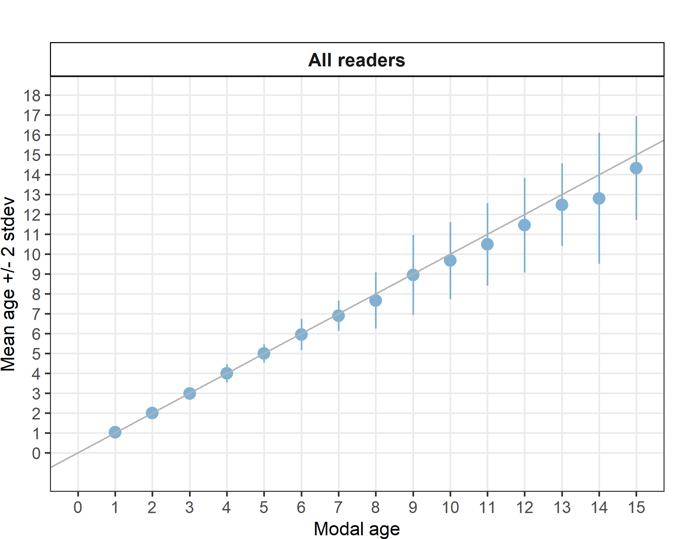
Figure 1: Age bias plot for advanced readers.
Bias is more obvious in the older ages, especially from age eight onwards (fig. 1 and table 8).

Age error matrices
Table 9: Age error matrix (AEM) for SS.
strata | Modal age | 1 | 2 | 3 | 4 | 5 | 6 | 7 | 8 | 9 | 10 | 11 | 12 | 13 | 14 | 15
SS | Age 1 | 0.97436 | - | - | - | - | - | - | - | - | - | - | - | - | - | -
SS | Age 2 | 0.02564 | 1 | 0.025 | - | - | - | - | - | - | - | - | - | - | - | -
SS | Age 3 | - | - | 0.975 | 0.02564 | - | - | - | - | - | - | - | - | - | - | -
SS | Age 4 | - | - | - | 0.94872 | 0.025 | 0.02564 | - | - | - | - | - | - | - | - | -
SS | Age 5 | - | - | - | 0.02564 | 0.950 | 0.02564 | 0.025 | - | - | - | - | - | - | - | -
SS | Age 6 | - | - | - | - | 0.025 | 0.92308 | 0.050 | 0.11111 | - | 0.025 | 0.02857 | - | - | - | -
SS | Age 7 | - | - | - | - | - | 0.02564 | 0.925 | 0.13333 | 0.100 | 0.025 | - | - | - | - | -
SS | Age 8 | - | - | - | - | - | - | - | 0.73333 | 0.075 | 0.025 | 0.02857 | 0.04545 | - | - | -
SS | Age 9 | - | - | - | - | - | - | - | 0.02222 | 0.675 | 0.175 | 0.02857 | 0.06818 | - | 0.06667 | -
SS | Age 10 | - | - | - | - | - | - | - | - | 0.125 | 0.700 | 0.22857 | 0.02273 | 0.08696 | 0.06667 | -
SS | Age 11 | - | - | - | - | - | - | - | - | - | 0.025 | 0.68571 | 0.18182 | 0.08696 | 0.06667 | 0.050
SS | Age 12 | - | - | - | - | - | - | - | - | - | 0.025 | - | 0.61364 | 0.13043 | 0.13333 | 0.075
SS | Age 13 | - | - | - | - | - | - | - | - | 0.025 | - | - | 0.06818 | 0.65217 | 0.16667 | 0.100
SS | Age 14 | - | - | - | - | - | - | - | - | - | - | - | - | 0.04348 | 0.46667 | 0.125
SS | Age 15 | - | - | - | - | - | - | - | - | - | - | - | - | - | 0.03333 | 0.600
SS | Age 16 | - | - | - | - | - | - | - | - | - | - | - | - | - | - | 0.025
SS | Age 17 | - | - | - | - | - | - | - | - | - | - | - | - | - | - | 0.025

Conclusion

All institutes tend to read this stock using the same preparation method of sectioned and stained. Sectioning is the best method to age sole especially for older specimens as otoliths can change the growth direction and older otoliths tend to get thicker instead of longer and wider. This phenomenon is described as ‘cliff edge effect’ and may cause underestimation of ages in whole otoliths especially if there is little or no otolith growth in the horizontal plane.
For advanced readers only, the percentage agreement was 80% with a weighted average CV of 9 % and APE of 5%, which are satisfying results. The percentage agreement was lower in this exchange compared to the last sole otolith exchange that took place in 2011 in the Bay of Biscay (88.6%). To our knowledge, this is the first otolith exchange of sole in area 7.d.
Differences in age determination relate to underestimation of older fish, especially from age eight on. It seemed that the smaller rings on the edge of the otolith were not being counted as true rings. Following on from this exchange it is recommended for a workshop to be carried out to discuss discrepancies in age readings.

