vSmartDots Report for event 355

Jorge Landa ꝉ

(coordination)

Larissa Modica

(coordination & analysis)

*In loving memory of Jorge Landa,*

*whose kindness, integrity, tireless dedication and indefatigable spirit inspired us all.*

Table of Contents

1 Executive summary 3

2 Agenda and participant list 4

3 Introduction 5

4 Methods 6

5 Overview of samples and readers 9

5.1 Results 10

5.1.1 All readers 10

5.1.2 Advanced readers 30

5.2 Discussion 46

5.3 Conclusion 53

6 Other ToRs 54

7 References 55

8 Annex 1. Protocol and Agenda 57

9 Annex 2. List of participants 68

10 Annex 3. Additional results 69

10.1 Results all readers 70

10.2 Results Advanced readers 85

11 Annex 5. Recommendations 100

# Executive summary

Event 355 in SmartDots.

An otolith exchange from the Celtic Seas and northern Bay of Biscay stock (Div. 7.b–k and 8.a,b,d) of megrim was performed after more than a decade. A total of 120 whole otoliths and images were analyzed, representative of the whole range of specimens commercially captured. The “multistage modal age approach” was used, and the percentage of multiple mode cases was reduced from 13% (traditional approach) to 0% (multistage approach).

For **all readers**, the overall agreement (PA) was 46%, CV was 23%, APE was 17% and relative bias (RB) was 0.32.

For **advanced readers**, the overall agreement (PA) was 49%, CV was 22%, APE was 16% and relative bias (RB) was 0.21.

For the **readers involved in the assessment** of this stock, similar results were obtained: overall PA of 48.8 %, CV of 18.6%, and RB of 0.29.

In no case the agreement exceeds 50%, or CV was lower than 10%.

Strata **semester** was analysed showing better results for **all readers** in the first semester compared to the second one: PA (50% vs 47%), CV (21% vs 22%), APE (15% vs 16%), RB (0.30 vs 0.12). The overall PA have values over 50% only for ages 3 to 6, CV doesn’t show any particular pattern, in fact it is over 20% for all modal ages except age 3. The modal ages estimated with highest accuracy are 3 and 4, the rest of modal ages are in general overestimated systematically until the age 9 when systematic underestimation appears and progressively get worse. Different criteria in the identification of the true annuli appeared. Worst results in present exchange than in previous megrim age estimation exchanges and workshops (almost all based on stock 7.b-k, 8.abd) are observed. General concerns related to the age estimation in that stock were found, **a new workshop is** **recommended to unify reading criteria.** Additionally, a reference collection training, with examples of structure’ interpretations clearly explained is recommended due to the difficulty of interpretation for otolith with high degree of opacity. A reference collection, trainings and continue calibration EXs for all readers are **recommended**.

Coordinator: Jorge Landa (Spain).

Data analysis: Larissa Modica (Spain).

The report is in preparation and will be uploaded to Smartdots when finished.

# Agenda and participant list

The agenda can be found in Annex 1 and the list of participants in Annex 2.

# Introduction

The megrim (*Lepidorhombus whiffiagonis*) inhabits northeast Atlantic, from Iceland to Cape Bojador, and the Mediterranean Sea, at depths from 50 m to 700 m, associated with fine sand bottoms (Whitehead et al., 1986; Sánchez et al, 1998; Mytilineou et al., 2005; Fernández‐Zapico et al., 2017). It is a commercially exploited flatfish, being mainly caught by mixed bottom trawl fisheries in European waters. Megrim landings were estimated at around 9650, being France, Spain, UK and Ireland the countries with highest landings (3468+2603+1360+1395) tons **in divisions 7.b–k and 8.a, 8.b, and 8.d.** in 2023 (ICES, 2024). The International Council for the Exploration of the Sea (ICES) has established four Atlantic stocks of megrim in: Div. 8.c, 9.a (Iberian Atlantic waters), Div. 7.b–k, 8.a,b,d (Celtic Seas and northern Bay of Biscay), Div. 4.a, 6.a (northern North Sea and West of Scotland), and Div. 6.b (Rockall) (ICES, 2021a; ICES, 2021b). The megrim in stock 7.b–k and 8.a, 8.b, and 8.d. here studied, is captured by 6 countries although 4 countries (France, Spain, Ireland and U.K.) in the order, cover more than 90% of the landings (ICES, 2024). The ICES Working Group on Biological Parameters (WGBIOP) in 2019 established the need to perform an age calibration exchange of megrim (*Lepidorhombus whiffiagonis*) from ICES Div. **7.b–k and 8.a, 8.b, and 8.d** in 2020, coordinated by Jorge Landa (IEO, Spain). Several age calibration exchanges and workshops on megrim took place in 1997, 2004 and 2010, 2020 most analysing samples from the 7.b‐k, 8.a,b,d stock (Anon, 1997; Egan et al, 2004; Etherton, 2011) and one based on samples of the 4.a, 6.a stock in 2018‐19 (Gault and Craig, 2019), and from the 8c, 9a in 2020 (Landa, 2020). The present exchange will therefore be the first based on the 7.b‐k, 8.a,b,d stock of megrim after 10 years. The sagitta otoliths are the common calcified structures used for the age estimation in megrim, and are the ones analysed in this exchange. The objective, as in other exchanges of calcified structures, is to estimate the agreement, precision and relative bias in the age estimations in megrim otoliths from age readers of the different age reading laboratories, to check that these parameters are within acceptable level (ICES, 2019b).

# Methods

This report contains statistical analyses and comparisons of age readings in the form of tables and graphical plots.

First, an overview of participating age readers and the samples is presented.

Before each table or plot there is a short explanation.

The first part of the results section includes the tables and plots from the Guus Eltink Excel sheet 'Age Reading Comparisons (Eltink, A.T.G.W. 2000). The order and numbering of tables and plots are the same as in the excel sheet.

**Modal age: a multistage approach to define the modal age by sampled fish**,

In this event, the multistage approach to calculate the modal age has been used. When summarizing the output and reporting the results of the exchange events developed within the SmartDots framework, the modal age (the most common age decided by the age readers for every fish sample) is the most relevant measurement. It is a key statistic by itself, but it is also fundamental for the estimation of some other relevant statistics to assess the performance of the techniques assessed in the exchange event, like the Percentage Agreement (PA), or input for stock assessments like the Age Error Matrix (AEM) (see below). However, the standard approach of calculating the mode (each reader has the same weight=1) the mode is taken as the lowest age of the multiple modal ages. This way renders multiple cases (fish samples) with multiple modal ages (i.e. different ages got the same highest number of readers). Accordingly, this imply a wrong perception of the age by fish individual and introduction of bias in the calculation of the PA and AEM. As a solution, in this report a multistage approach to select the modal age is used. This multistage approach is based in the different weight given to the age readers according to their experience. Two different weight scores scales were assigned, a weight score decreasing linearly with the experience and another decreasing with a negative exponential shape. The modal age by fish individual is decided following the next approach:

1.-If there is a single mode estimated with the standard approach (equal weight for all readers) this value is used as the modal age, if not

2.-Adding up, for each age category, the score assigned with the linear weighting for all the readers that decided that age for that fish. Next, the modal age is selected as the age category that obtains the highest score sum. If, despite this approach, there were still multiple ages with the same score (and hence multiple modes), the next step is applied:

3.-Adding up, for each age category, the score assigned with the negative exponential weighting for all the readers that decided that age for that fish. Select as the modal age the age with the highest score sum.

During the WGBIOP 2019 meeting it was found that the combination of the modes decided using these three methods (so called 'multistage approach'), allows assigning a single modal age to each fish individual.

It is important checking the table that indicates the percentage of multimodal cases (in the results section) and the table with the fishID and sampleID that obtained multiple modes (included in annex 3).

In all the cases, i.e. overall, expert readers only, the following measures were calculated, including the samples split by strata.

**Percentage Agreement (PA)**

The percentage agreement per reader per modal age tells how large is the part of readings that are equal to the modal age. The percentage agreement is estimated by modal age and reader as the proportion (as percentage) of times that the lectures of that reader agreed with the resulting modal age. This percentage is estimated as the number of times that a reader agreed with the modal age divided by the total number of otoliths read by a reader for each modal age.

$$PA=\frac{number of readings that agree with modal age}{total number of readings by modal age}⋅100\%$$

**Coefficient of Variation (CV)**

The Coefficient of Variation (CV) per modal age and reader are calculated as the ratio between the standard deviation (σ) and mean value (μ) per reader and modal age:

$$CV=\frac{σ}{μ}⋅100\%$$

To the table is also added the CV of all readers combined per modal age and a weighted mean of the CV per reader.

**Relative bias**

The relative bias is calculated as the difference between the mean and the modal age. This statistic is presented in first place by modal age and reader, but it is also calculated as an average value by modal age for all readers together (or only advanced readers).

**Average Percentage Error (APE)**

The Average Percentage Error (APE) was calculated based on the method outlined by Beamish & Fournier (1981). This method is dependent of fish age and thus provides a better estimate of precision than percentage agreement. As the calculations of both CV and APE pose problems if the mean age is close to 0, all observations for which modal age was 0 were omitted from the CV and APE calculations.

The average percentage error is calculated per image as:

$$APE=\frac{100\%}{n}\sum_{i=1}^{n}{|}\frac{a_{i}-\overline{a}}{\overline{a}}|$$

where $a_{i}$ is the age reading of reader $i$ and $\overline{a}$ is the mean of all readings from 1 to $n$.

**Age error matrix (AEM)**

Age error matrices (AEM) were produced following procedures outlined by WKSABCAL (2014) where the matrix shows the proportion of each modal age mis-aged as other ages. The sum of each row is 1, which equals 100%. The age data was analysed twice, the first time all readers were included and the second time only the “advanced” readers were included. If a reader is “advanced” then they are considered well trained and they provide ages for stock assessment or similar purposes. When the AEM is compiled for assessment purposes it uses only those readers who provide age data for the stock assessment in that specific area.

**Otolith Growth Analysis**

SmartDots provides a measure of distance between the annotations made by the readers and thus provides a measure of growth increment width. This data is used to establish growth curves for each otolith (fish) and for each reader.

# Overview of samples and readers

**Table 1:** Overview of samples used for the exchange event number 355.

|  |  |  |  |  |  |  |
| --- | --- | --- | --- | --- | --- | --- |
| **Year** | **ICES area** | **Strata** | **Quarter** | **Number of samples** | **Modal age range** | **Length range** |
| 2019 | 27.7 | Strata_S1 | 1 | 16 | 3-12 | 210-510 mm |
| 2019 | 27.7 | Strata_S1 | 2 | 14 | 5-9 | 310-500 mm |
| 2019 | 27.7 | Strata_S2 | 3 | 30 | 4-11 | 200-510 mm |
| 2019 | 27.8 | Strata_S1 | 1 | 7 | 4-6 | 205-380 mm |
| 2019 | 27.8 | Strata_S1 | 2 | 13 | 2-8 | 215-430 mm |
| 2019 | 27.8 | Strata_S2 | 4 | 21 | 4-9 | 220-445 mm |
| 2020 | 27.8 | Strata_S1 | 2 | 10 | 4-8 | 265-440 mm |
| 2020 | 27.8 | Strata_S2 | 4 | 9 | 4-16 | 315-490 mm |

**Table 2:** Reader overview.

|  |  |  |  |
| --- | --- | --- | --- |
| **Reader code** | **Expertise** | **Expertise_rank** | **strata** |
| R01 IE | Advanced | 1 | Strata_S1 |
| R01 IE | Advanced | 1 | Strata_S2 |
| R02 ES | Advanced | 2 | Strata_S2 |
| R02 ES | Advanced | 2 | Strata_S1 |
| R03 GB | Advanced | 3 | Strata_S2 |
| R03 GB | Advanced | 3 | Strata_S1 |
| R04 ES | Advanced | 4 | Strata_S2 |
| R04 ES | Advanced | 4 | Strata_S1 |
| R05 BE | Advanced | 5 | Strata_S2 |
| R05 BE | Advanced | 5 | Strata_S1 |
| R08 ES | Advanced | 8 | Strata_S2 |
| R08 ES | Advanced | 8 | Strata_S1 |
| R10 FR | Basic | 10 | Strata_S2 |
| R10 FR | Basic | 10 | Strata_S1 |
| R13 IE | Basic | 13 | Strata_S1 |
| R13 IE | Basic | 13 | Strata_S2 |
| R14 BE | Basic | 14 | Strata_S1 |
| R14 BE | Basic | 14 | Strata_S2 |
| R15 ES | Basic | 15 | Strata_S1 |
| R15 ES | Basic | 15 | Strata_S2 |

## Results

### All readers

**All samples included**

*Multimodal cases*

In this exchange event, 120 otolith fish individuals were aged (**Table 3**). Of those, 13 % showed multiple modes when the traditional approach (all readers equally weighted) is used to define the mode (**Table 3**). The percentage of multiple mode cases is reduced to 0 % when multistage approach is applied (**Table 3**). The complete list of cases with multiple modes is presented in **Table A3- 8** in the annex 3 section, where the ageing from each of the readers participating in the exchange event is presented.

**Table 3:** Total number of samples (NSample) and percentage of cases (fish samples) with multiple modes depending on the approach to weight the experience of the reader which will be considered when defining the fish age mode. PercMM_traditional shows the percentage of the total samples for which multiple modes are obtained when all the readers are equally weighted. PercMM_linear_weight shows the percentage of the total samples for which multiple modes are obtained when the weight assigned to the different readers decreases linearly with the experience, while in the PercMM_negexp the weight applied decreases with a negative exponential shape with the experience. The PercMM_multistage shows the percentage of multiple mode cases when a combination of the different methodologies is used, as explained in the material and methods section.

|  |  |  |  |  |
| --- | --- | --- | --- | --- |
| **NSample** | **PercMM_traditional** | **PercMM_linear_weight** | **PercMM_negexp_weight** | **PercMM_multistage** |
| 120 | 13 % | 6 % | 0 % | 0 % |

*List of multimodal cases*

As shown in **Table 4**, almost one out of three samples presented multimodal readings.

**Table 4:** List of cases for which multiple modes were obtained when all readers are considered. The column NModes_trad shows the number of multiple modes for each FishID or SampleID when all readers are given the same expertise weight.

|  |  |
| --- | --- |
| **NModes_trad** | **SampleID** |
| 2 | 164-S1 |
| 2 | 185-S1 |
| 3 | 278-S1 |
| 2 | 3-S1 |
| 2 | 323-S1 |
| 2 | 333-S1 |
| 2 | 389-S1 |
| 2 | 6009-S2 |
| 2 | 6014-S2 |
| 2 | 6046-S2 |
| 2 | 6051-S2 |
| 2 | 6071-S2 |
| 2 | 6074-S2 |
| 2 | 6207-S2 |
| 2 | 6294-S2 |
| 3 | 6618-S2 |
| 2 | MEG-010620-1-19-S1 |
| 2 | MEG-010620-2-26-S1 |
| 3 | MEG-010620-2-27-S1 |
| 2 | MEG-010620-4-19-S1 |
| 2 | MEG-060519-1-11-S1 |
| 2 | MEG-060519-1-42-S1 |
| 2 | MEG-060519-3-23-S1 |
| 2 | MEG-071019-1-1-S2 |
| 2 | MEG-071019-1-2-S2 |
| 2 | MEG-071019-2-1-S2 |
| 3 | MEG-071019-2-5-S2 |
| 2 | MEG-071019-3-1-S2 |
| 3 | MEG-071019-3-4-S2 |
| 2 | MEG-071019-4-1-S2 |
| 2 | MEG-071019-4-5-S2 |
| 3 | MEG-300619-1-41-S1 |
| 2 | MEG-301120-1-42-S2 |
| 6 | MEG-301120-1-44-S2 |
| 3 | MEG-301120-2-1-S2 |
| 2 | MEG-301120-3-2-S2 |
| 2 | SLW-9-S1 |

*Summary statistics*

When all the otolith samples are considered (both single and multimodal cases) the weighted average percentage agreement based on modal ages for all readers is 46 %, with the weighted average CV of 23 % and APE of 17 % (**Table 5**).

**Table 5:** Summary of statistics; Total number of samples (NSample), coefficient of variance (CV), percentage of agreement (PA) and average percentage error (APE) for all ages and readers.

|  |  |  |  |
| --- | --- | --- | --- |
| **NSample** | **CV** | **PA** | **APE** |
| 120 | 23 % | 46 % | 17 % |

*Coefficient of Variation (CV)*

This parameter tells how disperse around the mean readings (of one reader) are with respect to other readers. These results show that the weighted mean of relative variability of each reader is high, varying from 10 to 22% (**Table 6**). In no case this value is lower than the desired 10%. When considering the variation per modal age, it varied between 13 and 42% (**Table 6**). The main problem is the relative variability around the mean which is high. In fact, observing the table (**Table A3- 2**), readings per each otolith spread largely.

**Table 6:** Coefficient of Variation (CV) table presents the CV per modal age and reader, the CV of all readers combined per modal age and a weighted mean of the CV per reader.

|  |  |  |  |  |  |  |  |  |
| --- | --- | --- | --- | --- | --- | --- | --- | --- |
| **Modal age** | **R01 IE** | **R02 ES** | **R03 GB** | **R04 ES** | **R05 BE** | **R08 ES** | **R10 FR** | **R13 IE** |
| 2 | 0 % | 0 % | 17 % | 0 % | 0 % | 0 % | 0 % | 13 % |
| 3 | 0 % | 0 % | 0 % | 0 % | 0 % | 0 % | 0 % | 0 % |
| 4 | 32 % | 14 % | 21 % | 22 % | 17 % | 18 % | 9 % | 35 % |
| 5 | 30 % | 14 % | 22 % | 17 % | 19 % | 14 % | 16 % | 27 % |
| 6 | 21 % | 10 % | 13 % | 11 % | 19 % | 12 % | 15 % | 20 % |
| 7 | 14 % | 10 % | 15 % | 17 % | 21 % | 12 % | 14 % | 22 % |
| 8 | 15 % | 6 % | 11 % | 10 % | 17 % | 12 % | 11 % | 16 % |
| 9 | 18 % | 10 % | 13 % | 20 % | 21 % | 26 % | 14 % | 18 % |
| 10 | 13 % | 7 % | 10 % | 16 % | 16 % | 8 % | 27 % | 5 % |
| 11 | 17 % | 7 % | 0 % | 7 % | 6 % | 18 % | 25 % | 7 % |
| 12 | - | - | - | - | - | - | - | - |
| 13 | - | - | - | - | - | - | - | - |
| 14 | - | - | - | - | - | - | - | - |
| 15 | - | - | - | - | - | - | - | - |
| 16 | - | - | - | - | - | - | - | - |
| **Weighted Mean** | **22 %** | **10 %** | **16 %** | **15 %** | **17 %** | **13 %** | **14 %** | **22 %** |

|  |  |  |  |
| --- | --- | --- | --- |
| **Modal age** | **R14 BE** | **R15 ES** | **all** |
| 2 | 65 % | 0 % | **33 %** |
| 3 | 0 % | 0 % | **13 %** |
| 4 | 14 % | 12 % | **25 %** |
| 5 | 11 % | 13 % | **25 %** |
| 6 | 11 % | 11 % | **20 %** |
| 7 | 8 % | 16 % | **21 %** |
| 8 | 17 % | 14 % | **21 %** |
| 9 | 23 % | 11 % | **24 %** |
| 10 | 46 % | 29 % | **26 %** |
| 11 | 28 % | 0 % | **24 %** |
| 12 | - | - | **22 %** |
| 13 | - | - | **-** |
| 14 | - | - | **-** |
| 15 | - | - | **-** |
| 16 | - | - | **42 %** |
| **Weighted Mean** | **15 %** | **12 %** | **23 %** |

*Percentage of Agreement (PA)*

The percentage agreement per reader per modal age tells how much of the readings are equal to the modal age. The weighted mean including at the bottom of the table is weighted according to number of age readings.

Unfortunately, the overall percentage of agreement is low, being the overall value lower than 50% (**Table 7**). Also, weighted mean PA per each reader varies widely between 12 and 66% (**Table 7**). Lower values tells that some readers interpret the annuli in a very different way from the majority. Additionally, considering all the readers, only in the case of modal age 3, the PA is over 75% (**Table 7**).

**Table 7:** Percentage agreement (PA) table represents the PA per modal age and reader, the PA of all readers combined per modal age and a weighted mean of the PA per reader.

|  |  |  |  |  |  |  |  |  |
| --- | --- | --- | --- | --- | --- | --- | --- | --- |
| **Modal age** | **R01 IE** | **R02 ES** | **R03 GB** | **R04 ES** | **R05 BE** | **R08 ES** | **R10 FR** | **R13 IE** |
| 2 | 100 % | 0 % | 0 % | 100 % | 0 % | 100 % | 0 % | 0 % |
| 3 | 100 % | 100 % | 100 % | 100 % | 0 % | 100 % | 100 % | 100 % |
| 4 | 62 % | 69 % | 58 % | 54 % | 15 % | 54 % | 85 % | 54 % |
| 5 | 31 % | 66 % | 30 % | 63 % | 6 % | 80 % | 71 % | 29 % |
| 6 | 22 % | 64 % | 57 % | 70 % | 13 % | 74 % | 65 % | 23 % |
| 7 | 9 % | 82 % | 10 % | 73 % | 27 % | 27 % | 36 % | 36 % |
| 8 | 5 % | 79 % | 53 % | 55 % | 5 % | 65 % | 60 % | 25 % |
| 9 | 33 % | 67 % | 33 % | 17 % | 33 % | 33 % | 17 % | 17 % |
| 10 | 33 % | 50 % | 33 % | 33 % | 67 % | 0 % | 33 % | 33 % |
| 11 | 50 % | 0 % | 100 % | 50 % | 0 % | 0 % | 0 % | 50 % |
| 12 | 100 % | 0 % | 100 % | 0 % | 0 % | 0 % | 0 % | 0 % |
| 13 | - | - | - | - | - | - | - | - |
| 14 | - | - | - | - | - | - | - | - |
| 15 | - | - | - | - | - | - | - | - |
| 16 | 100 % | 0 % | 0 % | 0 % | 0 % | 0 % | 0 % | 100 % |
| **Weighted Mean** | **31 %** | **66 %** | **43 %** | **60 %** | **12 %** | **62 %** | **59 %** | **31 %** |

|  |  |  |  |
| --- | --- | --- | --- |
| **Modal age** | **R14 BE** | **R15 ES** | **total** |
| 2 | 33 % | 0 % | **33 %** |
| 3 | 100 % | 0 % | **80 %** |
| 4 | 69 % | 62 % | **58 %** |
| 5 | 69 % | 66 % | **51 %** |
| 6 | 50 % | 61 % | **50 %** |
| 7 | 73 % | 18 % | **39 %** |
| 8 | 30 % | 0 % | **37 %** |
| 9 | 50 % | 0 % | **30 %** |
| 10 | 33 % | 0 % | **31 %** |
| 11 | 0 % | 0 % | **25 %** |
| 12 | 0 % | 0 % | **20 %** |
| 13 | - | - | **-** |
| 14 | - | - | **-** |
| 15 | - | - | **-** |
| 16 | 0 % | 0 % | **20 %** |
| **Weighted Mean** | **55 %** | **39 %** | **46 %** |

*Average Percentage Error (APE)*

This measure tells us how precise is a reader in identifying the correct age, or in other words, how much this read is different from the mean, considering all the readers and all the readings per each otolith. In the modal age 2 to 6 these values ranged between 0 and 48% when considering the single readers, and between 10% and 27% when considering all the readers together (**Table 8**). While for ages 7+, they varied from 0 to 33% for single readers. Most of the readers showed good precision with values of 10% or less (**Table 8**). Best results when considering the readers pooled were obtained for modal age 3, while the worst for modal ages 7+ (**Table 8**).

**Table 8:** Average Percentage Error (APE) table represents the APE per modal age and reader, the APE of all advanced readers combined per modal age and a weighted mean of the APE per reader.

|  |  |  |  |  |  |  |  |  |
| --- | --- | --- | --- | --- | --- | --- | --- | --- |
| **Modal age** | **R01 IE** | **R02 ES** | **R03 GB** | **R04 ES** | **R05 BE** | **R08 ES** | **R10 FR** | **R13 IE** |
| 2 | 0 % | 0 % | 13 % | 0 % | 0 % | 0 % | 0 % | 10 % |
| 3 | 0 % | 0 % | 0 % | 0 % | 0 % | 0 % | 0 % | 0 % |
| 4 | 15 % | 8 % | 17 % | 15 % | 15 % | 14 % | 6 % | 24 % |
| 5 | 24 % | 11 % | 17 % | 12 % | 15 % | 8 % | 8 % | 19 % |
| 6 | 16 % | 8 % | 11 % | 7 % | 13 % | 9 % | 10 % | 16 % |
| 7 | 12 % | 5 % | 12 % | 8 % | 16 % | 10 % | 10 % | 17 % |
| 8 | 12 % | 4 % | 10 % | 8 % | 12 % | 9 % | 8 % | 13 % |
| 9 | 13 % | 8 % | 10 % | 15 % | 17 % | 22 % | 11 % | 14 % |
| 10 | 10 % | 5 % | 7 % | 11 % | 12 % | 6 % | 20 % | 4 % |
| 11 | 12 % | 5 % | 0 % | 5 % | 4 % | 12 % | 18 % | 5 % |
| 12 | 0 % | 0 % | 0 % | 0 % | 0 % | 0 % | 0 % | 0 % |
| 13 | - | - | - | - | - | - | - | - |
| 14 | - | - | - | - | - | - | - | - |
| 15 | - | - | - | - | - | - | - | - |
| 16 | 0 % | 0 % | 0 % | 0 % | 0 % | 0 % | 0 % | 0 % |
| **Weighted Mean** | **16 %** | **7 %** | **12 %** | **10 %** | **13 %** | **9 %** | **9 %** | **16 %** |

|  |  |  |  |
| --- | --- | --- | --- |
| **Modal age** | **R14 BE** | **R15 ES** | **all** |
| 2 | 48 % | 0 % | **27 %** |
| 3 | 0 % | 0 % | **10 %** |
| 4 | 10 % | 11 % | **17 %** |
| 5 | 7 % | 8 % | **19 %** |
| 6 | 10 % | 10 % | **15 %** |
| 7 | 5 % | 12 % | **16 %** |
| 8 | 13 % | 10 % | **16 %** |
| 9 | 20 % | 6 % | **18 %** |
| 10 | 33 % | 22 % | **21 %** |
| 11 | 20 % | 0 % | **19 %** |
| 12 | 0 % | 0 % | **18 %** |
| 13 | - | - | **-** |
| 14 | - | - | **-** |
| 15 | - | - | **-** |
| 16 | 0 % | 0 % | **34 %** |
| **Weighted Mean** | **11 %** | **9 %** | **17 %** |

*Relative bias*

The relative bias is the difference between the mean age (per modal age per reader) and modal age. As for the previous tables, a combined bias for all readers and weighted means are calculated.

Bias is defined as the estimate of the systematic error. In this case we can observe that 3 readers tend to overestimate the age largely (more than 1 year), while another group tend to slightly underestimate the age (**Figure 1**). General results in relative accuracy for all readers have been obtained (0.32), with values between ‐6.40 and +1.0 (**Table 9**). Showing the highest variability was observed in ages 2 and 16. If we pay attention to age classes 3-6, the accuracy is better, but not good (considering good a bias < 0.1) with a slight tendency to overestimate the age above all in the case of age 5 (**Table 9**). As it observed in the graph (**Figure 1**), the modal ages estimated with highest accuracy are 3 and 4, the rest of modal ages are in general overestimated systematically until the age 9 when systematic underestimation appears and progressively gets worse. Additionally, 3 readers outstand for showing a tendency to overestimate greatly with respect to the modal age with weighted means larger than 1 (**Table 9**) while another tends to underestimate as indicated by the value of bias near -1 (**Table 9**).

**Table 9:** The relative bias (as the difference between the mean and modal age) per modal age and reader is presented, as well as the weighted mean relative bias per reader and the relative bias per modal age for all readers combined.

|  |  |  |  |  |  |  |  |  |
| --- | --- | --- | --- | --- | --- | --- | --- | --- |
| **Modal age** | **R01 IE** | **R02 ES** | **R03 GB** | **R04 ES** | **R05 BE** | **R08 ES** | **R10 FR** | **R13 IE** |
| 2 | 0.00 | 1.00 | 1.33 | 0.00 | 2.00 | 0.00 | 1.00 | 2.33 |
| 3 | 0.00 | 0.00 | 0.00 | 0.00 | 1.00 | 0.00 | 0.00 | 0.00 |
| 4 | 0.00 | 0.00 | 0.67 | -0.08 | 1.54 | -0.15 | 0.15 | 1.08 |
| 5 | 1.14 | 0.26 | 1.24 | 0.26 | 2.54 | -0.11 | 0.03 | 1.63 |
| 6 | 1.26 | -0.27 | 0.65 | 0.17 | 2.00 | -0.26 | -0.22 | 1.32 |
| 7 | 1.82 | -0.09 | 0.40 | 0.00 | 2.18 | 0.18 | 0.00 | 1.91 |
| 8 | 2.55 | -0.11 | 0.63 | 0.35 | 2.35 | -0.35 | -0.30 | 1.65 |
| 9 | 1.50 | -0.50 | 0.17 | -0.33 | 2.17 | -1.33 | -0.83 | 1.33 |
| 10 | 1.67 | -0.50 | 0.00 | -0.33 | 1.00 | -2.33 | -2.33 | 0.67 |
| 11 | 1.50 | -1.50 | 0.00 | -0.50 | 1.50 | -3.00 | -2.50 | -0.50 |
| 12 | 0.00 | -3.00 | 0.00 | -1.00 | 2.00 | -4.00 | -3.00 | -2.00 |
| 13 | - | - | - | - | - | - | - | - |
| 14 | - | - | - | - | - | - | - | - |
| 15 | - | - | - | - | - | - | - | - |
| 16 | 0.00 | -9.00 | -7.00 | -8.00 | -3.00 | -7.00 | -11.00 | 0.00 |
| **Weighted Mean** | **1.31** | **-0.14** | **0.68** | **0.05** | **2.10** | **-0.41** | **-0.30** | **1.41** |

|  |  |  |  |
| --- | --- | --- | --- |
| **Modal age** | **R14 BE** | **R15 ES** | **all** |
| 2 | 0.33 | 2.00 | **1.00** |
| 3 | 0.00 | 1.00 | **0.20** |
| 4 | -0.15 | 0.38 | **0.34** |
| 5 | -0.09 | -0.03 | **0.69** |
| 6 | -0.41 | -0.43 | **0.38** |
| 7 | -0.09 | -1.27 | **0.50** |
| 8 | -0.90 | -2.05 | **0.38** |
| 9 | -1.50 | -3.00 | **-0.23** |
| 10 | -3.33 | -4.00 | **-0.95** |
| 11 | -3.50 | -5.00 | **-1.35** |
| 12 | -4.00 | -5.00 | **-2.00** |
| 13 | - | - | **-** |
| 14 | - | - | **-** |
| 15 | - | - | **-** |
| 16 | -9.00 | -10.00 | **-6.40** |
| **Weighted Mean** | **-0.60** | **-0.90** | **0.32** |

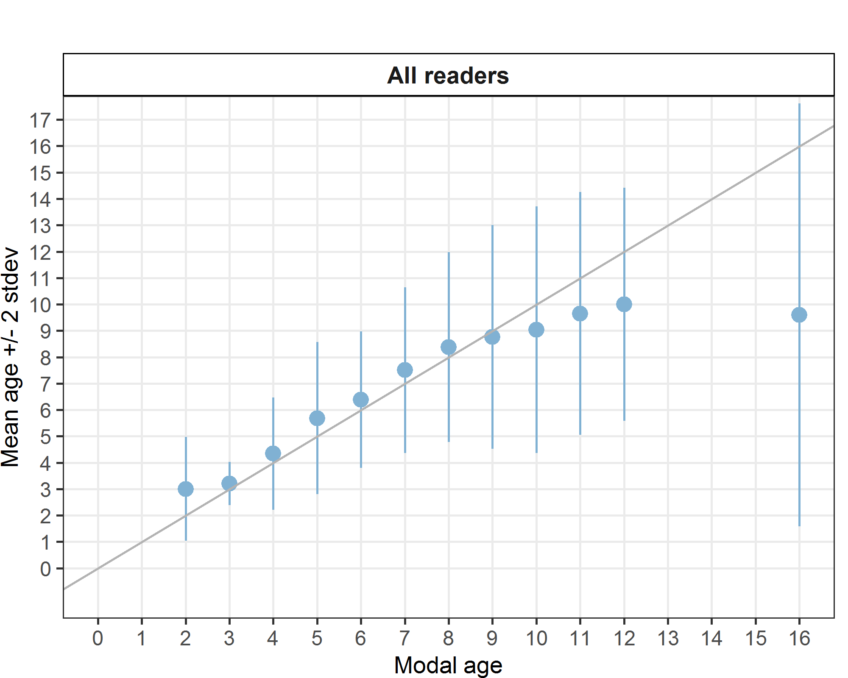

**Figure 1:** Age bias plot for all readers. Mean age recorded +/- 2 stdev of each reader and all readers combined are plotted against modal age. The estimated mean age corresponds to modal age, if the estimated mean age is on the 1:1 equilibrium line (solid line). Relative bias is the age difference between estimated mean age and modal age.

*Inter-reader bias test*

The inter-reader bias test show how practically all the readers, a part some exceptions, interpret the annuli differently, even within the same country (**Table 10**).

**Table 10:** Inter reader bias test. The Inter-reader bias test gives probability of bias between readers and with modal age. - = no sign of bias (p>0.05), * = possibility of bias (0.01<p<0.05), * * = certainty of bias (p<0.01), / = diagonal of the table (no bias).

|  |  |  |  |  |  |  |  |  |  |  |
| --- | --- | --- | --- | --- | --- | --- | --- | --- | --- | --- |
| **Comparison** | **R01 IE** | **R02 ES** | **R03 GB** | **R04 ES** | **R05 BE** | **R08 ES** | **R10 FR** | **R13 IE** | **R14 BE** | **R15 ES** |
| **R01 IE** | / | ** | - | ** | - | ** | ** | ** | ** | ** |
| **R02 ES** | ** | / | ** | ** | ** | ** | ** | ** | - | - |
| **R03 GB** | - | ** | / | - | ** | ** | ** | - | ** | ** |
| **R04 ES** | ** | ** | - | / | ** | - | ** | ** | - | * |
| **R05 BE** | - | ** | ** | ** | / | ** | ** | - | ** | ** |
| **R08 ES** | ** | ** | ** | - | ** | / | ** | ** | ** | - |
| **R10 FR** | ** | ** | ** | ** | ** | ** | / | ** | * | - |
| **R13 IE** | ** | ** | - | ** | - | ** | ** | / | ** | ** |
| **R14 BE** | ** | - | ** | - | ** | ** | * | ** | / | ** |
| **R15 ES** | ** | - | ** | * | ** | - | - | ** | ** | / |
| **Modal age** | ** | ** | ** | ** | ** | - | ** | ** | - | ** |

*Growth analysis*

There is scarce coherence in the marks in the identification of the first annulus between readers, with marked differences also in the successive winter annuli (**Figure 2**). Curiously the 5th annulus showed more coherence then the others analysed except for one reader.

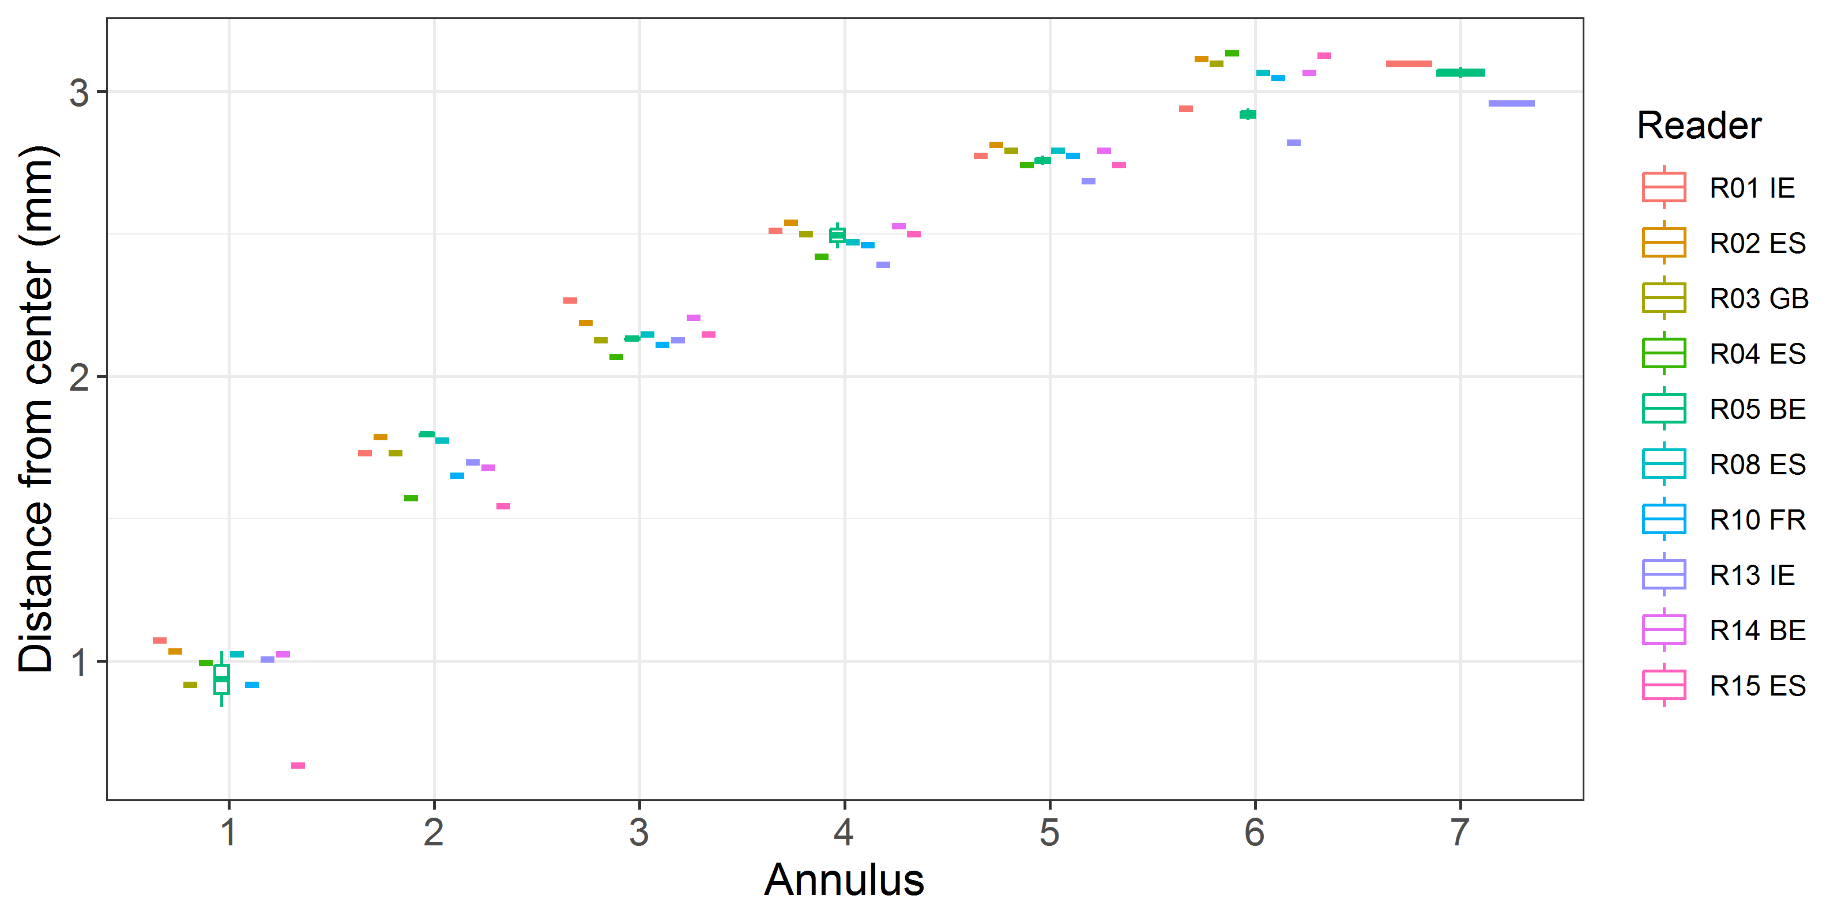

**Figure 2:** Plot of average distance from the centre to the winter rings for all readers. The boxes represent the median, upper and lower box boundaries of the interquartile range, whiskers represent the minimum and maximum values and the dots represent the outliers.

***Samples split by strata***

**Comparison results by reader on strata: Strata_S1**

*Multimodal cases*

**Table 11:** Strata S1. Total number of samples (NSample) and percentage of cases (fish samples) with multiple modes depending on the approach to weight the experience of the reader which will be considered when defining the fish age mode. PercMM_traditional shows the percentage of the total samples for which multiple modes are obtained when all the readers are equally weighted. PercMM_linear_weight shows the percentage of the total samples for which multiple modes are obtained when the weight assigned to the different readers decreases linearly with the experience, while in the PercMM_negexp the weight applied decreases with a negative exponential shape with the experience. The PercMM_multistage shows the percentage of multiple mode cases when a combination of the different methodologies is used, as explained in the material and methods section.

|  |  |  |  |  |
| --- | --- | --- | --- | --- |
| **NSample** | **PercMM_traditional** | **PercMM_linear_weight** | **PercMM_negexp_weight** | **PercMM_multistage** |
| 60 | 12 % | 3 % | 0 % | 0 % |

*Summary statistics*

The results obtained for the otolith of the first semester, do not differ significantly from the overall results.

**Table 12:** Strata Strata_S1. Summary of statistics; Total number of samples (NSample), coefficient of variance (CV), percentage of agreement (PA) and average percentage error (APE) for all ages and readers.

|  |  |  |  |
| --- | --- | --- | --- |
| **NSample** | **CV** | **PA** | **APE** |
| 60 | 21 % | 48 % | 16 % |

In this exchange event 60 otolith fish individuals were aged. Of those, 12 %when the traditional approach (all readers equally weighted) is used to define the mode. The percentage of multiple mode cases is reduced to 0 %. The complete list of cases with multiple modes is presented in **Table A3- 8** in the annex 3 section, where the ageing from each of the readers participating in the exchange event is presented. When all the otolith samples are considered (both single and multimodal cases) the weighted average percentage agreement based on modal ages for all readers is 48 %, with the weighted average CV of 21 % and APE of 16 %.

*Coefficient of Variation (CV)*

**Table 13:** Strata_S1. Coefficient of Variation (CV) table presents the CV per modal age and reader, the CV of all readers combined per modal age and a weighted mean of the CV per reader.

|  |  |  |  |  |  |  |  |  |
| --- | --- | --- | --- | --- | --- | --- | --- | --- |
| **Modal age** | **R01 IE** | **R02 ES** | **R03 GB** | **R04 ES** | **R05 BE** | **R08 ES** | **R10 FR** | **R13 IE** |
| 2 | 0 % | 0 % | 17 % | 0 % | 0 % | 0 % | 0 % | 13 % |
| 3 | 0 % | 0 % | 0 % | 0 % | 0 % | 0 % | 0 % | 0 % |
| 4 | 15 % | 11 % | 12 % | 31 % | 10 % | 12 % | 0 % | 25 % |
| 5 | 25 % | 14 % | 19 % | 14 % | 17 % | 11 % | 9 % | 20 % |
| 6 | 18 % | 9 % | 10 % | 9 % | 20 % | 8 % | 8 % | 20 % |
| 7 | 18 % | 14 % | 18 % | 6 % | 18 % | 14 % | 15 % | 27 % |
| 8 | 10 % | 0 % | 11 % | 8 % | 13 % | 7 % | 6 % | 15 % |
| 9 | 24 % | 0 % | 22 % | 16 % | 17 % | 18 % | 7 % | 18 % |
| 10 | - | - | - | - | - | - | - | - |
| 11 | - | - | - | - | - | - | - | - |
| 12 | - | - | - | - | - | - | - | - |
| 13 | - | - | - | - | - | - | - | - |
| 14 | - | - | - | - | - | - | - | - |
| 15 | - | - | - | - | - | - | - | - |
| 16 | - | - | - | - | - | - | - | - |
| **Weighted Mean** | **17 %** | **8 %** | **14 %** | **12 %** | **15 %** | **9 %** | **7 %** | **19 %** |

|  |  |  |  |
| --- | --- | --- | --- |
| **Modal age** | **R14 BE** | **R15 ES** | **all** |
| 2 | 65 % | 0 % | **33 %** |
| 3 | 0 % | 0 % | **13 %** |
| 4 | 12 % | 12 % | **21 %** |
| 5 | 11 % | 12 % | **21 %** |
| 6 | 11 % | 7 % | **19 %** |
| 7 | 6 % | 21 % | **23 %** |
| 8 | 12 % | 10 % | **19 %** |
| 9 | 0 % | 11 % | **22 %** |
| 10 | - | - | **18 %** |
| 11 | - | - | **-** |
| 12 | - | - | **22 %** |
| 13 | - | - | **-** |
| 14 | - | - | **-** |
| 15 | - | - | **-** |
| 16 | - | - | **-** |
| **Weighted Mean** | **13 %** | **10 %** | **21 %** |

*Percentage of Agreement (PA)*

The percentage agreement per reader per modal age tells how large part of the readings that are equal to the modal age. The weighted mean including at the bottom of the table is weighted according to number of age readings. The total PA varied between 20 and 80%, but more than half of the ages showed PA lower than 50% (**Table 14**). It is remarkable that one reader has no agreement with any of the others (**Table 14**).

**Table 14:** Strata_S1. Percentage agreement (PA) table represents the PA per modal age and reader, the PA of all readers combined per modal age and a weighted mean of the PA per reader.

|  |  |  |  |  |  |  |  |  |
| --- | --- | --- | --- | --- | --- | --- | --- | --- |
| **Modal age** | **R01 IE** | **R02 ES** | **R03 GB** | **R04 ES** | **R05 BE** | **R08 ES** | **R10 FR** | **R13 IE** |
| 2 | 100 % | 0 % | 0 % | 100 % | 0 % | 100 % | 0 % | 0 % |
| 3 | 100 % | 100 % | 100 % | 100 % | 0 % | 100 % | 100 % | 100 % |
| 4 | 60 % | 80 % | 75 % | 20 % | 0 % | 80 % | 100 % | 40 % |
| 5 | 22 % | 61 % | 44 % | 56 % | 0 % | 89 % | 78 % | 39 % |
| 6 | 25 % | 75 % | 58 % | 67 % | 0 % | 75 % | 75 % | 27 % |
| 7 | 20 % | 80 % | 0 % | 80 % | 0 % | 20 % | 40 % | 60 % |
| 8 | 0 % | 100 % | 45 % | 45 % | 0 % | 73 % | 82 % | 27 % |
| 9 | 0 % | 100 % | 0 % | 0 % | 0 % | 50 % | 50 % | 0 % |
| 10 | 0 % | 100 % | 100 % | 0 % | 0 % | 0 % | 100 % | 0 % |
| 11 | - | - | - | - | - | - | - | - |
| 12 | 100 % | 0 % | 100 % | 0 % | 0 % | 0 % | 0 % | 0 % |
| 13 | - | - | - | - | - | - | - | - |
| 14 | - | - | - | - | - | - | - | - |
| 15 | - | - | - | - | - | - | - | - |
| 16 | - | - | - | - | - | - | - | - |
| **Weighted Mean** | **28 %** | **73 %** | **46 %** | **55 %** | **0 %** | **73 %** | **72 %** | **34 %** |

|  |  |  |  |
| --- | --- | --- | --- |
| **Modal age** | **R14 BE** | **R15 ES** | **total** |
| 2 | 33 % | 0 % | **33 %** |
| 3 | 100 % | 0 % | **80 %** |
| 4 | 80 % | 40 % | **57 %** |
| 5 | 72 % | 61 % | **52 %** |
| 6 | 58 % | 83 % | **55 %** |
| 7 | 80 % | 20 % | **40 %** |
| 8 | 27 % | 0 % | **40 %** |
| 9 | 100 % | 0 % | **30 %** |
| 10 | 100 % | 0 % | **40 %** |
| 11 | - | - | **-** |
| 12 | 0 % | 0 % | **20 %** |
| 13 | - | - | **-** |
| 14 | - | - | **-** |
| 15 | - | - | **-** |
| 16 | - | - | **-** |
| **Weighted Mean** | **62 %** | **40 %** | **48 %** |

*Average Percentage Error (APE)*

In the modal age 2 to 6 the APE values ranged between 10 and 27% when considering all the readers together (**Table 15**). While for ages 7+, they varied from 13 to 18% (**Table 15**). Some readers showed good precision with values of 10% or less, but others overpass this threshold (**Table 15**). Best results when considering the readers pooled were obtained for modal age 3, while the worst for modal ages 2, however, the significance of this latter result should be considered low, as only two 2-year-old otoliths were analysed (**Table 15**).

**Table 15:** Strata_S1. Average Percentage Error (APE) table represents the APE per modal age and reader, the APE of all advanced readers combined per modal age and a weighted mean of the APE per reader.

|  |  |  |  |  |  |  |  |  |
| --- | --- | --- | --- | --- | --- | --- | --- | --- |
| **Modal age** | **R01 IE** | **R02 ES** | **R03 GB** | **R04 ES** | **R05 BE** | **R08 ES** | **R10 FR** | **R13 IE** |
| 2 | 0 % | 0 % | 13 % | 0 % | 0 % | 0 % | 0 % | 10 % |
| 3 | 0 % | 0 % | 0 % | 0 % | 0 % | 0 % | 0 % | 0 % |
| 4 | 13 % | 8 % | 9 % | 23 % | 9 % | 8 % | 0 % | 20 % |
| 5 | 21 % | 12 % | 16 % | 11 % | 14 % | 6 % | 6 % | 16 % |
| 6 | 13 % | 5 % | 9 % | 7 % | 14 % | 7 % | 7 % | 17 % |
| 7 | 12 % | 10 % | 15 % | 4 % | 14 % | 11 % | 12 % | 22 % |
| 8 | 8 % | 0 % | 9 % | 7 % | 9 % | 4 % | 2 % | 13 % |
| 9 | 17 % | 0 % | 16 % | 11 % | 12 % | 12 % | 5 % | 13 % |
| 10 | 0 % | 0 % | 0 % | 0 % | 0 % | 0 % | 0 % | 0 % |
| 11 | - | - | - | - | - | - | - | - |
| 12 | 0 % | 0 % | 0 % | 0 % | 0 % | 0 % | 0 % | 0 % |
| 13 | - | - | - | - | - | - | - | - |
| 14 | - | - | - | - | - | - | - | - |
| 15 | - | - | - | - | - | - | - | - |
| 16 | - | - | - | - | - | - | - | - |
| **Weighted Mean** | **13 %** | **6 %** | **11 %** | **9 %** | **11 %** | **6 %** | **5 %** | **15 %** |

|  |  |  |  |
| --- | --- | --- | --- |
| **Modal age** | **R14 BE** | **R15 ES** | **all** |
| 2 | 48 % | 0 % | **27 %** |
| 3 | 0 % | 0 % | **10 %** |
| 4 | 8 % | 10 % | **16 %** |
| 5 | 6 % | 9 % | **17 %** |
| 6 | 9 % | 5 % | **14 %** |
| 7 | 4 % | 16 % | **17 %** |
| 8 | 10 % | 7 % | **15 %** |
| 9 | 0 % | 8 % | **17 %** |
| 10 | 0 % | 0 % | **13 %** |
| 11 | - | - | **-** |
| 12 | 0 % | 0 % | **18 %** |
| 13 | - | - | **-** |
| 14 | - | - | **-** |
| 15 | - | - | **-** |
| 16 | - | - | **-** |
| **Weighted Mean** | **9 %** | **7 %** | **16 %** |

*Relative bias*

The relative bias is the difference between the mean age (per modal age per reader) and modal age. As for the previous tables, a combined bias for all readers and weighted means are calculated (**Table 16**, **Figure 3**). In this case we can observe that two readers tend to overestimate the age largely (more than 1 year), while another group tend to slightly underestimate the age (**Table 16**). General results in relative accuracy for all readers have been obtained (0.51), with values between ‐2.00 and +1.00 (**Table 9**).

**Table 16:** Strata_S1. The relative bias (as the difference between the mean and modal age) per modal age and reader is presented, as well as the weighted mean relative bias per reader and the relative bias per modal age for all readers combined.

|  |  |  |  |  |  |  |  |  |
| --- | --- | --- | --- | --- | --- | --- | --- | --- |
| **Modal age** | **R01 IE** | **R02 ES** | **R03 GB** | **R04 ES** | **R05 BE** | **R08 ES** | **R10 FR** | **R13 IE** |
| 2 | 0.00 | 1.00 | 1.33 | 0.00 | 2.00 | 0.00 | 1.00 | 2.33 |
| 3 | 0.00 | 0.00 | 0.00 | 0.00 | 1.00 | 0.00 | 0.00 | 0.00 |
| 4 | -0.40 | 0.20 | 0.25 | 0.20 | 1.60 | -0.20 | 0.00 | 1.20 |
| 5 | 0.89 | 0.39 | 0.81 | 0.28 | 2.50 | -0.17 | 0.11 | 1.17 |
| 6 | 1.08 | -0.08 | 0.50 | 0.17 | 2.58 | -0.25 | -0.25 | 1.27 |
| 7 | 1.40 | -0.40 | 0.40 | 0.20 | 3.20 | -0.40 | 0.40 | 1.60 |
| 8 | 2.36 | 0.00 | 0.91 | 0.36 | 2.73 | 0.09 | 0.00 | 2.00 |
| 9 | 3.00 | 0.00 | 0.50 | 0.00 | 3.50 | -1.00 | 0.50 | 2.50 |
| 10 | 3.00 | 0.00 | 0.00 | 1.00 | 3.00 | -2.00 | 0.00 | 1.00 |
| 11 | - | - | - | - | - | - | - | - |
| 12 | 0.00 | -3.00 | 0.00 | -1.00 | 2.00 | -4.00 | -3.00 | -2.00 |
| 13 | - | - | - | - | - | - | - | - |
| 14 | - | - | - | - | - | - | - | - |
| 15 | - | - | - | - | - | - | - | - |
| 16 | - | - | - | - | - | - | - | - |
| **Weighted Mean** | **1.15** | **0.08** | **0.65** | **0.22** | **2.50** | **-0.27** | **0.03** | **1.39** |

|  |  |  |  |
| --- | --- | --- | --- |
| **Modal age** | **R14 BE** | **R15 ES** | **all** |
| 2 | 0.33 | 2.00 | **1.00** |
| 3 | 0.00 | 1.00 | **0.20** |
| 4 | -0.20 | 0.60 | **0.33** |
| 5 | 0.06 | 0.17 | **0.62** |
| 6 | -0.25 | -0.17 | **0.46** |
| 7 | 0.20 | -1.60 | **0.50** |
| 8 | -0.73 | -1.82 | **0.59** |
| 9 | 0.00 | -2.50 | **0.65** |
| 10 | 0.00 | -3.00 | **0.30** |
| 11 | - | - | **-** |
| 12 | -4.00 | -5.00 | **-2.00** |
| 13 | - | - | **-** |
| 14 | - | - | **-** |
| 15 | - | - | **-** |
| 16 | - | - | **-** |
| **Weighted Mean** | **-0.22** | **-0.48** | **0.51** |

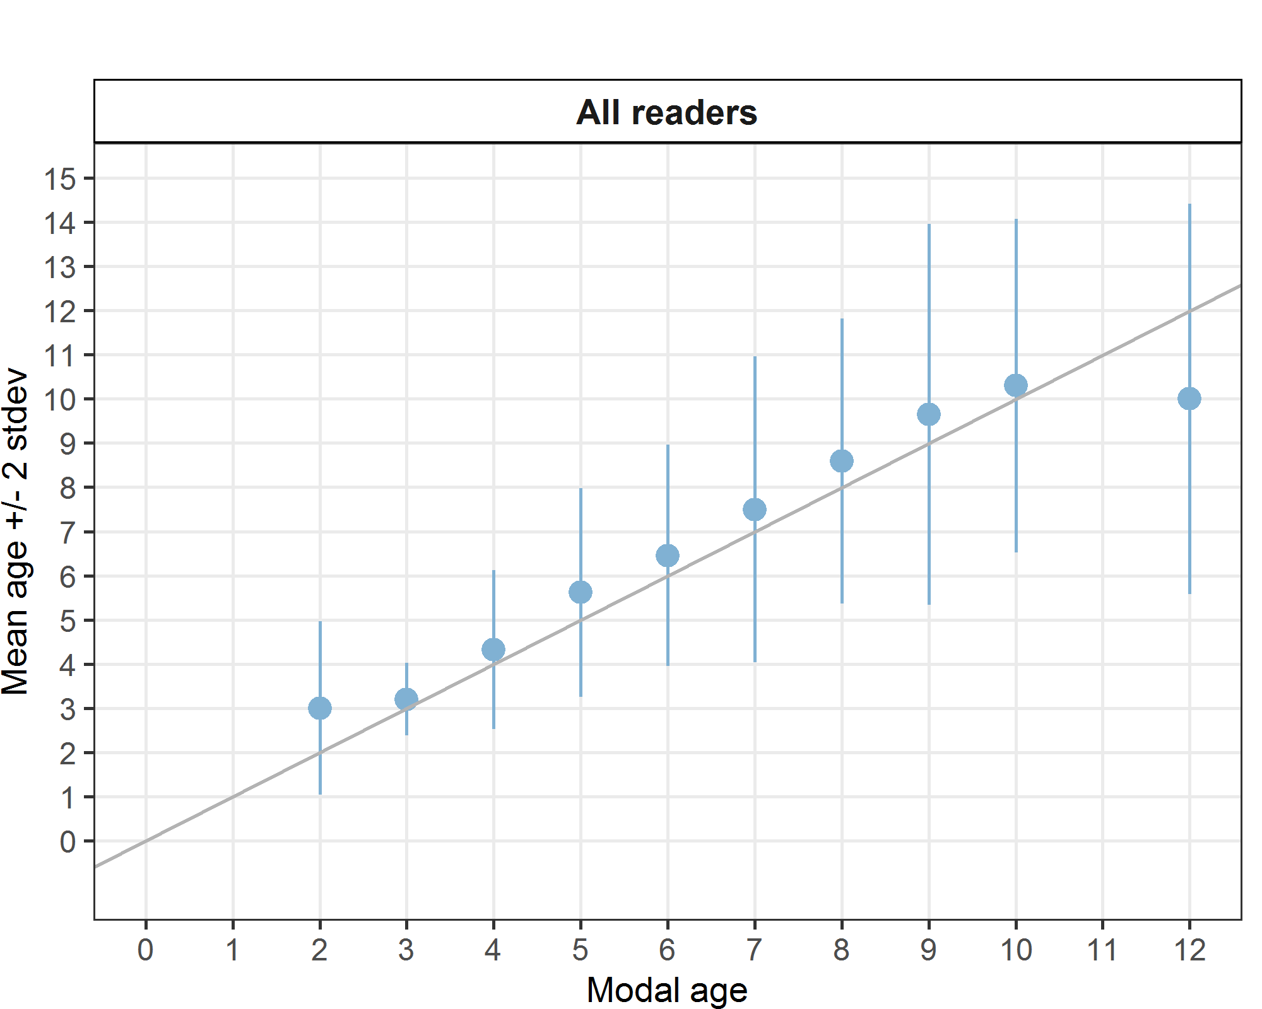

**Figure 3:** Strata_S1. Age bias plot for all readers. Mean age recorded +/- 2 stdev of each reader and all readers combined are plotted against modal age. The estimated mean age corresponds to modal age, if the estimated mean age is on the 1:1 equilibrium line (solid line). Relative bias is the age difference between estimated mean age and modal age.

*Inter-reader bias test*

**Table 17:** Strata_S1. Inter reader bias test. The Inter-reader bias test gives probability of bias between readers and with modal age. - = no sign of bias (p>0.05), * = possibility of bias (0.01<p<0.05), * * = certainty of bias (p<0.01), / = diagonal of the table (no bias).

|  |  |  |  |  |  |  |  |  |  |  |
| --- | --- | --- | --- | --- | --- | --- | --- | --- | --- | --- |
| **Comparison** | **R01 IE** | **R02 ES** | **R03 GB** | **R04 ES** | **R05 BE** | **R08 ES** | **R10 FR** | **R13 IE** | **R14 BE** | **R15 ES** |
| **R01 IE** | / | ** | - | ** | - | ** | ** | ** | ** | ** |
| **R02 ES** | ** | / | ** | ** | ** | ** | ** | ** | - | - |
| **R03 GB** | - | ** | / | - | ** | ** | ** | - | ** | ** |
| **R04 ES** | ** | ** | - | / | ** | - | ** | ** | - | * |
| **R05 BE** | - | ** | ** | ** | / | ** | ** | - | ** | ** |
| **R08 ES** | ** | ** | ** | - | ** | / | ** | ** | ** | - |
| **R10 FR** | ** | ** | ** | ** | ** | ** | / | ** | * | - |
| **R13 IE** | ** | ** | - | ** | - | ** | ** | / | ** | ** |
| **R14 BE** | ** | - | ** | - | ** | ** | * | ** | / | ** |
| **R15 ES** | ** | - | ** | * | ** | - | - | ** | ** | / |
| **Modal age** | ** | ** | ** | ** | ** | - | ** | ** | - | ** |

*Growth Analysis*

In the case of semester 1, there is scarce coherence in the marks in the identification of the first annulus between readers, and worse than when considering both strata (**Figure 4**).



**Figure 4:** Strata_S1. Plot of average distance from the centre to the winter rings for all readers. The boxes represent the median, upper and lower box boundaries of the interquartile range, whiskers represent the minimum and maximum values and the dots represent the outliers.

**Comparison results by reader on strata: Strata_S2**

*Multimodal cases*

**Table 18:** Strata S2. Total number of samples (NSample) and percentage of cases (fish samples) with multiple modes depending on the approach to weight the experience of the reader which will be considered when defining the fish age mode. PercMM_traditional shows the percentage of the total samples for which multiple modes are obtained when all the readers are equally weighted. PercMM_linear_weight shows the percentage of the total samples for which multiple modes are obtained when the weight assigned to the different readers decreases linearly with the experience, while in the PercMM_negexp the weight applied decreases with a negative exponential shape with the experience. The PercMM_multistage shows the percentage of multiple mode cases when a combination of the different methodologies is used, as explained in the material and methods section.

|  |  |  |  |  |
| --- | --- | --- | --- | --- |
| **NSample** | **PercMM_traditional** | **PercMM_linear_weight** | **PercMM_negexp_weight** | **PercMM_multistage** |
| 60 | 15 % | 2 % | 0 % | 0 % |

*Summary statistics*

**Table 19:** Strata Strata_S2. Summary of statistics; Total number of samples (NSample), coefficient of variance (CV), percentage of agreement (PA) and average percentage error (APE) for all ages and readers.

|  |  |  |  |
| --- | --- | --- | --- |
| **NSample** | **CV** | **PA** | **APE** |
| 60 | 25 % | 43 % | 19 % |

Results for the strata 2 (semester 2) are worse than those for strata 1 (semester 1). This is usual in this species considering that in the second semester the readers indicate that the edge of the otoliths is predominantly opaque, making more difficult: a) the readings and b) the identification of the true annuli at the edge of the structures.

*Coefficient of Variation (CV)*

The minimum CV per age group is higher than in Semester 1 (**Table 20**), reaching 19% rather than 13% for S1. The maximum is lower, reaching 29% for age 5, compared to 33% for the modal age 2 in S1. Therefore, in general, the CV is higher, but without spikes, compared with the first semester.

**Table 20:** Strata_S2. Coefficient of Variation (CV) table presents the CV per modal age and reader, the CV of all readers combined per modal age and a weighted mean of the CV per reader.

|  |  |  |  |  |  |  |  |  |
| --- | --- | --- | --- | --- | --- | --- | --- | --- |
| **Modal age** | **R01 IE** | **R02 ES** | **R03 GB** | **R04 ES** | **R05 BE** | **R08 ES** | **R10 FR** | **R13 IE** |
| 2 | - | - | - | - | - | - | - | - |
| 3 | - | - | - | - | - | - | - | - |
| 4 | 37 % | 17 % | 23 % | 12 % | 22 % | 22 % | 11 % | 41 % |
| 5 | 34 % | 14 % | 23 % | 21 % | 21 % | 17 % | 21 % | 30 % |
| 6 | 24 % | 10 % | 16 % | 12 % | 15 % | 16 % | 20 % | 20 % |
| 7 | 11 % | 6 % | 12 % | 23 % | 20 % | 7 % | 12 % | 19 % |
| 8 | 20 % | 9 % | 11 % | 13 % | 21 % | 15 % | 15 % | 16 % |
| 9 | 10 % | 12 % | 9 % | 24 % | 23 % | 32 % | 8 % | 18 % |
| 10 | 13 % | - | 14 % | 16 % | 0 % | 9 % | 11 % | 7 % |
| 11 | 17 % | 7 % | 0 % | 7 % | 6 % | 18 % | 25 % | 7 % |
| 12 | - | - | - | - | - | - | - | - |
| 13 | - | - | - | - | - | - | - | - |
| 14 | - | - | - | - | - | - | - | - |
| 15 | - | - | - | - | - | - | - | - |
| 16 | - | - | - | - | - | - | - | - |
| **Weighted Mean** | **25 %** | **11 %** | **17 %** | **17 %** | **19 %** | **17 %** | **17 %** | **24 %** |

|  |  |  |  |
| --- | --- | --- | --- |
| **Modal age** | **R14 BE** | **R15 ES** | **all** |
| 2 | - | - | **-** |
| 3 | - | - | **-** |
| 4 | 17 % | 11 % | **27 %** |
| 5 | 12 % | 14 % | **29 %** |
| 6 | 10 % | 12 % | **21 %** |
| 7 | 8 % | 11 % | **19 %** |
| 8 | 22 % | 18 % | **24 %** |
| 9 | 25 % | 9 % | **24 %** |
| 10 | 28 % | 39 % | **28 %** |
| 11 | 28 % | 0 % | **24 %** |
| 12 | - | - | **-** |
| 13 | - | - | **-** |
| 14 | - | - | **-** |
| 15 | - | - | **-** |
| 16 | - | - | **42 %** |
| **Weighted Mean** | **15 %** | **13 %** | **25 %** |

*Percentage of Agreement (PA)*

The PA in the S2 is lower than in S1 with values per age class ranging between 20 and 59% (modale ages 16 and 4 respectively) (**Table 21**). Even when considering the single readers, the highest value is 65%, while 3 readers are around 30% (**Table 21**) indicating different criteria in recognizing annual rings.

**Table 21:** Strata_S2. Percentage agreement (PA) table represents the PA per modal age and reader, the PA of all readers combined per modal age and a weighted mean of the PA per reader.

|  |  |  |  |  |  |  |  |  |
| --- | --- | --- | --- | --- | --- | --- | --- | --- |
| **Modal age** | **R01 IE** | **R02 ES** | **R03 GB** | **R04 ES** | **R05 BE** | **R08 ES** | **R10 FR** | **R13 IE** |
| 2 | - | - | - | - | - | - | - | **-** |
| 3 | - | - | - | - | - | - | - | - |
| 4 | 62 % | 62 % | 50 % | 75 % | 25 % | 38 % | 75 % | 62 % |
| 5 | 41 % | 71 % | 18 % | 71 % | 12 % | 71 % | 65 % | 18 % |
| 6 | 18 % | 50 % | 55 % | 73 % | 27 % | 73 % | 55 % | 18 % |
| 7 | 0 % | 83 % | 20 % | 67 % | 50 % | 33 % | 33 % | 17 % |
| 8 | 11 % | 50 % | 62 % | 67 % | 11 % | 56 % | 33 % | 22 % |
| 9 | 50 % | 50 % | 50 % | 25 % | 50 % | 25 % | 0 % | 25 % |
| 10 | 50 % | 0 % | 0 % | 50 % | 100 % | 0 % | 0 % | 50 % |
| 11 | 50 % | 0 % | 100 % | 50 % | 0 % | 0 % | 0 % | 50 % |
| 12 | - | - | - | - | - | - | - | - |
| 13 | - | - | - | - | - | - | - | - |
| 14 | - | - | - | - | - | - | - | - |
| 15 | - | - | - | - | - | - | - | - |
| 16 | 100 % | 0 % | 0 % | 0 % | 0 % | 0 % | 0 % | 100 % |
| **Weighted Mean** | **33 %** | **58 %** | **40 %** | **65 %** | **25 %** | **52 %** | **47 %** | **28 %** |

|  |  |  |  |
| --- | --- | --- | --- |
| **Modal age** | **R14 BE** | **R15 ES** | **total** |
| 2 | - | - | **-** |
| 3 | - | - | **-** |
| 4 | 62 % | 75 % | **59 %** |
| 5 | 65 % | 71 % | **50 %** |
| 6 | 40 % | 36 % | **44 %** |
| 7 | 67 % | 17 % | **39 %** |
| 8 | 33 % | 0 % | **34 %** |
| 9 | 25 % | 0 % | **30 %** |
| 10 | 0 % | 0 % | **26 %** |
| 11 | 0 % | 0 % | **25 %** |
| 12 | - | - | **-** |
| 13 | - | - | **-** |
| 14 | - | - | **-** |
| 15 | - | - | **-** |
| 16 | 0 % | 0 % | **20 %** |
| **Weighted Mean** | **47 %** | **38 %** | **43 %** |

*Average Percentage Error (APE)*

For otolith relative to the second semester, the precision has lowered when compared with data from the first semester (**Table 22**). The lowest value is 7 percent points higher than in the S1 (**Table 22**), also the maximum values has increased reaching 34% (**Table 22**).

**Table 22:** Strata_S2. Average Percentage Error (APE) table represents the APE per modal age and reader, the APE of all advanced readers combined per modal age and a weighted mean of the APE per reader.

|  |  |  |  |  |  |  |  |  |
| --- | --- | --- | --- | --- | --- | --- | --- | --- |
| **Modal age** | **R01 IE** | **R02 ES** | **R03 GB** | **R04 ES** | **R05 BE** | **R08 ES** | **R10 FR** | **R13 IE** |
| 2 | - | - | - | - | - | - | - | - |
| 3 | - | - | - | - | - | - | - | - |
| 4 | 22 % | 11 % | 18 % | 10 % | 18 % | 17 % | 9 % | 25 % |
| 5 | 28 % | 8 % | 18 % | 12 % | 17 % | 9 % | 11 % | 19 % |
| 6 | 19 % | 9 % | 13 % | 8 % | 13 % | 11 % | 14 % | 16 % |
| 7 | 9 % | 4 % | 10 % | 14 % | 16 % | 6 % | 10 % | 13 % |
| 8 | 16 % | 7 % | 8 % | 9 % | 15 % | 14 % | 11 % | 12 % |
| 9 | 8 % | 9 % | 6 % | 18 % | 17 % | 27 % | 7 % | 13 % |
| 10 | 9 % | 0 % | 10 % | 11 % | 0 % | 7 % | 8 % | 5 % |
| 11 | 12 % | 5 % | 0 % | 5 % | 4 % | 12 % | 18 % | 5 % |
| 12 | - | - | - | - | - | - | - | - |
| 13 | - | - | - | - | - | - | - | - |
| 14 | - | - | - | - | - | - | - | - |
| 15 | - | - | - | - | - | - | - | - |
| 16 | 0 % | 0 % | 0 % | 0 % | 0 % | 0 % | 0 % | 0 % |
| **Weighted Mean** | **19 %** | **8 %** | **13 %** | **11 %** | **15 %** | **12 %** | **11 %** | **16 %** |

|  |  |  |  |
| --- | --- | --- | --- |
| **Modal age** | **R14 BE** | **R15 ES** | **all** |
| 2 | - | - | **-** |
| 3 | - | - | **-** |
| 4 | 11 % | 9 % | **18 %** |
| 5 | 9 % | 10 % | **22 %** |
| 6 | 9 % | 10 % | **16 %** |
| 7 | 7 % | 6 % | **15 %** |
| 8 | 18 % | 14 % | **17 %** |
| 9 | 19 % | 7 % | **19 %** |
| 10 | 20 % | 27 % | **23 %** |
| 11 | 20 % | 0 % | **19 %** |
| 12 | - | - | **-** |
| 13 | - | - | **-** |
| 14 | - | - | **-** |
| 15 | - | - | **-** |
| 16 | 0 % | 0 % | **34 %** |
| **Weighted Mean** | **12 %** | **10 %** | **19 %** |

*Relative bias*

Result for bias in the S2 are better than those obtained for S1 otoliths, at least for modal ages until 8, indicating a slight overestimation for these modal ages (**Table 23**). From age 9 on there is a systematic underestimation (**Table 23**). Some readers overestimate abundantly practically for all the modal ages, while others tend to slightly underestimate systematically (**Table 23**). Considering all the readers, systematic underestimation occurred for modal ages higher than 8 years old (**Figure 5**).

**Table 23:** Strata_S2. The relative bias (as the difference between the mean and modal age) per modal age and reader is presented, as well as the weighted mean relative bias per reader and the relative bias per modal age for all readers combined.

|  |  |  |  |  |  |  |  |  |
| --- | --- | --- | --- | --- | --- | --- | --- | --- |
| **Modal age** | **R01 IE** | **R02 ES** | **R03 GB** | **R04 ES** | **R05 BE** | **R08 ES** | **R10 FR** | **R13 IE** |
| 2 | - | - | - | - | - | - | - | - |
| 3 | - | - | - | - | - | - | - | - |
| 4 | 0.25 | -0.12 | 0.88 | -0.25 | 1.50 | -0.12 | 0.25 | 1.00 |
| 5 | 1.41 | 0.12 | 1.65 | 0.24 | 2.59 | -0.06 | -0.06 | 2.12 |
| 6 | 1.45 | -0.50 | 0.82 | 0.18 | 1.36 | -0.27 | -0.18 | 1.36 |
| 7 | 2.17 | 0.17 | 0.40 | -0.17 | 1.33 | 0.67 | -0.33 | 2.17 |
| 8 | 2.78 | -0.25 | 0.25 | 0.33 | 1.89 | -0.89 | -0.67 | 1.22 |
| 9 | 0.75 | -0.75 | 0.00 | -0.50 | 1.50 | -1.50 | -1.50 | 0.75 |
| 10 | 1.00 | -1.00 | 0.00 | -1.00 | 0.00 | -2.50 | -3.50 | 0.50 |
| 11 | 1.50 | -1.50 | 0.00 | -0.50 | 1.50 | -3.00 | -2.50 | -0.50 |
| 12 | - | - | - | - | - | - | - | - |
| 13 | - | - | - | - | - | - | - | - |
| 14 | - | - | - | - | - | - | - | - |
| 15 | - | - | - | - | - | - | - | - |
| 16 | 0.00 | -9.00 | -7.00 | -8.00 | -3.00 | -7.00 | -11.00 | 0.00 |
| **Weighted Mean** | **1.47** | **-0.37** | **0.71** | **-0.12** | **1.70** | **-0.55** | **-0.63** | **1.43** |

|  |  |  |  |
| --- | --- | --- | --- |
| **Modal age** | **R14 BE** | **R15 ES** | **all** |
| 2 | - | - | **-** |
| 3 | - | - | **-** |
| 4 | -0.12 | 0.25 | **0.35** |
| 5 | -0.24 | -0.24 | **0.75** |
| 6 | -0.60 | -0.73 | **0.29** |
| 7 | -0.33 | -1.00 | **0.51** |
| 8 | -1.11 | -2.33 | **0.12** |
| 9 | -2.25 | -3.25 | **-0.68** |
| 10 | -5.00 | -4.50 | **-1.60** |
| 11 | -3.50 | -5.00 | **-1.35** |
| 12 | - | - | **-** |
| 13 | - | - | **-** |
| 14 | - | - | **-** |
| 15 | - | - | **-** |
| 16 | -9.00 | -10.00 | **-6.40** |
| **Weighted Mean** | **-0.98** | **-1.32** | **0.13** |

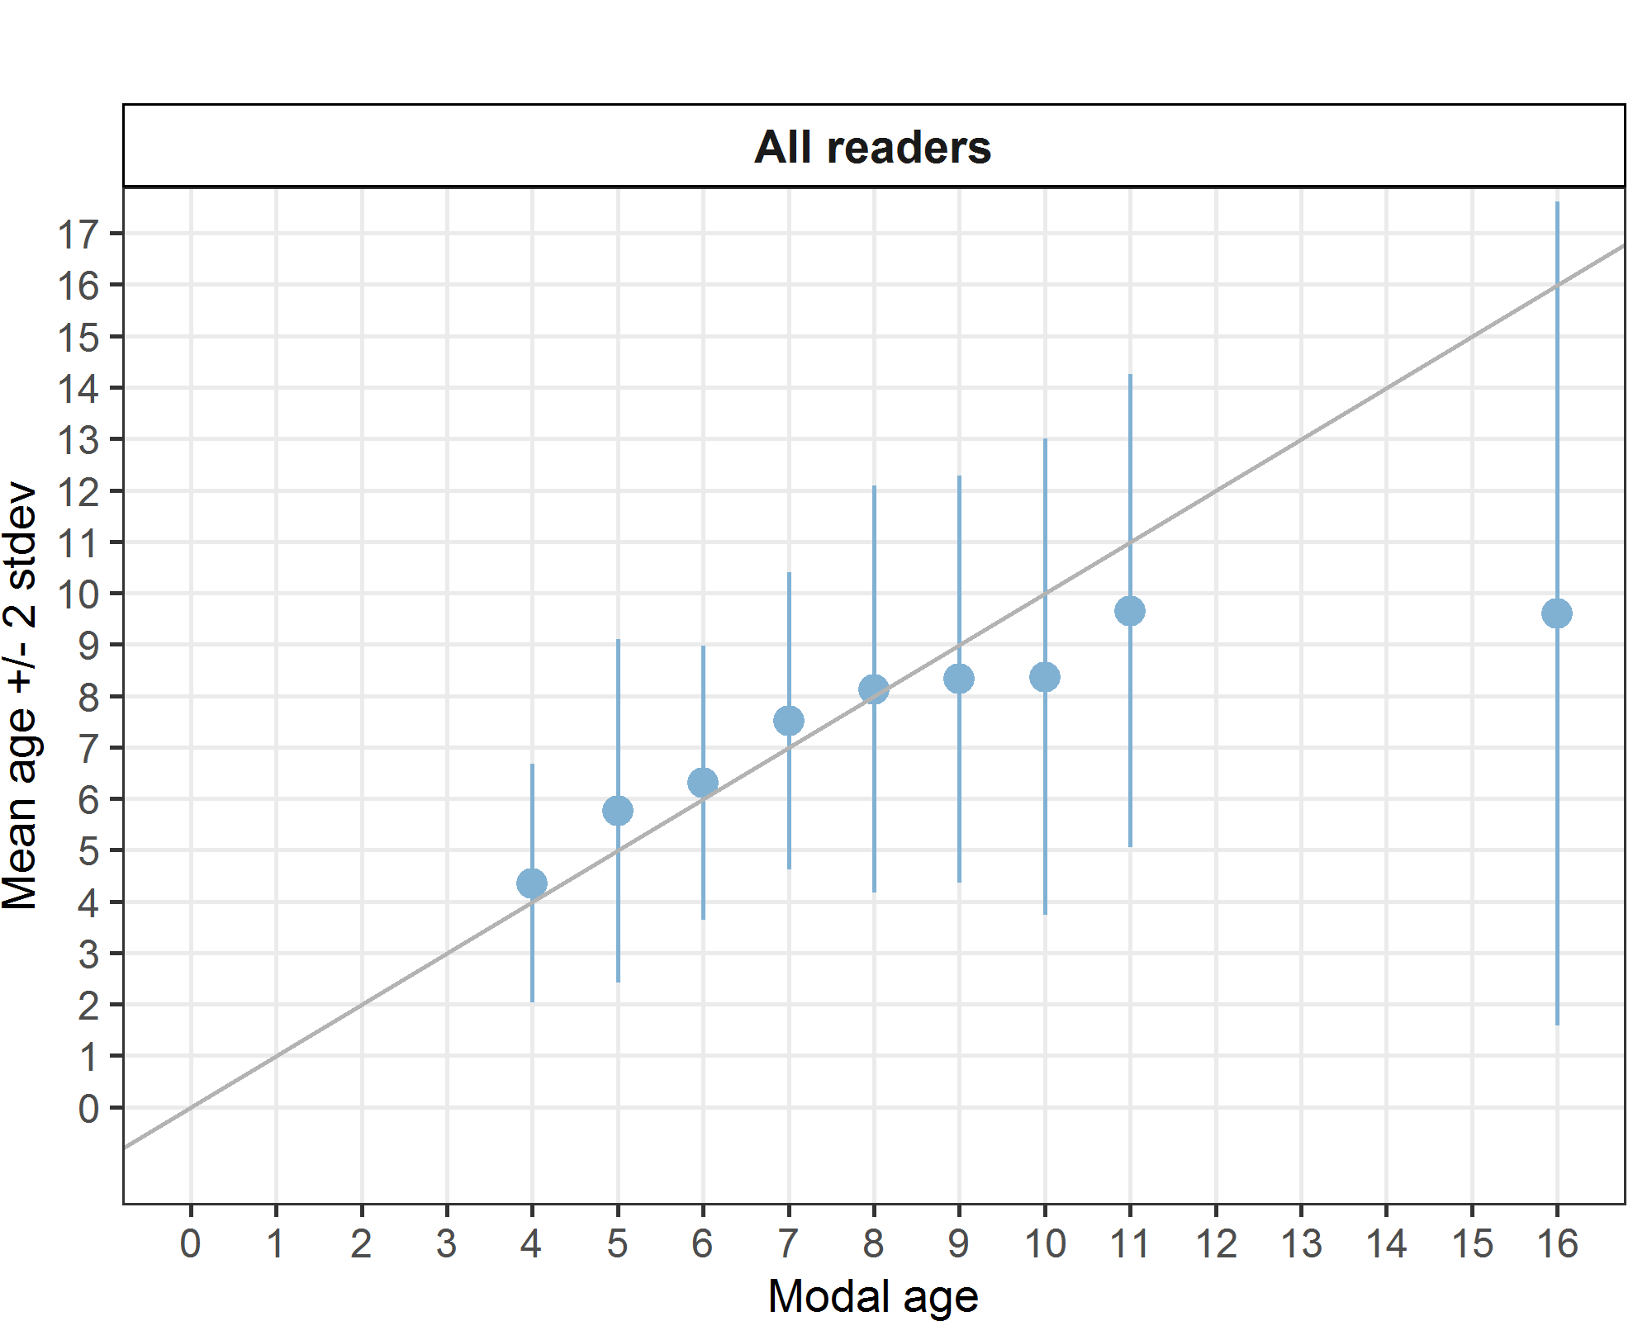

**Figure 5:** Strata_S2. Age bias plot for all readers. Mean age recorded +/- 2 stdev of each reader and all readers combined are plotted against modal age. The estimated mean age corresponds to modal age, if the estimated mean age is on the 1:1 equilibrium line (solid line). Relative bias is the age difference between estimated mean age and modal age.

*Inter-reader bias test*

**Table 24:** Strata_S2. Inter reader bias test. The Inter-reader bias test gives probability of bias between readers and with modal age. - = no sign of bias (p>0.05), * = possibility of bias (0.01<p<0.05), * * = certainty of bias (p<0.01), / = diagonal of the table (no bias).

|  |  |  |  |  |  |  |  |  |  |  |
| --- | --- | --- | --- | --- | --- | --- | --- | --- | --- | --- |
| **Comparison** | **R01 IE** | **R02 ES** | **R03 GB** | **R04 ES** | **R05 BE** | **R08 ES** | **R10 FR** | **R13 IE** | **R14 BE** | **R15 ES** |
| **R01 IE** | / | ** | - | ** | - | ** | ** | ** | ** | ** |
| **R02 ES** | ** | / | ** | ** | ** | ** | ** | ** | - | - |
| **R03 GB** | - | ** | / | - | ** | ** | ** | - | ** | ** |
| **R04 ES** | ** | ** | - | / | ** | - | ** | ** | - | * |
| **R05 BE** | - | ** | ** | ** | / | ** | ** | - | ** | ** |
| **R08 ES** | ** | ** | ** | - | ** | / | ** | ** | ** | - |
| **R10 FR** | ** | ** | ** | ** | ** | ** | / | ** | * | - |
| **R13 IE** | ** | ** | - | ** | - | ** | ** | / | ** | ** |
| **R14 BE** | ** | - | ** | - | ** | ** | * | ** | / | ** |
| **R15 ES** | ** | - | ** | * | ** | - | - | ** | ** | / |
| **Modal age** | ** | ** | ** | ** | ** | - | ** | ** | - | ** |

*Growth Analysis*

In this case the graphic is not correctly represented (is empty).

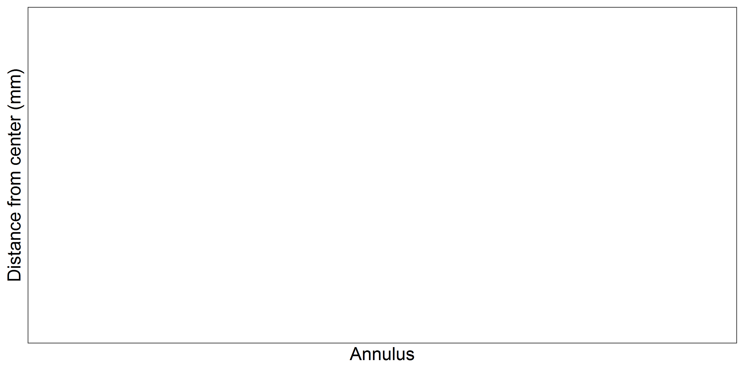

**Figure 6:** Strata_S2. Plot of average distance from the centre to the winter rings for all readers. The boxes represent the median, upper and lower box boundaries of the interquartile range, whiskers represent the minimum and maximum values and the dots represent the outliers. (Is not correctly represented).

***Overall comparison of results by strata***

The total number of otoliths read by each stratum is practically the same, but their distribution by modal age slightly differs (**Table 25**).

**Table 25:** Number of age readings per strata and modal age for all advanced readers combined.

|  |  |  |  |
| --- | --- | --- | --- |
| **Modal age** | **Strata_S1** | **Strata_S2** | **total** |
| 2 | 30 | 0 | **30** |
| 3 | 20 | 0 | **20** |
| 4 | 49 | 80 | **129** |
| 5 | 178 | 170 | **348** |
| 6 | 119 | 108 | **227** |
| 7 | 50 | 59 | **109** |
| 8 | 110 | 88 | **198** |
| 9 | 20 | 40 | **60** |
| 10 | 10 | 19 | **29** |
| 11 | 0 | 20 | **20** |
| 12 | 10 | 0 | **10** |
| 13 | 0 | 0 | **0** |
| 14 | 0 | 0 | **0** |
| 15 | 0 | 0 | **0** |
| 16 | 0 | 10 | **10** |
| **Total** | **596** | **594** | **1190** |

*Coefficient of Variation (CV)*

The CV is higher in the S2, nevertheless there is a spike (42%) (**Table 26**) due to two out of ten readers attributing the age of 16 to one otolith, while all the other readers gave different ages. In fact, two other pairs of readers (4 readers) found an agreement in giving this otolith an age of 7 and 9 respectively. Whatever the age, it is over 6, which is the last age used for assessment singularly.

**Table 26:** CV per strata and modal age for all advanced readers combined.

|  |  |  |  |
| --- | --- | --- | --- |
| **Modal age** | **Strata_S1** | **Strata_S2** | **all** |
| 2 | 33 % | - | 33 % |
| 3 | 13 % | - | 13 % |
| 4 | 21 % | 27 % | 25 % |
| 5 | 21 % | 29 % | 25 % |
| 6 | 19 % | 21 % | 20 % |
| 7 | 23 % | 19 % | 21 % |
| 8 | 19 % | 24 % | 21 % |
| 9 | 22 % | 24 % | 24 % |
| 10 | 18 % | 28 % | 26 % |
| 11 | - | 24 % | 24 % |
| 12 | 22 % | - | 22 % |
| 13 | - | - | - |
| 14 | - | - | - |
| 15 | - | - | - |
| 16 | - | 42 % | 42 % |
| **Weighted Mean** | **21 %** | **25 %** | **23 %** |

*Percentage of Agreement (PA)*

In both strata the PA doesn’t reach the 50%, above all from age 7 on (**Table 27**).

**Table 27:** Percentage Agreement per strata and modal age for all advanced readers combined.

|  |  |  |  |
| --- | --- | --- | --- |
| **Modal age** | **Strata_S1** | **Strata_S2** | **total** |
| 2 | 33 % | - | 33 % |
| 3 | 80 % | - | 80 % |
| 4 | 57 % | 59 % | 58 % |
| 5 | 52 % | 50 % | 51 % |
| 6 | 55 % | 44 % | 50 % |
| 7 | 40 % | 39 % | 39 % |
| 8 | 40 % | 34 % | 37 % |
| 9 | 30 % | 30 % | 30 % |
| 10 | 40 % | 26 % | 31 % |
| 11 | - | 25 % | 25 % |
| 12 | 20 % | - | 20 % |
| 13 | - | - | - |
| 14 | - | - | - |
| 15 | - | - | - |
| 16 | - | 20 % | 20 % |
| **Weighted Mean** | **48 %** | **43 %** | **46 %** |

*Average Percentage Error (APE)*

This parameter that should be lower than 10 or around 10%is considerably high in both semesters, and practically for all the ages except for modal age 3 (**Table 28**).

**Table 28:** Average Percentage Error per strata and modal age for all advanced readers combined.

|  |  |  |  |
| --- | --- | --- | --- |
| **Modal age** | **Strata_S1** | **Strata_S2** | **all** |
| 2 | 27 % | - | 27 % |
| 3 | 10 % | - | 10 % |
| 4 | 16 % | 18 % | 17 % |
| 5 | 17 % | 22 % | 19 % |
| 6 | 14 % | 16 % | 15 % |
| 7 | 17 % | 15 % | 16 % |
| 8 | 15 % | 17 % | 16 % |
| 9 | 17 % | 19 % | 18 % |
| 10 | 13 % | 23 % | 21 % |
| 11 | - | 19 % | 19 % |
| 12 | 18 % | - | 18 % |
| 13 | - | - | - |
| 14 | - | - | - |
| 15 | - | - | - |
| 16 | - | 34 % | 34 % |
| **Weighted Mean** | **16 %** | **19 %** | **17 %** |

*Relative bias*

The difference between the mean age read by reader vs the modal age is high above all in the S1, but also in this case it’s important to remark that in general in the first semester the readers tended to attribute ages higher than the modal ages, while in the second and from age 9 on the underestimation is more important (**Table 29**).

**Table 29:** Relative Bias per strata and modal age for all advanced readers combined.

|  |  |  |  |
| --- | --- | --- | --- |
| **Modal age** | **Strata_S1** | **Strata_S2** | **all** |
| 2 | 1.00 | - | - |
| 3 | 0.20 | - | - |
| 4 | 0.33 | 0.35 | 0.34 |
| 5 | 0.62 | 0.75 | 0.69 |
| 6 | 0.45 | 0.31 | 0.38 |
| 7 | 0.50 | 0.51 | 0.50 |
| 8 | 0.59 | 0.12 | 0.36 |
| 9 | 0.65 | -0.68 | -0.01 |
| 10 | 0.30 | -1.63 | -0.67 |
| 11 | - | -1.35 | - |
| 12 | -2.00 | - | - |
| 13 | - | - | - |
| 14 | - | - | - |
| 15 | - | - | - |
| 16 | - | -6.40 | - |
| **Weighted Mean** | **0.50** | **0.14** | **0.43** |

*Growth analysis*

In this case the graphic is not correctly represented (is empty).



**Figure 7:** Plot of average distance from the centre to the winter rings for all readers by strata. The boxes represent the median, upper and lower box boundaries of the interquartile range, whiskers represent the minimum and maximum values and the dots represent the outliers. (Is not correctly represented).

### Advanced readers

**All samples included**

*Multimodal cases*

Results about multimodal cases reflect that in more than one third of the cases there is more than a single mode for each sample (**Table 30**). In this exchange event, 120 otolith fish individuals were aged. Of those, 31 % when the traditional approach (all readers equally weighted) is used to define the mode. The percentage of multiple mode cases is reduced to 0 % (**Table 30**). The complete list of cases with multiple modes is presented in **Table A3- 8** in the annex 3 section, where the ageing from each of the readers participating in the exchange event is presented.

**Table 30:** Summary of statistics; Total number of samples (NSample), a percentage of cases (fish samples) with multiple modes depending on the approach to weight the experience of the reader which will be considered when defining the fish age mode. PercMM_traditional shows the percentage of the total samples for which multiple modes are obtained when all the readers are equally weighted. PercMM_linear_weight shows the percentage of the total samples for which multiple modes are obtained when the weight assigned to the different readers decreases linearly with the experience, while in the PercMM_negexp the weight applied decreases with a negative exponential shape with the experience. The PercMM_multistage shows the percentage of multiple mode cases when a combination of the different methodologies is used, as explained in the material and methods section.

|  |  |  |  |  |
| --- | --- | --- | --- | --- |
| **NSample** | **PercMM_traditional** | **PercMM_linear_weight** | **PercMM_negexp_weight** | **PercMM_multistage** |
| 120 | 31 % | 4 % | 0 % | 0 % |

*Summary statistics*

The results for advanced readers are slightly better than for all the readers (including not expert ones) (**Table 31**). When all the otolith samples are considered (both single and multimodal cases) the weighted average percentage agreement based on modal ages for expert readers is 49 %, with the weighted average CV of 22 % and APE of 16 %.

**Table 31:** Summary of statistics; Total number of samples (NSample), coefficient of variance (CV), percentage of agreement (PA) and average percentage error (APE) for all ages and readers.

|  |  |  |  |
| --- | --- | --- | --- |
| **NSample** | **CV** | **PA** | **APE** |
| 120 | 22 % | 49 % | 16 % |

*Coefficient of Variation (CV)*

These results show that the weighted mean of relative variability of each reader is high, varying from 11 to 20% (**Table 32**). For advanced readers, this value is always lower than the desired 10%. When considering the variation per modal age, it varied between 11 and 20% (**Table 32**). The main problem is the relative variability around the mean which is high.

**Table 32:** Coefficient of Variation (CV) table presents the CV per modal age and advanced reader, the CV of all advanced readers combined per modal age and a weighted mean of the CV per reader.

|  |  |  |  |  |  |  |  |
| --- | --- | --- | --- | --- | --- | --- | --- |
| **Modal age** | **R01 IE** | **R02 ES** | **R03 GB** | **R04 ES** | **R05 BE** | **R08 ES** | **all** |
| 2 | 0 % | 0 % | 17 % | 0 % | 0 % | 0 % | **30 %** |
| 3 | 14 % | 25 % | 22 % | 25 % | 25 % | 0 % | **28 %** |
| 4 | 32 % | 11 % | 21 % | 25 % | 22 % | 16 % | **26 %** |
| 5 | 23 % | 6 % | 17 % | 8 % | 17 % | 12 % | **20 %** |
| 6 | 24 % | 8 % | 12 % | 11 % | 20 % | 12 % | **21 %** |
| 7 | 17 % | 13 % | 13 % | 14 % | 20 % | 25 % | **22 %** |
| 8 | 16 % | 13 % | 11 % | 11 % | 15 % | 14 % | **18 %** |
| 9 | 21 % | 15 % | 13 % | 25 % | 18 % | 31 % | **25 %** |
| 10 | 12 % | 13 % | 11 % | 11 % | 15 % | 13 % | **19 %** |
| 11 | 17 % | 7 % | 0 % | 7 % | 6 % | 18 % | **18 %** |
| 12 | - | - | - | - | - | - | **20 %** |
| 13 | - | - | - | - | - | - | **-** |
| 14 | - | - | - | - | - | - | **21 %** |
| 15 | - | - | - | - | - | - | **25 %** |
| **Weighted Mean** | **20 %** | **11 %** | **14 %** | **14 %** | **18 %** | **15 %** | **22 %** |

*Percentage of Agreement (PA)*

For expert readers, the **PA** is relatively good for modal ages 3 to 6, reaching the maximum 59% at age 5 (**Table 33**).

The weighted mean per each expert reader varied widely from a minimum of 22% to a maximum of 62% (**Table 33**).

**Table 33:** Percentage agreement (PA) table represents the PA per modal age and reader, advanced the PA of all advanced readers combined per modal age and a weighted mean of the PA per reader.

|  |  |  |  |  |  |  |  |
| --- | --- | --- | --- | --- | --- | --- | --- |
| **Modal age** | **R01 IE** | **R02 ES** | **R03 GB** | **R04 ES** | **R05 BE** | **R08 ES** | **total** |
| 2 | 100 % | 0 % | 0 % | 100 % | 0 % | 100 % | **50 %** |
| 3 | 80 % | 60 % | 40 % | 60 % | 0 % | 100 % | **57 %** |
| 4 | 73 % | 82 % | 45 % | 64 % | 18 % | 64 % | **58 %** |
| 5 | 43 % | 91 % | 45 % | 83 % | 9 % | 78 % | **59 %** |
| 6 | 30 % | 70 % | 70 % | 70 % | 15 % | 60 % | **52 %** |
| 7 | 47 % | 67 % | 36 % | 53 % | 33 % | 13 % | **42 %** |
| 8 | 27 % | 60 % | 67 % | 55 % | 23 % | 50 % | **47 %** |
| 9 | 40 % | 30 % | 60 % | 30 % | 50 % | 20 % | **38 %** |
| 10 | 67 % | 20 % | 50 % | 17 % | 50 % | 0 % | **34 %** |
| 11 | 50 % | 0 % | 100 % | 50 % | 0 % | 0 % | **33 %** |
| 12 | 100 % | 0 % | 100 % | 0 % | 0 % | 0 % | **33 %** |
| 13 | - | - | - | - | - | - | **-** |
| 14 | 100 % | 0 % | 0 % | 0 % | 100 % | 0 % | **33 %** |
| 15 | 100 % | 0 % | 0 % | 0 % | 0 % | 0 % | **17 %** |
| **Weighted Mean** | **47 %** | **62 %** | **53 %** | **59 %** | **22 %** | **50 %** | **49 %** |

*Average Percentage Error (APE)*

The overall APE is high, reaching 16%, varying from 13 to 27% depending on the modal age considered (**Table 34**), on the other hand The results show varying levels of precision, with the calculated values for some readers being nearly double those of others (**Table 34**).

**Table 34:** Average Percentage Error (APE) table represents the APE per modal age and reader, the APE of all advanced readers combined per modal age and a weighted mean of the APE per reader.

|  |  |  |  |  |  |  |  |
| --- | --- | --- | --- | --- | --- | --- | --- |
| **Modal age** | **R01 IE** | **R02 ES** | **R03 GB** | **R04 ES** | **R05 BE** | **R08 ES** | **all** |
| 2 | 0 % | 0 % | 13 % | 0 % | 0 % | 0 % | **27 %** |
| 3 | 10 % | 20 % | 17 % | 20 % | 20 % | 0 % | **22 %** |
| 4 | 17 % | 5 % | 17 % | 14 % | 18 % | 9 % | **20 %** |
| 5 | 18 % | 3 % | 13 % | 5 % | 14 % | 5 % | **16 %** |
| 6 | 18 % | 7 % | 9 % | 6 % | 14 % | 10 % | **15 %** |
| 7 | 14 % | 11 % | 10 % | 11 % | 16 % | 20 % | **16 %** |
| 8 | 13 % | 10 % | 7 % | 8 % | 13 % | 13 % | **13 %** |
| 9 | 14 % | 13 % | 8 % | 19 % | 14 % | 26 % | **18 %** |
| 10 | 10 % | 9 % | 8 % | 8 % | 13 % | 10 % | **14 %** |
| 11 | 12 % | 5 % | 0 % | 5 % | 4 % | 12 % | **13 %** |
| 12 | 0 % | 0 % | 0 % | 0 % | 0 % | 0 % | **15 %** |
| 13 | - | - | - | - | - | - | **-** |
| 14 | 0 % | 0 % | 0 % | 0 % | 0 % | 0 % | **17 %** |
| 15 | 0 % | 0 % | 0 % | 0 % | 0 % | 0 % | **20 %** |
| **Weighted Mean** | **15 %** | **8 %** | **10 %** | **9 %** | **14 %** | **11 %** | **16 %** |

*Relative Bias*

The ideal relative bias should round zero, but in this case values per each modal age fluctuate widely over 0.4 in almost all the cases, nevertheless the overall result is 0.21 because positive and negative anomalies tend to cancel each other out (**Figure 8**), meaning that the overall effect is lower than expected (**Table 35**).

When readers are considered, values near or over 1 have been observed, showing a tendency to overestimate for these readers, while in other cases underestimation for more than 0.5 has been observed. The best rank is not due to little values of bias distributed in all the modal ages but to the compensation due the presence of positive and negative anomalies in the readings (**Table 35**).

**Table 35:** The relative bias (as the difference between the mean and modal age) per modal age and advanced reader is presented, as well as the weighted mean relative bias per reader and the relative bias per modal age for all advanced readers combined.

|  |  |  |  |  |  |  |  |
| --- | --- | --- | --- | --- | --- | --- | --- |
| **Modal age** | **R01 IE** | **R02 ES** | **R03 GB** | **R04 ES** | **R05 BE** | **R08 ES** | **all** |
| 2 | 0.00 | 1.00 | 1.33 | 0.00 | 2.00 | 0.00 | **0.72** |
| 3 | 0.20 | 0.60 | 0.80 | 0.60 | 2.20 | 0.00 | **0.73** |
| 4 | 0.18 | 0.00 | 0.91 | 0.00 | 1.73 | 0.00 | **0.47** |
| 5 | 0.43 | -0.09 | 0.65 | -0.09 | 1.91 | 0.00 | **0.47** |
| 6 | 0.95 | -0.30 | 0.40 | 0.05 | 2.05 | -0.35 | **0.47** |
| 7 | 1.13 | -0.53 | 0.29 | -0.67 | 1.93 | -0.87 | **0.21** |
| 8 | 1.77 | -0.50 | 0.10 | -0.27 | 1.36 | -0.77 | **0.28** |
| 9 | 1.50 | -1.40 | -0.20 | -1.20 | 1.30 | -2.20 | **-0.37** |
| 10 | 0.83 | -1.80 | -0.33 | -0.67 | 1.50 | -2.33 | **-0.47** |
| 11 | 1.50 | -1.50 | 0.00 | -0.50 | 1.50 | -3.00 | **-0.33** |
| 12 | 0.00 | -3.00 | 0.00 | -1.00 | 2.00 | -4.00 | **-1.00** |
| 13 | - | - | - | - | - | - | **-** |
| 14 | 0.00 | -5.00 | -3.00 | -4.00 | 0.00 | -5.00 | **-2.83** |
| 15 | 0.00 | -6.00 | -5.00 | -4.00 | -1.00 | -7.00 | **-3.83** |
| **Weighted Mean** | **0.93** | **-0.51** | **0.29** | **-0.33** | **1.72** | **-0.79** | **0.21** |

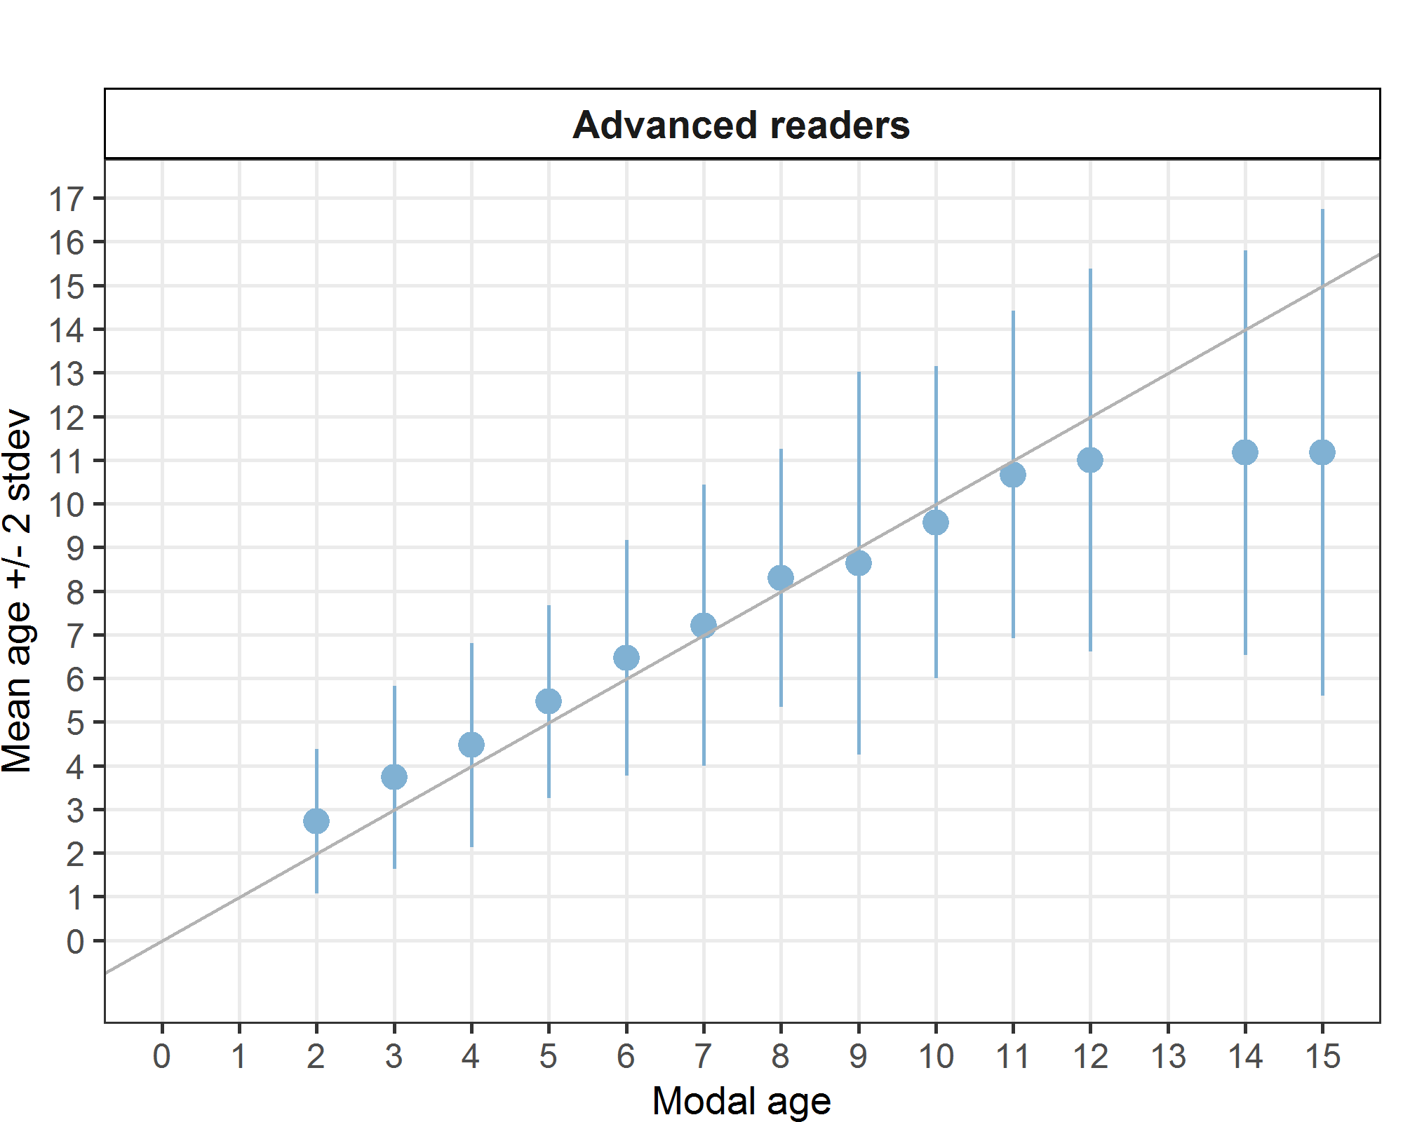

**Figure 8:** Age bias plot for advanced readers. Mean age recorded +/- 2 stdev of each reader and all readers combined are plotted against modal age. The estimated mean age corresponds to modal age, if the estimated mean age is on the 1:1 equilibrium line (solid line). Relative bias is the age difference between estimated mean age and modal age.

*Growth analysis*

A variability in the mark of the annuli has been observed in the case of expert readers, but one of them tended to attribute lower values of distance than the rest of readers, while another does exactly the contrary (**Figure 9**).

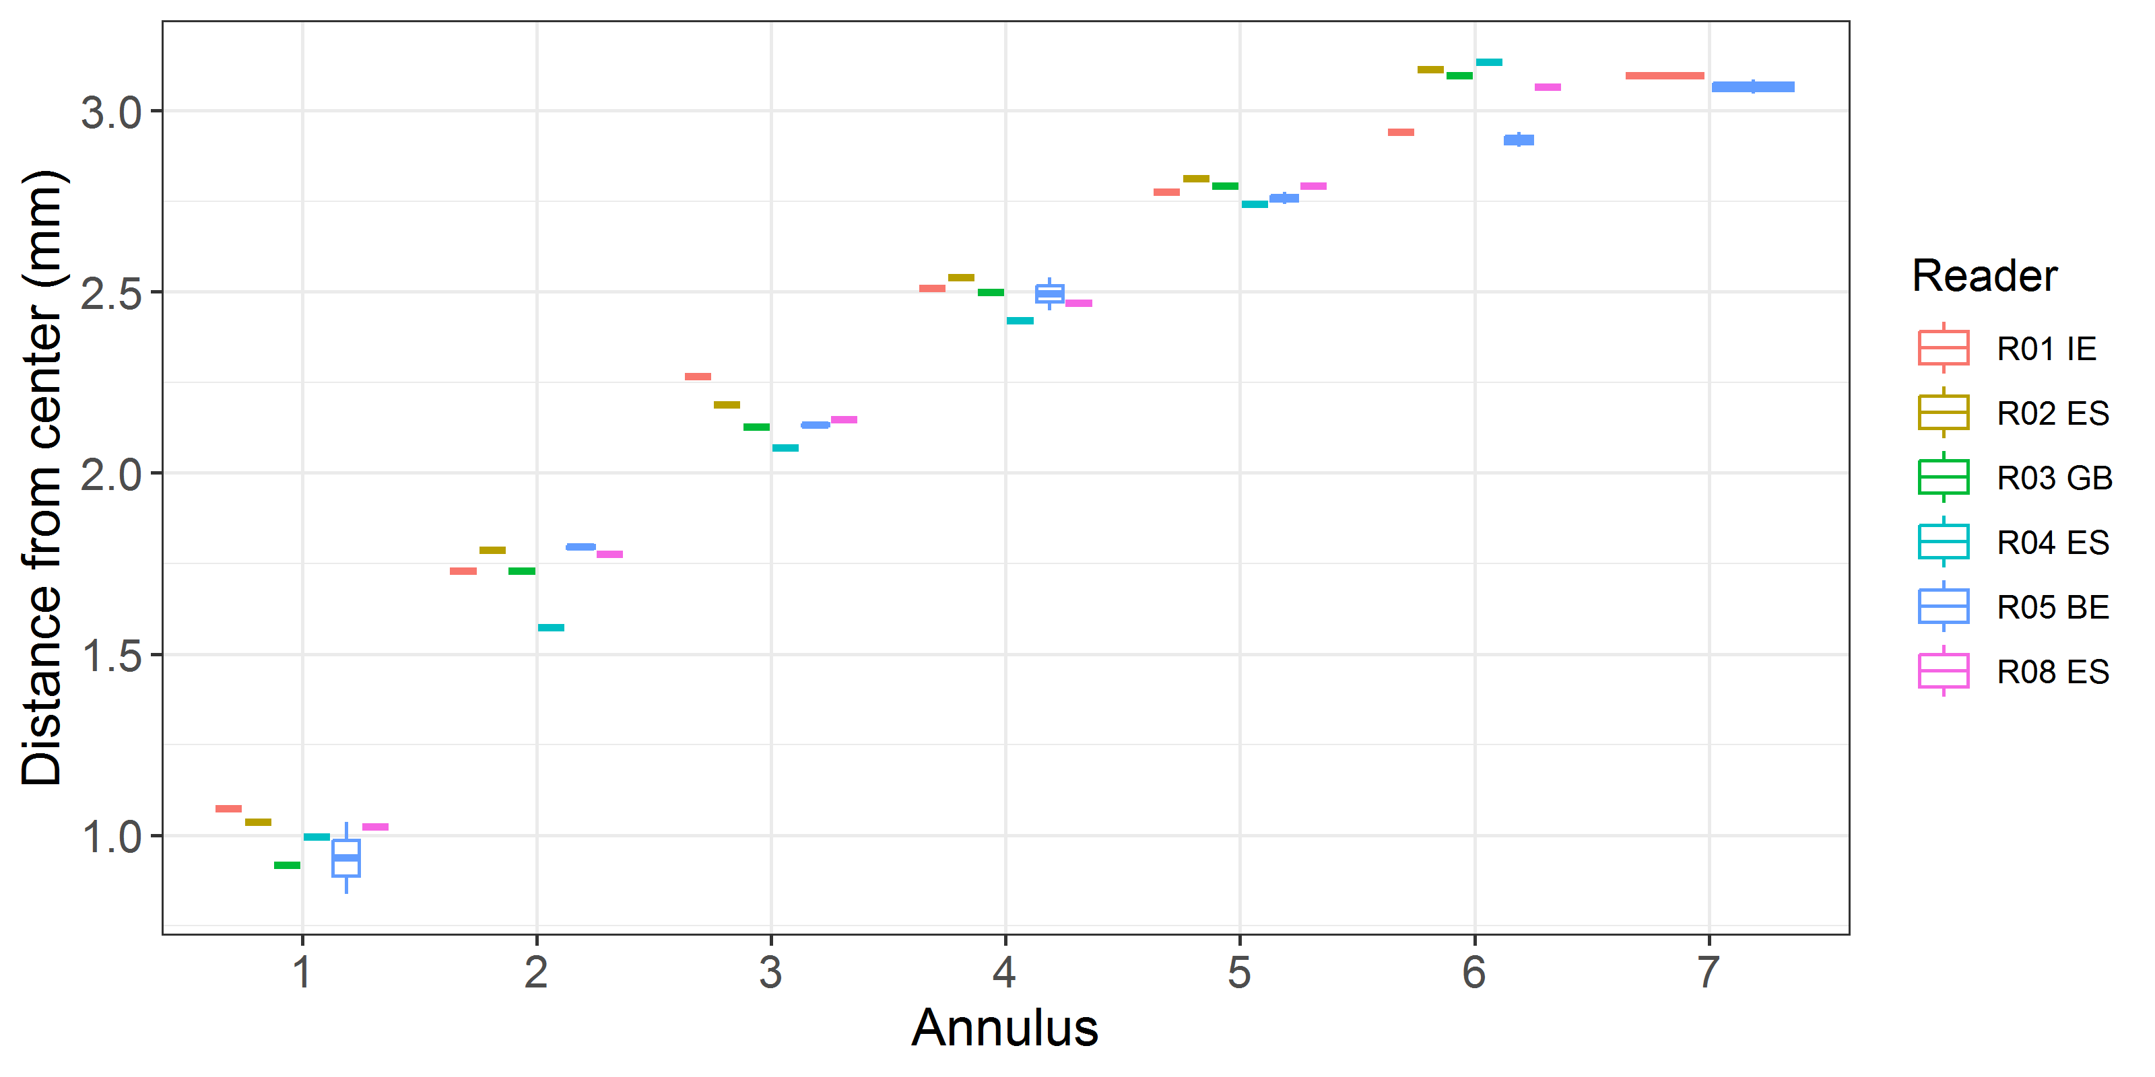

**Figure 9:** Plot of average distance from the centre to the winter rings for advanced readers. The boxes represent the mean, upper and lower box boundaries of the interquartile range, whiskers represent the minimum and maximum values and the dots represent the outliers.

*General Age Error Matrix (AEM)*

Relatively high values in the diagonal and adjacent cells reveal that in most cases the age attributed by the advanced readers coincide with the modal age, or nearest younger or older ages (**Table 36**) for ages until 6, but for ages older than 6, higher deviations have been recorded until 7 years more in one estimate (**Table 36**).

**Table 36:** General Age error matrix (AEM). The modal age is in rows and the age classifications by the advanced readers in columns.

|  |  |  |  |  |  |  |  |  |  |  |  |  |  |  |  |  |
| --- | --- | --- | --- | --- | --- | --- | --- | --- | --- | --- | --- | --- | --- | --- | --- | --- |
| **modal_age** | **2** | **3** | **4** | **5** | **6** | **7** | **8** | **9** | **10** | **11** | **12** | **13** | **14** | **15** | **16** | **Total** |
| **2** | 0.50 | 0.28 | 0.22 | - | - | - | - | - | - | - | - | - | - | - | - | 1.00 |
| **3** | - | 0.57 | 0.23 | 0.13 | 0.03 | 0.03 | - | - | - | - | - | - | - | - | - | 0.99 |
| **4** | 0.02 | 0.09 | 0.58 | 0.15 | 0.09 | 0.05 | 0.03 | - | - | - | - | - | - | - | - | 1.01 |
| **5** | - | - | 0.10 | 0.59 | 0.15 | 0.09 | 0.05 | 0.02 | - | - | - | - | - | - | - | 1.00 |
| **6** | - | - | 0.02 | 0.14 | 0.52 | 0.15 | 0.07 | 0.07 | 0.03 | - | - | 0.01 | - | - | - | 1.01 |
| **7** | - | 0.01 | 0.01 | 0.10 | 0.15 | 0.42 | 0.15 | 0.08 | 0.04 | 0.02 | 0.02 | - | - | - | - | 1.00 |
| **8** | - | - | - | 0.01 | 0.10 | 0.12 | 0.47 | 0.12 | 0.09 | 0.05 | 0.05 | - | - | - | - | 1.01 |
| **9** | - | - | 0.02 | 0.08 | 0.08 | 0.07 | 0.12 | 0.38 | 0.13 | 0.05 | 0.02 | 0.02 | 0.02 | - | 0.02 | 1.01 |
| **10** | - | - | - | - | 0.03 | 0.06 | 0.23 | 0.14 | 0.34 | 0.06 | 0.06 | 0.06 | 0.03 | - | - | 1.01 |
| **11** | - | - | - | - | - | 0.08 | - | 0.17 | 0.17 | 0.33 | 0.08 | 0.08 | 0.08 | - | - | 0.99 |
| **12** | - | - | - | - | - | - | 0.17 | 0.17 | - | 0.17 | 0.33 | - | 0.17 | - | - | 1.01 |
| **14** | - | - | - | - | - | - | - | 0.33 | 0.17 | 0.17 | - | - | 0.33 | - | - | 1.00 |
| **15** | - | - | - | - | - | - | 0.17 | 0.17 | 0.17 | 0.17 | - | - | 0.17 | 0.17 | - | 1.02 |

*AEM by ICES area*

In Area 27.7, younger modal ages such as 3 and 4 have high classification accuracy with values concentrated strongly along the diagonal (**Table 37**) than in area 27.8 (**Table 38**).

The classifications in Area 27.8 show broader age dispersion, especially at modal ages 3–6 (**Table 38**). This suggests that advanced readers experience greater difficulty differentiating between adjacent ages in Area 27.8, possibly due to more subtle or overlapping growth patterns.

**Table 37**: Age error matrix (AEM) for ICES area 27.7.

|  |  |  |  |  |  |  |  |  |  |  |  |  |  |  |  |  |  |
| --- | --- | --- | --- | --- | --- | --- | --- | --- | --- | --- | --- | --- | --- | --- | --- | --- | --- |
| **ices_area** | **modal_age** | **2** | **3** | **4** | **5** | **6** | **7** | **8** | **9** | **10** | **11** | **12** | **13** | **14** | **15** | **16** | **Total** |
| **27.7** | 3 | - | 0.72 | 0.22 | 0.06 | - | - | - | - | - | - | - | - | - | - | - | 1.00 |
| **27.7** | 4 | - | 0.07 | 0.63 | 0.07 | 0.13 | 0.07 | 0.03 | - | - | - | - | - | - | - | - | 1.00 |
| **27.7** | 5 | - | - | 0.02 | 0.67 | 0.19 | 0.05 | 0.05 | 0.02 | - | - | - | - | - | - | - | 1.00 |
| **27.7** | 6 | - | - | - | 0.04 | 0.56 | 0.23 | 0.06 | 0.04 | 0.04 | - | - | 0.02 | - | - | - | 0.99 |
| **27.7** | 7 | - | 0.02 | - | 0.14 | 0.21 | 0.38 | 0.07 | 0.07 | 0.02 | 0.02 | 0.05 | - | - | - | - | 0.98 |
| **27.7** | 8 | - | - | - | - | 0.11 | 0.11 | 0.45 | 0.16 | 0.09 | 0.05 | 0.04 | - | - | - | - | 1.01 |
| **27.7** | 9 | - | - | 0.02 | 0.10 | 0.10 | 0.06 | 0.12 | 0.38 | 0.12 | 0.04 | 0.02 | - | 0.02 | - | - | 0.98 |
| **27.7** | 10 | - | - | - | - | 0.03 | 0.07 | 0.21 | 0.10 | 0.34 | 0.07 | 0.07 | 0.07 | 0.03 | - | - | 0.99 |
| **27.7** | 11 | - | - | - | - | - | 0.08 | - | 0.17 | 0.17 | 0.33 | 0.08 | 0.08 | 0.08 | - | - | 0.99 |
| **27.7** | 12 | - | - | - | - | - | - | 0.17 | 0.17 | - | 0.17 | 0.33 | - | 0.17 | - | - | 1.01 |
| **27.7** | 14 | - | - | - | - | - | - | - | 0.33 | 0.17 | 0.17 | - | - | 0.33 | - | - | 1.00 |

**Table 38: :** Age error matrix (AEM) for ICES area 27.8.

|  |  |  |  |  |  |  |  |  |  |  |  |  |  |  |  |  |  |
| --- | --- | --- | --- | --- | --- | --- | --- | --- | --- | --- | --- | --- | --- | --- | --- | --- | --- |
| **ices_area** | **modal_age** | **2** | **3** | **4** | **5** | **6** | **7** | **8** | **9** | **10** | **11** | **12** | **13** | **14** | **15** | **16** | **Total** |
| **27.8** | 2 | 0.50 | 0.28 | 0.22 | - | - | - | - | - | - | - | - | - | - | - | - | 1.00 |
| **27.8** | 3 | - | 0.33 | 0.25 | 0.25 | 0.08 | 0.08 | - | - | - | - | - | - | - | - | - | 0.99 |
| **27.8** | 4 | 0.03 | 0.11 | 0.53 | 0.22 | 0.06 | 0.03 | 0.03 | - | - | - | - | - | - | - | - | 1.01 |
| **27.8** | 5 | - | - | 0.14 | 0.55 | 0.13 | 0.11 | 0.05 | 0.02 | - | - | - | - | - | - | - | 1.00 |
| **27.8** | 6 | - | - | 0.03 | 0.21 | 0.50 | 0.10 | 0.07 | 0.08 | 0.01 | - | - | - | - | - | - | 1.00 |
| **27.8** | 7 | - | - | 0.02 | 0.06 | 0.09 | 0.45 | 0.21 | 0.09 | 0.06 | 0.02 | - | - | - | - | - | 1.00 |
| **27.8** | 8 | - | - | - | 0.02 | 0.09 | 0.13 | 0.49 | 0.08 | 0.09 | 0.04 | 0.06 | - | - | - | - | 1.00 |
| **27.8** | 9 | - | - | - | - | - | 0.08 | 0.08 | 0.42 | 0.17 | 0.08 | - | 0.08 | - | - | 0.08 | 0.99 |
| **27.8** | 10 | - | - | - | - | - | - | 0.33 | 0.33 | 0.33 | - | - | - | - | - | - | 0.99 |
| **27.8** | 15 | - | - | - | - | - | - | 0.17 | 0.17 | 0.17 | 0.17 | - | - | 0.17 | 0.17 | - | 1.02 |

*AEM by strata*

**Table 39:** Age error matrix (AEM) for Strata_Strata_S1.

|  |  |  |  |  |  |  |  |  |  |  |  |  |  |  |  |  |  |
| --- | --- | --- | --- | --- | --- | --- | --- | --- | --- | --- | --- | --- | --- | --- | --- | --- | --- |
| **strata** | **modal_age** | **2** | **3** | **4** | **5** | **6** | **7** | **8** | **9** | **10** | **11** | **12** | **13** | **14** | **15** | **16** | **Total** |
| **Strata_S1** | 2 | 0.50 | 0.28 | 0.22 | - | - | - | - | - | - | - | - | - | - | - | - | 1.00 |
| **Strata_S1** | 3 | - | 0.67 | 0.17 | 0.11 | 0.06 | - | - | - | - | - | - | - | - | - | - | 1.01 |
| **Strata_S1** | 4 | 0.04 | 0.08 | 0.62 | 0.17 | 0.04 | - | 0.04 | - | - | - | - | - | - | - | - | 0.99 |
| **Strata_S1** | 5 | - | - | 0.11 | 0.62 | 0.14 | 0.10 | 0.03 | - | - | - | - | - | - | - | - | 1.00 |
| **Strata_S1** | 6 | - | - | 0.01 | 0.15 | 0.53 | 0.15 | 0.06 | 0.06 | 0.01 | - | - | 0.01 | - | - | - | 0.98 |
| **Strata_S1** | 7 | - | - | - | 0.10 | 0.15 | 0.40 | 0.15 | 0.10 | 0.04 | 0.02 | 0.04 | - | - | - | - | 1.00 |
| **Strata_S1** | 8 | - | - | - | 0.01 | 0.07 | 0.10 | 0.44 | 0.14 | 0.12 | 0.08 | 0.03 | - | - | - | - | 0.99 |
| **Strata_S1** | 10 | - | - | - | - | - | - | 0.29 | 0.17 | 0.33 | 0.04 | 0.04 | 0.08 | 0.04 | - | - | 0.99 |
| **Strata_S1** | 12 | - | - | - | - | - | - | 0.17 | 0.17 | - | 0.17 | 0.33 | - | 0.17 | - | - | 1.01 |
| **Strata_S1** | 14 | - | - | - | - | - | - | - | 0.33 | 0.17 | 0.17 | - | - | 0.33 | - | - | 1.00 |

**Table 40:**  Age error matrix (AEM) for Strata_Strata_S2.

|  |  |  |  |  |  |  |  |  |  |  |  |  |  |  |  |  |  |
| --- | --- | --- | --- | --- | --- | --- | --- | --- | --- | --- | --- | --- | --- | --- | --- | --- | --- |
| **strata** | **modal_age** | **2** | **3** | **4** | **5** | **6** | **7** | **8** | **9** | **10** | **11** | **12** | **13** | **14** | **15** | **16** | **Total** |
| **Strata_S2** | 3 | - | 0.42 | 0.33 | 0.17 | - | 0.08 | - | - | - | - | - | - | - | - | - | 1.00 |
| **Strata_S2** | 4 | - | 0.10 | 0.55 | 0.14 | 0.12 | 0.07 | 0.02 | - | - | - | - | - | - | - | - | 1.00 |
| **Strata_S2** | 5 | - | - | 0.10 | 0.56 | 0.15 | 0.08 | 0.07 | 0.04 | - | - | - | - | - | - | - | 1.00 |
| **Strata_S2** | 6 | - | - | 0.02 | 0.12 | 0.52 | 0.14 | 0.07 | 0.07 | 0.05 | - | - | - | - | - | - | 0.99 |
| **Strata_S2** | 7 | - | 0.02 | 0.02 | 0.10 | 0.15 | 0.44 | 0.15 | 0.05 | 0.05 | 0.02 | - | - | - | - | - | 1.00 |
| **Strata_S2** | 8 | - | - | - | - | 0.14 | 0.14 | 0.49 | 0.11 | 0.05 | - | 0.07 | - | - | - | - | 1.00 |
| **Strata_S2** | 9 | - | - | 0.02 | 0.08 | 0.08 | 0.07 | 0.12 | 0.38 | 0.13 | 0.05 | 0.02 | 0.02 | 0.02 | - | 0.02 | 1.01 |
| **Strata_S2** | 10 | - | - | - | - | 0.09 | 0.18 | 0.09 | 0.09 | 0.36 | 0.09 | 0.09 | - | - | - | - | 0.99 |
| **Strata_S2** | 11 | - | - | - | - | - | 0.08 | - | 0.17 | 0.17 | 0.33 | 0.08 | 0.08 | 0.08 | - | - | 0.99 |
| **Strata_S2** | 15 | - | - | - | - | - | - | 0.17 | 0.17 | 0.17 | 0.17 | - | - | 0.17 | 0.17 | - | 1.02 |

***Samples split by strata***

**Comparison results by reader on strata: Strata_S1**

*Multimodal cases*

In this exchange event and semester 1 (S1) 60 otolith fish individuals were aged by expert readers. Of those, 27 % when the traditional approach (all readers equally weighted) showed multimodal age (**Table 41**) which means that for almost 1 out of 3 otolith was classified differently by at least two groups of readers, evidencing discrepancies in the application of reading criteria including in the case of expert readers. The percentage of multiple mode cases is reduced to 0 % when the weight applied to each reader decreases with a negative exponential shape on the base of the experience. The complete list of cases with multiple modes is presented in **Table A3- 8** in the annex 3 section, where the ageing from each of the readers participating in the exchange event is presented.

**Table 41:** Strata Strata_S1. Total number of samples (NSample) and percentage of cases (fish samples) with multiple modes depending on the approach to weight the experience of the reader which will be considered when defining the fish age mode. PercMM_traditional shows the percentage of the total samples for which multiple modes are obtained when all the readers are equally weighted. PercMM_linear_weight shows the percentage of the total samples for which multiple modes are obtained when the weight assigned to the different readers decreases linearly with the experience, while in the PercMM_negexp the weight applied decreases with a negative exponential shape with the experience. The PercMM_multistage shows the percentage of multiple mode cases when a combination of the different methodologies is used, as explained in the material and methods section.

|  |  |  |  |  |
| --- | --- | --- | --- | --- |
| **NSample** | **PercMM_traditional** | **PercMM_linear_weight** | **PercMM_negexp_weight** | **PercMM_multistage** |
| 60 | 27 % | 2 % | 0 % | 0 % |

*Summary statistics*

In the S1 the weighted average percentage agreement based on modal ages for all readers is 50 %, with the weighted average CV of 21 % and APE of 15 % (**Table 42**).

**Table 42:** Strata Strata_S1. Summary of statistics; Total number of samples (NSample), coefficient of variance (CV), percentage of agreement (PA) and average percentage error (APE) for all ages and readers.

|  |  |  |  |
| --- | --- | --- | --- |
| **NSample** | **CV** | **PA** | **APE** |
| 60 | 21 % | 50 % | 15 % |

*Coefficient of Variation (CV)*

For the S1, v**ariability in age reading precision** among advanced readers was highlighted, with the most consistent age estimates in ages 5–8. The highest uncertainty occurs at **ages** 3–4 and **older ages** (12–14) (**Table 43**).

**Table 43:** Strata Strata_S1. Coefficient of Variation (CV) table presents the CV per modal age and reader, the CV of all readers combined per modal age and a weighted mean of the CV per reader.

|  |  |  |  |  |  |  |  |
| --- | --- | --- | --- | --- | --- | --- | --- |
| **Modal age** | **R01 IE** | **R02 ES** | **R03 GB** | **R04 ES** | **R05 BE** | **R08 ES** | **all** |
| 2 | 0 % | 0 % | 17 % | 0 % | 0 % | 0 % | **30 %** |
| 3 | 0 % | 17 % | 31 % | 31 % | 25 % | 0 % | **26 %** |
| 4 | 13 % | 0 % | 12 % | 34 % | 24 % | 13 % | **26 %** |
| 5 | 22 % | 0 % | 11 % | 6 % | 12 % | 8 % | **17 %** |
| 6 | 23 % | 6 % | 8 % | 8 % | 20 % | 9 % | **21 %** |
| 7 | 18 % | 11 % | 12 % | 8 % | 15 % | 19 % | **22 %** |
| 8 | 15 % | 14 % | 14 % | 9 % | 11 % | 13 % | **17 %** |
| 9 | - | - | - | - | - | - | **-** |
| 10 | 14 % | 12 % | 5 % | 14 % | 14 % | 6 % | **18 %** |
| 11 | - | - | - | - | - | - | **-** |
| 12 | - | - | - | - | - | - | **20 %** |
| 13 | - | - | - | - | - | - | **-** |
| 14 | - | - | - | - | - | - | **21 %** |
| 15 | - | - | - | - | - | - | **-** |
| **Weighted Mean** | **17 %** | **8 %** | **12 %** | **11 %** | **15 %** | **10 %** | **21 %** |

*Percentage of Agreement (PA)*

The percentage agreement per expert reader per modal age tells how large part of the readings that are equal to the modal age. The weighted mean including at the bottom of the table is weighted according to number of age readings.

In the case of PA for expert readers, some of them reached good results, overpassing 60% of PA, but others are far away from these values (**Table 44**).

**Table 44:** Strata Strata_S1. Percentage agreement (PA) table represents the PA per modal age and reader, the PA of all readers combined per modal age and a weighted mean of the PA per reader.

|  |  |  |  |  |  |  |  |
| --- | --- | --- | --- | --- | --- | --- | --- |
| **Modal age** | **R01 IE** | **R02 ES** | **R03 GB** | **R04 ES** | **R05 BE** | **R08 ES** | **total** |
| 2 | 100 % | 0 % | 0 % | 100 % | 0 % | 100 % | **50 %** |
| 3 | 100 % | 67 % | 67 % | 67 % | 0 % | 100 % | **67 %** |
| 4 | 75 % | 100 % | 75 % | 50 % | 0 % | 75 % | **62 %** |
| 5 | 27 % | 100 % | 75 % | 91 % | 0 % | 82 % | **62 %** |
| 6 | 31 % | 85 % | 69 % | 77 % | 0 % | 54 % | **53 %** |
| 7 | 50 % | 75 % | 38 % | 62 % | 0 % | 12 % | **40 %** |
| 8 | 25 % | 67 % | 58 % | 50 % | 17 % | 50 % | **44 %** |
| 9 | - | - | - | - | - | - | **-** |
| 10 | 75 % | 25 % | 75 % | 0 % | 25 % | 0 % | **33 %** |
| 11 | - | - | - | - | - | - | **-** |
| 12 | 100 % | 0 % | 100 % | 0 % | 0 % | 0 % | **33 %** |
| 13 | - | - | - | - | - | - | **-** |
| 14 | 100 % | 0 % | 0 % | 0 % | 100 % | 0 % | **33 %** |
| 15 | - | - | - | - | - | - | **-** |
| **Weighted Mean** | **47 %** | **72 %** | **60 %** | **63 %** | **7 %** | **53 %** | **50 %** |

*Average Percentage Error (APE)*

In Stratum S1, **reader accuracy improves with fish age,** peaking in the mid-range (ages 5–8), where otolith interpretation is likely clearest (**Table 45**). Ages 2 and 3 show the **highest group errors**, emphasizing the difficulty in early age classification. Readers’ consistency varies, with R02 and R04 performing best. These results suggest the need for **targeted calibration or quality control** especially for younger age classes and among readers with higher individual errors.

**Table 45:** Strata Strata_S1. Average Percentage Error (APE) table represents the APE per modal age and reader, the APE of all advanced readers combined per modal age and a weighted mean of the APE per reader.

|  |  |  |  |  |  |  |  |
| --- | --- | --- | --- | --- | --- | --- | --- |
| **Modal age** | **R01 IE** | **R02 ES** | **R03 GB** | **R04 ES** | **R05 BE** | **R08 ES** | **all** |
| 2 | 0 % | 0 % | 13 % | 0 % | 0 % | 0 % | **27 %** |
| 3 | 0 % | 13 % | 24 % | 24 % | 19 % | 0 % | **21 %** |
| 4 | 10 % | 0 % | 9 % | 23 % | 17 % | 10 % | **17 %** |
| 5 | 19 % | 0 % | 5 % | 3 % | 10 % | 6 % | **13 %** |
| 6 | 18 % | 4 % | 7 % | 5 % | 14 % | 9 % | **15 %** |
| 7 | 12 % | 8 % | 10 % | 7 % | 11 % | 15 % | **17 %** |
| 8 | 12 % | 10 % | 9 % | 6 % | 9 % | 11 % | **14 %** |
| 9 | - | - | - | - | - | - | **-** |
| 10 | 10 % | 9 % | 4 % | 9 % | 10 % | 5 % | **13 %** |
| 11 | - | - | - | - | - | - | **-** |
| 12 | 0 % | 0 % | 0 % | 0 % | 0 % | 0 % | **15 %** |
| 13 | - | - | - | - | - | - | **-** |
| 14 | 0 % | 0 % | 0 % | 0 % | 0 % | 0 % | **17 %** |
| 15 | - | - | - | - | - | - | **-** |
| **Weighted Mean** | **13 %** | **5 %** | **8 %** | **7 %** | **11 %** | **8 %** | **15 %** |

*Relative bias*

The relative bias is the difference between the mean age (per modal age per reader) and modal age. As for the previous tables, a combined bias for all readers and weighted means are calculated. For the advanced readers, In Stratum S1, most advanced readers show a slight overestimation bias, particularly at younger and mid-ages, while older age classes are often underestimated (**Table 46**; **Figure 10**). Reader R05 shows a clear tendency to over-age across all ages, while R08 tends to under-age, especially at older ages (**Table 46**). These biases highlight the need for correcting systematic tendencies and improve accuracy at the extremes of the age spectrum.

**Table 46:** Strata Strata_S1. The relative bias (as the difference between the mean and modal age) per modal age and advanced reader is presented, as well as the weighted mean relative bias per reader and the relative bias per modal age for all advanced readers combined.

|  |  |  |  |  |  |  |  |
| --- | --- | --- | --- | --- | --- | --- | --- |
| **Modal age** | **R01 IE** | **R02 ES** | **R03 GB** | **R04 ES** | **R05 BE** | **R08 ES** | **all** |
| 2 | 0.00 | 1.00 | 1.33 | 0.00 | 2.00 | 0.00 | **0.72** |
| 3 | 0.00 | 0.33 | 0.67 | 0.67 | 1.67 | 0.00 | **0.56** |
| 4 | -0.25 | 0.00 | 0.25 | -0.25 | 2.00 | -0.25 | **0.25** |
| 5 | 0.45 | 0.00 | 0.00 | -0.09 | 1.64 | -0.18 | **0.30** |
| 6 | 0.54 | -0.15 | 0.31 | -0.08 | 2.46 | -0.46 | **0.44** |
| 7 | 1.00 | -0.38 | 0.50 | -0.38 | 2.88 | -1.12 | **0.42** |
| 8 | 1.83 | -0.42 | 0.17 | 0.00 | 1.83 | -0.58 | **0.47** |
| 9 | - | - | - | - | - | - | **-** |
| 10 | 0.75 | -1.50 | -0.25 | -0.75 | 2.25 | -1.75 | **-0.21** |
| 11 | - | - | - | - | - | - | **-** |
| 12 | 0.00 | -3.00 | 0.00 | -1.00 | 2.00 | -4.00 | **-1.00** |
| 13 | - | - | - | - | - | - | **-** |
| 14 | 0.00 | -5.00 | -3.00 | -4.00 | 0.00 | -5.00 | **-2.83** |
| 15 | - | - | - | - | - | - | **-** |
| **Weighted Mean** | **0.73** | **-0.33** | **0.23** | **-0.20** | **2.08** | **-0.68** | **0.30** |

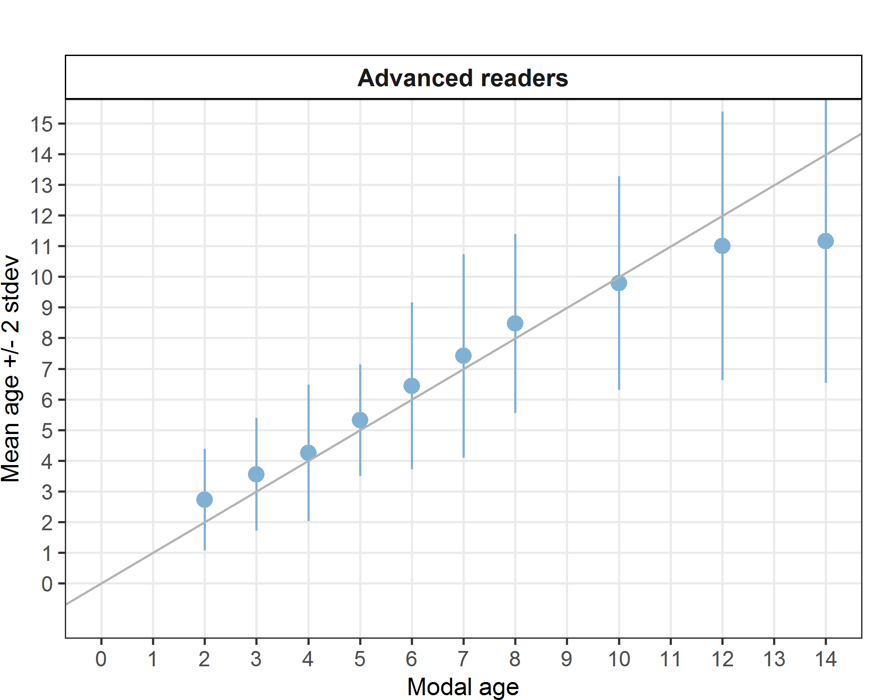

**Figure 10:** Strata Strata_S1. Age bias plot for advance readers. Mean age recorded +/- 2 stdev of each reader and all readers combined are plotted against modal age. The estimated mean age corresponds to modal age, if the estimated mean age is on the 1:1 equilibrium line (solid line). Relative bias is the age difference between estimated mean age and modal age.

*Inter-reader bias test*

Scarce consistency and few matches are evident in the inter-readers bias test (**Table 47**).

**Table 47:** Strata Strata_S1. Inter reader bias test. The Inter-reader bias test gives probability of bias between readers and with modal age. - = no sign of bias (p>0.05), * = possibility of bias (0.01<p<0.05), * * = certainty of bias (p<0.01).

|  |  |  |  |  |  |  |
| --- | --- | --- | --- | --- | --- | --- |
| **Comparison** | **R01 IE** | **R02 ES** | **R03 GB** | **R04 ES** | **R05 BE** | **R08 ES** |
| **R01 IE** | / | ** | - | ** | - | ** |
| **R02 ES** | ** | / | ** | ** | ** | ** |
| **R03 GB** | - | ** | / | - | ** | ** |
| **R04 ES** | ** | ** | - | / | ** | - |
| **R05 BE** | - | ** | ** | ** | / | ** |
| **R08 ES** | ** | ** | ** | - | ** | / |
| **Modal age** | ** | ** | - | - | ** | ** |

*Growth Analysis*

There is scarce coherence in the marks in the identification of the first annulus between advanced readers equally that in the case of all readers, with marked differences also in the successive winter annuli (**Figure 11**). Curiously, as in the case of all readers, the 5th annulus showed more coherence than the others analysed.



**Figure 11:** Strata Strata_S1. Plot of average distance from the centre to the winter rings for advanced readers. The boxes represent the median, upper and lower box boundaries of the interquartile range, whiskers represent the minimum and maximum values and the dots represent the outliers.

**Comparison results by reader on strata: Strata_S2**

*Multimodal cases*

During the exchange event in Semester 2 (S2), a total of 60 otoliths were aged by expert readers. Using the traditional approach—where all readers are equally weighted—35% of these otoliths showed multimodal age estimates (**Table 48**). This means that more than one in three otoliths were assigned different ages by at least two reader groups, revealing inconsistencies in the application of age-reading criteria, even among experienced readers. However, when a negative exponential weighting based on reader experience was applied—giving less weight to less experienced readers—the percentage of multimodal cases dropped to 0%, indicating improved consensus. A detailed list of the multimodal cases can be found in Annex 3, **Table A3- 8**, which presents the age estimates provided by each participating reader during the exchange.

**Table 48:** Strata Strata_S2. Total number of samples (NSample) and percentage of cases (fish samples) with multiple modes depending on the approach to weight the experience of the reader which will be considered when defining the fish age mode. PercMM_traditional shows the percentage of the total samples for which multiple modes are obtained when all the readers are equally weighted. PercMM_linear_weight shows the percentage of the total samples for which multiple modes are obtained when the weight assigned to the different readers decreases linearly with the experience, while in the PercMM_negexp the weight applied decreases with a negative exponential shape with the experience. The PercMM_multistage shows the percentage of multiple mode cases when a combination of the different methodologies is used, as explained in the material and methods section.

|  |  |  |  |  |
| --- | --- | --- | --- | --- |
| **NSample** | **PercMM_traditional** | **PercMM_linear_weight** | **PercMM_negexp_weight** | **PercMM_multistage** |
| 60 | 35 % | 2 % | 0 % | 0 % |

*Summary statistics*

In the second semester the results slightly worsened compared with those of the S1, which is quite common for this species. In fact, it has been observed a drop of 3% in the PA, and 1% in the CV and APE respectively (**Table 49**).

**Table 49:** Strata Strata_S2. Summary of statistics; Total number of samples (NSample), coefficient of variance (CV), percentage of agreement (PA) and average percentage error (APE) for all ages and readers.

|  |  |  |  |
| --- | --- | --- | --- |
| **NSample** | **CV** | **PA** | **APE** |
| 60 | 22 % | 47 % | 16 % |

*Coefficient of Variation (CV)*

In S2 no reader showed CV below 10%, and in one case a result over 20% appeared (**Table 50**). Modal ages from 5 to 8 are recognized more precisely by advanced readers than younger or older ages (**Table 50**).

**Table 50:** Strata Strata_S2. Coefficient of Variation (CV) table presents the CV per modal age and reader, the CV of all readers combined per modal age and a weighted mean of the CV per reader.

|  |  |  |  |  |  |  |  |
| --- | --- | --- | --- | --- | --- | --- | --- |
| **Modal age** | **R01 IE** | **R02 ES** | **R03 GB** | **R04 ES** | **R05 BE** | **R08 ES** | **all** |
| 2 | - | - | - | - | - | - | **-** |
| 3 | 20 % | 35 % | 0 % | 20 % | 24 % | 0 % | **30 %** |
| 4 | 37 % | 14 % | 21 % | 22 % | 23 % | 17 % | **26 %** |
| 5 | 25 % | 8 % | 15 % | 10 % | 20 % | 14 % | **22 %** |
| 6 | 22 % | 10 % | 17 % | 15 % | 19 % | 15 % | **21 %** |
| 7 | 17 % | 15 % | 13 % | 19 % | 20 % | 30 % | **22 %** |
| 8 | 18 % | 10 % | 6 % | 11 % | 18 % | 15 % | **18 %** |
| 9 | 21 % | 15 % | 13 % | 25 % | 18 % | 31 % | **25 %** |
| 10 | 13 % | - | 22 % | 7 % | 0 % | 11 % | **21 %** |
| 11 | 17 % | 7 % | 0 % | 7 % | 6 % | 18 % | **18 %** |
| 12 | - | - | - | - | - | - | **-** |
| 13 | - | - | - | - | - | - | **-** |
| 14 | - | - | - | - | - | - | **-** |
| 15 | - | - | - | - | - | - | **25 %** |
| **Weighted Mean** | **22 %** | **13 %** | **13 %** | **16 %** | **18 %** | **19 %** | **22 %** |

*Percentage of Agreement (PA)*

In S2 the PA varied less than in the case of S1, showing practically all the advanced readers at levels between 55 and 47% except one (**Table 51**). When considering the modal ages higher PA were observed for ages 5 and 6 but for example 60% of PA is never reached in this stratum (**Table 51**).

**Table 51:** Strata Strata_S2. Percentage agreement (PA) table represents the PA per modal age and reader, the PA of all readers combined per modal age and a weighted mean of the PA per reader.

|  |  |  |  |  |  |  |  |
| --- | --- | --- | --- | --- | --- | --- | --- |
| **Modal age** | **R01 IE** | **R02 ES** | **R03 GB** | **R04 ES** | **R05 BE** | **R08 ES** | **total** |
| 2 | - | - | - | - | - | - | **-** |
| 3 | 50 % | 50 % | 0 % | 50 % | 0 % | 100 % | **42 %** |
| 4 | 71 % | 71 % | 29 % | 71 % | 29 % | 57 % | **55 %** |
| 5 | 58 % | 83 % | 25 % | 75 % | 17 % | 75 % | **56 %** |
| 6 | 29 % | 43 % | 71 % | 57 % | 43 % | 71 % | **52 %** |
| 7 | 43 % | 57 % | 33 % | 43 % | 71 % | 14 % | **44 %** |
| 8 | 30 % | 50 % | 78 % | 60 % | 30 % | 50 % | **49 %** |
| 9 | 40 % | 30 % | 60 % | 30 % | 50 % | 20 % | **38 %** |
| 10 | 50 % | 0 % | 0 % | 50 % | 100 % | 0 % | **36 %** |
| 11 | 50 % | 0 % | 100 % | 50 % | 0 % | 0 % | **33 %** |
| 12 | - | - | - | - | - | - | **-** |
| 13 | - | - | - | - | - | - | **-** |
| 14 | - | - | - | - | - | - | **-** |
| 15 | 100 % | 0 % | 0 % | 0 % | 0 % | 0 % | **17 %** |
| **Weighted Mean** | **47 %** | **53 %** | **47 %** | **55 %** | **37 %** | **47 %** | **47 %** |

*Average Percentage Error (APE)*

**Table 52:** Strata Strata_S2. Average Percentage Error (APE) table represents the APE per modal age and reader, the APE of all advanced readers combined per modal age and a weighted mean of the APE per reader.

|  |  |  |  |  |  |  |  |
| --- | --- | --- | --- | --- | --- | --- | --- |
| **Modal age** | **R01 IE** | **R02 ES** | **R03 GB** | **R04 ES** | **R05 BE** | **R08 ES** | **all** |
| 2 | - | - | - | - | - | - | **-** |
| 3 | 14 % | 25 % | 0 % | 14 % | 17 % | 0 % | **21 %** |
| 4 | 23 % | 7 % | 17 % | 13 % | 19 % | 12 % | **21 %** |
| 5 | 18 % | 6 % | 10 % | 6 % | 16 % | 9 % | **17 %** |
| 6 | 18 % | 9 % | 12 % | 11 % | 16 % | 9 % | **16 %** |
| 7 | 14 % | 13 % | 10 % | 14 % | 16 % | 23 % | **14 %** |
| 8 | 15 % | 8 % | 3 % | 10 % | 14 % | 14 % | **12 %** |
| 9 | 14 % | 13 % | 8 % | 19 % | 14 % | 26 % | **18 %** |
| 10 | 9 % | 0 % | 16 % | 5 % | 0 % | 8 % | **17 %** |
| 11 | 12 % | 5 % | 0 % | 5 % | 4 % | 12 % | **13 %** |
| 12 | - | - | - | - | - | - | **-** |
| 13 | - | - | - | - | - | - | **-** |
| 14 | - | - | - | - | - | - | **-** |
| 15 | 0 % | 0 % | 0 % | 0 % | 0 % | 0 % | **20 %** |
| **Weighted Mean** | **16 %** | **9 %** | **9 %** | **11 %** | **14 %** | **14 %** | **16 %** |

*Relative bias*

The results for S2 show that while overall reader agreement is moderate (16% APE), there is notable variation by age and by reader (**Table 53**). The highest discrepancies occur at younger ages (3–4) and older ages (9–10), while the most accurate estimates occur in mid-range ages (5–8) (**Table 53**, **Figure 12**). Readers R02 and R03 demonstrate the highest overall accuracy, whereas R01 and R08 show more variability and potential need for calibration. These findings support targeted training or harmonization, especially for age classes and readers with higher APEs. When focusing on fish aged 3 to 10 (the most frequent), the data from Stratum S2 show that reader agreement improves steadily from age 5 to 8, likely due to clearer otolith structure. However, ages 3 and 4 remain problematic, with the highest APEs, pointing to potential inconsistencies in interpreting early growth marks. Readers R02 and R03 demonstrate strong performance in terms of consistency, while R01 and R08 show higher error rates that may warrant further calibration.

**Table 53:** Strata Strata_S2. The relative bias (as the difference between the mean and modal age) per modal age and advanced reader is presented, as well as the weighted mean relative bias per reader and the relative bias per modal age for all advanced readers combined.

|  |  |  |  |  |  |  |  |
| --- | --- | --- | --- | --- | --- | --- | --- |
| **Modal age** | **R01 IE** | **R02 ES** | **R03 GB** | **R04 ES** | **R05 BE** | **R08 ES** | **all** |
| 2 | - | - | - | - | - | - | **-** |
| 3 | 0.50 | 1.00 | 1.00 | 0.50 | 3.00 | 0.00 | **1.00** |
| 4 | 0.43 | 0.00 | 1.29 | 0.14 | 1.57 | 0.14 | **0.60** |
| 5 | 0.42 | -0.17 | 1.08 | -0.08 | 2.17 | 0.17 | **0.60** |
| 6 | 1.71 | -0.57 | 0.57 | 0.29 | 1.29 | -0.14 | **0.52** |
| 7 | 1.29 | -0.71 | 0.00 | -1.00 | 0.86 | -0.57 | **-0.02** |
| 8 | 1.70 | -0.62 | 0.00 | -0.60 | 0.80 | -1.00 | **0.05** |
| 9 | 1.50 | -1.40 | -0.20 | -1.20 | 1.30 | -2.20 | **-0.37** |
| 10 | 1.00 | -3.00 | -0.50 | -0.50 | 0.00 | -3.50 | **-1.08** |
| 11 | 1.50 | -1.50 | 0.00 | -0.50 | 1.50 | -3.00 | **-0.33** |
| 12 | - | - | - | - | - | - | **-** |
| 13 | - | - | - | - | - | - | **-** |
| 14 | - | - | - | - | - | - | **-** |
| 15 | 0.00 | -6.00 | -5.00 | -4.00 | -1.00 | -7.00 | **-3.83** |
| **Weighted Mean** | **1.12** | **-0.70** | **0.34** | **-0.47** | **1.35** | **-0.90** | **0.12** |

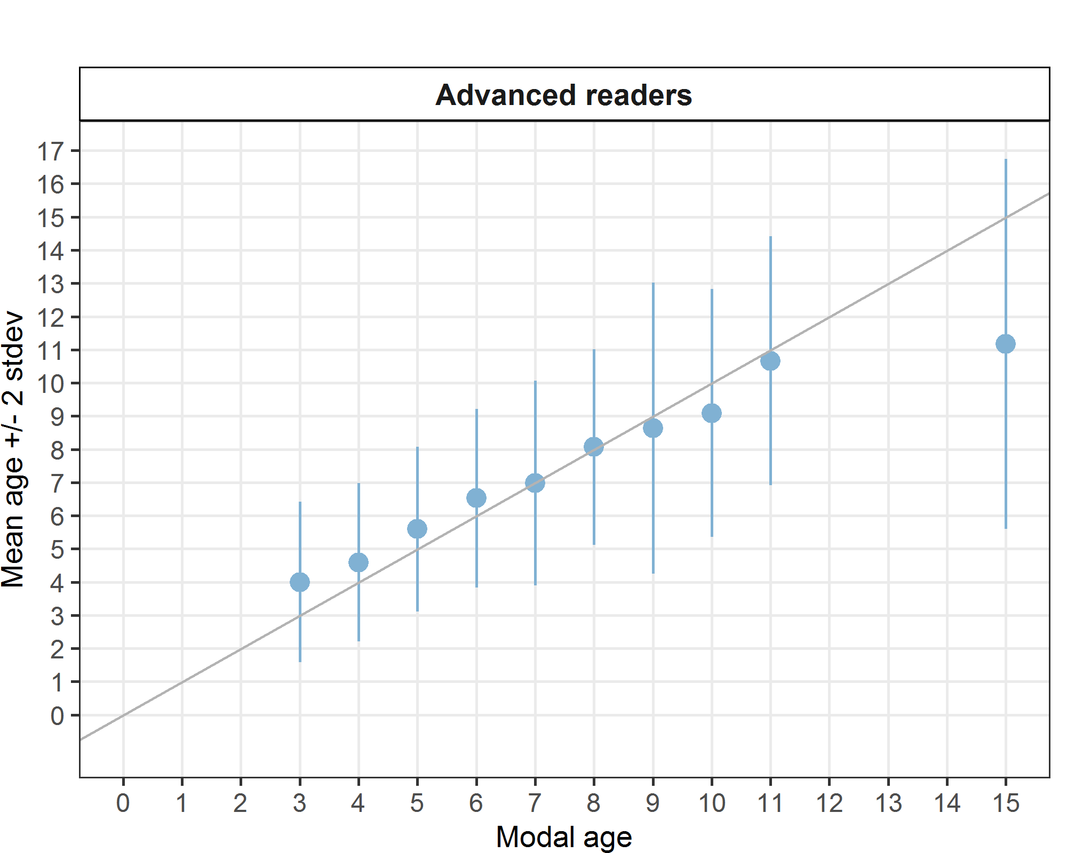

**Figure 12:** Strata Strata_S2. Age bias plot for advance readers. Mean age recorded +/- 2 stdev of each reader and all readers combined are plotted against modal age. The estimated mean age corresponds to modal age, if the estimated mean age is on the 1:1 equilibrium line (solid line). Relative bias is the age difference between estimated mean age and modal age.

*Inter-reader bias test*

The inter-reader bias test for Stratum S2 highlights significant variability among expert readers, with several readers showing systematic differences in age estimations (**Table 54**).

**Table 54**: Strata Strata_S2. Inter reader bias test. The Inter-reader bias test gives probability of bias between readers and with modal age. - = no sign of bias (p>0.05), * = possibility of bias (0.01<p<0.05), * * = certainty of bias (p<0.01).

|  |  |  |  |  |  |  |
| --- | --- | --- | --- | --- | --- | --- |
| **Comparison** | **R01 IE** | **R02 ES** | **R03 GB** | **R04 ES** | **R05 BE** | **R08 ES** |
| **R01 IE** | / | ** | - | ** | - | ** |
| **R02 ES** | ** | / | ** | ** | ** | ** |
| **R03 GB** | - | ** | / | - | ** | ** |
| **R04 ES** | ** | ** | - | / | ** | - |
| **R05 BE** | - | ** | ** | ** | / | ** |
| **R08 ES** | ** | ** | ** | - | ** | / |
| **Modal age** | ** | ** | - | - | ** | ** |

*Growth Analysis*

In this case the graph is empty.



**Figure 13:** Strata Strata_S2. Plot of average distance from the centre to the winter rings for advanced readers. The boxes represent the median, upper and lower box boundaries of the interquartile range, whiskers represent the minimum and maximum values and the dots represent the outliers.

***Overall comparison of results by strata***

The age readings across Strata S1 and S2 demonstrate a balanced and comprehensive sampling of the fish population, with a clear concentration of effort and representation in the mid-age classes (5–8) (**Table 55**).

**Table 55:** Number of age readings per strata and modal age for all advanced readers combined.

|  |  |  |  |
| --- | --- | --- | --- |
| **Modal age** | **Strata_S1** | **Strata_S2** | **total** |
| 2 | 18 | 0 | **18** |
| 3 | 18 | 12 | **30** |
| 4 | 24 | 42 | **66** |
| 5 | 63 | 72 | **135** |
| 6 | 78 | 42 | **120** |
| 7 | 48 | 41 | **89** |
| 8 | 72 | 57 | **129** |
| 9 | 0 | 60 | **60** |
| 10 | 24 | 11 | **35** |
| 11 | 0 | 12 | **12** |
| 12 | 6 | 0 | **6** |
| 13 | 0 | 0 | **0** |
| 14 | 6 | 0 | **6** |
| 15 | 0 | 6 | **6** |
| **Total** | **357** | **355** | **712** |

*Coefficient of Variation (CV)*

The coefficient of variation across Strata S1 and S2 reveals consistent reader performance, with lower variability in the mid-age classes (5–8) and higher variability at the extremes (ages 2, 9, 15) (**Table 56**). The weighted mean CV remains steady (≈22%), suggesting that while discrepancies exist, especially for the youngest and oldest fish, the overall level of agreement among advanced readers is moderate and uniform across both sampling strata.

**Table 56:** CV per strata and modal age for all advanced readers combined.

|  |  |  |  |
| --- | --- | --- | --- |
| **Modal age** | **Strata_S1** | **Strata_S2** | **all** |
| 2 | 30 % | - | 30 % |
| 3 | 26 % | 30 % | 28 % |
| 4 | 26 % | 26 % | 26 % |
| 5 | 17 % | 22 % | 20 % |
| 6 | 21 % | 21 % | 21 % |
| 7 | 22 % | 22 % | 22 % |
| 8 | 17 % | 18 % | 18 % |
| 9 | - | 25 % | 25 % |
| 10 | 18 % | 21 % | 19 % |
| 11 | - | 18 % | 18 % |
| 12 | 20 % | - | 20 % |
| 13 | - | - | - |
| 14 | 21 % | - | 21 % |
| 15 | - | 25 % | 25 % |
| **Weighted Mean** | **21 %** | **22 %** | **22 %** |

*Percentage of Agreement (PA)*

The percentage agreement among advanced readers reveals moderate consistency, with better alignment in younger age classes (especially ages 3–5) and increasing divergence for older ages (**Table 57**). The overall agreement hovers around 50%, suggesting that while the modal age often captures the majority opinion, a substantial proportion of otoliths still receive differing interpretations. These results highlight the need for targeted training and standardization.

**Table 57:** Percentage Agreement per strata and modal age for all advanced readers combined.

|  |  |  |  |
| --- | --- | --- | --- |
| **Modal age** | **Strata_S1** | **Strata_S2** | **total** |
| 2 | 50 % | - | 50 % |
| 3 | 67 % | 42 % | 57 % |
| 4 | 62 % | 55 % | 58 % |
| 5 | 62 % | 56 % | 59 % |
| 6 | 53 % | 52 % | 52 % |
| 7 | 40 % | 44 % | 42 % |
| 8 | 44 % | 49 % | 47 % |
| 9 | - | 38 % | 38 % |
| 10 | 33 % | 36 % | 34 % |
| 11 | - | 33 % | 33 % |
| 12 | 33 % | - | 33 % |
| 13 | - | - | - |
| 14 | 33 % | - | 33 % |
| 15 | - | 17 % | 17 % |
| **Weighted Mean** | **50 %** | **47 %** | **49 %** |

*Average Percentage Error (APE)*

The Average Percentage Error across strata and modal ages shows that reader precision is highest for modal ages 5 to 8 and lowest for the youngest and oldest age classes (**Table 58**). The overall error level (16%) reflects a moderate level of agreement, with no major difference between strata, pointing to consistent performance across strata.

**Table 58:** Average Percentage of Error per strata and modal age for all advanced readers combined.

|  |  |  |  |
| --- | --- | --- | --- |
| **Modal age** | **Strata_S1** | **Strata_S2** | **all** |
| 2 | 27 % | - | 27 % |
| 3 | 21 % | 21 % | 22 % |
| 4 | 17 % | 21 % | 20 % |
| 5 | 13 % | 17 % | 16 % |
| 6 | 15 % | 16 % | 15 % |
| 7 | 17 % | 14 % | 16 % |
| 8 | 14 % | 12 % | 13 % |
| 9 | - | 18 % | 18 % |
| 10 | 13 % | 17 % | 14 % |
| 11 | - | 13 % | 13 % |
| 12 | 15 % | - | 15 % |
| 13 | - | - | - |
| 14 | 17 % | - | 17 % |
| 15 | - | 20 % | 20 % |
| **Weighted Mean** | **15 %** | **16 %** | **16 %** |

*Relative bias*

The relative bias analysis shows that advanced readers tend to overestimate age in younger fish (ages 3–6) and increasingly underestimate in older age classes (ages 9–15) (**Table 59**). The magnitude of bias is reduced in Stratum S2, but this is due to the extreme positive and negative values relative to older and younger ages, not to a better performance for the otoliths of the S2.

**Table 59:** Relative Bias per strata and modal age for all advanced readers combined.

|  |  |  |  |
| --- | --- | --- | --- |
| **Modal age** | **Strata_S1** | **Strata_S2** | **all** |
| 2 | 0.72 | - | - |
| 3 | 0.56 | 1.00 | 0.78 |
| 4 | 0.25 | 0.60 | 0.42 |
| 5 | 0.32 | 0.60 | 0.46 |
| 6 | 0.44 | 0.52 | 0.48 |
| 7 | 0.42 | -0.02 | 0.20 |
| 8 | 0.47 | 0.07 | 0.27 |
| 9 | - | -0.37 | - |
| 10 | -0.21 | -0.91 | -0.56 |
| 11 | - | -0.33 | - |
| 12 | -1.00 | - | - |
| 13 | - | - | - |
| 14 | -2.83 | - | - |
| 15 | - | -3.83 | - |
| **Weighted Mean** | **0.31** | **0.13** | **0.34** |

*Growth analysis*



**Figure 14:** Plot of average distance from the centre to the winter rings for all readers by strata. The boxes represent the median, upper and lower box boundaries of the interquartile range, whiskers represent the minimum and maximum values and the dots represent the outliers.

## Discussion

The skeletal pieces analysed here included samples of the fish size range used in the stock assessments for the stock meg.27.7b-k8abd. These pieces included samples from different strata, i.e. semesters, in which a different type of border is generally shown, and from different ICES subdivisions. All these strata and data on size range were analysed and are important considerations in the present otolith exchange as recommended in the WGBIOP Guidelines for Otolith Exchanges and Workshops (ICES, 2019b). The inclusion of various types of otoliths (e.g., broken, damaged, or single otoliths) in this exchange, in proportions similar to those observed in commercial landings, allows for results that more accurately reflect the conditions under which age readings are typically performed for stock assessments. Despite the objective of improving the realism and reliability of age estimation performance, it is important to acknowledge that, due to significant delays and organizational complexities, not all designated stock assessment readers participated in the exchange. Specifically, only 7 out of 11 readers routinely responsible for ICES Divisions 7b–k and 8a, b, and d contributed readings. This indicates that over one-third of the usual readers did not participate. Additionally, several of the readers listed in the event protocol were substituted by colleagues from the same institutions, likely as a result of scheduling conflicts and delays.

The results obtained in the present exchange were compared with those from previous workshops and exchanges conducted for this species across all available areas (see Anon., 1997; Egan et al., 2004; Etherton, 2011; Gault and Craig, 2019; Landa, 2020). The current exchange focused on the megrim stock from ICES Divisions 7.b–k and 8.a,b,d (**Figure 15**). In contrast, the previous results include data from both the same and other megrim stocks (**Figure 16,**  **Figure 17, Table 60**).

The PA is low (**Figure 17**) and considerably below the 80% recommended as lowest acceptable limit for safe use of age data in stock assessment (Campana, 2001; ICES, 2013), remarking the non-uniformity of reading criteria. Also, higher values in the relative bias, CV and APE obtained in the present exchange indicate comparatively worst relative accuracy and precision in readings (**Figure 17**).

The current EX 2020-21, relative to ICES Divisions 7.b–k and 8.a, b, d, such as EX & WK 1997, EX & WK 2004, and EX 2010. In terms of PA, EX 2020-21 recorded a value of 46, the lowest among all exercises. This marks a little decline from EX 2004 and significantly from EX 1997 and EX 2010, suggesting that the agreement of the readings in 2020-21 was comparatively weaker (**Figure 17**).

Looking at CV (Coefficient of Variation), a measure of consistency, EX 2020-21 showed a value of 23, which is higher than both EX 2004 and EX 2010 (**Figure 17**). The higher CV indicates increased variability in the results, reinforcing the finding of reduced precision in EX 2020-21. The remarkably low CV in EX 2010 reflects its stronger consistency.

The Relative Bias of 0.32 in EX 2020-21 further highlights concerns, as it shows a noticeable tendency toward overestimation. This is considerably higher than the minimal bias in EX 2004 and the zero-bias reported in EX 2010, suggesting a substantial decline in age estimation accuracy (**Figure 17**).

With regard to APE (Average Percentage Error), EX 2020-21 recorded, an improvement over EX 1997, but slightly worse than EX 2004. This indicates performances better than the earliest exercise in the series in terms of APE, though not matching the performance of the mid-2000s.

Overall, when compared with previous exercises in the same ICES divisions, EX 2020-21 showed a decline in performance. It had the lowest accuracy, highest relative bias, and greater variability than previous events, particularly when measured against EX 2010, which remains the benchmark for precision and reliability in these divisions. While EX 2020-21 demonstrated some improvement in absolute error over EX 1997, the results suggest a need for methodological enhancements to restore the higher data quality achieved in earlier exercises.

Including further trials such as eliminating AQ3 readings did not improved the results, practically only two readers used this notation, one from Spain, and another from UK, while the rest of the readers seem convinced of the readings they performed. The same analysis performed only using data by expert readers, gave practically the same results than when all the readers were considered.

Coherence within some countries has been observed, but when we pool data from different countries together, the percentage of PA falls down dramatically and the CV and BIAS increase at unacceptable levels.

Another important point is the spread observed in the mean length at age per modal age per reader (**Figure 18** ). As it can be observed for the ages 2 to 3 the spread in mean length at age between readers is narrow. An acceptable spread has been observed for ages from 4 to 6, except for one reader that normally overestimate the age, as demonstrated by the systematically lower values of mean length per modal age obtained (**Figure 18**). For ages from 7 on, the spread between readers reaches 15 cm in some cases. These results are usual in ages 7 +, this is the reason why in the WGBIE, assessment of Megrim is done considering ages until 6 separately, but age of 7 or older are considered like a single category (7+) (ICES, 2024). Additionally, as shown in the length composition of catches from France and Spain (**Figure 19**), which together account for over 60% of the total landings for this stock (ICES, 2024), more than 90% of the catch consists of individuals younger than 7 years old. This analysis is based on a threshold length of 390 mm, corresponding to the highest mean length at age recorded for modal age 6 in the current Ex, used to distinguish between younger and older age groups (Figure 18).

Additionally, as it is possible to note from length composition of catches from France and Spain (**Figure 19)** (that together reach more than 60% of the landings for this stock)(ICES, 2024), more than 90% of the catch is of ages younger than 7 years old (data gathered considering a threshold length of 390 mm highest mean length at age recorded in this Ex for modal age 6for dividing the two groups ) (**Figure 18**). This underline another aspect which could have contributed to the poor results obtained in the current Ex, being the proportion of otoliths belonging to fish bigger than 390 mm TL more than 30% of the whole otolith set. Or in other terms, being the otoliths which attributed modal age belonged to group 7+, more than 36% of the whole set.



**Figure 15:** Ices divisions interested by the present Ex.



**Figure 16:** Map of ICES divisions in which previous Ex were performed.

**Table 60:** Previous Megrim otoliths Ex with ICES divisions.

|  |  |
| --- | --- |
| Event | stock |
| EX & WK 1997 | 7.b-k, 8.a,b,d |
| EX & WK 2004 | 7.b-k, 8.a,b,d |
| EX 2010 | 7.b-k, 8.a,b,d |
| EX 2018-19 | 4.a, 6.a |
| EX 2020 | 8.c, 9.a |
| EX 2020-21 (current) | 7.b-k, 8.a,b,d |

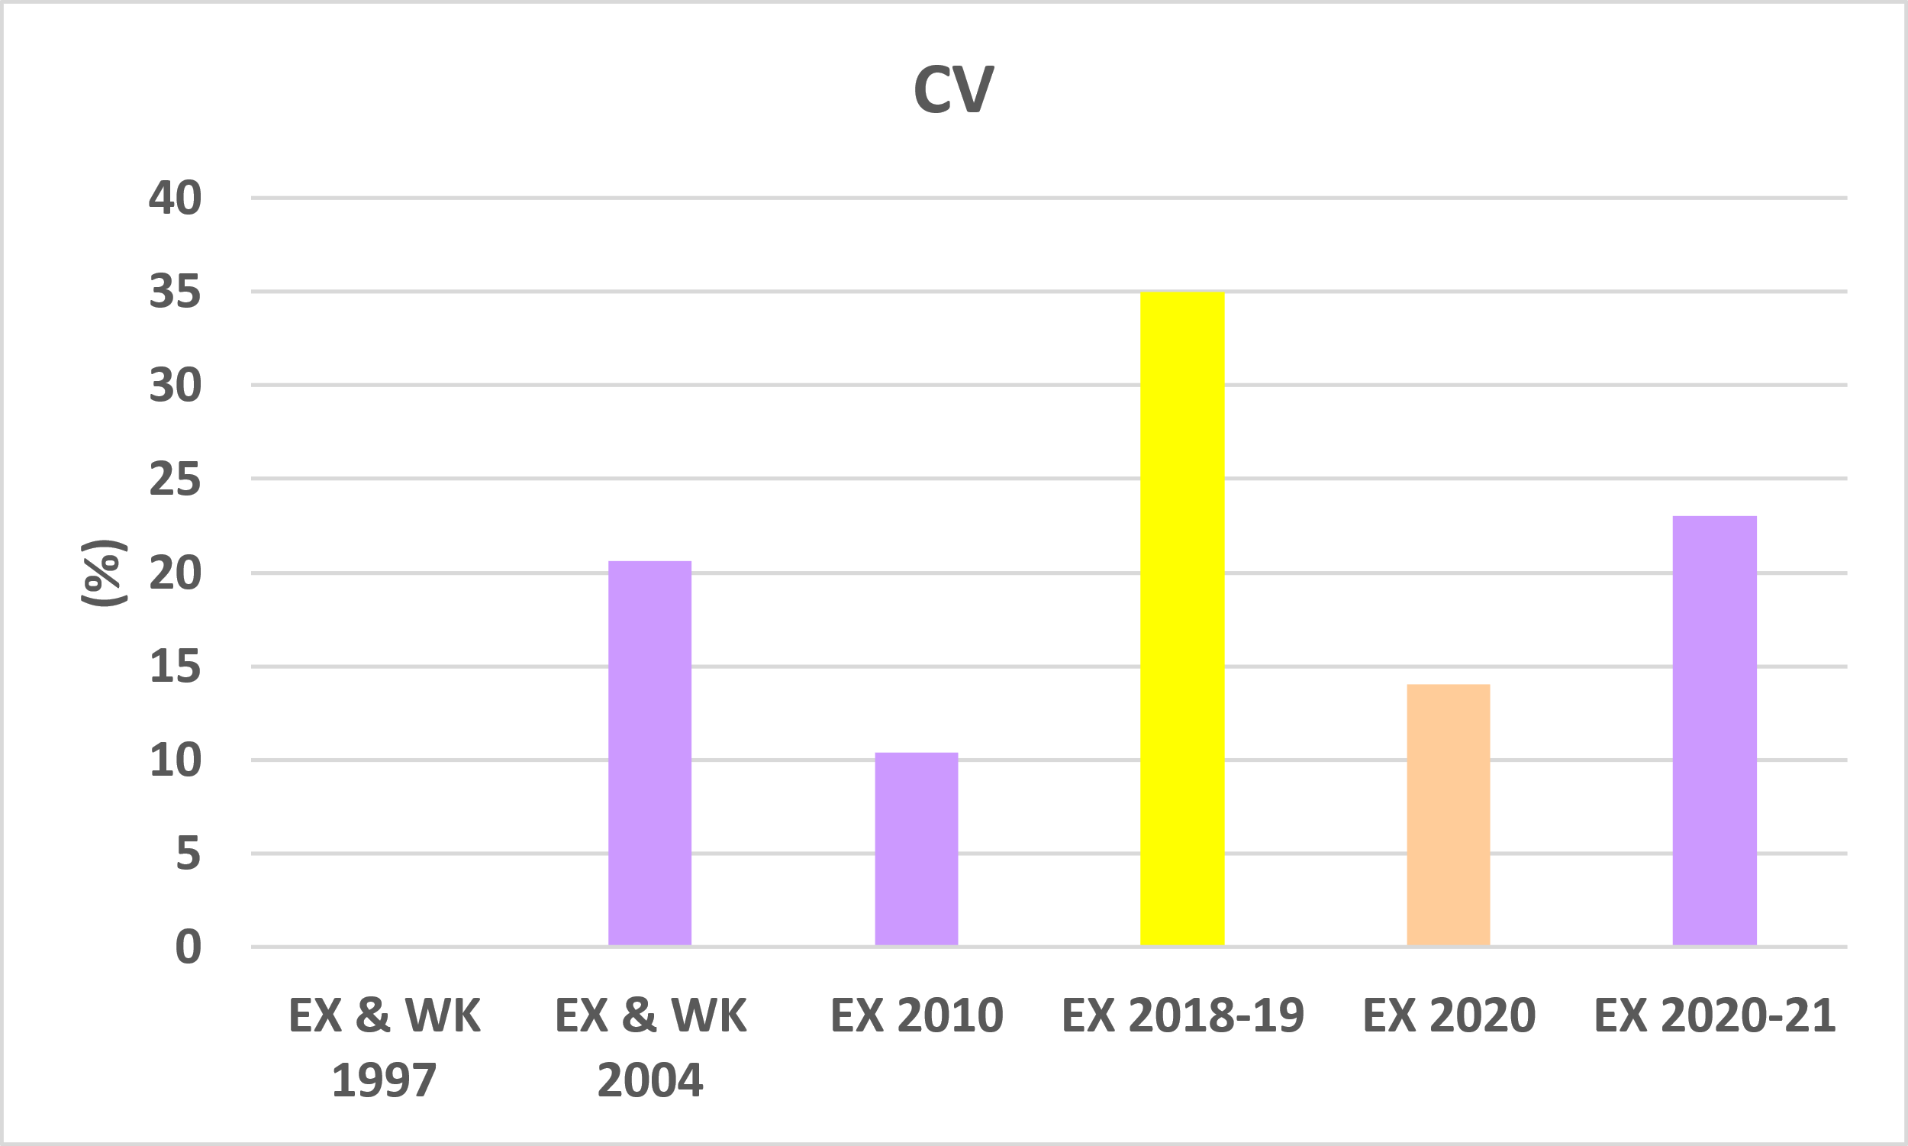

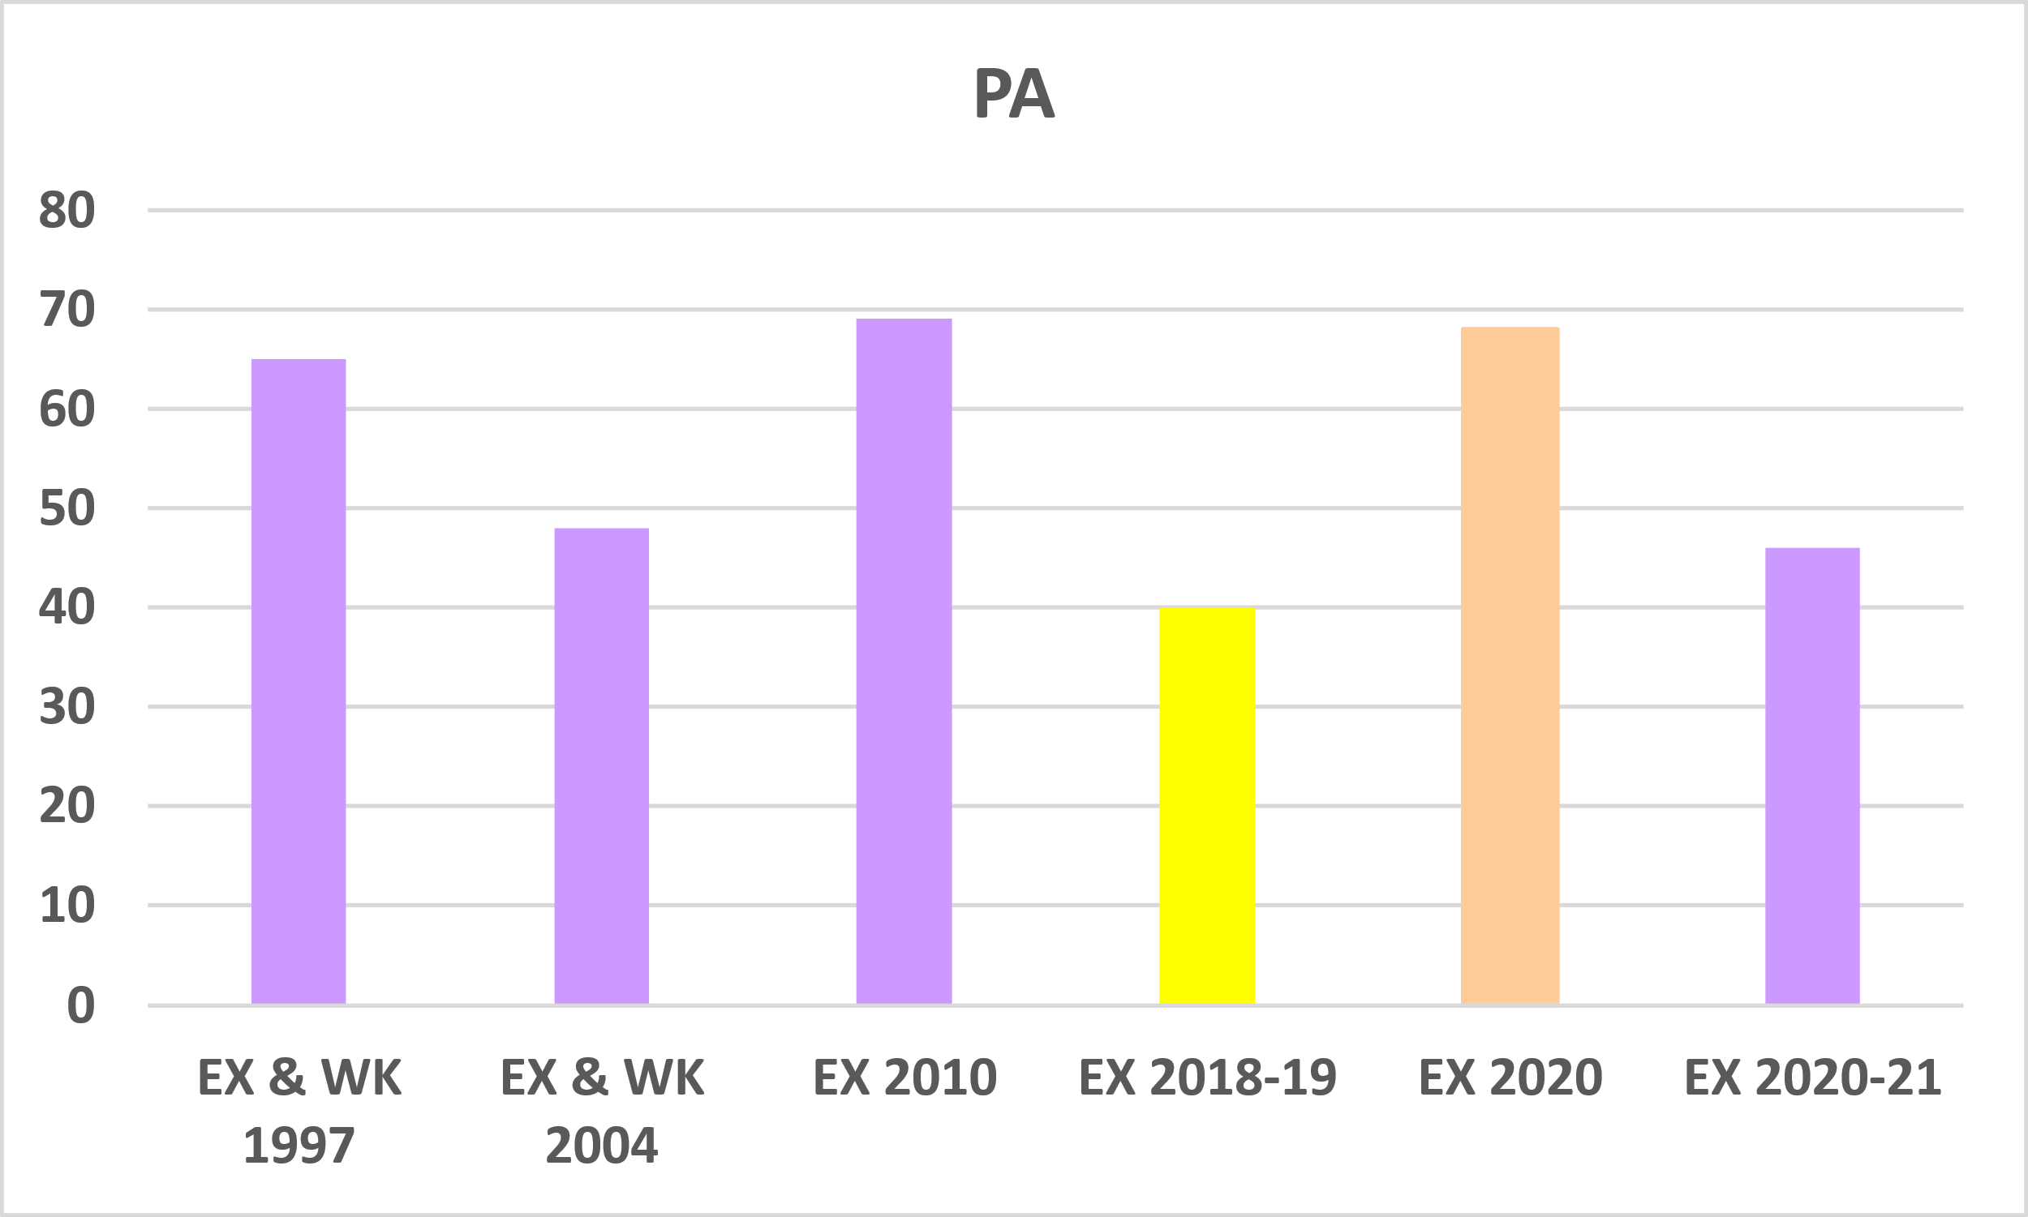

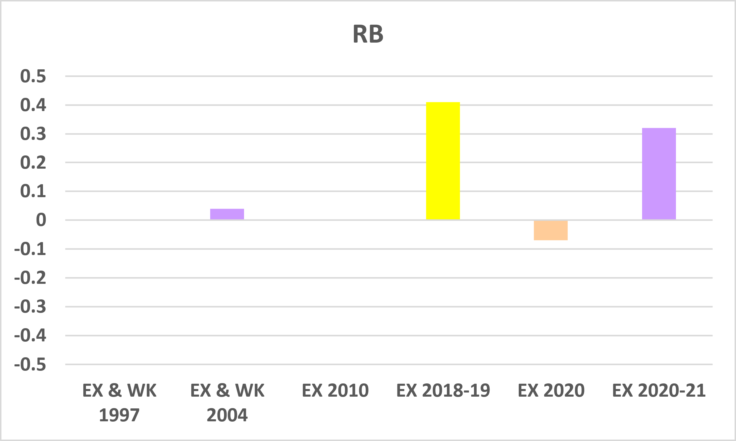

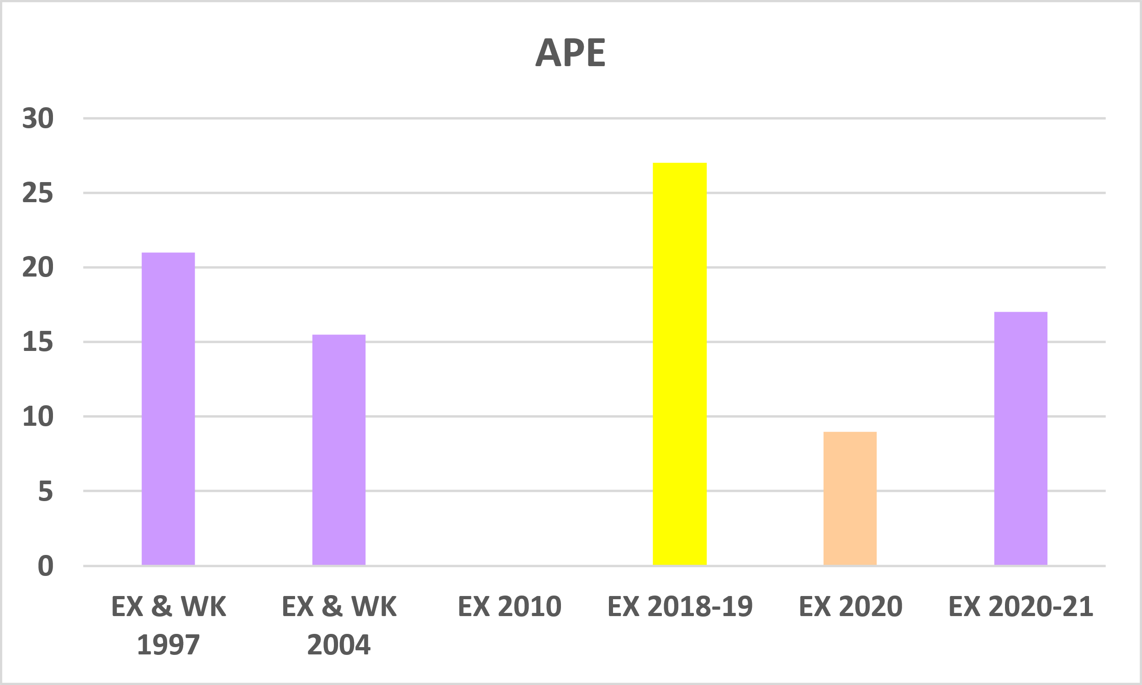

**Figure 17:** Results for the current exchange (2020‐21 EX), compared with previous megrim age estimation exchanges (EX) and workshops (WK). PA is the Percentage of Agreement; CV is the Coefficient of Variation expressed in terms of percentage; APE is the Average Percentage of Error; RB is the Relative Bias. The colour of each event indicates the studied stock described in Figure 16.

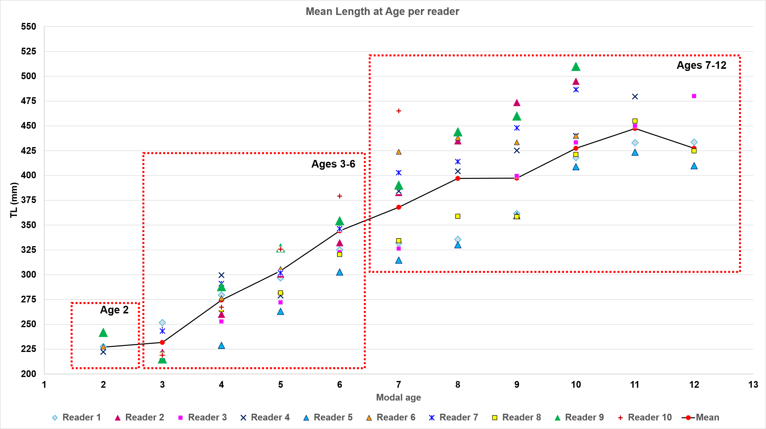

**Figure 18:** Mean Length at Age per modal age by readers including all samples analysed.

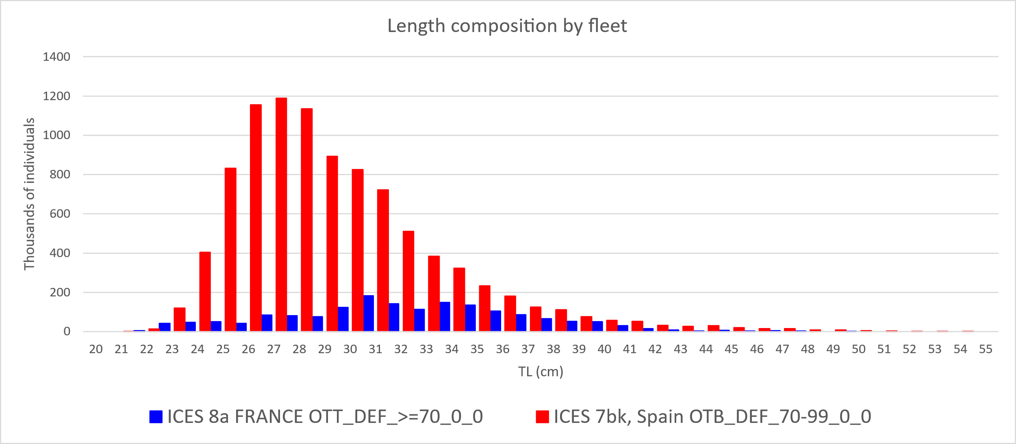

**Figure 19:** Megrim (*L. whiffiagonis*) in divisions 7.b–k and 8.a, 8.b, and 8.d. Length composition by fleet (thousands) in

2023.

Finally, when the present overall results obtained are compared with previous ones from the same ICES divisions and also from other divisions a worsening is evident. Probably the causes are due to multiple factors:

1. Analysis of the annuli close to the edge revealed that criteria to identify them are not uniform between readers, including within the expert readers group. Also differences has been observed in the first annulus.
2. Ten years lasted from the last Ex for this stock.
3. Four new readers attended the event, and not all the stock readers participated.
4. Although it is true that the size range considered for this exchange is appropriate, as it effectively covers the full range of landings for this ICES divisions, at the same time, this size distribution is unbalanced because the results showed a high proportion (more than 35%) of individuals older than 6 years. This percentage is much higher than what would represent the actual proportion of landings for those age/size classes.

## Conclusion

This is the first otolith exchange performed for the Celtic Seas and northern Bay of Biscay stock (Div. 7.b–k, 8.a,b,d) of megrim in the last 11 years, and the whole range of specimens commercially captured is analysed. The “multistage modal age approach” was used as in past megrim otolith exchanges, reducing the multiple modes to 0%. For all readers, the overall agreement (PA) was 46%, CV was 23%, APE was 17% and relative bias (RB) was 0.32. For the advanced readers the agreement was (PA) 47%, CV was 22%, and APE was 16 % with a relative bias. For the readers involved in the assessment of this stock (7 out of 10), results obtained were: overall PA of 48.8%, CV of 18.6%, and RB of 0.53. Strata semester showed better results for all readers in the first semester compared to the second one. PA decreased dramatically from age 6 on becoming lower than 50%, the overall CV was stably higher than 20% in all modal ages except age 3. RB show great values, and doesn’t follow any pattern with positive values in ages of 8 or lower and with negative and even greater values from age 9 on. Two readers (with advanced experience) showed the higher RB (>1) and the lower PA recorded. General concerns related to the age estimation in that stock were found, no coherent criteria seem to have been applied, except for some exception within some of the participant countries. The results slightly improved if considering ages lower than 7. It could be interesting, considering that stock assessment process is done considering age older than 6 as 7+ group, due to the usual increasing difficulty of interpretation in older megrim because of increased otolith opacity. The variation of interpretation of ageing criteria, also between expert readers, suggests a need for **harmonized training or calibration**, particularly for age classes that show divergent interpretations and are used as single age class in the assessment process.

Worse results in present exchange than in previous megrim age estimation exchanges and workshops (almost all based on stock 7.b-k, 8.abd) are observed. **A new workshop is recommended**. Additionally, a reference collection training, with examples of structure’ interpretations clearly explained is also recommended.

# Other ToRs

# References

**Anon. 1997. Report of workshop on megrim otolith and fin rays age reading. IEO, Vigo, Spain, 47 pp.**

**Beamish R. J. and Fournier D. A. (1981) A method for comparing the precision of a set of age determination. Canadian Journal of Fisheries and Aquatic Sciences, 38, 982–983**

**Egan, A., Etherton, M., Gomez de Segura, A., Iriondo, A., Marcal, A., Power, I., Quincoces, I., Santurtun, M., Vingaard Larsen, P. and Warne, S. 2004. Workshop on Megrim Otolith Age Readings. AZTI, Sukarrieta, Spain, 27 pp.**

**Eltink, A.T.G.W. (2000) Age reading comparisons. (MS Excel workbook version 1.0 October 2000) Internet:** [**http://www.efan.no**](http://www.efan.no)

**Etherton, M. 2011. Report of the international age determination exchange of megrim otoliths, 2010. CEFAS,**

**Lowestoft, UK, 24 pp.**

**Fernández‐Zapico, O., Punzón, A., Serrano, A., Landa, J., Ruiz‐Pico, S. and Velasco, F. 2017. Environmental drivers of**

**the distribution of the order Pleuronectiformes in the Northern Spanish Shelf. Journal of Sea Research, 130: 217–228.**

**Gault, M. and Craig, J. 2019. Megrim (*Lepidorhombus whiffiagonis*) Otolith Exchange 2018. Working document to the Working Group on Biological Parameters (WGBIOP), Lisbon (Portugal). 7-10 October 2019.**

**GUIDELINES AND TOOLS FOR AGE READING. Eltink, A.T.G.W., Newton A.W., Morgado C., Santamaria M.T.G and Modin J. (2000) Guidelines and tools for age Reading. (PDF document version 1.0 October 2000) Internet:** <http://www.efan.no>

**ICES (2014) Report of the Workshop on Statistical Analysis of Biological Calibration Studies (WKSABCAL). ICES CM 2014/ACOM: 35**

**ICES. 2019b. Working Group on Biological Parameters (WGBIOP). ICES Scientific Reports. 1:85. 93 pp.**

[**http://doi.org/10.17895/ices.pub.5682**](http://doi.org/10.17895/ices.pub.5682)

**ICES. 2021a. Working Group for the Bay of Biscay and the Iberian Waters Ecoregion (WGBIE). ICES Scientific Reports.**

**3:48. 1101 pp.** [**https://doi.org/10.17895/ices.pub.8212**](https://doi.org/10.17895/ices.pub.8212)

**ICES. 2021b. Working Group for the Celtic Seas Ecoregion (WGCSE). ICES Scientific Reports. 3:56. 1505 pp.**

[**https://doi.org/10.17895/ices.pub.8139**](https://doi.org/10.17895/ices.pub.8139)

**ICES. 2024. Working group for the Bay of Biscay and Iberian Waters Ecoregion (WGBIE). ICES Scientific Reports. 6:59. 762 pp.** [**https://doi.org/10.17895/ices.pub.25908130**](https://doi.org/10.17895/ices.pub.25908130)

**Landa, J., 2020. Megrim (*Lepidorhombus whiffiagonis*) 8.c, 9.a otolith exchange 2020. Working document to the Working Group on Biological Parameters (WGBIOP), 2020**

**Mytilineou, C., Politou, C.Y., Papaconstantinou, C., Kavadas, S., D'Onghia, G., and Sion, L. 2005. Deep‐water fish fauna in the Eastern Ionian Sea. Belgian Journal of Zoology, 135(2):229‐233.**

**Sánchez, F., Pérez, N., and Landa, J. 1998. Distribution and abundance of megrim (*Lepidorhombus boscii* and**

***Lepidorhombus whiffiagonis*) in the northern Spanish shelf. ICES Journal of Marine Science, 55: 494‐514.**

**Whitehead, P.J., Bauchot, M.L., Hureau, J.C., Nielsen, J., and Tortonesse, E. 1986. Fishes of the North‐eastern Atlantic and the Mediterranean. UNESCO, París, 1362 pp.**

# Annex 1. Protocol and Agenda

Protocol for the

"Megrim (*Lepidorhombus whiffiagonis*) 7.b-k, 8.abd otolith exchange 2021"

Coordinator: Jorge Landa

**1. Introduction**

Several age calibration exchanges and workshops on megrim samples from the 7.b-k, 8.a,b,d stock have taken place in 1997, 2004 and 2010 (Anon, 1997; Egan et al, 2004; Etherton, 2011). The ICES Working Group on Biological Parameters (WGBIOP) in 2019 (ICES, 2019b) established the need to perform an age calibration exchange of megrim (*Lepidorhombus whiffiagonis*) from ICES Div. 7.b-k, 8.abd. in 2021, coordinated by Jorge Landa (IEO, Spain). The results from the present exchange in this stock will update the status of the age interpretation among the readers involved in it, the main megrim stock by landings. Exchanges based on neighbouring stocks to that, one based on samples from the 4.a, 6.a stock in 2018-19 (Gault and Craig, 2019) and other based on the 8.c, 9.a in 2020 (Landa, 2020) have also taken place for the first time in recent years. Therefore, those results together with the coming from the present exchange will serve to have an updated overview of the megrim age interpretation in most of its Atlantic distribution. The objective of this otolith exchange is to estimate the agreement, precision and relative bias in the age estimations from age readers of the different age reading laboratories, to check that these parameters are within acceptable level (ICES, 2019b).

**2. Participants**

Age readers from different European institutes involved in the age estimation of megrim were contacted and the following ones, mainly involved in the fisheries in the 7.b-k, 8.abd stock, agreed to participate in this exchange (**Table A1- 1**).

**3. Otolith collection**

A total of 120 otoliths, 60 of them from each semester, from specimens collected in commercial catches and research surveys in 2019-20 from ICES Div. 7.b-k (60 otoliths from IEO) and Div. 8.abd (60 otoliths from AZTI), have been selected. The fish length range (20-51 cm) of the collection represents practically the whole range of specimens commercially captured by the commercial fleet in the ICES Div. 7.b-k, 8.abd stock. Including samples from both semesters, in which a different type of border is generally shown, and including samples of the fish size range used in the stock assessments, are considered important considerations in the otolith exchanges and recommended in the WGBIOP Guidelines for Otolith Exchanges and Workshops (ICES, 2019b). Information on sex will be available in all the specimens for the exchange, but not the fish length. Both whole saggital otoliths are available in most samples of the exchange collection, although for a few specimens, broken otoliths or only one otolith are included. The representation of this type of otoliths in the collection is proportional to that usually is read by the age readers in the age estimation monitoring for the stock assessment in the area. The otoliths from each specimen were immersed in water and the pictures were taken by IEO (L. Rodríguez) and AZTI (A. Maceira, C. Abaroa). Those digitized images have been uploaded to Smartdots. Therefore, the collection consists of:

* The whole otolith set
* The image set of those otoliths, available on Smartdots

**4. Age interpretation procedure**

Although the images are available on Smartdots from the beginning of the exchange, the participants will read the otoliths only when they receive the otolith set in their institutes, following the institute circulation program (**Figure A1- 1**). The age estimation should be performed first in the hard otoliths (whole otolith set) of each specimen, and then annotate their estimated annuli in the otolith image set on Smartdots. It is recommended to be using the Smardots app (in the computer) located next to the stereomiscroscope, to be able to record the ages in Smartdots immediately after having identified the annuli in the hard otoliths. If in some institute the computer and the stereo-microscope cannot be kept together, then they will be read first in the stereo-microscope and shortly afterwards (try to be the same day) the annuli will be recorded in smartdots.

**4.1. Otolith set**

The otoliths will be observed soaked in water on a black background, under a stereo microscope (around 15x magnification are recommended) and reflected light. Each age reader is free to leave the otoliths soaked in water for a time prior to reading, as usual in each institute. After reading, otoliths will be carefully dried and placed in each envelope. Every care should be taken to prevent damage to the otolith set, as this will reduce precision in age reading for subsequent readers. The age will be estimated by interpreting and counting the well-defined translucent growth bands/rings (winter rings) considered as annual (annuli), observed in the three main areas of the otoliths (**Figure A1- 2**, **Figure A1- 3**). The overall scheme of otolith edge interpretation (**Table A1- 2**) agreed in the workshop on megrim otolith and fin rays age reading (Anon, 1997) will be followed. Birthday is assumed to be 1st January.

**4.2. Image set in Smartdots:**

All images will be managed through SmartDots. A calibrated scale bar is visible on each image. The age can be estimated in one or more of the three recommended areas for ageing interpretation in the megrim otoliths (**Figure A1- 2**, **Figure A1- 3**). However, the final location of each annual winter ring in the image can only be done in a fixed reading line, and all participants will have to annotate the dots (corresponding to the winter rings) on this line created in the right otolith. Do not annotate the centre of the otolith or the outermost edge of the otolith. Only place a dot at the end of each winter ring in the fixed line, as these are counted when estimating the age. If you think that a winter ring should be located on the otolith edge (e. g. in the first quarter), logically, you should place it there. SmartDots will automatically give the age of the fish based on the number of annotations that you make. Please, use a width spot of 8 (Dot settings, width) in SmartDots for your spots. A Smartdots user manual v.5 (September 2020) is available for all exchange participants here: <https://ices.dk/data/tools/Pages/smartdots.aspx> (RESOURCES; User handbooks (2020)) Smartdots can be downloaded in: <https://ices.dk/data/tools/Pages/smartdots.aspx> (RESOURCES; Getting started, Download the app) Login for Smartdots. Each participant needs to connect to the ICES Web API using the Token authentication. A token can be obtained here <https://www.ices.dk/data/tools/Pages/smartdots.aspx> (Create token (login). In case users don’t have an ICES login they can request a guest token. Please find more information on it in the Smartdots user manual (ICES, 2019a). You can have a token for 5, 30 or 100 days (recommended).

**5. Timetable**

From 31/08/2021 the otolith set will begin to be read by the reader of the first institute and after that, to circulate between institutes (**Figure A1- 1**). From that day on, all readers should check that they can access Smartdots, even if they will not use it until the otolith set arrives. As soon as each otolith set has been read in one institute, please send it to the next institute to the address below.

**6. Participant contact details**

**Jorge Landa / Isabel Loureiro**

Instituto Español de Oceanografía (IEO), Centro Oceanográfico de Santander. Promontorio

San Martin, s/n. 39004 Santander. Spain.

**Lorena Rodríguez**

Instituto Español de Oceanografía (IEO), Centro Oceanográfico de Vigo. Subida a Radio Faro,

50. 36390 Vigo. Spain.

**Kelig Mahe / Antoine Dussuel / Solene Telliez**

IFREMER. 150 quai Gambetta. 62200 Boulogne sur Mer. France.

**Ilse Maertens / Martine Moerman**

ILVO. Ankerstraat 1, 8400 Oostende. Belgium

**Ben Hatton**

CEFAS. Pakefield Road, Lowestoft NR33 0HT. UK

**Ross Fitzgerald / Sinead O ‘Brien / John Enright**

MARINE INSTITUTE. Oranmore, Galway H91 R673. Ireland

**Carmen Abaroa / Arantza Maceira**

AZTI. Investigacion Marina, Txatxarramendi Ugartea z/g. 48395 Sukarrieta. Spain.

**7. Acknowledgments**

Many thanks to L. Rodríguez (IEO) and to A. Maceira (AZTI) for the selected images.

Thanks to AZTI for providing the otoliths from Div. 8.abd.

**8. References**

Anon., 1997. Report of workshop on megrim otolith and fin rays age reading. IEO, Vigo, Spain, 47 pp.

Egan, A., Etherton, M., Gomez de Segura, A., Iriondo, A., Marcal, A., Power, I., Quincoces, I., Santurtun, M., Vingaard Larsen, P., Warne, S., 2004. Workshop on Megrim Otolith Age Readings. AZTI, Sukarrieta, Spain, 27pp.

Etherton, M., 2011. Report of the international age determination exchange of megrim otoliths, 2010. CEFAS, Lowestoft, UK, 24 pp.

Gault, M. and Craig, J. 2019. Megrim (*Lepidorhombus whiffiagonis*) Otolith Exchange 2018. Working document to the Working Group on Biological Parameters (WGBIOP), Lisbon (Portugal). 7-10 October 2019.

ICES. 2019a. ICES Web Application Manual. 20 pp. <http://doi.org/10.17895/ices.pub.4603>

ICES. 2019b. Working Group on Biological Parameters (WGBIOP). ICES Scientific Reports. 1:85. 93 pp. <http://doi.org/10.17895/ices.pub.5682>

Landa, J., Fontenla, J., Rodríguez-Marín, E. 2019. Megrim (*Lepidorhombus whiffiagonis*) in northern Iberian waters: age determination corroboration, growth, abundance and mortality of the year-classes. Continental Shelf Research, 183: 1-13.

**Table A1- 1.** Age readers participating in the megrim 7.b-k, 8.abd otolith exchange 2021.

|  |  |  |  |  |  |
| --- | --- | --- | --- | --- | --- |
| **Name** | **Institute** | **Country** | **email** | **experience** | **Age estimate for stock assessment in 7b-k, 8a,b,d** |
| Jorge Landa (coordinator) | IEO | Spain | [jorge.landa@ieo.es](mailto:) | advanced | yes |
| Isabel  Loureiro | IEO | Spain | [isabel.loureiro@ieo.es](mailto:) | advanced | yes |
| Lorena  Rodríguez | IEO | Spain | [lorena.rodriguez@ieo.es](mailto:lorena.rodriguez@ieo.es) | intermediate | yes |
| Arantza  Maceira | AZTI | Spain | [amaceira@azti.es](mailto:amaceira@azti.es) | intermediate | yes |
| Carmen  Abaroa | AZTI | Spain | [cabaroa@azti.es](mailto:cabaroa@azti.es) | basic | yes |
| Antoine  Dussuel | IFREMER | France | [Antoine.Dussuel@ifremer.fr](mailto:Antoine.Dussuel@ifremer.fr) | intermediate | yes |
| Solene  Telliez | IFREMER | France | [Solene.Telliez@ifremer.fr](mailto:Solene.Telliez@ifremer.fr) | intermediate | yes |
| Ilse  Maertens | ILVO | Belgium | [ilse.maertens@ilvo.vlaanderen.be](mailto:ilse.maertens@ilvo.vlaanderen.be) | advanced | yes |
| Martine  Moerman | ILVO | Belgium | [martine.moerman@ilvo.vlaanderen.be](mailto:martine.moerman@ilvo.vlaanderen.be) | advanced | yes |
| Ben  Hatton | CEFAS | UK(England) | [enjamin.hatton@cefas.co.uk](mailto:) | advanced | yes |
| Ross  Fitzgerald | Mar. Inst. | Ireland | [Ross.Fitzgerald@Marine.ie](mailto:Ross.Fitzgerald@Marine.ie) | advanced | yes |
| Sinead  O ‘Brien | Mar. Inst. | Ireland | Sinead.O’Brien@Marine.ie | intermediate | no |
| John  Enright | Mar. Inst. | Ireland | [john.enright@marine.ie](mailto:john.enright@marine.ie) | basic | no |

**Table A1- 2:** Overall agreed scheme of otolith edge interpretation of *L. whiffiagonis* agreed in the Workshop on Megrim Otolith and Fin Rays Age Reading (from Anon, 1997).

|  |  |  |  |  |
| --- | --- | --- | --- | --- |
|  | **Quarter 1** | **Quarter 2** | **Quarter 3** | **Quarter 4** |
| **N annuli** |  |  |  |  |
| **Hyaline Edge** | Age = N | Age = N | Age = N-1  Early winter | Age = N-1  Early winter |
| **Opaque edge** | Age = N+ 1  late winter | Age = N | Age = N | Age = N |

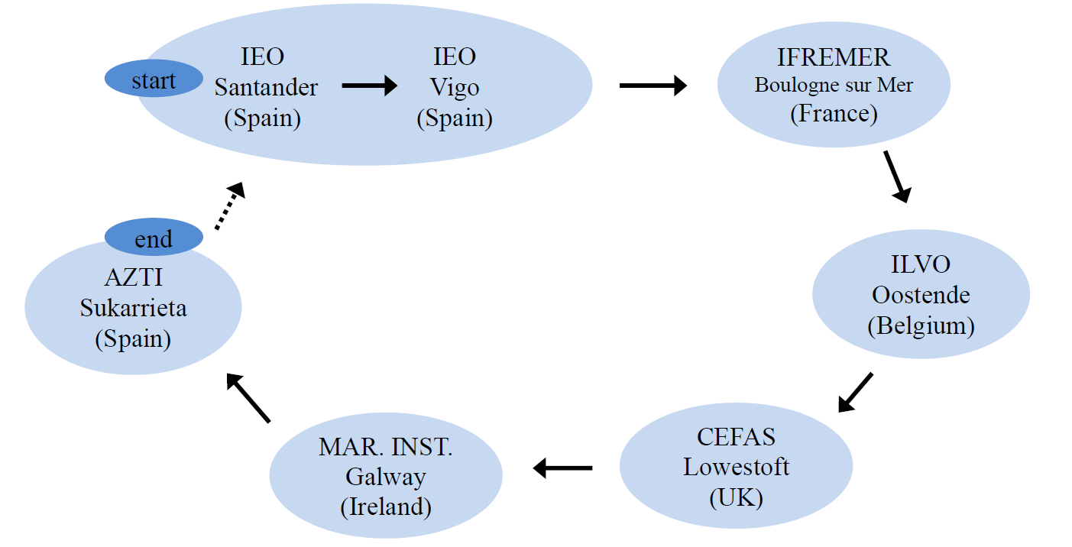

**Figure A1- 1**. Circulation of the otolith set.

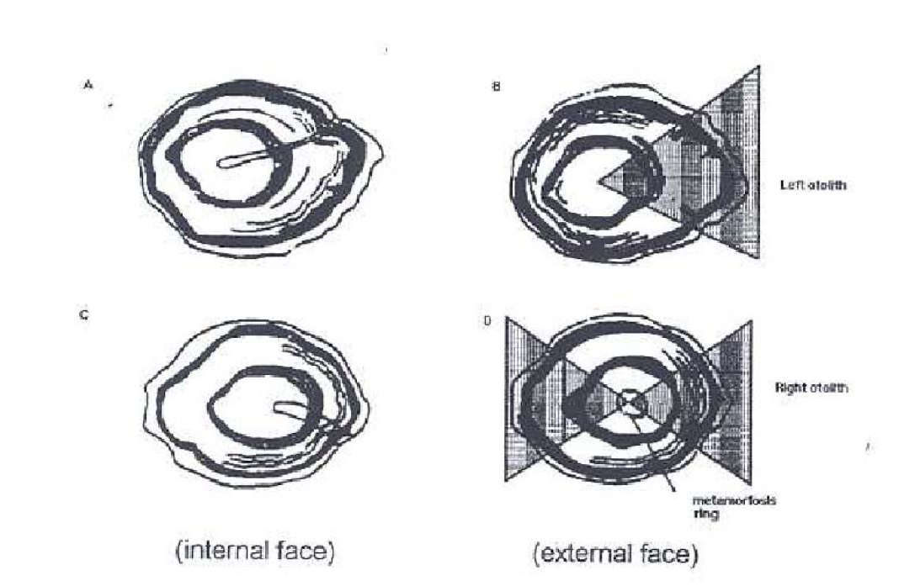

**Figure A1- 2.** Recommended areas for age estimation in the left otolith (B) and rigth otolith (D) of *L. whiffiagonis* in the Workshop on Megrim Otolith and Fin Rays Age Reading (from Anon, 1997).

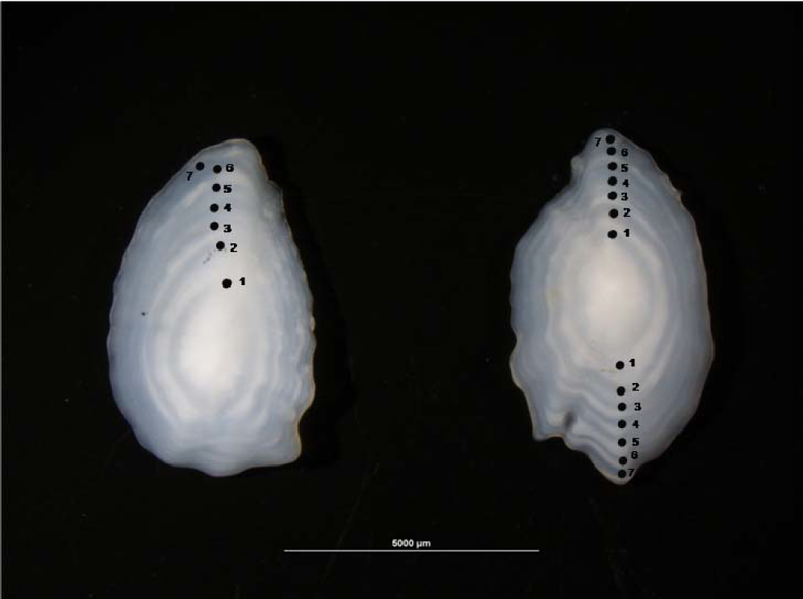

**Figure A1- 3**. Left and right otoliths of *L. whiffiagonis* from the fourth quarter and with an estimated age of 7 years. The image shows the three main age estimation areas in both otoliths and the translucent annuli counted in each area (from Landa et al., 2019).

**Table A1- 3:** List of participants. Indication of the readers for stock assessment in ICES division 7b-k, 8a,b,d.

|  |  |  |  |  |  |
| --- | --- | --- | --- | --- | --- |
| Name | Institute | Country | email | experience | Age estimate for stock assessment in 7b-k, 8a,b,d |
| Jorge Landa (coordinator) | IEO | Spain | jorge.landa@ieo.es | advanced | yes |
| Isabel  Loureiro | IEO | Spain | isabel.loureiro@ieo.es | advanced | yes |
| Lorena  Rodríguez | IEO | Spain | lorena.rodriguez@ieo.es | intermediate | yes |
| Arantza  Maceira | AZTI | Spain | amaceira@azti.es | intermediate | yes |
| Carmen  Abaroa | AZTI | Spain | cabaroa@azti.es | basic | yes |
| Antoine  Dussuel | IFREMER | France | Antoine.Dussuel@ifremer.fr | intermediate | yes |
| Solene  Telliez | IFREMER | France | Solene.Telliez@ifremer.fr | intermediate | yes |
| Ilse  Maertens | ILVO | Belgium | ilse.maertens@ilvo.vlaanderen.be | advanced | yes |
| Martine  Moerman | ILVO | Belgium | martine.moerman@ilvo.vlaanderen.be | advanced | yes |
| Ben  Hatton | CEFAS | UK(England) | benjamin.hatton@cefas.co.uk | advanced | yes |
| Ross  Fitzgerald | Mar. Inst. | Ireland | Ross.Fitzgerald@Marine.ie | advanced | yes |
| Sinead  O ‘Brien | Mar. Inst. | Ireland | Sinead.O'Brien@Marine.ie | intermediate | no |
| John  Enright | Mar. Inst. | Ireland | john.enright@marine.ie | basic | no |

# Annex 2. List of participants

The list of participants show the reader codes, their expertise and expertise rank in all the strata.

**Table A2- 1**: Participants list.

|  |  |  |  |
| --- | --- | --- | --- |
| **Reader code** | **Expertise** | **Expertise_rank** | **strata** |
| R01 IE | Advanced | 1 | Strata_S1 |
| R01 IE | Advanced | 1 | Strata_S2 |
| R02 ES | Advanced | 2 | Strata_S2 |
| R02 ES | Advanced | 2 | Strata_S1 |
| R03 GB | Advanced | 3 | Strata_S2 |
| R03 GB | Advanced | 3 | Strata_S1 |
| R04 ES | Advanced | 4 | Strata_S2 |
| R04 ES | Advanced | 4 | Strata_S1 |
| R05 BE | Advanced | 5 | Strata_S2 |
| R05 BE | Advanced | 5 | Strata_S1 |
| R08 ES | Advanced | 8 | Strata_S2 |
| R08 ES | Advanced | 8 | Strata_S1 |
| R10 FR | Basic | 10 | Strata_S2 |
| R10 FR | Basic | 10 | Strata_S1 |
| R13 IE | Basic | 13 | Strata_S1 |
| R13 IE | Basic | 13 | Strata_S2 |
| R14 BE | Basic | 14 | Strata_S1 |
| R14 BE | Basic | 14 | Strata_S2 |
| R15 ES | Basic | 15 | Strata_S1 |
| R15 ES | Basic | 15 | Strata_S2 |

# Annex 3. Additional results

## Results all readers

*Summary statistics*

**Table A3-** : Summary of statistics; PA (%), CV (%) and APE (%).

|  |  |  |  |
| --- | --- | --- | --- |
| **NSample** | **CV** | **PA** | **APE** |
| 60 | 25 % | 43 % | 19 % |

*Data Overview*

**Table A3- 2**: Data overview including modal age and statistics per sample.

|  |  |  |  |  |  |  |  |  |  |  |  |  |  |  |  |  |  |  |  |  |  |
| --- | --- | --- | --- | --- | --- | --- | --- | --- | --- | --- | --- | --- | --- | --- | --- | --- | --- | --- | --- | --- | --- |
| **Fish ID** | **Sample ID** | **Event ID** | **Image ID** | **length** | **sex** | **Catch date** | **ICES area** | **R01 IE** | **R02 ES** | **R03 GB** | **R04 ES** | **R05 BE** | **R08 ES** | **R10 FR** | **R13 IE** | **R14 BE** | **R15 ES** | **Modal age** | **PA %** | **CV %** | **APE %** |
| 142 | 142-S1 | 355 | - | 230 | F | 21/02/2019 00:00:00 | 27.7 | 3 | 3 | 3 | 3 | 4 | 3 | 3 | 3 | 3 | 4 | 3 | 80 | 13 | 10 |
| 164 | 164-S1 | 355 | - | 510 | F | 21/02/2019 00:00:00 | 27.7 | 13 | 10 | 10 | 11 | 13 | 8 | 10 | 11 | 10 | 7 | 10 | 40 | 18 | 13 |
| 185 | 185-S1 | 355 | - | 330 | F | 07/03/2019 00:00:00 | 27.7 | 9 | 7 | 7 | 6 | 9 | 5 | 5 | 8 | 6 | 5 | 5 | 30 | 23 | 19 |
| 212 | 212-S1 | 355 | - | 290 | F | 07/03/2019 00:00:00 | 27.7 | 7 | 5 | 5 | 5 | 8 | 5 | 6 | 7 | 5 | 6 | 5 | 50 | 19 | 15 |
| 278 | 278-S1 | 355 | - | 340 | F | 14/05/2019 00:00:00 | 27.7 | 8 | 6 | 7 | 7 | 8 | 6 | 6 | 10 | 6 | 6 | 6 | 50 | 19 | 14 |
| 282 | 282-S1 | 355 | - | 320 | F | 14/05/2019 00:00:00 | 27.7 | 7 | 6 | 6 | 7 | 8 | 6 | 6 | - | 7 | 6 | 6 | 56 | 11 | 9 |
| 284 | 284-S1 | 355 | - | 370 | F | 14/05/2019 00:00:00 | 27.7 | 9 | 6 | 7 | 6 | 10 | 6 | 6 | 8 | 5 | 6 | 6 | 50 | 23 | 19 |
| 291 | 291-S1 | 355 | - | 350 | F | 14/05/2019 00:00:00 | 27.7 | 8 | 6 | 7 | 7 | 9 | 5 | 5 | 6 | 4 | 5 | 5 | 30 | 25 | 20 |
| 3 | 3-S1 | 355 | - | 420 | F | 21/02/2019 00:00:00 | 27.7 | 11 | 7 | 8 | 7 | 12 | 8 | 9 | 12 | 8 | 7 | 7 | 30 | 23 | 19 |
| 320 | 320-S1 | 355 | - | 310 | F | 14/05/2019 00:00:00 | 27.7 | 8 | 7 | 8 | 8 | 9 | 6 | 7 | 7 | 7 | 5 | 7 | 40 | 16 | 12 |
| 321 | 321-S1 | 355 | - | 430 | F | 14/05/2019 00:00:00 | 27.7 | 10 | 8 | 9 | 8 | 11 | 8 | 8 | 9 | 8 | 6 | 8 | 50 | 16 | 12 |
| 323 | 323-S1 | 355 | - | 490 | F | 14/05/2019 00:00:00 | 27.7 | 10 | 8 | 10 | 9 | 14 | 8 | 8 | 11 | 8 | 6 | 8 | 40 | 24 | 18 |
| 328 | 328-S1 | 355 | - | 460 | F | 14/05/2019 00:00:00 | 27.7 | 9 | 8 | 8 | 8 | 10 | 7 | 7 | 8 | 8 | 7 | 8 | 50 | 12 | 8 |
| 330 | 330-S1 | 355 | - | 440 | F | 14/05/2019 00:00:00 | 27.7 | 10 | 8 | 8 | 9 | 11 | 8 | 8 | 10 | 6 | 6 | 8 | 40 | 20 | 15 |
| 333 | 333-S1 | 355 | - | 470 | F | 14/05/2019 00:00:00 | 27.7 | 14 | 9 | 11 | 10 | 14 | 9 | 10 | 13 | 9 | 6 | 9 | 30 | 24 | 19 |
| 349 | 349-S1 | 355 | - | 500 | F | 14/05/2019 00:00:00 | 27.7 | 10 | 9 | 8 | 8 | 11 | 7 | 9 | 10 | 9 | 7 | 9 | 30 | 15 | 12 |
| 384 | 384-S1 | 355 | - | 410 | F | 14/05/2019 00:00:00 | 27.7 | 9 | 8 | 8 | 8 | 10 | 8 | 8 | 8 | 7 | 6 | 8 | 60 | 13 | 8 |
| 389 | 389-S1 | 355 | - | 400 | F | 14/05/2019 00:00:00 | 27.7 | 10 | 8 | 10 | 9 | 12 | 8 | 8 | 12 | 7 | 6 | 8 | 30 | 22 | 18 |
| 403 | 403-S1 | 355 | - | 380 | F | 14/05/2019 00:00:00 | 27.7 | 6 | 6 | 6 | 6 | 7 | 6 | 6 | 6 | 6 | 5 | 6 | 80 | 8 | 3 |
| 54 | 54-S1 | 355 | - | 360 | F | 21/02/2019 00:00:00 | 27.7 | 7 | 6 | 6 | 6 | 7 | 6 | 6 | 7 | 6 | 6 | 6 | 70 | 8 | 7 |
| 6006 | 6006-S2 | 355 | - | 210 | M | 13/09/2019 00:00:00 | 27.7 | 4 | 5 | 6 | 5 | 7 | 5 | 6 | 8 | 4 | 5 | 5 | 40 | 23 | 18 |
| 6008 | 6008-S2 | 355 | - | 460 | F | 13/09/2019 00:00:00 | 27.7 | 10 | 8 | 6 | 9 | 9 | 7 | 8 | 7 | 7 | 6 | 7 | 30 | 17 | 14 |
| 6009 | 6009-S2 | 355 | - | 450 | F | 13/09/2019 00:00:00 | 27.7 | 9 | - | 8 | 6 | 8 | 6 | 7 | 5 | 5 | 6 | 6 | 33 | 21 | 18 |
| 6010 | 6010-S2 | 355 | - | 430 | F | 13/09/2019 00:00:00 | 27.7 | 9 | 8 | 9 | 6 | 9 | 6 | 7 | 8 | 5 | 5 | 9 | 30 | 22 | 19 |
| 6012 | 6012-S2 | 355 | - | 420 | F | 13/09/2019 00:00:00 | 27.7 | 12 | 8 | 9 | 8 | 10 | 6 | 7 | 7 | 9 | 5 | 8 | 20 | 25 | 19 |
| 6013 | 6013-S2 | 355 | - | 270 | M | 13/09/2019 00:00:00 | 27.7 | 9 | 6 | 10 | 5 | 9 | 4 | 5 | 9 | 5 | 5 | 5 | 40 | 34 | 30 |
| 6014 | 6014-S2 | 355 | - | 260 | M | 13/09/2019 00:00:00 | 27.7 | 9 | 6 | 9 | 5 | 11 | 5 | 8 | 14 | 5 | 5 | 5 | 40 | 40 | 32 |
| 6015 | 6015-S2 | 355 | - | 200 | M | 13/09/2019 00:00:00 | 27.7 | 4 | 3 | 4 | 3 | 4 | 4 | 4 | 5 | 3 | 4 | 4 | 60 | 17 | 13 |
| 6020 | 6020-S2 | 355 | - | 220 | M | 13/09/2019 00:00:00 | 27.7 | 8 | 4 | 7 | 4 | 6 | 4 | 5 | 10 | 4 | 5 | 4 | 40 | 36 | 29 |
| 6039 | 6039-S2 | 355 | - | 360 | F | 13/09/2019 00:00:00 | 27.7 | 7 | 5 | 6 | 6 | 7 | 6 | 6 | 6 | 5 | 5 | 6 | 50 | 13 | 9 |
| 6040 | 6040-S2 | 355 | - | 480 | F | 13/09/2019 00:00:00 | 27.7 | 14 | 10 | 11 | 11 | 13 | 9 | 10 | 11 | 9 | 6 | 11 | 30 | 21 | 15 |
| 6041 | 6041-S2 | 355 | - | 400 | F | 13/09/2019 00:00:00 | 27.7 | 7 | 5 | 6 | 6 | 6 | 6 | 6 | 8 | 5 | 5 | 6 | 50 | 16 | 10 |
| 6042 | 6042-S2 | 355 | - | 410 | F | 13/09/2019 00:00:00 | 27.7 | 12 | 7 | 9 | 9 | 9 | 5 | 5 | 7 | 5 | 5 | 5 | 40 | 33 | 27 |
| 6045 | 6045-S2 | 355 | - | 470 | F | 13/09/2019 00:00:00 | 27.7 | 11 | 9 | 11 | 10 | 12 | 7 | 7 | 10 | 6 | 6 | 11 | 20 | 25 | 22 |
| 6046 | 6046-S2 | 355 | - | 440 | F | 13/09/2019 00:00:00 | 27.7 | 10 | 9 | 9 | 11 | 14 | 10 | 8 | 12 | 9 | 6 | 9 | 30 | 22 | 16 |
| 6047 | 6047-S2 | 355 | - | 380 | F | 13/09/2019 00:00:00 | 27.7 | 12 | - | 11 | 10 | 10 | 7 | 6 | 11 | 4 | 4 | 10 | 22 | 37 | 33 |
| 6051 | 6051-S2 | 355 | - | 350 | F | 13/09/2019 00:00:00 | 27.7 | 9 | 7 | 8 | 8 | 9 | 5 | 7 | 9 | 6 | 6 | 9 | 30 | 19 | 16 |
| 6052 | 6052-S2 | 355 | - | 320 | F | 13/09/2019 00:00:00 | 27.7 | 10 | 6 | 7 | 8 | 9 | 6 | 6 | 9 | 5 | 5 | 6 | 30 | 25 | 21 |
| 6056 | 6056-S2 | 355 | - | 230 | F | 13/09/2019 00:00:00 | 27.7 | 4 | 3 | 4 | 3 | 5 | 3 | 4 | 4 | 3 | 4 | 4 | 50 | 18 | 15 |
| 6071 | 6071-S2 | 355 | - | 250 | F | 15/09/2019 00:00:00 | 27.7 | 4 | 5 | 6 | 6 | 7 | 4 | 6 | 7 | 6 | 5 | 6 | 40 | 19 | 16 |
| 6074 | 6074-S2 | 355 | - | 240 | M | 15/09/2019 00:00:00 | 27.7 | 7 | 5 | 6 | 5 | 7 | 3 | 5 | 6 | 4 | 5 | 5 | 40 | 24 | 18 |
| 6090 | 6090-S2 | 355 | - | 330 | F | 15/09/2019 00:00:00 | 27.7 | 10 | 7 | 8 | 9 | 10 | 6 | 8 | 8 | 8 | 5 | 8 | 40 | 20 | 14 |
| 6093 | 6093-S2 | 355 | - | 370 | F | 15/09/2019 00:00:00 | 27.7 | 9 | 7 | 8 | 8 | 12 | 6 | 7 | 9 | 5 | 4 | 8 | 20 | 30 | 23 |
| 6117 | 6117-S2 | 355 | - | 300 | F | 15/09/2019 00:00:00 | 27.7 | 5 | 5 | 6 | 6 | 9 | 5 | 5 | 6 | 5 | 4 | 5 | 50 | 24 | 16 |
| 6119 | 6119-S2 | 355 | - | 280 | F | 15/09/2019 00:00:00 | 27.7 | 4 | 4 | 4 | 4 | 4 | 4 | 4 | 4 | 4 | 4 | 4 | 100 | 0 | 0 |
| 6142 | 6142-S2 | 355 | - | 290 | F | 16/09/2019 00:00:00 | 27.7 | 5 | 5 | 6 | 5 | 8 | 5 | 5 | 7 | 6 | 5 | 5 | 60 | 19 | 15 |
| 6207 | 6207-S2 | 355 | - | 340 | F | 17/09/2019 00:00:00 | 27.7 | 8 | - | 7 | 8 | 7 | 6 | 7 | 8 | 5 | 6 | 8 | 33 | 15 | 12 |
| 6294 | 6294-S2 | 355 | - | 310 | F | 18/09/2019 00:00:00 | 27.7 | 7 | 6 | 7 | 6 | 7 | 6 | 8 | 6 | 6 | 6 | 6 | 60 | 11 | 9 |
| 6406 | 6406-S2 | 355 | - | 390 | F | 19/09/2019 00:00:00 | 27.7 | 9 | 8 | 8 | 8 | 9 | 8 | 9 | 9 | 7 | 5 | 8 | 40 | 16 | 10 |
| 66 | 66-S1 | 355 | - | 260 | F | 21/02/2019 00:00:00 | 27.7 | 6 | 5 | 5 | 5 | 6 | 5 | 5 | 6 | 5 | 6 | 5 | 60 | 10 | 9 |
| 6618 | 6618-S2 | 355 | - | 510 | F | 30/09/2019 00:00:00 | 27.7 | 10 | 9 | 9 | 8 | 10 | 8 | 7 | 10 | 6 | 7 | 10 | 30 | 17 | 14 |
| 73 | 73-S1 | 355 | - | 280 | F | 21/02/2019 00:00:00 | 27.7 | 4 | 4 | 4 | 5 | 6 | 4 | 4 | 5 | 4 | 5 | 4 | 60 | 16 | 13 |
| MEG-010620-1-1 | MEG-010620-1-1-S1 | 355 | - | 349 | F | 01/06/2020 00:00:00 | 27.8 | 4 | 5 | - | 5 | 6 | 5 | 4 | 6 | 4 | 5 | 5 | 44 | 16 | 12 |
| MEG-010620-1-19 | MEG-010620-1-19-S1 | 355 | - | 397 | F | 01/06/2020 00:00:00 | 27.8 | 4 | 5 | - | 5 | 6 | 4 | 4 | 6 | 4 | 5 | 4 | 44 | 17 | 14 |
| MEG-010620-1-5 | MEG-010620-1-5-S1 | 355 | - | 369 | F | 01/06/2020 00:00:00 | 27.8 | 5 | 6 | 6 | 6 | 8 | 5 | 5 | 7 | 5 | 5 | 5 | 50 | 18 | 14 |
| MEG-010620-2-25 | MEG-010620-2-25-S1 | 355 | - | 417 | F | 01/06/2020 00:00:00 | 27.8 | 11 | 8 | 8 | 9 | 10 | 8 | 8 | 12 | 7 | 6 | 8 | 40 | 21 | 17 |
| MEG-010620-2-26 | MEG-010620-2-26-S1 | 355 | - | 429 | F | 01/06/2020 00:00:00 | 27.8 | 12 | 8 | 10 | 8 | 9 | 9 | 8 | 10 | 7 | 6 | 8 | 30 | 20 | 15 |
| MEG-010620-2-27 | MEG-010620-2-27-S1 | 355 | - | 441 | F | 01/06/2020 00:00:00 | 27.8 | 10 | 8 | 9 | 8 | 10 | 9 | 8 | 11 | 7 | 7 | 8 | 30 | 15 | 13 |
| MEG-010620-3-19 | MEG-010620-3-19-S1 | 355 | - | 264 | M | 01/06/2020 00:00:00 | 27.8 | 7 | 5 | - | 5 | 7 | 5 | 5 | 5 | 5 | 5 | 5 | 78 | 16 | 13 |
| MEG-010620-3-38 | MEG-010620-3-38-S1 | 355 | - | 281 | M | 01/06/2020 00:00:00 | 27.8 | 9 | 6 | 6 | 6 | 9 | 6 | 6 | 9 | 5 | 5 | 6 | 50 | 24 | 21 |
| MEG-010620-3-40 | MEG-010620-3-40-S1 | 355 | - | 300 | F | 01/06/2020 00:00:00 | 27.8 | 4 | 5 | 4 | 5 | 8 | 5 | 5 | 6 | 5 | 5 | 5 | 60 | 22 | 14 |
| MEG-010620-4-19 | MEG-010620-4-19-S1 | 355 | - | 329 | F | 01/06/2020 00:00:00 | 27.8 | 4 | 6 | 6 | 5 | 7 | 5 | 5 | 5 | 5 | 5 | 5 | 60 | 16 | 12 |
| MEG-060519-1-11 | MEG-060519-1-11-S1 | 355 | - | 270 | M | 06/05/2019 00:00:00 | 27.8 | 8 | 5 | 6 | 7 | 8 | 6 | 7 | 7 | 7 | 4 | 7 | 40 | 20 | 15 |
| MEG-060519-1-27 | MEG-060519-1-27-S1 | 355 | - | 282 | F | 06/05/2019 00:00:00 | 27.8 | 4 | 4 | 4 | 4 | 5 | 4 | 4 | 4 | 4 | 4 | 4 | 90 | 8 | 4 |
| MEG-060519-1-42 | MEG-060519-1-42-S1 | 355 | - | 296 | F | 06/05/2019 00:00:00 | 27.8 | 3 | 4 | 5 | 5 | 6 | 3 | 4 | 4 | 4 | 4 | 4 | 50 | 22 | 16 |
| MEG-060519-2-12 | MEG-060519-2-12-S1 | 355 | - | 217 | F | 06/05/2019 00:00:00 | 27.8 | 2 | 3 | 3 | 2 | 4 | 2 | 3 | 4 | 1 | 4 | 2 | 30 | 37 | 30 |
| MEG-060519-2-27 | MEG-060519-2-27-S1 | 355 | - | 224 | F | 06/05/2019 00:00:00 | 27.8 | 2 | 3 | 3 | 2 | 4 | 2 | 3 | 5 | 4 | 4 | 2 | 30 | 32 | 26 |
| MEG-060519-2-42 | MEG-060519-2-42-S1 | 355 | - | 230 | F | 06/05/2019 00:00:00 | 27.8 | 4 | 4 | 5 | 4 | 8 | 3 | 5 | 5 | 6 | 5 | 5 | 40 | 28 | 19 |
| MEG-060519-2-57 | MEG-060519-2-57-S1 | 355 | - | 242 | F | 06/05/2019 00:00:00 | 27.8 | 2 | 3 | 4 | 2 | 4 | 2 | 3 | 4 | 2 | 4 | 2 | 40 | 31 | 27 |
| MEG-060519-3-23 | MEG-060519-3-23-S1 | 355 | - | 326 | M | 06/05/2019 00:00:00 | 27.8 | 7 | 5 | 5 | 4 | 6 | 4 | 5 | 5 | 5 | 4 | 5 | 50 | 19 | 12 |
| MEG-071019-1-1 | MEG-071019-1-1-S2 | 355 | - | 356 | F | 07/10/2019 00:00:00 | 27.8 | 8 | 6 | 8 | 6 | 8 | 6 | 6 | 9 | - | 6 | 6 | 56 | 17 | 16 |
| MEG-071019-1-2 | MEG-071019-1-2-S2 | 355 | - | 372 | F | 07/10/2019 00:00:00 | 27.8 | 5 | 5 | 8 | 4 | 8 | 7 | 4 | 7 | 5 | 5 | 5 | 40 | 27 | 23 |
| MEG-071019-1-22 | MEG-071019-1-22-S2 | 355 | - | 430 | F | 07/10/2019 00:00:00 | 27.8 | 11 | 9 | 10 | 9 | 10 | 9 | 8 | 10 | 7 | 6 | 9 | 30 | 17 | 13 |
| MEG-071019-1-23 | MEG-071019-1-23-S2 | 355 | - | 446 | F | 07/10/2019 00:00:00 | 27.8 | 12 | 8 | 8 | 8 | 9 | 8 | 8 | 12 | 5 | 7 | 8 | 50 | 25 | 18 |
| MEG-071019-1-6 | MEG-071019-1-6-S2 | 355 | - | 395 | F | 07/10/2019 00:00:00 | 27.8 | 10 | 7 | - | 8 | 8 | 8 | 5 | 10 | 7 | 6 | 8 | 33 | 22 | 16 |
| MEG-071019-1-9 | MEG-071019-1-9-S2 | 355 | - | 412 | F | 07/10/2019 00:00:00 | 27.8 | 10 | 7 | - | 7 | 9 | 8 | 6 | 9 | 6 | 7 | 7 | 33 | 18 | 15 |
| MEG-071019-2-1 | MEG-071019-2-1-S2 | 355 | - | 345 | F | 07/10/2019 00:00:00 | 27.8 | 8 | 7 | 8 | 7 | 7 | 8 | 7 | 8 | 7 | 6 | 7 | 50 | 9 | 8 |
| MEG-071019-2-5 | MEG-071019-2-5-S2 | 355 | - | 366 | F | 07/10/2019 00:00:00 | 27.8 | 8 | 6 | 6 | 7 | 8 | 7 | 6 | 7 | 6 | 5 | 6 | 40 | 15 | 12 |
| MEG-071019-3-1 | MEG-071019-3-1-S2 | 355 | - | 308 | F | 07/10/2019 00:00:00 | 27.8 | 4 | 4 | 5 | 4 | 5 | 5 | 4 | 5 | 4 | 5 | 4 | 50 | 12 | 11 |
| MEG-071019-3-3 | MEG-071019-3-3-S2 | 355 | - | 313 | F | 07/10/2019 00:00:00 | 27.8 | 7 | 5 | 7 | 5 | 9 | 5 | 5 | 9 | 5 | 6 | 5 | 50 | 26 | 22 |
| MEG-071019-3-4 | MEG-071019-3-4-S2 | 355 | - | 323 | M | 07/10/2019 00:00:00 | 27.8 | 7 | 5 | 6 | 6 | 7 | 5 | 5 | 7 | 5 | 5 | 5 | 50 | 16 | 14 |
| MEG-071019-3-8 | MEG-071019-3-8-S2 | 355 | - | 333 | F | 07/10/2019 00:00:00 | 27.8 | 5 | 5 | 5 | 5 | 5 | 5 | 4 | 5 | 4 | 5 | 5 | 80 | 9 | 7 |
| MEG-071019-4-1 | MEG-071019-4-1-S2 | 355 | - | 231 | M | 07/10/2019 00:00:00 | 27.8 | 9 | 5 | 6 | 5 | 8 | 6 | 5 | 7 | 4 | 5 | 5 | 40 | 26 | 20 |
| MEG-071019-4-11 | MEG-071019-4-11-S2 | 355 | - | 268 | F | 07/10/2019 00:00:00 | 27.8 | 4 | 4 | 6 | 4 | 7 | 3 | 5 | 4 | 4 | 4 | 4 | 60 | 26 | 20 |
| MEG-071019-4-18 | MEG-071019-4-18-S2 | 355 | - | 270 | F | 07/10/2019 00:00:00 | 27.8 | 6 | 5 | 6 | 5 | 6 | 4 | 4 | 7 | 6 | 4 | 6 | 40 | 20 | 17 |
| MEG-071019-4-28 | MEG-071019-4-28-S2 | 355 | - | 280 | F | 07/10/2019 00:00:00 | 27.8 | 4 | 5 | 6 | 5 | 7 | 5 | 4 | 6 | 4 | 5 | 5 | 40 | 19 | 15 |
| MEG-071019-4-3 | MEG-071019-4-3-S2 | 355 | - | 244 | F | 07/10/2019 00:00:00 | 27.8 | 5 | 5 | 7 | 5 | 8 | 5 | 5 | 5 | 5 | 4 | 5 | 70 | 22 | 16 |
| MEG-071019-4-35 | MEG-071019-4-35-S2 | 355 | - | 298 | M | 07/10/2019 00:00:00 | 27.8 | 10 | 6 | 9 | 6 | 9 | 6 | 4 | 10 | 5 | 5 | 6 | 30 | 32 | 29 |
| MEG-071019-4-5 | MEG-071019-4-5-S2 | 355 | - | 256 | M | 07/10/2019 00:00:00 | 27.8 | 3 | 5 | 4 | 4 | 7 | 3 | 4 | 4 | 4 | 4 | 4 | 60 | 27 | 17 |
| MEG-071019-5-1 | MEG-071019-5-1-S2 | 355 | - | 219 |  | 07/10/2019 00:00:00 | 27.8 | 5 | 4 | 5 | 5 | 6 | 5 | 5 | 6 | 5 | 3 | 5 | 60 | 18 | 11 |
| MEG-071019-5-2 | MEG-071019-5-2-S2 | 355 | - | 220 |  | 07/10/2019 00:00:00 | 27.8 | 6 | 4 | 5 | 5 | 5 | 5 | 5 | 5 | 5 | 4 | 5 | 70 | 12 | 7 |
| MEG-180219-1-1 | MEG-180219-1-1-S1 | 355 | - | 316 | F | 18/02/2019 00:00:00 | 27.8 | 6 | 5 | 6 | 5 | 7 | 5 | 5 | 6 | 5 | 6 | 5 | 50 | 12 | 11 |
| MEG-180219-1-11 | MEG-180219-1-11-S1 | 355 | - | 363 | F | 18/02/2019 00:00:00 | 27.8 | 7 | 5 | 6 | 6 | 8 | 6 | 6 | 6 | 5 | 6 | 6 | 60 | 14 | 9 |
| MEG-180219-1-19 | MEG-180219-1-19-S1 | 355 | - | 379 | F | 18/02/2019 00:00:00 | 27.8 | 7 | 7 | 8 | 7 | 8 | 6 | 6 | 8 | 6 | 6 | 6 | 40 | 13 | 10 |
| MEG-180219-1-2 | MEG-180219-1-2-S1 | 355 | - | 331 | F | 18/02/2019 00:00:00 | 27.8 | 6 | 6 | 6 | 5 | 9 | 5 | 5 | 7 | 6 | 6 | 6 | 50 | 20 | 12 |
| MEG-180219-1-8 | MEG-180219-1-8-S1 | 355 | - | 356 | F | 18/02/2019 00:00:00 | 27.8 | 5 | 6 | 6 | 6 | 9 | 5 | 5 | 5 | 6 | 6 | 6 | 50 | 20 | 12 |
| MEG-180219-3-1 | MEG-180219-3-1-S1 | 355 | - | 253 | F | 18/02/2019 00:00:00 | 27.8 | 5 | 5 | 5 | 5 | 7 | 5 | 6 | 5 | 5 | 4 | 5 | 70 | 15 | 10 |
| MEG-180219-3-2 | MEG-180219-3-2-S1 | 355 | - | 206 | F | 18/02/2019 00:00:00 | 27.8 | 3 | 4 | 4 | 2 | 5 | 4 | 4 | 7 | 3 | 5 | 4 | 40 | 33 | 23 |
| MEG-300619-1-40 | MEG-300619-1-40-S1 | 355 | - | 380 | F | 30/06/2019 00:00:00 | 27.8 | 6 | 6 | 7 | 6 | 8 | 5 | 5 | 7 | 5 | 5 | 5 | 40 | 18 | 13 |
| MEG-300619-1-41 | MEG-300619-1-41-S1 | 355 | - | 382 | F | 30/06/2019 00:00:00 | 27.8 | 6 | 5 | 7 | 6 | 7 | 5 | 5 | 6 | 5 | 6 | 6 | 40 | 14 | 11 |
| MEG-300619-1-42 | MEG-300619-1-42-S1 | 355 | - | 405 | F | 30/06/2019 00:00:00 | 27.8 | 7 | 7 | 8 | 6 | 9 | 5 | 6 | 9 | 5 | 5 | 5 | 30 | 23 | 19 |
| MEG-300619-1-43 | MEG-300619-1-43-S1 | 355 | - | 404 | F | 30/06/2019 00:00:00 | 27.8 | 8 | 7 | 9 | 7 | 10 | 7 | 8 | 10 | 7 | 5 | 7 | 40 | 20 | 15 |
| MEG-300619-1-44 | MEG-300619-1-44-S1 | 355 | - | 428 | F | 30/06/2019 00:00:00 | 27.8 | 11 | 8 | 8 | 7 | 10 | 8 | 8 | 11 | 6 | 5 | 8 | 40 | 24 | 18 |
| MEG-301120-1-17 | MEG-301120-1-17-S2 | 355 | - | 404 | F | 30/11/2020 00:00:00 | 27.8 | 10 | 7 | 8 | 4 | 7 | 7 | 6 | 9 | 7 | 6 | 7 | 40 | 23 | 16 |
| MEG-301120-1-25 | MEG-301120-1-25-S2 | 355 | - | 426 | F | 30/11/2020 00:00:00 | 27.8 | 8 | 7 | 7 | 7 | 7 | 8 | 6 | 12 | 6 | 5 | 7 | 40 | 26 | 17 |
| MEG-301120-1-3 | MEG-301120-1-3-S2 | 355 | - | 386 | F | 30/11/2020 00:00:00 | 27.8 | 6 | 5 | 6 | 6 | 6 | 6 | 5 | 7 | 5 | 6 | 6 | 60 | 11 | 8 |
| MEG-301120-1-39 | MEG-301120-1-39-S2 | 355 | - | 454 | F | 30/11/2020 00:00:00 | 27.8 | 12 | 8 | 8 | 7 | 10 | 8 | 7 | 10 | 8 | 6 | 8 | 40 | 21 | 16 |
| MEG-301120-1-42 | MEG-301120-1-42-S2 | 355 | - | 461 | F | 30/11/2020 00:00:00 | 27.8 | 9 | 7 | 8 | 7 | 11 | 8 | 7 | 10 | 7 | 6 | 7 | 40 | 20 | 15 |
| MEG-301120-1-44 | MEG-301120-1-44-S2 | 355 | - | 488 | F | 30/11/2020 00:00:00 | 27.8 | 15 | 9 | 10 | 11 | 14 | 8 | 8 | 10 | 8 | 7 | 8 | 30 | 27 | 20 |
| MEG-301120-2-1 | MEG-301120-2-1-S2 | 355 | - | 337 | F | 30/11/2020 00:00:00 | 27.8 | 5 | 5 | 6 | 4 | 6 | 4 | 3 | 7 | 5 | 5 | 5 | 40 | 23 | 16 |
| MEG-301120-2-23 | MEG-301120-2-23-S2 | 355 | - | 351 | M | 30/11/2020 00:00:00 | 27.8 | 16 | 7 | 9 | 8 | 13 | 9 | 5 | 16 | 7 | 6 | 16 | 20 | 42 | 34 |
| MEG-301120-3-2 | MEG-301120-3-2-S2 | 355 | - | 313 | F | 30/11/2020 00:00:00 | 27.8 | 3 | 4 | 5 | 4 | 6 | 5 | 4 | 4 | 5 | 4 | 4 | 50 | 19 | 15 |
| SLW-122 | SLW-122-S1 | 355 | - | 480 | F | 21/03/2019 00:00:00 | 27.7 | 12 | 9 | 12 | 11 | 14 | 8 | 9 | 10 | 8 | 7 | 12 | 20 | 22 | 18 |
| SLW-18 | SLW-18-S1 | 355 | - | 250 | F | 18/03/2019 00:00:00 | 27.7 | 5 | 5 | 5 | 5 | 6 | 5 | 5 | 5 | 5 | 6 | 5 | 80 | 8 | 6 |
| SLW-21 | SLW-21-S1 | 355 | - | 240 | F | 18/03/2019 00:00:00 | 27.7 | 5 | 5 | 5 | 5 | 6 | 5 | 5 | 5 | 5 | 6 | 5 | 80 | 8 | 6 |
| SLW-42 | SLW-42-S1 | 355 | - | 450 | F | 19/03/2019 00:00:00 | 27.7 | 12 | 8 | 10 | 9 | 11 | 8 | 9 | 8 | 9 | 7 | 8 | 30 | 17 | 13 |
| SLW-61 | SLW-61-S1 | 355 | - | 390 | F | 19/03/2019 00:00:00 | 27.7 | 7 | 7 | 6 | 7 | 12 | 6 | 6 | 7 | 7 | 6 | 7 | 50 | 25 | 14 |
| SLW-64 | SLW-64-S1 | 355 | - | 210 | F | 19/03/2019 00:00:00 | 27.7 | 3 | 3 | 3 | 3 | 4 | 3 | 3 | 3 | 3 | 4 | 3 | 80 | 13 | 10 |
| SLW-9 | SLW-9-S1 | 355 | - | 270 | M | 18/03/2019 00:00:00 | 27.7 | 7 | 5 | 7 | 6 | 10 | 5 | 5 | 8 | 6 | 5 | 5 | 40 | 26 | 20 |
| SLW-99 | SLW-99-S1 | 355 | - | 300 | M | 20/03/2019 00:00:00 | 27.7 | 8 | 6 | 7 | 6 | 13 | 6 | 6 | 8 | 6 | 6 | 6 | 60 | 31 | 21 |

*Number of age readings by modal age*

**Table A3- 3**: Number of age readings table gives an overview of number of readings per reader and modal age. The total numbers of readings by modal age and by reader are also presented.

|  |  |  |  |  |  |  |  |  |  |  |  |
| --- | --- | --- | --- | --- | --- | --- | --- | --- | --- | --- | --- |
| **Modal age** | **R01 IE** | **R02 ES** | **R03 GB** | **R04 ES** | **R05 BE** | **R08 ES** | **R10 FR** | **R13 IE** | **R14 BE** | **R15 ES** | **total** |
| 2 | 3 | 3 | 3 | 3 | 3 | 3 | 3 | 3 | 3 | 3 | 30 |
| 3 | 2 | 2 | 2 | 2 | 2 | 2 | 2 | 2 | 2 | 2 | 20 |
| 4 | 13 | 13 | 12 | 13 | 13 | 13 | 13 | 13 | 13 | 13 | 129 |
| 5 | 35 | 35 | 33 | 35 | 35 | 35 | 35 | 35 | 35 | 35 | 348 |
| 6 | 23 | 22 | 23 | 23 | 23 | 23 | 23 | 22 | 22 | 23 | 227 |
| 7 | 11 | 11 | 10 | 11 | 11 | 11 | 11 | 11 | 11 | 11 | 109 |
| 8 | 20 | 19 | 19 | 20 | 20 | 20 | 20 | 20 | 20 | 20 | 198 |
| 9 | 6 | 6 | 6 | 6 | 6 | 6 | 6 | 6 | 6 | 6 | 60 |
| 10 | 3 | 2 | 3 | 3 | 3 | 3 | 3 | 3 | 3 | 3 | 29 |
| 11 | 2 | 2 | 2 | 2 | 2 | 2 | 2 | 2 | 2 | 2 | 20 |
| 12 | 1 | 1 | 1 | 1 | 1 | 1 | 1 | 1 | 1 | 1 | 10 |
| 13 | 0 | 0 | 0 | 0 | 0 | 0 | 0 | 0 | 0 | 0 | 0 |
| 14 | 0 | 0 | 0 | 0 | 0 | 0 | 0 | 0 | 0 | 0 | 0 |
| 15 | 0 | 0 | 0 | 0 | 0 | 0 | 0 | 0 | 0 | 0 | 0 |
| 16 | 1 | 1 | 1 | 1 | 1 | 1 | 1 | 1 | 1 | 1 | 10 |
| **Total** | **120** | **117** | **115** | **120** | **120** | **120** | **120** | **119** | **119** | **120** | **1190** |

*Number of age readings by age*

**Table A3- 4:** Age composition by reader gives a summary of number of readings per reader and age. The total numbers of readings by age and by reader are also presented.

|  |  |  |  |  |  |  |  |  |  |  |  |
| --- | --- | --- | --- | --- | --- | --- | --- | --- | --- | --- | --- |
| **Age** | **R01 IE** | **R02 ES** | **R03 GB** | **R04 ES** | **R05 BE** | **R08 ES** | **R10 FR** | **R13 IE** | **R14 BE** | **R15 ES** | **total** |
| 1 | 0 | 0 | 0 | 0 | 0 | 0 | 0 | 0 | 1 | 0 | 1 |
| 2 | 3 | 0 | 0 | 4 | 0 | 3 | 0 | 0 | 1 | 0 | 11 |
| 3 | 6 | 7 | 4 | 4 | 0 | 8 | 6 | 2 | 5 | 1 | 43 |
| 4 | 15 | 12 | 9 | 12 | 7 | 12 | 17 | 9 | 18 | 22 | 133 |
| 5 | 12 | 33 | 13 | 27 | 6 | 34 | 33 | 16 | 39 | 44 | 257 |
| 6 | 9 | 20 | 28 | 24 | 15 | 26 | 24 | 15 | 22 | 42 | 225 |
| 7 | 16 | 18 | 15 | 15 | 20 | 9 | 14 | 21 | 18 | 11 | 157 |
| 8 | 12 | 17 | 22 | 17 | 18 | 21 | 18 | 14 | 8 | 0 | 147 |
| 9 | 14 | 8 | 11 | 9 | 20 | 6 | 5 | 12 | 6 | 0 | 91 |
| 10 | 15 | 2 | 8 | 3 | 14 | 1 | 3 | 15 | 1 | 0 | 62 |
| 11 | 5 | 0 | 4 | 5 | 6 | 0 | 0 | 6 | 0 | 0 | 26 |
| 12 | 8 | 0 | 1 | 0 | 5 | 0 | 0 | 6 | 0 | 0 | 20 |
| 13 | 1 | 0 | 0 | 0 | 4 | 0 | 0 | 1 | 0 | 0 | 6 |
| 14 | 2 | 0 | 0 | 0 | 5 | 0 | 0 | 1 | 0 | 0 | 8 |
| 15 | 1 | 0 | 0 | 0 | 0 | 0 | 0 | 0 | 0 | 0 | 1 |
| 16 | 1 | 0 | 0 | 0 | 0 | 0 | 0 | 1 | 0 | 0 | 2 |
| **Total** | **120** | **117** | **115** | **120** | **120** | **120** | **120** | **119** | **119** | **120** | **1190** |

*Separate age bias plots by reader*

In general, practically all the readers present bias in the readings in some point (**Figure A3- 1**), most of them tend to underestimate the modal ages older than 10 years, and some of them have the tendency to overestimate when reading ages from 2 to 7 (**Figure A3- 1**).

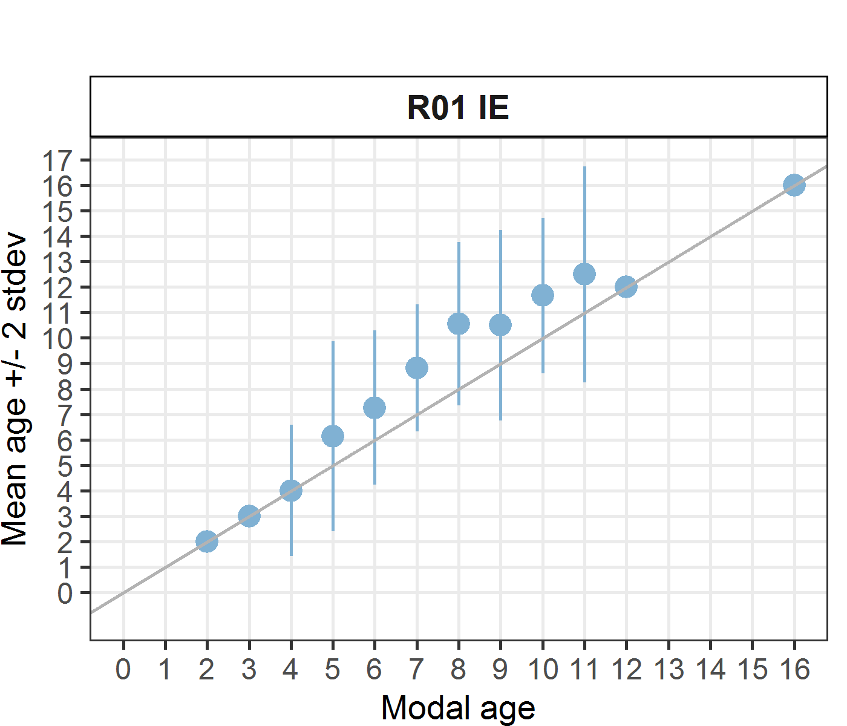 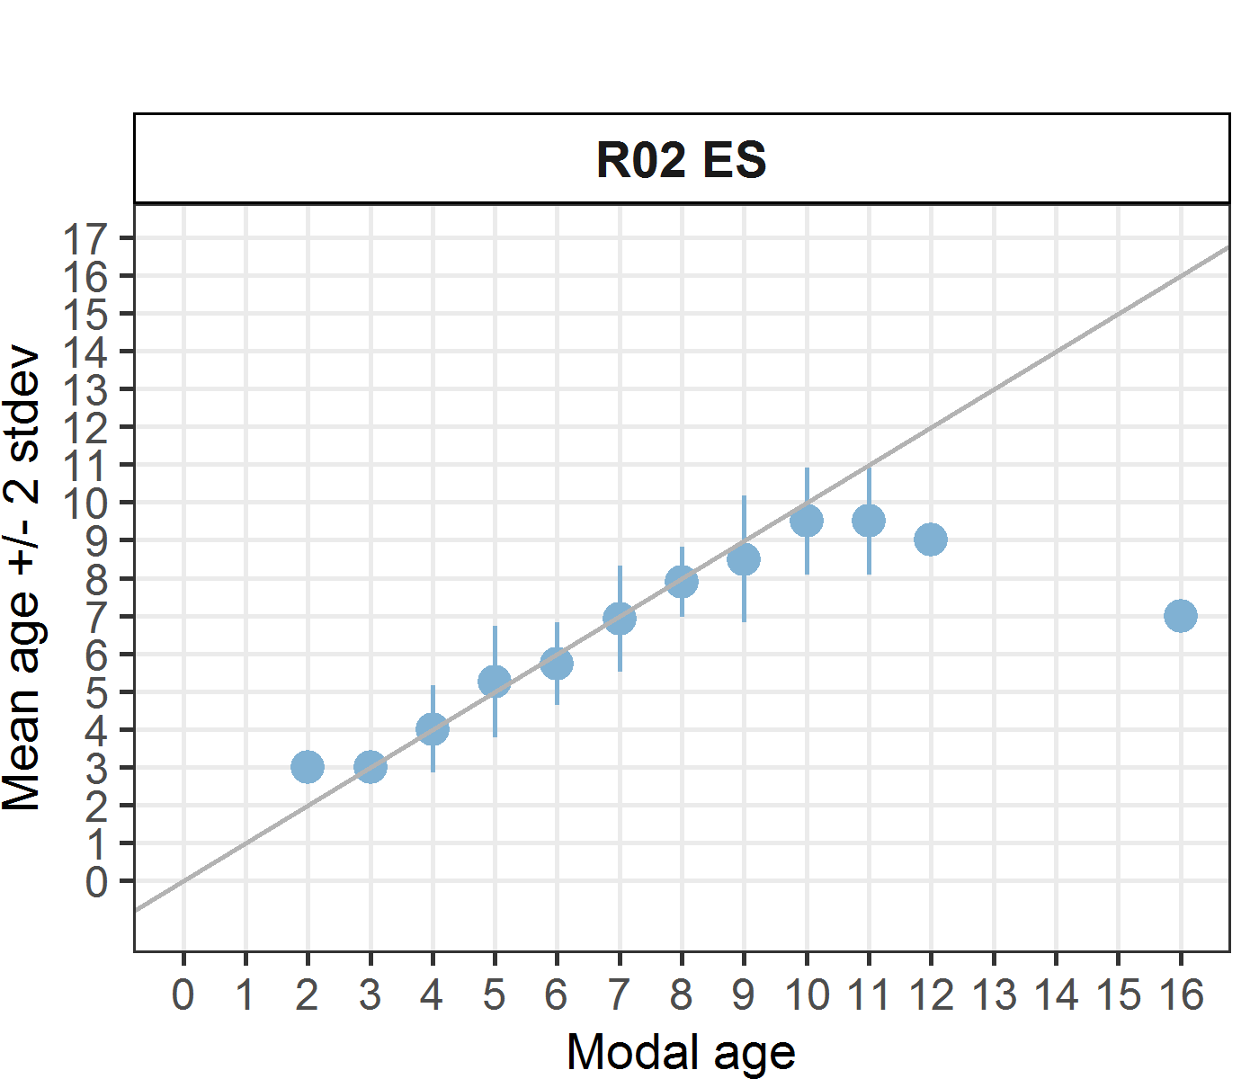 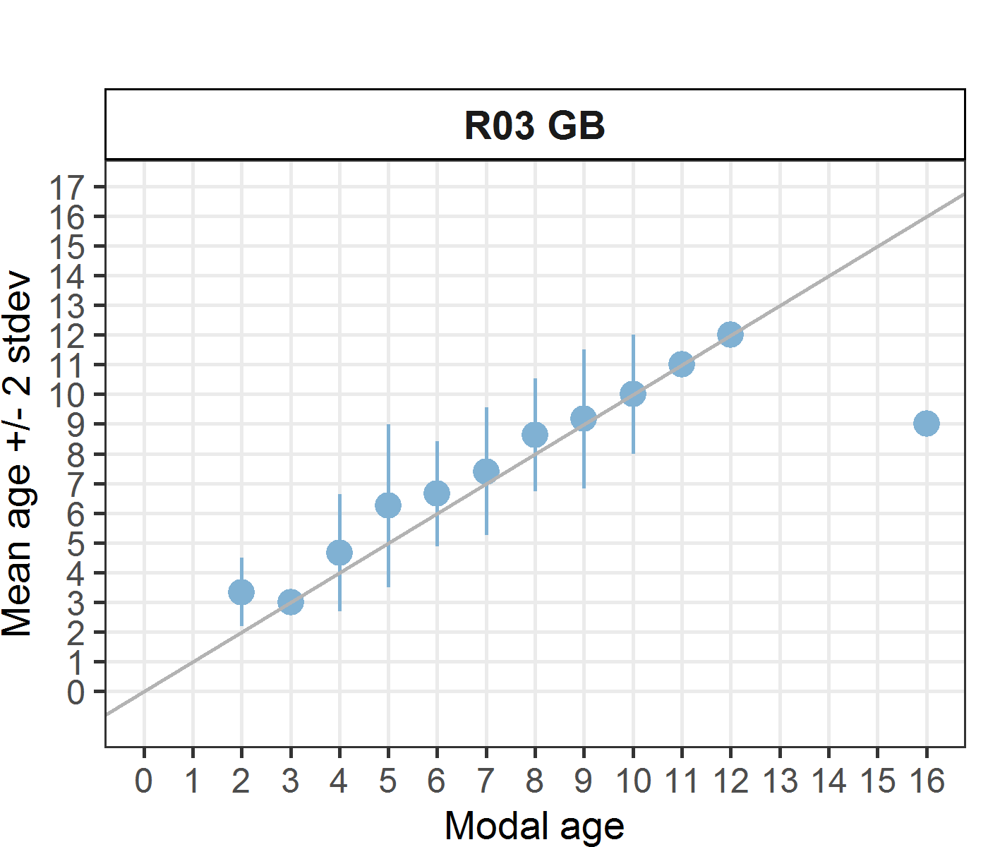 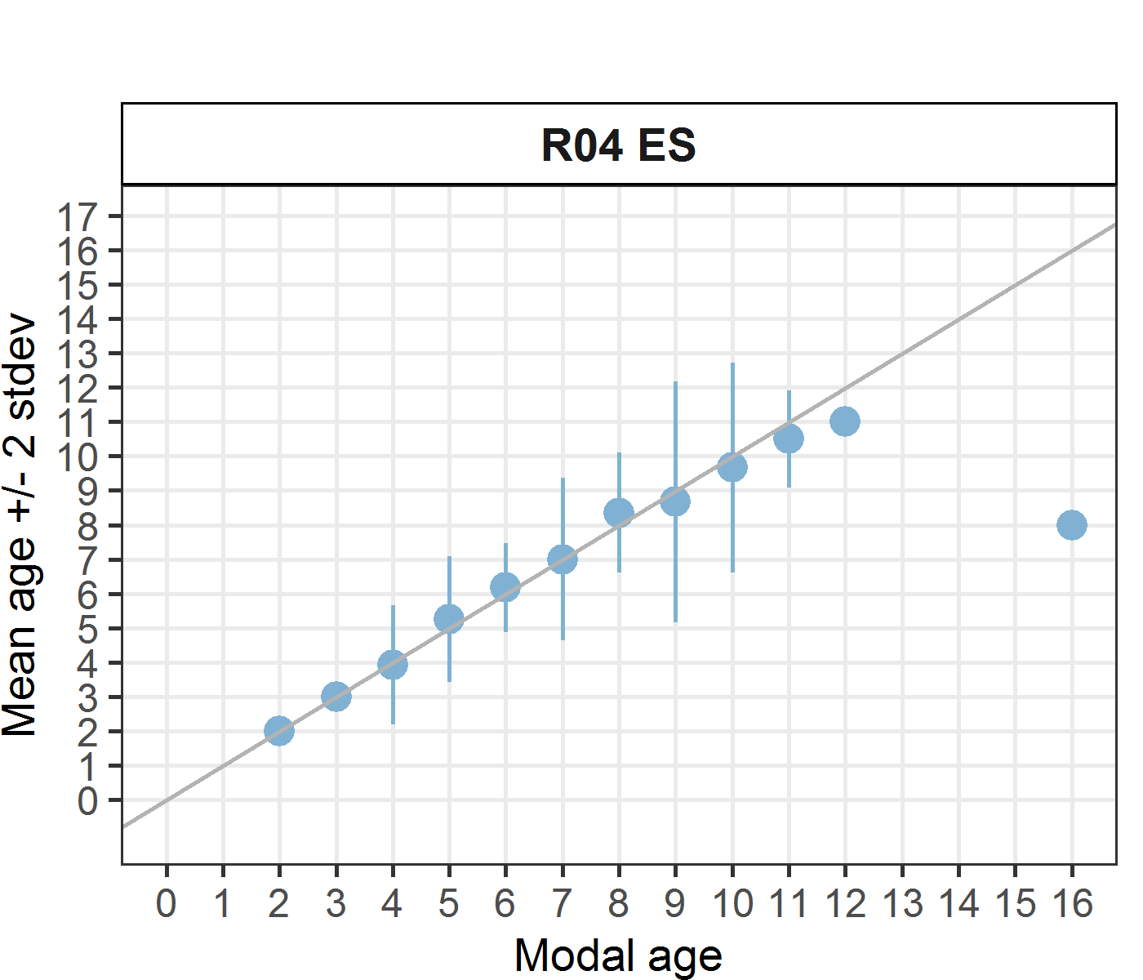 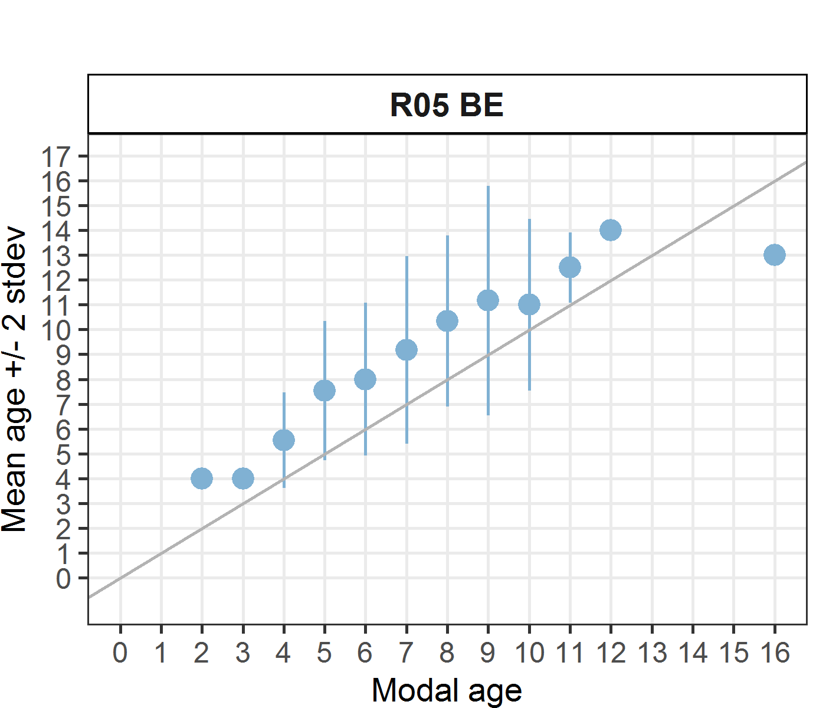 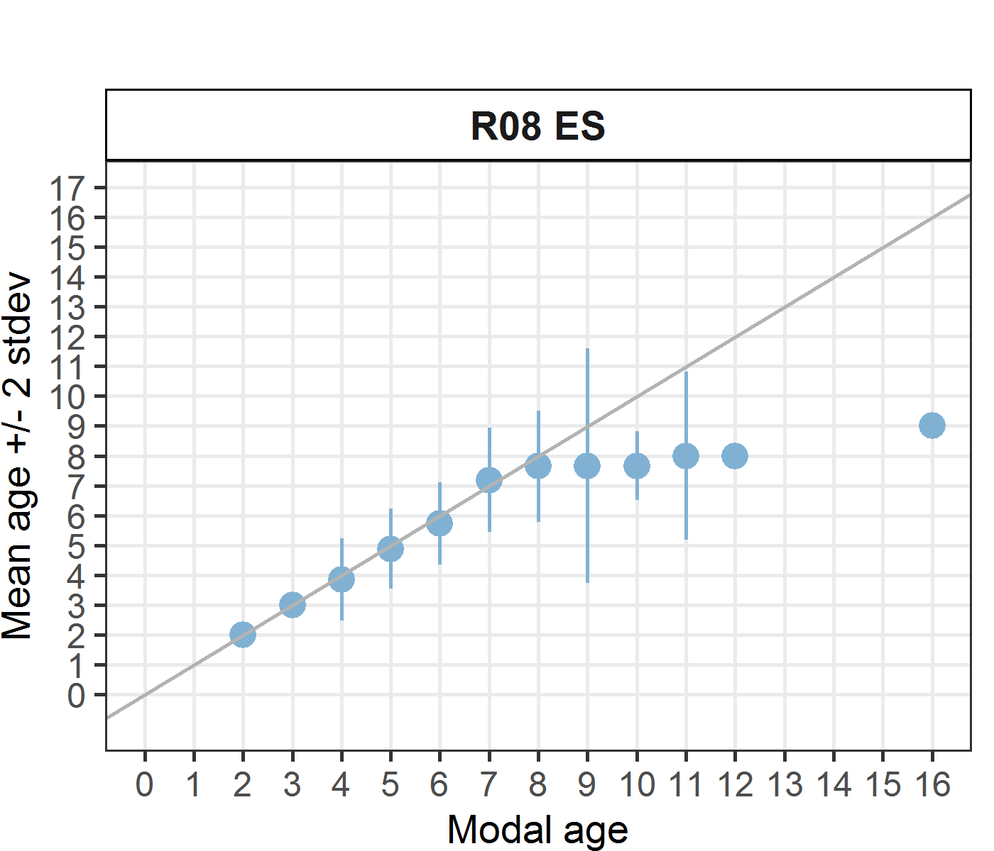 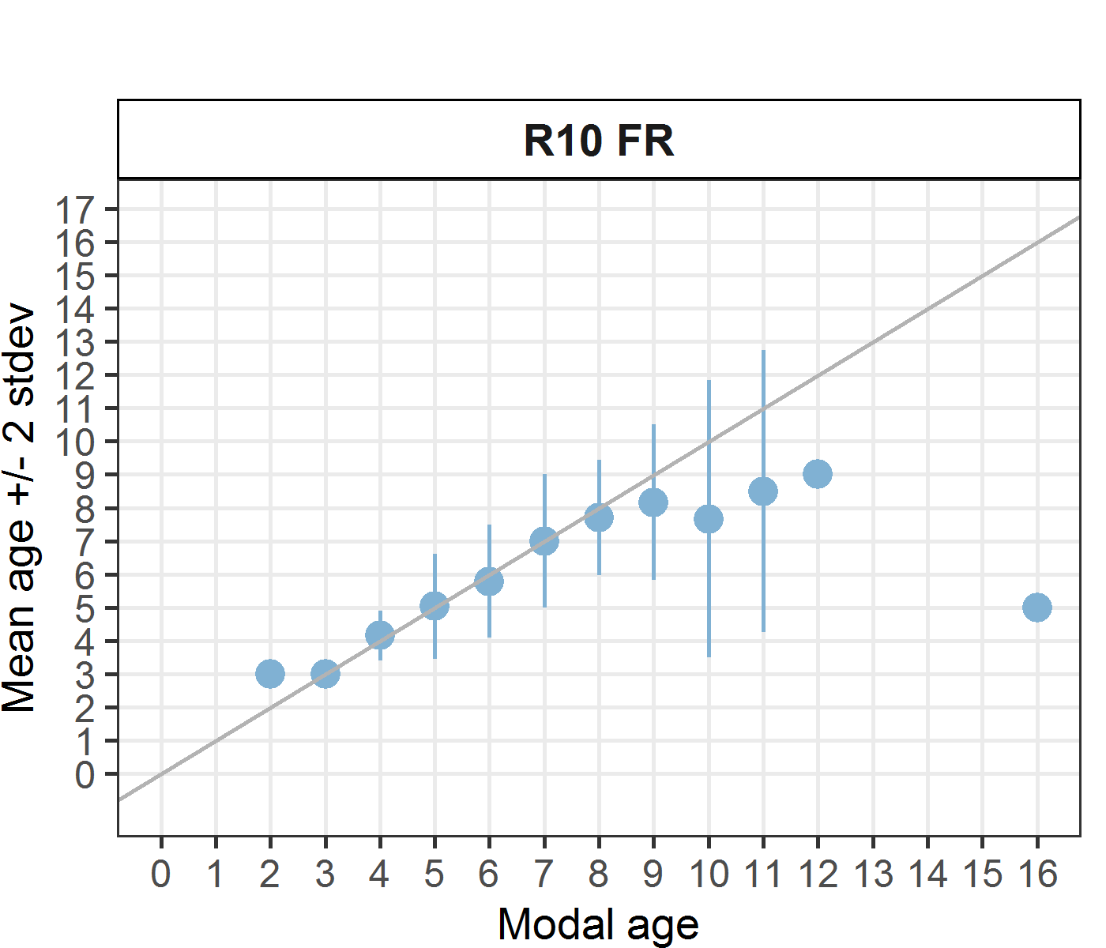 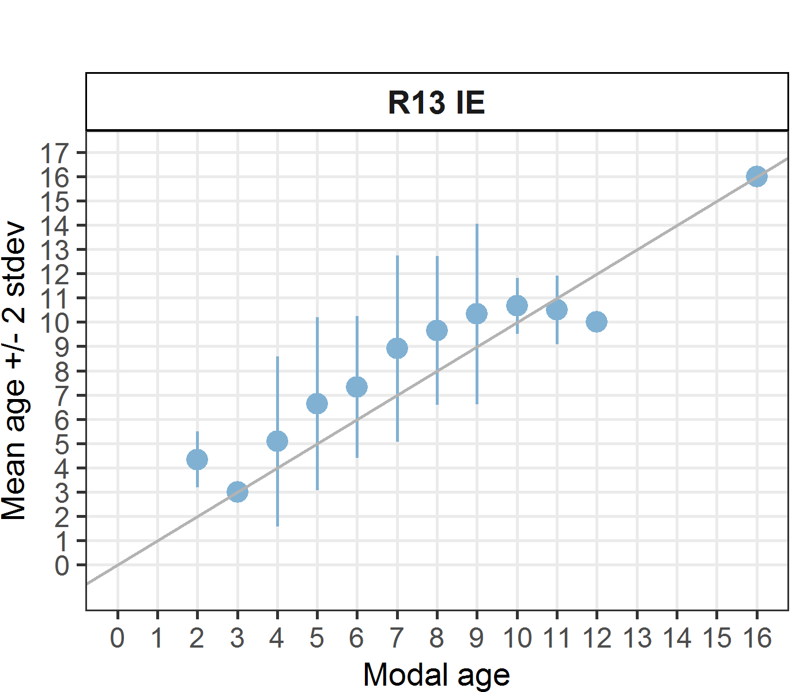 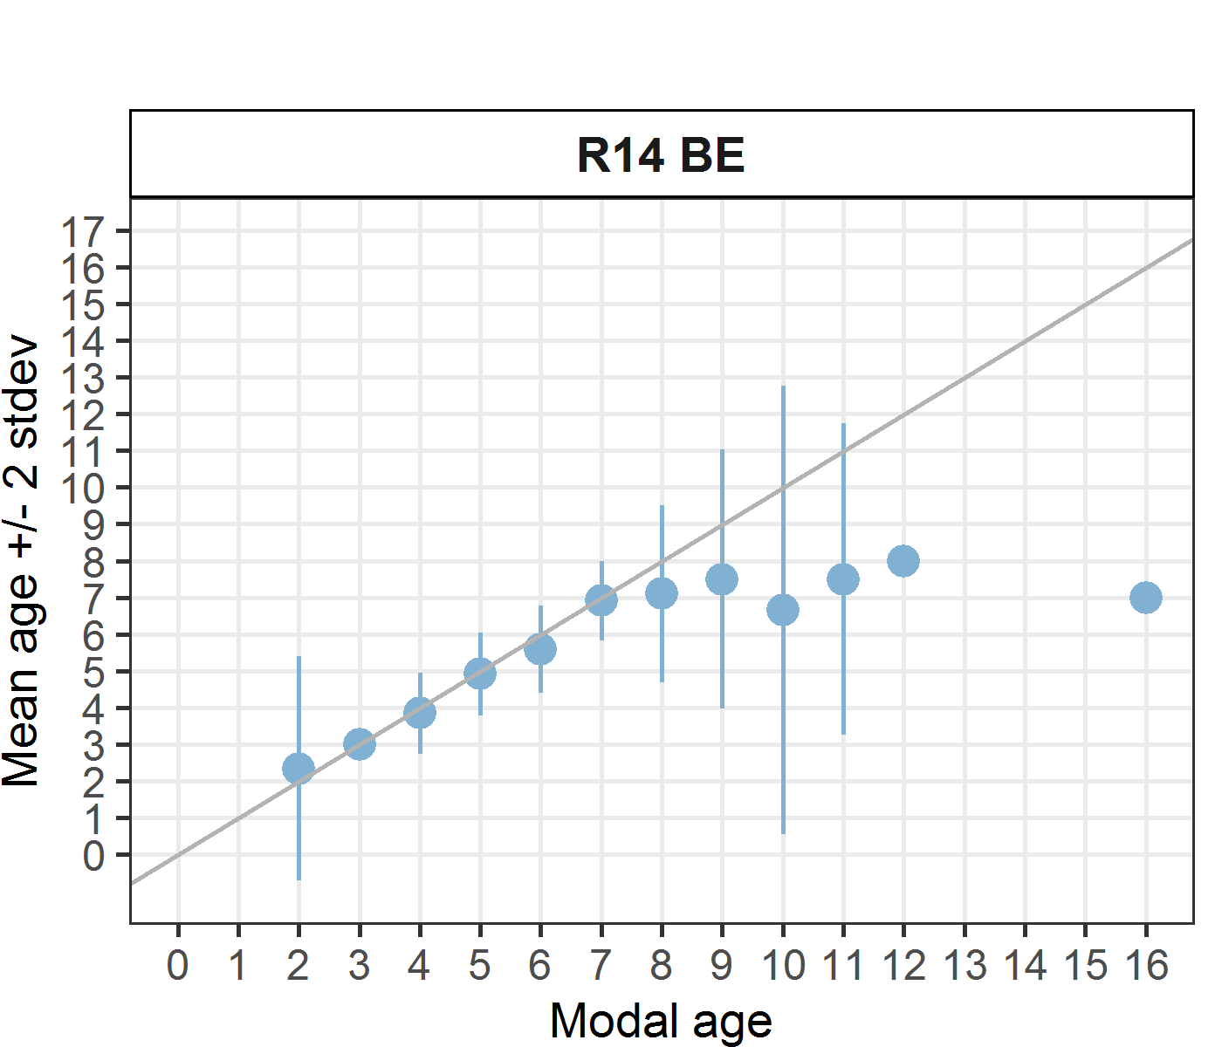 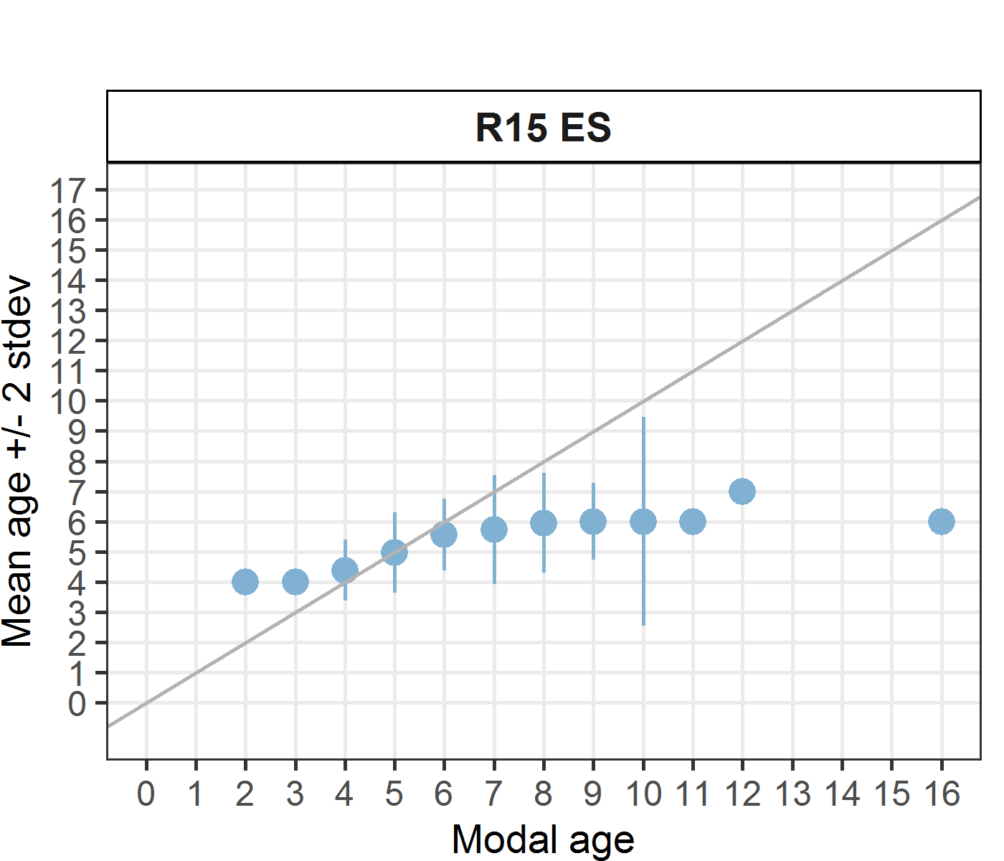

**Figure A3- 1:** Age bias plot per each reader.

*Statistics by modal age plot (STDEV, CV and PA)*

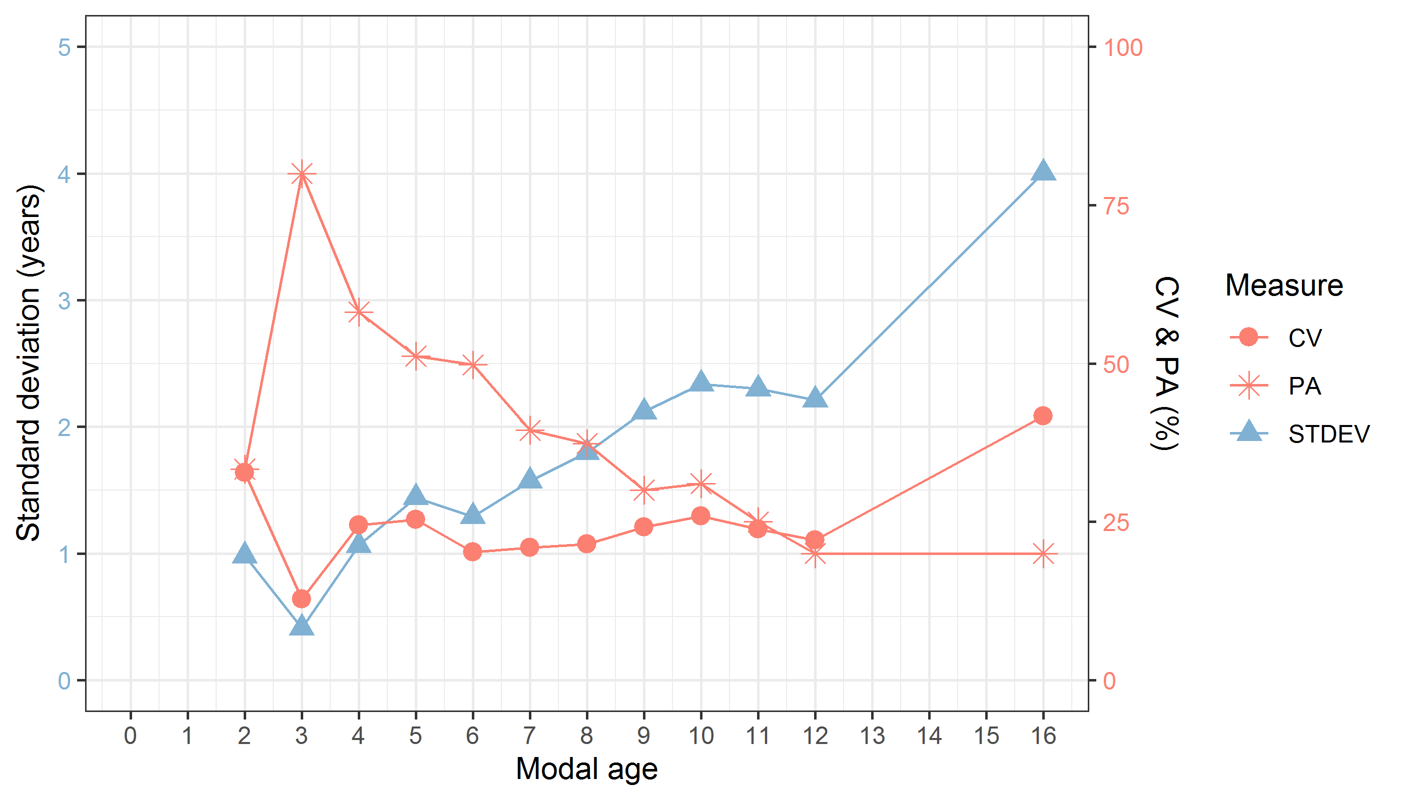

**Figure A3- 2:** CV, PA and (STDEV (standard deviation) are plotted against modal age.

*Distribution of age reading errors*

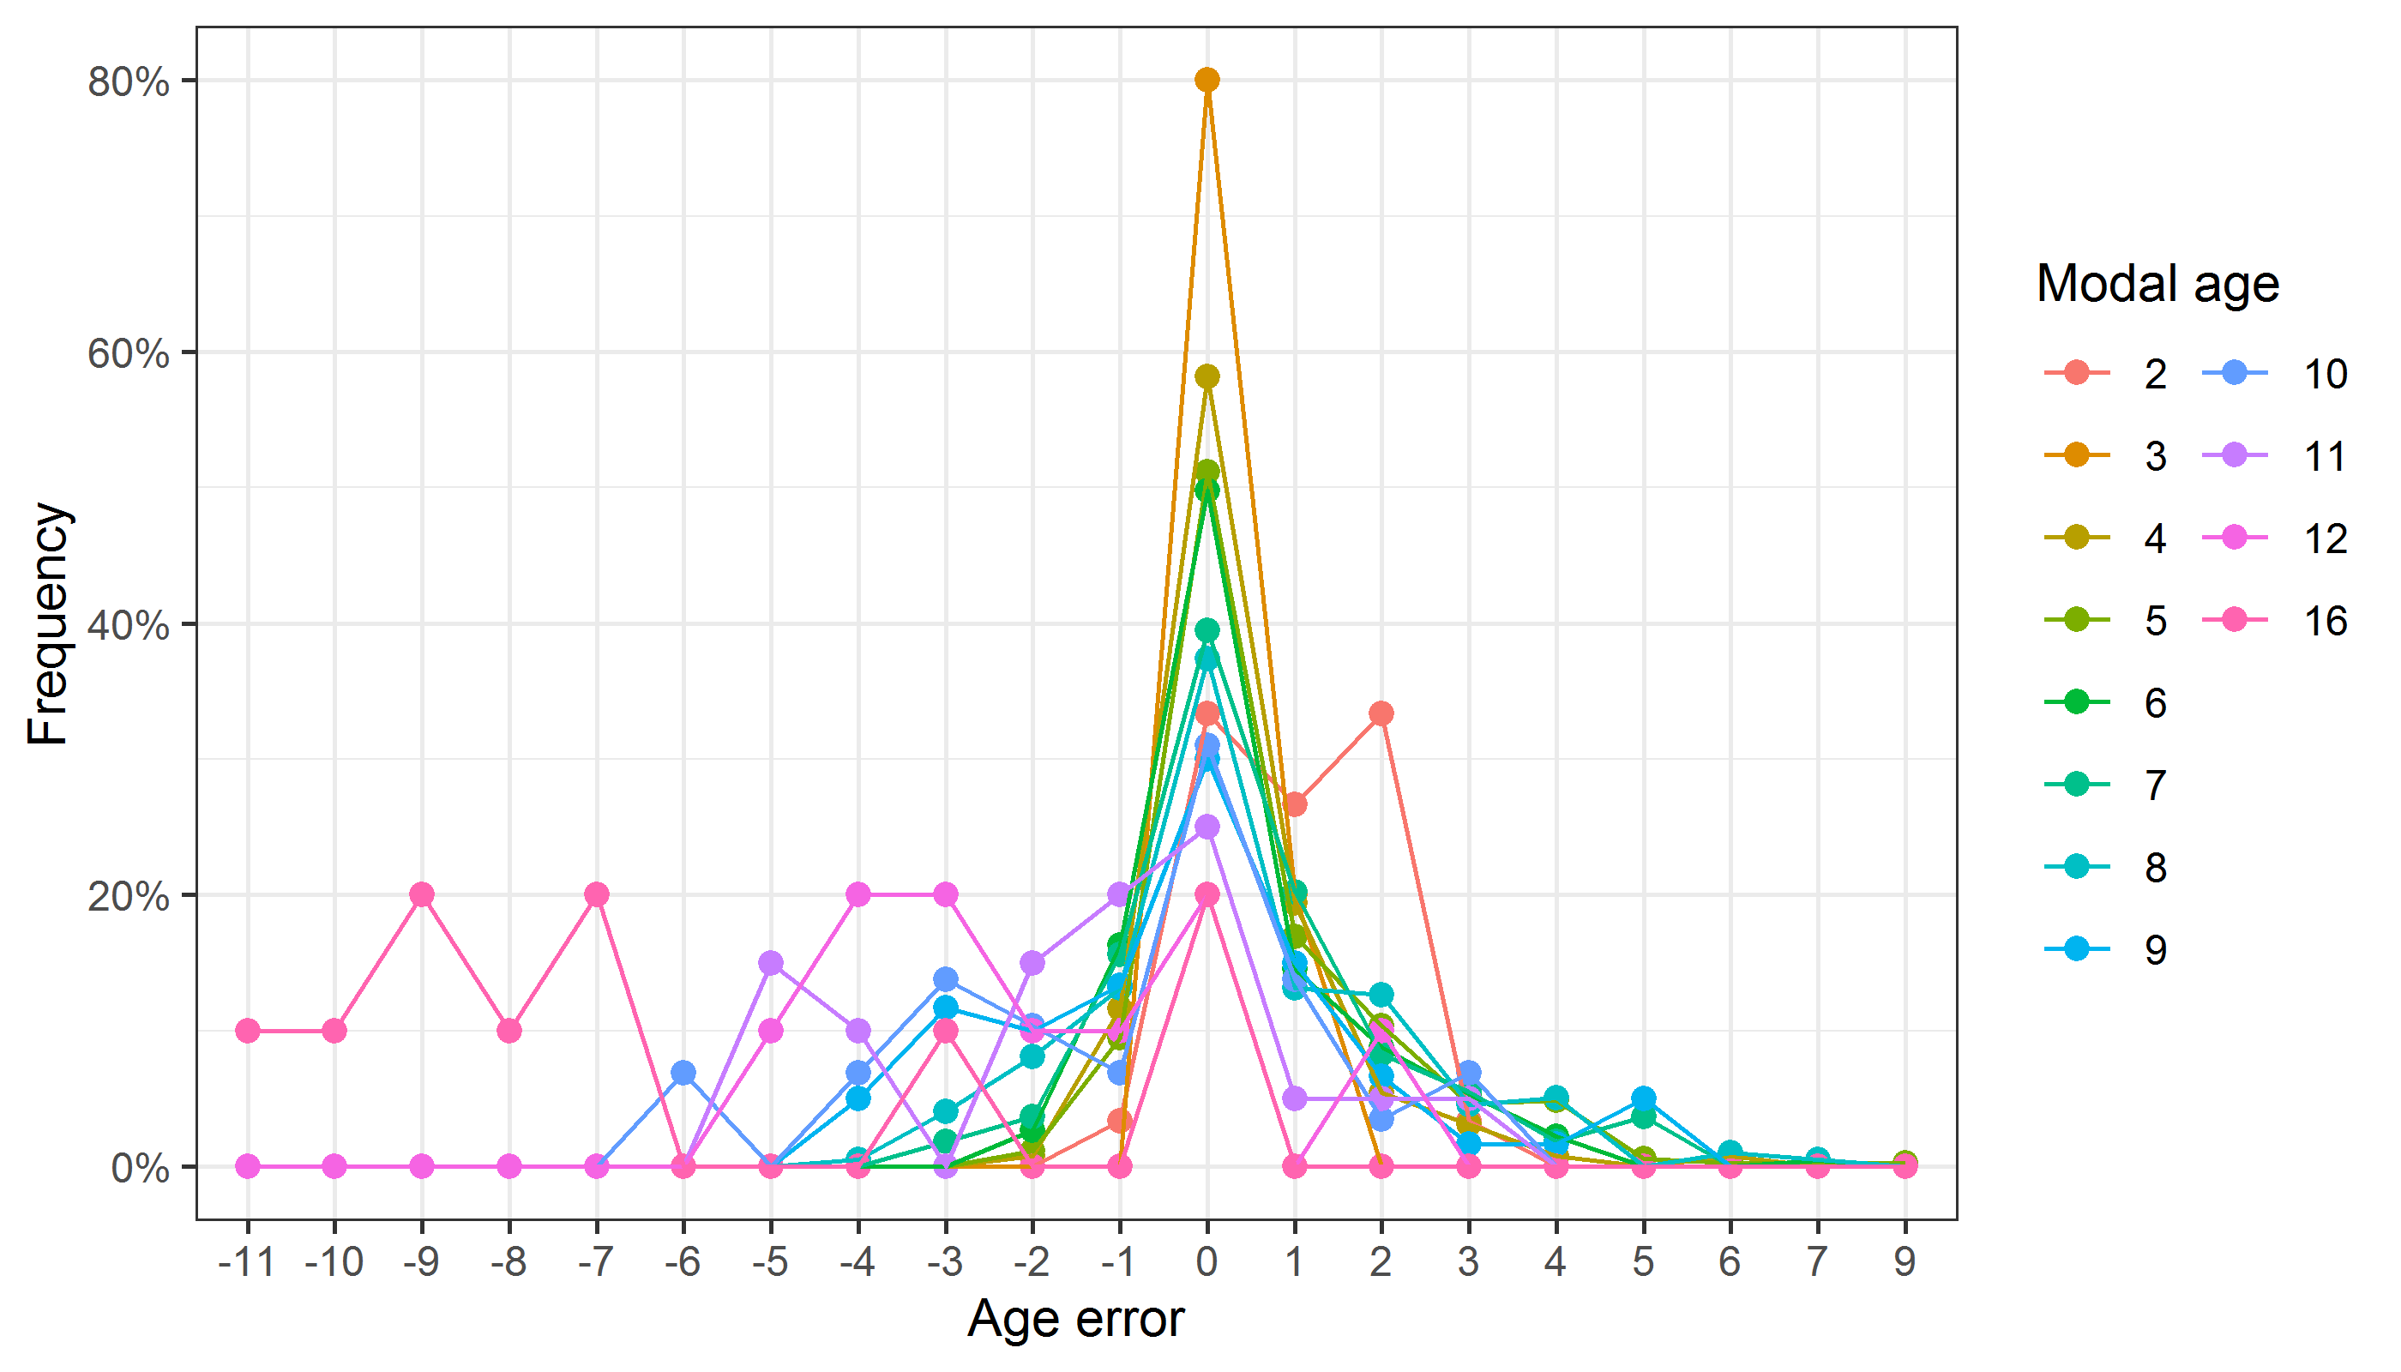

**Figure A3- 3:** The distribution of the age reading errors in percentage by modal age as observed from the whole group of age readers in an age reading comparison to modal age. The achieved precision in age reading by MODAL age group is shown by the spread of the age readings errors. There appears to be no relative bias, if the age reading errors are normally distributed. The distributions are skewed, if relative bias occurs.

*Relative bias for all readers*

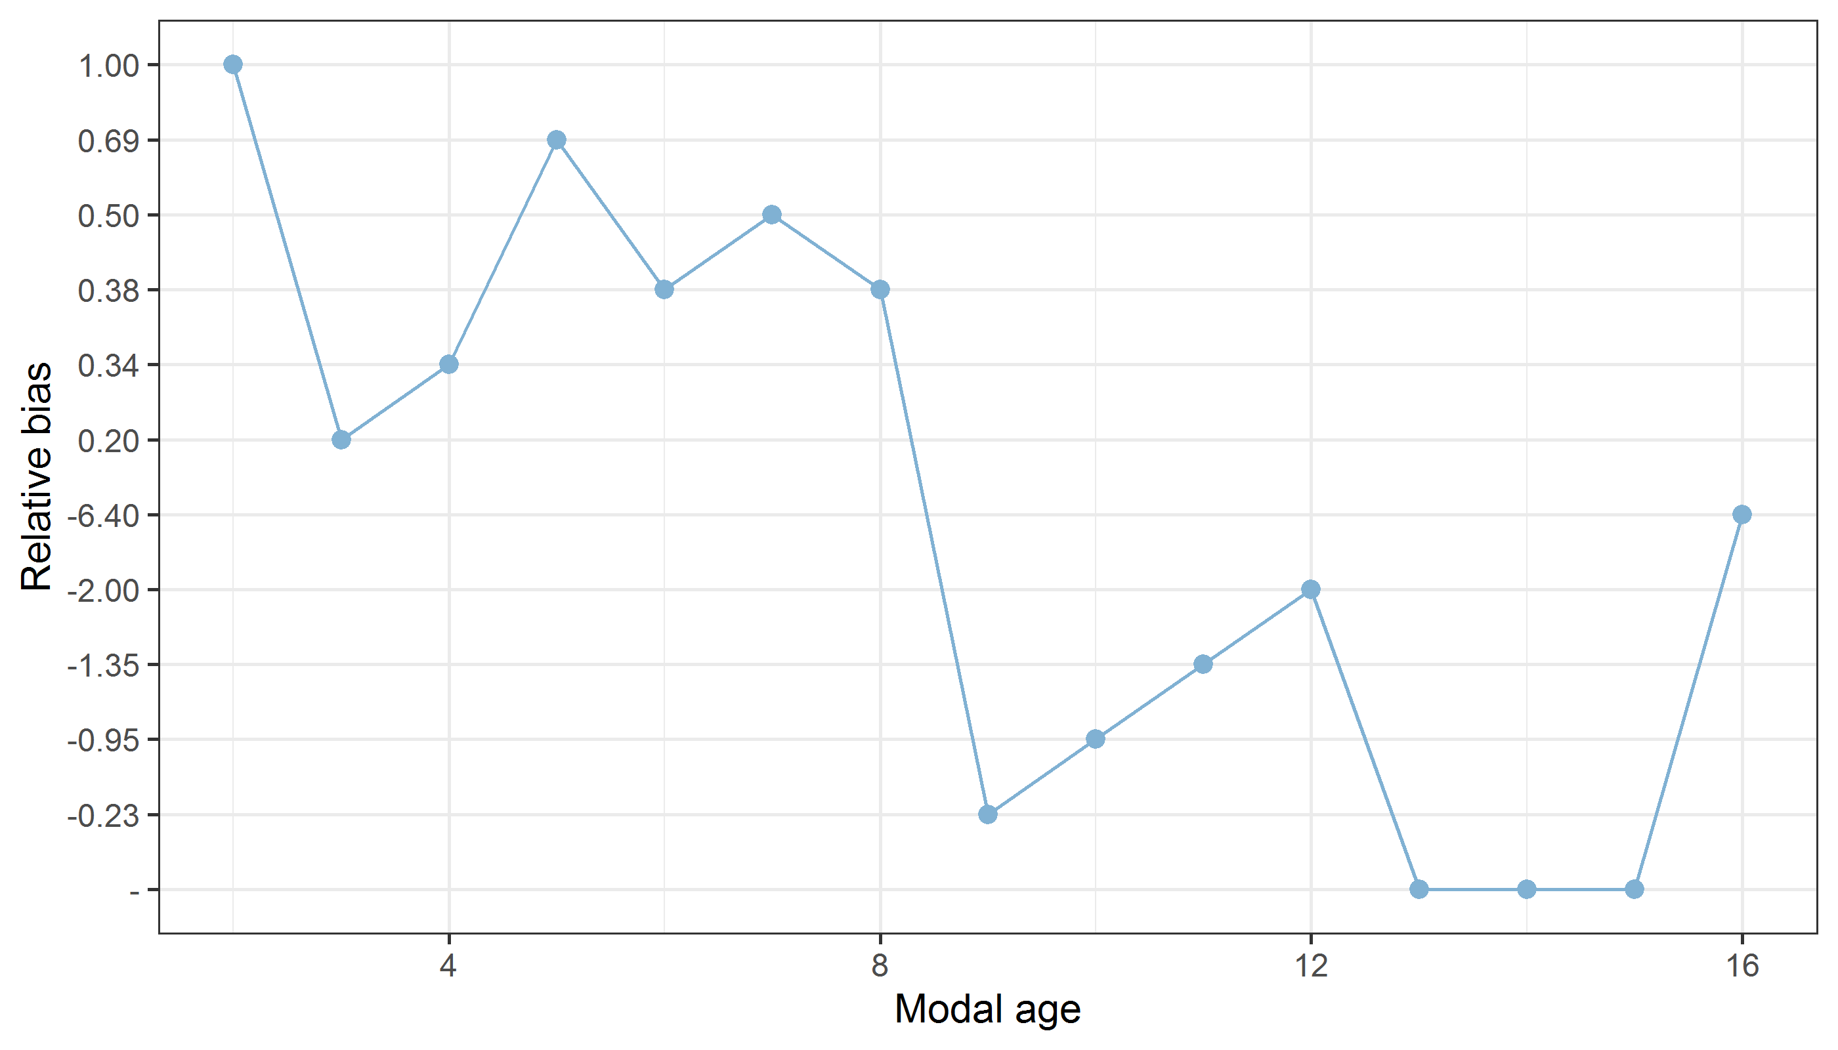

**Figure A3- 4:** The relative bias by modal age as estimated by all age readers combined.

*Mean length at age by reader*

**Table A3- 5:** Mean fish length at age per reader is calculated per reader and age (not modal age) and for all readers combined per age. A weighted mean is also given.

|  |  |  |  |  |  |  |  |  |  |  |
| --- | --- | --- | --- | --- | --- | --- | --- | --- | --- | --- |
| **Age** | **R01 IE** | **R02 ES** | **R03 GB** | **R04 ES** | **R05 BE** | **R08 ES** | **R10 FR** | **R13 IE** | **R14 BE** | **R15 ES** |
| 1 | - | - | - | - | - | - | - | - | 217 mm | - |
| 2 | 228 mm | - | - | 222 mm | - | 228 mm | - | - | 242 mm | - |
| 3 | 252 mm | 222 mm | 220 mm | 218 mm | - | 245 mm | 243 mm | 220 mm | 215 mm | 219 mm |
| 4 | 280 mm | 260 mm | 253 mm | 300 mm | 229 mm | 276 mm | 291 mm | 265 mm | 288 mm | 267 mm |
| 5 | 297 mm | 301 mm | 272 mm | 279 mm | 263 mm | 306 mm | 302 mm | 282 mm | 327 mm | 326 mm |
| 6 | 325 mm | 332 mm | 323 mm | 350 mm | 303 mm | 349 mm | 346 mm | 320 mm | 354 mm | 379 mm |
| 7 | 332 mm | 383 mm | 326 mm | 384 mm | 315 mm | 424 mm | 403 mm | 334 mm | 390 mm | 465 mm |
| 8 | 336 mm | 435 mm | 404 mm | 404 mm | 330 mm | 438 mm | 414 mm | 359 mm | 444 mm | - |
| 9 | 362 mm | 474 mm | 399 mm | 425 mm | 360 mm | 434 mm | 448 mm | 358 mm | 460 mm | - |
| 10 | 418 mm | 495 mm | 433 mm | 440 mm | 409 mm | 440 mm | 487 mm | 421 mm | 510 mm | - |
| 11 | 433 mm | - | 450 mm | 480 mm | 424 mm | - | - | 455 mm | - | - |
| 12 | 434 mm | - | 480 mm | - | 410 mm | - | - | 425 mm | - | - |
| 13 | 510 mm | - | - | - | 410 mm | - | - | 470 mm | - | - |
| 14 | 475 mm | - | - | - | 474 mm | - | - | 260 mm | - | - |
| 15 | 488 mm | - | - | - | - | - | - | - | - | - |
| 16 | 351 mm | - | - | - | - | - | - | 351 mm | - | - |
| **Weighted Mean** | **346 mm** | **345 mm** | **345 mm** | **346 mm** | **346 mm** | **346 mm** | **346 mm** | **346 mm** | **346 mm** | **346 mm** |

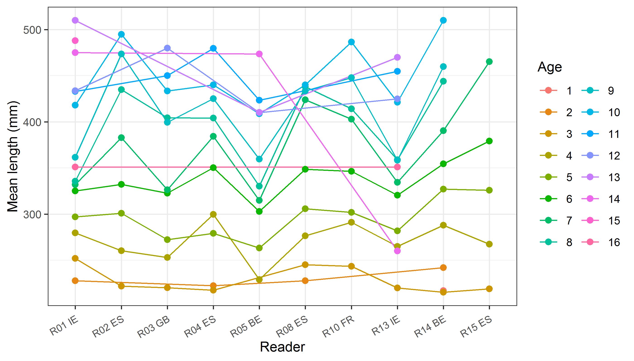

**Figure A3- 5:** The mean fish length at age as estimated by each age reader.

## Results Advanced readers

**All samples included**

*Summary statistics*

**Table A3- 6:** Summary of statistics; PA (%), CV (%) and APE (%).

|  |  |  |  |
| --- | --- | --- | --- |
| **NSample** | **CV** | **PA** | **APE** |
| 60 | 22 % | 47 % | 16 % |

*Data overview*

**Table A3- 7:** Data overview including modal age and statistics per sample.

|  |  |  |  |  |  |  |  |  |  |  |  |  |  |  |  |  |  |
| --- | --- | --- | --- | --- | --- | --- | --- | --- | --- | --- | --- | --- | --- | --- | --- | --- | --- |
| **Fish ID** | **Sample ID** | **Event ID** | **Image ID** | **length** | **sex** | **Catch date** | **ICES area** | **R01 IE** | **R02 ES** | **R03 GB** | **R04 ES** | **R05 BE** | **R08 ES** | **Modal age** | **PA %** | **CV %** | **APE %** |
| 142 | 142-S1 | 355 | - | 230 | F | 21/02/2019 00:00:00 | 27.7 | 3 | 3 | 3 | 3 | 4 | 3 | 3 | 83 | 13 | 9 |
| 164 | 164-S1 | 355 | - | 510 | F | 21/02/2019 00:00:00 | 27.7 | 13 | 10 | 10 | 11 | 13 | 8 | 10 | 33 | 18 | 14 |
| 185 | 185-S1 | 355 | - | 330 | F | 07/03/2019 00:00:00 | 27.7 | 9 | 7 | 7 | 6 | 9 | 5 | 7 | 33 | 22 | 17 |
| 212 | 212-S1 | 355 | - | 290 | F | 07/03/2019 00:00:00 | 27.7 | 7 | 5 | 5 | 5 | 8 | 5 | 5 | 67 | 23 | 19 |
| 278 | 278-S1 | 355 | - | 340 | F | 14/05/2019 00:00:00 | 27.7 | 8 | 6 | 7 | 7 | 8 | 6 | 8 | 33 | 13 | 10 |
| 282 | 282-S1 | 355 | - | 320 | F | 14/05/2019 00:00:00 | 27.7 | 7 | 6 | 6 | 7 | 8 | 6 | 6 | 50 | 12 | 10 |
| 284 | 284-S1 | 355 | - | 370 | F | 14/05/2019 00:00:00 | 27.7 | 9 | 6 | 7 | 6 | 10 | 6 | 6 | 50 | 24 | 20 |
| 291 | 291-S1 | 355 | - | 350 | F | 14/05/2019 00:00:00 | 27.7 | 8 | 6 | 7 | 7 | 9 | 5 | 7 | 33 | 20 | 14 |
| 3 | 3-S1 | 355 | - | 420 | F | 21/02/2019 00:00:00 | 27.7 | 11 | 7 | 8 | 7 | 12 | 8 | 7 | 33 | 24 | 20 |
| 320 | 320-S1 | 355 | - | 310 | F | 14/05/2019 00:00:00 | 27.7 | 8 | 7 | 8 | 8 | 9 | 6 | 8 | 50 | 13 | 10 |
| 321 | 321-S1 | 355 | - | 430 | F | 14/05/2019 00:00:00 | 27.7 | 10 | 8 | 9 | 8 | 11 | 8 | 8 | 50 | 14 | 11 |
| 323 | 323-S1 | 355 | - | 490 | F | 14/05/2019 00:00:00 | 27.7 | 10 | 8 | 10 | 9 | 14 | 8 | 10 | 33 | 23 | 15 |
| 328 | 328-S1 | 355 | - | 460 | F | 14/05/2019 00:00:00 | 27.7 | 9 | 8 | 8 | 8 | 10 | 7 | 8 | 50 | 12 | 9 |
| 330 | 330-S1 | 355 | - | 440 | F | 14/05/2019 00:00:00 | 27.7 | 10 | 8 | 8 | 9 | 11 | 8 | 8 | 50 | 14 | 11 |
| 333 | 333-S1 | 355 | - | 470 | F | 14/05/2019 00:00:00 | 27.7 | 14 | 9 | 11 | 10 | 14 | 9 | 14 | 33 | 21 | 17 |
| 349 | 349-S1 | 355 | - | 500 | F | 14/05/2019 00:00:00 | 27.7 | 10 | 9 | 8 | 8 | 11 | 7 | 8 | 33 | 17 | 13 |
| 384 | 384-S1 | 355 | - | 410 | F | 14/05/2019 00:00:00 | 27.7 | 9 | 8 | 8 | 8 | 10 | 8 | 8 | 67 | 10 | 8 |
| 389 | 389-S1 | 355 | - | 400 | F | 14/05/2019 00:00:00 | 27.7 | 10 | 8 | 10 | 9 | 12 | 8 | 10 | 33 | 16 | 12 |
| 403 | 403-S1 | 355 | - | 380 | F | 14/05/2019 00:00:00 | 27.7 | 6 | 6 | 6 | 6 | 7 | 6 | 6 | 83 | 7 | 5 |
| 54 | 54-S1 | 355 | - | 360 | F | 21/02/2019 00:00:00 | 27.7 | 7 | 6 | 6 | 6 | 7 | 6 | 6 | 67 | 8 | 7 |
| 6006 | 6006-S2 | 355 | - | 210 | M | 13/09/2019 00:00:00 | 27.7 | 4 | 5 | 6 | 5 | 7 | 5 | 5 | 50 | 19 | 15 |
| 6008 | 6008-S2 | 355 | - | 460 | F | 13/09/2019 00:00:00 | 27.7 | 10 | 8 | 6 | 9 | 9 | 7 | 9 | 33 | 18 | 14 |
| 6009 | 6009-S2 | 355 | - | 450 | F | 13/09/2019 00:00:00 | 27.7 | 9 | - | 8 | 6 | 8 | 6 | 8 | 40 | 18 | 15 |
| 6010 | 6010-S2 | 355 | - | 430 | F | 13/09/2019 00:00:00 | 27.7 | 9 | 8 | 9 | 6 | 9 | 6 | 9 | 50 | 19 | 16 |
| 6012 | 6012-S2 | 355 | - | 420 | F | 13/09/2019 00:00:00 | 27.7 | 12 | 8 | 9 | 8 | 10 | 6 | 8 | 33 | 23 | 17 |
| 6013 | 6013-S2 | 355 | - | 270 | M | 13/09/2019 00:00:00 | 27.7 | 9 | 6 | 10 | 5 | 9 | 4 | 9 | 33 | 35 | 30 |
| 6014 | 6014-S2 | 355 | - | 260 | M | 13/09/2019 00:00:00 | 27.7 | 9 | 6 | 9 | 5 | 11 | 5 | 9 | 33 | 33 | 29 |
| 6015 | 6015-S2 | 355 | - | 200 | M | 13/09/2019 00:00:00 | 27.7 | 4 | 3 | 4 | 3 | 4 | 4 | 4 | 67 | 14 | 12 |
| 6020 | 6020-S2 | 355 | - | 220 | M | 13/09/2019 00:00:00 | 27.7 | 8 | 4 | 7 | 4 | 6 | 4 | 4 | 50 | 32 | 27 |
| 6039 | 6039-S2 | 355 | - | 360 | F | 13/09/2019 00:00:00 | 27.7 | 7 | 5 | 6 | 6 | 7 | 6 | 6 | 50 | 12 | 9 |
| 6040 | 6040-S2 | 355 | - | 480 | F | 13/09/2019 00:00:00 | 27.7 | 14 | 10 | 11 | 11 | 13 | 9 | 11 | 33 | 16 | 13 |
| 6041 | 6041-S2 | 355 | - | 400 | F | 13/09/2019 00:00:00 | 27.7 | 7 | 5 | 6 | 6 | 6 | 6 | 6 | 67 | 11 | 6 |
| 6042 | 6042-S2 | 355 | - | 410 | F | 13/09/2019 00:00:00 | 27.7 | 12 | 7 | 9 | 9 | 9 | 5 | 9 | 50 | 28 | 20 |
| 6045 | 6045-S2 | 355 | - | 470 | F | 13/09/2019 00:00:00 | 27.7 | 11 | 9 | 11 | 10 | 12 | 7 | 11 | 33 | 18 | 13 |
| 6046 | 6046-S2 | 355 | - | 440 | F | 13/09/2019 00:00:00 | 27.7 | 10 | 9 | 9 | 11 | 14 | 10 | 9 | 33 | 18 | 13 |
| 6047 | 6047-S2 | 355 | - | 380 | F | 13/09/2019 00:00:00 | 27.7 | 12 | - | 11 | 10 | 10 | 7 | 10 | 40 | 19 | 12 |
| 6051 | 6051-S2 | 355 | - | 350 | F | 13/09/2019 00:00:00 | 27.7 | 9 | 7 | 8 | 8 | 9 | 5 | 9 | 33 | 20 | 14 |
| 6052 | 6052-S2 | 355 | - | 320 | F | 13/09/2019 00:00:00 | 27.7 | 10 | 6 | 7 | 8 | 9 | 6 | 6 | 33 | 21 | 17 |
| 6056 | 6056-S2 | 355 | - | 230 | F | 13/09/2019 00:00:00 | 27.7 | 4 | 3 | 4 | 3 | 5 | 3 | 3 | 50 | 22 | 18 |
| 6071 | 6071-S2 | 355 | - | 250 | F | 15/09/2019 00:00:00 | 27.7 | 4 | 5 | 6 | 6 | 7 | 4 | 4 | 33 | 23 | 19 |
| 6074 | 6074-S2 | 355 | - | 240 | M | 15/09/2019 00:00:00 | 27.7 | 7 | 5 | 6 | 5 | 7 | 3 | 7 | 33 | 28 | 21 |
| 6090 | 6090-S2 | 355 | - | 330 | F | 15/09/2019 00:00:00 | 27.7 | 10 | 7 | 8 | 9 | 10 | 6 | 10 | 33 | 20 | 16 |
| 6093 | 6093-S2 | 355 | - | 370 | F | 15/09/2019 00:00:00 | 27.7 | 9 | 7 | 8 | 8 | 12 | 6 | 8 | 33 | 25 | 17 |
| 6117 | 6117-S2 | 355 | - | 300 | F | 15/09/2019 00:00:00 | 27.7 | 5 | 5 | 6 | 6 | 9 | 5 | 5 | 50 | 26 | 17 |
| 6119 | 6119-S2 | 355 | - | 280 | F | 15/09/2019 00:00:00 | 27.7 | 4 | 4 | 4 | 4 | 4 | 4 | 4 | 100 | 0 | 0 |
| 6142 | 6142-S2 | 355 | - | 290 | F | 16/09/2019 00:00:00 | 27.7 | 5 | 5 | 6 | 5 | 8 | 5 | 5 | 67 | 21 | 16 |
| 6207 | 6207-S2 | 355 | - | 340 | F | 17/09/2019 00:00:00 | 27.7 | 8 | - | 7 | 8 | 7 | 6 | 8 | 40 | 12 | 9 |
| 6294 | 6294-S2 | 355 | - | 310 | F | 18/09/2019 00:00:00 | 27.7 | 7 | 6 | 7 | 6 | 7 | 6 | 7 | 50 | 8 | 8 |
| 6406 | 6406-S2 | 355 | - | 390 | F | 19/09/2019 00:00:00 | 27.7 | 9 | 8 | 8 | 8 | 9 | 8 | 8 | 67 | 6 | 5 |
| 66 | 66-S1 | 355 | - | 260 | F | 21/02/2019 00:00:00 | 27.7 | 6 | 5 | 5 | 5 | 6 | 5 | 5 | 67 | 10 | 8 |
| 6618 | 6618-S2 | 355 | - | 510 | F | 30/09/2019 00:00:00 | 27.7 | 10 | 9 | 9 | 8 | 10 | 8 | 9 | 33 | 10 | 7 |
| 73 | 73-S1 | 355 | - | 280 | F | 21/02/2019 00:00:00 | 27.7 | 4 | 4 | 4 | 5 | 6 | 4 | 4 | 67 | 19 | 15 |
| MEG-010620-1-1 | MEG-010620-1-1-S1 | 355 | - | 349 | F | 01/06/2020 00:00:00 | 27.8 | 4 | 5 | - | 5 | 6 | 5 | 5 | 60 | 14 | 8 |
| MEG-010620-1-19 | MEG-010620-1-19-S1 | 355 | - | 397 | F | 01/06/2020 00:00:00 | 27.8 | 4 | 5 | - | 5 | 6 | 4 | 5 | 40 | 17 | 13 |
| MEG-010620-1-5 | MEG-010620-1-5-S1 | 355 | - | 369 | F | 01/06/2020 00:00:00 | 27.8 | 5 | 6 | 6 | 6 | 8 | 5 | 6 | 50 | 18 | 11 |
| MEG-010620-2-25 | MEG-010620-2-25-S1 | 355 | - | 417 | F | 01/06/2020 00:00:00 | 27.8 | 11 | 8 | 8 | 9 | 10 | 8 | 8 | 50 | 14 | 11 |
| MEG-010620-2-26 | MEG-010620-2-26-S1 | 355 | - | 429 | F | 01/06/2020 00:00:00 | 27.8 | 12 | 8 | 10 | 8 | 9 | 9 | 8 | 33 | 16 | 12 |
| MEG-010620-2-27 | MEG-010620-2-27-S1 | 355 | - | 441 | F | 01/06/2020 00:00:00 | 27.8 | 10 | 8 | 9 | 8 | 10 | 9 | 10 | 33 | 10 | 7 |
| MEG-010620-3-19 | MEG-010620-3-19-S1 | 355 | - | 264 | M | 01/06/2020 00:00:00 | 27.8 | 7 | 5 | - | 5 | 7 | 5 | 5 | 60 | 19 | 17 |
| MEG-010620-3-38 | MEG-010620-3-38-S1 | 355 | - | 281 | M | 01/06/2020 00:00:00 | 27.8 | 9 | 6 | 6 | 6 | 9 | 6 | 6 | 67 | 22 | 19 |
| MEG-010620-3-40 | MEG-010620-3-40-S1 | 355 | - | 300 | F | 01/06/2020 00:00:00 | 27.8 | 4 | 5 | 4 | 5 | 8 | 5 | 5 | 50 | 28 | 18 |
| MEG-010620-4-19 | MEG-010620-4-19-S1 | 355 | - | 329 | F | 01/06/2020 00:00:00 | 27.8 | 4 | 6 | 6 | 5 | 7 | 5 | 6 | 33 | 19 | 15 |
| MEG-060519-1-11 | MEG-060519-1-11-S1 | 355 | - | 270 | M | 06/05/2019 00:00:00 | 27.8 | 8 | 5 | 6 | 7 | 8 | 6 | 8 | 33 | 18 | 15 |
| MEG-060519-1-27 | MEG-060519-1-27-S1 | 355 | - | 282 | F | 06/05/2019 00:00:00 | 27.8 | 4 | 4 | 4 | 4 | 5 | 4 | 4 | 83 | 10 | 7 |
| MEG-060519-1-42 | MEG-060519-1-42-S1 | 355 | - | 296 | F | 06/05/2019 00:00:00 | 27.8 | 3 | 4 | 5 | 5 | 6 | 3 | 3 | 33 | 28 | 23 |
| MEG-060519-2-12 | MEG-060519-2-12-S1 | 355 | - | 217 | F | 06/05/2019 00:00:00 | 27.8 | 2 | 3 | 3 | 2 | 4 | 2 | 2 | 50 | 31 | 25 |
| MEG-060519-2-27 | MEG-060519-2-27-S1 | 355 | - | 224 | F | 06/05/2019 00:00:00 | 27.8 | 2 | 3 | 3 | 2 | 4 | 2 | 2 | 50 | 31 | 25 |
| MEG-060519-2-42 | MEG-060519-2-42-S1 | 355 | - | 230 | F | 06/05/2019 00:00:00 | 27.8 | 4 | 4 | 5 | 4 | 8 | 3 | 4 | 50 | 38 | 26 |
| MEG-060519-2-57 | MEG-060519-2-57-S1 | 355 | - | 242 | F | 06/05/2019 00:00:00 | 27.8 | 2 | 3 | 4 | 2 | 4 | 2 | 2 | 50 | 35 | 29 |
| MEG-060519-3-23 | MEG-060519-3-23-S1 | 355 | - | 326 | M | 06/05/2019 00:00:00 | 27.8 | 7 | 5 | 5 | 4 | 6 | 4 | 5 | 33 | 23 | 17 |
| MEG-071019-1-1 | MEG-071019-1-1-S2 | 355 | - | 356 | F | 07/10/2019 00:00:00 | 27.8 | 8 | 6 | 8 | 6 | 8 | 6 | 8 | 50 | 16 | 14 |
| MEG-071019-1-2 | MEG-071019-1-2-S2 | 355 | - | 372 | F | 07/10/2019 00:00:00 | 27.8 | 5 | 5 | 8 | 4 | 8 | 7 | 5 | 33 | 28 | 24 |
| MEG-071019-1-22 | MEG-071019-1-22-S2 | 355 | - | 430 | F | 07/10/2019 00:00:00 | 27.8 | 11 | 9 | 10 | 9 | 10 | 9 | 9 | 50 | 8 | 7 |
| MEG-071019-1-23 | MEG-071019-1-23-S2 | 355 | - | 446 | F | 07/10/2019 00:00:00 | 27.8 | 12 | 8 | 8 | 8 | 9 | 8 | 8 | 67 | 18 | 13 |
| MEG-071019-1-6 | MEG-071019-1-6-S2 | 355 | - | 395 | F | 07/10/2019 00:00:00 | 27.8 | 10 | 7 | - | 8 | 8 | 8 | 8 | 60 | 13 | 9 |
| MEG-071019-1-9 | MEG-071019-1-9-S2 | 355 | - | 412 | F | 07/10/2019 00:00:00 | 27.8 | 10 | 7 | - | 7 | 9 | 8 | 7 | 40 | 16 | 13 |
| MEG-071019-2-1 | MEG-071019-2-1-S2 | 355 | - | 345 | F | 07/10/2019 00:00:00 | 27.8 | 8 | 7 | 8 | 7 | 7 | 8 | 8 | 50 | 7 | 7 |
| MEG-071019-2-5 | MEG-071019-2-5-S2 | 355 | - | 366 | F | 07/10/2019 00:00:00 | 27.8 | 8 | 6 | 6 | 7 | 8 | 7 | 6 | 33 | 13 | 10 |
| MEG-071019-3-1 | MEG-071019-3-1-S2 | 355 | - | 308 | F | 07/10/2019 00:00:00 | 27.8 | 4 | 4 | 5 | 4 | 5 | 5 | 4 | 50 | 12 | 11 |
| MEG-071019-3-3 | MEG-071019-3-3-S2 | 355 | - | 313 | F | 07/10/2019 00:00:00 | 27.8 | 7 | 5 | 7 | 5 | 9 | 5 | 5 | 50 | 26 | 21 |
| MEG-071019-3-4 | MEG-071019-3-4-S2 | 355 | - | 323 | M | 07/10/2019 00:00:00 | 27.8 | 7 | 5 | 6 | 6 | 7 | 5 | 7 | 33 | 15 | 11 |
| MEG-071019-3-8 | MEG-071019-3-8-S2 | 355 | - | 333 | F | 07/10/2019 00:00:00 | 27.8 | 5 | 5 | 5 | 5 | 5 | 5 | 5 | 100 | 0 | 0 |
| MEG-071019-4-1 | MEG-071019-4-1-S2 | 355 | - | 231 | M | 07/10/2019 00:00:00 | 27.8 | 9 | 5 | 6 | 5 | 8 | 6 | 5 | 33 | 25 | 21 |
| MEG-071019-4-11 | MEG-071019-4-11-S2 | 355 | - | 268 | F | 07/10/2019 00:00:00 | 27.8 | 4 | 4 | 6 | 4 | 7 | 3 | 4 | 50 | 32 | 26 |
| MEG-071019-4-18 | MEG-071019-4-18-S2 | 355 | - | 270 | F | 07/10/2019 00:00:00 | 27.8 | 6 | 5 | 6 | 5 | 6 | 4 | 6 | 50 | 15 | 12 |
| MEG-071019-4-28 | MEG-071019-4-28-S2 | 355 | - | 280 | F | 07/10/2019 00:00:00 | 27.8 | 4 | 5 | 6 | 5 | 7 | 5 | 5 | 50 | 19 | 15 |
| MEG-071019-4-3 | MEG-071019-4-3-S2 | 355 | - | 244 | F | 07/10/2019 00:00:00 | 27.8 | 5 | 5 | 7 | 5 | 8 | 5 | 5 | 67 | 23 | 19 |
| MEG-071019-4-35 | MEG-071019-4-35-S2 | 355 | - | 298 | M | 07/10/2019 00:00:00 | 27.8 | 10 | 6 | 9 | 6 | 9 | 6 | 6 | 50 | 24 | 22 |
| MEG-071019-4-5 | MEG-071019-4-5-S2 | 355 | - | 256 | M | 07/10/2019 00:00:00 | 27.8 | 3 | 5 | 4 | 4 | 7 | 3 | 3 | 33 | 35 | 26 |
| MEG-071019-5-1 | MEG-071019-5-1-S2 | 355 | - | 219 |  | 07/10/2019 00:00:00 | 27.8 | 5 | 4 | 5 | 5 | 6 | 5 | 5 | 67 | 13 | 7 |
| MEG-071019-5-2 | MEG-071019-5-2-S2 | 355 | - | 220 |  | 07/10/2019 00:00:00 | 27.8 | 6 | 4 | 5 | 5 | 5 | 5 | 5 | 67 | 13 | 7 |
| MEG-180219-1-1 | MEG-180219-1-1-S1 | 355 | - | 316 | F | 18/02/2019 00:00:00 | 27.8 | 6 | 5 | 6 | 5 | 7 | 5 | 5 | 50 | 14 | 12 |
| MEG-180219-1-11 | MEG-180219-1-11-S1 | 355 | - | 363 | F | 18/02/2019 00:00:00 | 27.8 | 7 | 5 | 6 | 6 | 8 | 6 | 6 | 50 | 16 | 12 |
| MEG-180219-1-19 | MEG-180219-1-19-S1 | 355 | - | 379 | F | 18/02/2019 00:00:00 | 27.8 | 7 | 7 | 8 | 7 | 8 | 6 | 7 | 50 | 11 | 8 |
| MEG-180219-1-2 | MEG-180219-1-2-S1 | 355 | - | 331 | F | 18/02/2019 00:00:00 | 27.8 | 6 | 6 | 6 | 5 | 9 | 5 | 6 | 50 | 24 | 15 |
| MEG-180219-1-8 | MEG-180219-1-8-S1 | 355 | - | 356 | F | 18/02/2019 00:00:00 | 27.8 | 5 | 6 | 6 | 6 | 9 | 5 | 6 | 50 | 24 | 15 |
| MEG-180219-3-1 | MEG-180219-3-1-S1 | 355 | - | 253 | F | 18/02/2019 00:00:00 | 27.8 | 5 | 5 | 5 | 5 | 7 | 5 | 5 | 83 | 15 | 10 |
| MEG-180219-3-2 | MEG-180219-3-2-S1 | 355 | - | 206 | F | 18/02/2019 00:00:00 | 27.8 | 3 | 4 | 4 | 2 | 5 | 4 | 4 | 50 | 28 | 21 |
| MEG-300619-1-40 | MEG-300619-1-40-S1 | 355 | - | 380 | F | 30/06/2019 00:00:00 | 27.8 | 6 | 6 | 7 | 6 | 8 | 5 | 6 | 50 | 16 | 12 |
| MEG-300619-1-41 | MEG-300619-1-41-S1 | 355 | - | 382 | F | 30/06/2019 00:00:00 | 27.8 | 6 | 5 | 7 | 6 | 7 | 5 | 6 | 33 | 15 | 11 |
| MEG-300619-1-42 | MEG-300619-1-42-S1 | 355 | - | 405 | F | 30/06/2019 00:00:00 | 27.8 | 7 | 7 | 8 | 6 | 9 | 5 | 7 | 33 | 20 | 14 |
| MEG-300619-1-43 | MEG-300619-1-43-S1 | 355 | - | 404 | F | 30/06/2019 00:00:00 | 27.8 | 8 | 7 | 9 | 7 | 10 | 7 | 7 | 50 | 16 | 12 |
| MEG-300619-1-44 | MEG-300619-1-44-S1 | 355 | - | 428 | F | 30/06/2019 00:00:00 | 27.8 | 11 | 8 | 8 | 7 | 10 | 8 | 8 | 50 | 17 | 14 |
| MEG-301120-1-17 | MEG-301120-1-17-S2 | 355 | - | 404 | F | 30/11/2020 00:00:00 | 27.8 | 10 | 7 | 8 | 4 | 7 | 7 | 7 | 50 | 27 | 17 |
| MEG-301120-1-25 | MEG-301120-1-25-S2 | 355 | - | 426 | F | 30/11/2020 00:00:00 | 27.8 | 8 | 7 | 7 | 7 | 7 | 8 | 7 | 67 | 7 | 6 |
| MEG-301120-1-3 | MEG-301120-1-3-S2 | 355 | - | 386 | F | 30/11/2020 00:00:00 | 27.8 | 6 | 5 | 6 | 6 | 6 | 6 | 6 | 83 | 7 | 5 |
| MEG-301120-1-39 | MEG-301120-1-39-S2 | 355 | - | 454 | F | 30/11/2020 00:00:00 | 27.8 | 12 | 8 | 8 | 7 | 10 | 8 | 8 | 50 | 21 | 16 |
| MEG-301120-1-42 | MEG-301120-1-42-S2 | 355 | - | 461 | F | 30/11/2020 00:00:00 | 27.8 | 9 | 7 | 8 | 7 | 11 | 8 | 7 | 33 | 18 | 13 |
| MEG-301120-1-44 | MEG-301120-1-44-S2 | 355 | - | 488 | F | 30/11/2020 00:00:00 | 27.8 | 15 | 9 | 10 | 11 | 14 | 8 | 15 | 17 | 25 | 20 |
| MEG-301120-2-1 | MEG-301120-2-1-S2 | 355 | - | 337 | F | 30/11/2020 00:00:00 | 27.8 | 5 | 5 | 6 | 4 | 6 | 4 | 5 | 33 | 18 | 13 |
| MEG-301120-2-23 | MEG-301120-2-23-S2 | 355 | - | 351 | M | 30/11/2020 00:00:00 | 27.8 | 16 | 7 | 9 | 8 | 13 | 9 | 9 | 33 | 33 | 27 |
| MEG-301120-3-2 | MEG-301120-3-2-S2 | 355 | - | 313 | F | 30/11/2020 00:00:00 | 27.8 | 3 | 4 | 5 | 4 | 6 | 5 | 4 | 33 | 23 | 19 |
| SLW-122 | SLW-122-S1 | 355 | - | 480 | F | 21/03/2019 00:00:00 | 27.7 | 12 | 9 | 12 | 11 | 14 | 8 | 12 | 33 | 20 | 15 |
| SLW-18 | SLW-18-S1 | 355 | - | 250 | F | 18/03/2019 00:00:00 | 27.7 | 5 | 5 | 5 | 5 | 6 | 5 | 5 | 83 | 8 | 5 |
| SLW-21 | SLW-21-S1 | 355 | - | 240 | F | 18/03/2019 00:00:00 | 27.7 | 5 | 5 | 5 | 5 | 6 | 5 | 5 | 83 | 8 | 5 |
| SLW-42 | SLW-42-S1 | 355 | - | 450 | F | 19/03/2019 00:00:00 | 27.7 | 12 | 8 | 10 | 9 | 11 | 8 | 8 | 33 | 17 | 14 |
| SLW-61 | SLW-61-S1 | 355 | - | 390 | F | 19/03/2019 00:00:00 | 27.7 | 7 | 7 | 6 | 7 | 12 | 6 | 7 | 50 | 30 | 20 |
| SLW-64 | SLW-64-S1 | 355 | - | 210 | F | 19/03/2019 00:00:00 | 27.7 | 3 | 3 | 3 | 3 | 4 | 3 | 3 | 83 | 13 | 9 |
| SLW-9 | SLW-9-S1 | 355 | - | 270 | M | 18/03/2019 00:00:00 | 27.7 | 7 | 5 | 7 | 6 | 10 | 5 | 7 | 33 | 28 | 20 |
| SLW-99 | SLW-99-S1 | 355 | - | 300 | M | 20/03/2019 00:00:00 | 27.7 | 8 | 6 | 7 | 6 | 13 | 6 | 6 | 50 | 36 | 25 |

*List of multimodal cases*

**Table A3- 8**: List of cases for which multiple modes where obtained when all readers are considered. The column NModes_trad shows the number of multiple modes for each FishID or SampleID when all readers are given the same expertise weight.

|  |  |
| --- | --- |
| **NModes_trad** | **SampleID** |
| 2 | 164-S1 |
| 2 | 185-S1 |
| 3 | 278-S1 |
| 2 | 3-S1 |
| 2 | 323-S1 |
| 2 | 333-S1 |
| 2 | 389-S1 |
| 2 | 6009-S2 |
| 2 | 6014-S2 |
| 2 | 6046-S2 |
| 2 | 6051-S2 |
| 2 | 6071-S2 |
| 2 | 6074-S2 |
| 2 | 6207-S2 |
| 2 | 6294-S2 |
| 3 | 6618-S2 |
| 2 | MEG-010620-1-19-S1 |
| 2 | MEG-010620-2-26-S1 |
| 3 | MEG-010620-2-27-S1 |
| 2 | MEG-010620-4-19-S1 |
| 2 | MEG-060519-1-11-S1 |
| 2 | MEG-060519-1-42-S1 |
| 2 | MEG-060519-3-23-S1 |
| 2 | MEG-071019-1-1-S2 |
| 2 | MEG-071019-1-2-S2 |
| 2 | MEG-071019-2-1-S2 |
| 3 | MEG-071019-2-5-S2 |
| 2 | MEG-071019-3-1-S2 |
| 3 | MEG-071019-3-4-S2 |
| 2 | MEG-071019-4-1-S2 |
| 2 | MEG-071019-4-5-S2 |
| 3 | MEG-300619-1-41-S1 |
| 2 | MEG-301120-1-42-S2 |
| 6 | MEG-301120-1-44-S2 |
| 3 | MEG-301120-2-1-S2 |
| 2 | MEG-301120-3-2-S2 |
| **2** | **SLW-9-S1** |

*Number of age readings by modal age*

**Table A3- 9:** Number of age readings table gives an overview of number of readings per reader and modal age. The total numbers of readings by modal age and by reader are also presented.

|  |  |  |  |  |  |  |  |
| --- | --- | --- | --- | --- | --- | --- | --- |
| **Modal age** | **R01 IE** | **R02 ES** | **R03 GB** | **R04 ES** | **R05 BE** | **R08 ES** | **total** |
| 2 | 3 | 3 | 3 | 3 | 3 | 3 | 18 |
| 3 | 5 | 5 | 5 | 5 | 5 | 5 | 30 |
| 4 | 11 | 11 | 11 | 11 | 11 | 11 | 66 |
| 5 | 23 | 23 | 20 | 23 | 23 | 23 | 135 |
| 6 | 20 | 20 | 20 | 20 | 20 | 20 | 120 |
| 7 | 15 | 15 | 14 | 15 | 15 | 15 | 89 |
| 8 | 22 | 20 | 21 | 22 | 22 | 22 | 129 |
| 9 | 10 | 10 | 10 | 10 | 10 | 10 | 60 |
| 10 | 6 | 5 | 6 | 6 | 6 | 6 | 35 |
| 11 | 2 | 2 | 2 | 2 | 2 | 2 | 12 |
| 12 | 1 | 1 | 1 | 1 | 1 | 1 | 6 |
| 13 | 0 | 0 | 0 | 0 | 0 | 0 | 0 |
| 14 | 1 | 1 | 1 | 1 | 1 | 1 | 6 |
| 15 | 1 | 1 | 1 | 1 | 1 | 1 | 6 |
| **Total** | **120** | **117** | **115** | **120** | **120** | **120** | **712** |

**Table A3- 10:** Age composition by reader gives a summary of number of readings per reader and age. The total numbers of readings by age and by reader are also presented.

|  |  |  |  |  |  |  |  |
| --- | --- | --- | --- | --- | --- | --- | --- |
| **Age** | **R01 IE** | **R02 ES** | **R03 GB** | **R04 ES** | **R05 BE** | **R08 ES** | **total** |
| 2 | 3 | 0 | 0 | 4 | 0 | 3 | 10 |
| 3 | 6 | 7 | 4 | 4 | 0 | 8 | 29 |
| 4 | 15 | 12 | 9 | 12 | 7 | 12 | 67 |
| 5 | 12 | 33 | 13 | 27 | 6 | 34 | 125 |
| 6 | 9 | 20 | 28 | 24 | 15 | 26 | 122 |
| 7 | 16 | 18 | 15 | 15 | 20 | 9 | 93 |
| 8 | 12 | 17 | 22 | 17 | 18 | 21 | 107 |
| 9 | 14 | 8 | 11 | 9 | 20 | 6 | 68 |
| 10 | 15 | 2 | 8 | 3 | 14 | 1 | 43 |
| 11 | 5 | 0 | 4 | 5 | 6 | 0 | 20 |
| 12 | 8 | 0 | 1 | 0 | 5 | 0 | 14 |
| 13 | 1 | 0 | 0 | 0 | 4 | 0 | 5 |
| 14 | 2 | 0 | 0 | 0 | 5 | 0 | 7 |
| 15 | 1 | 0 | 0 | 0 | 0 | 0 | 1 |
| 16 | 1 | 0 | 0 | 0 | 0 | 0 | 1 |
| **Total** | **120** | **117** | **115** | **120** | **120** | **120** | **712** |

*Separate age bias plots by expert readers*

In general, almost all the advanced readers present bias in the readings in some point (**Figure A3- 6**), most of them tend to underestimate the modal ages older than 10 years, and some of them have the tendency to overestimate systematically ages as indicated by the red oval areas in the **Figure A3- 6**.

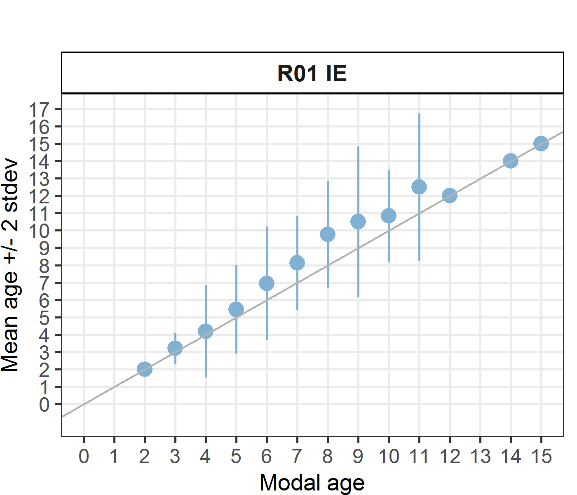 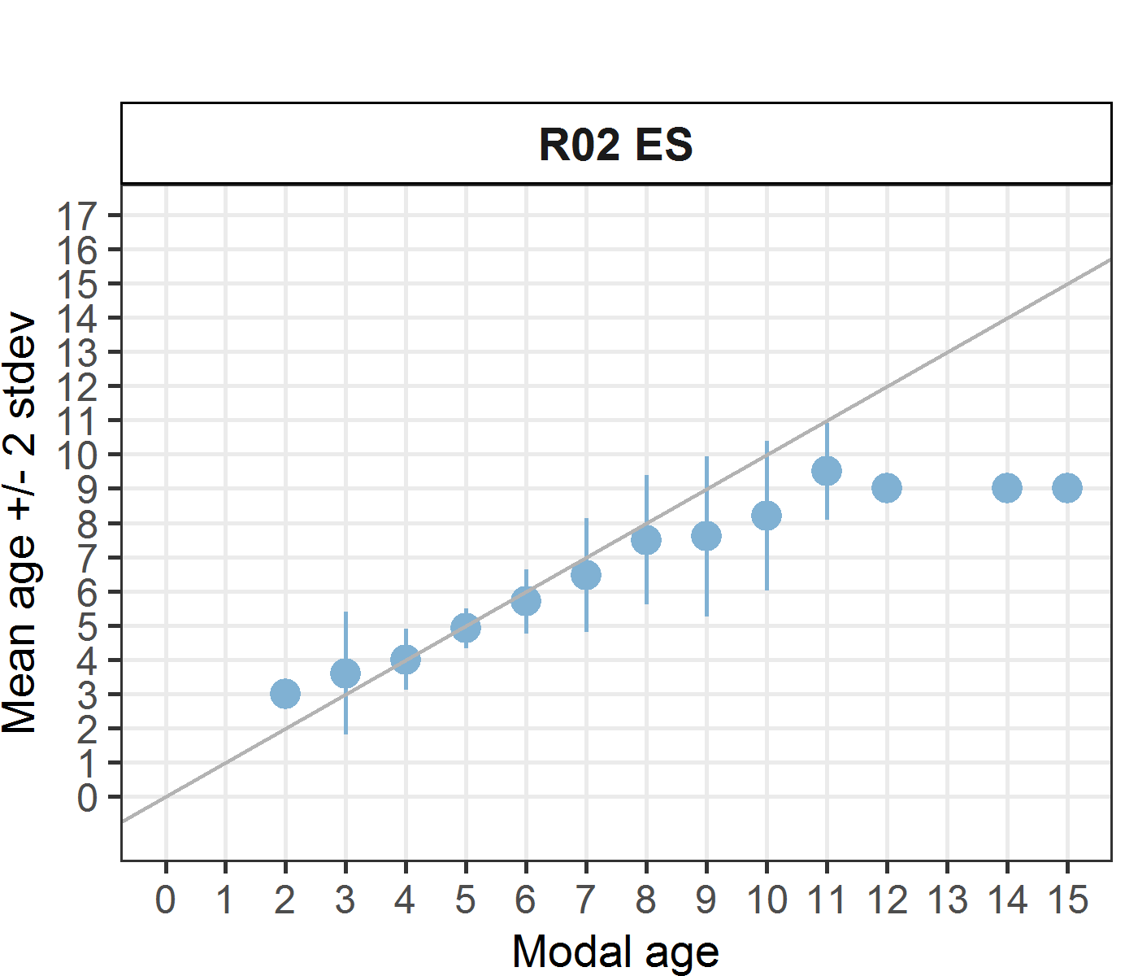 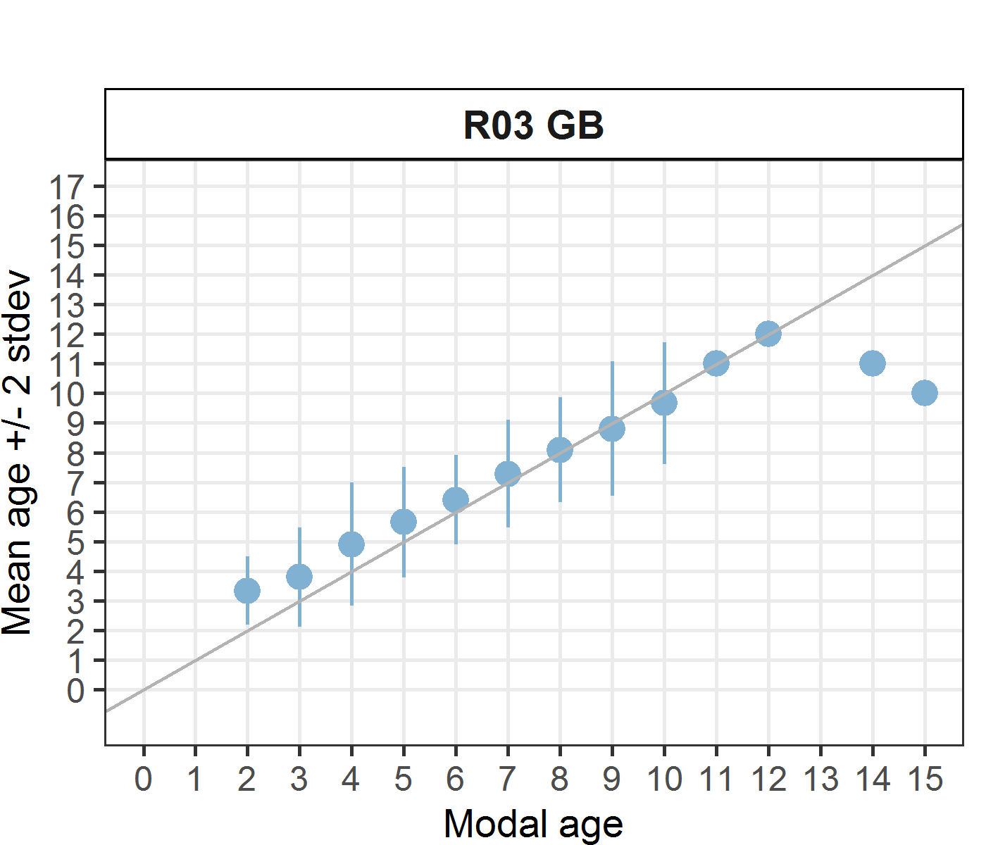 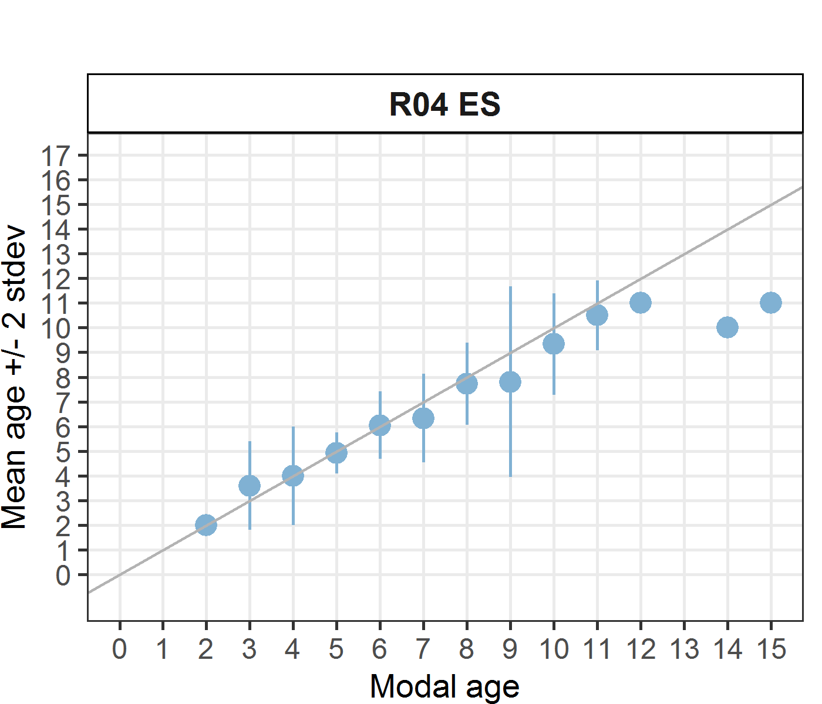 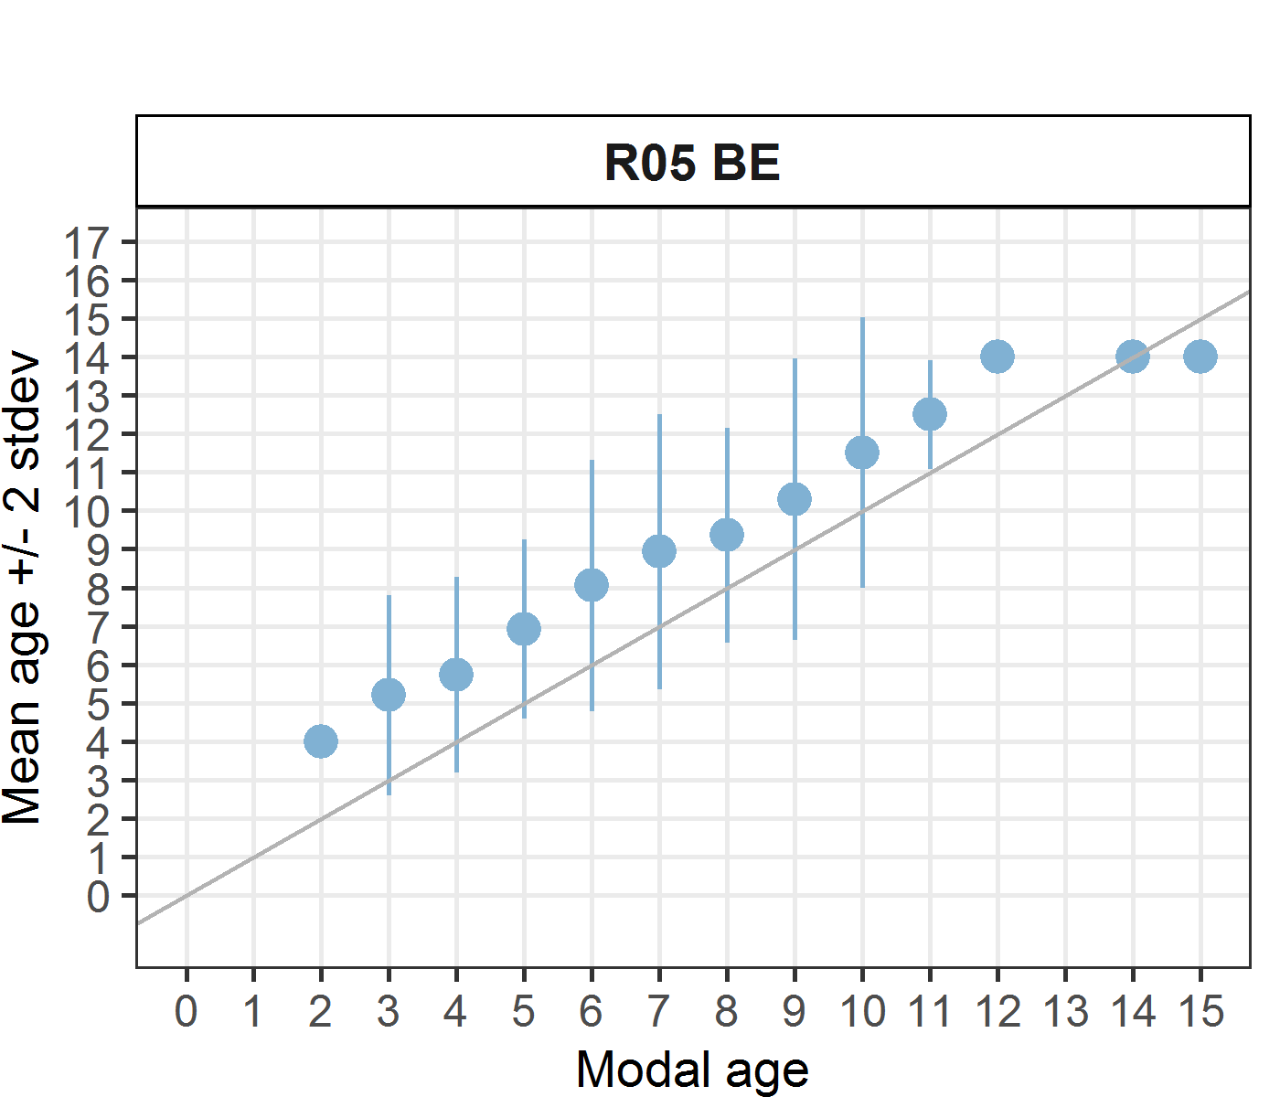 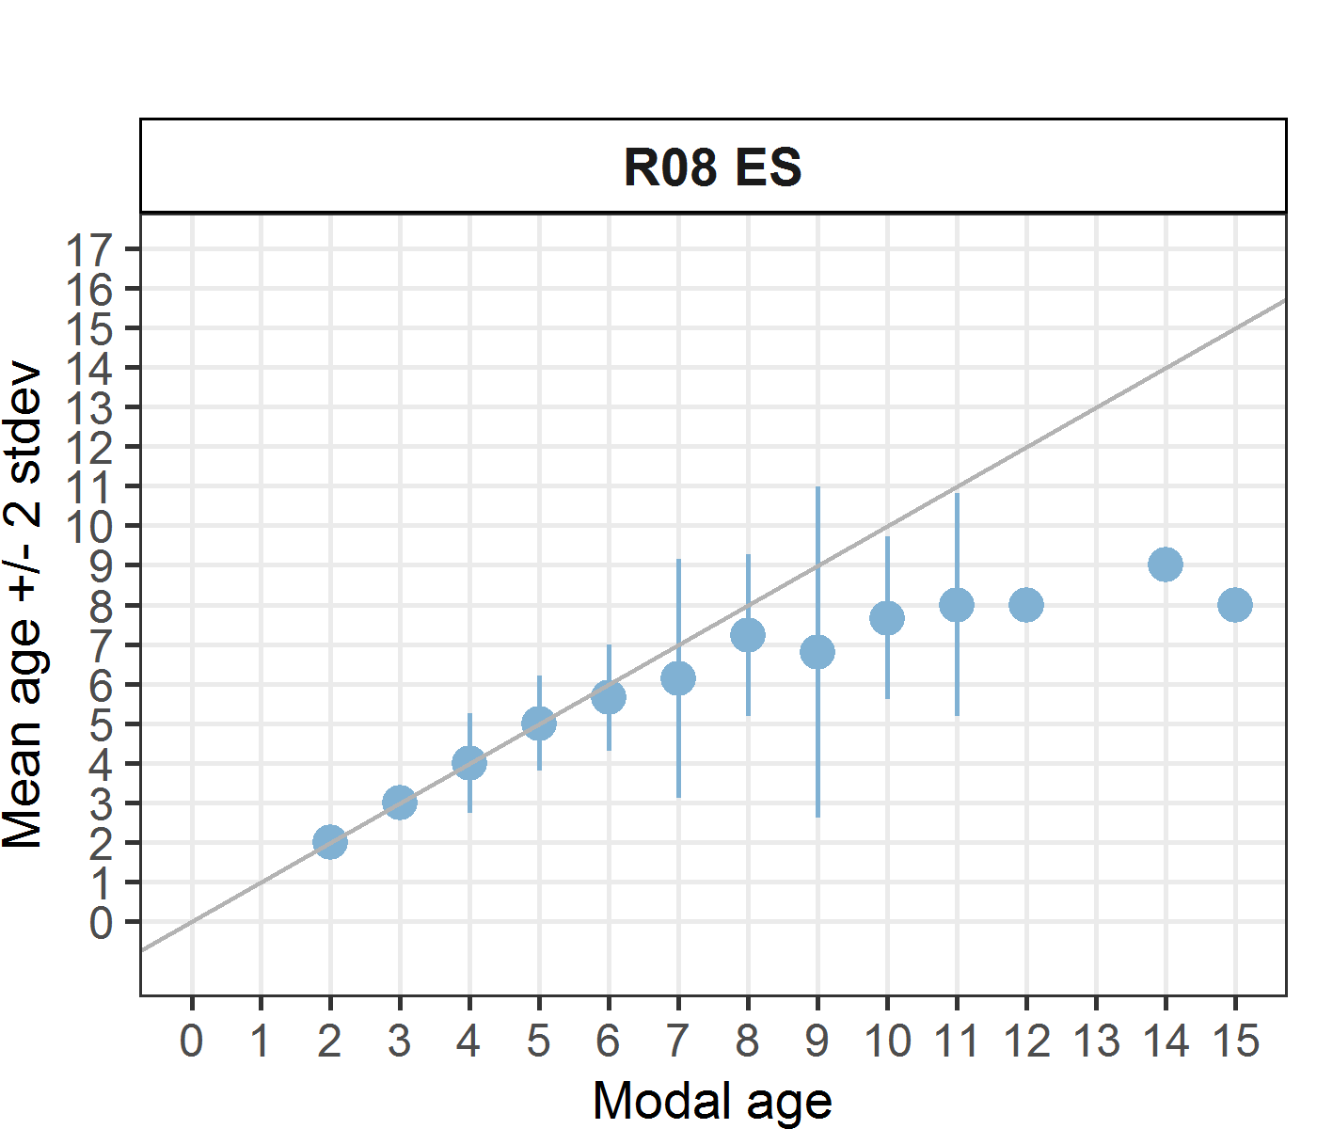

**Figure A3- 6:** Age bias plots per each expert reader.

*Statistics by modal age plot (STDEV, CV and PA)*

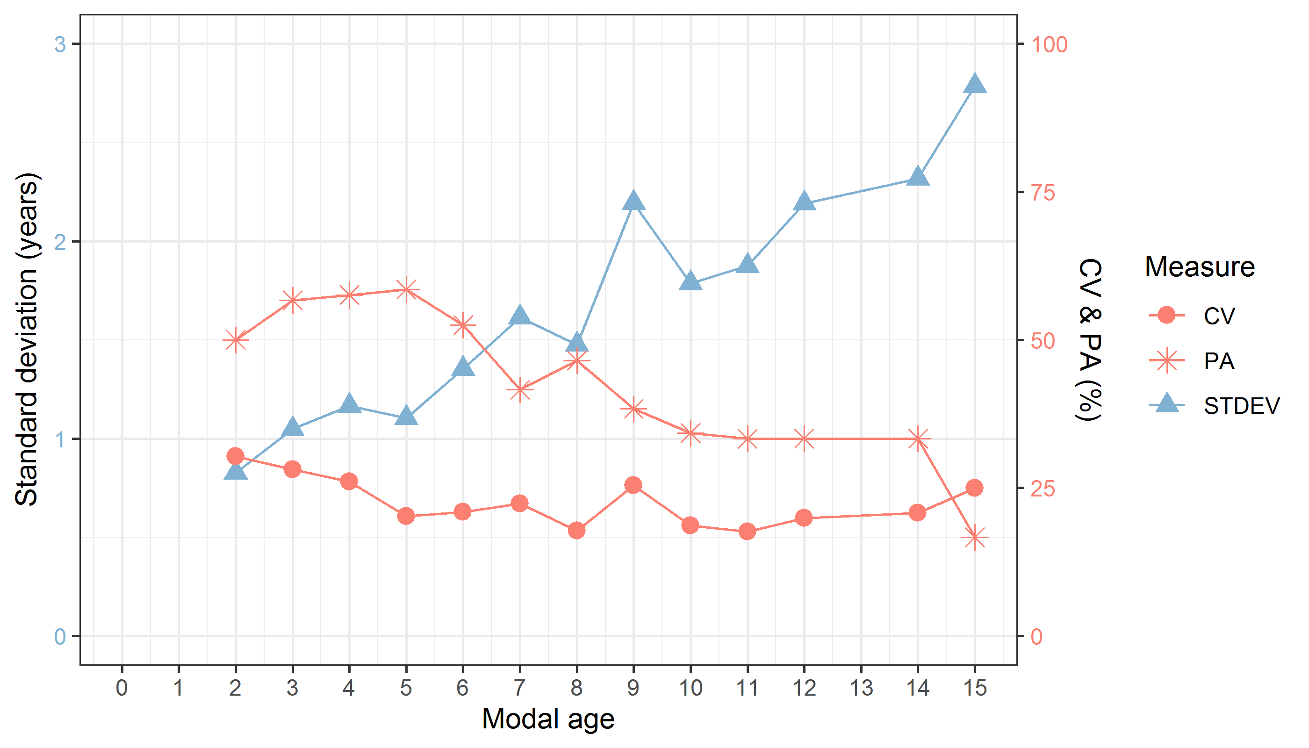

**Figure A3- 7:** CV, PA and (STDEV (standard deviation) are plotted against modal age for all expert readers.

*Distribution of age reading errors*

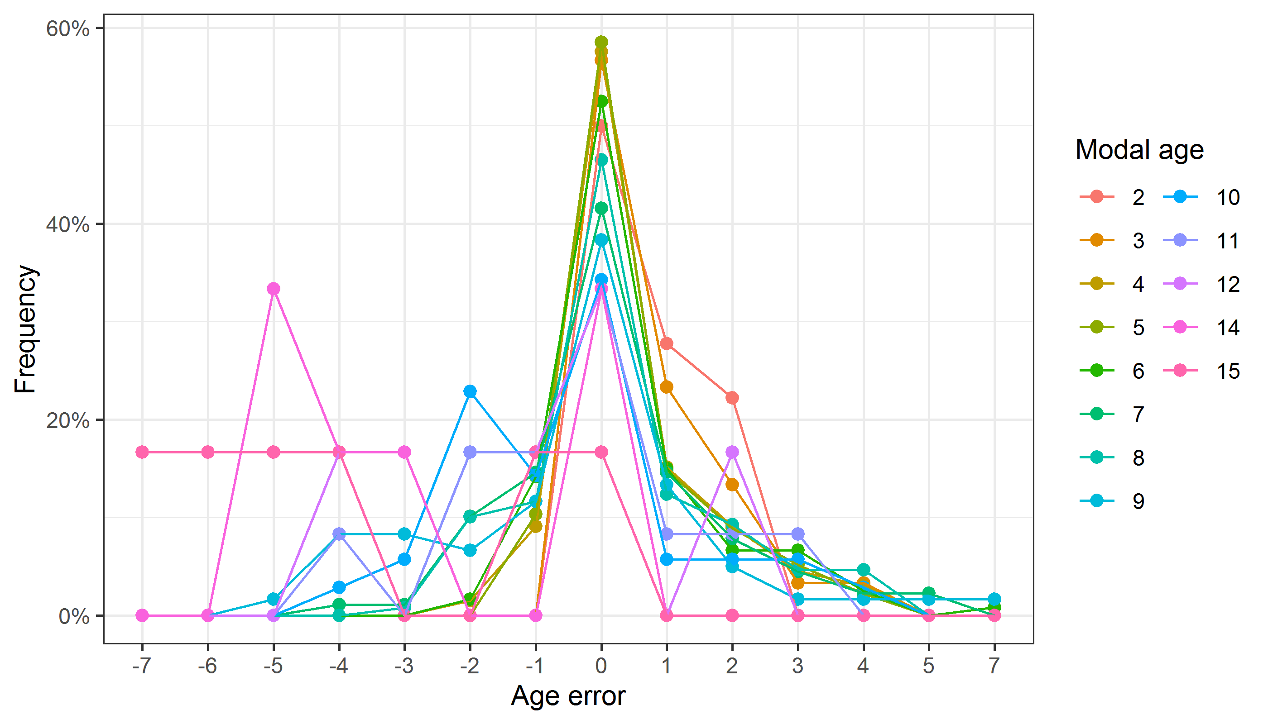

**Figure A3- 8:** The distribution of the age reading errors in percentage by modal age as observed from the whole group of age readers in an age reading comparison to modal age. The achieved precision in age reading by MODAL age group is shown by the spread of the age readings errors. There appears to be no relative bias, if the age reading errors are normally distributed. The distributions are skewed, if relative bias occurs.

*Relative bias for all readers*

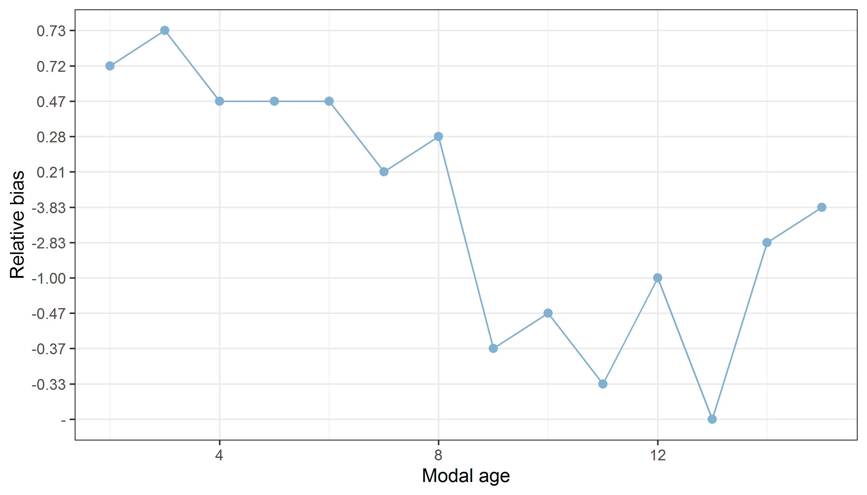

**Figure A3- 9:** The relative bias by modal age as estimated by all age readers combined.

*Mean length at age by reader*

**Table A3- 11:** Mean fish length at age per reader is calculated per reader and age (not modal age) and for all readers combined per age. A weighted mean is also given.

|  |  |  |  |  |  |  |
| --- | --- | --- | --- | --- | --- | --- |
| **Age** | **R01 IE** | **R02 ES** | **R03 GB** | **R04 ES** | **R05 BE** | **R08 ES** |
| 2 | 228 mm | - | - | 222 mm | - | 228 mm |
| 3 | 252 mm | 222 mm | 220 mm | 218 mm | - | 245 mm |
| 4 | 280 mm | 260 mm | 253 mm | 300 mm | 229 mm | 276 mm |
| 5 | 297 mm | 301 mm | 272 mm | 279 mm | 263 mm | 306 mm |
| 6 | 325 mm | 332 mm | 323 mm | 350 mm | 303 mm | 349 mm |
| 7 | 332 mm | 383 mm | 326 mm | 384 mm | 315 mm | 424 mm |
| 8 | 336 mm | 435 mm | 404 mm | 404 mm | 330 mm | 438 mm |
| 9 | 362 mm | 474 mm | 399 mm | 425 mm | 360 mm | 434 mm |
| 10 | 418 mm | 495 mm | 433 mm | 440 mm | 409 mm | 440 mm |
| 11 | 433 mm | - | 450 mm | 480 mm | 424 mm | - |
| 12 | 434 mm | - | 480 mm | - | 410 mm | - |
| 13 | 510 mm | - | - | - | 410 mm | - |
| 14 | 475 mm | - | - | - | 474 mm | - |
| 15 | 488 mm | - | - | - | - | - |
| 16 | 351 mm | - | - | - | - | - |
| **Weighted Mean** | **346 mm** | **345 mm** | **345 mm** | **346 mm** | **346 mm** | **346 mm** |

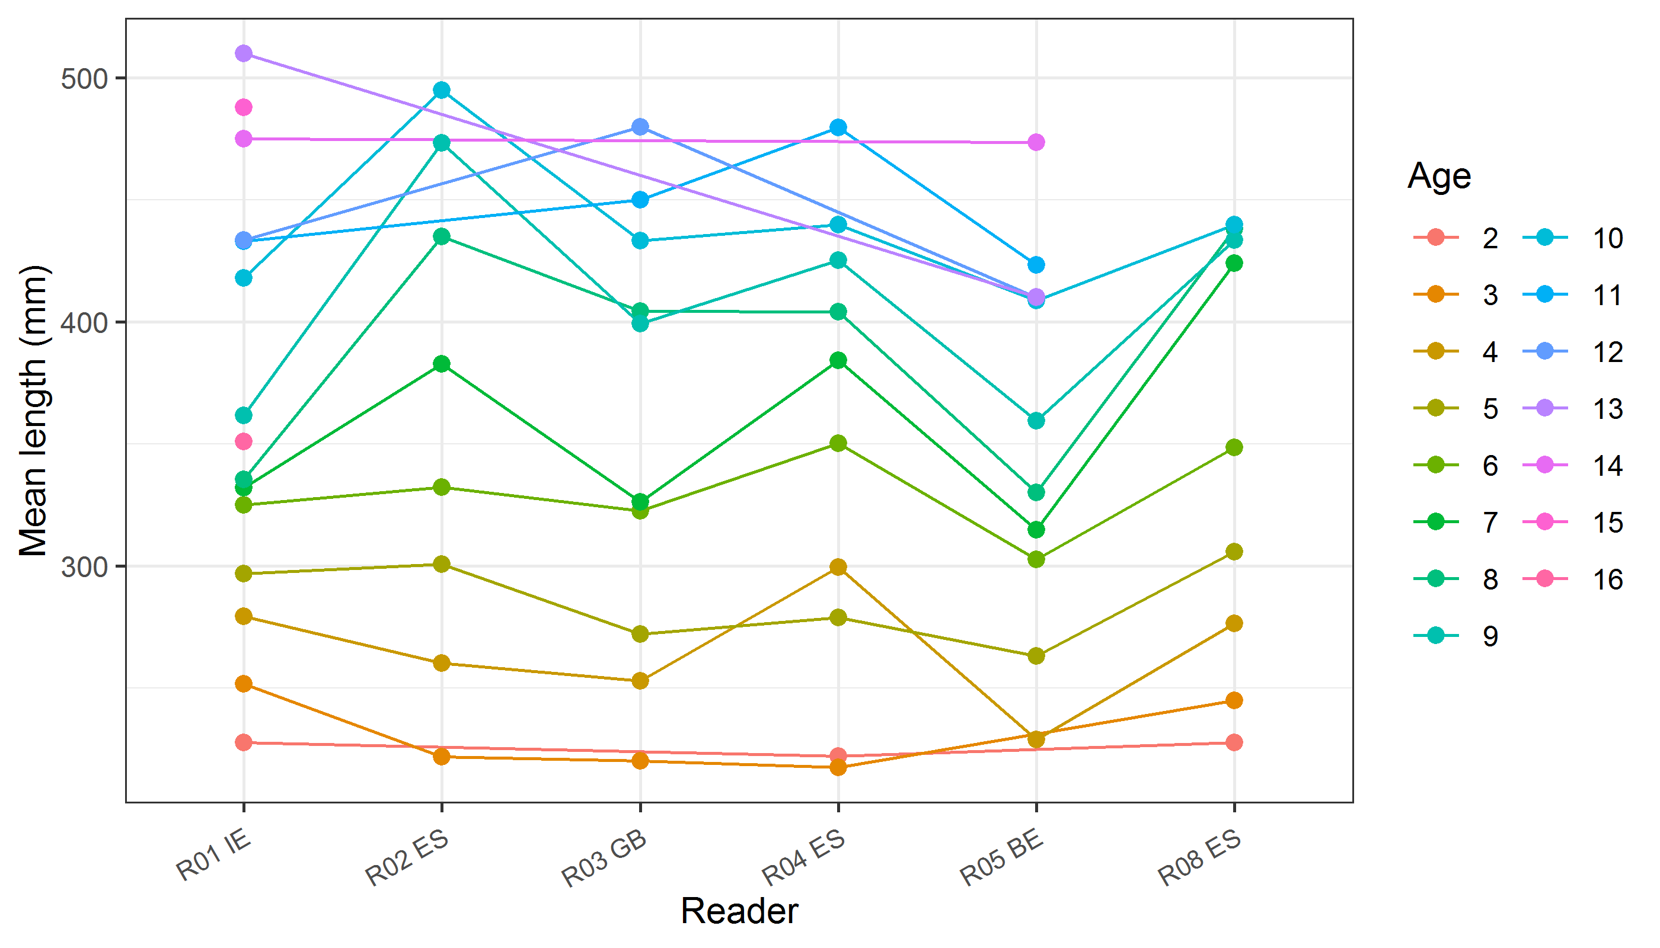

**Figure A3- 10:** The mean fish length at age as estimated by each age reader.

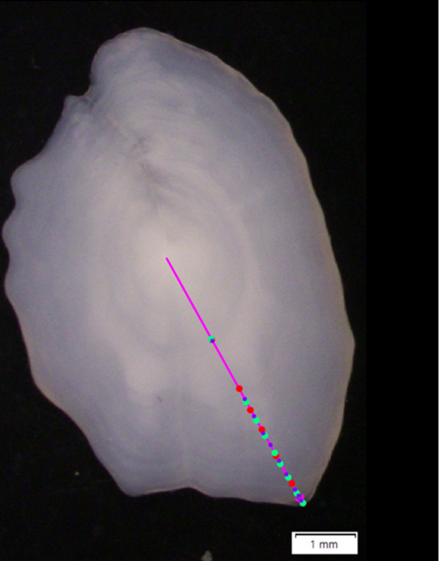

**Figure A3- 11:** MEG-300619-1-43-S1. Example of general discordance between readers for old otolith (modal age 7), marks correspond to expert readers. Red is the modal age (7 points), while: 10 points with Q1 were assigned in purple and 9 with Q2 in green.

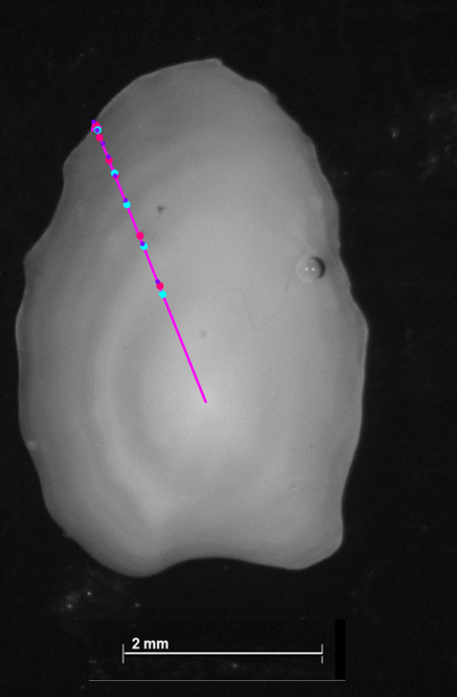

**Figure A3- 12**: Example of age overestimation by two readers (R01 and R05) on a 5 years otolith from the first half of the year. Location of the supposed annuli on otoliths 212-S1, considered to be of age 5 by most readers, including advanced readers. Note that of the last increment considered as annual by the expert reader R02 (in light blue), have been considered as 2 by R01 (in pink) and 3 by R05 in purple. Thus, both readers were overestimating the age (7 and 8 year years old).

# Annex 5. Recommendations

**All readers**

In general, most of the readers seem to tend underestimating ages older than 6, but some readers tend to overestimates ages from 2 to 6. Consequently, it is advisable that all the readers analyse the underestimation of age observed, in otoliths older than 6 years. And that those readers who tends to overestimate ages 2 to 6 would do the same for the overestimation. Furthermore, a general discordance has been observed when marking the true annuli (see for example **Figure A3- 11**). Reviewing the images of this Ex, with the marks put by each reader, could be helpful for preparing a workshop trying to include the same participants at least, and more participants especially those stock readers who missed the current Ex if it is possible. Also, the nature of the edge is interpreted in different way also between expert readers. Readers 1, reader 5 have the tendency to overestimate the number of true annuli, (see for example, **Figure A3- 12**). On the one hand, it would be advisable for readers R01 and R05 to analyse in detail the results obtained regarding the overestimation of the age obtained, especially in otoliths younger than 6 years. Similarly, reader R15 should analyse the underestimation of age observed, especially in otoliths older than 6 years. 4 out of 10 are readers with not extensive experience in megrim age estimation, but the results for experts don’t improve so much the general accordance, nor the bias or CV%. This underlying that there are different criteria for ageing this stock between readers. Reviewing the images in this Exchange, especially for ages younger than 6, may help them improve accordance in their age interpretation criteria. Considering that similar results between the two semesters have been obtained, focusing on these strata probably will not solve the problems observed in this Ex.

**Stock assessment readers**

This Ex was attended by only 7 out 11 stock assessment readers. The first recommendation for this group of readers was to trying attend the next WKs or Exs. Considering that all the stock assessment readers who participated to the present event, were classified as experts, and not very good results have been obtained, a new workshop would be recommended in order to unify readings criteria, lowering bias, CV and APE for improving precision and accuracy of the age estimation.

**General**

A lot of years have passed since the last Ex and WK have been organized, some readers have changed, and it would be a good idea to organize another WK for Megrim in the areas 7b-k, 8a,b,d. It would be advisable to conduct a new WK for this stock in the next future although main problems were observed when age are older than 6 (ages considered as one category (7+) in the stock assessment), the further calculation done revealed that including considering only the expert readers and for ages between 2 and 6 the PA doesn’t reach 60%. A reference collection and training of the readers are **recommended.**