SmartDots Report for the 2024 Irish Sea Sole (sol.27.7a) age reading exchange (ID 1842)
Coordination and analysis by Karen Bekaert, ILVO
January 2024

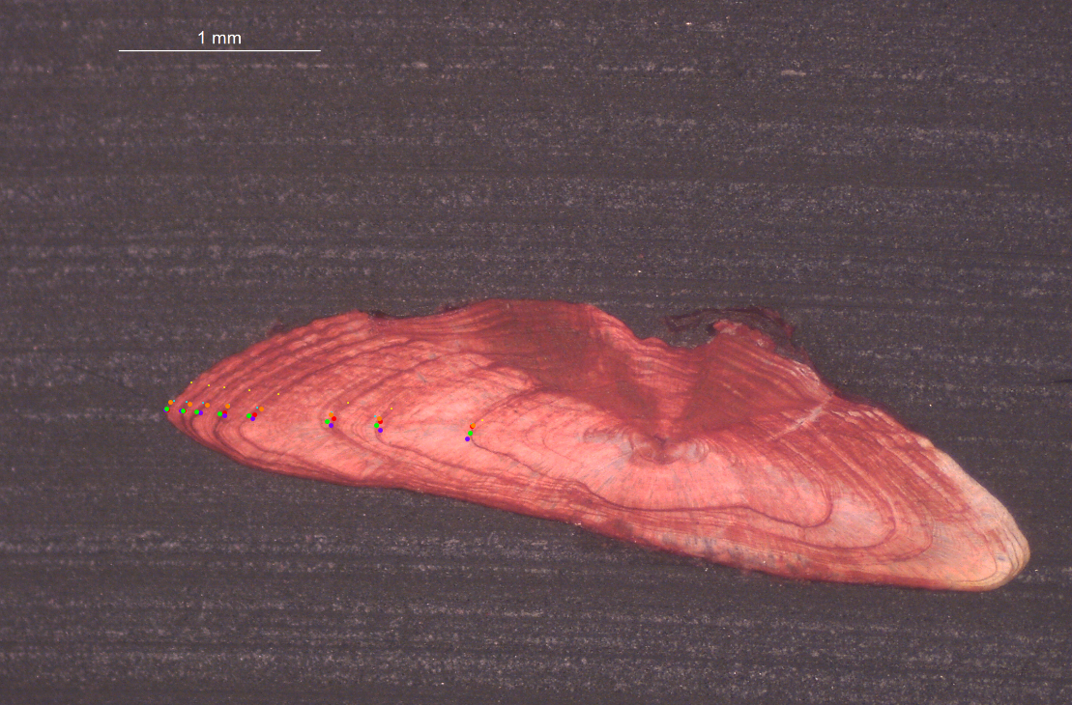
Table of Contents
Summary 3
1 Introduction 4
2 Methods 5
3 Overview of samples and readers 7
4 Results 8
4.1 All readers 9
4.2 Advanced readers 13
5 Discussion 16
6 Conclusion 19
7 References 20
8 Annex. Additional results 21
8.1 Results all readers 22
8.2 Results Advanced readers 36

Summary

This age reading exchange was held in preparation for the WKBFLATFISH1 Benchmark to check the level of agreement and bias between age readers providing age data for stock assessment of sole.27.7a. 160 images of sectioned otoliths from samples collected across the four quarters of 2021, 2022 and 2023 were taken at ILVO (Belgium) and the Marine Institute (Ireland) and uploaded to SmartDots. Age distribution went from modal age 1 to 12. 6 age readers participated in the event, from which 4 were advanced (delivering data for assessments). Readers were provided with instructions to annotate all images, provide an age estimate and a quality score for their age estimation. Readers were free to draw the reading line which they found the most appropriate for age reading of each sample. Therefore, no otolith growth analysis is included in the report. The reporting module in SmartDots was used to run a standardized analysis of age reader comparison and extract a template for a full report and summary report. Results were provided to WKBFLATFISH1 2024.
To my knowledge, no previous age reading exchanges of sole 7a otoliths took place. Before the age reading exchange, the sole 7a stock assessor drew the attention towards the fact that a higher mean weight at age was obtained in Irish sole data than in the Belgian and English dataset. Therefore, extra attention was given to the results of the Irish readers in the discussion as you would expect an age reading shift towards lower ages (underestimation of age) from the advanced Irish reader to explain this result.
Based on all readers included in the age reading exchange, the percentage agreement (PA) was 85% with a coefficient of variation (CV) of 10%. This is overall a good age reading result. 88 out of 160 samples reached a percentage agreement of 100%. Based on the results of the 4 advanced readers only from Belgium, Ireland and UK the results were even improved as can be expected with a percentage agreement (PA) of 89% and a coefficient of variation (CV) of 9%. These results seem very satisfactory from an analytical point of view. When focusing on the Irish advanced age readings, there is more deviation from modal age than the age readings from the other participating countries. For the advanced Irish reader, there seems to be an overestimation of age especially in age classes 7 and 8, and a small underestimation in the older age classes 10 and 12, while there was over- and underestimation in age class 11. This might partially explain the higher weight at age, but only for the older age classes.
The main age reading issues seem to be related to the counting of false rings and the identification of the first winter ring.
From this exchange, we can conclude that the overall results for the age readings of sole 7a are very good. There could be some improvement in agreement with the Irish readers, but the results from this exchange can only partially explain the higher weight at age from the Irish samples as no general underestimation of age could be detected. However, setting up a cooperation between age reading labs could help improve the quality of the age readings in sole 7a.

Introduction
The common sole (Solea solea) is a flatfish from the Order Pleuronectiformes which inhabits the Eastern Atlantic Ocean and the Mediterranean Sea. The species has been historically harvested through highly specialized mixed beam trawl fisheries in shallow waters by most of the ICES-community. Adult sole lives on the sandy or muddy seabed where it often buries itself in the substrate. Length rarely exceeds 60 cm but specimens up to 70 cm have been reported. The oldest specimen observed in Belgian landings was 43 years old (ILVO). Females attain a larger size than males and big soles are invariably females (ICES-Fishmap on sole).
To our knowledge, this is the first otolith exchange of sole in area 7.a. WGBIOP (October, 2023) identified the need for a sole exchange preceding the sole 7.a stock benchmark foreseen in February 2024. Therefore, this image-only exchange was organized using the SmartDots platform for annotating the images and analysing the results.
The aims of this exchange were:
- To evaluate the accuracy and precision in otolith age reading of sole in division 7.a (Irish Sea)
- To identify issues related to age reading of sole in division 7.a
In this report, we present the analysis of the results (precision and accuracy) of the readings by modal age and by age reader. The report highlights the potential bias of age reading for specific readers and allows to identify common issues related to age reading of sole in 7.a.

Methods
Results presented here are based on output from SmartDots and a standardised R-script. The analysis follows traditional methods where the level of accuracy compared to modal age is indicated by percentage agreement (PA), bias tests and plots, and the level of precision, i.e. the reproducibility of age estimates is indicated by the coefficient of variation (CV). The tables and plots presented are from the Guus Eltink Excel sheet ‘Age Reading Comparisons’ (Eltink, A.T.G.W. 2000). Additional analyses of age data were included in the form of age error matrices (AEM’s).

Determination of modal age: a multistage approach to define the modal age by sampled fish
In this event, the multistage approach to calculate the modal age has been used. When summarizing the output and reporting the results of the exchange events developed within the SmarDots framework, the modal age (the most common age decided by the age readers for every fish sample) is the most relevant measurement. It is a key statistic by itself, but it is also fundamental for the estimation of some other relevant statistics to assess the performance of the techniques assessed in the exchange event, like the Percentage Agreement (PA), or input for stock assessments like the Age Error Matrix (AEM) (see below). The multistage approach is based in the different weight given to the age readers according to their experience. Two different weight scores scales were assigned, a weight score decreasing linearly with the experience and another decreasing with a negative exponential shape. The modal age by fish individual is decided following the next approach:
1.-If there is a single mode estimated with the standard approach (equal weight for all readers) this value is used as the modal age, if not
2.-Adding up, for each age category, the score assigned with the linear weighting for all the readers that decided that age for that fish. Next, the modal age is selected as the age category that obtains the highest score sum. If, despite this approach, there were still multiple ages with the same score (and hence multiple modes), the next step is applied:
3.-Adding up, for each age category, the score assigned with the negative exponential weighting for all the readers that decided that age for that fish. Select as the modal age the age with the highest score sum.
During the WGBIOP 2019 meeting it was found that the combination of the modes decided using these three methods (so called 'multistage approach'), allows assigning a single modal age to each fish individual.

Percentage Agreement (PA)
The percentage agreement per reader per modal age tells how large is the part of readings that are equal to the modal age. The percentage agreement is estimated by modal age and reader as the proportion (as percentage) of times that the lectures of that reader agreed with the resulting modal age. This percentage is estimated as the number of times that a reader agreed with the modal age divided by the total number of otoliths read by a reader for each modal age. It does not give an indication of how important the deviation from the modal age is.
$$PA=\frac{number of readings that agree with modal age}{total number of readings by modal age}⋅100\%$$
Coefficient of Variation (CV)
The table presents the Coefficient of Variation (CV) per modal age and reader. The CV's are calculated as the ratio between the standard deviation (σ) and mean value (μ) per reader and modal age:
$$CV=\frac{σ}{μ}⋅100\%$$
To the table is also added the CV of all readers combined per modal age and a weighted mean of the CV per reader.
Relative bias
The relative bias is calculated as the difference between the mean and the modal age. This statistic is presented in first place by modal age and reader, but it is also calculated as an average value by modal age for all readers together or only advanced readers.
Average Percentage Error (APE)
The Average Percentage Error (APE) was calculated based on the method outlined by Beamish & Fournier (1981). This method is dependent of fish age and thus provides a better estimate of precision than percentage agreement. As the calculations of both CV and APE pose problems if the mean age is close to 0, all observations for which modal age was 0 were omitted from the CV and APE calculations.
The average percentage error is calculated per image as:
$$APE=\frac{100\%}{n}\sum_{i=1}^{n}{|}\frac{a_{i}-\overline{a}}{\overline{a}}|$$
where $a_{i}$ is the age reading of reader $i$ and $\overline{a}$ is the mean of all readings from 1 to $n$.
Age error matrix (AEM)
Age error matrices (AEM) were produced following procedures outlined by WKSABCAL (2014) where the matrix shows the proportion of each modal age mis-aged as other ages. The sum of each row is 1, which equals 100%. The age data was analysed twice, the first time all readers were included and the second time only the “advanced” readers were included. If a reader is “advanced” then they are considered well trained and they provide ages for stock assessment or similar purposes. When the AEM is compiled for assessment purposes it uses only those readers who provide age data for the stock assessment in that specific area.

Overview of samples and readers
160 images of sectioned and stained otoliths from samples collected across the four quarters of 2021, 2022 and 2023 were taken at ILVO (Belgium) and the Marine Institute (Ireland) and uploaded to SmartDots. Modal age ranged from 1 to 12. Readers were provided with instructions to annotate all images, provide an age estimate and a quality score for their age estimation. Six readers from 3 different countries participated in the exchange. Four of the readers were advanced, which means they deliver data for assessments.
Table 3.1: Overview of samples used for the exchange event number 1842
Year | ICES area | Strata | Quarter | Number of samples | Modal age range | Length range
2021 | 27.7.a | Strata_27.7.a | 2 | 40 | 2-12 | 195-495 mm
2021 | 27.7.a | Strata_27.7.a | 3 | 14 | 1-11 | 205-480 mm
2021 | 27.7.a | Strata_27.7.a | 4 | 6 | 6-12 | 395-445 mm
2022 | 27.7.a | Strata_27.7.a | 1 | 47 | 0-11 | 190-430 mm
2022 | 27.7.a | Strata_27.7.a | 2 | 10 | 4-11 | 300-430 mm
2022 | 27.7.a | Strata_27.7.a | 3 | 16 | 1-12 | 205-480 mm
2022 | 27.7.a | Strata_27.7.a | 4 | 18 | 1-10 | 180-425 mm
2023 | 27.7.a | Strata_27.7.a | 1 | 5 | 3-9 | 260-370 mm
2023 | 27.7.a | Strata_27.7.a | 2 | 5 | 5-11 | 320-430 mm

Table 3.2: Reader overview
Reader code | Expertise | Expertise_rank
R02 BE | Advanced | 2
R04 GB | Advanced | 4
R06 IE | Advanced | 6
R08 BE | Advanced | 8
R10 IE | Basic | 10
R12 IE | Basic | 12

Results

All readers
The weighted average percentage agreement based on modal ages for all readers is 85 %, with the weighted average CV of 10 % and APE of 5 %.
Coefficient of Variation (CV)
Table 4.1.1: Coefficient of Variation (CV) table presents the CV per modal age and reader, the CV of all readers combined per modal age and a weighted mean of the CV per reader
Modal age | R02 BE |  | R04 GB |  | R06 IE |  | R08 BE |  | R10 IE |  | R12 IE |  | all
1 | 0 % |  | 31 % |  | 53 % |  | 0 % |  | 53 % |  | 40 % |  | 36 %
2 | 0 % |  | 0 % |  | 17 % |  | 0 % |  | 0 % |  | 0 % |  | 7 %
3 | 0 % |  | 0 % |  | 15 % |  | 0 % |  | 13 % |  | 13 % |  | 11 %
4 | 0 % |  | 0 % |  | 11 % |  | 10 % |  | 10 % |  | 10 % |  | 9 %
5 | 5 % |  | 6 % |  | 9 % |  | 7 % |  | 5 % |  | 12 % |  | 8 %
6 | 0 % |  | 6 % |  | 8 % |  | 4 % |  | 6 % |  | 6 % |  | 6 %
7 | 4 % |  | 4 % |  | 13 % |  | 8 % |  | 13 % |  | 5 % |  | 9 %
8 | 5 % |  | 9 % |  | 16 % |  | 8 % |  | 23 % |  | 8 % |  | 14 %
9 | 4 % |  | 0 % |  | 4 % |  | 4 % |  | 4 % |  | 4 % |  | 4 %
10 | 4 % |  | 0 % |  | 5 % |  | 5 % |  | 6 % |  | 9 % |  | 5 %
11 | 3 % |  | 5 % |  | 9 % |  | 0 % |  | 5 % |  | 11 % |  | 7 %
12 | 0 % |  | 4 % |  | 4 % |  | 4 % |  | 6 % |  | 8 % |  | 5 %
Weighted Mean | 2 % |  | 5 % |  | 13 % |  | 5 % |  | 11 % |  | 11 % |  | 10 %
CV is highest at modal age 1, which is normal because the CV formula divides the standard deviation by the mean age normally around 1 at modal age 1. It can however indicate a difficulty in age reading in detecting the first ring. The CV is highest for the Irish readers.
Percentage of Agreement (PA)
The percentage agreement per reader per modal age tells how large part of the readings that are equal to the modal age. The weighted mean including at the bottom of the table is weighted according to number of age readings.
Table 4.1.2: Percentage agreement (PA) table represents the PA per modal age and reader, the PA of all readers combined per modal age and a weighted mean of the PA per reader.
Modal age | R02 BE | R04 GB | R06 IE | R08 BE | R10 IE | R12 IE | total
1 | 100 % | 88 % | 75 % | 100 % | 75 % | 88 % | 88 %
2 | 100 % | 100 % | 88 % | 100 % | 100 % | 100 % | 98 %
3 | 100 % | 100 % | 67 % | 100 % | 78 % | 78 % | 87 %
4 | 100 % | 100 % | 65 % | 96 % | 77 % | 81 % | 87 %
5 | 93 % | 90 % | 86 % | 97 % | 93 % | 72 % | 89 %
6 | 100 % | 87 % | 80 % | 93 % | 87 % | 86 % | 89 %
7 | 92 % | 92 % | 67 % | 92 % | 75 % | 83 % | 83 %
8 | 83 % | 75 % | 75 % | 83 % | 75 % | 64 % | 76 %
9 | 86 % | 100 % | 86 % | 86 % | 86 % | 86 % | 88 %
10 | 86 % | 100 % | 71 % | 71 % | 71 % | 71 % | 79 %
11 | 92 % | 77 % | 69 % | 100 % | 69 % | 38 % | 74 %
12 | 100 % | 80 % | 80 % | 80 % | 60 % | 60 % | 77 %
Weighted Mean | 95 % | 91 % | 75 % | 94 % | 81 % | 75 % | 85 %
The percentage agreement is very high for most ages and readers, however the Irish readers obtain a lower score than the other readers.
Average Percentage Error (APE)
Table 4.1.3: Average Percentage Error (APE) table represents the APE per modal age and reader, the APE of all advanced readers combined per modal age and a weighted mean of the APE per reader.
Modal age | R02 BE | R04 GB | R06 IE | R08 BE | R10 IE | R12 IE | all
1 | 0 % | 19 % | 25 % | 0 % | 25 % | 25 % | 12 %
2 | 0 % | 0 % | 10 % | 0 % | 0 % | 0 % | 2 %
3 | 0 % | 0 % | 13 % | 0 % | 11 % | 11 % | 7 %
4 | 0 % | 0 % | 10 % | 4 % | 8 % | 7 % | 6 %
5 | 1 % | 4 % | 6 % | 3 % | 3 % | 7 % | 3 %
6 | 0 % | 4 % | 4 % | 2 % | 4 % | 4 % | 2 %
7 | 2 % | 2 % | 9 % | 4 % | 8 % | 4 % | 4 %
8 | 3 % | 6 % | 10 % | 5 % | 16 % | 5 % | 7 %
9 | 3 % | 0 % | 3 % | 3 % | 3 % | 3 % | 2 %
10 | 2 % | 0 % | 4 % | 4 % | 3 % | 5 % | 2 %
11 | 1 % | 3 % | 5 % | 0 % | 3 % | 6 % | 4 %
12 | 0 % | 3 % | 3 % | 3 % | 3 % | 6 % | 3 %
Weighted Mean | 1 % | 3 % | 9 % | 2 % | 7 % | 7 % | 5 %
Relative bias
The relative bias is the difference between the mean age (per modal age per reader) and modal age. As for the previous tables, a combined bias for all readers and weighted means are calculated.
Table 4.1.4: The relative bias (as the difference between the mean and modal age) per modal age and reader is presented, as well as the weighted mean relative bias per reader and the relative bias per modal age for all readers combined.
Modal age | R02 BE | R04 GB | R06 IE | R08 BE | R10 IE | R12 IE | all
1 | 0.00 | 0.12 | 0.00 | 0.00 | 0.00 | -0.12 | 0.00
2 | 0.00 | 0.00 | 0.12 | 0.00 | 0.00 | 0.00 | 0.02
3 | 0.00 | 0.00 | 0.33 | 0.00 | 0.22 | 0.22 | 0.13
4 | 0.00 | 0.00 | 0.35 | 0.08 | 0.23 | 0.19 | 0.14
5 | 0.00 | -0.10 | 0.17 | 0.07 | 0.07 | 0.10 | 0.05
6 | 0.00 | -0.13 | 0.07 | 0.07 | 0.13 | 0.14 | 0.05
7 | -0.08 | -0.08 | 0.33 | -0.17 | 0.25 | 0.17 | 0.07
8 | 0.17 | -0.17 | 0.42 | 0.25 | 0.75 | 0.00 | 0.24
9 | 0.14 | 0.00 | 0.14 | 0.14 | 0.14 | -0.14 | 0.07
10 | 0.14 | 0.00 | -0.29 | 0.29 | 0.00 | -0.14 | 0.00
11 | 0.08 | -0.08 | 0.15 | 0.00 | 0.00 | -0.85 | -0.12
12 | 0.00 | 0.20 | -0.20 | 0.20 | 0.00 | -0.60 | -0.07
Weighted Mean | 0.02 | -0.04 | 0.19 | 0.06 | 0.17 | -0.01 | 0.07

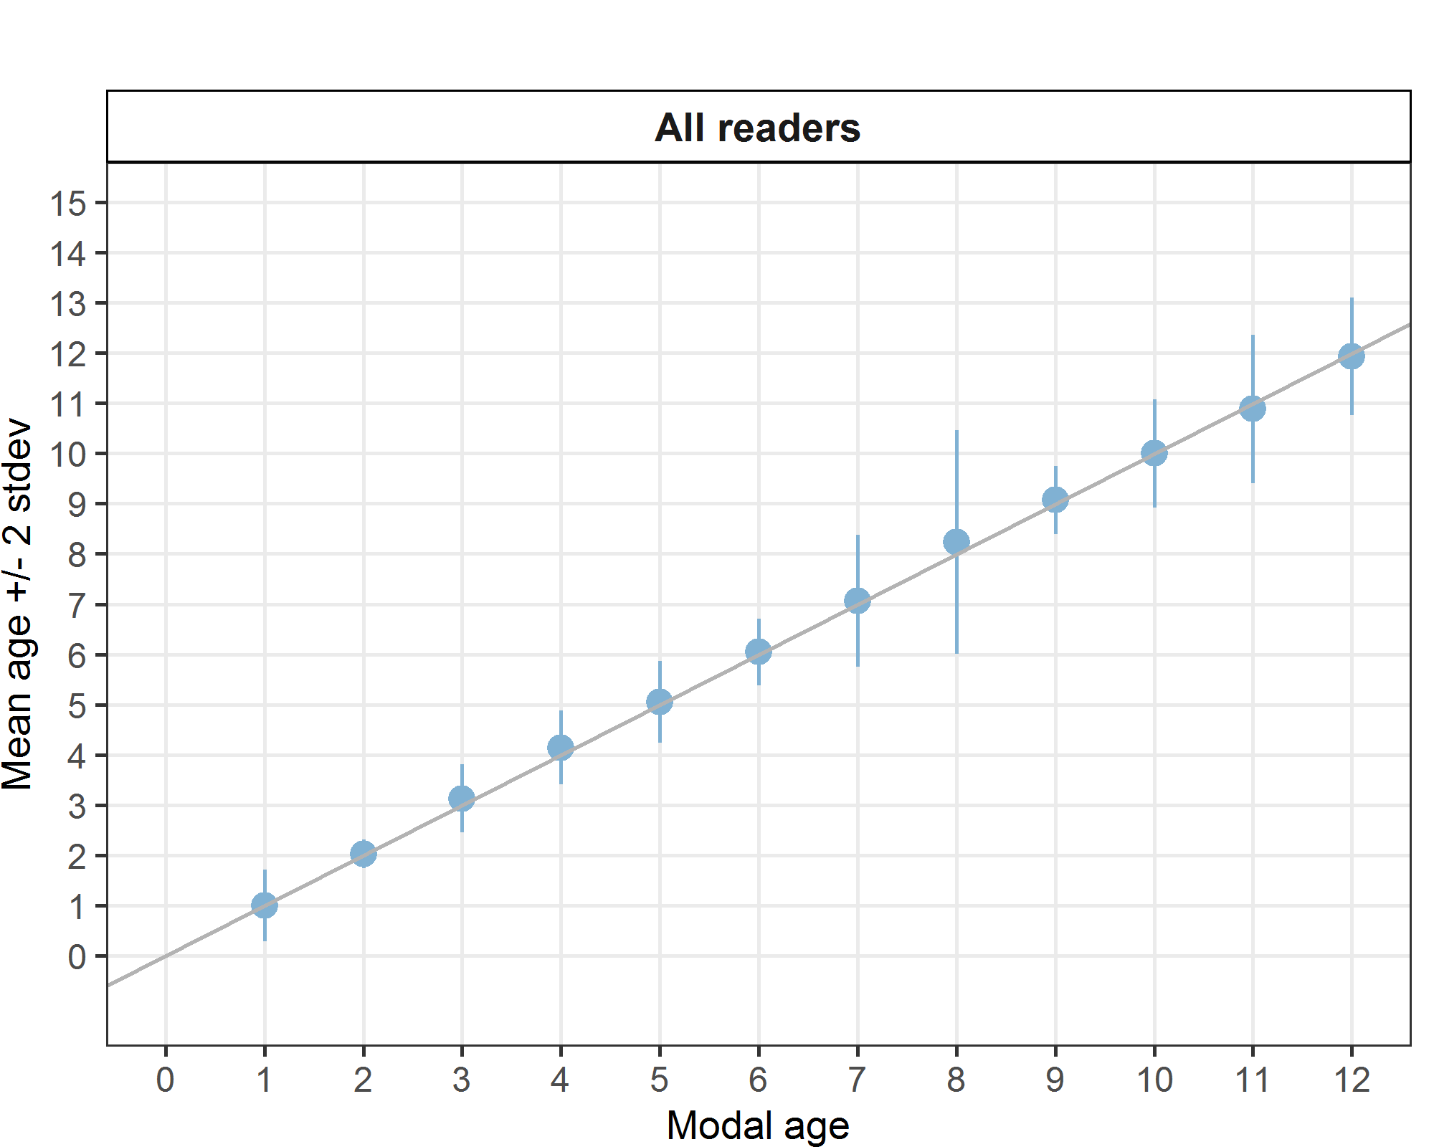
Figure 4.1.1:: Age bias plot for all readers. Mean age recorded +/- 2 stdev of each reader and all readers combined are plotted against modal age. The estimated mean age corresponds to modal age, if the estimated mean age is on the 1:1 equilibrium line (solid line). Relative bias is the age difference between estimated mean age and modal age.
Statistics by modal age plot (STDEV, CV and PA)
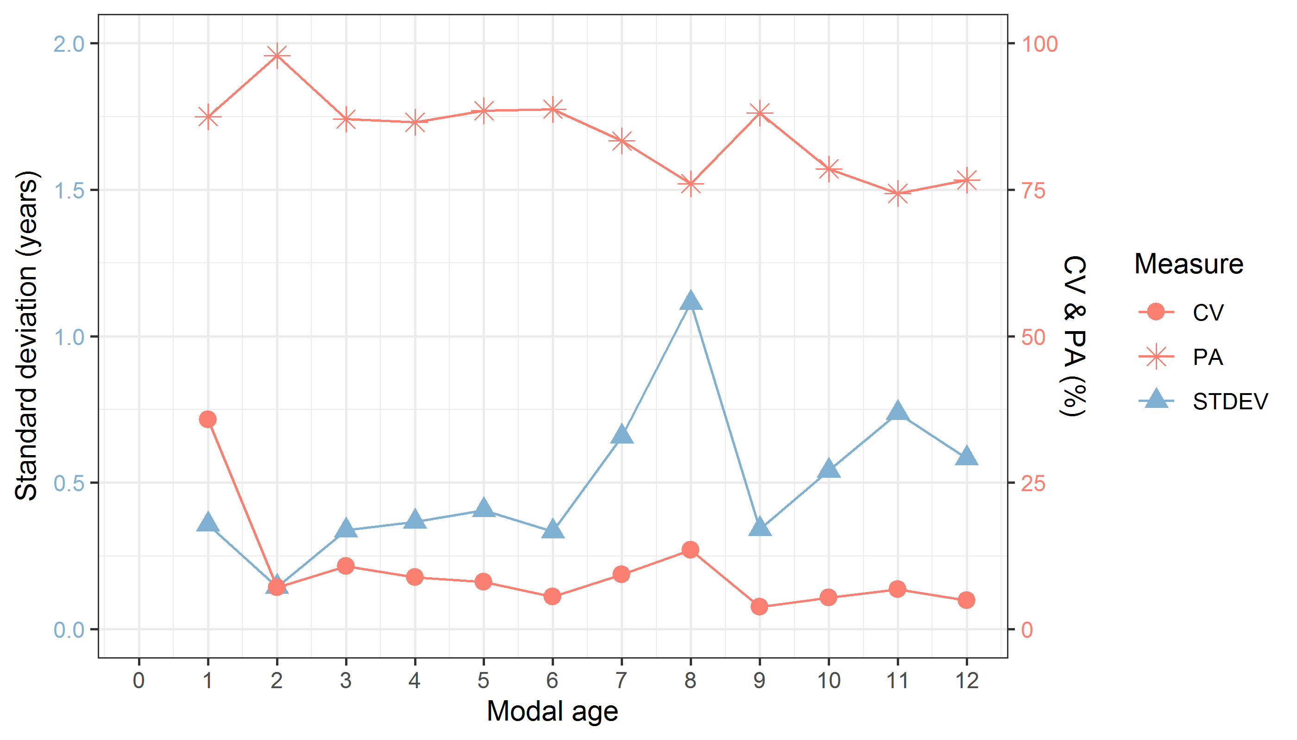
Figure 4.1.2: CV, PA and STDEV (standard deviation) are plotted against modal age
Overall good results are obtained for CV, PA and STDEV. PA is decreasing and STDEV increasing with age, which seems logical as with age, the variation in age readings can increase. Age 8 seems to be an exception with a very high STDEV which is due to several age readings as high as age 12 and 14 for some of these samples.
Inter-reader bias test
Table 4.1.5: Inter reader bias test. The Inter-reader bias test gives probability of bias between readers and with modal age. - = no sign of bias (p>0.05), * = possibility of bias (0.01<p<0.05), * * = certainty of bias (p<0.01) , / = diagonal of the table (no bias)
Comparison | R02 BE | R04 GB | R06 IE | R08 BE | R10 IE | R12 IE
R02 BE | / | - | ** | * | ** | **
R04 GB | - | / | - | - | - | **
R06 IE | ** | - | / | ** | ** | *
R08 BE | * | - | ** | / | ** | **
R10 IE | ** | - | ** | ** | / | **
R12 IE | ** | ** | * | ** | ** | /
Modal age | - | - | - | - | - | **

Advanced readers
The weighted average percentage agreement based on modal ages for all readers is 89 %, with the weighted average CV of 8 % and APE of 4 %.
Coefficient of Variation (CV)
Table 4.2.1: Coefficient of Variation (CV) table presents the CV per modal age and advanced reader, the CV of all advanced readers combined per modal age and a weighted mean of the CV per reader.
Modal age | R02 BE | R04 GB | R06 IE | R08 BE | all
1 | 0 % | 31 % | 53 % | 0 % | 30 %
2 | 0 % | 0 % | 17 % | 0 % | 9 %
3 | 0 % | 0 % | 15 % | 0 % | 9 %
4 | 0 % | 0 % | 11 % | 10 % | 9 %
5 | 4 % | 5 % | 9 % | 7 % | 7 %
6 | 0 % | 6 % | 8 % | 6 % | 6 %
7 | 0 % | 0 % | 14 % | 0 % | 7 %
8 | 5 % | 9 % | 16 % | 8 % | 10 %
9 | 4 % | 0 % | 4 % | 4 % | 3 %
10 | 0 % | 0 % | 5 % | 4 % | 4 %
11 | 0 % | 4 % | 9 % | 0 % | 5 %
12 | 0 % | 3 % | 4 % | 5 % | 4 %
Weighted Mean | 1 % | 4 % | 13 % | 5 % | 8 %
Also for the advanced readers, the CV is highest at modal age 1. The CV is quite high for the Irish advanced reader as compared to the other advanced readers.

Percentage of Agreement (PA)
Table 4.2.2: Percentage agreement (PA) table represents the PA per modal age and reader, advanced the PA of all advanced readers combined per modal age and a weighted mean of the PA per reader.
Modal age | R02 BE | R04 GB | R06 IE | R08 BE | total
1 | 100 % | 88 % | 75 % | 100 % | 91 %
2 | 100 % | 100 % | 88 % | 100 % | 97 %
3 | 100 % | 100 % | 67 % | 100 % | 92 %
4 | 100 % | 100 % | 63 % | 93 % | 89 %
5 | 96 % | 93 % | 86 % | 96 % | 93 %
6 | 100 % | 88 % | 75 % | 88 % | 88 %
7 | 100 % | 100 % | 64 % | 100 % | 91 %
8 | 83 % | 75 % | 75 % | 83 % | 79 %
9 | 86 % | 100 % | 86 % | 86 % | 89 %
10 | 100 % | 100 % | 67 % | 83 % | 88 %
11 | 100 % | 77 % | 62 % | 100 % | 85 %
12 | 100 % | 83 % | 67 % | 67 % | 79 %
Weighted Mean | 98 % | 92 % | 72 % | 93 % | 89 %

The overall percentage agreement of the advanced readers is very satisfactory, however the agreement of the Irish advanced readers can probably be improved when compared to the other readers.

Average Percentage Error (APE)
Table 4.2.3: Average Percentage Error (APE) table represents the APE per modal age and reader, the APE of all advanced readers combined per modal age and a weighted mean of the APE per reader.
Modal age | R02 BE | R04 GB | R06 IE | R08 BE | all
1 | 0 % | 19 % | 25 % | 0 % | 12 %
2 | 0 % | 0 % | 10 % | 0 % | 3 %
3 | 0 % | 0 % | 13 % | 0 % | 5 %
4 | 0 % | 0 % | 11 % | 5 % | 5 %
5 | 1 % | 3 % | 6 % | 3 % | 3 %
6 | 0 % | 4 % | 5 % | 2 % | 2 %
7 | 0 % | 0 % | 10 % | 0 % | 3 %
8 | 3 % | 6 % | 10 % | 5 % | 6 %
9 | 3 % | 0 % | 3 % | 3 % | 2 %
10 | 0 % | 0 % | 5 % | 3 % | 2 %
11 | 0 % | 3 % | 5 % | 0 % | 2 %
12 | 0 % | 2 % | 4 % | 3 % | 2 %
Weighted Mean | 1 % | 3 % | 9 % | 2 % | 4 %

The overall average percentage error of the advanced readers is very satisfactory, however the percentage error of the Irish advanced reader can probably be improved when compared to the other readers.
Relative Bias
Table 4.2.4: The relative bias (as the difference between the mean and modal age) per modal age and advanced reader is presented, as well as the weighted mean relative bias per reader and the relative bias per modal age for all advanced readers combined.
Modal age | R02 BE | R04 GB | R06 IE | R08 BE | all
1 | 0.00 | 0.12 | 0.00 | 0.00 | 0.03
2 | 0.00 | 0.00 | 0.12 | 0.00 | 0.03
3 | 0.00 | 0.00 | 0.33 | 0.00 | 0.08
4 | 0.00 | 0.00 | 0.37 | 0.11 | 0.12
5 | 0.04 | -0.07 | 0.18 | 0.07 | 0.05
6 | 0.00 | -0.12 | 0.12 | 0.00 | 0.00
7 | 0.00 | 0.00 | 0.36 | 0.00 | 0.09
8 | 0.17 | -0.17 | 0.42 | 0.25 | 0.17
9 | 0.14 | 0.00 | 0.14 | 0.14 | 0.11
10 | 0.00 | 0.00 | -0.33 | 0.17 | -0.04
11 | 0.00 | -0.23 | 0.08 | 0.00 | -0.04
12 | 0.00 | 0.17 | -0.33 | 0.00 | -0.04
Weighted Mean | 0.02 | -0.04 | 0.19 | 0.06 | 0.06

The general relative bias of the advanced readers is very low, however there seems to be an overall positive bias in the Irish age readings until age 9 and a negative in the older age readings, i. e. age 10 and 12.

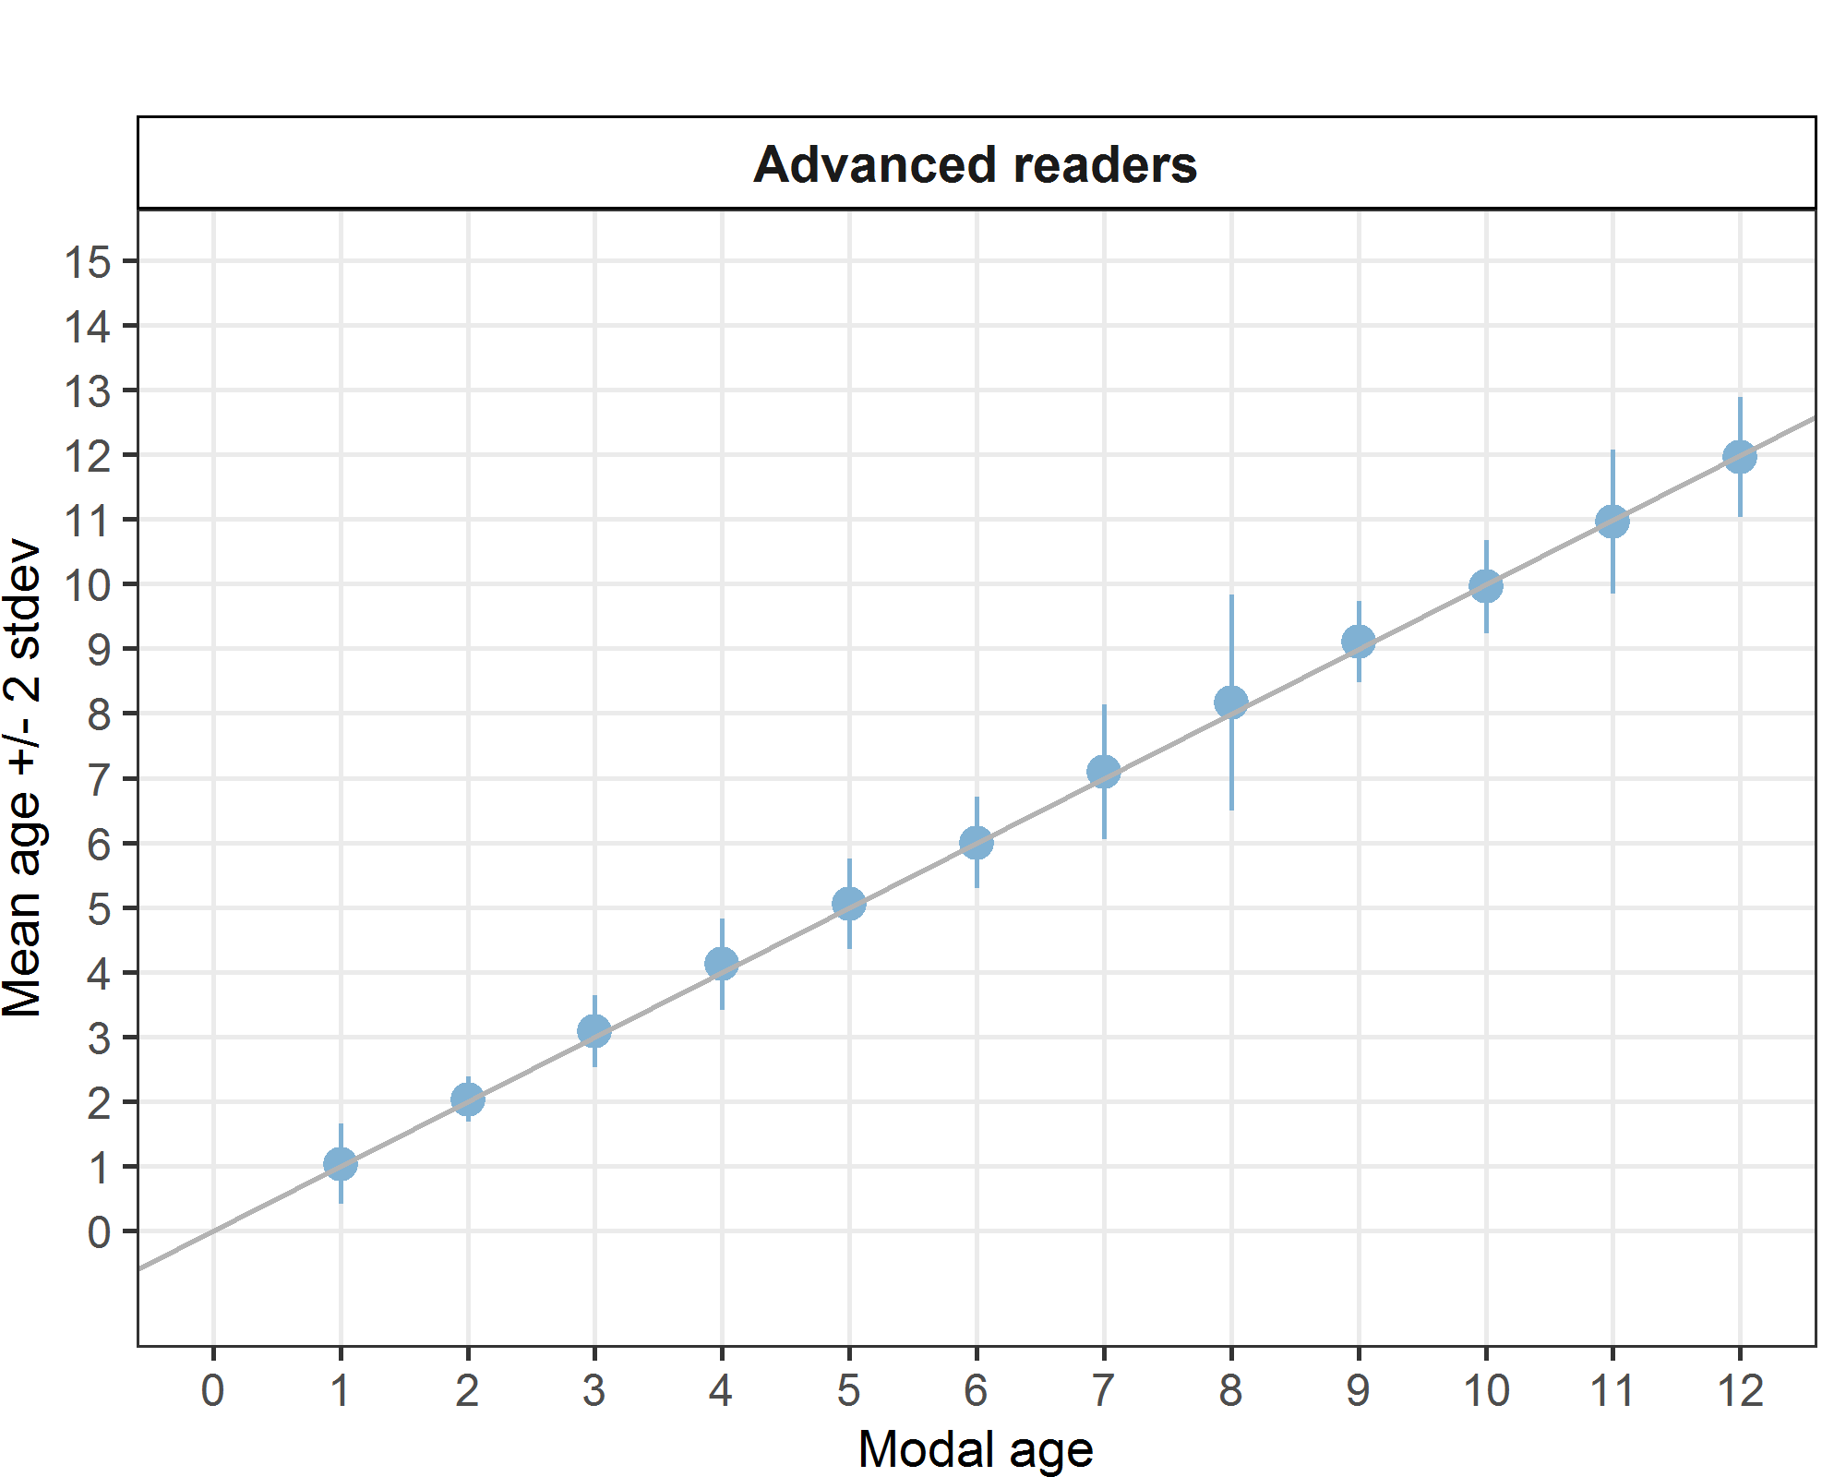

Figure 4.2.1: Age bias plot for advanced readers. Mean age recorded +/- 2 stdev of each reader and all readers combined are plotted against modal age. The estimated mean age corresponds to modal age, if the estimated mean age is on the 1:1 equilibrium line (solid line). Relative bias is the age difference between estimated mean age and modal age.
General Age Error Matrix (AEM)
Table 4.2.2: General Age error matrix (AEM). The modal age is in rows and the age classifications by the advanced readers in columns.
modal_age | 0 | 1 | 2 | 3 | 4 | 5 | 6 | 7 | 8 | 9 | 10 | 11 | 12 | 13 | 14 | Total
1 | 0.03 | 0.91 | 0.06 | - | - | - | - | - | - | - | - | - | - | - | - | 1.00
2 | - | - | 0.97 | 0.03 | - | - | - | - | - | - | - | - | - | - | - | 1.00
3 | - | - | - | 0.92 | 0.08 | - | - | - | - | - | - | - | - | - | - | 1.00
4 | - | - | - | - | 0.89 | 0.10 | 0.01 | - | - | - | - | - | - | - | - | 1.00
5 | - | - | - | - | 0.02 | 0.93 | 0.04 | 0.02 | - | - | - | - | - | - | - | 1.01
6 | - | - | - | - | - | 0.06 | 0.88 | 0.06 | - | - | - | - | - | - | - | 1.00
7 | - | - | - | - | - | - | 0.02 | 0.91 | 0.05 | - | 0.02 | - | - | - | - | 1.00
8 | - | - | - | - | - | - | 0.02 | 0.04 | 0.79 | 0.08 | 0.04 | - | 0.02 | - | - | 0.99
9 | - | - | - | - | - | - | - | - | - | 0.89 | 0.11 | - | - | - | - | 1.00
10 | - | - | - | - | - | - | - | - | - | 0.08 | 0.88 | 0.04 | - | - | - | 1.00
11 | - | - | - | - | - | - | - | - | - | - | 0.12 | 0.85 | 0.02 | - | 0.02 | 1.01
12 | - | - | - | - | - | - | - | - | - | - | - | 0.12 | 0.79 | 0.08 | - | 0.99

Discussion

Based on all readers included in the age reading exchange, the percentage agreement (PA) was 85% with a coefficient of variation (CV) of 10% and an APE of 5 %. Based on the four advanced readers providing age data for assessment from Belgium, Ireland and UK the results were even improved as can be expected with a percentage agreement (PA) of 89%, a coefficient of variation (CV) of 9% and an average percentage error of 4% which is considered very good for an age reading exchange. In general, the deviation from the modal age by an individual reader is rarely more than one year.
When focusing on the Irish age readings, it is true that there is more deviation from modal age than the readings from the other participating countries. For the advanced Irish reader, there seems to be an age reading shift towards older ages in the younger age classes, but towards younger ages in the older age classes (see table 4.2.4). This could explain the higher weight at age, but only for the older age classes.
When analysing the annotations more in detail, the main age readings issues seems to be the counting of false rings, different edge interpretation, the correct identification of the first winter ring, or the missing of rings when cliffed edge in older fish.
Examples of differences in interpretation

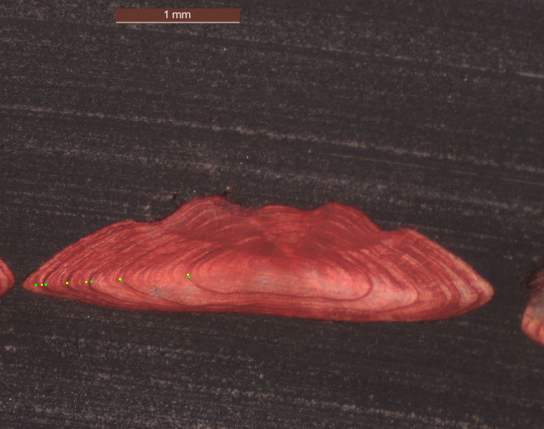
Fig. 5.1: NKSZ09_SOL_L_M_7A_2022112210163. Fish Length 364 mm – Catch date 22-11-2024 – Modal Age 5. Example of overestimation by green reader due to counting of false rings. PA: 83.3%

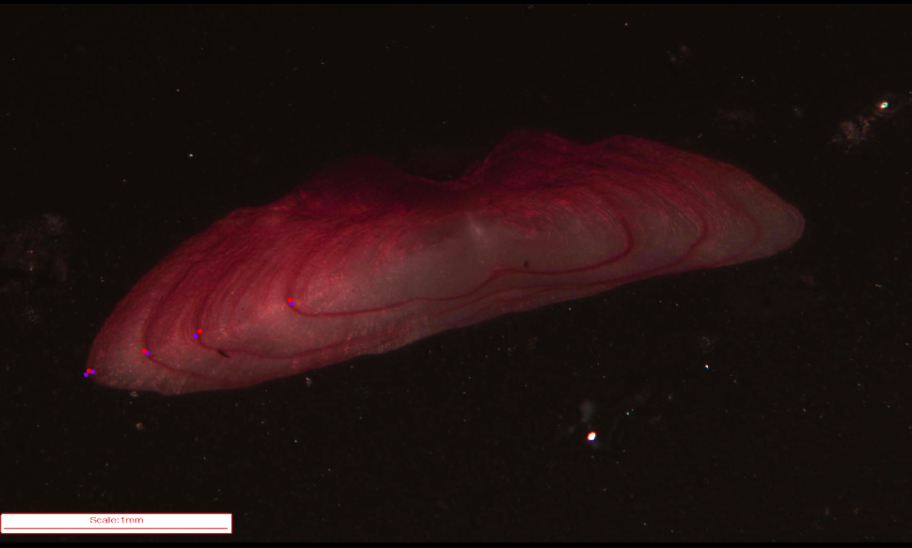
Fig. 5.2: SOL_7A_Q1_22_54561_006: Fish Length 310 mm – Catch date 07-03-2022 – Modal Age 4. Example of overestimation by purple reader due to different edge interpretation. PA 83.3%

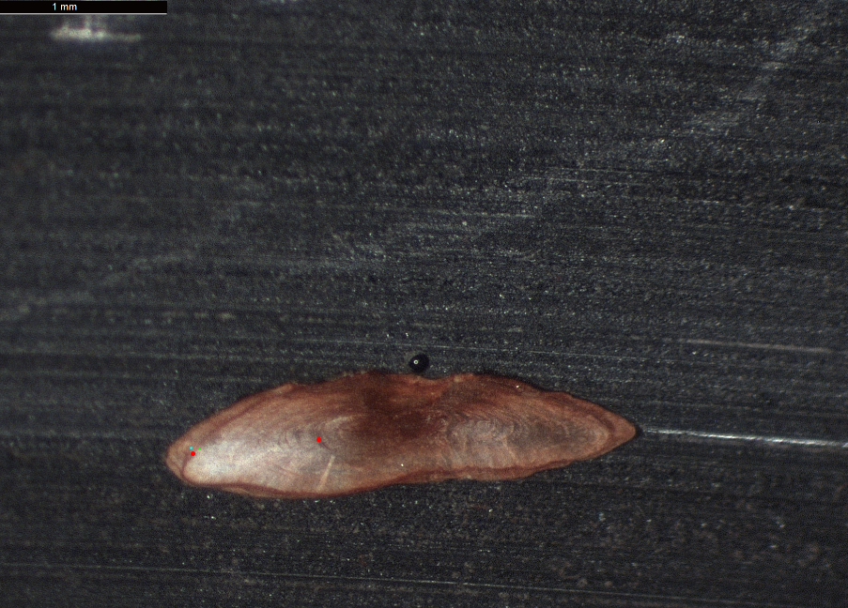
Fig. 5.3: SELF_SAMP_SOL_R_M_7 A_2022090310026: Fish Length 207 mm – Catch date 03-09-2022 – Modal Age 1. Example of overestimation by red reader due to different nucleus interpretation. PA 83.3%
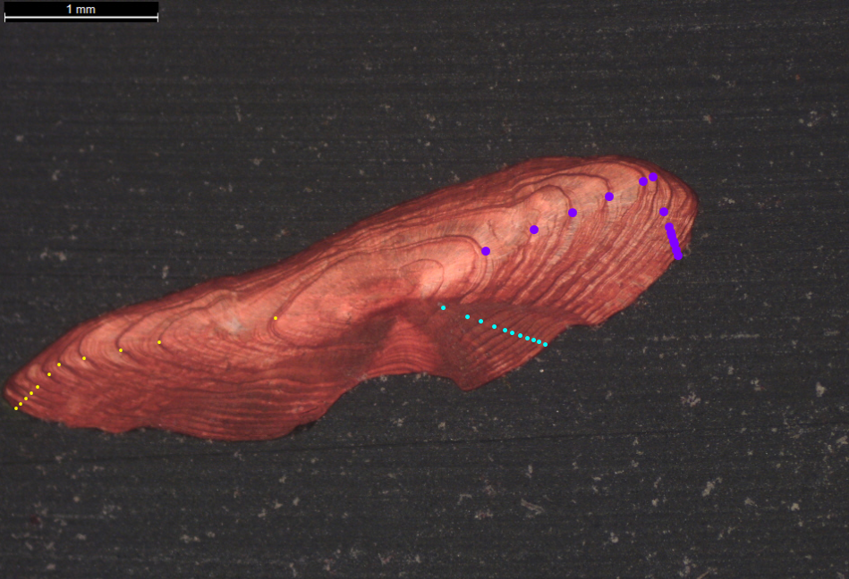
Fig. 5.4: PRVN05_SOL_L_M_7A_2021060210135: Fish Length 461 mm – Catch date 02-06-2021 – Modal Age 11. Example of overestimation (14 years) due to counting of false rings. PA 50 %
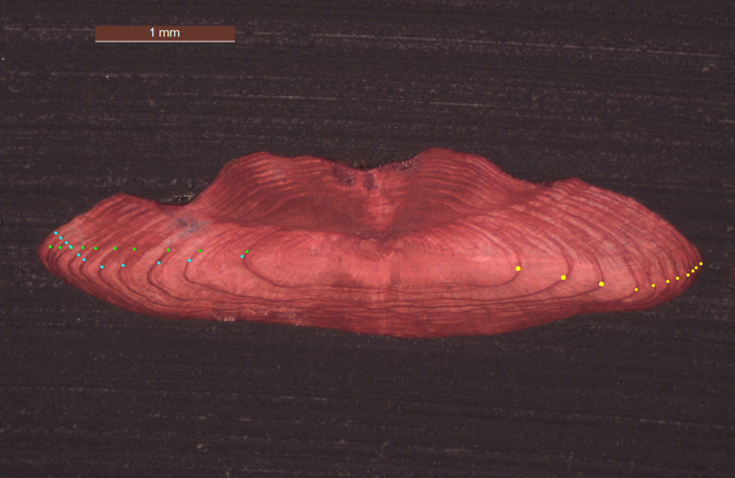
Fig. 5.5: SAS_SELF_SOL_L_ 7A_2022090310035: Fish Length 419 mm – Catch date 03/09/2022 – Modal Age 11. Example of underestimation of green reader (edge was not counted). PA 83.3 %

Conclusion

Considering the good overall results of the exchange, there doesn’t seem to be a major problem with the age readings of the sole 7a stock. However, we see some deviation in different readers, where percentage agreement is lower and bias is higher than for the other readers. Especially in age 7 and 8, an overestimation of age can be seen. This is not what we expected: an underestimation of age was expected as a higher mean weight at age was observed. In the older ages, there was some underestimation, but not so much. Therefore, in order to try to improve the agreement on an international level, a follow-up online meeting will be held in spring 2024. Afterwards, a similar exercise as this exchange can be organised in the coming year to see if results have improved.

References
Beamish R. J. and Fournier D. A. (1981) A method for comparing the precision of a set of age determination. Canadian Journal of Fisheries and Aquatic Sciences, 38, 982–983
GUIDELINES AND TOOLS FOR AGE READING. Eltink, A.T.G.W., Newton A.W., Morgado C., Santamaria M.T.G and Modin J. (2000) Guidelines and tools for age Reading. (PDF document version 1.0 October 2000) Internet: http://www.efan.no
Eltink, A.T.G.W. (2000) Age reading comparisons. (MS Excel workbook version 1.0 October 2000) Internet: http://www.efan.no
ICES (2014) Report of the Workshop on Statistical Analysis of Biological Calibration Studies (WKSABCAL). ICES CM 2014/ACOM: 35

Annex. Additional results

Results all readers
Summary statistics
Table 7.1.1: Summary of statistics; PA (%), CV (%) and APE (%).
NSample | CV | PA | APE
160 | 10 % | 85 % | 5 %
Data Overview
Table 7.1.2: Data overview including modal age and statistics per sample.
Fish ID | length | Catch date | ICES area | R02 BE | R04 GB | R06 IE | R08 BE | R10 IE | R12 IE | Modal age | PA % | CV % | APE %
BYDR02_SOL_L_M_7A_2021051720450 | 351 | 17/05/2021 00:00:00 | 27.7.a | 5 | 5 | 5 | 5 | 5 | 5 | 5 | 100 | 0 | 0
BYDR02_SOL_L_M_7A_2021051720453 | 432 | 17/05/2021 00:00:00 | 27.7.a | 12 | 12 | 11 | 12 | 11 | 11 | 12 | 50 | 5 | 4
BYDR02_SOL_L_M_7A_2021051720455 | 321 | 17/05/2021 00:00:00 | 27.7.a | 5 | 5 | 5 | 5 | 5 | 5 | 5 | 100 | 0 | 0
BYDR03_SOL_L_M_7A_2021101710191 | 394 | 17/10/2021 00:00:00 | 27.7.a | 6 | 6 | 6 | 6 | 6 | 6 | 6 | 100 | 0 | 0
BYDR03_SOL_L_M_7A_2021101710192 | 412 | 17/10/2021 00:00:00 | 27.7.a | 7 | 7 | 10 | 7 | 10 | 7 | 7 | 67 | 19 | 17
BYDR03_SOL_L_M_7A_2021101710194 | 445 | 17/10/2021 00:00:00 | 27.7.a | 12 | 12 | 12 | 12 | 12 | 12 | 12 | 100 | 0 | 0
BYDR03_SOL_L_M_7A_2021101710196 | 426 | 17/10/2021 00:00:00 | 27.7.a | 6 | 6 | 6 | 6 | 6 | 7 | 6 | 83 | 7 | 5
BYDR03_SOL_L_M_7A_2021101710200 | 419 | 17/10/2021 00:00:00 | 27.7.a | 7 | 7 | 6 | 7 | 6 | 8 | 7 | 50 | 11 | 8
BYDR03_SOL_L_M_7A_2021101710202 | 436 | 17/10/2021 00:00:00 | 27.7.a | 11 | 11 | 10 | 11 | 10 | 10 | 11 | 50 | 5 | 5
BYDR03_SOL_L_M_7A_2022041810185 | 431 | 18/04/2022 00:00:00 | 27.7.a | 8 | 8 | 12 | 8 | 12 | 7 | 8 | 50 | 24 | 21
BYDR03_SOL_L_M_7A_2022041810187 | 415 | 18/04/2022 00:00:00 | 27.7.a | 8 | 8 | 8 | 8 | 8 | 8 | 8 | 100 | 0 | 0
CDDR04_SOL_L_M_7A_2022032710174 | 432 | 27/03/2022 00:00:00 | 27.7.a | 8 | 8 | 8 | 8 | 8 | 9 | 8 | 83 | 5 | 3
CDDR04_SOL_L_M_7A_2022032710175 | 431 | 27/03/2022 00:00:00 | 27.7.a | 8 | 8 | 8 | 8 | 8 | 8 | 8 | 100 | 0 | 0
CDDR04_SOL_L_M_7A_2022032710177 | 401 | 27/03/2022 00:00:00 | 27.7.a | 6 | 6 | 5 | 6 | 6 | 6 | 6 | 83 | 7 | 5
CDDR04_SOL_L_M_7A_2022032710178 | 377 | 27/03/2022 00:00:00 | 27.7.a | 8 | 9 | 8 | 9 | 8 | 9 | 8 | 50 | 6 | 6
CDDR04_SOL_L_M_7A_2022032710179 | 423 | 27/03/2022 00:00:00 | 27.7.a | 9 | 9 | 9 | 9 | 9 | 9 | 9 | 100 | 0 | 0
CDDR04_SOL_L_M_7A_2022032710180 | 379 | 27/03/2022 00:00:00 | 27.7.a | 4 | 4 | 4 | 4 | 4 | 4 | 4 | 100 | 0 | 0
CDDR04_SOL_L_M_7A_2022032710181 | 364 | 27/03/2022 00:00:00 | 27.7.a | 6 | 6 | 6 | 6 | 6 | 6 | 6 | 100 | 0 | 0
CDDR04_SOL_L_M_7A_2022032710186 | 383 | 27/03/2022 00:00:00 | 27.7.a | 7 | 7 | 7 | 7 | 7 | 7 | 7 | 100 | 0 | 0
CDDR04_SOL_L_M_7A_2022032710196 | 384 | 27/03/2022 00:00:00 | 27.7.a | 11 | 11 | 11 | 11 | 10 | 10 | 11 | 67 | 5 | 4
CDDR04_SOL_L_M_7A_2022032710197 | 338 | 27/03/2022 00:00:00 | 27.7.a | 7 | 7 | 7 | 7 | 7 | 7 | 7 | 100 | 0 | 0
CDDR04_SOL_L_M_7A_2022032710198 | 325 | 27/03/2022 00:00:00 | 27.7.a | 5 | 5 | 5 | 5 | 5 | 5 | 5 | 100 | 0 | 0
CDDR04_SOL_L_M_7A_2022032710201 | 330 | 27/03/2022 00:00:00 | 27.7.a | 10 | 10 | 10 | 10 | 10 | 10 | 10 | 100 | 0 | 0
CDDR04_SOL_L_M_7A_2022032710202 | 329 | 27/03/2022 00:00:00 | 27.7.a | 5 | 5 | 5 | 5 | 5 | 5 | 5 | 100 | 0 | 0
CDDR04_SOL_L_M_7A_2022032710204 | 284 | 27/03/2022 00:00:00 | 27.7.a | 4 | 4 | 4 | 4 | 4 | 4 | 4 | 100 | 0 | 0
CDDR04_SOL_L_M_7A_2022032710211 | 312 | 27/03/2022 00:00:00 | 27.7.a | 3 | 3 | 3 | 3 | 3 | 3 | 3 | 100 | 0 | 0
CDDR04_SOL_L_M_7A_2022032710221 | 262 | 27/03/2022 00:00:00 | 27.7.a | 3 | 3 | 4 | 3 | 3 | 4 | 3 | 67 | 15 | 13
CDDR04_SOL_R_M_7A_2022032710131 | 192 | 27/03/2022 00:00:00 | 27.7.a | 2 | 2 | 2 | 2 | 2 | 2 | 2 | 100 | 0 | 0
CDDR04_SOL_R_M_7A_2022032710133 | 195 | 27/03/2022 00:00:00 | 27.7.a | 2 | 2 | 2 | 2 | 2 | 2 | 2 | 100 | 0 | 0
CDDR05_SOL_L_M_7A_2022042830188 | 331 | 28/04/2022 00:00:00 | 27.7.a | 7 | 7 | 8 | 7 | 7 | 7 | 7 | 83 | 6 | 4
CDDR05_SOL_L_M_7A_2022042830191 | 308 | 28/04/2022 00:00:00 | 27.7.a | 4 | 4 | 4 | 4 | 4 | 4 | 4 | 100 | 0 | 0
CDDR05_SOL_L_M_7A_2022042830192 | 393 | 28/04/2022 00:00:00 | 27.7.a | 6 | 6 | 6 | 6 | 6 | 6 | 6 | 100 | 0 | 0
CDDR05_SOL_L_M_7A_2022042830194 | 381 | 28/04/2022 00:00:00 | 27.7.a | 7 | 7 | 8 | 7 | 8 | 8 | 7 | 50 | 7 | 7
CDDR05_SOL_L_M_7A_2022042830195 | 401 | 28/04/2022 00:00:00 | 27.7.a | 10 | 10 | 10 | 10 | 10 | 10 | 10 | 100 | 0 | 0
CDDR05_SOL_L_M_7A_2022042830196 | 302 | 28/04/2022 00:00:00 | 27.7.a | 4 | 4 | 4 | 4 | 4 | 4 | 4 | 100 | 0 | 0
CDDR05_SOL_L_M_7A_2022042830197 | 405 | 28/04/2022 00:00:00 | 27.7.a | 11 | 11 | 11 | 11 | 11 | 11 | 11 | 100 | 0 | 0
CDDR05_SOL_L_M_7A_2022042830199 | 372 | 28/04/2022 00:00:00 | 27.7.a | 6 | 6 | 6 | 6 | 6 | 7 | 6 | 83 | 7 | 5
CNVE02_SOL_7A_R_M_2021092710114 | 204 | 27/09/2021 00:00:00 | 27.7.a | 1 | 1 | 2 | 1 | 2 | 1 | 1 | 67 | 39 | 33
CNVE02_SOL_L_M_7A_2021092710149 | 372 | 27/09/2021 00:00:00 | 27.7.a | 6 | 6 | 7 | 6 | 7 | 6 | 6 | 67 | 8 | 7
CNVE02_SOL_L_M_7A_2021092710156 | 318 | 27/09/2021 00:00:00 | 27.7.a | 3 | 3 | 4 | 3 | 4 | 4 | 3 | 50 | 16 | 14
CNVE02_SOL_L_M_7A_2021092710157 | 338 | 27/09/2021 00:00:00 | 27.7.a | 3 | 3 | 3 | 3 | 4 | 3 | 3 | 83 | 13 | 9
CNVE02_SOL_L_M_7A_2021092710190 | 428 | 27/09/2021 00:00:00 | 27.7.a | 11 | 11 | 11 | 11 | 12 | 10 | 11 | 67 | 6 | 3
CNVE02_SOL_L_M_7A_2021092710199 | 387 | 27/09/2021 00:00:00 | 27.7.a | 6 | 6 | 6 | 7 | 7 | 6 | 6 | 67 | 8 | 7
CNVE02_SOL_L_M_7A_2021092710204 | 481 | 27/09/2021 00:00:00 | 27.7.a | 10 | 9 | 9 | 9 | 9 | 8 | 9 | 67 | 7 | 4
CNVE02_SOL_L_M_7A_2021092710209 | 473 | 27/09/2021 00:00:00 | 27.7.a | 11 | 11 | 11 | 11 | 12 | 11 | 11 | 83 | 4 | 2
CNVE02_SOL_L_M_7A_2021092710211 | 436 | 27/09/2021 00:00:00 | 27.7.a | 11 | 11 | 10 | 11 | 11 | 10 | 11 | 67 | 5 | 4
NKSZ05_SOL_L_7A_2022081010142 | 375 | 10/08/2022 00:00:00 | 27.7.a | 8 | 8 | 8 | 8 | 8 | 8 | 8 | 100 | 0 | 0
NKSZ05_SOL_L_7A_2022081010143 | 347 | 10/08/2022 00:00:00 | 27.7.a | 8 | 8 | 8 | 8 | 8 | 7 | 8 | 83 | 5 | 4
NKSZ05_SOL_L_7A_2022081010144 | 365 | 10/08/2022 00:00:00 | 27.7.a | 10 | 10 | 10 | 11 | 11 | 10 | 10 | 67 | 5 | 4
NKSZ05_SOL_L_7A_2022081010146 | 380 | 10/08/2022 00:00:00 | 27.7.a | 12 | 12 | 12 | 12 | 13 | 12 | 12 | 83 | 3 | 2
NKSZ05_SOL_L_7A_2022081010151 | 321 | 10/08/2022 00:00:00 | 27.7.a | 4 | 4 | 4 | 4 | 5 | 5 | 4 | 67 | 12 | 10
NKSZ05_SOL_L_7A_2022081010158 | 315 | 10/08/2022 00:00:00 | 27.7.a | 4 | 4 | 4 | 4 | 5 | 4 | 4 | 83 | 10 | 7
NKSZ05_SOL_L_7A_2022081010161 | 334 | 10/08/2022 00:00:00 | 27.7.a | 12 | 12 | 11 | 11 | 11 | 7 | 11 | 50 | 17 | 11
NKSZ05_SOL_R_M_7A_2022081010100 | 209 | 10/08/2022 00:00:00 | 27.7.a | 2 | 2 | 2 | 2 | 2 | 2 | 2 | 100 | 0 | 0
NKSZ05_SOL_R_M_7A_2022081010101 | 223 | 10/08/2022 00:00:00 | 27.7.a | 2 | 2 | 2 | 2 | 2 | 2 | 2 | 100 | 0 | 0
NKSZ09_SOL_L_M_7A_2022112210156 | 425 | 22/11/2022 00:00:00 | 27.7.a | 7 | 7 | 7 | 7 | 7 | 7 | 7 | 100 | 0 | 0
NKSZ09_SOL_L_M_7A_2022112210157 | 389 | 22/11/2022 00:00:00 | 27.7.a | 10 | 10 | 9 | 10 | 9 | 8 | 10 | 50 | 9 | 7
NKSZ09_SOL_L_M_7A_2022112210163 | 364 | 22/11/2022 00:00:00 | 27.7.a | 5 | 5 | 5 | 5 | 5 | 6 | 5 | 83 | 8 | 5
NKSZ09_SOL_L_M_7A_2022112210164 | 375 | 22/11/2022 00:00:00 | 27.7.a | 7 | 7 | 7 | 7 | 7 | 7 | 7 | 100 | 0 | 0
NKSZ09_SOL_L_M_7A_2022112210167 | 369 | 22/11/2022 00:00:00 | 27.7.a | 4 | 4 | 5 | 4 | 4 | 5 | 4 | 67 | 12 | 10
NKSZ09_SOL_L_M_7A_2022112210169 | 352 | 22/11/2022 00:00:00 | 27.7.a | 4 | 4 | 4 | 4 | 4 | 5 | 4 | 83 | 10 | 7
NKSZ09_SOL_L_M_7A_2022112210171 | 318 | 22/11/2022 00:00:00 | 27.7.a | 5 | 5 | 5 | 5 | 5 | 6 | 5 | 83 | 8 | 5
NKSZ09_SOL_L_M_7A_2022112210173 | 319 | 22/11/2022 00:00:00 | 27.7.a | 3 | 3 | 4 | 3 | 4 | 4 | 3 | 50 | 16 | 14
NKSZ09_SOL_L_M_7A_2022112210176 | 319 | 22/11/2022 00:00:00 | 27.7.a | 3 | 3 | 3 | 3 | 3 | 4 | 3 | 83 | 13 | 9
NKSZ09_SOL_L_M_7A_2022112210195 | 276 | 22/11/2022 00:00:00 | 27.7.a | 2 | 2 | 2 | 2 | 2 | 2 | 2 | 100 | 0 | 0
NKSZ09_SOL_L_M_7A_2022112210196 | 251 | 22/11/2022 00:00:00 | 27.7.a | 2 | 2 | 2 | 2 | 2 | 2 | 2 | 100 | 0 | 0
NKSZ09_SOL_L_M_7A_2022112210198 | 256 | 22/11/2022 00:00:00 | 27.7.a | 9 | 8 | 8 | 8 | 8 | 8 | 8 | 83 | 5 | 3
NKSZ09_SOL_L_M_7A_2022112210204 | 258 | 22/11/2022 00:00:00 | 27.7.a | 8 | 8 | 8 | 8 | 8 | 8 | 8 | 100 | 0 | 0
NKSZ09_SOL_R_M_7A_2022112210125 | 185 | 22/11/2022 00:00:00 | 27.7.a | 1 | 1 | 1 | 1 | 1 | 1 | 1 | 100 | 0 | 0
NKSZ09_SOL_R_M_7A_2022112210126 | 202 | 22/11/2022 00:00:00 | 27.7.a | 1 | 1 | 1 | 1 | 1 | 1 | 1 | 100 | 0 | 0
NKSZ09_SOL_R_M_7A_2022112210127 | 211 | 22/11/2022 00:00:00 | 27.7.a | 1 | 1 | 1 | 1 | 1 | 1 | 1 | 100 | 0 | 0
NKSZ09_SOL_R_M_7A_2022112210133 | 197 | 22/11/2022 00:00:00 | 27.7.a | 1 | 1 | 0 | 1 | 0 | 0 | 1 | 50 | - | -
NKSZ09_SOL_R_M_7A_2022112210134 | 180 | 22/11/2022 00:00:00 | 27.7.a | 1 | 1 | 1 | 1 | 1 | 1 | 1 | 100 | 0 | 0
PRVN05_SOL_7A_R_M_2021060210101 | 197 | 02/06/2021 00:00:00 | 27.7.a | 2 | 2 | 2 | 2 | 2 | 2 | 2 | 100 | 0 | 0
PRVN05_SOL_7A_R_M_2021060210102 | 197 | 02/06/2021 00:00:00 | 27.7.a | 2 | 2 | 3 | 2 | 2 | 2 | 2 | 83 | 19 | 13
PRVN05_SOL_L_M_7A_2021060210135 | 461 | 02/06/2021 00:00:00 | 27.7.a | 11 | 10 | 14 | 11 | 11 | 10 | 11 | 50 | 13 | 8
PRVN05_SOL_L_M_7A_2021060210141 | 433 | 02/06/2021 00:00:00 | 27.7.a | 10 | 10 | 9 | 10 | 10 | 10 | 10 | 83 | 4 | 3
PRVN05_SOL_L_M_7A_2021060210142 | 496 | 02/06/2021 00:00:00 | 27.7.a | 11 | 10 | 10 | 11 | 10 | 11 | 10 | 50 | 5 | 5
PRVN05_SOL_L_M_7A_2021060210148 | 421 | 02/06/2021 00:00:00 | 27.7.a | 9 | 9 | 9 | 9 | 9 | 9 | 9 | 100 | 0 | 0
PRVN05_SOL_L_M_7A_2021060210154 | 402 | 02/06/2021 00:00:00 | 27.7.a | 9 | 9 | 9 | 9 | 9 | 9 | 9 | 100 | 0 | 0
PRVN05_SOL_L_M_7A_2021060210157 | 404 | 02/06/2021 00:00:00 | 27.7.a | 11 | 10 | 12 | 11 | 11 | 10 | 11 | 50 | 7 | 5
SAS_SELF_20210419_SOL_7A_L_M_2021041910118 | 258 | 19/04/2021 00:00:00 | 27.7.a | 3 | 3 | 3 | 3 | 3 | 3 | 3 | 100 | 0 | 0
SAS_SELF_20210419_SOL_7A_L_M_2021041910123 | 239 | 19/04/2021 00:00:00 | 27.7.a | 3 | 3 | 3 | 3 | 3 | 3 | 3 | 100 | 0 | 0
SAS_SELF_SOL_L_7A_2022090310035 | 419 | 03/09/2022 00:00:00 | 27.7.a | 11 | 11 | 11 | 11 | 11 | 10 | 11 | 83 | 4 | 3
SAS_SELF_SOL_L_7A_2022090310036 | 421 | 03/09/2022 00:00:00 | 27.7.a | 12 | 12 | 12 | 12 | 12 | 12 | 12 | 100 | 0 | 0
SAS_SELF_SOL_L_7A_2022090310049 | 482 | 03/09/2022 00:00:00 | 27.7.a | 10 | 10 | 10 | 10 | 10 | 10 | 10 | 100 | 0 | 0
SAS_SELF_SOL_L_7A_2022090310053 | 418 | 03/09/2022 00:00:00 | 27.7.a | 11 | 11 | 11 | 11 | 11 | 11 | 11 | 100 | 0 | 0
SAS_SELF_SOL_L_7A_2022090310054 | 403 | 03/09/2022 00:00:00 | 27.7.a | 12 | 13 | 12 | 13 | 12 | 10 | 12 | 50 | 9 | 6
SELF SAMP_SOL_R_M_7A_2022090310026 | 207 | 03/09/2022 00:00:00 | 27.7.a | 1 | 2 | 1 | 1 | 1 | 1 | 1 | 83 | 35 | 24
SELF SAMP_SOL_R_M_7A_2022090310029 | 207 | 03/09/2022 00:00:00 | 27.7.a | 1 | 1 | 1 | 1 | 1 | 1 | 1 | 100 | 0 | 0
SELF_210709_SOL_7A_L_M_2021070910030 | 264 | 09/07/2021 00:00:00 | 27.7.a | 5 | 5 | 5 | 5 | 5 | 5 | 5 | 100 | 0 | 0
SELF_210709_SOL_7A_L_M_2021070910031 | 365 | 09/07/2021 00:00:00 | 27.7.a | 9 | 9 | 9 | 9 | 9 | 9 | 9 | 100 | 0 | 0
SELF_210709_SOL_7A_L_M_2021070910033 | 421 | 09/07/2021 00:00:00 | 27.7.a | 5 | 5 | 5 | 5 | 5 | 5 | 5 | 100 | 0 | 0
SELF_210709_SOL_7A_L_M_2021070910040 | 401 | 09/07/2021 00:00:00 | 27.7.a | 9 | 9 | 10 | 10 | 10 | 9 | 9 | 50 | 6 | 5
SELF_210709_SOL_7A_L_M_2021070910041 | 408 | 09/07/2021 00:00:00 | 27.7.a | 6 | 5 | 5 | 7 | 5 | 6 | 5 | 50 | 14 | 12
SOL_7A_Q1_22_54379_020 | 310 | 09/02/2022 00:00:00 | 27.7.a | 4 | 4 | 4 | 4 | 5 | 4 | 4 | 83 | 10 | 7
SOL_7A_Q1_22_54379_021 | 330 | 09/02/2022 00:00:00 | 27.7.a | 4 | 4 | 4 | 4 | 4 | 4 | 4 | 100 | 0 | 0
SOL_7A_Q1_22_54379_022 | 320 | 09/02/2022 00:00:00 | 27.7.a | 4 | 4 | 5 | 4 | 4 | 4 | 4 | 83 | 10 | 7
SOL_7A_Q1_22_54379_023 | 280 | 09/02/2022 00:00:00 | 27.7.a | 5 | 5 | 5 | 5 | 5 | 5 | 5 | 100 | 0 | 0
SOL_7A_Q1_22_54379_024 | 340 | 09/02/2022 00:00:00 | 27.7.a | 5 | 5 | 5 | 5 | 5 | 5 | 5 | 100 | 0 | 0
SOL_7A_Q1_22_54379_025 | 280 | 09/02/2022 00:00:00 | 27.7.a | 4 | 4 | 5 | 4 | 4 | 4 | 4 | 83 | 10 | 7
SOL_7A_Q1_22_54379_026 | 280 | 09/02/2022 00:00:00 | 27.7.a | 4 | 4 | 5 | 4 | 5 | 5 | 4 | 50 | 12 | 11
SOL_7A_Q1_22_54379_027 | 310 | 09/02/2022 00:00:00 | 27.7.a | 4 | 4 | 5 | 4 | 5 | 5 | 4 | 50 | 12 | 11
SOL_7A_Q1_22_54379_028 | 390 | 09/02/2022 00:00:00 | 27.7.a | 8 | 7 | 8 | 8 | 7 | 8 | 8 | 67 | 7 | 6
SOL_7A_Q1_22_54379_029 | 240 | 09/02/2022 00:00:00 | 27.7.a | 3 | 3 | 4 | 3 | 3 | 3 | 3 | 83 | 13 | 9
SOL_7A_Q1_22_54379_030 | 250 | 09/02/2022 00:00:00 | 27.7.a | 3 | 3 | 3 | 3 | 3 | 3 | 3 | 100 | 0 | 0
SOL_7A_Q1_22_54379_031 | 400 | 09/02/2022 00:00:00 | 27.7.a | 9 | 8 | 10 | 8 | 8 | 8 | 8 | 67 | 10 | 8
SOL_7A_Q1_22_54379_032 | 380 | 09/02/2022 00:00:00 | 27.7.a | 6 | 6 | 7 | 5 | 7 | 7 | 7 | 50 | 13 | 11
SOL_7A_Q1_22_54561_006 | 310 | 07/03/2022 00:00:00 | 27.7.a | 4 | 4 | 5 | 4 | 4 | 4 | 4 | 83 | 10 | 7
SOL_7A_Q1_22_54561_007 | 280 | 07/03/2022 00:00:00 | 27.7.a | 4 | 4 | 5 | 6 | 4 | 4 | 4 | 67 | 19 | 15
SOL_7A_Q1_22_54561_009 | 260 | 07/03/2022 00:00:00 | 27.7.a | 3 | 3 | 4 | 3 | 3 | 3 | 3 | 83 | 13 | 9
SOL_7A_Q1_22_54561_010 | 260 | 07/03/2022 00:00:00 | 27.7.a | 3 | 3 | 4 | 3 | 4 | 3 | 3 | 67 | 15 | 13
SOL_7A_Q1_22_54561_011 | 270 | 07/03/2022 00:00:00 | 27.7.a | 3 | 3 | 3 | 3 | 3 | 3 | 3 | 100 | 0 | 0
SOL_7A_Q1_22_54561_012 | 270 | 07/03/2022 00:00:00 | 27.7.a | 4 | 4 | 4 | 4 | 4 | 4 | 4 | 100 | 0 | 0
SOL_7A_Q1_22_54561_013 | 290 | 07/03/2022 00:00:00 | 27.7.a | 4 | 4 | 5 | 4 | 4 | 4 | 4 | 83 | 10 | 7
SOL_7A_Q1_22_54561_014 | 400 | 07/03/2022 00:00:00 | 27.7.a | 6 | 6 | 6 | 6 | 6 | 6 | 6 | 100 | 0 | 0
SOL_7A_Q1_22_54561_015 | 370 | 07/03/2022 00:00:00 | 27.7.a | 6 | 6 | 6 | 6 | 6 | 6 | 6 | 100 | 0 | 0
SOL_7A_Q1_22_54561_016 | 300 | 07/03/2022 00:00:00 | 27.7.a | 6 | 5 | 7 | 6 | 6 | 6 | 6 | 67 | 11 | 6
SOL_7A_Q1_22_54561_017 | 290 | 07/03/2022 00:00:00 | 27.7.a | 4 | 4 | 4 | 4 | 4 | 4 | 4 | 100 | 0 | 0
SOL_7A_Q1_22_54561_018 | 310 | 07/03/2022 00:00:00 | 27.7.a | 4 | 4 | 4 | 4 | 4 | 4 | 4 | 100 | 0 | 0
SOL_7A_Q1_22_54561_019 | 350 | 07/03/2022 00:00:00 | 27.7.a | 5 | 5 | 5 | 5 | 5 | 5 | 5 | 100 | 0 | 0
SOL_7A_Q1_22_54561_020 | 290 | 07/03/2022 00:00:00 | 27.7.a | 4 | 4 | 4 | 4 | 4 | 4 | 4 | 100 | 0 | 0
SOL_7A_Q1_22_54561_021 | 270 | 07/03/2022 00:00:00 | 27.7.a | 4 | 4 | 4 | 4 | 4 | 4 | 4 | 100 | 0 | 0
SOL_7A_Q1_23_57776_014 | 370 | 14/02/2023 00:00:00 | 27.7.a | 9 | 9 | 9 | 9 | 9 | 9 | 9 | 100 | 0 | 0
SOL_7A_Q1_23_57776_015 | 260 | 14/02/2023 00:00:00 | 27.7.a | 3 | 3 | 3 | 3 | 3 | 3 | 3 | 100 | 0 | 0
SOL_7A_Q1_23_57776_016 | 360 | 14/02/2023 00:00:00 | 27.7.a | 5 | 5 | 5 | 5 | 5 | 5 | 5 | 100 | 0 | 0
SOL_7A_Q1_23_57776_017 | 350 | 14/02/2023 00:00:00 | 27.7.a | 5 | 5 | 6 | 5 | 5 | 6 | 5 | 67 | 10 | 8
SOL_7A_Q1_23_57776_018 | 300 | 14/02/2023 00:00:00 | 27.7.a | 5 | 5 | 5 | 5 | 5 | 5 | 5 | 100 | 0 | 0
SOL_7A_Q1_23_58173_002 | 320 | 04/04/2023 00:00:00 | 27.7.a | 5 | 5 | 5 | 5 | 5 | 5 | 5 | 100 | 0 | 0
SOL_7A_Q1_23_58173_003 | 360 | 04/04/2023 00:00:00 | 27.7.a | 6 | 6 | 6 | 6 | 6 | 6 | 6 | 100 | 0 | 0
SOL_7A_Q1_23_58173_004 | 430 | 04/04/2023 00:00:00 | 27.7.a | 11 | 11 | 11 | 11 | 11 | 11 | 11 | 100 | 0 | 0
SOL_7A_Q1_23_58173_005 | 420 | 04/04/2023 00:00:00 | 27.7.a | 11 | 11 | 11 | 11 | 11 | 11 | 11 | 100 | 0 | 0
SOL_7A_Q1_23_58173_006 | 400 | 04/04/2023 00:00:00 | 27.7.a | 7 | 7 | 7 | 7 | 7 | 7 | 7 | 100 | 0 | 0
SOL_7a_Q2_21_52497_012 | 300 | 27/04/2021 00:00:00 | 27.7.a | 3 | 3 | 3 | 3 | 3 | 3 | 3 | 100 | 0 | 0
SOL_7a_Q2_21_52497_013 | 350 | 27/04/2021 00:00:00 | 27.7.a | 4 | 4 | 5 | 4 | 5 | 4 | 4 | 67 | 12 | 10
SOL_7a_Q2_21_52497_014 | 360 | 27/04/2021 00:00:00 | 27.7.a | 6 | 6 | 6 | 6 | 6 | 6 | 6 | 100 | 0 | 0
SOL_7a_Q2_21_52497_015 | 290 | 27/04/2021 00:00:00 | 27.7.a | 4 | 4 | 4 | 4 | 4 | 4 | 4 | 100 | 0 | 0
SOL_7a_Q2_21_52497_016 | 360 | 27/04/2021 00:00:00 | 27.7.a | 5 | 5 | 6 | 5 | 6 | 5 | 5 | 67 | 10 | 8
SOL_7a_Q2_21_52520_020 | 310 | 12/05/2021 00:00:00 | 27.7.a | 4 | 4 | 4 | 4 | 4 | 4 | 4 | 100 | 0 | 0
SOL_7a_Q2_21_52520_021 | 300 | 12/05/2021 00:00:00 | 27.7.a | 3 | 3 | 3 | 3 | 3 | 3 | 3 | 100 | 0 | 0
SOL_7a_Q2_21_52520_022 | 280 | 12/05/2021 00:00:00 | 27.7.a | 3 | 3 | 3 | 3 | 3 | 3 | 3 | 100 | 0 | 0
SOL_7a_Q2_21_52520_023 | 340 | 12/05/2021 00:00:00 | 27.7.a | 5 | 5 | 5 | 5 | 5 | 5 | 5 | 100 | 0 | 0
SOL_7a_Q2_21_52520_024 | 370 | 12/05/2021 00:00:00 | 27.7.a | 5 | 5 | 5 | 5 | 5 | 5 | 5 | 100 | 0 | 0
SOL_7a_Q2_21_52520_025 | 270 | 12/05/2021 00:00:00 | 27.7.a | 5 | 4 | 5 | 5 | 5 | 5 | 5 | 83 | 8 | 6
SOL_7a_Q2_21_52520_026 | 250 | 12/05/2021 00:00:00 | 27.7.a | 3 | 3 | 3 | 3 | 3 | 3 | 3 | 100 | 0 | 0
SOL_7a_Q2_21_52630_015 | 360 | 19/05/2021 00:00:00 | 27.7.a | 5 | 5 | 5 | 5 | 5 | 5 | 5 | 100 | 0 | 0
SOL_7a_Q2_21_52630_016 | 310 | 19/05/2021 00:00:00 | 27.7.a | 5 | 5 | 5 | 5 | 5 | 5 | 5 | 100 | 0 | 0
SOL_7a_Q2_21_52630_017 | 330 | 19/05/2021 00:00:00 | 27.7.a | 5 | 5 | 5 | 5 | 5 | 5 | 5 | 100 | 0 | 0
SOL_7a_Q2_21_52630_018 | 360 | 19/05/2021 00:00:00 | 27.7.a | 6 | 6 | 6 | 6 | 6 | 6 | 6 | 100 | 0 | 0
SOL_7a_Q2_21_52630_019 | 330 | 19/05/2021 00:00:00 | 27.7.a | 4 | 4 | 4 | 4 | 4 | 4 | 4 | 100 | 0 | 0
SOL_7a_Q2_21_52630_020 | 320 | 19/05/2021 00:00:00 | 27.7.a | 5 | 5 | 6 | 5 | 6 | 6 | 5 | 50 | 10 | 9
SOL_7a_Q2_21_52630_021 | 380 | 19/05/2021 00:00:00 | 27.7.a | 7 | 7 | 7 | 7 | 7 | 7 | 7 | 100 | 0 | 0
SOL_7a_Q2_21_52791_001 | 360 | 30/05/2021 00:00:00 | 27.7.a | 7 | 7 | 7 | 7 | 7 | 7 | 7 | 100 | 0 | 0
SOL_7a_Q2_21_52791_002 | 370 | 30/05/2021 00:00:00 | 27.7.a | 5 | 5 | 5 | 5 | 5 | 5 | 5 | 100 | 0 | 0
SOL_7a_Q2_21_52791_003 | 330 | 30/05/2021 00:00:00 | 27.7.a | 5 | 5 | 5 | 5 | 5 | 5 | 5 | 100 | 0 | 0
SOL_7a_Q2_21_52791_004 | 310 | 30/05/2021 00:00:00 | 27.7.a | 5 | 5 | 7 | 5 | 5 | 6 | 5 | 67 | 15 | 12
SOL_7a_Q2_21_52791_005 | 310 | 30/05/2021 00:00:00 | 27.7.a | 5 | 4 | 5 | 5 | 5 | 4 | 5 | 67 | 11 | 10
SOL_7a_Q2_21_52791_006 | 440 | 30/05/2021 00:00:00 | 27.7.a | 8 | 6 | 7 | 10 | 14 | - | 8 | 20 | 35 | 27
SOL_7a_Q2_21_52791_007 | 350 | 30/05/2021 00:00:00 | 27.7.a | 6 | 5 | 6 | 6 | 6 | - | 6 | 80 | 8 | 6
SOL_7a_Q2_21_52791_008 | 270 | 30/05/2021 00:00:00 | 27.7.a | 4 | 4 | 5 | 5 | 5 | 3 | 5 | 50 | 19 | 15

Number of age readings by modal age
Table 7.1.3: Number of age readings table gives an overview of number of readings per reader and modal age. The total numbers of readings by modal age and by reader are also presented.
Modal age | R02 BE | R04 GB | R06 IE | R08 BE | R10 IE | R12 IE | total
0 | 0 | 0 | 0 | 0 | 0 | 1 | 1
1 | 8 | 8 | 8 | 8 | 8 | 8 | 48
2 | 8 | 8 | 8 | 8 | 8 | 8 | 48
3 | 18 | 18 | 18 | 18 | 18 | 18 | 108
4 | 26 | 26 | 26 | 26 | 26 | 26 | 156
5 | 29 | 29 | 29 | 29 | 29 | 29 | 174
6 | 15 | 15 | 15 | 15 | 15 | 14 | 89
7 | 12 | 12 | 12 | 12 | 12 | 12 | 72
8 | 12 | 12 | 12 | 12 | 12 | 11 | 71
9 | 7 | 7 | 7 | 7 | 7 | 7 | 42
10 | 7 | 7 | 7 | 7 | 7 | 7 | 42
11 | 13 | 13 | 13 | 13 | 13 | 13 | 78
12 | 5 | 5 | 5 | 5 | 5 | 5 | 30
Total | 160 | 160 | 160 | 160 | 160 | 159 | 959
Number of age readings by age
Table 7.1.4: Age composition by reader gives a summary of number of readings per reader and age. The total numbers of readings by age and by reader are also presented.
Age | R02 BE | R04 GB | R06 IE | R08 BE | R10 IE | R12 IE | total
0 | 0 | 0 | 1 | 0 | 1 | 2 | 4
1 | 8 | 7 | 6 | 8 | 6 | 7 | 42
2 | 8 | 9 | 8 | 8 | 9 | 8 | 50
3 | 18 | 18 | 13 | 18 | 14 | 15 | 96
4 | 27 | 29 | 23 | 25 | 24 | 26 | 154
5 | 27 | 28 | 35 | 29 | 33 | 26 | 178
6 | 17 | 15 | 16 | 15 | 16 | 18 | 97
7 | 11 | 12 | 12 | 13 | 12 | 15 | 75
8 | 10 | 9 | 11 | 10 | 10 | 11 | 61
9 | 8 | 8 | 8 | 7 | 7 | 8 | 46
10 | 7 | 9 | 10 | 7 | 9 | 13 | 55
11 | 13 | 10 | 10 | 15 | 11 | 7 | 66
12 | 6 | 5 | 6 | 4 | 6 | 3 | 30
13 | 0 | 1 | 0 | 1 | 1 | 0 | 3
14 | 0 | 0 | 1 | 0 | 1 | 0 | 2
Total | 160 | 160 | 160 | 160 | 160 | 159 | 959

Separate age bias plots by reader
[[1]] 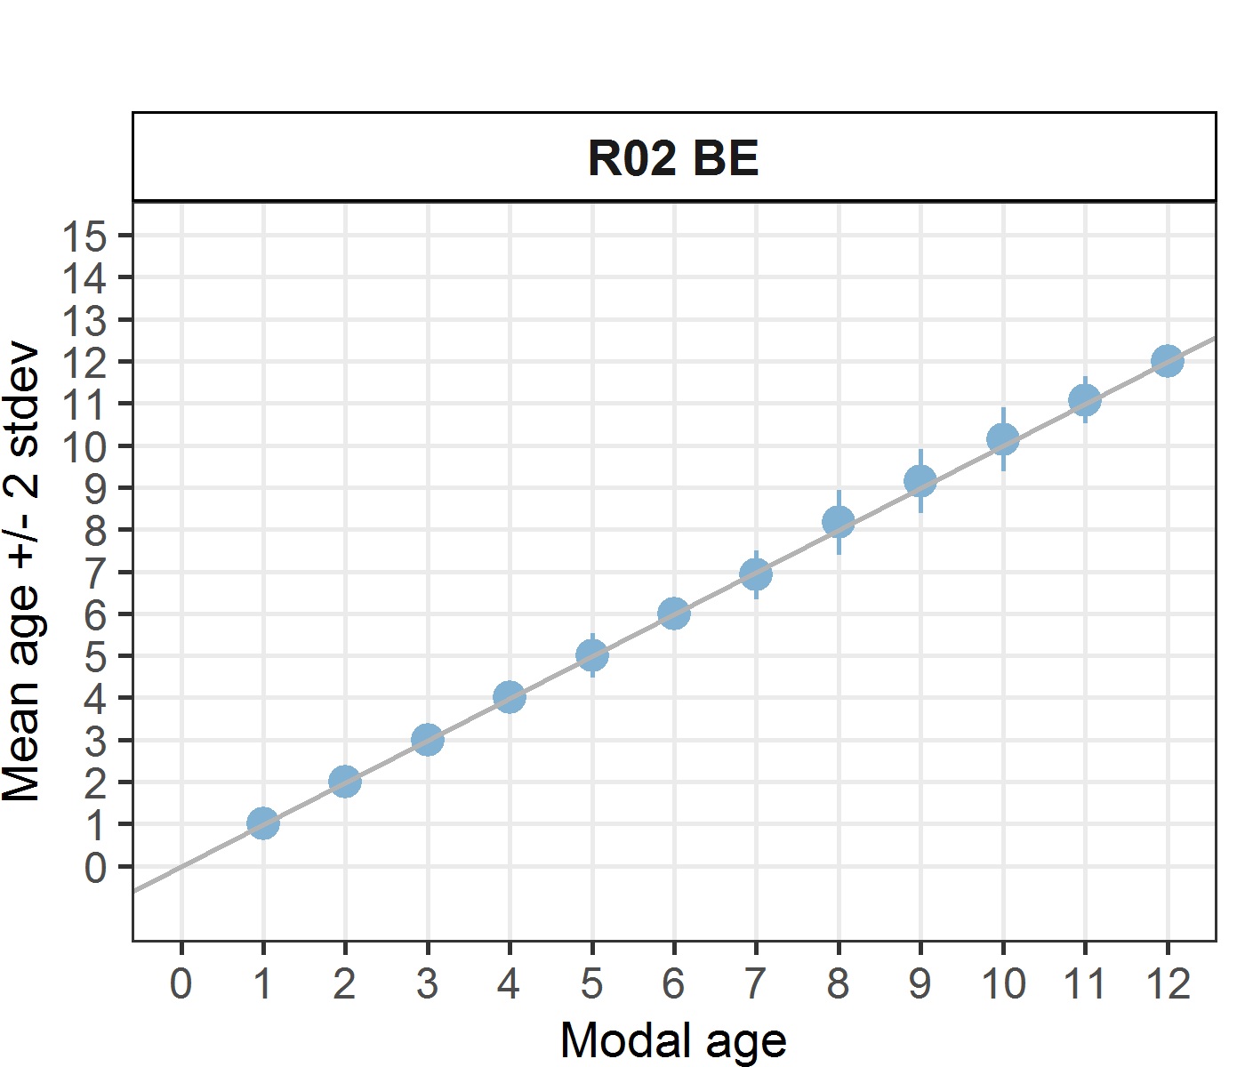 [[2]] 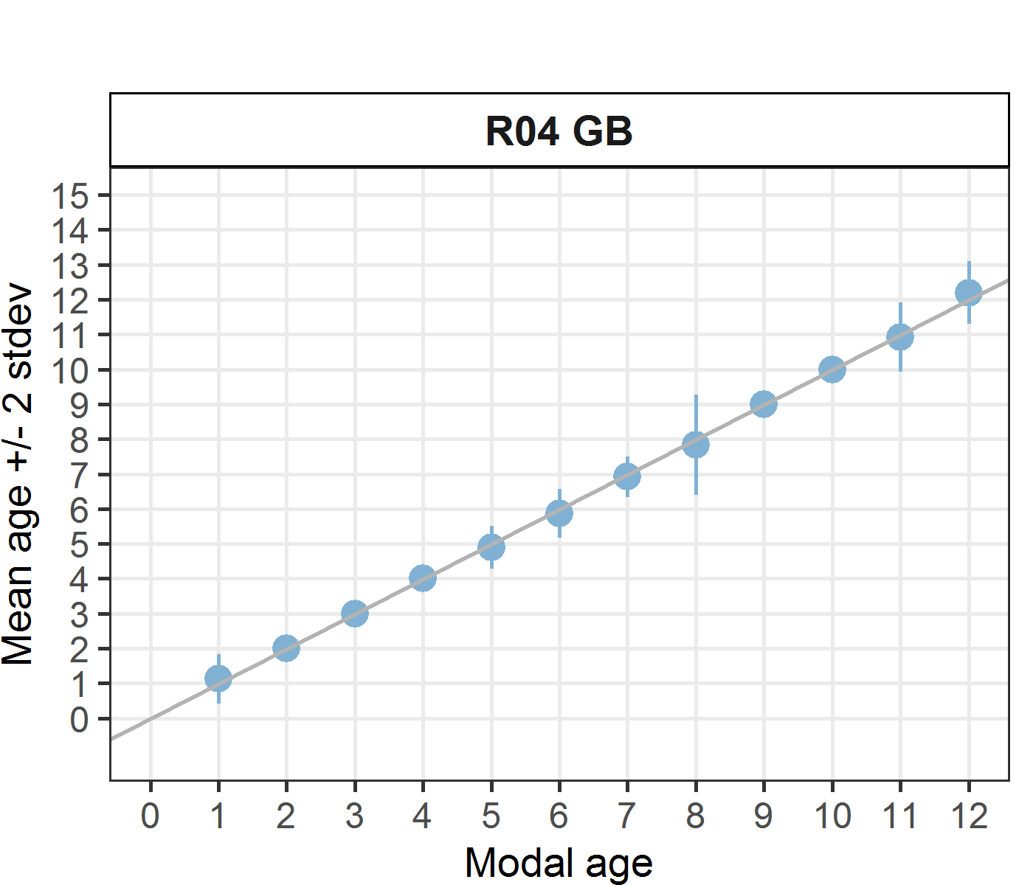 [[3]] 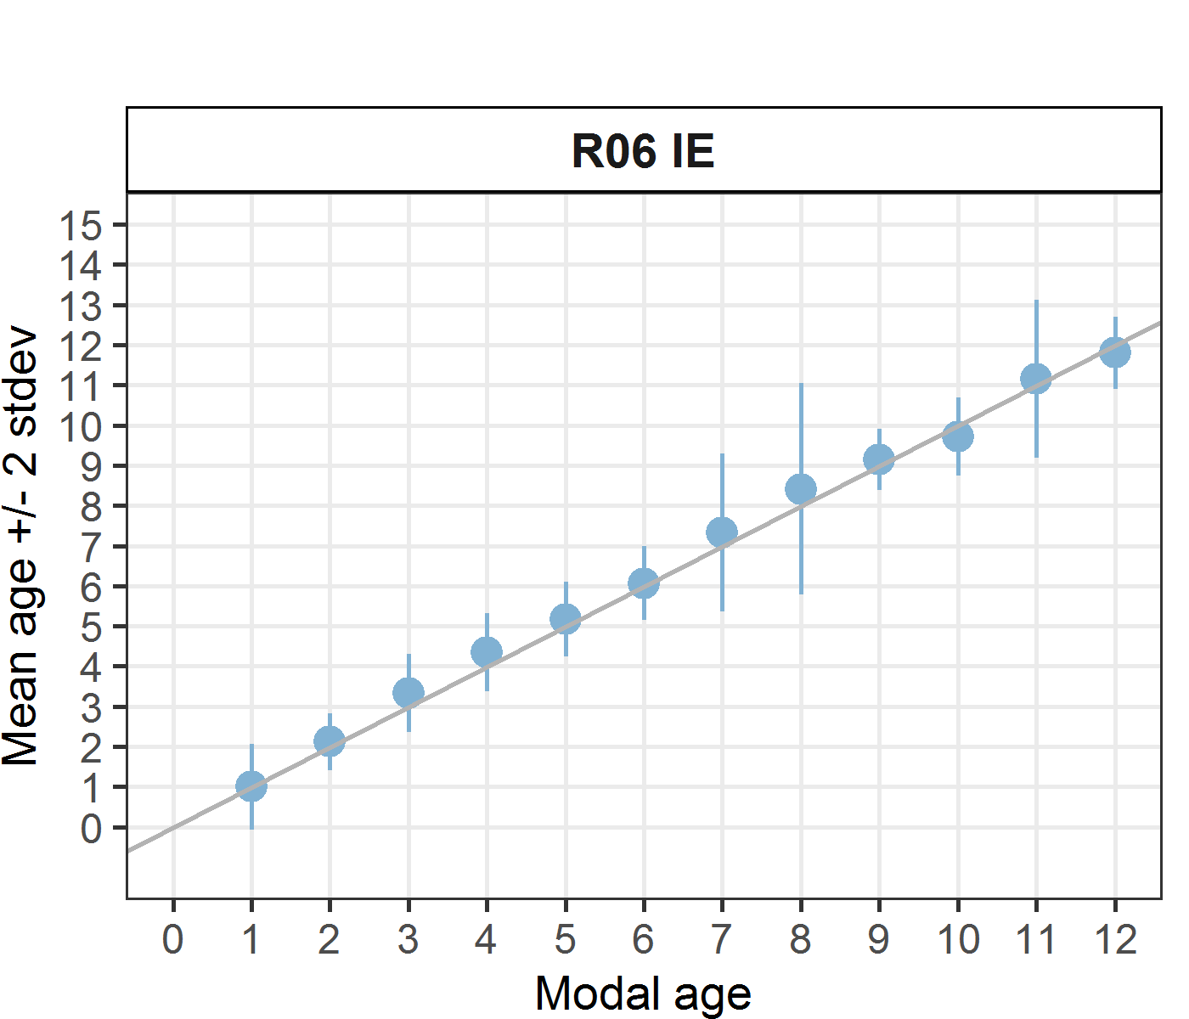 [[4]] 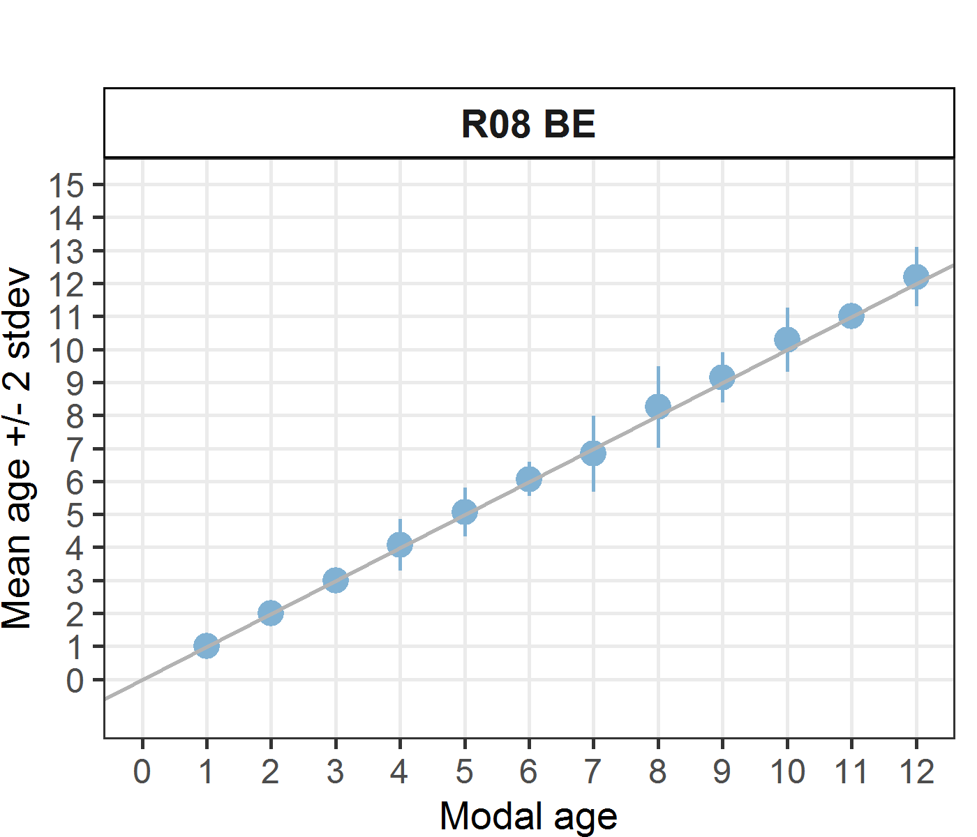 [[5]] 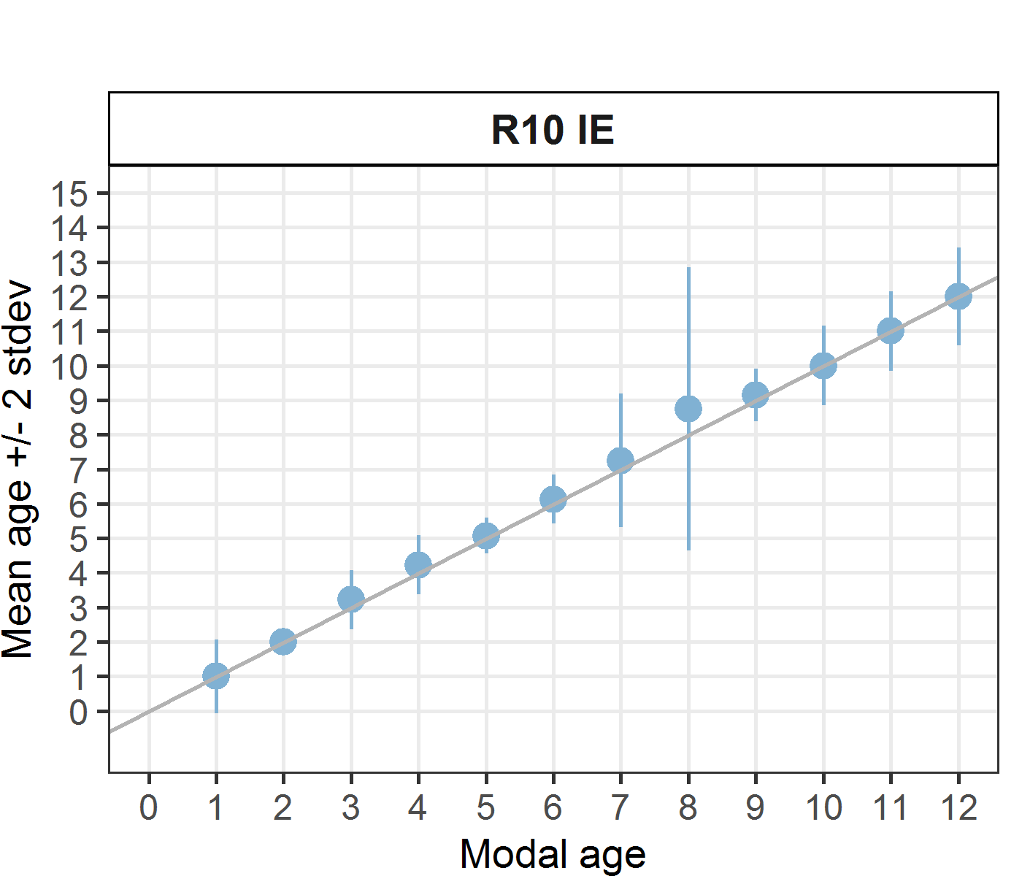 [[6]] 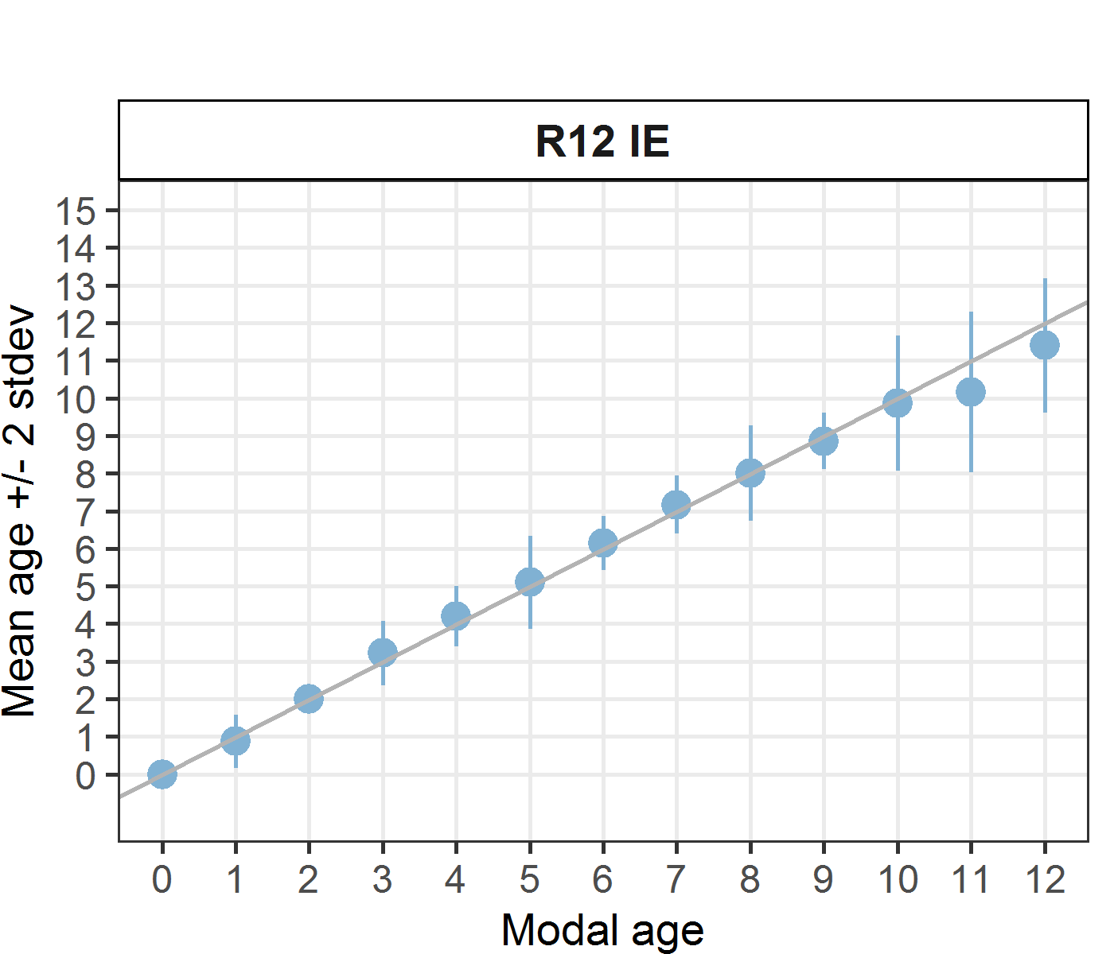

Statistics by modal age plot (STDEV, CV and PA)
Figure 7.1.1: CV, PA and STDEV (standard deviation) are plotted against modal age

Distribution of age reading errors
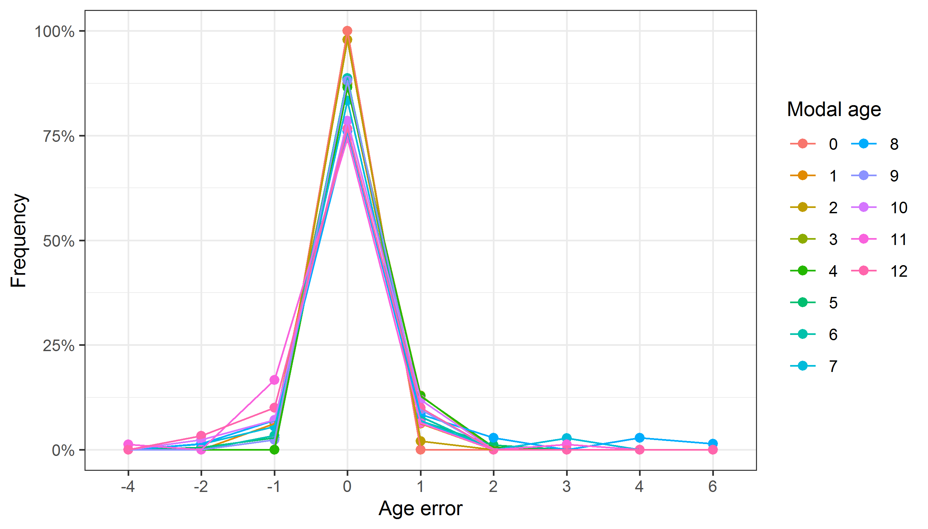
Figure 7.1.2: The distribution of the age reading errors in percentage by modal age as observed from the whole group of age readers in an age reading comparison to modal age. The achieved precision in age reading by MODAL age group is shown by the spread of the age readings errors. There appears to be no relative bias, if the age reading errors are normally distributed. The distributions are skewed, if relative bias occurs.

Relative bias for all readers
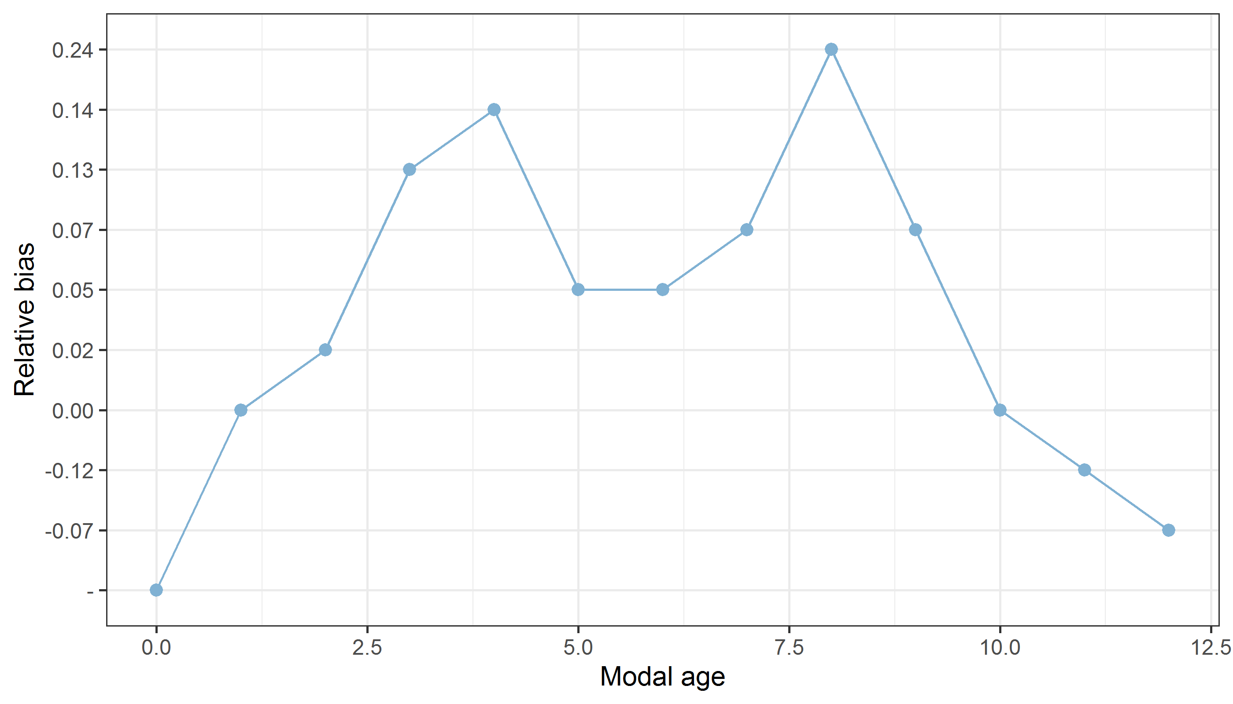
Figure 7.1.3: The relative bias by modal age as estimated by all age readers combined.
Mean length at age by reader
Table 7.1.5: Mean fish length at age per reader is calculated per reader and age (not modal age) and for all readers combined per age. A weighted mean is also given.
Age | R02 BE | R04 GB | R06 IE | R08 BE | R10 IE | R12 IE
0 | - | - | 197 mm | - | 197 mm | 244 mm
1 | 199 mm | 198 mm | 199 mm | 199 mm | 199 mm | 199 mm
2 | 218 mm | 216 mm | 218 mm | 218 mm | 216 mm | 218 mm
3 | 280 mm | 280 mm | 275 mm | 280 mm | 271 mm | 272 mm
4 | 308 mm | 307 mm | 301 mm | 311 mm | 308 mm | 306 mm
5 | 332 mm | 338 mm | 329 mm | 332 mm | 329 mm | 332 mm
6 | 376 mm | 385 mm | 374 mm | 367 mm | 372 mm | 363 mm
7 | 382 mm | 383 mm | 372 mm | 385 mm | 377 mm | 380 mm
8 | 390 mm | 372 mm | 363 mm | 374 mm | 367 mm | 381 mm
9 | 380 mm | 405 mm | 410 mm | 406 mm | 407 mm | 399 mm
10 | 412 mm | 418 mm | 416 mm | 411 mm | 419 mm | 414 mm
11 | 432 mm | 425 mm | 414 mm | 421 mm | 411 mm | 439 mm
12 | 402 mm | 402 mm | 414 mm | 420 mm | 434 mm | 415 mm
13 | - | 403 mm | - | 403 mm | 380 mm | -
14 | - | - | 461 mm | - | 440 mm | -
Weighted Mean | 338 mm | 338 mm | 338 mm | 338 mm | 338 mm | 337 mm
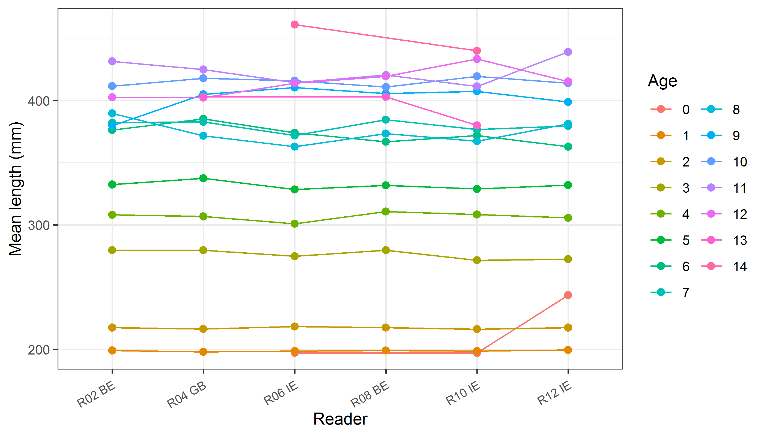
Figure 7.1.4: The mean fish length at age as estimated by each age reader.

Results Advanced readers
Summary statistics
Table 7.2.1: Summary of statistics; PA (%), CV (%) and APE (%).
NSample | CV | PA | APE
160 | 8 % | 89 % | 4 %
Data overview
Table 7.2.2: Data overview including modal age and statistics per sample.
Fish ID |  |  |  | length | Catch date | ICES area | R02 BE | R04 GB | R06 IE | R08 BE | Modal age | PA % | CV % | APE %
BYDR02_SOL_L_M_7A_2021051720450 |  |  |  | 351 | 17/05/2021 00:00:00 | 27.7.a | 5 | 5 | 5 | 5 | 5 | 100 | 0 | 0
BYDR02_SOL_L_M_7A_2021051720453 |  |  |  | 432 | 17/05/2021 00:00:00 | 27.7.a | 12 | 12 | 11 | 12 | 12 | 75 | 4 | 3
BYDR02_SOL_L_M_7A_2021051720455 |  |  |  | 321 | 17/05/2021 00:00:00 | 27.7.a | 5 | 5 | 5 | 5 | 5 | 100 | 0 | 0
BYDR03_SOL_L_M_7A_2021101710191 |  |  |  | 394 | 17/10/2021 00:00:00 | 27.7.a | 6 | 6 | 6 | 6 | 6 | 100 | 0 | 0
BYDR03_SOL_L_M_7A_2021101710192 |  |  |  | 412 | 17/10/2021 00:00:00 | 27.7.a | 7 | 7 | 10 | 7 | 7 | 75 | 19 | 15
BYDR03_SOL_L_M_7A_2021101710194 |  |  |  | 445 | 17/10/2021 00:00:00 | 27.7.a | 12 | 12 | 12 | 12 | 12 | 100 | 0 | 0
BYDR03_SOL_L_M_7A_2021101710196 |  |  |  | 426 | 17/10/2021 00:00:00 | 27.7.a | 6 | 6 | 6 | 6 | 6 | 100 | 0 | 0
BYDR03_SOL_L_M_7A_2021101710200 |  |  |  | 419 | 17/10/2021 00:00:00 | 27.7.a | 7 | 7 | 6 | 7 | 7 | 75 | 7 | 6
BYDR03_SOL_L_M_7A_2021101710202 |  |  |  | 436 | 17/10/2021 00:00:00 | 27.7.a | 11 | 11 | 10 | 11 | 11 | 75 | 5 | 3
BYDR03_SOL_L_M_7A_2022041810185 |  |  |  | 431 | 18/04/2022 00:00:00 | 27.7.a | 8 | 8 | 12 | 8 | 8 | 75 | 22 | 17
BYDR03_SOL_L_M_7A_2022041810187 |  |  |  | 415 | 18/04/2022 00:00:00 | 27.7.a | 8 | 8 | 8 | 8 | 8 | 100 | 0 | 0
CDDR04_SOL_L_M_7A_2022032710174 |  |  |  | 432 | 27/03/2022 00:00:00 | 27.7.a | 8 | 8 | 8 | 8 | 8 | 100 | 0 | 0
CDDR04_SOL_L_M_7A_2022032710175 |  |  |  | 431 | 27/03/2022 00:00:00 | 27.7.a | 8 | 8 | 8 | 8 | 8 | 100 | 0 | 0
CDDR04_SOL_L_M_7A_2022032710177 |  |  |  | 401 | 27/03/2022 00:00:00 | 27.7.a | 6 | 6 | 5 | 6 | 6 | 75 | 9 | 7
CDDR04_SOL_L_M_7A_2022032710178 |  |  |  | 377 | 27/03/2022 00:00:00 | 27.7.a | 8 | 9 | 8 | 9 | 8 | 50 | 7 | 6
CDDR04_SOL_L_M_7A_2022032710179 |  |  |  | 423 | 27/03/2022 00:00:00 | 27.7.a | 9 | 9 | 9 | 9 | 9 | 100 | 0 | 0
CDDR04_SOL_L_M_7A_2022032710180 |  |  |  | 379 | 27/03/2022 00:00:00 | 27.7.a | 4 | 4 | 4 | 4 | 4 | 100 | 0 | 0
CDDR04_SOL_L_M_7A_2022032710181 |  |  |  | 364 | 27/03/2022 00:00:00 | 27.7.a | 6 | 6 | 6 | 6 | 6 | 100 | 0 | 0
CDDR04_SOL_L_M_7A_2022032710186 |  |  |  | 383 | 27/03/2022 00:00:00 | 27.7.a | 7 | 7 | 7 | 7 | 7 | 100 | 0 | 0
CDDR04_SOL_L_M_7A_2022032710196 |  |  |  | 384 | 27/03/2022 00:00:00 | 27.7.a | 11 | 11 | 11 | 11 | 11 | 100 | 0 | 0
CDDR04_SOL_L_M_7A_2022032710197 |  |  |  | 338 | 27/03/2022 00:00:00 | 27.7.a | 7 | 7 | 7 | 7 | 7 | 100 | 0 | 0
CDDR04_SOL_L_M_7A_2022032710198 |  |  |  | 325 | 27/03/2022 00:00:00 | 27.7.a | 5 | 5 | 5 | 5 | 5 | 100 | 0 | 0
CDDR04_SOL_L_M_7A_2022032710201 |  |  |  | 330 | 27/03/2022 00:00:00 | 27.7.a | 10 | 10 | 10 | 10 | 10 | 100 | 0 | 0
CDDR04_SOL_L_M_7A_2022032710202 |  |  |  | 329 | 27/03/2022 00:00:00 | 27.7.a | 5 | 5 | 5 | 5 | 5 | 100 | 0 | 0
CDDR04_SOL_L_M_7A_2022032710204 |  |  |  | 284 | 27/03/2022 00:00:00 | 27.7.a | 4 | 4 | 4 | 4 | 4 | 100 | 0 | 0
CDDR04_SOL_L_M_7A_2022032710211 |  |  |  | 312 | 27/03/2022 00:00:00 | 27.7.a | 3 | 3 | 3 | 3 | 3 | 100 | 0 | 0
CDDR04_SOL_L_M_7A_2022032710221 |  |  |  | 262 | 27/03/2022 00:00:00 | 27.7.a | 3 | 3 | 4 | 3 | 3 | 75 | 15 | 12
CDDR04_SOL_R_M_7A_2022032710131 |  |  |  | 192 | 27/03/2022 00:00:00 | 27.7.a | 2 | 2 | 2 | 2 | 2 | 100 | 0 | 0
CDDR04_SOL_R_M_7A_2022032710133 |  |  |  | 195 | 27/03/2022 00:00:00 | 27.7.a | 2 | 2 | 2 | 2 | 2 | 100 | 0 | 0
CDDR05_SOL_L_M_7A_2022042830188 |  |  |  | 331 | 28/04/2022 00:00:00 | 27.7.a | 7 | 7 | 8 | 7 | 7 | 75 | 7 | 5
CDDR05_SOL_L_M_7A_2022042830191 |  |  |  | 308 | 28/04/2022 00:00:00 | 27.7.a | 4 | 4 | 4 | 4 | 4 | 100 | 0 | 0
CDDR05_SOL_L_M_7A_2022042830192 |  |  |  | 393 | 28/04/2022 00:00:00 | 27.7.a | 6 | 6 | 6 | 6 | 6 | 100 | 0 | 0
CDDR05_SOL_L_M_7A_2022042830194 |  |  |  | 381 | 28/04/2022 00:00:00 | 27.7.a | 7 | 7 | 8 | 7 | 7 | 75 | 7 | 5
CDDR05_SOL_L_M_7A_2022042830195 |  |  |  | 401 | 28/04/2022 00:00:00 | 27.7.a | 10 | 10 | 10 | 10 | 10 | 100 | 0 | 0
CDDR05_SOL_L_M_7A_2022042830196 |  |  |  | 302 | 28/04/2022 00:00:00 | 27.7.a | 4 | 4 | 4 | 4 | 4 | 100 | 0 | 0
CDDR05_SOL_L_M_7A_2022042830197 |  |  |  | 405 | 28/04/2022 00:00:00 | 27.7.a | 11 | 11 | 11 | 11 | 11 | 100 | 0 | 0
CDDR05_SOL_L_M_7A_2022042830199 |  |  |  | 372 | 28/04/2022 00:00:00 | 27.7.a | 6 | 6 | 6 | 6 | 6 | 100 | 0 | 0
CNVE02_SOL_7A_R_M_2021092710114 |  |  |  | 204 | 27/09/2021 00:00:00 | 27.7.a | 1 | 1 | 2 | 1 | 1 | 75 | 40 | 30
CNVE02_SOL_L_M_7A_2021092710149 |  |  |  | 372 | 27/09/2021 00:00:00 | 27.7.a | 6 | 6 | 7 | 6 | 6 | 75 | 8 | 6
CNVE02_SOL_L_M_7A_2021092710156 |  |  |  | 318 | 27/09/2021 00:00:00 | 27.7.a | 3 | 3 | 4 | 3 | 3 | 75 | 15 | 12
CNVE02_SOL_L_M_7A_2021092710157 |  |  |  | 338 | 27/09/2021 00:00:00 | 27.7.a | 3 | 3 | 3 | 3 | 3 | 100 | 0 | 0
CNVE02_SOL_L_M_7A_2021092710190 |  |  |  | 428 | 27/09/2021 00:00:00 | 27.7.a | 11 | 11 | 11 | 11 | 11 | 100 | 0 | 0
CNVE02_SOL_L_M_7A_2021092710199 |  |  |  | 387 | 27/09/2021 00:00:00 | 27.7.a | 6 | 6 | 6 | 7 | 6 | 75 | 8 | 6
CNVE02_SOL_L_M_7A_2021092710204 |  |  |  | 481 | 27/09/2021 00:00:00 | 27.7.a | 10 | 9 | 9 | 9 | 9 | 75 | 5 | 4
CNVE02_SOL_L_M_7A_2021092710209 |  |  |  | 473 | 27/09/2021 00:00:00 | 27.7.a | 11 | 11 | 11 | 11 | 11 | 100 | 0 | 0
CNVE02_SOL_L_M_7A_2021092710211 |  |  |  | 436 | 27/09/2021 00:00:00 | 27.7.a | 11 | 11 | 10 | 11 | 11 | 75 | 5 | 3
NKSZ05_SOL_L_7A_2022081010142 |  |  |  | 375 | 10/08/2022 00:00:00 | 27.7.a | 8 | 8 | 8 | 8 | 8 | 100 | 0 | 0
NKSZ05_SOL_L_7A_2022081010143 |  |  |  | 347 | 10/08/2022 00:00:00 | 27.7.a | 8 | 8 | 8 | 8 | 8 | 100 | 0 | 0
NKSZ05_SOL_L_7A_2022081010144 |  |  |  | 365 | 10/08/2022 00:00:00 | 27.7.a | 10 | 10 | 10 | 11 | 10 | 75 | 5 | 4
NKSZ05_SOL_L_7A_2022081010146 |  |  |  | 380 | 10/08/2022 00:00:00 | 27.7.a | 12 | 12 | 12 | 12 | 12 | 100 | 0 | 0
NKSZ05_SOL_L_7A_2022081010151 |  |  |  | 321 | 10/08/2022 00:00:00 | 27.7.a | 4 | 4 | 4 | 4 | 4 | 100 | 0 | 0
NKSZ05_SOL_L_7A_2022081010158 |  |  |  | 315 | 10/08/2022 00:00:00 | 27.7.a | 4 | 4 | 4 | 4 | 4 | 100 | 0 | 0
NKSZ05_SOL_L_7A_2022081010161 |  |  |  | 334 | 10/08/2022 00:00:00 | 27.7.a | 12 | 12 | 11 | 11 | 12 | 50 | 5 | 4
NKSZ05_SOL_R_M_7A_2022081010100 |  |  |  | 209 | 10/08/2022 00:00:00 | 27.7.a | 2 | 2 | 2 | 2 | 2 | 100 | 0 | 0
NKSZ05_SOL_R_M_7A_2022081010101 |  |  |  | 223 | 10/08/2022 00:00:00 | 27.7.a | 2 | 2 | 2 | 2 | 2 | 100 | 0 | 0
NKSZ09_SOL_L_M_7A_2022112210156 |  |  |  | 425 | 22/11/2022 00:00:00 | 27.7.a | 7 | 7 | 7 | 7 | 7 | 100 | 0 | 0
NKSZ09_SOL_L_M_7A_2022112210157 |  |  |  | 389 | 22/11/2022 00:00:00 | 27.7.a | 10 | 10 | 9 | 10 | 10 | 75 | 5 | 4
NKSZ09_SOL_L_M_7A_2022112210163 |  |  |  | 364 | 22/11/2022 00:00:00 | 27.7.a | 5 | 5 | 5 | 5 | 5 | 100 | 0 | 0
NKSZ09_SOL_L_M_7A_2022112210164 |  |  |  | 375 | 22/11/2022 00:00:00 | 27.7.a | 7 | 7 | 7 | 7 | 7 | 100 | 0 | 0
NKSZ09_SOL_L_M_7A_2022112210167 |  |  |  | 369 | 22/11/2022 00:00:00 | 27.7.a | 4 | 4 | 5 | 4 | 4 | 75 | 12 | 9
NKSZ09_SOL_L_M_7A_2022112210169 |  |  |  | 352 | 22/11/2022 00:00:00 | 27.7.a | 4 | 4 | 4 | 4 | 4 | 100 | 0 | 0
NKSZ09_SOL_L_M_7A_2022112210171 |  |  |  | 318 | 22/11/2022 00:00:00 | 27.7.a | 5 | 5 | 5 | 5 | 5 | 100 | 0 | 0
NKSZ09_SOL_L_M_7A_2022112210173 |  |  |  | 319 | 22/11/2022 00:00:00 | 27.7.a | 3 | 3 | 4 | 3 | 3 | 75 | 15 | 12
NKSZ09_SOL_L_M_7A_2022112210176 |  |  |  | 319 | 22/11/2022 00:00:00 | 27.7.a | 3 | 3 | 3 | 3 | 3 | 100 | 0 | 0
NKSZ09_SOL_L_M_7A_2022112210195 |  |  |  | 276 | 22/11/2022 00:00:00 | 27.7.a | 2 | 2 | 2 | 2 | 2 | 100 | 0 | 0
NKSZ09_SOL_L_M_7A_2022112210196 |  |  |  | 251 | 22/11/2022 00:00:00 | 27.7.a | 2 | 2 | 2 | 2 | 2 | 100 | 0 | 0
NKSZ09_SOL_L_M_7A_2022112210198 |  |  |  | 256 | 22/11/2022 00:00:00 | 27.7.a | 9 | 8 | 8 | 8 | 8 | 75 | 6 | 5
NKSZ09_SOL_L_M_7A_2022112210204 |  |  |  | 258 | 22/11/2022 00:00:00 | 27.7.a | 8 | 8 | 8 | 8 | 8 | 100 | 0 | 0
NKSZ09_SOL_R_M_7A_2022112210125 |  |  |  | 185 | 22/11/2022 00:00:00 | 27.7.a | 1 | 1 | 1 | 1 | 1 | 100 | 0 | 0
NKSZ09_SOL_R_M_7A_2022112210126 |  |  |  | 202 | 22/11/2022 00:00:00 | 27.7.a | 1 | 1 | 1 | 1 | 1 | 100 | 0 | 0
NKSZ09_SOL_R_M_7A_2022112210127 |  |  |  | 211 | 22/11/2022 00:00:00 | 27.7.a | 1 | 1 | 1 | 1 | 1 | 100 | 0 | 0
NKSZ09_SOL_R_M_7A_2022112210133 |  |  |  | 197 | 22/11/2022 00:00:00 | 27.7.a | 1 | 1 | 0 | 1 | 1 | 75 | 67 | 50
NKSZ09_SOL_R_M_7A_2022112210134 |  |  |  | 180 | 22/11/2022 00:00:00 | 27.7.a | 1 | 1 | 1 | 1 | 1 | 100 | 0 | 0
PRVN05_SOL_7A_R_M_2021060210101 |  |  |  | 197 | 02/06/2021 00:00:00 | 27.7.a | 2 | 2 | 2 | 2 | 2 | 100 | 0 | 0
PRVN05_SOL_7A_R_M_2021060210102 |  |  |  | 197 | 02/06/2021 00:00:00 | 27.7.a | 2 | 2 | 3 | 2 | 2 | 75 | 22 | 17
PRVN05_SOL_L_M_7A_2021060210135 |  |  |  | 461 | 02/06/2021 00:00:00 | 27.7.a | 11 | 10 | 14 | 11 | 11 | 50 | 15 | 11
PRVN05_SOL_L_M_7A_2021060210141 |  |  |  | 433 | 02/06/2021 00:00:00 | 27.7.a | 10 | 10 | 9 | 10 | 10 | 75 | 5 | 4
PRVN05_SOL_L_M_7A_2021060210142 |  |  |  | 496 | 02/06/2021 00:00:00 | 27.7.a | 11 | 10 | 10 | 11 | 11 | 50 | 5 | 5
PRVN05_SOL_L_M_7A_2021060210148 |  |  |  | 421 | 02/06/2021 00:00:00 | 27.7.a | 9 | 9 | 9 | 9 | 9 | 100 | 0 | 0
PRVN05_SOL_L_M_7A_2021060210154 |  |  |  | 402 | 02/06/2021 00:00:00 | 27.7.a | 9 | 9 | 9 | 9 | 9 | 100 | 0 | 0
PRVN05_SOL_L_M_7A_2021060210157 |  |  |  | 404 | 02/06/2021 00:00:00 | 27.7.a | 11 | 10 | 12 | 11 | 11 | 50 | 7 | 5
SAS_SELF_20210419_SOL_7A_L_M_2021041910118 |  |  |  | 258 | 19/04/2021 00:00:00 | 27.7.a | 3 | 3 | 3 | 3 | 3 | 100 | 0 | 0
SAS_SELF_20210419_SOL_7A_L_M_2021041910123 |  |  |  | 239 | 19/04/2021 00:00:00 | 27.7.a | 3 | 3 | 3 | 3 | 3 | 100 | 0 | 0
SAS_SELF_SOL_L_7A_2022090310035 |  |  |  | 419 | 03/09/2022 00:00:00 | 27.7.a | 11 | 11 | 11 | 11 | 11 | 100 | 0 | 0
SAS_SELF_SOL_L_7A_2022090310036 |  |  |  | 421 | 03/09/2022 00:00:00 | 27.7.a | 12 | 12 | 12 | 12 | 12 | 100 | 0 | 0
SAS_SELF_SOL_L_7A_2022090310049 |  |  |  | 482 | 03/09/2022 00:00:00 | 27.7.a | 10 | 10 | 10 | 10 | 10 | 100 | 0 | 0
SAS_SELF_SOL_L_7A_2022090310053 |  |  |  | 418 | 03/09/2022 00:00:00 | 27.7.a | 11 | 11 | 11 | 11 | 11 | 100 | 0 | 0
SAS_SELF_SOL_L_7A_2022090310054 |  |  |  | 403 | 03/09/2022 00:00:00 | 27.7.a | 12 | 13 | 12 | 13 | 12 | 50 | 5 | 4
SELF SAMP_SOL_R_M_7A_2022090310026 |  |  |  | 207 | 03/09/2022 00:00:00 | 27.7.a | 1 | 2 | 1 | 1 | 1 | 75 | 40 | 30
SELF SAMP_SOL_R_M_7A_2022090310029 |  |  |  | 207 | 03/09/2022 00:00:00 | 27.7.a | 1 | 1 | 1 | 1 | 1 | 100 | 0 | 0
SELF_210709_SOL_7A_L_M_2021070910030 |  |  |  | 264 | 09/07/2021 00:00:00 | 27.7.a | 5 | 5 | 5 | 5 | 5 | 100 | 0 | 0
SELF_210709_SOL_7A_L_M_2021070910031 |  |  |  | 365 | 09/07/2021 00:00:00 | 27.7.a | 9 | 9 | 9 | 9 | 9 | 100 | 0 | 0
SELF_210709_SOL_7A_L_M_2021070910033 |  |  |  | 421 | 09/07/2021 00:00:00 | 27.7.a | 5 | 5 | 5 | 5 | 5 | 100 | 0 | 0
SELF_210709_SOL_7A_L_M_2021070910040 |  |  |  | 401 | 09/07/2021 00:00:00 | 27.7.a | 9 | 9 | 10 | 10 | 9 | 50 | 6 | 5
SELF_210709_SOL_7A_L_M_2021070910041 |  |  |  | 408 | 09/07/2021 00:00:00 | 27.7.a | 6 | 5 | 5 | 7 | 5 | 50 | 17 | 13
SOL_7A_Q1_22_54379_020 |  |  |  | 310 | 09/02/2022 00:00:00 | 27.7.a | 4 | 4 | 4 | 4 | 4 | 100 | 0 | 0
SOL_7A_Q1_22_54379_021 |  |  |  | 330 | 09/02/2022 00:00:00 | 27.7.a | 4 | 4 | 4 | 4 | 4 | 100 | 0 | 0
SOL_7A_Q1_22_54379_022 |  |  |  | 320 | 09/02/2022 00:00:00 | 27.7.a | 4 | 4 | 5 | 4 | 4 | 75 | 12 | 9
SOL_7A_Q1_22_54379_023 |  |  |  | 280 | 09/02/2022 00:00:00 | 27.7.a | 5 | 5 | 5 | 5 | 5 | 100 | 0 | 0
SOL_7A_Q1_22_54379_024 |  |  |  | 340 | 09/02/2022 00:00:00 | 27.7.a | 5 | 5 | 5 | 5 | 5 | 100 | 0 | 0
SOL_7A_Q1_22_54379_025 |  |  |  | 280 | 09/02/2022 00:00:00 | 27.7.a | 4 | 4 | 5 | 4 | 4 | 75 | 12 | 9
SOL_7A_Q1_22_54379_026 |  |  |  | 280 | 09/02/2022 00:00:00 | 27.7.a | 4 | 4 | 5 | 4 | 4 | 75 | 12 | 9
SOL_7A_Q1_22_54379_027 |  |  |  | 310 | 09/02/2022 00:00:00 | 27.7.a | 4 | 4 | 5 | 4 | 4 | 75 | 12 | 9
SOL_7A_Q1_22_54379_028 |  |  |  | 390 | 09/02/2022 00:00:00 | 27.7.a | 8 | 7 | 8 | 8 | 8 | 75 | 6 | 5
SOL_7A_Q1_22_54379_029 |  |  |  | 240 | 09/02/2022 00:00:00 | 27.7.a | 3 | 3 | 4 | 3 | 3 | 75 | 15 | 12
SOL_7A_Q1_22_54379_030 |  |  |  | 250 | 09/02/2022 00:00:00 | 27.7.a | 3 | 3 | 3 | 3 | 3 | 100 | 0 | 0
SOL_7A_Q1_22_54379_031 |  |  |  | 400 | 09/02/2022 00:00:00 | 27.7.a | 9 | 8 | 10 | 8 | 8 | 50 | 11 | 9
SOL_7A_Q1_22_54379_032 |  |  |  | 380 | 09/02/2022 00:00:00 | 27.7.a | 6 | 6 | 7 | 5 | 6 | 50 | 14 | 8
SOL_7A_Q1_22_54561_006 |  |  |  | 310 | 07/03/2022 00:00:00 | 27.7.a | 4 | 4 | 5 | 4 | 4 | 75 | 12 | 9
SOL_7A_Q1_22_54561_007 |  |  |  | 280 | 07/03/2022 00:00:00 | 27.7.a | 4 | 4 | 5 | 6 | 4 | 50 | 20 | 16
SOL_7A_Q1_22_54561_009 |  |  |  | 260 | 07/03/2022 00:00:00 | 27.7.a | 3 | 3 | 4 | 3 | 3 | 75 | 15 | 12
SOL_7A_Q1_22_54561_010 |  |  |  | 260 | 07/03/2022 00:00:00 | 27.7.a | 3 | 3 | 4 | 3 | 3 | 75 | 15 | 12
SOL_7A_Q1_22_54561_011 |  |  |  | 270 | 07/03/2022 00:00:00 | 27.7.a | 3 | 3 | 3 | 3 | 3 | 100 | 0 | 0
SOL_7A_Q1_22_54561_012 |  |  |  | 270 | 07/03/2022 00:00:00 | 27.7.a | 4 | 4 | 4 | 4 | 4 | 100 | 0 | 0
SOL_7A_Q1_22_54561_013 |  |  |  | 290 | 07/03/2022 00:00:00 | 27.7.a | 4 | 4 | 5 | 4 | 4 | 75 | 12 | 9
SOL_7A_Q1_22_54561_014 |  |  |  | 400 | 07/03/2022 00:00:00 | 27.7.a | 6 | 6 | 6 | 6 | 6 | 100 | 0 | 0
SOL_7A_Q1_22_54561_015 |  |  |  | 370 | 07/03/2022 00:00:00 | 27.7.a | 6 | 6 | 6 | 6 | 6 | 100 | 0 | 0
SOL_7A_Q1_22_54561_016 |  |  |  | 300 | 07/03/2022 00:00:00 | 27.7.a | 6 | 5 | 7 | 6 | 6 | 50 | 14 | 8
SOL_7A_Q1_22_54561_017 |  |  |  | 290 | 07/03/2022 00:00:00 | 27.7.a | 4 | 4 | 4 | 4 | 4 | 100 | 0 | 0
SOL_7A_Q1_22_54561_018 |  |  |  | 310 | 07/03/2022 00:00:00 | 27.7.a | 4 | 4 | 4 | 4 | 4 | 100 | 0 | 0
SOL_7A_Q1_22_54561_019 |  |  |  | 350 | 07/03/2022 00:00:00 | 27.7.a | 5 | 5 | 5 | 5 | 5 | 100 | 0 | 0
SOL_7A_Q1_22_54561_020 |  |  |  | 290 | 07/03/2022 00:00:00 | 27.7.a | 4 | 4 | 4 | 4 | 4 | 100 | 0 | 0
SOL_7A_Q1_22_54561_021 |  |  |  | 270 | 07/03/2022 00:00:00 | 27.7.a | 4 | 4 | 4 | 4 | 4 | 100 | 0 | 0
SOL_7A_Q1_23_57776_014 |  |  |  | 370 | 14/02/2023 00:00:00 | 27.7.a | 9 | 9 | 9 | 9 | 9 | 100 | 0 | 0
SOL_7A_Q1_23_57776_015 |  |  |  | 260 | 14/02/2023 00:00:00 | 27.7.a | 3 | 3 | 3 | 3 | 3 | 100 | 0 | 0
SOL_7A_Q1_23_57776_016 |  |  |  | 360 | 14/02/2023 00:00:00 | 27.7.a | 5 | 5 | 5 | 5 | 5 | 100 | 0 | 0
SOL_7A_Q1_23_57776_017 |  |  |  | 350 | 14/02/2023 00:00:00 | 27.7.a | 5 | 5 | 6 | 5 | 5 | 75 | 10 | 7
SOL_7A_Q1_23_57776_018 |  |  |  | 300 | 14/02/2023 00:00:00 | 27.7.a | 5 | 5 | 5 | 5 | 5 | 100 | 0 | 0
SOL_7A_Q1_23_58173_002 |  |  |  | 320 | 04/04/2023 00:00:00 | 27.7.a | 5 | 5 | 5 | 5 | 5 | 100 | 0 | 0
SOL_7A_Q1_23_58173_003 |  |  |  | 360 | 04/04/2023 00:00:00 | 27.7.a | 6 | 6 | 6 | 6 | 6 | 100 | 0 | 0
SOL_7A_Q1_23_58173_004 |  |  |  | 430 | 04/04/2023 00:00:00 | 27.7.a | 11 | 11 | 11 | 11 | 11 | 100 | 0 | 0
SOL_7A_Q1_23_58173_005 |  |  |  | 420 | 04/04/2023 00:00:00 | 27.7.a | 11 | 11 | 11 | 11 | 11 | 100 | 0 | 0
SOL_7A_Q1_23_58173_006 |  |  |  | 400 | 04/04/2023 00:00:00 | 27.7.a | 7 | 7 | 7 | 7 | 7 | 100 | 0 | 0
SOL_7a_Q2_21_52497_012 |  |  |  | 300 | 27/04/2021 00:00:00 | 27.7.a | 3 | 3 | 3 | 3 | 3 | 100 | 0 | 0
SOL_7a_Q2_21_52497_013 |  |  |  | 350 | 27/04/2021 00:00:00 | 27.7.a | 4 | 4 | 5 | 4 | 4 | 75 | 12 | 9
SOL_7a_Q2_21_52497_014 |  |  |  | 360 | 27/04/2021 00:00:00 | 27.7.a | 6 | 6 | 6 | 6 | 6 | 100 | 0 | 0
SOL_7a_Q2_21_52497_015 |  |  |  | 290 | 27/04/2021 00:00:00 | 27.7.a | 4 | 4 | 4 | 4 | 4 | 100 | 0 | 0
SOL_7a_Q2_21_52497_016 |  |  |  | 360 | 27/04/2021 00:00:00 | 27.7.a | 5 | 5 | 6 | 5 | 5 | 75 | 10 | 7
SOL_7a_Q2_21_52520_020 |  |  |  | 310 | 12/05/2021 00:00:00 | 27.7.a | 4 | 4 | 4 | 4 | 4 | 100 | 0 | 0
SOL_7a_Q2_21_52520_021 |  |  |  | 300 | 12/05/2021 00:00:00 | 27.7.a | 3 | 3 | 3 | 3 | 3 | 100 | 0 | 0
SOL_7a_Q2_21_52520_022 |  |  |  | 280 | 12/05/2021 00:00:00 | 27.7.a | 3 | 3 | 3 | 3 | 3 | 100 | 0 | 0
SOL_7a_Q2_21_52520_023 |  |  |  | 340 | 12/05/2021 00:00:00 | 27.7.a | 5 | 5 | 5 | 5 | 5 | 100 | 0 | 0
SOL_7a_Q2_21_52520_024 |  |  |  | 370 | 12/05/2021 00:00:00 | 27.7.a | 5 | 5 | 5 | 5 | 5 | 100 | 0 | 0
SOL_7a_Q2_21_52520_025 |  |  |  | 270 | 12/05/2021 00:00:00 | 27.7.a | 5 | 4 | 5 | 5 | 5 | 75 | 11 | 8
SOL_7a_Q2_21_52520_026 |  |  |  | 250 | 12/05/2021 00:00:00 | 27.7.a | 3 | 3 | 3 | 3 | 3 | 100 | 0 | 0
SOL_7a_Q2_21_52630_015 |  |  |  | 360 | 19/05/2021 00:00:00 | 27.7.a | 5 | 5 | 5 | 5 | 5 | 100 | 0 | 0
SOL_7a_Q2_21_52630_016 |  |  |  | 310 | 19/05/2021 00:00:00 | 27.7.a | 5 | 5 | 5 | 5 | 5 | 100 | 0 | 0
SOL_7a_Q2_21_52630_017 |  |  |  | 330 | 19/05/2021 00:00:00 | 27.7.a | 5 | 5 | 5 | 5 | 5 | 100 | 0 | 0
SOL_7a_Q2_21_52630_018 |  |  |  | 360 | 19/05/2021 00:00:00 | 27.7.a | 6 | 6 | 6 | 6 | 6 | 100 | 0 | 0
SOL_7a_Q2_21_52630_019 |  |  |  | 330 | 19/05/2021 00:00:00 | 27.7.a | 4 | 4 | 4 | 4 | 4 | 100 | 0 | 0
SOL_7a_Q2_21_52630_020 |  |  |  | 320 | 19/05/2021 00:00:00 | 27.7.a | 5 | 5 | 6 | 5 | 5 | 75 | 10 | 7
SOL_7a_Q2_21_52630_021 |  |  |  | 380 | 19/05/2021 00:00:00 | 27.7.a | 7 | 7 | 7 | 7 | 7 | 100 | 0 | 0
SOL_7a_Q2_21_52791_001 |  |  |  | 360 | 30/05/2021 00:00:00 | 27.7.a | 7 | 7 | 7 | 7 | 7 | 100 | 0 | 0
SOL_7a_Q2_21_52791_002 |  |  |  | 370 | 30/05/2021 00:00:00 | 27.7.a | 5 | 5 | 5 | 5 | 5 | 100 | 0 | 0
SOL_7a_Q2_21_52791_003 |  |  |  | 330 | 30/05/2021 00:00:00 | 27.7.a | 5 | 5 | 5 | 5 | 5 | 100 | 0 | 0
SOL_7a_Q2_21_52791_004 |  |  |  | 310 | 30/05/2021 00:00:00 | 27.7.a | 5 | 5 | 7 | 5 | 5 | 75 | 18 | 14
SOL_7a_Q2_21_52791_005 |  |  |  | 310 | 30/05/2021 00:00:00 | 27.7.a | 5 | 4 | 5 | 5 | 5 | 75 | 11 | 8
SOL_7a_Q2_21_52791_006 |  |  |  | 440 | 30/05/2021 00:00:00 | 27.7.a | 8 | 6 | 7 | 10 | 8 | 25 | 22 | 16
SOL_7a_Q2_21_52791_007 |  |  |  | 350 | 30/05/2021 00:00:00 | 27.7.a | 6 | 5 | 6 | 6 | 6 | 75 | 9 | 7
SOL_7a_Q2_21_52791_008 |  |  |  | 270 | 30/05/2021 00:00:00 | 27.7.a | 4 | 4 | 5 | 5 | 4 | 50 | 13 | 11
List of multimodal cases
Table 7.2.3: List of cases for which multiple modes where obtained when all readers are considered. The column NModes_trad shows the number of multiple modes for each FishID or SampleID when all readers are given the same expertise weight.
NModes_trad | SampleID
2 | CDDR04_SOL_L_M_7A_2022032710178
2 | NKSZ05_SOL_L_7A_2022081010161
2 | PRVN05_SOL_L_M_7A_2021060210142
2 | SAS_SELF_SOL_L_7A_2022090310054
2 | SELF_210709_SOL_7A_L_M_2021070910040
4 | SOL_7a_Q2_21_52791_006
2 | SOL_7a_Q2_21_52791_008
Number of age readings by modal age
Table 7.2.4: Number of age readings table gives an overview of number of readings per reader and modal age. The total numbers of readings by modal age and by reader are also presented.
Number of age readings by age
Modal age | R02 BE | R04 GB | R06 IE | R08 BE | total
1 | 8 | 8 | 8 | 8 | 32
2 | 8 | 8 | 8 | 8 | 32
3 | 18 | 18 | 18 | 18 | 72
4 | 27 | 27 | 27 | 27 | 108
5 | 28 | 28 | 28 | 28 | 112
6 | 16 | 16 | 16 | 16 | 64
7 | 11 | 11 | 11 | 11 | 44
8 | 12 | 12 | 12 | 12 | 48
9 | 7 | 7 | 7 | 7 | 28
10 | 6 | 6 | 6 | 6 | 24
11 | 13 | 13 | 13 | 13 | 52
12 | 6 | 6 | 6 | 6 | 24
Total | 160 | 160 | 160 | 160 | 640
Table 7.2.5: Age composition by reader gives a summary of number of readings per reader and age. The total numbers of readings by age and by reader are also presented.
Age | R02 BE | R04 GB | R06 IE | R08 BE | total
0 | 0 | 0 | 1 | 0 | 1
1 | 8 | 7 | 6 | 8 | 29
2 | 8 | 9 | 8 | 8 | 33
3 | 18 | 18 | 13 | 18 | 67
4 | 27 | 29 | 23 | 25 | 104
5 | 27 | 28 | 35 | 29 | 119
6 | 17 | 15 | 16 | 15 | 63
7 | 11 | 12 | 12 | 13 | 48
8 | 10 | 9 | 11 | 10 | 40
9 | 8 | 8 | 8 | 7 | 31
10 | 7 | 9 | 10 | 7 | 33
11 | 13 | 10 | 10 | 15 | 48
12 | 6 | 5 | 6 | 4 | 21
13 | 0 | 1 | 0 | 1 | 2
14 | 0 | 0 | 1 | 0 | 1
Total | 160 | 160 | 160 | 160 | 640

Separate age bias plots by reader
[[1]] 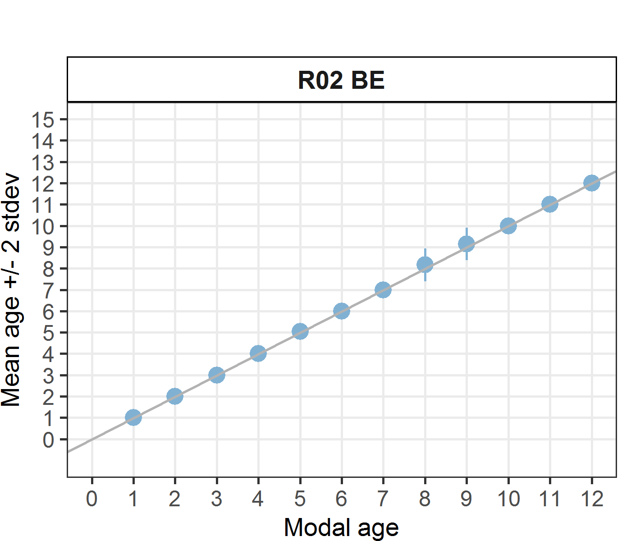 [[2]] 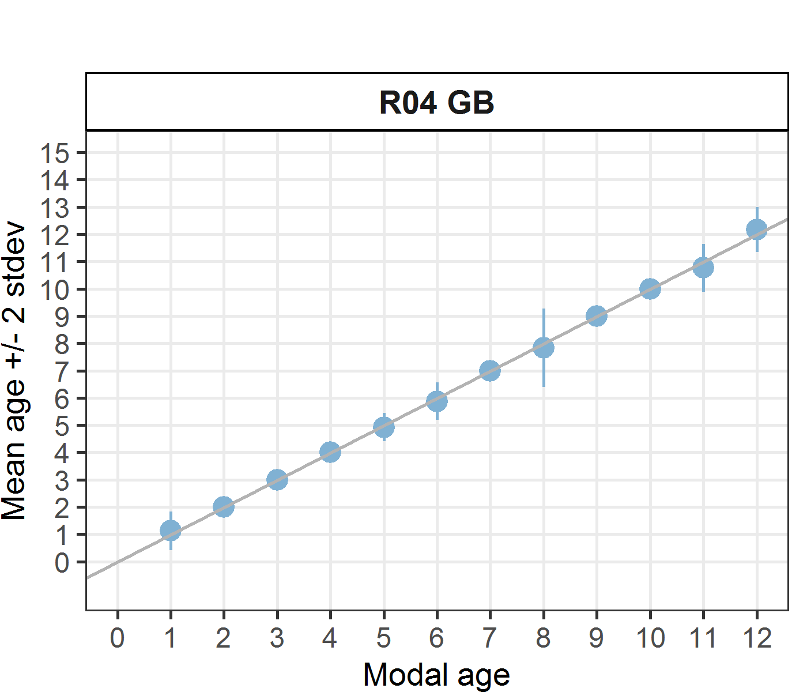 [[3]] 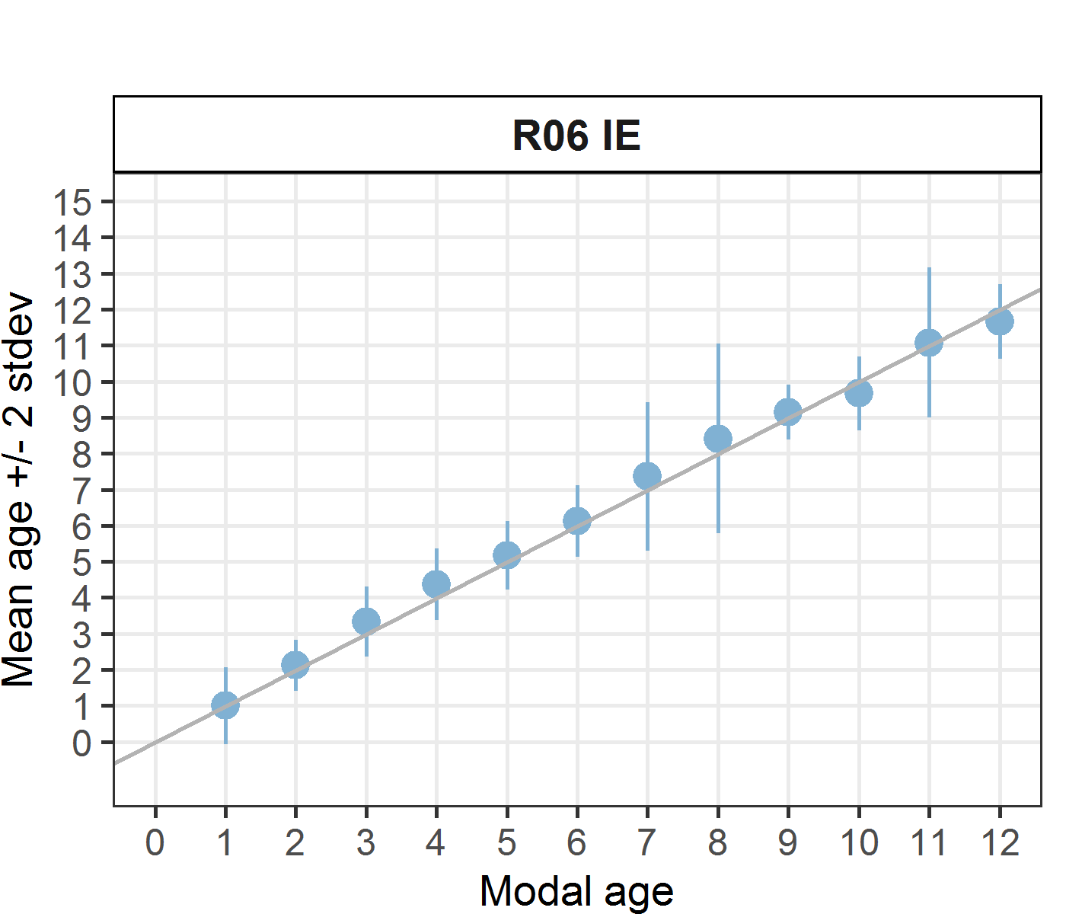 [[4]] 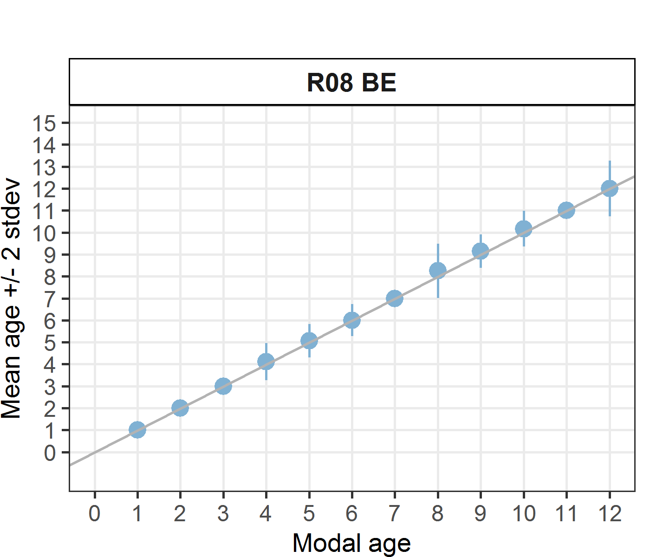

Statistics by modal age plot (STDEV, CV and PA)
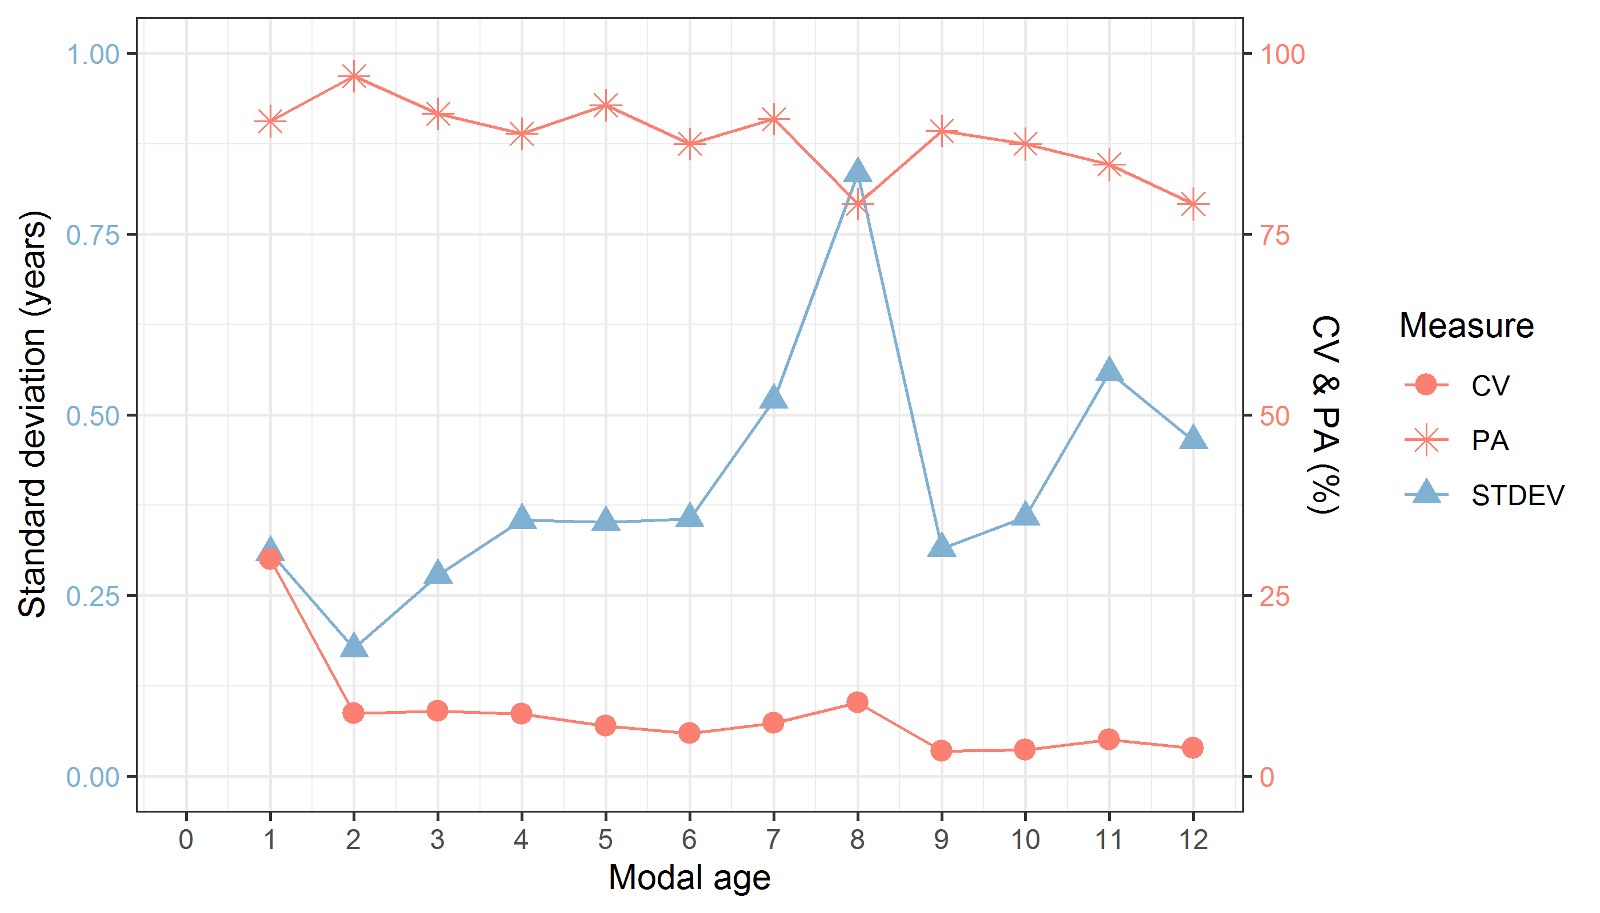
Figure 7.2.1: CV, PA and (STDEV (standard deviation) are plotted against modal age

Distribution of age reading errors
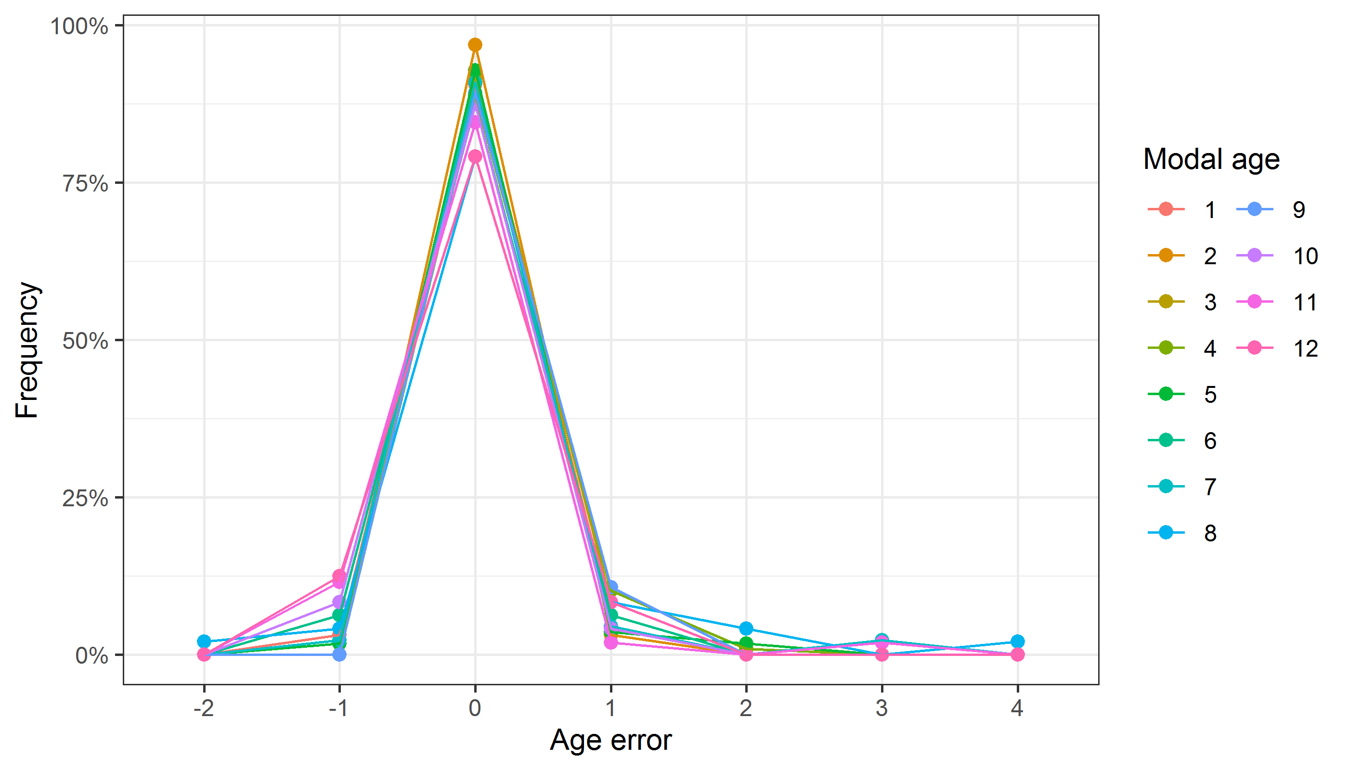
Figure 7.2.2: The distribution of the age reading errors in percentage by modal age as observed from the whole group of age readers in an age reading comparison to modal age. The achieved precision in age reading by MODAL age group is shown by the spread of the age readings errors. There appears to be no relative bias, if the age reading errors are normally distributed. The distributions are skewed, if relative bias occurs.

Relative bias for all readers
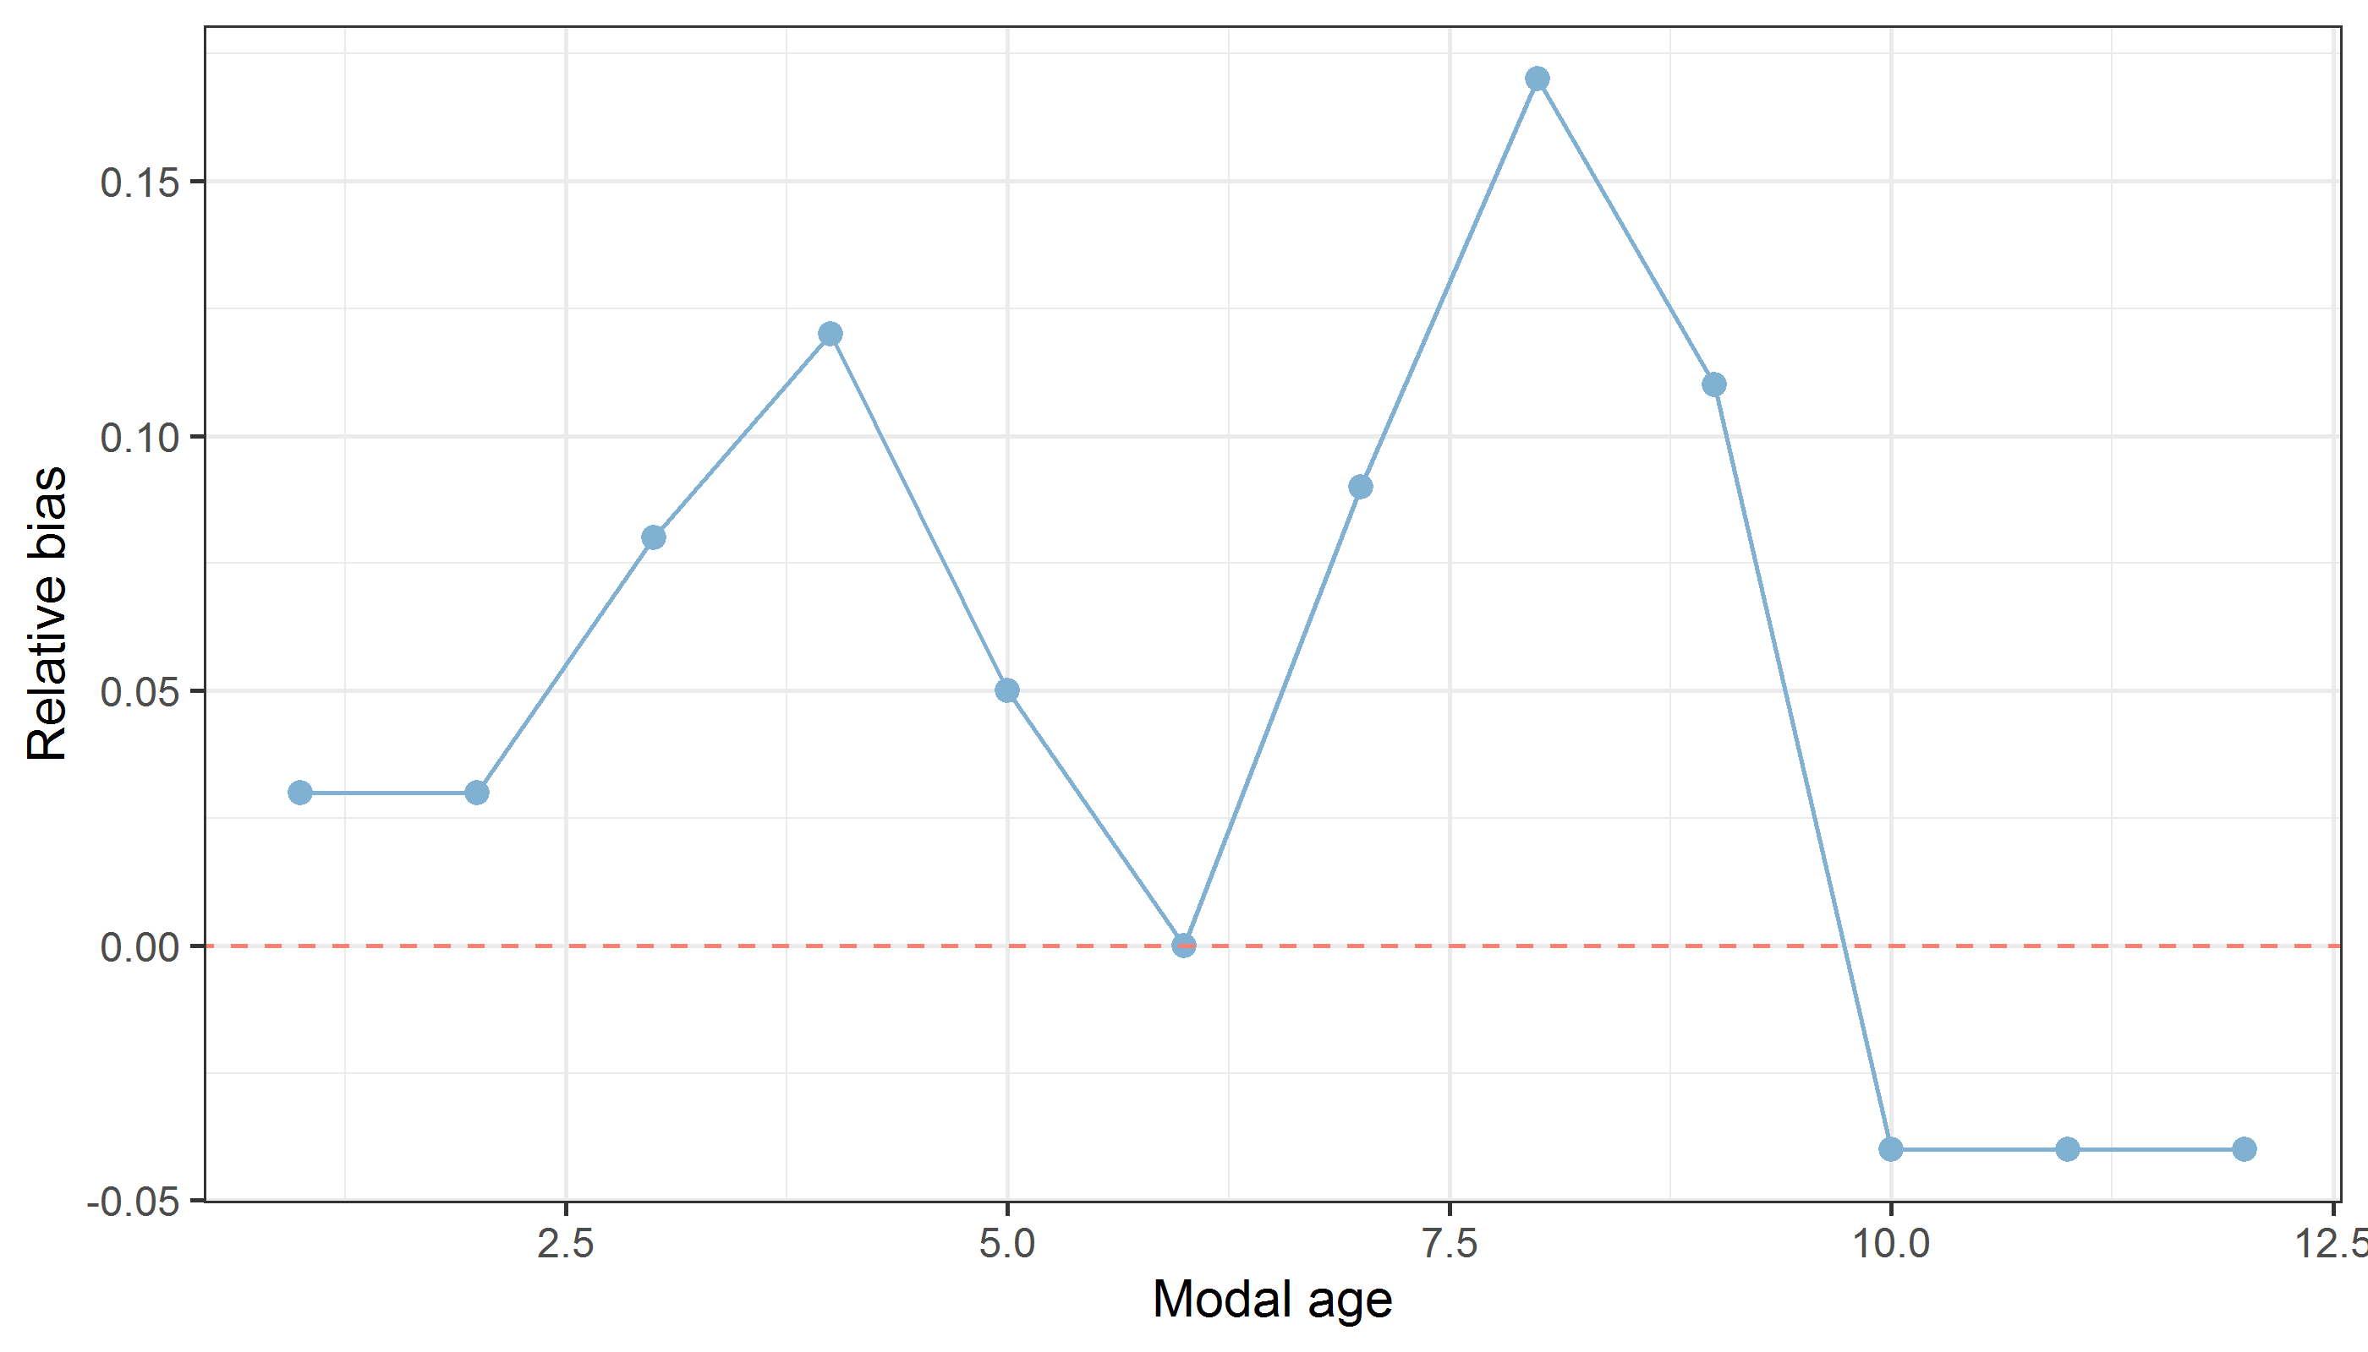
Figure 7.2.3: The relative bias by modal age as estimated by all age readers combined.
Mean length at age by reader
Table 7.2.6: Mean fish length at age per reader is calculated per reader and age (not modal age) and for all readers combined per age. A weighted mean is also given.
Age | R02 BE | R04 GB | R06 IE | R08 BE
0 | - | - | 197 mm | -
1 | 199 mm | 198 mm | 199 mm | 199 mm
2 | 218 mm | 216 mm | 218 mm | 218 mm
3 | 280 mm | 280 mm | 275 mm | 280 mm
4 | 308 mm | 307 mm | 301 mm | 311 mm
5 | 332 mm | 338 mm | 329 mm | 332 mm
6 | 376 mm | 385 mm | 374 mm | 367 mm
7 | 382 mm | 383 mm | 372 mm | 385 mm
8 | 390 mm | 372 mm | 363 mm | 374 mm
9 | 380 mm | 405 mm | 410 mm | 406 mm
10 | 412 mm | 418 mm | 416 mm | 411 mm
11 | 432 mm | 425 mm | 414 mm | 421 mm
12 | 402 mm | 402 mm | 414 mm | 420 mm
13 | - | 403 mm | - | 403 mm
14 | - | - | 461 mm | -
Weighted Mean | 338 mm | 338 mm | 338 mm | 338 mm
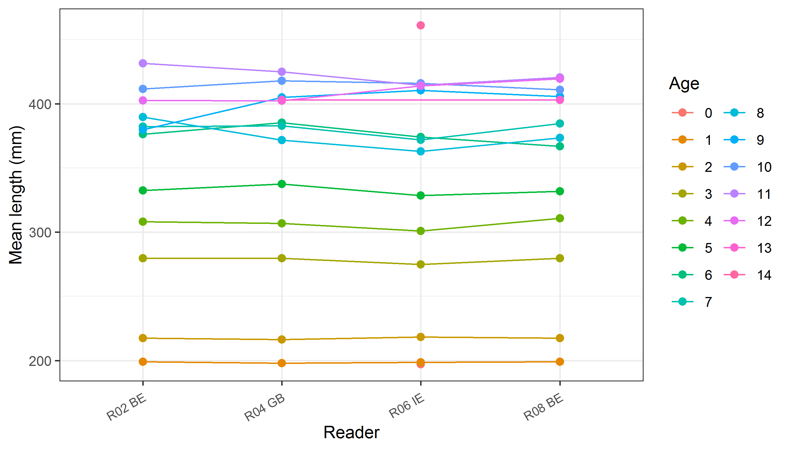
Figure 7.2.4: The mean fish length at age as estimated by each age reader.

