SmartDots Report for event 1849
Table of Contents

Executive summary

Terms of reference

Agenda and participant list
The agenda can be found in Annex 1 and the list of participants in Annex 2.

Introduction
This part should include a background to the species, the workshop/exchange and what to expect to read about in the report.

Methods
This report contains statistical analyses and comparisons of age readings in the form of tables and graphical plots.
First, an overview of participating age readers and the samples are presented.
Before each table or plot there is a short explanation. This text is thought as a help to understand the tables/plots and can just be deleted in the final output report if deemed unnecessary. The document can be edited just like any other .docx file. New text can be added, additional figures and tables can be included and the existing tables can be edited. If some tables which are presently in the annexes need to be moved to the body of the report this is also possible. Only the plots cannot be changed.
The first part of the results section include the tables and plots from the Guus Eltink Excel sheet ‘Age Reading Comparisons (Eltink, A.T.G.W. 2000). The order and numbering of tables and plots are the same as in the excel sheet. Tables 6.1 - 6.4 from the ’Age Reading Comparisons’ sheet are not outputted since these are merely used to do calculations for the other tables.
Modal age: a multistage approach to define the modal age by sampled fish,
In this event, the multistage approach to calculate the modal age has been used. When summarizing the output and reporting the results of the exchange events developed within the SmarDots framework, the modal age (the most common age decided by the age readers for every fish sample) is the most relevant measurement. It is a key statistic by itself, but it is also fundamental for the estimation of some other relevant statistics to assess the performance of the techniques assessed in the exchange event, like the Percentage Agreement (PA), or input for stock assessments like the Age Error Matrix (AEM) (see below). However, the standard approach of calculating the mode (each reader has the same weight=1) the mode is taken as the lowest age of the multiple modal ages. This way renders multiple cases (fish samples) with multiple modal ages (i.e. different ages got the same highest number of readers). Accordingly, this imply a wrong perception of the age by fish individual and introduction of bias in the calculation of the PA and AEM. As a solution, in this report a multistage approach to select the modal age is used. This multistage approach is based in the different weight given to the age readers according to their experience. Two different weight scores scales were assigned, a weight score decreasing linearly with the experience and another decreasing with a negative exponential shape. The modal age by fish individual is decided following the next approach:
1.-If there is a single mode estimated with the standard approach (equal weight for all readers) this value is used as the modal age, if not
2.-Adding up, for each age category, the score assigned with the linear weighting for all the readers that decided that age for that fish. Next, the modal age is selected as the age category that obtains the highest score sum. If, despite this approach, there were still multiple ages with the same score (and hence multiple modes), the next step is applied:
3.-Adding up, for each age category, the score assigned with the negative exponential weighting for all the readers that decided that age for that fish. Select as the modal age the age with the highest score sum.
During the WGBIOP 2019 meeting it was found that the combination of the modes decided using these three methods (so called ‘multistage approach’), allows assigning a single modal age to each fish individual.
It is important checking the table that indicates the percentage of multimodal cases (in the results section) and the table with the fishID and sampleID that obtained multiple modes (included in annex 3). Samples split by strata
Pecentage Agreement (PA)
The percentage agreement per reader per modal age tells how large is the part of readings that are equal to the modal age. The percentage agreement is estimated by modal age and reader as the proportion (as percentage) of times that the lectures of that reader agreed with the resulting modal age.This percentage is estimated as the number of times that a reader agreed with the modal age divided by the total number of otoliths read by a reader for each modal age.
$$PA=\frac{number of readings that agree with modal age}{total number of readings by modal age}⋅100\%$$
Coefficient of Variation (CV)
The table presents the Coefficient of Variation (CV) per modal age and reader. The CV’s are calculated as the ratio between the standard deviation (σ) and mean value (μ) per reader and modal age:
$$CV=\frac{σ}{μ}⋅100\%$$
To the table is also added the CV of all readers combined per modal age and a weighted mean of the CV per reader.
Relative bias
The relative bias is calculated as the difference between the mean and the modal age. This statistic is presented in first place by modal age and reader, but it is also calculated as an average value by modal age for all readers together (or only advanced readers).
Average Percentage Error (APE)
The Average Percentage Error (APE) was calculated based on the method outlined by Beamish & Fournier (1981). This method is dependent of fish age and thus provides a better estimate of precision than percentage agreement. As the calculations of both CV and APE pose problems if the mean age is close to 0, all observations for which modal age was 0 were omitted from the CV and APE calculations.
The average percentage error is calculated per image as:
$$APE=\frac{100\%}{n}\sum_{i=1}^{n}{|}\frac{a_{i}−\overset{‾}{a}}{\overset{‾}{a}}|$$
where $a_{i}$ is the age reading of reader $i$ and $\overset{‾}{a}$ is the mean of all readings from 1 to $n$.
Age error matrix (AEM)
Age error matrices (AEM) were produced following procedures outlined by WKSABCAL (2014) where the matrix shows the proportion of each modal age mis-aged as other ages. The sum of each row is 1, which equals 100%. The age data was analysed twice, the first time all readers were included and the second time only the “advanced” readers were included. If a reader is “advanced” then they are considered well trained and they provide ages for stock assessment or similar purposes. When the AEM is compiled for assessment purposes it uses only those readers who provide age data for the stock assessment in that specific area.
Otolith Growth Analysis
SmartDots provides a measure of distance between the annotations made by the readers and thus provides a measure of growth increment width. This data is used to establish growth curves for each otolith (fish) and for each reader.

Analysis of age calibration exercise (ToR?)

Overview of samples and readers
Table X: Overview of samples used for the exchange event number 1849
Year | ICES area | Strata | Quarter | Number of samples | Modal age range | Length range
2023 | 27.3.d.30 | Strata_27.3.d.30 | 1 | 35 | 1-9 | 90-185 mm
2023 | 27.3.d.30 | Strata_27.3.d.30 | 2 | 18 | 1-9 | 100-185 mm
2023 | 27.3.d.30 | Strata_27.3.d.30 | 3 | 109 | 0-16 | 85-200 mm
2023 | 27.3.d.30 | Strata_27.3.d.30 | 4 | 38 | 0-9 | 100-185 mm

Table X: Reader overview.
Reader code | Expertise | Expertise_rank | strata
R02 SE | Advanced | 2 | Strata_27.3.d.30
R04 SE | Advanced | 4 | Strata_27.3.d.30
R06 SE | Advanced | 6 | Strata_27.3.d.30
R08 FI | Advanced | 8 | Strata_27.3.d.30
R10 FI | Basic | 10 | Strata_27.3.d.30
R12 SE | Advanced | 12 | Strata_27.3.d.30
R14 FI | Basic | 14 | Strata_27.3.d.30
R16 FI | Basic | 16 | Strata_27.3.d.30
R18 FI | Basic | 18 | Strata_27.3.d.30
R20 FI | Basic | 20 | Strata_27.3.d.30
R22 FI | Basic | 22 | Strata_27.3.d.30
R28 FI | Advanced | 28 | Strata_27.3.d.30

Results

All readers
All samples included
Those writing the report put TEXT here describing the results

Multimodal cases
Table X: Total number of samples (NSample) and percentage of cases (fish samples) with multiple modes depending on the approach to weight the experience of the reader which will be considered when defining the fish age mode. PercMM_traditional shows the percentage of the total samples for which multiple modes are obtained when all the readers are equally weighted. PercMM_linear_weight shows the percentage of the total samples for which multiple modes are obtained when the weight assigned to the different readers decreases linearly with the experience, while in the PercMM_negexp the weight applied decreases with a negative exponential shape with the experience. The PercMM_multistage shows the percentage of multiple mode cases when a combination of the different methodologies is used, as explained in the material and methods section
NSample | PercMM_traditional | PercMM_linear_weight | PercMM_negexp_weight | PercMM_multistage
200 | 2 % | 0 % | 0 % | 0 %

List of multimodal cases
Table X: List of cases for which multiple modes where obtained when all readers are considered. The column NModes_trad shows the number of multiple modes for each FishID or SampleID when all readers are given the same expertise weight.
NModes_trad | SampleID
2 | 222
2 | 230
2 | 234
2 | 281
2 | 294
2 | 320
2 | 1409
2 | 1412
2 | 1426

Summary statistics
Table X: Summary of statistics; Total number of samples (NSample), coefficient of variance (CV), percentage of agreement (PA) and average percentage error (APE) for all ages and readers
NSample | CV | PA | APE
200 | 14 % | 87 % | 7 %
In this exchange event, 200 otolith fish individuals were aged. Of those, 2 %when the traditional approach (all readers equally weighted) is used to define the mode. The percentage of multiple mode cases is reduced to 0 %. The complete list of cases with multiple modes is presented in table X in the annex 3 section, where the ageing from each of the readers participating in the exchange event is presented. When all the otolith samples are considered (both single and multimodal cases) the weighted average percentage agreement based on modal ages for all readers is 87 %, with the weighted average CV of 14 % and APE of 7 %.

Coefficient of Variation (CV)
Table X: Coefficient of Variation (CV) table presents the CV per modal age and reader, the CV of all readers combined per modal age and a weighted mean of the CV per reader
Modal age | R02 SE | R04 SE | R06 SE | R08 FI | R10 FI | R12 SE | R14 FI | R16 FI
0 | - | - | - | - | - | - | - | -
1 | 15 % | 0 % | 15 % | 20 % | 20 % | 0 % | 39 % | 0 %
2 | 0 % | 0 % | 0 % | 0 % | 10 % | 0 % | 17 % | 13 %
3 | 14 % | 0 % | 6 % | 6 % | 13 % | 0 % | 6 % | 6 %
4 | 11 % | 8 % | 7 % | 10 % | 16 % | 0 % | 9 % | 8 %
5 | 0 % | 6 % | 5 % | 6 % | 9 % | 10 % | 8 % | 8 %
6 | 28 % | 17 % | 13 % | 7 % | 30 % | 12 % | 7 % | 14 %
7 | 7 % | 16 % | 7 % | 14 % | 11 % | 15 % | 11 % | 7 %
8 | 0 % | - | 0 % | 8 % | 0 % | 9 % | 0 % | 8 %
9 | 0 % | 18 % | 9 % | 23 % | 10 % | 20 % | 12 % | 10 %
10 | - | - | - | - | - | - | - | -
11 | - | - | - | - | - | - | - | -
12 | - | - | - | - | - | - | - | -
13 | - | - | - | - | - | - | - | -
14 | - | - | - | - | - | - | - | -
15 | - | - | - | - | - | - | - | -
16 | - | - | - | - | - | - | - | -
Weighted Mean | 9 % | 4 % | 8 % | 10 % | 15 % | 4 % | 17 % | 7 %

Modal age | R18 FI | R20 FI | R22 FI | R28 FI | all
0 | - | - | - | - | -
1 | 29 % | 34 % | 36 % | 24 % | 26 %
2 | 10 % | 13 % | 0 % | 10 % | 9 %
3 | 10 % | 6 % | 10 % | 8 % | 8 %
4 | 16 % | 10 % | 8 % | 13 % | 11 %
5 | 9 % | 9 % | 10 % | 8 % | 8 %
6 | 32 % | 9 % | 23 % | 14 % | 20 %
7 | 9 % | 16 % | 12 % | 15 % | 12 %
8 | 0 % | 0 % | 0 % | 9 % | 5 %
9 | 6 % | 22 % | 11 % | 18 % | 15 %
10 | - | - | - | - | 16 %
11 | - | - | - | - | 7 %
12 | - | - | - | - | -
13 | - | - | - | - | -
14 | - | - | - | - | 25 %
15 | - | - | - | - | -
16 | - | - | - | - | 4 %
Weighted Mean | 16 % | 18 % | 15 % | 14 % | 14 %

Percentage of Agreement (PA)
The percentage agreement per reader per modal age tells how large part of the readings that are equal to the modal age. The weighted mean including at the bottom of the table is weighted according to number of age readings.
Table X: Percentage agreement (PA) table represents the PA per modal age and reader, the PA of all readers combined per modal age and a weighted mean of the PA per reader.
Modal age | R02 SE | R04 SE | R06 SE | R08 FI | R10 FI | R12 SE | R14 FI | R16 FI
0 | 100 % | 91 % | 100 % | 100 % | 100 % | 100 % | 83 % | 100 %
1 | 98 % | 100 % | 98 % | 96 % | 96 % | 100 % | 76 % | 100 %
2 | 100 % | 100 % | 100 % | 100 % | 96 % | 100 % | 88 % | 92 %
3 | 93 % | 100 % | 97 % | 97 % | 93 % | 100 % | 97 % | 97 %
4 | 92 % | 91 % | 92 % | 75 % | 79 % | 100 % | 88 % | 88 %
5 | 100 % | 89 % | 94 % | 90 % | 81 % | 84 % | 84 % | 84 %
6 | 91 % | 70 % | 64 % | 82 % | 73 % | 73 % | 82 % | 91 %
7 | 70 % | 67 % | 70 % | 70 % | 60 % | 70 % | 70 % | 80 %
8 | 100 % | 100 % | 100 % | 50 % | 100 % | 50 % | 100 % | 50 %
9 | 100 % | 50 % | 40 % | 40 % | 80 % | 20 % | 0 % | 40 %
10 | 100 % | 100 % | 100 % | 0 % | 0 % | 100 % | 0 % | 0 %
11 | 100 % | 100 % | 100 % | 100 % | 100 % | 100 % | 0 % | 0 %
12 | - | - | - | - | - | - | - | -
13 | - | - | - | - | - | - | - | -
14 | - | - | 100 % | 0 % | 100 % | 0 % | 0 % | 0 %
15 | - | - | - | - | - | - | - | -
16 | 100 % | 100 % | 100 % | 100 % | 100 % | 100 % | 0 % | 100 %
Weighted Mean | 95 % | 92 % | 92 % | 88 % | 87 % | 91 % | 80 % | 89 %

Modal age | R18 FI | R20 FI | R22 FI | R28 FI | total
0 | 92 % | 17 % | 58 % | 100 % | 87 %
1 | 98 % | 80 % | 89 % | 93 % | 93 %
2 | 96 % | 92 % | 100 % | 96 % | 97 %
3 | 90 % | 97 % | 90 % | 93 % | 95 %
4 | 92 % | 83 % | 88 % | 67 % | 86 %
5 | 81 % | 77 % | 74 % | 81 % | 85 %
6 | 64 % | 55 % | 82 % | 64 % | 74 %
7 | 60 % | 60 % | 70 % | 80 % | 69 %
8 | 100 % | 100 % | 100 % | 50 % | 83 %
9 | 60 % | 40 % | 20 % | 60 % | 45 %
10 | 100 % | 0 % | 0 % | 0 % | 42 %
11 | 100 % | 100 % | 100 % | 0 % | 75 %
12 | - | - | - | - | -
13 | - | - | - | - | -
14 | 0 % | 0 % | 100 % | 0 % | 30 %
15 | - | - | - | - | -
16 | 100 % | 100 % | 100 % | 100 % | 92 %
Weighted Mean | 87 % | 76 % | 83 % | 84 % | 87 %

Average Percentage Error (APE)
Table X: Average Percentage Error (APE) table represents the APE per modal age and reader, the APE of all advanced readers combined per modal age and a weighted mean of the APE per reader.
Modal age | R02 SE | R04 SE | R06 SE | R08 FI | R10 FI | R12 SE | R14 FI | R16 FI
0 | - | - | - | - | - | - | - | -
1 | 4 % | 0 % | 4 % | 8 % | 8 % | 0 % | 32 % | 0 %
2 | 0 % | 0 % | 0 % | 0 % | 4 % | 0 % | 8 % | 7 %
3 | 7 % | 0 % | 2 % | 2 % | 6 % | 0 % | 2 % | 2 %
4 | 6 % | 2 % | 4 % | 9 % | 11 % | 0 % | 4 % | 5 %
5 | 0 % | 4 % | 1 % | 2 % | 4 % | 7 % | 5 % | 4 %
6 | 15 % | 9 % | 9 % | 5 % | 17 % | 9 % | 5 % | 8 %
7 | 6 % | 11 % | 6 % | 8 % | 8 % | 11 % | 8 % | 3 %
8 | 0 % | 0 % | 0 % | 6 % | 0 % | 7 % | 0 % | 6 %
9 | 0 % | 12 % | 7 % | 20 % | 7 % | 15 % | 10 % | 8 %
10 | 0 % | 0 % | 0 % | 0 % | 0 % | 0 % | 0 % | 0 %
11 | 0 % | 0 % | 0 % | 0 % | 0 % | 0 % | 0 % | 0 %
12 | - | - | - | - | - | - | - | -
13 | - | - | - | - | - | - | - | -
14 | - | - | 0 % | 0 % | 0 % | 0 % | 0 % | 0 %
15 | - | - | - | - | - | - | - | -
16 | 0 % | 0 % | 0 % | 0 % | 0 % | 0 % | 0 % | 0 %
Weighted Mean | 4 % | 2 % | 3 % | 5 % | 7 % | 3 % | 11 % | 3 %

Modal age | R18 FI | R20 FI | R22 FI | R28 FI | all
0 | - | - | - | - | -
1 | 8 % | 27 % | 21 % | 12 % | 12 %
2 | 4 % | 7 % | 0 % | 4 % | 3 %
3 | 6 % | 2 % | 6 % | 4 % | 3 %
4 | 6 % | 7 % | 5 % | 11 % | 6 %
5 | 5 % | 7 % | 5 % | 5 % | 4 %
6 | 18 % | 9 % | 11 % | 8 % | 9 %
7 | 7 % | 12 % | 8 % | 8 % | 7 %
8 | 0 % | 0 % | 0 % | 7 % | 2 %
9 | 6 % | 17 % | 9 % | 12 % | 12 %
10 | 0 % | 0 % | 0 % | 0 % | 10 %
11 | 0 % | 0 % | 0 % | 0 % | 4 %
12 | - | - | - | - | -
13 | - | - | - | - | -
14 | 0 % | 0 % | 0 % | 0 % | 20 %
15 | - | - | - | - | -
16 | 0 % | 0 % | 0 % | 0 % | 2 %
Weighted Mean | 7 % | 13 % | 9 % | 8 % | 7 %

Relative bias
The relative bias is the difference between the mean age (per modal age per reader) and modal age. As for the previous tables, a combined bias for all readers and weighted means are calculated.
Table X: The relative bias (as the difference between the mean and modal age) per modal age and reader is presented, as well as the weighted mean relative bias per reader and the relative bias per modal age for all readers combined.
Modal age | R02 SE | R04 SE | R06 SE | R08 FI | R10 FI | R12 SE | R14 FI | R16 FI
0 | 0.00 | 0.09 | 0.00 | 0.00 | 0.00 | 0.00 | 0.17 | 0.00
1 | 0.02 | 0.00 | 0.02 | 0.04 | 0.04 | 0.00 | 0.27 | 0.00
2 | 0.00 | 0.00 | 0.00 | 0.00 | 0.04 | 0.00 | 0.04 | 0.08
3 | 0.11 | 0.00 | 0.03 | -0.03 | 0.10 | 0.00 | 0.03 | 0.03
4 | 0.12 | 0.00 | 0.08 | 0.25 | 0.29 | 0.00 | 0.04 | 0.12
5 | 0.00 | -0.11 | 0.00 | 0.03 | 0.00 | -0.19 | -0.10 | -0.03
6 | 0.55 | -0.10 | 0.27 | 0.18 | 0.45 | -0.36 | -0.18 | 0.27
7 | 0.30 | -0.56 | 0.30 | 0.10 | 0.30 | -0.50 | -0.40 | 0.00
8 | 0.00 | 0.00 | 0.00 | 0.50 | 0.00 | -0.50 | 0.00 | 0.50
9 | 0.00 | -1.00 | 0.20 | -1.00 | 0.40 | -1.60 | -1.60 | -0.80
10 | 0.00 | 0.00 | 0.00 | 1.00 | 3.00 | 0.00 | -4.00 | 1.00
11 | 0.00 | 0.00 | 0.00 | 0.00 | 0.00 | 0.00 | -2.00 | -1.00
12 | - | - | - | - | - | - | - | -
13 | - | - | - | - | - | - | - | -
14 | - | - | 0.00 | -4.00 | 0.00 | -3.00 | -9.00 | 1.00
15 | - | - | - | - | - | - | - | -
16 | 0.00 | 0.00 | 0.00 | 0.00 | 0.00 | 0.00 | -2.00 | 0.00
Weighted Mean | 0.08 | -0.06 | 0.06 | 0.02 | 0.13 | -0.14 | -0.09 | 0.03

Modal age | R18 FI | R20 FI | R22 FI | R28 FI | all
0 | 0.08 | 0.83 | 0.42 | 0.00 | 0.13
1 | 0.05 | 0.20 | 0.13 | 0.07 | 0.07
2 | -0.04 | 0.08 | 0.00 | 0.04 | 0.02
3 | 0.10 | -0.03 | 0.10 | 0.07 | 0.04
4 | 0.08 | -0.17 | 0.12 | 0.38 | 0.11
5 | 0.06 | -0.16 | 0.00 | 0.13 | -0.03
6 | 0.36 | -0.45 | 0.18 | 0.09 | 0.11
7 | 0.20 | -0.40 | -0.20 | -0.20 | -0.09
8 | 0.00 | 0.00 | 0.00 | -0.50 | 0.00
9 | -0.40 | -1.40 | 0.00 | -0.40 | -0.63
10 | 0.00 | -1.00 | 1.00 | 1.00 | 0.17
11 | 0.00 | 0.00 | 0.00 | 1.00 | -0.17
12 | - | - | - | - | -
13 | - | - | - | - | -
14 | -4.00 | -1.00 | 0.00 | -3.00 | -
15 | - | - | - | - | -
16 | 0.00 | 0.00 | 0.00 | 0.00 | -0.17
Weighted Mean | 0.05 | -0.04 | 0.09 | 0.07 | 0.03
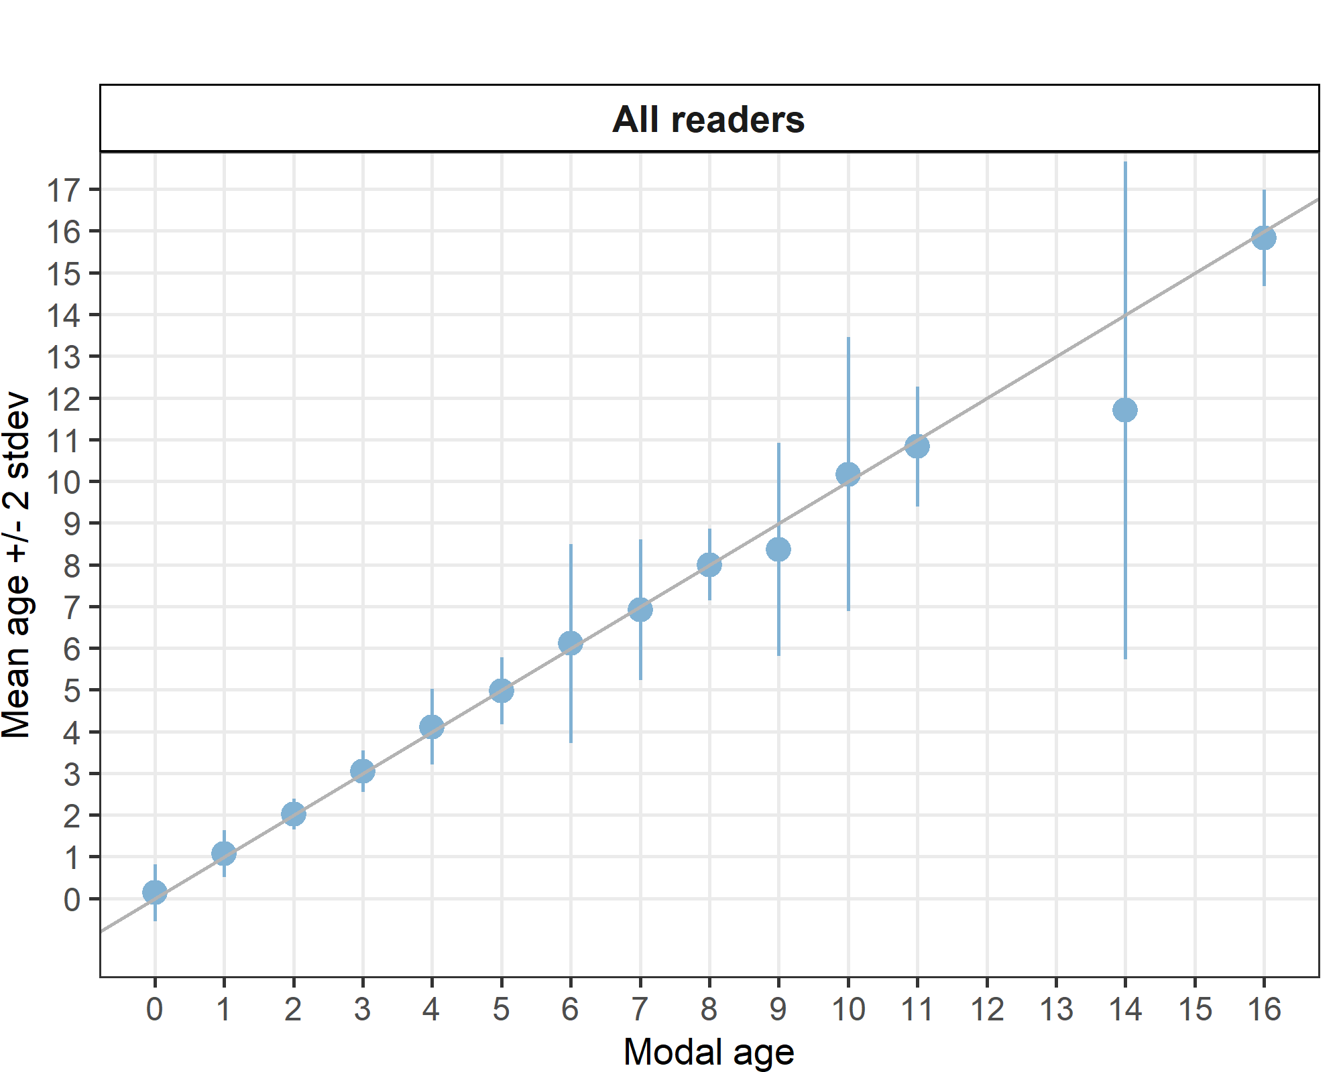
Figure X:: Age bias plot for all readers. Mean age recorded +/- 2 stdev of each reader and all readers combined are plotted against modal age. The estimated mean age corresponds to modal age, if the estimated mean age is on the 1:1 equilibrium line (solid line). Relative bias is the age difference between estimated mean age and modal age.

Inter-reader bias test
Table X: Inter reader bias test. The Inter-reader bias test gives probability of bias between readers and with modal age. - = no sign of bias (p>0.05), * = possibility of bias (0.01<p<0.05), * * = certainty of bias (p<0.01) , / = diagonal of the table (no bias)
Comparison | R02 SE | R04 SE | R06 SE | R08 FI | R10 FI | R12 SE | R14 FI | R16 FI | R18 FI | R20 FI | R22 FI | R28 FI
R02 SE | / | * | ** | ** | ** | ** | ** | ** | ** | ** | ** | **
R04 SE | * | / | ** | * | * | - | ** | - | - | ** | - | **
R06 SE | ** | ** | / | ** | ** | ** | ** | ** | ** | ** | ** | **
R08 FI | ** | * | ** | / | ** | ** | ** | ** | ** | ** | ** | **
R10 FI | ** | * | ** | ** | / | ** | ** | - | ** | ** | ** | **
R12 SE | ** | - | ** | ** | ** | / | - | - | - | ** | ** | **
R14 FI | ** | ** | ** | ** | ** | - | / | ** | ** | * | ** | **
R16 FI | ** | - | ** | ** | - | - | ** | / | ** | ** | ** | **
R18 FI | ** | - | ** | ** | ** | - | ** | ** | / | ** | ** | **
R20 FI | ** | ** | ** | ** | ** | ** | * | ** | ** | / | ** | **
R22 FI | ** | - | ** | ** | ** | ** | ** | ** | ** | ** | / | **
R28 FI | ** | ** | ** | ** | ** | ** | ** | ** | ** | ** | ** | /
Modal age | ** | - | - | - | - | ** | ** | ** | ** | * | - | -

Growth analysis
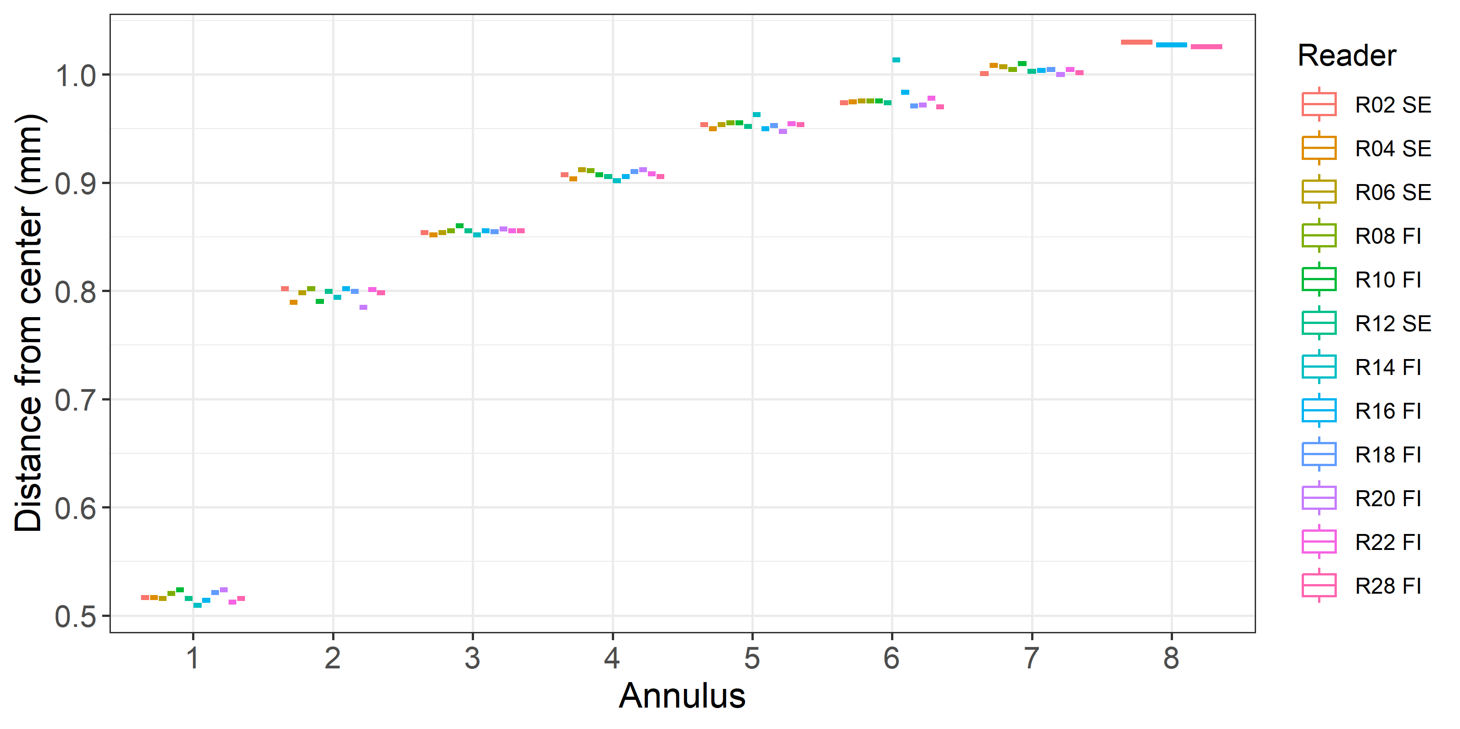
Figure X: Plot of average distance from the centre to the winter rings for all readers. The boxes represent the median, upper and lower box boundaries of the interquartile range, whiskers represent the minimum and maximum values and the dots represent the outliers.

Samples split by strata
Comparison results by reader on strata: Strata_27.3.d.30
Multimodal cases
Table X: Strata 27.3.d.30 .Total number of samples (NSample) and percentage of cases (fish samples) with multiple modes depending on the approach to weight the experience of the reader which will be considered when defining the fish age mode. PercMM_traditional shows the percentage of the total samples for which multiple modes are obtained when all the readers are equally weighted. PercMM_linear_weight shows the percentage of the total samples for which multiple modes are obtained when the weight assigned to the different readers decreases linearly with the experience, while in the PercMM_negexp the weight applied decreases with a negative exponential shape with the experience. The PercMM_multistage shows the percentage of multiple mode cases when a combination of the different methodologies is used, as explained in the material and methods section
NSample | PercMM_traditional | PercMM_linear_weight | PercMM_negexp_weight | PercMM_multistage
200 | 2 % | 0 % | 0 % | 0 %
Summary statistics
Table X: Strata Strata_27.3.d.30 .Summary of statistics; Total number of samples (NSample), coefficient of variance (CV), percentage of agreement (PA) and average percentage error (APE) for all ages and readers
NSample | CV | PA | APE
200 | 14 % | 87 % | 7 %
In this exchange event 200 otolith fish individuals were aged. Of those, 2 %when the traditional approach (all readers equally weighted) is used to define the mode. The percentage of multiple mode cases is reduced to 0 %. The complete list of cases with multiple modes is presented in table X in the annex 3 section, where the ageing from each of the readers participating in the exchange event is presented. When all the otolith samples are considered (both single and multimodal cases) the weighted average percentage agreement based on modal ages for all readers is 87 %, with the weighted average CV of 14 % and APE of 7 %.

Coefficient of Variation (CV)
Table X: Strata_27.3.d.30 .Coefficient of Variation (CV) table presents the CV per modal age and reader, the CV of all readers combined per modal age and a weighted mean of the CV per reader
 | Modal age | R02 SE | R04 SE | R06 SE | R08 FI | R10 FI | R12 SE | R14 FI | R16 FI
0 | 0 | - | - | - | - | - | - | - | -
1 | 1 | 15 % | 0 % | 15 % | 20 % | 20 % | 0 % | 39 % | 0 %
2 | 2 | 0 % | 0 % | 0 % | 0 % | 10 % | 0 % | 17 % | 13 %
3 | 3 | 14 % | 0 % | 6 % | 6 % | 13 % | 0 % | 6 % | 6 %
4 | 4 | 11 % | 8 % | 7 % | 10 % | 16 % | 0 % | 9 % | 8 %
5 | 5 | 0 % | 6 % | 5 % | 6 % | 9 % | 10 % | 8 % | 8 %
6 | 6 | 28 % | 17 % | 13 % | 7 % | 30 % | 12 % | 7 % | 14 %
7 | 7 | 7 % | 16 % | 7 % | 14 % | 11 % | 15 % | 11 % | 7 %
8 | 8 | 0 % | - | 0 % | 8 % | 0 % | 9 % | 0 % | 8 %
9 | 9 | 0 % | 18 % | 9 % | 23 % | 10 % | 20 % | 12 % | 10 %
10 | 10 | - | - | - | - | - | - | - | -
11 | 11 | - | - | - | - | - | - | - | -
12 | 12 | - | - | - | - | - | - | - | -
13 | 13 | - | - | - | - | - | - | - | -
14 | 14 | - | - | - | - | - | - | - | -
15 | 15 | - | - | - | - | - | - | - | -
16 | 16 | - | - | - | - | - | - | - | -
18 | Weighted Mean | 9 % | 4 % | 8 % | 10 % | 15 % | 4 % | 17 % | 7 %

 | Modal age | R18 FI | R20 FI | R22 FI | R28 FI | all
0 | 0 | - | - | - | - | -
1 | 1 | 29 % | 34 % | 36 % | 24 % | 26 %
2 | 2 | 10 % | 13 % | 0 % | 10 % | 9 %
3 | 3 | 10 % | 6 % | 10 % | 8 % | 8 %
4 | 4 | 16 % | 10 % | 8 % | 13 % | 11 %
5 | 5 | 9 % | 9 % | 10 % | 8 % | 8 %
6 | 6 | 32 % | 9 % | 23 % | 14 % | 20 %
7 | 7 | 9 % | 16 % | 12 % | 15 % | 12 %
8 | 8 | 0 % | 0 % | 0 % | 9 % | 5 %
9 | 9 | 6 % | 22 % | 11 % | 18 % | 15 %
10 | 10 | - | - | - | - | 16 %
11 | 11 | - | - | - | - | 7 %
12 | 12 | - | - | - | - | -
13 | 13 | - | - | - | - | -
14 | 14 | - | - | - | - | 25 %
15 | 15 | - | - | - | - | -
16 | 16 | - | - | - | - | 4 %
18 | Weighted Mean | 16 % | 18 % | 15 % | 14 % | 14 %

Percentage of Agreement (PA)
The percentage agreement per reader per modal age tells how large part of the readings that are equal to the modal age. The weighted mean including at the bottom of the table is weighted according to number of age readings.
Table X: Strata_27.3.d.30 .Percentage agreement (PA) table represents the PA per modal age and reader, the PA of all readers combined per modal age and a weighted mean of the PA per reader.
 | Modal age | R02 SE | R04 SE | R06 SE | R08 FI | R10 FI | R12 SE | R14 FI | R16 FI
0 | 0 | 100 % | 91 % | 100 % | 100 % | 100 % | 100 % | 83 % | 100 %
1 | 1 | 98 % | 100 % | 98 % | 96 % | 96 % | 100 % | 76 % | 100 %
2 | 2 | 100 % | 100 % | 100 % | 100 % | 96 % | 100 % | 88 % | 92 %
3 | 3 | 93 % | 100 % | 97 % | 97 % | 93 % | 100 % | 97 % | 97 %
4 | 4 | 92 % | 91 % | 92 % | 75 % | 79 % | 100 % | 88 % | 88 %
5 | 5 | 100 % | 89 % | 94 % | 90 % | 81 % | 84 % | 84 % | 84 %
6 | 6 | 91 % | 70 % | 64 % | 82 % | 73 % | 73 % | 82 % | 91 %
7 | 7 | 70 % | 67 % | 70 % | 70 % | 60 % | 70 % | 70 % | 80 %
8 | 8 | 100 % | 100 % | 100 % | 50 % | 100 % | 50 % | 100 % | 50 %
9 | 9 | 100 % | 50 % | 40 % | 40 % | 80 % | 20 % | 0 % | 40 %
10 | 10 | 100 % | 100 % | 100 % | 0 % | 0 % | 100 % | 0 % | 0 %
11 | 11 | 100 % | 100 % | 100 % | 100 % | 100 % | 100 % | 0 % | 0 %
12 | 12 | - | - | - | - | - | - | - | -
13 | 13 | - | - | - | - | - | - | - | -
14 | 14 | - | - | 100 % | 0 % | 100 % | 0 % | 0 % | 0 %
15 | 15 | - | - | - | - | - | - | - | -
16 | 16 | 100 % | 100 % | 100 % | 100 % | 100 % | 100 % | 0 % | 100 %
18 | Weighted Mean | 95 % | 92 % | 92 % | 88 % | 87 % | 91 % | 80 % | 89 %

 | Modal age | R18 FI | R20 FI | R22 FI | R28 FI | total
0 | 0 | 92 % | 17 % | 58 % | 100 % | 87 %
1 | 1 | 98 % | 80 % | 89 % | 93 % | 93 %
2 | 2 | 96 % | 92 % | 100 % | 96 % | 97 %
3 | 3 | 90 % | 97 % | 90 % | 93 % | 95 %
4 | 4 | 92 % | 83 % | 88 % | 67 % | 86 %
5 | 5 | 81 % | 77 % | 74 % | 81 % | 85 %
6 | 6 | 64 % | 55 % | 82 % | 64 % | 74 %
7 | 7 | 60 % | 60 % | 70 % | 80 % | 69 %
8 | 8 | 100 % | 100 % | 100 % | 50 % | 83 %
9 | 9 | 60 % | 40 % | 20 % | 60 % | 45 %
10 | 10 | 100 % | 0 % | 0 % | 0 % | 42 %
11 | 11 | 100 % | 100 % | 100 % | 0 % | 75 %
12 | 12 | - | - | - | - | -
13 | 13 | - | - | - | - | -
14 | 14 | 0 % | 0 % | 100 % | 0 % | 30 %
15 | 15 | - | - | - | - | -
16 | 16 | 100 % | 100 % | 100 % | 100 % | 92 %
18 | Weighted Mean | 87 % | 76 % | 83 % | 84 % | 87 %

Average Percentage Error (APE)
Table X: Strata_27.3.d.30 .Average Percentage Error (APE) table represents the APE per modal age and reader, the APE of all advanced readers combined per modal age and a weighted mean of the APE per reader.
 | Modal age | R02 SE | R04 SE | R06 SE | R08 FI | R10 FI | R12 SE | R14 FI | R16 FI
0 | 0 | - | - | - | - | - | - | - | -
1 | 1 | 4 % | 0 % | 4 % | 8 % | 8 % | 0 % | 32 % | 0 %
2 | 2 | 0 % | 0 % | 0 % | 0 % | 4 % | 0 % | 8 % | 7 %
3 | 3 | 7 % | 0 % | 2 % | 2 % | 6 % | 0 % | 2 % | 2 %
4 | 4 | 6 % | 2 % | 4 % | 9 % | 11 % | 0 % | 4 % | 5 %
5 | 5 | 0 % | 4 % | 1 % | 2 % | 4 % | 7 % | 5 % | 4 %
6 | 6 | 15 % | 9 % | 9 % | 5 % | 17 % | 9 % | 5 % | 8 %
7 | 7 | 6 % | 11 % | 6 % | 8 % | 8 % | 11 % | 8 % | 3 %
8 | 8 | 0 % | 0 % | 0 % | 6 % | 0 % | 7 % | 0 % | 6 %
9 | 9 | 0 % | 12 % | 7 % | 20 % | 7 % | 15 % | 10 % | 8 %
10 | 10 | 0 % | 0 % | 0 % | 0 % | 0 % | 0 % | 0 % | 0 %
11 | 11 | 0 % | 0 % | 0 % | 0 % | 0 % | 0 % | 0 % | 0 %
12 | 12 | - | - | - | - | - | - | - | -
13 | 13 | - | - | - | - | - | - | - | -
14 | 14 | - | - | 0 % | 0 % | 0 % | 0 % | 0 % | 0 %
15 | 15 | - | - | - | - | - | - | - | -
16 | 16 | 0 % | 0 % | 0 % | 0 % | 0 % | 0 % | 0 % | 0 %
18 | Weighted Mean | 4 % | 2 % | 3 % | 5 % | 7 % | 3 % | 11 % | 3 %

 | Modal age | R18 FI | R20 FI | R22 FI | R28 FI | all
0 | 0 | - | - | - | - | -
1 | 1 | 8 % | 27 % | 21 % | 12 % | 12 %
2 | 2 | 4 % | 7 % | 0 % | 4 % | 3 %
3 | 3 | 6 % | 2 % | 6 % | 4 % | 3 %
4 | 4 | 6 % | 7 % | 5 % | 11 % | 6 %
5 | 5 | 5 % | 7 % | 5 % | 5 % | 4 %
6 | 6 | 18 % | 9 % | 11 % | 8 % | 9 %
7 | 7 | 7 % | 12 % | 8 % | 8 % | 7 %
8 | 8 | 0 % | 0 % | 0 % | 7 % | 2 %
9 | 9 | 6 % | 17 % | 9 % | 12 % | 12 %
10 | 10 | 0 % | 0 % | 0 % | 0 % | 10 %
11 | 11 | 0 % | 0 % | 0 % | 0 % | 4 %
12 | 12 | - | - | - | - | -
13 | 13 | - | - | - | - | -
14 | 14 | 0 % | 0 % | 0 % | 0 % | 20 %
15 | 15 | - | - | - | - | -
16 | 16 | 0 % | 0 % | 0 % | 0 % | 2 %
18 | Weighted Mean | 7 % | 13 % | 9 % | 8 % | 7 %

Relative bias
The relative bias is the difference between the mean age (per modal age per reader) and modal age. As for the previous tables, a combined bias for all readers and weighted means are calculated.
Table X: Strata_27.3.d.30 . The relative bias (as the difference between the mean and modal age) per modal age and reader is presented, as well as the weighted mean relative bias per reader and the relative bias per modal age for all readers combined.
 | Modal age | R02 SE | R04 SE | R06 SE | R08 FI | R10 FI | R12 SE | R14 FI | R16 FI
0 | 0 | 0.00 | 0.09 | 0.00 | 0.00 | 0.00 | 0.00 | 0.17 | 0.00
1 | 1 | 0.02 | 0.00 | 0.02 | 0.04 | 0.04 | 0.00 | 0.27 | 0.00
2 | 2 | 0.00 | 0.00 | 0.00 | 0.00 | 0.04 | 0.00 | 0.04 | 0.08
3 | 3 | 0.11 | 0.00 | 0.03 | -0.03 | 0.10 | 0.00 | 0.03 | 0.03
4 | 4 | 0.12 | 0.00 | 0.08 | 0.25 | 0.29 | 0.00 | 0.04 | 0.12
5 | 5 | 0.00 | -0.11 | 0.00 | 0.03 | 0.00 | -0.19 | -0.10 | -0.03
6 | 6 | 0.55 | -0.10 | 0.27 | 0.18 | 0.45 | -0.36 | -0.18 | 0.27
7 | 7 | 0.30 | -0.56 | 0.30 | 0.10 | 0.30 | -0.50 | -0.40 | 0.00
8 | 8 | 0.00 | 0.00 | 0.00 | 0.50 | 0.00 | -0.50 | 0.00 | 0.50
9 | 9 | 0.00 | -1.00 | 0.20 | -1.00 | 0.40 | -1.60 | -1.60 | -0.80
10 | 10 | 0.00 | 0.00 | 0.00 | 1.00 | 3.00 | 0.00 | -4.00 | 1.00
11 | 11 | 0.00 | 0.00 | 0.00 | 0.00 | 0.00 | 0.00 | -2.00 | -1.00
12 | 12 | - | - | - | - | - | - | - | -
13 | 13 | - | - | - | - | - | - | - | -
14 | 14 | - | - | 0.00 | -4.00 | 0.00 | -3.00 | -9.00 | 1.00
15 | 15 | - | - | - | - | - | - | - | -
16 | 16 | 0.00 | 0.00 | 0.00 | 0.00 | 0.00 | 0.00 | -2.00 | 0.00
18 | Weighted Mean | 0.08 | -0.06 | 0.06 | 0.02 | 0.13 | -0.14 | -0.09 | 0.03

 | Modal age | R18 FI | R20 FI | R22 FI | R28 FI | all
0 | 0 | 0.08 | 0.83 | 0.42 | 0.00 | 0.13
1 | 1 | 0.05 | 0.20 | 0.13 | 0.07 | 0.07
2 | 2 | -0.04 | 0.08 | 0.00 | 0.04 | 0.02
3 | 3 | 0.10 | -0.03 | 0.10 | 0.07 | 0.04
4 | 4 | 0.08 | -0.17 | 0.12 | 0.38 | 0.11
5 | 5 | 0.06 | -0.16 | 0.00 | 0.13 | -0.03
6 | 6 | 0.36 | -0.45 | 0.18 | 0.09 | 0.11
7 | 7 | 0.20 | -0.40 | -0.20 | -0.20 | -0.09
8 | 8 | 0.00 | 0.00 | 0.00 | -0.50 | 0.00
9 | 9 | -0.40 | -1.40 | 0.00 | -0.40 | -0.63
10 | 10 | 0.00 | -1.00 | 1.00 | 1.00 | 0.17
11 | 11 | 0.00 | 0.00 | 0.00 | 1.00 | -0.17
12 | 12 | - | - | - | - | -
13 | 13 | - | - | - | - | -
14 | 14 | -4.00 | -1.00 | 0.00 | -3.00 | -
15 | 15 | - | - | - | - | -
16 | 16 | 0.00 | 0.00 | 0.00 | 0.00 | -0.17
18 | Weighted Mean | 0.05 | -0.04 | 0.09 | 0.07 | 0.03
Figure X: Strata_27.3.d.30 .Age bias plot for all readers. Mean age recorded +/- 2 stdev of each reader and all readers combined are plotted against modal age. The estimated mean age corresponds to modal age, if the estimated mean age is on the 1:1 equilibrium line (solid line). Relative bias is the age difference between estimated mean age and modal age.

Inter-reader bias test
Table X: Strata_27.3.d.30 .Inter reader bias test. The Inter-reader bias test gives probability of bias between readers and with modal age. - = no sign of bias (p>0.05), * = possibility of bias (0.01<p<0.05), * * = certainty of bias (p<0.01) , / = diagonal of the table (no bias)
Comparison | R02 SE | R04 SE | R06 SE | R08 FI | R10 FI | R12 SE | R14 FI | R16 FI | R18 FI | R20 FI | R22 FI | R28 FI
R02 SE | / | * | ** | ** | ** | ** | ** | ** | ** | ** | ** | **
R04 SE | * | / | ** | * | * | - | ** | - | - | ** | - | **
R06 SE | ** | ** | / | ** | ** | ** | ** | ** | ** | ** | ** | **
R08 FI | ** | * | ** | / | ** | ** | ** | ** | ** | ** | ** | **
R10 FI | ** | * | ** | ** | / | ** | ** | - | ** | ** | ** | **
R12 SE | ** | - | ** | ** | ** | / | - | - | - | ** | ** | **
R14 FI | ** | ** | ** | ** | ** | - | / | ** | ** | * | ** | **
R16 FI | ** | - | ** | ** | - | - | ** | / | ** | ** | ** | **
R18 FI | ** | - | ** | ** | ** | - | ** | ** | / | ** | ** | **
R20 FI | ** | ** | ** | ** | ** | ** | * | ** | ** | / | ** | **
R22 FI | ** | - | ** | ** | ** | ** | ** | ** | ** | ** | / | **
R28 FI | ** | ** | ** | ** | ** | ** | ** | ** | ** | ** | ** | /
Modal age | ** | - | - | - | - | ** | ** | ** | ** | * | - | -

Growth Analysis
Figure X: Strata_27.3.d.30 .Plot of average distance from the centre to the winter rings for all readers. The boxes represent the median, upper and lower box boundaries of the interquartile range, whiskers represent the minimum and maximum values and the dots represent the outliers.

Overall comparison of results by strata
Table X: Number of age readings per strata and modal age for all advanced readers combined.
Modal age | Strata_27.3.d.30 | total
0 | 142 | 142
1 | 536 | 536
2 | 299 | 299
3 | 357 | 357
4 | 287 | 287
5 | 369 | 369
6 | 131 | 131
7 | 119 | 119
8 | 23 | 23
9 | 58 | 58
10 | 12 | 12
11 | 12 | 12
12 | 0 | 0
13 | 0 | 0
14 | 10 | 10
15 | 0 | 0
16 | 12 | 12
Total | 2367 | 2367

Coefficient of Variation (CV)
Table X: CV per strata and modal age for all advanced readers combined.
Modal age | Strata_27.3.d.30 | all
0 | - | -
1 | 26 % | 26 %
2 | 9 % | 9 %
3 | 8 % | 8 %
4 | 11 % | 11 %
5 | 8 % | 8 %
6 | 20 % | 20 %
7 | 12 % | 12 %
8 | 5 % | 5 %
9 | 15 % | 15 %
10 | 16 % | 16 %
11 | 7 % | 7 %
12 | - | -
13 | - | -
14 | 25 % | 25 %
15 | - | -
16 | 4 % | 4 %
Weighted Mean | 14 % | 14 %

Percentage of Agreement (PA)
Table X: Percentage Agreement per strata and modal age for all advanced readers combined.
Modal age | Strata_27.3.d.30 | total
0 | 87 % | 87 %
1 | 93 % | 93 %
2 | 97 % | 97 %
3 | 95 % | 95 %
4 | 86 % | 86 %
5 | 85 % | 85 %
6 | 74 % | 74 %
7 | 69 % | 69 %
8 | 83 % | 83 %
9 | 45 % | 45 %
10 | 42 % | 42 %
11 | 75 % | 75 %
12 | - | -
13 | - | -
14 | 30 % | 30 %
15 | - | -
16 | 92 % | 92 %
Weighted Mean | 87 % | 87 %

Average Percentage Error (APE)
Table X: Average Percentage Error per strata and modal age for all advanced readers combined.
Modal age | Strata_27.3.d.30 | all
0 | - | -
1 | 12 % | 12 %
2 | 3 % | 3 %
3 | 3 % | 3 %
4 | 6 % | 6 %
5 | 4 % | 4 %
6 | 9 % | 9 %
7 | 7 % | 7 %
8 | 2 % | 2 %
9 | 12 % | 12 %
10 | 10 % | 10 %
11 | 4 % | 4 %
12 | - | -
13 | - | -
14 | 20 % | 20 %
15 | - | -
16 | 2 % | 2 %
Weighted Mean | 7 % | 7 %

Relative bias
Table X: Relative Bias per strata and modal age for all advanced readers combined.
Modal age | Strata_27.3.d.30 | all
0 | 0.13 | 0.13
1 | 0.07 | 0.07
2 | 0.02 | 0.02
3 | 0.04 | 0.04
4 | 0.11 | 0.11
5 | -0.03 | -0.03
6 | 0.11 | 0.11
7 | -0.08 | -0.08
8 | 0.00 | 0.00
9 | -0.64 | -0.64
10 | 0.17 | 0.17
11 | -0.17 | -0.17
12 | - | -
13 | - | -
14 | -2.30 | -2.30
15 | - | -
16 | -0.17 | -0.17
Weighted Mean | 0.02 | 0.02

Growth analysis
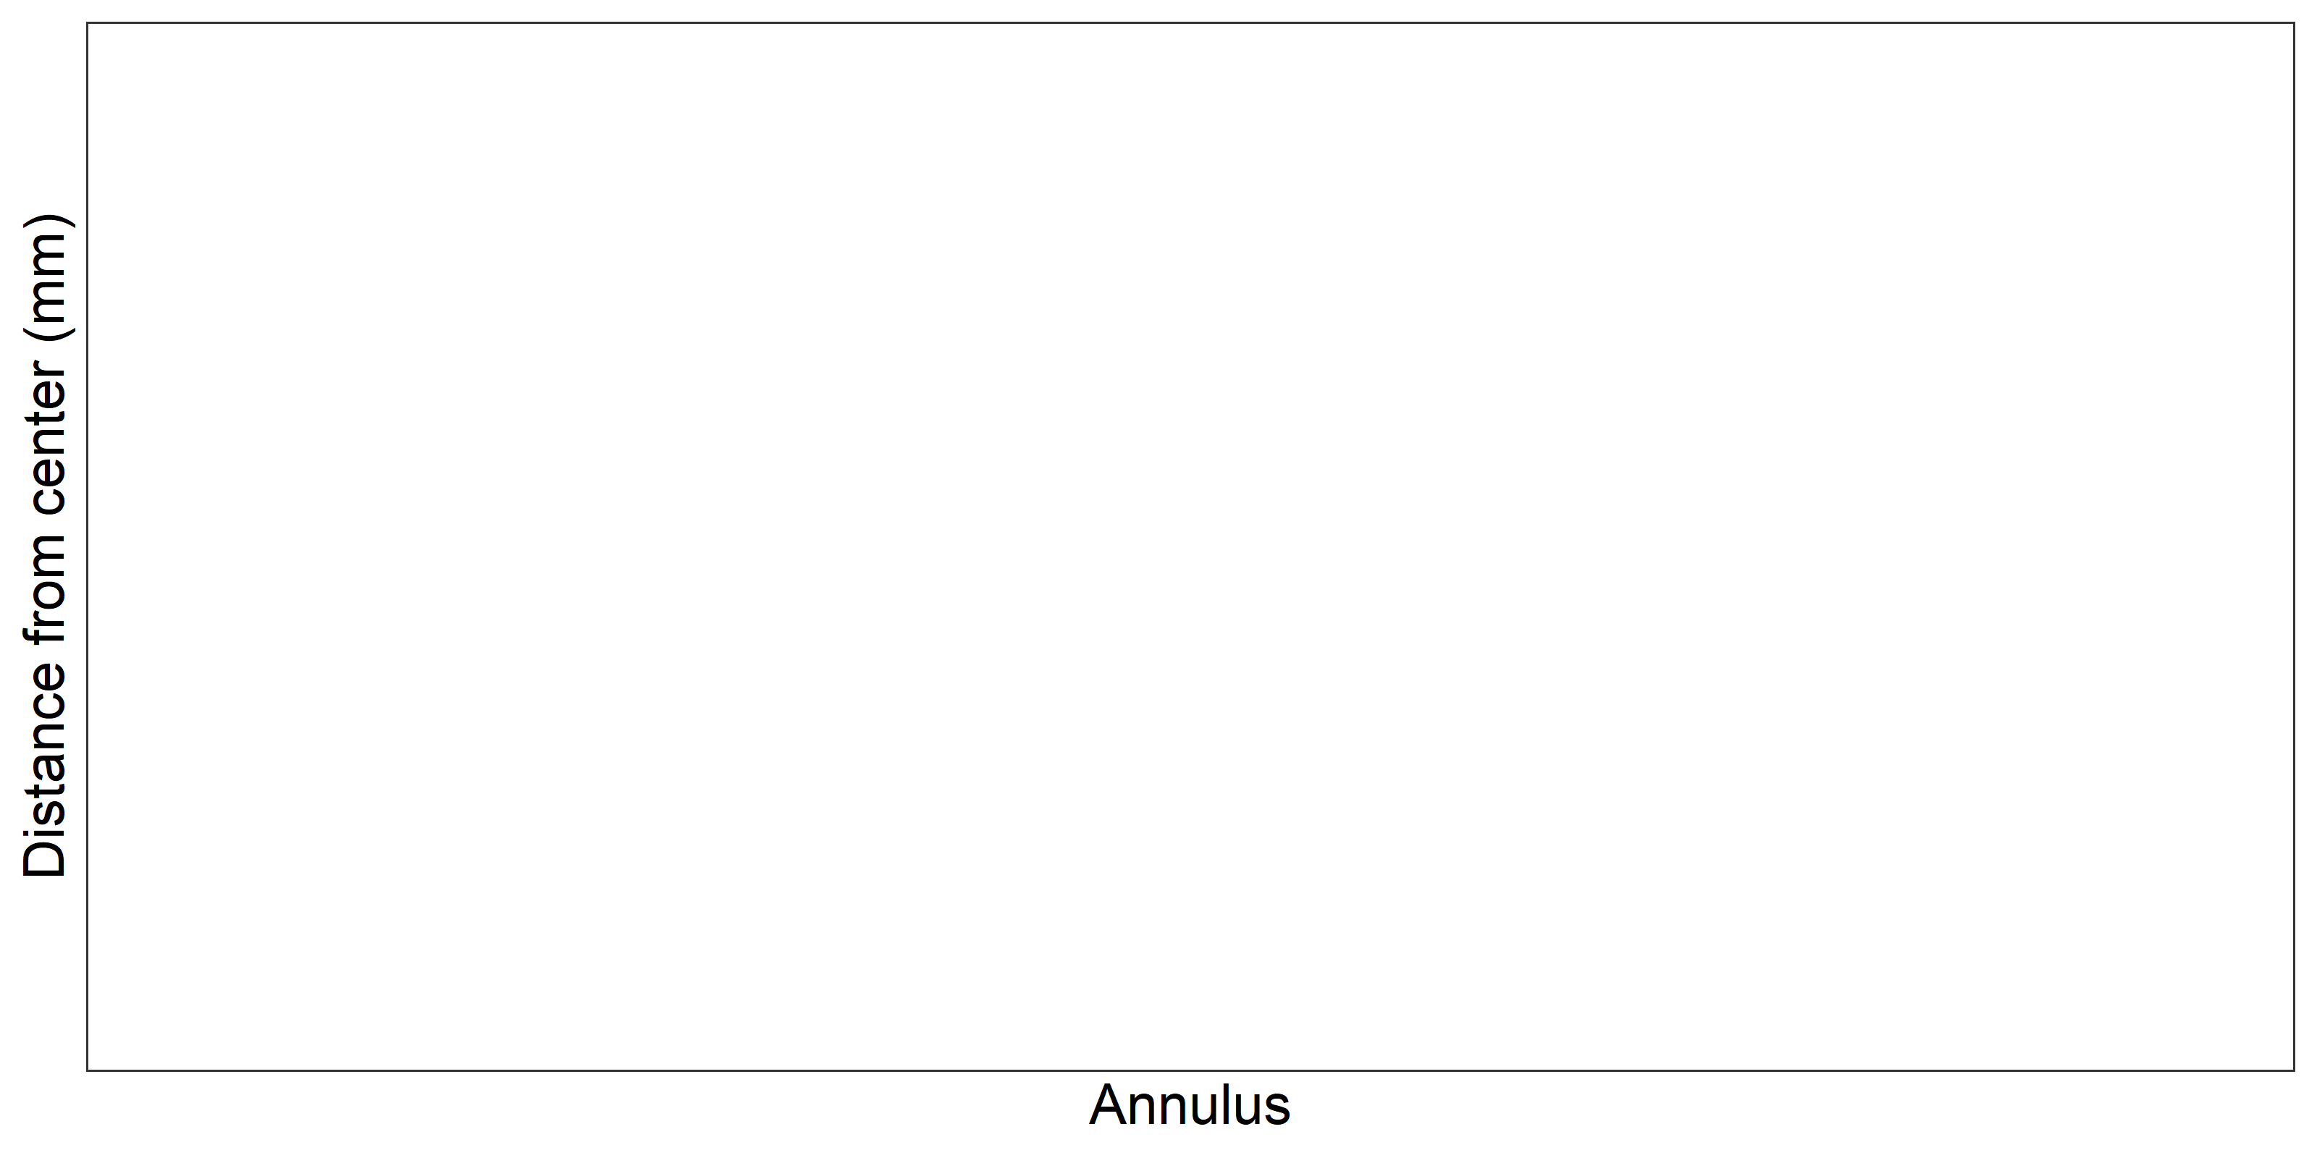
Figure X: Plot of average distance from the centre to the winter rings for all readers by strata. The boxes represent the median, upper and lower box boundaries of the interquartile range, whiskers represent the minimum and maximum values and the dots represent the outliers.

Advanced readers
All samples included
Multimodal cases
Table X: Summary of statistics; Total number of samples (NSample), a percentage of cases (fish samples) with multiple modes depending on the approach to weight the experience of the reader which will be considered when defining the fish age mode. PercMM_traditional shows the percentage of the total samples for which multiple modes are obtained when all the readers are equally weighted. PercMM_linear_weight shows the percentage of the total samples for which multiple modes are obtained when the weight assigned to the different readers decreases linearly with the experience, while in the PercMM_negexp the weight applied decreases with a negative exponential shape with the experience. The PercMM_multistage shows the percentage of multiple mode cases when a combination of the different methodologies is used, as explained in the material and methods section
NSample | PercMM_traditional | PercMM_linear_weight | PercMM_negexp_weight | PercMM_multistage
199 | 5 % | 0 % | 0 % | 0 %

Summary statistics
Table X: Summary of statistics; Total number of samples (NSample), coefficient of variance (CV), percentage of agreement (PA) and average percentage error (APE) for all ages and readers
NSample | CV | PA | APE
199 | 10 % | 91 % | 4 %
In this exchange event, 199 otolith fish individuals were aged. Of those, 5 %when the traditional approach (all readers equally weighted) is used to define the mode. The percentage of multiple mode cases is reduced to 0 %. The complete list of cases with multiple modes is presented in table X in the annex 3 section, where the ageing from each of the readers participating in the exchange event is presented. When all the otolith samples are considered (both single and multimodal cases) the weighted average percentage agreement based on modal ages for all readers is 91 %, with the weighted average CV of 10 % and APE of 4 %.

Coefficient of Variation (CV)
Table X: Coefficient of Variation (CV) table presents the CV per modal age and advanced reader, the CV of all advanced readers combined per modal age and a weighted mean of the CV per reader.
Modal age | R02 SE | R04 SE | R06 SE | R08 FI | R12 SE | R28 FI | all
0 | - | - | - | - | - | - | -
1 | 15 % | 0 % | 15 % | 20 % | 0 % | 24 % | 16 %
2 | 0 % | 0 % | 0 % | 0 % | 0 % | 10 % | 4 %
3 | 14 % | 0 % | 6 % | 6 % | 0 % | 8 % | 7 %
4 | 17 % | 7 % | 15 % | 11 % | 0 % | 13 % | 13 %
5 | 0 % | 4 % | 4 % | 5 % | 9 % | 9 % | 6 %
6 | 14 % | 12 % | 13 % | 7 % | 14 % | 17 % | 13 %
7 | 7 % | 7 % | 7 % | 10 % | 7 % | 5 % | 8 %
8 | 25 % | 0 % | 0 % | 20 % | 14 % | 8 % | 16 %
9 | 0 % | 8 % | 6 % | 22 % | 25 % | 22 % | 16 %
10 | - | 7 % | 0 % | 7 % | 7 % | 7 % | 6 %
11 | - | - | 17 % | 7 % | 0 % | 6 % | 9 %
12 | - | - | - | - | - | - | -
13 | - | - | - | - | - | - | -
14 | - | - | - | - | - | - | -
15 | - | - | - | - | - | - | -
16 | - | - | - | - | - | - | 0 %
Weighted Mean | 10 % | 3 % | 9 % | 10 % | 3 % | 14 % | 10 %

Percentage of Agreement (PA)
Table X: Percentage agreement (PA) table represents the PA per modal age and reader, advanced the PA of all advanced readers combined per modal age and a weighted mean of the PA per reader.
Modal age | R02 SE | R04 SE | R06 SE | R08 FI | R12 SE | R28 FI | total
0 | 100 % | 91 % | 100 % | 100 % | 100 % | 100 % | 99 %
1 | 98 % | 100 % | 98 % | 96 % | 100 % | 93 % | 97 %
2 | 100 % | 100 % | 100 % | 100 % | 100 % | 96 % | 99 %
3 | 93 % | 100 % | 97 % | 97 % | 100 % | 93 % | 97 %
4 | 81 % | 92 % | 85 % | 70 % | 100 % | 63 % | 82 %
5 | 100 % | 96 % | 97 % | 93 % | 90 % | 79 % | 92 %
6 | 91 % | 80 % | 64 % | 82 % | 64 % | 64 % | 74 %
7 | 67 % | 75 % | 67 % | 78 % | 78 % | 89 % | 75 %
8 | 67 % | 100 % | 100 % | 33 % | 33 % | 67 % | 65 %
9 | 100 % | 50 % | 67 % | 67 % | 0 % | 67 % | 59 %
10 | 100 % | 50 % | 100 % | 50 % | 50 % | 50 % | 64 %
11 | 100 % | 100 % | 50 % | 50 % | 100 % | 50 % | 70 %
12 | - | - | - | - | - | - | -
13 | - | - | - | - | - | - | -
14 | - | - | - | - | - | - | -
15 | - | - | - | - | - | - | -
16 | 100 % | 100 % | 100 % | 100 % | 100 % | 100 % | 100 %
Weighted Mean | 93 % | 95 % | 92 % | 89 % | 92 % | 84 % | 91 %

Average Percentage Error (APE)
Table X: Average Percentage Error (APE) table represents the APE per modal age and reader, the APE of all advanced readers combined per modal age and a weighted mean of the APE per reader.
Modal age | R02 SE | R04 SE | R06 SE | R08 FI | R12 SE | R28 FI | all
0 | - | - | - | - | - | - | -
1 | 4 % | 0 % | 4 % | 8 % | 0 % | 12 % | 5 %
2 | 0 % | 0 % | 0 % | 0 % | 0 % | 4 % | 1 %
3 | 7 % | 0 % | 2 % | 2 % | 0 % | 4 % | 2 %
4 | 11 % | 2 % | 9 % | 10 % | 0 % | 12 % | 8 %
5 | 0 % | 1 % | 1 % | 3 % | 5 % | 6 % | 2 %
6 | 8 % | 8 % | 9 % | 5 % | 10 % | 11 % | 7 %
7 | 6 % | 6 % | 6 % | 7 % | 5 % | 3 % | 5 %
8 | 19 % | 0 % | 0 % | 14 % | 10 % | 6 % | 9 %
9 | 0 % | 6 % | 5 % | 17 % | 19 % | 17 % | 12 %
10 | 0 % | 5 % | 0 % | 5 % | 5 % | 5 % | 4 %
11 | 0 % | 0 % | 12 % | 5 % | 0 % | 4 % | 6 %
12 | - | - | - | - | - | - | -
13 | - | - | - | - | - | - | -
14 | - | - | - | - | - | - | -
15 | - | - | - | - | - | - | -
16 | 0 % | 0 % | 0 % | 0 % | 0 % | 0 % | 0 %
Weighted Mean | 5 % | 1 % | 4 % | 5 % | 2 % | 8 % | 4 %

Relative Bias
Table X: The relative bias (as the difference between the mean and modal age) per modal age and advanced reader is presented, as well as the weighted mean relative bias per reader and the relative bias per modal age for all advanced readers combined.
Modal age | R02 SE | R04 SE | R06 SE | R08 FI | R12 SE | R28 FI | all
0 | 0.00 | 0.09 | 0.00 | 0.00 | 0.00 | 0.00 | 0.02
1 | 0.02 | 0.00 | 0.02 | 0.04 | 0.00 | 0.07 | 0.03
2 | 0.00 | 0.00 | 0.00 | 0.00 | 0.00 | 0.04 | 0.01
3 | 0.11 | 0.00 | 0.03 | -0.03 | 0.00 | 0.07 | 0.03
4 | 0.30 | 0.00 | 0.22 | 0.30 | 0.00 | 0.41 | 0.20
5 | 0.00 | -0.04 | 0.03 | 0.07 | -0.14 | 0.14 | 0.01
6 | 0.27 | -0.30 | 0.27 | 0.18 | -0.27 | 0.18 | 0.06
7 | 0.33 | -0.25 | 0.33 | 0.33 | -0.22 | 0.11 | 0.11
8 | 1.33 | 0.00 | 0.00 | -0.33 | -1.00 | -0.33 | -0.06
9 | 0.00 | -0.50 | 0.33 | -1.00 | -2.00 | -1.00 | -0.69
10 | 0.00 | -0.50 | 0.00 | 0.50 | -0.50 | 0.50 | 0.00
11 | 0.00 | 0.00 | 1.50 | -0.50 | 0.00 | 0.50 | 0.25
12 | - | - | - | - | - | - | -
13 | - | - | - | - | - | - | -
14 | - | - | - | - | - | - | -
15 | - | - | - | - | - | - | -
16 | 0.00 | 0.00 | 0.00 | 0.00 | 0.00 | 0.00 | 0.00
Weighted Mean | 0.11 | -0.04 | 0.10 | 0.06 | -0.10 | 0.11 | 0.04
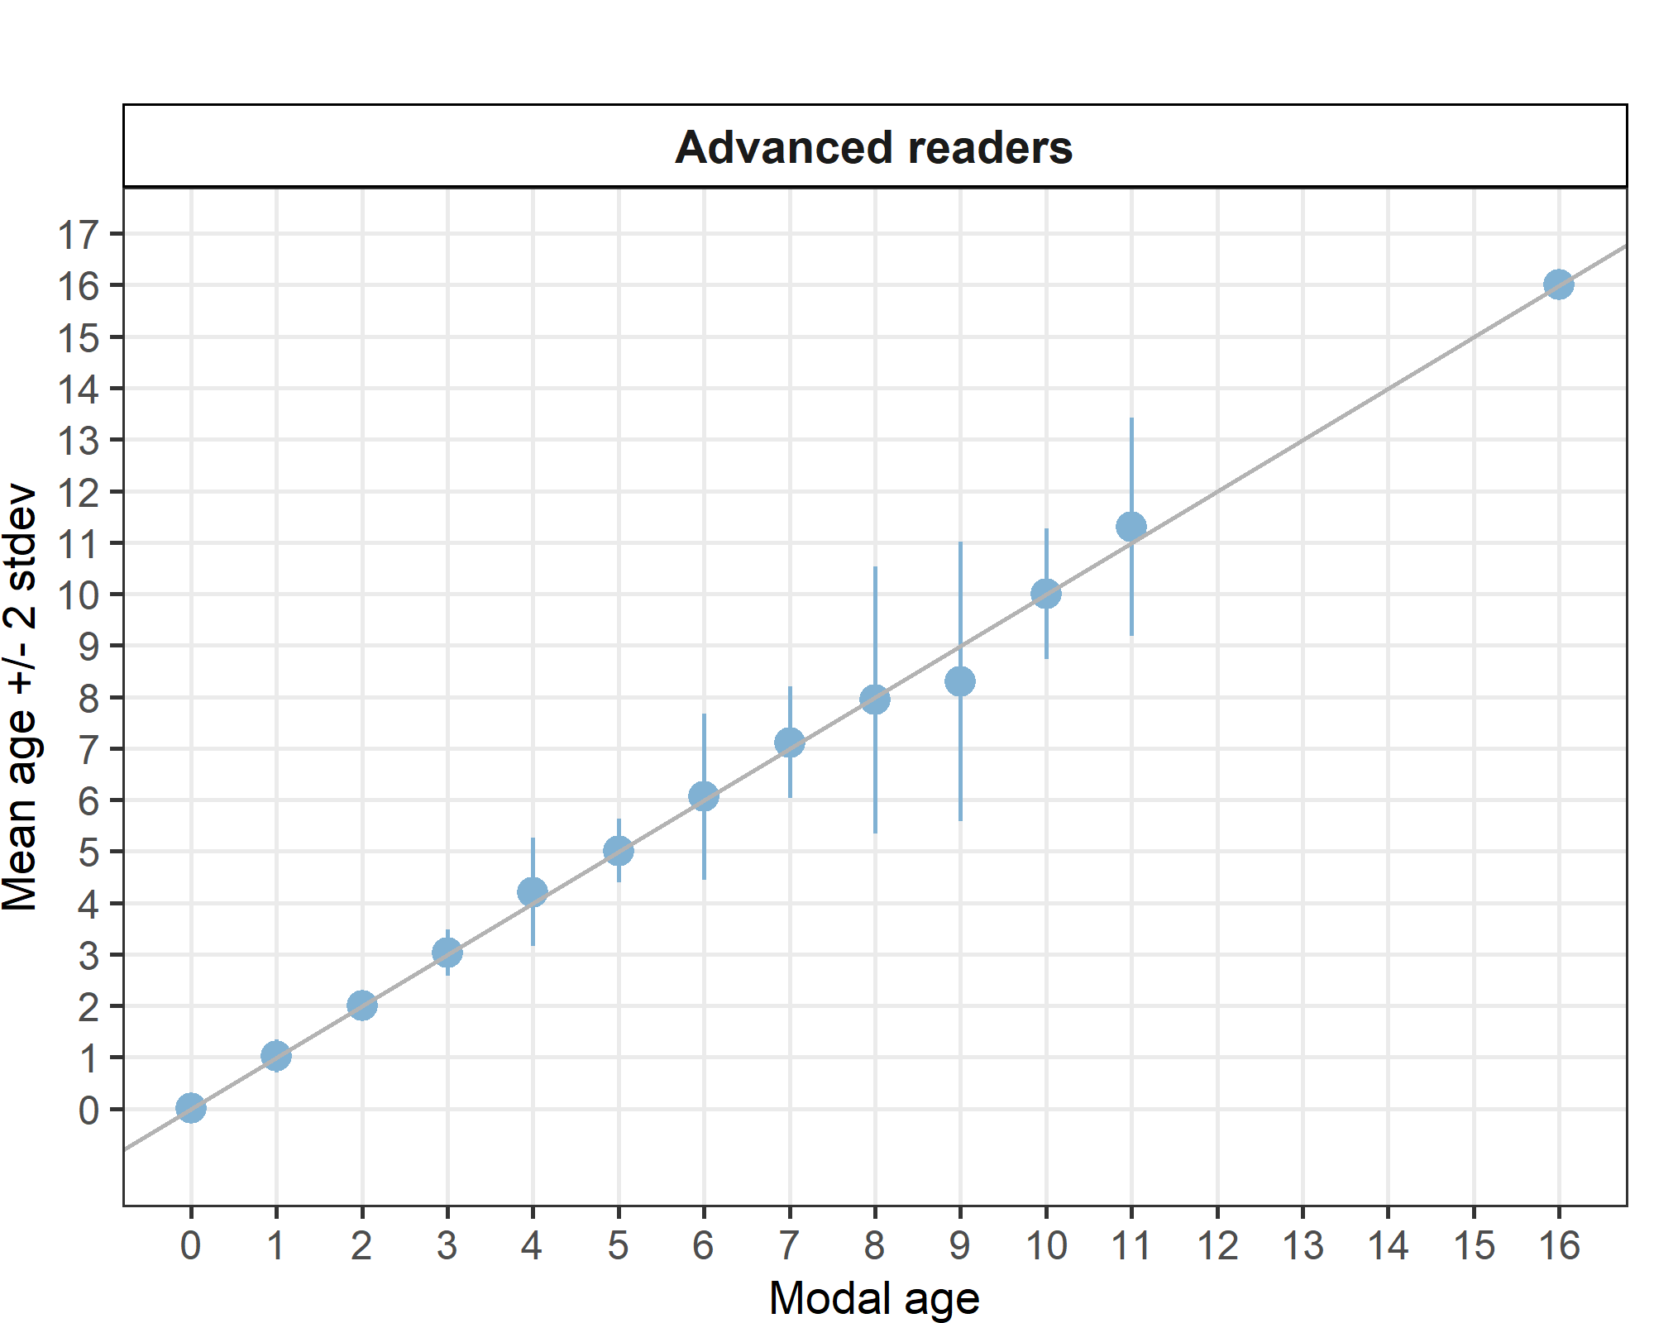
Figure X: Age bias plot for advanced readers. Mean age recorded +/- 2 stdev of each reader and all readers combined are plotted against modal age. The estimated mean age corresponds to modal age, if the estimated mean age is on the 1:1 equilibrium line (solid line). Relative bias is the age difference between estimated mean age and modal age.

Growth analysis
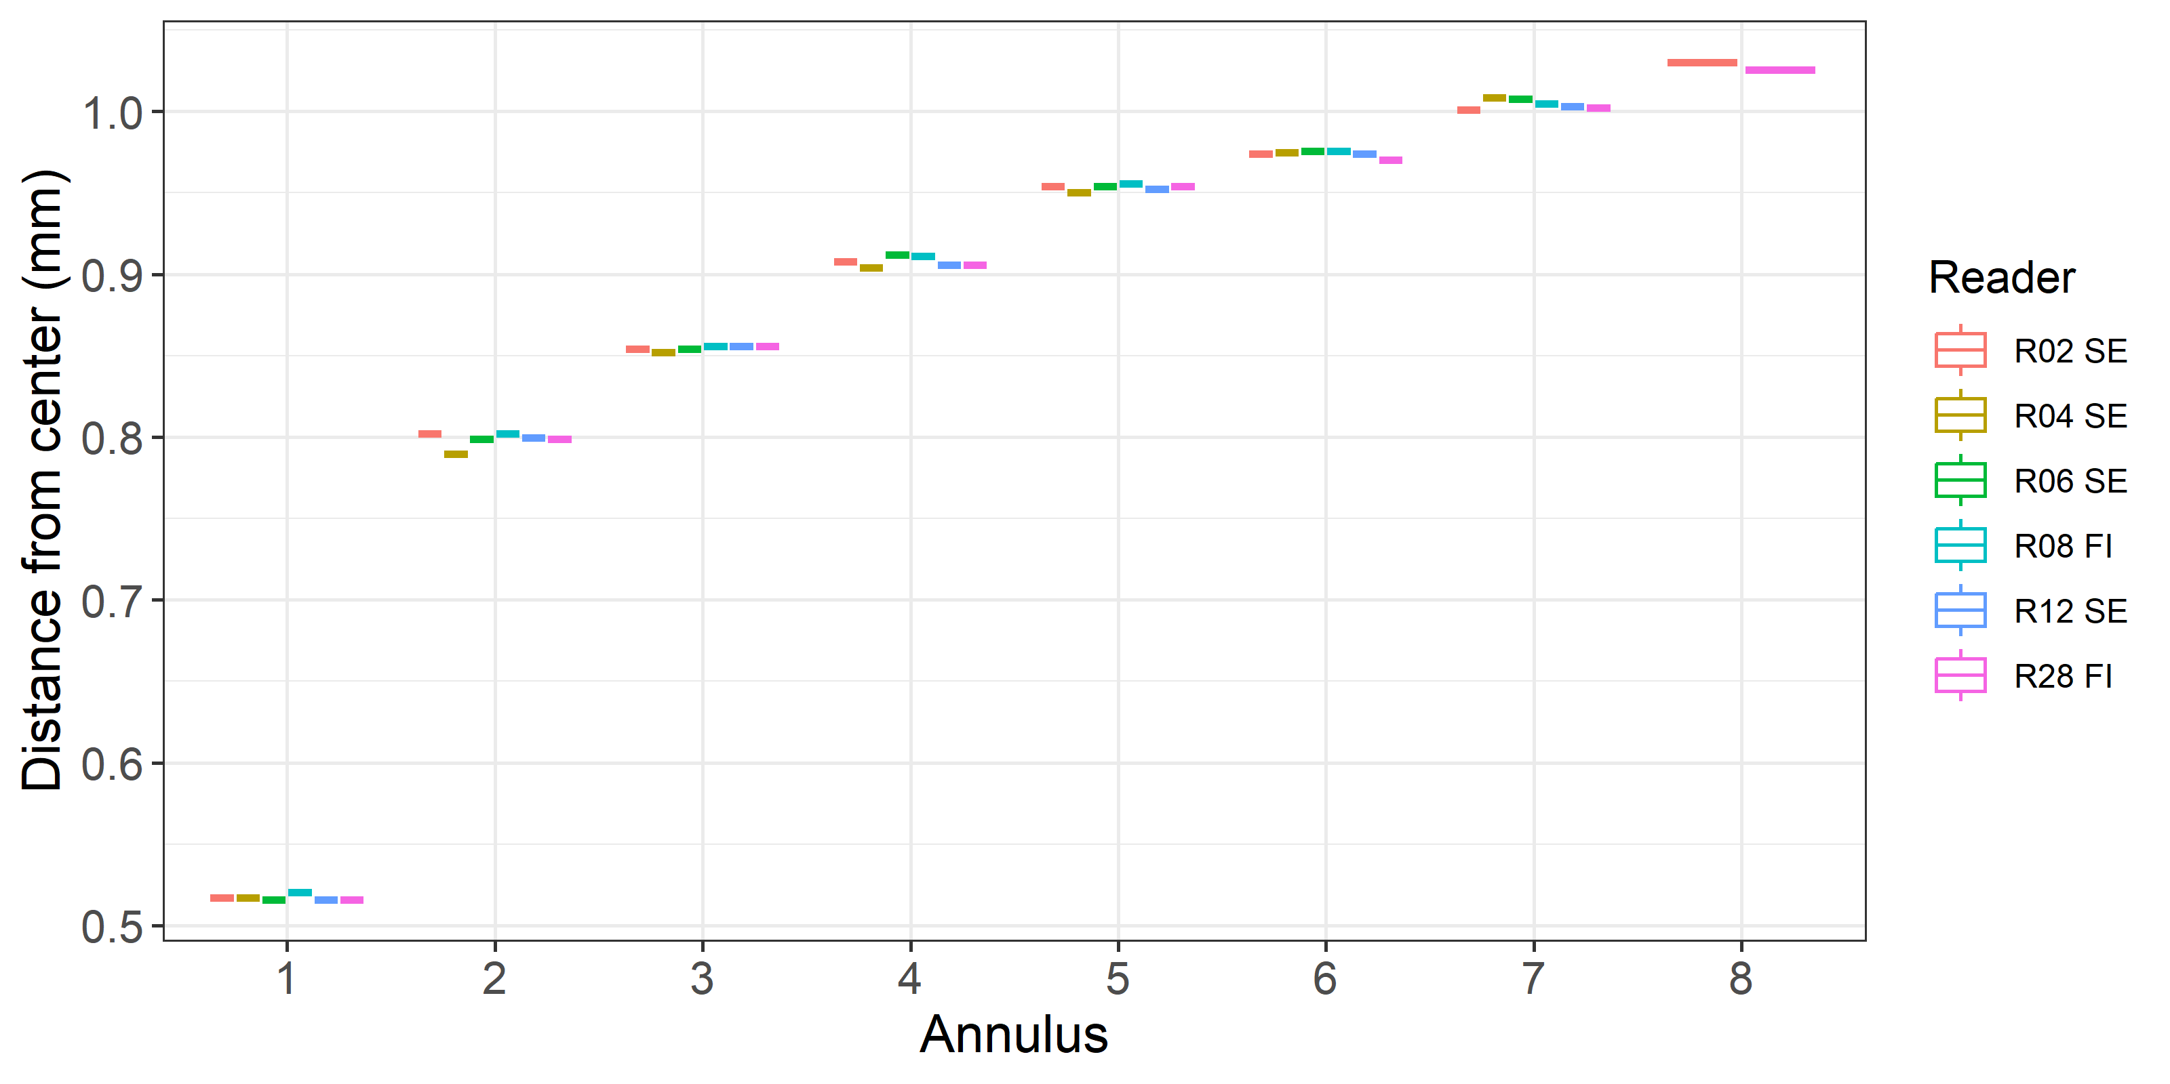
Figure X: Plot of average distacne from the centre to the winter rings for advanced readers. The boxes represent the mean, upper and lower box boundaries of the interquartile range, whiskers represent the minimum and maximum values and the dots represent the outliers.

General Age Error Matrix (AEM)
Table X: General Age error matrix (AEM). The modal age is in rows and the age classifications by the advanced readers in columns.
modal_age | 0 | 1 | 2 | 3 | 4 | 5 | 6 | 7 | 8 | 9 | 10 | 11 | 12 | 14 | 16 | Total
0 | 0.99 | 0.01 | - | - | - | - | - | - | - | - | - | - | - | - | - | 1.00
1 | - | 0.97 | 0.03 | - | - | - | - | - | - | - | - | - | - | - | - | 1.00
2 | - | - | 0.99 | 0.01 | - | - | - | - | - | - | - | - | - | - | - | 1.00
3 | - | - | 0.01 | 0.97 | 0.02 | 0.01 | - | - | - | - | - | - | - | - | - | 1.01
4 | - | - | - | 0.01 | 0.82 | 0.15 | 0.01 | 0.01 | - | - | - | - | - | - | - | 1.00
5 | - | - | - | 0.01 | 0.02 | 0.92 | 0.05 | - | - | - | - | - | - | - | - | 1.00
6 | - | - | - | - | 0.03 | 0.09 | 0.74 | 0.09 | 0.02 | 0.03 | - | - | - | - | - | 1.00
7 | - | - | - | - | - | - | 0.08 | 0.75 | 0.15 | 0.02 | - | - | - | - | - | 1.00
8 | - | - | - | - | - | - | 0.12 | 0.12 | 0.65 | 0.06 | - | - | 0.06 | - | - | 1.01
9 | - | - | - | - | - | 0.06 | 0.12 | - | 0.18 | 0.59 | 0.06 | - | - | - | - | 1.01
10 | - | - | - | - | - | - | - | - | - | 0.18 | 0.64 | 0.18 | - | - | - | 1.00
11 | - | - | - | - | - | - | - | - | - | - | 0.10 | 0.70 | 0.10 | 0.1 | - | 1.00
16 | - | - | - | - | - | - | - | - | - | - | - | - | - | - | 1 | 1.00

AEM by ICES area
Table X: Age error matrix (AEM) for ICES area 27.3.d.30.
ices_area | modal_age | 0 | 1 | 2 | 3 | 4 | 5 | 6 | 7 | 8 | 9 | 10 | 11 | 12 | 14 | 16 | Total
27.3.d.30 | 0 | 0.99 | 0.01 | - | - | - | - | - | - | - | - | - | - | - | - | - | 1.00
27.3.d.30 | 1 | - | 0.97 | 0.03 | - | - | - | - | - | - | - | - | - | - | - | - | 1.00
27.3.d.30 | 2 | - | - | 0.99 | 0.01 | - | - | - | - | - | - | - | - | - | - | - | 1.00
27.3.d.30 | 3 | - | - | 0.01 | 0.97 | 0.02 | 0.01 | - | - | - | - | - | - | - | - | - | 1.01
27.3.d.30 | 4 | - | - | - | 0.01 | 0.82 | 0.15 | 0.01 | 0.01 | - | - | - | - | - | - | - | 1.00
27.3.d.30 | 5 | - | - | - | 0.01 | 0.02 | 0.92 | 0.05 | - | - | - | - | - | - | - | - | 1.00
27.3.d.30 | 6 | - | - | - | - | 0.03 | 0.09 | 0.74 | 0.09 | 0.02 | 0.03 | - | - | - | - | - | 1.00
27.3.d.30 | 7 | - | - | - | - | - | - | 0.08 | 0.75 | 0.15 | 0.02 | - | - | - | - | - | 1.00
27.3.d.30 | 8 | - | - | - | - | - | - | 0.12 | 0.12 | 0.65 | 0.06 | - | - | 0.06 | - | - | 1.01
27.3.d.30 | 9 | - | - | - | - | - | 0.06 | 0.12 | - | 0.18 | 0.59 | 0.06 | - | - | - | - | 1.01
27.3.d.30 | 10 | - | - | - | - | - | - | - | - | - | 0.18 | 0.64 | 0.18 | - | - | - | 1.00
27.3.d.30 | 11 | - | - | - | - | - | - | - | - | - | - | 0.10 | 0.70 | 0.10 | 0.1 | - | 1.00
27.3.d.30 | 16 | - | - | - | - | - | - | - | - | - | - | - | - | - | - | 1 | 1.00

AEM by strata
Table X: Age error matrix (AEM) for Strata_Strata_27.3.d.30.
strata | modal_age | 0 | 1 | 2 | 3 | 4 | 5 | 6 | 7 | 8 | 9 | 10 | 11 | 12 | 14 | 16 | Total
Strata_27.3.d.30 | 0 | 0.99 | 0.01 | - | - | - | - | - | - | - | - | - | - | - | - | - | 1.00
Strata_27.3.d.30 | 1 | - | 0.97 | 0.03 | - | - | - | - | - | - | - | - | - | - | - | - | 1.00
Strata_27.3.d.30 | 2 | - | - | 0.99 | 0.01 | - | - | - | - | - | - | - | - | - | - | - | 1.00
Strata_27.3.d.30 | 3 | - | - | 0.01 | 0.97 | 0.02 | 0.01 | - | - | - | - | - | - | - | - | - | 1.01
Strata_27.3.d.30 | 4 | - | - | - | 0.01 | 0.82 | 0.15 | 0.01 | 0.01 | - | - | - | - | - | - | - | 1.00
Strata_27.3.d.30 | 5 | - | - | - | 0.01 | 0.02 | 0.92 | 0.05 | - | - | - | - | - | - | - | - | 1.00
Strata_27.3.d.30 | 6 | - | - | - | - | 0.03 | 0.09 | 0.74 | 0.09 | 0.02 | 0.03 | - | - | - | - | - | 1.00
Strata_27.3.d.30 | 7 | - | - | - | - | - | - | 0.08 | 0.75 | 0.15 | 0.02 | - | - | - | - | - | 1.00
Strata_27.3.d.30 | 8 | - | - | - | - | - | - | 0.12 | 0.12 | 0.65 | 0.06 | - | - | 0.06 | - | - | 1.01
Strata_27.3.d.30 | 9 | - | - | - | - | - | 0.06 | 0.12 | - | 0.18 | 0.59 | 0.06 | - | - | - | - | 1.01
Strata_27.3.d.30 | 10 | - | - | - | - | - | - | - | - | - | 0.18 | 0.64 | 0.18 | - | - | - | 1.00
Strata_27.3.d.30 | 11 | - | - | - | - | - | - | - | - | - | - | 0.10 | 0.70 | 0.10 | 0.1 | - | 1.00
Strata_27.3.d.30 | 16 | - | - | - | - | - | - | - | - | - | - | - | - | - | - | 1 | 1.00

Samples split by strata
Comparison results by reader on strata: Strata_27.3.d.30
Multimodal cases
Table X: Strata Strata_27.3.d.30 .Total number of samples (NSample) and percentage of cases (fish samples) with multiple modes depending on the approach to weight the experience of the reader which will be considered when defining the fish age mode. PercMM_traditional shows the percentage of the total samples for which multiple modes are obtained when all the readers are equally weighted. PercMM_linear_weight shows the percentage of the total samples for which multiple modes are obtained when the weight assigned to the different readers decreases linearly with the experience, while in the PercMM_negexp the weight applied decreases with a negative exponential shape with the experience. The PercMM_multistage shows the percentage of multiple mode cases when a combination of the different methodologies is used, as explained in the material and methods section
NSample | PercMM_traditional | PercMM_linear_weight | PercMM_negexp_weight | PercMM_multistage
199 | 5 % | 0 % | 0 % | 0 %

Summary statistics
Table X: Strata Strata_27.3.d.30 .Summary of statistics; Total number of samples (NSample), coefficient of variance (CV), percentage of agreement (PA) and average percentage error (APE) for all ages and readers
NSample | CV | PA | APE
199 | 10 % | 91 % | 4 %
In this exchange event 199 otolith fish individuals were aged. Of those, 5 %when the traditional approach (all readers equally weighted) is used to define the mode. The percentage of multiple mode cases is reduced to 0 %. The complete list of cases with multiple modes is presented in table X in the annex 3 section, where the ageing from each of the readers participating in the exchange event is presented. When all the otolith samples are considered (both single and multimodal cases) the weighted average percentage agreement based on modal ages for all readers is 91 %, with the weighted average CV of 10 % and APE of 4 %.

Coefficient of Variation (CV)
Table X: Strata Strata_27.3.d.30 .Coefficient of Variation (CV) table presents the CV per modal age and reader, the CV of all readers combined per modal age and a weighted mean of the CV per reader
 | Modal age | R02 SE | R04 SE | R06 SE | R08 FI | R12 SE | R28 FI | all
0 | 0 | - | - | - | - | - | - | -
1 | 1 | 15 % | 0 % | 15 % | 20 % | 0 % | 24 % | 16 %
2 | 2 | 0 % | 0 % | 0 % | 0 % | 0 % | 10 % | 4 %
3 | 3 | 14 % | 0 % | 6 % | 6 % | 0 % | 8 % | 7 %
4 | 4 | 17 % | 7 % | 15 % | 11 % | 0 % | 13 % | 13 %
5 | 5 | 0 % | 4 % | 4 % | 5 % | 9 % | 9 % | 6 %
6 | 6 | 14 % | 12 % | 13 % | 7 % | 14 % | 17 % | 13 %
7 | 7 | 7 % | 7 % | 7 % | 10 % | 7 % | 5 % | 8 %
8 | 8 | 25 % | 0 % | 0 % | 20 % | 14 % | 8 % | 16 %
9 | 9 | 0 % | 8 % | 6 % | 22 % | 25 % | 22 % | 16 %
10 | 10 | - | 7 % | 0 % | 7 % | 7 % | 7 % | 6 %
11 | 11 | - | - | 17 % | 7 % | 0 % | 6 % | 9 %
12 | 12 | - | - | - | - | - | - | -
13 | 13 | - | - | - | - | - | - | -
14 | 14 | - | - | - | - | - | - | -
15 | 15 | - | - | - | - | - | - | -
16 | 16 | - | - | - | - | - | - | 0 %
18 | Weighted Mean | 10 % | 3 % | 9 % | 10 % | 3 % | 14 % | 10 %

Percentage of Agreement (PA)
The percentage agreement per reader per modal age tells how large part of the readings that are equal to the modal age. The weighted mean including at the bottom of the table is weighted according to number of age readings.
Table X: Strata Strata_27.3.d.30 .Percentage agreement (PA) table represents the PA per modal age and reader, the PA of all readers combined per modal age and a weighted mean of the PA per reader.
 | Modal age | R02 SE | R04 SE | R06 SE | R08 FI | R12 SE | R28 FI | total
0 | 0 | 100 % | 91 % | 100 % | 100 % | 100 % | 100 % | 99 %
1 | 1 | 98 % | 100 % | 98 % | 96 % | 100 % | 93 % | 97 %
2 | 2 | 100 % | 100 % | 100 % | 100 % | 100 % | 96 % | 99 %
3 | 3 | 93 % | 100 % | 97 % | 97 % | 100 % | 93 % | 97 %
4 | 4 | 81 % | 92 % | 85 % | 70 % | 100 % | 63 % | 82 %
5 | 5 | 100 % | 96 % | 97 % | 93 % | 90 % | 79 % | 92 %
6 | 6 | 91 % | 80 % | 64 % | 82 % | 64 % | 64 % | 74 %
7 | 7 | 67 % | 75 % | 67 % | 78 % | 78 % | 89 % | 75 %
8 | 8 | 67 % | 100 % | 100 % | 33 % | 33 % | 67 % | 65 %
9 | 9 | 100 % | 50 % | 67 % | 67 % | 0 % | 67 % | 59 %
10 | 10 | 100 % | 50 % | 100 % | 50 % | 50 % | 50 % | 64 %
11 | 11 | 100 % | 100 % | 50 % | 50 % | 100 % | 50 % | 70 %
12 | 12 | - | - | - | - | - | - | -
13 | 13 | - | - | - | - | - | - | -
14 | 14 | - | - | - | - | - | - | -
15 | 15 | - | - | - | - | - | - | -
16 | 16 | 100 % | 100 % | 100 % | 100 % | 100 % | 100 % | 100 %
18 | Weighted Mean | 93 % | 95 % | 92 % | 89 % | 92 % | 84 % | 91 %

Average Percentage Error (APE)
Table X: Strata Strata_27.3.d.30 .Average Percentage Error (APE) table represents the APE per modal age and reader, the APE of all advanced readers combined per modal age and a weighted mean of the APE per reader.
 | Modal age | R02 SE | R04 SE | R06 SE | R08 FI | R12 SE | R28 FI | all
0 | 0 | - | - | - | - | - | - | -
1 | 1 | 4 % | 0 % | 4 % | 8 % | 0 % | 12 % | 5 %
2 | 2 | 0 % | 0 % | 0 % | 0 % | 0 % | 4 % | 1 %
3 | 3 | 7 % | 0 % | 2 % | 2 % | 0 % | 4 % | 2 %
4 | 4 | 11 % | 2 % | 9 % | 10 % | 0 % | 12 % | 8 %
5 | 5 | 0 % | 1 % | 1 % | 3 % | 5 % | 6 % | 2 %
6 | 6 | 8 % | 8 % | 9 % | 5 % | 10 % | 11 % | 7 %
7 | 7 | 6 % | 6 % | 6 % | 7 % | 5 % | 3 % | 5 %
8 | 8 | 19 % | 0 % | 0 % | 14 % | 10 % | 6 % | 9 %
9 | 9 | 0 % | 6 % | 5 % | 17 % | 19 % | 17 % | 12 %
10 | 10 | 0 % | 5 % | 0 % | 5 % | 5 % | 5 % | 4 %
11 | 11 | 0 % | 0 % | 12 % | 5 % | 0 % | 4 % | 6 %
12 | 12 | - | - | - | - | - | - | -
13 | 13 | - | - | - | - | - | - | -
14 | 14 | - | - | - | - | - | - | -
15 | 15 | - | - | - | - | - | - | -
16 | 16 | 0 % | 0 % | 0 % | 0 % | 0 % | 0 % | 0 %
18 | Weighted Mean | 5 % | 1 % | 4 % | 5 % | 2 % | 8 % | 4 %

Relative bias
The relative bias is the difference between the mean age (per modal age per reader) and modal age. As for the previous tables, a combined bias for all readers and weighted means are calculated.
Table X: Strata Strata_27.3.d.30 . The relative bias (as the difference between the mean and modal age) per modal age and advanced reader is presented, as well as the weighted mean relative bias per reader and the relative bias per modal age for all advanced readers combined.
 | Modal age | R02 SE | R04 SE | R06 SE | R08 FI | R12 SE | R28 FI | all
0 | 0 | 0.00 | 0.09 | 0.00 | 0.00 | 0.00 | 0.00 | 0.02
1 | 1 | 0.02 | 0.00 | 0.02 | 0.04 | 0.00 | 0.07 | 0.03
2 | 2 | 0.00 | 0.00 | 0.00 | 0.00 | 0.00 | 0.04 | 0.01
3 | 3 | 0.11 | 0.00 | 0.03 | -0.03 | 0.00 | 0.07 | 0.03
4 | 4 | 0.30 | 0.00 | 0.22 | 0.30 | 0.00 | 0.41 | 0.20
5 | 5 | 0.00 | -0.04 | 0.03 | 0.07 | -0.14 | 0.14 | 0.01
6 | 6 | 0.27 | -0.30 | 0.27 | 0.18 | -0.27 | 0.18 | 0.06
7 | 7 | 0.33 | -0.25 | 0.33 | 0.33 | -0.22 | 0.11 | 0.11
8 | 8 | 1.33 | 0.00 | 0.00 | -0.33 | -1.00 | -0.33 | -0.06
9 | 9 | 0.00 | -0.50 | 0.33 | -1.00 | -2.00 | -1.00 | -0.69
10 | 10 | 0.00 | -0.50 | 0.00 | 0.50 | -0.50 | 0.50 | 0.00
11 | 11 | 0.00 | 0.00 | 1.50 | -0.50 | 0.00 | 0.50 | 0.25
12 | 12 | - | - | - | - | - | - | -
13 | 13 | - | - | - | - | - | - | -
14 | 14 | - | - | - | - | - | - | -
15 | 15 | - | - | - | - | - | - | -
16 | 16 | 0.00 | 0.00 | 0.00 | 0.00 | 0.00 | 0.00 | 0.00
18 | Weighted Mean | 0.11 | -0.04 | 0.10 | 0.06 | -0.10 | 0.11 | 0.04
Figure X: Strata Strata_27.3.d.30 .Age bias plot for advance readers. Mean age recorded +/- 2 stdev of each reader and all readers combined are plotted against modal age. The estimated mean age corresponds to modal age, if the estimated mean age is on the 1:1 equilibrium line (solid line). Relative bias is the age difference between estimated mean age and modal age.

Inter-reader bias test
Table X: Strata Strata_27.3.d.30 .Inter reader bias test. The Inter-reader bias test gives probability of bias between readers and with modal age. - = no sign of bias (p>0.05), * = possibility of bias (0.01<p<0.05), * * = certainty of bias (p<0.01)
Comparison | R02 SE | R04 SE | R06 SE | R08 FI | R12 SE | R28 FI
R02 SE | / | * | ** | ** | ** | **
R04 SE | * | / | ** | * | - | **
R06 SE | ** | ** | / | ** | ** | **
R08 FI | ** | * | ** | / | ** | **
R12 SE | ** | - | ** | ** | / | **
R28 FI | ** | ** | ** | ** | ** | /
Modal age | ** | - | * | - | * | -

Growth Analysis
Figure X: Strata Strata_27.3.d.30 .Plot of average distance from the centre to the winter rings for advanced readers. The boxes represent the median, upper and lower box boundaries of the interquartile range, whiskers represent the minimum and maximum values and the dots represent the outliers.

Overall comparison of results by strata
Table X: Number of age readings per strata and modal age for all advanced readers combined.
Modal age | Strata_27.3.d.30 | total
0 | 70 | 70
1 | 267 | 267
2 | 149 | 149
3 | 177 | 177
4 | 160 | 160
5 | 171 | 171
6 | 65 | 65
7 | 53 | 53
8 | 17 | 17
9 | 17 | 17
10 | 11 | 11
11 | 10 | 10
12 | 0 | 0
13 | 0 | 0
14 | 0 | 0
15 | 0 | 0
16 | 6 | 6
Total | 1173 | 1173

Coefficient of Variation (CV)
Table X: CV per strata and modal age for all advanced readers combined.
Modal age | Strata_27.3.d.30 | all
0 | - | -
1 | 16 % | 16 %
2 | 4 % | 4 %
3 | 7 % | 7 %
4 | 13 % | 13 %
5 | 6 % | 6 %
6 | 13 % | 13 %
7 | 8 % | 8 %
8 | 16 % | 16 %
9 | 16 % | 16 %
10 | 6 % | 6 %
11 | 9 % | 9 %
12 | - | -
13 | - | -
14 | - | -
15 | - | -
16 | 0 % | 0 %
Weighted Mean | 10 % | 10 %

Percentage of Agreement (PA)
Table X: Percentage Agreement per strata and modal age for all advanced readers combined.
Modal age | Strata_27.3.d.30 | total
0 | 99 % | 99 %
1 | 97 % | 97 %
2 | 99 % | 99 %
3 | 97 % | 97 %
4 | 82 % | 82 %
5 | 92 % | 92 %
6 | 74 % | 74 %
7 | 75 % | 75 %
8 | 65 % | 65 %
9 | 59 % | 59 %
10 | 64 % | 64 %
11 | 70 % | 70 %
12 | - | -
13 | - | -
14 | - | -
15 | - | -
16 | 100 % | 100 %
Weighted Mean | 91 % | 91 %

Average Percentage Error (APE)
Table X: Average Percentag Error per strata and modal age for all advanced readers combined.
Modal age | Strata_27.3.d.30 | all
0 | - | -
1 | 5 % | 5 %
2 | 1 % | 1 %
3 | 2 % | 2 %
4 | 8 % | 8 %
5 | 2 % | 2 %
6 | 7 % | 7 %
7 | 5 % | 5 %
8 | 9 % | 9 %
9 | 12 % | 12 %
10 | 4 % | 4 %
11 | 6 % | 6 %
12 | - | -
13 | - | -
14 | - | -
15 | - | -
16 | 0 % | 0 %
Weighted Mean | 4 % | 4 %

Relative bias
Table X: Relative Bias per strata and modal age for all advanced readers combined.
Modal age | Strata_27.3.d.30 | all
0 | 0.01 | 0.01
1 | 0.03 | 0.03
2 | 0.01 | 0.01
3 | 0.03 | 0.03
4 | 0.21 | 0.21
5 | 0.01 | 0.01
6 | 0.06 | 0.06
7 | 0.11 | 0.11
8 | -0.06 | -0.06
9 | -0.71 | -0.71
10 | 0.00 | 0.00
11 | 0.30 | 0.30
12 | - | -
13 | - | -
14 | - | -
15 | - | -
16 | 0.00 | 0.00
Weighted Mean | 0.04 | 0.04

Growth analysis
Figure X: Plot of average distance from the centre to the winter rings for all readers by strata. The boxes represent the median, upper and lower box boundaries of the interquartile range, whiskers represent the minimum and maximum values and the dots represent the outliers.

Discussion

Conclusion

Other ToRs

References
Beamish R. J. and Fournier D. A. (1981) A method for comparing the precision of a set of age determination. Canadian Journal of Fisheries and Aquatic Sciences, 38, 982–983
GUIDELINES AND TOOLS FOR AGE READING. Eltink, A.T.G.W., Newton A.W., Morgado C., Santamaria M.T.G and Modin J. (2000) Guidelines and tools for age Reading. (PDF document version 1.0 October 2000) Internet: http://www.efan.no
Eltink, A.T.G.W. (2000) Age reading comparisons. (MS Excel workbook version 1.0 October 2000) Internet: http://www.efan.no
ICES (2014) Report of the Workshop on Statistical Analysis of Biological Calibration Studies (WKSABCAL). ICES CM 2014/ACOM: 35

Annex 1. Agenda

Annex 2. List of participants
Table X: Participants list.
Reader code | Expertise | Expertise_rank | strata
R02 SE | Advanced | 2 | Strata_27.3.d.30
R04 SE | Advanced | 4 | Strata_27.3.d.30
R06 SE | Advanced | 6 | Strata_27.3.d.30
R08 FI | Advanced | 8 | Strata_27.3.d.30
R10 FI | Basic | 10 | Strata_27.3.d.30
R12 SE | Advanced | 12 | Strata_27.3.d.30
R14 FI | Basic | 14 | Strata_27.3.d.30
R16 FI | Basic | 16 | Strata_27.3.d.30
R18 FI | Basic | 18 | Strata_27.3.d.30
R20 FI | Basic | 20 | Strata_27.3.d.30
R22 FI | Basic | 22 | Strata_27.3.d.30
R28 FI | Advanced | 28 | Strata_27.3.d.30

Annex 3. Additional results

Results all readers
Summary statistics
Table X: Summary of statistics; PA (%), CV (%) and APE (%).
NSample | CV | PA | APE
200 | 14 % | 87 % | 7 %

Data Overview
Table X: Data overview including modal age and statistics per sample.
Fish ID | Sample ID | Event ID | Image ID | length | sex | Catch date | ICES area | R02 SE | R04 SE | R06 SE | R08 FI | R10 FI | R12 SE | R14 FI | R16 FI | R18 FI | R20 FI | R22 FI | R28 FI | Modal age | PA % | CV % | APE %
12 | 12 | 1849 | 135029 | 85 | - | 11-09-2023 00:00:00 | 27.3.d.30 | 0 | - | 0 | 0 | 0 | 0 | 0 | 0 | 1 | 0 | 0 | 0 | 0 | 91 | - | -
29 | 29 | 1849 | 135030 | 90 | - | 22-03-2023 00:00:00 | 27.3.d.30 | 1 | 1 | 1 | 1 | 1 | 1 | 1 | 1 | 1 | 1 | 1 | 1 | 1 | 100 | 0 | 0
44 | 44 | 1849 | 135031 | 95 | - | 15-03-2023 00:00:00 | 27.3.d.30 | 1 | 1 | 1 | 1 | 1 | 1 | 1 | 1 | 1 | 1 | 1 | 1 | 1 | 100 | 0 | 0
47 | 47 | 1849 | 135032 | 100 | - | 07-12-2023 00:00:00 | 27.3.d.30 | 0 | 1 | - | 0 | 0 | 0 | 0 | 0 | 0 | 0 | 0 | 0 | 0 | 91 | - | -
55 | 55 | 1849 | 135033 | 100 | - | 12-04-2023 00:00:00 | 27.3.d.30 | - | 1 | 1 | 1 | 1 | 1 | 1 | 1 | 1 | 2 | 1 | 1 | 1 | 91 | 28 | 15
58 | 58 | 1849 | 135034 | 105 | - | 09-03-2023 00:00:00 | 27.3.d.30 | 1 | 1 | 1 | 1 | 1 | 1 | 1 | 1 | 1 | 1 | 1 | 1 | 1 | 100 | 0 | 0
74 | 74 | 1849 | 135035 | 110 | - | 16-04-2023 00:00:00 | 27.3.d.30 | 1 | 1 | 1 | 1 | 1 | 1 | 1 | 1 | 1 | 1 | 1 | 1 | 1 | 100 | 0 | 0
76 | 76 | 1849 | 135036 | 110 | - | 12-04-2023 00:00:00 | 27.3.d.30 | 1 | 1 | 1 | 1 | 1 | 1 | 1 | 1 | 1 | 2 | 1 | 1 | 1 | 92 | 27 | 14
85 | 85 | 1849 | 135037 | 115 | - | 16-04-2023 00:00:00 | 27.3.d.30 | 1 | 1 | 1 | 2 | 1 | 1 | 1 | 1 | 1 | 1 | 1 | 1 | 1 | 92 | 27 | 14
87 | 87 | 1849 | 135038 | 115 | - | 15-03-2023 00:00:00 | 27.3.d.30 | 1 | 1 | 1 | 1 | 1 | 1 | 1 | 1 | 1 | 1 | 1 | 1 | 1 | 100 | 0 | 0
95 | 95 | 1849 | 135039 | 120 | - | 09-03-2023 00:00:00 | 27.3.d.30 | 1 | - | 1 | 1 | 1 | 1 | 1 | 1 | 1 | 1 | 1 | 1 | 1 | 100 | 0 | 0
97 | 97 | 1849 | 135040 | 120 | - | 10-12-2023 00:00:00 | 27.3.d.30 | 1 | 1 | 1 | 1 | 1 | 1 | 1 | 1 | 1 | 1 | 1 | 1 | 1 | 100 | 0 | 0
99 | 99 | 1849 | 135041 | 120 | - | 09-03-2023 00:00:00 | 27.3.d.30 | 2 | 2 | 2 | 2 | 2 | 2 | 2 | 2 | 2 | 2 | 2 | 3 | 2 | 92 | 14 | 7
100 | 100 | 1849 | 135042 | 120 | - | 12-04-2023 00:00:00 | 27.3.d.30 | 2 | 2 | 2 | 2 | 2 | 2 | 2 | 2 | 2 | 2 | 2 | 2 | 2 | 100 | 0 | 0
101 | 101 | 1849 | 135043 | 120 | - | 11-09-2023 00:00:00 | 27.3.d.30 | 1 | - | 1 | 1 | 1 | 1 | 3 | 1 | 3 | 2 | 3 | 1 | 1 | 64 | 56 | 49
107 | 107 | 1849 | 135044 | 125 | - | 15-03-2023 00:00:00 | 27.3.d.30 | 2 | 2 | 2 | 2 | 2 | 2 | 2 | 2 | 2 | 2 | 2 | 2 | 2 | 100 | 0 | 0
109 | 109 | 1849 | 135045 | 125 | - | 14-12-2023 00:00:00 | 27.3.d.30 | 1 | 1 | 1 | 1 | 1 | 1 | 1 | 1 | 1 | 1 | 1 | 1 | 1 | 100 | 0 | 0
112 | 112 | 1849 | 135046 | 125 | - | 22-03-2023 00:00:00 | 27.3.d.30 | 2 | 2 | 2 | 2 | 2 | 2 | 1 | 2 | 2 | 2 | 2 | 2 | 2 | 92 | 15 | 8
113 | 113 | 1849 | 135047 | 125 | - | 22-03-2023 00:00:00 | 27.3.d.30 | 2 | 2 | 2 | 2 | 2 | 2 | 2 | 2 | 2 | 2 | 2 | 2 | 2 | 100 | 0 | 0
117 | 117 | 1849 | 135048 | 125 | - | 29-12-2023 00:00:00 | 27.3.d.30 | 1 | 1 | 1 | 1 | 1 | 1 | 1 | 1 | 1 | 1 | 1 | 1 | 1 | 100 | 0 | 0
118 | 118 | 1849 | 135049 | 125 | - | 09-03-2023 00:00:00 | 27.3.d.30 | 2 | 2 | 2 | 2 | 2 | 2 | 2 | 2 | 2 | 2 | 2 | 2 | 2 | 100 | 0 | 0
119 | 119 | 1849 | 135050 | 130 | - | 09-03-2023 00:00:00 | 27.3.d.30 | 2 | 2 | 2 | 2 | 2 | 2 | 2 | 2 | 2 | 2 | 2 | 2 | 2 | 100 | 0 | 0
128 | 128 | 1849 | 135051 | 130 | - | 13-12-2023 00:00:00 | 27.3.d.30 | 1 | 1 | 1 | 1 | 1 | 1 | 1 | 1 | - | 1 | 1 | 1 | 1 | 100 | 0 | 0
137 | 137 | 1849 | 135052 | 130 | - | 18-12-2023 00:00:00 | 27.3.d.30 | 1 | 1 | 1 | 1 | 1 | 1 | 1 | 1 | 1 | 1 | 1 | 1 | 1 | 100 | 0 | 0
143 | 143 | 1849 | 135053 | 135 | - | 11-09-2023 00:00:00 | 27.3.d.30 | 1 | 1 | 1 | 1 | 1 | 1 | 1 | 1 | 1 | 1 | 1 | 1 | 1 | 100 | 0 | 0
146 | 146 | 1849 | 135054 | 135 | - | 09-03-2023 00:00:00 | 27.3.d.30 | 3 | 3 | 3 | 3 | 3 | 3 | 3 | 3 | 3 | 3 | 3 | 3 | 3 | 100 | 0 | 0
150 | 150 | 1849 | 135055 | 135 | - | 14-12-2023 00:00:00 | 27.3.d.30 | 2 | 2 | 2 | 2 | 2 | 2 | 2 | 2 | 2 | 2 | 2 | 2 | 2 | 100 | 0 | 0
155 | 155 | 1849 | 135056 | 135 | - | 07-12-2023 00:00:00 | 27.3.d.30 | 1 | 1 | 1 | 2 | 1 | 1 | 1 | 1 | 1 | 2 | 1 | 1 | 1 | 83 | 33 | 24
160 | 160 | 1849 | 135057 | 140 | - | 10-12-2023 00:00:00 | 27.3.d.30 | 3 | 3 | 3 | 3 | 3 | 3 | 3 | 3 | 3 | 3 | 3 | 3 | 3 | 100 | 0 | 0
165 | 165 | 1849 | 135058 | 140 | - | 22-10-2023 00:00:00 | 27.3.d.30 | 1 | 1 | 1 | 1 | 1 | 1 | 1 | 1 | 1 | 1 | 1 | 1 | 1 | 100 | 0 | 0
178 | 178 | 1849 | 135059 | 145 | - | 10-12-2023 00:00:00 | 27.3.d.30 | 3 | 3 | 3 | 3 | 3 | 3 | 3 | 3 | 4 | 3 | 3 | 3 | 3 | 92 | 9 | 5
179 | 179 | 1849 | 135060 | 145 | - | 15-03-2023 00:00:00 | 27.3.d.30 | 4 | 4 | 4 | 4 | 4 | 4 | 4 | 4 | 4 | 3 | 4 | 5 | 4 | 83 | 11 | 4
180 | 180 | 1849 | 135061 | 145 | - | 12-04-2023 00:00:00 | 27.3.d.30 | 3 | 3 | 3 | 3 | 3 | 3 | 3 | 3 | 3 | 3 | 3 | 3 | 3 | 100 | 0 | 0
181 | 181 | 1849 | 135062 | 145 | - | 16-04-2023 00:00:00 | 27.3.d.30 | - | 3 | 3 | 3 | 3 | 3 | 3 | 3 | 3 | 3 | 3 | 3 | 3 | 100 | 0 | 0
182 | 182 | 1849 | 135063 | 145 | - | 10-12-2023 00:00:00 | 27.3.d.30 | 2 | 2 | 2 | 2 | 2 | 2 | 2 | 2 | 2 | 2 | 2 | 2 | 2 | 100 | 0 | 0
184 | 184 | 1849 | 135064 | 145 | - | 13-12-2023 00:00:00 | 27.3.d.30 | 2 | 2 | 2 | 2 | 2 | 2 | 2 | 2 | 2 | 2 | 2 | 2 | 2 | 100 | 0 | 0
185 | 185 | 1849 | 135065 | 145 | - | 22-03-2023 00:00:00 | 27.3.d.30 | - | 3 | 3 | 3 | 3 | 3 | 3 | 3 | 3 | 3 | 3 | 3 | 3 | 100 | 0 | 0
191 | 191 | 1849 | 135066 | 145 | - | 13-04-2023 00:00:00 | 27.3.d.30 | 2 | 2 | 2 | 2 | 2 | 2 | 2 | 3 | 2 | 3 | 2 | 2 | 2 | 83 | 18 | 13
195 | 195 | 1849 | 135067 | 150 | - | 14-12-2023 00:00:00 | 27.3.d.30 | 4 | - | 4 | 4 | 4 | 4 | 4 | 4 | 3 | 3 | 4 | 4 | 4 | 82 | 11 | 8
199 | 199 | 1849 | 135068 | 150 | - | 29-12-2023 00:00:00 | 27.3.d.30 | 2 | 2 | 2 | 2 | 3 | 2 | 2 | 2 | 2 | 3 | 2 | 2 | 2 | 83 | 18 | 13
202 | 202 | 1849 | 135069 | 150 | - | 22-03-2023 00:00:00 | 27.3.d.30 | 3 | 3 | 3 | 3 | 3 | 3 | 3 | 3 | 3 | 3 | 3 | 3 | 3 | 100 | 0 | 0
205 | 205 | 1849 | 135070 | 150 | - | 09-03-2023 00:00:00 | 27.3.d.30 | 3 | 3 | 3 | 3 | 3 | 3 | 3 | 3 | 3 | 3 | 3 | 3 | 3 | 100 | 0 | 0
209 | 209 | 1849 | 135071 | 150 | - | 15-03-2023 00:00:00 | 27.3.d.30 | 5 | 5 | 5 | 5 | 5 | 5 | 5 | 5 | 5 | 5 | 5 | 5 | 5 | 100 | 0 | 0
215 | 215 | 1849 | 135072 | 155 | - | 12-04-2023 00:00:00 | 27.3.d.30 | 4 | 4 | 4 | 4 | 4 | 4 | 4 | 4 | 4 | 4 | 4 | 4 | 4 | 100 | 0 | 0
222 | 222 | 1849 | 135073 | 155 | - | 22-03-2023 00:00:00 | 27.3.d.30 | 4 | 5 | 4 | 5 | 4 | 4 | 4 | 4 | 4 | 4 | 4 | 5 | 4 | 75 | 11 | 9
224 | 224 | 1849 | 135074 | 155 | - | 09-03-2023 00:00:00 | 27.3.d.30 | 5 | - | 5 | 5 | 4 | 5 | 4 | 4 | 5 | 5 | 5 | 5 | 5 | 73 | 10 | 8
228 | 228 | 1849 | 135075 | 155 | - | 15-03-2023 00:00:00 | 27.3.d.30 | 3 | 3 | 3 | 3 | 3 | 3 | 3 | 3 | 3 | 3 | 3 | 3 | 3 | 100 | 0 | 0
229 | 229 | 1849 | 135076 | 155 | - | 08-09-2023 00:00:00 | 27.3.d.30 | 5 | 3 | 3 | 3 | 3 | 3 | 3 | 3 | 3 | 3 | 3 | 3 | 3 | 92 | 18 | 10
230 | 230 | 1849 | 135077 | 155 | - | 22-10-2023 00:00:00 | 27.3.d.30 | 4 | 3 | 4 | 3 | 3 | 3 | 4 | 3 | 4 | 3 | 4 | 4 | 3 | 50 | 15 | 14
231 | 231 | 1849 | 135078 | 155 | - | 18-12-2023 00:00:00 | 27.3.d.30 | 4 | 4 | 4 | 4 | 4 | 4 | 4 | 4 | 4 | 4 | 4 | 4 | 4 | 100 | 0 | 0
232 | 232 | 1849 | 135079 | 160 | - | 22-03-2023 00:00:00 | 27.3.d.30 | - | 3 | 3 | 3 | 3 | 3 | 3 | 3 | 3 | 3 | 3 | 3 | 3 | 100 | 0 | 0
233 | 233 | 1849 | 135080 | 160 | - | 09-03-2023 00:00:00 | 27.3.d.30 | 5 | 5 | 5 | 5 | 5 | 5 | 5 | 5 | 5 | 5 | 5 | 5 | 5 | 100 | 0 | 0
234 | 234 | 1849 | 135081 | 160 | - | 09-03-2023 00:00:00 | 27.3.d.30 | 5 | 4 | 4 | 5 | 5 | 4 | 5 | 5 | 5 | 4 | 4 | 5 | 5 | 58 | 11 | 11
235 | 235 | 1849 | 135082 | 160 | - | 14-12-2023 00:00:00 | 27.3.d.30 | 3 | 3 | 3 | 3 | 3 | 3 | 3 | 3 | 3 | 3 | 3 | 3 | 3 | 100 | 0 | 0
237 | 237 | 1849 | 135083 | 160 | - | 12-04-2023 00:00:00 | 27.3.d.30 | 3 | 3 | 3 | 3 | 3 | 3 | 3 | 3 | 4 | 3 | 4 | 4 | 3 | 75 | 14 | 12
243 | 243 | 1849 | 135084 | 160 | - | 15-03-2023 00:00:00 | 27.3.d.30 | 3 | 3 | 3 | 2 | 3 | 3 | 3 | 3 | 3 | 3 | 3 | 3 | 3 | 92 | 10 | 5
245 | 245 | 1849 | 135085 | 160 | - | 16-04-2023 00:00:00 | 27.3.d.30 | 5 | 5 | 5 | 5 | 5 | 5 | 6 | 5 | 5 | 5 | 5 | 5 | 5 | 92 | 6 | 3
247 | 247 | 1849 | 135086 | 160 | - | 10-12-2023 00:00:00 | 27.3.d.30 | 4 | 4 | 4 | 4 | 4 | 4 | 4 | 4 | 4 | 4 | 4 | 4 | 4 | 100 | 0 | 0
249 | 249 | 1849 | 135087 | 160 | - | 13-04-2023 00:00:00 | 27.3.d.30 | 4 | 4 | 4 | 4 | 4 | 4 | 4 | 4 | 4 | 4 | 4 | 4 | 4 | 100 | 0 | 0
251 | 251 | 1849 | 135088 | 165 | - | 13-12-2023 00:00:00 | 27.3.d.30 | 4 | 4 | 4 | 4 | 4 | 4 | 4 | 4 | 4 | 4 | 4 | 4 | 4 | 100 | 0 | 0
258 | 258 | 1849 | 135089 | 165 | - | 11-09-2023 00:00:00 | 27.3.d.30 | 5 | 5 | 5 | 5 | 5 | 5 | 5 | 5 | 5 | 5 | 6 | 6 | 5 | 83 | 8 | 5
260 | 260 | 1849 | 135090 | 165 | - | 08-09-2023 00:00:00 | 27.3.d.30 | 4 | 4 | 4 | 4 | 4 | 4 | 4 | 4 | 4 | 4 | 4 | 5 | 4 | 92 | 7 | 4
261 | 261 | 1849 | 135091 | 165 | - | 22-10-2023 00:00:00 | 27.3.d.30 | 4 | 4 | 4 | 5 | 4 | 4 | 4 | 4 | 4 | 4 | 4 | 5 | 4 | 83 | 9 | 7
263 | 263 | 1849 | 135092 | 165 | - | 09-03-2023 00:00:00 | 27.3.d.30 | 4 | 4 | 4 | 5 | 4 | 4 | 4 | 4 | 4 | 4 | 4 | 5 | 4 | 83 | 9 | 7
270 | 270 | 1849 | 135093 | 170 | - | 09-03-2023 00:00:00 | 27.3.d.30 | 6 | 6 | 6 | 6 | 6 | 6 | 6 | 6 | 6 | 6 | 6 | 6 | 6 | 100 | 0 | 0
271 | 271 | 1849 | 135094 | 170 | - | 10-12-2023 00:00:00 | 27.3.d.30 | 5 | 5 | 5 | 5 | 5 | 5 | 5 | 5 | 4 | 5 | 5 | 5 | 5 | 92 | 6 | 3
274 | 274 | 1849 | 135095 | 170 | - | 16-04-2023 00:00:00 | 27.3.d.30 | 5 | 5 | 5 | 5 | 5 | 5 | 5 | 5 | 5 | 4 | 4 | 4 | 5 | 75 | 10 | 8
275 | 275 | 1849 | 135096 | 170 | - | 14-12-2023 00:00:00 | 27.3.d.30 | 5 | 5 | 5 | 5 | 5 | 4 | 5 | 5 | 5 | 5 | 5 | 5 | 5 | 92 | 6 | 3
278 | 278 | 1849 | 135097 | 170 | - | 07-12-2023 00:00:00 | 27.3.d.30 | 5 | 5 | 5 | 5 | 5 | 5 | 5 | 5 | 5 | 5 | 5 | 5 | 5 | 100 | 0 | 0
280 | 280 | 1849 | 135098 | 170 | - | 08-09-2023 00:00:00 | 27.3.d.30 | 6 | 4 | 4 | 4 | 5 | 4 | 4 | 4 | 4 | 3 | 5 | 5 | 4 | 58 | 18 | 14
281 | 281 | 1849 | 135099 | 170 | - | 22-03-2023 00:00:00 | 27.3.d.30 | 9 | 6 | 8 | 6 | 9 | 7 | 8 | 7 | 9 | 7 | 8 | 9 | 9 | 33 | 15 | 12
283 | 283 | 1849 | 135100 | 170 | - | 09-03-2023 00:00:00 | 27.3.d.30 | 5 | 5 | 5 | 5 | 5 | 5 | 5 | 5 | 6 | 5 | 6 | 5 | 5 | 83 | 8 | 5
284 | 284 | 1849 | 135101 | 170 | - | 13-04-2023 00:00:00 | 27.3.d.30 | 5 | 4 | 4 | 4 | 4 | 4 | 4 | 4 | 4 | 4 | 4 | 4 | 4 | 92 | 7 | 4
285 | 285 | 1849 | 135102 | 170 | - | 10-12-2023 00:00:00 | 27.3.d.30 | 7 | 4 | 7 | 5 | 7 | 4 | 5 | 6 | 7 | 4 | 5 | 4 | 7 | 33 | 24 | 21
288 | 288 | 1849 | 135103 | 170 | - | 29-12-2023 00:00:00 | 27.3.d.30 | 3 | 3 | 3 | 3 | 5 | 3 | 3 | 4 | 3 | 3 | 3 | 3 | 3 | 83 | 19 | 13
292 | 292 | 1849 | 135104 | 175 | - | 15-03-2023 00:00:00 | 27.3.d.30 | 6 | 6 | 7 | 6 | 6 | 6 | 6 | 6 | 6 | 6 | 6 | 6 | 6 | 92 | 5 | 3
294 | 294 | 1849 | 135105 | 175 | - | 11-09-2023 00:00:00 | 27.3.d.30 | 9 | - | 9 | 6 | 11 | 5 | 8 | 8 | 9 | 5 | 8 | 6 | 9 | 27 | 25 | 20
298 | 298 | 1849 | 135106 | 175 | - | 07-12-2023 00:00:00 | 27.3.d.30 | 5 | 5 | 5 | 5 | 5 | 3 | 4 | 5 | 5 | 5 | 5 | 5 | 5 | 83 | 13 | 9
299 | 299 | 1849 | 135107 | 175 | - | 22-10-2023 00:00:00 | 27.3.d.30 | 8 | 7 | 7 | 7 | 7 | 7 | 6 | 8 | 7 | 7 | 7 | 8 | 7 | 67 | 8 | 6
303 | 303 | 1849 | 135108 | 175 | - | 14-12-2023 00:00:00 | 27.3.d.30 | 12 | 8 | 8 | 6 | 12 | 6 | 6 | 9 | 12 | 6 | 10 | 8 | 6 | 33 | 28 | 23
304 | 304 | 1849 | 135109 | 175 | - | 12-04-2023 00:00:00 | 27.3.d.30 | 5 | - | 5 | 5 | 5 | 5 | 5 | 5 | 5 | 5 | 5 | 5 | 5 | 100 | 0 | 0
307 | 307 | 1849 | 135110 | 175 | - | 10-12-2023 00:00:00 | 27.3.d.30 | 5 | 5 | 5 | 5 | 5 | 5 | 5 | 5 | 5 | 5 | 5 | 5 | 5 | 100 | 0 | 0
308 | 308 | 1849 | 135111 | 180 | - | 09-03-2023 00:00:00 | 27.3.d.30 | 7 | 7 | 7 | 8 | 7 | 7 | 7 | 7 | 8 | 7 | 7 | 7 | 7 | 83 | 5 | 4
312 | 312 | 1849 | 135112 | 180 | - | 10-12-2023 00:00:00 | 27.3.d.30 | 4 | - | 4 | 5 | 5 | 4 | 4 | 5 | 7 | 4 | 4 | 6 | 4 | 55 | 21 | 17
315 | 315 | 1849 | 135113 | 180 | - | 13-12-2023 00:00:00 | 27.3.d.30 | 5 | 5 | 5 | 6 | 5 | 5 | 5 | 5 | 5 | 5 | 5 | 5 | 5 | 92 | 6 | 3
316 | 316 | 1849 | 135114 | 180 | - | 18-12-2023 00:00:00 | 27.3.d.30 | 4 | 3 | 4 | 4 | 5 | 4 | 4 | 4 | 4 | 4 | 4 | 5 | 4 | 75 | 13 | 7
318 | 318 | 1849 | 135115 | 180 | - | 12-04-2023 00:00:00 | 27.3.d.30 | 5 | 5 | 5 | 5 | 5 | 5 | 5 | 5 | 5 | 5 | 5 | 5 | 5 | 100 | 0 | 0
319 | 319 | 1849 | 135116 | 180 | - | 22-03-2023 00:00:00 | 27.3.d.30 | 8 | - | 8 | 8 | 8 | 7 | 8 | 8 | 8 | 8 | 8 | 7 | 8 | 82 | 5 | 4
320 | 320 | 1849 | 135117 | 180 | - | 07-12-2023 00:00:00 | 27.3.d.30 | 5 | 4 | 5 | 4 | 6 | 4 | 4 | 5 | 5 | 5 | 4 | 5 | 5 | 50 | 14 | 12
321 | 321 | 1849 | 135118 | 180 | - | 22-10-2023 00:00:00 | 27.3.d.30 | 4 | 4 | 4 | 4 | 4 | 4 | 4 | 4 | 4 | 4 | 4 | 4 | 4 | 100 | 0 | 0
323 | 323 | 1849 | 135119 | 180 | - | 16-04-2023 00:00:00 | 27.3.d.30 | 8 | 7 | 8 | 9 | 7 | 7 | 7 | 7 | 8 | 7 | 7 | 7 | 7 | 67 | 9 | 7
324 | 324 | 1849 | 135120 | 180 | - | 15-03-2023 00:00:00 | 27.3.d.30 | 8 | 8 | 8 | 9 | 8 | 8 | 8 | 9 | 8 | 8 | 8 | 8 | 8 | 83 | 5 | 3
329 | 329 | 1849 | 135121 | 185 | - | 12-04-2023 00:00:00 | 27.3.d.30 | - | 9 | 10 | 10 | 9 | 9 | 7 | 8 | 9 | 9 | 9 | 10 | 9 | 55 | 10 | 6
332 | 332 | 1849 | 135122 | 185 | - | 07-12-2023 00:00:00 | 27.3.d.30 | 5 | 5 | 5 | 5 | 6 | 5 | 5 | 6 | 6 | 5 | 5 | 6 | 5 | 67 | 9 | 8
334 | 334 | 1849 | 135123 | 185 | - | 14-12-2023 00:00:00 | 27.3.d.30 | 7 | - | 7 | 7 | 7 | 7 | 7 | 7 | 7 | 7 | 7 | 7 | 7 | 100 | 0 | 0
335 | 335 | 1849 | 135124 | 185 | - | 15-03-2023 00:00:00 | 27.3.d.30 | 5 | 5 | 5 | 5 | 6 | 5 | 5 | 6 | 6 | 6 | 5 | 5 | 5 | 67 | 9 | 8
337 | 337 | 1849 | 135125 | 185 | - | 09-03-2023 00:00:00 | 27.3.d.30 | 6 | 6 | 6 | 6 | 6 | 6 | 6 | 6 | 6 | 5 | 6 | 6 | 6 | 92 | 5 | 3
340 | 340 | 1849 | 135126 | 185 | - | 15-03-2023 00:00:00 | 27.3.d.30 | 6 | 6 | 6 | 6 | 6 | 6 | 6 | 6 | 6 | 6 | 6 | 6 | 6 | 100 | 0 | 0
341 | 341 | 1849 | 135127 | 185 | - | 29-12-2023 00:00:00 | 27.3.d.30 | 9 | 9 | 10 | 9 | 9 | 8 | 8 | 9 | 8 | 9 | 10 | 9 | 9 | 58 | 7 | 5
343 | 343 | 1849 | 135128 | 185 | - | 08-09-2023 00:00:00 | 27.3.d.30 | 8 | 7 | 8 | 7 | 8 | 7 | 7 | 7 | 8 | 8 | 7 | 7 | 7 | 58 | 7 | 7
402 | 402 | 1849 | 135129 | 90 | - | 27-09-2023 00:00:00 | 27.3.d.30 | 0 | 0 | 0 | 0 | 0 | 0 | 0 | 0 | 0 | 1 | 0 | 0 | 0 | 92 | - | -
403 | 403 | 1849 | 135130 | 90 | - | 27-09-2023 00:00:00 | 27.3.d.30 | 0 | 0 | 0 | 0 | 0 | 0 | 0 | 0 | 0 | 1 | 0 | 0 | 0 | 92 | - | -
409 | 409 | 1849 | 135131 | 90 | - | 29-09-2023 00:00:00 | 27.3.d.30 | 0 | 0 | 0 | 0 | 0 | 0 | 0 | 0 | 0 | 1 | 1 | 0 | 0 | 83 | - | -
425 | 425 | 1849 | 135132 | 95 | - | 28-09-2023 00:00:00 | 27.3.d.30 | 0 | 0 | 0 | 0 | 0 | 0 | 0 | 0 | 0 | 1 | 0 | 0 | 0 | 92 | - | -
426 | 426 | 1849 | 135133 | 95 | - | 28-09-2023 00:00:00 | 27.3.d.30 | 0 | 0 | 0 | 0 | 0 | 0 | 0 | 0 | 0 | 1 | 1 | 0 | 0 | 83 | - | -
433 | 433 | 1849 | 135134 | 100 | - | 27-09-2023 00:00:00 | 27.3.d.30 | 0 | 0 | 0 | 0 | 0 | 0 | 1 | 0 | 0 | 1 | 1 | 0 | 0 | 75 | - | -
437 | 437 | 1849 | 135135 | 100 | - | 27-09-2023 00:00:00 | 27.3.d.30 | 0 | 0 | 0 | 0 | 0 | 0 | 0 | 0 | 0 | 1 | 0 | 0 | 0 | 92 | - | -
440 | 440 | 1849 | 135136 | 105 | - | 25-09-2023 00:00:00 | 27.3.d.30 | 0 | 0 | 0 | 0 | 0 | 0 | 0 | 0 | 0 | 1 | 0 | 0 | 0 | 92 | - | -
445 | 445 | 1849 | 135137 | 110 | - | 27-09-2023 00:00:00 | 27.3.d.30 | 0 | 0 | 0 | 0 | 0 | 0 | 0 | 0 | 0 | 1 | 1 | 0 | 0 | 83 | - | -
458 | 458 | 1849 | 135138 | 115 | - | 27-09-2023 00:00:00 | 27.3.d.30 | 0 | 0 | 0 | 0 | 0 | 0 | 1 | 0 | 0 | 1 | 1 | 0 | 0 | 75 | - | -
466 | 466 | 1849 | 135139 | 120 | - | 25-09-2023 00:00:00 | 27.3.d.30 | 1 | 1 | 1 | 1 | 1 | 1 | 1 | 1 | 1 | 1 | 1 | 1 | 1 | 100 | 0 | 0
472 | 472 | 1849 | 135140 | 120 | - | 25-09-2023 00:00:00 | 27.3.d.30 | 1 | 1 | 1 | 1 | 1 | 1 | 1 | 1 | 1 | 1 | 1 | 1 | 1 | 100 | 0 | 0
473 | 473 | 1849 | 135141 | 120 | - | 25-09-2023 00:00:00 | 27.3.d.30 | 1 | 1 | 1 | 1 | 1 | 1 | 1 | 1 | 1 | 1 | 1 | 1 | 1 | 100 | 0 | 0
501 | 501 | 1849 | 135142 | 120 | - | 27-09-2023 00:00:00 | 27.3.d.30 | 1 | 1 | 1 | 1 | 1 | 1 | 1 | 1 | 1 | 1 | 1 | 1 | 1 | 100 | 0 | 0
530 | 530 | 1849 | 135143 | 125 | - | 27-09-2023 00:00:00 | 27.3.d.30 | 2 | 1 | 1 | 1 | 1 | 1 | 2 | 1 | 1 | 2 | 1 | 2 | 1 | 67 | 37 | 33
536 | 536 | 1849 | 135144 | 125 | - | 27-09-2023 00:00:00 | 27.3.d.30 | 1 | 1 | 1 | 1 | 1 | 1 | 1 | 1 | 1 | 1 | 1 | 1 | 1 | 100 | 0 | 0
544 | 544 | 1849 | 135145 | 125 | - | 29-09-2023 00:00:00 | 27.3.d.30 | 1 | 1 | 1 | 1 | 1 | 1 | 1 | 1 | 1 | 1 | 1 | 1 | 1 | 100 | 0 | 0
547 | 547 | 1849 | 135146 | 125 | - | 29-09-2023 00:00:00 | 27.3.d.30 | 1 | 1 | 1 | 1 | 1 | 1 | 2 | 1 | 1 | 1 | 2 | 1 | 1 | 83 | 33 | 24
549 | 549 | 1849 | 135147 | 125 | - | 29-09-2023 00:00:00 | 27.3.d.30 | 1 | 1 | 1 | 1 | 1 | 1 | 1 | 1 | 1 | 1 | 1 | 1 | 1 | 100 | 0 | 0
554 | 554 | 1849 | 135148 | 130 | - | 25-09-2023 00:00:00 | 27.3.d.30 | 1 | 1 | 1 | 1 | 1 | 1 | 1 | 1 | 1 | 1 | 1 | 1 | 1 | 100 | 0 | 0
588 | 588 | 1849 | 135149 | 130 | - | 27-09-2023 00:00:00 | 27.3.d.30 | 2 | 2 | 2 | 2 | 2 | 2 | 2 | 2 | 1 | 2 | 2 | 2 | 2 | 92 | 15 | 8
597 | 597 | 1849 | 135150 | 130 | - | 28-09-2023 00:00:00 | 27.3.d.30 | 1 | 1 | 1 | 1 | 1 | 1 | 1 | 1 | 1 | 1 | 1 | 1 | 1 | 100 | 0 | 0
605 | 605 | 1849 | 135151 | 130 | - | 28-09-2023 00:00:00 | 27.3.d.30 | 1 | 1 | 2 | 1 | 2 | 1 | 2 | 1 | 1 | 1 | 2 | 1 | 1 | 67 | 37 | 33
606 | 606 | 1849 | 135152 | 130 | - | 28-09-2023 00:00:00 | 27.3.d.30 | 1 | 1 | 1 | 1 | 1 | 1 | 2 | 1 | 1 | 1 | 2 | 1 | 1 | 83 | 33 | 24
608 | 608 | 1849 | 135153 | 130 | - | 29-09-2023 00:00:00 | 27.3.d.30 | 1 | 1 | 1 | 1 | 1 | 1 | 1 | 1 | 1 | 1 | 1 | 1 | 1 | 100 | 0 | 0
615 | 615 | 1849 | 135154 | 130 | - | 29-09-2023 00:00:00 | 27.3.d.30 | 1 | 1 | 1 | 1 | 1 | 1 | 2 | 1 | 1 | 1 | 1 | 1 | 1 | 92 | 27 | 14
633 | 633 | 1849 | 135155 | 135 | - | 25-09-2023 00:00:00 | 27.3.d.30 | 1 | 1 | 1 | 1 | 1 | 1 | 1 | 1 | 1 | 1 | 1 | 1 | 1 | 100 | 0 | 0
645 | 645 | 1849 | 135156 | 135 | - | 25-09-2023 00:00:00 | 27.3.d.30 | 1 | 1 | 1 | 1 | 1 | 1 | 1 | 1 | 1 | 1 | 1 | 1 | 1 | 100 | 0 | 0
659 | 659 | 1849 | 135157 | 135 | - | 27-09-2023 00:00:00 | 27.3.d.30 | 1 | 1 | 1 | 1 | 1 | 1 | 2 | 1 | 1 | 1 | 1 | 1 | 1 | 92 | 27 | 14
689 | 689 | 1849 | 135158 | 135 | - | 29-09-2023 00:00:00 | 27.3.d.30 | 2 | 2 | 2 | 2 | 2 | 2 | 2 | 2 | 2 | 2 | 2 | 2 | 2 | 100 | 0 | 0
694 | 694 | 1849 | 135159 | 135 | - | 29-09-2023 00:00:00 | 27.3.d.30 | 1 | 1 | 1 | 1 | 1 | 1 | 1 | 1 | 1 | 1 | 1 | 1 | 1 | 100 | 0 | 0
700 | 700 | 1849 | 135160 | 135 | - | 29-09-2023 00:00:00 | 27.3.d.30 | 1 | 1 | 1 | 1 | 1 | 1 | 1 | 1 | 1 | 2 | 1 | 1 | 1 | 92 | 27 | 14
704 | 704 | 1849 | 135161 | 135 | - | 29-09-2023 00:00:00 | 27.3.d.30 | 4 | 4 | 4 | 4 | 4 | 4 | 4 | 4 | 4 | 4 | 4 | 4 | 4 | 100 | 0 | 0
713 | 713 | 1849 | 135162 | 135 | - | 29-09-2023 00:00:00 | 27.3.d.30 | 1 | 1 | 1 | 1 | 2 | 1 | 2 | 1 | 1 | 2 | 1 | 1 | 1 | 75 | 36 | 30
714 | 714 | 1849 | 135163 | 135 | - | 29-09-2023 00:00:00 | 27.3.d.30 | 1 | 1 | 1 | 1 | 1 | 1 | 1 | 1 | 1 | 1 | 1 | 1 | 1 | 100 | 0 | 0
723 | 723 | 1849 | 135164 | 140 | - | 25-09-2023 00:00:00 | 27.3.d.30 | 1 | 1 | 1 | 1 | 1 | 1 | 1 | 1 | 1 | 1 | 1 | 2 | 1 | 92 | 27 | 14
761 | 761 | 1849 | 135165 | 140 | - | 28-09-2023 00:00:00 | 27.3.d.30 | 2 | 2 | 2 | 2 | 2 | 2 | 2 | 2 | 2 | 2 | 2 | 2 | 2 | 100 | 0 | 0
773 | 773 | 1849 | 135166 | 140 | - | 28-09-2023 00:00:00 | 27.3.d.30 | 1 | 1 | 1 | 1 | 1 | 1 | 1 | 1 | 1 | 1 | 1 | 2 | 1 | 92 | 27 | 14
783 | 783 | 1849 | 135167 | 140 | - | 29-09-2023 00:00:00 | 27.3.d.30 | 1 | 1 | 1 | 1 | 1 | 1 | 2 | 1 | 1 | 1 | 1 | 1 | 1 | 92 | 27 | 14
788 | 788 | 1849 | 135168 | 140 | - | 29-09-2023 00:00:00 | 27.3.d.30 | 1 | 1 | 1 | 1 | 1 | 1 | 2 | 1 | 1 | 2 | 2 | 1 | 1 | 75 | 36 | 30
793 | 793 | 1849 | 135169 | 140 | - | 29-09-2023 00:00:00 | 27.3.d.30 | 1 | 1 | 1 | 1 | 1 | 1 | 2 | 1 | 1 | 2 | 1 | 1 | 1 | 83 | 33 | 24
807 | 807 | 1849 | 135170 | 145 | - | 25-09-2023 00:00:00 | 27.3.d.30 | 2 | 2 | 2 | 2 | 2 | 2 | 2 | 2 | 2 | 2 | 2 | - | 2 | 100 | 0 | 0
829 | 829 | 1849 | 135171 | 145 | - | 26-09-2023 00:00:00 | 27.3.d.30 | 3 | 3 | 3 | 3 | 3 | 3 | 3 | 3 | 3 | 3 | 3 | 3 | 3 | 100 | 0 | 0
839 | 839 | 1849 | 135172 | 145 | - | 27-09-2023 00:00:00 | 27.3.d.30 | 2 | 2 | 2 | 2 | 2 | 2 | 2 | 2 | 2 | 2 | 2 | 2 | 2 | 100 | 0 | 0
852 | 852 | 1849 | 135173 | 145 | - | 28-09-2023 00:00:00 | 27.3.d.30 | 2 | 2 | 2 | 2 | 2 | 2 | 2 | 2 | 2 | 2 | 2 | 2 | 2 | 100 | 0 | 0
856 | 856 | 1849 | 135174 | 145 | - | 28-09-2023 00:00:00 | 27.3.d.30 | 2 | 2 | 2 | 2 | 2 | 2 | 2 | 2 | 2 | 2 | 2 | 2 | 2 | 100 | 0 | 0
860 | 860 | 1849 | 135175 | 145 | - | 28-09-2023 00:00:00 | 27.3.d.30 | 2 | 2 | 2 | 2 | 2 | 2 | 2 | 2 | 2 | 2 | 2 | 2 | 2 | 100 | 0 | 0
875 | 875 | 1849 | 135176 | 145 | - | 29-09-2023 00:00:00 | 27.3.d.30 | 2 | 2 | 2 | 2 | 2 | 2 | 2 | 2 | 2 | 2 | 2 | 2 | 2 | 100 | 0 | 0
887 | 887 | 1849 | 135177 | 150 | - | 25-09-2023 00:00:00 | 27.3.d.30 | 2 | 2 | 2 | 2 | 2 | 2 | 2 | 2 | 2 | 2 | 2 | 2 | 2 | 100 | 0 | 0
892 | 892 | 1849 | 135178 | 150 | - | 25-09-2023 00:00:00 | 27.3.d.30 | 3 | 3 | 3 | 3 | 3 | 3 | 3 | 3 | 3 | 2 | 3 | 3 | 3 | 92 | 10 | 5
894 | 894 | 1849 | 135179 | 150 | - | 25-09-2023 00:00:00 | 27.3.d.30 | 2 | 2 | 2 | 2 | 2 | 2 | 2 | 2 | 2 | 2 | 2 | 2 | 2 | 100 | 0 | 0
908 | 908 | 1849 | 135180 | 150 | - | 26-09-2023 00:00:00 | 27.3.d.30 | 3 | 3 | 3 | 3 | 3 | 3 | 3 | 3 | 3 | 3 | 3 | 3 | 3 | 100 | 0 | 0
944 | 944 | 1849 | 135181 | 150 | - | 28-09-2023 00:00:00 | 27.3.d.30 | 5 | 5 | 5 | 5 | 5 | 5 | 5 | 5 | 5 | 5 | 5 | 5 | 5 | 100 | 0 | 0
971 | 971 | 1849 | 135182 | 150 | - | 29-09-2023 00:00:00 | 27.3.d.30 | 3 | 3 | 3 | 3 | 3 | 3 | 3 | 3 | 3 | 3 | 3 | 3 | 3 | 100 | 0 | 0
979 | 979 | 1849 | 135183 | 155 | - | 25-09-2023 00:00:00 | 27.3.d.30 | 3 | 3 | 3 | 3 | 3 | 3 | 3 | 3 | 3 | 3 | 3 | 3 | 3 | 100 | 0 | 0
1071 | 1071 | 1849 | 135184 | 160 | - | 25-09-2023 00:00:00 | 27.3.d.30 | 3 | 3 | 3 | 3 | 3 | 3 | 3 | 3 | 3 | 3 | 3 | 3 | 3 | 100 | 0 | 0
1090 | 1090 | 1849 | 135185 | 160 | - | 27-09-2023 00:00:00 | 27.3.d.30 | 3 | 3 | 3 | 3 | 3 | 3 | 3 | 3 | 3 | 3 | 3 | 3 | 3 | 100 | 0 | 0
1098 | 1098 | 1849 | 135186 | 160 | - | 27-09-2023 00:00:00 | 27.3.d.30 | 5 | 5 | 5 | 5 | 5 | 5 | 5 | 5 | 5 | 5 | 5 | 6 | 5 | 92 | 6 | 3
1101 | 1101 | 1849 | 135187 | 160 | - | 28-09-2023 00:00:00 | 27.3.d.30 | 3 | 3 | 3 | 3 | 3 | 3 | 3 | 3 | 3 | 3 | 3 | 3 | 3 | 100 | 0 | 0
1103 | 1103 | 1849 | 135188 | 160 | - | 28-09-2023 00:00:00 | 27.3.d.30 | 3 | 3 | 3 | 3 | 3 | 3 | 3 | 3 | 3 | 3 | 3 | 3 | 3 | 100 | 0 | 0
1112 | 1112 | 1849 | 135189 | 160 | - | 28-09-2023 00:00:00 | 27.3.d.30 | 2 | 2 | 2 | 2 | 2 | 2 | 3 | 2 | 2 | 2 | 2 | 2 | 2 | 92 | 14 | 7
1122 | 1122 | 1849 | 135190 | 160 | - | 29-09-2023 00:00:00 | 27.3.d.30 | 2 | 2 | 2 | 2 | 2 | 2 | 3 | 3 | 2 | 2 | 2 | 2 | 2 | 83 | 18 | 13
1127 | 1127 | 1849 | 135191 | 160 | - | 29-09-2023 00:00:00 | 27.3.d.30 | 3 | 3 | 3 | 3 | 3 | 3 | 3 | 3 | 3 | 3 | 3 | 3 | 3 | 100 | 0 | 0
1137 | 1137 | 1849 | 135192 | 160 | - | 29-09-2023 00:00:00 | 27.3.d.30 | 3 | 3 | 3 | 3 | 3 | 3 | 3 | 3 | 3 | 3 | 4 | 3 | 3 | 92 | 9 | 5
1138 | 1138 | 1849 | 135193 | 160 | - | 29-09-2023 00:00:00 | 27.3.d.30 | 3 | 3 | 3 | 3 | 3 | 3 | 3 | 3 | 3 | 3 | 3 | 3 | 3 | 100 | 0 | 0
1142 | 1142 | 1849 | 135194 | 160 | - | 29-09-2023 00:00:00 | 27.3.d.30 | 4 | 4 | 4 | 4 | 4 | 4 | 4 | 4 | 4 | 4 | 4 | 4 | 4 | 100 | 0 | 0
1186 | 1186 | 1849 | 135195 | 165 | - | 28-09-2023 00:00:00 | 27.3.d.30 | 6 | 4 | 5 | 6 | 4 | 4 | 6 | 6 | 4 | 5 | 4 | 6 | 6 | 42 | 19 | 17
1188 | 1188 | 1849 | 135196 | 165 | - | 28-09-2023 00:00:00 | 27.3.d.30 | 3 | 3 | 3 | 3 | 3 | 3 | 3 | 3 | 3 | 3 | 3 | 3 | 3 | 100 | 0 | 0
1193 | 1193 | 1849 | 135197 | 165 | - | 28-09-2023 00:00:00 | 27.3.d.30 | 7 | 6 | 8 | 7 | 9 | 6 | 7 | 7 | 7 | 6 | 7 | 7 | 7 | 58 | 12 | 7
1219 | 1219 | 1849 | 135198 | 165 | - | 29-09-2023 00:00:00 | 27.3.d.30 | 5 | 5 | 5 | 5 | 5 | 5 | 5 | 5 | 5 | 4 | 6 | 5 | 5 | 83 | 9 | 3
1224 | 1224 | 1849 | 135199 | 165 | - | 29-09-2023 00:00:00 | 27.3.d.30 | 4 | 4 | 4 | 4 | 4 | 4 | 4 | 4 | 4 | 3 | 4 | 4 | 4 | 92 | 7 | 4
1249 | 1249 | 1849 | 135200 | 170 | - | 26-09-2023 00:00:00 | 27.3.d.30 | 4 | 4 | 4 | 4 | 5 | 4 | 3 | 4 | 4 | 4 | 4 | 4 | 4 | 83 | 11 | 4
1251 | 1251 | 1849 | 135201 | 170 | - | 26-09-2023 00:00:00 | 27.3.d.30 | 5 | - | 5 | 5 | 5 | 5 | 5 | 5 | 5 | 5 | 5 | 5 | 5 | 100 | 0 | 0
1255 | 1255 | 1849 | 135202 | 170 | - | 27-09-2023 00:00:00 | 27.3.d.30 | 4 | 4 | 5 | 5 | 4 | 4 | 4 | 5 | 4 | 4 | 5 | 4 | 4 | 67 | 11 | 10
1257 | 1257 | 1849 | 135203 | 170 | - | 28-09-2023 00:00:00 | 27.3.d.30 | 4 | 4 | 4 | 4 | 4 | 4 | 4 | 4 | 4 | 4 | 4 | 4 | 4 | 100 | 0 | 0
1262 | 1262 | 1849 | 135204 | 170 | - | 28-09-2023 00:00:00 | 27.3.d.30 | 4 | 4 | 4 | 4 | 4 | 4 | 5 | 4 | 4 | 4 | 4 | 4 | 4 | 92 | 7 | 4
1291 | 1291 | 1849 | 135205 | 170 | - | 29-09-2023 00:00:00 | 27.3.d.30 | 6 | - | 6 | 6 | 6 | 5 | 5 | 6 | 6 | 5 | 6 | 5 | 6 | 64 | 9 | 8
1294 | 1294 | 1849 | 135206 | 170 | - | 29-09-2023 00:00:00 | 27.3.d.30 | 3 | 3 | 3 | 3 | 4 | 3 | 3 | 3 | 3 | 3 | 3 | 3 | 3 | 92 | 9 | 5
1315 | 1315 | 1849 | 135207 | 175 | - | 25-09-2023 00:00:00 | 27.3.d.30 | 5 | 5 | 5 | 5 | 5 | 5 | 5 | 5 | 5 | 4 | 5 | 5 | 5 | 92 | 6 | 3
1323 | 1323 | 1849 | 135008 | 175 | - | 26-09-2023 00:00:00 | 27.3.d.30 | 7 | 7 | 7 | 7 | 8 | 7 | 6 | 7 | 7 | 7 | 7 | 7 | 7 | 83 | 6 | 2
1332 | 1332 | 1849 | 135009 | 175 | - | 27-09-2023 00:00:00 | 27.3.d.30 | 5 | 5 | 5 | 5 | 4 | 5 | 5 | 4 | 4 | 5 | 4 | 5 | 5 | 67 | 11 | 10
1345 | 1345 | 1849 | 135010 | 175 | - | 28-09-2023 00:00:00 | 27.3.d.30 | 7 | 6 | 7 | 7 | 6 | 6 | 7 | 7 | 6 | 6 | 6 | 7 | 7 | 50 | 8 | 8
1363 | 1363 | 1849 | 135011 | 175 | - | 29-09-2023 00:00:00 | 27.3.d.30 | 4 | 4 | 5 | 5 | 7 | 4 | 5 | 5 | 4 | 4 | 5 | 4 | 4 | 50 | 19 | 14
1377 | 1377 | 1849 | 135012 | 180 | - | 25-09-2023 00:00:00 | 27.3.d.30 | 5 | 5 | 5 | 5 | 5 | 5 | 4 | 4 | 5 | 5 | 5 | 5 | 5 | 83 | 8 | 6
1404 | 1404 | 1849 | 135013 | 180 | - | 28-09-2023 00:00:00 | 27.3.d.30 | 7 | 7 | 7 | 7 | 7 | 7 | 7 | 7 | 7 | 7 | 8 | 7 | 7 | 92 | 4 | 2
1409 | 1409 | 1849 | 135014 | 180 | - | 28-09-2023 00:00:00 | 27.3.d.30 | 6 | 6 | 7 | 7 | 6 | 6 | 6 | 6 | 7 | 6 | 6 | 7 | 6 | 67 | 8 | 7
1412 | 1412 | 1849 | 135015 | 180 | - | 28-09-2023 00:00:00 | 27.3.d.30 | 6 | 5 | 6 | 6 | 7 | 5 | 6 | 6 | 5 | 5 | 6 | 5 | 6 | 50 | 11 | 10
1425 | 1425 | 1849 | 135016 | 180 | - | 29-09-2023 00:00:00 | 27.3.d.30 | 5 | 5 | 5 | 5 | 5 | 5 | 5 | 5 | 5 | 5 | 5 | 6 | 5 | 92 | 6 | 3
1426 | 1426 | 1849 | 135017 | 180 | - | 29-09-2023 00:00:00 | 27.3.d.30 | 5 | 5 | 6 | 6 | 5 | 5 | 5 | 5 | 6 | 5 | 6 | 6 | 5 | 58 | 10 | 9
1430 | 1430 | 1849 | 135018 | 180 | - | 29-09-2023 00:00:00 | 27.3.d.30 | - | - | - | - | - | - | - | - | - | - | 4 | - | 4 | 100 | - | 0
1435 | 1435 | 1849 | 135019 | 180 | - | 29-09-2023 00:00:00 | 27.3.d.30 | 5 | 5 | 5 | 5 | 5 | 5 | 5 | 5 | 5 | 5 | 5 | 5 | 5 | 100 | 0 | 0
1444 | 1444 | 1849 | 135020 | 185 | - | 25-09-2023 00:00:00 | 27.3.d.30 | 6 | 6 | 6 | 6 | 6 | 6 | 6 | 6 | 6 | 6 | 6 | 6 | 6 | 100 | 0 | 0
1455 | 1455 | 1849 | 135021 | 185 | - | 28-09-2023 00:00:00 | 27.3.d.30 | 6 | 6 | 6 | 7 | 6 | 6 | 5 | 6 | 6 | 5 | 6 | 6 | 6 | 75 | 9 | 5
1457 | 1457 | 1849 | 135022 | 185 | - | 28-09-2023 00:00:00 | 27.3.d.30 | 5 | 4 | 5 | 5 | 4 | 4 | 5 | 5 | 5 | 4 | 5 | 5 | 5 | 67 | 11 | 10
1482 | 1482 | 1849 | 135023 | 185 | - | 29-09-2023 00:00:00 | 27.3.d.30 | 5 | 5 | 5 | 5 | 5 | 5 | 5 | 5 | 5 | 4 | 5 | 5 | 5 | 92 | 6 | 3
1522 | 1522 | 1849 | 135024 | 195 | - | 25-09-2023 00:00:00 | 27.3.d.30 | - | - | 14 | 10 | 14 | 11 | 5 | 15 | 10 | 13 | 14 | 11 | 14 | 30 | 25 | 20
1538 | 1538 | 1849 | 135025 | 195 | - | 28-09-2023 00:00:00 | 27.3.d.30 | 11 | 11 | 11 | 11 | 11 | 11 | 9 | 10 | 11 | 11 | 11 | 12 | 11 | 75 | 7 | 4
1544 | 1544 | 1849 | 135026 | 195 | - | 29-09-2023 00:00:00 | 27.3.d.30 | 10 | 10 | 10 | 11 | 13 | 10 | 6 | 11 | 10 | 9 | 11 | 11 | 10 | 42 | 16 | 10
1548 | 1548 | 1849 | 135027 | 200 | - | 25-09-2023 00:00:00 | 27.3.d.30 | 9 | 8 | 9 | 9 | 9 | 8 | 6 | 9 | 8 | 8 | 10 | 9 | 9 | 50 | 12 | 9
1549 | 1549 | 1849 | 135028 | 200 | - | 26-09-2023 00:00:00 | 27.3.d.30 | 16 | 16 | 16 | 16 | 16 | 16 | 14 | 16 | 16 | 16 | 16 | 16 | 16 | 92 | 4 | 2
Number of age readings by modal age
Table X: Number of age readings table gives an overview of number of readings per reader and modal age. The total numbers of readings by modal age and by reader are also presented.
Modal age | R02 SE | R04 SE | R06 SE | R08 FI | R10 FI | R12 SE | R14 FI | R16 FI | R18 FI | R20 FI | R22 FI | R28 FI | total
0 | 12 | 11 | 11 | 12 | 12 | 12 | 12 | 12 | 12 | 12 | 12 | 12 | 142
1 | 44 | 43 | 45 | 45 | 45 | 45 | 45 | 45 | 44 | 45 | 45 | 45 | 536
2 | 25 | 25 | 25 | 25 | 25 | 25 | 25 | 25 | 25 | 25 | 25 | 24 | 299
3 | 27 | 30 | 30 | 30 | 30 | 30 | 30 | 30 | 30 | 30 | 30 | 30 | 357
4 | 24 | 22 | 24 | 24 | 24 | 24 | 24 | 24 | 24 | 24 | 25 | 24 | 287
5 | 31 | 28 | 31 | 31 | 31 | 31 | 31 | 31 | 31 | 31 | 31 | 31 | 369
6 | 11 | 10 | 11 | 11 | 11 | 11 | 11 | 11 | 11 | 11 | 11 | 11 | 131
7 | 10 | 9 | 10 | 10 | 10 | 10 | 10 | 10 | 10 | 10 | 10 | 10 | 119
8 | 2 | 1 | 2 | 2 | 2 | 2 | 2 | 2 | 2 | 2 | 2 | 2 | 23
9 | 4 | 4 | 5 | 5 | 5 | 5 | 5 | 5 | 5 | 5 | 5 | 5 | 58
10 | 1 | 1 | 1 | 1 | 1 | 1 | 1 | 1 | 1 | 1 | 1 | 1 | 12
11 | 1 | 1 | 1 | 1 | 1 | 1 | 1 | 1 | 1 | 1 | 1 | 1 | 12
12 | 0 | 0 | 0 | 0 | 0 | 0 | 0 | 0 | 0 | 0 | 0 | 0 | 0
13 | 0 | 0 | 0 | 0 | 0 | 0 | 0 | 0 | 0 | 0 | 0 | 0 | 0
14 | 0 | 0 | 1 | 1 | 1 | 1 | 1 | 1 | 1 | 1 | 1 | 1 | 10
15 | 0 | 0 | 0 | 0 | 0 | 0 | 0 | 0 | 0 | 0 | 0 | 0 | 0
16 | 1 | 1 | 1 | 1 | 1 | 1 | 1 | 1 | 1 | 1 | 1 | 1 | 12
Total | 193 | 186 | 198 | 199 | 199 | 199 | 199 | 199 | 198 | 199 | 200 | 198 | 2367

Number of age readings by age
Table X: Age composition by reader gives a summary of number of readings per reader and age. The total numbers of readings by age and by reader are also presented.
Age | R02 SE | R04 SE | R06 SE | R08 FI | R10 FI | R12 SE | R14 FI | R16 FI | R18 FI | R20 FI | R22 FI | R28 FI | total
0 | 12 | 10 | 11 | 12 | 12 | 12 | 10 | 12 | 11 | 2 | 7 | 12 | 123
1 | 43 | 44 | 44 | 43 | 43 | 45 | 37 | 45 | 45 | 46 | 45 | 42 | 522
2 | 26 | 25 | 26 | 28 | 26 | 25 | 32 | 23 | 24 | 33 | 29 | 26 | 323
3 | 25 | 31 | 29 | 29 | 29 | 31 | 33 | 31 | 29 | 35 | 28 | 29 | 359
4 | 23 | 25 | 24 | 19 | 24 | 30 | 26 | 25 | 28 | 27 | 30 | 20 | 301
5 | 33 | 27 | 32 | 35 | 30 | 29 | 32 | 29 | 26 | 30 | 27 | 34 | 364
6 | 11 | 10 | 8 | 13 | 12 | 10 | 14 | 13 | 12 | 9 | 14 | 14 | 140
7 | 7 | 6 | 9 | 9 | 8 | 9 | 8 | 9 | 8 | 7 | 7 | 10 | 97
8 | 5 | 3 | 7 | 2 | 4 | 3 | 5 | 4 | 7 | 4 | 5 | 3 | 52
9 | 4 | 2 | 2 | 4 | 5 | 1 | 1 | 4 | 3 | 3 | 1 | 3 | 33
10 | 1 | 1 | 3 | 2 | 0 | 1 | 0 | 1 | 2 | 0 | 3 | 1 | 15
11 | 1 | 1 | 1 | 2 | 2 | 2 | 0 | 1 | 1 | 1 | 2 | 2 | 16
12 | 1 | 0 | 0 | 0 | 1 | 0 | 0 | 0 | 1 | 0 | 0 | 1 | 4
13 | 0 | 0 | 0 | 0 | 1 | 0 | 0 | 0 | 0 | 1 | 0 | 0 | 2
14 | 0 | 0 | 1 | 0 | 1 | 0 | 1 | 0 | 0 | 0 | 1 | 0 | 4
15 | 0 | 0 | 0 | 0 | 0 | 0 | 0 | 1 | 0 | 0 | 0 | 0 | 1
16 | 1 | 1 | 1 | 1 | 1 | 1 | 0 | 1 | 1 | 1 | 1 | 1 | 11
Total | 193 | 186 | 198 | 199 | 199 | 199 | 199 | 199 | 198 | 199 | 200 | 198 | 2367

Separate age bias plots by reader
[[1]] 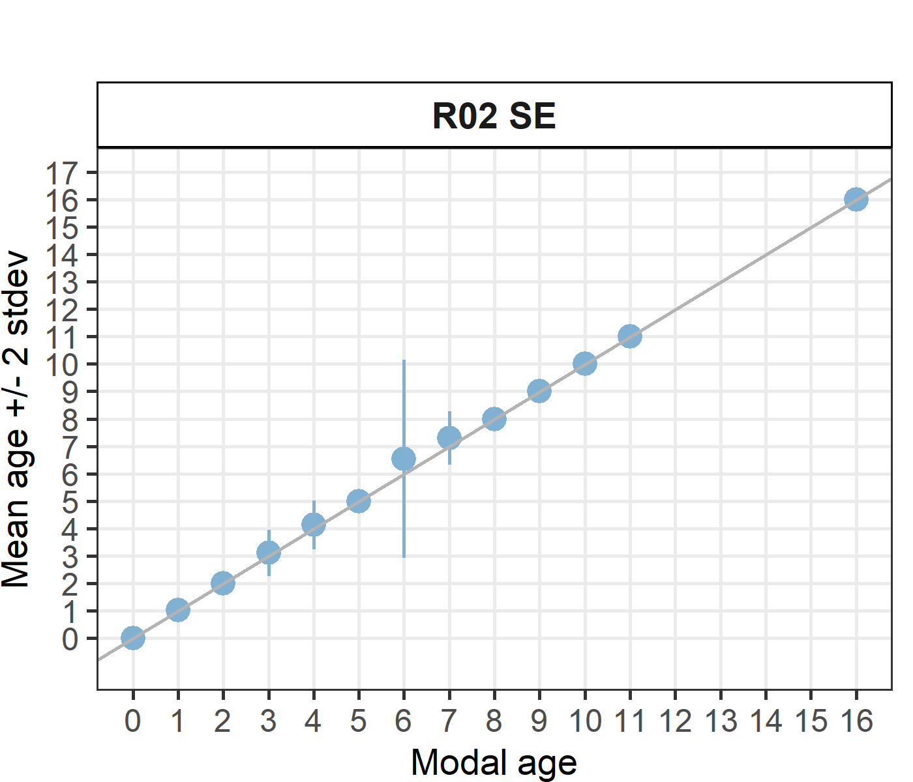 [[2]] 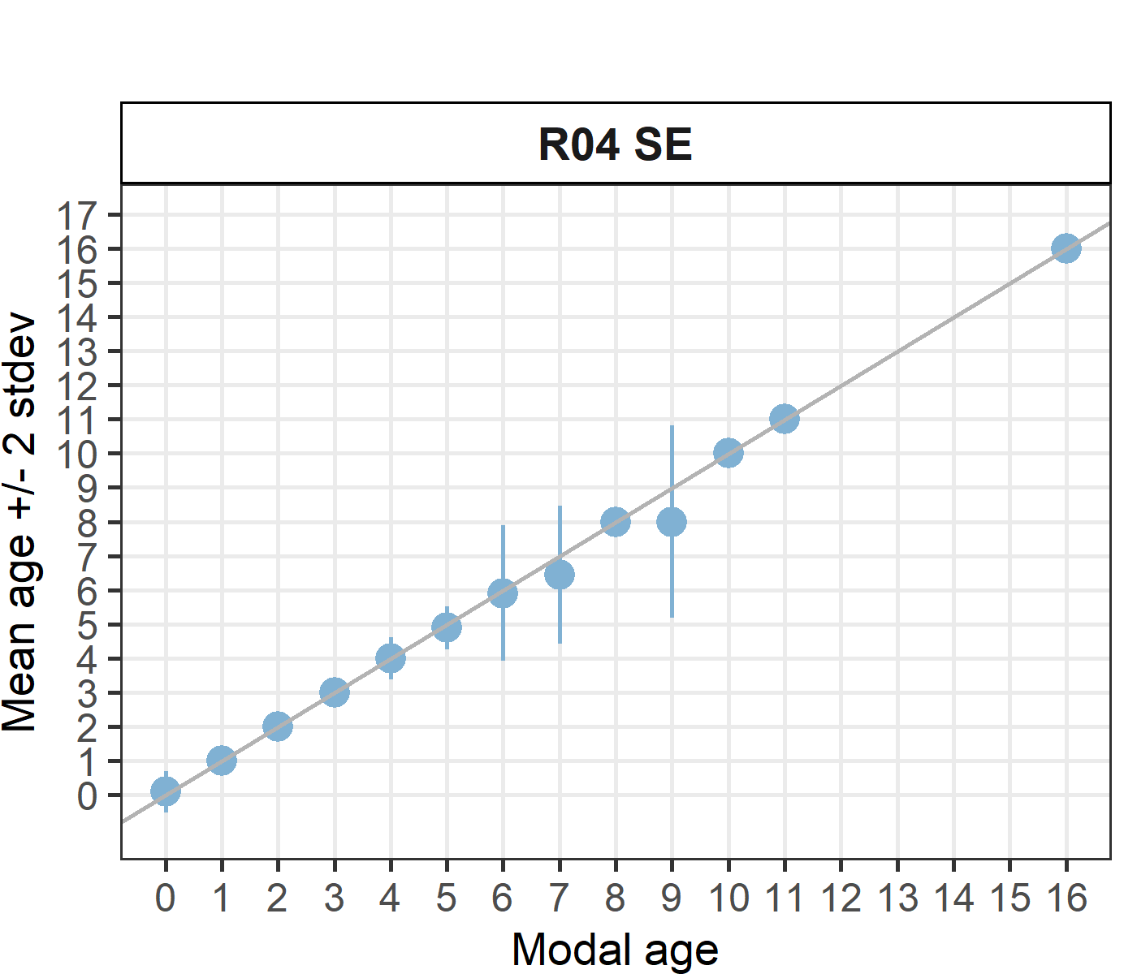 [[3]] 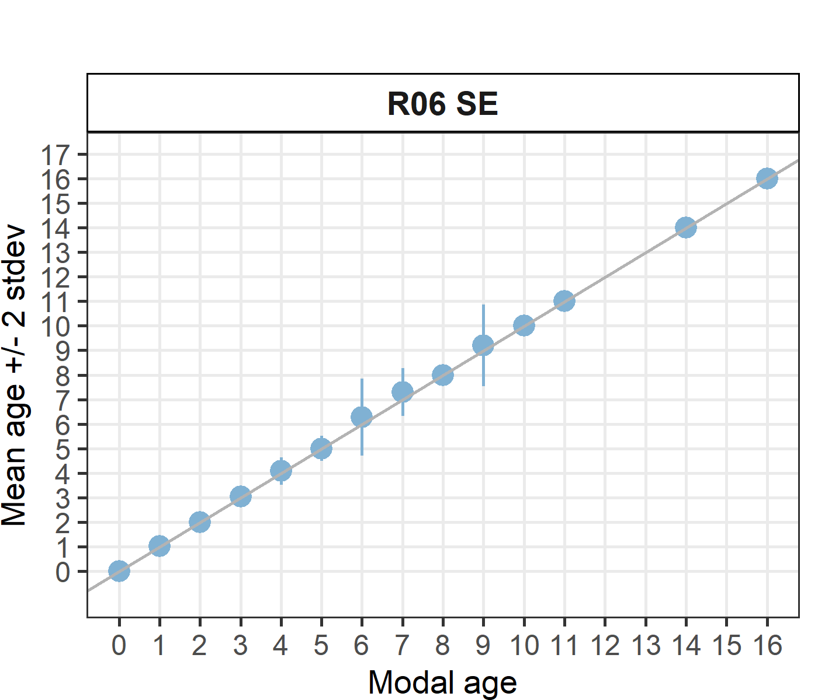 [[4]] 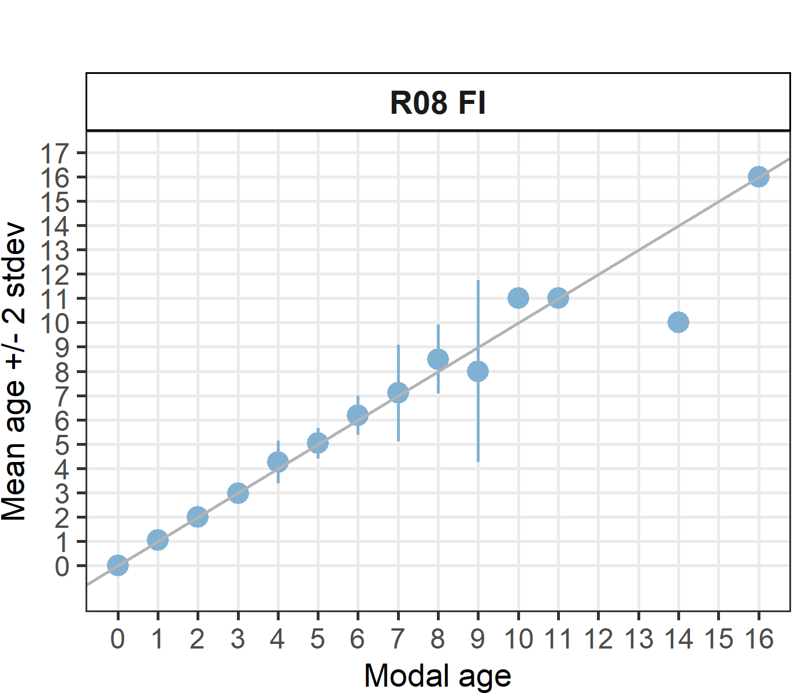 [[5]] 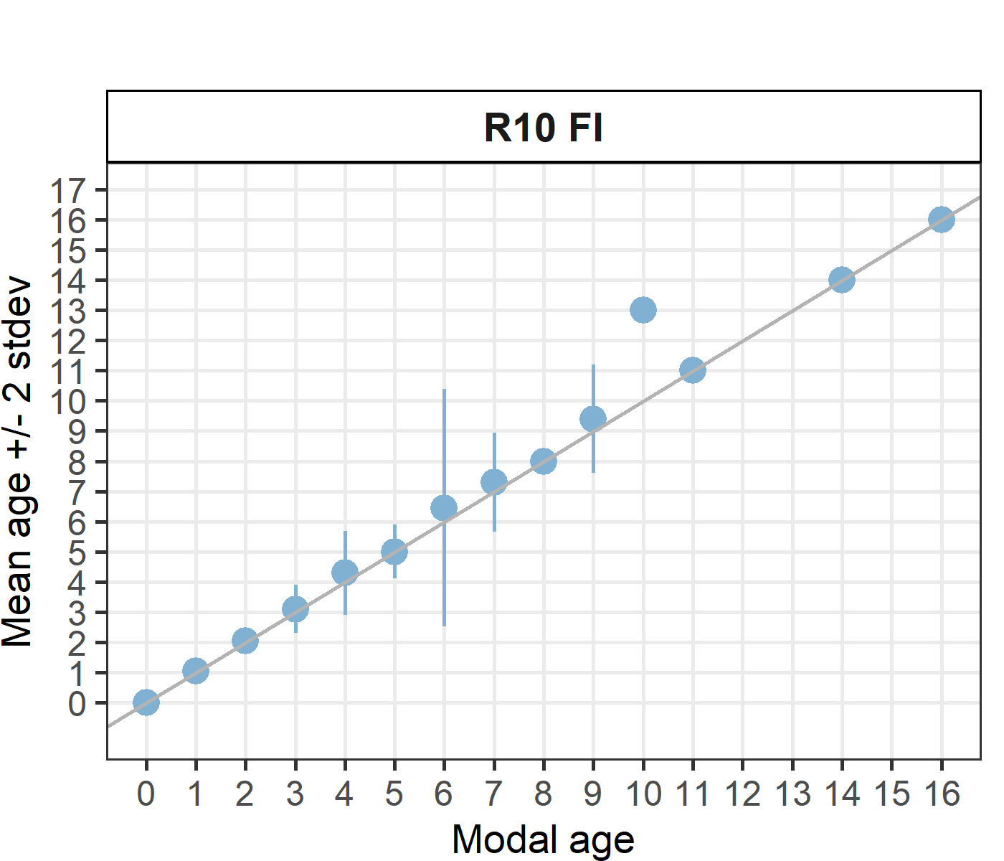 [[6]] 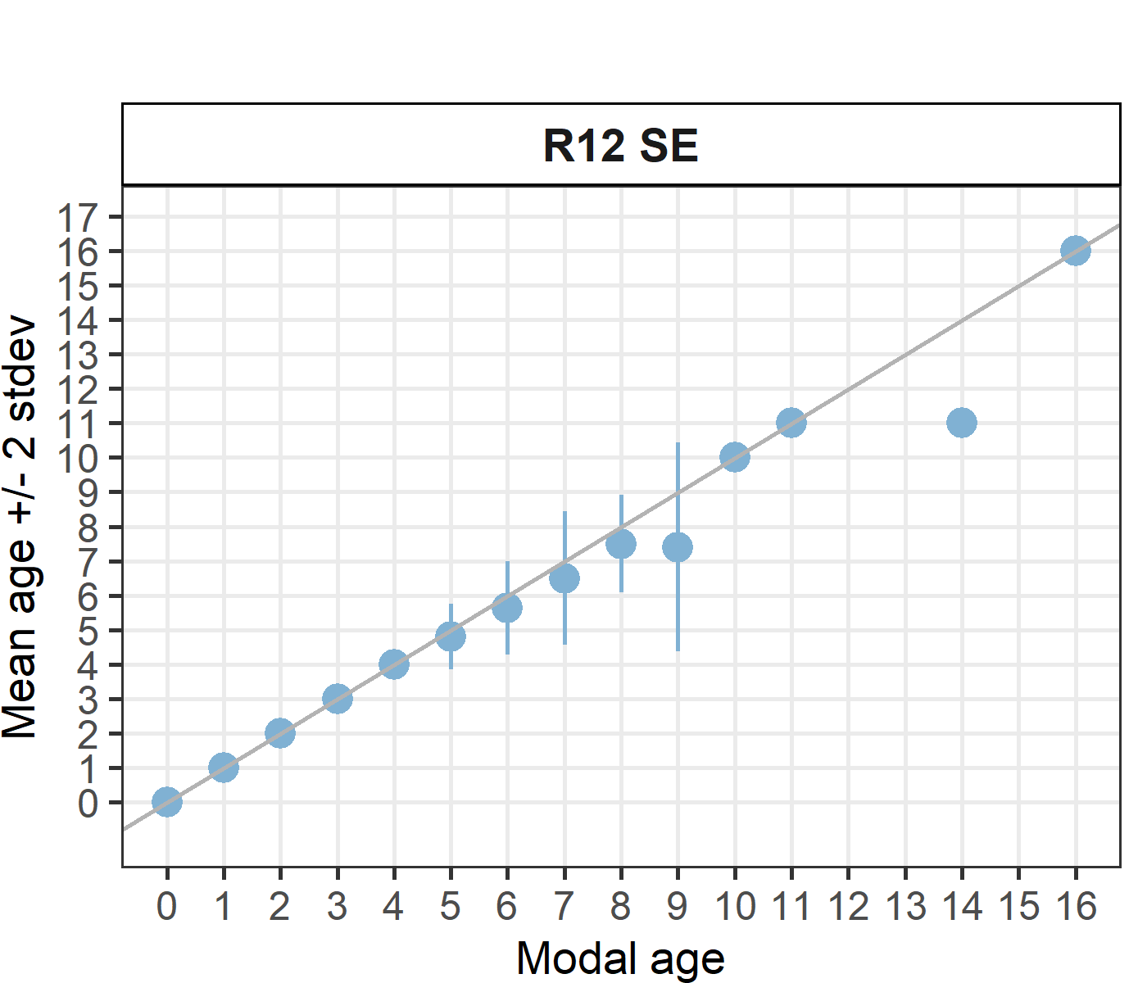 [[7]] 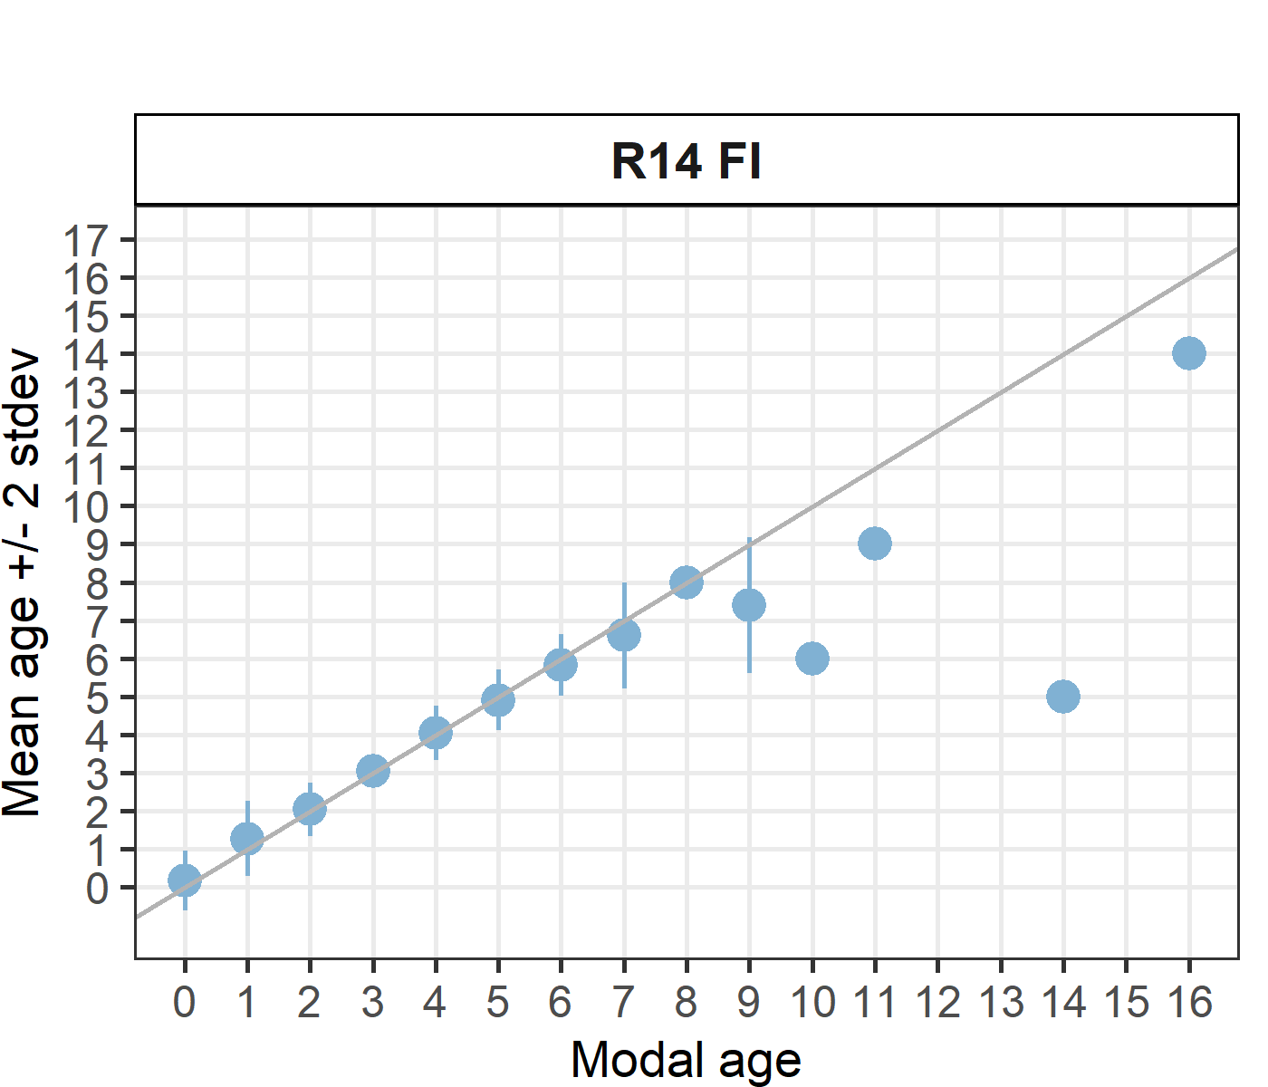 [[8]] 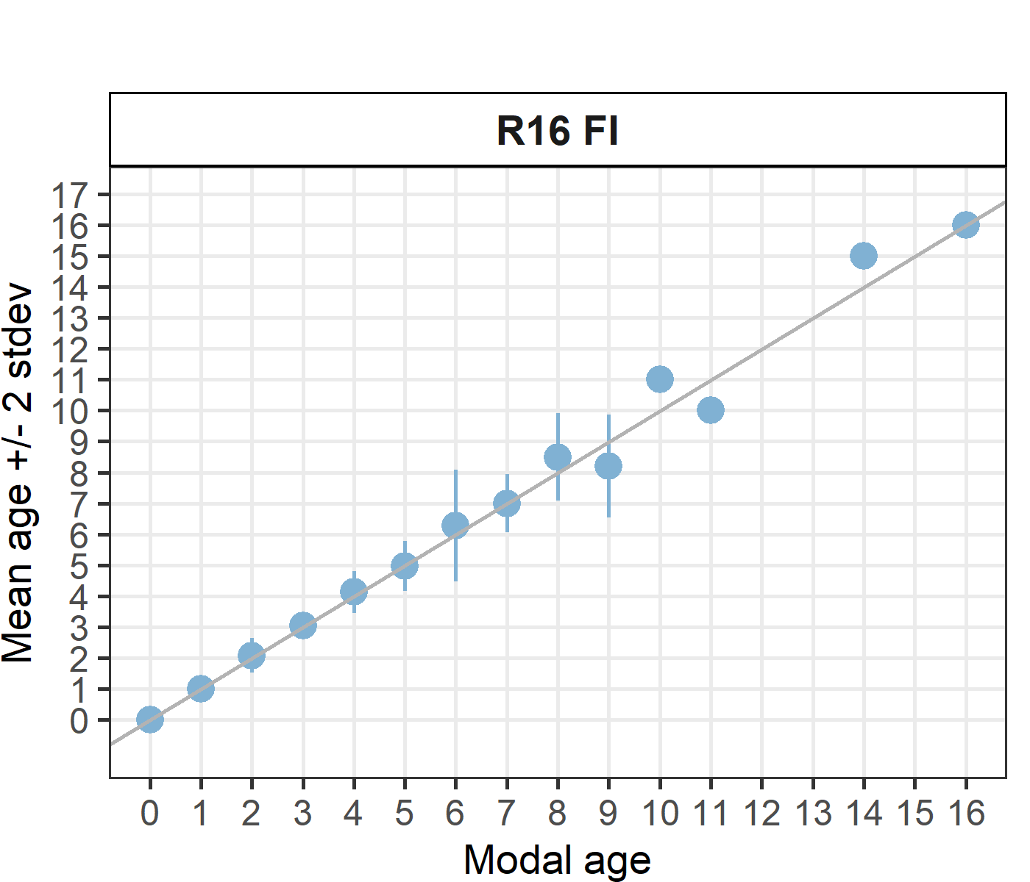 [[9]] 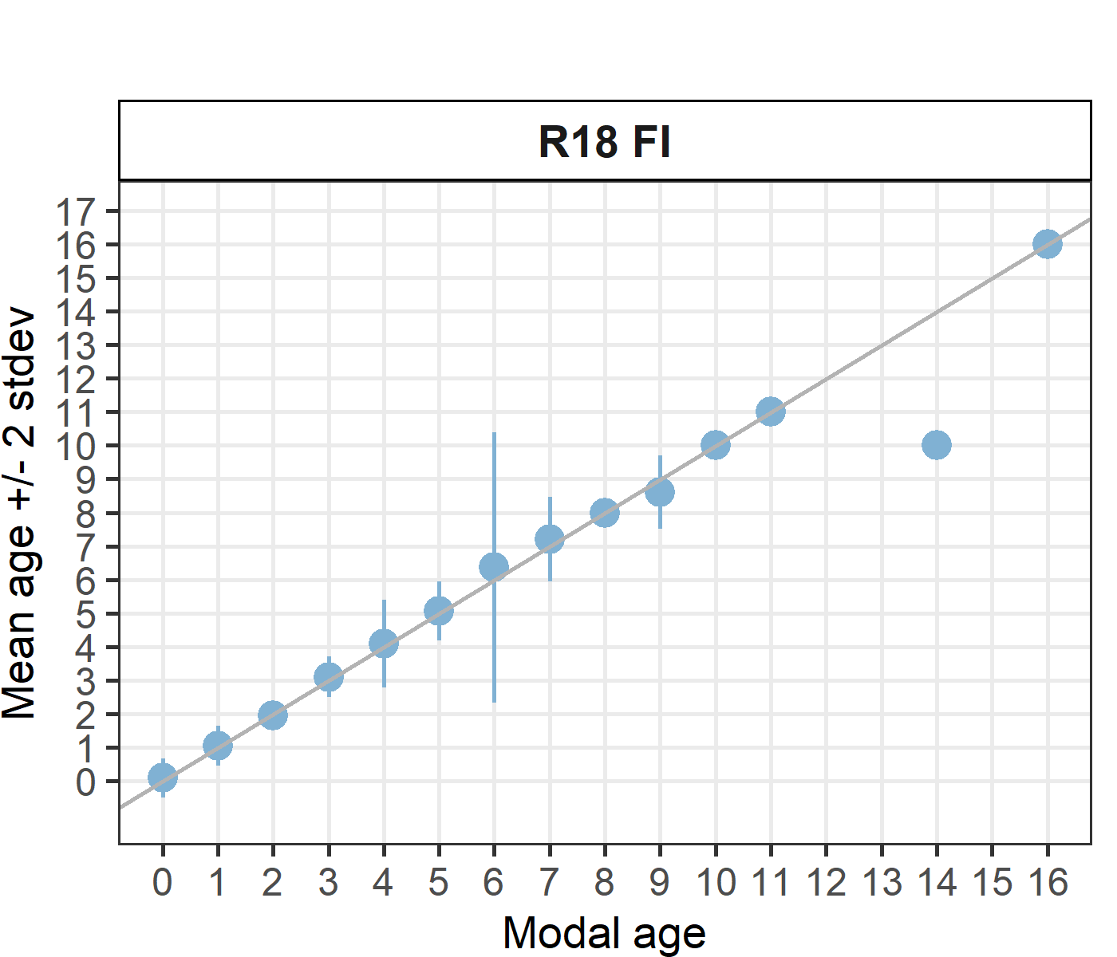 [[10]] 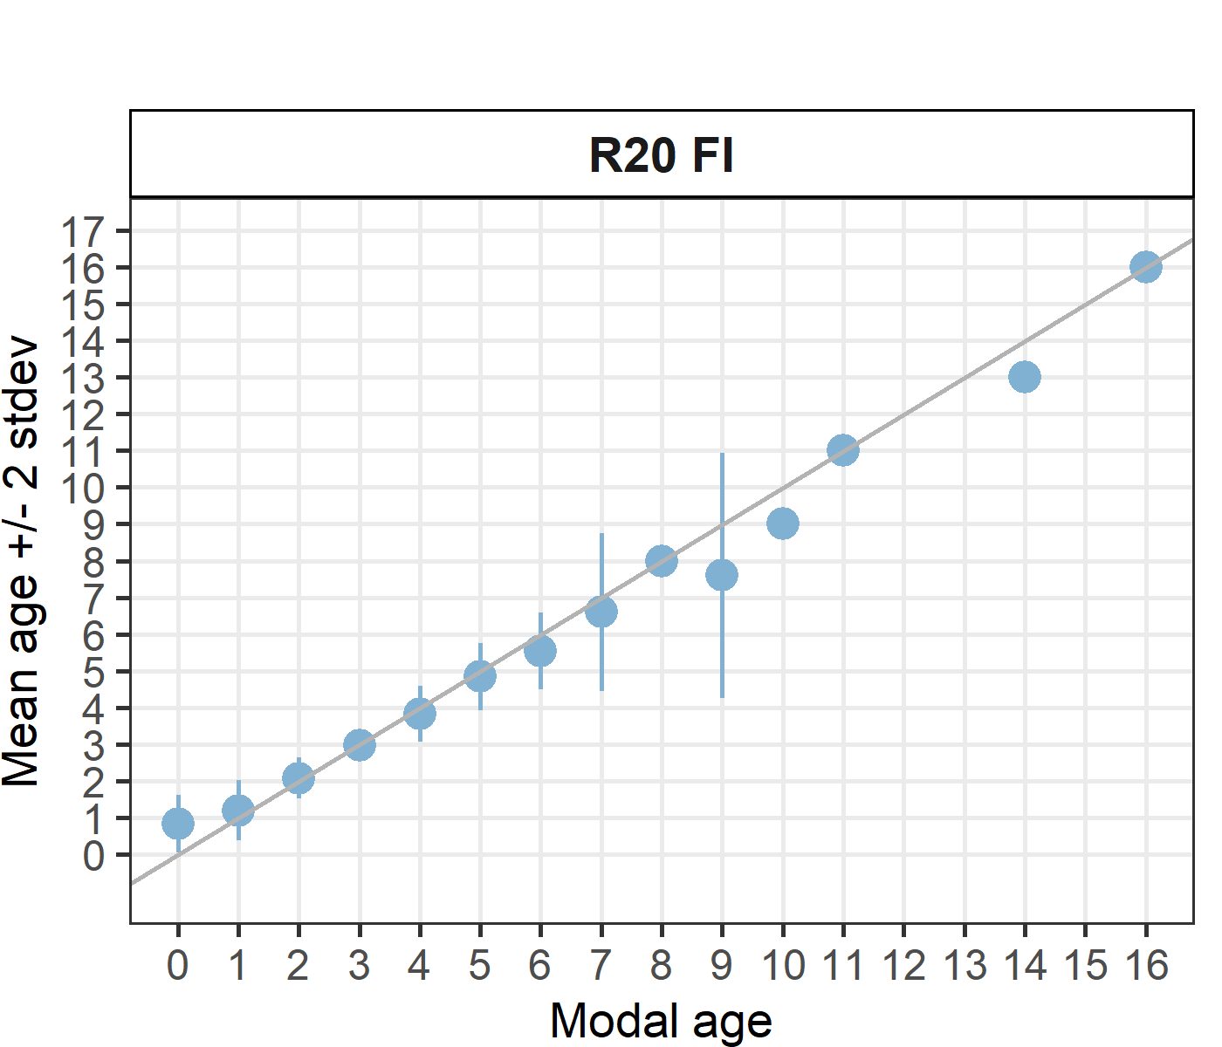 [[11]] 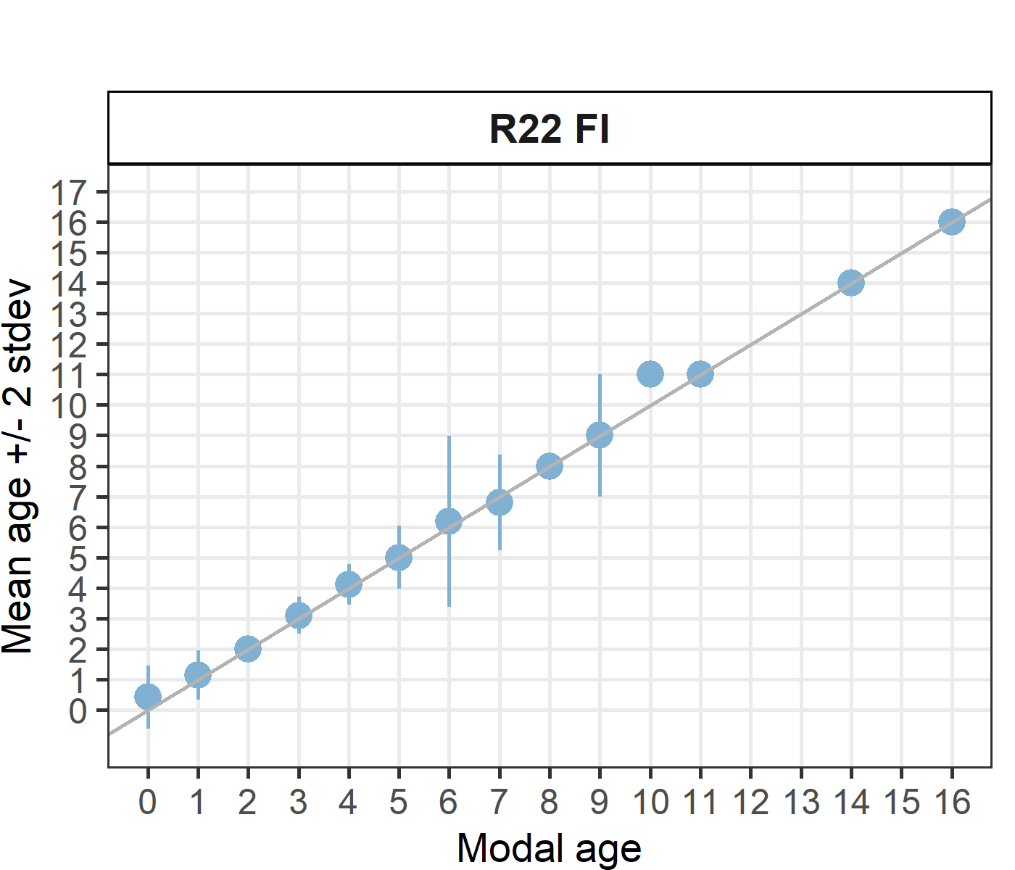 [[12]] 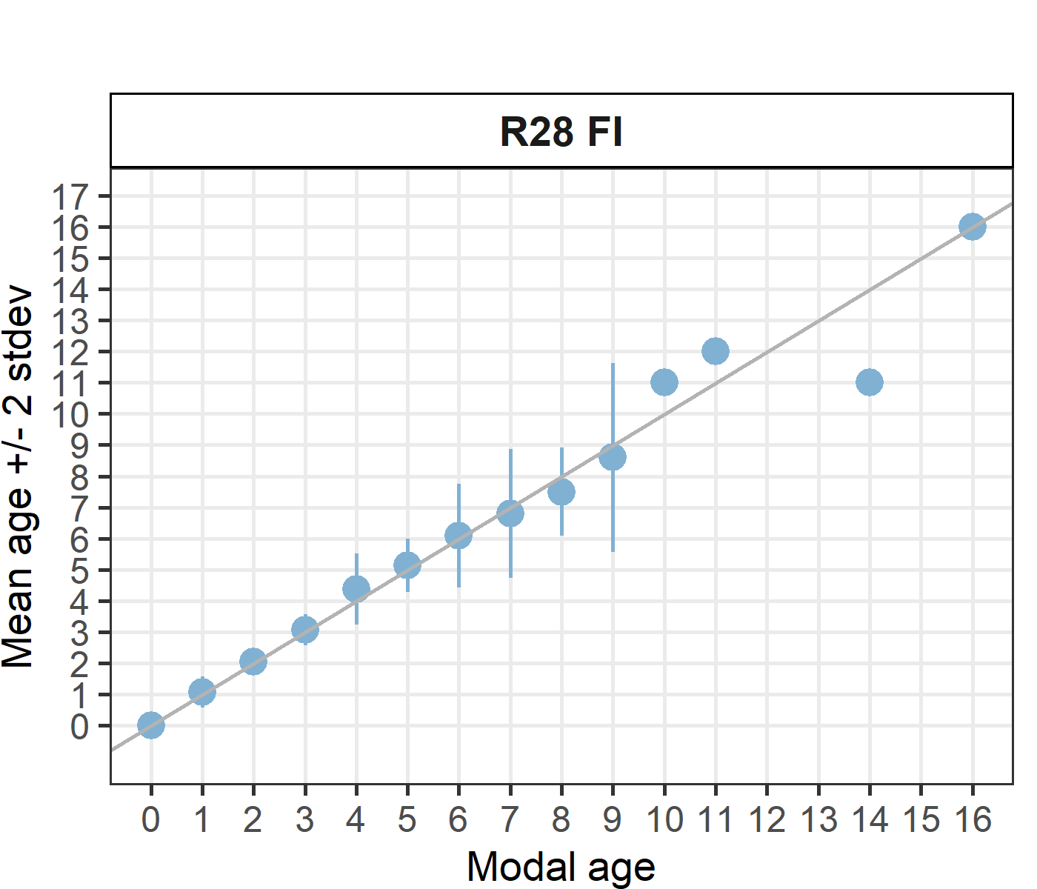

Statistics by modal age plot (STDEV, CV and PA)
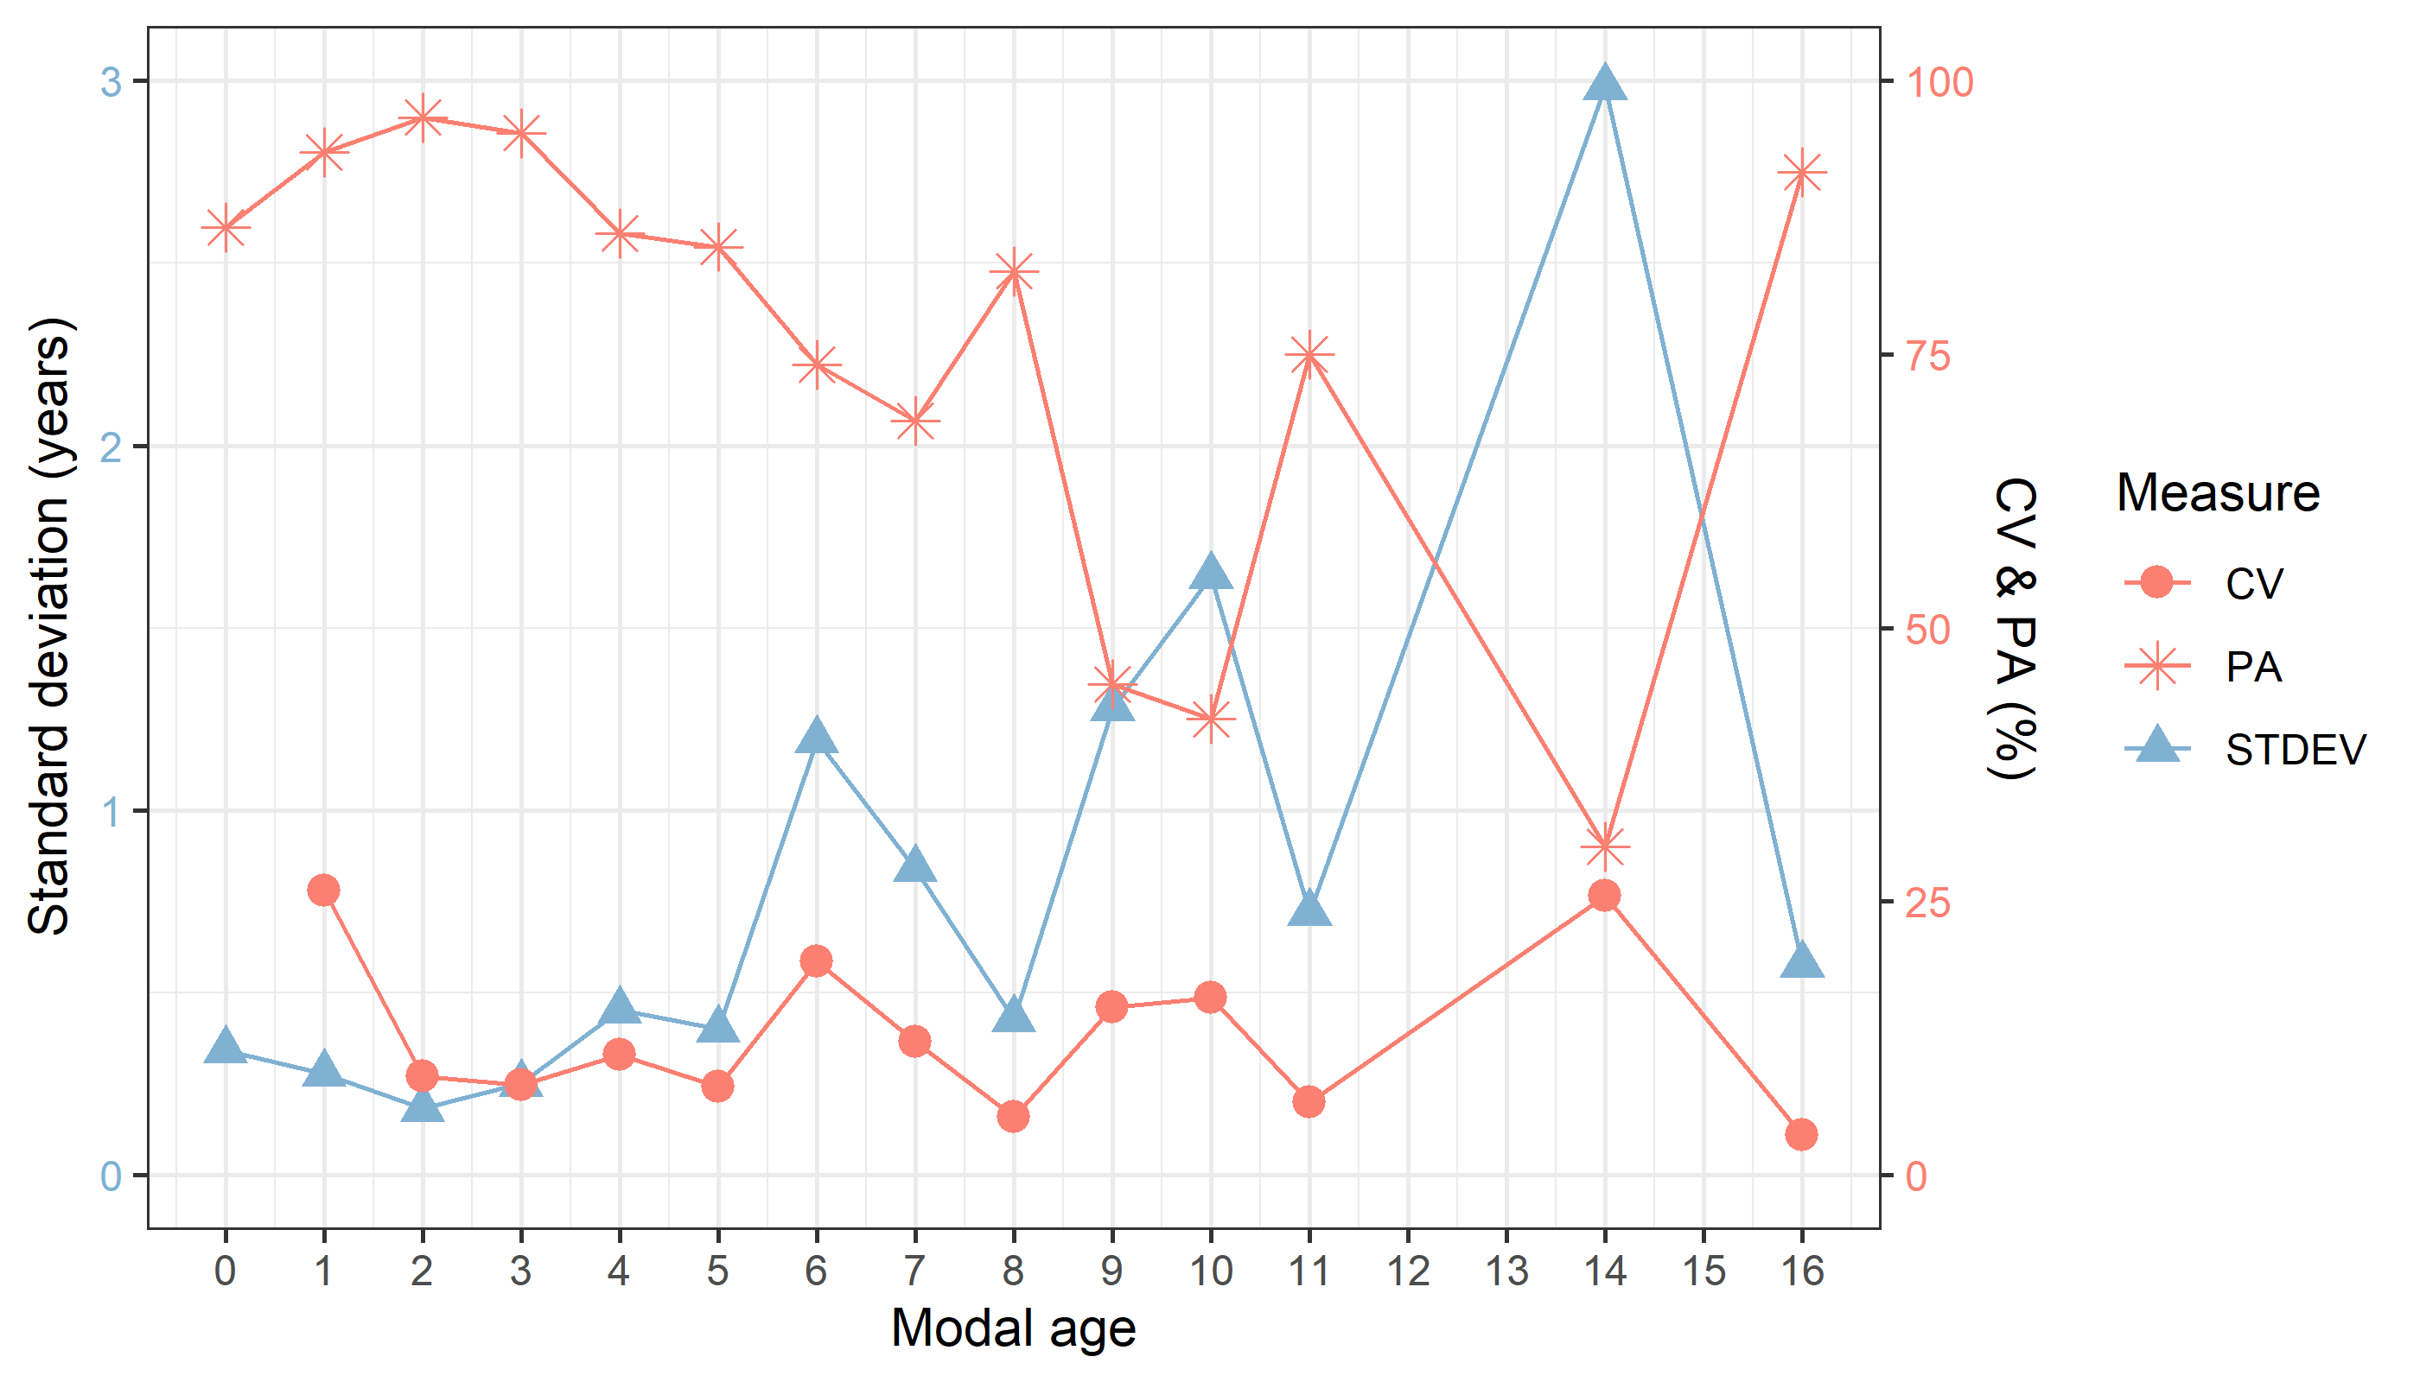
Figure X: CV, PA and (STDEV (standard deviation) are plotted against modal age

Distribution of age reading errors
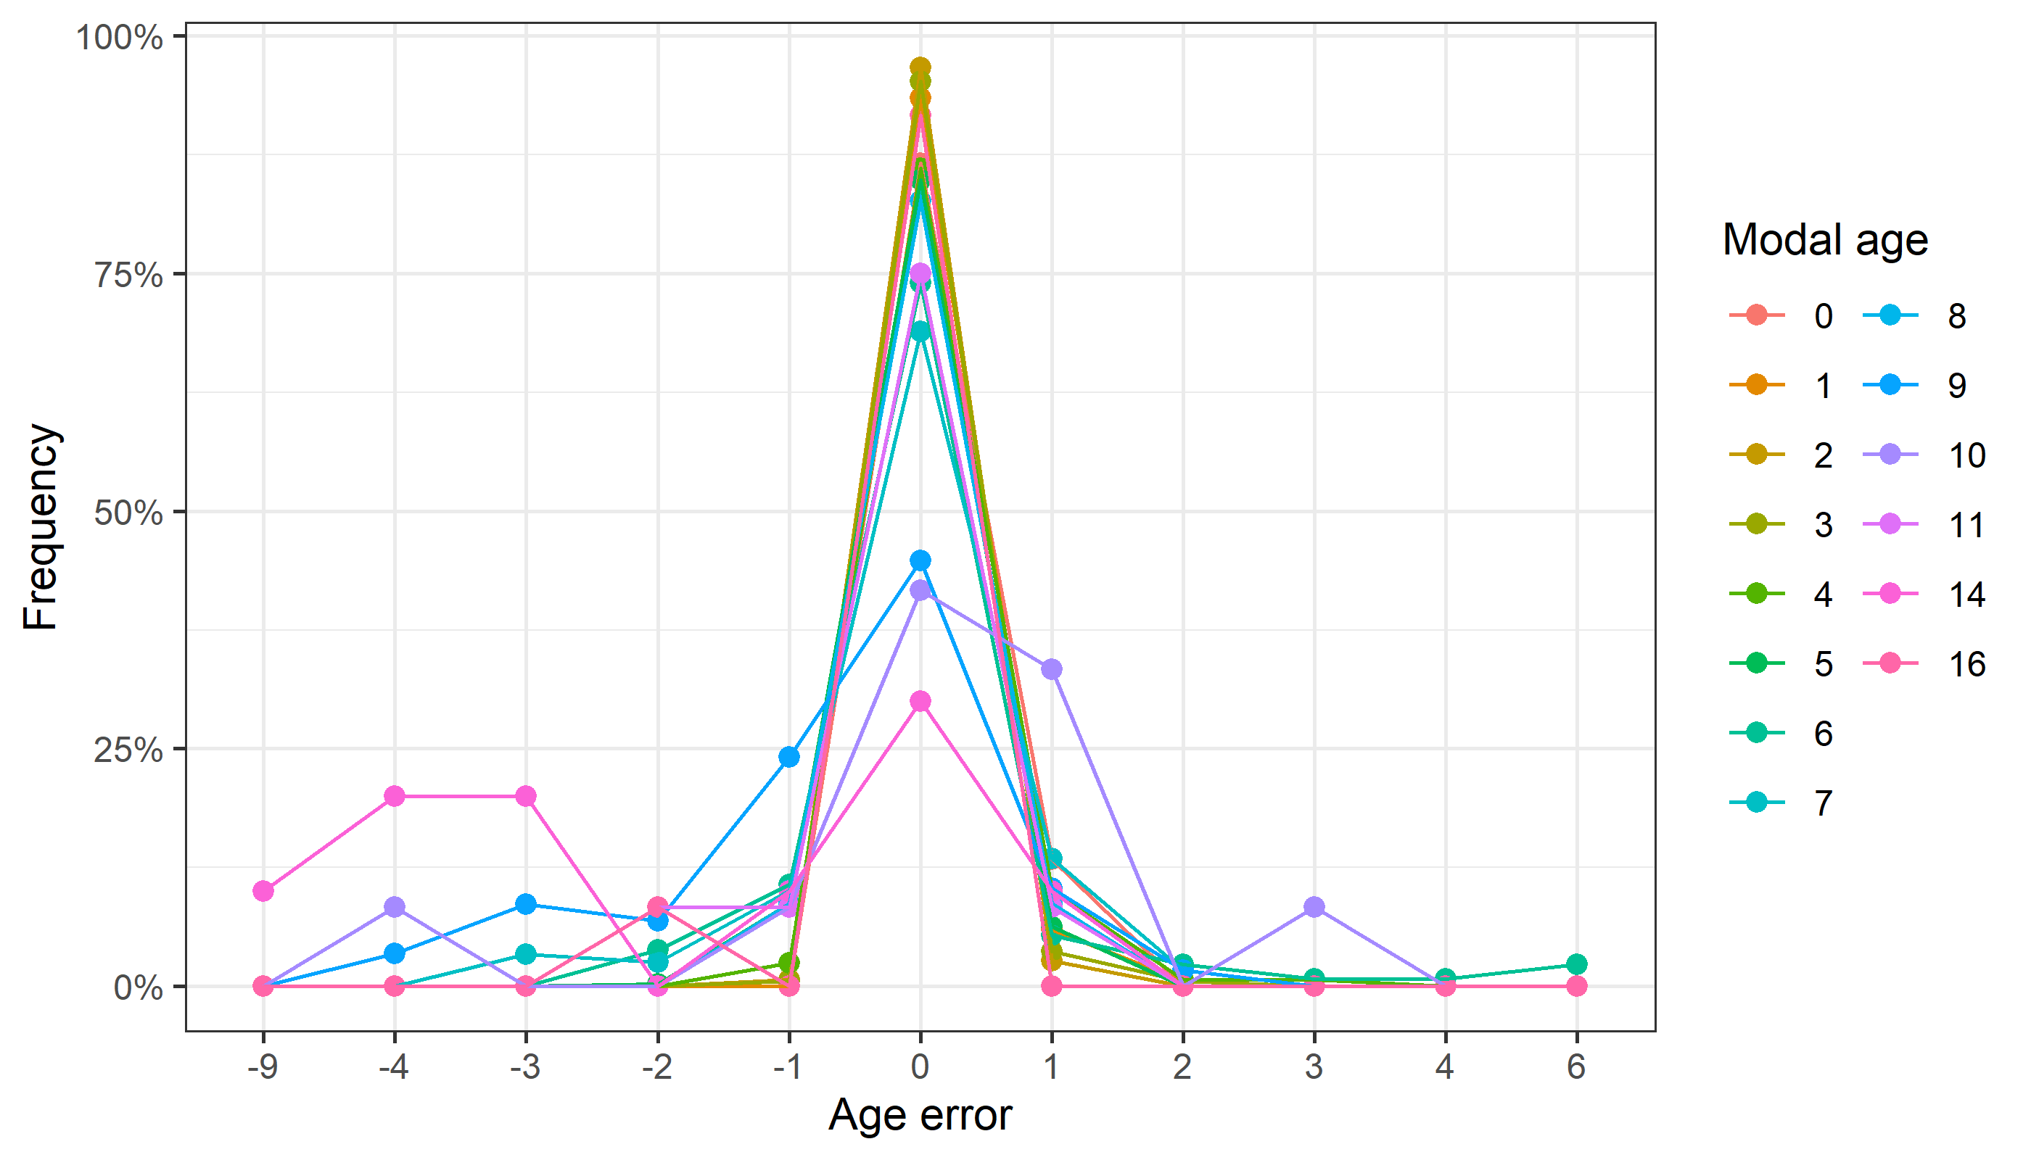
Figure X: The distribution of the age reading errors in percentage by modal age as observed from the whole group of age readers in an age reading comparison to modal age. The achieved precision in age reading by MODAL age group is shown by the spread of the age readings errors. There appears to be no relative bias, if the age reading errors are normally distributed. The distributions are skewed, if relative bias occurs.

Relative bias for all readers
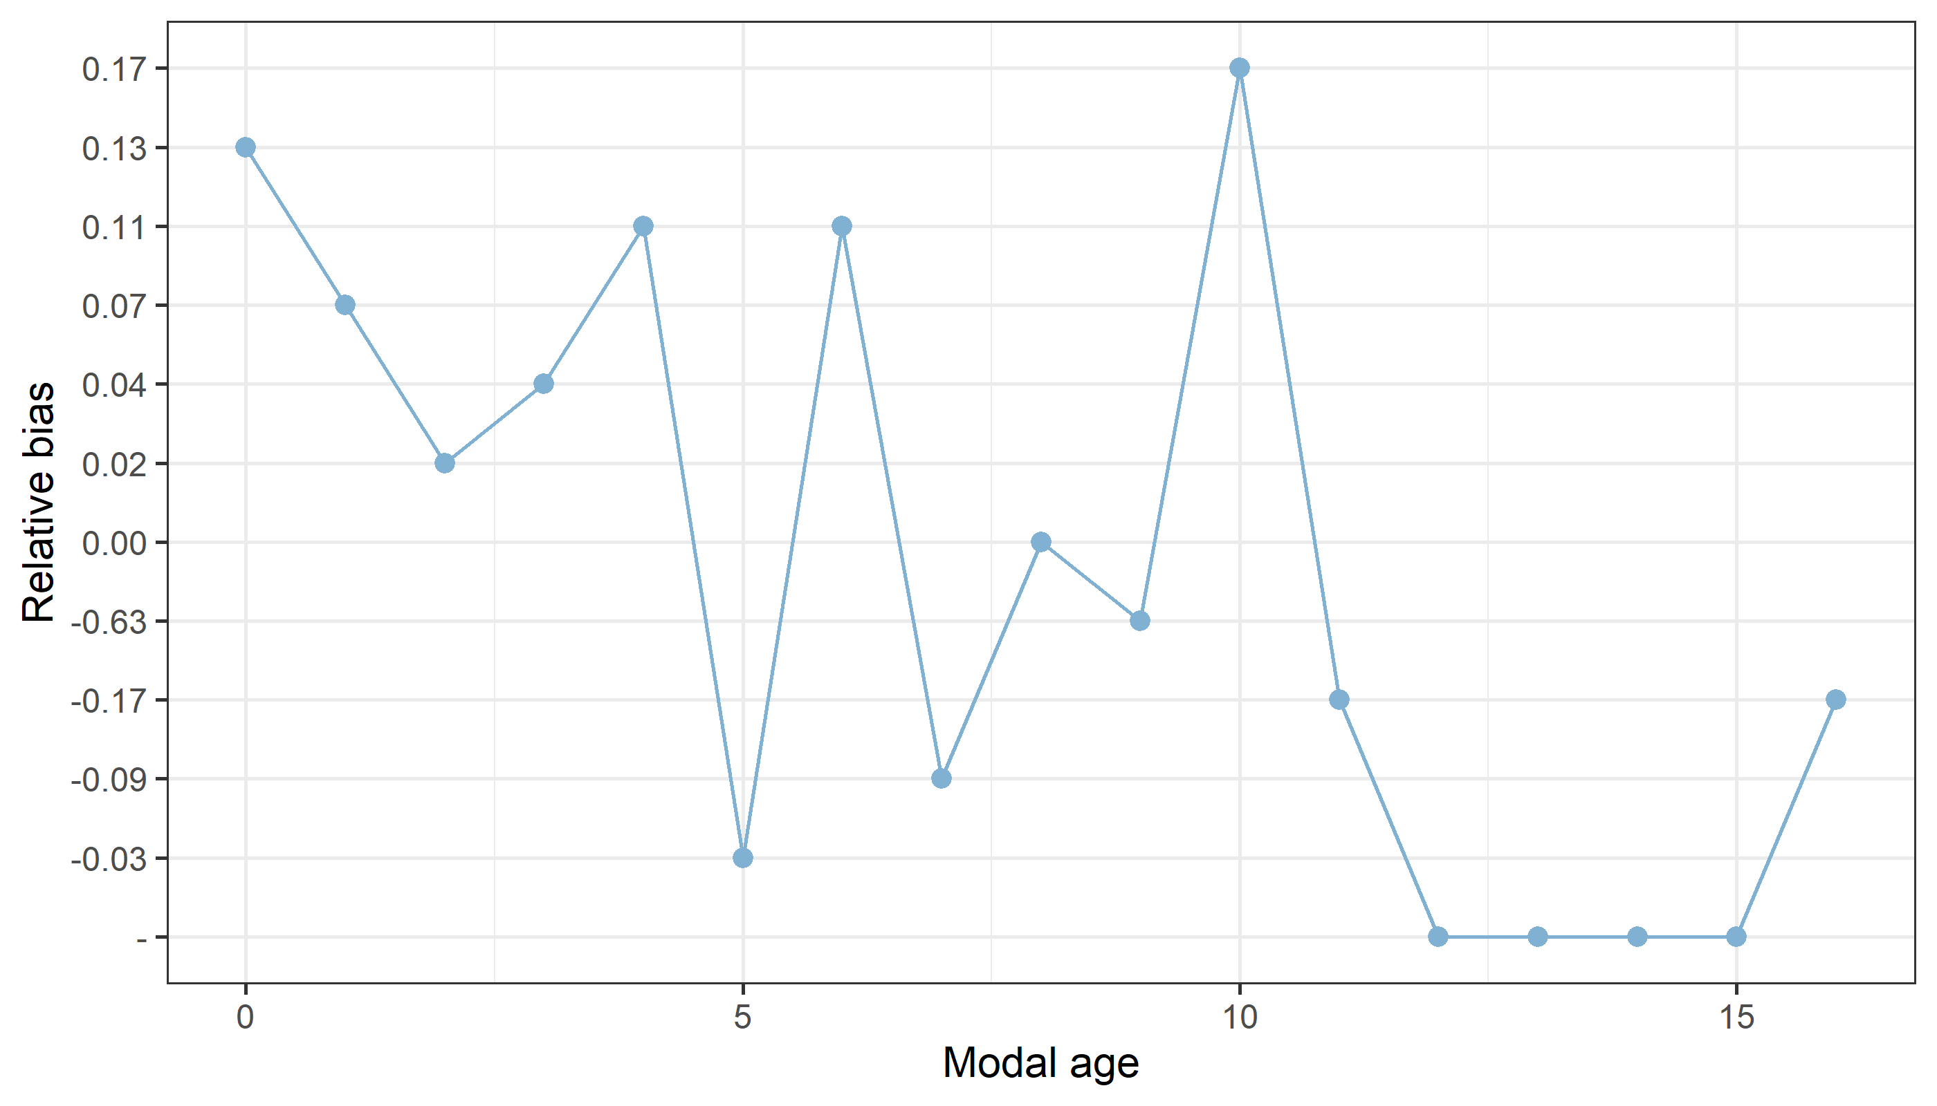
Figure X: The relative bias by modal age as estimated by all age readers combined.

Mean length at age by reader
Table X: Mean fish length at age per reader is calculated per reader and age (not modal age) and for all readers combined per age. A weighted mean is also given.
Age | R02 SE | R04 SE | R06 SE | R08 FI | R10 FI | R12 SE | R14 FI | R16 FI | R18 FI | R20 FI | R22 FI | R28 FI
0 | 98 mm | 99 mm | 98 mm | 98 mm | 98 mm | 98 mm | 96 mm | 98 mm | 99 mm | 92 mm | 95 mm | 98 mm
1 | 126 mm | 125 mm | 125 mm | 126 mm | 125 mm | 126 mm | 123 mm | 126 mm | 125 mm | 120 mm | 123 mm | 125 mm
2 | 139 mm | 139 mm | 139 mm | 139 mm | 138 mm | 139 mm | 137 mm | 138 mm | 140 mm | 136 mm | 138 mm | 139 mm
3 | 155 mm | 155 mm | 154 mm | 154 mm | 153 mm | 155 mm | 154 mm | 154 mm | 153 mm | 155 mm | 153 mm | 153 mm
4 | 163 mm | 165 mm | 163 mm | 163 mm | 163 mm | 166 mm | 164 mm | 164 mm | 163 mm | 167 mm | 164 mm | 163 mm
5 | 171 mm | 171 mm | 172 mm | 170 mm | 171 mm | 172 mm | 173 mm | 171 mm | 171 mm | 172 mm | 172 mm | 170 mm
6 | 177 mm | 178 mm | 180 mm | 177 mm | 180 mm | 178 mm | 179 mm | 178 mm | 179 mm | 177 mm | 176 mm | 177 mm
7 | 176 mm | 179 mm | 177 mm | 178 mm | 178 mm | 179 mm | 179 mm | 177 mm | 176 mm | 178 mm | 178 mm | 178 mm
8 | 180 mm | 185 mm | 176 mm | 180 mm | 180 mm | 188 mm | 178 mm | 179 mm | 184 mm | 186 mm | 177 mm | 177 mm
9 | 182 mm | 185 mm | 188 mm | 186 mm | 181 mm | 185 mm | 195 mm | 185 mm | 177 mm | 188 mm | 185 mm | 185 mm
10 | 195 mm | 195 mm | 188 mm | 190 mm | - | 195 mm | - | 195 mm | 195 mm | - | 187 mm | 185 mm
11 | 195 mm | 195 mm | 195 mm | 195 mm | 185 mm | 195 mm | - | 195 mm | 195 mm | 195 mm | 195 mm | 195 mm
12 | 175 mm | - | - | - | 175 mm | - | - | - | 175 mm | - | - | 195 mm
13 | - | - | - | - | 195 mm | - | - | - | - | 195 mm | - | -
14 | - | - | 195 mm | - | 195 mm | - | 200 mm | - | - | - | 195 mm | -
15 | - | - | - | - | - | - | - | 195 mm | - | - | - | -
16 | 200 mm | 200 mm | 200 mm | 200 mm | 200 mm | 200 mm | - | 200 mm | 200 mm | 200 mm | 200 mm | 200 mm
Weighted Mean | 151 mm | 150 mm | 151 mm | 151 mm | 151 mm | 151 mm | 151 mm | 151 mm | 151 mm | 151 mm | 151 mm | 151 mm
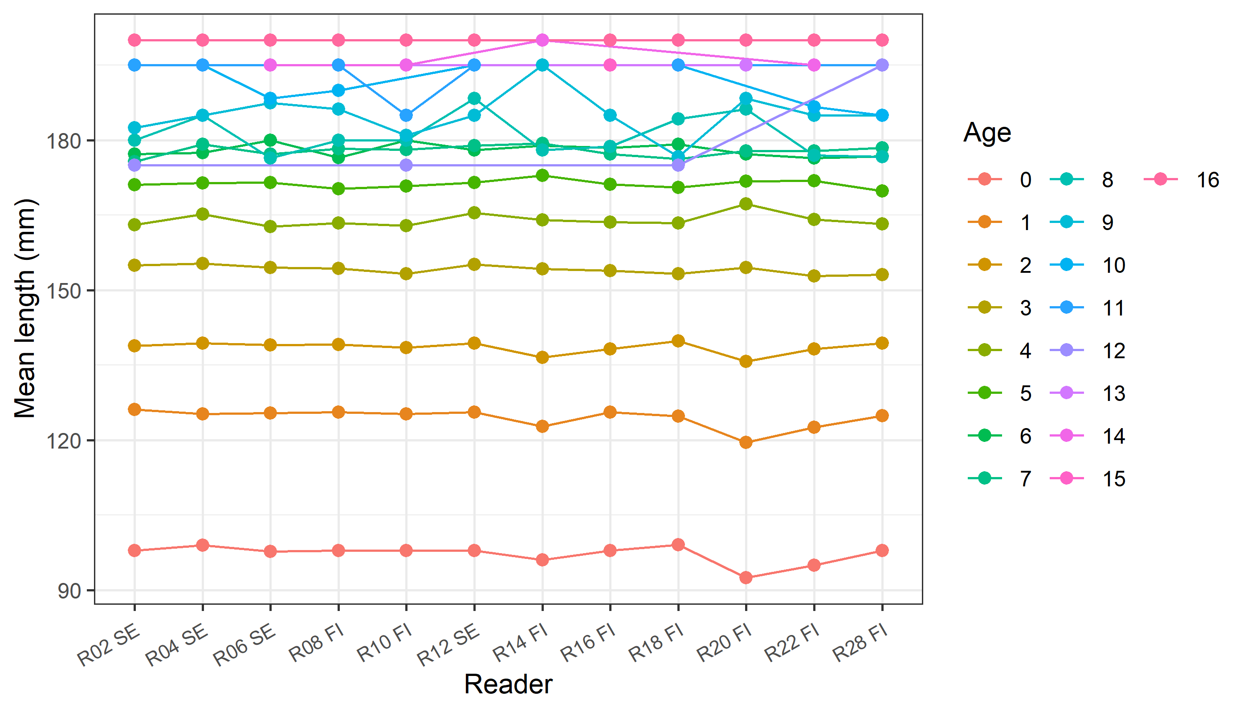
Figure X: The mean fish length at age as estimated by each age reader.

Results Advanced readers
All samples included
Summary statistics
Table X: Summary of statistics; PA (%), CV (%) and APE (%).
NSample | CV | PA | APE
199 | 10 % | 91 % | 4 %

Data overview
Table X: Data overview including modal age and statistics per sample.
Fish ID | Sample ID | Event ID | Image ID | length | sex | Catch date | ICES area | R02 SE | R04 SE | R06 SE | R08 FI | R12 SE | R28 FI | Modal age | PA % | CV % | APE %
12 | 12 | 1849 | 135029 | 85 | - | 11-09-2023 00:00:00 | 27.3.d.30 | 0 | - | 0 | 0 | 0 | 0 | 0 | 100 | - | -
29 | 29 | 1849 | 135030 | 90 | - | 22-03-2023 00:00:00 | 27.3.d.30 | 1 | 1 | 1 | 1 | 1 | 1 | 1 | 100 | 0 | 0
44 | 44 | 1849 | 135031 | 95 | - | 15-03-2023 00:00:00 | 27.3.d.30 | 1 | 1 | 1 | 1 | 1 | 1 | 1 | 100 | 0 | 0
47 | 47 | 1849 | 135032 | 100 | - | 07-12-2023 00:00:00 | 27.3.d.30 | 0 | 1 | - | 0 | 0 | 0 | 0 | 80 | - | -
55 | 55 | 1849 | 135033 | 100 | - | 12-04-2023 00:00:00 | 27.3.d.30 | - | 1 | 1 | 1 | 1 | 1 | 1 | 100 | 0 | 0
58 | 58 | 1849 | 135034 | 105 | - | 09-03-2023 00:00:00 | 27.3.d.30 | 1 | 1 | 1 | 1 | 1 | 1 | 1 | 100 | 0 | 0
74 | 74 | 1849 | 135035 | 110 | - | 16-04-2023 00:00:00 | 27.3.d.30 | 1 | 1 | 1 | 1 | 1 | 1 | 1 | 100 | 0 | 0
76 | 76 | 1849 | 135036 | 110 | - | 12-04-2023 00:00:00 | 27.3.d.30 | 1 | 1 | 1 | 1 | 1 | 1 | 1 | 100 | 0 | 0
85 | 85 | 1849 | 135037 | 115 | - | 16-04-2023 00:00:00 | 27.3.d.30 | 1 | 1 | 1 | 2 | 1 | 1 | 1 | 83 | 35 | 24
87 | 87 | 1849 | 135038 | 115 | - | 15-03-2023 00:00:00 | 27.3.d.30 | 1 | 1 | 1 | 1 | 1 | 1 | 1 | 100 | 0 | 0
95 | 95 | 1849 | 135039 | 120 | - | 09-03-2023 00:00:00 | 27.3.d.30 | 1 | - | 1 | 1 | 1 | 1 | 1 | 100 | 0 | 0
97 | 97 | 1849 | 135040 | 120 | - | 10-12-2023 00:00:00 | 27.3.d.30 | 1 | 1 | 1 | 1 | 1 | 1 | 1 | 100 | 0 | 0
99 | 99 | 1849 | 135041 | 120 | - | 09-03-2023 00:00:00 | 27.3.d.30 | 2 | 2 | 2 | 2 | 2 | 3 | 2 | 83 | 19 | 13
100 | 100 | 1849 | 135042 | 120 | - | 12-04-2023 00:00:00 | 27.3.d.30 | 2 | 2 | 2 | 2 | 2 | 2 | 2 | 100 | 0 | 0
101 | 101 | 1849 | 135043 | 120 | - | 11-09-2023 00:00:00 | 27.3.d.30 | 1 | - | 1 | 1 | 1 | 1 | 1 | 100 | 0 | 0
107 | 107 | 1849 | 135044 | 125 | - | 15-03-2023 00:00:00 | 27.3.d.30 | 2 | 2 | 2 | 2 | 2 | 2 | 2 | 100 | 0 | 0
109 | 109 | 1849 | 135045 | 125 | - | 14-12-2023 00:00:00 | 27.3.d.30 | 1 | 1 | 1 | 1 | 1 | 1 | 1 | 100 | 0 | 0
112 | 112 | 1849 | 135046 | 125 | - | 22-03-2023 00:00:00 | 27.3.d.30 | 2 | 2 | 2 | 2 | 2 | 2 | 2 | 100 | 0 | 0
113 | 113 | 1849 | 135047 | 125 | - | 22-03-2023 00:00:00 | 27.3.d.30 | 2 | 2 | 2 | 2 | 2 | 2 | 2 | 100 | 0 | 0
117 | 117 | 1849 | 135048 | 125 | - | 29-12-2023 00:00:00 | 27.3.d.30 | 1 | 1 | 1 | 1 | 1 | 1 | 1 | 100 | 0 | 0
118 | 118 | 1849 | 135049 | 125 | - | 09-03-2023 00:00:00 | 27.3.d.30 | 2 | 2 | 2 | 2 | 2 | 2 | 2 | 100 | 0 | 0
119 | 119 | 1849 | 135050 | 130 | - | 09-03-2023 00:00:00 | 27.3.d.30 | 2 | 2 | 2 | 2 | 2 | 2 | 2 | 100 | 0 | 0
128 | 128 | 1849 | 135051 | 130 | - | 13-12-2023 00:00:00 | 27.3.d.30 | 1 | 1 | 1 | 1 | 1 | 1 | 1 | 100 | 0 | 0
137 | 137 | 1849 | 135052 | 130 | - | 18-12-2023 00:00:00 | 27.3.d.30 | 1 | 1 | 1 | 1 | 1 | 1 | 1 | 100 | 0 | 0
143 | 143 | 1849 | 135053 | 135 | - | 11-09-2023 00:00:00 | 27.3.d.30 | 1 | 1 | 1 | 1 | 1 | 1 | 1 | 100 | 0 | 0
146 | 146 | 1849 | 135054 | 135 | - | 09-03-2023 00:00:00 | 27.3.d.30 | 3 | 3 | 3 | 3 | 3 | 3 | 3 | 100 | 0 | 0
150 | 150 | 1849 | 135055 | 135 | - | 14-12-2023 00:00:00 | 27.3.d.30 | 2 | 2 | 2 | 2 | 2 | 2 | 2 | 100 | 0 | 0
155 | 155 | 1849 | 135056 | 135 | - | 07-12-2023 00:00:00 | 27.3.d.30 | 1 | 1 | 1 | 2 | 1 | 1 | 1 | 83 | 35 | 24
160 | 160 | 1849 | 135057 | 140 | - | 10-12-2023 00:00:00 | 27.3.d.30 | 3 | 3 | 3 | 3 | 3 | 3 | 3 | 100 | 0 | 0
165 | 165 | 1849 | 135058 | 140 | - | 22-10-2023 00:00:00 | 27.3.d.30 | 1 | 1 | 1 | 1 | 1 | 1 | 1 | 100 | 0 | 0
178 | 178 | 1849 | 135059 | 145 | - | 10-12-2023 00:00:00 | 27.3.d.30 | 3 | 3 | 3 | 3 | 3 | 3 | 3 | 100 | 0 | 0
179 | 179 | 1849 | 135060 | 145 | - | 15-03-2023 00:00:00 | 27.3.d.30 | 4 | 4 | 4 | 4 | 4 | 5 | 4 | 83 | 10 | 7
180 | 180 | 1849 | 135061 | 145 | - | 12-04-2023 00:00:00 | 27.3.d.30 | 3 | 3 | 3 | 3 | 3 | 3 | 3 | 100 | 0 | 0
181 | 181 | 1849 | 135062 | 145 | - | 16-04-2023 00:00:00 | 27.3.d.30 | - | 3 | 3 | 3 | 3 | 3 | 3 | 100 | 0 | 0
182 | 182 | 1849 | 135063 | 145 | - | 10-12-2023 00:00:00 | 27.3.d.30 | 2 | 2 | 2 | 2 | 2 | 2 | 2 | 100 | 0 | 0
184 | 184 | 1849 | 135064 | 145 | - | 13-12-2023 00:00:00 | 27.3.d.30 | 2 | 2 | 2 | 2 | 2 | 2 | 2 | 100 | 0 | 0
185 | 185 | 1849 | 135065 | 145 | - | 22-03-2023 00:00:00 | 27.3.d.30 | - | 3 | 3 | 3 | 3 | 3 | 3 | 100 | 0 | 0
191 | 191 | 1849 | 135066 | 145 | - | 13-04-2023 00:00:00 | 27.3.d.30 | 2 | 2 | 2 | 2 | 2 | 2 | 2 | 100 | 0 | 0
195 | 195 | 1849 | 135067 | 150 | - | 14-12-2023 00:00:00 | 27.3.d.30 | 4 | - | 4 | 4 | 4 | 4 | 4 | 100 | 0 | 0
199 | 199 | 1849 | 135068 | 150 | - | 29-12-2023 00:00:00 | 27.3.d.30 | 2 | 2 | 2 | 2 | 2 | 2 | 2 | 100 | 0 | 0
202 | 202 | 1849 | 135069 | 150 | - | 22-03-2023 00:00:00 | 27.3.d.30 | 3 | 3 | 3 | 3 | 3 | 3 | 3 | 100 | 0 | 0
205 | 205 | 1849 | 135070 | 150 | - | 09-03-2023 00:00:00 | 27.3.d.30 | 3 | 3 | 3 | 3 | 3 | 3 | 3 | 100 | 0 | 0
209 | 209 | 1849 | 135071 | 150 | - | 15-03-2023 00:00:00 | 27.3.d.30 | 5 | 5 | 5 | 5 | 5 | 5 | 5 | 100 | 0 | 0
215 | 215 | 1849 | 135072 | 155 | - | 12-04-2023 00:00:00 | 27.3.d.30 | 4 | 4 | 4 | 4 | 4 | 4 | 4 | 100 | 0 | 0
222 | 222 | 1849 | 135073 | 155 | - | 22-03-2023 00:00:00 | 27.3.d.30 | 4 | 5 | 4 | 5 | 4 | 5 | 4 | 50 | 12 | 11
224 | 224 | 1849 | 135074 | 155 | - | 09-03-2023 00:00:00 | 27.3.d.30 | 5 | - | 5 | 5 | 5 | 5 | 5 | 100 | 0 | 0
228 | 228 | 1849 | 135075 | 155 | - | 15-03-2023 00:00:00 | 27.3.d.30 | 3 | 3 | 3 | 3 | 3 | 3 | 3 | 100 | 0 | 0
229 | 229 | 1849 | 135076 | 155 | - | 08-09-2023 00:00:00 | 27.3.d.30 | 5 | 3 | 3 | 3 | 3 | 3 | 3 | 83 | 24 | 17
230 | 230 | 1849 | 135077 | 155 | - | 22-10-2023 00:00:00 | 27.3.d.30 | 4 | 3 | 4 | 3 | 3 | 4 | 3 | 50 | 16 | 14
231 | 231 | 1849 | 135078 | 155 | - | 18-12-2023 00:00:00 | 27.3.d.30 | 4 | 4 | 4 | 4 | 4 | 4 | 4 | 100 | 0 | 0
232 | 232 | 1849 | 135079 | 160 | - | 22-03-2023 00:00:00 | 27.3.d.30 | - | 3 | 3 | 3 | 3 | 3 | 3 | 100 | 0 | 0
233 | 233 | 1849 | 135080 | 160 | - | 09-03-2023 00:00:00 | 27.3.d.30 | 5 | 5 | 5 | 5 | 5 | 5 | 5 | 100 | 0 | 0
234 | 234 | 1849 | 135081 | 160 | - | 09-03-2023 00:00:00 | 27.3.d.30 | 5 | 4 | 4 | 5 | 4 | 5 | 4 | 50 | 12 | 11
235 | 235 | 1849 | 135082 | 160 | - | 14-12-2023 00:00:00 | 27.3.d.30 | 3 | 3 | 3 | 3 | 3 | 3 | 3 | 100 | 0 | 0
237 | 237 | 1849 | 135083 | 160 | - | 12-04-2023 00:00:00 | 27.3.d.30 | 3 | 3 | 3 | 3 | 3 | 4 | 3 | 83 | 13 | 9
243 | 243 | 1849 | 135084 | 160 | - | 15-03-2023 00:00:00 | 27.3.d.30 | 3 | 3 | 3 | 2 | 3 | 3 | 3 | 83 | 14 | 10
245 | 245 | 1849 | 135085 | 160 | - | 16-04-2023 00:00:00 | 27.3.d.30 | 5 | 5 | 5 | 5 | 5 | 5 | 5 | 100 | 0 | 0
247 | 247 | 1849 | 135086 | 160 | - | 10-12-2023 00:00:00 | 27.3.d.30 | 4 | 4 | 4 | 4 | 4 | 4 | 4 | 100 | 0 | 0
249 | 249 | 1849 | 135087 | 160 | - | 13-04-2023 00:00:00 | 27.3.d.30 | 4 | 4 | 4 | 4 | 4 | 4 | 4 | 100 | 0 | 0
251 | 251 | 1849 | 135088 | 165 | - | 13-12-2023 00:00:00 | 27.3.d.30 | 4 | 4 | 4 | 4 | 4 | 4 | 4 | 100 | 0 | 0
258 | 258 | 1849 | 135089 | 165 | - | 11-09-2023 00:00:00 | 27.3.d.30 | 5 | 5 | 5 | 5 | 5 | 6 | 5 | 83 | 8 | 5
260 | 260 | 1849 | 135090 | 165 | - | 08-09-2023 00:00:00 | 27.3.d.30 | 4 | 4 | 4 | 4 | 4 | 5 | 4 | 83 | 10 | 7
261 | 261 | 1849 | 135091 | 165 | - | 22-10-2023 00:00:00 | 27.3.d.30 | 4 | 4 | 4 | 5 | 4 | 5 | 4 | 67 | 12 | 10
263 | 263 | 1849 | 135092 | 165 | - | 09-03-2023 00:00:00 | 27.3.d.30 | 4 | 4 | 4 | 5 | 4 | 5 | 4 | 67 | 12 | 10
270 | 270 | 1849 | 135093 | 170 | - | 09-03-2023 00:00:00 | 27.3.d.30 | 6 | 6 | 6 | 6 | 6 | 6 | 6 | 100 | 0 | 0
271 | 271 | 1849 | 135094 | 170 | - | 10-12-2023 00:00:00 | 27.3.d.30 | 5 | 5 | 5 | 5 | 5 | 5 | 5 | 100 | 0 | 0
274 | 274 | 1849 | 135095 | 170 | - | 16-04-2023 00:00:00 | 27.3.d.30 | 5 | 5 | 5 | 5 | 5 | 4 | 5 | 83 | 8 | 6
275 | 275 | 1849 | 135096 | 170 | - | 14-12-2023 00:00:00 | 27.3.d.30 | 5 | 5 | 5 | 5 | 4 | 5 | 5 | 83 | 8 | 6
278 | 278 | 1849 | 135097 | 170 | - | 07-12-2023 00:00:00 | 27.3.d.30 | 5 | 5 | 5 | 5 | 5 | 5 | 5 | 100 | 0 | 0
280 | 280 | 1849 | 135098 | 170 | - | 08-09-2023 00:00:00 | 27.3.d.30 | 6 | 4 | 4 | 4 | 4 | 5 | 4 | 67 | 19 | 15
281 | 281 | 1849 | 135099 | 170 | - | 22-03-2023 00:00:00 | 27.3.d.30 | 9 | 6 | 8 | 6 | 7 | 9 | 6 | 33 | 18 | 16
283 | 283 | 1849 | 135100 | 170 | - | 09-03-2023 00:00:00 | 27.3.d.30 | 5 | 5 | 5 | 5 | 5 | 5 | 5 | 100 | 0 | 0
284 | 284 | 1849 | 135101 | 170 | - | 13-04-2023 00:00:00 | 27.3.d.30 | 5 | 4 | 4 | 4 | 4 | 4 | 4 | 83 | 10 | 7
285 | 285 | 1849 | 135102 | 170 | - | 10-12-2023 00:00:00 | 27.3.d.30 | 7 | 4 | 7 | 5 | 4 | 4 | 4 | 50 | 28 | 24
288 | 288 | 1849 | 135103 | 170 | - | 29-12-2023 00:00:00 | 27.3.d.30 | 3 | 3 | 3 | 3 | 3 | 3 | 3 | 100 | 0 | 0
292 | 292 | 1849 | 135104 | 175 | - | 15-03-2023 00:00:00 | 27.3.d.30 | 6 | 6 | 7 | 6 | 6 | 6 | 6 | 83 | 7 | 5
294 | 294 | 1849 | 135105 | 175 | - | 11-09-2023 00:00:00 | 27.3.d.30 | 9 | - | 9 | 6 | 5 | 6 | 9 | 40 | 27 | 23
298 | 298 | 1849 | 135106 | 175 | - | 07-12-2023 00:00:00 | 27.3.d.30 | 5 | 5 | 5 | 5 | 3 | 5 | 5 | 83 | 17 | 12
299 | 299 | 1849 | 135107 | 175 | - | 22-10-2023 00:00:00 | 27.3.d.30 | 8 | 7 | 7 | 7 | 7 | 8 | 7 | 67 | 7 | 6
303 | 303 | 1849 | 135108 | 175 | - | 14-12-2023 00:00:00 | 27.3.d.30 | 12 | 8 | 8 | 6 | 6 | 8 | 8 | 50 | 27 | 17
304 | 304 | 1849 | 135109 | 175 | - | 12-04-2023 00:00:00 | 27.3.d.30 | 5 | - | 5 | 5 | 5 | 5 | 5 | 100 | 0 | 0
307 | 307 | 1849 | 135110 | 175 | - | 10-12-2023 00:00:00 | 27.3.d.30 | 5 | 5 | 5 | 5 | 5 | 5 | 5 | 100 | 0 | 0
308 | 308 | 1849 | 135111 | 180 | - | 09-03-2023 00:00:00 | 27.3.d.30 | 7 | 7 | 7 | 8 | 7 | 7 | 7 | 83 | 6 | 4
312 | 312 | 1849 | 135112 | 180 | - | 10-12-2023 00:00:00 | 27.3.d.30 | 4 | - | 4 | 5 | 4 | 6 | 4 | 60 | 19 | 16
315 | 315 | 1849 | 135113 | 180 | - | 13-12-2023 00:00:00 | 27.3.d.30 | 5 | 5 | 5 | 6 | 5 | 5 | 5 | 83 | 8 | 5
316 | 316 | 1849 | 135114 | 180 | - | 18-12-2023 00:00:00 | 27.3.d.30 | 4 | 3 | 4 | 4 | 4 | 5 | 4 | 67 | 16 | 8
318 | 318 | 1849 | 135115 | 180 | - | 12-04-2023 00:00:00 | 27.3.d.30 | 5 | 5 | 5 | 5 | 5 | 5 | 5 | 100 | 0 | 0
319 | 319 | 1849 | 135116 | 180 | - | 22-03-2023 00:00:00 | 27.3.d.30 | 8 | - | 8 | 8 | 7 | 7 | 8 | 60 | 7 | 6
320 | 320 | 1849 | 135117 | 180 | - | 07-12-2023 00:00:00 | 27.3.d.30 | 5 | 4 | 5 | 4 | 4 | 5 | 4 | 50 | 12 | 11
321 | 321 | 1849 | 135118 | 180 | - | 22-10-2023 00:00:00 | 27.3.d.30 | 4 | 4 | 4 | 4 | 4 | 4 | 4 | 100 | 0 | 0
323 | 323 | 1849 | 135119 | 180 | - | 16-04-2023 00:00:00 | 27.3.d.30 | 8 | 7 | 8 | 9 | 7 | 7 | 7 | 50 | 11 | 9
324 | 324 | 1849 | 135120 | 180 | - | 15-03-2023 00:00:00 | 27.3.d.30 | 8 | 8 | 8 | 9 | 8 | 8 | 8 | 83 | 5 | 3
329 | 329 | 1849 | 135121 | 185 | - | 12-04-2023 00:00:00 | 27.3.d.30 | - | 9 | 10 | 10 | 9 | 10 | 10 | 60 | 6 | 5
332 | 332 | 1849 | 135122 | 185 | - | 07-12-2023 00:00:00 | 27.3.d.30 | 5 | 5 | 5 | 5 | 5 | 6 | 5 | 83 | 8 | 5
334 | 334 | 1849 | 135123 | 185 | - | 14-12-2023 00:00:00 | 27.3.d.30 | 7 | - | 7 | 7 | 7 | 7 | 7 | 100 | 0 | 0
335 | 335 | 1849 | 135124 | 185 | - | 15-03-2023 00:00:00 | 27.3.d.30 | 5 | 5 | 5 | 5 | 5 | 5 | 5 | 100 | 0 | 0
337 | 337 | 1849 | 135125 | 185 | - | 09-03-2023 00:00:00 | 27.3.d.30 | 6 | 6 | 6 | 6 | 6 | 6 | 6 | 100 | 0 | 0
340 | 340 | 1849 | 135126 | 185 | - | 15-03-2023 00:00:00 | 27.3.d.30 | 6 | 6 | 6 | 6 | 6 | 6 | 6 | 100 | 0 | 0
341 | 341 | 1849 | 135127 | 185 | - | 29-12-2023 00:00:00 | 27.3.d.30 | 9 | 9 | 10 | 9 | 8 | 9 | 9 | 67 | 7 | 4
343 | 343 | 1849 | 135128 | 185 | - | 08-09-2023 00:00:00 | 27.3.d.30 | 8 | 7 | 8 | 7 | 7 | 7 | 7 | 67 | 7 | 6
402 | 402 | 1849 | 135129 | 90 | - | 27-09-2023 00:00:00 | 27.3.d.30 | 0 | 0 | 0 | 0 | 0 | 0 | 0 | 100 | - | -
403 | 403 | 1849 | 135130 | 90 | - | 27-09-2023 00:00:00 | 27.3.d.30 | 0 | 0 | 0 | 0 | 0 | 0 | 0 | 100 | - | -
409 | 409 | 1849 | 135131 | 90 | - | 29-09-2023 00:00:00 | 27.3.d.30 | 0 | 0 | 0 | 0 | 0 | 0 | 0 | 100 | - | -
425 | 425 | 1849 | 135132 | 95 | - | 28-09-2023 00:00:00 | 27.3.d.30 | 0 | 0 | 0 | 0 | 0 | 0 | 0 | 100 | - | -
426 | 426 | 1849 | 135133 | 95 | - | 28-09-2023 00:00:00 | 27.3.d.30 | 0 | 0 | 0 | 0 | 0 | 0 | 0 | 100 | - | -
433 | 433 | 1849 | 135134 | 100 | - | 27-09-2023 00:00:00 | 27.3.d.30 | 0 | 0 | 0 | 0 | 0 | 0 | 0 | 100 | - | -
437 | 437 | 1849 | 135135 | 100 | - | 27-09-2023 00:00:00 | 27.3.d.30 | 0 | 0 | 0 | 0 | 0 | 0 | 0 | 100 | - | -
440 | 440 | 1849 | 135136 | 105 | - | 25-09-2023 00:00:00 | 27.3.d.30 | 0 | 0 | 0 | 0 | 0 | 0 | 0 | 100 | - | -
445 | 445 | 1849 | 135137 | 110 | - | 27-09-2023 00:00:00 | 27.3.d.30 | 0 | 0 | 0 | 0 | 0 | 0 | 0 | 100 | - | -
458 | 458 | 1849 | 135138 | 115 | - | 27-09-2023 00:00:00 | 27.3.d.30 | 0 | 0 | 0 | 0 | 0 | 0 | 0 | 100 | - | -
466 | 466 | 1849 | 135139 | 120 | - | 25-09-2023 00:00:00 | 27.3.d.30 | 1 | 1 | 1 | 1 | 1 | 1 | 1 | 100 | 0 | 0
472 | 472 | 1849 | 135140 | 120 | - | 25-09-2023 00:00:00 | 27.3.d.30 | 1 | 1 | 1 | 1 | 1 | 1 | 1 | 100 | 0 | 0
473 | 473 | 1849 | 135141 | 120 | - | 25-09-2023 00:00:00 | 27.3.d.30 | 1 | 1 | 1 | 1 | 1 | 1 | 1 | 100 | 0 | 0
501 | 501 | 1849 | 135142 | 120 | - | 27-09-2023 00:00:00 | 27.3.d.30 | 1 | 1 | 1 | 1 | 1 | 1 | 1 | 100 | 0 | 0
530 | 530 | 1849 | 135143 | 125 | - | 27-09-2023 00:00:00 | 27.3.d.30 | 2 | 1 | 1 | 1 | 1 | 2 | 1 | 67 | 39 | 33
536 | 536 | 1849 | 135144 | 125 | - | 27-09-2023 00:00:00 | 27.3.d.30 | 1 | 1 | 1 | 1 | 1 | 1 | 1 | 100 | 0 | 0
544 | 544 | 1849 | 135145 | 125 | - | 29-09-2023 00:00:00 | 27.3.d.30 | 1 | 1 | 1 | 1 | 1 | 1 | 1 | 100 | 0 | 0
547 | 547 | 1849 | 135146 | 125 | - | 29-09-2023 00:00:00 | 27.3.d.30 | 1 | 1 | 1 | 1 | 1 | 1 | 1 | 100 | 0 | 0
549 | 549 | 1849 | 135147 | 125 | - | 29-09-2023 00:00:00 | 27.3.d.30 | 1 | 1 | 1 | 1 | 1 | 1 | 1 | 100 | 0 | 0
554 | 554 | 1849 | 135148 | 130 | - | 25-09-2023 00:00:00 | 27.3.d.30 | 1 | 1 | 1 | 1 | 1 | 1 | 1 | 100 | 0 | 0
588 | 588 | 1849 | 135149 | 130 | - | 27-09-2023 00:00:00 | 27.3.d.30 | 2 | 2 | 2 | 2 | 2 | 2 | 2 | 100 | 0 | 0
597 | 597 | 1849 | 135150 | 130 | - | 28-09-2023 00:00:00 | 27.3.d.30 | 1 | 1 | 1 | 1 | 1 | 1 | 1 | 100 | 0 | 0
605 | 605 | 1849 | 135151 | 130 | - | 28-09-2023 00:00:00 | 27.3.d.30 | 1 | 1 | 2 | 1 | 1 | 1 | 1 | 83 | 35 | 24
606 | 606 | 1849 | 135152 | 130 | - | 28-09-2023 00:00:00 | 27.3.d.30 | 1 | 1 | 1 | 1 | 1 | 1 | 1 | 100 | 0 | 0
608 | 608 | 1849 | 135153 | 130 | - | 29-09-2023 00:00:00 | 27.3.d.30 | 1 | 1 | 1 | 1 | 1 | 1 | 1 | 100 | 0 | 0
615 | 615 | 1849 | 135154 | 130 | - | 29-09-2023 00:00:00 | 27.3.d.30 | 1 | 1 | 1 | 1 | 1 | 1 | 1 | 100 | 0 | 0
633 | 633 | 1849 | 135155 | 135 | - | 25-09-2023 00:00:00 | 27.3.d.30 | 1 | 1 | 1 | 1 | 1 | 1 | 1 | 100 | 0 | 0
645 | 645 | 1849 | 135156 | 135 | - | 25-09-2023 00:00:00 | 27.3.d.30 | 1 | 1 | 1 | 1 | 1 | 1 | 1 | 100 | 0 | 0
659 | 659 | 1849 | 135157 | 135 | - | 27-09-2023 00:00:00 | 27.3.d.30 | 1 | 1 | 1 | 1 | 1 | 1 | 1 | 100 | 0 | 0
689 | 689 | 1849 | 135158 | 135 | - | 29-09-2023 00:00:00 | 27.3.d.30 | 2 | 2 | 2 | 2 | 2 | 2 | 2 | 100 | 0 | 0
694 | 694 | 1849 | 135159 | 135 | - | 29-09-2023 00:00:00 | 27.3.d.30 | 1 | 1 | 1 | 1 | 1 | 1 | 1 | 100 | 0 | 0
700 | 700 | 1849 | 135160 | 135 | - | 29-09-2023 00:00:00 | 27.3.d.30 | 1 | 1 | 1 | 1 | 1 | 1 | 1 | 100 | 0 | 0
704 | 704 | 1849 | 135161 | 135 | - | 29-09-2023 00:00:00 | 27.3.d.30 | 4 | 4 | 4 | 4 | 4 | 4 | 4 | 100 | 0 | 0
713 | 713 | 1849 | 135162 | 135 | - | 29-09-2023 00:00:00 | 27.3.d.30 | 1 | 1 | 1 | 1 | 1 | 1 | 1 | 100 | 0 | 0
714 | 714 | 1849 | 135163 | 135 | - | 29-09-2023 00:00:00 | 27.3.d.30 | 1 | 1 | 1 | 1 | 1 | 1 | 1 | 100 | 0 | 0
723 | 723 | 1849 | 135164 | 140 | - | 25-09-2023 00:00:00 | 27.3.d.30 | 1 | 1 | 1 | 1 | 1 | 2 | 1 | 83 | 35 | 24
761 | 761 | 1849 | 135165 | 140 | - | 28-09-2023 00:00:00 | 27.3.d.30 | 2 | 2 | 2 | 2 | 2 | 2 | 2 | 100 | 0 | 0
773 | 773 | 1849 | 135166 | 140 | - | 28-09-2023 00:00:00 | 27.3.d.30 | 1 | 1 | 1 | 1 | 1 | 2 | 1 | 83 | 35 | 24
783 | 783 | 1849 | 135167 | 140 | - | 29-09-2023 00:00:00 | 27.3.d.30 | 1 | 1 | 1 | 1 | 1 | 1 | 1 | 100 | 0 | 0
788 | 788 | 1849 | 135168 | 140 | - | 29-09-2023 00:00:00 | 27.3.d.30 | 1 | 1 | 1 | 1 | 1 | 1 | 1 | 100 | 0 | 0
793 | 793 | 1849 | 135169 | 140 | - | 29-09-2023 00:00:00 | 27.3.d.30 | 1 | 1 | 1 | 1 | 1 | 1 | 1 | 100 | 0 | 0
807 | 807 | 1849 | 135170 | 145 | - | 25-09-2023 00:00:00 | 27.3.d.30 | 2 | 2 | 2 | 2 | 2 | - | 2 | 100 | 0 | 0
829 | 829 | 1849 | 135171 | 145 | - | 26-09-2023 00:00:00 | 27.3.d.30 | 3 | 3 | 3 | 3 | 3 | 3 | 3 | 100 | 0 | 0
839 | 839 | 1849 | 135172 | 145 | - | 27-09-2023 00:00:00 | 27.3.d.30 | 2 | 2 | 2 | 2 | 2 | 2 | 2 | 100 | 0 | 0
852 | 852 | 1849 | 135173 | 145 | - | 28-09-2023 00:00:00 | 27.3.d.30 | 2 | 2 | 2 | 2 | 2 | 2 | 2 | 100 | 0 | 0
856 | 856 | 1849 | 135174 | 145 | - | 28-09-2023 00:00:00 | 27.3.d.30 | 2 | 2 | 2 | 2 | 2 | 2 | 2 | 100 | 0 | 0
860 | 860 | 1849 | 135175 | 145 | - | 28-09-2023 00:00:00 | 27.3.d.30 | 2 | 2 | 2 | 2 | 2 | 2 | 2 | 100 | 0 | 0
875 | 875 | 1849 | 135176 | 145 | - | 29-09-2023 00:00:00 | 27.3.d.30 | 2 | 2 | 2 | 2 | 2 | 2 | 2 | 100 | 0 | 0
887 | 887 | 1849 | 135177 | 150 | - | 25-09-2023 00:00:00 | 27.3.d.30 | 2 | 2 | 2 | 2 | 2 | 2 | 2 | 100 | 0 | 0
892 | 892 | 1849 | 135178 | 150 | - | 25-09-2023 00:00:00 | 27.3.d.30 | 3 | 3 | 3 | 3 | 3 | 3 | 3 | 100 | 0 | 0
894 | 894 | 1849 | 135179 | 150 | - | 25-09-2023 00:00:00 | 27.3.d.30 | 2 | 2 | 2 | 2 | 2 | 2 | 2 | 100 | 0 | 0
908 | 908 | 1849 | 135180 | 150 | - | 26-09-2023 00:00:00 | 27.3.d.30 | 3 | 3 | 3 | 3 | 3 | 3 | 3 | 100 | 0 | 0
944 | 944 | 1849 | 135181 | 150 | - | 28-09-2023 00:00:00 | 27.3.d.30 | 5 | 5 | 5 | 5 | 5 | 5 | 5 | 100 | 0 | 0
971 | 971 | 1849 | 135182 | 150 | - | 29-09-2023 00:00:00 | 27.3.d.30 | 3 | 3 | 3 | 3 | 3 | 3 | 3 | 100 | 0 | 0
979 | 979 | 1849 | 135183 | 155 | - | 25-09-2023 00:00:00 | 27.3.d.30 | 3 | 3 | 3 | 3 | 3 | 3 | 3 | 100 | 0 | 0
1071 | 1071 | 1849 | 135184 | 160 | - | 25-09-2023 00:00:00 | 27.3.d.30 | 3 | 3 | 3 | 3 | 3 | 3 | 3 | 100 | 0 | 0
1090 | 1090 | 1849 | 135185 | 160 | - | 27-09-2023 00:00:00 | 27.3.d.30 | 3 | 3 | 3 | 3 | 3 | 3 | 3 | 100 | 0 | 0
1098 | 1098 | 1849 | 135186 | 160 | - | 27-09-2023 00:00:00 | 27.3.d.30 | 5 | 5 | 5 | 5 | 5 | 6 | 5 | 83 | 8 | 5
1101 | 1101 | 1849 | 135187 | 160 | - | 28-09-2023 00:00:00 | 27.3.d.30 | 3 | 3 | 3 | 3 | 3 | 3 | 3 | 100 | 0 | 0
1103 | 1103 | 1849 | 135188 | 160 | - | 28-09-2023 00:00:00 | 27.3.d.30 | 3 | 3 | 3 | 3 | 3 | 3 | 3 | 100 | 0 | 0
1112 | 1112 | 1849 | 135189 | 160 | - | 28-09-2023 00:00:00 | 27.3.d.30 | 2 | 2 | 2 | 2 | 2 | 2 | 2 | 100 | 0 | 0
1122 | 1122 | 1849 | 135190 | 160 | - | 29-09-2023 00:00:00 | 27.3.d.30 | 2 | 2 | 2 | 2 | 2 | 2 | 2 | 100 | 0 | 0
1127 | 1127 | 1849 | 135191 | 160 | - | 29-09-2023 00:00:00 | 27.3.d.30 | 3 | 3 | 3 | 3 | 3 | 3 | 3 | 100 | 0 | 0
1137 | 1137 | 1849 | 135192 | 160 | - | 29-09-2023 00:00:00 | 27.3.d.30 | 3 | 3 | 3 | 3 | 3 | 3 | 3 | 100 | 0 | 0
1138 | 1138 | 1849 | 135193 | 160 | - | 29-09-2023 00:00:00 | 27.3.d.30 | 3 | 3 | 3 | 3 | 3 | 3 | 3 | 100 | 0 | 0
1142 | 1142 | 1849 | 135194 | 160 | - | 29-09-2023 00:00:00 | 27.3.d.30 | 4 | 4 | 4 | 4 | 4 | 4 | 4 | 100 | 0 | 0
1186 | 1186 | 1849 | 135195 | 165 | - | 28-09-2023 00:00:00 | 27.3.d.30 | 6 | 4 | 5 | 6 | 4 | 6 | 6 | 50 | 19 | 16
1188 | 1188 | 1849 | 135196 | 165 | - | 28-09-2023 00:00:00 | 27.3.d.30 | 3 | 3 | 3 | 3 | 3 | 3 | 3 | 100 | 0 | 0
1193 | 1193 | 1849 | 135197 | 165 | - | 28-09-2023 00:00:00 | 27.3.d.30 | 7 | 6 | 8 | 7 | 6 | 7 | 7 | 50 | 11 | 8
1219 | 1219 | 1849 | 135198 | 165 | - | 29-09-2023 00:00:00 | 27.3.d.30 | 5 | 5 | 5 | 5 | 5 | 5 | 5 | 100 | 0 | 0
1224 | 1224 | 1849 | 135199 | 165 | - | 29-09-2023 00:00:00 | 27.3.d.30 | 4 | 4 | 4 | 4 | 4 | 4 | 4 | 100 | 0 | 0
1249 | 1249 | 1849 | 135200 | 170 | - | 26-09-2023 00:00:00 | 27.3.d.30 | 4 | 4 | 4 | 4 | 4 | 4 | 4 | 100 | 0 | 0
1251 | 1251 | 1849 | 135201 | 170 | - | 26-09-2023 00:00:00 | 27.3.d.30 | 5 | - | 5 | 5 | 5 | 5 | 5 | 100 | 0 | 0
1255 | 1255 | 1849 | 135202 | 170 | - | 27-09-2023 00:00:00 | 27.3.d.30 | 4 | 4 | 5 | 5 | 4 | 4 | 4 | 67 | 12 | 10
1257 | 1257 | 1849 | 135203 | 170 | - | 28-09-2023 00:00:00 | 27.3.d.30 | 4 | 4 | 4 | 4 | 4 | 4 | 4 | 100 | 0 | 0
1262 | 1262 | 1849 | 135204 | 170 | - | 28-09-2023 00:00:00 | 27.3.d.30 | 4 | 4 | 4 | 4 | 4 | 4 | 4 | 100 | 0 | 0
1291 | 1291 | 1849 | 135205 | 170 | - | 29-09-2023 00:00:00 | 27.3.d.30 | 6 | - | 6 | 6 | 5 | 5 | 6 | 60 | 10 | 9
1294 | 1294 | 1849 | 135206 | 170 | - | 29-09-2023 00:00:00 | 27.3.d.30 | 3 | 3 | 3 | 3 | 3 | 3 | 3 | 100 | 0 | 0
1315 | 1315 | 1849 | 135207 | 175 | - | 25-09-2023 00:00:00 | 27.3.d.30 | 5 | 5 | 5 | 5 | 5 | 5 | 5 | 100 | 0 | 0
1323 | 1323 | 1849 | 135008 | 175 | - | 26-09-2023 00:00:00 | 27.3.d.30 | 7 | 7 | 7 | 7 | 7 | 7 | 7 | 100 | 0 | 0
1332 | 1332 | 1849 | 135009 | 175 | - | 27-09-2023 00:00:00 | 27.3.d.30 | 5 | 5 | 5 | 5 | 5 | 5 | 5 | 100 | 0 | 0
1345 | 1345 | 1849 | 135010 | 175 | - | 28-09-2023 00:00:00 | 27.3.d.30 | 7 | 6 | 7 | 7 | 6 | 7 | 7 | 67 | 8 | 7
1363 | 1363 | 1849 | 135011 | 175 | - | 29-09-2023 00:00:00 | 27.3.d.30 | 4 | 4 | 5 | 5 | 4 | 4 | 4 | 67 | 12 | 10
1377 | 1377 | 1849 | 135012 | 180 | - | 25-09-2023 00:00:00 | 27.3.d.30 | 5 | 5 | 5 | 5 | 5 | 5 | 5 | 100 | 0 | 0
1404 | 1404 | 1849 | 135013 | 180 | - | 28-09-2023 00:00:00 | 27.3.d.30 | 7 | 7 | 7 | 7 | 7 | 7 | 7 | 100 | 0 | 0
1409 | 1409 | 1849 | 135014 | 180 | - | 28-09-2023 00:00:00 | 27.3.d.30 | 6 | 6 | 7 | 7 | 6 | 7 | 6 | 50 | 8 | 8
1412 | 1412 | 1849 | 135015 | 180 | - | 28-09-2023 00:00:00 | 27.3.d.30 | 6 | 5 | 6 | 6 | 5 | 5 | 6 | 50 | 10 | 9
1425 | 1425 | 1849 | 135016 | 180 | - | 29-09-2023 00:00:00 | 27.3.d.30 | 5 | 5 | 5 | 5 | 5 | 6 | 5 | 83 | 8 | 5
1426 | 1426 | 1849 | 135017 | 180 | - | 29-09-2023 00:00:00 | 27.3.d.30 | 5 | 5 | 6 | 6 | 5 | 6 | 5 | 50 | 10 | 9
1435 | 1435 | 1849 | 135019 | 180 | - | 29-09-2023 00:00:00 | 27.3.d.30 | 5 | 5 | 5 | 5 | 5 | 5 | 5 | 100 | 0 | 0
1444 | 1444 | 1849 | 135020 | 185 | - | 25-09-2023 00:00:00 | 27.3.d.30 | 6 | 6 | 6 | 6 | 6 | 6 | 6 | 100 | 0 | 0
1455 | 1455 | 1849 | 135021 | 185 | - | 28-09-2023 00:00:00 | 27.3.d.30 | 6 | 6 | 6 | 7 | 6 | 6 | 6 | 83 | 7 | 5
1457 | 1457 | 1849 | 135022 | 185 | - | 28-09-2023 00:00:00 | 27.3.d.30 | 5 | 4 | 5 | 5 | 4 | 5 | 5 | 67 | 11 | 10
1482 | 1482 | 1849 | 135023 | 185 | - | 29-09-2023 00:00:00 | 27.3.d.30 | 5 | 5 | 5 | 5 | 5 | 5 | 5 | 100 | 0 | 0
1522 | 1522 | 1849 | 135024 | 195 | - | 25-09-2023 00:00:00 | 27.3.d.30 | - | - | 14 | 10 | 11 | 11 | 11 | 50 | 15 | 11
1538 | 1538 | 1849 | 135025 | 195 | - | 28-09-2023 00:00:00 | 27.3.d.30 | 11 | 11 | 11 | 11 | 11 | 12 | 11 | 83 | 4 | 2
1544 | 1544 | 1849 | 135026 | 195 | - | 29-09-2023 00:00:00 | 27.3.d.30 | 10 | 10 | 10 | 11 | 10 | 11 | 10 | 67 | 5 | 4
1548 | 1548 | 1849 | 135027 | 200 | - | 25-09-2023 00:00:00 | 27.3.d.30 | 9 | 8 | 9 | 9 | 8 | 9 | 9 | 67 | 6 | 5
1549 | 1549 | 1849 | 135028 | 200 | - | 26-09-2023 00:00:00 | 27.3.d.30 | 16 | 16 | 16 | 16 | 16 | 16 | 16 | 100 | 0 | 0

List of multimodal cases
Table X: List of cases for which multiple modes where obtained when all readers are considered. The column NModes_trad shows the number of multiple modes for each FishID or SampleID when all readers are given the same expertise weight.
NModes_trad | SampleID
2 | 222
2 | 230
2 | 234
2 | 281
2 | 294
2 | 320
2 | 1409
2 | 1412
2 | 1426

Number of age readings by modal age
Table X: Number of age readings table gives an overview of number of readings per reader and modal age. The total numbers of readings by modal age and by reader are also presented.
Modal age | R02 SE | R04 SE | R06 SE | R08 FI | R12 SE | R28 FI | total
0 | 12 | 11 | 11 | 12 | 12 | 12 | 70
1 | 44 | 43 | 45 | 45 | 45 | 45 | 267
2 | 25 | 25 | 25 | 25 | 25 | 24 | 149
3 | 27 | 30 | 30 | 30 | 30 | 30 | 177
4 | 27 | 25 | 27 | 27 | 27 | 27 | 160
5 | 29 | 26 | 29 | 29 | 29 | 29 | 171
6 | 11 | 10 | 11 | 11 | 11 | 11 | 65
7 | 9 | 8 | 9 | 9 | 9 | 9 | 53
8 | 3 | 2 | 3 | 3 | 3 | 3 | 17
9 | 3 | 2 | 3 | 3 | 3 | 3 | 17
10 | 1 | 2 | 2 | 2 | 2 | 2 | 11
11 | 1 | 1 | 2 | 2 | 2 | 2 | 10
12 | 0 | 0 | 0 | 0 | 0 | 0 | 0
13 | 0 | 0 | 0 | 0 | 0 | 0 | 0
14 | 0 | 0 | 0 | 0 | 0 | 0 | 0
15 | 0 | 0 | 0 | 0 | 0 | 0 | 0
16 | 1 | 1 | 1 | 1 | 1 | 1 | 6
Total | 193 | 186 | 198 | 199 | 199 | 198 | 1173
Number of age readings by age
Table X: Age composition by reader gives a summary of number of readings per reader and age. The total numbers of readings by age and by reader are also presented.
Age | R02 SE | R04 SE | R06 SE | R08 FI | R12 SE | R28 FI | total
0 | 12 | 10 | 11 | 12 | 12 | 12 | 69
1 | 43 | 44 | 44 | 43 | 45 | 42 | 261
2 | 26 | 25 | 26 | 28 | 25 | 26 | 156
3 | 25 | 31 | 29 | 29 | 31 | 29 | 174
4 | 23 | 25 | 24 | 19 | 30 | 20 | 141
5 | 33 | 27 | 32 | 35 | 29 | 34 | 190
6 | 11 | 10 | 8 | 13 | 10 | 14 | 66
7 | 7 | 6 | 9 | 9 | 9 | 10 | 50
8 | 5 | 3 | 7 | 2 | 3 | 3 | 23
9 | 4 | 2 | 2 | 4 | 1 | 3 | 16
10 | 1 | 1 | 3 | 2 | 1 | 1 | 9
11 | 1 | 1 | 1 | 2 | 2 | 2 | 9
12 | 1 | 0 | 0 | 0 | 0 | 1 | 2
14 | 0 | 0 | 1 | 0 | 0 | 0 | 1
16 | 1 | 1 | 1 | 1 | 1 | 1 | 6
Total | 193 | 186 | 198 | 199 | 199 | 198 | 1173

Separate age bias plots by reader
[[1]] 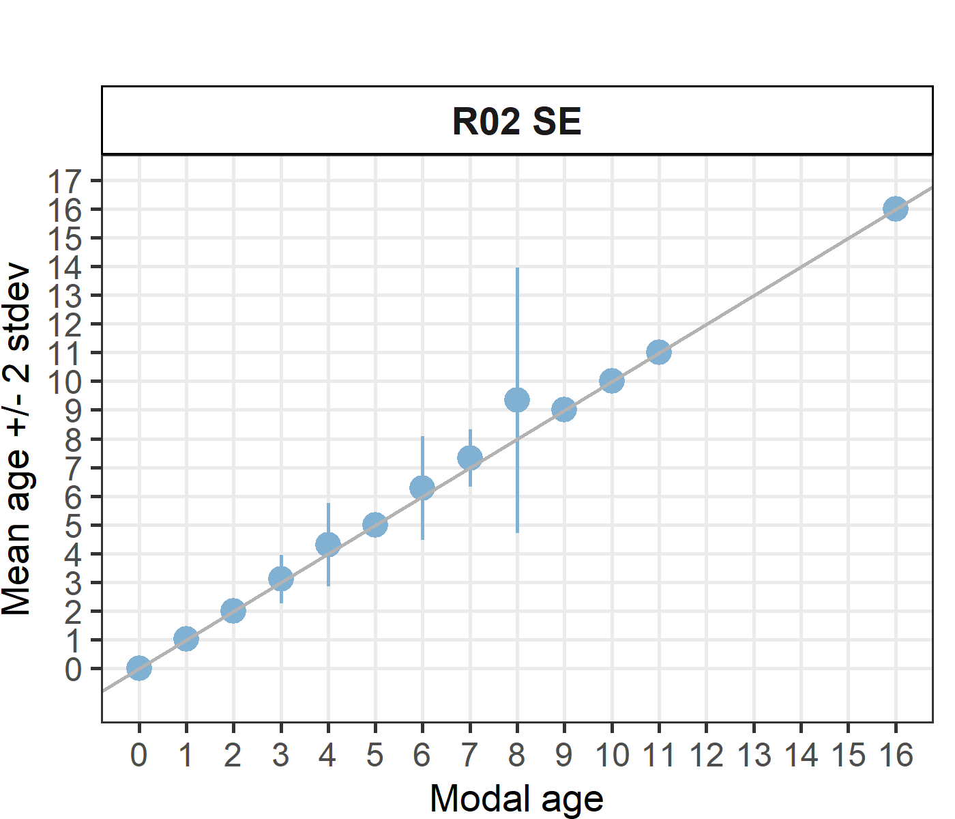 [[2]] 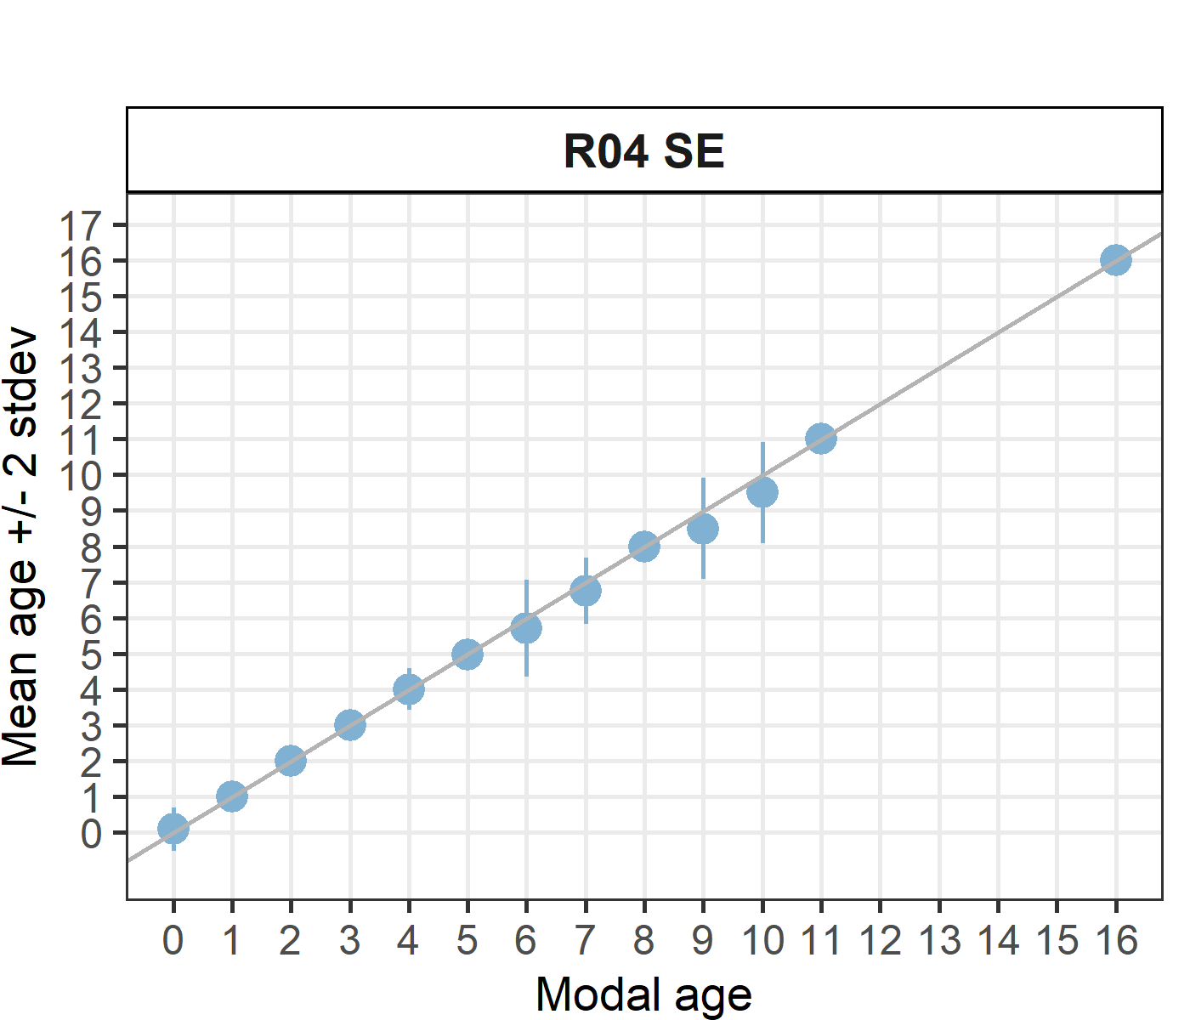 [[3]] 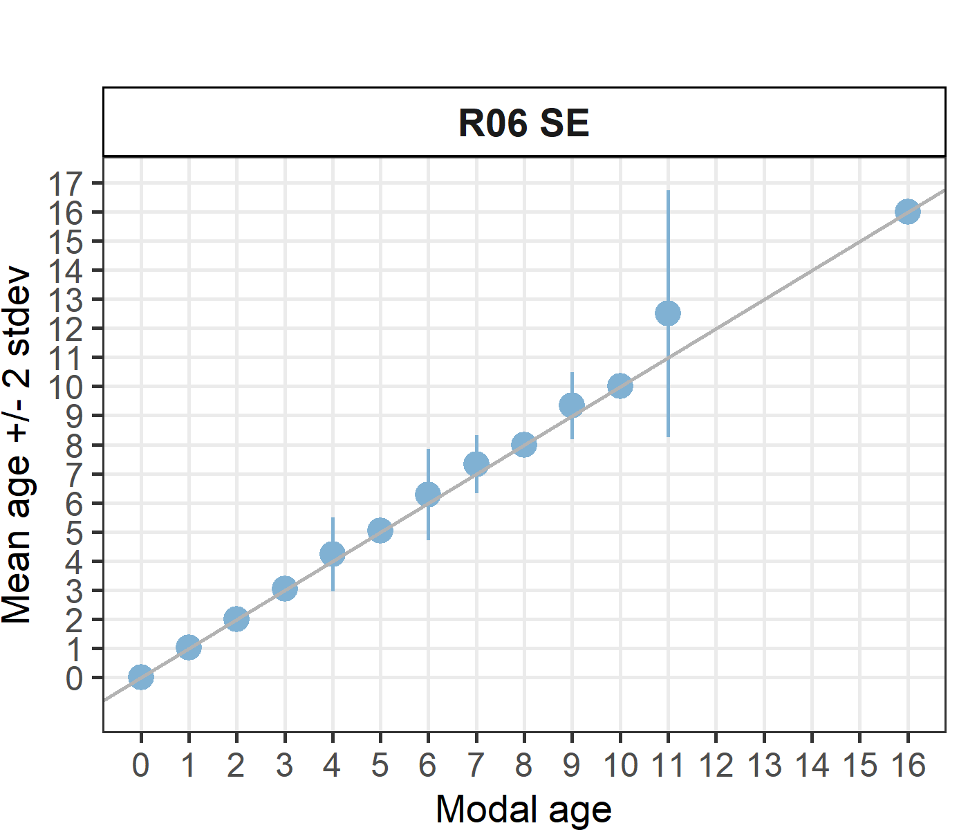 [[4]] 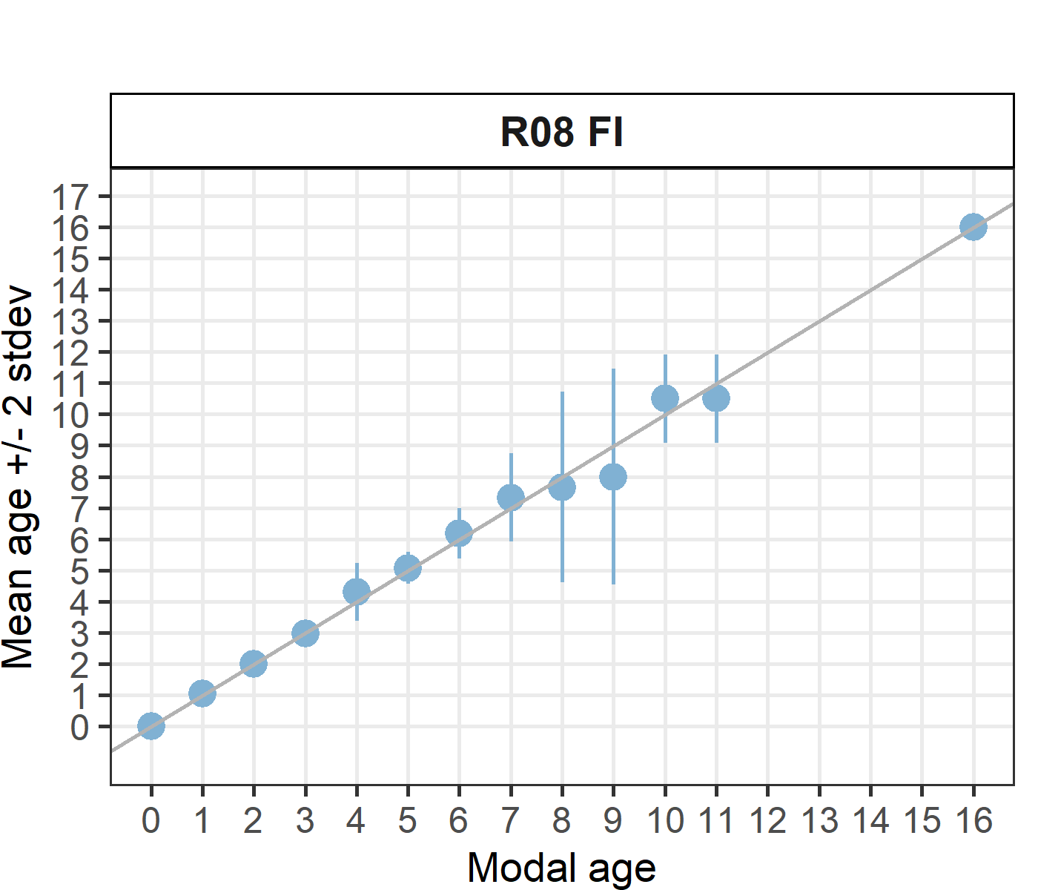 [[5]] 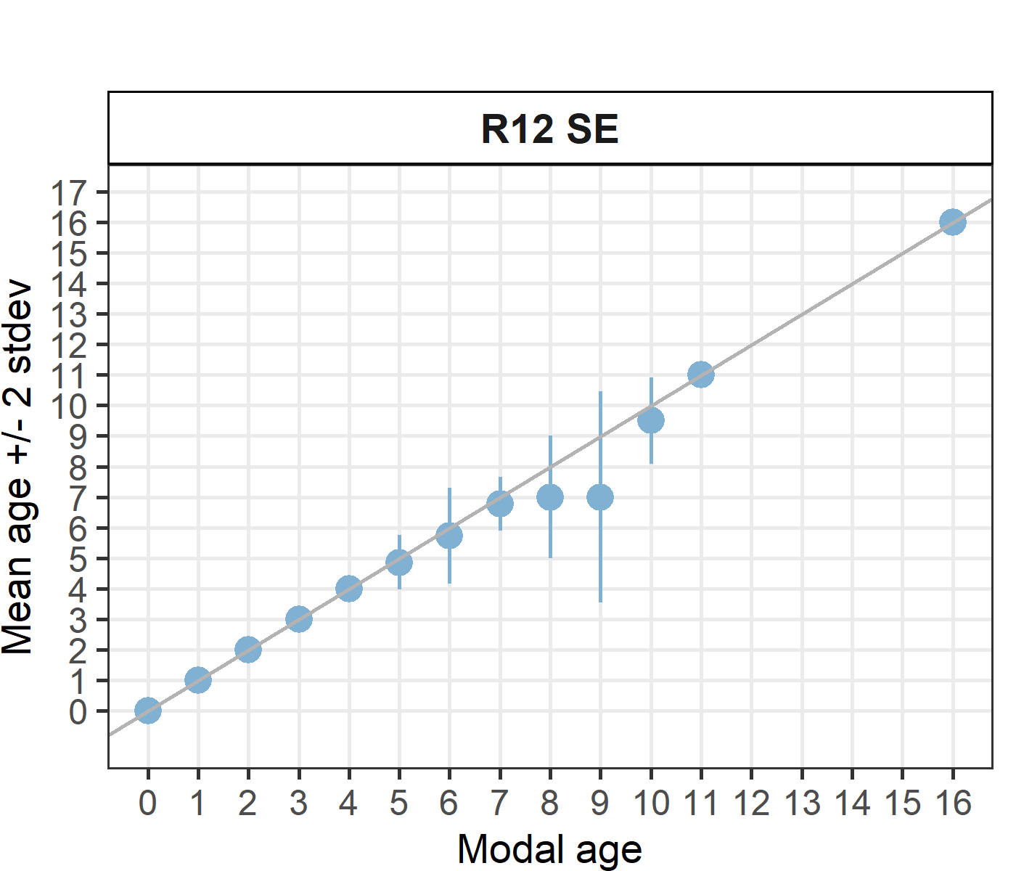 [[6]] 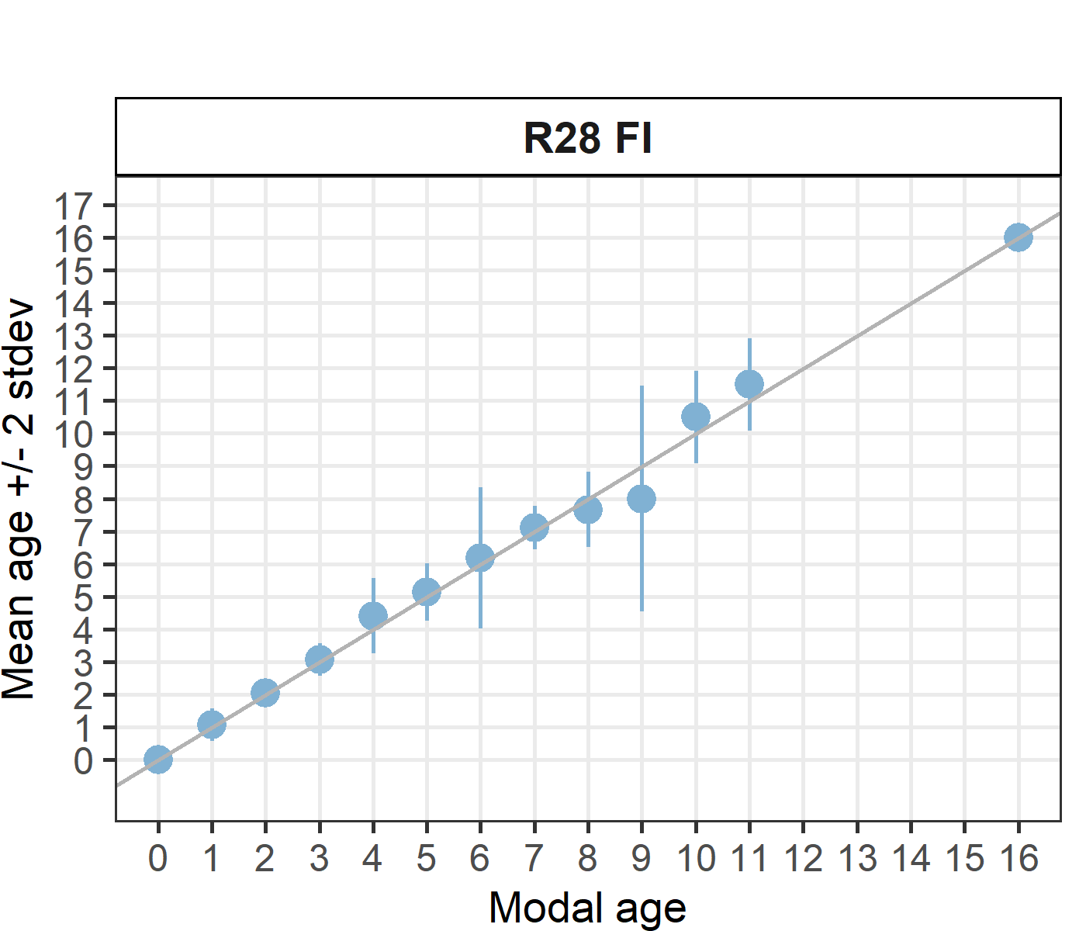

Statistics by modal age plot (STDEV, CV and PA)
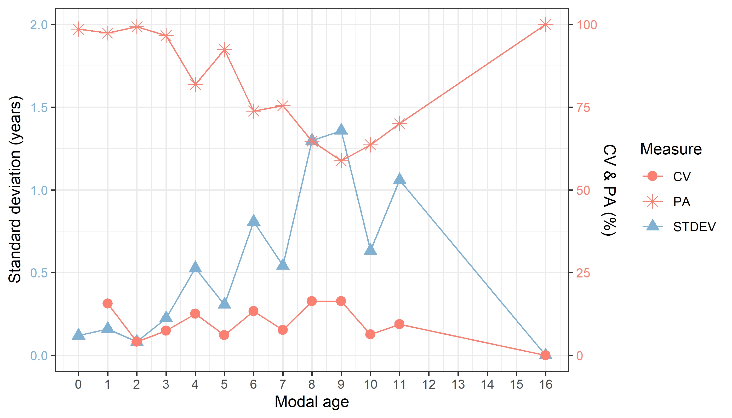
Figure X: CV, PA and (STDEV (standard deviation) are plotted against modal age

Distribution of age reading errors
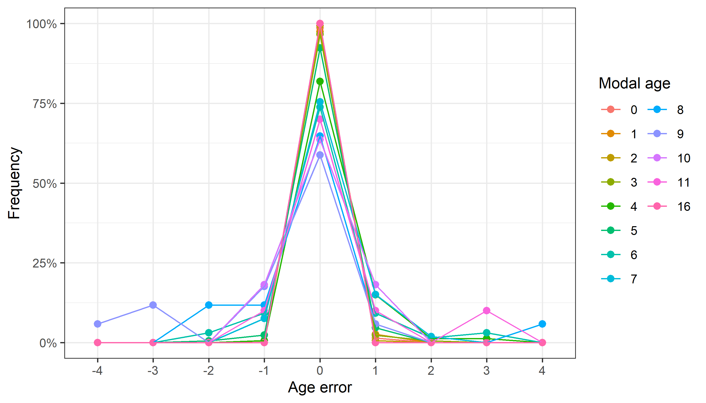
Figure X: The distribution of the age reading errors in percentage by modal age as observed from the whole group of age readers in an age reading comparison to modal age. The achieved precision in age reading by MODAL age group is shown by the spread of the age readings errors. There appears to be no relative bias, if the age reading errors are normally distributed. The distributions are skewed, if relative bias occurs.

Relative bias for all readers
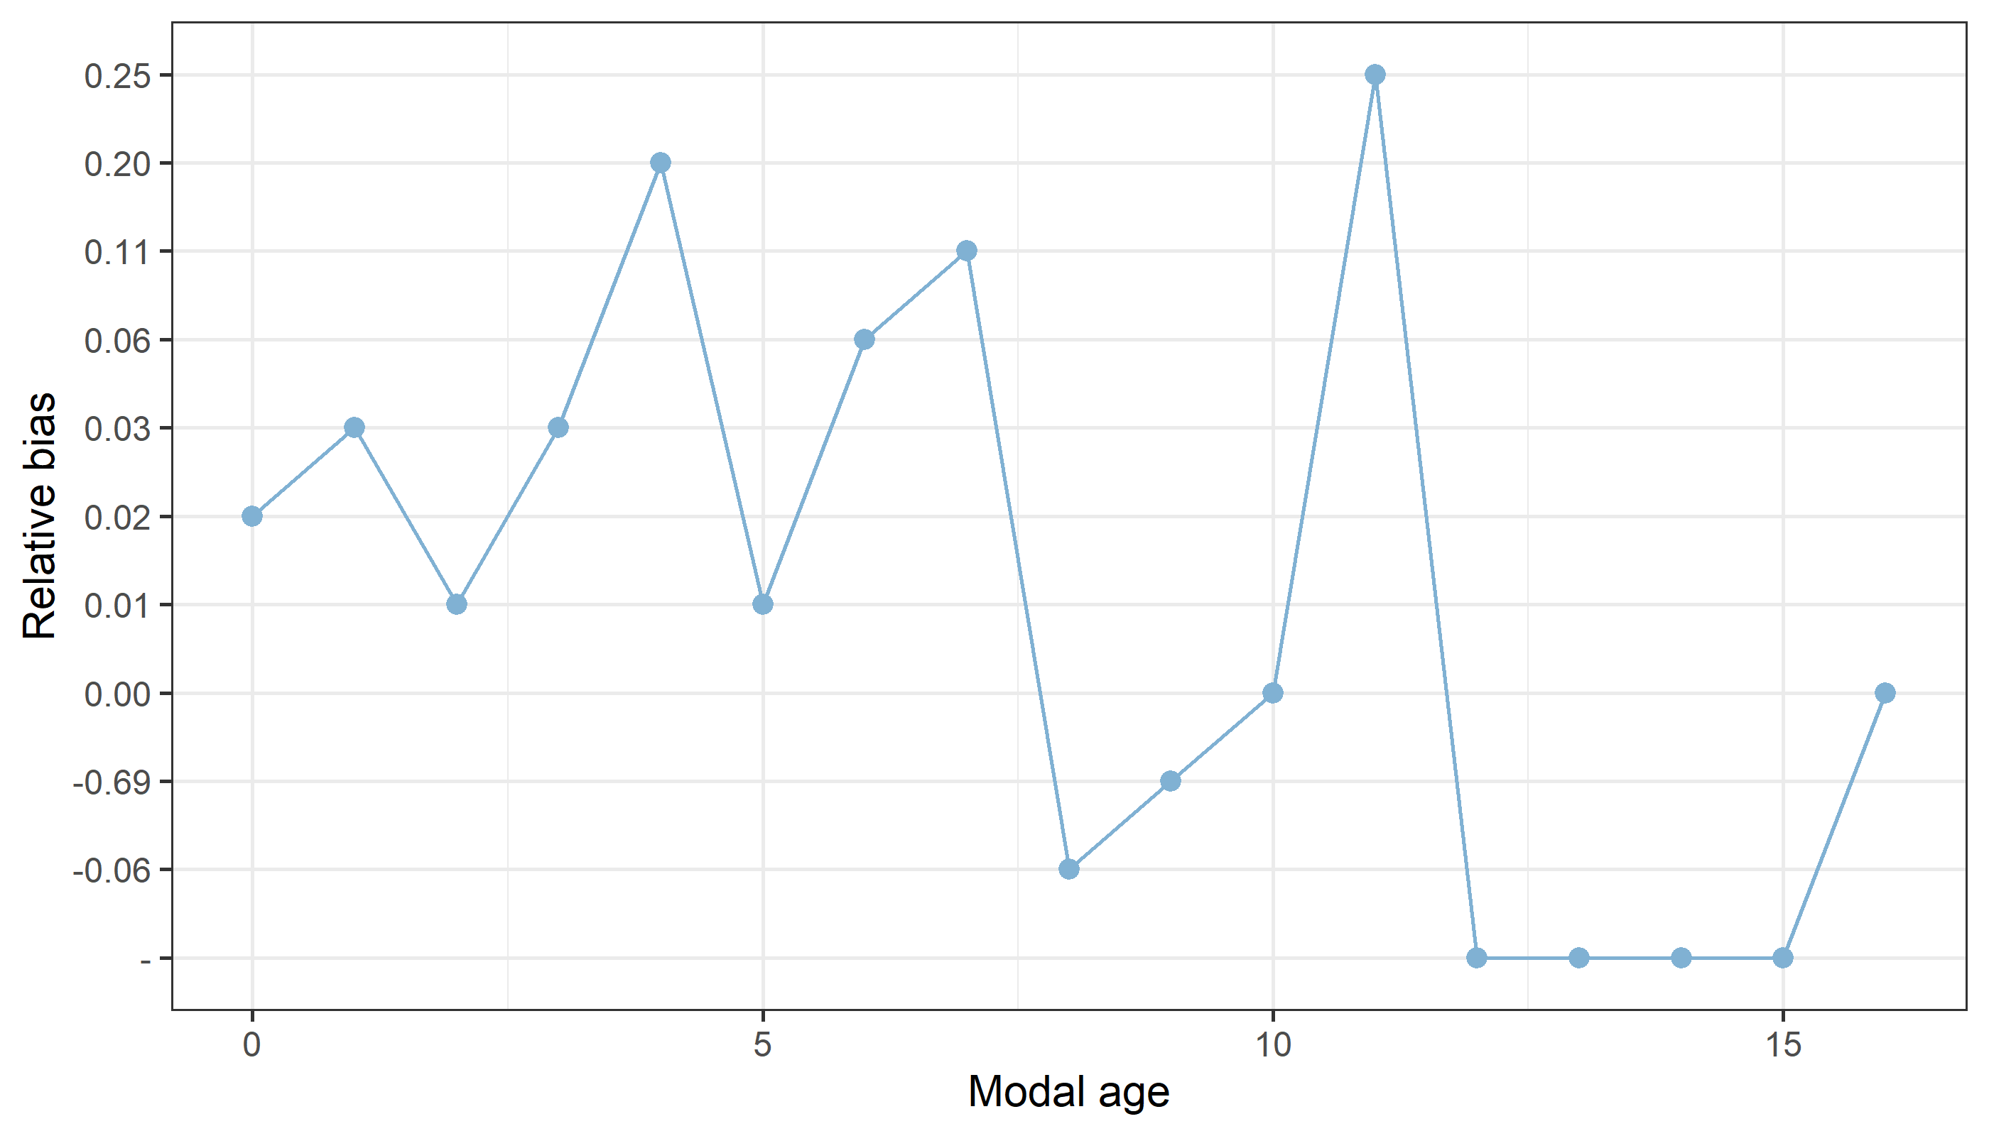
Figure X: The relative bias by modal age as estimated by all age readers combined.

Mean length at age by reader
Table X: Mean fish length at age per reader is calculated per reader and age (not modal age) and for all readers combined per age. A weighted mean is also given.
Age | R02 SE | R04 SE | R06 SE | R08 FI | R12 SE | R28 FI
0 | 98 mm | 99 mm | 98 mm | 98 mm | 98 mm | 98 mm
1 | 126 mm | 125 mm | 125 mm | 126 mm | 126 mm | 125 mm
2 | 139 mm | 139 mm | 139 mm | 139 mm | 139 mm | 139 mm
3 | 155 mm | 155 mm | 154 mm | 154 mm | 155 mm | 153 mm
4 | 163 mm | 165 mm | 163 mm | 163 mm | 166 mm | 163 mm
5 | 171 mm | 171 mm | 172 mm | 170 mm | 172 mm | 170 mm
6 | 177 mm | 178 mm | 180 mm | 177 mm | 178 mm | 177 mm
7 | 176 mm | 179 mm | 177 mm | 178 mm | 179 mm | 178 mm
8 | 180 mm | 185 mm | 176 mm | 180 mm | 188 mm | 177 mm
9 | 182 mm | 185 mm | 188 mm | 186 mm | 185 mm | 185 mm
10 | 195 mm | 195 mm | 188 mm | 190 mm | 195 mm | 185 mm
11 | 195 mm | 195 mm | 195 mm | 195 mm | 195 mm | 195 mm
12 | 175 mm | - | - | - | - | 195 mm
14 | - | - | 195 mm | - | - | -
16 | 200 mm | 200 mm | 200 mm | 200 mm | 200 mm | 200 mm
Weighted Mean | 151 mm | 150 mm | 151 mm | 151 mm | 151 mm | 151 mm
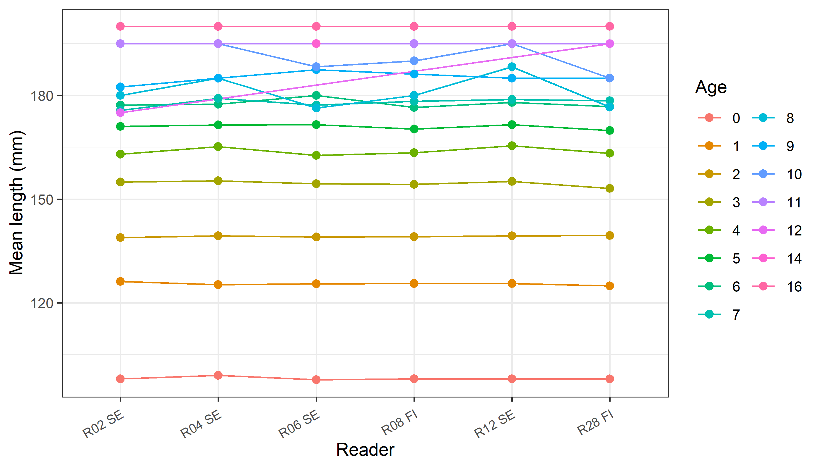
Figure X: The mean fish length at age as estimated by each age reader.

Annex 4. ToRs for next meeting

Annex 5. Recommendations

Annex 6. Report specific annexes

