SmartDots Summary for event 1849

Executive summary

Overview of samples and advanced readers
Table X: Overview of samples used for the exchange event1849. The modal age range for all samples is 0-16.
Year | ICES area | Strata | Quarter | Number of samples | Modal age range | Length range
2023 | 27.3.d.30 | Strata_27.3.d.30 | 1 | 35 | 1-9 | 90-185 mm
2023 | 27.3.d.30 | Strata_27.3.d.30 | 2 | 18 | 1-9 | 100-185 mm
2023 | 27.3.d.30 | Strata_27.3.d.30 | 3 | 109 | 0-16 | 85-200 mm
2023 | 27.3.d.30 | Strata_27.3.d.30 | 4 | 38 | 0-9 | 100-185 mm

Table X: Overview of number of readers.
Expertise | strata | N_readers
Advanced | Strata_27.3.d.30 | 6

Results overview

Multimodal cases
Table X: Summary of statistics; Total number of samples (NSample), a percentage of cases (fish samples) with multiple modes depending on the approach to weight the experience of the reader which will be considered when defining the fish age mode. PercMM_traditional shows the percentage of the total samples for which multiple modes are obtained when all the readers are equally weighted. PercMM_linear_weight shows the percentage of the total samples for which multiple modes are obtained when the weight assigned to the different readers decreases linearly with the experience, while in the PercMM_negexp the weight applied decreases with a negative exponential shape with the experience. The PercMM_multistage shows the percentage of multiple mode cases when a combination of the different methodologies is used, as explained in the material and methods section
NSample | PercMM_traditional | PercMM_linear_weight | PercMM_negexp_weight | PercMM_multistage
199 | 5 % | 0 % | 0 % | 0 %

Age readings
Table X: Age reading table shows the number of readings by modal age.
Modal age | total
0 | 70
1 | 267
2 | 149
3 | 177
4 | 160
5 | 171
6 | 65
7 | 53
8 | 17
9 | 17
10 | 11
11 | 10
12 | 0
13 | 0
14 | 0
15 | 0
16 | 6
Total | 1173

CV table
Table X: Coefficient of Variation (CV) table presents the CV per modal age for all advanced readers combined.
Modal age | all
0 | -
1 | 16 %
2 | 4 %
3 | 7 %
4 | 13 %
5 | 6 %
6 | 13 %
7 | 8 %
8 | 16 %
9 | 16 %
10 | 6 %
11 | 9 %
12 | -
13 | -
14 | -
15 | -
16 | 0 %
Weighted Mean | 10 %

PA table
Table X: Percentage agreement (PA) table represents the PA per modal age for all advanced readers combined.
Modal age | total
0 | 99 %
1 | 97 %
2 | 99 %
3 | 97 %
4 | 82 %
5 | 92 %
6 | 74 %
7 | 75 %
8 | 65 %
9 | 59 %
10 | 64 %
11 | 70 %
12 | -
13 | -
14 | -
15 | -
16 | 100 %
Weighted Mean | 91 %

APE table
Table X: Average Percentage Error (APE) table represents the APE per modal age for all advanced readers combined.
Modal age | all
0 | -
1 | 5 %
2 | 1 %
3 | 2 %
4 | 8 %
5 | 2 %
6 | 7 %
7 | 5 %
8 | 9 %
9 | 12 %
10 | 4 %
11 | 6 %
12 | -
13 | -
14 | -
15 | -
16 | 0 %
Weighted Mean | 4 %

Relative bias table
Table X: The relative bias (as the difference between the mean and modal age) per modal age for all advanced readers combined.
Modal age | all
0 | 0.02
1 | 0.03
2 | 0.01
3 | 0.03
4 | 0.20
5 | 0.01
6 | 0.06
7 | 0.11
8 | -0.06
9 | -0.69
10 | 0.00
11 | 0.25
12 | -
13 | -
14 | -
15 | -
16 | 0.00
Weighted Mean | 0.04

Bias plot
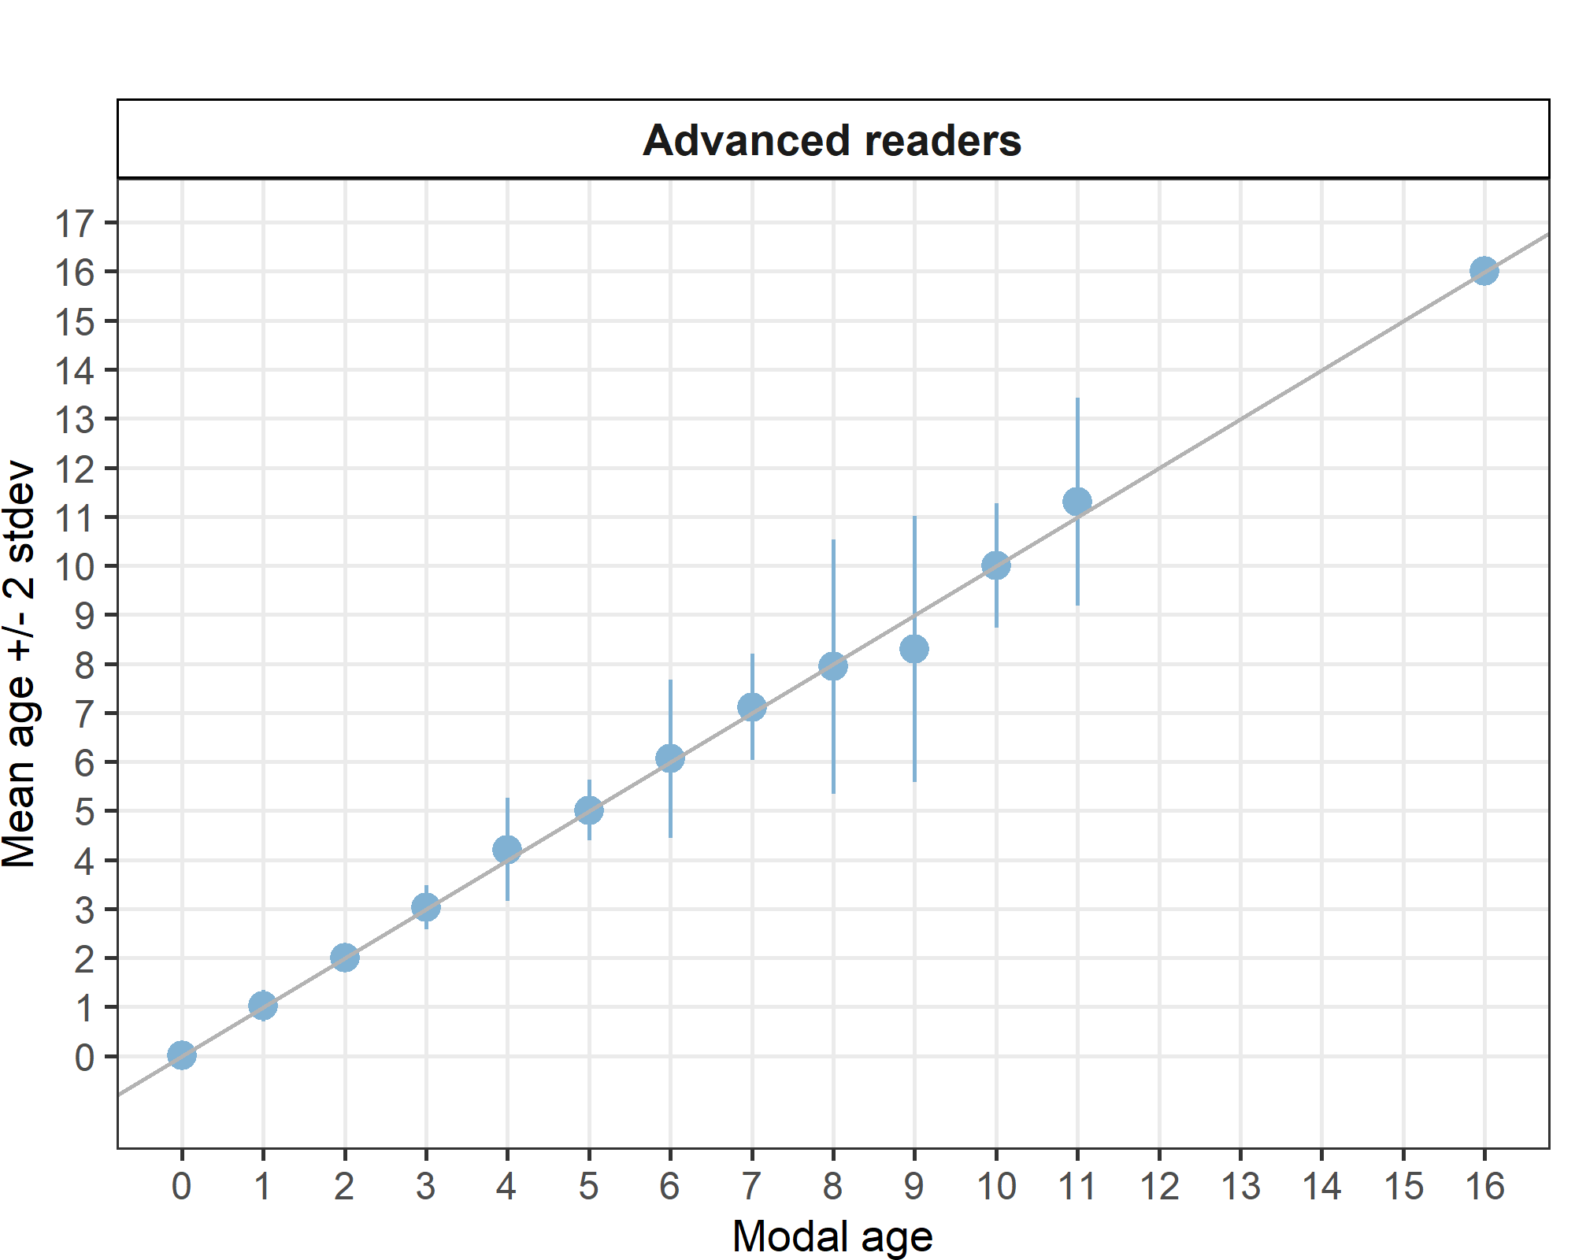
Figure X: Age bias plot for advanced readers.

Growth analysis
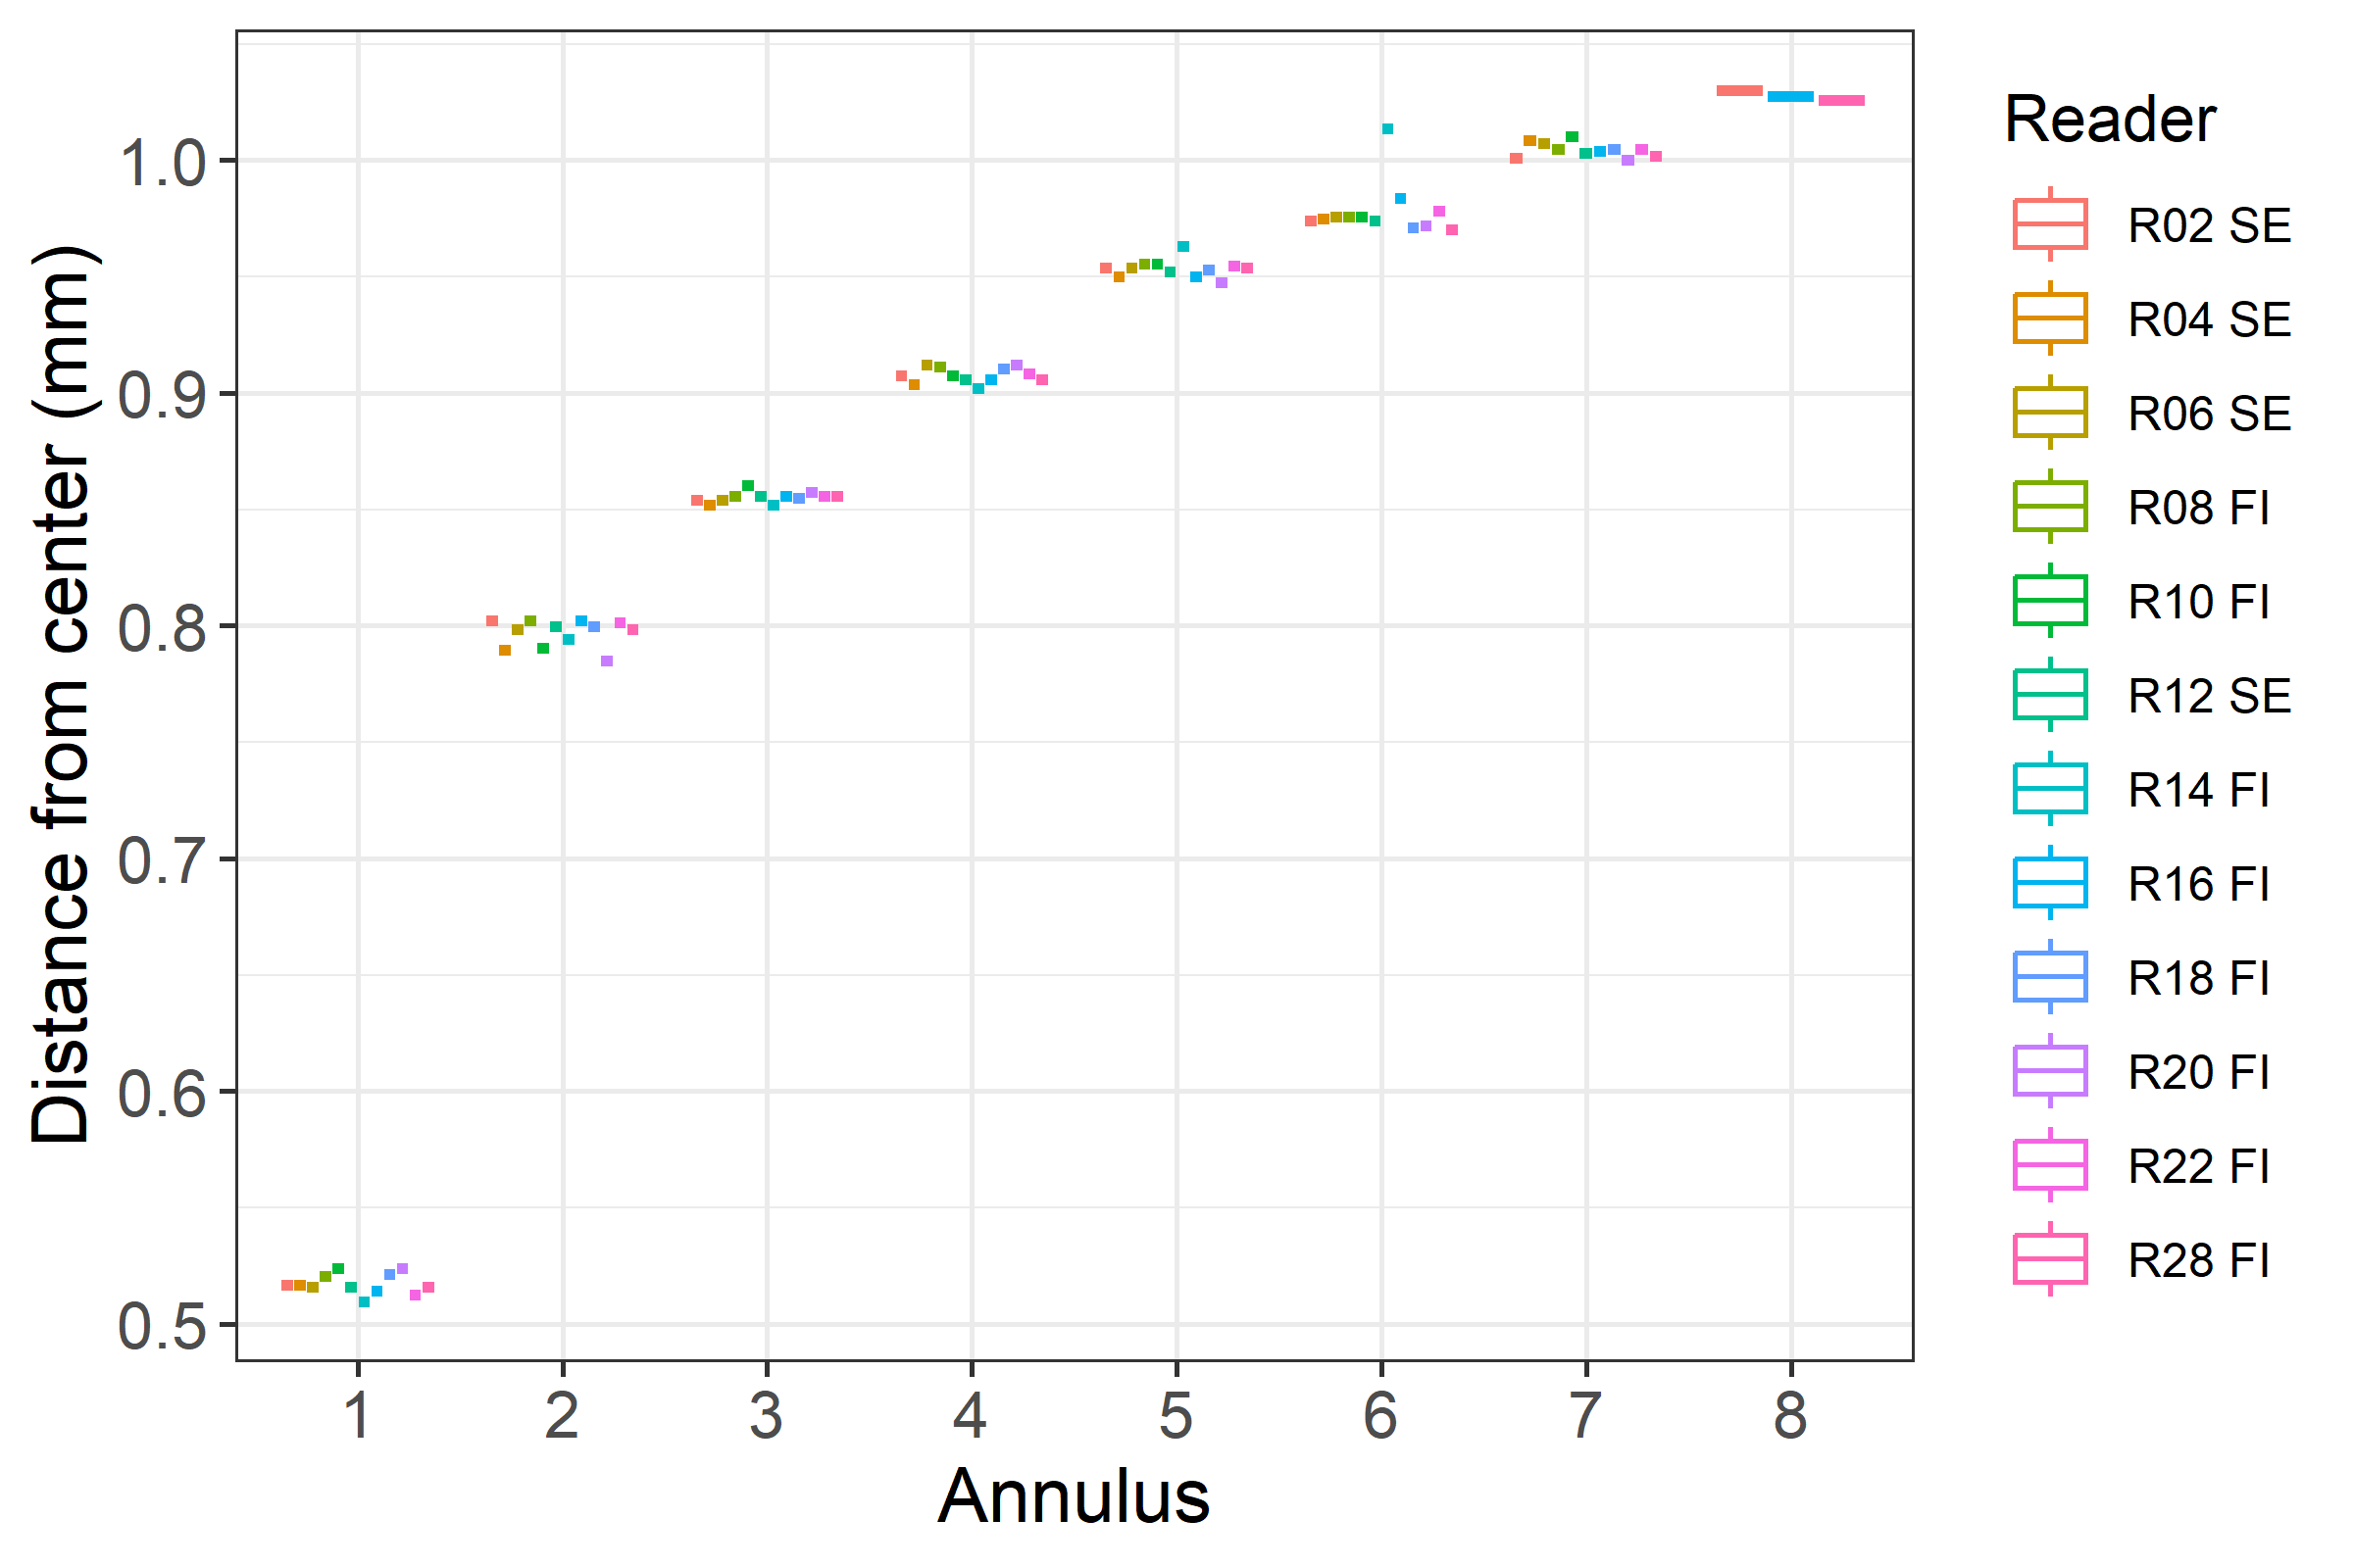
Figure X: Plot of average distance from the centre to the winter rings for advanced readers. The boxes represent the median, upper and lower box boundaries of the interquartile range, whiskers extend no further than 1.5 * IQR (where IQR is the inter-quartile range) from the box boundary. Data beyond the end of the whiskers are represent outlers and are plotted individually.

Age error matrices AEM

General Age Error Matrix (AEM)
Table X: General Age error matrix (AEM). The modal age is in rows and the age classifications by the advanced readers in columns.
modal_age | 0 | 1 | 2 | 3 | 4 | 5 | 6 | 7 | 8 | 9 | 10 | 11 | 12 | 14 | 16 | Total
0 | 0.99 | 0.01 | - | - | - | - | - | - | - | - | - | - | - | - | - | 1.00
1 | - | 0.97 | 0.03 | - | - | - | - | - | - | - | - | - | - | - | - | 1.00
2 | - | - | 0.99 | 0.01 | - | - | - | - | - | - | - | - | - | - | - | 1.00
3 | - | - | 0.01 | 0.97 | 0.02 | 0.01 | - | - | - | - | - | - | - | - | - | 1.01
4 | - | - | - | 0.01 | 0.82 | 0.15 | 0.01 | 0.01 | - | - | - | - | - | - | - | 1.00
5 | - | - | - | 0.01 | 0.02 | 0.92 | 0.05 | - | - | - | - | - | - | - | - | 1.00
6 | - | - | - | - | 0.03 | 0.09 | 0.74 | 0.09 | 0.02 | 0.03 | - | - | - | - | - | 1.00
7 | - | - | - | - | - | - | 0.08 | 0.75 | 0.15 | 0.02 | - | - | - | - | - | 1.00
8 | - | - | - | - | - | - | 0.12 | 0.12 | 0.65 | 0.06 | - | - | 0.06 | - | - | 1.01
9 | - | - | - | - | - | 0.06 | 0.12 | - | 0.18 | 0.59 | 0.06 | - | - | - | - | 1.01
10 | - | - | - | - | - | - | - | - | - | 0.18 | 0.64 | 0.18 | - | - | - | 1.00
11 | - | - | - | - | - | - | - | - | - | - | 0.10 | 0.70 | 0.10 | 0.1 | - | 1.00
16 | - | - | - | - | - | - | - | - | - | - | - | - | - | - | 1 | 1.00

AEM by ICES area
Table X: Age error matrix (AEM) for ICES area 27.3.d.30.
ices_area | modal_age | 0 | 1 | 2 | 3 | 4 | 5 | 6 | 7 | 8 | 9 | 10 | 11 | 12 | 14 | 16 | Total
27.3.d.30 | 0 | 0.99 | 0.01 | - | - | - | - | - | - | - | - | - | - | - | - | - | 1.00
27.3.d.30 | 1 | - | 0.97 | 0.03 | - | - | - | - | - | - | - | - | - | - | - | - | 1.00
27.3.d.30 | 2 | - | - | 0.99 | 0.01 | - | - | - | - | - | - | - | - | - | - | - | 1.00
27.3.d.30 | 3 | - | - | 0.01 | 0.97 | 0.02 | 0.01 | - | - | - | - | - | - | - | - | - | 1.01
27.3.d.30 | 4 | - | - | - | 0.01 | 0.82 | 0.15 | 0.01 | 0.01 | - | - | - | - | - | - | - | 1.00
27.3.d.30 | 5 | - | - | - | 0.01 | 0.02 | 0.92 | 0.05 | - | - | - | - | - | - | - | - | 1.00
27.3.d.30 | 6 | - | - | - | - | 0.03 | 0.09 | 0.74 | 0.09 | 0.02 | 0.03 | - | - | - | - | - | 1.00
27.3.d.30 | 7 | - | - | - | - | - | - | 0.08 | 0.75 | 0.15 | 0.02 | - | - | - | - | - | 1.00
27.3.d.30 | 8 | - | - | - | - | - | - | 0.12 | 0.12 | 0.65 | 0.06 | - | - | 0.06 | - | - | 1.01
27.3.d.30 | 9 | - | - | - | - | - | 0.06 | 0.12 | - | 0.18 | 0.59 | 0.06 | - | - | - | - | 1.01
27.3.d.30 | 10 | - | - | - | - | - | - | - | - | - | 0.18 | 0.64 | 0.18 | - | - | - | 1.00
27.3.d.30 | 11 | - | - | - | - | - | - | - | - | - | - | 0.10 | 0.70 | 0.10 | 0.1 | - | 1.00
27.3.d.30 | 16 | - | - | - | - | - | - | - | - | - | - | - | - | - | - | 1 | 1.00

AEM by strata
Table X: Age error matrix (AEM) for Strata_Strata_27.3.d.30.
strata | modal_age | 0 | 1 | 2 | 3 | 4 | 5 | 6 | 7 | 8 | 9 | 10 | 11 | 12 | 14 | 16 | Total
Strata_27.3.d.30 | 0 | 0.99 | 0.01 | - | - | - | - | - | - | - | - | - | - | - | - | - | 1.00
Strata_27.3.d.30 | 1 | - | 0.97 | 0.03 | - | - | - | - | - | - | - | - | - | - | - | - | 1.00
Strata_27.3.d.30 | 2 | - | - | 0.99 | 0.01 | - | - | - | - | - | - | - | - | - | - | - | 1.00
Strata_27.3.d.30 | 3 | - | - | 0.01 | 0.97 | 0.02 | 0.01 | - | - | - | - | - | - | - | - | - | 1.01
Strata_27.3.d.30 | 4 | - | - | - | 0.01 | 0.82 | 0.15 | 0.01 | 0.01 | - | - | - | - | - | - | - | 1.00
Strata_27.3.d.30 | 5 | - | - | - | 0.01 | 0.02 | 0.92 | 0.05 | - | - | - | - | - | - | - | - | 1.00
Strata_27.3.d.30 | 6 | - | - | - | - | 0.03 | 0.09 | 0.74 | 0.09 | 0.02 | 0.03 | - | - | - | - | - | 1.00
Strata_27.3.d.30 | 7 | - | - | - | - | - | - | 0.08 | 0.75 | 0.15 | 0.02 | - | - | - | - | - | 1.00
Strata_27.3.d.30 | 8 | - | - | - | - | - | - | 0.12 | 0.12 | 0.65 | 0.06 | - | - | 0.06 | - | - | 1.01
Strata_27.3.d.30 | 9 | - | - | - | - | - | 0.06 | 0.12 | - | 0.18 | 0.59 | 0.06 | - | - | - | - | 1.01
Strata_27.3.d.30 | 10 | - | - | - | - | - | - | - | - | - | 0.18 | 0.64 | 0.18 | - | - | - | 1.00
Strata_27.3.d.30 | 11 | - | - | - | - | - | - | - | - | - | - | 0.10 | 0.70 | 0.10 | 0.1 | - | 1.00
Strata_27.3.d.30 | 16 | - | - | - | - | - | - | - | - | - | - | - | - | - | - | 1 | 1.00
Overall comparison of results by strata
Table X: Number of age readings per strata and modal age for all advanced readers combined.
Modal age | Strata_27.3.d.30 | total
0 | 70 | 70
1 | 267 | 267
2 | 149 | 149
3 | 177 | 177
4 | 160 | 160
5 | 171 | 171
6 | 65 | 65
7 | 53 | 53
8 | 17 | 17
9 | 17 | 17
10 | 11 | 11
11 | 10 | 10
12 | 0 | 0
13 | 0 | 0
14 | 0 | 0
15 | 0 | 0
16 | 6 | 6
Total | 1173 | 1173

Coefficient of Variation (CV)
Table X: CV per strata and modal age for all advanced readers combined.
Modal age | Strata_27.3.d.30 | all
0 | - | -
1 | 16 % | 16 %
2 | 4 % | 4 %
3 | 7 % | 7 %
4 | 13 % | 13 %
5 | 6 % | 6 %
6 | 13 % | 13 %
7 | 8 % | 8 %
8 | 16 % | 16 %
9 | 16 % | 16 %
10 | 6 % | 6 %
11 | 9 % | 9 %
12 | - | -
13 | - | -
14 | - | -
15 | - | -
16 | 0 % | 0 %
Weighted Mean | 10 % | 10 %

Percentage of Agreement (PA)
Table X: Percentage Agreement per strata and modal age for all advanced readers combined.
Modal age | Strata_27.3.d.30 | total
0 | 99 % | 99 %
1 | 97 % | 97 %
2 | 99 % | 99 %
3 | 97 % | 97 %
4 | 82 % | 82 %
5 | 92 % | 92 %
6 | 74 % | 74 %
7 | 75 % | 75 %
8 | 65 % | 65 %
9 | 59 % | 59 %
10 | 64 % | 64 %
11 | 70 % | 70 %
12 | - | -
13 | - | -
14 | - | -
15 | - | -
16 | 100 % | 100 %
Weighted Mean | 91 % | 91 %

Average Percentage Error (APE)
Table X: Average Percentage Error per strata and modal age for all advanced readers combined.
Modal age | Strata_27.3.d.30 | all
0 | - | -
1 | 5 % | 5 %
2 | 1 % | 1 %
3 | 2 % | 2 %
4 | 8 % | 8 %
5 | 2 % | 2 %
6 | 7 % | 7 %
7 | 5 % | 5 %
8 | 9 % | 9 %
9 | 12 % | 12 %
10 | 4 % | 4 %
11 | 6 % | 6 %
12 | - | -
13 | - | -
14 | - | -
15 | - | -
16 | 0 % | 0 %
Weighted Mean | 4 % | 4 %

Relative bias
Table X: Relative Bias per strata and modal age for all advanced readers combined.
Modal age | Strata_27.3.d.30 | all
0 | 0.01 | 0.01
1 | 0.03 | 0.03
2 | 0.01 | 0.01
3 | 0.03 | 0.03
4 | 0.21 | 0.21
5 | 0.01 | 0.01
6 | 0.06 | 0.06
7 | 0.11 | 0.11
8 | -0.06 | -0.06
9 | -0.71 | -0.71
10 | 0.00 | 0.00
11 | 0.30 | 0.30
12 | - | -
13 | - | -
14 | - | -
15 | - | -
16 | 0.00 | 0.00
Weighted Mean | 0.04 | 0.04

Growth analysis
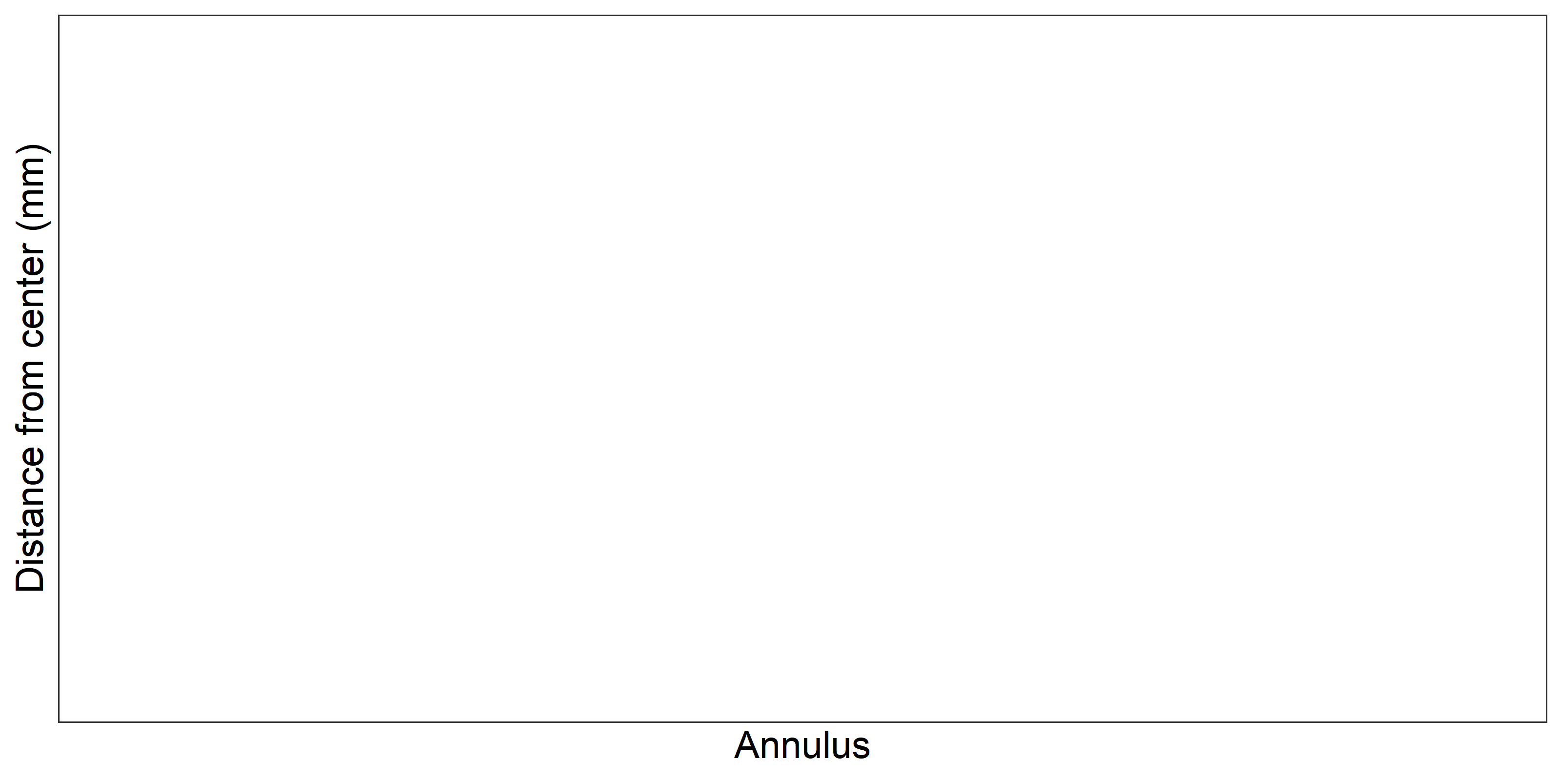
Figure X: Plot of average distance from the centre to the winter rings for all advanced readers by strata. The boxes represent the median, upper and lower box boundaries of the interquartile range, whiskers represent the minimum and maximum values and the dots represent the outliers.

Conclusion

