Report for the 2024 Western Baltic Spring Spawning Herring age reading exchange on SmartDots (ID 1853)
Coordination and analysis: Florian Berg, Institute of Marine Resources, IMR Norway and Julie Coad Davies, National Institute of Aquatic Resources, DTU Aqua, Denmark

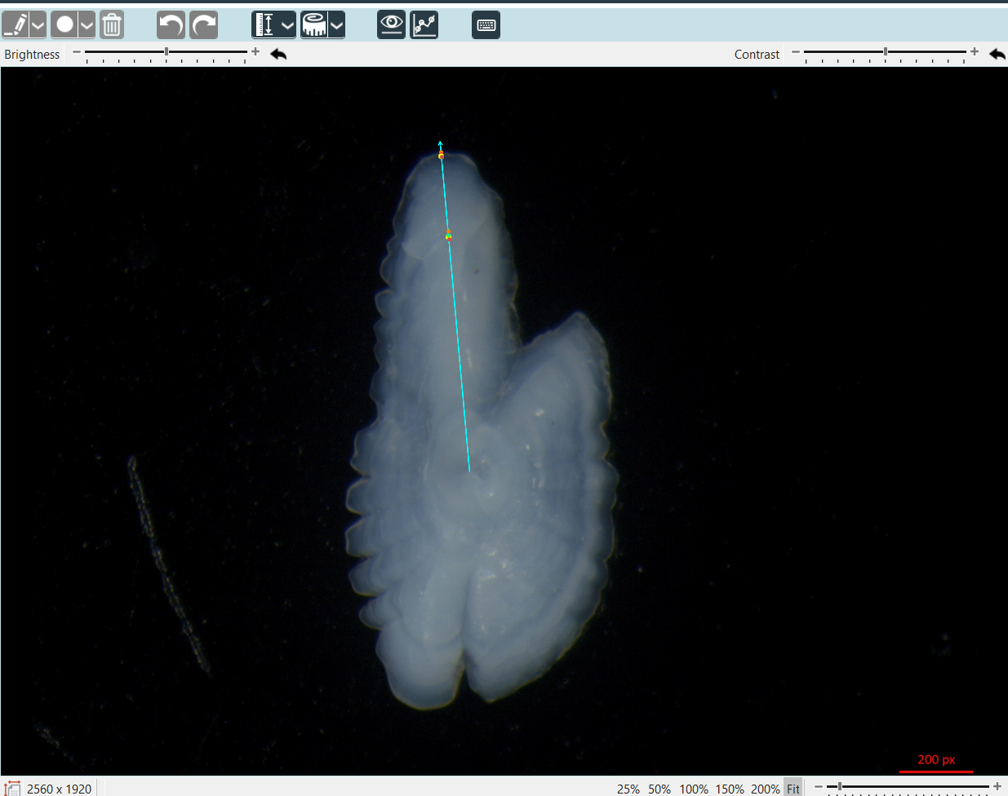
Table of Contents
1 Summary 3
2 Methods applied 4
3 Overview of samples and readers 6
4 Results 7
4.1 All readers (basic and advanced) 8
4.1.1 All samples included 8
4.1.2 Strata_27.3.a.20 (ICES Area) 4
4.1.3 Strata_27.4.a (ICES Area) 7
4.1.4 Strata_27.3.d.24 (ICES Area) 10
4.1.5 Strata_27.3.a.21 (ICES Area) 13
4.1.6 Strata_27.3.c.22 (ICES Area) 16
4.2 Advanced readers 1
4.2.1 All samples included 1
4.2.2 Strata_27.3.a.20 (ICES Area) 5
4.2.3 Strata_27.4.a (ICES Area) 8
4.2.4 Strata_27.3.d.24 (ICES Area) 11
4.2.5 Strata_27.3.a.21 (ICES Area) 14
4.2.6 Strata_27.3.c.22 (ICES Area) 17
4.2.7 Overall comparison of results by ICES area 20
4.2.8 Strata_ her_3a22 (WBSS, genetic population) 22
4.2.9 Strata_her_4c7d (Downs, genetic population) 25
4.2.10 Strata_her_2532_gor (CBSS, genetic population) 28
4.2.11 Strata_her_3a (WBSS-SK, genetic population) 31
4.2.12 Strata_her_riga (BASH, genetic population) 34
4.2.13 Strata_her_47d3 (NSAS, genetic population) 37
4.2.14 Overall comparison of results by genetic population 40
5 References 42

Summary
Due to the upcoming benchmark for western Baltic spring-spawning herring and given that no age calibration exercises have taken place since 2005 WGBIOP organized an age-reading exchange in 2024 to calibrate age determination practices. Common sources of bias in herring age reading include stock mixing during certain time periods and areas, as well as inconsistent interpretation of the first winter ring between different spawning types (autumn/winter vs. spring spawners). The objective of this exchange was therefore to identify and address potential issues in age determination, thereby minimizing bias in the age data.
Images of whole otoliths were provided by Norway, Germany, Sweden and Denmark and uploaded to the ICES SmartDots platform. In total, 306 herring were aged (Table 3.1) by 16 readers (11 advanced and 5 basic) from Poland, Germany, Sweden, Denmark, Norway, and Scotland (Table 3.2). Across all readers, the exchange yielded a 72% percentage agreement (PA), a 22% coefficient of variation (CV), and a 13% average percentage error (APE) (Table 4.2). When restricted to advanced readers, results improved slightly (PA = 76%, CV = 20%, APE = 11%) (Table 4.33). An overall age error matrix (AEM) (Table 4.38), as well as area-specific AEMs, were produced and may serve as input for the stock assessment.
Overall, age-reading practices were found to be generally consistent among participants. When comparing results by ICES areas the poorest results are seen in area 27.3.d.24 (PA = 66%, CV = 22% and APE = 16%) where most uncertainty lies is modal ages 0, 1 and above 7 and in area 27.3.d.22 (PA = 70%, CV = 23% and APE = 15%) where within a modal age range of 2-6 years the most uncertainty lies at modal age 2 and 6. However, a key challenge remains the mixing of herring populations. Only genetically assigned individuals were included in this exchange and when considering the results by genetic population the highest agreement was for the NSAS and Downs populations, PA of 86% and 85% respectively. The results reached for the WBSS were PA = 76%, CV = 20% and APE = 11%) where PA at modal age 0 was just 55%. PA values decreased for populations not typically present within the western Baltic spring-spawning herring distribution. Figure 4.15 shows an example of where disagreement exists between readers on the identification of the first winter ring in WBSS fish, where at modal age 0 the PA is just 55% with 6 advanced readers estimating the age of the fish to be 1. This is likely due to the variation in distance from centre to the first winter ring apparent for different genetic populations with diverging spawning times (Figure 4.8), combined with readers varying experience in reading otoliths from different populations and areas. Given the complexity of stock mixing and variation in spawning times no clear pattern has been identified to resolve such issues.
The results highlight the need for more frequent calibration of age readers and age determination procedures. The implications for the assessment require further investigation, particularly given the recent increase in the abundance of other herring populations in the area.
Individual reader PA, CV and APE are shown in each report section and a recently added feature to the software shows modal age and PA per image. All readers annotations are now visible in the SmartDots software for comparison purposes.

Methods applied
This report contains statistical analyses and comparisons of age readings in the form of tables and graphical plots from the Guus Eltink Excel sheet 'Age Reading Comparisons (Eltink, A.T.G.W. 2000).
Modal age: a multistage approach to define the modal age by sampled fish
In this event, the multistage approach to calculate the modal age has been used. It is a key statistic by itself, but it is also fundamental for the estimation of some other relevant statistics to assess the performance of the techniques assessed in the exchange event, like the Percentage Agreement (PA), or input for stock assessments like the Age Error Matrix (AEM). However, when the standard approach of calculating the mode (each reader has the same weight=1) is applied, the mode is taken as the lowest age of the multiple modal ages. The multistage approach is based on the different weight given to the age readers according to their experience and an application of 3 methods/stages. During the WGBIOP 2019 meeting it was found that the combination of the modes decided using these three methods (so called 'multistage approach'), allows assigning a single modal age to each fish individual.
Percentage Agreement (PA)
The percentage agreement per reader per modal age tells how large is the part of readings that are equal to the modal age. The percentage agreement is estimated by modal age and reader as the proportion (as percentage) of times that the lectures of that reader agreed with the resulting modal age.
$$PA=\frac{number of readings that agree with modal age}{total number of readings by modal age}⋅100\%$$
Coefficient of Variation (CV)
The table presents the Coefficient of Variation (CV) per modal age and reader. The CV’s are calculated as the ratio between the standard deviation (σ) and mean value (μ) per reader and modal age:
$$CV=\frac{σ}{μ}⋅100\%$$
To the table is also added the CV of all readers combined per modal age and a weighted mean of the CV per reader.
Relative bias
The relative bias is calculated as the difference between the mean and the modal age. This statistic is presented in first place by modal age and reader, but it is also calculated as an average value by modal age for all readers together (or only advanced readers).
Average Percentage Error (APE)
The Average Percentage Error (APE) was calculated based on the method outlined by Beamish & Fournier (1981). This method is dependent of fish age and thus provides a better estimate of precision than percentage agreement. As the calculations of both CV and APE pose problems if the mean age is close to 0, all observations for which modal age was 0 were omitted from the CV and APE calculations.
The average percentage error is calculated per image as:
$$APE=\frac{100\%}{n}\sum_{i=1}^{n}{\left|\frac{a_{i}-\overset{‾}{a}}{\overset{‾}{a}}\right|}$$
where $a_{i}$ is the age reading of reader $i$ and $\overset{‾}{a}$ is the mean of all readings from 1 to $n$.
Age error matrix (AEM)
Age error matrices (AEM) were produced following procedures outlined by WKSABCAL (2014) where the matrix shows the proportion of each modal age mis-aged as other ages. The sum of each row is 1, which equals 100%. The age data was analysed twice, the first time all readers were included and the second time only the “advanced” readers were included. If a reader is “advanced” then they are considered well trained and they provide ages for stock assessment or similar purposes. When the AEM is compiled for assessment purposes it uses only those readers who provide age data for the stock assessment in that specific area.

Otolith Growth Analysis
SmartDots provides a measure of distance between the annotations made by the readers and thus provides a measure of growth increment width. This data is used to establish growth curves for each otolith (fish) and for each reader.

Strata applied
In this report additional analysis are done based on the following strata:
By ICES areas:
Strata_27.3.a.20
Strata_27.4.a
Strata_27.3.d.24
Strata_27.3.a.21
Strata_27.3.b.23 - Only 1 sample so comparison not included
Strata_27.3.c.22

By genetic populations:
Strata_her_3a22 (Western Baltic spring spawners (WBSS))
Strata_her_4c7d (Downs winter spawners (Downs))
Strata_her_2532_gor (Central Baltic spring spawners (CBH/CBSS))
Strata_her_3a (Western Baltic spring spawners from the Skagerrak (WBSS-SK))
Strata_her_riga (Baltic autumn spawners (BASH))
Strata_her_47d3 (North Sea autumn spawners (NSAS))
Strata_her_noss (Norwegian spring spawners (NSS)) – Only 1 sample so comparison not included
Strata_her_4ab (Spring spawners from 6a (west of Scotland, Sp-6a)) – Only 1 sample so comparison not included

Overview of samples and readers
Table 3.1: Overview of samples used for the exchange event number 1853 (n=306)
Year | ICES area | Strata | Quarter | Number of samples | Modal age range | Length range
2022 | 27.3.a.20 | Strata_27.3.a.20 | 1 | 35 | 1-6 | 140-290 mm
2022 | 27.3.a.21 | Strata_27.3.a.21 | 1 | 21 | 1-5 | 125-275 mm
2022 | 27.4.a | Strata_27.4.a | 2 | 22 | 2-9 | 220-290 mm
2022 | 27.4.a | Strata_27.4.a | 3 | 41 | 2-9 | 220-310 mm
2022 | 27.4.a | Strata_27.4.a | 4 | 12 | 4-9 | 270-315 mm
2023 | 27.3.a.20 | Strata_27.3.a.20 | 3 | 31 | 0-10 | 95-300 mm
2023 | 27.3.a.21 | Strata_27.3.a.21 | 1 | 20 | 1-5 | 125-260 mm
2023 | 27.3.a.21 | Strata_27.3.a.21 | 3 | 24 | 2-9 | 220-315 mm
2023 | 27.3.b.23 | Strata_27.3.b.23 | 4 | 1 | 9 | 295 mm
2023 | 27.3.c.22 | Strata_27.3.c.22 | 1 | 30 | 2-6 | 195-250 mm
2023 | 27.3.d.24 | Strata_27.3.d.24 | 1 | 20 | 4-9 | 260-305 mm
2023 | 27.3.d.24 | Strata_27.3.d.24 | 4 | 49 | 0-10 | 105-305 mm

Table 3.2: Reader overview showing expertise level and ranking indicating level of experience (1 being most experienced and 16 the least).
Reader code | Expertise | Expertise_rank
R01 DK | Advanced | 1
R02 SE | Advanced | 2
R03 NO | Advanced | 3
R04 DE | Advanced | 4
R05 NO | Advanced | 5
R06 NO | Advanced | 6
R07 NO | Advanced | 7
R08 NO | Advanced | 8
R09 NO | Advanced | 9
R10 PL | Advanced | 10
R11 SE | Basic | 11
R12 NO | Advanced | 12
R13 SE | Basic | 13
R14 SE | Basic | 14
R15 GB-SCT | Basic | 15
R16 GB-SCT | Basic | 16

Results

All readers (basic and advanced)

All samples included
Table 4.1: List of cases for which multiple modes where obtained. The column NModes_trad shows the number of multiple modes for each FishID or SampleID when all readers are given the same expertise weight.
NModes_trad | SampleID
2 | 24191_007
2 | 24191_049
2 | 2801_19
2 | 2801_27
2 | 4803_48
2 | 8640940
2 | BIAS_29
2 | BIAS_34
Table 4.2: Summary of statistics; Total number of samples (NSample), coefficient of variance (CV), percentage of agreement (PA) and average percentage error (APE) for all ages and readers
NSample | CV | PA | APE
306 | 22 % | 72 % | 13 %

Coefficient of Variation (CV)
Table 4.3: Coefficient of Variation (CV) table presents the CV per modal age and reader, the CV of all readers combined per modal age and a weighted mean of the CV per reader
Modal age | R01 DK | R02 SE | R03 NO | R04 DE | R05 NO | R06 NO | R07 NO | R08 NO | R09 NO | R10 PL | R11 SE | R12 NO | R13 SE | R14 SE | R15 GB-SCT | R16 GB-SCT | R17 GB-SCT | all
0 | - | - | - | - | - | - | - | - | - | - | - | - | - | - | - | - | - | -
1 | 70 % | 77 % | 82 % | 77 % | 55 % | 95 % | 48 % | 20 % | 19 % | 62 % | 52 % | 42 % | 64 % | 0 % | 42 % | 53 % | 53 % | 62 %
2 | 17 % | 16 % | 45 % | 17 % | 23 % | 23 % | 22 % | 26 % | 14 % | 24 % | 25 % | 20 % | 18 % | 14 % | 20 % | 32 % | 30 % | 29 %
3 | 9 % | 13 % | 29 % | 16 % | 16 % | 20 % | 23 % | 13 % | 12 % | 12 % | 14 % | 5 % | 15 % | 12 % | 15 % | 24 % | 25 % | 20 %
4 | 5 % | 10 % | 21 % | 7 % | 24 % | 12 % | 17 % | 13 % | 10 % | 15 % | 13 % | 13 % | 10 % | 11 % | 11 % | 20 % | 25 % | 17 %
5 | 9 % | 11 % | 22 % | 4 % | 19 % | 12 % | 19 % | 18 % | 14 % | 9 % | 8 % | 10 % | 10 % | 8 % | 13 % | 19 % | 24 % | 16 %
6 | 11 % | 14 % | 20 % | 8 % | 16 % | 10 % | 10 % | 11 % | 9 % | 10 % | 11 % | 9 % | 11 % | 10 % | 12 % | 21 % | 24 % | 15 %
7 | 8 % | 20 % | 25 % | 16 % | 13 % | 20 % | 17 % | 17 % | 8 % | 11 % | 21 % | 11 % | 15 % | 15 % | 16 % | 19 % | 21 % | 19 %
8 | 7 % | 11 % | 7 % | 11 % | 10 % | 5 % | 13 % | 13 % | 8 % | 14 % | 17 % | 6 % | 10 % | 11 % | 8 % | 14 % | 16 % | 13 %
9 | 7 % | 15 % | 7 % | 11 % | 7 % | 13 % | 11 % | 12 % | 9 % | 10 % | 18 % | 9 % | 16 % | 16 % | 10 % | 11 % | 6 % | 13 %
10 | 7 % | 11 % | 7 % | 7 % | 7 % | 0 % | 7 % | 7 % | 0 % | 7 % | 47 % | 0 % | 0 % | 0 % | 0 % | 7 % | 0 % | 15 %
Weighted Mean | 15 % | 19 % | 30 % | 16 % | 21 % | 22 % | 20 % | 16 % | 12 % | 18 % | 19 % | 13 % | 17 % | 11 % | 16 % | 24 % | 26 % | 22 %

Percentage of Agreement (PA)
Table 4.4: Percentage agreement (PA) table represents the PA per modal age and reader, the PA of all readers combined per modal age and a weighted mean of the PA per reader.
Modal age | R01 DK | R02 SE | R03 NO | R04 DE | R05 NO | R06 NO | R07 NO | R08 NO | R09 NO | R10 PL | R11 SE | R12 NO | R13 SE | R14 SE | R15 GB-SCT | R16 GB-SCT | R17 GB-SCT | total
0 | 100 % | 100 % | 100 % | 100 % | 67 % | 100 % | 0 % | 67 % | 67 % | 100 % | 100 % | 67 % | 67 % | 100 % | 100 % | 67 % | 100 % | 82 %
1 | 68 % | 64 % | 64 % | 64 % | 72 % | 68 % | 84 % | 96 % | 96 % | 72 % | 84 % | 83 % | 88 % | 100 % | 80 % | 48 % | 72 % | 77 %
2 | 88 % | 90 % | 66 % | 89 % | 52 % | 79 % | 73 % | 81 % | 92 % | 77 % | 73 % | 83 % | 85 % | 92 % | 67 % | 28 % | 77 % | 76 %
3 | 93 % | 91 % | 65 % | 85 % | 78 % | 76 % | 76 % | 78 % | 87 % | 87 % | 83 % | 98 % | 80 % | 87 % | 80 % | 31 % | 64 % | 79 %
4 | 96 % | 91 % | 52 % | 93 % | 61 % | 89 % | 78 % | 69 % | 84 % | 84 % | 73 % | 89 % | 84 % | 87 % | 84 % | 38 % | 56 % | 77 %
5 | 87 % | 78 % | 53 % | 95 % | 81 % | 84 % | 76 % | 67 % | 84 % | 80 % | 82 % | 91 % | 80 % | 84 % | 80 % | 27 % | 51 % | 75 %
6 | 78 % | 75 % | 50 % | 75 % | 60 % | 74 % | 83 % | 78 % | 86 % | 67 % | 56 % | 77 % | 67 % | 75 % | 72 % | 50 % | 50 % | 69 %
7 | 71 % | 52 % | 40 % | 50 % | 53 % | 43 % | 52 % | 48 % | 81 % | 50 % | 43 % | 70 % | 43 % | 63 % | 52 % | 48 % | 40 % | 53 %
8 | 68 % | 74 % | 47 % | 47 % | 53 % | 79 % | 68 % | 53 % | 79 % | 42 % | 32 % | 79 % | 16 % | 63 % | 74 % | 26 % | 47 % | 56 %
9 | 81 % | 56 % | 69 % | 69 % | 87 % | 69 % | 56 % | 81 % | 81 % | 44 % | 31 % | 75 % | 44 % | 56 % | 56 % | 44 % | 69 % | 63 %
10 | 50 % | 0 % | 50 % | 50 % | 50 % | 100 % | 50 % | 50 % | 100 % | 50 % | 50 % | 100 % | 0 % | 100 % | 100 % | 50 % | 100 % | 62 %
Weighted Mean | 84 % | 79 % | 57 % | 80 % | 66 % | 77 % | 73 % | 73 % | 86 % | 73 % | 68 % | 85 % | 71 % | 83 % | 75 % | 37 % | 60 % | 72 %

Average Percentage Error (APE)
Table 4.5: Average Percentage Error (APE) table represents the APE per modal age and reader, the APE of all advanced readers combined per modal age and a weighted mean of the APE per reader.
Modal age | R01 DK | R02 SE | R03 NO | R04 DE | R05 NO | R06 NO | R07 NO | R08 NO | R09 NO | R10 PL | R11 SE | R12 NO | R13 SE | R14 SE | R15 GB-SCT | R16 GB-SCT | R17 GB-SCT | all
0 | - | - | - | - | - | - | - | - | - | - | - | - | - | - | - | - | - | -
1 | 64 % | 72 % | 56 % | 72 % | 41 % | 56 % | 33 % | 8 % | 7 % | 48 % | 22 % | 29 % | 32 % | 0 % | 31 % | 43 % | 40 % | 31 %
2 | 8 % | 6 % | 34 % | 10 % | 22 % | 10 % | 19 % | 16 % | 6 % | 16 % | 18 % | 14 % | 11 % | 6 % | 19 % | 25 % | 21 % | 20 %
3 | 3 % | 6 % | 23 % | 9 % | 13 % | 11 % | 10 % | 11 % | 4 % | 8 % | 8 % | 1 % | 7 % | 6 % | 7 % | 18 % | 17 % | 11 %
4 | 2 % | 4 % | 18 % | 2 % | 17 % | 6 % | 10 % | 11 % | 5 % | 5 % | 7 % | 5 % | 5 % | 4 % | 7 % | 15 % | 16 % | 10 %
5 | 3 % | 5 % | 16 % | 2 % | 13 % | 7 % | 13 % | 13 % | 6 % | 5 % | 5 % | 4 % | 7 % | 4 % | 8 % | 13 % | 15 % | 10 %
6 | 6 % | 9 % | 15 % | 7 % | 13 % | 6 % | 4 % | 8 % | 4 % | 9 % | 10 % | 6 % | 8 % | 7 % | 7 % | 17 % | 13 % | 8 %
7 | 4 % | 16 % | 19 % | 13 % | 11 % | 13 % | 13 % | 13 % | 4 % | 9 % | 16 % | 7 % | 12 % | 12 % | 11 % | 13 % | 16 % | 11 %
8 | 5 % | 5 % | 6 % | 9 % | 7 % | 4 % | 10 % | 10 % | 5 % | 11 % | 14 % | 4 % | 7 % | 9 % | 4 % | 11 % | 12 % | 8 %
9 | 3 % | 12 % | 6 % | 8 % | 3 % | 8 % | 9 % | 8 % | 6 % | 8 % | 14 % | 6 % | 12 % | 12 % | 8 % | 8 % | 4 % | 8 %
10 | 5 % | 8 % | 5 % | 5 % | 5 % | 0 % | 5 % | 5 % | 0 % | 5 % | 33 % | 0 % | 0 % | 0 % | 0 % | 5 % | 0 % | 11 %
Weighted Mean | 9 % | 12 % | 22 % | 12 % | 16 % | 12 % | 13 % | 11 % | 5 % | 12 % | 12 % | 8 % | 10 % | 6 % | 11 % | 18 % | 17 % | 13 %
Relative bias
Table 4.6: The relative bias (as the difference between the mean and modal age) per modal age and reader is presented, as well as the weighted mean relative bias per reader and the relative bias per modal age for all readers combined.
Modal age | R01 DK | R02 SE | R03 NO | R04 DE | R05 NO | R06 NO | R07 NO | R08 NO | R09 NO | R10 PL | R11 SE | R12 NO | R13 SE | R14 SE | R15 GB-SCT | R16 GB-SCT | R17 GB-SCT | all
0 | 0.0 | 0.0 | 0.0 | 0.0 | 0.3 | 0.0 | 1.0 | 0.3 | 0.3 | 0.0 | 0.0 | 0.3 | 0.3 | 0.0 | 0.0 | 0.3 | 0.0 | 0.2
1 | -0.3 | -0.4 | -0.2 | -0.4 | 0.4 | -0.2 | 0.2 | 0.0 | 0.0 | -0.2 | 0.0 | 0.2 | 0.2 | 0.0 | 0.2 | 0.8 | 0.3 | 0.0
2 | 0.0 | 0.0 | 0.6 | -0.1 | 0.5 | 0.0 | 0.3 | 0.1 | 0.0 | 0.2 | 0.2 | 0.2 | 0.1 | 0.0 | 0.3 | 1.2 | 0.3 | 0.2
3 | 0.0 | -0.1 | 0.7 | -0.1 | 0.3 | 0.1 | 0.0 | 0.2 | 0.0 | -0.1 | -0.1 | 0.0 | 0.0 | 0.0 | 0.0 | 1.1 | 0.2 | 0.1
4 | 0.0 | -0.1 | 0.8 | 0.0 | 0.5 | 0.1 | 0.2 | 0.4 | 0.1 | 0.0 | 0.0 | 0.1 | 0.1 | 0.0 | 0.1 | 1.0 | 0.2 | 0.2
5 | 0.0 | 0.0 | 0.8 | 0.0 | 0.4 | 0.2 | 0.3 | 0.5 | 0.1 | -0.1 | -0.1 | 0.1 | -0.1 | -0.1 | 0.2 | 1.1 | 0.4 | 0.2
6 | -0.1 | -0.2 | 0.8 | -0.2 | 0.7 | 0.1 | 0.1 | 0.3 | 0.1 | -0.4 | -0.4 | 0.2 | -0.2 | -0.2 | 0.1 | 0.8 | 0.0 | 0.1
7 | 0.0 | -0.5 | 1.6 | -0.8 | 0.5 | -0.3 | 0.4 | 0.8 | 0.0 | -0.6 | -0.8 | 0.2 | -0.4 | -0.5 | -0.3 | 0.3 | 0.2 | 0.0
8 | 0.2 | 0.0 | 0.6 | -0.7 | 0.0 | -0.2 | 0.6 | 0.8 | -0.2 | -0.5 | -1.3 | -0.1 | -0.9 | -0.5 | 0.0 | 0.7 | 0.5 | -0.1
9 | 0.0 | -0.7 | 0.4 | -0.5 | 0.1 | -0.2 | 0.6 | 0.4 | -0.3 | -0.8 | -1.4 | -0.2 | -1.1 | -0.9 | -0.4 | 0.1 | -0.1 | -0.3
10 | 0.5 | -3.5 | 0.5 | -0.5 | 0.5 | 0.0 | 0.5 | 0.5 | 0.0 | -0.5 | -2.5 | 0.0 | -3.0 | 0.0 | 0.0 | -0.5 | 0.0 | -0.5
Weighted Mean | 0.0 | -0.2 | 0.7 | -0.2 | 0.4 | 0.0 | 0.3 | 0.4 | 0.0 | -0.2 | -0.2 | 0.1 | -0.2 | -0.1 | 0.1 | 0.9 | 0.2 | 0.1

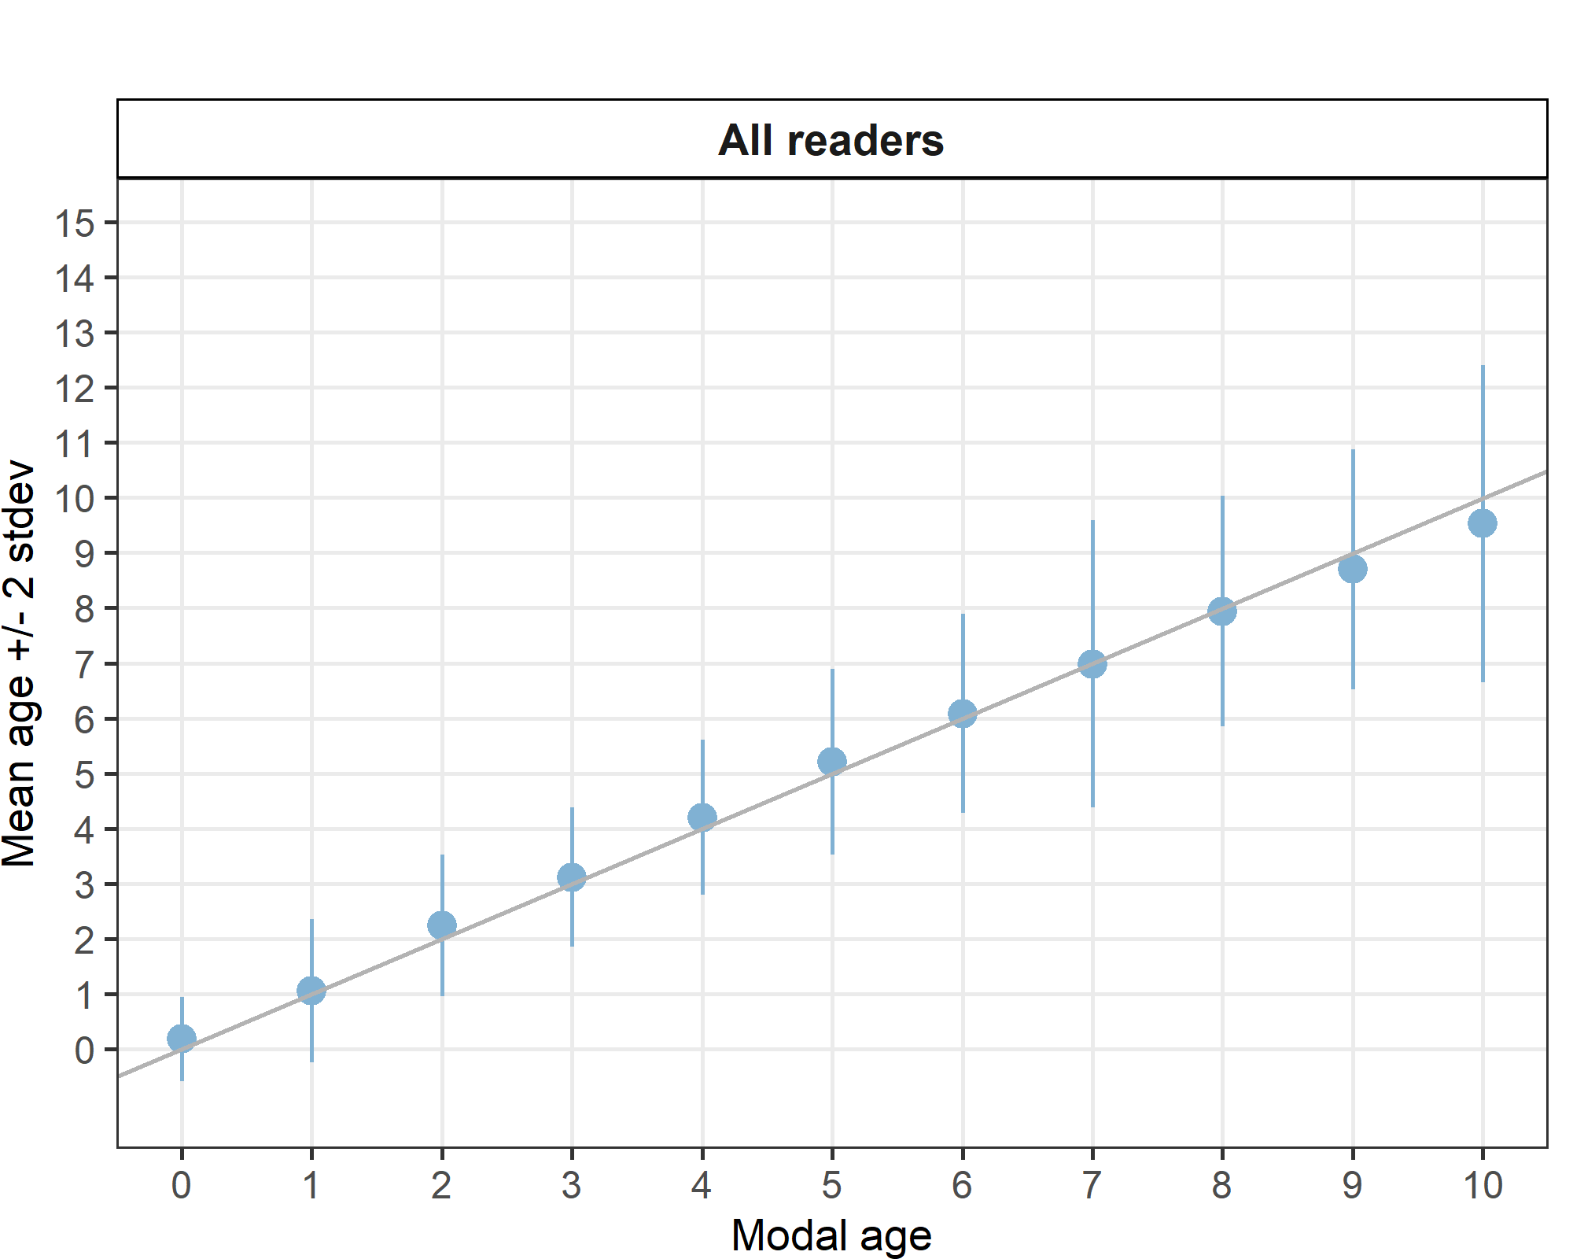
Figure 4.1: Age bias plot for all readers. Mean age recorded +/- 2 stdev of each reader and all readers combined are plotted against modal age. The estimated mean age corresponds to modal age, if the estimated mean age is on the 1:1 equilibrium line (solid line). Relative bias is the age difference between estimated mean age and modal age.

Strata_27.3.a.20 (ICES Area)
Table 4.7: Strata Strata_27.3.a.20 .Summary of statistics; Total number of samples (NSample), coefficient of variance (CV), percentage of agreement (PA) and average percentage error (APE) for all ages and readers
NSample | CV | PA | APE
66 | 23 % | 76 % | 15 %
Coefficient of Variation (CV)
Table 4.8: Strata_27.3.a.20 .Coefficient of Variation (CV) table presents the CV per modal age and reader, the CV of all readers combined per modal age and a weighted mean of the CV per reader
Modal age | R01 DK | R02 SE | R03 NO | R04 DE | R05 NO | R06 NO | R07 NO | R08 NO | R09 NO | R10 PL | R11 SE | R12 NO | R13 SE | R14 SE | R15 GB-SCT | R16 GB-SCT | R17 GB-SCT | all
0 | - | - | - | - | - | - | - | - | - | - | - | - | - | - | - | - | - | -
1 | 0 % | 0 % | 57 % | 0 % | 46 % | 0 % | 50 % | 0 % | 31 % | 0 % | 57 % | 55 % | 73 % | 0 % | 36 % | 53 % | 50 % | 50 %
2 | 0 % | 0 % | 27 % | 28 % | 30 % | 18 % | 21 % | 0 % | 16 % | 18 % | 18 % | 16 % | 0 % | 0 % | 22 % | 44 % | 41 % | 27 %
3 | 0 % | 14 % | 13 % | 14 % | 26 % | 16 % | 13 % | 15 % | 13 % | 14 % | 13 % | 14 % | 15 % | 13 % | 14 % | 20 % | 14 % | 18 %
4 | 11 % | 17 % | 19 % | 7 % | 35 % | 19 % | 11 % | 15 % | 8 % | 23 % | 16 % | 21 % | 0 % | 11 % | 13 % | 20 % | 22 % | 21 %
5 | 5 % | 12 % | 28 % | 0 % | 18 % | 6 % | 17 % | 22 % | 6 % | 7 % | 7 % | 14 % | 10 % | 7 % | 11 % | 19 % | 29 % | 17 %
6 | 19 % | 20 % | 23 % | 6 % | 23 % | 11 % | 0 % | 7 % | 0 % | 13 % | 13 % | 6 % | 15 % | 13 % | 6 % | 25 % | 15 % | 17 %
7 | 8 % | 8 % | 19 % | 0 % | 15 % | 16 % | 8 % | 7 % | 0 % | 9 % | 38 % | 0 % | 14 % | 8 % | 0 % | 15 % | 9 % | 14 %
8 | - | - | - | - | - | - | - | - | - | - | - | - | - | - | - | - | - | 14 %
9 | - | - | - | - | - | - | - | - | - | - | - | - | - | - | - | - | - | -
10 | - | - | - | - | - | - | - | - | - | - | - | - | - | - | - | - | - | 10 %
Weighted Mean | 6 % | 11 % | 27 % | 7 % | 28 % | 11 % | 17 % | 12 % | 11 % | 12 % | 19 % | 19 % | 17 % | 7 % | 15 % | 28 % | 28 % | 23 %

Percentage of Agreement (PA)
Table 4.9: Strata_27.3.a.20 .Percentage agreement (PA) table represents the PA per modal age and reader, the PA of all readers combined per modal age and a weighted mean of the PA per reader.
Modal age | R01 DK | R02 SE | R03 NO | R04 DE | R05 NO | R06 NO | R07 NO | R08 NO | R09 NO | R10 PL | R11 SE | R12 NO | R13 SE | R14 SE | R15 GB-SCT | R16 GB-SCT | R17 GB-SCT | total
0 | 100 % | 100 % | 100 % | 100 % | 100 % | 100 % | 0 % | 100 % | 100 % | 100 % | 100 % | 100 % | 100 % | 100 % | 100 % | 100 % | 100 % | 94 %
1 | 100 % | 100 % | 88 % | 100 % | 50 % | 100 % | 62 % | 100 % | 88 % | 100 % | 88 % | 71 % | 75 % | 100 % | 50 % | 38 % | 62 % | 81 %
2 | 100 % | 100 % | 75 % | 71 % | 67 % | 89 % | 67 % | 100 % | 89 % | 89 % | 89 % | 89 % | 100 % | 100 % | 56 % | 56 % | 78 % | 83 %
3 | 100 % | 83 % | 83 % | 83 % | 50 % | 50 % | 83 % | 67 % | 83 % | 83 % | 83 % | 83 % | 67 % | 83 % | 83 % | 20 % | 80 % | 75 %
4 | 82 % | 82 % | 55 % | 91 % | 40 % | 82 % | 73 % | 55 % | 91 % | 82 % | 64 % | 82 % | 100 % | 82 % | 73 % | 18 % | 64 % | 71 %
5 | 94 % | 82 % | 56 % | 100 % | 73 % | 88 % | 82 % | 53 % | 88 % | 88 % | 88 % | 88 % | 94 % | 88 % | 71 % | 25 % | 59 % | 78 %
6 | 88 % | 75 % | 50 % | 88 % | 62 % | 62 % | 100 % | 75 % | 100 % | 75 % | 38 % | 86 % | 62 % | 75 % | 88 % | 25 % | 62 % | 71 %
7 | 67 % | 33 % | 0 % | 100 % | 67 % | 0 % | 33 % | 0 % | 100 % | 33 % | 33 % | 100 % | 33 % | 67 % | 100 % | 67 % | 33 % | 50 %
8 | 100 % | 0 % | 100 % | 0 % | 100 % | 100 % | 100 % | 0 % | 0 % | 0 % | 0 % | 100 % | 0 % | 0 % | 100 % | 0 % | 100 % | 47 %
9 | - | - | - | - | - | - | - | - | - | - | - | - | - | - | - | - | - | -
10 | 100 % | 0 % | 100 % | 0 % | 100 % | 100 % | 100 % | 100 % | 100 % | 100 % | 100 % | 100 % | 0 % | 100 % | 100 % | 100 % | 100 % | 82 %
Weighted Mean | 92 % | 82 % | 64 % | 89 % | 62 % | 79 % | 74 % | 68 % | 89 % | 83 % | 74 % | 86 % | 82 % | 86 % | 73 % | 34 % | 66 % | 76 %

Average Percentage Error (APE)
Table 4.10: Strata_27.3.a.20 .Average Percentage Error (APE) table represents the APE per modal age and reader, the APE of all advanced readers combined per modal age and a weighted mean of the APE per reader.
Modal age | R01 DK | R02 SE | R03 NO | R04 DE | R05 NO | R06 NO | R07 NO | R08 NO | R09 NO | R10 PL | R11 SE | R12 NO | R13 SE | R14 SE | R15 GB-SCT | R16 GB-SCT | R17 GB-SCT | all
0 | - | - | - | - | - | - | - | - | - | - | - | - | - | - | - | - | - | -
1 | 0 % | 0 % | 35 % | 0 % | 38 % | 0 % | 42 % | 0 % | 19 % | 0 % | 35 % | 43 % | 58 % | 0 % | 33 % | 38 % | 42 % | 36 %
2 | 0 % | 0 % | 12 % | 24 % | 24 % | 10 % | 19 % | 0 % | 9 % | 10 % | 10 % | 9 % | 0 % | 0 % | 20 % | 34 % | 28 % | 15 %
3 | 0 % | 10 % | 9 % | 10 % | 22 % | 14 % | 9 % | 13 % | 9 % | 10 % | 9 % | 10 % | 13 % | 9 % | 10 % | 15 % | 10 % | 13 %
4 | 8 % | 12 % | 17 % | 4 % | 26 % | 14 % | 9 % | 13 % | 4 % | 12 % | 9 % | 14 % | 0 % | 5 % | 8 % | 17 % | 17 % | 14 %
5 | 2 % | 6 % | 21 % | 0 % | 14 % | 4 % | 13 % | 14 % | 4 % | 2 % | 4 % | 8 % | 5 % | 2 % | 9 % | 15 % | 16 % | 10 %
6 | 12 % | 12 % | 16 % | 4 % | 20 % | 7 % | 0 % | 6 % | 0 % | 10 % | 11 % | 4 % | 11 % | 10 % | 4 % | 17 % | 8 % | 8 %
7 | 6 % | 6 % | 15 % | 0 % | 12 % | 12 % | 6 % | 5 % | 0 % | 7 % | 27 % | 0 % | 10 % | 6 % | 0 % | 12 % | 7 % | 11 %
8 | 0 % | 0 % | 0 % | 0 % | 0 % | 0 % | 0 % | 0 % | 0 % | 0 % | 0 % | 0 % | 0 % | 0 % | 0 % | 0 % | 0 % | 13 %
9 | - | - | - | - | - | - | - | - | - | - | - | - | - | - | - | - | - | -
10 | 0 % | 0 % | 0 % | 0 % | 0 % | 0 % | 0 % | 0 % | 0 % | 0 % | 0 % | 0 % | 0 % | 0 % | 0 % | 0 % | 0 % | 7 %
Weighted Mean | 4 % | 6 % | 18 % | 5 % | 22 % | 8 % | 13 % | 8 % |  |  | 12 % | 12 % | 12 % | 4 % | 12 % | 21 % | 19 % | 15 %

Relative bias
Table 4.11: Strata_27.3.a.20 . The relative bias (as the difference between the mean and modal age) per modal age and reader is presented, as well as the weighted mean relative bias per reader and the relative bias per modal age for all readers combined.
Modal age | R01 DK | R02 SE | R03 NO | R04 DE | R05 NO | R06 NO | R07 NO | R08 NO | R09 NO | R10 PL | R11 SE | R12 NO | R13 SE | R14 SE | R15 GB-SCT | R16 GB-SCT | R17 GB-SCT | all
0 | 0.00 | 0.00 | 0.00 | 0.00 | 0.00 | 0.00 | 1.00 | 0.00 | 0.00 | 0.00 | 0.00 | 0.00 | 0.00 | 0.00 | 0.00 | 0.00 | 0.00 | 0.06
1 | 0.00 | 0.00 | 0.25 | 0.00 | 0.62 | 0.00 | 0.50 | 0.00 | 0.12 | 0.00 | 0.25 | 0.43 | 0.62 | 0.00 | 0.50 | 1.00 | 0.50 | 0.28
2 | 0.00 | 0.00 | 0.00 | -0.29 | 0.44 | -0.11 | 0.33 | 0.00 | 0.11 | -0.11 | -0.11 | 0.11 | 0.00 | 0.00 | 0.44 | 0.89 | 0.44 | 0.13
3 | 0.00 | -0.17 | 0.17 | -0.17 | 0.83 | 0.50 | 0.17 | 0.33 | 0.17 | -0.17 | 0.17 | -0.17 | 0.33 | 0.17 | -0.17 | 1.20 | 0.20 | 0.20
4 | -0.18 | -0.27 | 0.73 | 0.09 | 1.10 | 0.36 | 0.27 | 0.55 | -0.09 | 0.18 | 0.00 | 0.36 | 0.00 | 0.00 | 0.09 | 1.55 | 0.64 | 0.32
5 | -0.06 | 0.12 | 0.88 | 0.00 | 0.53 | 0.12 | 0.41 | 0.76 | 0.12 | 0.00 | -0.12 | 0.24 | -0.12 | 0.00 | 0.35 | 1.38 | -0.18 | 0.26
6 | -0.38 | -0.25 | 0.62 | -0.12 | 1.12 | -0.12 | 0.00 | 0.25 | 0.00 | -0.38 | -0.75 | 0.14 | -0.25 | -0.38 | 0.12 | 1.12 | 0.00 | 0.05
7 | 0.33 | 0.67 | 2.00 | 0.00 | 0.67 | 0.33 | 0.67 | 1.33 | 0.00 | -0.67 | -0.33 | 0.00 | 0.00 | 0.33 | 0.00 | 0.67 | -0.67 | 0.31
8 | 0.00 | -1.00 | 0.00 | -2.00 | 0.00 | 0.00 | 0.00 | 1.00 | -1.00 | -2.00 | -2.00 | 0.00 | -2.00 | -2.00 | 0.00 | -2.00 | 0.00 | -0.76
9 | - | - | - | - | - | - | - | - | - | - | - | - | - | - | - | - | - | -
10 | 0.00 | -3.00 | 0.00 | -1.00 | 0.00 | 0.00 | 0.00 | 0.00 | 0.00 | 0.00 | 0.00 | 0.00 | -3.00 | 0.00 | 0.00 | 0.00 | 0.00 | -0.41
Weighted Mean | -0.08 | -0.09 | 0.56 | -0.10 | 0.70 | 0.12 | 0.33 | 0.43 | 0.05 | -0.11 | -0.14 | 0.19 | -0.03 | -0.05 | 0.23 | 1.09 | 0.17 | 0.19

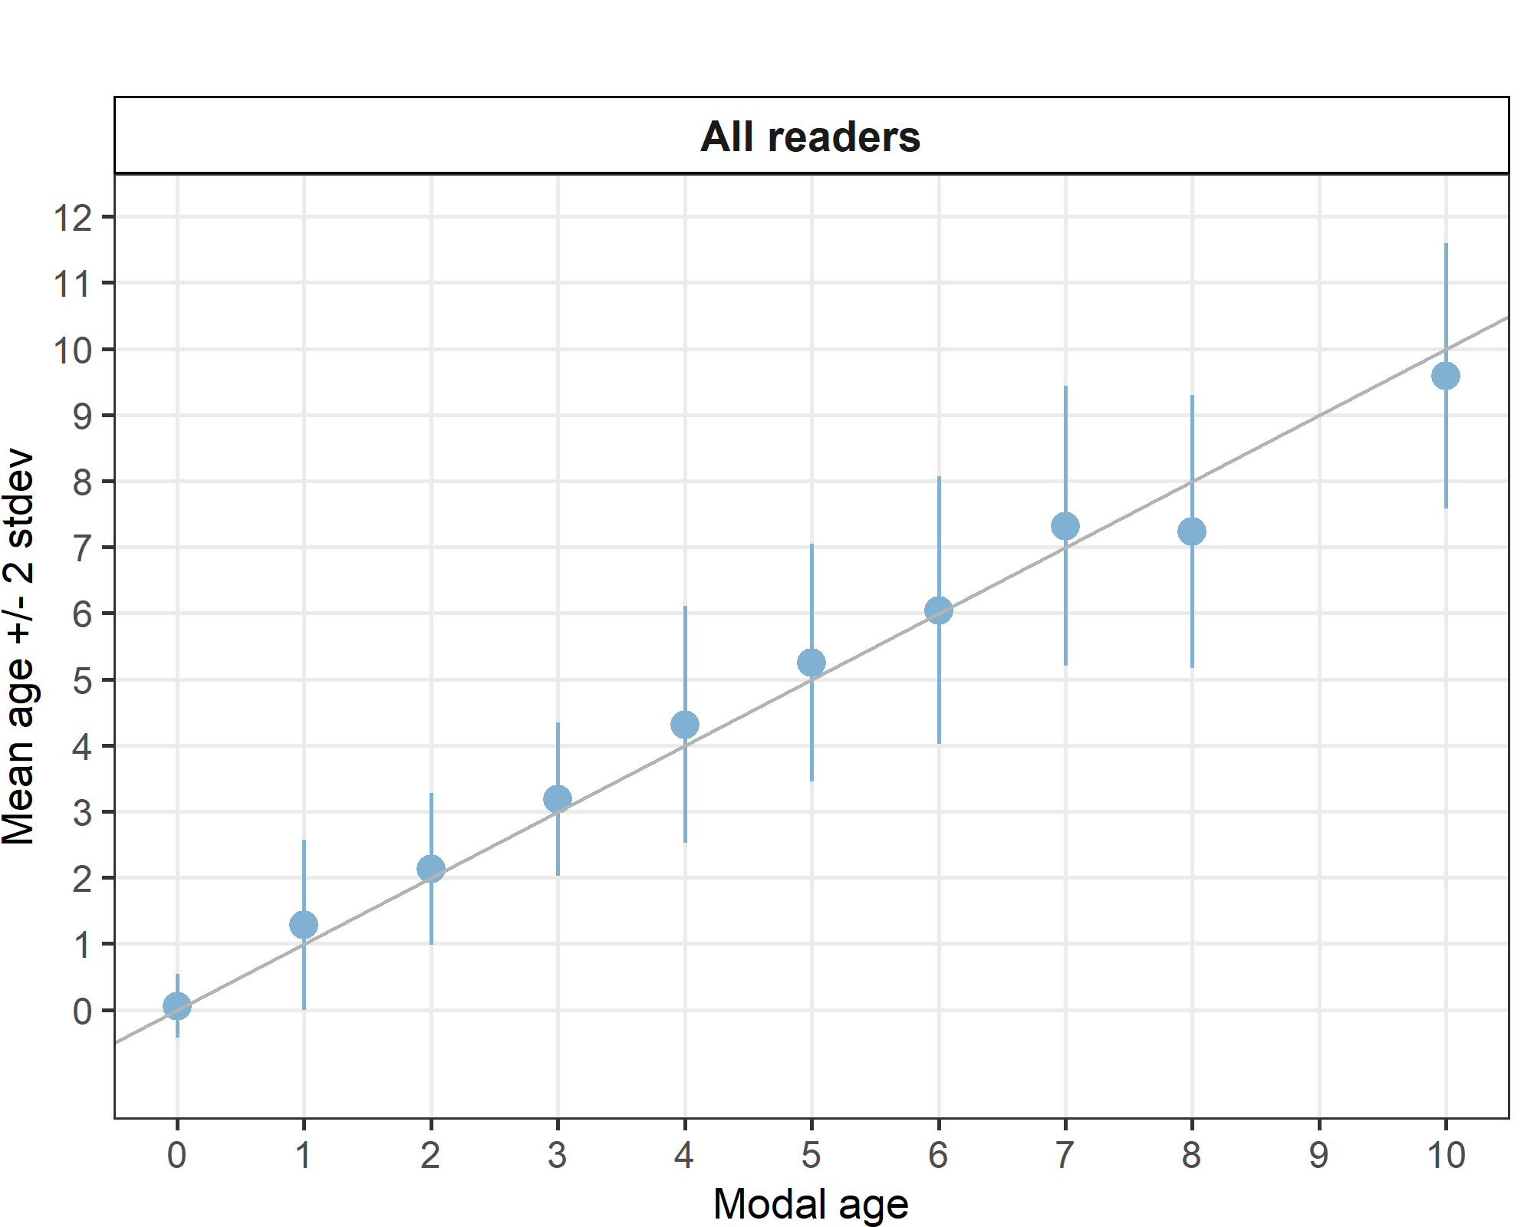
Figure 4.2: Strata_27.3.a.20 .Age bias plot for all readers. Mean age recorded +/- 2 stdev of each reader and all readers combined are plotted against modal age. The estimated mean age corresponds to modal age, if the estimated mean age is on the 1:1 equilibrium line (solid line). Relative bias is the age difference between estimated mean age and modal age.

Strata_27.4.a (ICES Area)
Table 4.13: Strata Strata_27.4.a .Summary of statistics; Total number of samples (NSample), coefficient of variance (CV), percentage of agreement (PA) and average percentage error (APE) for all ages and readers
NSample | CV | PA | APE
75 | 17 % | 75 % | 11 %
Coefficient of Variation (CV)
Table 4.14: Strata_27.4.a .Coefficient of Variation (CV) table presents the CV per modal age and reader, the CV of all readers combined per modal age and a weighted mean of the CV per reader
Modal age | R01 DK | R02 SE | R03 NO | R04 DE | R05 NO | R06 NO | R07 NO | R08 NO | R09 NO | R10 PL | R11 SE | R12 NO | R13 SE | R14 SE | R15 GB-SCT | R16 GB-SCT | R17 GB-SCT | all
0 | - | - | - | - | - | - | - | - | - | - | - | - | - | - | - | - | - | -
1 | - | - | - | - | - | - | - | - | - | - | - | - | - | - | - | - | - | -
2 | 0 % | 0 % | 21 % | 0 % | 19 % | 0 % | 29 % | 0 % | 0 % | 19 % | 19 % | 15 % | 16 % | 0 % | 21 % | 37 % | 33 % | 28 %
3 | 0 % | 0 % | 20 % | 0 % | 13 % | 13 % | 24 % | 0 % | 10 % | 0 % | 0 % | 0 % | 10 % | 14 % | 13 % | 22 % | 36 % | 22 %
4 | 0 % | 8 % | 18 % | 8 % | 18 % | 7 % | 27 % | 0 % | 0 % | 13 % | 11 % | 8 % | 13 % | 16 % | 0 % | 19 % | 14 % | 16 %
5 | 13 % | 0 % | 22 % | 0 % | 28 % | 18 % | 24 % | 18 % | 23 % | 9 % | 6 % | 6 % | 12 % | 6 % | 18 % | 19 % | 23 % | 19 %
6 | 0 % | 0 % | 19 % | 6 % | 16 % | 5 % | 14 % | 16 % | 0 % | 8 % | 8 % | 11 % | 9 % | 8 % | 14 % | 19 % | 15 % | 15 %
7 | 9 % | 0 % | 15 % | 0 % | 15 % | 0 % | 22 % | 0 % | 0 % | 0 % | 17 % | 0 % | 9 % | 9 % | 0 % | 25 % | 24 % | 16 %
8 | 6 % | 5 % | 6 % | 6 % | 8 % | 5 % | 15 % | 9 % | 0 % | 8 % | 16 % | 5 % | 11 % | 6 % | 8 % | 10 % | 14 % | 12 %
9 | 0 % | 8 % | 5 % | 4 % | 4 % | 4 % | 7 % | 3 % | 4 % | 8 % | 15 % | 9 % | 10 % | 11 % | 5 % | 9 % | 6 % | 8 %
10 | - | - | - | - | - | - | - | - | - | - | - | - | - | - | - | - | - | -
Weighted Mean | 3 % | 3 % | 16 % | 3 % | 15 % | 7 % | 20 % | 6 % | 5 % | 9 % | 11 % | 7 % | 11 % | 9 % | 10 % | 19 % | 21 % | 17 %

Percentage of Agreement (PA)
Table 4.15: Strata_27.4.a .Percentage agreement (PA) table represents the PA per modal age and reader, the PA of all readers combined per modal age and a weighted mean of the PA per reader.
Modal age | R01 DK | R02 SE | R03 NO | R04 DE | R05 NO | R06 NO | R07 NO | R08 NO | R09 NO | R10 PL | R11 SE | R12 NO | R13 SE | R14 SE | R15 GB-SCT | R16 GB-SCT | R17 GB-SCT | total
0 | - | - | - | - | - | - | - | - | - | - | - | - | - | - | - | - | - | -
1 | - | - | - | - | - | - | - | - | - | - | - | - | - | - | - | - | - | -
2 | 100 % | 100 % | 70 % | 100 % | 80 % | 100 % | 70 % | 100 % | 100 % | 80 % | 80 % | 90 % | 89 % | 100 % | 70 % | 22 % | 40 % | 82 %
3 | 100 % | 100 % | 82 % | 100 % | 82 % | 82 % | 73 % | 100 % | 91 % | 100 % | 100 % | 100 % | 91 % | 82 % | 82 % | 9 % | 18 % | 82 %
4 | 100 % | 91 % | 73 % | 91 % | 73 % | 91 % | 73 % | 100 % | 100 % | 73 % | 82 % | 91 % | 73 % | 91 % | 100 % | 27 % | 36 % | 80 %
5 | 80 % | 100 % | 70 % | 100 % | 70 % | 90 % | 80 % | 70 % | 90 % | 80 % | 90 % | 90 % | 70 % | 90 % | 80 % | 0 % | 20 % | 75 %
6 | 100 % | 100 % | 67 % | 89 % | 75 % | 89 % | 78 % | 89 % | 100 % | 78 % | 22 % | 78 % | 56 % | 78 % | 78 % | 33 % | 44 % | 74 %
7 | 67 % | 100 % | 67 % | 100 % | 67 % | 100 % | 67 % | 100 % | 100 % | 100 % | 33 % | 100 % | 67 % | 67 % | 100 % | 0 % | 33 % | 73 %
8 | 64 % | 82 % | 36 % | 73 % | 55 % | 82 % | 55 % | 55 % | 100 % | 55 % | 45 % | 82 % | 18 % | 73 % | 82 % | 18 % | 36 % | 59 %
9 | 100 % | 80 % | 70 % | 90 % | 90 % | 90 % | 60 % | 90 % | 90 % | 60 % | 30 % | 70 % | 50 % | 70 % | 80 % | 60 % | 70 % | 74 %
10 | - | - | - | - | - | - | - | - | - | - | - | - | - | - | - | - | - | -
Weighted Mean | 91 % | 93 % | 67 % | 92 % | 74 % | 89 % | 69 % | 87 % | 96 % | 76 % | 64 % | 86 % | 64 % | 83 % | 83 % | 23 % | 37 % | 75 %

Average Percentage Error (APE)
Table 4.16: Strata_27.4.a .Average Percentage Error (APE) table represents the APE per modal age and reader, the APE of all advanced readers combined per modal age and a weighted mean of the APE per reader.
Modal age | R01 DK | R02 SE | R03 NO | R04 DE | R05 NO | R06 NO | R07 NO | R08 NO | R09 NO | R10 PL | R11 SE | R12 NO | R13 SE | R14 SE | R15 GB-SCT | R16 GB-SCT | R17 GB-SCT | all
0 | - | - | - | - | - | - | - | - | - | - | - | - | - | - | - | - | - | -
1 | - | - | - | - | - | - | - | - | - | - | - | - | - | - | - | - | - | -
2 | 0 % | 0 % | 18 % | 0 % | 15 % | 0 % | 23 % | 0 % | 0 % | 15 % | 15 % | 9 % | 9 % | 0 % | 18 % | 30 % | 23 % | 18 %
3 | 0 % | 0 % | 14 % | 0 % | 9 % | 9 % | 15 % | 0 % | 6 % | 0 % | 0 % | 0 % | 5 % | 11 % | 9 % | 17 % | 29 % | 13 %
4 | 0 % | 4 % | 11 % | 4 % | 15 % | 4 % | 17 % | 0 % | 0 % | 11 % | 8 % | 4 % | 8 % | 9 % | 0 % | 16 % | 11 % | 9 %
5 | 9 % | 0 % | 17 % | 0 % | 23 % | 10 % | 17 % | 13 % | 13 % | 7 % | 4 % | 4 % | 7 % | 4 % | 12 % | 13 % | 14 % | 13 %
6 | 0 % | 0 % | 14 % | 3 % | 12 % | 3 % | 11 % | 9 % | 0 % | 6 % | 7 % | 8 % | 9 % | 6 % | 11 % | 15 % | 11 % | 9 %
7 | 7 % | 0 % | 12 % | 0 % | 12 % | 0 % | 17 % | 0 % | 0 % | 0 % | 11 % | 0 % | 7 % | 7 % | 0 % | 19 % | 18 % | 9 %
8 | 6 % | 4 % | 5 % | 5 % | 6 % | 4 % | 12 % | 8 % | 0 % | 7 % | 13 % | 4 % | 8 % | 5 % | 5 % | 8 % | 11 % | 8 %
9 | 0 % | 6 % | 5 % | 2 % | 2 % | 2 % | 5 % | 2 % | 2 % | 7 % | 12 % | 6 % | 8 % | 8 % | 4 % | 8 % | 4 % | 5 %
10 | - | - | - | - | - | - | - | - | - | - | - | - | - | - | - | - | - | -
Weighted Mean | 2 % | 2 % | 12 % | 2 % | 12 % | 5 % | 15 % | 4 % | 3 % | 7 % | 8 % | 5 % | 8 % | 6 % | 8 % | 15 % | 15 % | 11 %

Relative bias
Table 4.17: Strata_27.4.a . The relative bias (as the difference between the mean and modal age) per modal age and reader is presented, as well as the weighted mean relative bias per reader and the relative bias per modal age for all readers combined.
Modal age | R01 DK | R02 SE | R03 NO | R04 DE | R05 NO | R06 NO | R07 NO | R08 NO | R09 NO | R10 PL | R11 SE | R12 NO | R13 SE | R14 SE | R15 GB-SCT | R16 GB-SCT | R17 GB-SCT | all
0 | - | - | - | - | - | - | - | - | - | - | - | - | - | - | - | - | - | -
1 | - | - | - | - | - | - | - | - | - | - | - | - | - | - | - | - | - | -
2 | 0.00 | 0.00 | 0.30 | 0.00 | 0.20 | 0.00 | 0.40 | 0.00 | 0.00 | 0.20 | 0.20 | 0.10 | 0.11 | 0.00 | 0.30 | 1.78 | 0.80 | 0.26
3 | 0.00 | 0.00 | 0.27 | 0.00 | 0.18 | 0.18 | 0.18 | 0.00 | -0.09 | 0.00 | 0.00 | 0.00 | 0.09 | -0.18 | 0.18 | 2.09 | 0.55 | 0.20
4 | 0.00 | -0.09 | 0.18 | -0.09 | 0.45 | 0.09 | 0.55 | 0.00 | 0.00 | -0.27 | -0.18 | -0.09 | 0.09 | -0.18 | 0.00 | 1.27 | 0.73 | 0.14
5 | 0.30 | 0.00 | 0.70 | 0.00 | 1.00 | 0.30 | 0.60 | 0.50 | 0.40 | -0.20 | -0.10 | 0.10 | -0.10 | 0.10 | 0.40 | 1.60 | 1.30 | 0.41
6 | 0.00 | 0.00 | 0.44 | -0.11 | 0.50 | 0.11 | 0.44 | 0.33 | 0.00 | -0.22 | -0.78 | 0.33 | -0.44 | -0.22 | 0.44 | 1.78 | 0.89 | 0.21
7 | -0.33 | 0.00 | 0.67 | 0.00 | 0.67 | 0.00 | 1.00 | 0.00 | 0.00 | 0.00 | -1.00 | 0.00 | -0.33 | -0.33 | 0.00 | 2.33 | 1.67 | 0.25
8 | 0.36 | 0.18 | 0.64 | -0.27 | 0.27 | -0.18 | 1.00 | 0.64 | 0.00 | -0.27 | -1.00 | -0.18 | -0.73 | -0.27 | 0.27 | 1.27 | 1.18 | 0.17
9 | 0.00 | -0.30 | 0.30 | -0.10 | -0.10 | -0.10 | 0.20 | 0.10 | -0.10 | -0.50 | -1.30 | -0.20 | -0.70 | -0.50 | -0.20 | 0.60 | -0.10 | -0.18
10 | - | - | - | - | - | - | - | - | - | - | - | - | - | - | - | - | - | -
Weighted Mean | 0.08 | -0.03 | 0.41 | -0.08 | 0.36 | 0.05 | 0.51 | 0.21 | 0.03 | -0.18 | -0.47 | 0.00 | -0.24 | -0.19 | 0.19 | 1.51 | 0.80 | 0.18

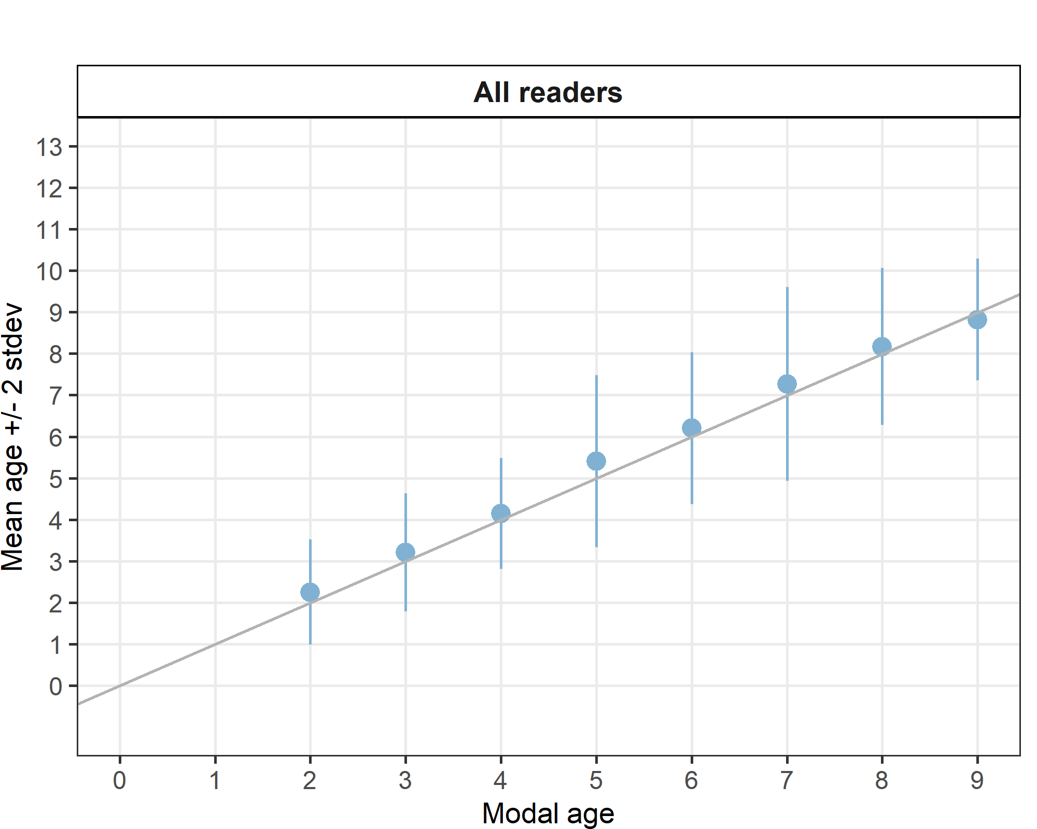
Figure 4.3: Strata_27.4.a .Age bias plot for all readers. Mean age recorded +/- 2 stdev of each reader and all readers combined are plotted against modal age. The estimated mean age corresponds to modal age, if the estimated mean age is on the 1:1 equilibrium line (solid line). Relative bias is the age difference between estimated mean age and modal age.

Strata_27.3.d.24 (ICES Area)
Summary statistics
Table 4.18: Strata Strata_27.3.d.24 .Summary of statistics; Total number of samples (NSample), coefficient of variance (CV), percentage of agreement (PA) and average percentage error (APE) for all ages and readers
NSample | CV | PA | APE
69 | 24 % | 66 % | 19 %
Coefficient of Variation (CV)
Table 4.19: Strata_27.3.d.24 .Coefficient of Variation (CV) table presents the CV per modal age and reader, the CV of all readers combined per modal age and a weighted mean of the CV per reader
Modal age | R01 DK | R02 SE | R03 NO | R04 DE | R05 NO | R06 NO | R07 NO | R08 NO | R09 NO | R10 PL | R11 SE | R12 NO | R13 SE | R14 SE | R15 GB-SCT | R16 GB-SCT | R17 GB-SCT | all
0 | - | - | - | - | - | - | - | - | - | - | - | - | - | - | - | - | - | -
1 | - | - | - | - | 0 % | - | 0 % | 0 % | 0 % | - | 57 % | 0 % | 38 % | 0 % | 0 % | 55 % | 50 % | 75 %
2 | 26 % | 16 % | 14 % | 16 % | 14 % | 34 % | 21 % | 17 % | 0 % | 24 % | 21 % | 19 % | 21 % | 0 % | 19 % | 21 % | 14 % | 23 %
3 | 0 % | 22 % | 31 % | 22 % | 16 % | 25 % | 43 % | 17 % | 22 % | 0 % | 0 % | 0 % | 17 % | 22 % | 17 % | 25 % | 31 % | 24 %
4 | 0 % | 0 % | 16 % | 0 % | 18 % | 9 % | 0 % | 18 % | 9 % | 11 % | 11 % | 0 % | 0 % | 9 % | 0 % | 22 % | 9 % | 12 %
5 | 7 % | 12 % | 10 % | 7 % | 7 % | 13 % | 10 % | 12 % | 12 % | 8 % | 12 % | 0 % | 0 % | 7 % | 9 % | 9 % | 9 % | 10 %
6 | 8 % | 19 % | 18 % | 9 % | 11 % | 6 % | 8 % | 5 % | 12 % | 8 % | 10 % | 0 % | 0 % | 7 % | 9 % | 6 % | 39 % | 14 %
7 | 8 % | 26 % | 26 % | 20 % | 13 % | 26 % | 20 % | 22 % | 12 % | 13 % | 22 % | 13 % | 16 % | 19 % | 23 % | 9 % | 22 % | 21 %
8 | 5 % | 20 % | 10 % | 16 % | 11 % | 7 % | 5 % | 19 % | 9 % | 15 % | 17 % | 5 % | 6 % | 6 % | 6 % | 16 % | 6 % | 14 %
9 | 6 % | 29 % | 0 % | 10 % | 0 % | 27 % | 5 % | 0 % | 18 % | 0 % | 32 % | 12 % | 24 % | 18 % | 16 % | 0 % | 6 % | 15 %
10 | - | - | - | - | - | - | - | - | - | - | - | - | - | - | - | - | - | 19 %
Weighted Mean | 9 % | 17 % | 16 % | 12 % | 10 % | 19 % | 11 % | 12 % | 9 % | 12 % | 22 % | 6 % | 14 % | 8 % | 11 % | 19 % | 22 % | 24 %

Percentage of Agreement (PA)
Table 4.20 Strata_27.3.d.24 .Percentage agreement (PA) table represents the PA per modal age and reader, the PA of all readers combined per modal age and a weighted mean of the PA per reader.
Modal age | R01 DK | R02 SE | R03 NO | R04 DE | R05 NO | R06 NO | R07 NO | R08 NO | R09 NO | R10 PL | R11 SE | R12 NO | R13 SE | R14 SE | R15 GB-SCT | R16 GB-SCT | R17 GB-SCT | total
0 | 100 % | 100 % | 100 % | 100 % | 0 % | 100 % | 0 % | 0 % | 0 % | 100 % | 100 % | 0 % | 0 % | 100 % | 100 % | 0 % | 100 % | 59 %
1 | 11 % | 0 % | 22 % | 0 % | 100 % | 22 % | 100 % | 100 % | 100 % | 33 % | 78 % | 100 % | 89 % | 100 % | 100 % | 89 % | 78 % | 66 %
2 | 73 % | 91 % | 91 % | 91 % | 18 % | 55 % | 73 % | 90 % | 100 % | 36 % | 55 % | 82 % | 73 % | 100 % | 82 % | 27 % | 91 % | 72 %
3 | 100 % | 67 % | 67 % | 67 % | 33 % | 33 % | 67 % | 67 % | 67 % | 100 % | 100 % | 100 % | 67 % | 67 % | 67 % | 33 % | 67 % | 69 %
4 | 100 % | 100 % | 33 % | 100 % | 71 % | 86 % | 100 % | 71 % | 86 % | 71 % | 71 % | 100 % | 100 % | 86 % | 100 % | 43 % | 86 % | 83 %
5 | 89 % | 67 % | 50 % | 89 % | 89 % | 78 % | 78 % | 67 % | 67 % | 78 % | 67 % | 100 % | 100 % | 89 % | 78 % | 67 % | 67 % | 77 %
6 | 78 % | 44 % | 56 % | 56 % | 44 % | 89 % | 78 % | 89 % | 89 % | 78 % | 67 % | 100 % | 100 % | 78 % | 67 % | 89 % | 44 % | 73 %
7 | 70 % | 30 % | 40 % | 30 % | 44 % | 30 % | 50 % | 40 % | 70 % | 50 % | 40 % | 50 % | 50 % | 56 % | 20 % | 60 % | 33 % | 45 %
8 | 80 % | 60 % | 40 % | 20 % | 40 % | 60 % | 80 % | 40 % | 60 % | 40 % | 20 % | 80 % | 20 % | 80 % | 80 % | 20 % | 80 % | 53 %
9 | 75 % | 25 % | 100 % | 25 % | 100 % | 25 % | 75 % | 100 % | 50 % | 0 % | 50 % | 75 % | 50 % | 50 % | 25 % | 0 % | 75 % | 53 %
10 | 0 % | 0 % | 0 % | 100 % | 0 % | 100 % | 0 % | 0 % | 100 % | 0 % | 0 % | 100 % | 0 % | 100 % | 100 % | 0 % | 100 % | 41 %
Weighted Mean | 71 % | 54 % | 54 % | 57 % | 57 % | 57 % | 75 % | 72 % | 80 % | 54 % | 59 % | 86 % | 74 % | 82 % | 71 % | 52 % | 69 % | 66 %

Average Percentage Error (APE)
Table 4.21: Strata_27.3.d.24 .Average Percentage Error (APE) table represents the APE per modal age and reader, the APE of all advanced readers combined per modal age and a weighted mean of the APE per reader.
Modal age | R01 DK | R02 SE | R03 NO | R04 DE | R05 NO | R06 NO | R07 NO | R08 NO | R09 NO | R10 PL | R11 SE | R12 NO | R13 SE | R14 SE | R15 GB-SCT | R16 GB-SCT | R17 GB-SCT | all
0 | - | - | - | - | - | - | - | - | - | - | - | - | - | - | - | - | - | -
1 | - | - | - | - | 0 % | - | 0 % | 0 % | 0 % | - | 44 % | 0 % | 22 % | 0 % | 0 % | 32 % | 22 % | 65 %
2 | 16 % | 9 % | 8 % | 9 % | 11 % | 24 % | 17 % | 9 % | 0 % | 19 % | 20 % | 14 % | 17 % | 0 % | 14 % | 16 % | 8 % | 18 %
3 | 0 % | 17 % | 24 % | 17 % | 12 % | 17 % | 33 % | 13 % | 17 % | 0 % | 0 % | 0 % | 13 % | 17 % | 13 % | 17 % | 24 % | 18 %
4 | 0 % | 0 % | 11 % | 0 % | 14 % | 6 % | 0 % | 14 % | 6 % | 10 % | 10 % | 0 % | 0 % | 6 % | 0 % | 15 % | 6 % | 8 %
5 | 4 % | 8 % | 9 % | 4 % | 4 % | 10 % | 4 % | 8 % | 8 % | 7 % | 8 % | 0 % | 0 % | 4 % | 7 % | 8 % | 8 % | 6 %
6 | 6 % | 13 % | 13 % | 9 % | 9 % | 3 % | 6 % | 3 % | 7 % | 6 % | 6 % | 0 % | 0 % | 6 % | 8 % | 3 % | 24 % | 7 %
7 | 5 % | 23 % | 19 % | 17 % | 11 % | 15 % | 15 % | 16 % | 8 % | 11 % | 16 % | 9 % | 11 % | 16 % | 17 % | 7 % | 16 % | 15 %
8 | 4 % | 14 % | 7 % | 11 % | 8 % | 6 % | 4 % | 16 % | 5 % | 10 % | 13 % | 4 % | 4 % | 4 % | 4 % | 13 % | 4 % | 9 %
9 | 4 % | 23 % | 0 % | 6 % | 0 % | 19 % | 4 % | 0 % | 12 % | 0 % | 23 % | 9 % | 18 % | 12 % | 11 % | 0 % | 4 % | 11 %
10 | 0 % | 0 % | 0 % | 0 % | 0 % | 0 % | 0 % | 0 % | 0 % | 0 % | 0 % | 0 % | 0 % | 0 % | 0 % | 0 % | 0 % | 14 %
Weighted Mean | 6 % | 12 % | 11 % | 9 % | 7 % | 12 % | 8 % | 8 % | 5 % | 9 % | 17 % | 4 % | 9 % | 6 % | 8 % | 12 % | 13 % | 19 %

Relative bias
Table 4.22: Strata_27.3.d.24 . The relative bias (as the difference between the mean and modal age) per modal age and reader is presented, as well as the weighted mean relative bias per reader and the relative bias per modal age for all readers combined.
Modal age | R01 DK | R02 SE | R03 NO | R04 DE | R05 NO | R06 NO | R07 NO | R08 NO | R09 NO | R10 PL | R11 SE | R12 NO | R13 SE | R14 SE | R15 GB-SCT | R16 GB-SCT | R17 GB-SCT | all
0 | 0.00 | 0.00 | 0.00 | 0.00 | 1.00 | 0.00 | 1.00 | 1.00 | 1.00 | 0.00 | 0.00 | 1.00 | 1.00 | 0.00 | 0.00 | 1.00 | 0.00 | 0.41
1 | -0.89 | -1.00 | -0.78 | -1.00 | 0.00 | -0.78 | 0.00 | 0.00 | 0.00 | -0.67 | -0.22 | 0.00 | -0.11 | 0.00 | 0.00 | 0.22 | 0.00 | -0.31
2 | 0.09 | -0.09 | 0.09 | -0.09 | 0.82 | 0.09 | 0.27 | -0.10 | 0.00 | 0.73 | 0.45 | 0.18 | 0.27 | 0.00 | 0.18 | 0.82 | 0.09 | 0.22
3 | 0.00 | -0.33 | 0.67 | -0.33 | 0.67 | 1.00 | 1.00 | 0.33 | -0.33 | 0.00 | 0.00 | 0.00 | 0.33 | -0.33 | 0.33 | 1.00 | 0.67 | 0.27
4 | 0.00 | 0.00 | 0.83 | 0.00 | 0.43 | 0.14 | 0.00 | 0.43 | 0.14 | 0.29 | 0.29 | 0.00 | 0.00 | 0.14 | 0.00 | 0.86 | 0.14 | 0.22
5 | 0.11 | -0.11 | 0.50 | -0.11 | 0.11 | 0.33 | 0.00 | 0.11 | -0.11 | 0.22 | 0.11 | 0.00 | 0.00 | -0.11 | -0.22 | 0.33 | 0.33 | 0.09
6 | -0.22 | -0.78 | 0.44 | -0.44 | 0.67 | -0.11 | -0.22 | 0.11 | -0.22 | -0.22 | 0.11 | 0.00 | 0.00 | 0.22 | -0.33 | -0.11 | -0.44 | -0.09
7 | -0.10 | -1.30 | 1.50 | -1.30 | 0.56 | -0.90 | 0.30 | 0.90 | -0.20 | -0.70 | -1.10 | 0.20 | -0.10 | -0.89 | -0.40 | -0.20 | 0.22 | -0.21
8 | 0.20 | -0.40 | 0.80 | -1.20 | -0.20 | -0.40 | 0.20 | 1.60 | 0.00 | 0.00 | -1.40 | 0.20 | -0.80 | -0.20 | -0.20 | 0.20 | -0.20 | -0.11
9 | -0.25 | -1.25 | 0.00 | -1.00 | 0.00 | -1.00 | 0.25 | 0.00 | -1.00 | -1.00 | -1.50 | -0.50 | -1.25 | -1.00 | -1.25 | -1.00 | -0.25 | -0.71
10 | 1.00 | -4.00 | 1.00 | 0.00 | 1.00 | 0.00 | 1.00 | 1.00 | 0.00 | -1.00 | -5.00 | 0.00 | -3.00 | 0.00 | 0.00 | -1.00 | 0.00 | -0.53
Weighted Mean | -0.12 | -0.62 | 0.43 | -0.57 | 0.40 | -0.22 | 0.16 | 0.35 | -0.12 | -0.12 | -0.32 | 0.06 | -0.13 | -0.18 | -0.17 | 0.25 | 0.04 | -0.05

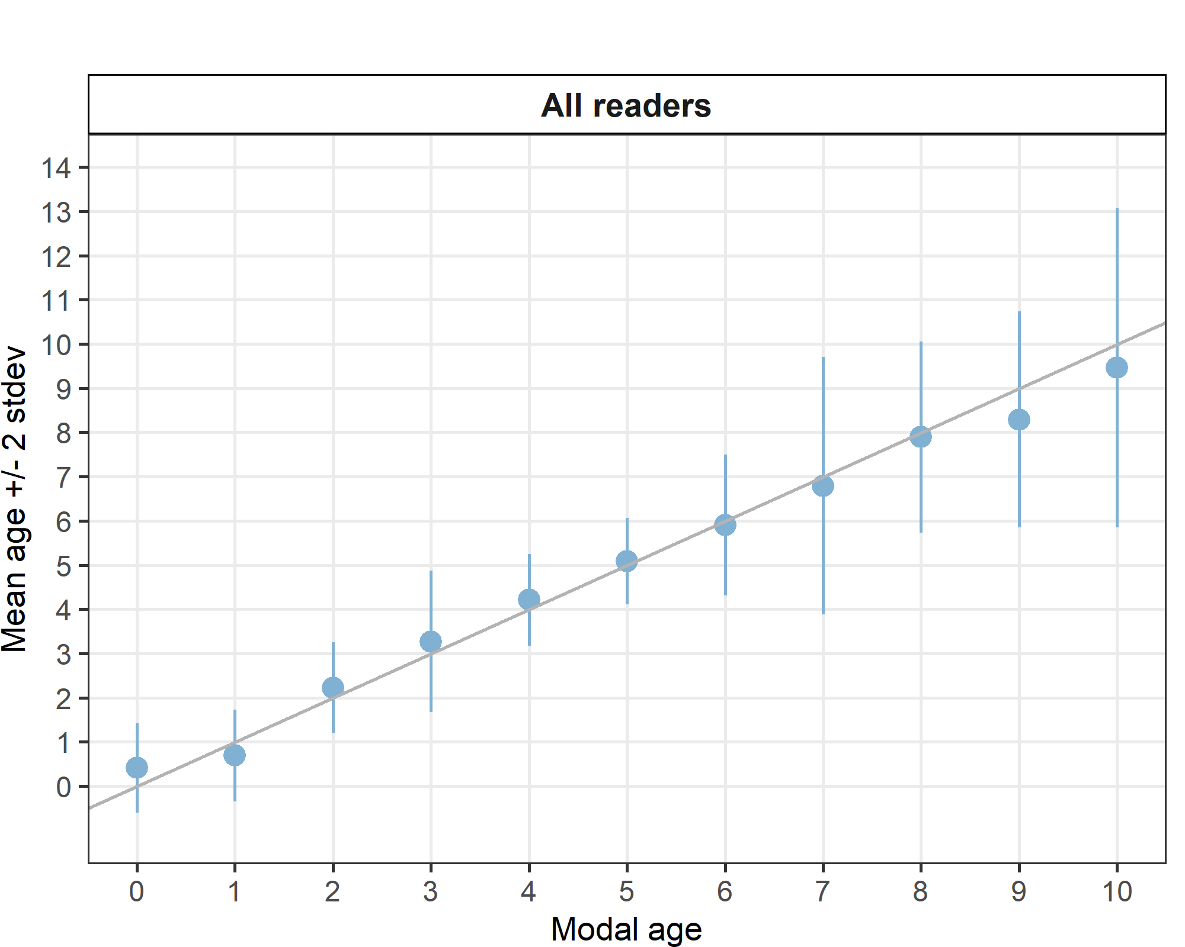
Figure 4.4: Strata_27.3.d.24 .Age bias plot for all readers. Mean age recorded +/- 2 stdev of each reader and all readers combined are plotted against modal age. The estimated mean age corresponds to modal age, if the estimated mean age is on the 1:1 equilibrium line (solid line). Relative bias is the age difference between estimated mean age and modal age.

Strata_27.3.a.21 (ICES Area)
Table 4.23: Strata Strata_27.3.a.21 .Summary of statistics; Total number of samples (NSample), coefficient of variance (CV), percentage of agreement (PA) and average percentage error (APE) for all ages and readers
NSample | CV | PA | APE
65 | 22 % | 74 % | 13 %

Coefficient of Variation (CV)
Table 4.24: Strata_27.3.a.21 .Coefficient of Variation (CV) table presents the CV per modal age and reader, the CV of all readers combined per modal age and a weighted mean of the CV per reader
Modal age | R01 DK | R02 SE | R03 NO | R04 DE | R05 NO | R06 NO | R07 NO | R08 NO | R09 NO | R10 PL | R11 SE | R12 NO | R13 SE | R14 SE | R15 GB-SCT | R16 GB-SCT | R17 GB-SCT | all
0 | - | - | - | - | - | - | - | - | - | - | - | - | - | - | - | - | - | -
1 | 0 % | 0 % | 31 % | 0 % | 65 % | 77 % | 57 % | 31 % | 0 % | 31 % | 31 % | 37 % | 0 % | 0 % | 57 % | 39 % | 54 % | 50 %
2 | 15 % | 21 % | 50 % | 21 % | 27 % | 30 % | 21 % | 25 % | 21 % | 15 % | 33 % | 28 % | 21 % | 21 % | 20 % | 28 % | 14 % | 31 %
3 | 9 % | 17 % | 18 % | 19 % | 0 % | 17 % | 12 % | 14 % | 9 % | 9 % | 0 % | 0 % | 9 % | 9 % | 11 % | 16 % | 16 % | 14 %
4 | 0 % | 0 % | 22 % | 11 % | 11 % | 0 % | 10 % | 12 % | 16 % | 0 % | 10 % | 0 % | 12 % | 10 % | 12 % | 17 % | 16 % | 13 %
5 | 10 % | 15 % | 18 % | 7 % | 0 % | 7 % | 24 % | 13 % | 7 % | 10 % | 10 % | 7 % | 16 % | 10 % | 0 % | 17 % | 17 % | 14 %
6 | 11 % | 6 % | 19 % | 10 % | 6 % | 8 % | 6 % | 12 % | 8 % | 9 % | 6 % | 8 % | 12 % | 9 % | 11 % | 23 % | 17 % | 14 %
7 | 6 % | 6 % | 37 % | 9 % | 12 % | 7 % | 10 % | 12 % | 6 % | 9 % | 8 % | 12 % | 14 % | 7 % | 8 % | 17 % | 20 % | 16 %
8 | 9 % | 0 % | 0 % | 0 % | 20 % | 0 % | 0 % | 0 % | 20 % | 0 % | 13 % | 9 % | 11 % | 24 % | 0 % | 0 % | 11 % | 13 %
9 | - | - | - | - | - | - | - | - | - | - | - | - | - | - | - | - | - | 19 %
10 | - | - | - | - | - | - | - | - | - | - | - | - | - | - | - | - | - | -
Weighted Mean | 8 % | 11 % | 27 % | 12 % | 17 % | 22 % | 19 % | 17 % | 10 % | 12 % | 14 % | 13 % | 12 % | 11 % | 17 % | 22 % | 21 % | 22 %

Percentage of Agreement (PA)
Table 4.25: Strata_27.3.a.21 .Percentage agreement (PA) table represents the PA per modal age and reader, the PA of all readers combined per modal age and a weighted mean of the PA per reader.
Modal age | R01 DK | R02 SE | R03 NO | R04 DE | R05 NO | R06 NO | R07 NO | R08 NO | R09 NO | R10 PL | R11 SE | R12 NO | R13 SE | R14 SE | R15 GB-SCT | R16 GB-SCT | R17 GB-SCT | total
0 | - | - | - | - | - | - | - | - | - | - | - | - | - | - | - | - | - | -
1 | 100 % | 100 % | 88 % | 100 % | 62 % | 88 % | 88 % | 88 % | 100 % | 88 % | 88 % | 75 % | 100 % | 100 % | 88 % | 12 % | 75 % | 85 %
2 | 92 % | 83 % | 67 % | 83 % | 58 % | 67 % | 67 % | 75 % | 83 % | 92 % | 58 % | 75 % | 83 % | 83 % | 42 % | 25 % | 92 % | 72 %
3 | 94 % | 94 % | 62 % | 88 % | 100 % | 94 % | 88 % | 75 % | 94 % | 94 % | 100 % | 100 % | 94 % | 94 % | 88 % | 38 % | 75 % | 86 %
4 | 100 % | 100 % | 67 % | 83 % | 83 % | 100 % | 83 % | 67 % | 67 % | 100 % | 83 % | 100 % | 67 % | 83 % | 50 % | 50 % | 67 % | 79 %
5 | 75 % | 50 % | 38 % | 88 % | 100 % | 88 % | 50 % | 88 % | 88 % | 75 % | 75 % | 88 % | 38 % | 75 % | 100 % | 12 % | 50 % | 69 %
6 | 57 % | 86 % | 29 % | 57 % | 86 % | 67 % | 86 % | 71 % | 71 % | 29 % | 86 % | 57 % | 57 % | 71 % | 57 % | 29 % | 57 % | 62 %
7 | 80 % | 80 % | 50 % | 40 % | 50 % | 60 % | 60 % | 60 % | 80 % | 40 % | 60 % | 80 % | 20 % | 75 % | 60 % | 40 % | 60 % | 59 %
8 | 50 % | 100 % | 100 % | 0 % | 50 % | 100 % | 100 % | 100 % | 50 % | 0 % | 0 % | 50 % | 0 % | 0 % | 0 % | 100 % | 0 % | 47 %
9 | 0 % | 0 % | 0 % | 100 % | - | 0 % | 0 % | 0 % | 100 % | 100 % | 0 % | 100 % | 0 % | 0 % | 0 % | 100 % | 0 % | 31 %
10 | - | - | - | - | - | - | - | - | - | - | - | - | - | - | - | - | - | -
Weighted Mean | 85 % | 85 % | 59 % | 78 % | 79 % | 81 % | 75 % | 75 % | 85 % | 77 % | 77 % | 83 % | 69 % | 81 % | 68 % | 32 % | 68 % | 74 %

Average Percentage Error (APE)
Table 4.26: Strata_27.3.a.21 .Average Percentage Error (APE) table represents the APE per modal age and reader, the APE of all advanced readers combined per modal age and a weighted mean of the APE per reader.
Modal age | R01 DK | R02 SE | R03 NO | R04 DE | R05 NO | R06 NO | R07 NO | R08 NO | R09 NO | R10 PL | R11 SE | R12 NO | R13 SE | R14 SE | R15 GB-SCT | R16 GB-SCT | R17 GB-SCT | all
0 | - | - | - | - | - | - | - | - | - | - | - | - | - | - | - | - | - | -
1 | 0 % | 0 % | 19 % | 0 % | 48 % | 48 % | 35 % | 19 % | 0 % | 19 % | 19 % | 30 % | 0 % | 0 % | 35 % | 28 % | 41 % | 31 %
2 | 8 % | 15 % | 39 % | 15 % | 23 % | 17 % | 19 % | 15 % | 8 % | 8 % | 26 % | 21 % | 8 % | 8 % | 19 % | 17 % | 7 % | 21 %
3 | 4 % | 8 % | 16 % | 12 % | 0 % | 8 % | 8 % | 12 % | 4 % | 4 % | 0 % | 0 % | 4 % | 4 % | 7 % | 14 % | 11 % | 6 %
4 | 0 % | 0 % | 19 % | 7 % | 7 % | 0 % | 7 % | 10 % | 8 % | 0 % | 7 % | 0 % | 10 % | 7 % | 11 % | 14 % | 8 % | 8 %
5 | 8 % | 12 % | 12 % | 4 % | 0 % | 4 % | 17 % | 8 % | 4 % | 8 % | 8 % | 4 % | 14 % | 8 % | 0 % | 12 % | 13 % | 8 %
6 | 8 % | 4 % | 14 % | 9 % | 4 % | 7 % | 4 % | 10 % | 6 % | 8 % | 4 % | 8 % | 8 % | 7 % | 8 % | 19 % | 12 % | 9 %
7 | 4 % | 4 % | 28 % | 8 % | 7 % | 6 % | 6 % | 9 % | 4 % | 8 % | 7 % | 9 % | 11 % | 6 % | 7 % | 11 % | 11 % | 8 %
8 | 7 % | 0 % | 0 % | 0 % | 14 % | 0 % | 0 % | 0 % | 14 % | 0 % | 9 % | 7 % | 8 % | 17 % | 0 % | 0 % | 8 % | 11 %
9 | 0 % | 0 % | 0 % | 0 % | - | 0 % | 0 % | 0 % | 0 % | 0 % | 0 % | 0 % | 0 % | 0 % | 0 % | 0 % | 0 % | 14 %
10 | - | - | - | - | - | - | - | - | - | - | - | - | - | - | - | - | - | -
Weighted Mean | 5 % | 7 % | 20 % | 8 % | 13 % | 13 % | 13 % | 12 % | 5 % | 7 % | 10 % | 10 % | 7 % | 6 % | 12 % | 16 % | 14 % | 13 %

Relative bias
Table 4.27: Strata_27.3.a.21 . The relative bias (as the difference between the mean and modal age) per modal age and reader is presented, as well as the weighted mean relative bias per reader and the relative bias per modal age for all readers combined.
Modal age | R01 DK | R02 SE | R03 NO | R04 DE | R05 NO | R06 NO | R07 NO | R08 NO | R09 NO | R10 PL | R11 SE | R12 NO | R13 SE | R14 SE | R15 GB-SCT | R16 GB-SCT | R17 GB-SCT | all
0 | - | - | - | - | - | - | - | - | - | - | - | - | - | - | - | - | - | -
1 | 0.00 | 0.00 | 0.12 | 0.00 | 0.62 | 0.38 | 0.25 | 0.12 | 0.00 | 0.12 | 0.12 | 0.25 | 0.00 | 0.00 | 0.25 | 1.25 | 0.38 | 0.23
2 | -0.08 | -0.17 | 0.83 | -0.17 | 0.50 | 0.00 | 0.33 | 0.08 | 0.00 | -0.08 | 0.33 | 0.33 | 0.00 | 0.00 | 0.58 | 1.00 | 0.08 | 0.21
3 | -0.06 | -0.12 | 0.44 | -0.19 | 0.00 | -0.12 | -0.12 | 0.25 | -0.06 | -0.06 | 0.00 | 0.00 | -0.06 | -0.06 | 0.12 | 0.69 | 0.12 | 0.04
4 | 0.00 | 0.00 | 0.67 | -0.17 | -0.17 | 0.00 | 0.17 | 0.33 | 0.00 | 0.00 | 0.17 | 0.00 | 0.33 | 0.17 | 0.50 | 0.67 | 0.00 | 0.16
5 | -0.25 | -0.25 | 1.00 | -0.12 | 0.00 | 0.12 | 0.25 | 0.25 | 0.12 | -0.25 | -0.25 | -0.12 | -0.38 | -0.25 | 0.00 | 0.88 | 0.38 | 0.07
6 | 0.14 | 0.14 | 1.43 | -0.43 | 0.14 | 0.33 | 0.14 | 0.43 | 0.29 | -0.71 | -0.14 | 0.43 | -0.14 | -0.29 | 0.14 | 0.57 | -0.29 | 0.13
7 | 0.20 | 0.20 | 2.00 | -0.60 | 0.00 | 0.40 | 0.00 | 0.60 | 0.20 | -0.60 | -0.40 | 0.40 | -1.20 | -0.25 | -0.40 | 0.00 | 0.00 | 0.03
8 | -0.50 | 0.00 | 0.00 | -1.00 | -1.00 | 0.00 | 0.00 | 0.00 | -1.00 | -2.00 | -2.50 | -0.50 | -1.50 | -2.00 | -1.00 | 0.00 | -1.50 | -0.85
9 | 2.00 | -1.00 | 2.00 | 0.00 | - | 1.00 | 3.00 | 2.00 | 0.00 | 0.00 | -1.00 | 0.00 | -2.00 | -4.00 | 1.00 | 0.00 | 1.00 | -
10 | - | - | - | - | - | - | - | - | - | - | - | - | - | - | - | - | - | -
Weighted Mean | -0.02 | -0.08 | 0.78 | -0.23 | 0.14 | 0.11 | 0.17 | 0.28 | 0.02 | -0.23 | -0.08 | 0.14 | -0.22 | -0.20 | 0.18 | 0.74 | 0.08 | 0.09

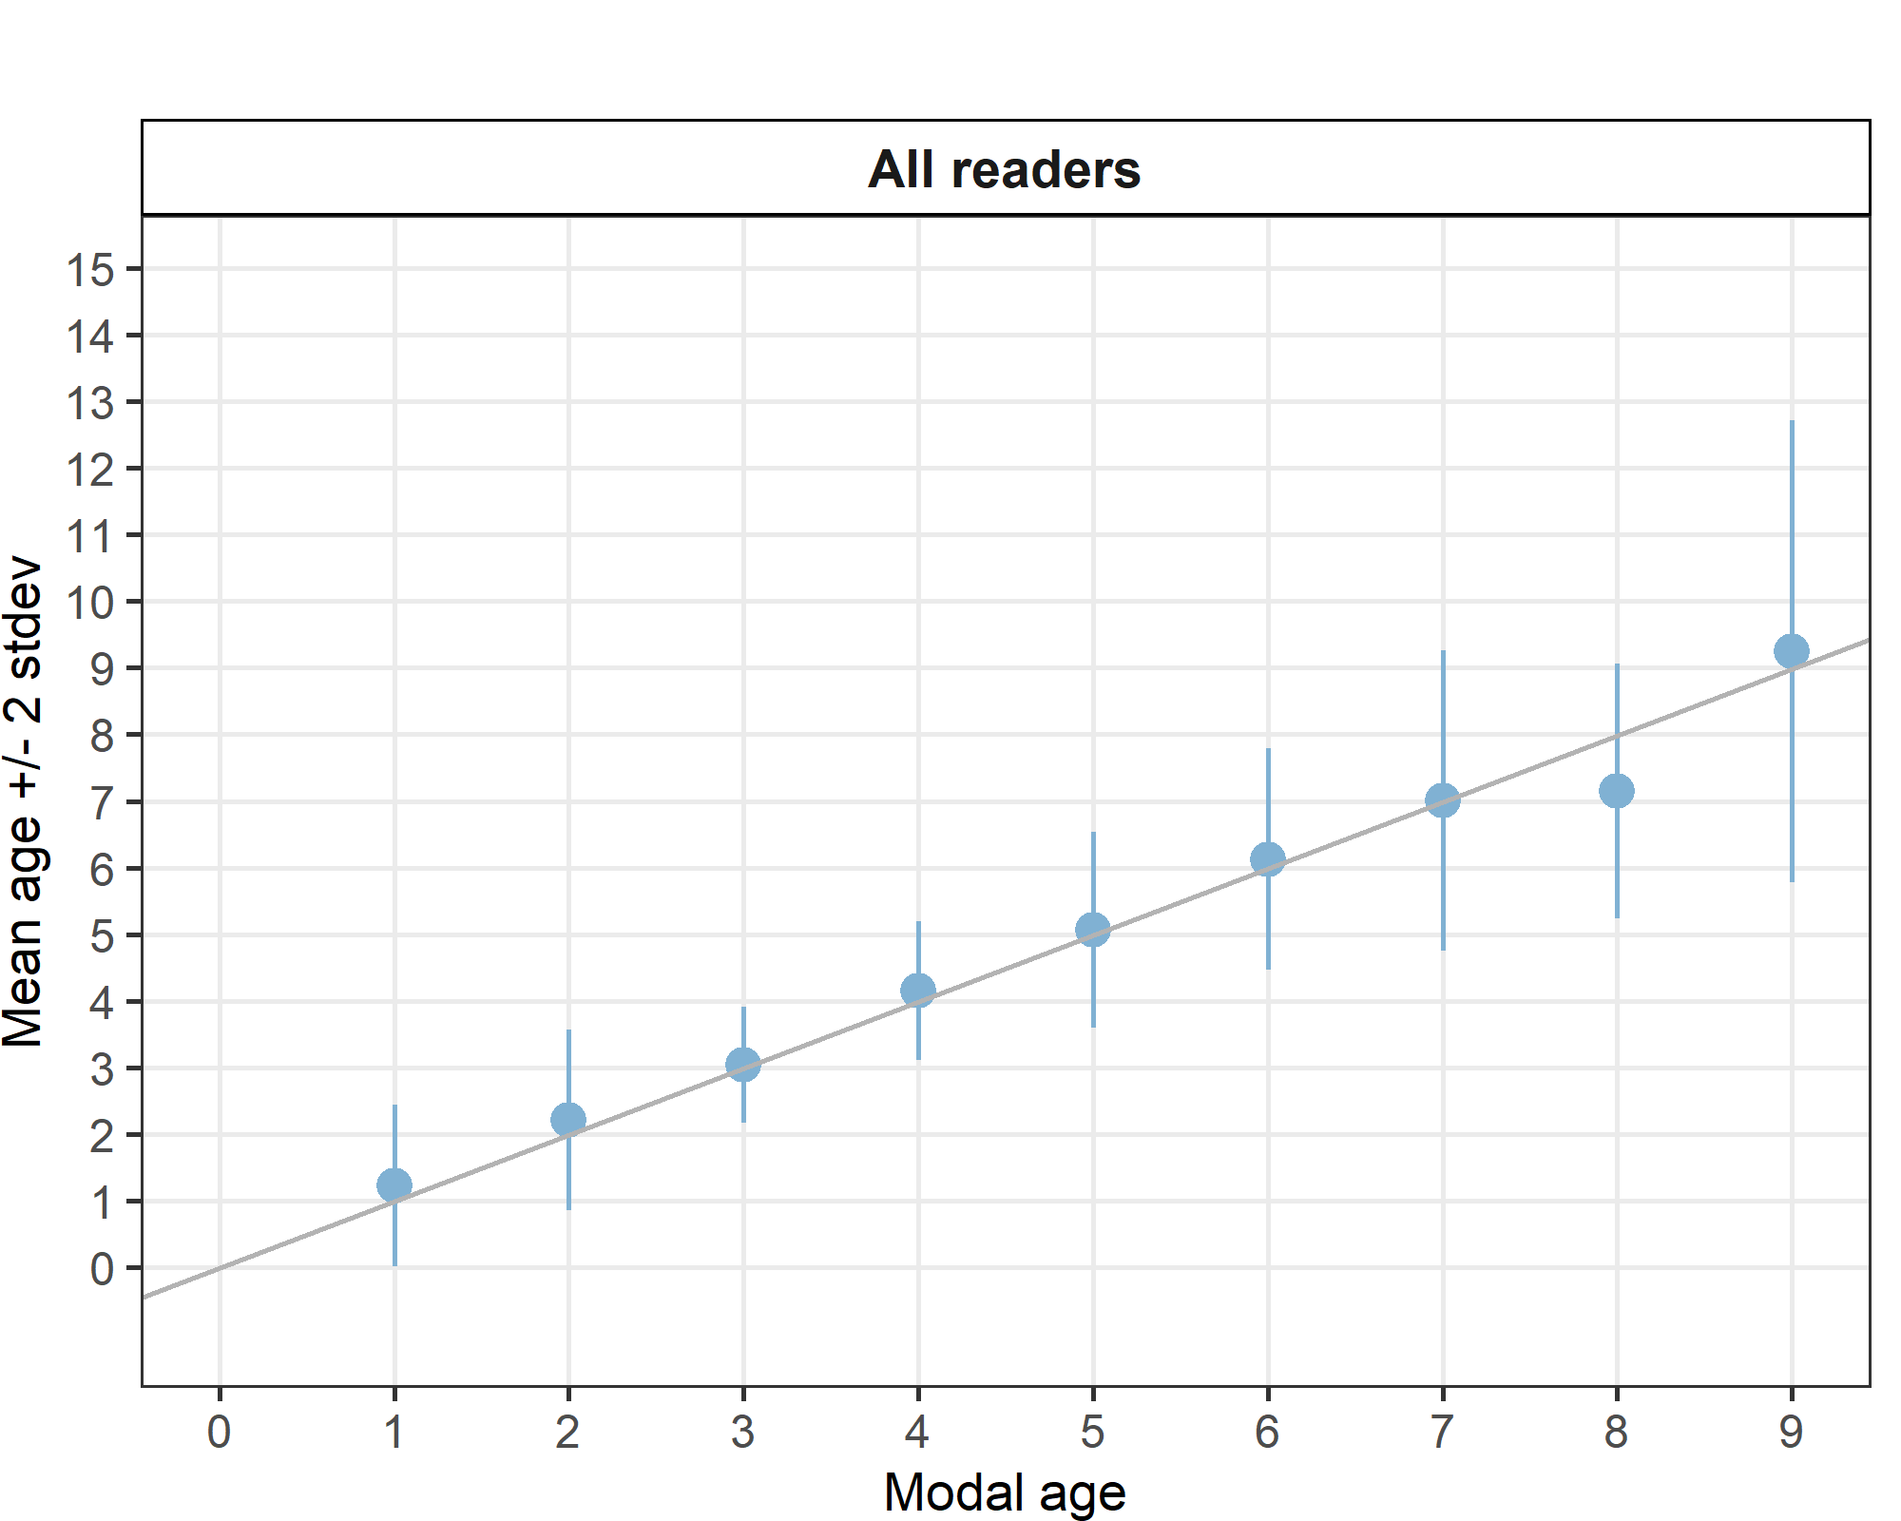
Figure 4.5: Strata_27.3.a.21 .Age bias plot for all readers. Mean age recorded +/- 2 stdev of each reader and all readers combined are plotted against modal age. The estimated mean age corresponds to modal age, if the estimated mean age is on the 1:1 equilibrium line (solid line). Relative bias is the age difference between estimated mean age and modal age.

Strata_27.3.c.22 (ICES Area)
Table 4.28: Strata_27.3.c.22 .Summary of statistics; Total number of samples (NSample), coefficient of variance (CV), percentage of agreement (PA) and average percentage error (APE) for all ages and readers
NSample | CV | PA | APE
30 | 23 % | 70 % | 14 %

Coefficient of Variation (CV)
Table 4.29: Strata_27.3.c.22 .Coefficient of Variation (CV) table presents the CV per modal age and reader, the CV of all readers combined per modal age and a weighted mean of the CV per reader
Modal age | R01 DK | R02 SE | R03 NO | R04 DE | R05 NO | R06 NO | R07 NO | R08 NO | R09 NO | R10 PL | R11 SE | R12 NO | R13 SE | R14 SE | R15 GB-SCT | R16 GB-SCT | R17 GB-SCT | all
0 | - | - | - | - | - | - | - | - | - | - | - | - | - | - | - | - | - | -
1 | - | - | - | - | - | - | - | - | - | - | - | - | - | - | - | - | - | -
2 | 22 % | 22 % | 31 % | 0 % | 19 % | 0 % | 0 % | 24 % | 19 % | 0 % | 0 % | 19 % | 19 % | 22 % | 0 % | 14 % | 19 % | 34 %
3 | 16 % | 10 % | 33 % | 20 % | 15 % | 18 % | 20 % | 15 % | 13 % | 20 % | 28 % | 0 % | 20 % | 10 % | 18 % | 15 % | 11 % | 25 %
4 | 0 % | 8 % | 22 % | 0 % | 12 % | 8 % | 15 % | 12 % | 11 % | 0 % | 14 % | 12 % | 12 % | 8 % | 15 % | 12 % | 39 % | 17 %
5 | - | - | - | - | - | - | - | - | - | - | - | - | - | - | - | - | - | 10 %
6 | 17 % | 10 % | 21 % | 0 % | 8 % | 14 % | 10 % | 14 % | 14 % | 10 % | 0 % | 17 % | 17 % | 10 % | 17 % | 0 % | 11 % | 15 %
7 | - | - | - | - | - | - | - | - | - | - | - | - | - | - | - | - | - | -
8 | - | - | - | - | - | - | - | - | - | - | - | - | - | - | - | - | - | -
9 | - | - | - | - | - | - | - | - | - | - | - | - | - | - | - | - | - | -
10 | - | - | - | - | - | - | - | - | - | - | - | - | - | - | - | - | - | -
Weighted Mean | 12 % | 12 % | 27 % | 7 % | 14 % | 10 % | 13 % | 15 % | 14 % | 8 % | 15 % | 10 % | 17 % | 12 % | 13 % | 12 % | 22 % | 23 %

Percentage of Agreement (PA)
Table 4.30: Strata_27.3.c.22 .Percentage agreement (PA) table represents the PA per modal age and reader, the PA of all readers combined per modal age and a weighted mean of the PA per reader.
Modal age | R01 DK | R02 SE | R03 NO | R04 DE | R05 NO | R06 NO | R07 NO | R08 NO | R09 NO | R10 PL | R11 SE | R12 NO | R13 SE | R14 SE | R15 GB-SCT | R16 GB-SCT | R17 GB-SCT | total
0 | - | - | - | - | - | - | - | - | - | - | - | - | - | - | - | - | - | -
1 | - | - | - | - | - | - | - | - | - | - | - | - | - | - | - | - | - | -
2 | 67 % | 67 % | 0 % | 100 % | 33 % | 100 % | 100 % | 17 % | 83 % | 100 % | 100 % | 83 % | 83 % | 67 % | 100 % | 0 % | 83 % | 70 %
3 | 80 % | 90 % | 40 % | 70 % | 70 % | 70 % | 60 % | 70 % | 80 % | 60 % | 30 % | 100 % | 60 % | 90 % | 70 % | 50 % | 90 % | 69 %
4 | 100 % | 90 % | 30 % | 100 % | 50 % | 90 % | 70 % | 50 % | 70 % | 100 % | 70 % | 80 % | 80 % | 90 % | 90 % | 60 % | 40 % | 74 %
5 | 100 % | 100 % | 0 % | 100 % | 100 % | 0 % | 100 % | 100 % | 100 % | 0 % | 100 % | 100 % | 100 % | 0 % | 100 % | 100 % | 100 % | 76 %
6 | 33 % | 67 % | 33 % | 100 % | 0 % | 33 % | 67 % | 33 % | 33 % | 67 % | 100 % | 33 % | 33 % | 67 % | 67 % | 100 % | 33 % | 53 %
7 | - | - | - | - | - | - | - | - | - | - | - | - | - | - | - | - | - | -
8 | - | - | - | - | - | - | - | - | - | - | - | - | - | - | - | - | - | -
9 | - | - | - | - | - | - | - | - | - | - | - | - | - | - | - | - | - | -
10 | - | - | - | - | - | - | - | - | - | - | - | - | - | - | - | - | - | -
Weighted Mean | 80 % | 83 % | 27 % | 90 % | 50 % | 77 % | 73 % | 50 % | 73 % | 80 % | 67 % | 83 % | 70 % | 80 % | 83 % | 50 % | 67 % | 70 %

Average Percentage Error (APE)
Table 4.31: Strata_27.3.c.22 .Average Percentage Error (APE) table represents the APE per modal age and reader, the APE of all advanced readers combined per modal age and a weighted mean of the APE per reader.
Modal age | R01 DK | R02 SE | R03 NO | R04 DE | R05 NO | R06 NO | R07 NO | R08 NO | R09 NO | R10 PL | R11 SE | R12 NO | R13 SE | R14 SE | R15 GB-SCT | R16 GB-SCT | R17 GB-SCT | all
0 | - | - | - | - | - | - | - | - | - | - | - | - | - | - | - | - | - | -
1 | - | - | - | - | - | - | - | - | - | - | - | - | - | - | - | - | - | -
2 | 19 % | 19 % | 26 % | 0 % | 17 % | 0 % | 0 % | 18 % | 13 % | 0 % | 0 % | 13 % | 13 % | 19 % | 0 % | 12 % | 13 % | 26 %
3 | 7 % | 6 % | 29 % | 12 % | 13 % | 16 % | 18 % | 13 % | 10 % | 18 % | 24 % | 0 % | 18 % | 6 % | 16 % | 14 % | 6 % | 13 %
4 | 0 % | 4 % | 19 % | 0 % | 11 % | 5 % | 9 % | 11 % | 10 % | 0 % | 9 % | 5 % | 5 % | 4 % | 9 % | 11 % | 23 % | 10 %
5 | 0 % | 0 % | 0 % | 0 % | 0 % | 0 % | 0 % | 0 % | 0 % | 0 % | 0 % | 0 % | 0 % | 0 % | 0 % | 0 % | 0 % | 6 %
6 | 11 % | 8 % | 15 % | 0 % | 6 % | 10 % | 8 % | 10 % | 10 % | 8 % | 0 % | 11 % | 11 % | 8 % | 13 % | 0 % | 8 % | 12 %
7 | - | - | - | - | - | - | - | - | - | - | - | - | - | - | - | - | - | -
8 | - | - | - | - | - | - | - | - | - | - | - | - | - | - | - | - | - | -
9 | - | - | - | - | - | - | - | - | - | - | - | - | - | - | - | - | - | -
10 | - | - | - | - | - | - | - | - | - | - | - | - | - | - | - | - | - | -
Weighted Mean | 7 % | 8 % | 23 % | 4 % | 12 % | 8 % | 10 % | 12 % | 10 % | 7 % | 11 % | 5 % | 11 % | 8 % | 9 % | 11 % | 13 % | 14 %

Relative bias
Table 4.32: Strata_27.3.c.22 . The relative bias (as the difference between the mean and modal age) per modal age and reader is presented, as well as the weighted mean relative bias per reader and the relative bias per modal age for all readers combined.
Modal age | R01 DK | R02 SE | R03 NO | R04 DE | R05 NO | R06 NO | R07 NO | R08 NO | R09 NO | R10 PL | R11 SE | R12 NO | R13 SE | R14 SE | R15 GB-SCT | R16 GB-SCT | R17 GB-SCT | all
0 | - | - | - | - | - | - | - | - | - | - | - | - | - | - | - | - | - | -
1 | - | - | - | - | - | - | - | - | - | - | - | - | - | - | - | - | - | -
2 | 0.33 | 0.33 | 2.50 | 0.00 | 0.67 | 0.00 | 0.00 | 1.17 | 0.17 | 0.00 | 0.00 | 0.17 | 0.17 | 0.33 | 0.00 | 1.67 | 0.17 | 0.45
3 | 0.00 | 0.10 | 1.70 | -0.10 | 0.30 | -0.30 | -0.40 | 0.30 | 0.20 | -0.40 | -0.50 | 0.00 | -0.40 | 0.10 | -0.30 | 0.50 | -0.10 | 0.04
4 | 0.00 | 0.10 | 1.40 | 0.00 | 0.50 | -0.10 | -0.10 | 0.50 | 0.30 | 0.00 | 0.10 | 0.00 | 0.00 | 0.10 | 0.20 | 0.40 | -0.90 | 0.15
5 | 0.00 | 0.00 | 1.00 | 0.00 | 0.00 | -1.00 | 0.00 | 0.00 | 0.00 | -1.00 | 0.00 | 0.00 | 0.00 | -1.00 | 0.00 | 0.00 | 0.00 | -0.12
6 | 0.00 | -0.33 | 1.33 | 0.00 | 1.67 | 1.00 | -0.33 | 1.00 | 1.00 | -0.33 | 0.00 | 0.00 | 0.00 | -0.33 | 0.67 | 0.00 | -0.67 | 0.27
7 | - | - | - | - | - | - | - | - | - | - | - | - | - | - | - | - | - | -
8 | - | - | - | - | - | - | - | - | - | - | - | - | - | - | - | - | - | -
9 | - | - | - | - | - | - | - | - | - | - | - | - | - | - | - | - | - | -
10 | - | - | - | - | - | - | - | - | - | - | - | - | - | - | - | - | - | -
Weighted Mean | 0.07 | 0.10 | 1.70 | -0.03 | 0.57 | -0.07 | -0.20 | 0.60 | 0.30 | -0.20 | -0.13 | 0.03 | -0.10 | 0.07 | 0.03 | 0.63 | -0.37 | 0.18

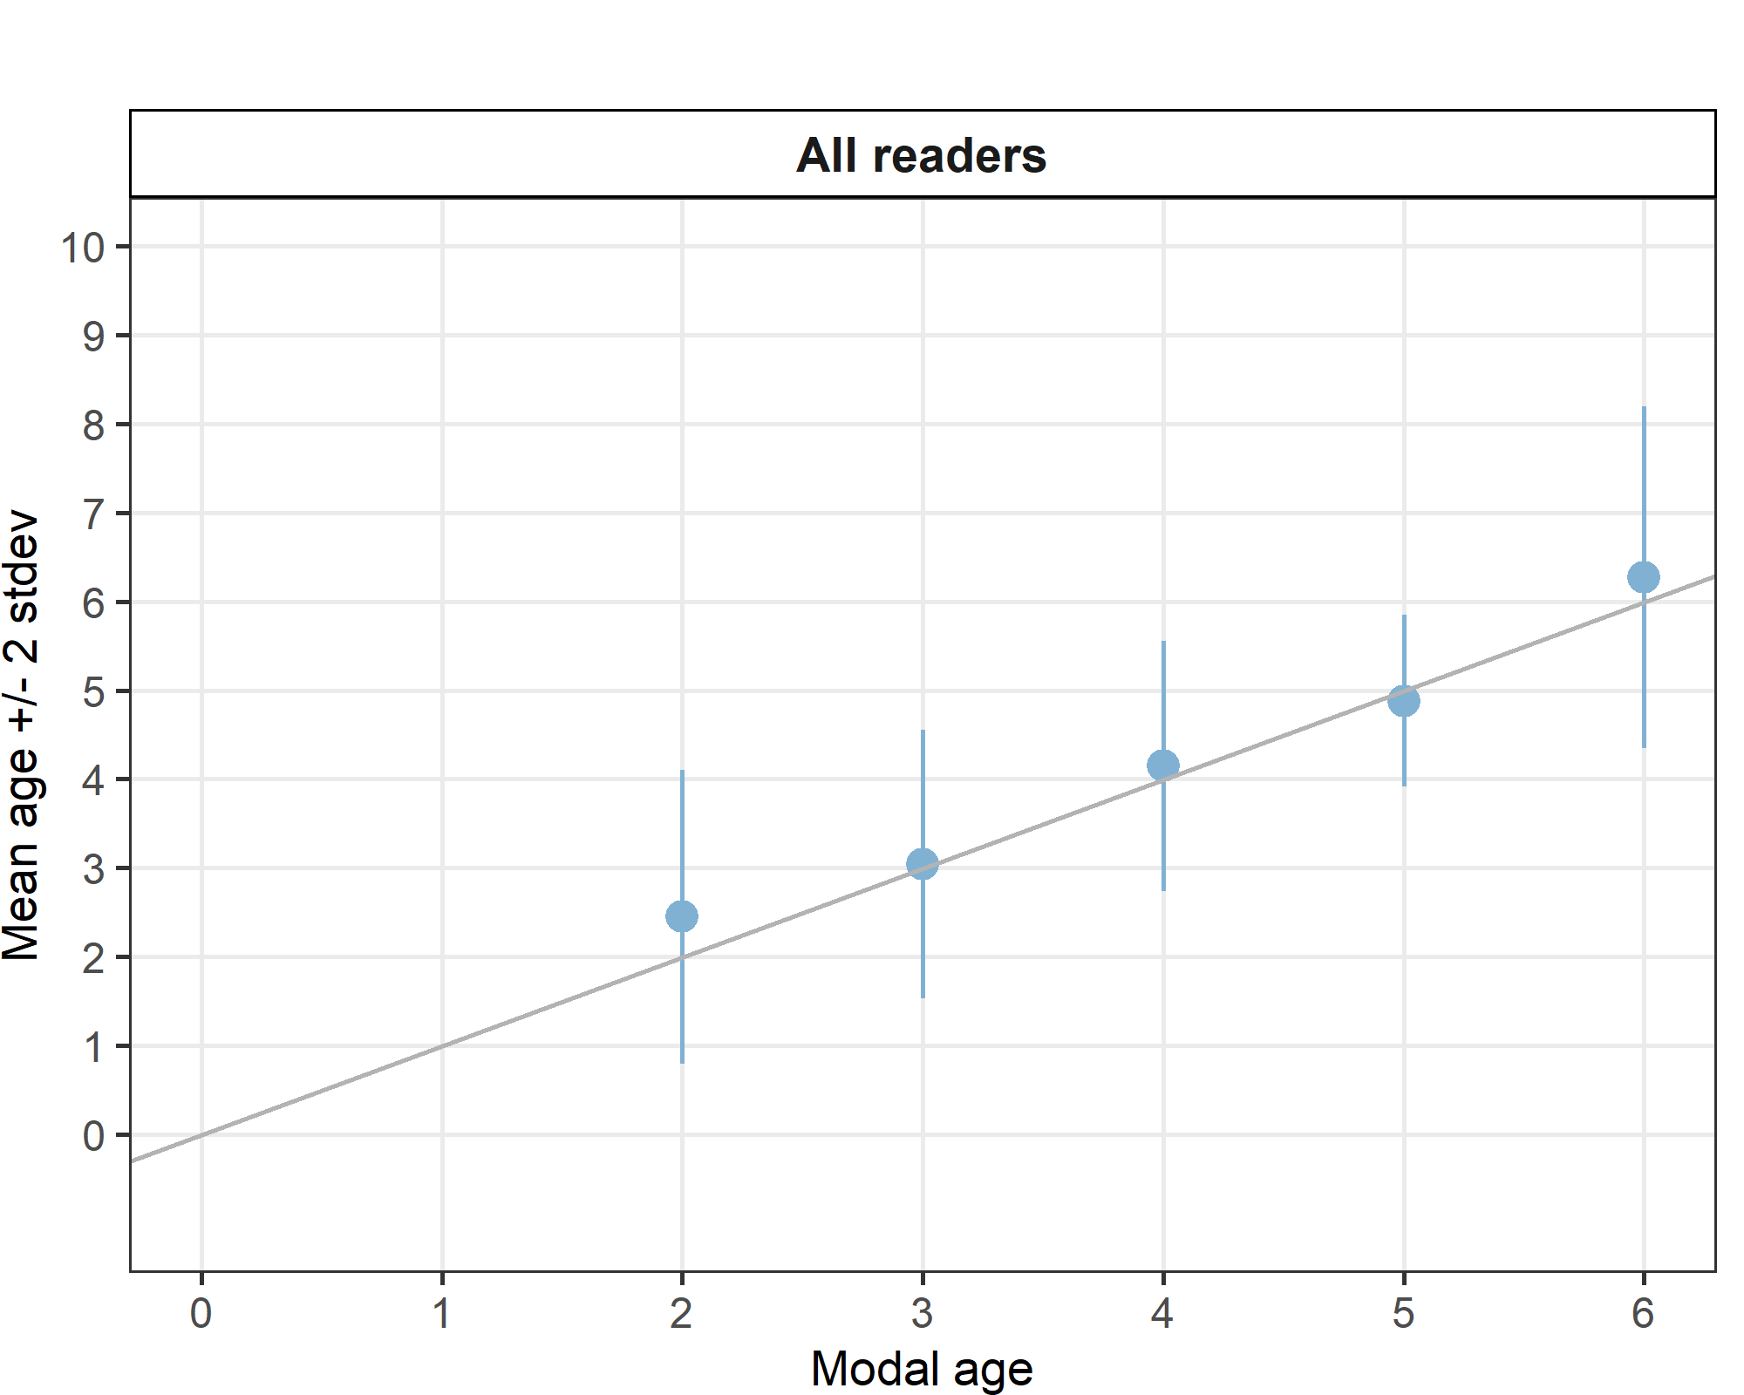
Figure 4.6: Strata_27.3.c.22 .Age bias plot for all readers. Mean age recorded +/- 2 stdev of each reader and all readers combined are plotted against modal age. The estimated mean age corresponds to modal age, if the estimated mean age is on the 1:1 equilibrium line (solid line). Relative bias is the age difference between estimated mean age and modal age.

Advanced readers

All samples included
Table 4.33: Summary of statistics; Total number of samples (NSample), coefficient of variance (CV), percentage of agreement (PA) and average percentage error (APE) for all ages and readers
NSample | CV | PA | APE
306 | 20 % | 76 % | 11 %

Coefficient of Variation (CV)
Table 4.34: Coefficient of Variation (CV) table presents the CV per modal age and advanced reader, the CV of all advanced readers combined per modal age and a weighted mean of the CV per reader.
Modal age | R01 DK | R02 SE | R03 NO | R04 DE | R05 NO | R06 NO | R07 NO | R08 NO | R09 NO | R10 PL | R12 NO | all
0 | - | - | - | - | - | - | - | - | - | - | - | -
1 | 48 % | 56 % | 62 % | 56 % | 53 % | 76 % | 49 % | 21 % | 27 % | 55 % | 49 % | 56 %
2 | 16 % | 16 % | 45 % | 17 % | 23 % | 23 % | 22 % | 25 % | 14 % | 24 % | 20 % | 27 %
3 | 5 % | 7 % | 26 % | 11 % | 17 % | 17 % | 23 % | 13 % | 10 % | 11 % | 5 % | 17 %
4 | 5 % | 10 % | 22 % | 6 % | 24 % | 12 % | 18 % | 13 % | 10 % | 15 % | 14 % | 16 %
5 | 9 % | 10 % | 22 % | 4 % | 20 % | 11 % | 19 % | 19 % | 14 % | 9 % | 10 % | 15 %
6 | 11 % | 15 % | 18 % | 8 % | 17 % | 9 % | 9 % | 11 % | 9 % | 10 % | 9 % | 13 %
7 | 8 % | 20 % | 24 % | 17 % | 13 % | 19 % | 21 % | 17 % | 9 % | 12 % | 10 % | 19 %
8 | 6 % | 10 % | 11 % | 11 % | 10 % | 5 % | 10 % | 14 % | 7 % | 13 % | 7 % | 11 %
9 | 7 % | 15 % | 6 % | 10 % | 7 % | 13 % | 11 % | 11 % | 9 % | 10 % | 9 % | 11 %
10 | - | - | - | - | - | - | - | - | - | - | - | 10 %
11 | - | - | - | - | - | - | - | - | - | - | - | 15 %
Weighted Mean | 12 % | 16 % | 27 % | 14 % | 22 % | 19 % | 20 % | 17 % | 13 % | 17 % | 15 % | 20 %

Percentage of Agreement (PA)
Table 4.35: Percentage agreement (PA) table represents the PA per modal age and reader, advanced the PA of all advanced readers combined per modal age and a weighted mean of the PA per reader.
Modal age | R01 DK | R02 SE | R03 NO | R04 DE | R05 NO | R06 NO | R07 NO | R08 NO | R09 NO | R10 PL | R12 NO | total
0 | 100 % | 100 % | 100 % | 100 % | 29 % | 100 % | 0 % | 29 % | 29 % | 100 % | 29 % | 65 %
1 | 82 % | 77 % | 73 % | 77 % | 64 % | 82 % | 77 % | 95 % | 91 % | 82 % | 76 % | 80 %
2 | 90 % | 90 % | 64 % | 89 % | 50 % | 79 % | 73 % | 81 % | 92 % | 79 % | 83 % | 79 %
3 | 98 % | 95 % | 66 % | 89 % | 77 % | 77 % | 77 % | 80 % | 91 % | 89 % | 98 % | 85 %
4 | 96 % | 91 % | 51 % | 93 % | 60 % | 87 % | 76 % | 70 % | 85 % | 83 % | 87 % | 80 %
5 | 88 % | 81 % | 56 % | 95 % | 83 % | 88 % | 79 % | 70 % | 86 % | 81 % | 91 % | 82 %
6 | 81 % | 73 % | 51 % | 73 % | 64 % | 78 % | 84 % | 78 % | 84 % | 68 % | 75 % | 74 %
7 | 85 % | 55 % | 37 % | 42 % | 56 % | 60 % | 60 % | 50 % | 75 % | 42 % | 68 % | 57 %
8 | 75 % | 80 % | 50 % | 40 % | 50 % | 85 % | 75 % | 60 % | 75 % | 35 % | 70 % | 63 %
9 | 76 % | 59 % | 71 % | 65 % | 81 % | 65 % | 59 % | 82 % | 82 % | 41 % | 76 % | 69 %
10 | 100 % | 0 % | 100 % | 0 % | 100 % | 100 % | 100 % | 100 % | 100 % | 100 % | 100 % | 82 %
11 | 100 % | 0 % | 100 % | 0 % | 100 % | 0 % | 100 % | 100 % | 0 % | 0 % | 0 % | 45 %
Weighted Mean | 88 % | 82 % | 59 % | 80 % | 65 % | 80 % | 74 % | 74 % | 84 % | 73 % | 82 % | 76 %

Average Percentage Error (APE)
Table 4.36: Average Percentage Error (APE) table represents the APE per modal age and reader, the APE of all advanced readers combined per modal age and a weighted mean of the APE per reader.
Modal age | R01 DK | R02 SE | R03 NO | R04 DE | R05 NO | R06 NO | R07 NO | R08 NO | R09 NO | R10 PL | R12 NO | all
0 | - | - | - | - | - | - | - | - | - | - | - | -
1 | 36 % | 45 % | 34 % | 45 % | 42 % | 27 % | 37 % | 9 % | 15 % | 25 % | 38 % | 28 %
2 | 8 % | 6 % | 34 % | 10 % | 21 % | 10 % | 19 % | 16 % | 6 % | 15 % | 14 % | 17 %
3 | 1 % | 3 % | 22 % | 7 % | 13 % | 11 % | 10 % | 10 % | 3 % | 7 % | 1 % | 8 %
4 | 2 % | 4 % | 19 % | 2 % | 17 % | 6 % | 10 % | 11 % | 5 % | 5 % | 5 % | 9 %
5 | 3 % | 5 % | 16 % | 2 % | 14 % | 5 % | 12 % | 13 % | 6 % | 5 % | 4 % | 8 %
6 | 6 % | 10 % | 14 % | 7 % | 13 % | 5 % | 4 % | 8 % | 4 % | 8 % | 6 % | 7 %
7 | 3 % | 16 % | 18 % | 13 % | 11 % | 12 % | 14 % | 13 % | 5 % | 10 % | 6 % | 10 %
8 | 4 % | 5 % | 8 % | 8 % | 7 % | 3 % | 8 % | 11 % | 6 % | 11 % | 5 % | 6 %
9 | 4 % | 11 % | 5 % | 8 % | 3 % | 8 % | 8 % | 7 % | 6 % | 8 % | 6 % | 6 %
10 | 0 % | 0 % | 0 % | 0 % | 0 % | 0 % | 0 % | 0 % | 0 % | 0 % | 0 % | 6 %
11 | 0 % | 0 % | 0 % | 0 % | 0 % | 0 % | 0 % | 0 % | 0 % | 0 % | 0 % | 9 %
Weighted Mean | 6 % | 9 % | 20 % | 9 % | 17 % | 9 % | 13 % | 12 % | 7 % | 10 % | 10 % | 11 %

Relative Bias
Table 4.37: The relative bias (as the difference between the mean and modal age) per modal age and advanced reader is presented, as well as the weighted mean relative bias per reader and the relative bias per modal age for all advanced readers combined.
Modal age | R01 DK | R02 SE | R03 NO | R04 DE | R05 NO | R06 NO | R07 NO | R08 NO | R09 NO | R10 PL | R12 NO | all
0 | 0.0 | 0.0 | 0.0 | 0.0 | 0.7 | 0.0 | 1.0 | 0.7 | 0.7 | 0.0 | 0.7 | 0.3
1 | -0.2 | -0.2 | 0.0 | -0.2 | 0.5 | 0.0 | 0.3 | 0.0 | 0.1 | 0.0 | 0.3 | 0.1
2 | 0.1 | 0.0 | 0.6 | -0.1 | 0.5 | 0.0 | 0.3 | 0.2 | 0.0 | 0.1 | 0.2 | 0.2
3 | 0.0 | 0.0 | 0.6 | -0.1 | 0.3 | 0.1 | 0.0 | 0.2 | 0.0 | -0.1 | 0.0 | 0.1
4 | 0.0 | -0.1 | 0.8 | 0.0 | 0.5 | 0.1 | 0.2 | 0.3 | 0.1 | 0.0 | 0.0 | 0.2
5 | 0.0 | 0.0 | 0.7 | 0.0 | 0.5 | 0.1 | 0.3 | 0.4 | 0.1 | -0.1 | 0.1 | 0.2
6 | -0.2 | -0.3 | 0.7 | -0.3 | 0.6 | 0.1 | 0.0 | 0.3 | 0.0 | -0.3 | 0.1 | 0.1
7 | 0.0 | -0.7 | 1.5 | -0.9 | 0.4 | -0.4 | 0.4 | 0.6 | -0.1 | -0.7 | 0.2 | 0.0
8 | 0.1 | -0.1 | 0.7 | -0.8 | 0.0 | -0.1 | 0.4 | 0.8 | -0.3 | -0.6 | -0.2 | 0.0
9 | -0.1 | -0.7 | 0.3 | -0.5 | 0.0 | -0.3 | 0.5 | 0.4 | -0.3 | -0.8 | -0.2 | -0.1
10 | 0.0 | -3.0 | 0.0 | -1.0 | 0.0 | 0.0 | 0.0 | 0.0 | 0.0 | 0.0 | 0.0 | -0.4
11 | 0.0 | -5.0 | 0.0 | -1.0 | 0.0 | -1.0 | 0.0 | 0.0 | -1.0 | -2.0 | -1.0 | -1.0
Weighted Mean | 0.0 | -0.2 | 0.7 | -0.2 | 0.4 | 0.0 | 0.2 | 0.3 | 0.0 | -0.2 | 0.1 | 0.1

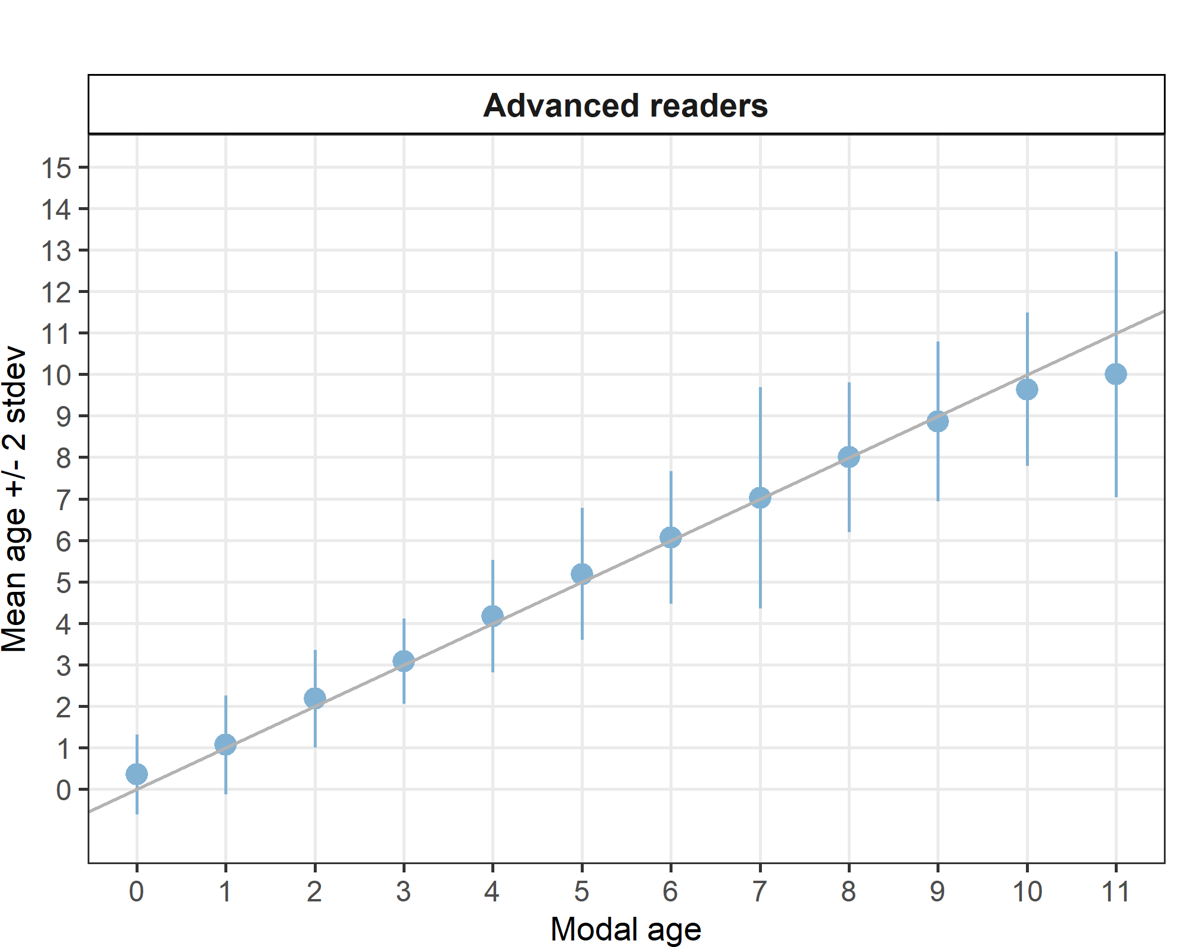
Figure 4.7: Age bias plot for advanced readers and all samples included. Mean age recorded +/- 2 stdev of each reader and all readers combined are plotted against modal age. The estimated mean age corresponds to modal age, if the estimated mean age is on the 1:1 equilibrium line (solid line).
Growth analysis
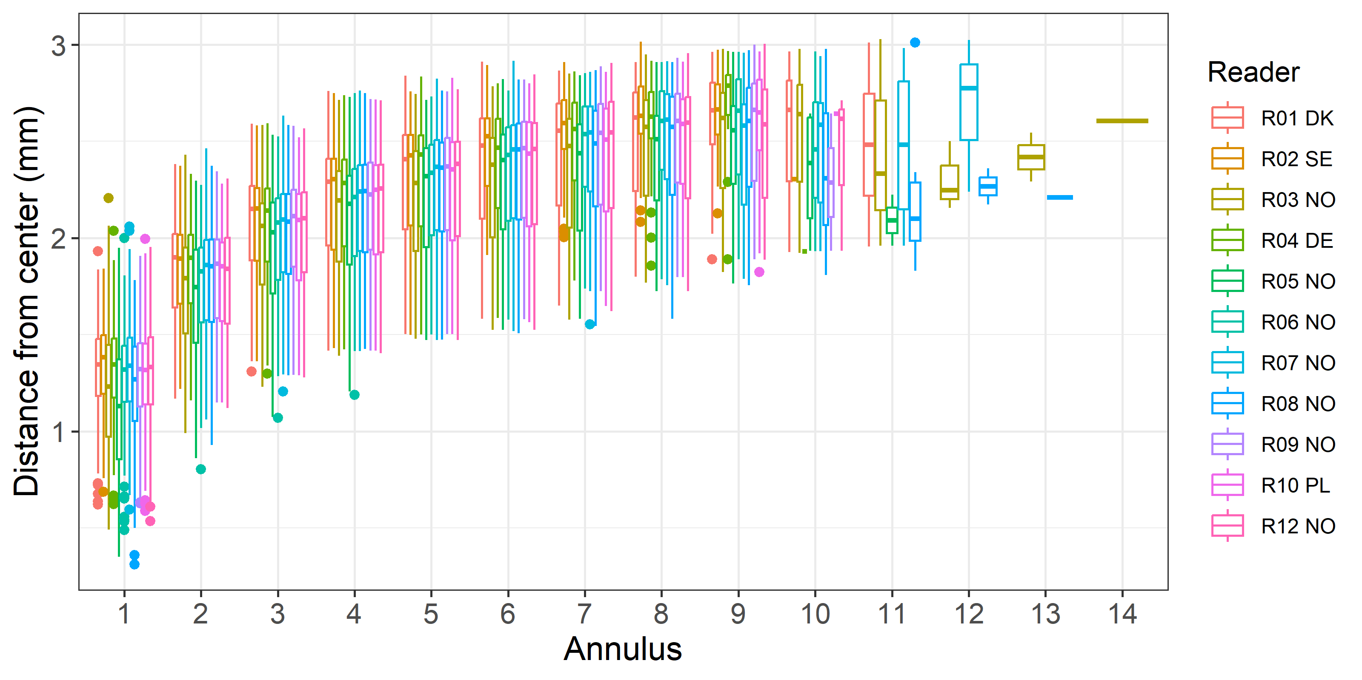
Figure 4.8: Plot of average distance from the centre to the winter rings for advanced readers and all samples included. The boxes represent the mean, upper and lower box boundaries of the interquartile range, whiskers represent the minimum and maximum values and the dots represent the outliers.

General Age Error Matrix (AEM) for all strata combined
Table 4.38: General Age error matrix (AEM). The modal age is in rows and the age classifications by the advanced readers in columns.
modal_age | 0 | 1 | 2 | 3 | 4 | 5 | 6 | 7 | 8 | 9 | 10 | 11 | 12 | 13 | 14 | Total
0 | 0.7 | 0.3 | - | - | - | - | - | - | - | - | - | - | - | - | - | 1
1 | 0.1 | 0.8 | 0.1 | 0.0 | 0.0 | - | - | - | - | - | - | - | - | - | - | 1
2 | - | 0.0 | 0.8 | 0.1 | 0.0 | 0.0 | 0.0 | - | - | - | - | - | - | - | - | 1
3 | - | - | 0.0 | 0.8 | 0.1 | 0.0 | 0.0 | - | - | - | - | - | - | - | - | 1
4 | - | - | 0.0 | 0.0 | 0.8 | 0.1 | 0.0 | 0.0 | 0.0 | 0.0 | - | - | - | - | - | 1
5 | - | - | - | - | 0.0 | 0.8 | 0.1 | 0.0 | 0.0 | 0.0 | 0.0 | - | - | - | - | 1
6 | - | - | - | 0.0 | 0.0 | 0.1 | 0.7 | 0.1 | 0.0 | 0.0 | 0.0 | - | - | - | - | 1
7 | - | - | 0.0 | - | 0.0 | 0.0 | 0.2 | 0.6 | 0.1 | 0.0 | 0.0 | 0.0 | 0 | 0 | 0 | 1
8 | - | - | - | - | - | 0.0 | 0.0 | 0.1 | 0.6 | 0.1 | 0.0 | 0.0 | 0 | - | - | 1
9 | - | - | - | - | - | 0.0 | 0.0 | 0.0 | 0.1 | 0.7 | 0.1 | 0.0 | 0 | 0 | - | 1
10 | - | - | - | - | - | - | - | 0.1 | - | 0.1 | 0.8 | - | - | - | - | 1
11 | - | - | - | - | - | - | 0.1 | - | - | 0.1 | 0.4 | 0.4 | - | - | - | 1

Strata_27.3.a.20 (ICES Area)
Table 4.39: Strata_27.3.a.20 .Summary of statistics; Total number of samples (NSample), coefficient of variance (CV), percentage of agreement (PA) and average percentage error (APE) for all ages and readers
NSample | CV | PA | APE
66 | 20 % | 79 % | 12 %

Coefficient of Variation (CV)
Table 4.40: Strata_27.3.a.20 .Coefficient of Variation (CV) table presents the CV per modal age and reader, the CV of all readers combined per modal age and a weighted mean of the CV per reader
Modal age | R01 DK | R02 SE | R03 NO | R04 DE | R05 NO | R06 NO | R07 NO | R08 NO | R09 NO | R10 PL | R12 NO | all
0 | - | - | - | - | - | - | - | - | - | - | - | -
1 | 0 % | 0 % | 57 % | 0 % | 46 % | 0 % | 50 % | 0 % | 31 % | 0 % | 55 % | 42 %
2 | 0 % | 0 % | 27 % | 28 % | 30 % | 18 % | 21 % | 0 % | 16 % | 18 % | 16 % | 20 %
3 | 0 % | 14 % | 13 % | 14 % | 26 % | 16 % | 13 % | 15 % | 13 % | 14 % | 14 % | 18 %
4 | 11 % | 17 % | 19 % | 7 % | 35 % | 19 % | 11 % | 15 % | 8 % | 23 % | 21 % | 21 %
5 | 5 % | 12 % | 28 % | 0 % | 19 % | 5 % | 16 % | 22 % | 5 % | 7 % | 14 % | 16 %
6 | 18 % | 20 % | 22 % | 8 % | 23 % | 10 % | 5 % | 7 % | 0 % | 13 % | 6 % | 16 %
7 | 0 % | 9 % | 22 % | - | 18 % | 20 % | 9 % | 8 % | 0 % | 0 % | 0 % | 16 %
8 | 0 % | 9 % | 0 % | 11 % | 9 % | 0 % | 0 % | 8 % | 0 % | 11 % | 9 % | 10 %
9 | - | - | - | - | - | - | - | - | - | - | - | -
10 | - | - | - | - | - | - | - | - | - | - | - | 10 %
11 | - | - | - | - | - | - | - | - | - | - | - | -
Weighted Mean | 6 % | 11 % | 27 % | 8 % | 28 % | 11 % | 17 % | 12 % | 10 % | 12 % | 19 % | 20 %

Percentage of Agreement (PA)
Table 4.41: Strata_27.3.a.20 .Percentage agreement (PA) table represents the PA per modal age and reader, the PA of all readers combined per modal age and a weighted mean of the PA per reader.
Modal age | R01 DK | R02 SE | R03 NO | R04 DE | R05 NO | R06 NO | R07 NO | R08 NO | R09 NO | R10 PL | R12 NO | total
0 | 100 % | 100 % | 100 % | 100 % | 100 % | 100 % | 0 % | 100 % | 100 % | 100 % | 100 % | 91 %
1 | 100 % | 100 % | 88 % | 100 % | 50 % | 100 % | 62 % | 100 % | 88 % | 100 % | 71 % | 87 %
2 | 100 % | 100 % | 75 % | 71 % | 67 % | 89 % | 67 % | 100 % | 89 % | 89 % | 89 % | 85 %
3 | 100 % | 83 % | 83 % | 83 % | 50 % | 50 % | 83 % | 67 % | 83 % | 83 % | 83 % | 77 %
4 | 82 % | 82 % | 55 % | 91 % | 40 % | 82 % | 73 % | 55 % | 91 % | 82 % | 82 % | 74 %
5 | 94 % | 81 % | 60 % | 100 % | 79 % | 94 % | 88 % | 56 % | 94 % | 88 % | 94 % | 84 %
6 | 78 % | 67 % | 44 % | 78 % | 67 % | 67 % | 89 % | 78 % | 100 % | 67 % | 88 % | 74 %
7 | 100 % | 50 % | 0 % | 100 % | 50 % | 0 % | 50 % | 0 % | 100 % | 0 % | 100 % | 48 %
8 | 100 % | 50 % | 100 % | 0 % | 50 % | 100 % | 100 % | 50 % | 0 % | 0 % | 50 % | 55 %
9 | - | - | - | - | - | - | - | - | - | - | - | -
10 | 100 % | 0 % | 100 % | 0 % | 100 % | 100 % | 100 % | 100 % | 100 % | 100 % | 100 % | 82 %
11 | - | - | - | - | - | - | - | - | - | - | - | -
Weighted Mean | 92 % | 82 % | 66 % | 85 % | 62 % | 82 % | 76 % | 71 % | 89 % | 80 % | 86 % | 79 %

Average Percentage Error (APE)
Table 4.42: Strata_27.3.a.20 .Average Percentage Error (APE) table represents the APE per modal age and reader, the APE of all advanced readers combined per modal age and a weighted mean of the APE per reader.
Modal age | R01 DK | R02 SE | R03 NO | R04 DE | R05 NO | R06 NO | R07 NO | R08 NO | R09 NO | R10 PL | R12 NO | all
0 | - | - | - | - | - | - | - | - | - | - | - | -
1 | 0 % | 0 % | 35 % | 0 % | 38 % | 0 % | 42 % | 0 % | 19 % | 0 % | 43 % | 26 %
2 | 0 % | 0 % | 12 % | 24 % | 24 % | 10 % | 19 % | 0 % | 9 % | 10 % | 9 % | 10 %
3 | 0 % | 10 % | 9 % | 10 % | 22 % | 14 % | 9 % | 13 % | 9 % | 10 % | 10 % | 11 %
4 | 8 % | 12 % | 17 % | 4 % | 26 % | 14 % | 9 % | 13 % | 4 % | 12 % | 14 % | 13 %
5 | 2 % | 7 % | 19 % | 0 % | 14 % | 2 % | 10 % | 15 % | 2 % | 2 % | 7 % | 9 %
6 | 12 % | 13 % | 16 % | 6 % | 19 % | 7 % | 3 % | 6 % | 0 % | 11 % | 4 % | 7 %
7 | 0 % | 7 % | 16 % | 0 % | 12 % | 14 % | 7 % | 6 % | 0 % | 0 % | 0 % | 12 %
8 | 0 % | 7 % | 0 % | 8 % | 7 % | 0 % | 0 % | 6 % | 0 % | 8 % | 7 % | 8 %
9 | - | - | - | - | - | - | - | - | - | - | - | -
10 | 0 % | 0 % | 0 % | 0 % | 0 % | 0 % | 0 % | 0 % | 0 % | 0 % | 0 % | 6 %
11 | - | - | - | - | - | - | - | - | - | - | - | -
Weighted Mean | 4 % | 7 % | 17 % | 6 % | 22 % | 7 % | 13 % | 8 % | 6 % | 7 % | 12 % | 12 %

Relative bias
Table 4.43: Strata_27.3.a.20 . The relative bias (as the difference between the mean and modal age) per modal age and advanced reader is presented, as well as the weighted mean relative bias per reader and the relative bias per modal age for all advanced readers combined.
Modal age | R01 DK | R02 SE | R03 NO | R04 DE | R05 NO | R06 NO | R07 NO | R08 NO | R09 NO | R10 PL | R12 NO | all
0 | 0.00 | 0.00 | 0.00 | 0.00 | 0.00 | 0.00 | 1.00 | 0.00 | 0.00 | 0.00 | 0.00 | 0.09
1 | 0.00 | 0.00 | 0.25 | 0.00 | 0.62 | 0.00 | 0.50 | 0.00 | 0.12 | 0.00 | 0.43 | 0.18
2 | 0.00 | 0.00 | 0.00 | -0.29 | 0.44 | -0.11 | 0.33 | 0.00 | 0.11 | -0.11 | 0.11 | 0.04
3 | 0.00 | -0.17 | 0.17 | -0.17 | 0.83 | 0.50 | 0.17 | 0.33 | 0.17 | -0.17 | -0.17 | 0.14
4 | -0.18 | -0.27 | 0.73 | 0.09 | 1.10 | 0.36 | 0.27 | 0.55 | -0.09 | 0.18 | 0.36 | 0.28
5 | -0.06 | 0.12 | 0.73 | 0.00 | 0.50 | 0.06 | 0.31 | 0.75 | 0.06 | 0.00 | 0.19 | 0.24
6 | -0.44 | -0.33 | 0.78 | -0.22 | 1.00 | -0.11 | 0.11 | 0.22 | 0.00 | -0.44 | 0.12 | 0.06
7 | 0.00 | 0.50 | 2.50 | 0.00 | 1.00 | 0.00 | 0.50 | 1.50 | 0.00 | -1.00 | 0.00 | 0.45
8 | 0.00 | -0.50 | 0.00 | -1.50 | -0.50 | 0.00 | 0.00 | 0.50 | -1.00 | -1.50 | -0.50 | -0.45
9 | - | - | - | - | - | - | - | - | - | - | - | -
10 | 0.00 | -3.00 | 0.00 | -1.00 | 0.00 | 0.00 | 0.00 | 0.00 | 0.00 | 0.00 | 0.00 | -0.36
11 | - | - | - | - | - | - | - | - | - | - | - | -
Weighted Mean | -0.11 | -0.12 | 0.53 | -0.13 | 0.67 | 0.09 | 0.30 | 0.40 | 0.02 | -0.14 | 0.16 | 0.15

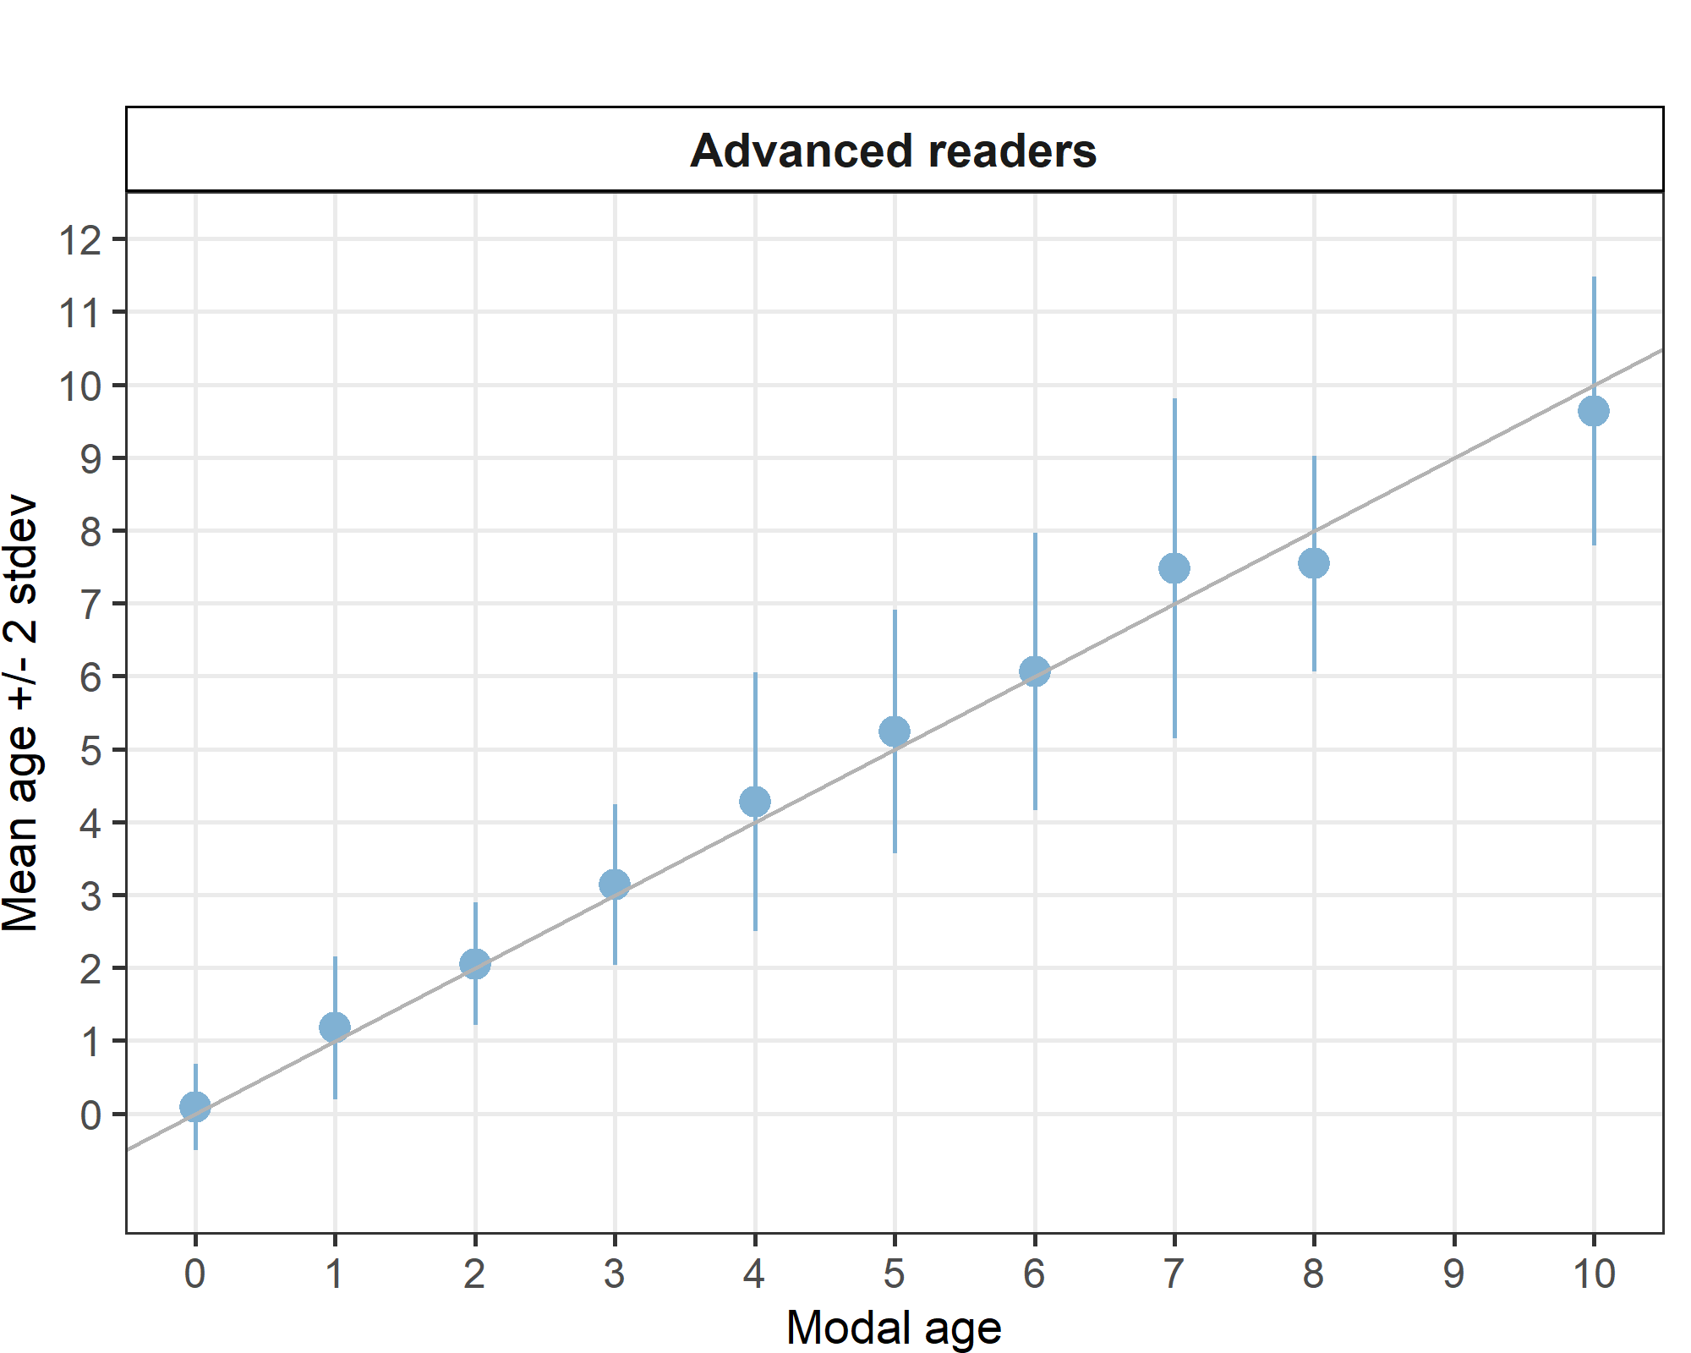
Figure 4.9: _27.3.a.20 .Age bias plot for advance readers. Mean age recorded +/- 2 stdev of each reader and all readers combined are plotted against modal age. The estimated mean age corresponds to modal age, if the estimated mean age is on the 1:1 equilibrium line (solid line).
Table 4.44: Age error matrix (AEM) for ICES area 27.3.a.20.
ices_area | modal_age | 0 | 1 | 2 | 3 | 4 | 5 | 6 | 7 | 8 | 9 | 10 | 11 | 12 | 13 | 14 | Total
27.3.a.20 | 0 | 0.9 | 0.1 | - | - | - | - | - | - | - | - | - | - | - | - | - | 1
27.3.a.20 | 1 | - | 0.9 | 0.1 | 0.0 | - | - | - | - | - | - | - | - | - | - | - | 1
27.3.a.20 | 2 | - | 0.0 | 0.8 | 0.1 | 0.0 | - | - | - | - | - | - | - | - | - | - | 1
27.3.a.20 | 3 | - | - | 0.1 | 0.8 | 0.1 | 0.0 | - | - | - | - | - | - | - | - | - | 1
27.3.a.20 | 4 | - | - | 0.0 | 0.0 | 0.7 | 0.1 | 0.1 | 0.0 | - | 0.0 | - | - | - | - | - | 1
27.3.a.20 | 5 | - | - | - | - | 0.0 | 0.8 | 0.1 | 0.0 | 0.0 | 0.0 | 0.0 | - | - | - | - | 1
27.3.a.20 | 6 | - | - | - | 0.0 | 0.0 | 0.1 | 0.7 | 0.1 | 0.0 | 0.0 | 0.0 | - | - | - | - | 1
27.3.a.20 | 7 | - | - | - | - | - | - | 0.1 | 0.5 | 0.2 | 0.1 | - | 0 | - | - | - | 1
27.3.a.20 | 8 | - | - | - | - | - | - | 0.1 | 0.3 | 0.6 | 0.0 | - | - | - | - | - | 1
27.3.a.20 | 10 | - | - | - | - | - | - | - | 0.1 | - | 0.1 | 0.8 | - | - | - | - | 1

Strata_27.4.a (ICES Area)
Table 4.45: Strata_27.4.a .Summary of statistics; Total number of samples (NSample), coefficient of variance (CV), percentage of agreement (PA) and average percentage error (APE) for all ages and readers
NSample | CV | PA | APE
75 | 12 % | 84 % | 7 %
Coefficient of Variation (CV)
Table 4.46: Strata_27.4.a .Coefficient of Variation (CV) table presents the CV per modal age and reader, the CV of all readers combined per modal age and a weighted mean of the CV per reader
Modal age | R01 DK | R02 SE | R03 NO | R04 DE | R05 NO | R06 NO | R07 NO | R08 NO | R09 NO | R10 PL | R12 NO | all
0 | - | - | - | - | - | - | - | - | - | - | - | -
1 | - | - | - | - | - | - | - | - | - | - | - | -
2 | 0 % | 0 % | 21 % | 0 % | 19 % | 0 % | 29 % | 0 % | 0 % | 19 % | 15 % | 16 %
3 | 0 % | 0 % | 20 % | 0 % | 13 % | 13 % | 24 % | 0 % | 10 % | 0 % | 0 % | 12 %
4 | 0 % | 8 % | 18 % | 8 % | 18 % | 7 % | 27 % | 0 % | 0 % | 13 % | 8 % | 14 %
5 | 13 % | 0 % | 22 % | 0 % | 28 % | 18 % | 24 % | 18 % | 23 % | 9 % | 6 % | 19 %
6 | 0 % | 0 % | 19 % | 6 % | 16 % | 5 % | 14 % | 16 % | 0 % | 8 % | 11 % | 11 %
7 | 17 % | 7 % | 12 % | 0 % | 13 % | 0 % | 27 % | 13 % | 7 % | 0 % | 8 % | 14 %
8 | 6 % | 5 % | 6 % | 5 % | 6 % | 4 % | 11 % | 10 % | 0 % | 8 % | 5 % | 8 %
9 | 0 % | 8 % | 5 % | 4 % | 4 % | 4 % | 7 % | 3 % | 4 % | 8 % | 9 % | 6 %
10 | - | - | - | - | - | - | - | - | - | - | - | -
11 | - | - | - | - | - | - | - | - | - | - | - | -
Weighted Mean | 3 % | 3 % | 16 % | 3 % | 15 % | 7 % | 20 % | 7 % | 5 % | 9 % | 8 % | 12 %

Percentage of Agreement (PA)
Table 4.47: Strata_27.4.a .Percentage agreement (PA) table represents the PA per modal age and reader, the PA of all readers combined per modal age and a weighted mean of the PA per reader.
Modal age | R01 DK | R02 SE | R03 NO | R04 DE | R05 NO | R06 NO | R07 NO | R08 NO | R09 NO | R10 PL | R12 NO | total
0 | - | - | - | - | - | - | - | - | - | - | - | -
1 | - | - | - | - | - | - | - | - | - | - | - | -
2 | 100 % | 100 % | 70 % | 100 % | 80 % | 100 % | 70 % | 100 % | 100 % | 80 % | 90 % | 90 %
3 | 100 % | 100 % | 82 % | 100 % | 82 % | 82 % | 73 % | 100 % | 91 % | 100 % | 100 % | 92 %
4 | 100 % | 91 % | 73 % | 91 % | 73 % | 91 % | 73 % | 100 % | 100 % | 73 % | 91 % | 87 %
5 | 80 % | 100 % | 70 % | 100 % | 70 % | 90 % | 80 % | 70 % | 90 % | 80 % | 90 % | 84 %
6 | 100 % | 100 % | 67 % | 89 % | 75 % | 89 % | 78 % | 89 % | 100 % | 78 % | 78 % | 86 %
7 | 50 % | 75 % | 50 % | 100 % | 75 % | 100 % | 50 % | 75 % | 75 % | 100 % | 67 % | 74 %
8 | 70 % | 80 % | 30 % | 80 % | 60 % | 90 % | 60 % | 60 % | 100 % | 60 % | 80 % | 70 %
9 | 100 % | 80 % | 70 % | 90 % | 90 % | 90 % | 60 % | 90 % | 90 % | 60 % | 70 % | 81 %
10 | - | - | - | - | - | - | - | - | - | - | - | -
11 | - | - | - | - | - | - | - | - | - | - | - | -
Weighted Mean | 91 % | 92 % | 65 % | 93 % | 76 % | 91 % | 69 % | 87 % | 95 % | 77 % | 85 % | 84 %

Average Percentage Error (APE)
Table 4.48: Strata_27.4.a .Average Percentage Error (APE) table represents the APE per modal age and reader, the APE of all advanced readers combined per modal age and a weighted mean of the APE per reader.
Modal age | R01 DK | R02 SE | R03 NO | R04 DE | R05 NO | R06 NO | R07 NO | R08 NO | R09 NO | R10 PL | R12 NO | all
0 | - | - | - | - | - | - | - | - | - | - | - | -
1 | - | - | - | - | - | - | - | - | - | - | - | -
2 | 0 % | 0 % | 18 % | 0 % | 15 % | 0 % | 23 % | 0 % | 0 % | 15 % | 9 % | 9 %
3 | 0 % | 0 % | 14 % | 0 % | 9 % | 9 % | 15 % | 0 % | 6 % | 0 % | 0 % | 5 %
4 | 0 % | 4 % | 11 % | 4 % | 15 % | 4 % | 17 % | 0 % | 0 % | 11 % | 4 % | 6 %
5 | 9 % | 0 % | 17 % | 0 % | 23 % | 10 % | 17 % | 13 % | 13 % | 7 % | 4 % | 11 %
6 | 0 % | 0 % | 14 % | 3 % | 12 % | 3 % | 11 % | 9 % | 0 % | 6 % | 8 % | 6 %
7 | 12 % | 5 % | 10 % | 0 % | 10 % | 0 % | 22 % | 10 % | 5 % | 0 % | 6 % | 10 %
8 | 5 % | 4 % | 5 % | 4 % | 6 % | 2 % | 10 % | 8 % | 0 % | 6 % | 4 % | 6 %
9 | 0 % | 6 % | 5 % | 2 % | 2 % | 2 % | 5 % | 2 % | 2 % | 7 % | 6 % | 3 %
10 | - | - | - | - | - | - | - | - | - | - | - | -
11 | - | - | - | - | - | - | - | - | - | - | - | -
Weighted Mean | 3 % | 2 % | 12 % | 2 % | 12 % | 4 % | 15 % | 5 % | 3 % | 7 % | 5 % | 7 %

Relative bias
Table 4.49: Strata_27.4.a . The relative bias (as the difference between the mean and modal age) per modal age and advanced reader is presented, as well as the weighted mean relative bias per reader and the relative bias per modal age for all advanced readers combined.
Modal age | R01 DK | R02 SE | R03 NO | R04 DE | R05 NO | R06 NO | R07 NO | R08 NO | R09 NO | R10 PL | R12 NO | all
0 | - | - | - | - | - | - | - | - | - | - | - | -
1 | - | - | - | - | - | - | - | - | - | - | - | -
2 | 0.00 | 0.00 | 0.30 | 0.00 | 0.20 | 0.00 | 0.40 | 0.00 | 0.00 | 0.20 | 0.10 | 0.11
3 | 0.00 | 0.00 | 0.27 | 0.00 | 0.18 | 0.18 | 0.18 | 0.00 | -0.09 | 0.00 | 0.00 | 0.07
4 | 0.00 | -0.09 | 0.18 | -0.09 | 0.45 | 0.09 | 0.55 | 0.00 | 0.00 | -0.27 | -0.09 | 0.07
5 | 0.30 | 0.00 | 0.70 | 0.00 | 1.00 | 0.30 | 0.60 | 0.50 | 0.40 | -0.20 | 0.10 | 0.34
6 | 0.00 | 0.00 | 0.44 | -0.11 | 0.50 | 0.11 | 0.44 | 0.33 | 0.00 | -0.22 | 0.33 | 0.17
7 | 0.25 | 0.25 | 0.75 | 0.00 | 0.50 | 0.00 | 2.00 | 0.50 | 0.25 | 0.00 | 0.33 | 0.44
8 | 0.30 | 0.20 | 0.70 | -0.20 | 0.40 | -0.10 | 0.70 | 0.60 | 0.00 | -0.20 | -0.20 | 0.20
9 | 0.00 | -0.30 | 0.30 | -0.10 | -0.10 | -0.10 | 0.20 | 0.10 | -0.10 | -0.50 | -0.20 | -0.07
10 | - | - | - | - | - | - | - | - | - | - | - | -
11 | - | - | - | - | - | - | - | - | - | - | - | -
Weighted Mean | 0.09 | -0.01 | 0.43 | -0.07 | 0.38 | 0.07 | 0.52 | 0.23 | 0.04 | -0.16 | 0.01 | 0.14

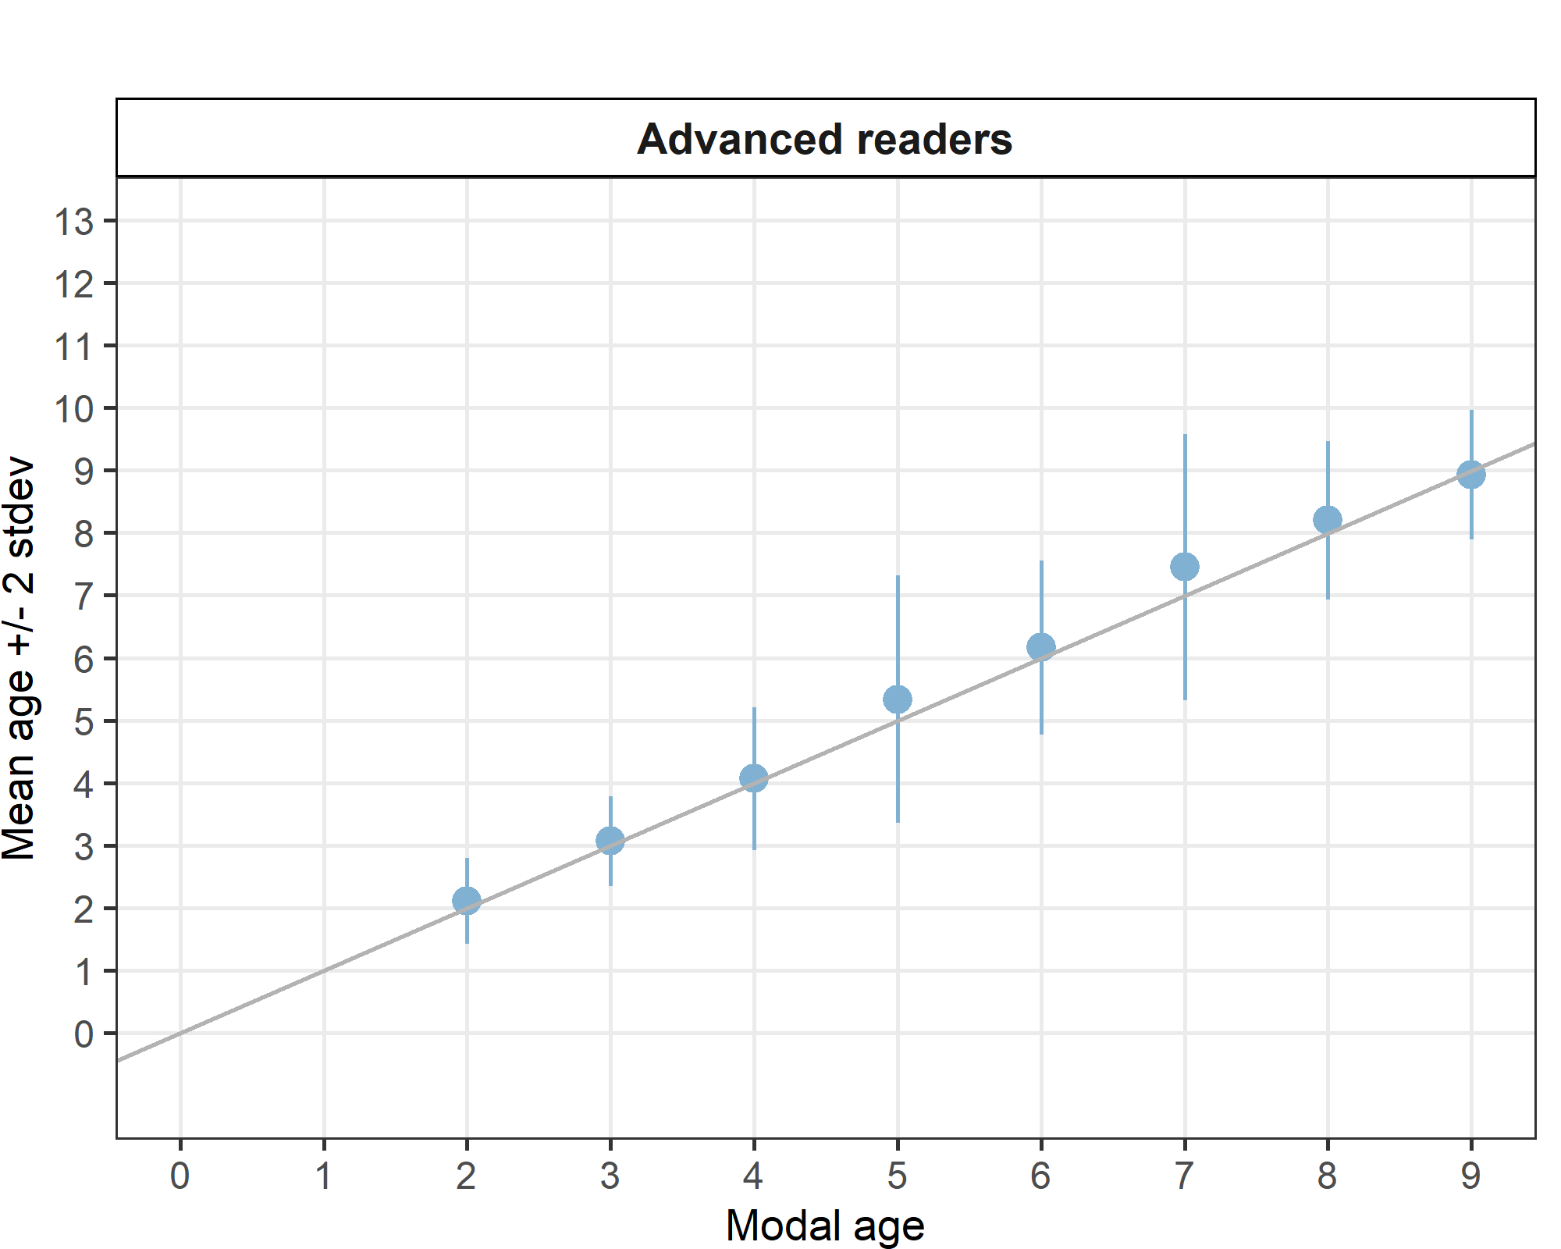
Figure 4.10: Strata_27.4.a .Age bias plot for advance readers. Mean age recorded +/- 2 stdev of each reader and all readers combined are plotted against modal age. The estimated mean age corresponds to modal age, if the estimated mean age is on the 1:1 equilibrium line (solid line).
Table 4.50: Age error matrix (AEM) for ICES area 27.4.a.
ices_area | modal_age | 0 | 1 | 2 | 3 | 4 | 5 | 6 | 7 | 8 | 9 | 10 | 11 | 12 | 13 | 14 | Total
27.4.a | 2 | - | - | 0.9 | 0.1 | 0.0 | - | - | - | - | - | - | - | - | - | - | 1
27.4.a | 3 | - | - | 0.0 | 0.9 | 0.0 | 0.0 | - | - | - | - | - | - | - | - | - | 1
27.4.a | 4 | - | - | - | 0.1 | 0.9 | 0.0 | 0.0 | - | 0.0 | - | - | - | - | - | - | 1
27.4.a | 5 | - | - | - | - | 0.0 | 0.8 | 0.0 | 0.0 | 0.0 | 0.0 | - | - | - | - | - | 1
27.4.a | 6 | - | - | - | - | - | 0.0 | 0.9 | 0.0 | 0.0 | 0.0 | - | - | - | - | - | 1
27.4.a | 7 | - | - | - | - | - | - | 0.0 | 0.7 | 0.1 | 0.1 | 0.0 | - | 0 | - | - | 1
27.4.a | 8 | - | - | - | - | - | - | - | 0.1 | 0.7 | 0.2 | 0.0 | - | - | - | - | 1
27.4.a | 9 | - | - | - | - | - | - | - | 0.0 | 0.1 | 0.8 | 0.1 | - | - | - | - | 1

Strata_27.3.d.24 (ICES Area)
Table 4.51: Strata_27.3.d.24 .Summary of statistics; Total number of samples (NSample), coefficient of variance (CV), percentage of agreement (PA) and average percentage error (APE) for all ages and readers
NSample | CV | PA | APE
69 | 22 % | 66 % | 16 %

Coefficient of Variation (CV)
Table 4.52: Strata_27.3.d.24 .Coefficient of Variation (CV) table presents the CV per modal age and reader, the CV of all readers combined per modal age and a weighted mean of the CV per reader
Modal age | R01 DK | R02 SE | R03 NO | R04 DE | R05 NO | R06 NO | R07 NO | R08 NO | R09 NO | R10 PL | R12 NO | all
0 | - | - | - | - | - | - | - | - | - | - | - | -
1 | - | - | - | - | 35 % | - | 35 % | 0 % | 35 % | 110 % | 61 % | 88 %
2 | 19 % | 0 % | 15 % | 0 % | 11 % | 29 % | 21 % | 0 % | 0 % | 25 % | 15 % | 21 %
3 | 0 % | 22 % | 31 % | 22 % | 16 % | 25 % | 43 % | 17 % | 22 % | 0 % | 0 % | 26 %
4 | 0 % | 0 % | 16 % | 0 % | 18 % | 9 % | 0 % | 18 % | 9 % | 11 % | 0 % | 12 %
5 | 0 % | 7 % | 10 % | 7 % | 13 % | 7 % | 7 % | 11 % | 13 % | 7 % | 7 % | 9 %
6 | 7 % | 21 % | 16 % | 9 % | 13 % | 7 % | 7 % | 7 % | 13 % | 7 % | 9 % | 12 %
7 | 5 % | 24 % | 24 % | 22 % | 12 % | 28 % | 17 % | 23 % | 13 % | 14 % | 11 % | 22 %
8 | 5 % | 18 % | 18 % | 14 % | 11 % | 7 % | 11 % | 18 % | 7 % | 17 % | 5 % | 16 %
9 | 6 % | 25 % | 0 % | 9 % | 5 % | 23 % | 5 % | 0 % | 16 % | 0 % | 10 % | 12 %
10 | - | - | - | - | - | - | - | - | - | - | - | -
11 | - | - | - | - | - | - | - | - | - | - | - | 15 %
Weighted Mean | 6 % | 13 % | 16 % | 9 % | 13 % | 16 % | 13 % | 9 % | 12 % | 21 % | 12 % | 22 %

Percentage of Agreement (PA)
Table 4.53: Strata_27.3.d.24 .Percentage agreement (PA) table represents the PA per modal age and reader, the PA of all readers combined per modal age and a weighted mean of the PA per reader.
Modal age | R01 DK | R02 SE | R03 NO | R04 DE | R05 NO | R06 NO | R07 NO | R08 NO | R09 NO | R10 PL | R12 NO | total
0 | 100 % | 100 % | 100 % | 100 % | 0 % | 100 % | 0 % | 0 % | 0 % | 100 % | 0 % | 55 %
1 | 33 % | 17 % | 33 % | 17 % | 83 % | 50 % | 83 % | 100 % | 83 % | 50 % | 83 % | 58 %
2 | 80 % | 100 % | 90 % | 100 % | 10 % | 60 % | 70 % | 100 % | 100 % | 40 % | 90 % | 76 %
3 | 100 % | 67 % | 67 % | 67 % | 33 % | 33 % | 67 % | 67 % | 67 % | 100 % | 100 % | 70 %
4 | 100 % | 100 % | 33 % | 100 % | 71 % | 86 % | 100 % | 71 % | 86 % | 71 % | 100 % | 84 %
5 | 100 % | 88 % | 57 % | 88 % | 88 % | 88 % | 88 % | 75 % | 62 % | 88 % | 88 % | 83 %
6 | 82 % | 45 % | 55 % | 55 % | 55 % | 82 % | 82 % | 82 % | 73 % | 82 % | 73 % | 69 %
7 | 88 % | 25 % | 38 % | 25 % | 57 % | 38 % | 62 % | 38 % | 62 % | 50 % | 50 % | 48 %
8 | 80 % | 80 % | 40 % | 0 % | 40 % | 60 % | 80 % | 40 % | 60 % | 20 % | 80 % | 53 %
9 | 60 % | 40 % | 100 % | 20 % | 80 % | 20 % | 80 % | 100 % | 60 % | 0 % | 80 % | 58 %
10 | - | - | - | - | - | - | - | - | - | - | - | -
11 | 100 % | 0 % | 100 % | 0 % | 100 % | 0 % | 100 % | 100 % | 0 % | 0 % | 0 % | 45 %
Weighted Mean | 83 % | 65 % | 61 % | 59 % | 53 % | 64 % | 74 % | 71 % | 68 % | 59 % | 74 % | 66 %

Average Percentage Error (APE)
Table 4.54: Strata_27.3.d.24 .Average Percentage Error (APE) table represents the APE per modal age and reader, the APE of all advanced readers combined per modal age and a weighted mean of the APE per reader.
Modal age | R01 DK | R02 SE | R03 NO | R04 DE | R05 NO | R06 NO | R07 NO | R08 NO | R09 NO | R10 PL | R12 NO | all
0 | - | - | - | - | - | - | - | - | - | - | - | -
1 | - | - | - | - | 24 % | - | 24 % | 0 % | 24 % | 67 % | 42 % | 67 %
2 | 15 % | 0 % | 9 % | 0 % | 6 % | 22 % | 18 % | 0 % | 0 % | 21 % | 9 % | 17 %
3 | 0 % | 17 % | 24 % | 17 % | 12 % | 17 % | 33 % | 13 % | 17 % | 0 % | 0 % | 17 %
4 | 0 % | 0 % | 11 % | 0 % | 14 % | 6 % | 0 % | 14 % | 6 % | 10 % | 0 % | 8 %
5 | 0 % | 4 % | 9 % | 4 % | 8 % | 4 % | 4 % | 5 % | 9 % | 4 % | 4 % | 4 %
6 | 5 % | 16 % | 12 % | 9 % | 10 % | 3 % | 5 % | 5 % | 8 % | 5 % | 6 % | 7 %
7 | 3 % | 20 % | 14 % | 18 % | 11 % | 16 % | 10 % | 16 % | 9 % | 12 % | 7 % | 15 %
8 | 4 % | 13 % | 14 % | 10 % | 8 % | 6 % | 8 % | 15 % | 6 % | 13 % | 4 % | 10 %
9 | 6 % | 20 % | 0 % | 5 % | 4 % | 15 % | 3 % | 0 % | 12 % | 0 % | 7 % | 9 %
10 | - | - | - | - | - | - | - | - | - | - | - | -
11 | 0 % | 0 % | 0 % | 0 % | 0 % | 0 % | 0 % | 0 % | 0 % | 0 % | 0 % | 9 %
Weighted Mean | 5 % | 10 % | 11 % | 7 % | 10 % | 11 % | 9 % | 6 % | 8 % | 14 % | 8 % | 16 %

Relative bias
Table 4.55: Strata_27.3.d.24 . The relative bias (as the difference between the mean and modal age) per modal age and advanced reader is presented, as well as the weighted mean relative bias per reader and the relative bias per modal age for all advanced readers combined.
Modal age | R01 DK | R02 SE | R03 NO | R04 DE | R05 NO | R06 NO | R07 NO | R08 NO | R09 NO | R10 PL | R12 NO | all
0 | 0.00 | 0.00 | 0.00 | 0.00 | 1.00 | 0.00 | 1.00 | 1.00 | 1.00 | 0.00 | 1.00 | 0.45
1 | -0.67 | -0.83 | -0.33 | -0.83 | 0.17 | -0.50 | 0.17 | 0.00 | 0.17 | 0.00 | 0.33 | -0.21
2 | 0.20 | 0.00 | 0.10 | 0.00 | 0.90 | 0.20 | 0.30 | 0.00 | 0.00 | 0.70 | 0.10 | 0.23
3 | 0.00 | -0.33 | 0.67 | -0.33 | 0.67 | 1.00 | 1.00 | 0.33 | -0.33 | 0.00 | 0.00 | 0.24
4 | 0.00 | 0.00 | 0.83 | 0.00 | 0.43 | 0.14 | 0.00 | 0.43 | 0.14 | 0.29 | 0.00 | 0.21
5 | 0.00 | -0.12 | 0.43 | -0.12 | 0.25 | 0.12 | -0.12 | 0.00 | -0.12 | 0.12 | 0.12 | 0.05
6 | -0.18 | -0.64 | 0.45 | -0.45 | 0.36 | 0.00 | -0.18 | 0.18 | -0.18 | -0.18 | -0.09 | -0.08
7 | -0.12 | -1.75 | 1.25 | -1.50 | 0.71 | -1.12 | 0.12 | 0.75 | -0.25 | -0.75 | 0.00 | -0.24
8 | 0.20 | -0.60 | 1.40 | -1.40 | -0.20 | -0.40 | 0.40 | 1.80 | -0.40 | -0.20 | 0.20 | 0.07
9 | -0.40 | -1.00 | 0.00 | -1.00 | -0.20 | -1.00 | 0.20 | 0.00 | -0.80 | -1.00 | -0.40 | -0.51
10 | - | - | - | - | - | - | - | - | - | - | - | -
11 | 0.00 | -5.00 | 0.00 | -1.00 | 0.00 | -1.00 | 0.00 | 0.00 | -1.00 | -2.00 | -1.00 | -1.00
Weighted Mean | -0.09 | -0.59 | 0.46 | -0.54 | 0.43 | -0.19 | 0.19 | 0.38 | -0.09 | -0.09 | 0.09 | -0.00

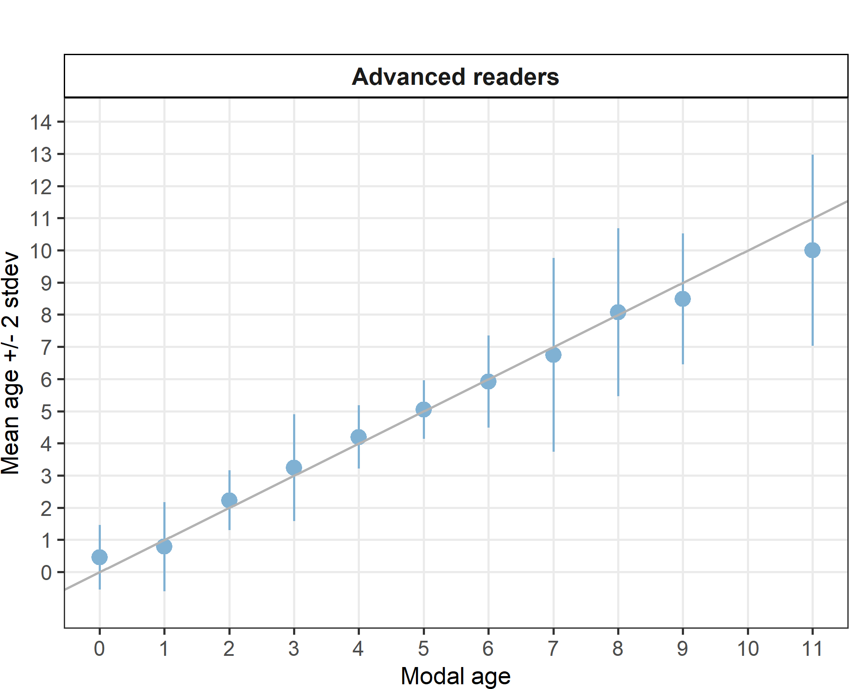
Figure 4.11: Strata Strata_27.3.d.24 .Age bias plot for advance readers. Mean age recorded +/- 2 stdev of each reader and all readers combined are plotted against modal age. The estimated mean age corresponds to modal age, if the estimated mean age is on the 1:1 equilibrium line (solid line). Relative bias is the age difference between estimated mean age and modal age.
Table 4.56: Age error matrix (AEM) for ICES area 27.3.d.24.
ices_area | modal_age | 0 | 1 | 2 | 3 | 4 | 5 | 6 | 7 | 8 | 9 | 10 | 11 | 12 | 13 | 14 | Total
27.3.d.24 | 0 | 0.6 | 0.4 | - | - | - | - | - | - | - | - | - | - | - | - | - | 1
27.3.d.24 | 1 | 0.3 | 0.6 | 0.1 | 0.0 | - | - | - | - | - | - | - | - | - | - | - | 1
27.3.d.24 | 2 | - | 0.0 | 0.8 | 0.2 | 0.0 | - | - | - | - | - | - | - | - | - | - | 1
27.3.d.24 | 3 | - | - | 0.1 | 0.7 | 0.1 | 0.1 | 0.0 | - | - | - | - | - | - | - | - | 1
27.3.d.24 | 4 | - | - | - | - | 0.8 | 0.1 | 0.0 | - | - | - | - | - | - | - | - | 1
27.3.d.24 | 5 | - | - | - | - | 0.1 | 0.8 | 0.1 | 0.0 | - | - | - | - | - | - | - | 1
27.3.d.24 | 6 | - | - | - | 0.0 | 0.0 | 0.2 | 0.7 | 0.1 | 0.0 | 0.0 | - | - | - | - | - | 1
27.3.d.24 | 7 | - | - | 0.0 | - | 0.1 | 0.1 | 0.2 | 0.5 | 0.1 | 0.0 | 0.0 | 0.0 | - | 0 | - | 1
27.3.d.24 | 8 | - | - | - | - | - | 0.0 | 0.0 | 0.2 | 0.5 | 0.1 | 0.0 | 0.0 | 0 | - | - | 1
27.3.d.24 | 9 | - | - | - | - | - | 0.0 | 0.0 | 0.0 | 0.2 | 0.6 | 0.0 | - | - | - | - | 1
27.3.d.24 | 11 | - | - | - | - | - | - | 0.1 | - | - | 0.1 | 0.4 | 0.4 | - | - | - | 1

Strata_27.3.a.21 (ICES Area)
Table 4.57: Strata_27.3.a.21 .Summary of statistics; Total number of samples (NSample), coefficient of variance (CV), percentage of agreement (PA) and average percentage error (APE) for all ages and readers
NSample | CV | PA | APE
65 | 20 % | 79 % | 11 %
Coefficient of Variation (CV)
Table 4.58: Strata_27.3.a.21 .Coefficient of Variation (CV) table presents the CV per modal age and reader, the CV of all readers combined per modal age and a weighted mean of the CV per reader
Modal age | R01 DK | R02 SE | R03 NO | R04 DE | R05 NO | R06 NO | R07 NO | R08 NO | R09 NO | R10 PL | R12 NO | all
0 | - | - | - | - | - | - | - | - | - | - | - | -
1 | 0 % | 0 % | 31 % | 0 % | 65 % | 77 % | 57 % | 31 % | 0 % | 31 % | 37 % | 47 %
2 | 14 % | 25 % | 47 % | 25 % | 26 % | 33 % | 21 % | 26 % | 20 % | 14 % | 27 % | 32 %
3 | 0 % | 0 % | 18 % | 9 % | 0 % | 0 % | 9 % | 14 % | 0 % | 0 % | 0 % | 10 %
4 | 0 % | 0 % | 22 % | 11 % | 11 % | 0 % | 10 % | 12 % | 16 % | 0 % | 0 % | 12 %
5 | 10 % | 15 % | 18 % | 7 % | 0 % | 7 % | 24 % | 13 % | 7 % | 10 % | 7 % | 14 %
6 | 8 % | 0 % | 12 % | 10 % | 0 % | 0 % | 0 % | 14 % | 7 % | 9 % | 7 % | 10 %
7 | 0 % | 6 % | 32 % | 11 % | 12 % | 6 % | 8 % | 14 % | 6 % | 11 % | 11 % | 17 %
8 | 8 % | 0 % | 0 % | 0 % | 14 % | 0 % | 0 % | 0 % | 16 % | 9 % | 8 % | 9 %
9 | - | - | - | - | - | - | - | - | - | - | - | 13 %
10 | - | - | - | - | - | - | - | - | - | - | - | -
11 | - | - | - | - | - | - | - | - | - | - | - | -
Weighted Mean | 5 % | 7 % | 26 % | 11 % | 16 % | 18 % | 18 % | 18 % | 8 % | 10 % | 13 % | 20 %

Percentage of Agreement (PA)
Table 4.59: Strata_27.3.a.21 .Percentage agreement (PA) table represents the PA per modal age and reader, the PA of all readers combined per modal age and a weighted mean of the PA per reader.
Modal age | R01 DK | R02 SE | R03 NO | R04 DE | R05 NO | R06 NO | R07 NO | R08 NO | R09 NO | R10 PL | R12 NO | total
0 | - | - | - | - | - | - | - | - | - | - | - | -
1 | 100 % | 100 % | 88 % | 100 % | 62 % | 88 % | 88 % | 88 % | 100 % | 88 % | 75 % | 89 %
2 | 92 % | 77 % | 62 % | 77 % | 54 % | 62 % | 69 % | 69 % | 85 % | 92 % | 69 % | 73 %
3 | 100 % | 100 % | 60 % | 93 % | 100 % | 100 % | 93 % | 73 % | 100 % | 100 % | 100 % | 93 %
4 | 100 % | 100 % | 67 % | 83 % | 83 % | 100 % | 83 % | 67 % | 67 % | 100 % | 100 % | 86 %
5 | 75 % | 50 % | 38 % | 88 % | 100 % | 88 % | 50 % | 88 % | 88 % | 75 % | 88 % | 75 %
6 | 80 % | 100 % | 40 % | 60 % | 100 % | 100 % | 100 % | 80 % | 80 % | 20 % | 80 % | 76 %
7 | 100 % | 83 % | 40 % | 17 % | 40 % | 83 % | 67 % | 67 % | 83 % | 17 % | 83 % | 62 %
8 | 67 % | 100 % | 100 % | 0 % | 33 % | 100 % | 100 % | 100 % | 67 % | 0 % | 33 % | 64 %
9 | 0 % | 0 % | 0 % | 100 % | - | 0 % | 0 % | 0 % | 100 % | 100 % | 100 % | 40 %
10 | - | - | - | - | - | - | - | - | - | - | - | -
11 | - | - | - | - | - | - | - | - | - | - | - | -
Weighted Mean | 91 % | 86 % | 59 % | 75 % | 76 % | 86 % | 78 % | 75 % | 88 % | 75 % | 83 % | 79 %

Average Percentage Error (APE)
Table 4.60: Strata_27.3.a.21 .Average Percentage Error (APE) table represents the APE per modal age and reader, the APE of all advanced readers combined per modal age and a weighted mean of the APE per reader.
Modal age | R01 DK | R02 SE | R03 NO | R04 DE | R05 NO | R06 NO | R07 NO | R08 NO | R09 NO | R10 PL | R12 NO | all
0 | - | - | - | - | - | - | - | - | - | - | - | -
1 | 0 % | 0 % | 19 % | 0 % | 48 % | 48 % | 35 % | 19 % | 0 % | 19 % | 30 % | 26 %
2 | 7 % | 20 % | 37 % | 20 % | 23 % | 22 % | 18 % | 18 % | 8 % | 7 % | 22 % | 19 %
3 | 0 % | 0 % | 16 % | 4 % | 0 % | 0 % | 4 % | 12 % | 0 % | 0 % | 0 % | 4 %
4 | 0 % | 0 % | 19 % | 7 % | 7 % | 0 % | 7 % | 10 % | 8 % | 0 % | 0 % | 6 %
5 | 8 % | 12 % | 12 % | 4 % | 0 % | 4 % | 17 % | 8 % | 4 % | 8 % | 4 % | 7 %
6 | 6 % | 0 % | 9 % | 9 % | 0 % | 0 % | 0 % | 10 % | 5 % | 6 % | 5 % | 5 %
7 | 0 % | 4 % | 24 % | 6 % | 9 % | 4 % | 7 % | 9 % | 4 % | 6 % | 8 % | 8 %
8 | 6 % | 0 % | 0 % | 0 % | 10 % | 0 % | 0 % | 0 % | 12 % | 7 % | 6 % | 8 %
9 | 0 % | 0 % | 0 % | 0 % | - | 0 % | 0 % | 0 % | 0 % | 0 % | 0 % | 11 %
10 | - | - | - | - | - | - | - | - | - | - | - | -
11 | - | - | - | - | - | - | - | - | - | - | - | -
Weighted Mean | 3 % | 6 % | 20 % | 7 % | 13 % | 11 % | 12 % | 12 % | 4 % | 6 % | 10 % | 11 %

Relative bias
Table 4.61: Strata_27.3.a.21 . The relative bias (as the difference between the mean and modal age) per modal age and advanced reader is presented, as well as the weighted mean relative bias per reader and the relative bias per modal age for all advanced readers combined.
Modal age | R01 DK | R02 SE | R03 NO | R04 DE | R05 NO | R06 NO | R07 NO | R08 NO | R09 NO | R10 PL | R12 NO | all
0 | - | - | - | - | - | - | - | - | - | - | - | -
1 | 0.00 | 0.00 | 0.12 | 0.00 | 0.62 | 0.38 | 0.25 | 0.12 | 0.00 | 0.12 | 0.25 | 0.17
2 | -0.08 | -0.23 | 0.85 | -0.23 | 0.54 | -0.08 | 0.31 | 0.15 | 0.00 | -0.08 | 0.38 | 0.14
3 | 0.00 | 0.00 | 0.47 | -0.07 | 0.00 | 0.00 | -0.07 | 0.27 | 0.00 | 0.00 | 0.00 | 0.05
4 | 0.00 | 0.00 | 0.67 | -0.17 | -0.17 | 0.00 | 0.17 | 0.33 | 0.00 | 0.00 | 0.00 | 0.08
5 | -0.25 | -0.25 | 1.00 | -0.12 | 0.00 | 0.12 | 0.25 | 0.25 | 0.12 | -0.25 | -0.12 | 0.07
6 | -0.20 | 0.00 | 0.80 | -0.40 | 0.00 | 0.00 | 0.00 | 0.40 | 0.20 | -0.80 | 0.20 | 0.02
7 | 0.00 | -0.17 | 2.20 | -1.00 | -0.20 | 0.17 | -0.33 | 0.17 | -0.17 | -1.00 | 0.33 | 0.00
8 | -0.33 | 0.00 | 0.00 | -1.00 | -1.00 | 0.00 | 0.00 | 0.00 | -0.67 | -1.67 | -0.67 | -0.48
9 | 2.00 | -1.00 | 2.00 | 0.00 | - | 1.00 | 3.00 | 2.00 | 0.00 | 0.00 | 0.00 | -
10 | - | - | - | - | - | - | - | - | - | - | - | -
11 | - | - | - | - | - | - | - | - | - | - | - | -
Weighted Mean | -0.05 | -0.11 | 0.75 | -0.26 | 0.11 | 0.08 | 0.14 | 0.25 | -0.02 | -0.26 | 0.11 | 0.06

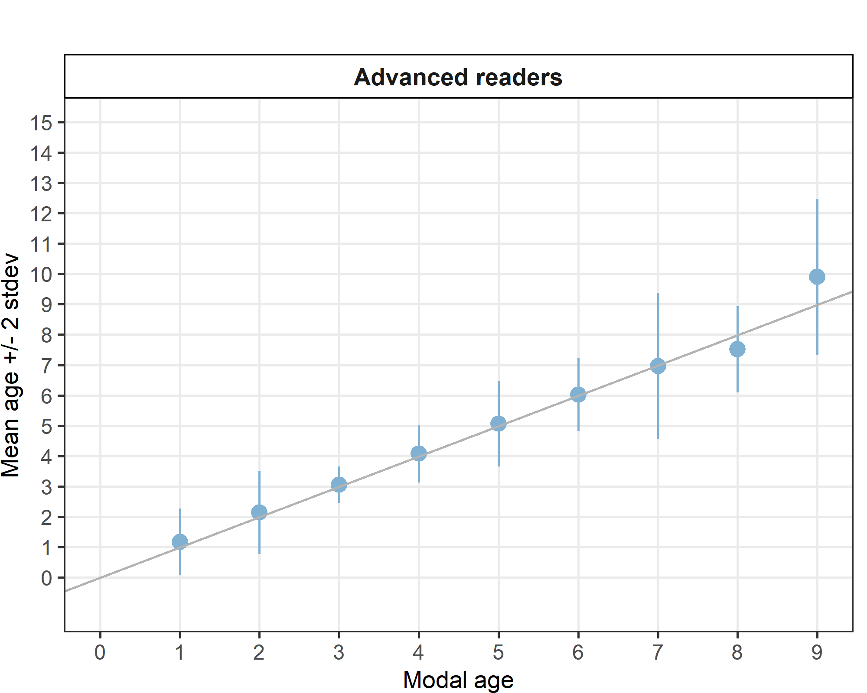
Figure 4.12: Strata_27.3.a.21 .Age bias plot for advance readers. Mean age recorded +/- 2 stdev of each reader and all readers combined are plotted against modal age. The estimated mean age corresponds to modal age, if the estimated mean age is on the 1:1 equilibrium line (solid line). Relative bias is the age difference between estimated mean age and modal age.
Table 4.62: Age error matrix (AEM) for ICES area 27.3.a.21.
ices_area | modal_age | 0 | 1 | 2 | 3 | 4 | 5 | 6 | 7 | 8 | 9 | 10 | 11 | 12 | 13 | 14 | Total
27.3.a.21 | 1 | - | 0.9 | 0.1 | 0.0 | 0.0 | - | - | - | - | - | - | - | - | - | - | 1
27.3.a.21 | 2 | - | 0.1 | 0.7 | 0.1 | 0.0 | 0.0 | 0.0 | - | - | - | - | - | - | - | - | 1
27.3.a.21 | 3 | - | - | 0.0 | 0.9 | 0.0 | 0.0 | - | - | - | - | - | - | - | - | - | 1
27.3.a.21 | 4 | - | - | - | 0.0 | 0.9 | 0.1 | 0.0 | - | - | - | - | - | - | - | - | 1
27.3.a.21 | 5 | - | - | - | - | 0.1 | 0.8 | 0.1 | 0.0 | 0.0 | - | - | - | - | - | - | 1
27.3.a.21 | 6 | - | - | - | - | - | 0.1 | 0.8 | 0.1 | 0.0 | - | - | - | - | - | - | 1
27.3.a.21 | 7 | - | - | - | - | - | 0.0 | 0.2 | 0.6 | 0.0 | 0.0 | 0.0 | - | - | - | 0 | 1
27.3.a.21 | 8 | - | - | - | - | - | - | 0.1 | 0.2 | 0.6 | - | - | - | - | - | - | 1
27.3.a.21 | 9 | - | - | - | - | - | - | - | - | 0.1 | 0.4 | 0.1 | 0.3 | 0.1 | - | - | 1

Strata_27.3.c.22 (ICES Area)
Table 4.63: Strata_27.3.c.22 .Summary of statistics; Total number of samples (NSample), coefficient of variance (CV), percentage of agreement (PA) and average percentage error (APE) for all ages and readers
NSample | CV | PA | APE
30 | 23 % | 70 % | 15 %
Coefficient of Variation (CV)
Table 4.64: Strata_27.3.c.22 .Coefficient of Variation (CV) table presents the CV per modal age and reader, the CV of all readers combined per modal age and a weighted mean of the CV per reader
Modal age | R01 DK | R02 SE | R03 NO | R04 DE | R05 NO | R06 NO | R07 NO | R08 NO | R09 NO | R10 PL | R12 NO | all
0 | - | - | - | - | - | - | - | - | - | - | - | -
1 | - | - | - | - | - | - | - | - | - | - | - | -
2 | 22 % | 22 % | 31 % | 0 % | 19 % | 0 % | 0 % | 24 % | 19 % | 0 % | 19 % | 36 %
3 | 12 % | 0 % | 32 % | 16 % | 15 % | 19 % | 21 % | 14 % | 11 % | 21 % | 0 % | 25 %
4 | 0 % | 7 % | 22 % | 0 % | 15 % | 11 % | 16 % | 12 % | 11 % | 8 % | 14 % | 17 %
5 | - | - | - | - | - | - | - | - | - | - | - | 11 %
6 | 17 % | 10 % | 21 % | 0 % | 8 % | 14 % | 10 % | 14 % | 14 % | 10 % | 17 % | 16 %
7 | - | - | - | - | - | - | - | - | - | - | - | -
8 | - | - | - | - | - | - | - | - | - | - | - | -
9 | - | - | - | - | - | - | - | - | - | - | - | -
10 | - | - | - | - | - | - | - | - | - | - | - | -
11 | - | - | - | - | - | - | - | - | - | - | - | -
Weighted Mean | 10 % | 8 % | 27 % | 5 % | 15 % | 11 % | 13 % | 15 % | 13 % | 10 % | 11 % | 23 %

Percentage of Agreement (PA)
Table 4.65: Strata_27.3.c.22 .Percentage agreement (PA) table represents the PA per modal age and reader, the PA of all readers combined per modal age and a weighted mean of the PA per reader.
Modal age | R01 DK | R02 SE | R03 NO | R04 DE | R05 NO | R06 NO | R07 NO | R08 NO | R09 NO | R10 PL | R12 NO | total
0 | - | - | - | - | - | - | - | - | - | - | - | -
1 | - | - | - | - | - | - | - | - | - | - | - | -
2 | 67 % | 67 % | 0 % | 100 % | 33 % | 100 % | 100 % | 17 % | 83 % | 100 % | 83 % | 68 %
3 | 89 % | 100 % | 44 % | 78 % | 67 % | 67 % | 56 % | 78 % | 89 % | 56 % | 100 % | 75 %
4 | 100 % | 91 % | 27 % | 100 % | 45 % | 82 % | 64 % | 55 % | 73 % | 91 % | 73 % | 73 %
5 | 100 % | 100 % | 0 % | 100 % | 100 % | 0 % | 100 % | 100 % | 100 % | 0 % | 100 % | 73 %
6 | 33 % | 67 % | 33 % | 100 % | 0 % | 33 % | 67 % | 33 % | 33 % | 67 % | 33 % | 45 %
7 | - | - | - | - | - | - | - | - | - | - | - | -
8 | - | - | - | - | - | - | - | - | - | - | - | -
9 | - | - | - | - | - | - | - | - | - | - | - | -
10 | - | - | - | - | - | - | - | - | - | - | - | -
11 | - | - | - | - | - | - | - | - | - | - | - | -
Weighted Mean | 83 % | 87 % | 27 % | 93 % | 47 % | 73 % | 70 % | 53 % | 77 % | 77 % | 80 % | 70 %

Average Percentage Error (APE)
Table 4.66: Strata_27.3.c.22 .Average Percentage Error (APE) table represents the APE per modal age and reader, the APE of all advanced readers combined per modal age and a weighted mean of the APE per reader.
Modal age | R01 DK | R02 SE | R03 NO | R04 DE | R05 NO | R06 NO | R07 NO | R08 NO | R09 NO | R10 PL | R12 NO | all
0 | - | - | - | - | - | - | - | - | - | - | - | -
1 | - | - | - | - | - | - | - | - | - | - | - | -
2 | 19 % | 19 % | 26 % | 0 % | 17 % | 0 % | 0 % | 18 % | 13 % | 0 % | 13 % | 27 %
3 | 7 % | 0 % | 29 % | 12 % | 13 % | 17 % | 19 % | 11 % | 6 % | 19 % | 0 % | 12 %
4 | 0 % | 4 % | 19 % | 0 % | 13 % | 8 % | 12 % | 11 % | 9 % | 4 % | 8 % | 11 %
5 | 0 % | 0 % | 0 % | 0 % | 0 % | 0 % | 0 % | 0 % | 0 % | 0 % | 0 % | 7 %
6 | 11 % | 8 % | 15 % | 0 % | 6 % | 10 % | 8 % | 10 % | 10 % | 8 % | 11 % | 13 %
7 | - | - | - | - | - | - | - | - | - | - | - | -
8 | - | - | - | - | - | - | - | - | - | - | - | -
9 | - | - | - | - | - | - | - | - | - | - | - | -
10 | - | - | - | - | - | - | - | - | - | - | - | -
11 | - | - | - | - | - | - | - | - | - | - | - | -
Weighted Mean | 7 % | 6 % | 22 % | 4 % | 13 % | 9 % | 11 % | 12 % | 9 % | 8 % | 7 % | 15 %

Relative bias
Table 4.67: Strata_27.3.c.22 . The relative bias (as the difference between the mean and modal age) per modal age and advanced reader is presented, as well as the weighted mean relative bias per reader and the relative bias per modal age for all advanced readers combined.
Modal age | R01 DK | R02 SE | R03 NO | R04 DE | R05 NO | R06 NO | R07 NO | R08 NO | R09 NO | R10 PL | R12 NO | all
0 | - | - | - | - | - | - | - | - | - | - | - | -
1 | - | - | - | - | - | - | - | - | - | - | - | -
2 | 0.33 | 0.33 | 2.50 | 0.00 | 0.67 | 0.00 | 0.00 | 1.17 | 0.17 | 0.00 | 0.17 | 0.48
3 | -0.11 | 0.00 | 1.44 | -0.22 | 0.33 | -0.33 | -0.44 | 0.22 | 0.11 | -0.44 | 0.00 | 0.05
4 | 0.00 | 0.09 | 1.55 | 0.00 | 0.36 | -0.18 | -0.18 | 0.45 | 0.27 | -0.09 | -0.09 | 0.20
5 | 0.00 | 0.00 | 1.00 | 0.00 | 0.00 | -1.00 | 0.00 | 0.00 | 0.00 | -1.00 | 0.00 | -0.09
6 | 0.00 | -0.33 | 1.33 | 0.00 | 1.67 | 1.00 | -0.33 | 1.00 | 1.00 | -0.33 | 0.00 | 0.45
7 | - | - | - | - | - | - | - | - | - | - | - | -
8 | - | - | - | - | - | - | - | - | - | - | - | -
9 | - | - | - | - | - | - | - | - | - | - | - | -
10 | - | - | - | - | - | - | - | - | - | - | - | -
11 | - | - | - | - | - | - | - | - | - | - | - | -
Weighted Mean | 0.03 | 0.07 | 1.67 | -0.07 | 0.53 | -0.10 | -0.23 | 0.57 | 0.27 | -0.23 | 0.00 | 0.23

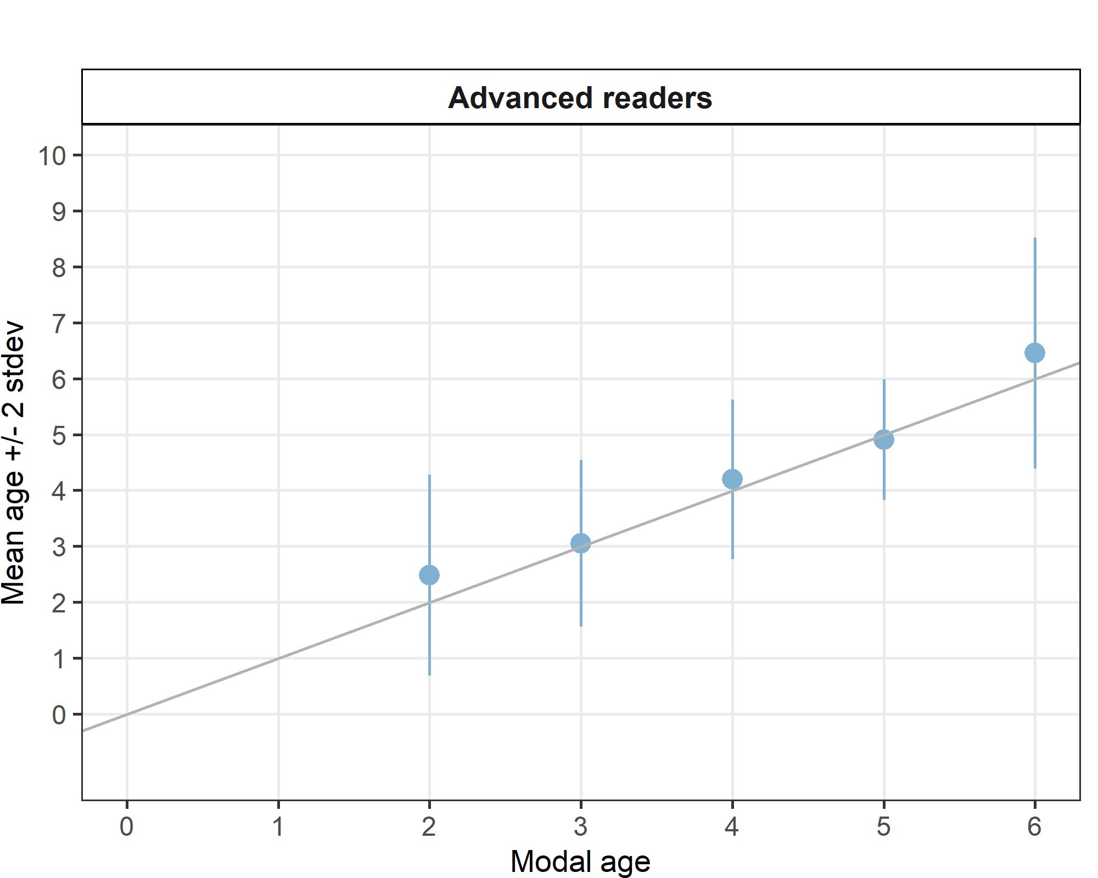
Figure 4.13: Strata_27.3.c.22 .Age bias plot for advance readers. Mean age recorded +/- 2 stdev of each reader and all readers combined are plotted against modal age. The estimated mean age corresponds to modal age, if the estimated mean age is on the 1:1 equilibrium line (solid line). Relative bias is the age difference between estimated mean age and modal age.
Table 4.68: Age error matrix (AEM) for ICES area 27.3.c.22.
ices_area | modal_age | 0 | 1 | 2 | 3 | 4 | 5 | 6 | 7 | 8 | 9 | 10 | 11 | 12 | 13 | 14 | Total
27.3.c.22 | 2 | - | - | 0.7 | 0.2 | 0.0 | 0.0 | 0.0 | - | - | - | - | - | - | - | - | 1
27.3.c.22 | 3 | - | - | 0.1 | 0.8 | 0.1 | 0.0 | 0.0 | - | - | - | - | - | - | - | - | 1
27.3.c.22 | 4 | - | - | - | 0.1 | 0.7 | 0.1 | 0.0 | 0.0 | - | - | - | - | - | - | - | 1
27.3.c.22 | 5 | - | - | - | - | 0.2 | 0.7 | 0.1 | - | - | - | - | - | - | - | - | 1
27.3.c.22 | 6 | - | - | - | - | - | 0.1 | 0.4 | 0.2 | 0.1 | 0 | - | - | - | - | - | 1

Overall comparison of results by ICES area
Table 4.69: Number of age readings per strata (ICES area) and modal age for all advanced readers combined.
Modal age | Strata_27.3.a.20 | Strata_27.3.a.21 | Strata_27.3.b.23 | Strata_27.3.c.22 | Strata_27.3.d.24 | Strata_27.4.a | total
0 | 22 | 0 | 0 | 0 | 55 | 0 | 77
1 | 86 | 88 | 0 | 0 | 66 | 0 | 240
2 | 96 | 143 | 0 | 66 | 109 | 110 | 524
3 | 66 | 165 | 0 | 99 | 33 | 121 | 484
4 | 120 | 66 | 0 | 121 | 76 | 121 | 504
5 | 172 | 88 | 0 | 11 | 87 | 110 | 468
6 | 98 | 54 | 0 | 33 | 121 | 98 | 404
7 | 21 | 64 | 0 | 0 | 87 | 42 | 214
8 | 22 | 33 | 0 | 0 | 55 | 110 | 220
9 | 0 | 10 | 11 | 0 | 55 | 110 | 186
10 | 11 | 0 | 0 | 0 | 0 | 0 | 11
11 | 0 | 0 | 0 | 0 | 11 | 0 | 11
Total | 714 | 711 | 11 | 330 | 755 | 822 | 3343
Coefficient of Variation (CV)
Table 4.70: CV per strata (ICES area) and modal age for all advanced readers combined.
Modal age | Strata_27.3.a.20 | Strata_27.3.a.21 | Strata_27.3.b.23 | Strata_27.3.c.22 | Strata_27.3.d.24 | Strata_27.4.a | all
0 | - | - | - | - | - | - | -
1 | 42 % | 47 % | - | - | 88 % | - | 56 %
2 | 20 % | 32 % | - | 36 % | 21 % | 16 % | 27 %
3 | 18 % | 10 % | - | 25 % | 26 % | 12 % | 17 %
4 | 21 % | 12 % | - | 17 % | 12 % | 14 % | 16 %
5 | 16 % | 14 % | - | 11 % | 9 % | 19 % | 15 %
6 | 16 % | 10 % | - | 16 % | 12 % | 11 % | 13 %
7 | 16 % | 17 % | - | - | 22 % | 14 % | 19 %
8 | 10 % | 9 % | - | - | 16 % | 8 % | 11 %
9 | - | 13 % | 25 % | - | 12 % | 6 % | 11 %
10 | 10 % | - | - | - | - | - | 10 %
11 | - | - | - | - | 15 % | - | 15 %
Weighted Mean | 20 % | 20 % | 25 % | 23 % | 22 % | 12 % | 20 %
Percentage of Agreement (PA)
Table 4.71: Percentage Agreement per strata (ICES area) and modal age for all advanced readers combined.
Modal age | Strata_27.3.a.20 | Strata_27.3.a.21 | Strata_27.3.b.23 | Strata_27.3.c.22 | Strata_27.3.d.24 | Strata_27.4.a | total
0 | 91 % | - | - | - | 55 % | - | 65 %
1 | 87 % | 89 % | - | - | 58 % | - | 80 %
2 | 85 % | 73 % | - | 68 % | 76 % | 90 % | 79 %
3 | 77 % | 93 % | - | 75 % | 70 % | 92 % | 85 %
4 | 74 % | 86 % | - | 73 % | 84 % | 87 % | 80 %
5 | 84 % | 75 % | - | 73 % | 83 % | 84 % | 82 %
6 | 74 % | 76 % | - | 45 % | 69 % | 86 % | 74 %
7 | 48 % | 62 % | - | - | 48 % | 74 % | 57 %
8 | 55 % | 64 % | - | - | 53 % | 70 % | 63 %
9 | - | 40 % | 27 % | - | 58 % | 81 % | 69 %
10 | 82 % | - | - | - | - | - | 82 %
11 | - | - | - | - | 45 % | - | 45 %
Weighted Mean | 79 % | 79 % | 27 % | 70 % | 66 % | 84 % | 76 %
Average Percentage Error (APE)
Table 4.72: Average Percentage Error per strata (ICES area) and modal age for all advanced readers combined.
Modal age | Strata_27.3.a.20 | Strata_27.3.a.21 | Strata_27.3.b.23 | Strata_27.3.c.22 | Strata_27.3.d.24 | Strata_27.4.a | all
0 | - | - | - | - | - | - | -
1 | 26 % | 26 % | - | - | 67 % | - | 28 %
2 | 10 % | 19 % | - | 27 % | 17 % | 9 % | 17 %
3 | 11 % | 4 % | - | 12 % | 17 % | 5 % | 8 %
4 | 13 % | 6 % | - | 11 % | 8 % | 6 % | 9 %
5 | 9 % | 7 % | - | 7 % | 4 % | 11 % | 8 %
6 | 7 % | 5 % | - | 13 % | 7 % | 6 % | 7 %
7 | 12 % | 8 % | - | - | 15 % | 10 % | 10 %
8 | 8 % | 8 % | - | - | 10 % | 6 % | 6 %
9 | - | 11 % | 19 % | - | 9 % | 3 % | 6 %
10 | 6 % | - | - | - | - | - | 6 %
11 | - | - | - | - | 9 % | - | 9 %
Weighted Mean | 12 % | 11 % | 19 % | 15 % | 16 % | 7 % | 11 %
Relative bias
Table 4.73: Relative Bias per strata (ICES area) and modal age for all advanced readers combined.
Modal age | Strata_27.3.a.20 | Strata_27.3.a.21 | Strata_27.3.b.23 | Strata_27.3.c.22 | Strata_27.3.d.24 | Strata_27.4.a | all
0 | 0.09 | - | - | - | 0.45 | - | -
1 | 0.17 | 0.17 | - | - | -0.21 | - | -
2 | 0.05 | 0.14 | - | 0.48 | 0.23 | 0.11 | -
3 | 0.14 | 0.05 | - | 0.05 | 0.24 | 0.07 | -
4 | 0.28 | 0.08 | - | 0.20 | 0.20 | 0.07 | -
5 | 0.24 | 0.07 | - | -0.09 | 0.05 | 0.34 | -
6 | 0.06 | 0.02 | - | 0.45 | -0.08 | 0.16 | -
7 | 0.48 | -0.03 | - | - | -0.25 | 0.45 | -
8 | -0.45 | -0.48 | - | - | 0.07 | 0.20 | -
9 | - | 0.90 | 0.09 | - | -0.51 | -0.07 | -
10 | -0.36 | - | - | - | - | - | -
11 | - | - | - | - | -1.00 | - | -
Weighted Mean | 0.15 | 0.07 | 0.09 | 0.23 | -0.01 | 0.14 | -

Strata_ her_3a22 (WBSS, genetic population)
Table 4.74: Strata_her_3a22 .Summary of statistics; Total number of samples (NSample), coefficient of variance (CV), percentage of agreement (PA) and average percentage error (APE) for all ages and readers
NSample | CV | PA | APE
192 | 20 % | 76 % | 11 %

Coefficient of Variation (CV)
Table 4.75: Strata_her_3a22 .Coefficient of Variation (CV) table presents the CV per modal age and reader, the CV of all readers combined per modal age and a weighted mean of the CV per reader
Modal age | R01 DK | R02 SE | R03 NO | R04 DE | R05 NO | R06 NO | R07 NO | R08 NO | R09 NO | R10 PL | R12 NO | all
0 | - | - | - | - | - | - | - | - | - | - | - | -
1 | 33 % | 49 % | 45 % | 49 % | 60 % | 96 % | 51 % | 29 % | 0 % | 28 % | 35 % | 53 %
2 | 17 % | 20 % | 45 % | 18 % | 25 % | 18 % | 24 % | 29 % | 17 % | 17 % | 17 % | 29 %
3 | 6 % | 6 % | 29 % | 12 % | 18 % | 16 % | 16 % | 13 % | 9 % | 14 % | 6 % | 17 %
4 | 4 % | 6 % | 22 % | 4 % | 27 % | 12 % | 20 % | 14 % | 11 % | 16 % | 16 % | 18 %
5 | 9 % | 11 % | 23 % | 5 % | 22 % | 11 % | 21 % | 20 % | 15 % | 9 % | 11 % | 17 %
6 | 13 % | 14 % | 18 % | 8 % | 18 % | 10 % | 10 % | 13 % | 9 % | 10 % | 10 % | 14 %
7 | 10 % | 8 % | 26 % | 11 % | 15 % | 8 % | 24 % | 14 % | 6 % | 9 % | 9 % | 18 %
8 | 7 % | 4 % | 15 % | 12 % | 11 % | 5 % | 10 % | 15 % | 9 % | 14 % | 8 % | 12 %
9 | 10 % | 10 % | 8 % | 13 % | 11 % | 9 % | 15 % | 15 % | 4 % | 13 % | 8 % | 12 %
10 | - | - | - | - | - | - | - | - | - | - | - | 10 %
11 | - | - | - | - | - | - | - | - | - | - | - | -
Weighted Mean | 11 % | 13 % | 26 % | 12 % | 22 % | 17 % | 19 % | 17 % | 10 % | 14 % | 12 % | 20 %

Percentage of Agreement (PA)
Table 4.76: Strata_her_3a22 .Percentage agreement (PA) table represents the PA per modal age and reader, the PA of all readers combined per modal age and a weighted mean of the PA per reader.
Modal age | R01 DK | R02 SE | R03 NO | R04 DE | R05 NO | R06 NO | R07 NO | R08 NO | R09 NO | R10 PL | R12 NO | total
0 | 100 % | 100 % | 100 % | 100 % | 0 % | 100 % | 0 % | 0 % | 0 % | 100 % | 0 % | 55 %
1 | 91 % | 82 % | 82 % | 82 % | 64 % | 73 % | 91 % | 90 % | 100 % | 91 % | 80 % | 84 %
2 | 88 % | 85 % | 56 % | 88 % | 54 % | 88 % | 77 % | 69 % | 88 % | 88 % | 85 % | 79 %
3 | 96 % | 96 % | 64 % | 86 % | 75 % | 79 % | 79 % | 79 % | 93 % | 82 % | 96 % | 84 %
4 | 97 % | 94 % | 47 % | 97 % | 47 % | 88 % | 76 % | 67 % | 79 % | 85 % | 85 % | 78 %
5 | 88 % | 82 % | 48 % | 94 % | 81 % | 91 % | 76 % | 67 % | 88 % | 82 % | 94 % | 81 %
6 | 72 % | 76 % | 44 % | 76 % | 67 % | 75 % | 80 % | 68 % | 80 % | 68 % | 67 % | 70 %
7 | 82 % | 73 % | 20 % | 50 % | 50 % | 73 % | 55 % | 45 % | 82 % | 20 % | 82 % | 58 %
8 | 73 % | 91 % | 64 % | 36 % | 55 % | 82 % | 73 % | 73 % | 73 % | 36 % | 55 % | 64 %
9 | 62 % | 62 % | 62 % | 50 % | 57 % | 38 % | 50 % | 75 % | 88 % | 25 % | 88 % | 60 %
10 | 100 % | 0 % | 100 % | 0 % | 100 % | 100 % | 100 % | 100 % | 100 % | 100 % | 100 % | 82 %
11 | - | - | - | - | - | - | - | - | - | - | - | -
Weighted Mean | 87 % | 85 % | 55 % | 81 % | 61 % | 82 % | 73 % | 68 % | 83 % | 74 % | 82 % | 76 %

Average Percentage Error (APE)
Table 4.77: Strata_her_3a22 .Average Percentage Error (APE) table represents the APE per modal age and reader, the APE of all advanced readers combined per modal age and a weighted mean of the APE per reader.
Modal age | R01 DK | R02 SE | R03 NO | R04 DE | R05 NO | R06 NO | R07 NO | R08 NO | R09 NO | R10 PL | R12 NO | all
0 | - | - | - | - | - | - | - | - | - | - | - | -
1 | 18 % | 36 % | 18 % | 36 % | 45 % | 48 % | 28 % | 16 % | 0 % | 15 % | 27 % | 24 %
2 | 7 % | 8 % | 35 % | 12 % | 23 % | 8 % | 18 % | 23 % | 7 % | 7 % | 12 % | 18 %
3 | 2 % | 2 % | 24 % | 9 % | 15 % | 7 % | 11 % | 10 % | 4 % | 10 % | 2 % | 8 %
4 | 1 % | 2 % | 19 % | 1 % | 20 % | 4 % | 11 % | 12 % | 7 % | 6 % | 6 % | 11 %
5 | 4 % | 5 % | 17 % | 2 % | 16 % | 5 % | 14 % | 14 % | 6 % | 5 % | 4 % | 10 %
6 | 9 % | 9 % | 14 % | 6 % | 15 % | 6 % | 4 % | 10 % | 6 % | 9 % | 6 % | 8 %
7 | 5 % | 5 % | 21 % | 9 % | 11 % | 5 % | 17 % | 13 % | 3 % | 6 % | 6 % | 12 %
8 | 4 % | 2 % | 11 % | 8 % | 8 % | 4 % | 8 % | 12 % | 7 % | 12 % | 7 % | 7 %
9 | 6 % | 7 % | 7 % | 9 % | 6 % | 7 % | 12 % | 12 % | 2 % | 9 % | 5 % | 7 %
10 | 0 % | 0 % | 0 % | 0 % | 0 % | 0 % | 0 % | 0 % | 0 % | 0 % | 0 % | 6 %
11 | - | - | - | - | - | - | - | - | - | - | - | -
Weighted Mean | 5 % | 6 % | 20 % | 8 % | 17 % | 8 % | 12 % | 13 % | 5 % | 8 % | 7 % | 11 %

Relative bias
Table 4.78: Strata_her_3a22 . The relative bias (as the difference between the mean and modal age) per modal age and advanced reader is presented, as well as the weighted mean relative bias per reader and the relative bias per modal age for all advanced readers combined.
Modal age | R01 DK | R02 SE | R03 NO | R04 DE | R05 NO | R06 NO | R07 NO | R08 NO | R09 NO | R10 PL | R12 NO | all
0 | 0.00 | 0.00 | 0.00 | 0.00 | 1.00 | 0.00 | 1.00 | 1.00 | 1.00 | 0.00 | 1.00 | 0.45
1 | -0.09 | -0.18 | 0.00 | -0.18 | 0.55 | 0.09 | 0.18 | 0.10 | 0.00 | 0.09 | 0.20 | 0.07
2 | 0.04 | 0.00 | 0.92 | -0.12 | 0.54 | -0.04 | 0.27 | 0.31 | 0.04 | 0.04 | 0.15 | 0.19
3 | -0.04 | -0.04 | 0.68 | -0.14 | 0.32 | 0.00 | -0.14 | 0.21 | 0.07 | -0.18 | -0.04 | 0.06
4 | -0.03 | 0.00 | 1.00 | -0.03 | 0.66 | 0.03 | 0.15 | 0.39 | 0.09 | -0.03 | 0.03 | 0.21
5 | 0.03 | 0.03 | 0.90 | -0.06 | 0.55 | 0.09 | 0.33 | 0.52 | 0.09 | -0.06 | 0.12 | 0.23
6 | -0.28 | -0.20 | 0.96 | -0.24 | 0.62 | 0.12 | 0.00 | 0.48 | 0.16 | -0.36 | 0.08 | 0.12
7 | 0.09 | 0.09 | 2.50 | -0.60 | 0.30 | 0.09 | 0.64 | 0.73 | 0.00 | -0.90 | 0.27 | 0.29
8 | 0.09 | 0.09 | 0.73 | -0.82 | -0.36 | -0.18 | 0.45 | 0.73 | -0.36 | -0.73 | -0.27 | -0.06
9 | 0.00 | -0.25 | 0.50 | -0.75 | 0.00 | -0.12 | 0.75 | 0.75 | -0.12 | -1.12 | -0.25 | -0.06
10 | 0.00 | -3.00 | 0.00 | -1.00 | 0.00 | 0.00 | 0.00 | 0.00 | 0.00 | 0.00 | 0.00 | -0.36
11 | - | - | - | - | - | - | - | - | - | - | - | -

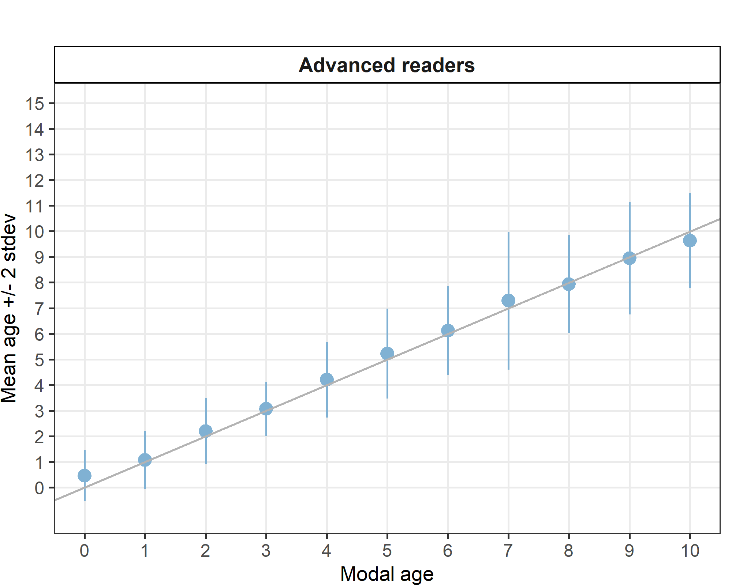
Figure 4.14: Strata_her_3a22 .Age bias plot for advance readers. Mean age recorded +/- 2 stdev of each reader and all readers combined are plotted against modal age. The estimated mean age corresponds to modal age, if the estimated mean age is on the 1:1 equilibrium line (solid line). Relative bias is the age difference between estimated mean age and modal age.
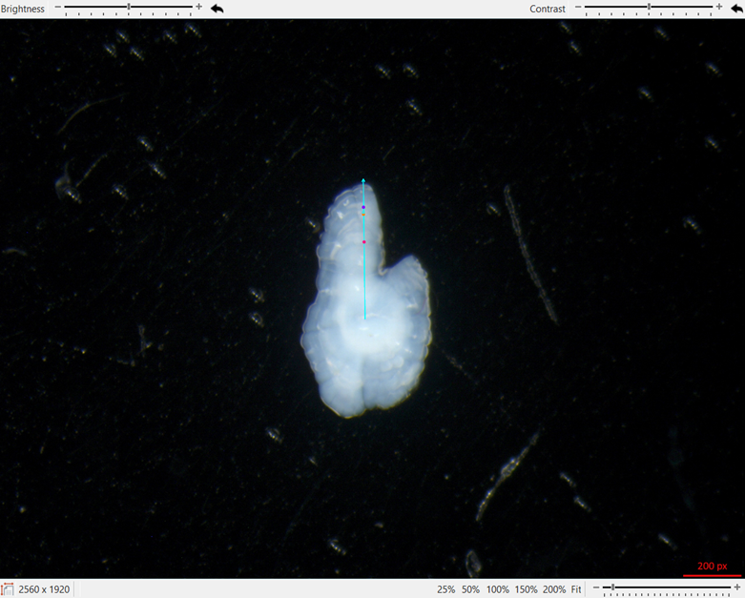
Figure 4.15. Sample ID Bias_05, TL 120mm, Catch date 05_10_2023, ICES Area 27.3.d.24, Genetic population her-3a22, Modal age 0, PA = 55%. Dots represent the annotations of readers estimating the age of the fish to be 1 year old.

Strata_her_4c7d (Downs, genetic population)
Table 4.79: Strata_her_4c7d .Summary of statistics; Total number of samples (NSample), coefficient of variance (CV), percentage of agreement (PA) and average percentage error (APE) for all ages and readers
NSample | CV | PA | APE
15 | 20 % | 85 % | 12 %
Coefficient of Variation (CV)
Table 4.80: Strata_her_4c7d .Coefficient of Variation (CV) table presents the CV per modal age and reader, the CV of all readers combined per modal age and a weighted mean of the CV per reader
Modal age | R01 DK | R02 SE | R03 NO | R04 DE | R05 NO | R06 NO | R07 NO | R08 NO | R09 NO | R10 PL | R12 NO | all
0 | - | - | - | - | - | - | - | - | - | - | - | -
1 | 0 % | 0 % | 71 % | 0 % | 47 % | 0 % | 47 % | 0 % | 0 % | 0 % | 47 % | 43 %
2 | 0 % | 22 % | 57 % | 31 % | 22 % | 22 % | 22 % | 19 % | 19 % | 0 % | 33 % | 32 %
3 | 0 % | 0 % | 0 % | 0 % | 0 % | 0 % | 0 % | 0 % | 0 % | 0 % | 0 % | 0 %
4 | - | - | - | - | - | - | - | - | - | - | - | 0 %
5 | - | - | - | - | - | - | - | - | - | - | - | 6 %
6 | - | - | - | - | - | - | - | - | - | - | - | 0 %
7 | - | - | - | - | - | - | - | - | - | - | - | -
8 | - | - | - | - | - | - | - | - | - | - | - | -
9 | 0 % | 0 % | 0 % | 0 % | 0 % | 0 % | 0 % | 0 % | 8 % | 0 % | 7 % | 5 %
10 | - | - | - | - | - | - | - | - | - | - | - | -
11 | - | - | - | - | - | - | - | - | - | - | - | -
Weighted Mean | 0 % | 11 % | 40 % | 15 % | 19 % | 11 % | 19 % | 9 % | 11 % | 0 % | 26 % | 20 %

Percentage of Agreement (PA)
Table 4.81: Strata_her_4c7d .Percentage agreement (PA) table represents the PA per modal age and reader, the PA of all readers combined per modal age and a weighted mean of the PA per reader.
Modal age | R01 DK | R02 SE | R03 NO | R04 DE | R05 NO | R06 NO | R07 NO | R08 NO | R09 NO | R10 PL | R12 NO | total
0 | - | - | - | - | - | - | - | - | - | - | - | -
1 | 100 % | 100 % | 50 % | 100 % | 50 % | 100 % | 50 % | 100 % | 100 % | 100 % | 50 % | 82 %
2 | 100 % | 83 % | 67 % | 67 % | 67 % | 83 % | 50 % | 83 % | 83 % | 100 % | 67 % | 77 %
3 | 100 % | 100 % | 100 % | 100 % | 100 % | 100 % | 100 % | 100 % | 100 % | 100 % | 100 % | 100 %
4 | 100 % | 100 % | 100 % | 100 % | 100 % | 100 % | 100 % | 100 % | 100 % | 100 % | 100 % | 100 %
5 | 100 % | 100 % | 100 % | 100 % | 100 % | 100 % | 100 % | 100 % | 100 % | 0 % | 100 % | 91 %
6 | 100 % | 100 % | 100 % | 100 % | 100 % | 100 % | 100 % | 100 % | 100 % | 100 % | 100 % | 100 %
7 | - | - | - | - | - | - | - | - | - | - | - | -
8 | - | - | - | - | - | - | - | - | - | - | - | -
9 | 100 % | 100 % | 100 % | 100 % | 100 % | 100 % | 0 % | 100 % | 50 % | 100 % | 50 % | 82 %
10 | - | - | - | - | - | - | - | - | - | - | - | -
11 | - | - | - | - | - | - | - | - | - | - | - | -
Weighted Mean | 100 % | 93 % | 80 % | 87 % | 80 % | 93 % | 60 % | 93 % | 87 % | 93 % | 73 % | 85 %

Average Percentage Error (APE)
Table 4.82: Strata_her_4c7d .Average Percentage Error (APE) table represents the APE per modal age and reader, the APE of all advanced readers combined per modal age and a weighted mean of the APE per reader.
Modal age | R01 DK | R02 SE | R03 NO | R04 DE | R05 NO | R06 NO | R07 NO | R08 NO | R09 NO | R10 PL | R12 NO | all
0 | - | - | - | - | - | - | - | - | - | - | - | -
1 | 0 % | 0 % | 50 % | 0 % | 33 % | 0 % | 33 % | 0 % | 0 % | 0 % | 33 % | 30 %
2 | 0 % | 15 % | 39 % | 27 % | 19 % | 15 % | 20 % | 13 % | 13 % | 0 % | 27 % | 18 %
3 | 0 % | 0 % | 0 % | 0 % | 0 % | 0 % | 0 % | 0 % | 0 % | 0 % | 0 % | 0 %
4 | 0 % | 0 % | 0 % | 0 % | 0 % | 0 % | 0 % | 0 % | 0 % | 0 % | 0 % | 0 %
5 | 0 % | 0 % | 0 % | 0 % | 0 % | 0 % | 0 % | 0 % | 0 % | 0 % | 0 % | 3 %
6 | 0 % | 0 % | 0 % | 0 % | 0 % | 0 % | 0 % | 0 % | 0 % | 0 % | 0 % | 0 %
7 | - | - | - | - | - | - | - | - | - | - | - | -
8 | - | - | - | - | - | - | - | - | - | - | - | -
9 | 0 % | 0 % | 0 % | 0 % | 0 % | 0 % | 0 % | 0 % | 6 % | 0 % | 5 % | 3 %
10 | - | - | - | - | - | - | - | - | - | - | - | -
11 | - | - | - | - | - | - | - | - | - | - | - | -
Weighted Mean | 0 % | 6 % | 22 % | 11 % | 12 % | 6 % | 12 % | 5 % | 6 % | 0 % | 16 % | 12 %

Relative bias
Table 4.83: Strata_her_4c7d . The relative bias (as the difference between the mean and modal age) per modal age and advanced reader is presented, as well as the weighted mean relative bias per reader and the relative bias per modal age for all advanced readers combined.
Modal age | R01 DK | R02 SE | R03 NO | R04 DE | R05 NO | R06 NO | R07 NO | R08 NO | R09 NO | R10 PL | R12 NO | all
0 | - | - | - | - | - | - | - | - | - | - | - | -
1 | 0.00 | 0.00 | 1.00 | 0.00 | 0.50 | 0.00 | 0.50 | 0.00 | 0.00 | 0.00 | 0.50 | 0.23
2 | 0.00 | -0.17 | 0.83 | -0.33 | 0.33 | -0.17 | 0.50 | 0.17 | 0.17 | 0.00 | 0.50 | 0.17
3 | 0.00 | 0.00 | 0.00 | 0.00 | 0.00 | 0.00 | 0.00 | 0.00 | 0.00 | 0.00 | 0.00 | 0.00
4 | 0.00 | 0.00 | 0.00 | 0.00 | 0.00 | 0.00 | 0.00 | 0.00 | 0.00 | 0.00 | 0.00 | 0.00
5 | 0.00 | 0.00 | 0.00 | 0.00 | 0.00 | 0.00 | 0.00 | 0.00 | 0.00 | -1.00 | 0.00 | -0.09
6 | 0.00 | 0.00 | 0.00 | 0.00 | 0.00 | 0.00 | 0.00 | 0.00 | 0.00 | 0.00 | 0.00 | 0.00
7 | - | - | - | - | - | - | - | - | - | - | - | -
8 | - | - | - | - | - | - | - | - | - | - | - | -
9 | 0.00 | 0.00 | 0.00 | 0.00 | 0.00 | 0.00 | 1.00 | 0.00 | -0.50 | 0.00 | 0.50 | 0.09
10 | - | - | - | - | - | - | - | - | - | - | - | -
11 | - | - | - | - | - | - | - | - | - | - | - | -
Weighted Mean | 0.00 | -0.07 | 0.47 | -0.13 | 0.20 | -0.07 | 0.40 | 0.07 | -0.00 | -0.07 | 0.33 | 0.10

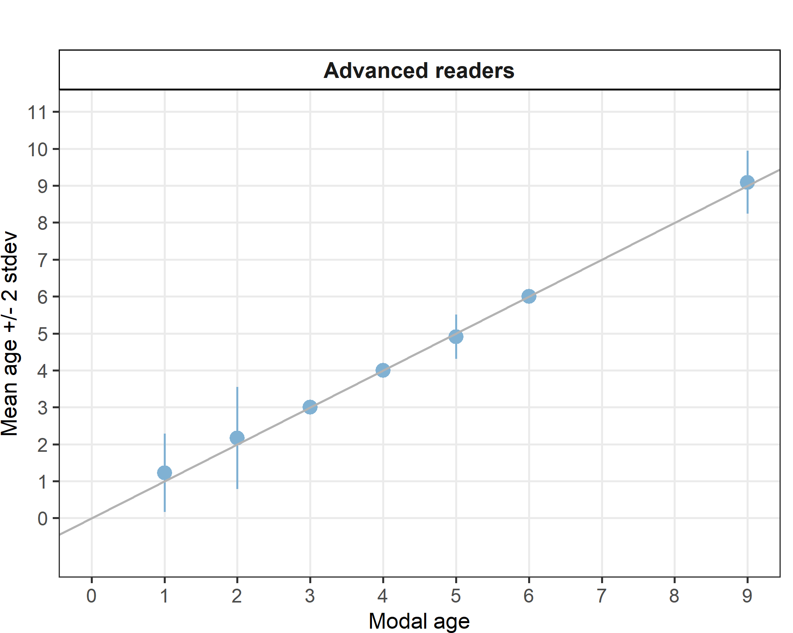
Figure 4.16: Strata_her_4c7d .Age bias plot for advance readers. Mean age recorded +/- 2 stdev of each reader and all readers combined are plotted against modal age. The estimated mean age corresponds to modal age, if the estimated mean age is on the 1:1 equilibrium line (solid line). Relative bias is the age difference between estimated mean age and modal age.

Strata_her_2532_gor (CBSS, genetic population)
Table 4.84: Strata_her_2532_gor .Summary of statistics; Total number of samples (NSample), coefficient of variance (CV), percentage of agreement (PA) and average percentage error (APE) for all ages and readers
NSample | CV | PA | APE
27 | 13 % | 72 % | 8 %
Coefficient of Variation (CV)
Table 4.85: Strata_her_2532_gor .Coefficient of Variation (CV) table presents the CV per modal age and reader, the CV of all readers combined per modal age and a weighted mean of the CV per reader
Modal age | R01 DK | R02 SE | R03 NO | R04 DE | R05 NO | R06 NO | R07 NO | R08 NO | R09 NO | R10 PL | R12 NO | all
0 | - | - | - | - | - | - | - | - | - | - | - | -
1 | - | - | - | - | - | - | - | - | - | - | - | -
2 | 0 % | 0 % | 0 % | 0 % | 0 % | 0 % | 0 % | 0 % | 0 % | 0 % | 0 % | 18 %
3 | 0 % | 0 % | 0 % | 0 % | 0 % | 16 % | 31 % | 17 % | 0 % | 0 % | 0 % | 14 %
4 | 0 % | 0 % | 16 % | 0 % | 16 % | 0 % | 0 % | 16 % | 0 % | 16 % | 0 % | 9 %
5 | 8 % | 8 % | 10 % | 0 % | 15 % | 8 % | 0 % | 10 % | 8 % | 8 % | 13 % | 9 %
6 | 0 % | 21 % | 14 % | 10 % | 14 % | 10 % | 12 % | 0 % | 13 % | 9 % | 12 % | 13 %
7 | 0 % | 24 % | 6 % | 22 % | 15 % | 8 % | 26 % | 23 % | 12 % | 0 % | 7 % | 18 %
8 | - | - | - | - | - | - | - | - | - | - | - | 18 %
9 | - | - | - | - | - | - | - | - | - | - | - | 8 %
10 | - | - | - | - | - | - | - | - | - | - | - | -
11 | - | - | - | - | - | - | - | - | - | - | - | 15 %
Weighted Mean | 2 % | 12 % | 9 % | 6 % | 12 % | 8 % | 12 % | 10 % | 8 % | 6 % | 8 % | 13 %

Percentage of Agreement (PA)
Table 4.86: Strata_her_2532_gor .Percentage agreement (PA) table represents the PA per modal age and reader, the PA of all readers combined per modal age and a weighted mean of the PA per reader.
Modal age | R01 DK | R02 SE | R03 NO | R04 DE | R05 NO | R06 NO | R07 NO | R08 NO | R09 NO | R10 PL | R12 NO | total
0 | - | - | - | - | - | - | - | - | - | - | - | -
1 | - | - | - | - | - | - | - | - | - | - | - | -
2 | 100 % | 100 % | 100 % | 100 % | 0 % | 100 % | 100 % | 100 % | 100 % | 0 % | 100 % | 82 %
3 | 100 % | 100 % | 100 % | 100 % | 100 % | 33 % | 67 % | 67 % | 100 % | 100 % | 100 % | 88 %
4 | 100 % | 100 % | 50 % | 100 % | 50 % | 100 % | 100 % | 50 % | 100 % | 50 % | 100 % | 82 %
5 | 83 % | 83 % | 67 % | 100 % | 83 % | 83 % | 100 % | 67 % | 83 % | 83 % | 67 % | 82 %
6 | 100 % | 43 % | 43 % | 57 % | 29 % | 71 % | 86 % | 100 % | 86 % | 71 % | 86 % | 70 %
7 | 100 % | 25 % | 25 % | 25 % | 67 % | 25 % | 25 % | 50 % | 50 % | 100 % | 75 % | 51 %
8 | 100 % | 0 % | 0 % | 0 % | 0 % | 100 % | 100 % | 0 % | 100 % | 0 % | 100 % | 45 %
9 | 100 % | 0 % | 100 % | 0 % | 100 % | 100 % | 100 % | 100 % | 100 % | 0 % | 100 % | 73 %
10 | - | - | - | - | - | - | - | - | - | - | - | -
11 | 100 % | 0 % | 100 % | 0 % | 100 % | 0 % | 100 % | 100 % | 0 % | 0 % | 0 % | 45 %
Weighted Mean | 96 % | 59 % | 59 % | 67 % | 58 % | 67 % | 81 % | 74 % | 81 % | 67 % | 81 % | 72 %

Average Percentage Error (APE)
Table 4.87: Strata_her_2532_gor .Average Percentage Error (APE) table represents the APE per modal age and reader, the APE of all advanced readers combined per modal age and a weighted mean of the APE per reader.
Modal age | R01 DK | R02 SE | R03 NO | R04 DE | R05 NO | R06 NO | R07 NO | R08 NO | R09 NO | R10 PL | R12 NO | all
0 | - | - | - | - | - | - | - | - | - | - | - | -
1 | - | - | - | - | - | - | - | - | - | - | - | -
2 | 0 % | 0 % | 0 % | 0 % | 0 % | 0 % | 0 % | 0 % | 0 % | 0 % | 0 % | 14 %
3 | 0 % | 0 % | 0 % | 0 % | 0 % | 12 % | 24 % | 13 % | 0 % | 0 % | 0 % | 8 %
4 | 0 % | 0 % | 11 % | 0 % | 11 % | 0 % | 0 % | 11 % | 0 % | 11 % | 0 % | 7 %
5 | 6 % | 6 % | 8 % | 0 % | 10 % | 5 % | 0 % | 8 % | 5 % | 6 % | 7 % | 5 %
6 | 0 % | 14 % | 10 % | 9 % | 8 % | 5 % | 8 % | 0 % | 9 % | 7 % | 8 % | 7 %
7 | 0 % | 17 % | 5 % | 15 % | 12 % | 6 % | 19 % | 17 % | 7 % | 0 % | 5 % | 12 %
8 | 0 % | 0 % | 0 % | 0 % | 0 % | 0 % | 0 % | 0 % | 0 % | 0 % | 0 % | 12 %
9 | 0 % | 0 % | 0 % | 0 % | 0 % | 0 % | 0 % | 0 % | 0 % | 0 % | 0 % | 6 %
10 | - | - | - | - | - | - | - | - | - | - | - | -
11 | 0 % | 0 % | 0 % | 0 % | 0 % | 0 % | 0 % | 0 % | 0 % | 0 % | 0 % | 9 %
Weighted Mean | 1 % | 7 % | 6 % | 5 % | 7 % | 5 % | 8 % | 7 % | 4 % | 4 % | 4 % | 8 %

Relative bias
Table 4.88: Strata_her_2532_gor . The relative bias (as the difference between the mean and modal age) per modal age and advanced reader is presented, as well as the weighted mean relative bias per reader and the relative bias per modal age for all advanced readers combined.
Modal age | R01 DK | R02 SE | R03 NO | R04 DE | R05 NO | R06 NO | R07 NO | R08 NO | R09 NO | R10 PL | R12 NO | all
0 | - | - | - | - | - | - | - | - | - | - | - | -
1 | - | - | - | - | - | - | - | - | - | - | - | -
2 | 0.00 | 0.00 | 0.00 | 0.00 | 1.00 | 0.00 | 0.00 | 0.00 | 0.00 | 1.00 | 0.00 | 0.18
3 | 0.00 | 0.00 | 0.00 | 0.00 | 0.00 | 0.67 | 0.67 | 0.33 | 0.00 | 0.00 | 0.00 | 0.15
4 | 0.00 | 0.00 | 0.50 | 0.00 | 0.50 | 0.00 | 0.00 | 0.50 | 0.00 | 0.50 | 0.00 | 0.18
5 | -0.17 | -0.17 | 0.33 | 0.00 | 0.33 | 0.17 | 0.00 | 0.33 | 0.17 | -0.17 | 0.00 | 0.08
6 | 0.00 | -0.86 | 0.00 | -0.43 | 1.00 | 0.00 | 0.29 | 0.00 | -0.29 | -0.29 | 0.29 | -0.03
7 | 0.00 | -1.75 | 0.75 | -1.25 | 0.67 | -0.75 | 0.25 | 1.25 | 0.00 | 0.00 | 0.25 | -0.05
8 | 0.00 | -3.00 | 1.00 | -1.00 | 1.00 | 0.00 | 0.00 | 3.00 | 0.00 | 1.00 | 0.00 | 0.18
9 | 0.00 | -2.00 | 0.00 | -1.00 | 0.00 | 0.00 | 0.00 | 0.00 | 0.00 | -1.00 | 0.00 | -0.36
10 | - | - | - | - | - | - | - | - | - | - | - | -
11 | 0.00 | -5.00 | 0.00 | -1.00 | 0.00 | -1.00 | 0.00 | 0.00 | -1.00 | -2.00 | -1.00 | -1.00
Weighted Mean | -0.04 | -0.89 | 0.26 | -0.41 | 0.58 | -0.04 | 0.19 | 0.44 | -0.07 | -0.07 | 0.07 | 0.00

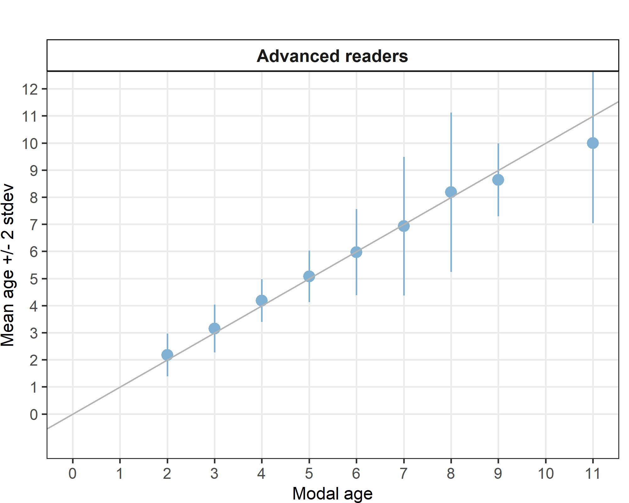
Figure 4.17: Strata_her_2532_gor .Age bias plot for advance readers. Mean age recorded +/- 2 stdev of each reader and all readers combined are plotted against modal age. The estimated mean age corresponds to modal age, if the estimated mean age is on the 1:1 equilibrium line (solid line).

Strata_her_3a (WBSS-SK, genetic population)
Table 4.89: Strata_her_3a .Summary of statistics; Total number of samples (NSample), coefficient of variance (CV), percentage of agreement (PA) and average percentage error (APE) for all ages and readers
NSample | CV | PA | APE
8 | 23 % | 70 % | 18 %
Coefficient of Variation (CV)
Table 4.90: Strata_her_3a .Coefficient of Variation (CV) table presents the CV per modal age and reader, the CV of all readers combined per modal age and a weighted mean of the CV per reader
Modal age | R01 DK | R02 SE | R03 NO | R04 DE | R05 NO | R06 NO | R07 NO | R08 NO | R09 NO | R10 PL | R12 NO | all
0 | - | - | - | - | - | - | - | - | - | - | - | -
1 | 0 % | 0 % | 0 % | 0 % | 28 % | 0 % | 28 % | 0 % | 47 % | 0 % | 71 % | 52 %
2 | - | - | - | - | - | - | - | - | - | - | - | 33 %
3 | - | - | - | - | - | - | - | - | - | - | - | 14 %
4 | - | - | - | - | - | - | - | - | - | - | - | 15 %
5 | - | - | - | - | - | - | - | - | - | - | - | 0 %
6 | - | - | - | - | - | - | - | - | - | - | - | -
7 | - | - | - | - | - | - | - | - | - | - | - | -
8 | 0 % | 8 % | 0 % | 0 % | 8 % | 0 % | 0 % | 7 % | 0 % | 9 % | 0 % | 9 %
9 | - | - | - | - | - | - | - | - | - | - | - | -
10 | - | - | - | - | - | - | - | - | - | - | - | -
11 | - | - | - | - | - | - | - | - | - | - | - | -
Weighted Mean | 0 % | 4 % | 0 % | 0 % | 18 % | 0 % | 14 % | 4 % | 24 % | 5 % | 35 % | 23 %

Percentage of Agreement (PA)
Table 4.91: Strata_her_3a .Percentage agreement (PA) table represents the PA per modal age and reader, the PA of all readers combined per modal age and a weighted mean of the PA per reader.
Modal age | R01 DK | R02 SE | R03 NO | R04 DE | R05 NO | R06 NO | R07 NO | R08 NO | R09 NO | R10 PL | R12 NO | total
0 | - | - | - | - | - | - | - | - | - | - | - | -
1 | 100 % | 100 % | 100 % | 100 % | 0 % | 100 % | 0 % | 100 % | 50 % | 100 % | 50 % | 73 %
2 | 100 % | 100 % | 0 % | 100 % | 100 % | 0 % | 0 % | 100 % | 100 % | 0 % | 100 % | 64 %
3 | 100 % | 100 % | 100 % | 100 % | 100 % | 100 % | 0 % | 100 % | 0 % | 100 % | 100 % | 82 %
4 | 100 % | 100 % | 0 % | 100 % | 100 % | 100 % | 0 % | 0 % | 100 % | 100 % | 100 % | 73 %
5 | 100 % | 100 % | 100 % | 100 % | 100 % | 100 % | 100 % | 100 % | 100 % | 100 % | 100 % | 100 %
6 | - | - | - | - | - | - | - | - | - | - | - | -
7 | - | - | - | - | - | - | - | - | - | - | - | -
8 | 0 % | 50 % | 0 % | 100 % | 50 % | 100 % | 0 % | 0 % | 100 % | 50 % | 100 % | 50 %
9 | - | - | - | - | - | - | - | - | - | - | - | -
10 | - | - | - | - | - | - | - | - | - | - | - | -
11 | - | - | - | - | - | - | - | - | - | - | - | -
Weighted Mean | 75 % | 88 % | 50 % | 100 % | 62 % | 88 % | 12 % | 62 % | 75 % | 75 % | 88 % | 70 %

Average Percentage Error (APE)
Table 4.92: Strata_her_3a .Average Percentage Error (APE) table represents the APE per modal age and reader, the APE of all advanced readers combined per modal age and a weighted mean of the APE per reader.
Modal age | R01 DK | R02 SE | R03 NO | R04 DE | R05 NO | R06 NO | R07 NO | R08 NO | R09 NO | R10 PL | R12 NO | all
0 | - | - | - | - | - | - | - | - | - | - | - | -
1 | 0 % | 0 % | 0 % | 0 % | 20 % | 0 % | 20 % | 0 % | 33 % | 0 % | 50 % | 42 %
2 | 0 % | 0 % | 0 % | 0 % | 0 % | 0 % | 0 % | 0 % | 0 % | 0 % | 0 % | 25 %
3 | 0 % | 0 % | 0 % | 0 % | 0 % | 0 % | 0 % | 0 % | 0 % | 0 % | 0 % | 11 %
4 | 0 % | 0 % | 0 % | 0 % | 0 % | 0 % | 0 % | 0 % | 0 % | 0 % | 0 % | 12 %
5 | 0 % | 0 % | 0 % | 0 % | 0 % | 0 % | 0 % | 0 % | 0 % | 0 % | 0 % | 0 %
6 | - | - | - | - | - | - | - | - | - | - | - | -
7 | - | - | - | - | - | - | - | - | - | - | - | -
8 | 0 % | 6 % | 0 % | 0 % | 6 % | 0 % | 0 % | 5 % | 0 % | 7 % | 0 % | 8 %
9 | - | - | - | - | - | - | - | - | - | - | - | -
10 | - | - | - | - | - | - | - | - | - | - | - | -
11 | - | - | - | - | - | - | - | - | - | - | - | -
Weighted Mean | 0 % | 1 % | 0 % | 0 % | 6 % | 0 % | 5 % | 1 % | 8 % | 2 % | 12 % | 18 %

Relative bias
Table 4.93: Strata_her_3a . The relative bias (as the difference between the mean and modal age) per modal age and advanced reader is presented, as well as the weighted mean relative bias per reader and the relative bias per modal age for all advanced readers combined.
Modal age | R01 DK | R02 SE | R03 NO | R04 DE | R05 NO | R06 NO | R07 NO | R08 NO | R09 NO | R10 PL | R12 NO | all
0 | - | - | - | - | - | - | - | - | - | - | - | -
1 | 0.00 | 0.00 | 0.00 | 0.00 | 1.50 | 0.00 | 1.50 | 0.00 | 0.50 | 0.00 | 1.00 | 0.41
2 | 0.00 | 0.00 | -1.00 | 0.00 | 0.00 | -1.00 | 1.00 | 0.00 | 0.00 | -1.00 | 0.00 | -0.18
3 | 0.00 | 0.00 | 0.00 | 0.00 | 0.00 | 0.00 | -1.00 | 0.00 | -1.00 | 0.00 | 0.00 | -0.18
4 | 0.00 | 0.00 | 2.00 | 0.00 | 0.00 | 0.00 | 1.00 | 1.00 | 0.00 | 0.00 | 0.00 | 0.36
5 | 0.00 | 0.00 | 0.00 | 0.00 | 0.00 | 0.00 | 0.00 | 0.00 | 0.00 | 0.00 | 0.00 | 0.00
6 | - | - | - | - | - | - | - | - | - | - | - | -
7 | - | - | - | - | - | - | - | - | - | - | - | -
8 | 1.00 | 0.50 | 1.00 | 0.00 | 0.50 | 0.00 | 2.00 | 1.50 | 0.00 | -0.50 | 0.00 | 0.55
9 | - | - | - | - | - | - | - | - | - | - | - | -
10 | - | - | - | - | - | - | - | - | - | - | - | -
11 | - | - | - | - | - | - | - | - | - | - | - | -
Weighted Mean | 0.25 | 0.12 | 0.38 | 0.00 | 0.50 | -0.12 | 1.00 | 0.50 | 0.00 | -0.25 | 0.25 | 0.24

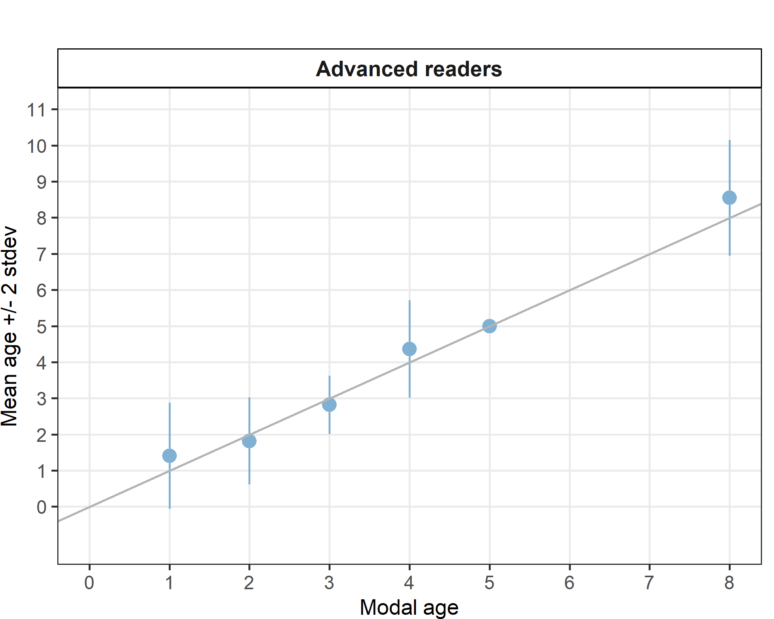
Figure 4.18: Strata_her_3a .Age bias plot for advance readers. Mean age recorded +/- 2 stdev of each reader and all readers combined are plotted against modal age. The estimated mean age corresponds to modal age, if the estimated mean age is on the 1:1 equilibrium line (solid line).

Strata_her_riga (BASH, genetic population)
Table 4.94: Strata_her_riga .Summary of statistics; Total number of samples (NSample), coefficient of variance (CV), percentage of agreement (PA) and average percentage error (APE) for all ages and readers
NSample | CV | PA | APE
33 | 24 % | 73 % | 15 %

Coefficient of Variation (CV)
Table 4.95: Strata_her_riga .Coefficient of Variation (CV) table presents the CV per modal age and reader, the CV of all readers combined per modal age and a weighted mean of the CV per reader
Modal age | R01 DK | R02 SE | R03 NO | R04 DE | R05 NO | R06 NO | R07 NO | R08 NO | R09 NO | R10 PL | R12 NO | all
0 | - | - | - | - | - | - | - | - | - | - | - | -
1 | 91 % | 91 % | - | 91 % | 37 % | 0 % | 37 % | 0 % | 37 % | 91 % | 64 % | 63 %
2 | 20 % | 0 % | 20 % | 0 % | 16 % | 30 % | 21 % | 0 % | 0 % | 30 % | 20 % | 21 %
3 | 0 % | 18 % | 26 % | 18 % | 15 % | 29 % | 40 % | 15 % | 18 % | 0 % | 0 % | 23 %
4 | 13 % | 29 % | 12 % | 12 % | 0 % | 20 % | 0 % | 12 % | 0 % | 12 % | 12 % | 14 %
5 | 0 % | 16 % | 0 % | 0 % | 0 % | 13 % | 13 % | 0 % | 13 % | 0 % | 0 % | 8 %
6 | 0 % | 0 % | 0 % | 10 % | 0 % | 0 % | 0 % | 0 % | 0 % | 10 % | 0 % | 4 %
7 | 7 % | 29 % | 7 % | 24 % | 12 % | 43 % | 0 % | 19 % | 15 % | 17 % | 14 % | 21 %
8 | - | - | - | - | - | - | - | - | - | - | - | 7 %
9 | - | - | - | - | - | - | - | - | - | - | - | 21 %
10 | - | - | - | - | - | - | - | - | - | - | - | -
11 | - | - | - | - | - | - | - | - | - | - | - | -
Weighted Mean | 23 % | 25 % | 14 % | 23 % | 14 % | 21 % | 18 % | 6 % | 11 % | 28 % | 19 % | 24 %

Percentage of Agreement (PA)
Table 4.96: Strata_her_riga .Percentage agreement (PA) table represents the PA per modal age and reader, the PA of all readers combined per modal age and a weighted mean of the PA per reader.
Modal age | R01 DK | R02 SE | R03 NO | R04 DE | R05 NO | R06 NO | R07 NO | R08 NO | R09 NO | R10 PL | R12 NO | total
0 | - | - | - | - | - | - | - | - | - | - | - | -
1 | 60 % | 60 % | 40 % | 60 % | 80 % | 100 % | 80 % | 100 % | 80 % | 60 % | 80 % | 73 %
2 | 78 % | 100 % | 78 % | 100 % | 22 % | 44 % | 67 % | 100 % | 100 % | 67 % | 78 % | 76 %
3 | 100 % | 75 % | 50 % | 75 % | 75 % | 75 % | 75 % | 75 % | 75 % | 100 % | 100 % | 80 %
4 | 75 % | 75 % | 75 % | 75 % | 100 % | 50 % | 100 % | 75 % | 100 % | 75 % | 75 % | 80 %
5 | 100 % | 50 % | 100 % | 100 % | 100 % | 50 % | 50 % | 100 % | 50 % | 100 % | 100 % | 82 %
6 | 100 % | 100 % | 100 % | 67 % | 100 % | 100 % | 100 % | 100 % | 100 % | 67 % | 100 % | 94 %
7 | 75 % | 25 % | 75 % | 25 % | 50 % | 50 % | 100 % | 50 % | 75 % | 25 % | 25 % | 52 %
8 | 100 % | 100 % | 100 % | 0 % | 0 % | 100 % | 100 % | 100 % | 0 % | 0 % | 0 % | 55 %
9 | 0 % | 0 % | 100 % | 0 % | 100 % | 0 % | 100 % | 100 % | 0 % | 0 % | 0 % | 36 %
10 | - | - | - | - | - | - | - | - | - | - | - | -
11 | - | - | - | - | - | - | - | - | - | - | - | -
Weighted Mean | 79 % | 73 % | 73 % | 70 % | 64 % | 64 % | 82 % | 88 % | 82 % | 64 % | 73 % | 73 %

Average Percentage Error (APE)
Table 4.97: Strata_her_riga .Average Percentage Error (APE) table represents the APE per modal age and reader, the APE of all advanced readers combined per modal age and a weighted mean of the APE per reader.
Modal age | R01 DK | R02 SE | R03 NO | R04 DE | R05 NO | R06 NO | R07 NO | R08 NO | R09 NO | R10 PL | R12 NO | all
0 | - | - | - | - | - | - | - | - | - | - | - | -
1 | 80 % | 80 % | - | 80 % | 27 % | 0 % | 27 % | 0 % | 27 % | 60 % | 46 % | 33 %
2 | 16 % | 0 % | 16 % | 0 % | 12 % | 25 % | 19 % | 0 % | 0 % | 24 % | 16 % | 17 %
3 | 0 % | 14 % | 20 % | 14 % | 12 % | 21 % | 30 % | 12 % | 14 % | 0 % | 0 % | 13 %
4 | 10 % | 21 % | 9 % | 9 % | 0 % | 16 % | 0 % | 9 % | 0 % | 9 % | 9 % | 8 %
5 | 0 % | 11 % | 0 % | 0 % | 0 % | 9 % | 9 % | 0 % | 9 % | 0 % | 0 % | 5 %
6 | 0 % | 0 % | 0 % | 8 % | 0 % | 0 % | 0 % | 0 % | 0 % | 8 % | 0 % | 2 %
7 | 6 % | 24 % | 5 % | 17 % | 10 % | 32 % | 0 % | 13 % | 12 % | 13 % | 11 % | 16 %
8 | 0 % | 0 % | 0 % | 0 % | 0 % | 0 % | 0 % | 0 % | 0 % | 0 % | 0 % | 7 %
9 | 0 % | 0 % | 0 % | 0 % | 0 % | 0 % | 0 % | 0 % | 0 % | 0 % | 0 % | 18 %
10 | - | - | - | - | - | - | - | - | - | - | - | -
11 | - | - | - | - | - | - | - | - | - | - | - | -
Weighted Mean | 18 % | 20 % | 10 % | 18 % | 10 % | 16 % | 13 % | 4 % | 8 % | 19 % | 14 % | 15 %

Relative bias
Table 4.98: Strata_her_riga . The relative bias (as the difference between the mean and modal age) per modal age and advanced reader is presented, as well as the weighted mean relative bias per reader and the relative bias per modal age for all advanced readers combined.
Modal age | R01 DK | R02 SE | R03 NO | R04 DE | R05 NO | R06 NO | R07 NO | R08 NO | R09 NO | R10 PL | R12 NO | all
0 | - | - | - | - | - | - | - | - | - | - | - | -
1 | -0.40 | -0.40 | -0.20 | -0.40 | 0.20 | 0.00 | 0.20 | 0.00 | 0.20 | 0.20 | 0.40 | -0.02
2 | 0.22 | 0.00 | 0.22 | 0.00 | 0.78 | 0.33 | 0.33 | 0.00 | 0.00 | 0.44 | 0.22 | 0.23
3 | 0.00 | -0.25 | 0.75 | -0.25 | 0.25 | 0.50 | 0.75 | 0.25 | -0.25 | 0.00 | 0.00 | 0.16
4 | -0.25 | -0.50 | 0.25 | 0.25 | 0.00 | 0.75 | 0.00 | 0.25 | 0.00 | 0.25 | 0.25 | 0.11
5 | 0.00 | -0.50 | 0.00 | 0.00 | 0.00 | 0.50 | 0.50 | 0.00 | 0.50 | 0.00 | 0.00 | 0.09
6 | 0.00 | 0.00 | 0.00 | -0.33 | 0.00 | 0.00 | 0.00 | 0.00 | 0.00 | -0.33 | 0.00 | -0.06
7 | -0.25 | -1.75 | 0.25 | -1.75 | 0.75 | -1.50 | 0.00 | -0.25 | -0.50 | -1.25 | -0.25 | -0.59
8 | 0.00 | 0.00 | 0.00 | -1.00 | -1.00 | 0.00 | 0.00 | 0.00 | -1.00 | -1.00 | -1.00 | -0.45
9 | -1.00 | -4.00 | 0.00 | -2.00 | 0.00 | -4.00 | 0.00 | 0.00 | -3.00 | -1.00 | -2.00 | -1.55
10 | - | - | - | - | - | - | - | - | - | - | - | -
11 | - | - | - | - | - | - | - | - | - | - | - | -
Weighted Mean | -0.09 | -0.52 | 0.18 | -0.39 | 0.33 | -0.03 | 0.24 | 0.03 | -0.15 | -0.06 | 0.03 | -0.04

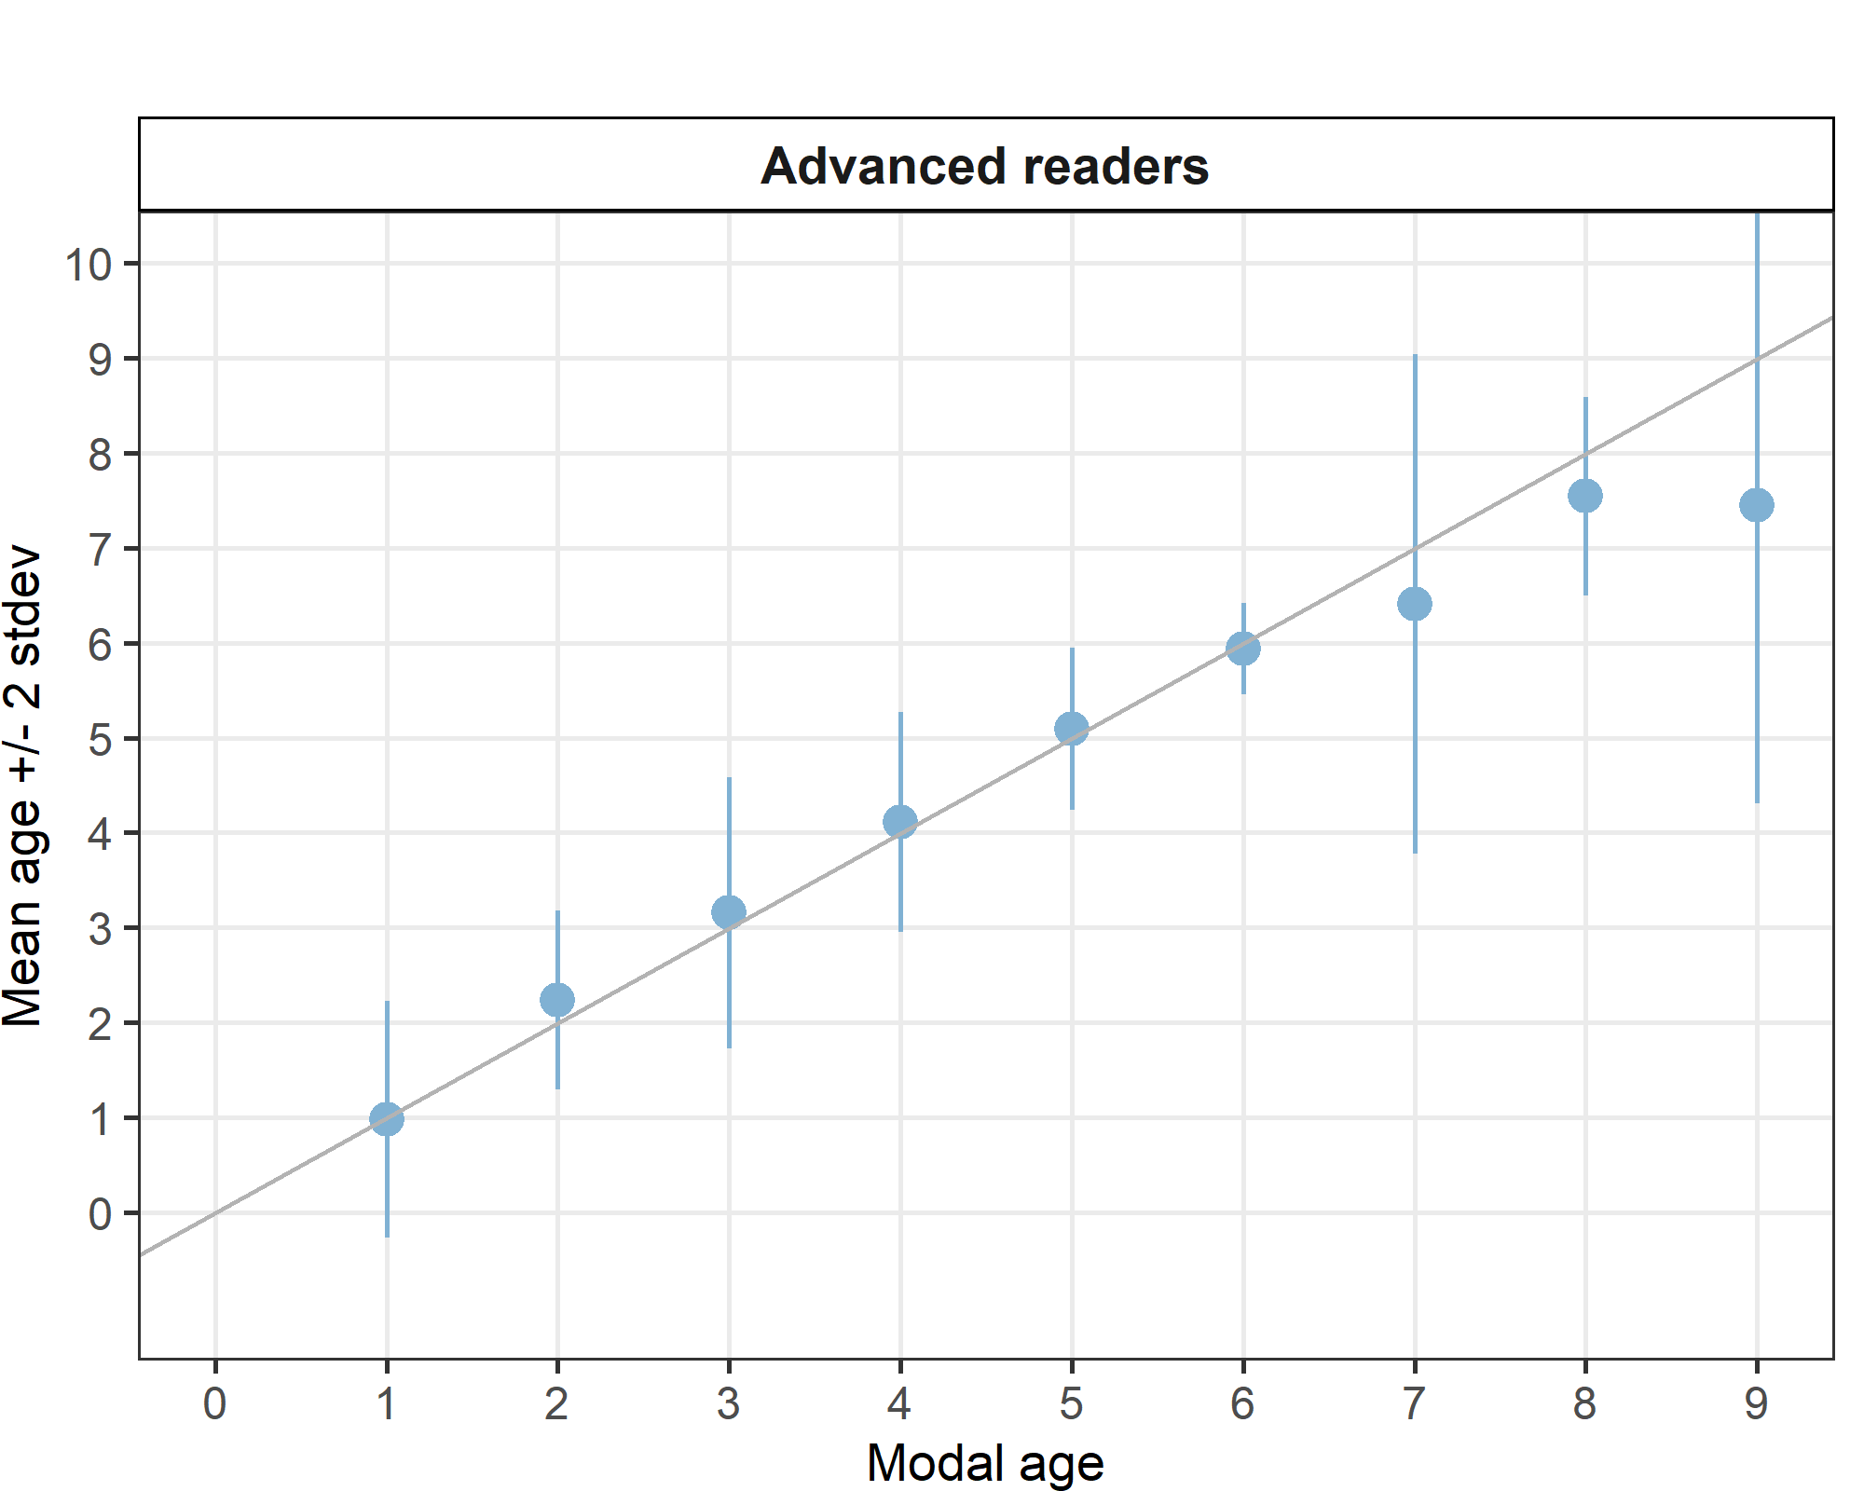
Figure 4.19: Strata_her_riga .Age bias plot for advance readers. Mean age recorded +/- 2 stdev of each reader and all readers combined are plotted against modal age. The estimated mean age corresponds to modal age, if the estimated mean age is on the 1:1 equilibrium line (solid line).

Strata_her_47d3 (NSAS, genetic population)
Table 4.99: Strata_her_47d3 .Summary of statistics; Total number of samples (NSample), coefficient of variance (CV), percentage of agreement (PA) and average percentage error (APE) for all ages and readers
NSample | CV | PA | APE
29 | 12 % | 86 % | 8 %
Coefficient of Variation (CV)
Table 4.100: Strata_her_47d3 .Coefficient of Variation (CV) table presents the CV per modal age and reader, the CV of all readers combined per modal age and a weighted mean of the CV per reader
Modal age | R01 DK | R02 SE | R03 NO | R04 DE | R05 NO | R06 NO | R07 NO | R08 NO | R09 NO | R10 PL | R12 NO | all
0 | - | - | - | - | - | - | - | - | - | - | - | -
1 | - | - | 0 % | - | 0 % | - | 0 % | 0 % | 0 % | - | 0 % | 56 %
2 | 0 % | 0 % | 22 % | 0 % | 22 % | 0 % | 0 % | 0 % | 0 % | 22 % | 0 % | 12 %
3 | 0 % | 0 % | 22 % | 0 % | 16 % | 14 % | 14 % | 14 % | 0 % | 0 % | 0 % | 13 %
4 | 0 % | 0 % | 12 % | 0 % | 0 % | 0 % | 12 % | 0 % | 0 % | 0 % | 0 % | 5 %
5 | - | - | - | - | - | - | - | - | - | - | - | -
6 | - | - | - | - | - | - | - | - | - | - | - | 5 %
7 | - | - | - | - | - | - | - | - | - | - | - | 0 %
8 | 0 % | 6 % | 6 % | 12 % | 7 % | 6 % | 0 % | 7 % | 6 % | 15 % | 0 % | 8 %
9 | 0 % | 11 % | 6 % | 0 % | 0 % | 0 % | 5 % | 5 % | 0 % | 6 % | 5 % | 5 %
10 | - | - | - | - | - | - | - | - | - | - | - | -
11 | - | - | - | - | - | - | - | - | - | - | - | -
Weighted Mean | 0 % | 4 % | 12 % | 3 % | 8 % | 4 % | 5 % | 5 % | 1 % | 9 % | 1 % | 12 %

Percentage of Agreement (PA)
Table 4.101: Strata_her_47d3 .Percentage agreement (PA) table represents the PA per modal age and reader, the PA of all readers combined per modal age and a weighted mean of the PA per reader.
Modal age | R01 DK | R02 SE | R03 NO | R04 DE | R05 NO | R06 NO | R07 NO | R08 NO | R09 NO | R10 PL | R12 NO | total
0 | 100 % | 100 % | 100 % | 100 % | 100 % | 100 % | 0 % | 100 % | 100 % | 100 % | 100 % | 91 %
1 | 50 % | 50 % | 100 % | 50 % | 100 % | 50 % | 100 % | 100 % | 100 % | 50 % | 100 % | 77 %
2 | 100 % | 100 % | 75 % | 100 % | 75 % | 100 % | 100 % | 100 % | 100 % | 75 % | 100 % | 93 %
3 | 100 % | 100 % | 40 % | 100 % | 60 % | 80 % | 80 % | 80 % | 100 % | 100 % | 100 % | 85 %
4 | 100 % | 100 % | 75 % | 100 % | 100 % | 100 % | 75 % | 100 % | 100 % | 100 % | 100 % | 95 %
5 | - | - | - | - | - | - | - | - | - | - | - | -
6 | 100 % | 100 % | 100 % | 100 % | 100 % | 100 % | 100 % | 100 % | 100 % | 0 % | 100 % | 91 %
7 | 100 % | 100 % | 100 % | 100 % | 100 % | 100 % | 100 % | 100 % | 100 % | 100 % | - | 100 %
8 | 100 % | 80 % | 40 % | 40 % | 60 % | 80 % | 100 % | 60 % | 80 % | 40 % | 100 % | 71 %
9 | 100 % | 60 % | 60 % | 100 % | 100 % | 100 % | 80 % | 80 % | 100 % | 60 % | 80 % | 84 %
10 | - | - | - | - | - | - | - | - | - | - | - | -
11 | - | - | - | - | - | - | - | - | - | - | - | -
Weighted Mean | 97 % | 86 % | 66 % | 86 % | 83 % | 90 % | 83 % | 86 % | 97 % | 72 % | 96 % | 86 %

Average Percentage Error (APE)
Table 4.102: Strata_her_47d3 .Average Percentage Error (APE) table represents the APE per modal age and reader, the APE of all advanced readers combined per modal age and a weighted mean of the APE per reader.
Modal age | R01 DK | R02 SE | R03 NO | R04 DE | R05 NO | R06 NO | R07 NO | R08 NO | R09 NO | R10 PL | R12 NO | all
0 | - | - | - | - | - | - | - | - | - | - | - | -
1 | - | - | 0 % | - | 0 % | - | 0 % | 0 % | 0 % | - | 0 % | 45 %
2 | 0 % | 0 % | 17 % | 0 % | 17 % | 0 % | 0 % | 0 % | 0 % | 17 % | 0 % | 6 %
3 | 0 % | 0 % | 17 % | 0 % | 14 % | 10 % | 10 % | 10 % | 0 % | 0 % | 0 % | 9 %
4 | 0 % | 0 % | 9 % | 0 % | 0 % | 0 % | 9 % | 0 % | 0 % | 0 % | 0 % | 2 %
5 | - | - | - | - | - | - | - | - | - | - | - | -
6 | 0 % | 0 % | 0 % | 0 % | 0 % | 0 % | 0 % | 0 % | 0 % | 0 % | 0 % | 3 %
7 | 0 % | 0 % | 0 % | 0 % | 0 % | 0 % | 0 % | 0 % | 0 % | 0 % | - | 0 %
8 | 0 % | 4 % | 6 % | 9 % | 6 % | 4 % | 0 % | 6 % | 4 % | 12 % | 0 % | 4 %
9 | 0 % | 9 % | 5 % | 0 % | 0 % | 0 % | 3 % | 3 % | 0 % | 6 % | 4 % | 2 %
10 | - | - | - | - | - | - | - | - | - | - | - | -
11 | - | - | - | - | - | - | - | - | - | - | - | -
Weighted Mean | 0 % | 3 % | 9 % | 2 % | 6 % | 3 % | 4 % | 4 % | 1 % | 6 % | 1 % | 8 %

Relative bias
Table 4.103: Strata_her_47d3 . The relative bias (as the difference between the mean and modal age) per modal age and advanced reader is presented, as well as the weighted mean relative bias per reader and the relative bias per modal age for all advanced readers combined.
Modal age | R01 DK | R02 SE | R03 NO | R04 DE | R05 NO | R06 NO | R07 NO | R08 NO | R09 NO | R10 PL | R12 NO | all
0 | 0.00 | 0.00 | 0.00 | 0.00 | 0.00 | 0.00 | 1.00 | 0.00 | 0.00 | 0.00 | 0.00 | 0.09
1 | -0.50 | -0.50 | 0.00 | -0.50 | 0.00 | -0.50 | 0.00 | 0.00 | 0.00 | -0.50 | 0.00 | -0.23
2 | 0.00 | 0.00 | 0.25 | 0.00 | 0.25 | 0.00 | 0.00 | 0.00 | 0.00 | 0.25 | 0.00 | 0.07
3 | 0.00 | 0.00 | 0.80 | 0.00 | 0.40 | 0.20 | 0.20 | 0.20 | 0.00 | 0.00 | 0.00 | 0.16
4 | 0.00 | 0.00 | 0.25 | 0.00 | 0.00 | 0.00 | 0.25 | 0.00 | 0.00 | 0.00 | 0.00 | 0.05
5 | - | - | - | - | - | - | - | - | - | - | - | -
6 | 0.00 | 0.00 | 0.00 | 0.00 | 0.00 | 0.00 | 0.00 | 0.00 | 0.00 | -1.00 | 0.00 | -0.09
7 | 0.00 | 0.00 | 0.00 | 0.00 | 0.00 | 0.00 | 0.00 | 0.00 | 0.00 | 0.00 | - | -
8 | 0.00 | -0.20 | 0.60 | -0.80 | 0.40 | -0.20 | 0.00 | 0.40 | -0.20 | -0.40 | 0.00 | -0.04
9 | 0.00 | -0.60 | 0.40 | 0.00 | 0.00 | 0.00 | 0.20 | 0.20 | 0.00 | -0.40 | -0.20 | -0.04
10 | - | - | - | - | - | - | - | - | - | - | - | -
11 | - | - | - | - | - | - | - | - | - | - | - | -
Weighted Mean | -0.03 | -0.17 | 0.38 | -0.17 | 0.17 | -0.03 | 0.17 | 0.14 | -0.03 | -0.17 | -0.04 | 0.02

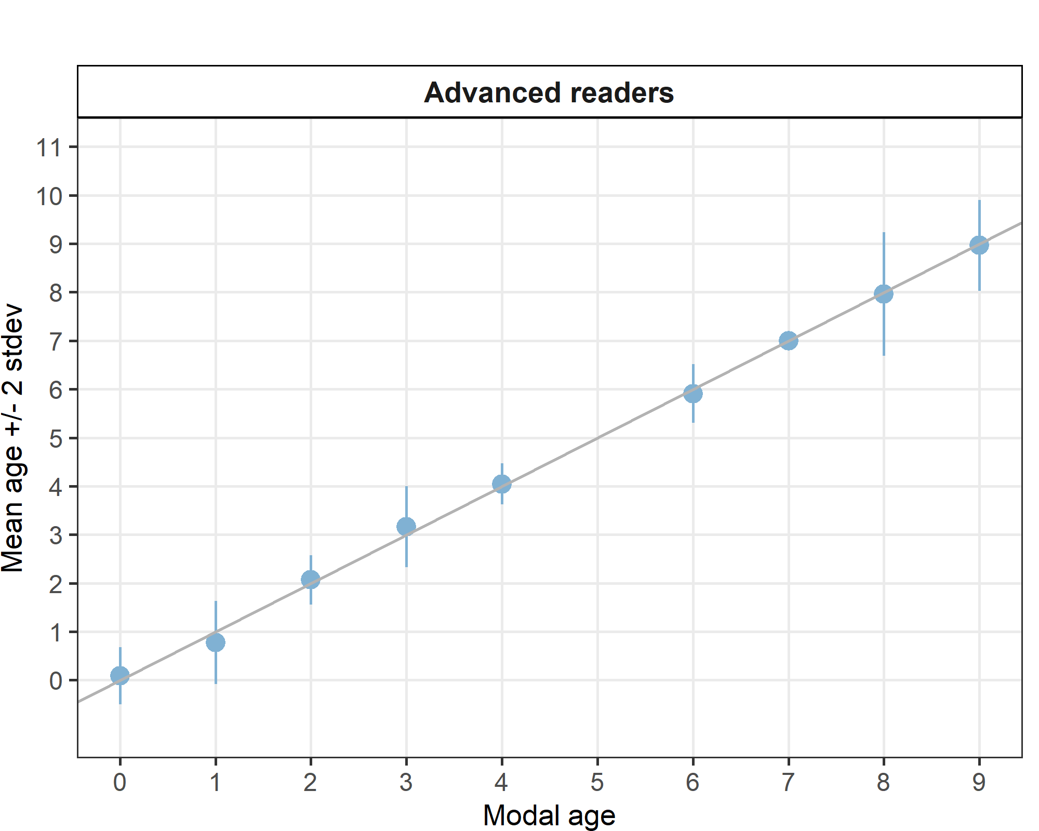
Figure 4.20: Strata Strata_her_47d3 .Age bias plot for advance readers. Mean age recorded +/- 2 stdev of each reader and all readers combined are plotted against modal age. The estimated mean age corresponds to modal age, if the estimated mean age is on the 1:1 equilibrium line (solid line).

Overall comparison of results by genetic population
Table 4.104: Number of age readings per strata (genetic population) and modal age for all advanced readers combined.
Modal age | her_2532_gor | her_3a | her_3a22 | her_47d3 | her_4ab | her_4c7d | her_noss | her_riga | total
0 | 0 | 0 | 55 | 22 | 0 | 0 | 0 | 0 | 77
1 | 0 | 22 | 119 | 22 | 0 | 22 | 0 | 55 | 240
2 | 22 | 11 | 283 | 44 | 0 | 66 | 0 | 98 | 524
3 | 33 | 11 | 308 | 55 | 11 | 22 | 0 | 44 | 484
4 | 22 | 11 | 361 | 44 | 0 | 11 | 11 | 44 | 504
5 | 66 | 11 | 358 | 0 | 0 | 11 | 0 | 22 | 468
6 | 77 | 0 | 272 | 11 | 0 | 11 | 0 | 33 | 404
7 | 43 | 0 | 117 | 10 | 0 | 0 | 0 | 44 | 214
8 | 11 | 22 | 121 | 55 | 0 | 0 | 0 | 11 | 220
9 | 11 | 0 | 87 | 55 | 0 | 22 | 0 | 11 | 186
10 | 0 | 0 | 11 | 0 | 0 | 0 | 0 | 0 | 11
11 | 11 | 0 | 0 | 0 | 0 | 0 | 0 | 0 | 11
Total | 296 | 88 | 2092 | 318 | 11 | 165 | 11 | 362 | 3343
Coefficient of Variation (CV)
Table 4.105: CV per strata (genetic population) and modal age for all advanced readers combined.
Modal age | her_2532_gor | her_3a | her_3a22 | her_47d3 | her_4ab | her_4c7d | her_noss | her_riga | all
0 | - | - | - | - | - | - | - | - | -
1 | - | 52 % | 53 % | 56 % | - | 43 % | - | 63 % | 56 %
2 | 18 % | 33 % | 29 % | 12 % | - | 32 % | - | 21 % | 27 %
3 | 14 % | 14 % | 17 % | 13 % | 0 % | 0 % | - | 23 % | 17 %
4 | 9 % | 15 % | 18 % | 5 % | - | 0 % | 17 % | 14 % | 16 %
5 | 9 % | 0 % | 17 % | - | - | 6 % | - | 8 % | 15 %
6 | 13 % | - | 14 % | 5 % | - | 0 % | - | 4 % | 13 %
7 | 18 % | - | 18 % | 0 % | - | - | - | 21 % | 19 %
8 | 18 % | 9 % | 12 % | 8 % | - | - | - | 7 % | 11 %
9 | 8 % | - | 12 % | 5 % | - | 5 % | - | 21 % | 11 %
10 | - | - | 10 % | - | - | - | - | - | 10 %
11 | 15 % | - | - | - | - | - | - | - | 15 %
Weighted Mean | 13 % | 23 % | 20 % | 12 % | 0 % | 20 % | 17 % | 24 % | 20 %
Percentage of Agreement (PA)
Table 4.106: Percentage Agreement per strata (genetic population) and modal age for all advanced readers combined.
Modal age | her_2532_gor | her_3a | her_3a22 | her_47d3 | her_4ab | her_4c7d | her_noss | her_riga | total
0 | - | - | 55 % | 91 % | - | - | - | - | 65 %
1 | - | 73 % | 84 % | 77 % | - | 82 % | - | 73 % | 80 %
2 | 82 % | 64 % | 79 % | 93 % | - | 77 % | - | 76 % | 79 %
3 | 88 % | 82 % | 84 % | 85 % | 100 % | 100 % | - | 80 % | 85 %
4 | 82 % | 73 % | 78 % | 95 % | - | 100 % | 55 % | 80 % | 80 %
5 | 82 % | 100 % | 81 % | - | - | 91 % | - | 82 % | 82 %
6 | 70 % | - | 70 % | 91 % | - | 100 % | - | 94 % | 74 %
7 | 51 % | - | 58 % | 100 % | - | - | - | 52 % | 57 %
8 | 45 % | 50 % | 64 % | 71 % | - | - | - | 55 % | 63 %
9 | 73 % | - | 60 % | 84 % | - | 82 % | - | 36 % | 69 %
10 | - | - | 82 % | - | - | - | - | - | 82 %
11 | 45 % | - | - | - | - | - | - | - | 45 %
Weighted Mean | 72 % | 70 % | 76 % | 86 % | 100 % | 85 % | 55 % | 73 % | 76 %
Average Percentage Error (APE)
Table 4.107: Average Percentage Error per strata (genetic population) and modal age for all advanced readers combined.
Modal age | her_2532_gor | her_3a | her_3a22 | her_47d3 | her_4ab | her_4c7d | her_noss | her_riga | all
0 | - | - | - | - | - | - | - | - | -
1 | - | 42 % | 24 % | 45 % | - | 30 % | - | 33 % | 28 %
2 | 14 % | 25 % | 18 % | 6 % | - | 18 % | - | 17 % | 17 %
3 | 8 % | 11 % | 8 % | 9 % | 0 % | 0 % | - | 13 % | 8 %
4 | 7 % | 12 % | 11 % | 2 % | - | 0 % | 14 % | 8 % | 9 %
5 | 5 % | 0 % | 10 % | - | - | 3 % | - | 5 % | 8 %
6 | 7 % | - | 8 % | 3 % | - | 0 % | - | 2 % | 7 %
7 | 12 % | - | 12 % | 0 % | - | - | - | 16 % | 10 %
8 | 12 % | 8 % | 7 % | 4 % | - | - | - | 7 % | 6 %
9 | 6 % | - | 7 % | 2 % | - | 3 % | - | 18 % | 6 %
10 | - | - | 6 % | - | - | - | - | - | 6 %
11 | 9 % | - | - | - | - | - | - | - | 9 %
Weighted Mean | 8 % | 18 % | 11 % | 8 % | 0 % | 12 % | 14 % | 15 % | 11 %

Relative bias
Table 4.108: Relative Bias per strata (genetic population) and modal age for all advanced readers combined.
Modal age | her_2532_gor | her_3a | her_3a22 | her_47d3 | her_4ab | her_4c7d | her_noss | her_riga | all
0 | - | - | 0.45 | 0.09 | - | - | - | - | -
1 | - | 0.41 | 0.07 | -0.23 | - | 0.23 | - | -0.02 | -
2 | 0.18 | -0.18 | 0.19 | 0.07 | - | 0.17 | - | 0.23 | -
3 | 0.15 | -0.18 | 0.06 | 0.16 | 0.00 | 0.00 | - | 0.16 | -
4 | 0.18 | 0.36 | 0.20 | 0.05 | - | 0.00 | -0.27 | 0.11 | -
5 | 0.08 | 0.00 | 0.23 | - | - | -0.09 | - | 0.09 | -
6 | -0.03 | - | 0.12 | -0.09 | - | 0.00 | - | -0.06 | -
7 | -0.07 | - | 0.29 | 0.00 | - | - | - | -0.59 | -
8 | 0.18 | 0.55 | -0.06 | -0.04 | - | - | - | -0.45 | -
9 | -0.36 | - | -0.06 | -0.04 | - | 0.09 | - | -1.55 | -
10 | - | - | -0.36 | - | - | - | - | - | -
11 | -1.00 | - | - | - | - | - | - | - | -
Weighted Mean | -0.00 | 0.24 | 0.15 | 0.02 | 0.00 | 0.10 | -0.27 | -0.04 | -

References
Beamish R. J. and Fournier D. A. (1981) A method for comparing the precision of a set of age determination. Canadian Journal of Fisheries and Aquatic Sciences, 38, 982–983
GUIDELINES AND TOOLS FOR AGE READING. Eltink, A.T.G.W., Newton A.W., Morgado C., Santamaria M.T.G and Modin J. (2000) Guidelines and tools for age Reading. (PDF document version 1.0 October 2000) Internet: http://www.efan.no
Eltink, A.T.G.W. (2000) Age reading comparisons. (MS Excel workbook version 1.0 October 2000) Internet: http://www.efan.no
ICES (2014) Report of the Workshop on Statistical Analysis of Biological Calibration Studies (WKSABCAL). ICES CM 2014/ACOM: 35

