Summary Report for the 2024 Western Baltic Spring Spawning Herring age reading exchange on SmartDots

(ID 1853)

Summary
Due to the upcoming benchmark for western Baltic spring-spawning herring and given that no age calibration exercises have taken place since 2005 WGBIOP organized an age-reading exchange in 2024 to calibrate age determination practices. Common sources of bias in herring age reading include stock mixing during certain time periods and areas, as well as inconsistent interpretation of the first winter ring between different spawning types (autumn/winter vs. spring spawners). The objective of this exchange was therefore to identify and address potential issues in age determination, thereby minimizing bias in the age data.
Images of whole otoliths were provided by Norway, Germany, Sweden and Denmark and uploaded to the ICES SmartDots platform. In total, 306 herring were aged (Table 3.1) by 16 readers (11 advanced and 5 basic) from Poland, Germany, Sweden, Denmark, Norway, and Scotland (Table 3.2). Across all readers, the exchange yielded a 72% percentage agreement (PA), a 22% coefficient of variation (CV), and a 13% average percentage error (APE) (Table 4.2). When restricted to advanced readers, results improved slightly (PA = 76%, CV = 20%, APE = 11%) (Table 4.33). An overall age error matrix (AEM) (Table 4.38), as well as area-specific AEMs, were produced and may serve as input for the stock assessment.
Overall, age-reading practices were found to be generally consistent among participants. When comparing results by ICES areas the poorest results are seen in area 27.3.d.24 (PA = 66%, CV = 22% and APE = 16%) where most uncertainty lies is modal ages 0, 1 and above 7 and in area 27.3.d.22 (PA = 70%, CV = 23% and APE = 15%) where within a modal age range of 2-6 years the most uncertainty lies at modal age 2 and 6. However, a key challenge remains the mixing of herring populations. Only genetically assigned individuals were included in this exchange and when considering the results by genetic population the highest agreement was for the NSAS and Downs populations, PA of 86% and 85% respectively. The results reached for the WBSS were PA = 76%, CV = 20% and APE = 11%) where PA at modal age 0 was just 55%. PA values decreased for populations not typically present within the western Baltic spring-spawning herring distribution. Figure 4.15 shows an example of where disagreement exists between readers on the identification of the first winter ring in WBSS fish, where at modal age 0 the PA is just 55% with 6 advanced readers estimating the age of the fish to be 1. This is likely due to the variation in distance from centre to the first winter ring apparent for different genetic populations with diverging spawning times (Figure 4.8), combined with readers varying experience in reading otoliths from different populations and areas. Given the complexity of stock mixing and variation in spawning times no clear pattern has been identified to resolve such issues.
The results highlight the need for more frequent calibration of age readers and age determination procedures. The implications for the assessment require further investigation, particularly given the recent increase in the abundance of other herring populations in the area.
Individual reader PA, CV and APE are shown in each report section and a recently added feature to the software shows modal age and PA per image. All readers annotations are now visible in the SmartDots software for comparison purposes.

Overview of samples and advanced readers
Table 1: Overview of samples used for the exchange event 1853 (n=306). The modal age range for all samples is 0-10.
Year | ICES area | Quarter | Number of samples | Modal age range | Length range
2022 | 27.3.a.20 | 1 | 35 | 1-6 | 140-290 mm
2022 | 27.3.a.21 | 1 | 21 | 1-5 | 125-275 mm
2022 | 27.4.a | 2 | 22 | 2-9 | 220-290 mm
2022 | 27.4.a | 3 | 41 | 2-9 | 220-310 mm
2022 | 27.4.a | 4 | 12 | 4-9 | 270-315 mm
2023 | 27.3.a.20 | 3 | 31 | 0-10 | 95-300 mm
2023 | 27.3.a.21 | 1 | 20 | 1-5 | 125-260 mm
2023 | 27.3.a.21 | 3 | 24 | 2-9 | 220-315 mm
2023 | 27.3.b.23 | 4 | 1 | 9 | 295 mm
2023 | 27.3.c.22 | 1 | 30 | 2-6 | 195-250 mm
2023 | 27.3.d.24 | 1 | 20 | 4-9 | 260-305 mm
2023 | 27.3.d.24 | 4 | 49 | 0-10 | 105-305 mm

Table 2: Advanced reader overview showing expertise level and expertise rank indicating the level of experience (1 being most experienced and 11 the least).
Reader code | Expertise | Expertise_rank
R01 DK | Advanced | 1
R02 SE | Advanced | 2
R03 NO | Advanced | 3
R04 DE | Advanced | 4
R05 NO | Advanced | 5
R06 NO | Advanced | 6
R07 NO | Advanced | 7
R08 NO | Advanced | 8
R09 NO | Advanced | 9
R10 PL | Advanced | 10
R12 NO | Advanced | 11

Results
The results below are based on all samples from all areas and all genetic populations combined. The full report provides more detailed results based on ICES areas and genetic populations.

PA, CV, APE and Relative Bias
Table 3: Presents the Coefficient of Variation (CV), Percentage Agreement (PA), Average Percentage Error (APE) and Relative Bias per modal age for all advanced readers combined. Total number of readings by modal age is also shown.
Modal age | CV | PA | APE | Relative bias | Total no. of age readings
0 | - | 65 % | - | 0.35 | 77
1 | 56 % | 80 % | 28 % | 0.07 | 240
2 | 27 % | 79 % | 17 % | 0.18 | 524
3 | 17 % | 85 % | 8 % | 0.08 | 484
4 | 16 % | 80 % | 9 % | 0.17 | 504
5 | 15 % | 82 % | 8 % | 0.19 | 468
6 | 13 % | 74 % | 7 % | 0.07 | 404
7 | 19 % | 57 % | 10 % | 0.03 | 214
8 | 11 % | 63 % | 6 % | 0.00 | 220
9 | 11 % | 69 % | 6 % | -0.14 | 186
10 | 10 % | 82 % | 6 % | -0.36 | 11
11 | 15 % | 45 % | 9 % | -1.00 | 11
Weighted mean | 20 % | 76 % | 11 % | 0.10 | 3343
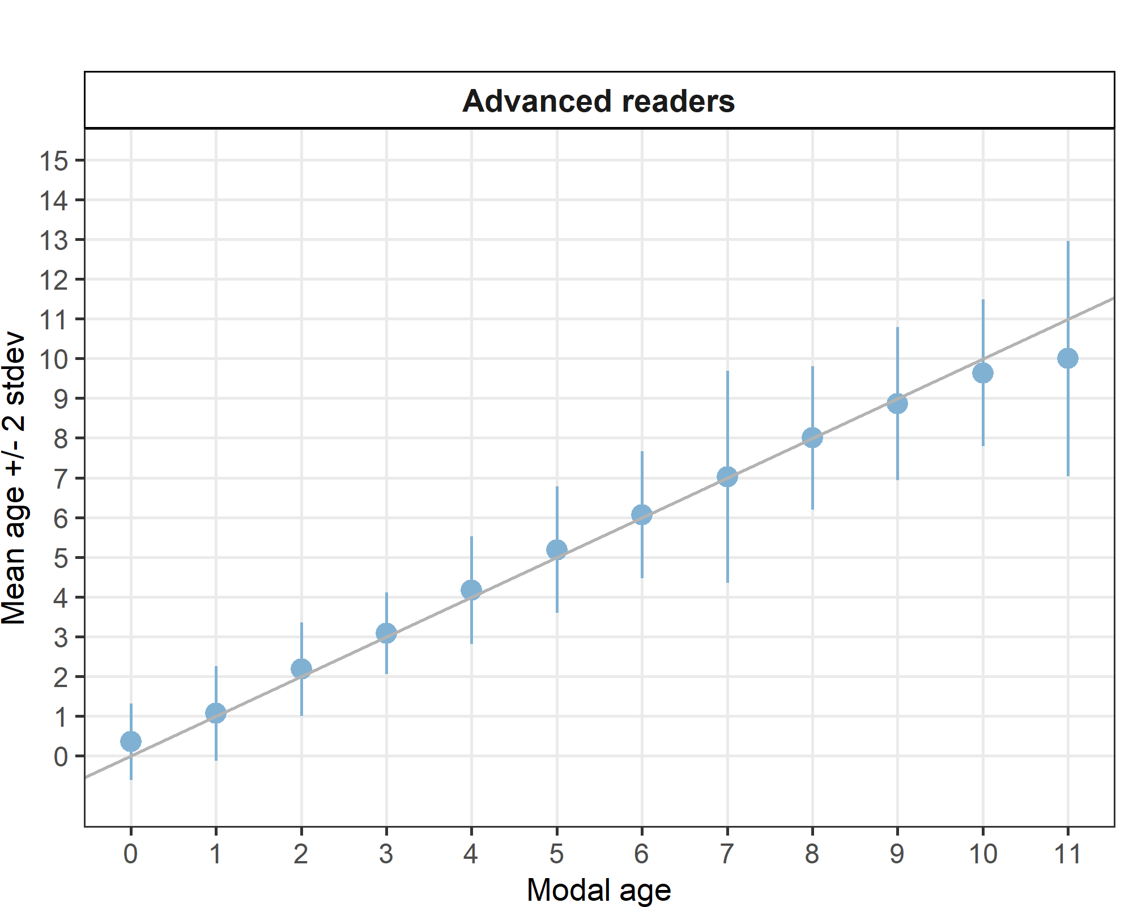
Figure 1: Age bias plot for advanced readers. Mean age recorded +/- 2 stdev of each reader and all readers combined are plotted against modal age. The estimated mean age corresponds to modal age, if the estimated mean age is on the 1:1 equilibrium line (solid line).

Growth analysis
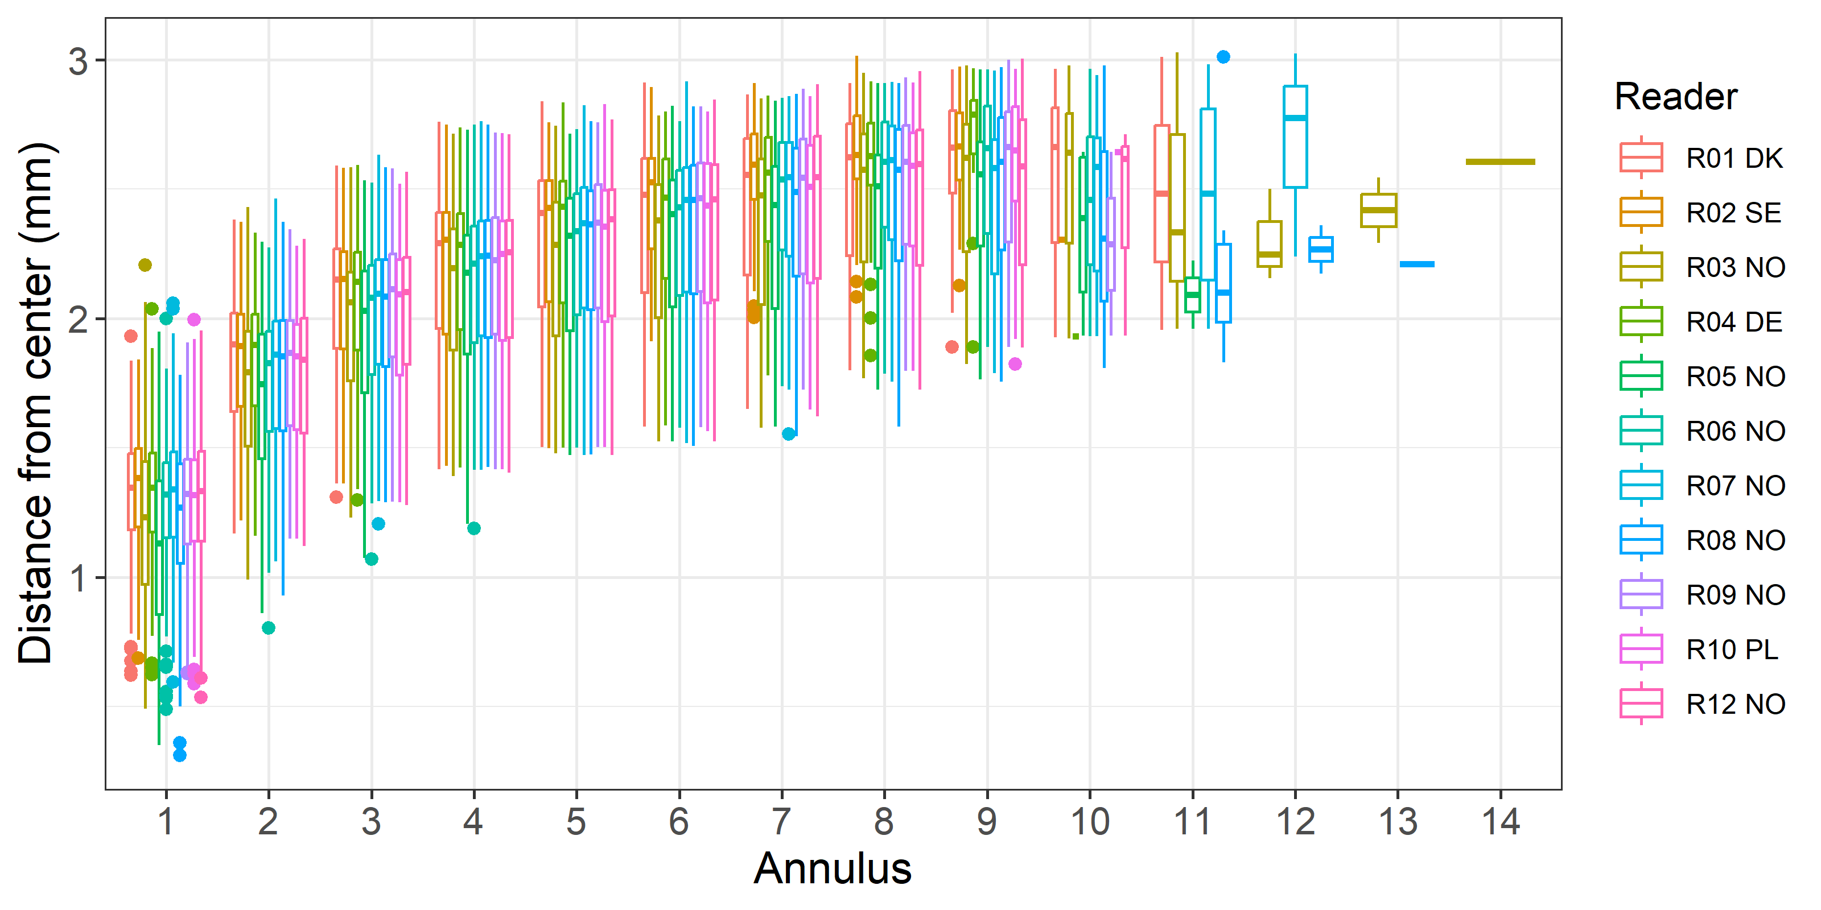
Figure 2: Plot of average distance from the centre to the winter rings for advanced readers and all samples included. The boxes represent the mean, upper and lower box boundaries of the interquartile range, whiskers represent the minimum and maximum values and the dots represent the outliers.

Age error matrix AEM
Table 4: Age error matrix (AEM) showing modal age in rows and the age classifications of advanced readers in columns. The matrix shows the proportion of each modal age mis-aged as other ages. The sum of each row is 1 (or as close to depending on rounding), which equals 100%.
Modal age | 0 | 1 | 2 | 3 | 4 | 5 | 6 | 7 | 8 | 9 | 10 | 11 | 12 | 13 | 14 | Total
0 | 0.65 | 0.35 | - | - | - | - | - | - | - | - | - | - | - | - | - | 1.00
1 | 0.09 | 0.80 | 0.07 | 0.03 | 0.01 | - | - | - | - | - | - | - | - | - | - | 1.00
2 | - | 0.04 | 0.79 | 0.15 | 0.02 | 0.00 | 0.01 | - | - | - | - | - | - | - | - | 1.01
3 | - | - | 0.05 | 0.85 | 0.07 | 0.02 | 0.01 | - | - | - | - | - | - | - | - | 1.00
4 | - | - | 0.00 | 0.05 | 0.80 | 0.10 | 0.04 | 0.01 | 0.00 | 0.00 | - | - | - | - | - | 1.00
5 | - | - | - | - | 0.05 | 0.82 | 0.07 | 0.02 | 0.02 | 0.01 | 0.00 | - | - | - | - | 0.99
6 | - | - | - | 0.01 | 0.01 | 0.11 | 0.74 | 0.08 | 0.03 | 0.01 | 0.00 | - | - | - | - | 0.99
7 | - | - | 0.00 | - | 0.02 | 0.05 | 0.16 | 0.57 | 0.10 | 0.05 | 0.01 | 0.01 | 0.00 | 0.00 | 0 | 0.97
8 | - | - | - | - | - | 0.01 | 0.03 | 0.15 | 0.63 | 0.12 | 0.04 | 0.00 | 0.01 | - | - | 0.99
9 | - | - | - | - | - | 0.01 | 0.02 | 0.04 | 0.14 | 0.69 | 0.07 | 0.02 | 0.01 | 0.01 | - | 1.01
10 | - | - | - | - | - | - | - | 0.09 | - | 0.09 | 0.82 | - | - | - | - | 1.00
11 | - | - | - | - | - | - | 0.09 | - | - | 0.09 | 0.36 | 0.45 | - | - | - | 0.99

