Contents
1 SmartDots website 1
2 Page descriptions 2
2.1 Add new users and edit their First Year of Age Reading and Number of Years Reading Otoliths 2
2.2 Setup user expertise (for your country) 3
2.3 List of reader expertise 4
2.4 Propose a new event 5
2.4.1 Complete all fields on the Propose a new event page 6
2.4.2 Complete the SmartDotsSampleFile Excel template (to facilitate the upload of samples) 7
2.4.3 Screen the SmartDotsSampleFile to ensure it is in the correct format 1
2.4.4 Create an event 2
2.5 Manage current events 2
2.5.1 Edit event 3
2.5.1.1 Specific Edit Event options for ageing events 5
2.5.1.2 Specific Edit event options for maturity events 6
2.5.2 View event page 8
2.6 List of events 10
2.7 Verify that a sample file is according to the format 10
2.8 Create a new token to work with the web services and the SmartDots software 10
3 Reporting 11
3.1 Ranking readers 12
3.2 Strata for ageing events 13
3.3 AQ 3 15
4 Publish the event 16
5 Important general guidelines for setting up events 17
5.1 Instructions for images 17
5.2 Event name 17
5.3 SmartDots age reading module 17
6 Creating Reference Collections (new chapter) 18
6.1 Types of Reference Collections 18
6.2 Creating Reference Collections 18
6.2.1 Age 18
6.2.2 Maturity 21
6.2.3 Downloads 21

- Background
This manual is intended for coordinators of age and maturity exchanges and workshops using the ICES SmartDots webpage. The manual details how to set up calibration events for age and maturity, and describes all pages on the web application. It combines the previously separate manuals for age and maturity events.

Changes since the last version
This guidance updates version 4 of “ICES SmartDots Web Application Manual”. A complete version history can be seen in Annex 1.
Location | Change description
Section 2.4 | Text added with important key points before creating an event and information on the CC by 4.0 licence.
Section 3 | Additions made related to the CC by 4.0 licence
Section 4 | Additions made related to the CC by 4.0 licence
Annex 3 | Text added to clarify abbreviations

Other relevant information
This guidance is written and maintained by ICES Working Group on SmartDots Governance (WGSMART). It is reviewed annually, in line with the review of the SmartDots platform, and updated as needed.
The current version of the guidance was prepared by Cindy van Damme (WMR, The Netherlands), Gudrun Finnbogadottir (Marine and Freshwater Research Institute, Iceland), Mandy Gault (Marine Scotland Science, UK), Julie Coad Davies (DTU Aqua, Denmark), and Patrícia Gonçalves (IPMA, Portugal).
- Key points
In 2023, new modules for maturity staging and egg and larvae identification were added to the SmartDots software. This resulted in a major change to the web application. Consequently, the former ICES SmartDots Web Application Manual has been renamed to SmartDots Manual: How to Run Events. The manual has also been expanded to cover setting up events for all software modules combined.
This guidance uses the following acronyms and definitions:
WGSMART | ICES Working Group on SmartDots Governance
Event | A collection of images and associated data for one age or maturity calibration or validation exercise
SmartDots | The entire platform, including the image analysis software, the Web API, the web application, and the reporting tool
Software | Graphical user interface for image analysis that receives and sends annotation data to a Web API. The software is an open source (GPL v3.0) Microsoft WPF application.
Web API | Interface between the SmartDots client and the database. The web API contains all business logic and, consequently, determines who has access and how to process and store the data.
Web application | Web portal for the SmartDots platform. Some of the actions that go through this portal are as follows: view published events, create token for users, create and manage events, add and manage users and expertise.
Report | Compilation of the analysis carried out by the reporting tool, which is developed in R and runs when the event is closed. The tool reads the annotations of the readers, carries out data analysis, and creates the standard output used in the final report of the event.

SmartDots website
The SmartDots website was developed by ICES to facilitate the setup of exchanges, workshops, and training events. This system was envisaged and developed by ICES; Flanders Research Institute for Agriculture, Fisheries, and Food (Belgium, ILVO); Technical University of Denmark (DTU); and Institute of Marine Research (Norway, IMR). ICES Working Group on Biological Parameters (WGBIOP) is the main user and oversees further developments of the finer details by testing the system, providing feedback, and ensuring that the system covers the needs of the community.
The main aims of the SmartDots website are to allow the community to store and update age, maturity, and ichthyoplankton readers’ expertise; to organize events; and to store and allow images to be read by the SmartDots software.
The web interface currently has three areas:
- The public front page, which allows all users to view and explore public events
- The manage area, which only authorized users can access. There are two types of SmartDots users: country coordinators and readers (maturity, age, eggs and larvae). To access the manage area, users must have an ICES login, which can be requested by sending an email to: reception@ices.dk
- The administrative area, which can only be accessed by the chairs of WGBIOP and WGSMART to define a reader as national coordinator and endorse events (this will not be explained in this manual).
In the SmartDots platform, there are two types of users: (a) national coordinators and (b) readers (age, maturity, and ichthyoplankton). Table 1.1 shows the permissions attributed to each role.
Table 1.1. Permission options by role.
Permissions | Readers | National coordinators
List of readers expertise
List of events
Add new users and edit their years of reading otoliths
Set up users’ expertise
List of readers expertise
Manage current events
Propose a new event
Verify whether a sample file is according to the format
Create a token to work with the web service and software

Page descriptions
After logging in at the SmartDots webpage, users are shown a menu with a list of possible operations that can be selected (Figure 2.1). Each page listed is explained in this section.
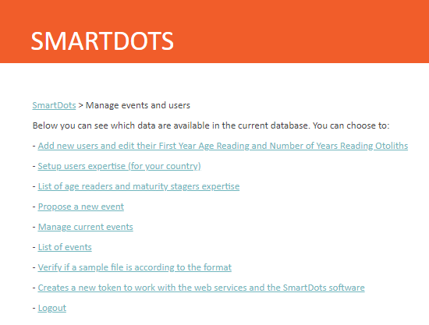
Figure 2-1. Print screen of the list of operations in the page “manage event and users” (login as a national coordinator).

Add new users and edit their First Year of Age Reading and Number of Years Reading Otoliths
This page allows the national coordinators to insert, edit, deactivate, or delete users in the system (for their country only). In addition, the First Year of Age Reading and the Number of Years Reading Otoliths can be edited.
The page shows a list of all the readers for the national coordinator’s country. At the bottom of the page, there is a textbox (Figure 2.2) where the national coordinator can insert the SharePoint usernames or email addresses of the intended users. Multiple emails need to be separated by commas. Once all the emails have been inserted, select “Add Users”. For each user that is added to the system, the national coordinator will receive an information line that can be one of the following:
- If the email was found in the ICES user directory and was not associated to a SmartDots user, the system will retrieve the message “the user xxxx has now access to the system”.
- If the email was found in the ICES user directory and is already associated to a SmartDots user, the system will retrieve the message “the user was already part of the SmartDots application”.
- If the email was not found in the ICES user directory, the system will retrieve the message “the email was not found in the system, please contact reception@ices.dk to add this email to the system”.

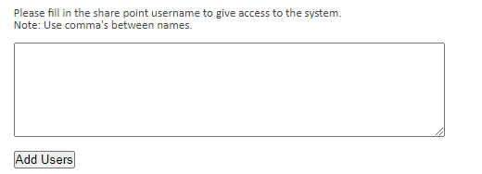
Figure 2-2. Print screen of the Add Users field in the SmartDots web application.
For readers who were already added as users, it is possible to add or modify the first year of age reading and the number of years reading otoliths (Figure 2.3). This is not automatically updated, as an individual may not read otoliths every consecutive year.
- In the table of users, click on Edit (Figure 2.3).
- Add name, First Year of Age Reading, and Number of Years Reading Otoliths in the respective columns.
- Click “update” to store the data.
It is also possible to deactivate users by following step (a), placing a check mark in the final column “User not active in SmartDots”, and clicking “update” to store this preference.
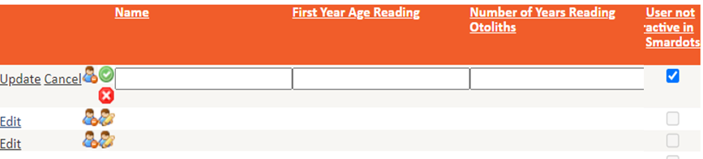
Figure 2-3. Table to edit First Year Age Reading and Number of Years Reading Otoliths.

Setup user expertise (for your country)
This page allows national coordinators to manage their readers’ expertise. National coordinators can only set up a reader’s expertise for their own country (Figure 2.4). It is the responsibility of the national coordinators to ensure that their readers’ expertise is up to date.
On this page, national coordinators have a drop-down menu with a list of all the readers for their country. After selecting a reader, the page will display a list of all the skills for that reader (Figure 2.5).
The national coordinator has the following operations available for the selected reader:
- Delete skills for that reader.
- Edit or change the expertise level for a specific species, preparation method, and stock or area (only for the Mediterranean).
- Add new skills to the reader. First, choose the expertise level, the species, sample type, preparation method, preservations method, observation method, first year of otolith reading, number of years reading, mean number of otoliths read per year, and one or multiple stock(s).
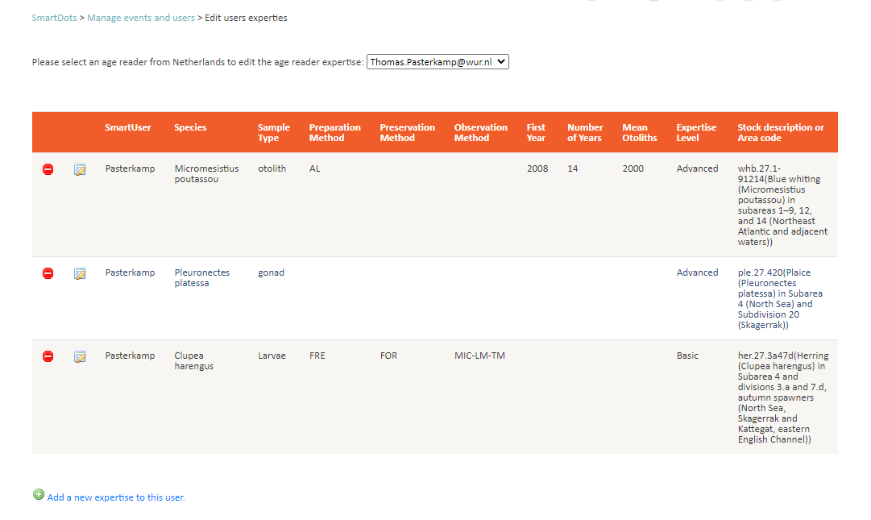
Figure 2-4. Page to manage reader expertise.
The national coordinator should set his/her own expertise per species. For the country coordinators, it is possible to add a skill to a species without choosing area or preparation method.

List of reader expertise
This page (Figure 2.5) is accessible to the readers and to the national coordinators. On this page, the system user can see a list of all the readers and national coordinators in the system. The columns “Country coordinator (age reading)” and “Country coordinator (maturity)” of the table will specify whether the individual is a national coordinator.
The list can be filtered by country and/or role, and the user can sort the table by any of the specified fields. The list can also be downloaded as a .csv file.
Note: Readers who have been added to the system but who do not have any expertise will also appear in this list.

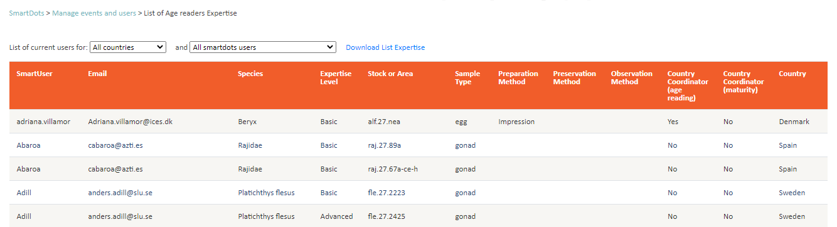
Figure 2-5. List of Age Readers’ expertise.

Propose a new event
This page is only accessible to the national coordinators.
Before proposing a new event check, the following points should be considered:
- The required report structure.
  - The results can be analysed separately by applying strata to the samples (see Section 2.5.1.1 [point 6] and Section 3.2). If more sophisticated analysis/splitting samples are needed, consider unique identifiers to be included in the relevant Sample_IDs (i.e. image names).
  - At this stage, reporting does not facilitate preparation method comparison, i.e. analysis of results for whole and sectioned otoliths of the same fish in the same event.
- Quality/scale of images and their source.
  - If there are few institutes involved in providing samples, check the scale/magnification applied to the images. If the standards of configuration are different, consider adding unique codes/identifiers to the names of Sample_ID/images for each batch. This will make applying scale easier further on (see Section 2.5.1 [point 5]).
- Images cannot be rotated in the SmartDots application.
  - Image orientation (e.g. sulcus down/up, anterior up/down, dorsal/ventral) should be agreed in advance. If needed, images should be rotated prior to uploading them.

Complete all fields on the Propose a new event page
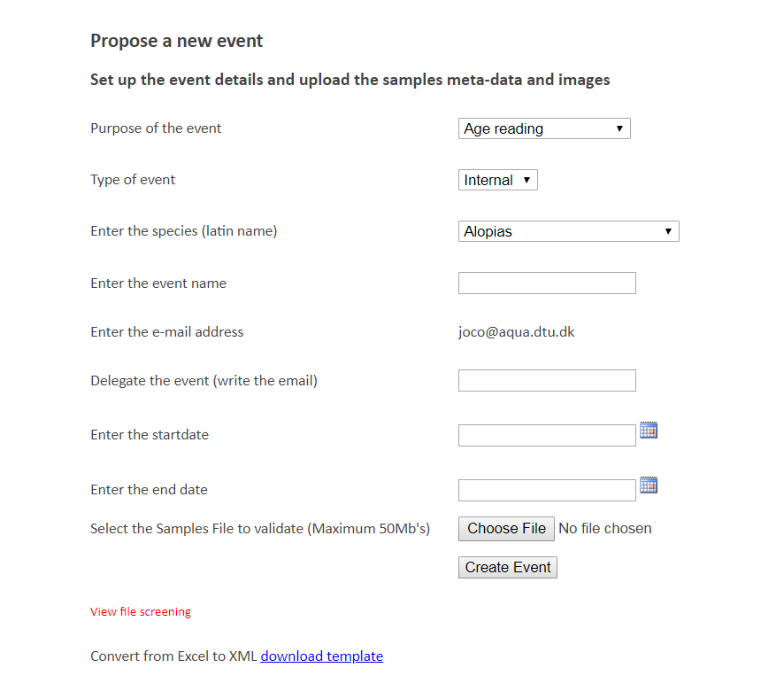
Figure 2-6. Propose new event page.
Purpose of the event: Mandatory and with controlled vocabulary. The options are “Age Reading”, “Maturity Determination”, “Eggs identification”, “Larvae identification” and “Fecundity and atresia determination”.
Type of event: Mandatory and with controlled vocabulary. The options are “Workshop”, “Exchange” “Training”, “Test” or “Reference Collection”. A Workshop and an Exchange both need to be endorsed by the chairs of WGBIOP.
Species: The species’ scientific name. This is a controlled vocabulary. Users can view the list in the drop-down menu.
- If the species is not listed, a request can be sent to ICES Data Centre to add the species to the vocabulary.
Event Name: It is recommended that the event name clearly explain the intention of the event. This will be helpful in a few years’ time, when the national coordinator can have a long list of organized events. Specify at least the following items:
- Year
- English name of the species
- ICES area codes/GFCM codes
Note: Do not use commas in the event name. This is important for the R-script dealing with the reporting.
Email address: This value is automatically filled.
Delegate the event: This is where the event creator enters the email address of another SmartDots user (maximum of six) who will coordinate the event.
Start date: This field is the date when the event will become visible to and open for annotations by the readers.
End date: This field is the date when the event will close for annotations by the readers.
Samples file: This is an XML file with the data of all the samples in the event. To prepare the file for upload, ICES provides an Excel template (SmartDotsSampleFile) to help the national coordinators follow the specified format for the samples.
Upon creating the event, the user accepts that the data in the event will be publicly available under the Creative Commons (CC by 4.0) licence.

Complete the SmartDotsSampleFile Excel template (to facilitate the upload of samples)
The template can be found at https://smartdots.ices.dk/manage/EventForm. It should be downloaded each time to get the most up-to-date version. The SmartDotsSampleFile Excel template was created to facilitate the work of building a sample list file. In this template (Figure 2.7), the controlled vocabularies are in drop-down boxes, the mandatory fields are marked in red, and all fields have the format defined above the cell.
To produce a sample file, the user must fill in all the fields in the file information sheet.
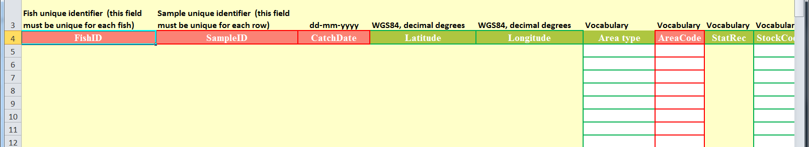
Figure 2-7. The SmartDotsSampleFile Excel template for uploading samples.
This template is where the user enters all data for the event samples. The “Export_data” sheet gives instructions on how to complete this file, with links to find relevant codes and information. The “File_information” sheet must be filled in. The “Sample_data” sheet is where the user enters all the sample data. Fields in red are mandatory; those in green are optional. The controlled vocabularies are provided in this spreadsheet by a list box where the user can choose the description of the field; when exporting, the descriptions will be converted to the code value (vocabulary). The number of characters in the SampleID is limited to 50 characters. The “Vocabularies” sheet gives information on the relevant codes to be used when completing the file.
The File information record has the following fields:
- ContactEmail (event co-ordinator)
- EDMO code
- Species
Note: The EDMO code is a controlled vocabulary, and a full list of the EDMO codes can be found here:
- ICES Vocabularies. 2023. ICES, Copenhagen, Denmark. http://vocab.ices.dk/?ref=1398
- European Directory of Marine Organisations. 2023. http://www.seadatanet.org/Metadata/EDMO-Organisations
The Sample_Data has the following fields:

- Fish ID (see note below)
- SampleID (see note below)
- DataRightsHolder (see note below)
- CatchDate
- Latitude
- Longitude
- Area Type
- Area Code
- StatRec
- StockCode
- SampleOrigin
- SampleType
- PreparationMethod
- FishLength
- FishWeight
- Sex
- MaturityScale
- MaturityStage
- Comments

Note: The SampleID is used to match the image to the sample. It is important that the beginning of the image file name matches the SampleID. Within each event, each sample must have a unique SampleID. To that end, please avoid having samples that begin in the same way as other samples; for instance, samples should be called Npo001 and Npo011, not Npo1 and Npo11.
Note: The Fish ID is used to match multiple samples from the same fish. For instance, Fish ID NPout_001 should be used for SampleID NPout_001_ and SampleID NPout_001_b.
Note: The DataRightsHolder is used to generate the reference to the data source acknowledging the institutes holding the data rights of the specific photo. In the case of age, each reader can only have a single approved annotation per fish. Multiple approved annotations will mean the report cannot be produced.
Once all data are entered, the Excel template must be exported to an .xml format file before the upload can be completed. This is done by selecting “Export data to XML” (Figure 2.8) on the “Export_data” sheet and saving the file with the images.

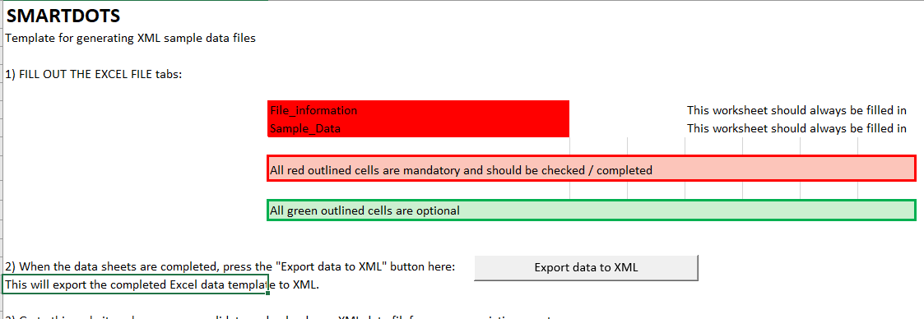
Figure 2-8. SmartDotsSampleFile Excel template for uploading sample for an event, the “Export_data” sheet where the users can export the file to XML.

Screen the SmartDotsSampleFile to ensure it is in the correct format
Users should check that the sample file is in the correct format by navigating to the Manage Events and Users page, then following the link to “Verify if a sample file is according to the format”. This page is accessible to all system users. The user can “screen” the file to verify that the file is according to the format. Once the format has been checked (Figure 2.9), the screening utility will also run some QC procedures implemented by the data manager. Figure 2.10 shows the specifications of the SmartDots format in the Data screening Utility (Datsu).
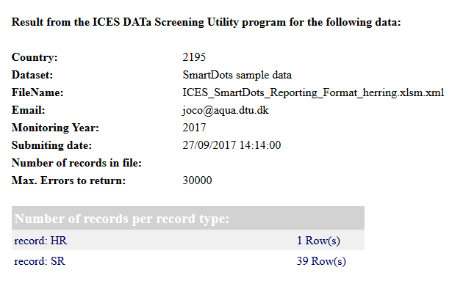
Figure 2-9. Screen result when the file presents no problems and can be imported to an event.

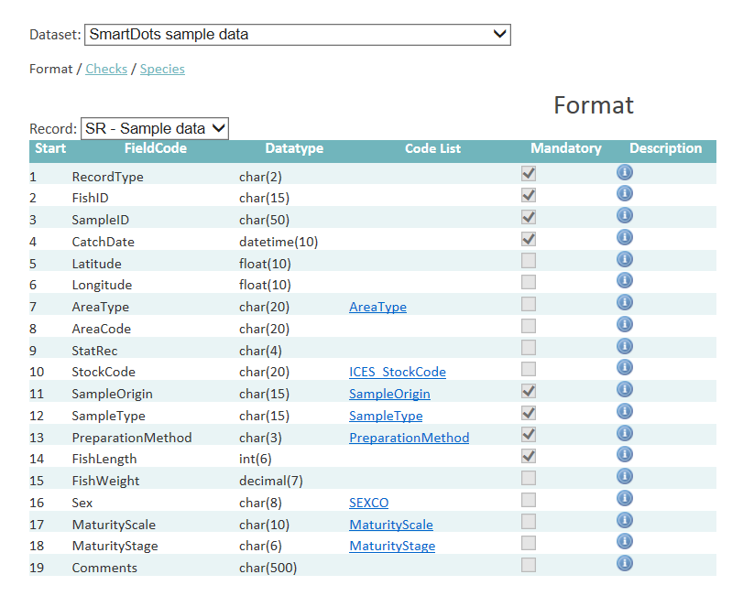
Figure 2-10. The format definition of SmartDots and associated checks can be found at https://datsu.ices.dk/web/selRep.aspx?Dataset=129

Create an event
After the national coordinator has selected “Create event” and filled in all the fields correctly, they will be redirected automatically to the Edit Event page.

Manage current events
This page shows a list of all the events that the national coordinator has created and is only accessible to the national coordinators (Figure 2.11).
On this page, the event organizer can view the details of all the events. There are two operations that can be accessed by clicking the icon next to the event: “View event” and “Edit event”.

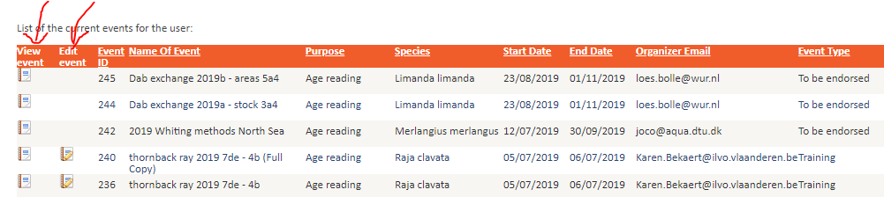
Figure 2-11. Page showing the list of events where the national coordinator is the organizer or has some readers involved in the event.

Edit event
Once an event has been proposed, the Edit Event page allows the national coordinator or delegate to perform various operations (listed below). For age and maturity events, the specific options are described in sections 2.5.1.1 to 2.5.1.2.
- Delete the event: Deleting an event is only possible if no images have been added to the event. If images have been added, ICES Data Centre (smartdots@ices.dk) should be contacted to delete an event.
- Edit event details: Event name, start date, and end date.
- Add a delegate to the event: The delegate has the same rights as the coordinator for setting up the event. Type the SmartUser name of the delegate to be added, then select “Add”.
Event coordinators and delegates can see all the readers’ annotations, but readers cannot. Therefore, delegates cannot also be readers in the event. If a delegate tries to annotate an event, the software will raise an error.
If it is desired that a delegate also be a reader, the reader must first be made a delegate to this event for setting up the event. Once the event has been created, they must be removed from the event as a delegate, then re-added, this time as a reader. When the reader has finished annotating the event, the event coordinator can add the user as a delegate again.
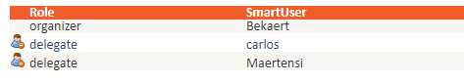
Figure 2-12. Delegates and organizer of an event.
- Choose which extra properties will be shown in the list of samples in the software (Figure 2.13).
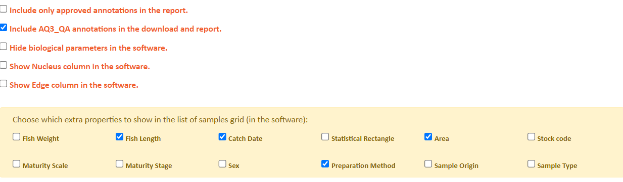
Figure 2-13. Choosing event-specific properties to be shown in the software.
- Set the scale of all images: This is a value calculated using the scale bar tool in the SmartDots software (Figure 2.14). Once inserted here, it will appear in the sample data for each sample in the SmartDots software. Applying the same scale to all images can only be used if all images were taken using a standard setup configuration and magnification. The scale of the images equals the number of pixels per 1 mm length on the image. Therefore, it needs to be whole number, with no decimal points.

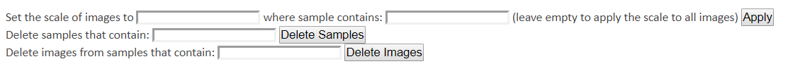
Figure 2-14. Setting the scale and deleting samples and images.
- Delete samples or images: These buttons will delete any image or samples where the SampleID field contains the text that is input in the textbox. If the user writes “SA_01”, any sample or image that contains the text “SA_01” will be deleted. Note that this function only deletes images or samples that do not have annotations.
- Add more sample data to the event: This will upload another sample file to the event. All SampleIDs in the file that already exist in the event will be deleted.
- Add sample images: Here, the user can upload images. This can be done in two ways: by dragging and dropping the images or by clicking “Select file”.
- Check that images are associated to the correct sample. Each sample will have a green or red icon next to it. When sample data are uploaded, all icons will be red; once the user has uploaded the images, the icons will turn green. The green icons are hyperlinked to all the associated images of the sample.
- Add/delete/edit/rank readers.
There are two options for adding readers to the event:
- If a reader has expertise in the species of the event, then the reader will appear automatically in the summary table. The national coordinator can then select the icon to add the reader to the event. Once a reader has been added to the event, they are removed from the summary list.
- There is a text box below the list where the national coordinator can insert the email[s] or SmartUser name[s] of the reader[s] to be added to the event. Emails/usernames should be separated by commas. Once the email or username for each reader is added to the text box, select “Add Users” to add these readers to the event. This gives access to the selected users, and the system will retrieve some information for each of the users.
For each new user added, the system will return one of three messages:
- If the email/username was found in ICES users directory and was not previously included in the event, the message “The user xxxx was added to the event” is returned.
- If the email/username was found in the list of readers included in the event, the message “The user is already part of the event” is returned.
- If the email/username was not found in ICES user directory, the message “the email was not found in the system, please contact advice@ices.dk to add this email to the system” is returned.
To delete a user, click on the “delete” button.
By selecting the “Edit” icon, the user can add or change the rank (number) attributed to each reader in the box provided. The user can also edit reader expertise level and select whether readers provide data for assessment (based on the species and the defined preparation method). The user can automatically order the readers by selecting “Generate the no. of readers”. This will allocate a random number to participants, with the lowest numbers being assigned to the advanced readers. For more information, see Section 3.
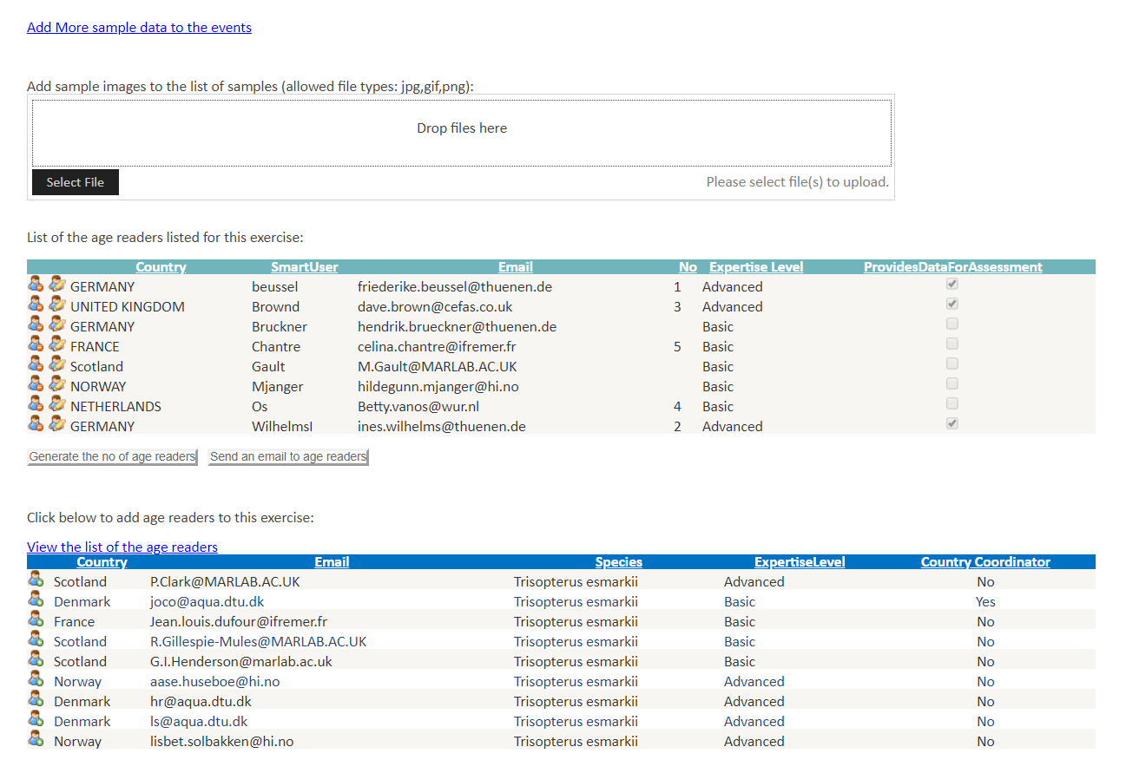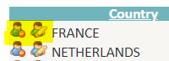
Figure 2-15. Adding and removing users in a SmartDots event.
Note: the national coordinators of the countries whose readers are taking part in an event will automatically have access to the event, but their names will not appear on the list of readers.
Send an email to the participants of the event by selecting “Send an email to readers”. Note for ageing events: read Section 2.5.1.1 before sending out this email.
Readers who do not have a ranking number are excluded from the report. This gives the possibility for the event organizers to generate distinct reports with groups of users. It is also possible to change the expertise level of users before the report is generated. Note, however, that the report will only generate if there is at least one advanced reader.

Specific Edit Event options for ageing events
In addition to general Edit Event options, there are specific edit options for ageing events (Figure 2.16):
- To fix a reading line in the event, go to the SmartDots software and fix the reading line on the otolith images. Once the coordinator chooses the reading line, it needs to be pinned so that every reader will annotate along that line. The pinned line must be saved in a separate record. Readers can annotate by selecting the new record, then selecting “Create new annotation”.
- Include AQ3_QA (or QS_QA for other biological parameters) annotations in the download and report by ticking the box (see Section 3).
- Choose to hide biological parameters in the software, so readers will not have access to this information.
- Show a nucleus column in the software by ticking the box. This is for readers to record whether the otolith nucleus is opaque or translucent.
- Show an edge column in the software by ticking the box. This is for readers to record whether the otolith edge is opaque or translucent.
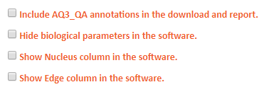
Figure 2-16. Specific age options in a SmartDots event.
- Update strata for reporting (Figure 2.17; also see Section 3). The user can employ predefined strata by using the “Update strata to be the same as” fields (area, maturity stage, stock code, type of structure, preparation method, area code, and quarter). The user can also customize strata by using the “Update strata to” field. In this field, the user selects a custom value (e.g. A or 1). In the field “where SampleID contains”, the user fills in the part of the SampleID name for the samples that are to be linked to this stratum.
Note: Only samples with strata are included in the report, as the inclusion of strata enables the event coordinator to generate reports for distinct areas or preparation methods. If none of the samples have strata, the report will be empty.
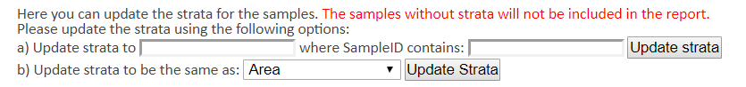
Figure 2-17. Strata setting in a SmartDots event.

Specific Edit event options for maturity events
In addition to the general Edit event options, there are specific Edit options for maturity events:
- Choose the maturity scale. The options are “SMSF” and “SMSF with subscales”. For further details concerning these maturity scales, please see ICES (2018).
- Hide/Unhide images. When histological images are available for validation of the maturity stage, it is possible to hide these images while the event is open. When the event is closed, these images will become available to the readers.
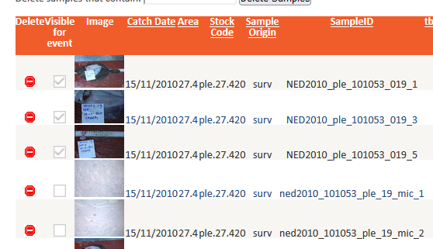
Figure 2-18. Hide and unhide images in a maturity event.
- Add sample images. In macroscopic maturity staging events, a set of multiple images should be made available for classification. These images should at least represent (a) the gonad inside the abdominal cavity, (b) the gonad outside the abdominal cavity and next to the fish, and (c) the gonad only. Figure 2.19 features images of type (a) and (c). The images should contain a grid for scale to help users during the staging classification. It should be reported whether the gonads were fresh or frozen when they were photographed.
In microscopic maturity staging events, the multiple images available must be taken with different magnifications (Figure 2.20) to show different details of the histological sections of the gonad. Images of the macroscopic aspect of the gonad should also be included. The images of the histological section should at least include: an image with (a) gonad wall visible, (b) oviduct or spermatoduct visible, (c) overview of the inside of the gonad, and (d) zoomed in on specific cells. Thus, for males and females, different magnifications should be used to allow the details to be visible. The images should include a scale bar.

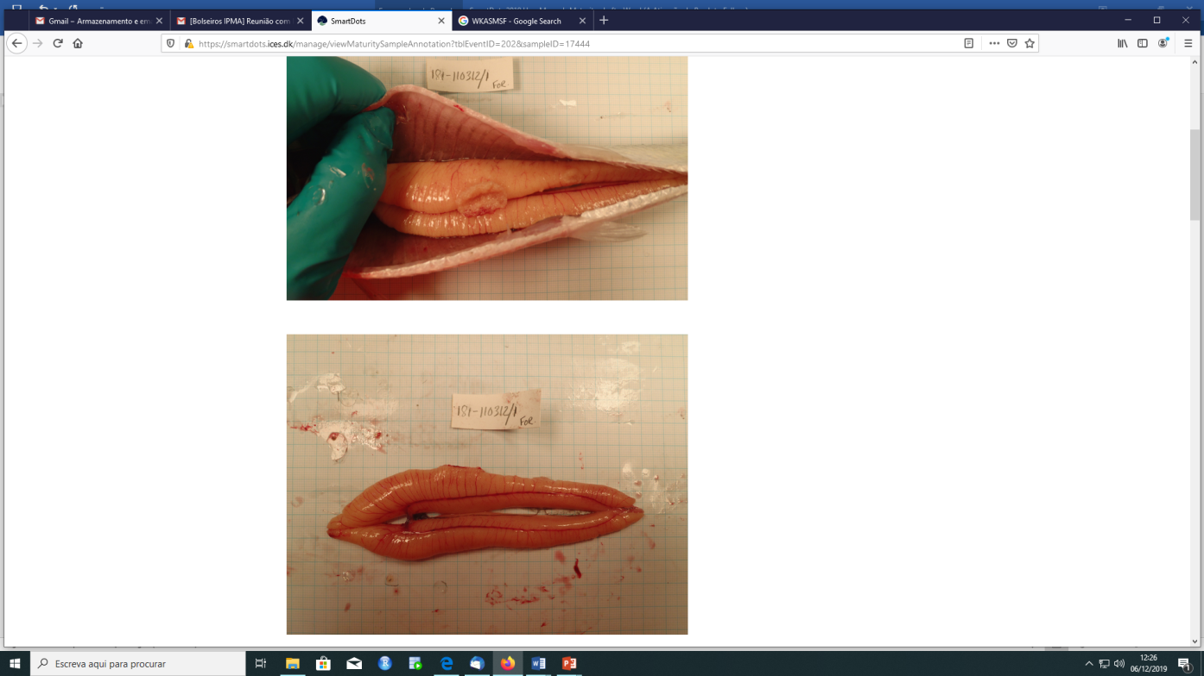
Figure 2-19. Macroscopic gonad image examples (with a size reference grid). L: The gonad inside the abdominal cavity; R: The gonad only.
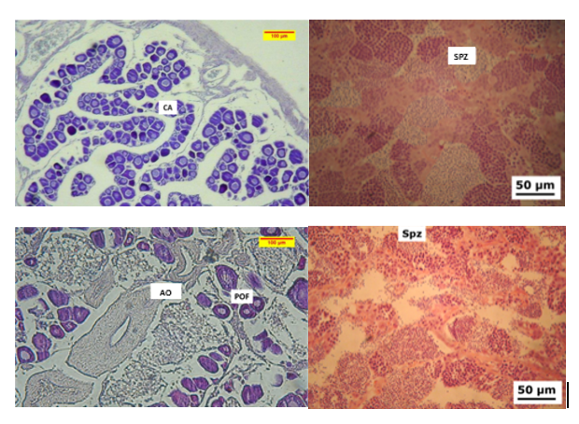
Figure 2-20. Microscopic gonad image examples, with different magnifications.

View event page
The “View event” page under “Manage current events” (Figure 2.21) can be accessed by selecting the relevant event’s “View event” icon. This page gives an overview of the event details and samples and allows the event coordinator to track the progress of an event. Thumbnails of all images are provided.
Event coordinators will be able to see additional links:
Summary Annotations: Provides an overview of the number of annotations approved/not approved per reader.
Anonymized names to Smartuser: Provides an overview of the anonymized names per reader for the event reports to be published.
Open/close event: When an event is closed, readers will no longer be able to annotate. The event can be re-opened as required, e.g. if a reader has not approved all annotations, until it is published. Note: If the user needs to re-use an event, ask to make a copy of the event. Do not try to delete all the annotations of the users.
Download data: Produces a zip file with two or three documents: an annotation file (providing sample and annotation data), a file with the distances between the dots (for each reader and annotation; for age events only), and a data disclaimer document.
Download report: Produces a standardized report based on the strata chosen under Edit event (see Section 3). Downloading the report can take several minutes.
Report log: Logs any errors that have occurred when downloading.
Selecting any of the thumbnails will give information on the readers’ annotations. Depending on the user’s role in the SmartDots event, they will have access to different information (Figure 2.21). On selecting an image thumbnail, the event coordinator will see the results of all readers in the event. National coordinators will see both the overview list and the results of their countries’ readers. Readers will see their own readings.
A complete overview table of the annotations from each reader for each image will be found in the report.
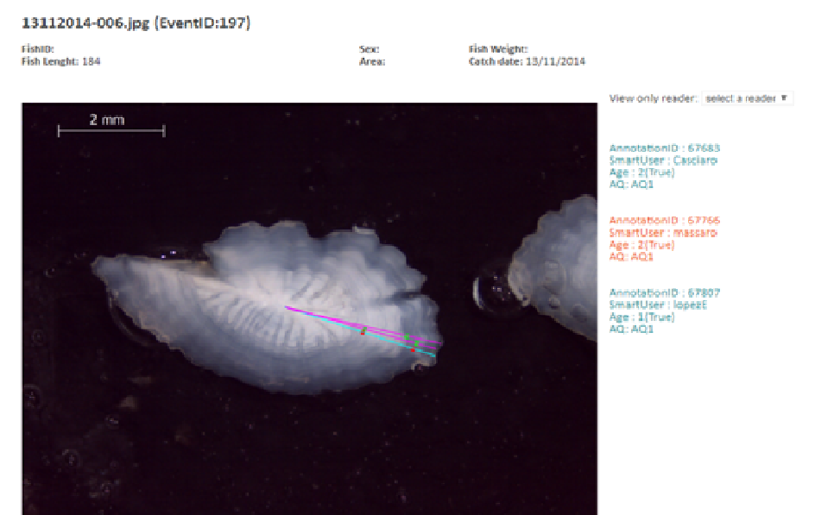
Figure 2-21a. Sample information when clicking on the thumbnails for ageing events.
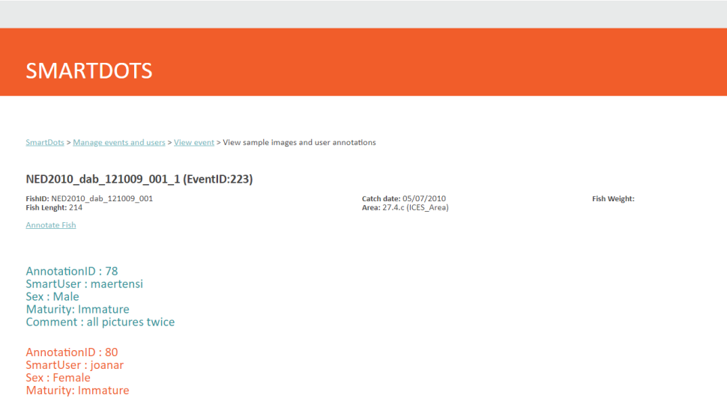
Figure 2.21b. Sample information when clicking on the thumbnails for maturity events.

List of events
This page is accessible to all the system users. It lists all the events that have taken place, filterable by year. Sorting the events is possible by clicking on any of the headings.

Verify that a sample file is according to the format
Allows the user to check that their file is according to the format (see Section 2.4.3).

Create a new token to work with the web services and the SmartDots software
Once an event is created and readers and images are added to an event, the event will be visible for the participants in the SmartDots reading software.
This page allows users to create a new token that can be used by clients of the secure webservices. This token can be requested for a period of 5, 30, or 100 days. The token can be copied directly from the SmartDots login screen (Figure 2.22). By placing the cursor within the characters of the token and clicking three times, the user can copy the full token.
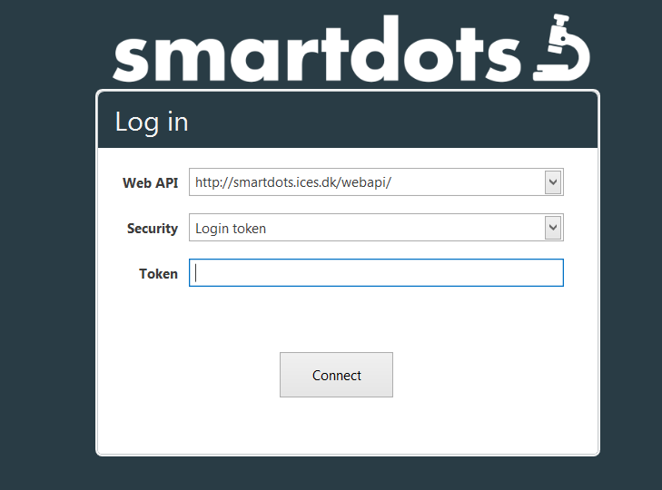
Figure 2-22. SmartDots login screen.

Reporting
Only the coordinator of an event can generate and download the report and corresponding data for all participants.
To generate a report from an event, go to ”Manage current events” on the SmartDots website. Select the icon to the left (“View event”; Figure 3.1) to get the option to download report (Figure 3.2).
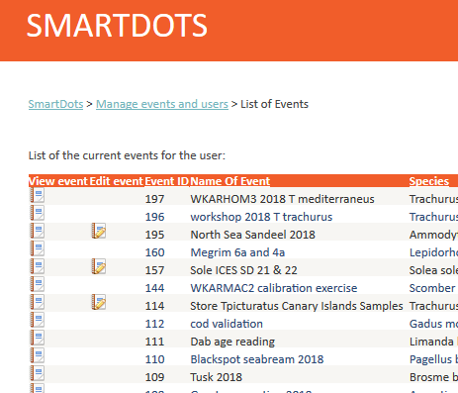
Figure 3-1. List of events.
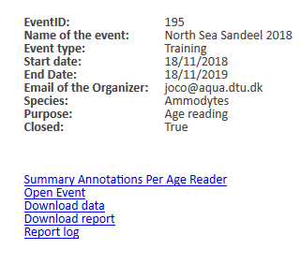
Figure 3-2. View event page.
To ensure that the data are properly included in the generated report, readers must approve each annotation estimate by selecting the designated function, as outlined on page 14 of the manual “SmartDots HowToAnnotate”. Without this approval, data will not be included in the report, which could lead to inaccurate results.

Ranking readers
For a reader to be included in the analyses of the report, they need to be ranked before downloading the report. This is done on the ”Edit event” page. Scroll down to the section where the readers are listed, then select ”Generate the no. of age readers” (see Section 2.5.1). The readers will be automatically ordered such that the most advanced reader has the lowest ranking number.
To exclude a reader from the report, select the “Edit user” icon on the “Edit event” page (Figure 3.3). The coordinator can now remove the number next to the “No.” column for a specific reader. This reader will not be included in the report. In the same way, the user can change the expertise level or the ranking number of the reader.
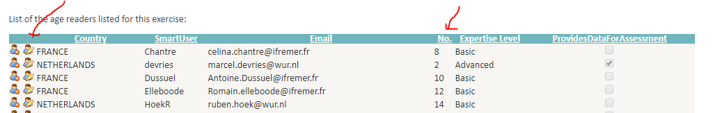
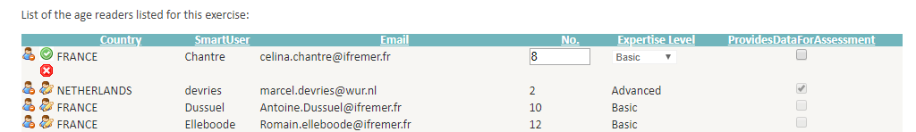
Figure 3-3. Edit User on the view event page.
The modal age is calculated based on the readers who are ranked. Readers need to be ranked according to their experience. Annotations by more experienced readers will have more weight on the modal age calculation. If an equal number of readers have given different age estimates, the rank will be used to prioritize the estimates of age readers with a lower rank number in the calculation of the modal age. To rank the users based on their expertise (e.g. number of years reading the ages on a particular species, number of structures read by year), the event coordinator should ask the readers to download and fill in the spreadsheet on the “Edit event” page (Figure 3.4).
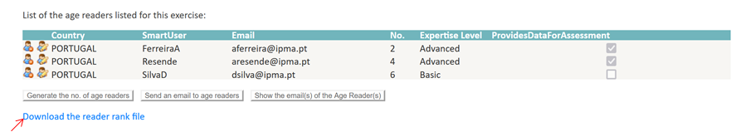
Figure 3-4. Template Spreadsheet SmartDots ranking users.
Once the reader information has been filled in the template (Figure 3.4), the readers’ rankings are automatically generated according to their expertise within the species and stratum. Afterwards, the event coordinator should change the expertise level and/or the ranking number of the readers by following the indications on Figure 3.3. Note that the ranking of the readers could change by changing the stratum considered on the event (e.g. area, type of structure, preparation method). In events during which different strata are considered to produce different reports, the ranking of the readers must be confirmed/edited on the event page to reflect the expertise for that particular stratum. In these cases, it will be also worth having a spreadsheet with the user rankings by strata. Details for setting different strata can be found in Section 3.2.

Strata for ageing events
The strata need to be defined under ”Edit event” prior to downloading the report. Strata are used in the report to split the samples for comparison between e.g. area, type of structure, preparation method, or any other parameter the user defined. Samples for which no strata were defined will not be included in the report. If the user changes the strata, a different report will be generated. Samples without strata will not be part of the report.
Selecting the strata can be done using the drop-down box (Figure 3.5).
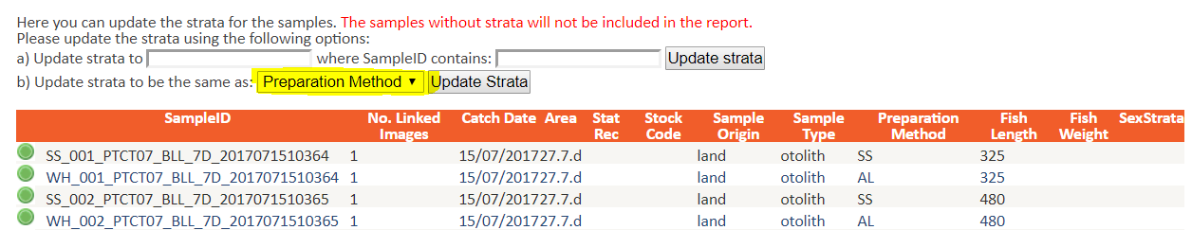
Figure 3-5. Selection of strata in drop-down box (marked in yellow).
By clicking “update strata”, the strata will be set in the last column (Figure 3.6).
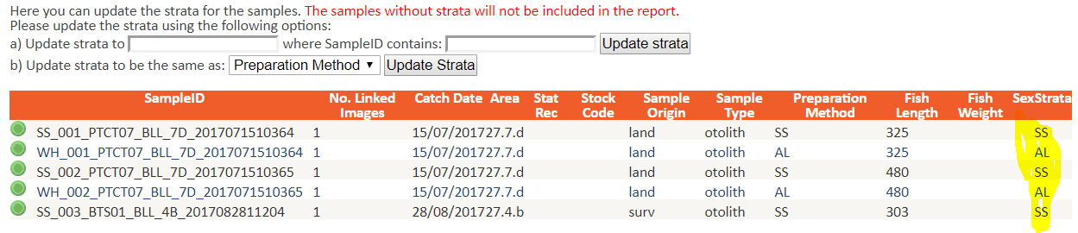
Figure 3-6. View of the strata column after updating strata (marked in yellow).
Strata can also be set in a more flexible way, so that they are applicable to e.g. trips or quarters, if the event coordinator included this information in the Sample_ID. Use the field “update strata to” and choose the names of the strata. Then, fill in the field “where sampleID contains” with the part of the Sample_ID corresponding to the method. Select “Update Strata” (Figure 3.7). The Strata column (last column) will now contain the chosen name for the method for which the user wants to generate the report (Figure 3.7).
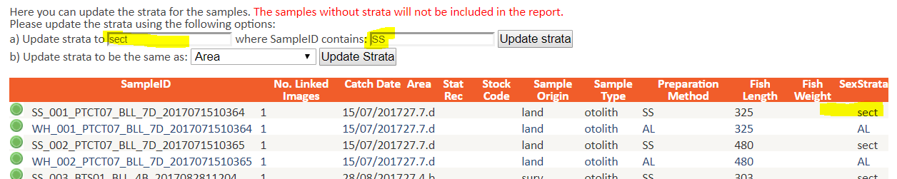
Figure 3-7. Flexible way of updating strata.
Note that only one annotation can exist per reader per Fish_ID. Otherwise, the R-script for the report will return an error.
If different preparation methods were used for the same fish, and the readers annotate both methods, a separate report for each preparation method must be extracted. To do so, the strata should be set for only one method at a time. The user must first empty the strata column for one method by changing the “Update strata to” field to empty, then clicking “Update strata”. The last column will now have only one method in it (Figure 3.8). The user can now download the report from the “View event” page (Figure 3.2). It will arrive in the user’s mailbox after a couple of minutes.
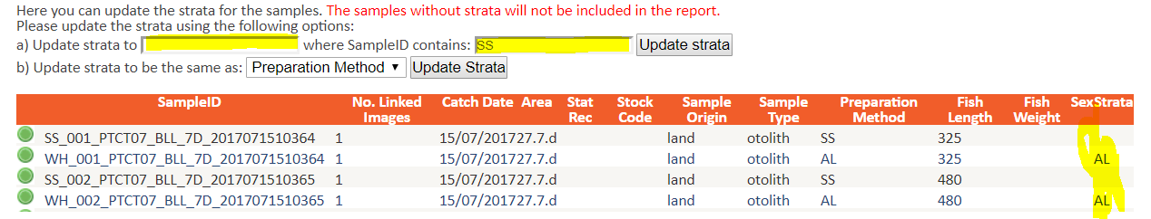
Figure 3-8. Include only one method in strata if readers annotated more than one otolith per fish (in case of multiple preparation methods or structures).
The user can now do the same for the second method. The strata column first needs to be emptied (empty the “Update strata to” field, then click “Update strata”). The strata for the second method should then be set and the report downloaded again from the “View event” page. It will arrive in the user’s mailbox after a couple of minutes.
The reports produced are not publication-ready. Text must be provided, tables and figures checked, and adjustments made to fit the format.
The final section of the report is a table with the reading per specimen for each reader (Figure 3.9), including modal age, percentage agreement (PA), coefficient of variation (CV), and average percentage error (APE%) or unlikability (for maturity only).
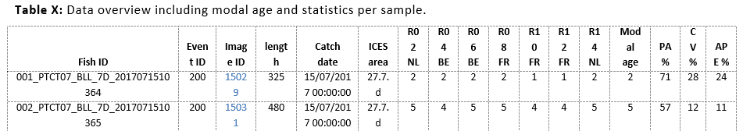
Figure 3-9. Overview table of results per fish and per reader.

AQ 3
The user can choose to include the AQ3_QA (QS3_QA for other biological parameters) annotations in the report (Figure 3.10). Explanations of this vocabulary can be found at ICES Vocabularies.
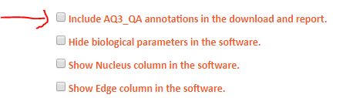
Figure 3-10. Include AQ3_QA annotations on the “View event” page.
When reporting on an event the data sources should be acknowledged by a citation. Detailed information and examples of citations can be found in ICES Data Policy.
A minimum requirement citation can be found in the disclaimer text, which is included in the zip file received when downloading the data of the event. The minimum required citation contains the institutes that provided images to the event, as stated in the DataRightsHolder column in the SmartDotsSampleFile Excel.

Publish the event
Only workshops and exchanges should be published. Once the event is closed and reported, it can be published under the “Manage current events” page. Go to the “Edit event” page and select ”Publish the event”. Then upload the report and the summary report (both are required) and choose how the pictures will be shown on the public “View events” page (Figure 3.2). If the user wants to use the dataset for further training, high-resolution pictures should be chosen.

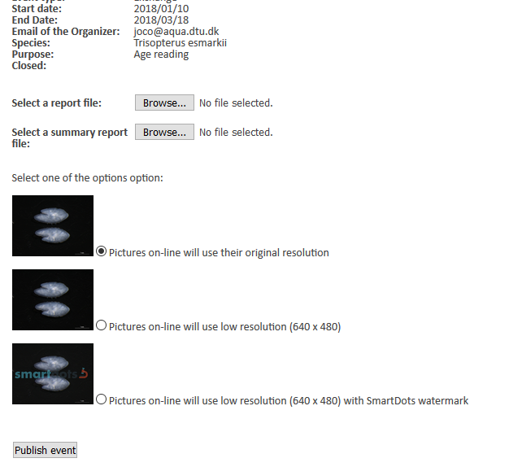
Figure 4.1. Publish events page.
Only images of published events can be used for further developments of SmartDots. Therefore, users are urgently requested to finalize and publish their event, even if it is neither extensive nor complete.

Important general guidelines for setting up events
Before the start of the event, thought should be given as to the content of the report. The goals of the exchange or workshop organized will determine what is included.

Instructions for images
Separate guidelines for taking images for the different events are available at https://www.ices.dk/data/tools/Pages/smartdots.aspx

Event name
The naming of the event should be:
- Year
- English name of the species
- ICES area codes/GFCM codes
Do not use any commas in the event name. This is important for the R-code for the reporting.

SmartDots age reading module
- Best practice is to pin the reading line in SmartDots software before informing the age readers that the event is open. The best readable direction for age reading should be used; ensure that the end of the line is past the otolith edge so that readers can annotate the winter ring at the edge. This can be different for each otolith. If the organizer chooses not to use the pinned reading line, the growth between readers cannot be compared.
- The event coordinator should instruct the readers to refer to the SmartDots manual on How to annotate. If there are any special instructions for readers to follow for a specific exchange or workshop, a concise document should be provided.
- The event organizer should instruct readers that each dot will be counted as an age (except when the non-counting mark is used), because SmartDots will automatically give the age of the fish based on the number of annotations. The centre or the outermost edge of the otolith should not be annotated. Dots are to be placed at the end of each winter ring. If the increments are not yet formed but should be counted (e.g. winter rings not yet formed in Q1), a dot should be placed on the edge of the otolith. In addition, if the last winter ring should not be counted, it should be left unmarked. The non-counting mark can always be used to indicate important features that should not be counted.
- If the birthday of the fish is 1 July, the coordinator needs to instruct the readers accordingly.
- Images should be approved to be included in the report. Please instruct the readers.

Creating Reference Collections (new chapter)

Types of Reference Collections
Two types of reference collections can be created for age: a Training Reference Collection (TRC) and a Control Reference Collection (CRC) Reference collections are created per species including different quarters, areas, preparation methods and age classes.
A Training Reference Collection contains samples with a high level of percentage agreement (PA) and a low coefficient of variation (CV). It is intended for training new readers and for calibrating age interpretation.
A Control Reference Collection contains all images of good age quality that represent both high- and low- agreement cases. They are intended to be reused in future events. A CRC can be used to assess temporal consistency within readers, consistency between experienced and new readers, and consistency between different methods.
Further information on age reference collections can be found in the WGBIOP document “WGBIOP Reference Collection Guidelines”.
For maturity, only a Training Reference Collection can be created in SmartDots. The maturity TRC includes only samples for which histological images have been annotated by an expert (i.e. the event organizer or a delegate), in order to have a “true” maturity stage.

Creating Reference Collections

Age
For age, thresholds for percentage agreement (PA) and coefficient of variation (CV) have been established per species to determine which samples will be included in a TRC. For example, only samples with an agreement greater than 90% and a CV lower than 15% will be selected for a reference collection.
The thresholds can be accessed from the Manage Events and Users page by clicking “Customize the thresholds for selecting samples into the training reference collections” (Figure 6-1).
Country coordinators can set the PA and CV thresholds in this table by clicking the Edit icon (Figure 6-2), thresholds are approved by WGBIOP and should remain fixed.
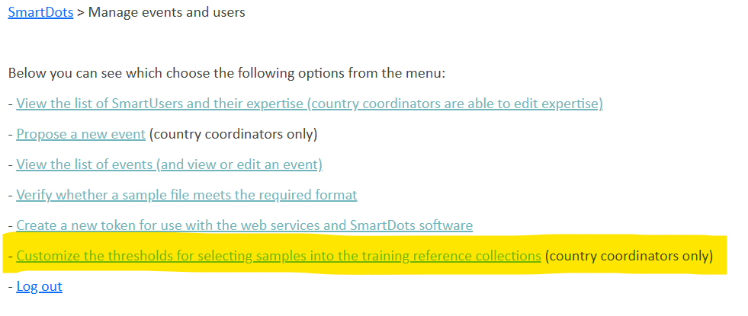
Figure 6-1. Manage events and Users page.

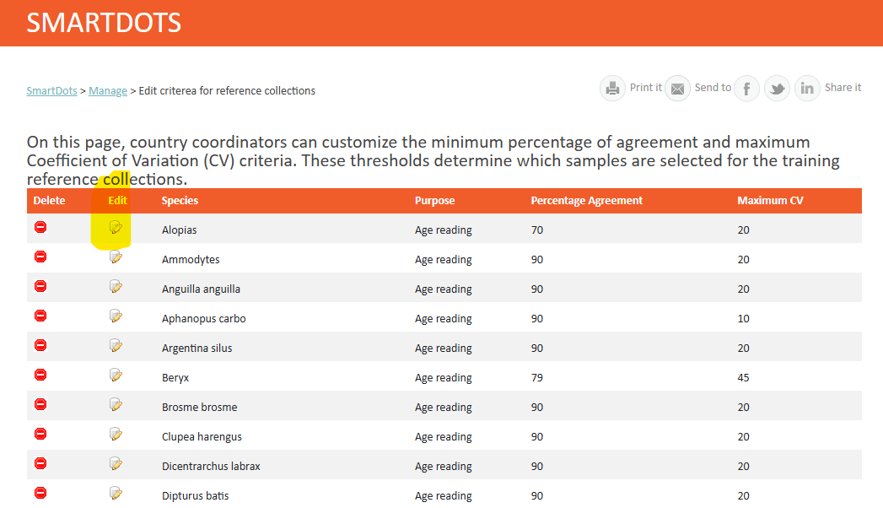
Figure 6-2. Percentage Agreement (PA) and Coefficient of Variation (CV) Threshold table

After a WGBIOP exchange or workshop has been closed, both a TRC and a CRC can be created from the Edit Event page.
- Creation of a TRC: Click “Copy the Samples of this Event to a Training Reference Collection” (Figure 6-3). The TRC will then be created automatically and will appear in the event overview list.
Samples that meet the PA and CV thresholds specified in the threshold table will be transferred to the reference collection, together with the annotations provided by all advanced readers. The person who added samples to a reference collection automatically becomes a delegate in the reference collection.
If only the annotations of a specific expert reader should be transferred to the TRC, you can enter the SmartUser name or email address of that reader in “Copy annotations from SmartUser (optional)”. In this case, only that reader’s annotations will be transferred, provided that the reader’s annotation matches the modal age. If it does not match the modal age, the annotations of all expert readers will be transferred. Copying only one reader’s annotation will save time for cleaning the TRC afterwards.
Another programmed condition is that a sample will only be transferred if there are readings from at least three advanced readers from at least two different institutes agreeing on the modal age. Therefore, it is important to note that changing a reader’s status from advanced to basic, or vice versa, can affect which samples are transferred to a Training Reference Collection.
- Creation of a CRC: Click “Copy the Samples of this Event to a Control Reference Collection” (Figure 6-3). The CRC will then be created automatically and will appear in the event overview list.
All samples with good age quality will be copied to the CRC. Samples with a high percentage of AQ3 scores will not be transferred if more than 50% of readers assigned an AQ3 or AQ3-QA score in the original event.
In a CRC, annotations are not visible in the SmartDots software. Only the modal age (MA), PA, CV, and the number of advanced readers who provided annotations are displayed. The statistics are based on advanced readers only.

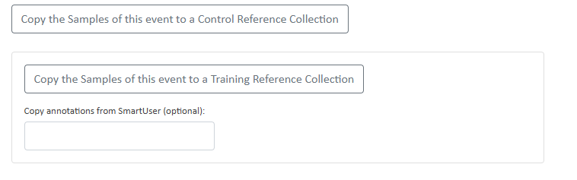
Figure 6-3. Creating reference collections

Cleaning the TRC in the SmartDots software is necessary after it’s creation! The aim of the TRC is to contain only one final approved expert annotation. Event coordinators need to go through the samples added to the TRC in the SmartDots software to remove unnecessary annotations (in case multiple annotations were transferred) or samples. Afterwards, best practice is to ask one or a team of advanced readers from the exchange or workshop to verify all annotations, reposition dots if necessary and approve a final agreed annotation. Therefore, this expert reader will need to be added as a reader in the reference collection.

Maturity

After a WGBIOP maturity exchange or workshop has been closed, a TRC can be created from the Edit Event page. Navigate to the “Create Reference Collections” tab. Only samples with histological images will be included in the TRC. The maturity stages assigned by the expert delegate or event organizer who created the histological annotations should be copied to the TRC. If several delegates or coordinators have staged the images, enter the SmartUser name or email address of the person whose maturity stages you want to copy and Click “Copy the Samples of this Event to a Maturity Training Reference Collection” (Figure 6-4The TRC will then be created automatically and will appear in the event overview list.

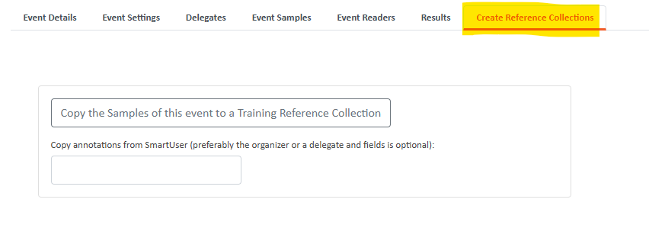
Figure 6-4. Creating a maturity training collection

Downloads
Images and sample metadata information from any reference collection can be downloaded from the “edit event” page (Figure 6-5). Navigate to the “event details” tab. The sample metadata file contains biological information of the sample, the sample statistics and the original event data.
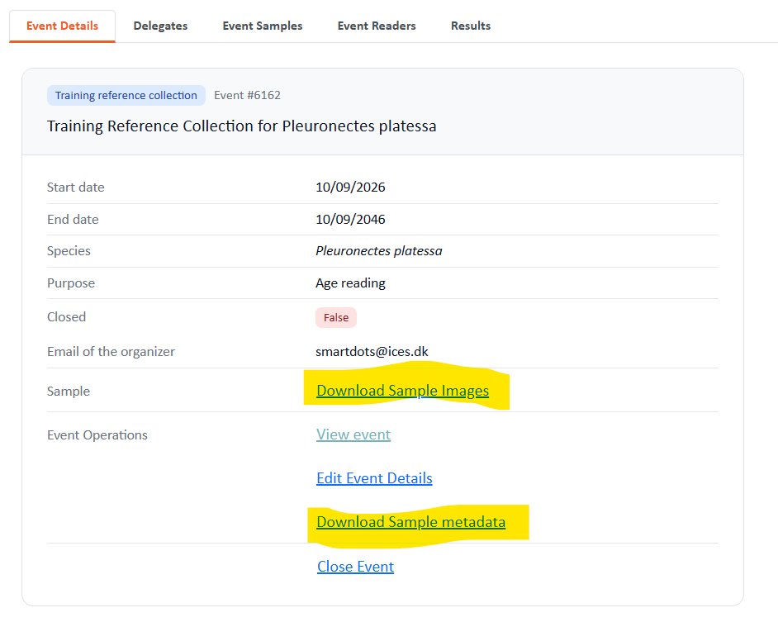
Figure 6-5. Download of samples and images
Keep in mind that sample statistics are calculated by FishID. That means that in case of several preparation methods for the same FishID, the statistics will be calculated over all preparation methods (same result for all preparation methods).

Annex 1: Version history
Version | Date | Major changes
6 | Xxx/2026 | Section 6 Creating Reference Collections added
5 | April/2023 | Age and maturity event guidance combined into one manual  Title changed from “SmartDots web application manual” to “How to run SmartDots events”  https://doi.org/10.17895/ices.pub.22810682
4 | Oct/2019 | Minor updates  https://doi.org/10.17895/ices.pub.4603
3 | Oct/2019 | Minor updates
2 | Dec/2018 | Minor updates
1 | Nov/2018 | “SmartDots web application manual” established  https://doi.org/10.17895/ices.pub.7686

Annex 2: Author contact information
Name | Country | Institute | E-mail
Julie Coad Davies | Denmark | DTU Aqua | joco@aqua.dtu.dk
Karen Bekaert | Belgium | ILVO | karen.bekaert@ilvo.vlaanderen.be
Cindy van Damme | The Netherlands | Wageningen Marine Research | cindy.vandamme@wur.nl
Carlos Pinto | Denmark | ICES | carlos@ices.dk
Patrícia Gonçalves | Portugal | IPMA | patricia@ipma.pt
Jane Aanestad Godiksen | Norway | Institute of Marine Research | jane.godiksen@hi.no

For inquiries, the SmartDots email box should be used:
SmartDots, ICES Data Centre: smartdots@ices.dk
The following people can be contacted about SmartDots:
- Carlos Pinto, ICES Data Centre: carlos@ices.dk
- Joana Ribeiro, ICES Data Centre: joana.ribeiro@ices.dk
- Julie Coad Davies, DTU Aqua: joco@aqua.dtu.dk
- Wim Allegaert, ILVO: Wim.Allegaert@ilvo.vlaanderen.be
- Kevin DeCoster, ILVO: Kevin.DeCoster@ilvo.vlaanderen.be
- Karen Bekaert, ILVO: Karen.Bekaert@ilvo.vlaanderen.be

Annex 3: List of abbreviations
EDMO | European Directory of Marine Organisations
ICES | International Council for the Exploration of the Sea
Q1 | Quarter 1
Q4 | Quarter 4
WGBIOP | ICES Working Group on Biological Parameters
WGSMART | ICES Working Group on SmartDots Governance
WKASMSF | ICES Workshop for Advancing Sexual Maturity Staging in Fish

ICES SmartDots webpage. 2023. ICES, Copenhagen, Denmark. https://www.ices.dk/data/tools/Pages/smartdots.aspx
ICES. 2020. SmartDots user manual. Version 5. ICES User Handbooks. 21 pp. https://doi.org/10.17895/ices.pub.7473
ICES. 2020. SmartDots maturity manual. Version 1. ICES User Handbooks. 29 pp. https://doi.org/10.17895/ices.pub.4602
ICES. 2020. ICES SmartDots Web Application Manual. Version 4. ICES User Handbooks. 20 pp. https://doi.org/10.17895/ices.pub.4603
ICES Working Group on SmartDots Governance. 2023. ICES, Copenhagen, Denmark. https://www.ices.dk/community/groups/Pages/WGSMART.aspx
ICES. 2020. ICES SmartDots Web Application Manual. Version 4. ICES User Handbooks. 20 pp. https://doi.org/10.17895/ices.pub.4603.
SmartDots manage area. 2023. ICES, Copenhagen, Denmark. http://smartdots.ices.dk/manage
ICES. 2018. Report of the workshop for advancing sexual maturity staging in fish (WKASMSF), 30 April–4 May 2018, ICES Headquarters, Copenhagen, Denmark. ICES CM/EOSG: 38. 75 pp. https://doi.org/10.17895/ices.pub.19212915
SmartDots website. 2023. ICES, Copenhagen, Denmark. https://smartdots.ices.dk
ICES Vocabularies – Measurement certainty. 2023. ICES, Copenhagen, Denmark. https://vocab.ices.dk/?codetypeguid=e08ec685-61f6-4ccb-9e93-594047b05797
ICES. 2021. Data policy for data managed by ICES. ICES Data Licences and Policies. https://doi.org/10.17895/ices.pub.8883
ICES. 2023. SmartDots manual: How to annotate. ICES User Handbooks. https://doi.org/10.17895/ices.pub.22810604

