Report of Otolith Exchange Analysis for Turbot

Coordinated by Karen Bekaert
Institute for Agricultural and Fisheries Research (ILVO)
Ankerstraat 1, 8400 Oostende, Belgium

Participants (in alphabetical order): Chantre, C., Devries, M., Dussuel, A., Elleboode, R., Hoek, R., Maertens, I., Moerman, M.

May 2019
Table of Contents
1 Executive summary 3
2 Introduction 4
3 Methods and Analysis 5
3.1 Statistical analyses 5
3.2 Overview of readers and samples 6
4 Results 8
4.1 All readers – Sectioned and stained otoliths 8
4.2 Advanced readers only – stained sectioned otoliths 11
4.3 All readers – whole otoliths 14
4.4 Advanced readers only – whole otoliths 16
4.5 Comparison between whole and stained sectioned otoliths 18
5 Discussion and conclusion 19
6 References 22
7 Annex 23
7.1 . List of participants 23
7.2 Results all readers (stained sections) 23
7.3 Results Advanced readers (stained sections) 37
7.4 Results all readers (whole otoliths) 48
7.5 Results Advanced readers (whole otoliths) 63

Executive summary

The last turbot (Scophthalmus maximus) exchange took place in Ostend in 2008 (WKART, 2008) for North Sea and Baltic turbot. A new small scale exchange for North Sea turbot was then recommended. Moreover, turbot became a category 1 stock in 2019 (ages are used for assessment) and the first advice will be given for 2020 using age data from 2018.
The objectives of this new exchange were:
- Estimate the accuracy and precision of the age readings for whole otoliths and sectioned and stained otoliths.
- Detect any potential age reading problems.
- Compare the results between whole and sectioned & stained otoliths
- To report the results to WGBIOP that will take place in October 2019

Two otolith sets were included in the exchange: a North Sea (27.4.a, 27.4.b, 27.4.c) turbot set (N=126) and a set from the English Channel (27.7.d) (N = 52). A total of 8 participants from 3 countries (Belgium, France and the Netherlands) participated in the exchange. Only 3 advanced readers participated, which are all used to reading stained sectioned otoliths. Whole otoliths are only read in France, but these readers are all basic (not providing data for assessment).
The statistics were better for stained sectioned otoliths than for whole otoliths. The average percentage agreement of 68 %, CV of 24 % and APE of 15 % was reached by all readers annotating stained sectioned otoliths. There was an important improvement when only advanced readers were combined: PA=78%, CV = 19%, APE = 7%. For whole otoliths, the statistical results were not satisfactory. The average percentage agreement of 53 %, CV of 50 % and APE of 32 % was obtained by all readers, while for advanced readers, the results were better: PA=71%, CV = 29%, APE = 21%.
When comparing whole and stained sectioned otoliths, fish are generally assigned an older age when otoliths are sectioned and stained (in 57 % of the cases). Often, otoliths with a cliffed edge are not detected when read whole. This has also been confirmed in other flatfish species. In only 34 % of the cases, fishes were aged the same. The results show that stained sections are the better method for the age reading of turbot otoliths.
During the 2008 workshop, the overall agreement rate for the North Sea sample was high 82.8%. In this exchange, the percentage agreement for stained sectioned otoliths of the advanced readers was rather high (78 %) but was not satisfactory for all readers (68 %). The main issue between advanced readers was the analysis of the first small ring and whether or not this is a true annulus. Therefore, a validation study of the growth patterns in the first year of life using day-ring analyses is recommended.

Introduction
Turbot (Scophthalmus maximus) is a flatfish species of the family Scophthalmidae that are widely distributed from Norway to the Mediterranean and the Black Sea (Nielsen, 1986). They occur in relatively low abundance throughout their distributional range (Whitehead et al., 1986). They inhabit sandy and muddy bottoms in the shallower part of the continental shelf where they feed on crustaceans and fish. They are highly valued commercial fishes and their high market value makes them important bycatch species in mixed bottom trawl fishery. Spawning takes place from May to July in the Atlantic, where eggs are spawned offshore and larvae are transported by wind-driven currents to sandy beach nurseries (Riley et al., 1981; van der Land, 1991). Early demersal juveniles are restricted to the shallow sandy grounds on exposed shores (Besyst et al., 1999; Nissling et al., 2007; Riley et al., 1981). Variation in 0-group abundance across beaches and inter-annual variation in abundance may be related to variations in the transport of larvae towards the inshore nursery grounds (Haynes et al., 2011b; Nissling et al., 2006; Sparrevohn and Stottrup, 2008).

The last turbot workshop took place in Ostend in 2008. The percentage agreement was high (82%) and no bias between the readers was evident. A small scale exchange for North Sea turbot was recommended in 2009 by PGCCDBS for turbot in the North Sea and English Channel (Subarea 4 and 7.d-e). Turbot became a category 1 stock in 2019 (ages used in the assessment) and the first advice will be given for 2020 using age data from 2018. Nevertheless, several countries already collected age samples for turbot, partly under obligation by the EU Data Collection Regulation for several years. A scoping meeting for turbot is planned in 2020.
The objectives of this new exchange were:
- Estimate the accuracy and precision of the age readings for whole otoliths and sectioned and stained otoliths.
- Detect any potential age reading problems.
- Compare the results between whole and sectioned & stained otoliths

Methods and Analysis

Statistical analyses
This report contains statistical analyses and comparisons of age readings in the form of tables and graphical plots based on Guus Eltink Excel sheet ‘Age Reading Comparisons’ (Eltink, A.T.G.W. 2000) and R scripts specifically developed for SmartDots. For each individual fish the Coefficient of Variation (CV), percentage agreement (PA) and Average Percentage Error (APE) to modal age was calculated. Additionally, age error matrices (AEM) were produced for advanced age readers separately for whole and sectioned otoliths.
All statistical analyses were produced separately for whole and sectioned otoliths and for all and then for only advanced age readers who provide data for stock assessment.
Percentage Agreement
The percentage agreement per reader per modal age tells how large is the part of readings that are equal to the modal age. The weighted mean included at the bottom of the table is weighted according to number of age readings.
PA = ( no. of readings agreeing with modal age/total no. of readings) x 100%.
Co-efficient of Variation (CV)
The table presents the CV per modal age and reader. The CV’s are calculated as the ratio between the standard deviation (σ) and mean value (μ) per reader and modal age:
$$CV=\frac{σ}{μ}⋅100\%$$
To the table is also added the CV of all readers combined per modal age and a weighted mean of the CV per reader.
Average Percentage Error (APE)
APE was calculated based on the method outlined by Beamish & Fournier (1981). This method is not independent of fish age and thus provides a better estimate of precision. As the calculations of both CV and APE pose problems if the mean age is close to 0, all observations for which modal age was 0 were omitted from the CV and APE calculations.
The average percentage error is calculated per image as:
$$APE=\frac{100\%}{n}\sum_{i=1}^{n}{|}\frac{a_{i}-\overline{a}}{\overline{a}}|$$
where $a_{i}$ is the age reading of reader $i$ and $\overline{a}$ is the mean of all readings from 1 to $n$.

Age error matrix (AEM)
Age error matrices (AEM) were produced following procedures outlined by WKSABCAL (2014) where the matrix shows the proportion of each modal age miss-aged as other ages. The sum of each row is 1, which equals 100%. The age data was analysed twice, the first time all readers were included and the second time only the “advanced” readers were included. If a reader is “advanced” then they are considered well trained and they provide ages for stock assessment or similar purposes. When the AEM is compiled for assessment purposes it uses only those readers who provide age data for the stock assessment in that specific area.
Otolith Growth Analysis
SmartDots provides a measure of distance between the annotations made by the readers and thus provides a measure of growth increment width. This data is used to establish growth curves for each fish and for each reader.

Overview of readers and samples
A total of 7 participants from 3 different countries were involved in the turbot otoliths exchange. A list of the participants with a summary of their experience in age estimation of turbot is shown in Table 3.1. Age estimation of turbot is based on sectioned and stained otoliths with the exception of France where whole otoliths are used (only small fish are collected).

Table 3.1: overview table of participants
Country | Reader name | Reader code | Expertise* | Provides data for assessment | Preparation method used for ageing turbot
Netherlands | Devries Marcel | R02 NL | Advanced | Yes | Sectioned & Stained
Belgium | Maertens Ilse | R04 BE | Advanced | Yes | Sectioned & Stained
Belgium | Moerman Martine | R06 BE | Advanced | Yes | Sectioned & Stained
France | Celina Chantre | R08 FR | Basic | No | Whole
France | Antoine Dussuel | R10 FR | Basic | No | Whole
France | Romain Elleboode | R12 FR | Basic | No | Whole
Netherlands | Ruben Hoek | R14 NL | Basic | No | Sectioned & Stained

* level of expertise in Smartdots: advanced=provides data for assessment; basic=does not provide data for assessment

Following WGBIOP Guidelines for Otoliths Exchanges (2018) a set of turbot otoliths were selected and uploaded for analysing using the SmartDots application (http://ices.dk/marine-data/tools/Pages/smartdots.aspx).
A total of 178 whole and sectioned & stained otoliths were used in the exchange. The images of the whole and the sectioned & stained otolith were originating from the same otolith. First, an image was taken from the whole otoliths, which was afterwards sectioned, stained and photographed. The otoliths were from ICES areas 4.a (18), 4.b (68), 4.c (40) and 7.d (52), they were stratified by quarter and age.
Table 3.2: Overview of samples used for the turbot exchange.
Year | ICES area | Quarter | Number of samples | Modal age range | Length range
2014 | 27.7.d | 3 | 2 | 2 | 240-340 mm
2015 | 27.4.a | 1 | 4 | 9-13 | 400-450 mm
2015 | 27.4.b | 3 | 1 | 12 | 560 mm
2015 | 27.4.b | 4 | 2 | 9-10 | 380-650 mm
2015 | 27.4.c | 3 | 9 | 1-5 | 215-575 mm
2015 | 27.7.d | 1 | 25 | 2-20 | 245-350 mm
2015 | 27.7.d | 4 | 11 | 1-13 | 180-370 mm
2016 | 27.4.b | 3 | 2 | 8 | 540-590 mm
2016 | 27.4.c | 4 | 2 | 2-3 | 360-415 mm
2016 | 27.7.d | 4 | 14 | 2-15 | 240-470 mm
2017 | 27.4.a | 1 | 6 | 2-4 | 260-450 mm
2017 | 27.4.a | 2 | 1 | 5 | 520 mm
2017 | 27.4.a | 3 | 7 | 1-5 | 390-550 mm
2017 | 27.4.b | 1 | 5 | 3-7 | 390-520 mm
2017 | 27.4.b | 2 | 7 | 3-9 | 430-590 mm
2017 | 27.4.b | 3 | 26 | 2-13 | 250-610 mm
2017 | 27.4.b | 4 | 25 | 1-12 | 190-675 mm
2017 | 27.4.c | 2 | 4 | 3-6 | 325-400 mm
2017 | 27.4.c | 3 | 15 | 1-4 | 200-540 mm
2018 | 27.4.c | 3 | 10 | 0-1 | 100-250 mm

Results

All readers – Sectioned and stained otoliths
All samples included (no AQ3 otoliths)
The weighted average percentage agreement based on modal ages for all readers is 68 %, with the weighted average CV of 24 % and APE of 15 %.
Table 6.3: Coefficient of Variation (CV) table presents the CV per modal age and reader, the CV of all readers combined per modal age and a weighted mean of the CV per reader.
Modal age | R02 NL | R04 BE | R06 BE | R08 FR | R10 FR | R12 FR | R14 NL | all
0 | - | - | - | - | - | - | - | -
1 | 81 % | 21 % | 42 % | 46 % | 0 % | 42 % | 33 % | 47 %
2 | 22 % | 25 % | 26 % | 26 % | 18 % | 28 % | 16 % | 26 %
3 | 20 % | 13 % | 12 % | 21 % | 16 % | 27 % | 9 % | 19 %
4 | 17 % | 11 % | 6 % | 17 % | 11 % | 18 % | 13 % | 15 %
5 | 33 % | 26 % | 16 % | 9 % | 18 % | 26 % | 23 % | 25 %
6 | 31 % | 13 % | 30 % | 21 % | 17 % | 29 % | 22 % | 26 %
7 | 8 % | 8 % | 9 % | 9 % | 4 % | 23 % | 13 % | 14 %
8 | 13 % | 15 % | 23 % | 14 % | 13 % | 15 % | 5 % | 16 %
9 | 7 % | 0 % | 0 % | 24 % | 25 % | 31 % | 7 % | 19 %
10 | 4 % | 5 % | 14 % | 23 % | 23 % | 28 % | 7 % | 22 %
11 | 17 % | 8 % | 19 % | 29 % | 23 % | 13 % | 9 % | 21 %
12 | 19 % | 24 % | 11 % | 18 % | 15 % | 17 % | 20 % | 24 %
13 | 3 % | 3 % | 7 % | 9 % | 27 % | 20 % | 9 % | 19 %
14 | - | - | - | - | - | - | - | -
15 | 0 % | 0 % | 4 % | 6 % | 36 % | 8 % | 4 % | 16 %
16 | - | - | - | - | - | - | - | -
17 | - | - | - | - | - | - | - | 22 %
18 | - | - | - | - | - | - | - | -
19 | - | - | - | - | - | - | - | -
20 | - | - | - | - | - | - | - | 17 %
Weighted Mean | 28 % | 16 % | 19 % | 21 % | 14 % | 26 % | 16 % | 24 %
The percentage agreement per reader per modal age tells how large part of the readings that are equal to the modal age. The weighted mean including at the bottom of the table is weighted according to number of age readings
Table 6.4: Percentage agreement (PA) table represents the PA per modal age and reader, the PA of all readers combined per modal age and a weighted mean of the PA per reader.
Modal age | R02 NL | R04 BE | R06 BE | R08 FR | R10 FR | R12 FR | R14 NL | all
0 | 100 % | 100 % | 100 % | 100 % | 100 % | 100 % | 100 % | 100 %
1 | 83 % | 95 % | 83 % | 62 % | 100 % | 83 % | 83 % | 84 %
2 | 81 % | 87 % | 81 % | 57 % | 88 % | 69 % | 87 % | 79 %
3 | 58 % | 78 % | 81 % | 83 % | 81 % | 63 % | 93 % | 77 %
4 | 47 % | 82 % | 94 % | 75 % | 82 % | 35 % | 71 % | 69 %
5 | 57 % | 70 % | 65 % | 78 % | 67 % | 46 % | 62 % | 63 %
6 | 27 % | 82 % | 82 % | 45 % | 73 % | 27 % | 64 % | 57 %
7 | 36 % | 92 % | 83 % | 83 % | 92 % | 17 % | 83 % | 70 %
8 | 40 % | 80 % | 70 % | 67 % | 50 % | 30 % | 78 % | 59 %
9 | 67 % | 100 % | 100 % | 0 % | 33 % | 33 % | 67 % | 60 %
10 | 86 % | 62 % | 71 % | 0 % | 25 % | 12 % | 88 % | 50 %
11 | 60 % | 60 % | 20 % | 0 % | 60 % | 40 % | 60 % | 44 %
12 | 57 % | 57 % | 50 % | 0 % | 43 % | 43 % | 71 % | 46 %
13 | 80 % | 80 % | 60 % | 0 % | 40 % | 20 % | 60 % | 53 %
14 | - | - | - | - | - | - | - | -
15 | 100 % | 100 % | 33 % | 0 % | 33 % | 0 % | 67 % | 50 %
16 | - | - | - | - | - | - | - | -
17 | 100 % | 100 % | 0 % | 0 % | 0 % | 0 % | 100 % | 43 %
18 | - | - | - | - | - | - | - | -
19 | - | - | - | - | - | - | - | -
20 | 100 % | 0 % | 100 % | - | - | 0 % | - | 50 %
Weighted Mean | 62 % | 80 % | 76 % | 61 % | 73 % | 48 % | 78 % | 68 %
The relative bias is the difference between the mean age (per modal age per reader) and modal age. As for the previous tables, a combined bias for all readers and weighted means are calculated.
Table 6.5: Relative bias table represents the relative bias per modal age per reader, the relative bias of all readers combined per modal age and a weighted mean of the relative bias per reader.
Modal age | R02 NL | R04 BE | R06 BE | R08 FR | R10 FR | R12 FR | R14 NL | all
0 | 0.00 | 0.00 | 0.00 | 0.00 | 0.00 | 0.00 | 0.00 | 0.00
1 | 0.13 | 0.05 | 0.21 | 0.48 | 0.00 | 0.00 | 0.17 | 0.15
2 | -0.19 | 0.20 | 0.25 | 0.50 | 0.00 | -0.31 | 0.13 | 0.08
3 | -0.42 | 0.22 | 0.19 | 0.29 | 0.22 | -0.30 | 0.07 | 0.04
4 | -0.41 | 0.06 | 0.06 | 0.06 | 0.06 | -0.71 | 0.18 | -0.10
5 | 0.74 | 0.78 | 0.55 | 0.04 | 0.04 | -0.58 | 0.67 | 0.32
6 | 0.18 | 0.36 | 0.91 | -0.64 | -0.45 | -1.09 | 0.45 | -0.04
7 | -0.64 | 0.17 | 0.08 | -0.25 | -0.08 | -1.75 | 0.17 | -0.33
8 | -0.10 | 0.50 | 0.60 | -0.56 | -0.50 | -1.20 | 0.22 | -0.15
9 | -0.33 | 0.00 | 0.00 | -3.00 | -2.00 | -2.33 | -0.33 | -1.14
10 | -0.14 | 0.38 | 0.71 | -3.50 | -2.50 | -2.62 | -0.25 | -1.13
11 | 0.60 | 0.60 | 1.60 | -3.25 | -1.40 | -1.20 | 0.80 | -0.32
12 | 1.29 | 1.71 | 1.00 | -3.71 | -1.29 | -1.57 | 1.14 | -0.20
13 | 0.20 | 0.20 | 0.60 | -5.50 | -1.80 | -2.40 | 0.80 | -1.13
14 | - | - | - | - | - | - | - | -
15 | 0.00 | 0.00 | 0.67 | -3.50 | -3.67 | -3.00 | -0.33 | -1.40
16 | - | - | - | - | - | - | - | -
17 | 0.00 | 0.00 | -1.00 | -8.00 | -6.00 | -2.00 | 0.00 | -2.43
18 | - | - | - | - | - | - | - | -
19 | - | - | - | - | - | - | - | -
20 | 0.00 | 1.00 | 0.00 | - | - | -6.00 | - | -
Weighted Mean | 0.02 | 0.35 | 0.38 | -0.52 | -0.40 | -0.89 | 0.27 | -0.12
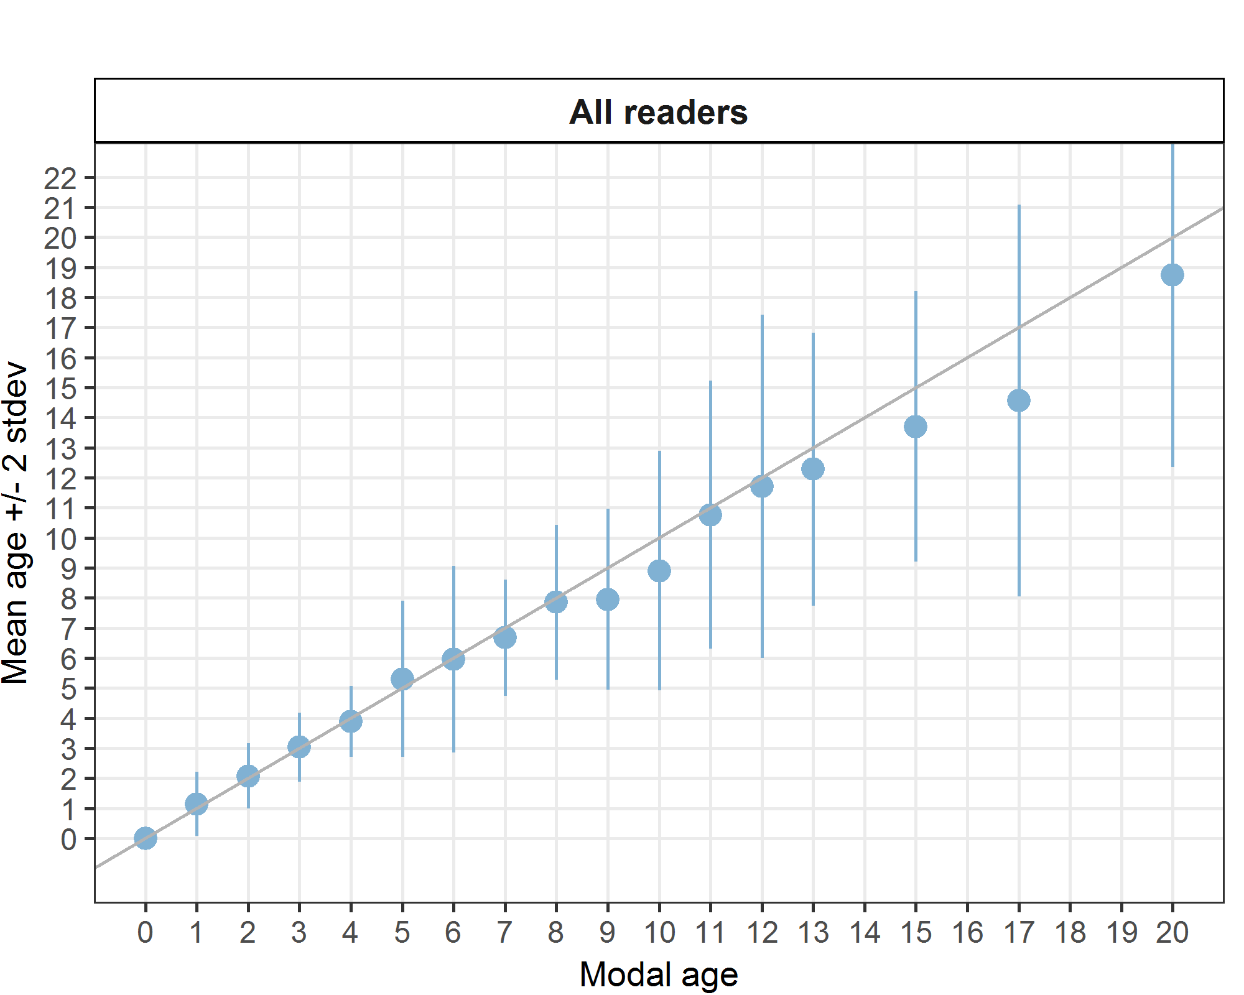
Figure 6.1:: Age bias plot for all readers. Mean age recorded +/- 2 stdev of each reader and all readers combined are plotted against modal age. The estimated mean age corresponds to modal age, if the estimated mean age is on the 1:1 equilibrium line (solid line). Relative bias is the age difference between estimated mean age and modal age.
Table 6.6: Inter reader bias test. The Inter-reader bias test gives probability of bias between readers and with modal age. - = no sign of bias (p>0.05), * = possibility of bias (0.01<p<0.05), * * = certainty of bias (p<0.01)
Comparison | R02 NL | R04 BE | R06 BE | R08 FR | R10 FR | R12 FR | R14 NL
R02 NL | - | ** | ** | - | * | ** | **
R04 BE | ** | - | * | ** | ** | ** | -
R06 BE | ** | * | - | ** | ** | ** | *
R08 FR | - | ** | ** | - | - | ** | **
R10 FR | * | ** | ** | - | - | ** | **
R12 FR | ** | ** | ** | ** | ** | - | **
R14 NL | ** | - | * | ** | ** | ** | -
Modal age | - | ** | ** | ** | ** | ** | **

Advanced readers only – stained sectioned otoliths
All samples included (except AQ3 samples)
Table 6.7: Coefficient of Variation (CV) table presents the CV per modal age and advanced reader, the CV of all advanced readers combined per modal age and a weighted mean of the CV per reader.
Modal age | R02 NL | R04 BE | R06 BE | all
0 | - | - | - | -
1 | 81 % | 40 % | 42 % | 57 %
2 | 21 % | 33 % | 25 % | 30 %
3 | 20 % | 14 % | 10 % | 16 %
4 | 17 % | 8 % | 6 % | 12 %
5 | 22 % | 9 % | 15 % | 16 %
6 | 16 % | 5 % | 5 % | 10 %
7 | 11 % | 4 % | 0 % | 7 %
8 | 13 % | 0 % | 17 % | 12 %
9 | 9 % | 5 % | 0 % | 7 %
10 | 4 % | 11 % | 17 % | 13 %
11 | 5 % | 0 % | 5 % | 5 %
12 | 0 % | 0 % | 5 % | 2 %
13 | 6 % | 3 % | 9 % | 7 %
14 | - | - | - | -
15 | 0 % | 0 % | 4 % | 3 %
16 | - | - | - | -
17 | - | - | - | 3 %
18 | - | - | - | -
19 | - | - | - | 7 %
20 | - | - | - | 3 %
Weighted Mean | 24 % | 14 % | 15 % | 19 %
Table 6.8: Percentage agreement (PA) table represents the PA per modal age and reader, advanced the PA of all advanced readers combined per modal age and a weighted mean of the PA per reader.
Modal age | R02 NL | R04 BE | R06 BE | all
0 | 100 % | 100 % | 100 % | 100 %
1 | 83 % | 95 % | 83 % | 87 %
2 | 83 % | 82 % | 72 % | 79 %
3 | 57 % | 95 % | 91 % | 82 %
4 | 40 % | 90 % | 95 % | 75 %
5 | 72 % | 94 % | 76 % | 81 %
6 | 42 % | 92 % | 92 % | 75 %
7 | 36 % | 92 % | 100 % | 78 %
8 | 38 % | 100 % | 88 % | 75 %
9 | 57 % | 71 % | 100 % | 74 %
10 | 80 % | 45 % | 70 % | 65 %
11 | 67 % | 100 % | 67 % | 78 %
12 | 100 % | 100 % | 67 % | 91 %
13 | 75 % | 75 % | 43 % | 65 %
14 | - | - | - | -
15 | 100 % | 100 % | 33 % | 78 %
16 | - | - | - | -
17 | 100 % | 100 % | 0 % | 67 %
18 | - | - | - | -
19 | 100 % | 0 % | - | 50 %
20 | 100 % | 0 % | 100 % | 67 %
Weighted Mean | 65 % | 87 % | 82 % | 78 %
Table 6.9: Relative bias table represents the relative bias per modal age and advanced reader, the relative bias of all advanced readers combined per modal age and a weighted mean of the relative bias per reader.
Modal age | R02 NL | R04 BE | R06 BE | all
0 | 0.00 | 0.00 | 0.00 | 0.00
1 | 0.13 | 0.10 | 0.21 | 0.14
2 | -0.17 | 0.35 | 0.33 | 0.17
3 | -0.43 | 0.09 | 0.09 | -0.08
4 | -0.50 | 0.00 | 0.05 | -0.15
5 | 0.00 | 0.12 | 0.35 | 0.16
6 | -0.33 | 0.08 | 0.08 | -0.06
7 | -0.45 | 0.08 | 0.00 | -0.13
8 | 0.00 | 0.00 | 0.50 | 0.17
9 | -0.57 | 0.29 | 0.00 | -0.10
10 | 0.20 | 0.45 | 1.20 | 0.62
11 | -0.33 | 0.00 | 0.33 | 0.00
12 | 0.00 | 0.00 | 0.33 | 0.11
13 | 0.38 | 0.25 | 1.14 | 0.59
14 | - | - | - | -
15 | 0.00 | 0.00 | 0.67 | 0.22
16 | - | - | - | -
17 | 0.00 | 0.00 | -1.00 | -0.33
18 | - | - | - | -
19 | 0.00 | 2.00 | - | -
20 | 0.00 | 1.00 | 0.00 | 0.33
Weighted Mean | -0.16 | 0.15 | 0.28 | 0.09
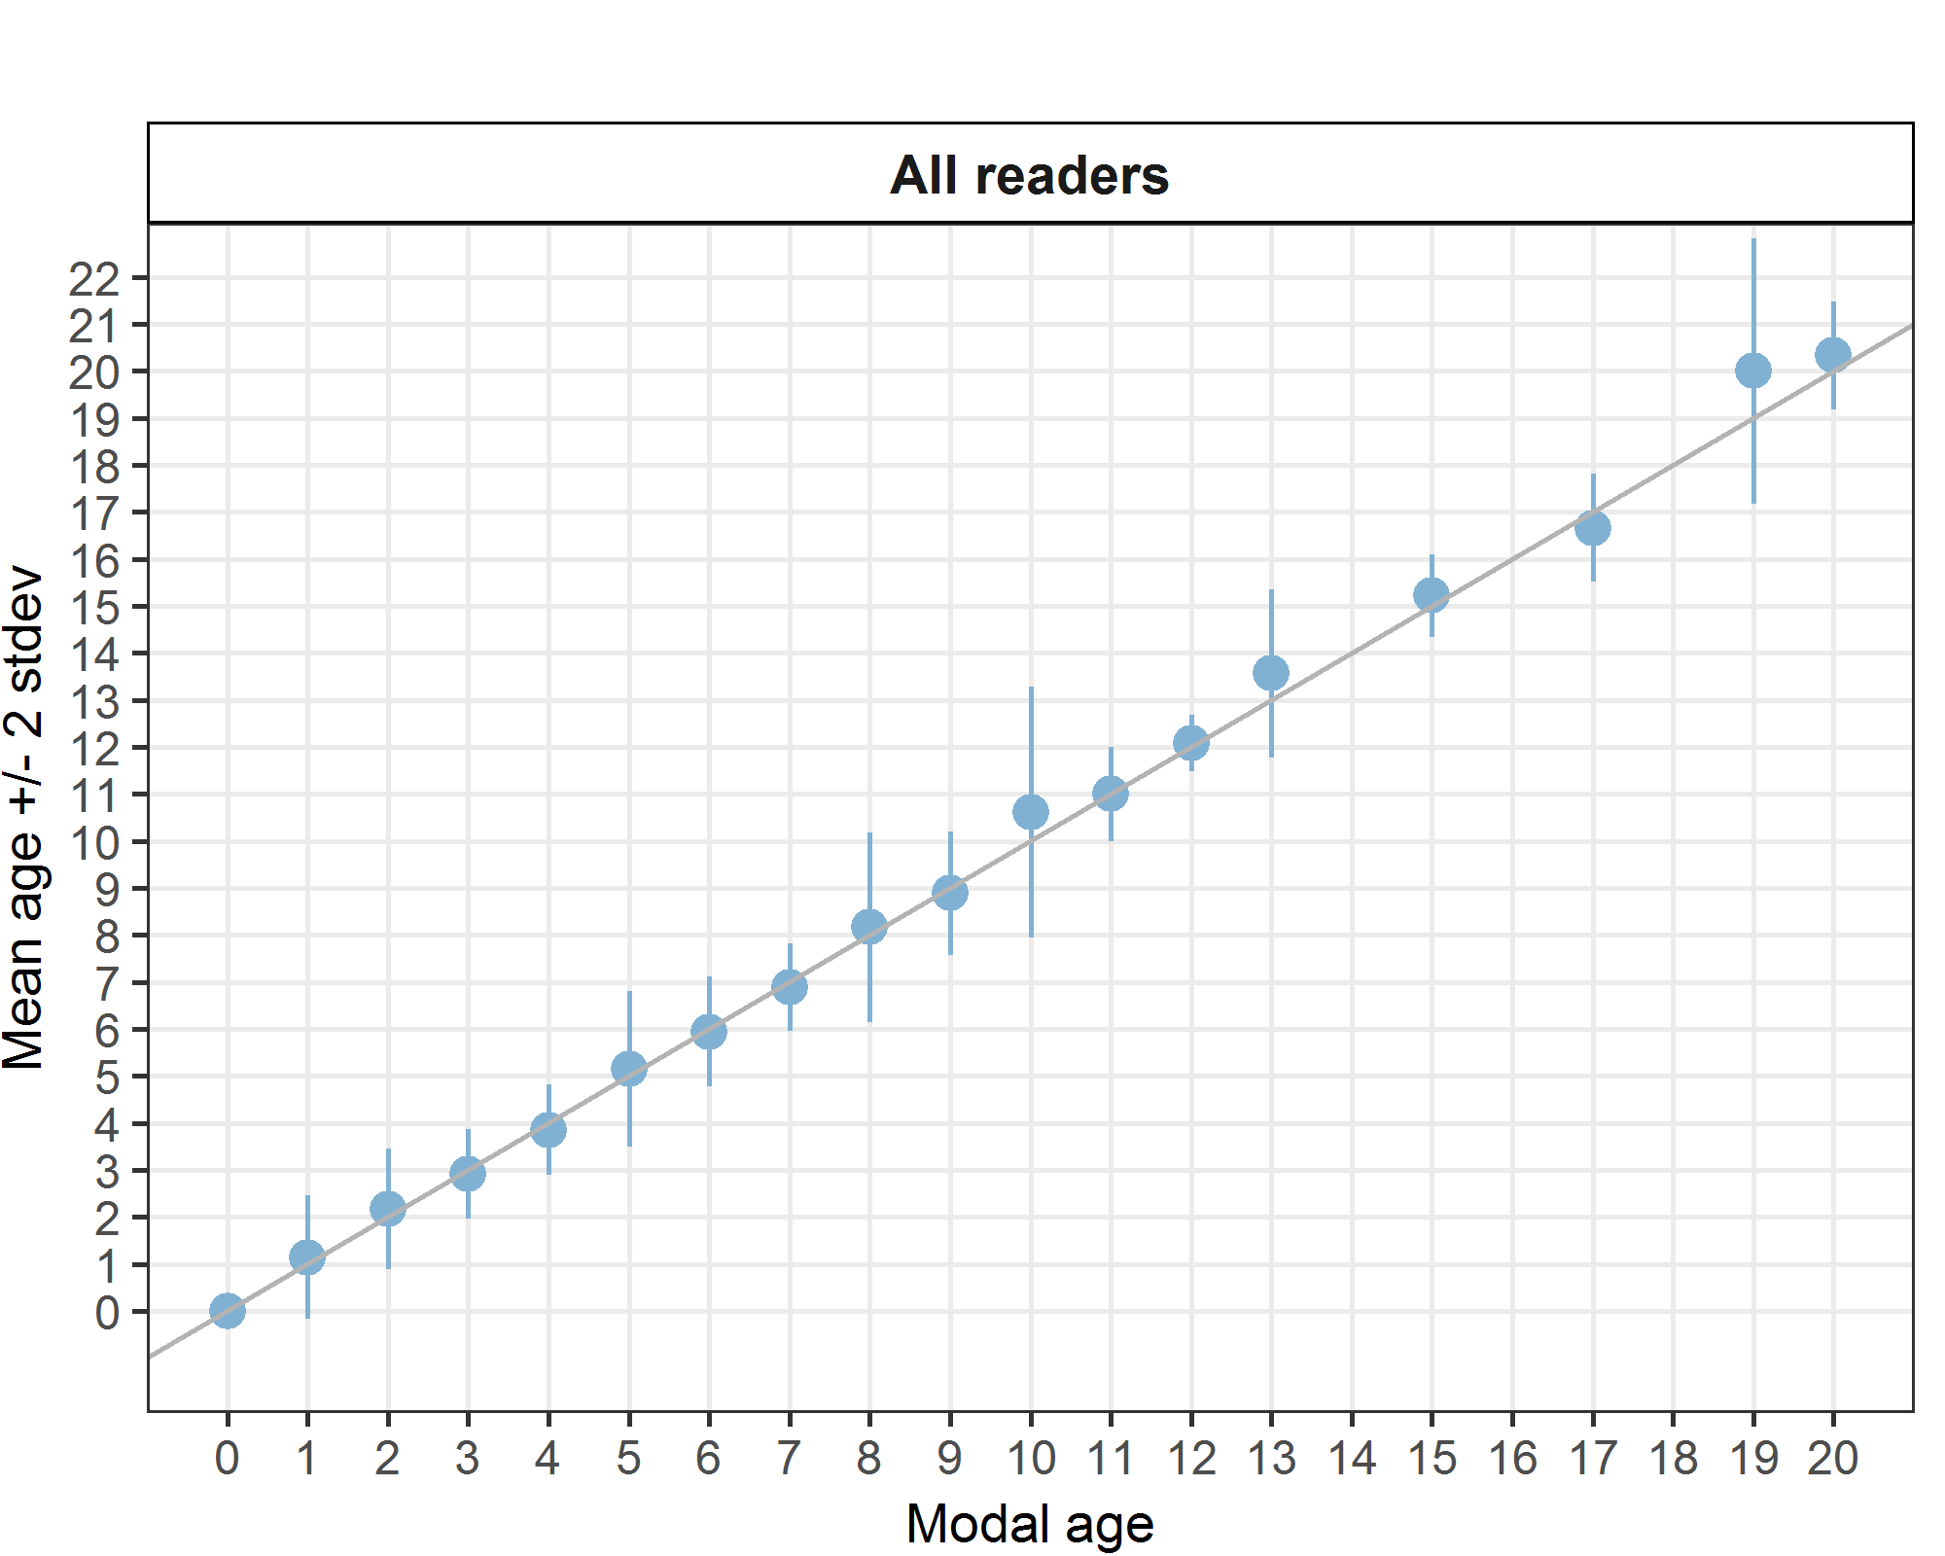
Figure 6.2: Age bias plot for advanced readers.

Age error matrices are calculated per area and only based on the age readings of the advanced readers.
Table 6.10: Age error matrix (AEM) for SS. The AEM shows the proportional distribution of age readings for each modal age. Age column should sum to one but due to rounding there might be small deviations in some cases. Only advanced readers are used for calculating the AEM.
strata | Modal age | 0 | 1 | 2 | 3 | 4 | 5 | 6 | 7 | 8 | 9 | 10 | 11 | 12 | 13 | 15 | 17 | 19 | 20
SS | Age 0 | 1 | 0.02941 | - | - | - | - | - | - | - | - | - | - | - | - | - | - | - | -
SS | Age 1 | - | 0.86765 | 0.05660 | - | - | - | - | - | - | - | - | - | - | - | - | - | - | -
SS | Age 2 | - | 0.05882 | 0.79245 | 0.13846 | - | - | - | - | - | - | - | - | - | - | - | - | - | -
SS | Age 3 | - | 0.02941 | 0.07547 | 0.81538 | 0.20 | - | - | - | - | - | - | - | - | - | - | - | - | -
SS | Age 4 | - | - | 0.07547 | 0.03077 | 0.75 | 0.07692 | - | - | - | - | - | - | - | - | - | - | - | -
SS | Age 5 | - | 0.01471 | - | 0.01538 | 0.05 | 0.80769 | 0.16667 | - | - | - | - | - | - | - | - | - | - | -
SS | Age 6 | - | - | - | - | - | 0.05769 | 0.75000 | 0.16667 | - | - | - | - | - | - | - | - | - | -
SS | Age 7 | - | - | - | - | - | 0.01923 | 0.05556 | 0.77778 | 0.12500 | 0.05263 | - | - | - | - | - | - | - | -
SS | Age 8 | - | - | - | - | - | 0.01923 | 0.02778 | 0.05556 | 0.75000 | 0.10526 | 0.03226 | - | - | - | - | - | - | -
SS | Age 9 | - | - | - | - | - | 0.01923 | - | - | 0.04167 | 0.73684 | - | - | - | - | - | - | - | -
SS | Age 10 | - | - | - | - | - | - | - | - | 0.04167 | 0.10526 | 0.64516 | 0.1111 | - | - | - | - | - | -
SS | Age 11 | - | - | - | - | - | - | - | - | - | - | 0.16129 | 0.7778 | - | - | - | - | - | -
SS | Age 12 | - | - | - | - | - | - | - | - | 0.04167 | - | 0.06452 | 0.1111 | 0.90909 | - | - | - | - | -
SS | Age 13 | - | - | - | - | - | - | - | - | - | - | - | - | 0.09091 | 0.65217 | - | - | - | -
SS | Age 14 | - | - | - | - | - | - | - | - | - | - | 0.09677 | - | - | 0.17391 | - | - | - | -
SS | Age 15 | - | - | - | - | - | - | - | - | - | - | - | - | - | 0.13043 | 0.7778 | - | - | -
SS | Age 16 | - | - | - | - | - | - | - | - | - | - | - | - | - | 0.04348 | 0.2222 | 0.3333 | - | -
SS | Age 17 | - | - | - | - | - | - | - | - | - | - | - | - | - | - | - | 0.6667 | - | -
SS | Age 19 | - | - | - | - | - | - | - | - | - | - | - | - | - | - | - | - | 0.5 | -
SS | Age 20 | - | - | - | - | - | - | - | - | - | - | - | - | - | - | - | - | - | 0.6667
SS | Age 21 | - | - | - | - | - | - | - | - | - | - | - | - | - | - | - | - | 0.5 | 0.3333

All readers – whole otoliths
All samples included, except AQ3 samples
The weighted average percentage agreement based on modal ages for all readers is 53 %, with the weighted average CV of 50 % and APE of 32 %.
Table 6.11: Coefficient of Variation (CV) table presents the CV per modal age and reader, the CV of all readers combined per modal age and a weighted mean of the CV per reader.
Modal age | R02 NL | R04 BE | R06 BE | R08 FR | R10 FR | R12 FR | R14 NL | all
0 | - | - | - | - | - | - | - | -
1 | 29 % | 73 % | 106 % | 36 % | 100 % | 83 % | 31 % | 94 %
2 | 20 % | 47 % | 58 % | 24 % | 44 % | 31 % | 52 % | 56 %
3 | 24 % | 34 % | 60 % | 19 % | 23 % | 23 % | 25 % | 48 %
4 | 19 % | 33 % | 54 % | 16 % | 19 % | 12 % | 34 % | 39 %
5 | 32 % | 36 % | 42 % | 13 % | 39 % | 22 % | 31 % | 35 %
6 | 19 % | 11 % | 29 % | 11 % | 11 % | 22 % | 24 % | 22 %
7 | 21 % | 17 % | 29 % | 11 % | 9 % | 10 % | 24 % | 20 %
8 | 16 % | 23 % | 30 % | 11 % | 22 % | 18 % | 21 % | 25 %
Weighted Mean | 23 % | 40 % | 59 % | 20 % | 39 % | 32 % | 33 % | 50 %
The percentage agreement per reader per modal age tells how large part of the readings that are equal to the modal age. The weighted mean including at the bottom of the table is weighted according to number of age readings.
Table 6.12: Percentage agreement (PA) table represents the PA per modal age and reader, the PA of all readers combined per modal age and a weighted mean of the PA per reader.
Modal age | R02 NL | R04 BE | R06 BE | R08 FR | R10 FR | R12 FR | R14 NL | all
0 | 100 % | 50 % | 25 % | 0 % | 100 % | 100 % | 100 % | 67 %
1 | 93 % | 39 % | 54 % | 10 % | 50 % | 43 % | 86 % | 55 %
2 | 84 % | 31 % | 24 % | 6 % | 58 % | 78 % | 55 % | 48 %
3 | 63 % | 46 % | 35 % | 40 % | 68 % | 71 % | 54 % | 54 %
4 | 62 % | 45 % | 41 % | 52 % | 52 % | 77 % | 45 % | 54 %
5 | 67 % | 56 % | 25 % | 73 % | 44 % | 50 % | 38 % | 50 %
6 | 75 % | 50 % | 25 % | 57 % | 88 % | 62 % | 50 % | 58 %
7 | 25 % | 50 % | 45 % | 75 % | 58 % | 67 % | 45 % | 52 %
8 | 43 % | 43 % | 33 % | 83 % | 14 % | 43 % | 57 % | 45 %
Weighted Mean | 71 % | 43 % | 35 % | 38 % | 58 % | 66 % | 57 % | 53 %
The relative bias is the difference between the mean age (per modal age per reader) and modal age.

Table 6.13: Relative bias table represents the relative bias per modal age per reader, the relative bias of all readers combined per modal age and a weighted mean of the relative bias per reader.
Modal age | R02 NL | R04 BE | R06 BE | R08 FR | R10 FR | R12 FR | R14 NL | all
0 | 0.00 | 0.50 | 0.75 | 1.00 | 0.00 | 0.00 | 0.00 | 0.32
1 | -0.07 | 1.25 | 1.15 | 1.45 | -0.43 | -0.07 | 0.14 | 0.49
2 | 0.00 | 1.56 | 2.34 | 1.57 | 0.34 | 0.00 | 0.18 | 0.86
3 | -0.32 | 1.12 | 2.28 | 0.75 | 0.15 | -0.15 | -0.34 | 0.50
4 | -0.24 | 1.09 | 2.18 | 0.62 | 0.17 | -0.14 | -0.14 | 0.51
5 | 0.27 | 0.69 | 1.62 | 0.20 | 0.44 | -0.56 | 0.25 | 0.41
6 | -0.50 | 0.62 | 1.38 | 0.14 | 0.25 | -0.75 | -0.62 | 0.07
7 | -0.83 | 0.83 | 0.91 | -0.17 | -0.25 | -0.42 | 0.00 | 0.01
8 | -0.29 | 1.86 | 2.50 | -0.33 | 0.71 | -1.14 | 1.29 | 0.66
Weighted Mean | -0.18 | 1.16 | 1.89 | 0.82 | 0.12 | -0.22 | 0.01 | 0.52
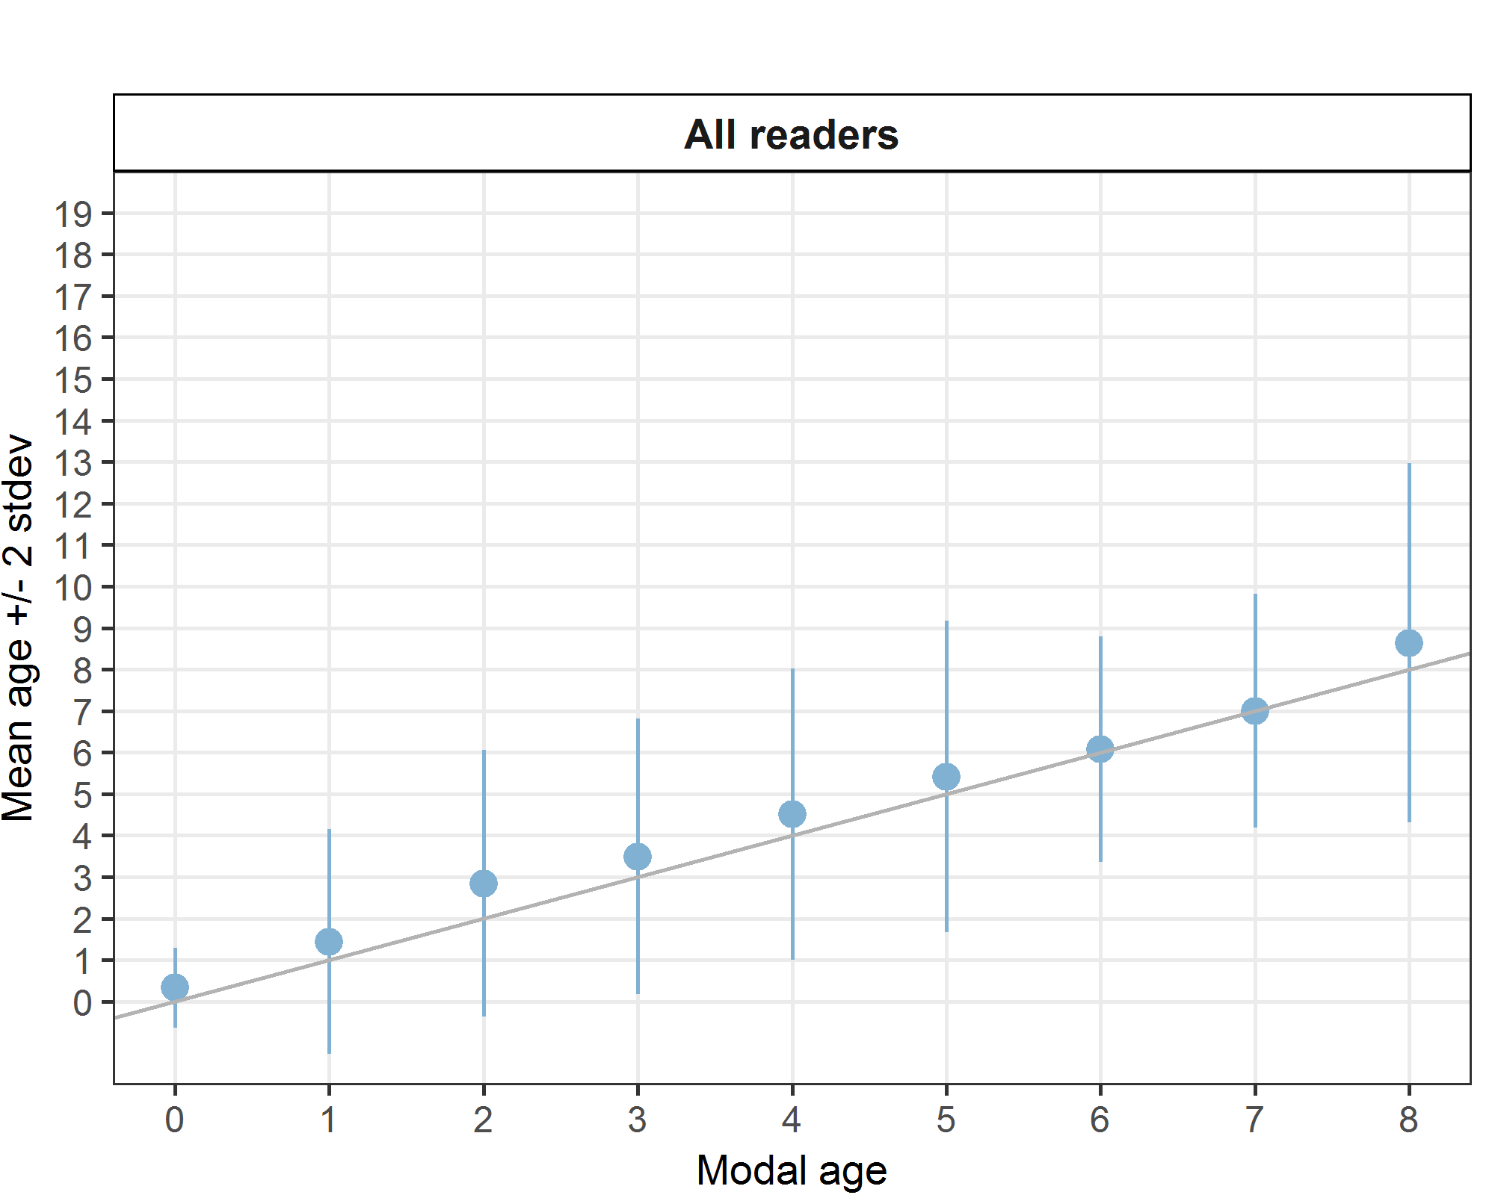
Figure 6.3: Age bias plot for all readers. Mean age recorded +/- 2 stdev of each reader and all readers combined are plotted against modal age. The estimated mean age corresponds to modal age, if the estimated mean age is on the 1:1 equilibrium line (solid line). Relative bias is the age difference between estimated mean age and modal age.
Table 6.14: Inter reader bias test. The Inter-reader bias test gives probability of bias between readers and with modal age. - = no sign of bias (p>0.05), * = possibility of bias (0.01<p<0.05), * * = certainty of bias (p<0.01)
Comparison | R02 NL | R04 BE | R06 BE | R08 FR | R10 FR | R12 FR | R14 NL
R02 NL | - | ** | ** | ** | ** | - | *
R04 BE | ** | . | ** | * | ** | ** | **
R06 BE | ** | ** | . | ** | ** | ** | **
R08 FR | ** | * | ** | . | ** | ** | **
R10 FR | ** | ** | ** | ** | - | ** | -
R12 FR | - | ** | ** | ** | ** | - | -
R14 NL | * | ** | ** | ** | - | - | -
Modal age | ** | ** | ** | ** | - | ** | -

Advanced readers only – whole otoliths
All samples included, except AQ3 samples
Table 6.15: Coefficient of Variation (CV) table presents the CV per modal age and advanced reader, the CV of all advanced readers combined per modal age and a weighted mean of the CV per reader.
Modal age | R02 NL | R04 BE | R06 BE | all
0 | - | - | - | -
1 | 32 % | 80 % | 123 % | 116 %
2 | 22 % | 58 % | 73 % | 76 %
3 | 21 % | 39 % | 65 % | 58 %
4 | 15 % | 28 % | 30 % | 28 %
5 | 28 % | 27 % | 34 % | 34 %
6 | 7 % | 11 % | 23 % | 20 %
7 | 8 % | 7 % | 14 % | 10 %
8 | 14 % | 16 % | 30 % | 25 %
9 | - | - | - | 6 %
10 | - | - | - | 17 %
11 | - | - | - | 20 %
Weighted Mean | 21 % | 42 % | 61 % | 58 %
Table 16: Percentage agreement (PA) table represents the PA per modal age and reader, advanced the PA of all advanced readers combined per modal age and a weighted mean of the PA per reader.
Modal age | R02 NL | R04 BE | R06 BE | all
0 | 100 % | 50 % | 33 % | 64 %
1 | 91 % | 48 % | 68 % | 69 %
2 | 82 % | 43 % | 37 % | 54 %
3 | 73 % | 61 % | 48 % | 61 %
4 | 77 % | 52 % | 57 % | 62 %
5 | 75 % | 76 % | 35 % | 62 %
6 | 80 % | 50 % | 30 % | 53 %
7 | 57 % | 71 % | 67 % | 65 %
8 | 50 % | 50 % | 60 % | 53 %
9 | 100 % | 0 % | 100 % | 67 %
10 | 100 % | 0 % | 0 % | 33 %
11 | 100 % | 0 % | 0 % | 33 %
Weighted Mean | 78 % | 54 % | 47 % | 60 %
Table 17: Relative bias table represents the relative bias per modal age and advanced reader, the relative bias of all advanced readers combined per modal age and a weighted mean of the relative bias per reader.
Modal age | R02 NL | R04 BE | R06 BE | all
0 | 0.00 | 0.50 | 0.67 | 0.39
1 | -0.09 | 1.48 | 1.77 | 1.05
2 | -0.18 | 1.68 | 2.61 | 1.37
3 | -0.27 | 0.95 | 1.95 | 0.88
4 | -0.18 | 0.65 | 1.00 | 0.49
5 | -0.62 | 0.71 | 1.41 | 0.50
6 | -0.20 | 0.60 | 1.60 | 0.67
7 | -0.43 | 0.29 | -0.17 | -0.10
8 | -0.83 | 1.17 | 2.20 | 0.84
9 | 0.00 | 1.00 | 0.00 | 0.33
10 | 0.00 | 4.00 | 3.00 | 2.33
11 | 0.00 | 1.00 | 5.00 | 2.00
Weighted Mean | -0.26 | 1.08 | 1.80 | 0.87
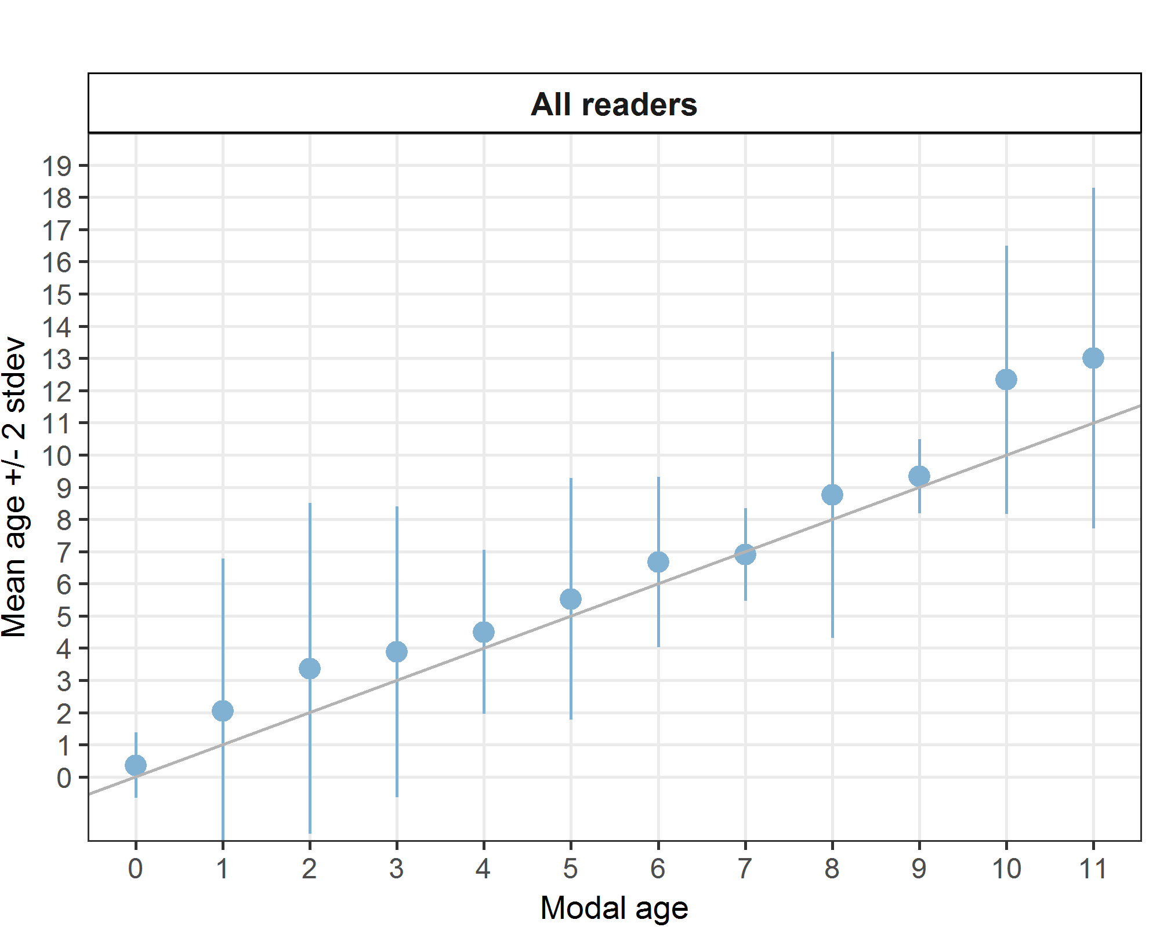
Figure 6.4: Age bias plot for advanced readers.
Age error matrices are calculated per area and only based on the age readings of the advanced readers.
Table 6.18: Age error matrix (AEM) . The AEM shows the proportional distribution of age readings for each modal age. Age column should sum to one but due to rounding there might be small deviations in some cases. Only advanced readers are used for calculating the AEM.
Modal age | 0 | 1 | 2 | 3 | 4 | 5 | 6 | 7 | 8 | 9 | 10 | 11
Age 0 | 0.6364 | 0.02941 | - | - | - | - | - | - | - | - | - | -
Age 1 | 0.3636 | 0.69118 | 0.07080 | 0.015152 | - | - | - | - | - | - | - | -
Age 2 | - | 0.08824 | 0.53982 | 0.068182 | 0.01471 | 0.06 | - | - | - | - | - | -
Age 3 | - | 0.05882 | 0.10619 | 0.606061 | 0.07353 | - | - | - | - | - | - | -
Age 4 | - | - | 0.05310 | 0.090909 | 0.61765 | 0.02 | - | - | - | - | - | -
Age 5 | - | 0.04412 | 0.05310 | 0.090909 | 0.13235 | 0.62 | 0.06667 | 0.05 | - | - | - | -
Age 6 | - | - | 0.07080 | 0.045455 | 0.08824 | 0.16 | 0.53333 | 0.15 | 0.11765 | - | - | -
Age 7 | - | 0.02941 | 0.03540 | 0.022727 | 0.02941 | 0.06 | 0.20000 | 0.65 | 0.05882 | - | - | -
Age 8 | - | - | 0.01770 | 0.015152 | 0.01471 | - | 0.16667 | 0.15 | 0.52941 | - | - | -
Age 9 | - | 0.01471 | - | 0.022727 | 0.02941 | 0.04 | - | - | 0.05882 | 0.6667 | - | -
Age 10 | - | 0.04412 | 0.02655 | - | - | 0.02 | - | - | - | 0.3333 | 0.3333 | -
Age 11 | - | - | 0.01770 | 0.007576 | - | - | - | - | 0.11765 | - | - | 0.3333
Age 12 | - | - | - | - | - | - | 0.03333 | - | - | - | - | 0.3333
Age 13 | - | - | - | - | - | - | - | - | 0.05882 | - | 0.3333 | -
Age 14 | - | - | - | - | - | 0.02 | - | - | 0.05882 | - | 0.3333 | -
Age 15 | - | - | - | 0.007576 | - | - | - | - | - | - | - | -
Age 16 | - | - | 0.00885 | - | - | - | - | - | - | - | - | 0.3333
Age 18 | - | - | - | 0.007576 | - | - | - | - | - | - | - | -

Comparison between whole and stained sectioned otoliths

Figure 6.5: Comparison of age determinations based on whole and sectioned otoliths from the same fish. The y=x line indicates when both methods give the same result for modal age.
The same age is given in 34% of the cases for whole and stained sectioned otoliths (fig. 6.5), 9% are above the line (older age for whole) and 57% are below the line (older age for whole). The outcome of the age readings clearly differed depending on the method, indicating that one of the methods is less accurate. Fish are generally assigned an older age when using sectioned otoliths compared to whole otoliths. The deviation becomes very clear in older fish, where otoliths with a “cliffed edge” are not at all detected when read “whole”.

Discussion and conclusion
This exchange was an image only exchange executed in SmartDots. The statistics representing age reading performance were calculated for all readers combined and for experienced readers only, using the R-script as provided in SmartDots. All areas were included and calculations were carried separately for each preparation method. There were 3 advanced readers, all used to reading S&S otoliths. No advanced readers were used to reading whole otoliths. As expected, percentage agreement was higher and coefficient of variation was lower for advanced readers compared to all readers regardless of preparation method. We should stress here that the advanced readers were used to reading stained sectioned otoliths, and not whole otoliths, although they were used to reading whole otoliths of other flatfish species. Only the French readers usually read whole otoliths, but they are all basic readers, not reporting data for assessments.
The statistics were better for stained sectioned otoliths than for whole otoliths. The average percentage agreement of 68 %, CV of 24 % and APE of 15 % was reached by all readers annotating stained sectioned otoliths. There was an important improvement when only advanced readers were combined: PA=78%, CV = 19%, APE = 7%. For whole otoliths, the statistical results were not satisfactory. The average percentage agreement of 53 %, CV of 50 % and APE of 32 % was obtained by all readers, while for advanced readers, the results were better: PA=71%, CV = 29%, APE = 21%. In whole otoliths, the different rings are often difficult to interpret.
When comparing whole and stained sectioned otoliths, fish are generally assigned an older age when otoliths are sectioned and stained. This has also been confirmed in other flatfish species. Question is whether age is underestimated when using whole otoliths or overestimated when using sections. In a validation study on two other flatfish species (plaice Pleuronectes platessa and sole Solea solea) it was concluded that age will be underestimated when using whole otoliths (Etherton, 2015). Often, the age of old fish is underestimated when read whole, due to presence of cliffed edge which in not detected in whole otoliths. On the other hand, in young fish, it is more difficult to distinguish the different growth structures in general. A very small first ring often occurs in turbot otoliths, causing uncertainty on whether or not this is a true annulus. In stained sectioned otoliths, this small ring is posing less problems but still it is also an issue and the main cause of bias. For those different reasons, we recommend to use stained sections for reading turbot otoliths.
When analysing only the results of the stained sections, the percentage agreement decreases with age while standard deviation increases. The lower overall PA (68%) and higher APE (15%) attained when analysing the readings of all readers is partly attributed to the poor level of agreement of readers R08, R10, R12 starting from modal age 2. Often, the age of the fish is underestimated by these readers. This fact that these readers are used to reading only whole otoliths of only young fish, can be an explanation for this. A closer examination of the annotated images shows that the main issue between advanced readers only, is the interpretation of the first small ring. Often, it is not clear if this should be interpreted as the first growth year. Moreover there was a discrepancy between the advanced readers from Belgium annotating this ring as the first year, and the advanced reader from the Netherlands, not counting this ring. This could cause discrepancies between the Belgian and the Dutch readings. Compared to the WKART (2008) workshop, the results between advanced readers were less good. In 2008, agreements were made for the interpretation of the first ring, but the agreements were not specified in the report. It seems that the readers are not aware any more about the agreements concerning the first ring. It will be necessary to find out what the agreement was and to inform the readers about it. If it turns out to be impossible to retrieve the needed information, an small workshop on this issue will be necessary. Moreover a validation study on whether this first ring should be counted as first annulus is recommended.
Compared to the brill exchange (event 200 in SmartDots), the results of the turbot exchange are less good. Although brill and turbot are closely related and their ecology is similar (e.g. time of spawning and settlement, location of nursery areas), differences in growth patterns occur. Especially the presence of this small first ring in turbot otoliths, which does not occur (frequently) in brill otoliths, is at the origin of this.
Table 6.19: Images of whole and stained sectioned otoliths representing frequently encountered situations in the interpretation of the structures.
Whole otolith | Stained sectioned otolith from the same fish | Comment
WH_056_DTU2017_TUR_4B_270_04092017  Model age: 4; PA = 71 %; CV = 32 %; APE: = 22 % (all)  Model age: 4; PA = 67 %; CV = 43 %; APE: = 33 % (adv.) | SS_056_DTU2017_TUR_4B_270_04092017  Model age: 10; PA = 67 %; CV = 17 %; APE: = 15 % (all)  Model age: 10; PA = 100 %; CV = 0 %; APE: = 0 % (adv.) | Otolith with cliffed edge where age is underestimated in whole otoliths.
WH_079_DTU2017_TUR_4A_258_12072017  Model age= 2; PA = 58 %; CV = 43 %; APE = 34 %  Model age= 2; PA = 67 %; CV = 25 %; APE = 19 % | SS_079_DTU2017_TUR_4A_258_12072017  Model age= 2; PA = 71 %; CV = 21 %; APE = 18 %  Model age= 2; PA = 67 %; CV = 25 %; APE = 19 % | Otolith with difficulty in interpretation of the first ring.
WH_016_BYDR07_TUR_4B_D_S_2017110910115  Model age= 2; PA = 57 %; CV = 34 %; APE = 31 %  Model age= 3; PA = 67 %; CV = 22 %; APE = 17 % | 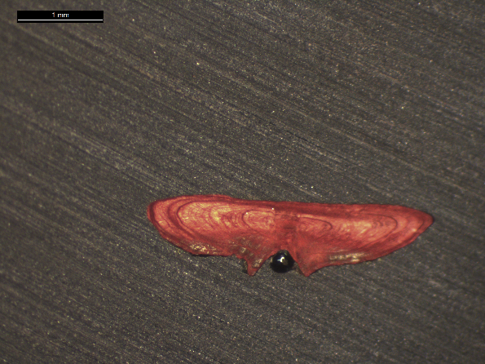  SS_016_BYDR07_TUR_4B_D_S_2017110910115  Model age= 3; PA = 67 %; CV = 19 %; APE = 17 %  Model age= 3; PA = 67 %; CV = 22 %; APE = 17 % | Otolith with difficulty in interpretation of the first ring.
WH_126_DTU2016_TUR_BA_7D_298_10112016  Model age= 7; PA = 57 %; CV = 12 %; APE = 10 %  Model age= 7; PA = 67 %; CV = 9 %; APE = 7 % | 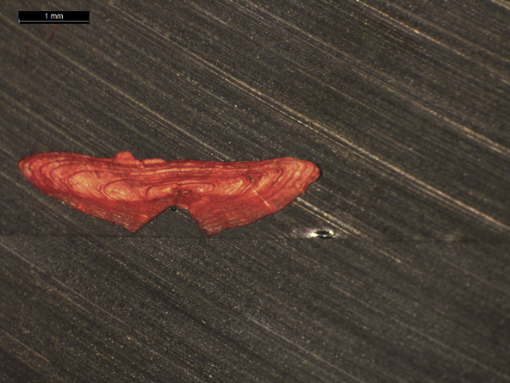  SS_126_DTU2016_TUR_BA_7D_298_10112016  Model age= 7; PA = 86 %; CV = 6 %; APE = 4 %  Model age= 7; PA = 100 %; CV = 0 %; APE = 0 % | Otolith with difficulty in interpretation of the structures in the whole otolith, while the stained section gets a better PA for all readers (86%) and advanced readers only (100%)
WH_097_NDGP15_BTS01_TUR_4C_55090  Model age= 4; PA = 43 %; CV = 16 %; APE = 13 %  Model age= 5; PA = 100 %; CV = 0 %; APE = 0 % | SS_097_NDGP15_BTS01_TUR_4C_55090  Model age= 5; PA = 100 %; CV = 0 %; APE = 0 %  Model age= 5; PA = 100 %; CV = 0 %; APE = 0 % | Otolith with difficulty in interpretation of the structures in the whole otolith, while the stained section gets a PA of 100 %.

References
Etherton M. (2015) European plaice (Pleuronectes platessa) and sole (Solea solea) indirect age validation using otoliths from mark-recapture experiments from the North Sea. Fisheries Research 170: 76–81.
ICES. 2008. Report on the Workshop on Age Reading of Turbot (WKART), 24-27 June 2008, Oostende, Belgium.

Annex

List of participants
Table 7.1: Participants list.
Reader code | Expertise
R02 NL | Advanced
R04 BE | Advanced
R06 BE | Advanced
R08 FR | Basic
R10 FR | Basic
R12 FR | Basic
R14 NL | Basic

Results all readers (stained sections)
Data Overview – Stained sections
Table 7.2: Summary of statistics; PA (%), CV (%) and APE (%).
CV | PA | APE
24 % | 68 % | 15 %
Table 7.3: Data overview including modal age and statistics per sample.
Fish ID | Event ID | Image ID | length | sex | Catch date | ICES area | R02 NL | R04 BE | R06 BE | R08 FR | R10 FR | R12 FR | R14 NL | Modal age | PA % | CV % | APE %
001_BYDR05_TUR_4B_D_S_2017071410086 | 216 | - | 250 | - | 14/07/2017 00:00:00 | 27.4.b | 2 | 2 | 2 | 2 | 1 | 1 | 2 | 2 | 71 | 28 | 24
002_BYDR05_TUR_4B_D_S_2017071410087 | 216 | - | 260 | - | 14/07/2017 00:00:00 | 27.4.b | 2 | 3 | 3 | 3 | 3 | 1 | 3 | 3 | 71 | 31 | 24
003_BYDR05_TUR_4B_D_S_2017071410088 | 216 | - | 270 | - | 14/07/2017 00:00:00 | 27.4.b | 2 | 3 | 3 | 3 | 3 | 1 | 3 | 3 | 71 | 31 | 24
004_BYDR05_TUR_4B_L_M_2017071410335 | 216 | - | 305 | - | 14/07/2017 00:00:00 | 27.4.b | 3 | 4 | 4 | 3 | 4 | 2 | 3 | 3 | 43 | 23 | 19
005_BYDR05_TUR_4B_L_M_2017071410336 | 216 | - | 445 | - | 14/07/2017 00:00:00 | 27.4.b | 3 | 4 | 4 | - | 4 | 2 | 3 | 4 | 50 | 24 | 20
006_BYDR05_TUR_4B_L_M_2017071410337 | 216 | - | 435 | - | 14/07/2017 00:00:00 | 27.4.b | 3 | 4 | 4 | 5 | 5 | 2 | 3 | 3 | 29 | 30 | 24
007_BYDR05_TUR_4B_L_M_2017071410357 | 216 | - | 575 | - | 14/07/2017 00:00:00 | 27.4.b | 5 | 5 | 5 | 5 | 6 | 4 | 6 | 5 | 57 | 13 | 10
008_BYDR05_TUR_4B_L_M_2017071410358 | 216 | - | 565 | - | 14/07/2017 00:00:00 | 27.4.b | 5 | 5 | 5 | 5 | 4 | 4 | 5 | 5 | 71 | 10 | 9
009_BYDR05_TUR_4B_L_M_2017071410360 | 216 | - | 520 | - | 14/07/2017 00:00:00 | 27.4.b | 5 | 5 | 5 | 5 | 5 | 4 | 5 | 5 | 86 | 8 | 5
010_BYDR05_TUR_4B_L_M_2017071410361 | 216 | - | 590 | - | 14/07/2017 00:00:00 | 27.4.b | 6 | 7 | 6 | 7 | 7 | 5 | 7 | 7 | 57 | 12 | 10
011_BYDR05_TUR_4B_L_M_2017071410362 | 216 | - | 610 | - | 14/07/2017 00:00:00 | 27.4.b | 6 | 6 | 6 | 7 | 6 | 5 | 7 | 6 | 57 | 11 | 8
012_BYDR07_TUR_4B_D_S_2017110910094 | 216 | - | 190 | - | 09/11/2017 00:00:00 | 27.4.b | 0 | 1 | 1 | 1 | 1 | 0 | 1 | 1 | 71 | 68 | 57
013_BYDR07_TUR_4B_D_S_2017110910095 | 216 | - | 200 | - | 09/11/2017 00:00:00 | 27.4.b | 0 | 1 | 1 | 1 | 1 | 1 | 1 | 1 | 86 | 44 | 29
014_BYDR07_TUR_4B_D_S_2017110910105 | 216 | - | 260 | - | 09/11/2017 00:00:00 | 27.4.b | 1 | 3 | 2 | 2 | 2 | 2 | 2 | 2 | 71 | 29 | 14
015_BYDR07_TUR_4B_D_S_2017110910112 | 216 | - | 290 | - | 09/11/2017 00:00:00 | 27.4.b | 1 | 2 | 2 | 1 | 1 | 1 | 2 | 1 | 57 | 37 | 34
016_BYDR07_TUR_4B_D_S_2017110910115 | 216 | - | 300 | - | 09/11/2017 00:00:00 | 27.4.b | 2 | 3 | 3 | - | 3 | 2 | 3 | 3 | 67 | 19 | 17
017_BYDR07_TUR_4B_D_S_2017110910118 | 216 | - | 300 | - | 09/11/2017 00:00:00 | 27.4.b | 2 | 4 | 3 | 3 | 3 | 3 | 3 | 3 | 71 | 19 | 10
019_BYDR07_TUR_4B_L_M_2017110910340 | 216 | - | 525 | - | 09/11/2017 00:00:00 | 27.4.b | 3 | 4 | 4 | 4 | 4 | 3 | 4 | 4 | 71 | 13 | 11
020_BYDR07_TUR_4B_L_M_2017110910341 | 216 | - | 510 | - | 09/11/2017 00:00:00 | 27.4.b | 3 | 4 | 4 | 3 | 4 | 3 | 3 | 3 | 57 | 16 | 14
021_BYDR07_TUR_4B_L_M_2017110910343 | 216 | - | 485 | - | 09/11/2017 00:00:00 | 27.4.b | 3 | 4 | 4 | 4 | 4 | 3 | 4 | 4 | 71 | 13 | 11
022_BYDR07_TUR_4B_L_M_2017110910350 | 216 | - | 590 | - | 09/11/2017 00:00:00 | 27.4.b | 7 | 8 | 8 | 8 | 8 | 6 | 8 | 8 | 71 | 10 | 8
023_BYDR07_TUR_4B_L_M_2017110910351 | 216 | - | 560 | - | 09/11/2017 00:00:00 | 27.4.b | 6 | 7 | 7 | 7 | 7 | 5 | 7 | 7 | 71 | 12 | 9
024_BYDR07_TUR_4B_L_M_2017110910352 | 216 | - | 675 | - | 09/11/2017 00:00:00 | 27.4.b | 6 | 7 | 7 | 7 | 7 | 7 | 7 | 7 | 86 | 6 | 4
025_BYDR07_TUR_4B_L_M_2017110910353 | 216 | - | 590 | - | 09/11/2017 00:00:00 | 27.4.b | 7 | 8 | 8 | 8 | 8 | 8 | 8 | 8 | 86 | 5 | 3
026_BYDR07_TUR_4B_L_M_2017110910354 | 216 | - | 635 | - | 09/11/2017 00:00:00 | 27.4.b | 7 | 7 | 7 | 7 | 7 | 6 | 7 | 7 | 86 | 6 | 4
027_CDDR06_TUR_4B_L_M_2017073110492 | 216 | - | 425 | - | 31/07/2017 00:00:00 | 27.4.b | 5 | 7 | - | 6 | 7 | 5 | 6 | 5 | 33 | 15 | 11
028_CDDR07_TUR_4B_D_S_2017102010073 | 216 | - | 230 | - | 20/10/2017 00:00:00 | 27.4.b | 1 | 1 | 1 | 2 | 1 | 2 | 1 | 1 | 71 | 38 | 32
029_CDDR07_TUR_4B_D_S_2017102010074 | 216 | - | 240 | - | 20/10/2017 00:00:00 | 27.4.b | 1 | 1 | 1 | 1 | 1 | 1 | 1 | 1 | 100 | 0 | 0
030_CDDR07_TUR_4B_D_S_2017102010098 | 216 | - | 220 | - | 20/10/2017 00:00:00 | 27.4.b | 1 | 1 | 1 | 1 | 1 | 1 | 1 | 1 | 100 | 0 | 0
031_CDDR07_TUR_4B_L_M_2017102010266 | 216 | - | 515 | - | 20/10/2017 00:00:00 | 27.4.b | 5 | 5 | 5 | 6 | 5 | 4 | 5 | 5 | 71 | 12 | 6
032_CDDR07_TUR_4B_L_M_2017102010270 | 216 | - | 555 | - | 20/10/2017 00:00:00 | 27.4.b | 5 | 6 | 6 | 6 | 6 | 6 | 6 | 6 | 86 | 6 | 4
033_DTU2015_TUR_4B_039_161115 | 216 | - | 380 | - | 16/11/2015 00:00:00 | 27.4.b | 9 | 9 | 9 | - | 9 | 6 | 8 | 9 | 67 | 15 | 11
034_DTU2015_TUR_4B_064_161115 | 216 | - | 650 | - | 16/11/2015 00:00:00 | 27.4.b | - | 10 | 10 | 7 | 10 | 9 | 10 | 10 | 67 | 13 | 10
035_DTU2015_TUR_4B_090_020915 | 216 | - | 560 | - | 02/09/2015 00:00:00 | 27.4.b | 12 | 12 | - | 9 | 8 | 7 | 13 | 12 | 33 | 24 | 21
036_DTU2016_TUR_4B_318_05092016 | 216 | - | 590 | - | 05/09/2016 00:00:00 | 27.4.b | 8 | 8 | 8 | 8 | 8 | 7 | 8 | 8 | 86 | 5 | 3
037_DTU2016_TUR_4B_321_05092016 | 216 | - | 540 | - | 05/09/2016 00:00:00 | 27.4.b | 7 | 8 | 7 | 8 | 8 | 7 | 8 | 8 | 57 | 7 | 6
038_DTU2017_TUR_4B_054_16032017 | 216 | - | 520 | - | 16/03/2017 00:00:00 | 27.4.b | 4 | 5 | 4 | 4 | 5 | 4 | 5 | 4 | 57 | 12 | 11
039_DTU2017_TUR_4B_063_21052017 | 216 | - | 500 | - | 21/05/2017 00:00:00 | 27.4.b | 6 | 7 | 7 | 7 | 7 | 4 | 7 | 7 | 71 | 18 | 13
040_DTU2017_TUR_4B_067_16032017 | 216 | - | 490 | - | 16/03/2017 00:00:00 | 27.4.b | 7 | 7 | 7 | 6 | 7 | 3 | 7 | 7 | 71 | 24 | 16
041_DTU2017_TUR_4B_070_17032017 | 216 | - | 390 | - | 17/03/2017 00:00:00 | 27.4.b | 3 | 4 | 4 | 4 | 4 | 3 | 4 | 4 | 71 | 13 | 11
042_DTU2017_TUR_4B_071_17032017 | 216 | - | 430 | - | 17/03/2017 00:00:00 | 27.4.b | 3 | 3 | 3 | 3 | 3 | 2 | 3 | 3 | 86 | 13 | 9
043_DTU2017_TUR_4B_077_17032017 | 216 | - | 460 | - | 17/03/2017 00:00:00 | 27.4.b | 3 | 4 | 4 | 4 | 4 | 3 | 4 | 4 | 71 | 13 | 11
044_DTU2017_TUR_4B_157_21052017 | 216 | - | 580 | - | 21/05/2017 00:00:00 | 27.4.b | 5 | 5 | 6 | 6 | 5 | 5 | 5 | 5 | 71 | 9 | 8
045_DTU2017_TUR_4B_161_21052017 | 216 | - | 500 | - | 21/05/2017 00:00:00 | 27.4.b | 5 | 6 | 6 | 6 | 5 | 3 | 6 | 6 | 57 | 21 | 15
046_DTU2017_TUR_4B_164_21052017 | 216 | - | 470 | - | 21/05/2017 00:00:00 | 27.4.b | 3 | 4 | 4 | 4 | 3 | 3 | 4 | 4 | 57 | 15 | 14
047_DTU2017_TUR_4B_184_06062017 | 216 | - | 570 | - | 06/06/2017 00:00:00 | 27.4.b | 9 | 8 | 8 | 7 | 6 | 5 | 9 | 8 | 29 | 20 | 16
048_DTU2017_TUR_4B_191_06062017 | 216 | - | 590 | - | 06/06/2017 00:00:00 | 27.4.b | 8 | 9 | 9 | 7 | 6 | 5 | 9 | 9 | 43 | 21 | 18
049_DTU2017_TUR_4B_205_06062017 | 216 | - | 430 | - | 06/06/2017 00:00:00 | 27.4.b | 3 | 3 | 3 | - | 3 | 2 | 3 | 3 | 83 | 14 | 10
050_DTU2017_TUR_4B_261_04092017 | 216 | - | 600 | - | 04/09/2017 00:00:00 | 27.4.b | 8 | 9 | 9 | 8 | 9 | 6 | 8 | 8 | 43 | 13 | 9
051_DTU2017_TUR_4B_262_04092017 | 216 | - | 590 | - | 04/09/2017 00:00:00 | 27.4.b | 13 | 13 | 14 | - | 13 | 9 | 13 | 13 | 67 | 14 | 9
052_DTU2017_TUR_4B_263_04092017 | 216 | - | 580 | - | 04/09/2017 00:00:00 | 27.4.b | - | 7 | 7 | 7 | 7 | 5 | 7 | 7 | 83 | 12 | 8
053_DTU2017_TUR_4B_264_04092017 | 216 | - | 590 | - | 04/09/2017 00:00:00 | 27.4.b | 13 | 14 | 13 | - | 14 | 11 | 13 | 13 | 50 | 8 | 5
054_DTU2017_TUR_4B_266_04092017 | 216 | - | 600 | - | 04/09/2017 00:00:00 | 27.4.b | 13 | 13 | 13 | 8 | 7 | 8 | 14 | 13 | 43 | 28 | 25
055_DTU2017_TUR_4B_267_04092017 | 216 | - | 460 | - | 04/09/2017 00:00:00 | 27.4.b | 7 | 9 | 9 | 7 | 7 | 7 | 10 | 7 | 57 | 16 | 14
056_DTU2017_TUR_4B_270_04092017 | 216 | - | 460 | - | 04/09/2017 00:00:00 | 27.4.b | 10 | 10 | 10 | - | 7 | 7 | 10 | 10 | 67 | 17 | 15
057_DTU2017_TUR_4B_276_04092017 | 216 | - | 440 | - | 04/09/2017 00:00:00 | 27.4.b | 6 | 6 | 6 | 5 | 5 | 5 | - | 5 | 50 | 10 | 9
058_DTU2017_TUR_4B_286_04092017 | 216 | - | 420 | - | 04/09/2017 00:00:00 | 27.4.b | 6 | 6 | 6 | 3 | 3 | 2 | 4 | 6 | 43 | 40 | 34
059_DTU2017_TUR_4B_288_04092017 | 216 | - | 530 | - | 04/09/2017 00:00:00 | 27.4.b | 6 | 7 | 7 | 7 | 7 | 5 | 7 | 7 | 71 | 12 | 9
060_DTU2017_TUR_4B_290_04092017 | 216 | - | 530 | - | 04/09/2017 00:00:00 | 27.4.b | 5 | 6 | 6 | 6 | 6 | 4 | 6 | 6 | 71 | 14 | 11
061_DTU2017_TUR_4B_292_04092017 | 216 | - | 510 | - | 04/09/2017 00:00:00 | 27.4.b | 6 | 7 | 7 | 7 | 7 | 6 | 6 | 7 | 57 | 8 | 7
062_DTU2017_TUR_4B_293_04092017 | 216 | - | 530 | - | 04/09/2017 00:00:00 | 27.4.b | 10 | 11 | 14 | 9 | 10 | 9 | 10 | 10 | 43 | 16 | 11
063_DTU2017_TUR_4B_294_04092017 | 216 | - | 600 | - | 04/09/2017 00:00:00 | 27.4.b | 5 | 5 | 5 | 4 | 5 | 3 | 5 | 5 | 71 | 17 | 13
064_DTU2017_TUR_4B_303_26102017 | 216 | - | 590 | - | 26/10/2017 00:00:00 | 27.4.b | 10 | 11 | 14 | 9 | 11 | 8 | 13 | 11 | 29 | 19 | 15
065_DTU2017_TUR_4B_304_26102017 | 216 | - | 630 | - | 26/10/2017 00:00:00 | 27.4.b | 12 | 12 | 12 | 7 | 9 | 10 | 12 | 12 | 57 | 19 | 15
066_DTU2017_TUR_4B_305_26102017 | 216 | - | 550 | - | 26/10/2017 00:00:00 | 27.4.b | 4 | 5 | 5 | 4 | 5 | 4 | 5 | 5 | 57 | 12 | 11
067_DTU2017_TUR_4B_309_26102017 | 216 | - | 520 | - | 26/10/2017 00:00:00 | 27.4.b | 4 | 4 | 5 | 5 | 5 | 4 | 4 | 4 | 57 | 12 | 11
068_DTU2017_TUR_4B_326_26102017 | 216 | - | 450 | - | 26/10/2017 00:00:00 | 27.4.b | 9 | 10 | - | 7 | 6 | 5 | 10 | 10 | 33 | 27 | 23
069_DTU2017_TUR_4B_369_02112017 | 216 | - | 570 | - | 02/11/2017 00:00:00 | 27.4.b | 5 | - | 6 | 5 | 5 | 5 | 5 | 5 | 83 | 8 | 5
070_DTU2015_TUR_4A_035_260215 | 216 | - | 450 | - | 26/02/2015 00:00:00 | 27.4.a | 14 | 13 | 15 | 7 | 13 | 13 | 16 | 13 | 43 | 22 | 13
071_DTU2015_TUR_4A_037_260215 | 216 | - | 440 | - | 26/02/2015 00:00:00 | 27.4.a | 15 | 13 | 16 | 10 | 11 | 11 | 13 | 11 | 29 | 17 | 14
072_DTU2015_TUR_4A_039_260215 | 216 | - | 430 | - | 26/02/2015 00:00:00 | 27.4.a | 10 | 10 | 10 | 5 | 6 | 10 | 10 | 10 | 71 | 25 | 21
073_DTU2015_TUR_4A_042_260215 | 216 | - | 400 | - | 26/02/2015 00:00:00 | 27.4.a | 9 | 9 | 9 | 5 | 6 | 9 | 9 | 9 | 71 | 22 | 18
074_DTU2017_TUR_4A_104_03042017 | 216 | - | 520 | - | 03/04/2017 00:00:00 | 27.4.a | 4 | 5 | 5 | 5 | 5 | 4 | 5 | 5 | 71 | 10 | 9
075_DTU2017_TUR_4A_250_12072017 | 216 | - | 550 | - | 12/07/2017 00:00:00 | 27.4.a | 5 | 5 | 5 | 5 | 5 | 3 | 5 | 5 | 86 | 16 | 10
076_DTU2017_TUR_4A_252_12072017 | 216 | - | 510 | - | 12/07/2017 00:00:00 | 27.4.a | 5 | 5 | 6 | 5 | 5 | 3 | 6 | 5 | 57 | 20 | 11
077_DTU2017_TUR_4A_254_12072017 | 216 | - | 460 | - | 12/07/2017 00:00:00 | 27.4.a | 5 | 5 | 5 | 5 | 4 | 4 | 5 | 5 | 71 | 10 | 9
078_DTU2017_TUR_4A_257_12072017 | 216 | - | 420 | - | 12/07/2017 00:00:00 | 27.4.a | - | 7 | - | 5 | 2 | 5 | - | 5 | 50 | 43 | 29
079_DTU2017_TUR_4A_258_12072017 | 216 | - | 430 | - | 12/07/2017 00:00:00 | 27.4.a | 2 | 2 | 3 | 3 | 2 | 2 | 2 | 2 | 71 | 21 | 18
080_DTU2017_TUR_4A_259_12072017 | 216 | - | 470 | - | 12/07/2017 00:00:00 | 27.4.a | 3 | 3 | 4 | 3 | 3 | 2 | 4 | 3 | 57 | 22 | 16
081_DTU2017_TUR_4A_260_12072017 | 216 | - | 390 | - | 12/07/2017 00:00:00 | 27.4.a | 5 | 1 | 3 | 3 | 1 | 2 | 2 | 1 | 29 | 58 | 44
082_NDGP11_JB_TUR_4A_NZ1_003 | 216 | - | 260 | - | 18/02/2017 00:00:00 | 27.4.a | 2 | 2 | 2 | - | 2 | 2 | 2 | 2 | 100 | 0 | 0
083_NDGP11_JB_TUR_4A_NZ1_004 | 216 | - | 450 | - | 18/02/2017 00:00:00 | 27.4.a | - | 3 | 3 | 3 | 3 | 4 | 3 | 3 | 83 | 13 | 9
084_NDGP11_JB_TUR_4A_NZ1_007 | 216 | - | 420 | - | 18/02/2017 00:00:00 | 27.4.a | 2 | 3 | 3 | 3 | 3 | 3 | 3 | 3 | 86 | 13 | 9
085_NDGP11_JB_TUR_4A_NZ1_008 | 216 | - | 290 | - | 18/02/2017 00:00:00 | 27.4.a | 2 | 2 | 2 | 2 | 2 | 2 | 2 | 2 | 100 | 0 | 0
086_NDGP11_JB_TUR_4A_NZ1_010 | 216 | - | 450 | - | 18/02/2017 00:00:00 | 27.4.a | 3 | 3 | 3 | 3 | 3 | 3 | 3 | 3 | 100 | 0 | 0
087_NDGP11_JB_TUR_4A_NZ1_015 | 216 | - | 430 | - | 18/02/2017 00:00:00 | 27.4.a | 4 | 3 | 4 | 4 | 4 | 3 | 4 | 4 | 71 | 13 | 11
088_BTS01_TUR_4C_C_2017082810012 | 216 | - | 446 | - | 28/08/2017 00:00:00 | 27.4.c | 3 | 3 | 3 | 3 | 3 | 3 | 3 | 3 | 100 | 0 | 0
089_BTS01_TUR_4C_C_2017082810011 | 216 | - | 443 | - | 28/08/2017 00:00:00 | 27.4.c | 2 | 3 | 3 | 3 | 3 | 3 | 3 | 3 | 86 | 13 | 9
090_BTS01_TUR_4C_C_2017082810010 | 216 | - | 334 | - | 28/08/2017 00:00:00 | 27.4.c | 1 | 2 | 2 | 3 | 2 | 1 | 2 | 2 | 57 | 37 | 26
091_BTS01_TUR_4C_C_2017082810009 | 216 | - | 425 | - | 28/08/2017 00:00:00 | 27.4.c | 4 | 4 | 4 | 4 | 4 | 3 | 4 | 4 | 86 | 10 | 6
092_NDGP15_BTS01_TUR_4C_55083 | 216 | - | 245 | - | 13/09/2015 00:00:00 | 27.4.c | 1 | 1 | 2 | 2 | 1 | 1 | 1 | 1 | 71 | 38 | 32
093_NDGP15_BTS01_TUR_4C_55084 | 216 | - | 250 | - | 13/09/2015 00:00:00 | 27.4.c | 1 | 1 | 2 | 2 | 1 | 1 | 1 | 1 | 71 | 38 | 32
094_NDGP15_BTS01_TUR_4C_55085 | 216 | - | 290 | - | 13/09/2015 00:00:00 | 27.4.c | 1 | 2 | 2 | 4 | 2 | 2 | 2 | 2 | 71 | 42 | 25
095_NDGP15_BTS01_TUR_4C_55086 | 216 | - | 240 | - | 13/09/2015 00:00:00 | 27.4.c | 2 | 2 | 2 | 2 | 2 | 2 | 2 | 2 | 100 | 0 | 0
096_NDGP15_BTS01_TUR_4C_55088 | 216 | - | 485 | - | 13/09/2015 00:00:00 | 27.4.c | 4 | 5 | 5 | 5 | 5 | 4 | 5 | 5 | 71 | 10 | 9
097_NDGP15_BTS01_TUR_4C_55090 | 216 | - | 575 | - | 13/09/2015 00:00:00 | 27.4.c | 5 | 5 | 5 | 5 | 5 | 5 | 5 | 5 | 100 | 0 | 0
098_NDGP15_BTS01_TUR_4C_55097 | 216 | - | 225 | - | 13/09/2015 00:00:00 | 27.4.c | 1 | 1 | 1 | 1 | 1 | 1 | 1 | 1 | 100 | 0 | 0
099_NDGP15_BTS01_TUR_4C_55098 | 216 | - | 215 | - | 13/09/2015 00:00:00 | 27.4.c | 1 | 1 | 1 | 3 | 1 | 1 | 1 | 1 | 86 | 59 | 38
100_NDGP15_BTS01_TUR_4C_55099 | 216 | - | 245 | - | 13/09/2015 00:00:00 | 27.4.c | - | 1 | 1 | 2 | 1 | 1 | 1 | 1 | 83 | 35 | 24
101_NDGP16_BTS01_TUR_4C_220936 | 216 | - | 360 | - | 04/10/2016 00:00:00 | 27.4.c | 3 | 3 | 3 | 3 | 3 | 3 | 3 | 3 | 100 | 0 | 0
102_NDGP16_BTS01_TUR_4C_220944 | 216 | - | 415 | - | 04/10/2016 00:00:00 | 27.4.c | 2 | 4 | 3 | 3 | 3 | 2 | 2 | 2 | 43 | 28 | 23
103_PTCT03_TUR_4C_2017040310395 | 216 | - | 340 | - | 03/04/2017 00:00:00 | 27.4.c | 3 | 3 | 3 | 3 | 3 | 3 | 3 | 3 | 100 | 0 | 0
104_PTCT03_TUR_4C_2017040310396 | 216 | - | 325 | - | 03/04/2017 00:00:00 | 27.4.c | 5 | 6 | 6 | 5 | 6 | 5 | 6 | 6 | 57 | 10 | 9
105_PTCT03_TUR_4C_2017040310397 | 216 | - | 395 | - | 03/04/2017 00:00:00 | 27.4.c | 2 | 3 | 3 | 3 | 3 | 3 | 3 | 3 | 86 | 13 | 9
106_PTCT03_TUR_4C_2017040310398 | 216 | - | 400 | - | 03/04/2017 00:00:00 | 27.4.c | 5 | 6 | 6 | 6 | 6 | 6 | 6 | 6 | 86 | 6 | 4
107_TUR_EX-NL_4C_4100008_001_130918 | 216 | - | 252 | - | 13/09/2018 00:00:00 | 27.4.c | 2 | 1 | 1 | 1 | 1 | 1 | 1 | 1 | 86 | 33 | 21
108_TUR_EX-NL_4C_4100010_002_130918 | 216 | - | 118 | - | 13/09/2018 00:00:00 | 27.4.c | 0 | 0 | 0 | 0 | 0 | 0 | 0 | 0 | 100 | - | -
109_TUR_EX-NL_4C_4100011_003_130918 | 216 | - | 137 | - | 13/09/2018 00:00:00 | 27.4.c | 0 | 0 | 0 | 0 | 0 | 0 | 0 | 0 | 100 | - | -
110_TUR_EX-NL_4C_4100011_004_130918 | 216 | - | 122 | - | 13/09/2018 00:00:00 | 27.4.c | 0 | 0 | 0 | 0 | 0 | 0 | 0 | 0 | 100 | - | -
111_TUR_EX-NL_4C_4100011_005_130918 | 216 | - | 102 | - | 13/09/2018 00:00:00 | 27.4.c | 0 | 0 | 0 | - | 0 | 0 | 0 | 0 | 100 | - | -
112_TUR_EX-NL_4C_4100014_006_140918 | 216 | - | 198 | - | 14/09/2018 00:00:00 | 27.4.c | 1 | 1 | 1 | 1 | 1 | 1 | 1 | 1 | 100 | 0 | 0
113_TUR_EX-NL_4C_4100015_010_140918 | 216 | - | 237 | - | 14/09/2018 00:00:00 | 27.4.c | 1 | 1 | 1 | 1 | 1 | 1 | 1 | 1 | 100 | 0 | 0
114_TUR_EX-NL_4C_4100017_012_140918 | 216 | - | 225 | - | 14/09/2018 00:00:00 | 27.4.c | 1 | 1 | 1 | - | 1 | 1 | 1 | 1 | 100 | 0 | 0
115_TUR_EX-NL_4C_4100023_013_170918 | 216 | - | 204 | - | 17/09/2018 00:00:00 | 27.4.c | 1 | 1 | 1 | 2 | 1 | 1 | 1 | 1 | 86 | 33 | 21
116_TUR_EX-NL_4C_4100024_014_170918 | 216 | - | 213 | - | 17/09/2018 00:00:00 | 27.4.c | 1 | 1 | 1 | 2 | 1 | 1 | 1 | 1 | 86 | 33 | 21
117_CEFAS_016_TUR_7D_093_300714 | 216 | - | 340 | - | 30/07/2014 00:00:00 | 27.7.d | 2 | 2 | 2 | 3 | 2 | 1 | 2 | 2 | 71 | 29 | 14
118_CEFAS_017_TUR_7D_099_300714 | 216 | - | 240 | - | 30/07/2014 00:00:00 | 27.7.d | 2 | 2 | 2 | 2 | 2 | 2 | 3 | 2 | 86 | 18 | 11
119_DTU2016_TUR_BA_7D_266_02112016 | 216 | - | 350 | - | 02/11/2016 00:00:00 | 27.7.d | 8 | 8 | 8 | 8 | 7 | 6 | 8 | 8 | 71 | 10 | 8
120_DTU2016_TUR_BA_7D_267_02112016 | 216 | - | 470 | - | 02/11/2016 00:00:00 | 27.7.d | 15 | 15 | 16 | 11 | 12 | 11 | 15 | 15 | 43 | 16 | 14
121_DTU2016_TUR_BA_7D_268_02112016 | 216 | - | 310 | - | 02/11/2016 00:00:00 | 27.7.d | 6 | 7 | 7 | 5 | 6 | 4 | 7 | 7 | 43 | 19 | 14
122_DTU2016_TUR_BA_7D_272_03112016 | 216 | - | 320 | - | 03/11/2016 00:00:00 | 27.7.d | 3 | 4 | 4 | 4 | 4 | 4 | 5 | 4 | 71 | 14 | 7
123_DTU2016_TUR_BA_7D_274_03112016 | 216 | - | 240 | - | 03/11/2016 00:00:00 | 27.7.d | 3 | 3 | 3 | 3 | 3 | 3 | 4 | 3 | 86 | 12 | 8
124_DTU2016_TUR_BA_7D_276_04112016 | 216 | - | 310 | - | 04/11/2016 00:00:00 | 27.7.d | 2 | 2 | 2 | 2 | 2 | 2 | 3 | 2 | 86 | 18 | 11
125_DTU2016_TUR_BA_7D_277_04112016 | 216 | - | 290 | - | 04/11/2016 00:00:00 | 27.7.d | 2 | 4 | 3 | 5 | 3 | 3 | 3 | 3 | 57 | 29 | 21
126_DTU2016_TUR_BA_7D_298_10112016 | 216 | - | 430 | - | 10/11/2016 00:00:00 | 27.7.d | 7 | 7 | 7 | 7 | 7 | 6 | 7 | 7 | 86 | 6 | 4
127_DTU2016_TUR_BA_7D_299_10112016 | 216 | - | 350 | - | 10/11/2016 00:00:00 | 27.7.d | 3 | 5 | 4 | 4 | 4 | 3 | 5 | 4 | 43 | 20 | 14
128_DTU2016_TUR_BA_7D_300_10112016 | 216 | - | 270 | - | 10/11/2016 00:00:00 | 27.7.d | 2 | 3 | 3 | 3 | 3 | 3 | 3 | 3 | 86 | 13 | 9
129_DTU2016_TUR_BA_7D_302_11112016 | 216 | - | 290 | - | 11/11/2016 00:00:00 | 27.7.d | 4 | 4 | 4 | 4 | 4 | 3 | 4 | 4 | 86 | 10 | 6
130_DTU2016_TUR_BA_7D_303_12112016 | 216 | - | 330 | - | 12/11/2016 00:00:00 | 27.7.d | 2 | 2 | 2 | 2 | 2 | 2 | 2 | 2 | 100 | 0 | 0
131_DTU2016_TUR_BA_7D_310_12112016 | 216 | - | 240 | - | 12/11/2016 00:00:00 | 27.7.d | 10 | 8 | 12 | 6 | 6 | 7 | 9 | 6 | 29 | 27 | 21
132_DTU2016_TUR_BA_7D_314_17112016 | 216 | - | 460 | - | 17/11/2016 00:00:00 | 27.7.d | 15 | 15 | 16 | 12 | 15 | 13 | 14 | 15 | 43 | 10 | 8
133_DTU2015_TUR_BA_7D_037_181115 | 216 | - | 330 | - | 18/11/2015 00:00:00 | 27.7.d | 8 | 6 | 7 | 5 | 6 | 5 | 7 | 5 | 29 | 18 | 14
134_DTU2015_TUR_BA_7D_001_120315 | 216 | - | 255 | - | 12/03/2015 00:00:00 | 27.7.d | 8 | 7 | 7 | 5 | 5 | 5 | 8 | 5 | 43 | 22 | 19
135_DTU2015_TUR_BA_7D_002_120315 | 216 | - | 351 | - | 12/03/2015 00:00:00 | 27.7.d | 3 | 4 | 4 | 3 | 4 | 3 | 3 | 3 | 57 | 16 | 14
136_DTU2015_TUR_BA_7D_003_041115 | 216 | - | 180 | - | 04/11/2015 00:00:00 | 27.7.d | 1 | 1 | 1 | - | 1 | 1 | 1 | 1 | 100 | 0 | 0
137_DTU2015_TUR_BA_7D_004_120315 | 216 | - | 297 | - | 12/03/2015 00:00:00 | 27.7.d | 10 | 11 | 10 | - | 6 | 4 | 8 | 10 | 33 | 33 | 27
138_DTU2015_TUR_BA_7D_005_120315 | 216 | - | 292 | - | 12/03/2015 00:00:00 | 27.7.d | 2 | 2 | 2 | - | 2 | 1 | - | 2 | 80 | 25 | 18
139_DTU2015_TUR_BA_7D_006_120315 | 216 | - | 288 | - | 12/03/2015 00:00:00 | 27.7.d | 9 | 10 | - | 5 | 6 | 5 | 8 | 5 | 33 | 30 | 26
140_DTU2015_TUR_BA_7D_007_120315 | 216 | - | 307 | - | 12/03/2015 00:00:00 | 27.7.d | 2 | 3 | 3 | - | 3 | 3 | 3 | 3 | 83 | 14 | 10
141_DTU2015_TUR_BA_7D_008_120315 | 216 | - | 260 | - | 12/03/2015 00:00:00 | 27.7.d | 10 | 11 | 11 | 5 | 7 | 8 | 10 | 10 | 29 | 26 | 21
142_DTU2015_TUR_BA_7D_009_120315 | 216 | - | 272 | - | 12/03/2015 00:00:00 | 27.7.d | 11 | 12 | 10 | 5 | 6 | 9 | 11 | 11 | 29 | 29 | 23
143_DTU2015_TUR_BA_7D_010_120315 | 216 | - | 271 | - | 12/03/2015 00:00:00 | 27.7.d | 15 | 15 | 15 | - | 7 | 12 | 15 | 15 | 67 | 25 | 19
144_DTU2015_TUR_BA_7D_011_120315 | 216 | - | 296 | - | 12/03/2015 00:00:00 | 27.7.d | 10 | 12 | 14 | - | 8 | 8 | - | 8 | 40 | 25 | 20
145_DTU2015_TUR_BA_7D_012_091115 | 216 | - | 260 | - | 09/11/2015 00:00:00 | 27.7.d | 11 | 10 | - | 5 | 5 | 8 | 9 | 5 | 33 | 32 | 25
146_DTU2015_TUR_BA_7D_012_120315 | 216 | - | 295 | - | 12/03/2015 00:00:00 | 27.7.d | 5 | 6 | 6 | 5 | 6 | 5 | 6 | 6 | 57 | 10 | 9
147_DTU2015_TUR_BA_7D_013_091115 | 216 | - | 220 | - | 09/11/2015 00:00:00 | 27.7.d | 7 | 8 | 8 | 7 | 6 | 8 | 9 | 8 | 43 | 13 | 10
148_DTU2015_TUR_BA_7D_013_120315 | 216 | - | 278 | - | 12/03/2015 00:00:00 | 27.7.d | 4 | 5 | 5 | - | 5 | 2 | 4 | 5 | 50 | 28 | 20
149_DTU2015_TUR_BA_7D_014_120315 | 216 | - | 246 | - | 12/03/2015 00:00:00 | 27.7.d | 4 | 4 | 4 | 3 | 4 | 4 | 4 | 4 | 86 | 10 | 6
150_DTU2015_TUR_BA_7D_003_120315 | 216 | - | 336 | - | 12/03/2015 00:00:00 | 27.7.d | 4 | 4 | 4 | 3 | 4 | 4 | 4 | 4 | 86 | 10 | 6
151_DTU2015_TUR_BA_7D_015_120315 | 216 | - | 258 | - | 12/03/2015 00:00:00 | 27.7.d | 2 | 3 | 3 | 3 | 3 | 3 | 3 | 3 | 86 | 13 | 9
152_DTU2015_TUR_BA_7D_016_120315 | 216 | - | 260 | - | 12/03/2015 00:00:00 | 27.7.d | 12 | 12 | 12 | 6 | 11 | 10 | 12 | 12 | 57 | 21 | 14
153_DTU2015_TUR_BA_7D_017_120315 | 216 | - | 254 | - | 12/03/2015 00:00:00 | 27.7.d | 10 | 8 | 10 | 5 | 6 | 6 | 9 | 6 | 29 | 27 | 23
154_DTU2015_TUR_BA_7D_018_091115 | 216 | - | 250 | - | 09/11/2015 00:00:00 | 27.7.d | 13 | 13 | 13 | - | 9 | 12 | 13 | 13 | 67 | 13 | 9
155_DTU2015_TUR_BA_7D_018_120315 | 216 | - | 251 | - | 12/03/2015 00:00:00 | 27.7.d | 10 | 10 | 10 | 6 | 8 | 7 | 10 | 10 | 57 | 20 | 17
156_DTU2015_TUR_BA_7D_019_120315 | 216 | - | 255 | - | 12/03/2015 00:00:00 | 27.7.d | 3 | 3 | 3 | 4 | 4 | 4 | 3 | 3 | 57 | 16 | 14
157_DTU2015_TUR_BA_7D_020_120315 | 216 | - | 292 | - | 12/03/2015 00:00:00 | 27.7.d | 20 | 21 | 20 | - | - | 14 | - | 20 | 50 | 17 | 13
158_DTU2015_TUR_BA_7D_021_091115 | 216 | - | 260 | - | 09/11/2015 00:00:00 | 27.7.d | 12 | 12 | 13 | 8 | 11 | 10 | 12 | 12 | 43 | 15 | 11
159_DTU2015_TUR_BA_7D_021_120315 | 216 | - | 317 | - | 12/03/2015 00:00:00 | 27.7.d | 6 | 6 | 6 | 4 | 5 | 5 | 6 | 6 | 57 | 14 | 12
160_DTU2015_TUR_BA_7D_022_091115 | 216 | - | 260 | - | 09/11/2015 00:00:00 | 27.7.d | 11 | 11 | 11 | 7 | 9 | 11 | 11 | 11 | 71 | 16 | 12
161_DTU2015_TUR_BA_7D_022_120315 | 216 | - | 302 | - | 12/03/2015 00:00:00 | 27.7.d | 11 | 11 | 12 | - | 11 | 10 | 11 | 11 | 67 | 6 | 3
162_DTU2015_TUR_BA_7D_023_120315 | 216 | - | 285 | - | 12/03/2015 00:00:00 | 27.7.d | 19 | 21 | - | 10 | 12 | 12 | 19 | 12 | 33 | 30 | 27
163_DTU2015_TUR_BA_7D_024_120315 | 216 | - | 270 | - | 12/03/2015 00:00:00 | 27.7.d | 9 | 5 | 8 | 5 | 6 | 5 | - | 5 | 50 | 28 | 23
164_DTU2015_TUR_BA_7D_025_091115 | 216 | - | 240 | - | 09/11/2015 00:00:00 | 27.7.d | 13 | 13 | - | 8 | 12 | 12 | 12 | 12 | 50 | 16 | 10
165_DTU2015_TUR_BA_7D_027_091115 | 216 | - | 240 | - | 09/11/2015 00:00:00 | 27.7.d | 13 | 14 | 15 | 10 | 12 | 12 | 12 | 12 | 43 | 13 | 10
166_DTU2015_TUR_BA_7D_025_120315 | 216 | - | 286 | - | 12/03/2015 00:00:00 | 27.7.d | 17 | 17 | 16 | 9 | 11 | 15 | 17 | 17 | 43 | 22 | 18
167_DTU2015_TUR_BA_7D_030_121115 | 216 | - | 370 | - | 12/11/2015 00:00:00 | 27.7.d | 5 | 5 | 5 | 5 | 5 | 5 | 5 | 5 | 100 | 0 | 0
168_DTU2015_TUR_BA_7D_035_171115 | 216 | - | 290 | - | 17/11/2015 00:00:00 | 27.7.d | 8 | 8 | 8 | 5 | 7 | 7 | 8 | 8 | 57 | 15 | 11
169_BTS01_TUR_4C_C_2017082810008 | 216 | - | 436 | - | 28/08/2017 00:00:00 | 27.4.c | 3 | 3 | 3 | 3 | 3 | 3 | 3 | 3 | 100 | 0 | 0
170_BTS01_TUR_4C_C_2017082810007 | 216 | - | 304 | - | 28/08/2017 00:00:00 | 27.4.c | 2 | 2 | 4 | 3 | 2 | 1 | 2 | 2 | 57 | 42 | 30
171_BTS01_TUR_4C_C_2017082810006 | 216 | - | 541 | - | 28/08/2017 00:00:00 | 27.4.c | 4 | 4 | 4 | 6 | 4 | 3 | 4 | 4 | 71 | 22 | 13
172_BTS01_TUR_4C_C_2017082810005 | 216 | - | 407 | - | 28/08/2017 00:00:00 | 27.4.c | 3 | 3 | 3 | 5 | 3 | 3 | 3 | 3 | 86 | 23 | 15
173_BTS01_TUR_4C_C_2017082810004 | 216 | - | 424 | - | 28/08/2017 00:00:00 | 27.4.c | 5 | 4 | 4 | 4 | 4 | 4 | 5 | 4 | 71 | 11 | 10
174_BTS01_TUR_4C_C_2017082810003 | 216 | - | 205 | - | 28/08/2017 00:00:00 | 27.4.c | 1 | 1 | 1 | 1 | 1 | 1 | 1 | 1 | 100 | 0 | 0
175_BTS01_TUR_4C_C_2017082810015 | 216 | - | 202 | - | 28/08/2017 00:00:00 | 27.4.c | 1 | - | 1 | - | 1 | 0 | 1 | 1 | 80 | 56 | 40
176_BTS01_TUR_4C_C_2017082810014 | 216 | - | 239 | - | 28/08/2017 00:00:00 | 27.4.c | 1 | 1 | 1 | 1 | 1 | 1 | 1 | 1 | 100 | 0 | 0
177_BTS01_TUR_4C_C_2017082810013 | 216 | - | 253 | - | 28/08/2017 00:00:00 | 27.4.c | 1 | - | 1 | 1 | 1 | 1 | 2 | 1 | 83 | 35 | 24
178_BTS01_TUR_4C_C_2017082810002 | 216 | - | 302 | - | 28/08/2017 00:00:00 | 27.4.c | 2 | - | 2 | 2 | 2 | 2 | 2 | 2 | 100 | 0 | 0
179_BTS01_TUR_4C_C_2017082810001 | 216 | - | 243 | - | 28/08/2017 00:00:00 | 27.4.c | 1 | - | 1 | 1 | 1 | 1 | 2 | 1 | 83 | 35 | 24
Table 7.4: Number of age readings table gives an overview of number of readings per reader and modal age. The total numbers of readings per reader and per modal age are summarized at the end of the table.
Modal age | R02 NL | R04 BE | R06 BE | R08 FR | R10 FR | R12 FR | R14 NL | total
0 | 4 | 4 | 4 | 3 | 4 | 4 | 4 | 27
1 | 23 | 21 | 24 | 21 | 24 | 24 | 24 | 161
2 | 16 | 15 | 16 | 14 | 16 | 16 | 15 | 108
3 | 26 | 27 | 27 | 24 | 27 | 27 | 27 | 185
4 | 17 | 17 | 17 | 16 | 17 | 17 | 17 | 118
5 | 23 | 23 | 20 | 23 | 24 | 24 | 21 | 158
6 | 11 | 11 | 11 | 11 | 11 | 11 | 11 | 77
7 | 11 | 12 | 12 | 12 | 12 | 12 | 12 | 83
8 | 10 | 10 | 10 | 9 | 10 | 10 | 9 | 68
9 | 3 | 3 | 3 | 2 | 3 | 3 | 3 | 20
10 | 7 | 8 | 7 | 6 | 8 | 8 | 8 | 52
11 | 5 | 5 | 5 | 4 | 5 | 5 | 5 | 34
12 | 7 | 7 | 4 | 7 | 7 | 7 | 7 | 46
13 | 5 | 5 | 5 | 2 | 5 | 5 | 5 | 32
14 | 0 | 0 | 0 | 0 | 0 | 0 | 0 | 0
15 | 3 | 3 | 3 | 2 | 3 | 3 | 3 | 20
16 | 0 | 0 | 0 | 0 | 0 | 0 | 0 | 0
17 | 1 | 1 | 1 | 1 | 1 | 1 | 1 | 7
18 | 0 | 0 | 0 | 0 | 0 | 0 | 0 | 0
19 | 0 | 0 | 0 | 0 | 0 | 0 | 0 | 0
20 | 1 | 1 | 1 | 0 | 0 | 1 | 0 | 4
Total | 173 | 173 | 170 | 157 | 177 | 178 | 172 | 1200
Table 7.5: Age composition by reader gives a summary of number of readings per reader.
Modal age | R02 NL | R04 BE | R06 BE | R08 FR | R10 FR | R12 FR | R14 NL
0 | 6 | 4 | 4 | 3 | 4 | 6 | 4
1 | 22 | 20 | 20 | 13 | 25 | 27 | 20
2 | 25 | 14 | 16 | 14 | 15 | 22 | 17
3 | 23 | 23 | 25 | 30 | 25 | 32 | 28
4 | 12 | 21 | 22 | 17 | 20 | 20 | 16
5 | 21 | 18 | 14 | 31 | 21 | 22 | 17
6 | 11 | 11 | 14 | 12 | 21 | 10 | 11
7 | 8 | 14 | 13 | 19 | 18 | 9 | 12
8 | 7 | 10 | 8 | 9 | 7 | 7 | 11
9 | 6 | 5 | 5 | 4 | 5 | 5 | 7
10 | 10 | 7 | 7 | 3 | 2 | 5 | 8
11 | 4 | 6 | 2 | 1 | 6 | 4 | 3
12 | 4 | 6 | 4 | 1 | 4 | 5 | 5
13 | 6 | 6 | 4 | 0 | 2 | 2 | 6
14 | 1 | 2 | 4 | 0 | 1 | 1 | 2
15 | 4 | 3 | 3 | 0 | 1 | 1 | 2
16 | 0 | 0 | 4 | 0 | 0 | 0 | 1
17 | 1 | 1 | 0 | 0 | 0 | 0 | 1
19 | 1 | 0 | 0 | 0 | 0 | 0 | 1
20 | 1 | 0 | 1 | 0 | 0 | 0 | 0
21 | 0 | 2 | 0 | 0 | 0 | 0 | 0
Total | 173 | 173 | 170 | 157 | 177 | 178 | 172
Table 7.6: Mean length at age per reader is calculated per reader and age (not modal age) and for all readers combined per age. A weighted mean is also given.
Age | R02 NL | R04 BE | R06 BE | R08 FR | R10 FR | R12 FR | R14 NL
0 | 145 mm | 120 mm | 120 mm | 126 mm | 120 mm | 145 mm | 120 mm
1 | 236 mm | 230 mm | 221 mm | 230 mm | 234 mm | 246 mm | 221 mm
2 | 311 mm | 300 mm | 283 mm | 258 mm | 309 mm | 341 mm | 307 mm
3 | 405 mm | 362 mm | 360 mm | 361 mm | 371 mm | 414 mm | 361 mm
4 | 428 mm | 404 mm | 411 mm | 418 mm | 406 mm | 445 mm | 408 mm
5 | 487 mm | 488 mm | 506 mm | 402 mm | 470 mm | 452 mm | 498 mm
6 | 497 mm | 429 mm | 474 mm | 441 mm | 391 mm | 470 mm | 449 mm
7 | 494 mm | 494 mm | 488 mm | 521 mm | 479 mm | 452 mm | 520 mm
8 | 429 mm | 423 mm | 434 mm | 484 mm | 488 mm | 402 mm | 434 mm
9 | 393 mm | 486 mm | 486 mm | 492 mm | 424 mm | 488 mm | 362 mm
10 | 361 mm | 398 mm | 373 mm | 322 mm | 590 mm | 376 mm | 436 mm
11 | 274 mm | 373 mm | 260 mm | 470 mm | 356 mm | 440 mm | 278 mm
12 | 428 mm | 380 mm | 358 mm | 460 mm | 309 mm | 257 mm | 326 mm
13 | 418 mm | 428 mm | 425 mm | - | 520 mm | 455 mm | 503 mm
14 | 450 mm | 415 mm | 502 mm | - | 590 mm | 292 mm | 530 mm
15 | 410 mm | 400 mm | 320 mm | - | 460 mm | 286 mm | 370 mm
16 | - | - | 414 mm | - | - | - | 450 mm
17 | 286 mm | 286 mm | - | - | - | - | 286 mm
19 | 285 mm | - | - | - | - | - | 285 mm
20 | 292 mm | - | 292 mm | - | - | - | -
21 | - | 288 mm | - | - | - | - | -
Weighted Mean | 377 mm | 381 mm | 380 mm | 387 mm | 380 mm | 379 mm | 381 mm
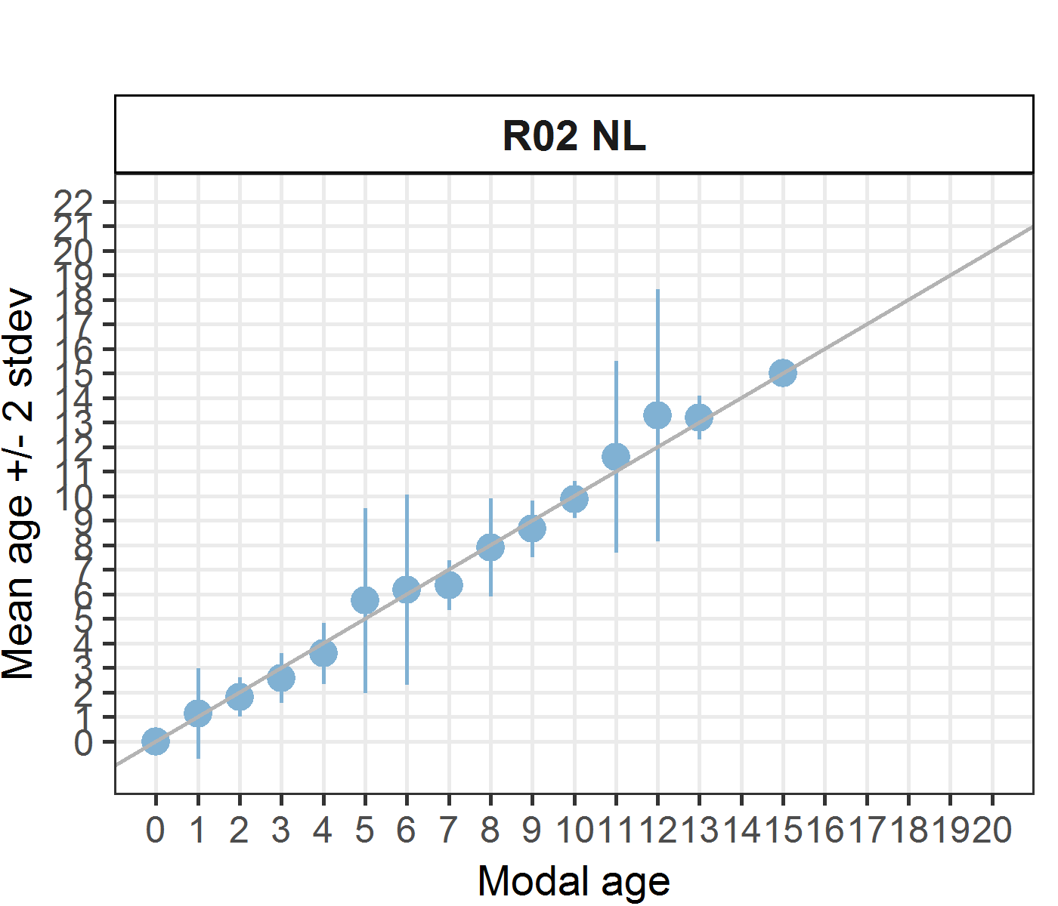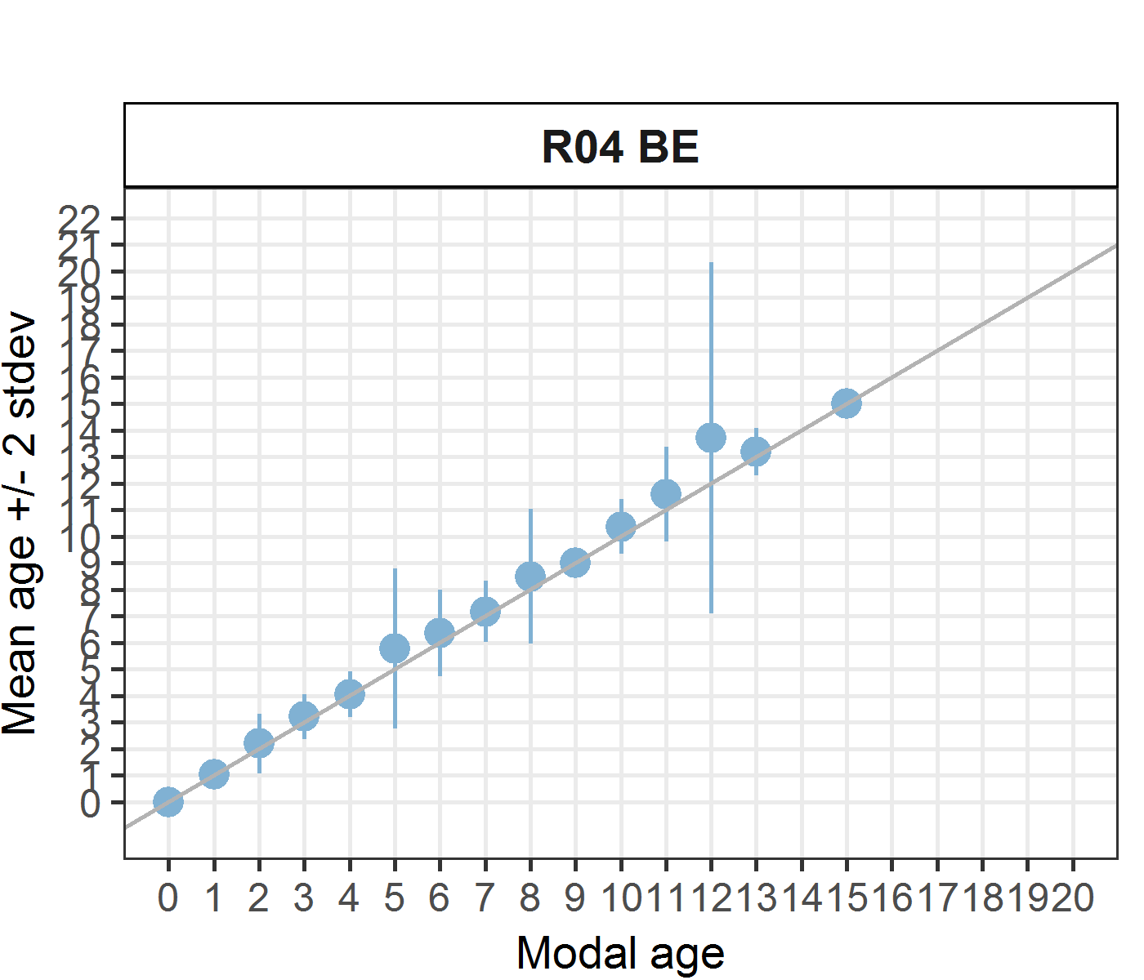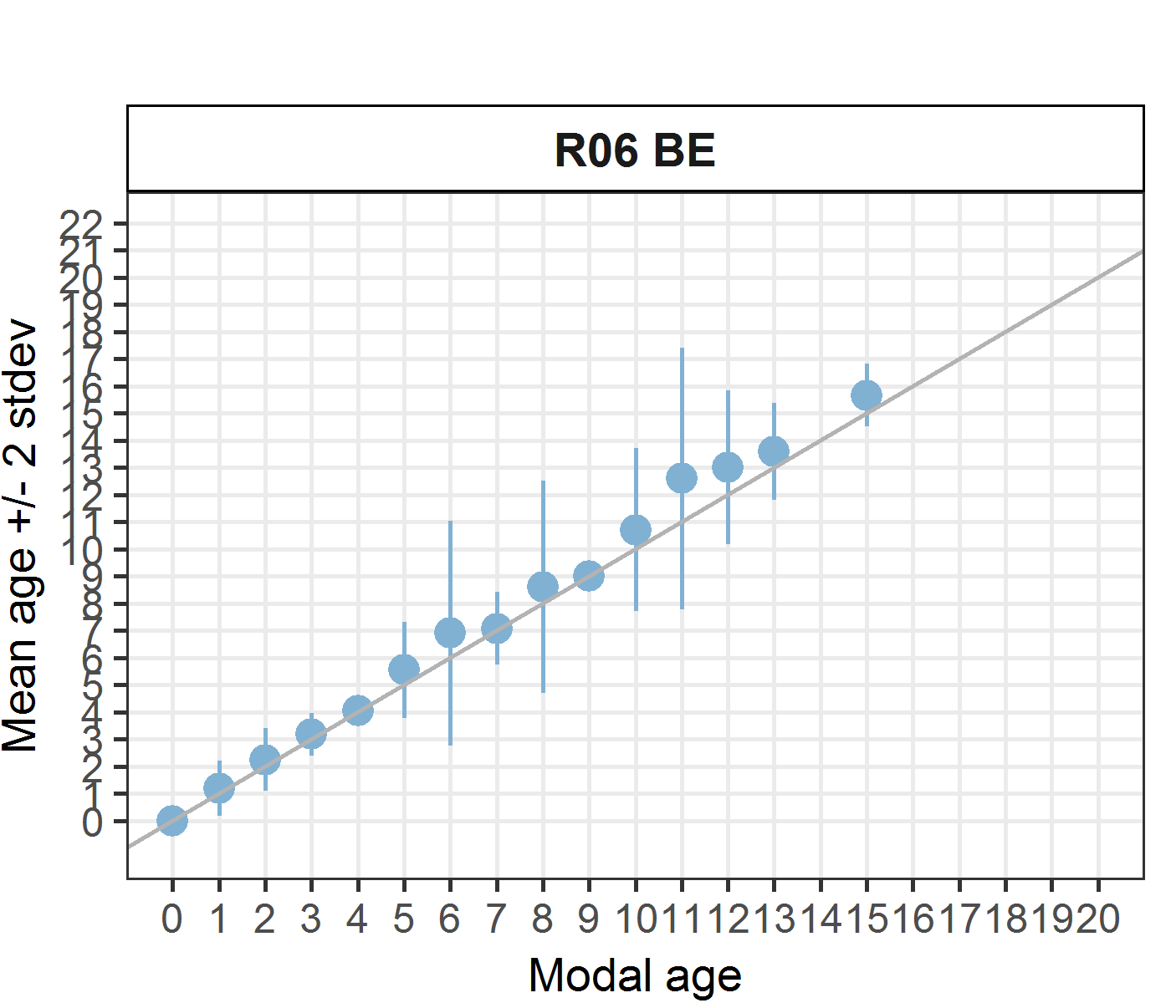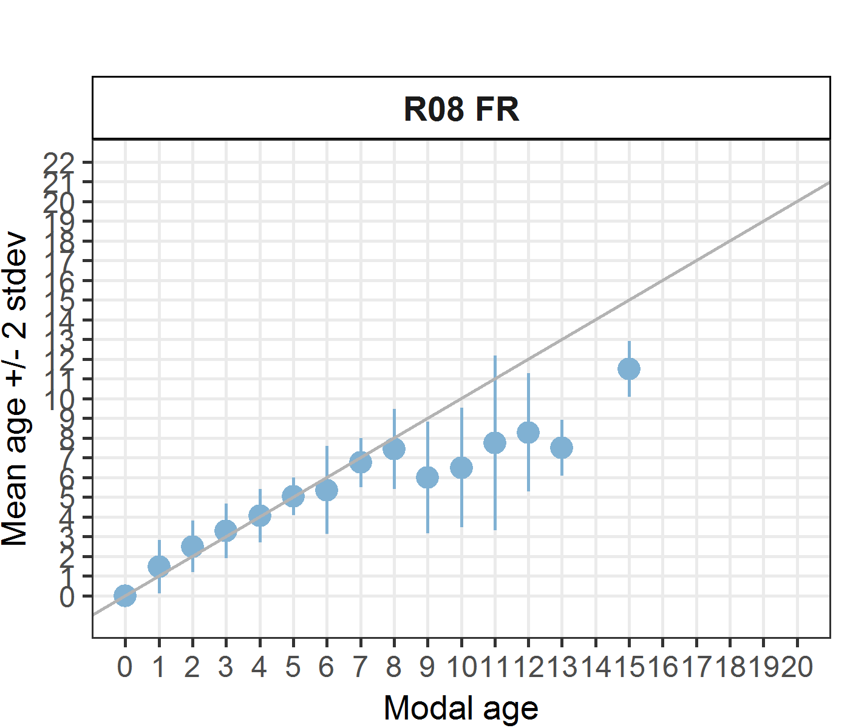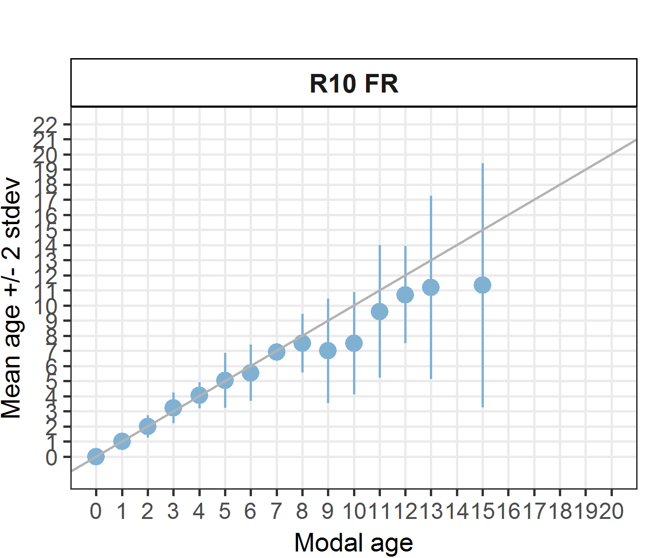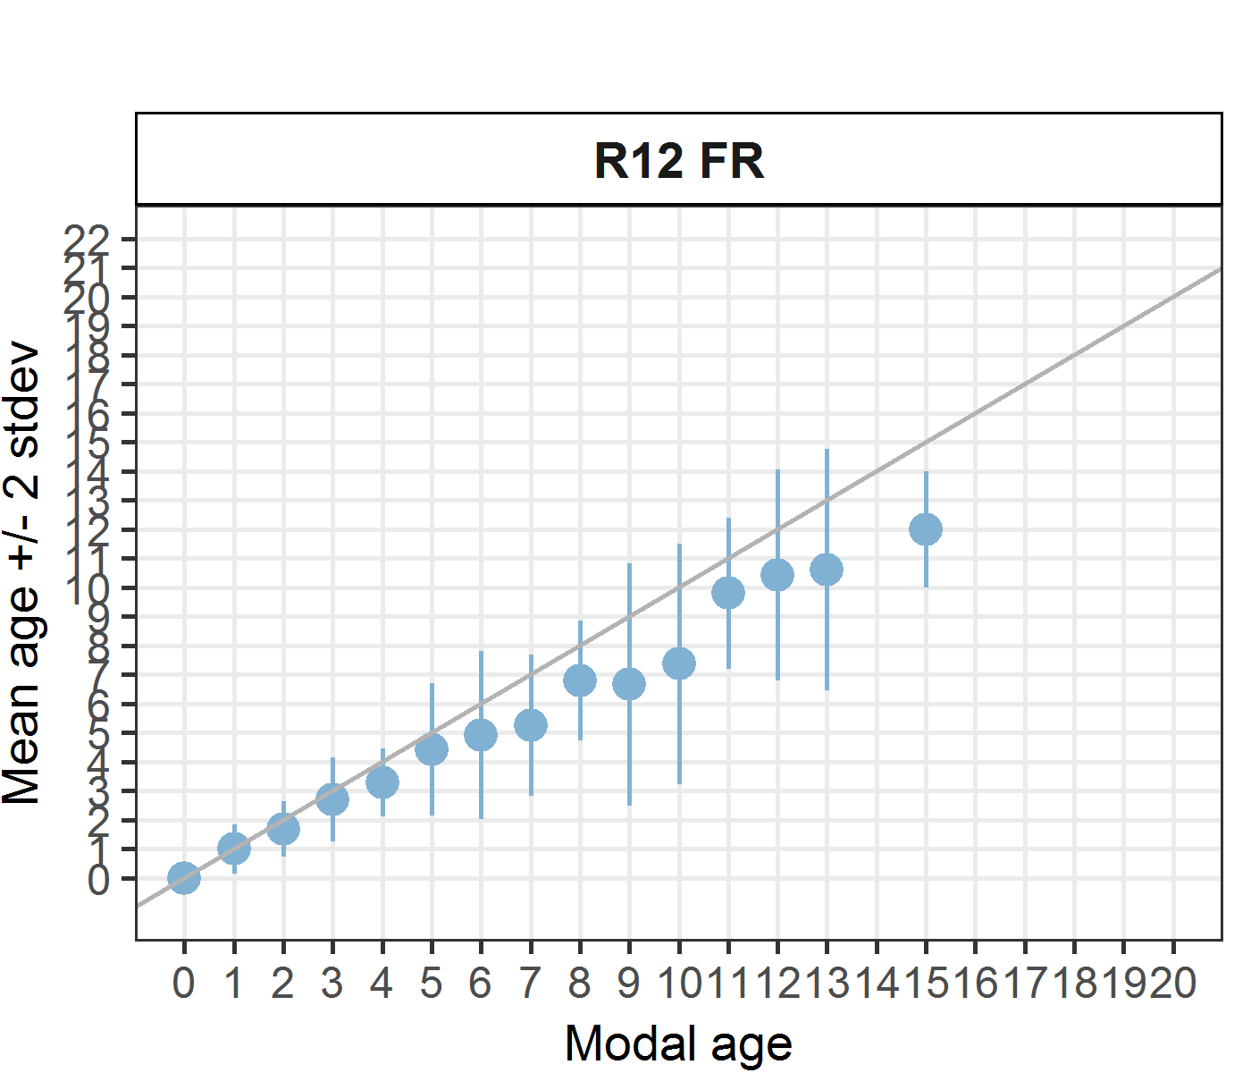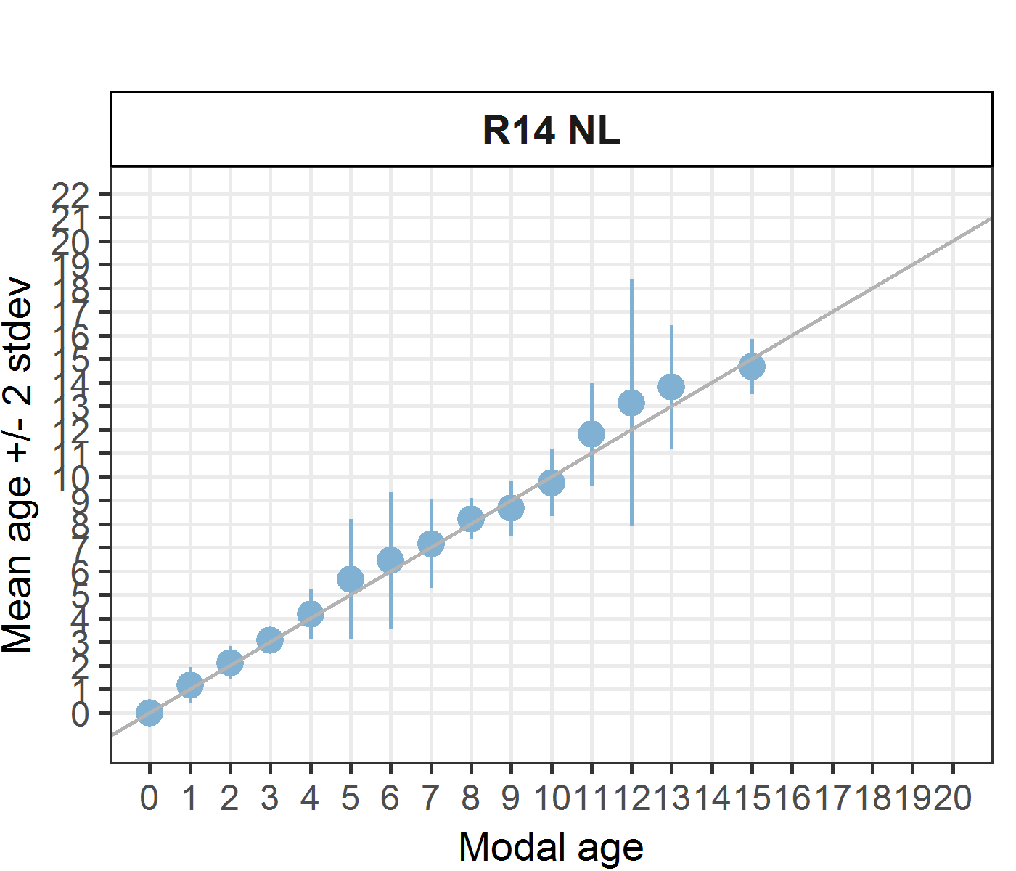
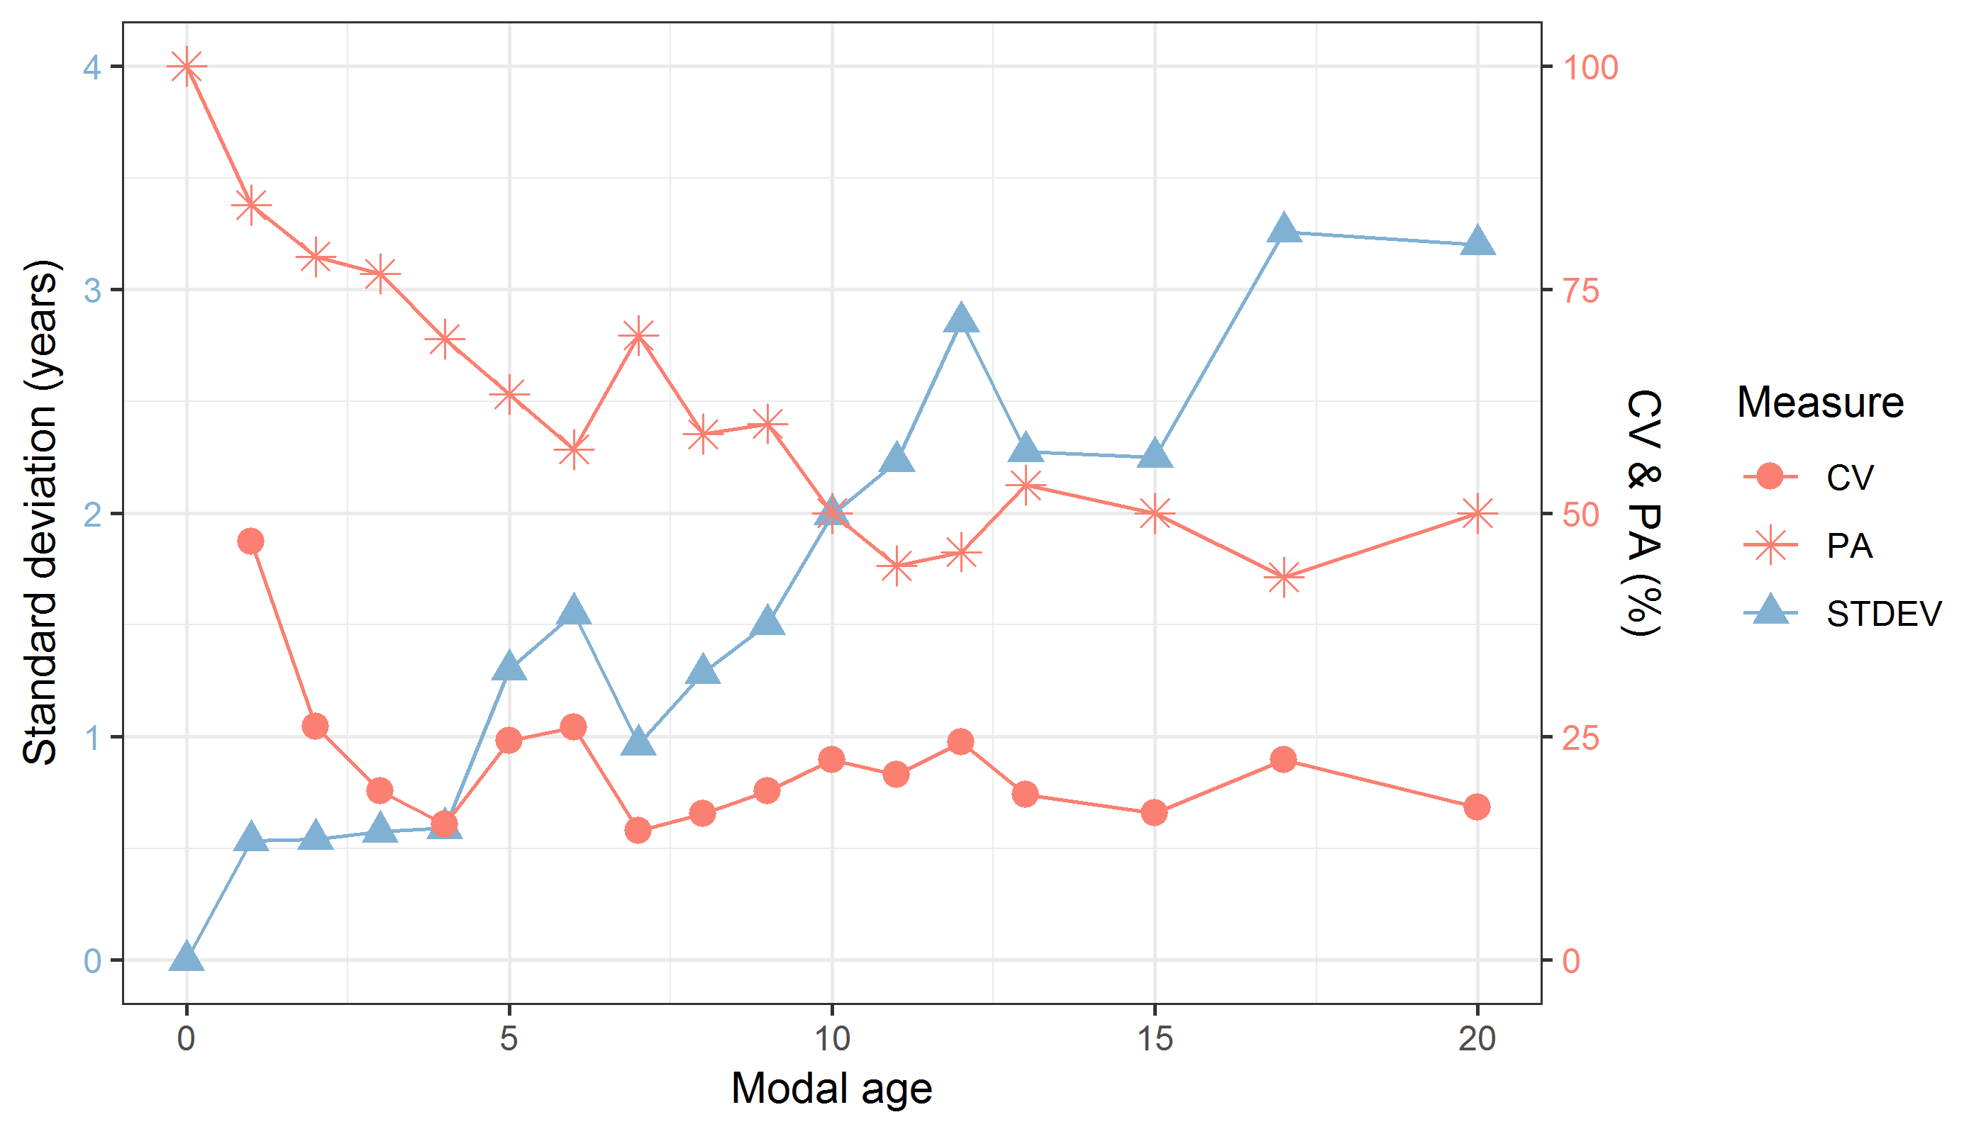
Figure 7.1: CV, PA and (STDEV (standard deviation) are plotted against modal age
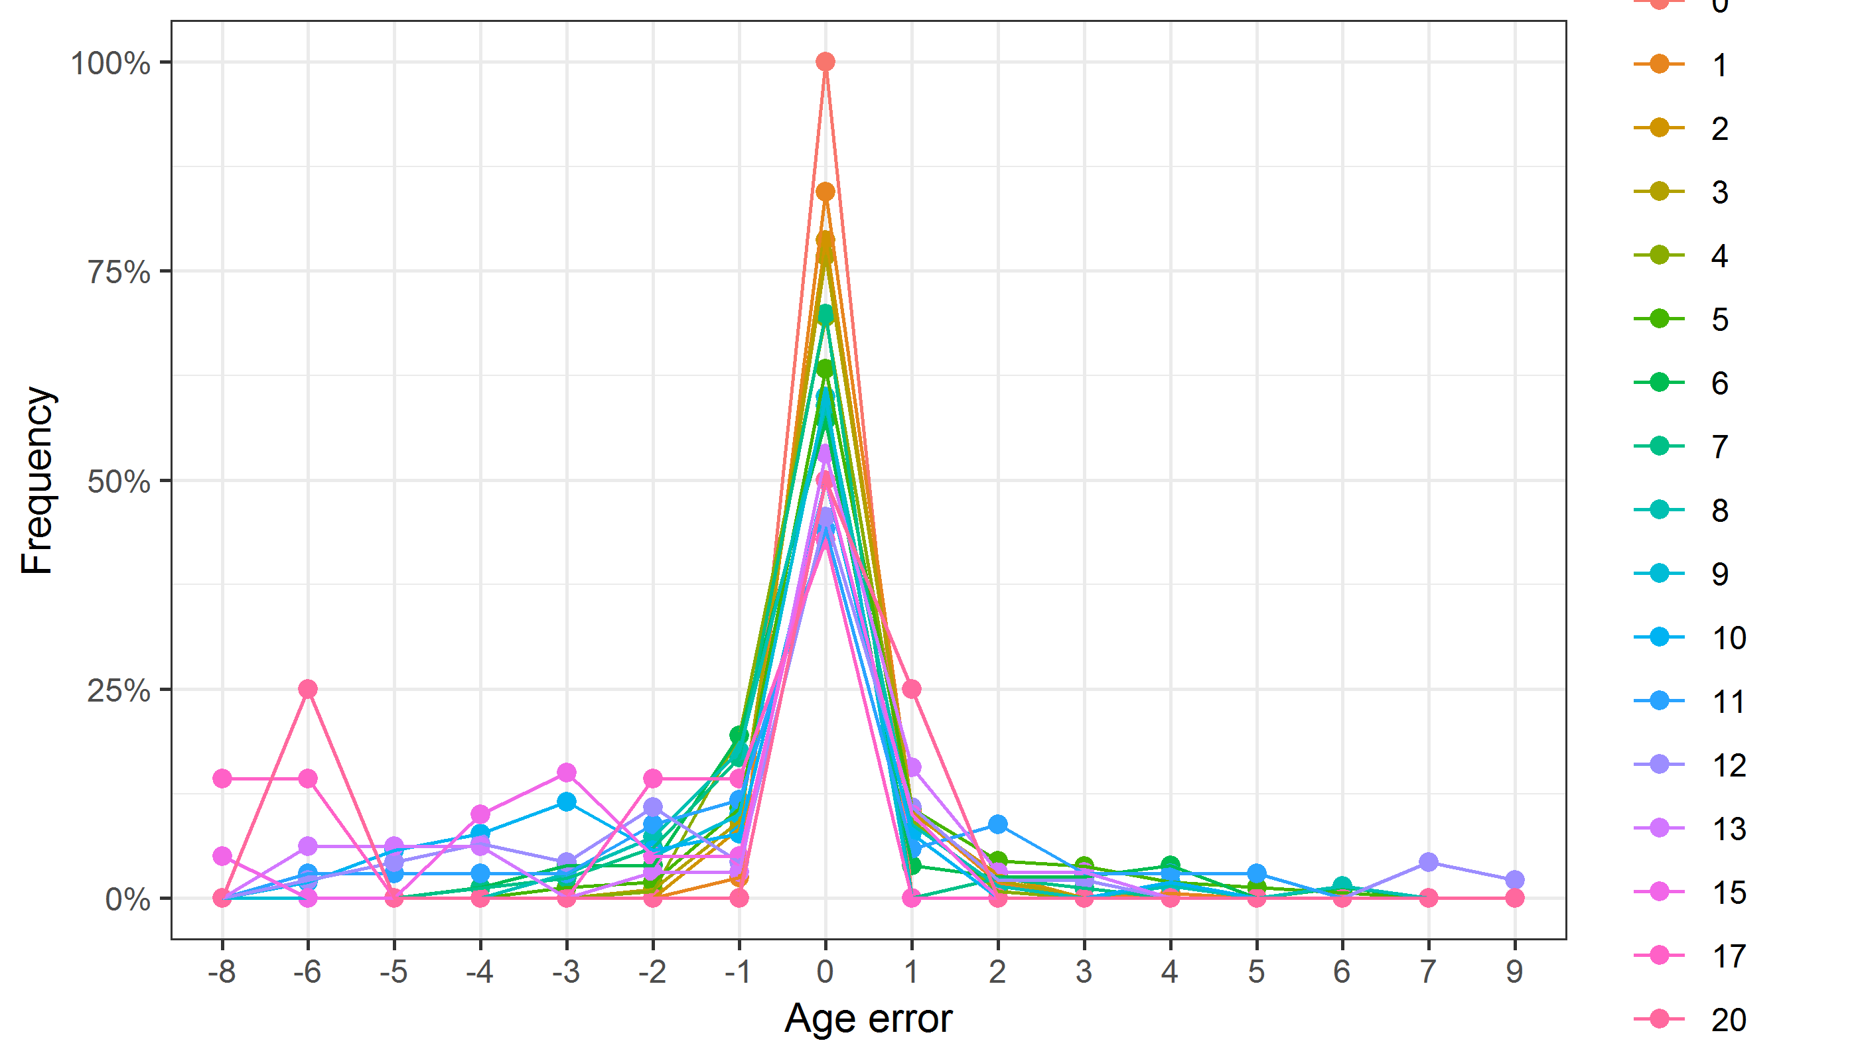

Figure 7.2: The distribution of the age reading errors in percentage by modal age as observed from the whole group of age readers in an age reading comparison to modal age. The achieved precision in age reading by MODAL age group is shown
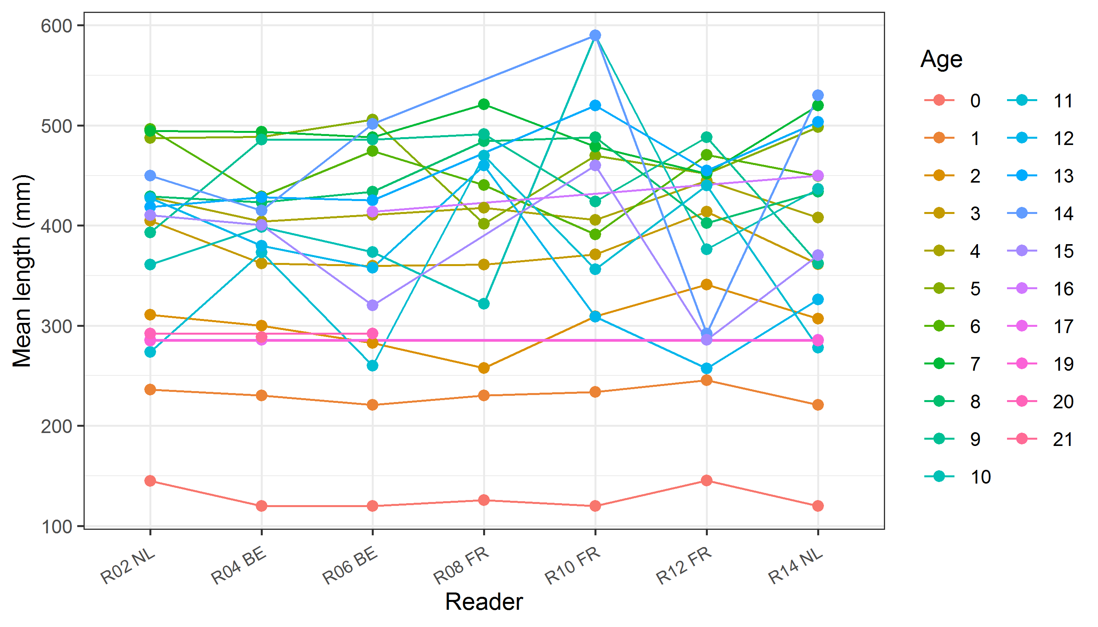
Figure 7.3 : The mean length at age as estimated by each age reader.

Results Advanced readers (stained sections)
All samples included
Data Overview
Table 7.7: Data overview including modal age and statistics per sample.
Fish ID | Event ID | Image ID | length | sex | Catch date | ICES area | R02 NL | R04 BE | R06 BE | Modal age | PA % | CV % | APE %
001_BYDR05_TUR_4B_D_S_2017071410086 | 216 | - | 250 | - | 14/07/2017 00:00:00 | 27.4.b | 2 | 2 | 2 | 2 | 100 | 0 | 0
002_BYDR05_TUR_4B_D_S_2017071410087 | 216 | - | 260 | - | 14/07/2017 00:00:00 | 27.4.b | 2 | 3 | 3 | 3 | 67 | 22 | 17
003_BYDR05_TUR_4B_D_S_2017071410088 | 216 | - | 270 | - | 14/07/2017 00:00:00 | 27.4.b | 2 | 3 | 3 | 3 | 67 | 22 | 17
004_BYDR05_TUR_4B_L_M_2017071410335 | 216 | - | 305 | - | 14/07/2017 00:00:00 | 27.4.b | 3 | 4 | 4 | 4 | 67 | 16 | 12
005_BYDR05_TUR_4B_L_M_2017071410336 | 216 | - | 445 | - | 14/07/2017 00:00:00 | 27.4.b | 3 | 4 | 4 | 4 | 67 | 16 | 12
006_BYDR05_TUR_4B_L_M_2017071410337 | 216 | - | 435 | - | 14/07/2017 00:00:00 | 27.4.b | 3 | 4 | 4 | 4 | 67 | 16 | 12
007_BYDR05_TUR_4B_L_M_2017071410357 | 216 | - | 575 | - | 14/07/2017 00:00:00 | 27.4.b | 5 | 5 | 5 | 5 | 100 | 0 | 0
008_BYDR05_TUR_4B_L_M_2017071410358 | 216 | - | 565 | - | 14/07/2017 00:00:00 | 27.4.b | 5 | 5 | 5 | 5 | 100 | 0 | 0
009_BYDR05_TUR_4B_L_M_2017071410360 | 216 | - | 520 | - | 14/07/2017 00:00:00 | 27.4.b | 5 | 5 | 5 | 5 | 100 | 0 | 0
010_BYDR05_TUR_4B_L_M_2017071410361 | 216 | - | 590 | - | 14/07/2017 00:00:00 | 27.4.b | 6 | 7 | 6 | 6 | 67 | 9 | 7
011_BYDR05_TUR_4B_L_M_2017071410362 | 216 | - | 610 | - | 14/07/2017 00:00:00 | 27.4.b | 6 | 6 | 6 | 6 | 100 | 0 | 0
012_BYDR07_TUR_4B_D_S_2017110910094 | 216 | - | 190 | - | 09/11/2017 00:00:00 | 27.4.b | 0 | 1 | 1 | 1 | 67 | 87 | 67
013_BYDR07_TUR_4B_D_S_2017110910095 | 216 | - | 200 | - | 09/11/2017 00:00:00 | 27.4.b | 0 | 1 | 1 | 1 | 67 | 87 | 67
014_BYDR07_TUR_4B_D_S_2017110910105 | 216 | - | 260 | - | 09/11/2017 00:00:00 | 27.4.b | 1 | 3 | 2 | 1 | 33 | 50 | 33
015_BYDR07_TUR_4B_D_S_2017110910112 | 216 | - | 290 | - | 09/11/2017 00:00:00 | 27.4.b | 1 | 2 | 2 | 2 | 67 | 35 | 27
016_BYDR07_TUR_4B_D_S_2017110910115 | 216 | - | 300 | - | 09/11/2017 00:00:00 | 27.4.b | 2 | 3 | 3 | 3 | 67 | 22 | 17
017_BYDR07_TUR_4B_D_S_2017110910118 | 216 | - | 300 | - | 09/11/2017 00:00:00 | 27.4.b | 2 | 4 | 3 | 2 | 33 | 33 | 22
019_BYDR07_TUR_4B_L_M_2017110910340 | 216 | - | 525 | - | 09/11/2017 00:00:00 | 27.4.b | 3 | 4 | 4 | 4 | 67 | 16 | 12
020_BYDR07_TUR_4B_L_M_2017110910341 | 216 | - | 510 | - | 09/11/2017 00:00:00 | 27.4.b | 3 | 4 | 4 | 4 | 67 | 16 | 12
021_BYDR07_TUR_4B_L_M_2017110910343 | 216 | - | 485 | - | 09/11/2017 00:00:00 | 27.4.b | 3 | 4 | 4 | 4 | 67 | 16 | 12
022_BYDR07_TUR_4B_L_M_2017110910350 | 216 | - | 590 | - | 09/11/2017 00:00:00 | 27.4.b | 7 | 8 | 8 | 8 | 67 | 8 | 6
023_BYDR07_TUR_4B_L_M_2017110910351 | 216 | - | 560 | - | 09/11/2017 00:00:00 | 27.4.b | 6 | 7 | 7 | 7 | 67 | 9 | 7
024_BYDR07_TUR_4B_L_M_2017110910352 | 216 | - | 675 | - | 09/11/2017 00:00:00 | 27.4.b | 6 | 7 | 7 | 7 | 67 | 9 | 7
025_BYDR07_TUR_4B_L_M_2017110910353 | 216 | - | 590 | - | 09/11/2017 00:00:00 | 27.4.b | 7 | 8 | 8 | 8 | 67 | 8 | 6
026_BYDR07_TUR_4B_L_M_2017110910354 | 216 | - | 635 | - | 09/11/2017 00:00:00 | 27.4.b | 7 | 7 | 7 | 7 | 100 | 0 | 0
027_CDDR06_TUR_4B_L_M_2017073110492 | 216 | - | 425 | - | 31/07/2017 00:00:00 | 27.4.b | 5 | 7 | - | 5 | 50 | 24 | 17
028_CDDR07_TUR_4B_D_S_2017102010073 | 216 | - | 230 | - | 20/10/2017 00:00:00 | 27.4.b | 1 | 1 | 1 | 1 | 100 | 0 | 0
029_CDDR07_TUR_4B_D_S_2017102010074 | 216 | - | 240 | - | 20/10/2017 00:00:00 | 27.4.b | 1 | 1 | 1 | 1 | 100 | 0 | 0
030_CDDR07_TUR_4B_D_S_2017102010098 | 216 | - | 220 | - | 20/10/2017 00:00:00 | 27.4.b | 1 | 1 | 1 | 1 | 100 | 0 | 0
031_CDDR07_TUR_4B_L_M_2017102010266 | 216 | - | 515 | - | 20/10/2017 00:00:00 | 27.4.b | 5 | 5 | 5 | 5 | 100 | 0 | 0
032_CDDR07_TUR_4B_L_M_2017102010270 | 216 | - | 555 | - | 20/10/2017 00:00:00 | 27.4.b | 5 | 6 | 6 | 6 | 67 | 10 | 8
033_DTU2015_TUR_4B_039_161115 | 216 | - | 380 | - | 16/11/2015 00:00:00 | 27.4.b | 9 | 9 | 9 | 9 | 100 | 0 | 0
034_DTU2015_TUR_4B_064_161115 | 216 | - | 650 | - | 16/11/2015 00:00:00 | 27.4.b | - | 10 | 10 | 10 | 100 | 0 | 0
035_DTU2015_TUR_4B_090_020915 | 216 | - | 560 | - | 02/09/2015 00:00:00 | 27.4.b | 12 | 12 | - | 12 | 100 | 0 | 0
036_DTU2016_TUR_4B_318_05092016 | 216 | - | 590 | - | 05/09/2016 00:00:00 | 27.4.b | 8 | 8 | 8 | 8 | 100 | 0 | 0
037_DTU2016_TUR_4B_321_05092016 | 216 | - | 540 | - | 05/09/2016 00:00:00 | 27.4.b | 7 | 8 | 7 | 7 | 67 | 8 | 6
038_DTU2017_TUR_4B_054_16032017 | 216 | - | 520 | - | 16/03/2017 00:00:00 | 27.4.b | 4 | 5 | 4 | 4 | 67 | 13 | 10
039_DTU2017_TUR_4B_063_21052017 | 216 | - | 500 | - | 21/05/2017 00:00:00 | 27.4.b | 6 | 7 | 7 | 7 | 67 | 9 | 7
040_DTU2017_TUR_4B_067_16032017 | 216 | - | 490 | - | 16/03/2017 00:00:00 | 27.4.b | 7 | 7 | 7 | 7 | 100 | 0 | 0
041_DTU2017_TUR_4B_070_17032017 | 216 | - | 390 | - | 17/03/2017 00:00:00 | 27.4.b | 3 | 4 | 4 | 4 | 67 | 16 | 12
042_DTU2017_TUR_4B_071_17032017 | 216 | - | 430 | - | 17/03/2017 00:00:00 | 27.4.b | 3 | 3 | 3 | 3 | 100 | 0 | 0
043_DTU2017_TUR_4B_077_17032017 | 216 | - | 460 | - | 17/03/2017 00:00:00 | 27.4.b | 3 | 4 | 4 | 4 | 67 | 16 | 12
044_DTU2017_TUR_4B_157_21052017 | 216 | - | 580 | - | 21/05/2017 00:00:00 | 27.4.b | 5 | 5 | 6 | 5 | 67 | 11 | 8
045_DTU2017_TUR_4B_161_21052017 | 216 | - | 500 | - | 21/05/2017 00:00:00 | 27.4.b | 5 | 6 | 6 | 6 | 67 | 10 | 8
046_DTU2017_TUR_4B_164_21052017 | 216 | - | 470 | - | 21/05/2017 00:00:00 | 27.4.b | 3 | 4 | 4 | 4 | 67 | 16 | 12
047_DTU2017_TUR_4B_184_06062017 | 216 | - | 570 | - | 06/06/2017 00:00:00 | 27.4.b | 9 | 8 | 8 | 8 | 67 | 7 | 5
048_DTU2017_TUR_4B_191_06062017 | 216 | - | 590 | - | 06/06/2017 00:00:00 | 27.4.b | 8 | 9 | 9 | 9 | 67 | 7 | 5
049_DTU2017_TUR_4B_205_06062017 | 216 | - | 430 | - | 06/06/2017 00:00:00 | 27.4.b | 3 | 3 | 3 | 3 | 100 | 0 | 0
050_DTU2017_TUR_4B_261_04092017 | 216 | - | 600 | - | 04/09/2017 00:00:00 | 27.4.b | 8 | 9 | 9 | 9 | 67 | 7 | 5
051_DTU2017_TUR_4B_262_04092017 | 216 | - | 590 | - | 04/09/2017 00:00:00 | 27.4.b | 13 | 13 | 14 | 13 | 67 | 4 | 3
052_DTU2017_TUR_4B_263_04092017 | 216 | - | 580 | - | 04/09/2017 00:00:00 | 27.4.b | - | 7 | 7 | 7 | 100 | 0 | 0
053_DTU2017_TUR_4B_264_04092017 | 216 | - | 590 | - | 04/09/2017 00:00:00 | 27.4.b | 13 | 14 | 13 | 13 | 67 | 4 | 3
054_DTU2017_TUR_4B_266_04092017 | 216 | - | 600 | - | 04/09/2017 00:00:00 | 27.4.b | 13 | 13 | 13 | 13 | 100 | 0 | 0
055_DTU2017_TUR_4B_267_04092017 | 216 | - | 460 | - | 04/09/2017 00:00:00 | 27.4.b | 7 | 9 | 9 | 9 | 67 | 14 | 11
056_DTU2017_TUR_4B_270_04092017 | 216 | - | 460 | - | 04/09/2017 00:00:00 | 27.4.b | 10 | 10 | 10 | 10 | 100 | 0 | 0
057_DTU2017_TUR_4B_276_04092017 | 216 | - | 440 | - | 04/09/2017 00:00:00 | 27.4.b | 6 | 6 | 6 | 6 | 100 | 0 | 0
058_DTU2017_TUR_4B_286_04092017 | 216 | - | 420 | - | 04/09/2017 00:00:00 | 27.4.b | 6 | 6 | 6 | 6 | 100 | 0 | 0
059_DTU2017_TUR_4B_288_04092017 | 216 | - | 530 | - | 04/09/2017 00:00:00 | 27.4.b | 6 | 7 | 7 | 7 | 67 | 9 | 7
060_DTU2017_TUR_4B_290_04092017 | 216 | - | 530 | - | 04/09/2017 00:00:00 | 27.4.b | 5 | 6 | 6 | 6 | 67 | 10 | 8
061_DTU2017_TUR_4B_292_04092017 | 216 | - | 510 | - | 04/09/2017 00:00:00 | 27.4.b | 6 | 7 | 7 | 7 | 67 | 9 | 7
062_DTU2017_TUR_4B_293_04092017 | 216 | - | 530 | - | 04/09/2017 00:00:00 | 27.4.b | 10 | 11 | 14 | 10 | 33 | 18 | 13
063_DTU2017_TUR_4B_294_04092017 | 216 | - | 600 | - | 04/09/2017 00:00:00 | 27.4.b | 5 | 5 | 5 | 5 | 100 | 0 | 0
064_DTU2017_TUR_4B_303_26102017 | 216 | - | 590 | - | 26/10/2017 00:00:00 | 27.4.b | 10 | 11 | 14 | 10 | 33 | 18 | 13
065_DTU2017_TUR_4B_304_26102017 | 216 | - | 630 | - | 26/10/2017 00:00:00 | 27.4.b | 12 | 12 | 12 | 12 | 100 | 0 | 0
066_DTU2017_TUR_4B_305_26102017 | 216 | - | 550 | - | 26/10/2017 00:00:00 | 27.4.b | 4 | 5 | 5 | 5 | 67 | 12 | 10
067_DTU2017_TUR_4B_309_26102017 | 216 | - | 520 | - | 26/10/2017 00:00:00 | 27.4.b | 4 | 4 | 5 | 4 | 67 | 13 | 10
068_DTU2017_TUR_4B_326_26102017 | 216 | - | 450 | - | 26/10/2017 00:00:00 | 27.4.b | 9 | 10 | - | 9 | 50 | 7 | 5
069_DTU2017_TUR_4B_369_02112017 | 216 | - | 570 | - | 02/11/2017 00:00:00 | 27.4.b | 5 | - | 6 | 5 | 50 | 13 | 9
070_DTU2015_TUR_4A_035_260215 | 216 | - | 450 | - | 26/02/2015 00:00:00 | 27.4.a | 14 | 13 | 15 | 13 | 33 | 7 | 5
071_DTU2015_TUR_4A_037_260215 | 216 | - | 440 | - | 26/02/2015 00:00:00 | 27.4.a | 15 | 13 | 16 | 13 | 33 | 10 | 8
072_DTU2015_TUR_4A_039_260215 | 216 | - | 430 | - | 26/02/2015 00:00:00 | 27.4.a | 10 | 10 | 10 | 10 | 100 | 0 | 0
073_DTU2015_TUR_4A_042_260215 | 216 | - | 400 | - | 26/02/2015 00:00:00 | 27.4.a | 9 | 9 | 9 | 9 | 100 | 0 | 0
074_DTU2017_TUR_4A_104_03042017 | 216 | - | 520 | - | 03/04/2017 00:00:00 | 27.4.a | 4 | 5 | 5 | 5 | 67 | 12 | 10
075_DTU2017_TUR_4A_250_12072017 | 216 | - | 550 | - | 12/07/2017 00:00:00 | 27.4.a | 5 | 5 | 5 | 5 | 100 | 0 | 0
076_DTU2017_TUR_4A_252_12072017 | 216 | - | 510 | - | 12/07/2017 00:00:00 | 27.4.a | 5 | 5 | 6 | 5 | 67 | 11 | 8
077_DTU2017_TUR_4A_254_12072017 | 216 | - | 460 | - | 12/07/2017 00:00:00 | 27.4.a | 5 | 5 | 5 | 5 | 100 | 0 | 0
078_DTU2017_TUR_4A_257_12072017 | 216 | - | 420 | - | 12/07/2017 00:00:00 | 27.4.a | - | 7 | - | 7 | 100 | - | 0
079_DTU2017_TUR_4A_258_12072017 | 216 | - | 430 | - | 12/07/2017 00:00:00 | 27.4.a | 2 | 2 | 3 | 2 | 67 | 25 | 19
080_DTU2017_TUR_4A_259_12072017 | 216 | - | 470 | - | 12/07/2017 00:00:00 | 27.4.a | 3 | 3 | 4 | 3 | 67 | 17 | 13
081_DTU2017_TUR_4A_260_12072017 | 216 | - | 390 | - | 12/07/2017 00:00:00 | 27.4.a | 5 | 1 | 3 | 1 | 33 | 67 | 44
082_NDGP11_JB_TUR_4A_NZ1_003 | 216 | - | 260 | - | 18/02/2017 00:00:00 | 27.4.a | 2 | 2 | 2 | 2 | 100 | 0 | 0
083_NDGP11_JB_TUR_4A_NZ1_004 | 216 | - | 450 | - | 18/02/2017 00:00:00 | 27.4.a | - | 3 | 3 | 3 | 100 | 0 | 0
084_NDGP11_JB_TUR_4A_NZ1_007 | 216 | - | 420 | - | 18/02/2017 00:00:00 | 27.4.a | 2 | 3 | 3 | 3 | 67 | 22 | 17
085_NDGP11_JB_TUR_4A_NZ1_008 | 216 | - | 290 | - | 18/02/2017 00:00:00 | 27.4.a | 2 | 2 | 2 | 2 | 100 | 0 | 0
086_NDGP11_JB_TUR_4A_NZ1_010 | 216 | - | 450 | - | 18/02/2017 00:00:00 | 27.4.a | 3 | 3 | 3 | 3 | 100 | 0 | 0
087_NDGP11_JB_TUR_4A_NZ1_015 | 216 | - | 430 | - | 18/02/2017 00:00:00 | 27.4.a | 4 | 3 | 4 | 4 | 67 | 16 | 12
088_BTS01_TUR_4C_C_2017082810012 | 216 | - | 446 | - | 28/08/2017 00:00:00 | 27.4.c | 3 | 3 | 3 | 3 | 100 | 0 | 0
089_BTS01_TUR_4C_C_2017082810011 | 216 | - | 443 | - | 28/08/2017 00:00:00 | 27.4.c | 2 | 3 | 3 | 3 | 67 | 22 | 17
090_BTS01_TUR_4C_C_2017082810010 | 216 | - | 334 | - | 28/08/2017 00:00:00 | 27.4.c | 1 | 2 | 2 | 2 | 67 | 35 | 27
091_BTS01_TUR_4C_C_2017082810009 | 216 | - | 425 | - | 28/08/2017 00:00:00 | 27.4.c | 4 | 4 | 4 | 4 | 100 | 0 | 0
092_NDGP15_BTS01_TUR_4C_55083 | 216 | - | 245 | - | 13/09/2015 00:00:00 | 27.4.c | 1 | 1 | 2 | 1 | 67 | 43 | 33
093_NDGP15_BTS01_TUR_4C_55084 | 216 | - | 250 | - | 13/09/2015 00:00:00 | 27.4.c | 1 | 1 | 2 | 1 | 67 | 43 | 33
094_NDGP15_BTS01_TUR_4C_55085 | 216 | - | 290 | - | 13/09/2015 00:00:00 | 27.4.c | 1 | 2 | 2 | 2 | 67 | 35 | 27
095_NDGP15_BTS01_TUR_4C_55086 | 216 | - | 240 | - | 13/09/2015 00:00:00 | 27.4.c | 2 | 2 | 2 | 2 | 100 | 0 | 0
096_NDGP15_BTS01_TUR_4C_55088 | 216 | - | 485 | - | 13/09/2015 00:00:00 | 27.4.c | 4 | 5 | 5 | 5 | 67 | 12 | 10
097_NDGP15_BTS01_TUR_4C_55090 | 216 | - | 575 | - | 13/09/2015 00:00:00 | 27.4.c | 5 | 5 | 5 | 5 | 100 | 0 | 0
098_NDGP15_BTS01_TUR_4C_55097 | 216 | - | 225 | - | 13/09/2015 00:00:00 | 27.4.c | 1 | 1 | 1 | 1 | 100 | 0 | 0
099_NDGP15_BTS01_TUR_4C_55098 | 216 | - | 215 | - | 13/09/2015 00:00:00 | 27.4.c | 1 | 1 | 1 | 1 | 100 | 0 | 0
100_NDGP15_BTS01_TUR_4C_55099 | 216 | - | 245 | - | 13/09/2015 00:00:00 | 27.4.c | - | 1 | 1 | 1 | 100 | 0 | 0
101_NDGP16_BTS01_TUR_4C_220936 | 216 | - | 360 | - | 04/10/2016 00:00:00 | 27.4.c | 3 | 3 | 3 | 3 | 100 | 0 | 0
102_NDGP16_BTS01_TUR_4C_220944 | 216 | - | 415 | - | 04/10/2016 00:00:00 | 27.4.c | 2 | 4 | 3 | 2 | 33 | 33 | 22
103_PTCT03_TUR_4C_2017040310395 | 216 | - | 340 | - | 03/04/2017 00:00:00 | 27.4.c | 3 | 3 | 3 | 3 | 100 | 0 | 0
104_PTCT03_TUR_4C_2017040310396 | 216 | - | 325 | - | 03/04/2017 00:00:00 | 27.4.c | 5 | 6 | 6 | 6 | 67 | 10 | 8
105_PTCT03_TUR_4C_2017040310397 | 216 | - | 395 | - | 03/04/2017 00:00:00 | 27.4.c | 2 | 3 | 3 | 3 | 67 | 22 | 17
106_PTCT03_TUR_4C_2017040310398 | 216 | - | 400 | - | 03/04/2017 00:00:00 | 27.4.c | 5 | 6 | 6 | 6 | 67 | 10 | 8
107_TUR_EX-NL_4C_4100008_001_130918 | 216 | - | 252 | - | 13/09/2018 00:00:00 | 27.4.c | 2 | 1 | 1 | 1 | 67 | 43 | 33
108_TUR_EX-NL_4C_4100010_002_130918 | 216 | - | 118 | - | 13/09/2018 00:00:00 | 27.4.c | 0 | 0 | 0 | 0 | 100 | - | -
109_TUR_EX-NL_4C_4100011_003_130918 | 216 | - | 137 | - | 13/09/2018 00:00:00 | 27.4.c | 0 | 0 | 0 | 0 | 100 | - | -
110_TUR_EX-NL_4C_4100011_004_130918 | 216 | - | 122 | - | 13/09/2018 00:00:00 | 27.4.c | 0 | 0 | 0 | 0 | 100 | - | -
111_TUR_EX-NL_4C_4100011_005_130918 | 216 | - | 102 | - | 13/09/2018 00:00:00 | 27.4.c | 0 | 0 | 0 | 0 | 100 | - | -
112_TUR_EX-NL_4C_4100014_006_140918 | 216 | - | 198 | - | 14/09/2018 00:00:00 | 27.4.c | 1 | 1 | 1 | 1 | 100 | 0 | 0
113_TUR_EX-NL_4C_4100015_010_140918 | 216 | - | 237 | - | 14/09/2018 00:00:00 | 27.4.c | 1 | 1 | 1 | 1 | 100 | 0 | 0
114_TUR_EX-NL_4C_4100017_012_140918 | 216 | - | 225 | - | 14/09/2018 00:00:00 | 27.4.c | 1 | 1 | 1 | 1 | 100 | 0 | 0
115_TUR_EX-NL_4C_4100023_013_170918 | 216 | - | 204 | - | 17/09/2018 00:00:00 | 27.4.c | 1 | 1 | 1 | 1 | 100 | 0 | 0
116_TUR_EX-NL_4C_4100024_014_170918 | 216 | - | 213 | - | 17/09/2018 00:00:00 | 27.4.c | 1 | 1 | 1 | 1 | 100 | 0 | 0
117_CEFAS_016_TUR_7D_093_300714 | 216 | - | 340 | - | 30/07/2014 00:00:00 | 27.7.d | 2 | 2 | 2 | 2 | 100 | 0 | 0
118_CEFAS_017_TUR_7D_099_300714 | 216 | - | 240 | - | 30/07/2014 00:00:00 | 27.7.d | 2 | 2 | 2 | 2 | 100 | 0 | 0
119_DTU2016_TUR_BA_7D_266_02112016 | 216 | - | 350 | - | 02/11/2016 00:00:00 | 27.7.d | 8 | 8 | 8 | 8 | 100 | 0 | 0
120_DTU2016_TUR_BA_7D_267_02112016 | 216 | - | 470 | - | 02/11/2016 00:00:00 | 27.7.d | 15 | 15 | 16 | 15 | 67 | 4 | 3
121_DTU2016_TUR_BA_7D_268_02112016 | 216 | - | 310 | - | 02/11/2016 00:00:00 | 27.7.d | 6 | 7 | 7 | 7 | 67 | 9 | 7
122_DTU2016_TUR_BA_7D_272_03112016 | 216 | - | 320 | - | 03/11/2016 00:00:00 | 27.7.d | 3 | 4 | 4 | 4 | 67 | 16 | 12
123_DTU2016_TUR_BA_7D_274_03112016 | 216 | - | 240 | - | 03/11/2016 00:00:00 | 27.7.d | 3 | 3 | 3 | 3 | 100 | 0 | 0
124_DTU2016_TUR_BA_7D_276_04112016 | 216 | - | 310 | - | 04/11/2016 00:00:00 | 27.7.d | 2 | 2 | 2 | 2 | 100 | 0 | 0
125_DTU2016_TUR_BA_7D_277_04112016 | 216 | - | 290 | - | 04/11/2016 00:00:00 | 27.7.d | 2 | 4 | 3 | 2 | 33 | 33 | 22
126_DTU2016_TUR_BA_7D_298_10112016 | 216 | - | 430 | - | 10/11/2016 00:00:00 | 27.7.d | 7 | 7 | 7 | 7 | 100 | 0 | 0
127_DTU2016_TUR_BA_7D_299_10112016 | 216 | - | 350 | - | 10/11/2016 00:00:00 | 27.7.d | 3 | 5 | 4 | 3 | 33 | 25 | 17
128_DTU2016_TUR_BA_7D_300_10112016 | 216 | - | 270 | - | 10/11/2016 00:00:00 | 27.7.d | 2 | 3 | 3 | 3 | 67 | 22 | 17
129_DTU2016_TUR_BA_7D_302_11112016 | 216 | - | 290 | - | 11/11/2016 00:00:00 | 27.7.d | 4 | 4 | 4 | 4 | 100 | 0 | 0
130_DTU2016_TUR_BA_7D_303_12112016 | 216 | - | 330 | - | 12/11/2016 00:00:00 | 27.7.d | 2 | 2 | 2 | 2 | 100 | 0 | 0
131_DTU2016_TUR_BA_7D_310_12112016 | 216 | - | 240 | - | 12/11/2016 00:00:00 | 27.7.d | 10 | 8 | 12 | 8 | 33 | 20 | 13
132_DTU2016_TUR_BA_7D_314_17112016 | 216 | - | 460 | - | 17/11/2016 00:00:00 | 27.7.d | 15 | 15 | 16 | 15 | 67 | 4 | 3
133_DTU2015_TUR_BA_7D_037_181115 | 216 | - | 330 | - | 18/11/2015 00:00:00 | 27.7.d | 8 | 6 | 7 | 6 | 33 | 14 | 10
134_DTU2015_TUR_BA_7D_001_120315 | 216 | - | 255 | - | 12/03/2015 00:00:00 | 27.7.d | 8 | 7 | 7 | 7 | 67 | 8 | 6
135_DTU2015_TUR_BA_7D_002_120315 | 216 | - | 351 | - | 12/03/2015 00:00:00 | 27.7.d | 3 | 4 | 4 | 4 | 67 | 16 | 12
136_DTU2015_TUR_BA_7D_003_041115 | 216 | - | 180 | - | 04/11/2015 00:00:00 | 27.7.d | 1 | 1 | 1 | 1 | 100 | 0 | 0
137_DTU2015_TUR_BA_7D_004_120315 | 216 | - | 297 | - | 12/03/2015 00:00:00 | 27.7.d | 10 | 11 | 10 | 10 | 67 | 6 | 4
138_DTU2015_TUR_BA_7D_005_120315 | 216 | - | 292 | - | 12/03/2015 00:00:00 | 27.7.d | 2 | 2 | 2 | 2 | 100 | 0 | 0
139_DTU2015_TUR_BA_7D_006_120315 | 216 | - | 288 | - | 12/03/2015 00:00:00 | 27.7.d | 9 | 10 | - | 9 | 50 | 7 | 5
140_DTU2015_TUR_BA_7D_007_120315 | 216 | - | 307 | - | 12/03/2015 00:00:00 | 27.7.d | 2 | 3 | 3 | 3 | 67 | 22 | 17
141_DTU2015_TUR_BA_7D_008_120315 | 216 | - | 260 | - | 12/03/2015 00:00:00 | 27.7.d | 10 | 11 | 11 | 11 | 67 | 5 | 4
142_DTU2015_TUR_BA_7D_009_120315 | 216 | - | 272 | - | 12/03/2015 00:00:00 | 27.7.d | 11 | 12 | 10 | 10 | 33 | 9 | 6
143_DTU2015_TUR_BA_7D_010_120315 | 216 | - | 271 | - | 12/03/2015 00:00:00 | 27.7.d | 15 | 15 | 15 | 15 | 100 | 0 | 0
144_DTU2015_TUR_BA_7D_011_120315 | 216 | - | 296 | - | 12/03/2015 00:00:00 | 27.7.d | 10 | 12 | 14 | 10 | 33 | 17 | 11
145_DTU2015_TUR_BA_7D_012_091115 | 216 | - | 260 | - | 09/11/2015 00:00:00 | 27.7.d | 11 | 10 | - | 10 | 50 | 7 | 5
146_DTU2015_TUR_BA_7D_012_120315 | 216 | - | 295 | - | 12/03/2015 00:00:00 | 27.7.d | 5 | 6 | 6 | 6 | 67 | 10 | 8
147_DTU2015_TUR_BA_7D_013_091115 | 216 | - | 220 | - | 09/11/2015 00:00:00 | 27.7.d | 7 | 8 | 8 | 8 | 67 | 8 | 6
148_DTU2015_TUR_BA_7D_013_120315 | 216 | - | 278 | - | 12/03/2015 00:00:00 | 27.7.d | 4 | 5 | 5 | 5 | 67 | 12 | 10
149_DTU2015_TUR_BA_7D_014_120315 | 216 | - | 246 | - | 12/03/2015 00:00:00 | 27.7.d | 4 | 4 | 4 | 4 | 100 | 0 | 0
150_DTU2015_TUR_BA_7D_003_120315 | 216 | - | 336 | - | 12/03/2015 00:00:00 | 27.7.d | 4 | 4 | 4 | 4 | 100 | 0 | 0
151_DTU2015_TUR_BA_7D_015_120315 | 216 | - | 258 | - | 12/03/2015 00:00:00 | 27.7.d | 2 | 3 | 3 | 3 | 67 | 22 | 17
152_DTU2015_TUR_BA_7D_016_120315 | 216 | - | 260 | - | 12/03/2015 00:00:00 | 27.7.d | 12 | 12 | 12 | 12 | 100 | 0 | 0
153_DTU2015_TUR_BA_7D_017_120315 | 216 | - | 254 | - | 12/03/2015 00:00:00 | 27.7.d | 10 | 8 | 10 | 10 | 67 | 12 | 10
154_DTU2015_TUR_BA_7D_018_091115 | 216 | - | 250 | - | 09/11/2015 00:00:00 | 27.7.d | 13 | 13 | 13 | 13 | 100 | 0 | 0
155_DTU2015_TUR_BA_7D_018_120315 | 216 | - | 251 | - | 12/03/2015 00:00:00 | 27.7.d | 10 | 10 | 10 | 10 | 100 | 0 | 0
156_DTU2015_TUR_BA_7D_019_120315 | 216 | - | 255 | - | 12/03/2015 00:00:00 | 27.7.d | 3 | 3 | 3 | 3 | 100 | 0 | 0
157_DTU2015_TUR_BA_7D_020_120315 | 216 | - | 292 | - | 12/03/2015 00:00:00 | 27.7.d | 20 | 21 | 20 | 20 | 67 | 3 | 2
158_DTU2015_TUR_BA_7D_021_091115 | 216 | - | 260 | - | 09/11/2015 00:00:00 | 27.7.d | 12 | 12 | 13 | 12 | 67 | 5 | 4
159_DTU2015_TUR_BA_7D_021_120315 | 216 | - | 317 | - | 12/03/2015 00:00:00 | 27.7.d | 6 | 6 | 6 | 6 | 100 | 0 | 0
160_DTU2015_TUR_BA_7D_022_091115 | 216 | - | 260 | - | 09/11/2015 00:00:00 | 27.7.d | 11 | 11 | 11 | 11 | 100 | 0 | 0
161_DTU2015_TUR_BA_7D_022_120315 | 216 | - | 302 | - | 12/03/2015 00:00:00 | 27.7.d | 11 | 11 | 12 | 11 | 67 | 5 | 4
162_DTU2015_TUR_BA_7D_023_120315 | 216 | - | 285 | - | 12/03/2015 00:00:00 | 27.7.d | 19 | 21 | - | 19 | 50 | 7 | 5
163_DTU2015_TUR_BA_7D_024_120315 | 216 | - | 270 | - | 12/03/2015 00:00:00 | 27.7.d | 9 | 5 | 8 | 5 | 33 | 28 | 21
164_DTU2015_TUR_BA_7D_025_091115 | 216 | - | 240 | - | 09/11/2015 00:00:00 | 27.7.d | 13 | 13 | - | 13 | 100 | 0 | 0
165_DTU2015_TUR_BA_7D_027_091115 | 216 | - | 240 | - | 09/11/2015 00:00:00 | 27.7.d | 13 | 14 | 15 | 13 | 33 | 7 | 5
166_DTU2015_TUR_BA_7D_025_120315 | 216 | - | 286 | - | 12/03/2015 00:00:00 | 27.7.d | 17 | 17 | 16 | 17 | 67 | 3 | 3
167_DTU2015_TUR_BA_7D_030_121115 | 216 | - | 370 | - | 12/11/2015 00:00:00 | 27.7.d | 5 | 5 | 5 | 5 | 100 | 0 | 0
168_DTU2015_TUR_BA_7D_035_171115 | 216 | - | 290 | - | 17/11/2015 00:00:00 | 27.7.d | 8 | 8 | 8 | 8 | 100 | 0 | 0
169_BTS01_TUR_4C_C_2017082810008 | 216 | - | 436 | - | 28/08/2017 00:00:00 | 27.4.c | 3 | 3 | 3 | 3 | 100 | 0 | 0
170_BTS01_TUR_4C_C_2017082810007 | 216 | - | 304 | - | 28/08/2017 00:00:00 | 27.4.c | 2 | 2 | 4 | 2 | 67 | 43 | 33
171_BTS01_TUR_4C_C_2017082810006 | 216 | - | 541 | - | 28/08/2017 00:00:00 | 27.4.c | 4 | 4 | 4 | 4 | 100 | 0 | 0
172_BTS01_TUR_4C_C_2017082810005 | 216 | - | 407 | - | 28/08/2017 00:00:00 | 27.4.c | 3 | 3 | 3 | 3 | 100 | 0 | 0
173_BTS01_TUR_4C_C_2017082810004 | 216 | - | 424 | - | 28/08/2017 00:00:00 | 27.4.c | 5 | 4 | 4 | 4 | 67 | 13 | 10
174_BTS01_TUR_4C_C_2017082810003 | 216 | - | 205 | - | 28/08/2017 00:00:00 | 27.4.c | 1 | 1 | 1 | 1 | 100 | 0 | 0
175_BTS01_TUR_4C_C_2017082810015 | 216 | - | 202 | - | 28/08/2017 00:00:00 | 27.4.c | 1 | - | 1 | 1 | 100 | 0 | 0
176_BTS01_TUR_4C_C_2017082810014 | 216 | - | 239 | - | 28/08/2017 00:00:00 | 27.4.c | 1 | 1 | 1 | 1 | 100 | 0 | 0
177_BTS01_TUR_4C_C_2017082810013 | 216 | - | 253 | - | 28/08/2017 00:00:00 | 27.4.c | 1 | - | 1 | 1 | 100 | 0 | 0
178_BTS01_TUR_4C_C_2017082810002 | 216 | - | 302 | - | 28/08/2017 00:00:00 | 27.4.c | 2 | - | 2 | 2 | 100 | 0 | 0
179_BTS01_TUR_4C_C_2017082810001 | 216 | - | 243 | - | 28/08/2017 00:00:00 | 27.4.c | 1 | - | 1 | 1 | 100 | 0 | 0
Table 7.8: Number of age readings table gives an overview of number of readings per reader and modal age. The total numbers of readings per reader and per modal age are summarized at the end of the table.
Modal age | R02 NL | R04 BE | R06 BE | total
0 | 4 | 4 | 4 | 12
1 | 23 | 21 | 24 | 68
2 | 18 | 17 | 18 | 53
3 | 21 | 22 | 22 | 65
4 | 20 | 20 | 20 | 60
5 | 18 | 17 | 17 | 52
6 | 12 | 12 | 12 | 36
7 | 11 | 13 | 12 | 36
8 | 8 | 8 | 8 | 24
9 | 7 | 7 | 5 | 19
10 | 10 | 11 | 10 | 31
11 | 3 | 3 | 3 | 9
12 | 4 | 4 | 3 | 11
13 | 8 | 8 | 7 | 23
14 | 0 | 0 | 0 | 0
15 | 3 | 3 | 3 | 9
16 | 0 | 0 | 0 | 0
17 | 1 | 1 | 1 | 3
18 | 0 | 0 | 0 | 0
19 | 1 | 1 | 0 | 2
20 | 1 | 1 | 1 | 3
Total | 173 | 173 | 170 | 516
Table 7.9: Age composition by reader gives a summary of number of readings per reader.
Modal age | R02 NL | R04 BE | R06 BE
0 | 6 | 4 | 4
1 | 22 | 20 | 20
2 | 25 | 14 | 16
3 | 23 | 23 | 25
4 | 12 | 21 | 22
5 | 21 | 18 | 14
6 | 11 | 11 | 14
7 | 8 | 14 | 13
8 | 7 | 10 | 8
9 | 6 | 5 | 5
10 | 10 | 7 | 7
11 | 4 | 6 | 2
12 | 4 | 6 | 4
13 | 6 | 6 | 4
14 | 1 | 2 | 4
15 | 4 | 3 | 3
16 | 0 | 0 | 4
17 | 1 | 1 | 0
19 | 1 | 0 | 0
20 | 1 | 0 | 1
21 | 0 | 2 | 0
Total | 173 | 173 | 170
Table 7.10: Mean length at age per reader is calculated per reader and age (not modal age) and for all readers combined per age. A weighted mean is also given.
Age | R02 NL | R04 BE | R06 BE
0 | 145 mm | 120 mm | 120 mm
1 | 236 mm | 230 mm | 221 mm
2 | 311 mm | 300 mm | 283 mm
3 | 405 mm | 362 mm | 360 mm
4 | 428 mm | 404 mm | 411 mm
5 | 487 mm | 488 mm | 506 mm
6 | 497 mm | 429 mm | 474 mm
7 | 494 mm | 494 mm | 488 mm
8 | 429 mm | 423 mm | 434 mm
9 | 393 mm | 486 mm | 486 mm
10 | 361 mm | 398 mm | 373 mm
11 | 274 mm | 373 mm | 260 mm
12 | 428 mm | 380 mm | 358 mm
13 | 418 mm | 428 mm | 425 mm
14 | 450 mm | 415 mm | 502 mm
15 | 410 mm | 400 mm | 320 mm
16 | - | - | 414 mm
17 | 286 mm | 286 mm | -
19 | 285 mm | - | -
20 | 292 mm | - | 292 mm
21 | - | 288 mm | -
Weighted Mean | 377 mm | 381 mm | 380 mm
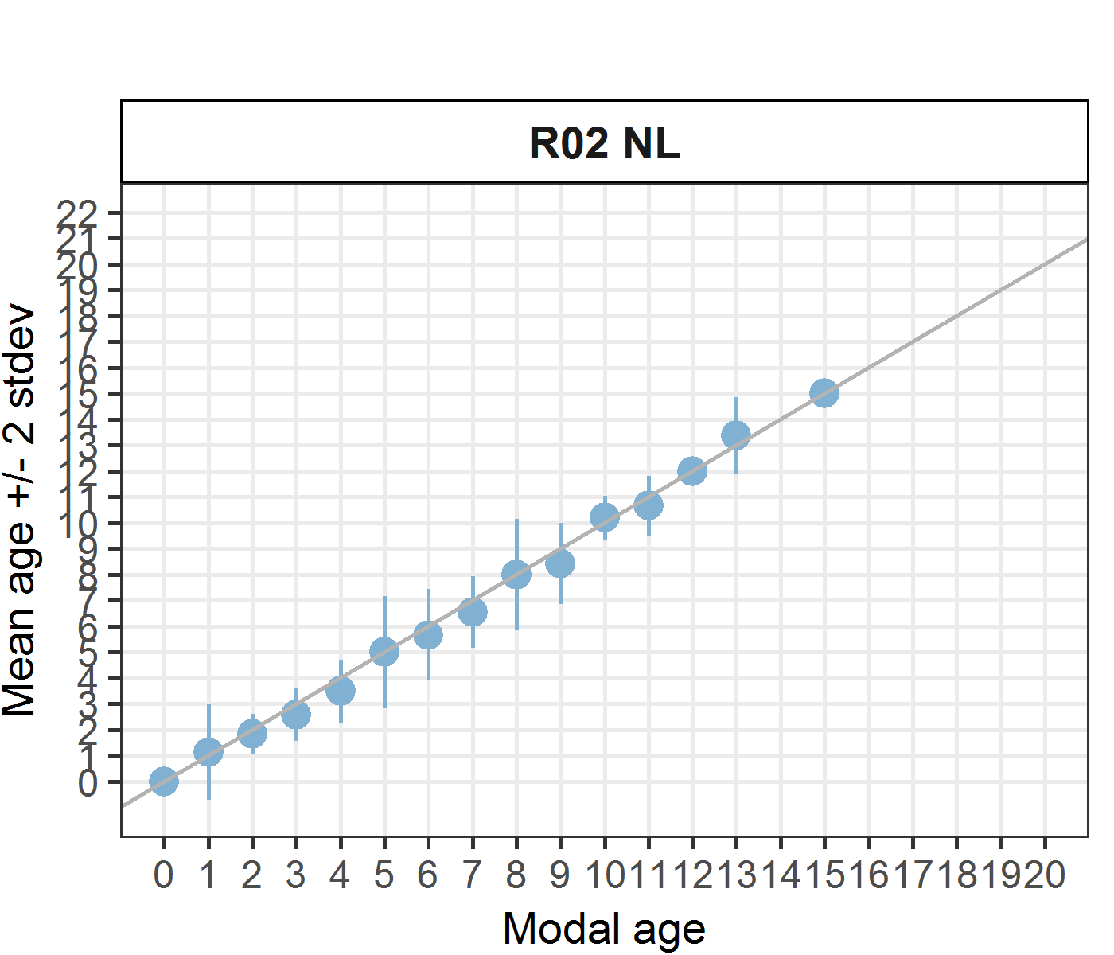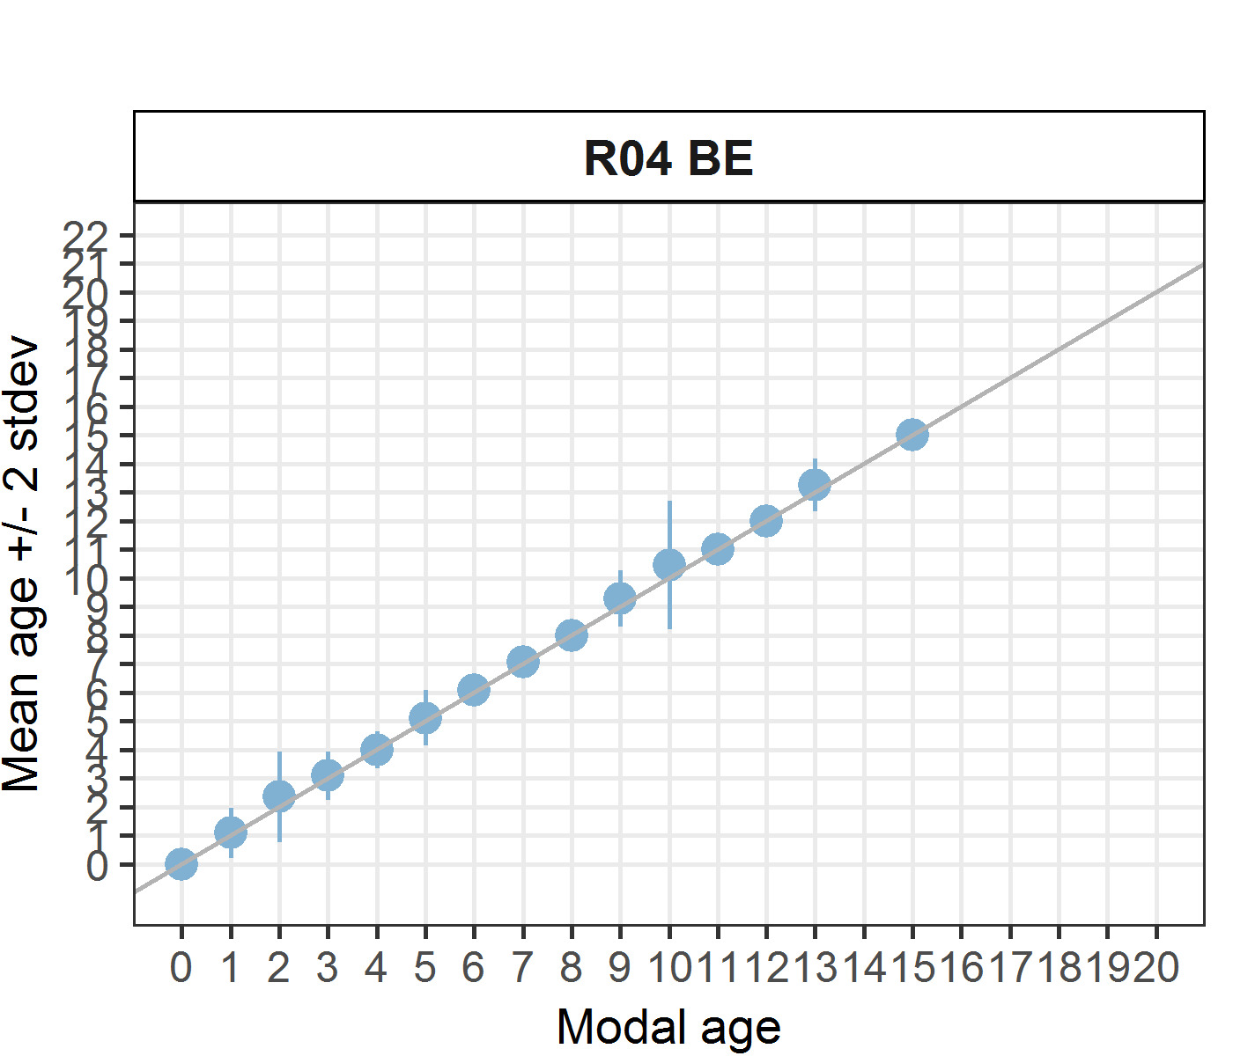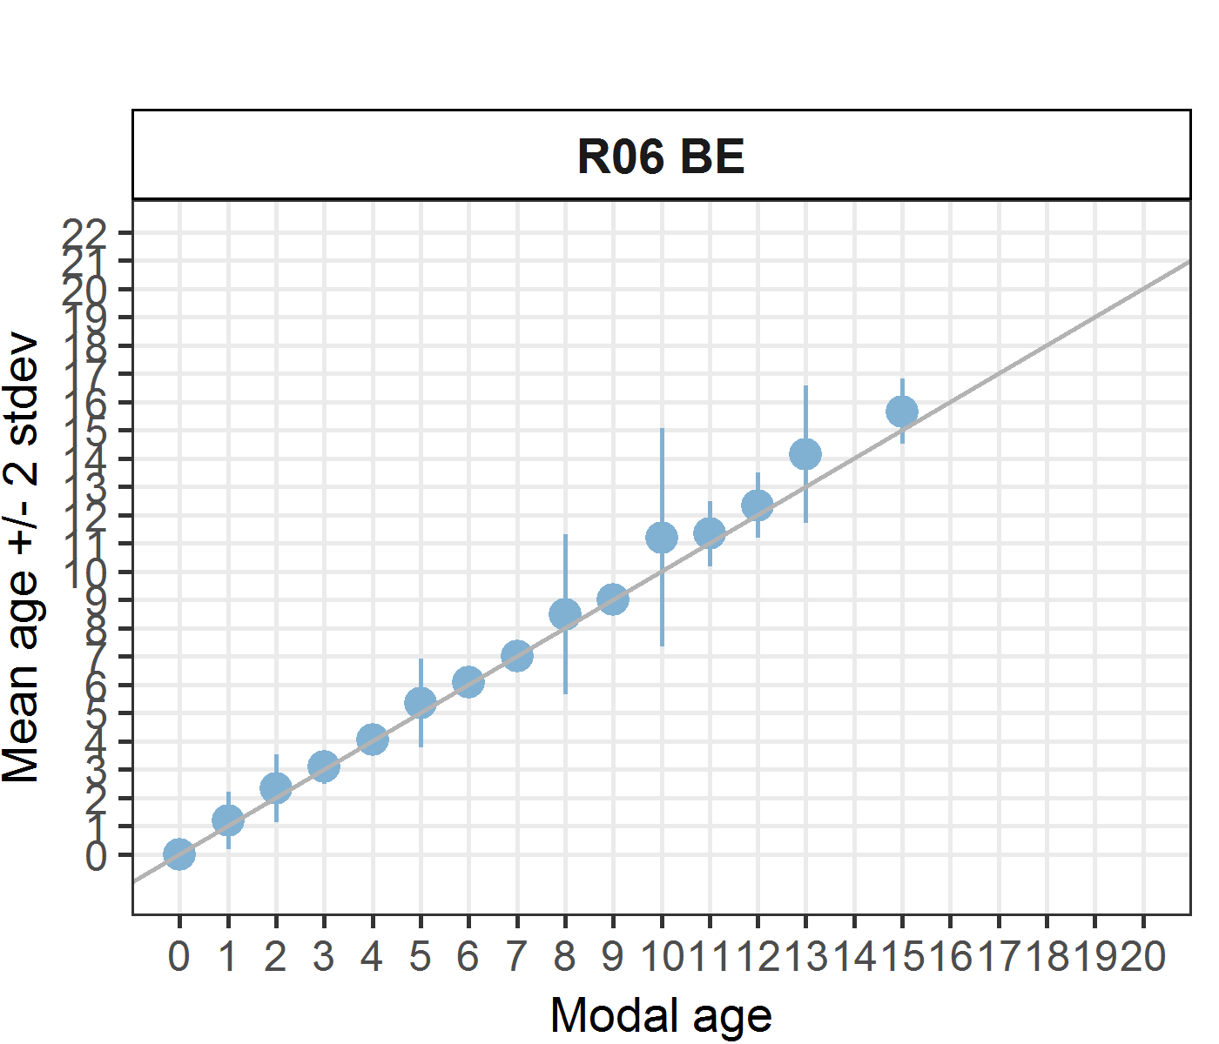
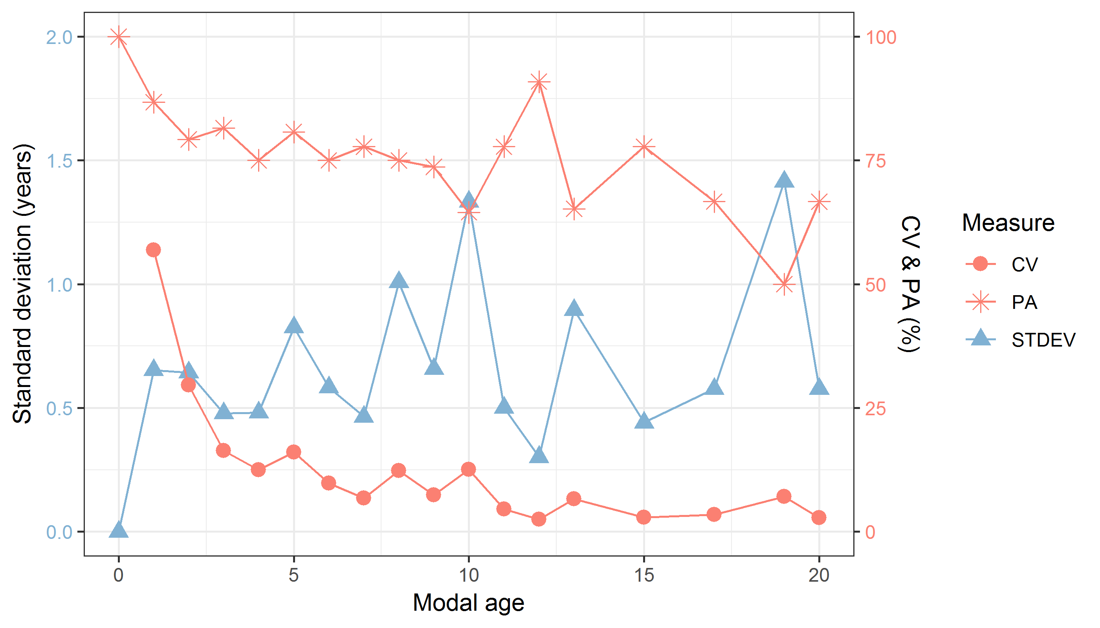
Figure 7.4: CV, PA and (STDEV (standard deviation) are plotted against modal age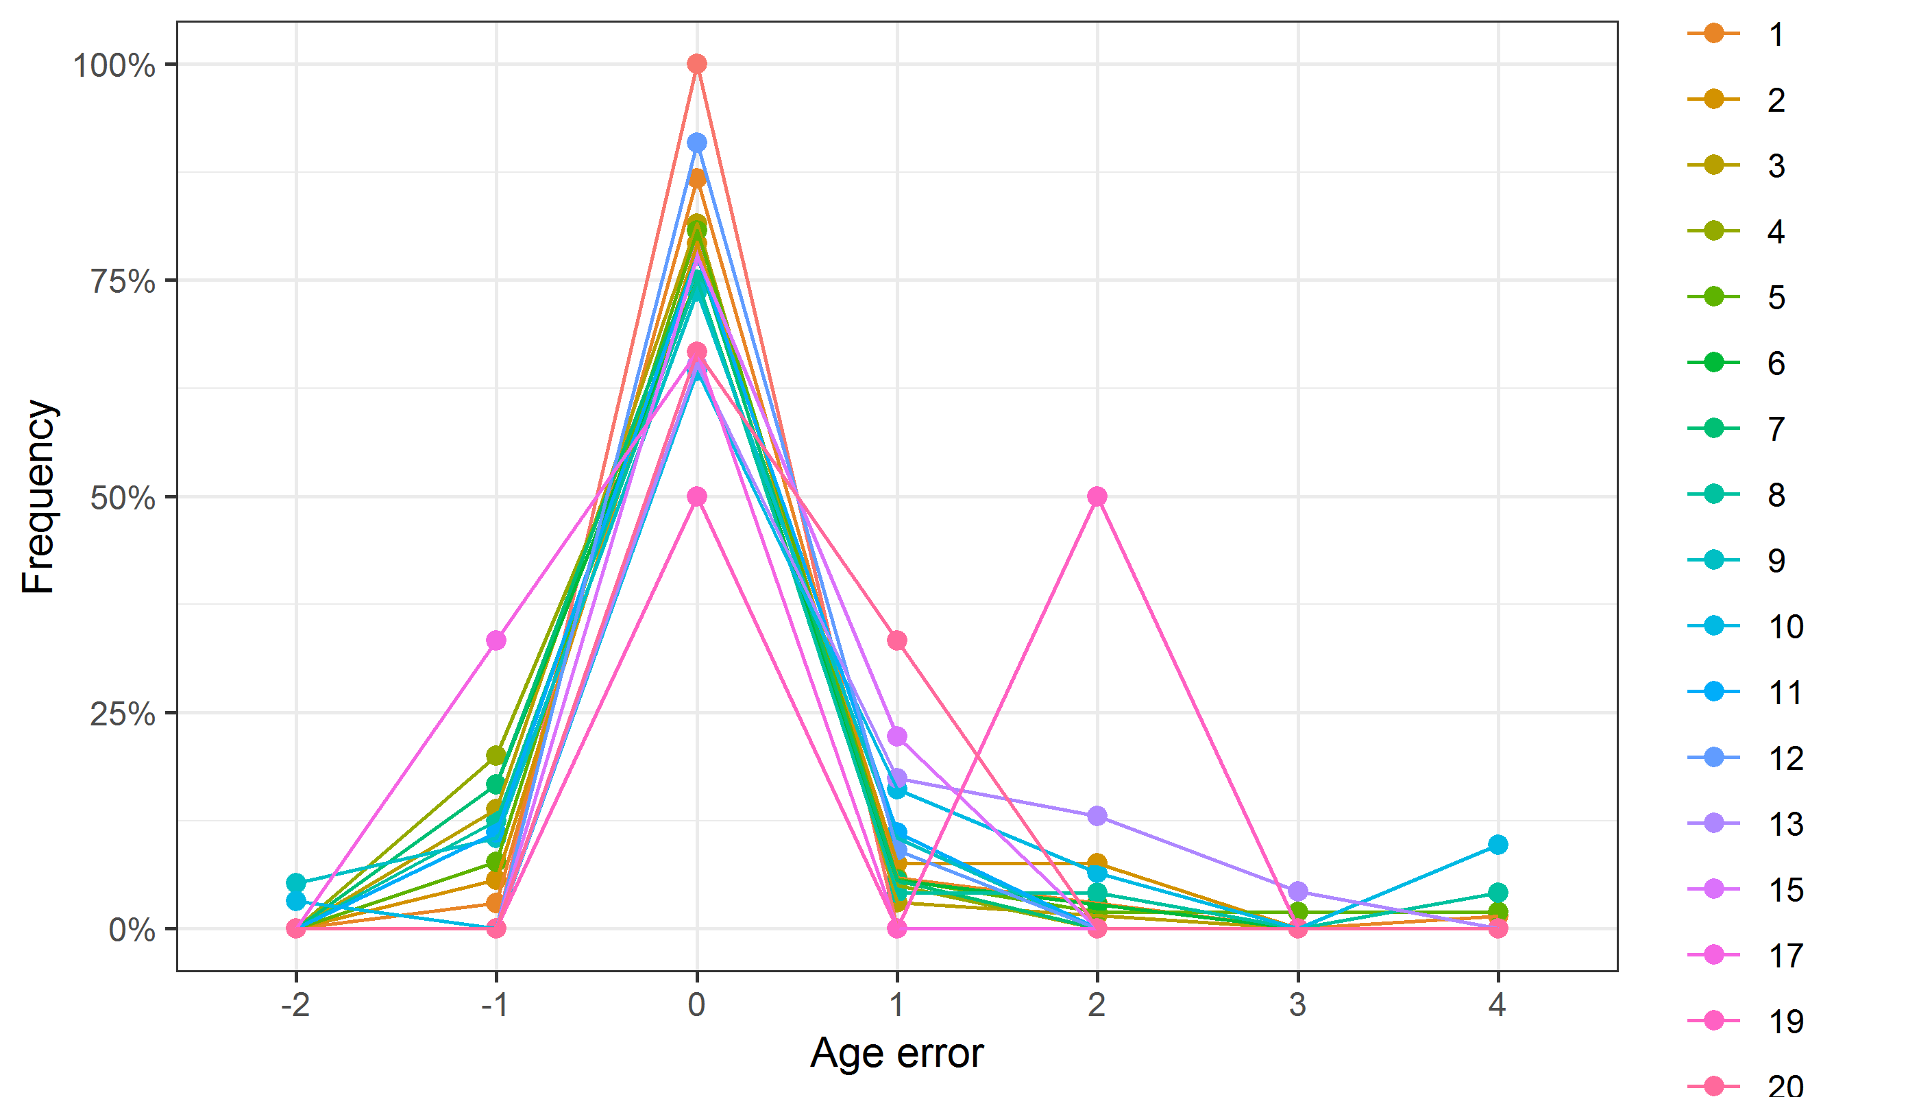
Figure 7.5: The distribution of the age reading errors in percentage by modal age as observed from the whole group of age readers in an age reading comparison to modal age. The achieved precision in age reading by MODAL age group is shown

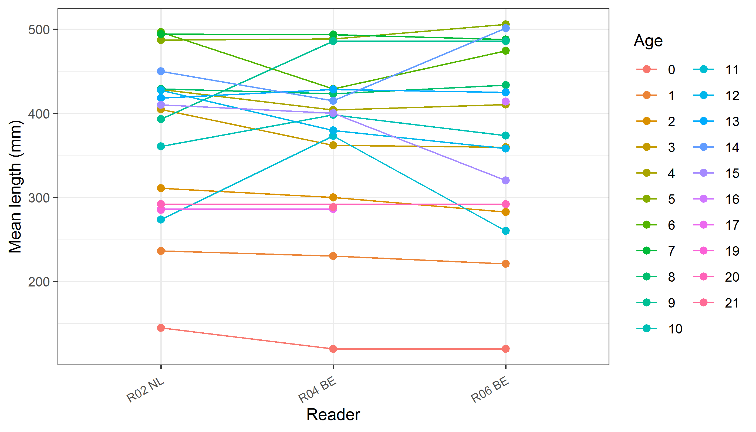
Figure 7.6: The mean length at age as estimated by each age reader.

Results all readers (whole otoliths)
Data Overview
Table 7.11: Summary of statistics; PA (%), CV (%) and APE (%).
CV | PA | APE
50 % | 53 % | 32 %
Table 7.12: Data overview including modal age and statistics per sample.
Fish ID | Event ID | Image ID | length | sex | Catch date | ICES area | R02 NL | R04 BE | R06 BE | R08 FR | R10 FR | R12 FR | R14 NL | Modal age | PA % | CV % | APE %
001_BYDR05_TUR_4B_2017071410335 | 216 | 15954 | 250 | - | 14/07/2017 00:00:00 | 27.4.b | 3 | 4 | 4 | 4 | 3 | 3 | 2 | 3 | 43 | 23 | 19
002_BYDR05_TUR_4B_2017071410358 | 216 | 15955 | 260 | - | 14/07/2017 00:00:00 | 27.4.b | - | 5 | 5 | 5 | 4 | 4 | 3 | 5 | 50 | 19 | 15
003_BYDR05_TUR_4B_D_S_2017071410086 | 216 | 15956 | 270 | - | 14/07/2017 00:00:00 | 27.4.b | - | 2 | 2 | 3 | 1 | 1 | 1 | 1 | 50 | 49 | 40
004_BYDR05_TUR_4B_D_S_2017071410087 | 216 | 15957 | 305 | - | 14/07/2017 00:00:00 | 27.4.b | 2 | 3 | 3 | - | 2 | 2 | 2 | 2 | 67 | 22 | 19
005_BYDR05_TUR_4B_D_S_2017071410088 | 216 | 15958 | 445 | - | 14/07/2017 00:00:00 | 27.4.b | 3 | 3 | 3 | 5 | 2 | 2 | 2 | 2 | 43 | 37 | 26
006_BYDR05_TUR_4B_M_2017071410336 | 216 | 15959 | 435 | - | 14/07/2017 00:00:00 | 27.4.b | 3 | 3 | 4 | 4 | 3 | 4 | 3 | 3 | 57 | 16 | 14
007_BYDR05_TUR_4B_M_2017071410337 | 216 | 15960 | 575 | - | 14/07/2017 00:00:00 | 27.4.b | 3 | 4 | 4 | 5 | 3 | 4 | 3 | 3 | 43 | 20 | 16
008_BYDR05_TUR_4B_M_2017071410357 | 216 | 15961 | 565 | - | 14/07/2017 00:00:00 | 27.4.b | 7 | 7 | 5 | 7 | 6 | 7 | 5 | 7 | 57 | 15 | 13
009_BYDR05_TUR_4B_M_2017071410360 | 216 | 15962 | 520 | - | 14/07/2017 00:00:00 | 27.4.b | 5 | 7 | 5 | 6 | 6 | 5 | 7 | 5 | 43 | 15 | 13
010_BYDR05_TUR_4B_M_2017071410361 | 216 | 15963 | 590 | - | 14/07/2017 00:00:00 | 27.4.b | 7 | 8 | 7 | 8 | 7 | 8 | 8 | 8 | 57 | 7 | 6
011_BYDR05_TUR_4B_M_2017071410362 | 216 | 15964 | 610 | - | 14/07/2017 00:00:00 | 27.4.b | 6 | 8 | 6 | 7 | 6 | 6 | 6 | 6 | 71 | 12 | 10
012_BYDR07_TUR_4B_D_S_2017110910094 | 216 | 15965 | 190 | - | 09/11/2017 00:00:00 | 27.4.b | 0 | 1 | - | 2 | 0 | 1 | 1 | 1 | 50 | 90 | 67
013_BYDR07_TUR_4B_D_S_2017110910095 | 216 | 15966 | 200 | - | 09/11/2017 00:00:00 | 27.4.b | 0 | 1 | 1 | 2 | 0 | 1 | 1 | 1 | 57 | 81 | 57
014_BYDR07_TUR_4B_D_S_2017110910105 | 216 | 15967 | 260 | - | 09/11/2017 00:00:00 | 27.4.b | 1 | 2 | 2 | 2 | 1 | 2 | 1 | 2 | 57 | 34 | 31
015_BYDR07_TUR_4B_D_S_2017110910112 | 216 | 15968 | 290 | - | 09/11/2017 00:00:00 | 27.4.b | 2 | 1 | 2 | 2 | 1 | 2 | 1 | 2 | 57 | 34 | 31
016_BYDR07_TUR_4B_D_S_2017110910115 | 216 | 15969 | 300 | - | 09/11/2017 00:00:00 | 27.4.b | 2 | 3 | 3 | 3 | 2 | 2 | 2 | 2 | 57 | 22 | 20
017_BYDR07_TUR_4B_D_S_2017110910118 | 216 | 15970 | 300 | - | 09/11/2017 00:00:00 | 27.4.b | 3 | 3 | 3 | 3 | 2 | 3 | 2 | 3 | 71 | 18 | 15
019_BYDR07_TUR_4B_M_2017110910340 | 216 | 15972 | 525 | - | 09/11/2017 00:00:00 | 27.4.b | 4 | 5 | 4 | 4 | 3 | 4 | 4 | 4 | 71 | 14 | 7
020_BYDR07_TUR_4B_M_2017110910341 | 216 | 15973 | 510 | - | 09/11/2017 00:00:00 | 27.4.b | - | 4 | 4 | 5 | 4 | 4 | 4 | 4 | 83 | 10 | 7
021_BYDR07_TUR_4B_M_2017110910343 | 216 | 15974 | 485 | - | 09/11/2017 00:00:00 | 27.4.b | 3 | 4 | 4 | 5 | 3 | 4 | 5 | 4 | 43 | 20 | 14
022_BYDR07_TUR_4B_M_2017110910350 | 216 | 15975 | 590 | - | 09/11/2017 00:00:00 | 27.4.b | 6 | 7 | 8 | 7 | 6 | 7 | 9 | 7 | 43 | 15 | 11
023_BYDR07_TUR_4B_M_2017110910351 | 216 | 15976 | 560 | - | 09/11/2017 00:00:00 | 27.4.b | 6 | 6 | 7 | 8 | 7 | 7 | 7 | 7 | 57 | 10 | 7
024_BYDR07_TUR_4B_M_2017110910352 | 216 | 15977 | 675 | - | 09/11/2017 00:00:00 | 27.4.b | 5 | 9 | 7 | 7 | 7 | 6 | - | 7 | 50 | 19 | 13
025_BYDR07_TUR_4B_M_2017110910353 | 216 | 15978 | 590 | - | 09/11/2017 00:00:00 | 27.4.b | 7 | 7 | 8 | 6 | 7 | 7 | 8 | 7 | 57 | 10 | 7
026_BYDR07_TUR_4B_M_2017110910354 | 216 | 15979 | 635 | - | 09/11/2017 00:00:00 | 27.4.b | 6 | 7 | 7 | 7 | 6 | 7 | 6 | 7 | 57 | 8 | 7
027_CDDR06_TUR_4B_M_2017073110492 | 216 | 15980 | 425 | - | 31/07/2017 00:00:00 | 27.4.b | 4 | 5 | 7 | 6 | 4 | 5 | 3 | 4 | 29 | 28 | 21
028_CDDR07_TUR_4B_D_S_2017102010073 | 216 | 15981 | 230 | - | 20/10/2017 00:00:00 | 27.4.b | 1 | 1 | 1 | 1 | 0 | 2 | 2 | 1 | 57 | 60 | 43
029_CDDR07_TUR_4B_D_S_2017102010074 | 216 | 15982 | 240 | - | 20/10/2017 00:00:00 | 27.4.b | 1 | 2 | 1 | 2 | 0 | 1 | 1 | 1 | 57 | 60 | 43
030_CDDR07_TUR_4B_D_S_2017102010098 | 216 | 15983 | 220 | - | 20/10/2017 00:00:00 | 27.4.b | 1 | 1 | 1 | 2 | 0 | 1 | 1 | 1 | 71 | 58 | 29
031_CDDR07_TUR_4B_M_2017102010266 | 216 | 15984 | 515 | - | 20/10/2017 00:00:00 | 27.4.b | 4 | 6 | 5 | 5 | 5 | 5 | 5 | 5 | 71 | 12 | 6
032_CDDR07_TUR_4B_M_2017102010270 | 216 | 15985 | 555 | - | 20/10/2017 00:00:00 | 27.4.b | 5 | 5 | 6 | 5 | 5 | 6 | 6 | 5 | 57 | 10 | 9
033_DTU2015_TUR_4B_039_161115 | 216 | 15986 | 380 | - | 16/11/2015 00:00:00 | 27.4.b | 1 | 1 | 3 | 2 | 1 | 2 | 2 | 1 | 43 | 44 | 36
034_DTU2015_TUR_4B_064_161115 | 216 | 15987 | 650 | - | 16/11/2015 00:00:00 | 27.4.b | 5 | 5 | 6 | 4 | 3 | 2 | 5 | 5 | 43 | 32 | 26
035_DTU2015_TUR_4B_090_020915 | 216 | 15988 | 560 | - | 02/09/2015 00:00:00 | 27.4.b | 4 | 4 | 5 | 5 | 5 | 5 | 4 | 5 | 57 | 12 | 11
036_DTU2016_TUR_4B_318_05092016 | 216 | 15989 | 590 | - | 05/09/2016 00:00:00 | 27.4.b | 6 | 8 | 8 | 8 | 6 | 7 | 8 | 8 | 57 | 13 | 11
037_DTU2016_TUR_4B_321_05092016 | 216 | 15990 | 540 | - | 05/09/2016 00:00:00 | 27.4.b | 6 | 7 | 8 | 7 | 7 | 7 | 7 | 7 | 71 | 8 | 4
038_DTU2017_TUR_4B_054_16032017 | 216 | 15991 | 520 | - | 16/03/2017 00:00:00 | 27.4.b | 5 | 6 | 4 | 5 | 4 | 4 | 4 | 4 | 57 | 17 | 14
039_DTU2017_TUR_4B_063_16032017 | 216 | 15992 | 500 | - | 21/05/2017 00:00:00 | 27.4.b | 5 | 5 | 7 | 5 | 4 | 5 | 5 | 5 | 71 | 17 | 10
040_DTU2017_TUR_4B_067_16032017 | 216 | 15993 | 490 | - | 16/03/2017 00:00:00 | 27.4.b | 4 | 9 | 7 | 7 | 7 | 6 | 4 | 7 | 43 | 29 | 22
041_DTU2017_TUR_4B_070_17032017 | 216 | 15994 | 390 | - | 17/03/2017 00:00:00 | 27.4.b | 2 | 4 | 3 | 4 | 3 | 3 | 3 | 3 | 57 | 22 | 16
042_DTU2017_TUR_4B_071_17032017 | 216 | 15995 | 430 | - | 17/03/2017 00:00:00 | 27.4.b | 3 | 5 | 4 | 5 | 3 | 3 | 3 | 3 | 57 | 26 | 22
043_DTU2017_TUR_4B_077_17032017 | 216 | 15996 | 460 | - | 17/03/2017 00:00:00 | 27.4.b | 2 | 5 | 4 | 4 | 3 | 3 | 3 | 3 | 43 | 28 | 23
044_DTU2017_TUR_4B_157_21052017 | 216 | 15997 | 580 | - | 21/05/2017 00:00:00 | 27.4.b | 5 | 6 | 6 | 5 | 4 | 4 | 4 | 4 | 43 | 19 | 15
045_DTU2017_TUR_4B_161_21052017 | 216 | 15998 | 500 | - | 21/05/2017 00:00:00 | 27.4.b | 5 | 6 | 6 | 6 | 6 | 5 | 4 | 6 | 57 | 14 | 12
046_DTU2017_TUR_4B_164_21052017 | 216 | 15999 | 470 | - | 21/05/2017 00:00:00 | 27.4.b | 3 | 3 | 4 | 4 | 3 | 3 | 4 | 3 | 57 | 16 | 14
047_DTU2017_TUR_4B_184_06062017 | 216 | 16000 | 570 | - | 06/06/2017 00:00:00 | 27.4.b | 4 | 5 | 6 | 4 | 4 | 4 | 4 | 4 | 71 | 18 | 14
048_DTU2017_TUR_4B_191_06062017 | 216 | 16001 | 590 | - | 06/06/2017 00:00:00 | 27.4.b | 6 | 8 | 8 | 6 | 5 | 5 | 4 | 5 | 29 | 25 | 19
049_DTU2017_TUR_4B_205_06062017 | 216 | 16002 | 430 | - | 06/06/2017 00:00:00 | 27.4.b | 2 | 2 | 3 | 4 | 2 | 2 | 3 | 2 | 57 | 31 | 25
050_DTU2017_TUR_4B_261_04092017 | 216 | 16003 | 600 | - | 04/09/2017 00:00:00 | 27.4.b | 9 | 10 | 9 | 7 | 8 | 7 | 10 | 7 | 29 | 15 | 12
051_DTU2017_TUR_4B_262_04092017 | 216 | 16004 | 590 | - | 04/09/2017 00:00:00 | 27.4.b | 8 | 11 | 14 | 6 | 11 | 8 | 9 | 8 | 29 | 28 | 22
052_DTU2017_TUR_4B_263_04092017 | 216 | 16005 | 580 | - | 04/09/2017 00:00:00 | 27.4.b | 7 | 8 | 8 | 8 | 8 | 6 | 8 | 8 | 71 | 10 | 8
053_DTU2017_TUR_4B_264_04092017 | 216 | 16006 | 590 | - | 04/09/2017 00:00:00 | 27.4.b | 8 | 11 | 13 | 8 | 11 | 6 | 13 | 8 | 29 | 27 | 23
054_DTU2017_TUR_4B_266_04092017 | 216 | 16007 | 600 | - | 04/09/2017 00:00:00 | 27.4.b | 10 | 14 | 13 | 8 | 9 | 8 | 11 | 8 | 29 | 23 | 18
055_DTU2017_TUR_4B_267_04092017 | 216 | 16008 | 460 | - | 04/09/2017 00:00:00 | 27.4.b | 5 | 6 | 9 | 7 | 8 | 5 | 6 | 5 | 29 | 23 | 19
056_DTU2017_TUR_4B_270_04092017 | 216 | 16009 | 460 | - | 04/09/2017 00:00:00 | 27.4.b | 4 | 4 | 8 | 5 | 4 | 4 | 4 | 4 | 71 | 32 | 22
057_DTU2017_TUR_4B_276_04092017 | 216 | 16010 | 440 | - | 04/09/2017 00:00:00 | 27.4.b | 5 | 5 | 6 | 5 | 6 | 4 | 4 | 5 | 43 | 16 | 11
058_DTU2017_TUR_4B_286_04092017 | 216 | 16011 | 420 | - | 04/09/2017 00:00:00 | 27.4.b | 5 | 5 | 6 | 5 | 3 | 4 | 5 | 5 | 57 | 20 | 15
059_DTU2017_TUR_4B_288_04092017 | 216 | 16012 | 530 | - | 04/09/2017 00:00:00 | 27.4.b | 6 | 6 | 7 | 6 | 6 | 6 | 6 | 6 | 86 | 6 | 4
060_DTU2017_TUR_4B_290_04092017 | 216 | 16013 | 530 | - | 04/09/2017 00:00:00 | 27.4.b | 5 | 5 | 6 | - | 6 | 5 | 5 | 5 | 67 | 10 | 8
061_DTU2017_TUR_4B_292_04092017 | 216 | 16014 | 510 | - | 04/09/2017 00:00:00 | 27.4.b | 6 | 7 | 7 | 6 | 6 | 6 | 7 | 6 | 57 | 8 | 8
062_DTU2017_TUR_4B_293_04092017 | 216 | 16015 | 530 | - | 04/09/2017 00:00:00 | 27.4.b | 8 | 9 | - | - | 9 | 5 | 8 | 8 | 40 | 21 | 14
063_DTU2017_TUR_4B_294_04092017 | 216 | 16016 | 600 | - | 04/09/2017 00:00:00 | 27.4.b | 4 | 6 | 5 | 4 | 5 | 4 | 6 | 4 | 43 | 19 | 15
064_DTU2017_TUR_4B_303_26102017 | 216 | 16017 | 590 | - | 26/10/2017 00:00:00 | 27.4.b | 6 | 6 | 12 | - | 6 | 6 | 6 | 6 | 83 | 35 | 24
065_DTU2017_TUR_4B_304_26102017 | 216 | 16018 | 630 | - | 26/10/2017 00:00:00 | 27.4.b | 7 | 8 | - | 7 | 6 | 7 | 7 | 7 | 67 | 9 | 5
066_DTU2017_TUR_4B_305_26102017 | 216 | 16019 | 550 | - | 26/10/2017 00:00:00 | 27.4.b | 3 | 4 | 5 | 4 | 3 | 4 | 5 | 4 | 43 | 20 | 14
067_DTU2017_TUR_4B_309_26102017 | 216 | 16020 | 520 | - | 26/10/2017 00:00:00 | 27.4.b | 3 | 6 | 5 | 5 | 6 | 4 | 6 | 6 | 43 | 23 | 17
068_DTU2017_TUR_4B_326_26102017 | 216 | 16021 | 450 | - | 26/10/2017 00:00:00 | 27.4.b | 4 | 6 | 9 | 5 | 6 | 4 | 4 | 4 | 43 | 33 | 25
069_DTU2017_TUR_4B_369_02112017 | 216 | 16022 | 570 | - | 02/11/2017 00:00:00 | 27.4.b | 5 | 5 | 6 | 5 | 5 | 4 | 6 | 5 | 57 | 13 | 10
070_DTU2015_TUR_4A_035_260215 | 216 | 16023 | 450 | - | 26/02/2015 00:00:00 | 27.4.a | - | - | 4 | - | - | - | - | 4 | 100 | - | 0
071_DTU2015_TUR_4A_037_260215 | 216 | 16024 | 440 | - | 26/02/2015 00:00:00 | 27.4.a | 3 | 5 | 6 | 4 | 3 | 3 | 3 | 3 | 57 | 31 | 25
072_DTU2015_TUR_4A_039_260215 | 216 | 16025 | 430 | - | 26/02/2015 00:00:00 | 27.4.a | 4 | 3 | 3 | 4 | 3 | 2 | 3 | 3 | 57 | 22 | 16
073_DTU2015_TUR_4A_042_150215 | 216 | 16026 | 400 | - | 26/02/2015 00:00:00 | 27.4.a | 6 | 7 | 8 | 7 | 8 | 6 | 5 | 6 | 29 | 17 | 13
074_DTU2017_TUR_4A_104_03042017 | 216 | 16027 | 520 | - | 03/04/2017 00:00:00 | 27.4.a | 4 | 3 | 4 | 4 | 4 | 3 | 4 | 4 | 71 | 13 | 11
075_DTU2017_TUR_4A_250_12072017 | 216 | 16028 | 550 | - | 12/07/2017 00:00:00 | 27.4.a | - | - | - | - | 4 | - | - | 4 | 100 | - | 0
076_DTU2017_TUR_4A_252_12072017 | 216 | 16029 | 510 | - | 12/07/2017 00:00:00 | 27.4.a | 4 | 4 | - | 4 | 4 | 3 | 6 | 4 | 67 | 24 | 15
077_DTU2017_TUR_4A_254_12072017 | 216 | 16030 | 460 | - | 12/07/2017 00:00:00 | 27.4.a | 2 | 5 | 5 | 4 | 2 | 2 | 7 | 2 | 43 | 51 | 41
078_DTU2017_TUR_4A_257_12072017 | 216 | 16031 | 420 | - | 12/07/2017 00:00:00 | 27.4.a | 2 | 3 | 7 | 4 | 3 | 2 | 3 | 3 | 43 | 50 | 35
079_DTU2017_TUR_4A_258_12072017 | 216 | 16032 | 430 | - | 12/07/2017 00:00:00 | 27.4.a | 2 | 2 | 3 | 4 | 2 | 2 | 5 | 2 | 57 | 43 | 34
080_DTU2017_TUR_4A_259_12072017 | 216 | 16033 | 470 | - | 12/07/2017 00:00:00 | 27.4.a | 4 | 3 | 4 | 5 | 5 | 3 | 5 | 5 | 43 | 22 | 18
081_DTU2017_TUR_4A_260_12072017 | 216 | 16034 | 390 | - | 12/07/2017 00:00:00 | 27.4.a | 2 | 2 | 3 | 4 | 2 | 2 | 3 | 2 | 57 | 31 | 25
082_NDGP11_JB_TUR_4A_NZ1_003 | 216 | 16035 | 260 | - | 18/02/2017 00:00:00 | 27.4.a | 2 | 3 | 2 | 3 | 2 | 2 | 2 | 2 | 71 | 21 | 18
083_NDGP11_JB_TUR_4A_NZ1_004 | 216 | 16036 | 450 | - | 18/02/2017 00:00:00 | 27.4.a | 2 | 2 | 3 | - | 2 | 2 | 3 | 2 | 67 | 22 | 19
084_NDGP11_JB_TUR_4A_NZ1_007 | 216 | 16037 | 420 | - | 18/02/2017 00:00:00 | 27.4.a | 2 | 2 | 3 | 5 | 3 | 2 | 3 | 2 | 43 | 37 | 26
085_NDGP11_JB_TUR_4A_NZ1_008 | 216 | 16038 | 290 | - | 18/02/2017 00:00:00 | 27.4.a | 2 | 3 | 2 | 3 | 2 | 2 | 2 | 2 | 71 | 21 | 18
086_NDGP11_JB_TUR_4A_NZ1_010 | 216 | 16039 | 450 | - | 18/02/2017 00:00:00 | 27.4.a | 3 | 3 | 3 | 4 | 5 | 2 | 3 | 3 | 57 | 29 | 21
087_NDGP11_JB_TUR_4A_NZ1_015 | 216 | 16040 | 430 | - | 18/02/2017 00:00:00 | 27.4.a | 3 | 4 | 3 | 5 | 3 | 3 | 3 | 3 | 71 | 23 | 18
088_BTS01_TUR_4C_C_2017082810012 | 216 | 16041 | 446 | - | 28/08/2017 00:00:00 | 27.4.c | 2 | 4 | 3 | 4 | 3 | 3 | 3 | 3 | 57 | 22 | 16
089_BTS01_TUR_4C_C_2017082810011 | 216 | 16042 | 443 | - | 28/08/2017 00:00:00 | 27.4.c | 3 | 5 | 3 | 5 | 4 | 3 | 4 | 3 | 43 | 23 | 19
091_BTS01_TUR_4C_C_2017082810010 | 216 | 16043 | 334 | - | 28/08/2017 00:00:00 | 27.4.c | 2 | 3 | 2 | 4 | 3 | 2 | 2 | 2 | 57 | 31 | 25
092_BTS01_TUR_4C_C_2017082810009 | 216 | 16044 | 425 | - | 28/08/2017 00:00:00 | 27.4.c | 4 | 4 | 4 | 4 | 5 | 3 | 3 | 4 | 57 | 18 | 13
092_NDGP15_BTS01_TUR_4C_55083 | 216 | 16045 | 245 | - | 13/09/2015 00:00:00 | 27.4.c | 1 | 1 | 2 | 3 | 0 | 0 | 1 | 1 | 43 | 94 | 68
093_NDGP15_BTS01_TUR_4C_55084 | 216 | 16046 | 250 | - | 13/09/2015 00:00:00 | 27.4.c | 2 | 2 | 2 | 3 | 0 | 1 | 2 | 2 | 57 | 55 | 40
094_NDGP15_BTS01_TUR_4C_55085 | 216 | 16047 | 290 | - | 13/09/2015 00:00:00 | 27.4.c | 1 | 2 | 2 | 3 | 1 | 1 | 2 | 1 | 43 | 44 | 36
095_NDGP15_BTS01_TUR_4C_55086 | 216 | 16048 | 240 | - | 13/09/2015 00:00:00 | 27.4.c | 1 | 2 | 2 | 2 | 1 | 1 | 1 | 1 | 57 | 37 | 34
096_NDGP15_BTS01_TUR_4C_55088 | 216 | 16049 | 485 | - | 13/09/2015 00:00:00 | 27.4.c | 3 | 6 | 5 | 6 | 5 | 4 | 4 | 4 | 29 | 24 | 19
097_NDGP15_BTS01_TUR_4C_55090 | 216 | 16050 | 575 | - | 13/09/2015 00:00:00 | 27.4.c | 4 | 4 | 5 | 6 | 5 | 4 | 5 | 4 | 43 | 16 | 13
098_NDGP15_BTS01_TUR_4C_55097 | 216 | 16051 | 225 | - | 13/09/2015 00:00:00 | 27.4.c | 1 | 1 | 1 | - | 0 | 0 | 1 | 1 | 67 | 77 | 67
099_NDGP15_BTS01_TUR_4C_55098 | 216 | 16052 | 215 | - | 13/09/2015 00:00:00 | 27.4.c | 1 | 1 | 1 | - | 0 | 0 | 1 | 1 | 67 | 77 | 67
100_NDGP15_BTS01_TUR_4C_55099 | 216 | 16053 | 245 | - | 13/09/2015 00:00:00 | 27.4.c | 1 | 3 | 1 | 3 | 0 | 1 | 1 | 1 | 57 | 79 | 63
101_NDGP16_BTS01_TUR_4C_220936 | 216 | 16054 | 360 | - | 04/10/2016 00:00:00 | 27.4.c | 2 | 3 | 3 | 3 | 1 | 1 | 3 | 3 | 57 | 42 | 36
102_NDGP16_BTS01_TUR_4C_220944 | 216 | 16055 | 415 | - | 04/10/2016 00:00:00 | 27.4.c | 2 | 3 | 3 | 3 | 2 | 2 | 3 | 3 | 57 | 21 | 19
103_PTCT03_TUR_4C_2017040310395 | 216 | 16056 | 340 | - | 03/04/2017 00:00:00 | 27.4.c | 3 | 3 | 3 | 3 | 2 | 2 | 2 | 3 | 57 | 21 | 19
104_PTCT03_TUR_4C_2017040310396 | 216 | 16057 | 325 | - | 03/04/2017 00:00:00 | 27.4.c | 4 | 5 | 6 | 4 | 5 | 4 | 5 | 4 | 43 | 16 | 13
105_PTCT03_TUR_4C_2017040310397 | 216 | 16058 | 395 | - | 03/04/2017 00:00:00 | 27.4.c | 2 | 3 | 3 | 5 | 2 | 2 | 3 | 2 | 43 | 37 | 26
106_PTCT03_TUR_4C_2017040310398 | 216 | 16059 | 400 | - | 03/04/2017 00:00:00 | 27.4.c | 5 | 5 | 6 | 5 | 5 | 4 | 4 | 5 | 57 | 14 | 10
107_TUR_EX-NL_4C_4100008_001_130918 | 216 | 16060 | 252 | - | 13/09/2018 00:00:00 | 27.4.c | 3 | 3 | 3 | 3 | 3 | 3 | 2 | 3 | 86 | 13 | 9
108_TUR_EX-NL_4C_4100010_002_130918 | 216 | 16061 | 118 | - | 13/09/2018 00:00:00 | 27.4.c | 0 | 1 | 1 | 1 | 0 | 0 | 0 | 0 | 57 | - | -
109_TUR_EX-NL_4C_4100011_003_130918 | 216 | 16062 | 137 | - | 13/09/2018 00:00:00 | 27.4.c | 0 | 0 | 1 | 1 | 0 | 0 | 0 | 0 | 71 | - | -
110_TUR_EX-NL_4C_4100011_004_130918 | 216 | 16063 | 122 | - | 13/09/2018 00:00:00 | 27.4.c | 0 | 0 | 1 | 1 | 0 | 0 | - | 0 | 67 | - | -
111_TUR_EX-NL_4C_4100011_005_130918 | 216 | 16064 | 102 | - | 13/09/2018 00:00:00 | 27.4.c | 0 | 1 | 0 | 1 | 0 | 0 | 0 | 0 | 71 | - | -
112_TUR_EX-NL_4C_4100014_006_140918 | 216 | 16065 | 198 | - | 14/09/2018 00:00:00 | 27.4.c | 1 | 2 | 1 | 3 | 2 | 2 | 1 | 1 | 43 | 44 | 36
113_TUR_EX-NL_4C_4100015_010_140918 | 216 | 16066 | 237 | - | 14/09/2018 00:00:00 | 27.4.c | 1 | 3 | 2 | 5 | 1 | 2 | 1 | 1 | 43 | 68 | 50
114_TUR_EX-NL_4C_4100017_012_140918 | 216 | 16067 | 225 | - | 14/09/2018 00:00:00 | 27.4.c | 1 | 2 | 2 | - | 1 | 1 | 1 | 1 | 67 | 39 | 33
115_TUR_EX-NL_4C_4100023_013_170918 | 216 | 16068 | 204 | - | 17/09/2018 00:00:00 | 27.4.c | 1 | 2 | 2 | 3 | 2 | 2 | 1 | 2 | 57 | 37 | 26
116_TUR_EX-NL_4C_4100024_014_170918 | 216 | 16069 | 213 | - | 17/09/2018 00:00:00 | 27.4.c | 1 | 2 | 2 | 3 | 2 | 2 | 1 | 2 | 57 | 37 | 26
117_CEFAS_016_TUR_7D_093_300714 | 216 | 16070 | 340 | - | 30/07/2014 00:00:00 | 27.7.d | 2 | 2 | 3 | - | 1 | 1 | 2 | 2 | 50 | 41 | 30
118_CEFAS_017_TUR_7D_099_300714 | 216 | 16071 | 240 | - | 30/07/2014 00:00:00 | 27.7.d | 1 | 3 | 3 | - | 1 | 1 | 1 | 1 | 67 | 62 | 53
119_DTU2016_TUR_BA_7D_266_02112016 | 216 | 16072 | 350 | - | 02/11/2016 00:00:00 | 27.7.d | 6 | 7 | 8 | 6 | 6 | 3 | 3 | 6 | 43 | 34 | 26
120_DTU2016_TUR_BA_7D_267_02112016 | 216 | 16073 | 470 | - | 02/11/2016 00:00:00 | 27.7.d | 5 | 10 | 14 | 7 | 7 | 5 | 7 | 7 | 43 | 41 | 30
121_DTU2016_TUR_BA_7D_268_02112016 | 216 | 16074 | 310 | - | 02/11/2016 00:00:00 | 27.7.d | 3 | 4 | 7 | 5 | 3 | 2 | 2 | 2 | 29 | 48 | 37
122_DTU2016_TUR_BA_7D_272_03112016 | 216 | 16075 | 320 | - | 03/11/2016 00:00:00 | 27.7.d | 4 | 5 | 5 | 4 | 3 | 3 | 2 | 3 | 29 | 30 | 24
123_DTU2016_TUR_BA_7D_274_03112016 | 216 | 16076 | 240 | - | 03/11/2016 00:00:00 | 27.7.d | 1 | 3 | 3 | 3 | 1 | 1 | 1 | 1 | 57 | 58 | 53
124_DTU2016_TUR_BA_7D_276_04112016 | 216 | 16077 | 310 | - | 04/11/2016 00:00:00 | 27.7.d | 2 | - | 6 | 4 | 4 | 1 | 2 | 2 | 33 | 58 | 47
125_DTU2016_TUR_BA_7D_277_04112016 | 216 | 16078 | 290 | - | 04/11/2016 00:00:00 | 27.7.d | 2 | 5 | 5 | 5 | 2 | 2 | 2 | 2 | 57 | 49 | 45
126_DTU2016_TUR_BA_7D_298_10112016 | 216 | 16079 | 430 | - | 10/11/2016 00:00:00 | 27.7.d | 6 | 7 | 7 | 5 | 7 | 6 | 7 | 7 | 57 | 12 | 10
127_DTU2016_TUR_BA_7D_299_10112016 | 216 | 16080 | 350 | - | 10/11/2016 00:00:00 | 27.7.d | 4 | 4 | 4 | 5 | 4 | 4 | 3 | 4 | 71 | 14 | 7
128_DTU2016_TUR_BA_7D_300_10112016 | 216 | 16081 | 270 | - | 10/11/2016 00:00:00 | 27.7.d | 2 | 3 | 3 | 3 | 2 | 2 | 2 | 2 | 57 | 22 | 20
129_DTU2016_TUR_BA_7D_302_11112016 | 216 | 16082 | 290 | - | 11/11/2016 00:00:00 | 27.7.d | 2 | 5 | 5 | 4 | 3 | 1 | 2 | 2 | 29 | 50 | 42
130_DTU2016_TUR_BA_7D_303_12112016 | 216 | 16083 | 330 | - | 12/11/2016 00:00:00 | 27.7.d | 1 | 2 | 2 | - | 1 | 1 | 2 | 1 | 50 | 37 | 33
131_DTU2016_TUR_BA_7D_310_12112016 | 216 | 16084 | 240 | - | 12/11/2016 00:00:00 | 27.7.d | 1 | 7 | - | - | 0 | 2 | 1 | 1 | 40 | 126 | 87
132_DTU2016_TUR_BA_7D_314_17112016 | 216 | 16085 | 460 | - | 17/11/2016 00:00:00 | 27.7.d | 11 | 12 | 16 | 5 | 12 | 5 | 10 | 5 | 29 | 39 | 29
133_DTU2015_TUR_BA_7D_037_181115 | 216 | 16086 | 330 | - | 18/11/2015 00:00:00 | 27.7.d | 2 | 4 | - | 3 | 3 | 3 | 3 | 3 | 67 | 21 | 11
134_DTU2015_TUR_BA_7D_001_120315 | 216 | 16087 | 255 | - | 12/03/2015 00:00:00 | 27.7.d | 2 | 6 | 7 | 4 | 4 | 3 | 2 | 2 | 29 | 48 | 36
135_DTU2015_TUR_BA_7D_002_120315 | 216 | 16088 | 351 | - | 12/03/2015 00:00:00 | 27.7.d | 3 | 3 | 4 | 3 | 4 | 3 | 3 | 3 | 71 | 15 | 12
136_DTU2015_TUR_BA_7D_003_041115 | 216 | 16089 | 180 | - | 04/11/2015 00:00:00 | 27.7.d | 1 | 2 | 1 | 1 | 0 | 0 | 1 | 1 | 57 | 81 | 57
137_DTU2015_TUR_BA_7D_004_120315 | 216 | 16090 | 297 | - | 12/03/2015 00:00:00 | 27.7.d | 3 | 5 | 8 | 4 | 5 | 3 | 2 | 3 | 29 | 46 | 34
138_DTU2015_TUR_BA_7D_005_120315 | 216 | 16091 | 292 | - | 12/03/2015 00:00:00 | 27.7.d | 3 | 5 | 3 | 3 | 3 | 2 | 2 | 3 | 57 | 33 | 19
139_DTU2015_TUR_BA_7D_006_120315 | 216 | 16092 | 288 | - | 12/03/2015 00:00:00 | 27.7.d | 3 | 5 | 6 | 3 | 3 | 3 | 2 | 3 | 57 | 39 | 31
140_DTU2015_TUR_BA_7D_007_120315 | 216 | 16093 | 307 | - | 12/03/2015 00:00:00 | 27.7.d | 2 | 3 | 3 | 3 | 2 | 2 | 2 | 2 | 57 | 22 | 20
141_DTU2015_TUR_BA_7D_008_120315 | 216 | 16094 | 260 | - | 12/03/2015 00:00:00 | 27.7.d | 1 | 5 | 10 | 4 | 3 | 3 | 2 | 3 | 29 | 74 | 50
142_DTU2015_TUR_BA_7D_009_120315 | 216 | 16095 | 272 | - | 12/03/2015 00:00:00 | 27.7.d | 2 | - | 6 | 3 | 4 | 2 | 3 | 2 | 33 | 45 | 33
143_DTU2015_TUR_BA_7D_010_120315 | 216 | 16096 | 271 | - | 12/03/2015 00:00:00 | 27.7.d | 3 | 5 | 8 | 3 | 4 | 3 | 2 | 3 | 43 | 50 | 36
144_DTU2015_TUR_BA_7D_011_120315 | 216 | 16097 | 296 | - | 12/03/2015 00:00:00 | 27.7.d | 3 | 4 | 9 | 4 | 4 | 3 | 2 | 4 | 43 | 55 | 33
145_DTU2015_TUR_BA_7D_012_091115 | 216 | 16098 | 260 | - | 09/11/2015 00:00:00 | 27.7.d | 3 | 3 | 4 | 3 | 3 | 2 | 2 | 3 | 57 | 24 | 17
146_DTU2015_TUR_BA_7D_012_120315 | 216 | 16099 | 295 | - | 12/03/2015 00:00:00 | 27.7.d | 3 | 3 | 6 | 4 | 3 | 2 | 2 | 3 | 43 | 42 | 30
147_DTU2015_TUR_BA_7D_013_091115 | 216 | 16100 | 220 | - | 09/11/2015 00:00:00 | 27.7.d | 1 | 5 | 9 | 3 | 1 | 2 | 1 | 1 | 43 | 94 | 70
148_DTU2015_TUR_BA_7D_013_120315 | 216 | 16101 | 278 | - | 12/03/2015 00:00:00 | 27.7.d | 3 | 3 | 5 | 3 | 3 | 3 | 2 | 3 | 71 | 29 | 17
149_DTU2015_TUR_BA_7D_014_120315 | 216 | 16102 | 246 | - | 12/03/2015 00:00:00 | 27.7.d | 3 | 3 | 4 | 3 | 3 | 3 | 2 | 3 | 71 | 19 | 10
150_DTU2015_TUR_BA_7D_003_120315 | 216 | 16103 | 336 | - | 12/03/2015 00:00:00 | 27.7.d | 3 | 3 | 4 | 4 | 3 | 3 | 3 | 3 | 71 | 15 | 12
151_DTU2015_TUR_BA_7D_015_120315 | 216 | 16104 | 258 | - | 12/03/2015 00:00:00 | 27.7.d | 2 | 4 | 5 | 3 | 2 | 2 | 2 | 2 | 57 | 43 | 34
152_DTU2015_TUR_BA_7D_016_120315 | 216 | 16105 | 260 | - | 12/03/2015 00:00:00 | 27.7.d | 2 | 8 | 11 | 3 | 3 | 4 | 2 | 2 | 29 | 73 | 58
153_DTU2015_TUR_BA_7D_017_120315 | 216 | 16106 | 254 | - | 12/03/2015 00:00:00 | 27.7.d | 2 | 6 | 10 | 3 | 3 | - | 2 | 2 | 33 | 72 | 56
154_DTU2015_TUR_BA_7D_018_091115 | 216 | 16107 | 250 | - | 09/11/2015 00:00:00 | 27.7.d | 2 | 5 | 6 | 4 | 2 | 2 | 1 | 2 | 43 | 59 | 51
155_DTU2015_TUR_BA_7D_018_120315 | 216 | 16108 | 251 | - | 12/03/2015 00:00:00 | 27.7.d | 2 | 8 | 10 | 3 | 3 | 3 | 2 | 3 | 43 | 72 | 59
156_DTU2015_TUR_BA_7D_019_120315 | 216 | 16109 | 255 | - | 12/03/2015 00:00:00 | 27.7.d | 2 | 4 | 4 | 3 | 3 | 2 | 2 | 2 | 43 | 31 | 26
157_DTU2015_TUR_BA_7D_020_120315 | 216 | 16110 | 292 | - | 12/03/2015 00:00:00 | 27.7.d | 2 | 6 | 16 | - | 3 | 3 | 3 | 3 | 50 | 97 | 67
158_DTU2015_TUR_BA_7D_021_091115 | 216 | 16111 | 260 | - | 09/11/2015 00:00:00 | 27.7.d | 2 | 5 | 6 | 3 | 3 | 2 | 1 | 2 | 29 | 56 | 43
159_DTU2015_TUR_BA_7D_021_120315 | 216 | 16112 | 317 | - | 12/03/2015 00:00:00 | 27.7.d | 3 | 3 | 6 | 3 | 3 | 3 | 3 | 3 | 86 | 33 | 21
160_DTU2015_TUR_BA_7D_022_091115 | 216 | 16113 | 260 | - | 09/11/2015 00:00:00 | 27.7.d | 2 | 6 | 7 | 3 | 2 | 2 | 1 | 2 | 43 | 70 | 56
161_DTU2015_TUR_BA_7D_022_120315 | 216 | 16114 | 302 | - | 12/03/2015 00:00:00 | 27.7.d | 3 | 7 | 11 | 5 | 6 | 4 | 2 | 2 | 14 | 55 | 41
162_DTU2015_TUR_BA_7D_023_120315 | 216 | 16115 | 285 | - | 12/03/2015 00:00:00 | 27.7.d | 3 | 9 | 18 | 4 | 4 | 4 | 1 | 4 | 43 | 94 | 68
163_DTU2015_TUR_BA_7D_024_120315 | 216 | 16116 | 270 | - | 12/03/2015 00:00:00 | 27.7.d | 2 | 10 | 11 | 4 | 3 | 4 | 1 | 4 | 29 | 78 | 63
164_DTU2015_TUR_BA_7D_025_091115 | 216 | 16117 | 240 | - | 09/11/2015 00:00:00 | 27.7.d | 1 | 7 | 10 | 3 | 1 | 2 | 1 | 1 | 43 | 99 | 79
165_DTU2015_TUR_BA_7D_027_091115 | 216 | 16118 | 240 | - | 09/11/2015 00:00:00 | 27.7.d | 1 | 5 | 10 | 3 | 3 | 3 | 1 | 3 | 43 | 83 | 58
166_DTU2015_TUR_BA_7D_025_120315 | 216 | 16119 | 286 | - | 12/03/2015 00:00:00 | 27.7.d | 3 | 9 | 15 | 4 | 4 | 5 | 3 | 3 | 29 | 72 | 54
167_DTU2015_TUR_BA_7D_030_121115 | 216 | 16120 | 370 | - | 12/11/2015 00:00:00 | 27.7.d | 3 | 5 | 7 | 5 | 4 | 3 | 4 | 3 | 29 | 32 | 24
168_DTU2015_TUR_BA_7D_035_171115 | 216 | 16121 | 290 | - | 17/11/2015 00:00:00 | 27.7.d | 2 | 5 | 7 | 3 | 2 | 2 | 3 | 2 | 43 | 55 | 43
169_BTS01_TUR_4C_C_2017082810008 | 216 | 16122 | 436 | - | 28/08/2017 00:00:00 | 27.4.c | 2 | 3 | 3 | 4 | 3 | 3 | 3 | 3 | 71 | 19 | 10
170_BTS01_TUR_4C_C_2017082810007 | 216 | 16123 | 304 | - | 28/08/2017 00:00:00 | 27.4.c | 2 | 3 | 3 | 4 | 2 | 2 | 2 | 2 | 57 | 31 | 25
171_BTS01_TUR_4C_C_2017082810006 | 216 | 16124 | 541 | - | 28/08/2017 00:00:00 | 27.4.c | 4 | 4 | 4 | - | 5 | 4 | 4 | 4 | 83 | 10 | 7
172_BTS01_TUR_4C_C_2017082810005 | 216 | 16125 | 407 | - | 28/08/2017 00:00:00 | 27.4.c | 3 | 3 | 3 | 4 | 4 | 3 | 3 | 3 | 71 | 15 | 12
173_BTS01_TUR_4C_C_2017082810004 | 216 | 16126 | 424 | - | 28/08/2017 00:00:00 | 27.4.c | 2 | 5 | 4 | 5 | 4 | 3 | 3 | 3 | 29 | 30 | 24
174_BTS01_TUR_4C_C_2017082810003 | 216 | 16127 | 205 | - | 28/08/2017 00:00:00 | 27.4.c | 1 | 1 | 1 | 2 | 0 | 0 | 1 | 1 | 57 | 81 | 57
175_BTS01_TUR_4C_C_2017082810015 | 216 | 16128 | 202 | - | 28/08/2017 00:00:00 | 27.4.c | 1 | 1 | 1 | 2 | 0 | 0 | 1 | 1 | 57 | 81 | 57
176_BTS01_TUR_4C_C_2017082810014 | 216 | 16129 | 239 | - | 28/08/2017 00:00:00 | 27.4.c | 1 | 3 | 1 | 2 | 1 | 0 | 1 | 1 | 57 | 74 | 54
177_BTS01_TUR_4C_C_2017082810013 | 216 | 16130 | 253 | - | 28/08/2017 00:00:00 | 27.4.c | 1 | 1 | 1 | - | 1 | 0 | 1 | 1 | 83 | 49 | 33
178_BTS01_TUR_4C_C_2017082810002 | 216 | 16131 | 302 | - | 28/08/2017 00:00:00 | 27.4.c | 2 | 2 | 2 | 3 | 2 | 1 | 1 | 2 | 57 | 37 | 26
179_BTS01_TUR_4C_C_2017082810001 | 216 | 16132 | 243 | - | 28/08/2017 00:00:00 | 27.4.c | 1 | 2 | 1 | - | 1 | 0 | 1 | 1 | 67 | 63 | 33
Table 7.13: Number of age readings table gives an overview of number of readings per reader and modal age. The total numbers of readings per reader and per modal age are summarized at the end of the table.
Modal age | R02 NL | R04 BE | R06 BE | R08 FR | R10 FR | R12 FR | R14 NL | total
0 | 4 | 4 | 4 | 4 | 4 | 4 | 3 | 27
1 | 27 | 28 | 26 | 20 | 28 | 28 | 28 | 185
2 | 38 | 36 | 38 | 35 | 38 | 37 | 38 | 260
3 | 41 | 41 | 40 | 40 | 41 | 41 | 41 | 285
4 | 21 | 22 | 22 | 21 | 23 | 22 | 22 | 153
5 | 15 | 16 | 16 | 15 | 16 | 16 | 16 | 110
6 | 8 | 8 | 8 | 7 | 8 | 8 | 8 | 55
7 | 12 | 12 | 11 | 12 | 12 | 12 | 11 | 82
8 | 7 | 7 | 6 | 6 | 7 | 7 | 7 | 47
Total | 173 | 174 | 171 | 160 | 177 | 175 | 174 | 1204
Table 7.14: Age composition by reader gives a summary of number of readings per reader.
Modal age | R02 NL | R04 BE | R06 BE | R08 FR | R10 FR | R12 FR | R14 NL
0 | 6 | 2 | 1 | 0 | 18 | 13 | 3
1 | 30 | 14 | 17 | 6 | 18 | 18 | 35
2 | 44 | 20 | 16 | 11 | 26 | 45 | 41
3 | 35 | 36 | 30 | 41 | 42 | 36 | 34
4 | 19 | 20 | 22 | 40 | 24 | 27 | 19
5 | 15 | 33 | 16 | 33 | 15 | 13 | 13
6 | 13 | 16 | 20 | 11 | 17 | 11 | 10
7 | 5 | 13 | 16 | 12 | 8 | 9 | 8
8 | 3 | 8 | 11 | 6 | 4 | 3 | 5
9 | 1 | 5 | 5 | 0 | 2 | 0 | 2
10 | 1 | 3 | 5 | 0 | 0 | 0 | 2
11 | 1 | 2 | 3 | 0 | 2 | 0 | 1
12 | 0 | 1 | 1 | 0 | 1 | 0 | 0
13 | 0 | 0 | 2 | 0 | 0 | 0 | 1
14 | 0 | 1 | 2 | 0 | 0 | 0 | 0
15 | 0 | 0 | 1 | 0 | 0 | 0 | 0
16 | 0 | 0 | 2 | 0 | 0 | 0 | 0
18 | 0 | 0 | 1 | 0 | 0 | 0 | 0
Total | 173 | 174 | 171 | 160 | 177 | 175 | 174
Table 7.15: Mean length at age per reader is calculated per reader and age (not modal age) and for all readers combined per age. A weighted mean is also given.
Age | R02 NL | R04 BE | R06 BE | R08 FR | R10 FR | R12 FR | R14 NL
0 | 145 mm | 130 mm | 102 mm | - | 198 mm | 191 mm | 119 mm
1 | 240 mm | 220 mm | 204 mm | 148 mm | 272 mm | 266 mm | 237 mm
2 | 330 mm | 295 mm | 265 mm | 242 mm | 321 mm | 322 mm | 291 mm
3 | 365 mm | 339 mm | 368 mm | 274 mm | 361 mm | 357 mm | 392 mm
4 | 477 mm | 425 mm | 422 mm | 395 mm | 405 mm | 454 mm | 496 mm
5 | 519 mm | 387 mm | 440 mm | 440 mm | 491 mm | 488 mm | 493 mm
6 | 533 mm | 461 mm | 429 mm | 515 mm | 521 mm | 542 mm | 558 mm
7 | 591 mm | 455 mm | 453 mm | 555 mm | 543 mm | 589 mm | 515 mm
8 | 570 mm | 513 mm | 478 mm | 585 mm | 510 mm | 593 mm | 576 mm
9 | 600 mm | 453 mm | 405 mm | - | 565 mm | - | 590 mm
10 | 600 mm | 447 mm | 249 mm | - | - | - | 530 mm
11 | 460 mm | 590 mm | 277 mm | - | 590 mm | - | 600 mm
12 | - | 460 mm | 590 mm | - | 460 mm | - | -
13 | - | - | 595 mm | - | - | - | 590 mm
14 | - | 600 mm | 530 mm | - | - | - | -
15 | - | - | 286 mm | - | - | - | -
16 | - | - | 376 mm | - | - | - | -
18 | - | - | 285 mm | - | - | - | -
Weighted Mean | 379 mm | 379 mm | 377 mm | 381 mm | 379 mm | 379 mm | 378 mm
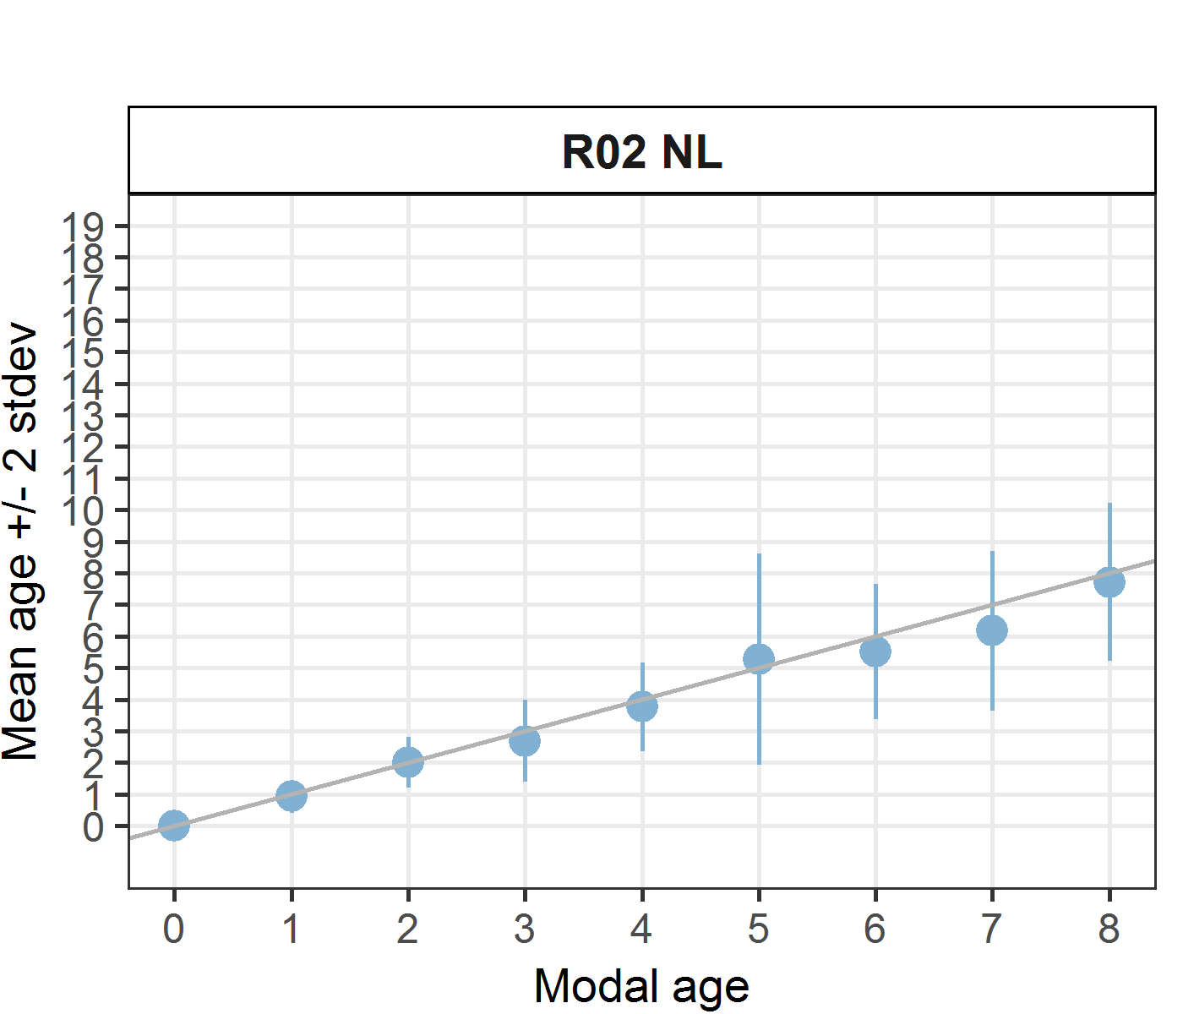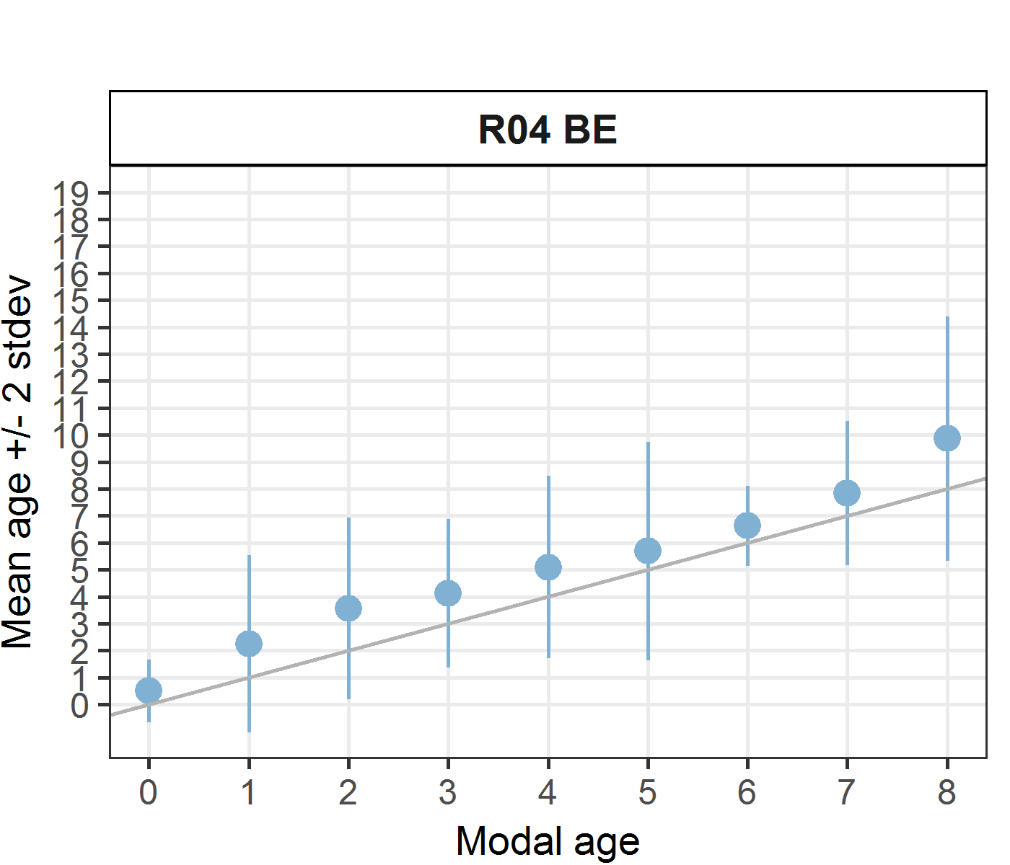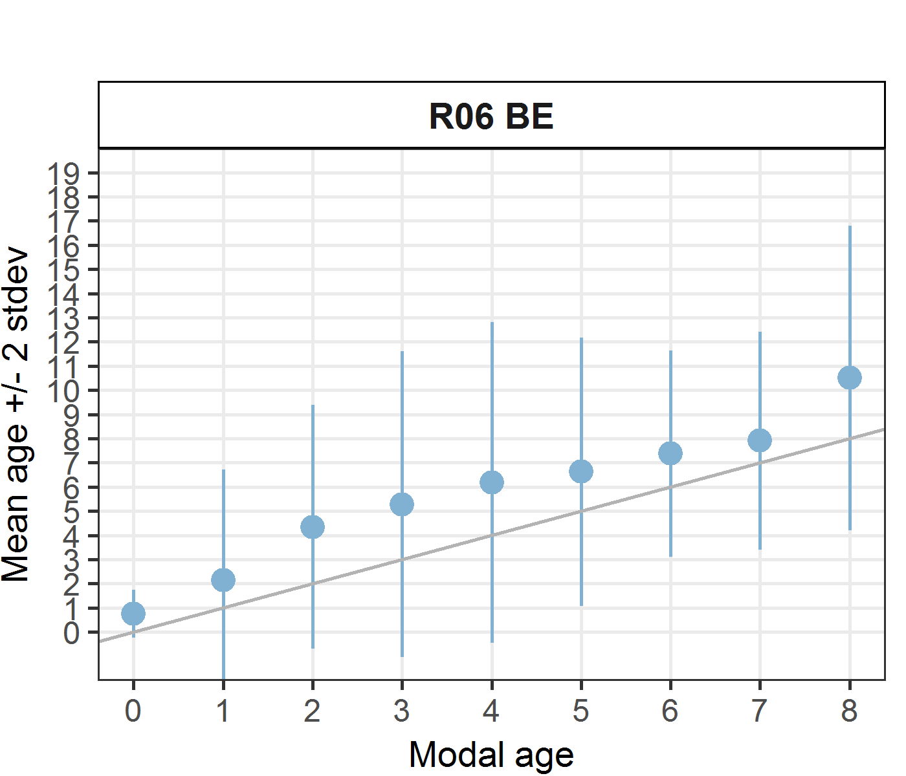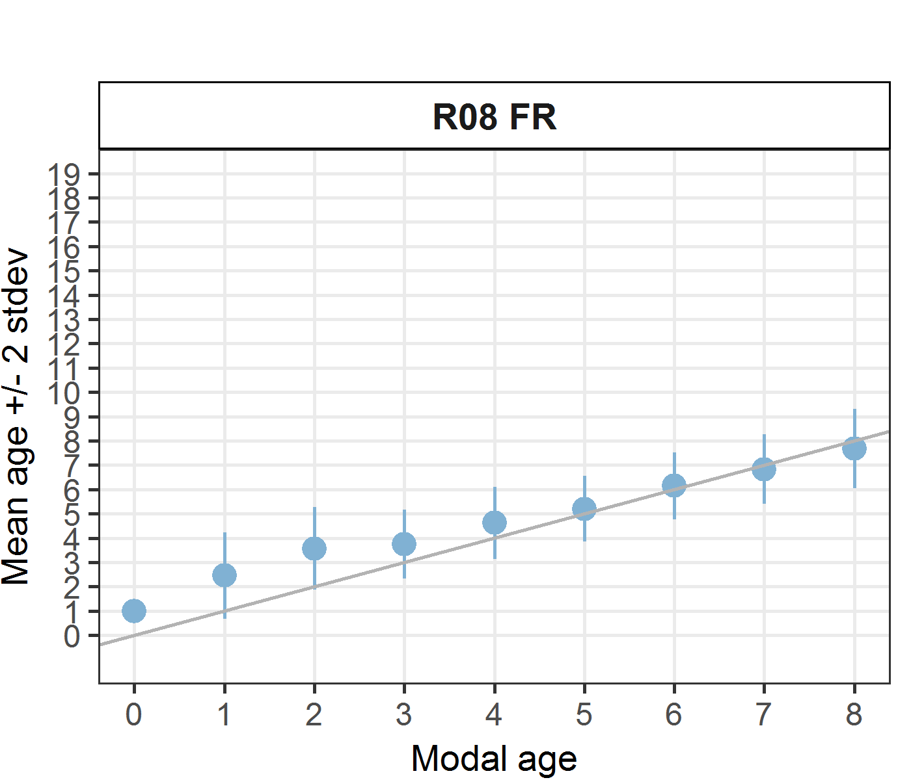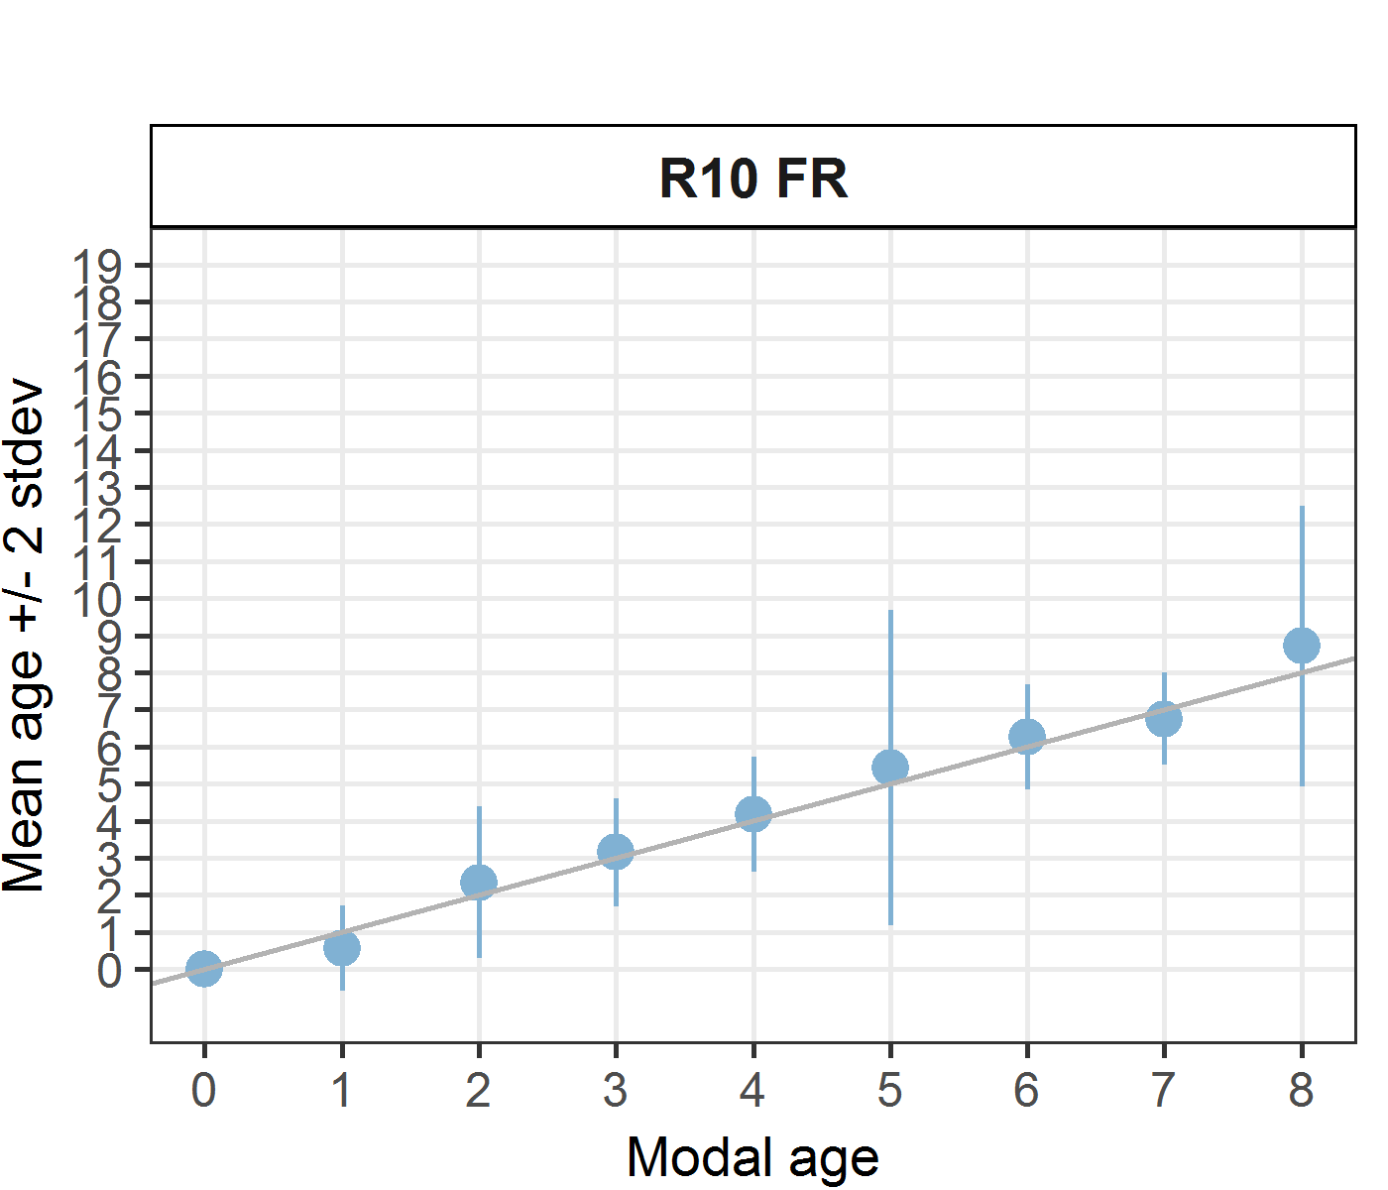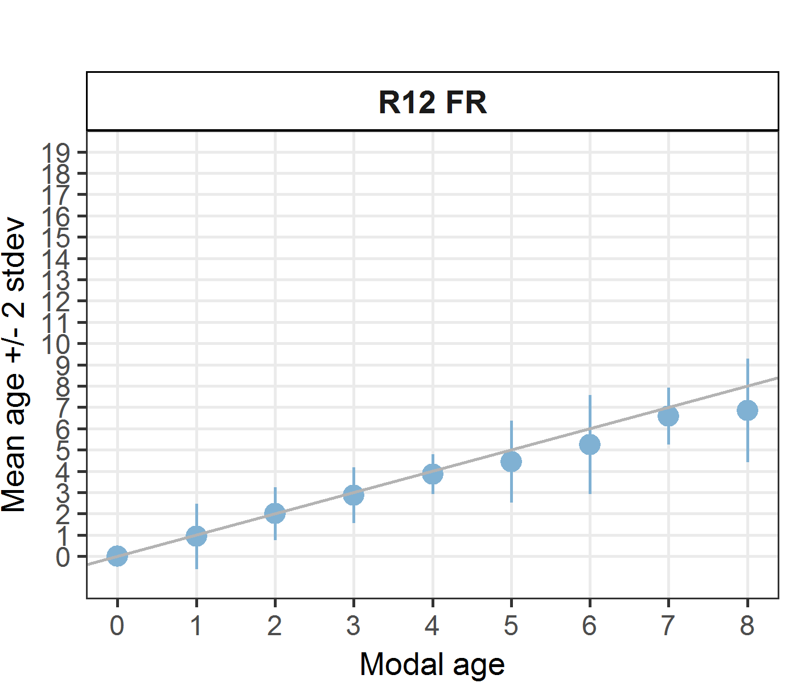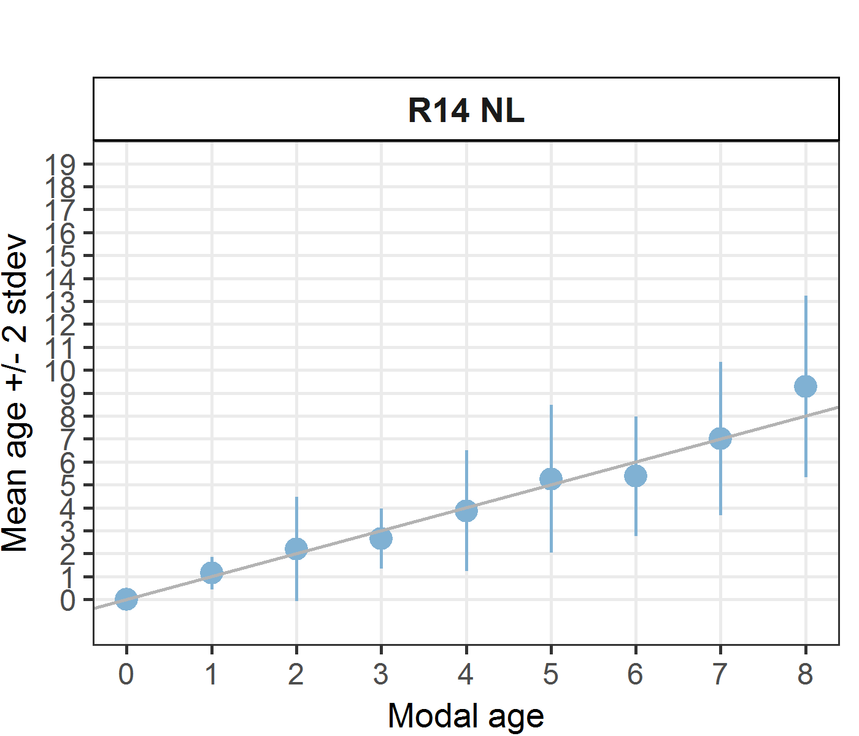
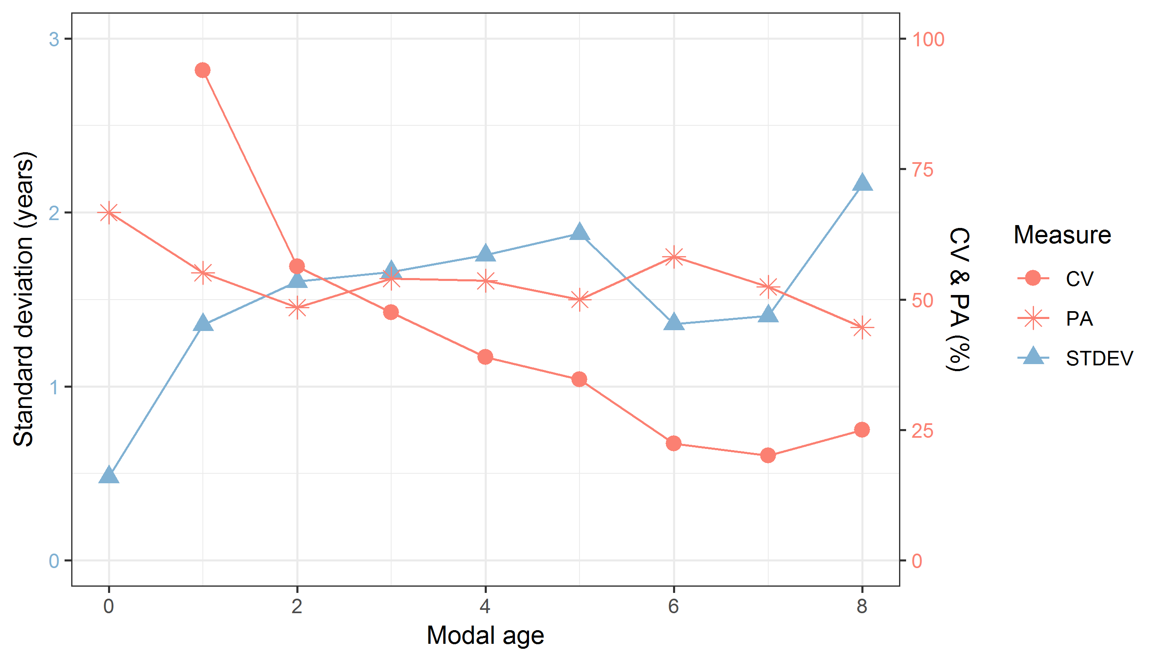
Figure 7.7: CV, PA and (STDEV (standard deviation) are plotted against modal age
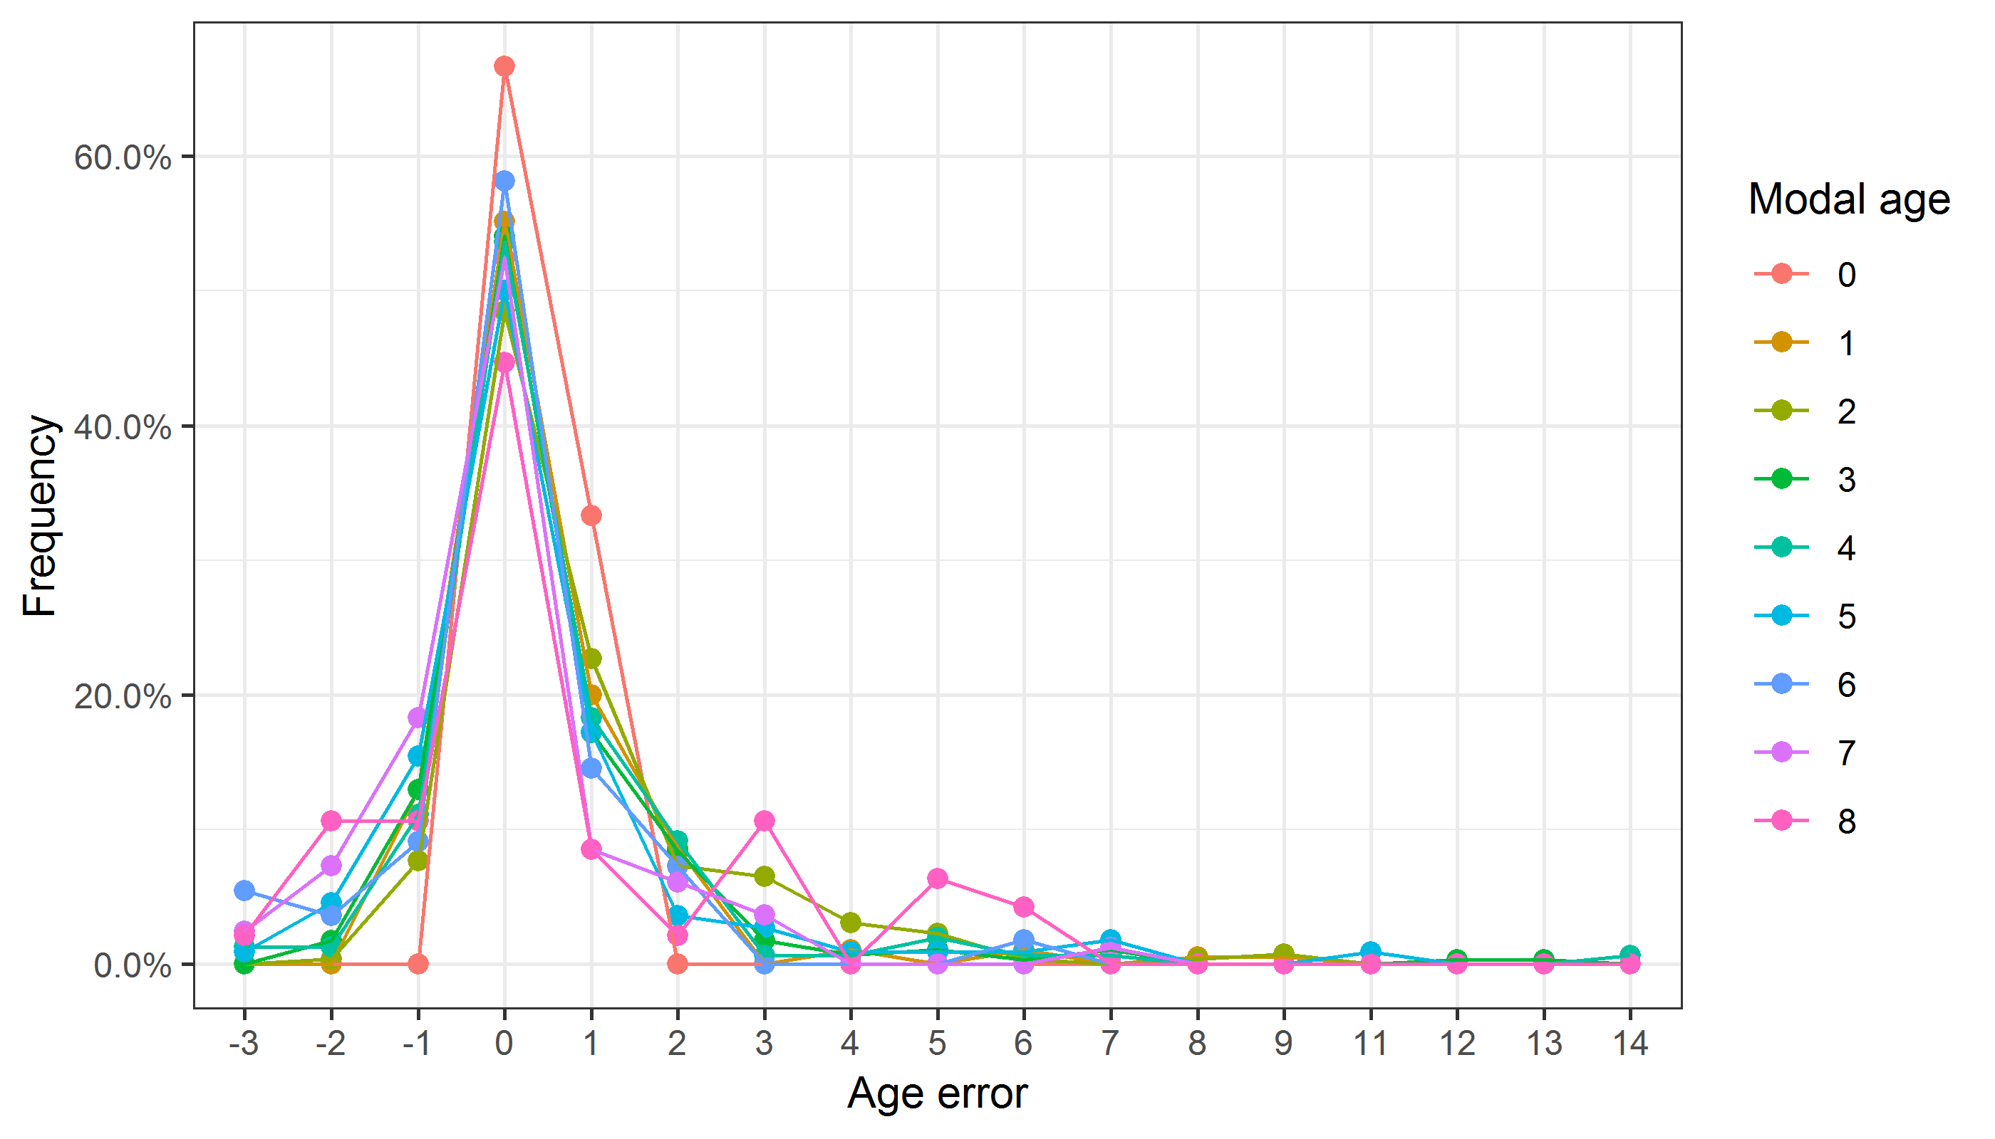
Figure 7.8: The distribution of the age reading errors in percentage by modal age as observed from the whole group of age readers in an age reading comparison to modal age. The achieved precision in age reading by MODAL age group is shown by the spread of the age readings errors. There appears to be no relative bias, if the age reading errors are normally distributed. The distributions are skewed, if relative bias occurs.
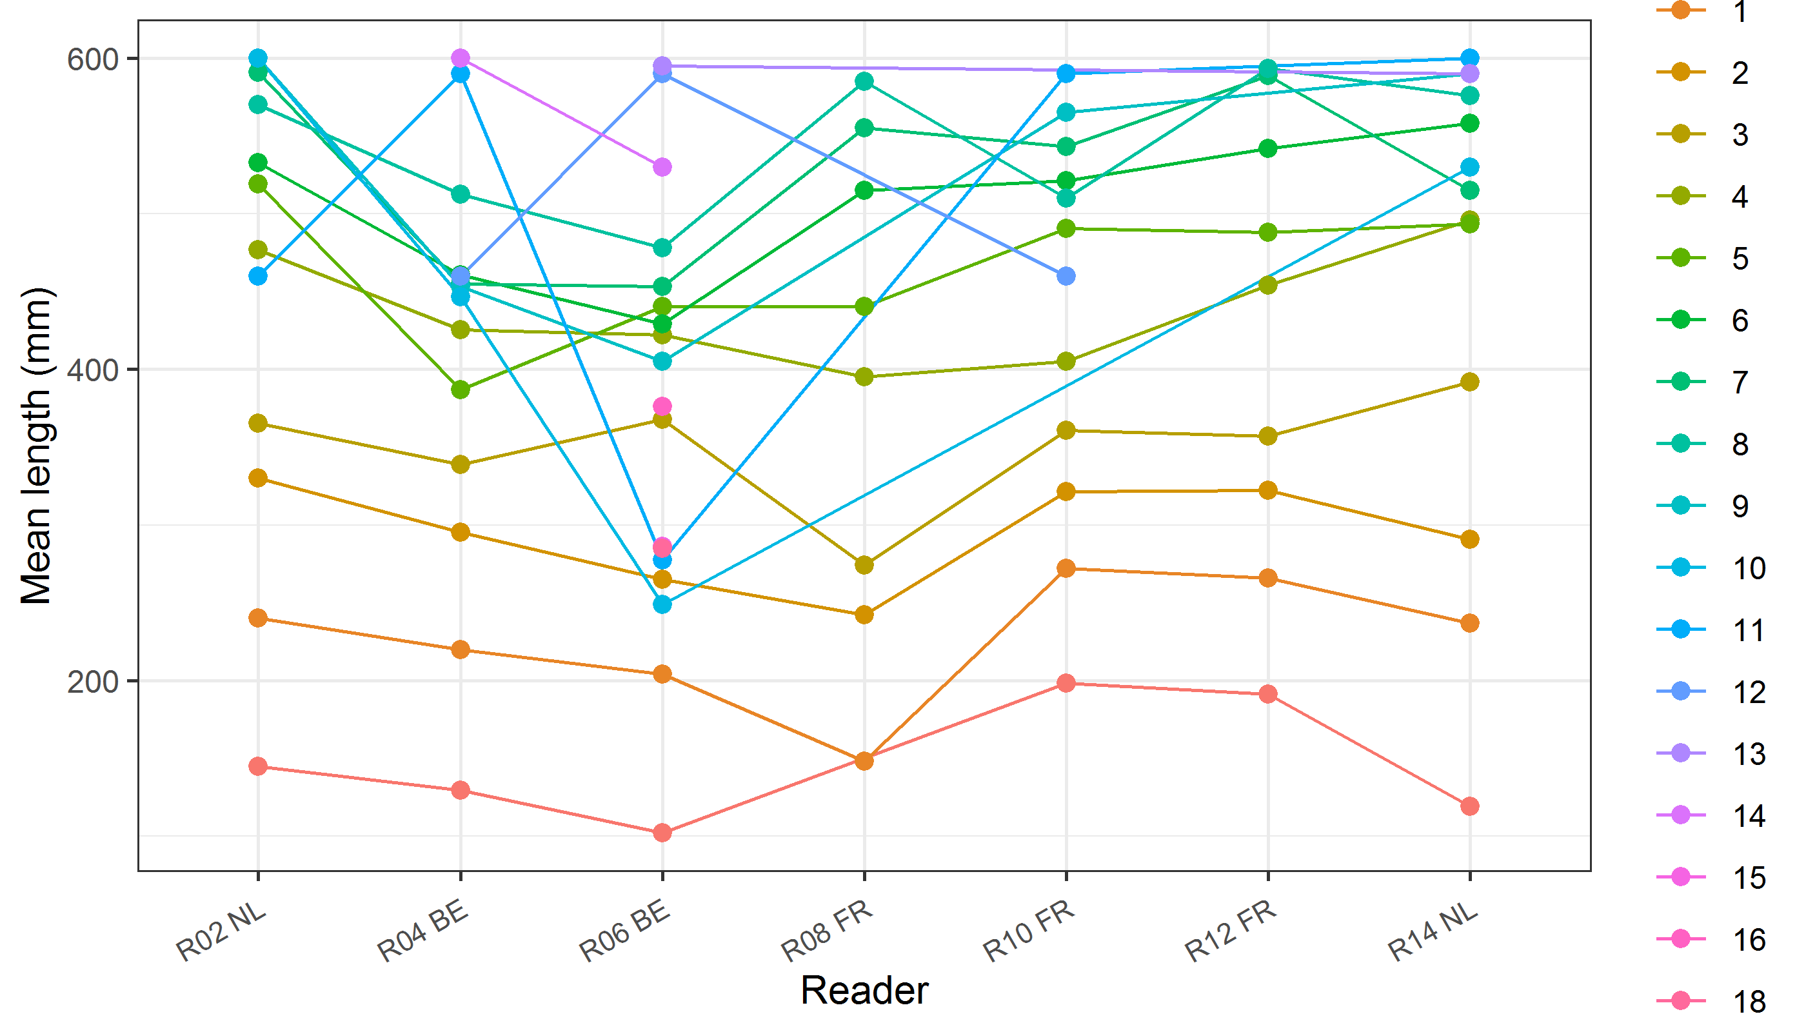
Figure 7.9: The mean length at age as estimated by each age reader.

Results Advanced readers (whole otoliths)
All samples included
Data Overview
Table 7.16: Data overview including modal age and statistics per sample.
Fish ID | Event ID | Image ID | length | sex | Catch date | ICES area | R02 NL | R04 BE | R06 BE | Modal age | PA % | CV % | APE %
001_BYDR05_TUR_4B_2017071410335 | 216 | 15954 | 250 | - | 14/07/2017 00:00:00 | 27.4.b | 3 | 4 | 4 | 4 | 67 | 16 | 12
002_BYDR05_TUR_4B_2017071410358 | 216 | 15955 | 260 | - | 14/07/2017 00:00:00 | 27.4.b | - | 5 | 5 | 5 | 100 | 0 | 0
003_BYDR05_TUR_4B_D_S_2017071410086 | 216 | 15956 | 270 | - | 14/07/2017 00:00:00 | 27.4.b | - | 2 | 2 | 2 | 100 | 0 | 0
004_BYDR05_TUR_4B_D_S_2017071410087 | 216 | 15957 | 305 | - | 14/07/2017 00:00:00 | 27.4.b | 2 | 3 | 3 | 3 | 67 | 22 | 17
005_BYDR05_TUR_4B_D_S_2017071410088 | 216 | 15958 | 445 | - | 14/07/2017 00:00:00 | 27.4.b | 3 | 3 | 3 | 3 | 100 | 0 | 0
006_BYDR05_TUR_4B_M_2017071410336 | 216 | 15959 | 435 | - | 14/07/2017 00:00:00 | 27.4.b | 3 | 3 | 4 | 3 | 67 | 17 | 13
007_BYDR05_TUR_4B_M_2017071410337 | 216 | 15960 | 575 | - | 14/07/2017 00:00:00 | 27.4.b | 3 | 4 | 4 | 4 | 67 | 16 | 12
008_BYDR05_TUR_4B_M_2017071410357 | 216 | 15961 | 565 | - | 14/07/2017 00:00:00 | 27.4.b | 7 | 7 | 5 | 7 | 67 | 18 | 14
009_BYDR05_TUR_4B_M_2017071410360 | 216 | 15962 | 520 | - | 14/07/2017 00:00:00 | 27.4.b | 5 | 7 | 5 | 5 | 67 | 20 | 16
010_BYDR05_TUR_4B_M_2017071410361 | 216 | 15963 | 590 | - | 14/07/2017 00:00:00 | 27.4.b | 7 | 8 | 7 | 7 | 67 | 8 | 6
011_BYDR05_TUR_4B_M_2017071410362 | 216 | 15964 | 610 | - | 14/07/2017 00:00:00 | 27.4.b | 6 | 8 | 6 | 6 | 67 | 17 | 13
012_BYDR07_TUR_4B_D_S_2017110910094 | 216 | 15965 | 190 | - | 09/11/2017 00:00:00 | 27.4.b | 0 | 1 | - | 0 | 50 | - | -
013_BYDR07_TUR_4B_D_S_2017110910095 | 216 | 15966 | 200 | - | 09/11/2017 00:00:00 | 27.4.b | 0 | 1 | 1 | 1 | 67 | 87 | 67
014_BYDR07_TUR_4B_D_S_2017110910105 | 216 | 15967 | 260 | - | 09/11/2017 00:00:00 | 27.4.b | 1 | 2 | 2 | 2 | 67 | 35 | 27
015_BYDR07_TUR_4B_D_S_2017110910112 | 216 | 15968 | 290 | - | 09/11/2017 00:00:00 | 27.4.b | 2 | 1 | 2 | 2 | 67 | 35 | 27
016_BYDR07_TUR_4B_D_S_2017110910115 | 216 | 15969 | 300 | - | 09/11/2017 00:00:00 | 27.4.b | 2 | 3 | 3 | 3 | 67 | 22 | 17
017_BYDR07_TUR_4B_D_S_2017110910118 | 216 | 15970 | 300 | - | 09/11/2017 00:00:00 | 27.4.b | 3 | 3 | 3 | 3 | 100 | 0 | 0
019_BYDR07_TUR_4B_M_2017110910340 | 216 | 15972 | 525 | - | 09/11/2017 00:00:00 | 27.4.b | 4 | 5 | 4 | 4 | 67 | 13 | 10
020_BYDR07_TUR_4B_M_2017110910341 | 216 | 15973 | 510 | - | 09/11/2017 00:00:00 | 27.4.b | - | 4 | 4 | 4 | 100 | 0 | 0
021_BYDR07_TUR_4B_M_2017110910343 | 216 | 15974 | 485 | - | 09/11/2017 00:00:00 | 27.4.b | 3 | 4 | 4 | 4 | 67 | 16 | 12
022_BYDR07_TUR_4B_M_2017110910350 | 216 | 15975 | 590 | - | 09/11/2017 00:00:00 | 27.4.b | 6 | 7 | 8 | 6 | 33 | 14 | 10
023_BYDR07_TUR_4B_M_2017110910351 | 216 | 15976 | 560 | - | 09/11/2017 00:00:00 | 27.4.b | 6 | 6 | 7 | 6 | 67 | 9 | 7
024_BYDR07_TUR_4B_M_2017110910352 | 216 | 15977 | 675 | - | 09/11/2017 00:00:00 | 27.4.b | 5 | 9 | 7 | 5 | 33 | 29 | 19
025_BYDR07_TUR_4B_M_2017110910353 | 216 | 15978 | 590 | - | 09/11/2017 00:00:00 | 27.4.b | 7 | 7 | 8 | 7 | 67 | 8 | 6
026_BYDR07_TUR_4B_M_2017110910354 | 216 | 15979 | 635 | - | 09/11/2017 00:00:00 | 27.4.b | 6 | 7 | 7 | 7 | 67 | 9 | 7
027_CDDR06_TUR_4B_M_2017073110492 | 216 | 15980 | 425 | - | 31/07/2017 00:00:00 | 27.4.b | 4 | 5 | 7 | 4 | 33 | 29 | 21
028_CDDR07_TUR_4B_D_S_2017102010073 | 216 | 15981 | 230 | - | 20/10/2017 00:00:00 | 27.4.b | 1 | 1 | 1 | 1 | 100 | 0 | 0
029_CDDR07_TUR_4B_D_S_2017102010074 | 216 | 15982 | 240 | - | 20/10/2017 00:00:00 | 27.4.b | 1 | 2 | 1 | 1 | 67 | 43 | 33
030_CDDR07_TUR_4B_D_S_2017102010098 | 216 | 15983 | 220 | - | 20/10/2017 00:00:00 | 27.4.b | 1 | 1 | 1 | 1 | 100 | 0 | 0
031_CDDR07_TUR_4B_M_2017102010266 | 216 | 15984 | 515 | - | 20/10/2017 00:00:00 | 27.4.b | 4 | 6 | 5 | 4 | 33 | 20 | 13
032_CDDR07_TUR_4B_M_2017102010270 | 216 | 15985 | 555 | - | 20/10/2017 00:00:00 | 27.4.b | 5 | 5 | 6 | 5 | 67 | 11 | 8
033_DTU2015_TUR_4B_039_161115 | 216 | 15986 | 380 | - | 16/11/2015 00:00:00 | 27.4.b | 1 | 1 | 3 | 1 | 67 | 69 | 53
034_DTU2015_TUR_4B_064_161115 | 216 | 15987 | 650 | - | 16/11/2015 00:00:00 | 27.4.b | 5 | 5 | 6 | 5 | 67 | 11 | 8
035_DTU2015_TUR_4B_090_020915 | 216 | 15988 | 560 | - | 02/09/2015 00:00:00 | 27.4.b | 4 | 4 | 5 | 4 | 67 | 13 | 10
036_DTU2016_TUR_4B_318_05092016 | 216 | 15989 | 590 | - | 05/09/2016 00:00:00 | 27.4.b | 6 | 8 | 8 | 8 | 67 | 16 | 12
037_DTU2016_TUR_4B_321_05092016 | 216 | 15990 | 540 | - | 05/09/2016 00:00:00 | 27.4.b | 6 | 7 | 8 | 6 | 33 | 14 | 10
038_DTU2017_TUR_4B_054_16032017 | 216 | 15991 | 520 | - | 16/03/2017 00:00:00 | 27.4.b | 5 | 6 | 4 | 4 | 33 | 20 | 13
039_DTU2017_TUR_4B_063_16032017 | 216 | 15992 | 500 | - | 21/05/2017 00:00:00 | 27.4.b | 5 | 5 | 7 | 5 | 67 | 20 | 16
040_DTU2017_TUR_4B_067_16032017 | 216 | 15993 | 490 | - | 16/03/2017 00:00:00 | 27.4.b | 4 | 9 | 7 | 4 | 33 | 38 | 27
041_DTU2017_TUR_4B_070_17032017 | 216 | 15994 | 390 | - | 17/03/2017 00:00:00 | 27.4.b | 2 | 4 | 3 | 2 | 33 | 33 | 22
042_DTU2017_TUR_4B_071_17032017 | 216 | 15995 | 430 | - | 17/03/2017 00:00:00 | 27.4.b | 3 | 5 | 4 | 3 | 33 | 25 | 17
043_DTU2017_TUR_4B_077_17032017 | 216 | 15996 | 460 | - | 17/03/2017 00:00:00 | 27.4.b | 2 | 5 | 4 | 2 | 33 | 42 | 30
044_DTU2017_TUR_4B_157_21052017 | 216 | 15997 | 580 | - | 21/05/2017 00:00:00 | 27.4.b | 5 | 6 | 6 | 6 | 67 | 10 | 8
045_DTU2017_TUR_4B_161_21052017 | 216 | 15998 | 500 | - | 21/05/2017 00:00:00 | 27.4.b | 5 | 6 | 6 | 6 | 67 | 10 | 8
046_DTU2017_TUR_4B_164_21052017 | 216 | 15999 | 470 | - | 21/05/2017 00:00:00 | 27.4.b | 3 | 3 | 4 | 3 | 67 | 17 | 13
047_DTU2017_TUR_4B_184_06062017 | 216 | 16000 | 570 | - | 06/06/2017 00:00:00 | 27.4.b | 4 | 5 | 6 | 4 | 33 | 20 | 13
048_DTU2017_TUR_4B_191_06062017 | 216 | 16001 | 590 | - | 06/06/2017 00:00:00 | 27.4.b | 6 | 8 | 8 | 8 | 67 | 16 | 12
049_DTU2017_TUR_4B_205_06062017 | 216 | 16002 | 430 | - | 06/06/2017 00:00:00 | 27.4.b | 2 | 2 | 3 | 2 | 67 | 25 | 19
050_DTU2017_TUR_4B_261_04092017 | 216 | 16003 | 600 | - | 04/09/2017 00:00:00 | 27.4.b | 9 | 10 | 9 | 9 | 67 | 6 | 5
051_DTU2017_TUR_4B_262_04092017 | 216 | 16004 | 590 | - | 04/09/2017 00:00:00 | 27.4.b | 8 | 11 | 14 | 8 | 33 | 27 | 18
052_DTU2017_TUR_4B_263_04092017 | 216 | 16005 | 580 | - | 04/09/2017 00:00:00 | 27.4.b | 7 | 8 | 8 | 8 | 67 | 8 | 6
053_DTU2017_TUR_4B_264_04092017 | 216 | 16006 | 590 | - | 04/09/2017 00:00:00 | 27.4.b | 8 | 11 | 13 | 8 | 33 | 24 | 17
054_DTU2017_TUR_4B_266_04092017 | 216 | 16007 | 600 | - | 04/09/2017 00:00:00 | 27.4.b | 10 | 14 | 13 | 10 | 33 | 17 | 13
055_DTU2017_TUR_4B_267_04092017 | 216 | 16008 | 460 | - | 04/09/2017 00:00:00 | 27.4.b | 5 | 6 | 9 | 5 | 33 | 31 | 23
056_DTU2017_TUR_4B_270_04092017 | 216 | 16009 | 460 | - | 04/09/2017 00:00:00 | 27.4.b | 4 | 4 | 8 | 4 | 67 | 43 | 33
057_DTU2017_TUR_4B_276_04092017 | 216 | 16010 | 440 | - | 04/09/2017 00:00:00 | 27.4.b | 5 | 5 | 6 | 5 | 67 | 11 | 8
058_DTU2017_TUR_4B_286_04092017 | 216 | 16011 | 420 | - | 04/09/2017 00:00:00 | 27.4.b | 5 | 5 | 6 | 5 | 67 | 11 | 8
059_DTU2017_TUR_4B_288_04092017 | 216 | 16012 | 530 | - | 04/09/2017 00:00:00 | 27.4.b | 6 | 6 | 7 | 6 | 67 | 9 | 7
060_DTU2017_TUR_4B_290_04092017 | 216 | 16013 | 530 | - | 04/09/2017 00:00:00 | 27.4.b | 5 | 5 | 6 | 5 | 67 | 11 | 8
061_DTU2017_TUR_4B_292_04092017 | 216 | 16014 | 510 | - | 04/09/2017 00:00:00 | 27.4.b | 6 | 7 | 7 | 7 | 67 | 9 | 7
062_DTU2017_TUR_4B_293_04092017 | 216 | 16015 | 530 | - | 04/09/2017 00:00:00 | 27.4.b | 8 | 9 | - | 8 | 50 | 8 | 6
063_DTU2017_TUR_4B_294_04092017 | 216 | 16016 | 600 | - | 04/09/2017 00:00:00 | 27.4.b | 4 | 6 | 5 | 4 | 33 | 20 | 13
064_DTU2017_TUR_4B_303_26102017 | 216 | 16017 | 590 | - | 26/10/2017 00:00:00 | 27.4.b | 6 | 6 | 12 | 6 | 67 | 43 | 33
065_DTU2017_TUR_4B_304_26102017 | 216 | 16018 | 630 | - | 26/10/2017 00:00:00 | 27.4.b | 7 | 8 | - | 7 | 50 | 9 | 7
066_DTU2017_TUR_4B_305_26102017 | 216 | 16019 | 550 | - | 26/10/2017 00:00:00 | 27.4.b | 3 | 4 | 5 | 3 | 33 | 25 | 17
067_DTU2017_TUR_4B_309_26102017 | 216 | 16020 | 520 | - | 26/10/2017 00:00:00 | 27.4.b | 3 | 6 | 5 | 3 | 33 | 33 | 24
068_DTU2017_TUR_4B_326_26102017 | 216 | 16021 | 450 | - | 26/10/2017 00:00:00 | 27.4.b | 4 | 6 | 9 | 4 | 33 | 40 | 28
069_DTU2017_TUR_4B_369_02112017 | 216 | 16022 | 570 | - | 02/11/2017 00:00:00 | 27.4.b | 5 | 5 | 6 | 5 | 67 | 11 | 8
070_DTU2015_TUR_4A_035_260215 | 216 | 16023 | 450 | - | 26/02/2015 00:00:00 | 27.4.a | - | - | 4 | 4 | 100 | - | 0
071_DTU2015_TUR_4A_037_260215 | 216 | 16024 | 440 | - | 26/02/2015 00:00:00 | 27.4.a | 3 | 5 | 6 | 3 | 33 | 33 | 24
072_DTU2015_TUR_4A_039_260215 | 216 | 16025 | 430 | - | 26/02/2015 00:00:00 | 27.4.a | 4 | 3 | 3 | 3 | 67 | 17 | 13
073_DTU2015_TUR_4A_042_150215 | 216 | 16026 | 400 | - | 26/02/2015 00:00:00 | 27.4.a | 6 | 7 | 8 | 6 | 33 | 14 | 10
074_DTU2017_TUR_4A_104_03042017 | 216 | 16027 | 520 | - | 03/04/2017 00:00:00 | 27.4.a | 4 | 3 | 4 | 4 | 67 | 16 | 12
076_DTU2017_TUR_4A_252_12072017 | 216 | 16029 | 510 | - | 12/07/2017 00:00:00 | 27.4.a | 4 | 4 | - | 4 | 100 | 0 | 0
077_DTU2017_TUR_4A_254_12072017 | 216 | 16030 | 460 | - | 12/07/2017 00:00:00 | 27.4.a | 2 | 5 | 5 | 5 | 67 | 43 | 33
078_DTU2017_TUR_4A_257_12072017 | 216 | 16031 | 420 | - | 12/07/2017 00:00:00 | 27.4.a | 2 | 3 | 7 | 2 | 33 | 66 | 50
079_DTU2017_TUR_4A_258_12072017 | 216 | 16032 | 430 | - | 12/07/2017 00:00:00 | 27.4.a | 2 | 2 | 3 | 2 | 67 | 25 | 19
080_DTU2017_TUR_4A_259_12072017 | 216 | 16033 | 470 | - | 12/07/2017 00:00:00 | 27.4.a | 4 | 3 | 4 | 4 | 67 | 16 | 12
081_DTU2017_TUR_4A_260_12072017 | 216 | 16034 | 390 | - | 12/07/2017 00:00:00 | 27.4.a | 2 | 2 | 3 | 2 | 67 | 25 | 19
082_NDGP11_JB_TUR_4A_NZ1_003 | 216 | 16035 | 260 | - | 18/02/2017 00:00:00 | 27.4.a | 2 | 3 | 2 | 2 | 67 | 25 | 19
083_NDGP11_JB_TUR_4A_NZ1_004 | 216 | 16036 | 450 | - | 18/02/2017 00:00:00 | 27.4.a | 2 | 2 | 3 | 2 | 67 | 25 | 19
084_NDGP11_JB_TUR_4A_NZ1_007 | 216 | 16037 | 420 | - | 18/02/2017 00:00:00 | 27.4.a | 2 | 2 | 3 | 2 | 67 | 25 | 19
085_NDGP11_JB_TUR_4A_NZ1_008 | 216 | 16038 | 290 | - | 18/02/2017 00:00:00 | 27.4.a | 2 | 3 | 2 | 2 | 67 | 25 | 19
086_NDGP11_JB_TUR_4A_NZ1_010 | 216 | 16039 | 450 | - | 18/02/2017 00:00:00 | 27.4.a | 3 | 3 | 3 | 3 | 100 | 0 | 0
087_NDGP11_JB_TUR_4A_NZ1_015 | 216 | 16040 | 430 | - | 18/02/2017 00:00:00 | 27.4.a | 3 | 4 | 3 | 3 | 67 | 17 | 13
088_BTS01_TUR_4C_C_2017082810012 | 216 | 16041 | 446 | - | 28/08/2017 00:00:00 | 27.4.c | 2 | 4 | 3 | 2 | 33 | 33 | 22
089_BTS01_TUR_4C_C_2017082810011 | 216 | 16042 | 443 | - | 28/08/2017 00:00:00 | 27.4.c | 3 | 5 | 3 | 3 | 67 | 31 | 24
091_BTS01_TUR_4C_C_2017082810010 | 216 | 16043 | 334 | - | 28/08/2017 00:00:00 | 27.4.c | 2 | 3 | 2 | 2 | 67 | 25 | 19
092_BTS01_TUR_4C_C_2017082810009 | 216 | 16044 | 425 | - | 28/08/2017 00:00:00 | 27.4.c | 4 | 4 | 4 | 4 | 100 | 0 | 0
092_NDGP15_BTS01_TUR_4C_55083 | 216 | 16045 | 245 | - | 13/09/2015 00:00:00 | 27.4.c | 1 | 1 | 2 | 1 | 67 | 43 | 33
093_NDGP15_BTS01_TUR_4C_55084 | 216 | 16046 | 250 | - | 13/09/2015 00:00:00 | 27.4.c | 2 | 2 | 2 | 2 | 100 | 0 | 0
094_NDGP15_BTS01_TUR_4C_55085 | 216 | 16047 | 290 | - | 13/09/2015 00:00:00 | 27.4.c | 1 | 2 | 2 | 2 | 67 | 35 | 27
095_NDGP15_BTS01_TUR_4C_55086 | 216 | 16048 | 240 | - | 13/09/2015 00:00:00 | 27.4.c | 1 | 2 | 2 | 2 | 67 | 35 | 27
096_NDGP15_BTS01_TUR_4C_55088 | 216 | 16049 | 485 | - | 13/09/2015 00:00:00 | 27.4.c | 3 | 6 | 5 | 3 | 33 | 33 | 24
097_NDGP15_BTS01_TUR_4C_55090 | 216 | 16050 | 575 | - | 13/09/2015 00:00:00 | 27.4.c | 4 | 4 | 5 | 4 | 67 | 13 | 10
098_NDGP15_BTS01_TUR_4C_55097 | 216 | 16051 | 225 | - | 13/09/2015 00:00:00 | 27.4.c | 1 | 1 | 1 | 1 | 100 | 0 | 0
099_NDGP15_BTS01_TUR_4C_55098 | 216 | 16052 | 215 | - | 13/09/2015 00:00:00 | 27.4.c | 1 | 1 | 1 | 1 | 100 | 0 | 0
100_NDGP15_BTS01_TUR_4C_55099 | 216 | 16053 | 245 | - | 13/09/2015 00:00:00 | 27.4.c | 1 | 3 | 1 | 1 | 67 | 69 | 53
101_NDGP16_BTS01_TUR_4C_220936 | 216 | 16054 | 360 | - | 04/10/2016 00:00:00 | 27.4.c | 2 | 3 | 3 | 3 | 67 | 22 | 17
102_NDGP16_BTS01_TUR_4C_220944 | 216 | 16055 | 415 | - | 04/10/2016 00:00:00 | 27.4.c | 2 | 3 | 3 | 3 | 67 | 22 | 17
103_PTCT03_TUR_4C_2017040310395 | 216 | 16056 | 340 | - | 03/04/2017 00:00:00 | 27.4.c | 3 | 3 | 3 | 3 | 100 | 0 | 0
104_PTCT03_TUR_4C_2017040310396 | 216 | 16057 | 325 | - | 03/04/2017 00:00:00 | 27.4.c | 4 | 5 | 6 | 4 | 33 | 20 | 13
105_PTCT03_TUR_4C_2017040310397 | 216 | 16058 | 395 | - | 03/04/2017 00:00:00 | 27.4.c | 2 | 3 | 3 | 3 | 67 | 22 | 17
106_PTCT03_TUR_4C_2017040310398 | 216 | 16059 | 400 | - | 03/04/2017 00:00:00 | 27.4.c | 5 | 5 | 6 | 5 | 67 | 11 | 8
107_TUR_EX-NL_4C_4100008_001_130918 | 216 | 16060 | 252 | - | 13/09/2018 00:00:00 | 27.4.c | 3 | 3 | 3 | 3 | 100 | 0 | 0
108_TUR_EX-NL_4C_4100010_002_130918 | 216 | 16061 | 118 | - | 13/09/2018 00:00:00 | 27.4.c | 0 | 1 | 1 | 1 | 67 | 87 | 67
109_TUR_EX-NL_4C_4100011_003_130918 | 216 | 16062 | 137 | - | 13/09/2018 00:00:00 | 27.4.c | 0 | 0 | 1 | 0 | 67 | - | -
110_TUR_EX-NL_4C_4100011_004_130918 | 216 | 16063 | 122 | - | 13/09/2018 00:00:00 | 27.4.c | 0 | 0 | 1 | 0 | 67 | - | -
111_TUR_EX-NL_4C_4100011_005_130918 | 216 | 16064 | 102 | - | 13/09/2018 00:00:00 | 27.4.c | 0 | 1 | 0 | 0 | 67 | - | -
112_TUR_EX-NL_4C_4100014_006_140918 | 216 | 16065 | 198 | - | 14/09/2018 00:00:00 | 27.4.c | 1 | 2 | 1 | 1 | 67 | 43 | 33
113_TUR_EX-NL_4C_4100015_010_140918 | 216 | 16066 | 237 | - | 14/09/2018 00:00:00 | 27.4.c | 1 | 3 | 2 | 1 | 33 | 50 | 33
114_TUR_EX-NL_4C_4100017_012_140918 | 216 | 16067 | 225 | - | 14/09/2018 00:00:00 | 27.4.c | 1 | 2 | 2 | 2 | 67 | 35 | 27
115_TUR_EX-NL_4C_4100023_013_170918 | 216 | 16068 | 204 | - | 17/09/2018 00:00:00 | 27.4.c | 1 | 2 | 2 | 2 | 67 | 35 | 27
116_TUR_EX-NL_4C_4100024_014_170918 | 216 | 16069 | 213 | - | 17/09/2018 00:00:00 | 27.4.c | 1 | 2 | 2 | 2 | 67 | 35 | 27
117_CEFAS_016_TUR_7D_093_300714 | 216 | 16070 | 340 | - | 30/07/2014 00:00:00 | 27.7.d | 2 | 2 | 3 | 2 | 67 | 25 | 19
118_CEFAS_017_TUR_7D_099_300714 | 216 | 16071 | 240 | - | 30/07/2014 00:00:00 | 27.7.d | 1 | 3 | 3 | 3 | 67 | 49 | 38
119_DTU2016_TUR_BA_7D_266_02112016 | 216 | 16072 | 350 | - | 02/11/2016 00:00:00 | 27.7.d | 6 | 7 | 8 | 6 | 33 | 14 | 10
120_DTU2016_TUR_BA_7D_267_02112016 | 216 | 16073 | 470 | - | 02/11/2016 00:00:00 | 27.7.d | 5 | 10 | 14 | 5 | 33 | 47 | 32
121_DTU2016_TUR_BA_7D_268_02112016 | 216 | 16074 | 310 | - | 02/11/2016 00:00:00 | 27.7.d | 3 | 4 | 7 | 3 | 33 | 45 | 33
122_DTU2016_TUR_BA_7D_272_03112016 | 216 | 16075 | 320 | - | 03/11/2016 00:00:00 | 27.7.d | 4 | 5 | 5 | 5 | 67 | 12 | 10
123_DTU2016_TUR_BA_7D_274_03112016 | 216 | 16076 | 240 | - | 03/11/2016 00:00:00 | 27.7.d | 1 | 3 | 3 | 3 | 67 | 49 | 38
124_DTU2016_TUR_BA_7D_276_04112016 | 216 | 16077 | 310 | - | 04/11/2016 00:00:00 | 27.7.d | 2 | - | 6 | 2 | 50 | 71 | 50
125_DTU2016_TUR_BA_7D_277_04112016 | 216 | 16078 | 290 | - | 04/11/2016 00:00:00 | 27.7.d | 2 | 5 | 5 | 5 | 67 | 43 | 33
126_DTU2016_TUR_BA_7D_298_10112016 | 216 | 16079 | 430 | - | 10/11/2016 00:00:00 | 27.7.d | 6 | 7 | 7 | 7 | 67 | 9 | 7
127_DTU2016_TUR_BA_7D_299_10112016 | 216 | 16080 | 350 | - | 10/11/2016 00:00:00 | 27.7.d | 4 | 4 | 4 | 4 | 100 | 0 | 0
128_DTU2016_TUR_BA_7D_300_10112016 | 216 | 16081 | 270 | - | 10/11/2016 00:00:00 | 27.7.d | 2 | 3 | 3 | 3 | 67 | 22 | 17
129_DTU2016_TUR_BA_7D_302_11112016 | 216 | 16082 | 290 | - | 11/11/2016 00:00:00 | 27.7.d | 2 | 5 | 5 | 5 | 67 | 43 | 33
130_DTU2016_TUR_BA_7D_303_12112016 | 216 | 16083 | 330 | - | 12/11/2016 00:00:00 | 27.7.d | 1 | 2 | 2 | 2 | 67 | 35 | 27
131_DTU2016_TUR_BA_7D_310_12112016 | 216 | 16084 | 240 | - | 12/11/2016 00:00:00 | 27.7.d | 1 | 7 | - | 1 | 50 | 106 | 75
132_DTU2016_TUR_BA_7D_314_17112016 | 216 | 16085 | 460 | - | 17/11/2016 00:00:00 | 27.7.d | 11 | 12 | 16 | 11 | 33 | 20 | 15
133_DTU2015_TUR_BA_7D_037_181115 | 216 | 16086 | 330 | - | 18/11/2015 00:00:00 | 27.7.d | 2 | 4 | - | 2 | 50 | 47 | 33
134_DTU2015_TUR_BA_7D_001_120315 | 216 | 16087 | 255 | - | 12/03/2015 00:00:00 | 27.7.d | 2 | 6 | 7 | 2 | 33 | 53 | 40
135_DTU2015_TUR_BA_7D_002_120315 | 216 | 16088 | 351 | - | 12/03/2015 00:00:00 | 27.7.d | 3 | 3 | 4 | 3 | 67 | 17 | 13
136_DTU2015_TUR_BA_7D_003_041115 | 216 | 16089 | 180 | - | 04/11/2015 00:00:00 | 27.7.d | 1 | 2 | 1 | 1 | 67 | 43 | 33
137_DTU2015_TUR_BA_7D_004_120315 | 216 | 16090 | 297 | - | 12/03/2015 00:00:00 | 27.7.d | 3 | 5 | 8 | 3 | 33 | 47 | 33
138_DTU2015_TUR_BA_7D_005_120315 | 216 | 16091 | 292 | - | 12/03/2015 00:00:00 | 27.7.d | 3 | 5 | 3 | 3 | 67 | 31 | 24
139_DTU2015_TUR_BA_7D_006_120315 | 216 | 16092 | 288 | - | 12/03/2015 00:00:00 | 27.7.d | 3 | 5 | 6 | 3 | 33 | 33 | 24
140_DTU2015_TUR_BA_7D_007_120315 | 216 | 16093 | 307 | - | 12/03/2015 00:00:00 | 27.7.d | 2 | 3 | 3 | 3 | 67 | 22 | 17
141_DTU2015_TUR_BA_7D_008_120315 | 216 | 16094 | 260 | - | 12/03/2015 00:00:00 | 27.7.d | 1 | 5 | 10 | 1 | 33 | 85 | 58
142_DTU2015_TUR_BA_7D_009_120315 | 216 | 16095 | 272 | - | 12/03/2015 00:00:00 | 27.7.d | 2 | - | 6 | 2 | 50 | 71 | 50
143_DTU2015_TUR_BA_7D_010_120315 | 216 | 16096 | 271 | - | 12/03/2015 00:00:00 | 27.7.d | 3 | 5 | 8 | 3 | 33 | 47 | 33
144_DTU2015_TUR_BA_7D_011_120315 | 216 | 16097 | 296 | - | 12/03/2015 00:00:00 | 27.7.d | 3 | 4 | 9 | 3 | 33 | 60 | 46
145_DTU2015_TUR_BA_7D_012_091115 | 216 | 16098 | 260 | - | 09/11/2015 00:00:00 | 27.7.d | 3 | 3 | 4 | 3 | 67 | 17 | 13
146_DTU2015_TUR_BA_7D_012_120315 | 216 | 16099 | 295 | - | 12/03/2015 00:00:00 | 27.7.d | 3 | 3 | 6 | 3 | 67 | 43 | 33
147_DTU2015_TUR_BA_7D_013_091115 | 216 | 16100 | 220 | - | 09/11/2015 00:00:00 | 27.7.d | 1 | 5 | 9 | 1 | 33 | 80 | 53
148_DTU2015_TUR_BA_7D_013_120315 | 216 | 16101 | 278 | - | 12/03/2015 00:00:00 | 27.7.d | 3 | 3 | 5 | 3 | 67 | 31 | 24
149_DTU2015_TUR_BA_7D_014_120315 | 216 | 16102 | 246 | - | 12/03/2015 00:00:00 | 27.7.d | 3 | 3 | 4 | 3 | 67 | 17 | 13
150_DTU2015_TUR_BA_7D_003_120315 | 216 | 16103 | 336 | - | 12/03/2015 00:00:00 | 27.7.d | 3 | 3 | 4 | 3 | 67 | 17 | 13
151_DTU2015_TUR_BA_7D_015_120315 | 216 | 16104 | 258 | - | 12/03/2015 00:00:00 | 27.7.d | 2 | 4 | 5 | 2 | 33 | 42 | 30
152_DTU2015_TUR_BA_7D_016_120315 | 216 | 16105 | 260 | - | 12/03/2015 00:00:00 | 27.7.d | 2 | 8 | 11 | 2 | 33 | 65 | 48
153_DTU2015_TUR_BA_7D_017_120315 | 216 | 16106 | 254 | - | 12/03/2015 00:00:00 | 27.7.d | 2 | 6 | 10 | 2 | 33 | 67 | 44
154_DTU2015_TUR_BA_7D_018_091115 | 216 | 16107 | 250 | - | 09/11/2015 00:00:00 | 27.7.d | 2 | 5 | 6 | 2 | 33 | 48 | 36
155_DTU2015_TUR_BA_7D_018_120315 | 216 | 16108 | 251 | - | 12/03/2015 00:00:00 | 27.7.d | 2 | 8 | 10 | 2 | 33 | 62 | 47
156_DTU2015_TUR_BA_7D_019_120315 | 216 | 16109 | 255 | - | 12/03/2015 00:00:00 | 27.7.d | 2 | 4 | 4 | 4 | 67 | 35 | 27
157_DTU2015_TUR_BA_7D_020_120315 | 216 | 16110 | 292 | - | 12/03/2015 00:00:00 | 27.7.d | 2 | 6 | 16 | 2 | 33 | 90 | 67
158_DTU2015_TUR_BA_7D_021_091115 | 216 | 16111 | 260 | - | 09/11/2015 00:00:00 | 27.7.d | 2 | 5 | 6 | 2 | 33 | 48 | 36
159_DTU2015_TUR_BA_7D_021_120315 | 216 | 16112 | 317 | - | 12/03/2015 00:00:00 | 27.7.d | 3 | 3 | 6 | 3 | 67 | 43 | 33
160_DTU2015_TUR_BA_7D_022_091115 | 216 | 16113 | 260 | - | 09/11/2015 00:00:00 | 27.7.d | 2 | 6 | 7 | 2 | 33 | 53 | 40
161_DTU2015_TUR_BA_7D_022_120315 | 216 | 16114 | 302 | - | 12/03/2015 00:00:00 | 27.7.d | 3 | 7 | 11 | 3 | 33 | 57 | 38
162_DTU2015_TUR_BA_7D_023_120315 | 216 | 16115 | 285 | - | 12/03/2015 00:00:00 | 27.7.d | 3 | 9 | 18 | 3 | 33 | 75 | 53
163_DTU2015_TUR_BA_7D_024_120315 | 216 | 16116 | 270 | - | 12/03/2015 00:00:00 | 27.7.d | 2 | 10 | 11 | 2 | 33 | 64 | 49
164_DTU2015_TUR_BA_7D_025_091115 | 216 | 16117 | 240 | - | 09/11/2015 00:00:00 | 27.7.d | 1 | 7 | 10 | 1 | 33 | 76 | 56
165_DTU2015_TUR_BA_7D_027_091115 | 216 | 16118 | 240 | - | 09/11/2015 00:00:00 | 27.7.d | 1 | 5 | 10 | 1 | 33 | 85 | 58
166_DTU2015_TUR_BA_7D_025_120315 | 216 | 16119 | 286 | - | 12/03/2015 00:00:00 | 27.7.d | 3 | 9 | 15 | 3 | 33 | 67 | 44
167_DTU2015_TUR_BA_7D_030_121115 | 216 | 16120 | 370 | - | 12/11/2015 00:00:00 | 27.7.d | 3 | 5 | 7 | 3 | 33 | 40 | 27
168_DTU2015_TUR_BA_7D_035_171115 | 216 | 16121 | 290 | - | 17/11/2015 00:00:00 | 27.7.d | 2 | 5 | 7 | 2 | 33 | 54 | 38
169_BTS01_TUR_4C_C_2017082810008 | 216 | 16122 | 436 | - | 28/08/2017 00:00:00 | 27.4.c | 2 | 3 | 3 | 3 | 67 | 22 | 17
170_BTS01_TUR_4C_C_2017082810007 | 216 | 16123 | 304 | - | 28/08/2017 00:00:00 | 27.4.c | 2 | 3 | 3 | 3 | 67 | 22 | 17
171_BTS01_TUR_4C_C_2017082810006 | 216 | 16124 | 541 | - | 28/08/2017 00:00:00 | 27.4.c | 4 | 4 | 4 | 4 | 100 | 0 | 0
172_BTS01_TUR_4C_C_2017082810005 | 216 | 16125 | 407 | - | 28/08/2017 00:00:00 | 27.4.c | 3 | 3 | 3 | 3 | 100 | 0 | 0
173_BTS01_TUR_4C_C_2017082810004 | 216 | 16126 | 424 | - | 28/08/2017 00:00:00 | 27.4.c | 2 | 5 | 4 | 2 | 33 | 42 | 30
174_BTS01_TUR_4C_C_2017082810003 | 216 | 16127 | 205 | - | 28/08/2017 00:00:00 | 27.4.c | 1 | 1 | 1 | 1 | 100 | 0 | 0
175_BTS01_TUR_4C_C_2017082810015 | 216 | 16128 | 202 | - | 28/08/2017 00:00:00 | 27.4.c | 1 | 1 | 1 | 1 | 100 | 0 | 0
176_BTS01_TUR_4C_C_2017082810014 | 216 | 16129 | 239 | - | 28/08/2017 00:00:00 | 27.4.c | 1 | 3 | 1 | 1 | 67 | 69 | 53
177_BTS01_TUR_4C_C_2017082810013 | 216 | 16130 | 253 | - | 28/08/2017 00:00:00 | 27.4.c | 1 | 1 | 1 | 1 | 100 | 0 | 0
178_BTS01_TUR_4C_C_2017082810002 | 216 | 16131 | 302 | - | 28/08/2017 00:00:00 | 27.4.c | 2 | 2 | 2 | 2 | 100 | 0 | 0
179_BTS01_TUR_4C_C_2017082810001 | 216 | 16132 | 243 | - | 28/08/2017 00:00:00 | 27.4.c | 1 | 2 | 1 | 1 | 67 | 43 | 33
Table 7.17: Number of age readings table gives an overview of number of readings per reader and modal age. The total numbers of readings per reader and per modal age are summarized at the end of the table.
Modal age | R02 NL | R04 BE | R06 BE | total
0 | 4 | 4 | 3 | 11
1 | 23 | 23 | 22 | 68
2 | 38 | 37 | 38 | 113
3 | 44 | 44 | 44 | 132
4 | 22 | 23 | 23 | 68
5 | 16 | 17 | 17 | 50
6 | 10 | 10 | 10 | 30
7 | 7 | 7 | 6 | 20
8 | 6 | 6 | 5 | 17
9 | 1 | 1 | 1 | 3
10 | 1 | 1 | 1 | 3
11 | 1 | 1 | 1 | 3
Total | 173 | 174 | 171 | 518
Table 7.18: Age composition by reader gives a summary of number of readings per reader.
Modal age | R02 NL | R04 BE | R06 BE
0 | 6 | 2 | 1
1 | 30 | 14 | 17
2 | 44 | 20 | 16
3 | 35 | 36 | 30
4 | 19 | 20 | 22
5 | 15 | 33 | 16
6 | 13 | 16 | 20
7 | 5 | 13 | 16
8 | 3 | 8 | 11
9 | 1 | 5 | 5
10 | 1 | 3 | 5
11 | 1 | 2 | 3
12 | 0 | 1 | 1
13 | 0 | 0 | 2
14 | 0 | 1 | 2
15 | 0 | 0 | 1
16 | 0 | 0 | 2
18 | 0 | 0 | 1
Total | 173 | 174 | 171
Table 7.19: Mean length at age per reader is calculated per reader and age (not modal age) and for all readers combined per age. A weighted mean is also given.
Age | R02 NL | R04 BE | R06 BE
0 | 145 mm | 130 mm | 102 mm
1 | 240 mm | 220 mm | 204 mm
2 | 330 mm | 295 mm | 265 mm
3 | 365 mm | 339 mm | 368 mm
4 | 477 mm | 425 mm | 422 mm
5 | 519 mm | 387 mm | 440 mm
6 | 533 mm | 461 mm | 429 mm
7 | 591 mm | 455 mm | 453 mm
8 | 570 mm | 513 mm | 478 mm
9 | 600 mm | 453 mm | 405 mm
10 | 600 mm | 447 mm | 249 mm
11 | 460 mm | 590 mm | 277 mm
12 | - | 460 mm | 590 mm
13 | - | - | 595 mm
14 | - | 600 mm | 530 mm
15 | - | - | 286 mm
16 | - | - | 376 mm
18 | - | - | 285 mm
Weighted Mean | 379 mm | 379 mm | 377 mm
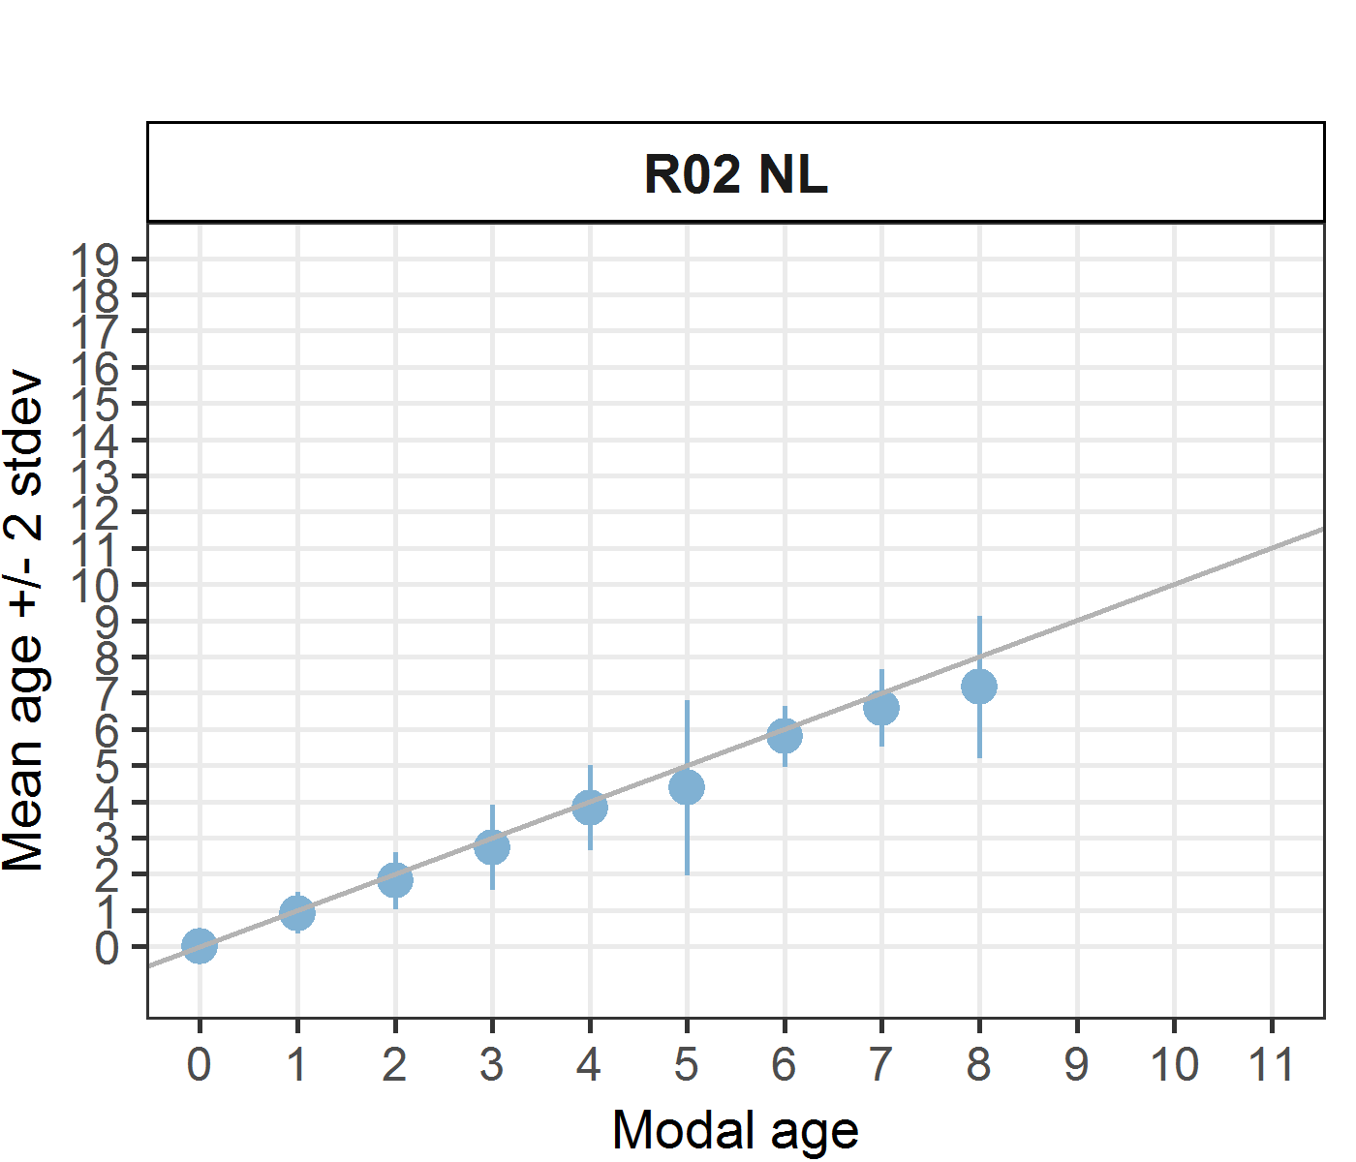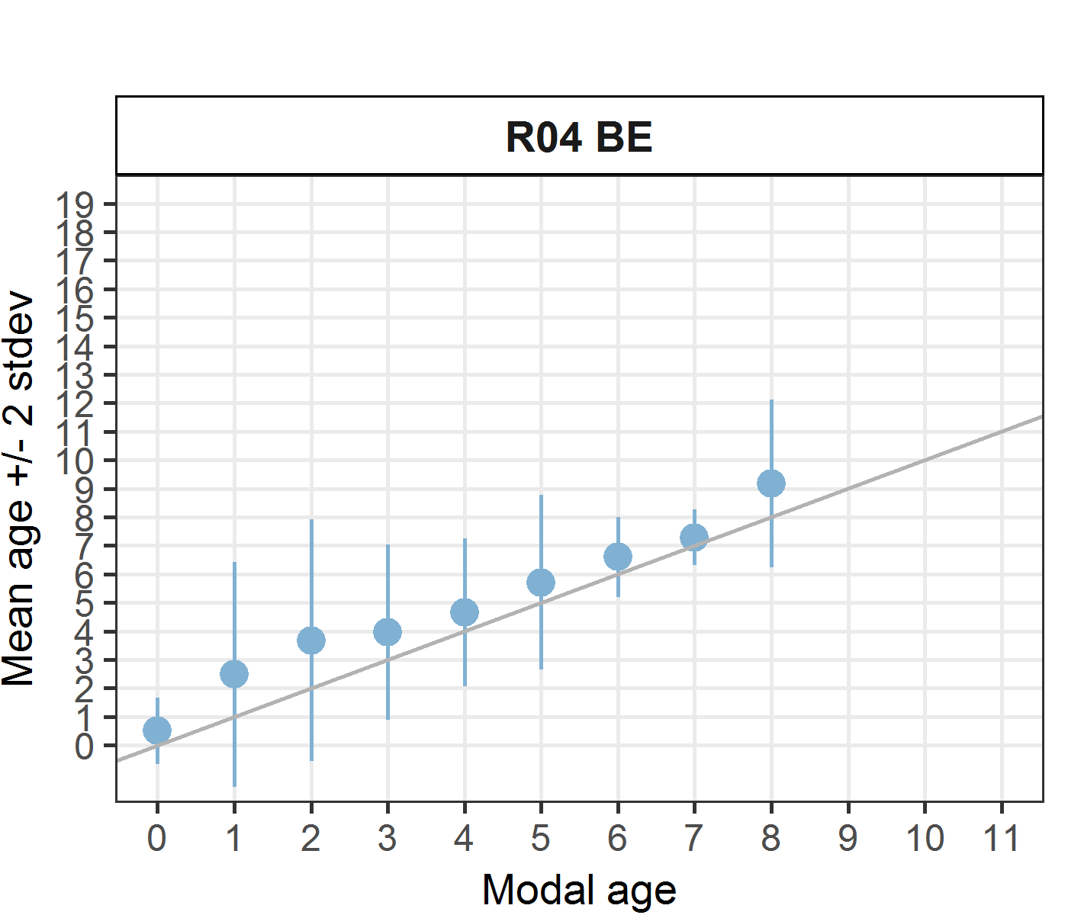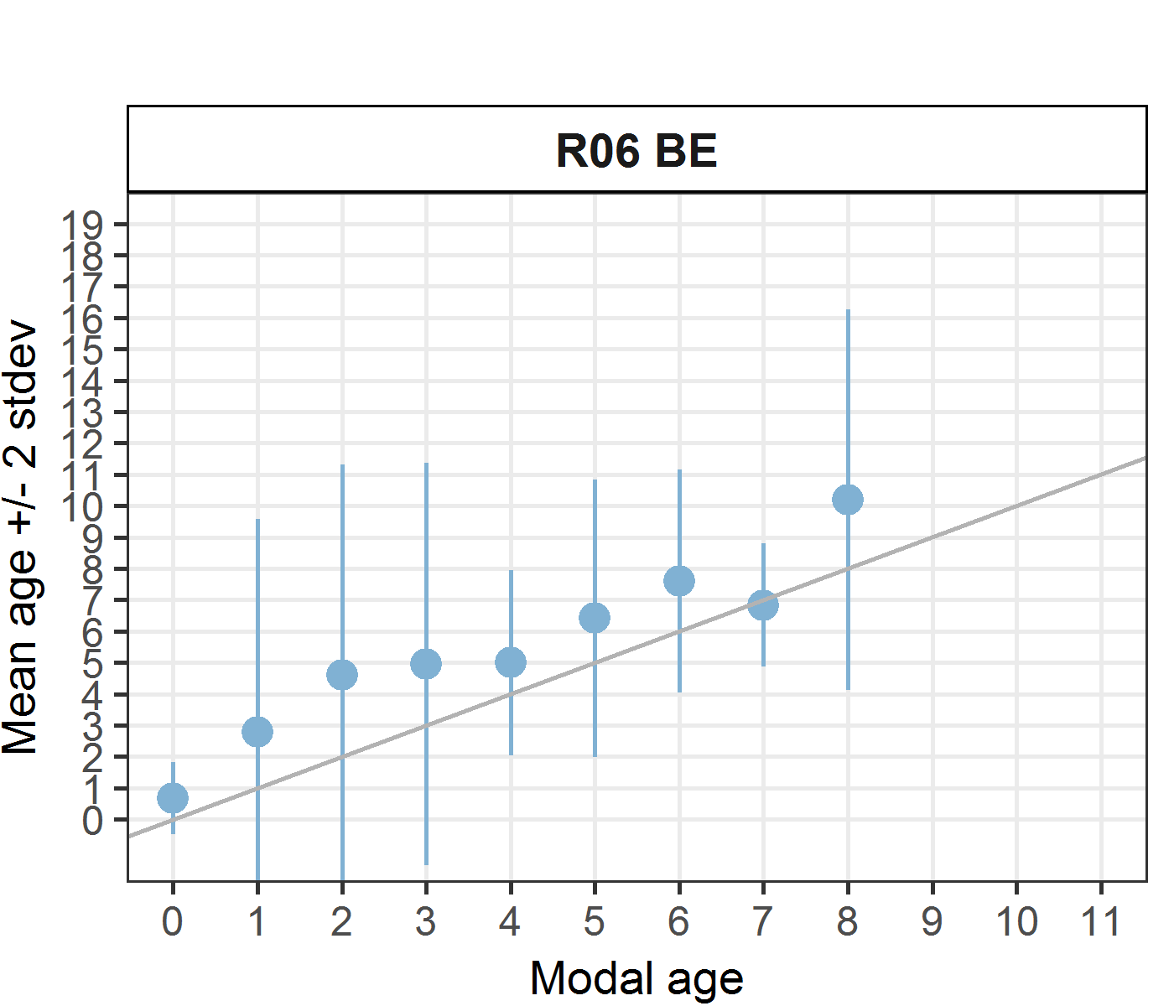
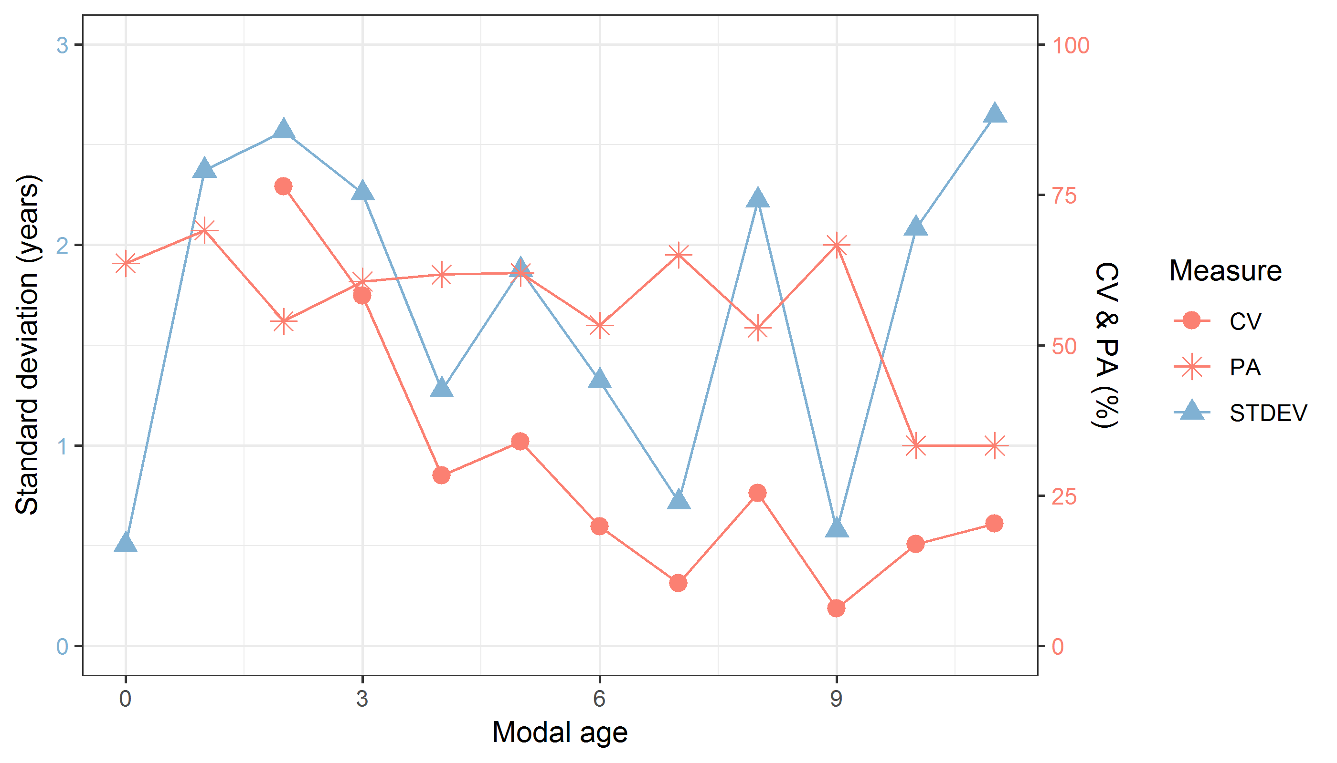
Figure 7.10: CV, PA and (STDEV (standard deviation) are plotted against modal age
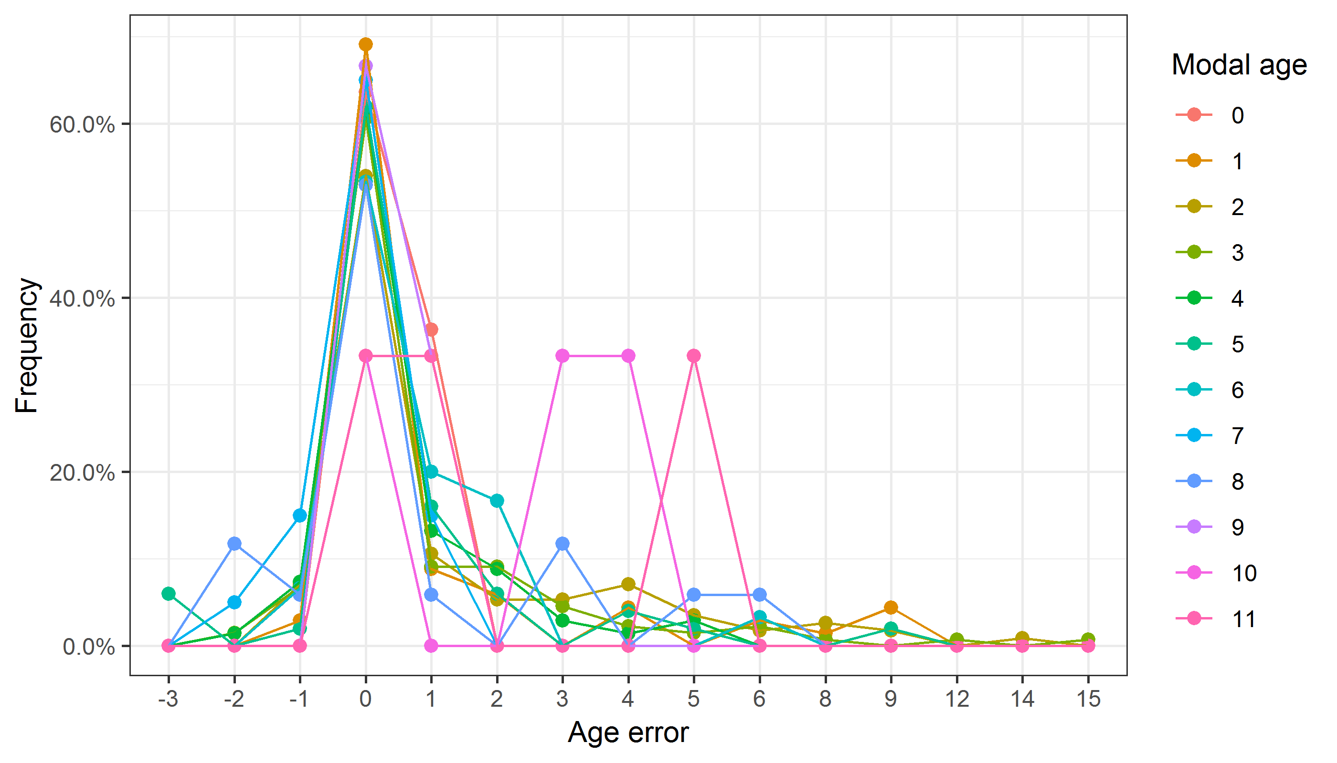
Figure 7.11: The distribution of the age reading errors in percentage by modal age as observed from the whole group of age readers in an age reading comparison to modal age. The achieved precision in age reading by MODAL age group is shown by the spread of the age readings errors. There appears to be no relative bias, if the age reading errors are normally distributed. The distributions are skewed, if relative bias occurs.
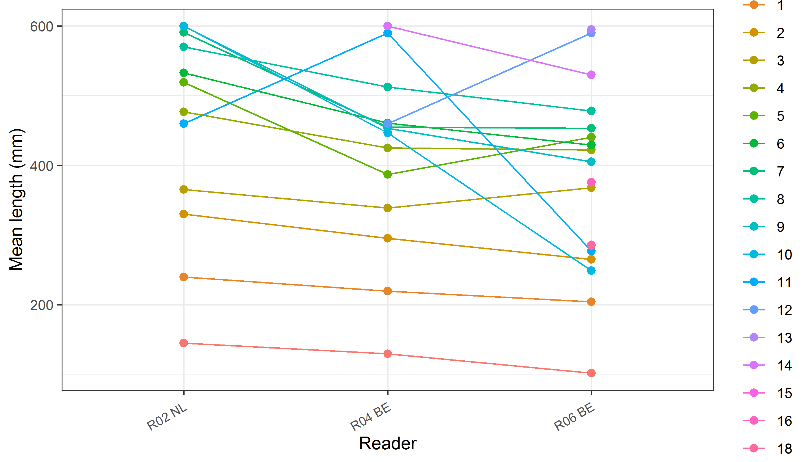
Figure 7.12: The mean length at age as estimated by each age reader.

