SmartDots Report for event 250
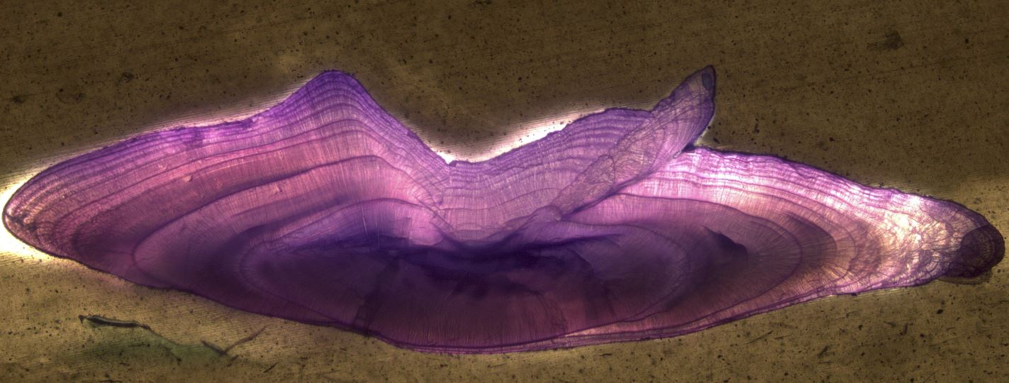
Table of Contents
1 Executive summary 3
2 Agenda and participant list 4
3 Introduction 5
4 Methods 6
5 Analysis of age calibration exercise (ToR?) 8
5.1 Overview of samples and readers 9
5.2 Results 10
5.2.1 All readers 10
5.2.2 Advanced readers 15
5.3 Discussion 20
5.4 Conclusion 21
6 Other ToRs 22
7 References 23
8 Annex 1. Agenda 24
9 Annex 2. List of participants 25
10 Annex 3. Additional results 26
10.1 Results all readers 27
10.2 Results Advanced readers 39
11 Annex 4. ToRs for next meeting 48
12 Annex 5. Recommendations 49
13 Annex 6. Report specific annexes 50

Executive summary
Experienced assessment readers showed better results than non-assessment readers and met the criteria of CV < 5%
Experienced assessment readers’ results for Age 0-5 met the criteria PA% > 95%, but not the criteria for Age > 6
Non assessment readers’ CV% for herring < 14 cm and modal age ≤ 1 was higher than expected due to image scaling difficulties for non-assessment readers when interpreting the size of the otoliths.
Finnish otolith images generally resulted in lower CV, indicating higher quality images with their EDF multi focus micro scope camera system.
The results conclude that age calibration with SmartDots is comparable to the traditional way of circulating samples between labs if we solve the scaling problem and use high quality images.

Agenda and participant list
Table 1. List of participants
Name | Country | Institute and address e-mail | Experience
Tarja Wiik | FINLAND | tarja.wiik@luke.fi | Advanced
Sami Vesala | FINLAND | sami.vesala@luke.fi | Basic
Meri Heliseva | FINLAND | meri.heliseva@luke.fi | Basic
Jan Eklund | FINLAND | jan.eklund@netikka.fi | Basic
Martina Blass | SWEDEN | martina.blass@slu.se | Advanced
Marju Kaljuste | SWEDEN | marju.kaljuste@slu.se | Advanced
Yvette Heimbrand | SWEDEN | yvette.heimbrand@slu.se | Advanced

Introduction
The pelagic fish species Baltic herring (Clupea harengus membras), is a subspecies of the larger Atlantic herring (Clupea harengus). There are two spawning types of Baltic herring, spring and autumn spawners. The spring spawners migrate to the coast to spawn and the autumn spawners migrate to shallow banks or steep coastal slopes to spawn (Parmanne et al. 1994). Outside of the spawning season the two spawning types mix in the offshore area. The herring fishery is the most economically important commercial fishery in the Bothnian Sea. The herring perform diel vertical feeding migrations following the movements of zooplankton resulting in that the herring is spatially distributed dispersed at the surface during the night and aggregated at the bottom during the day (Cardinale et al., 2003). The Baltic herring mature at two to four years of age and can reach a maximum age of 25 years and about 26 cm in length (SLU Aqua).
For quality control of age data provided for analytical assessment purposes, age calibrations of Baltic herring (Clupea harengus membras) for ICES sub division 30 to compare Finnish and Swedish age readers are carried out annually. Prior to this first otolith image age calibration in SmartDots, otolith samples for age calibrations have been sent between the age reading labs at SLU Aqua in Sweden (Swedish University of Agricultural Sciences, Department of Aquatic Resources Institute of Coastal Research) and LUKE in Finland (Natural Resources Institute Finland). Using otolith images in SmartDots for the age calibration instead of real samples meant that all readers age estimated under the same circumstances without factors affecting the visual interpretation of growth zones such as different microscopes and light sources.

Seven age readers from Sweden and Finland participated in the event. The results include a comparison between four experienced age readers providing age data for the analytical assessment and three non-assessment readers with less experience as well as a comparison between all seven age readers. To assess how image quality can affect the results, the Swedish and Finnish otolith images was compared.

Methods
The sample collection consisted of 100 herring otoliths caught in the Bothnian Sea (SD 30) in October during the Baltic International Acoustic Survey expedition 2018. The otoliths were sectioned in 0.3 mm transverse cross sections, etched in 1% hydro chloride acid and stained with toluidine blue dye to enhance growth zones. A Leica microscope, connected to a DM2900 camera system in Sweden at the Coastal department at SLU Aqua was used to photograph 50 of the otoliths, whereas the remaining 50 otoliths were photographed at LUKE in Finland with the image acquisition system ZEN, creating extended depth of focus (EDF) images of Z-Stack images.

The otolith images were uploaded to the web based age calibration platform SmartDots (ICES 2018), developed by the International Council for the Exploration of the Sea (ICES). The age readers annotated annuli on otolith images along a pre-defined line, running from the core to the edge, using by convention the 1st of January as the date of birth. Information of the fish length was available and a scale bar was provided for the Swedish images, but not for the Finnish images.
The results were compared between readers, age classes and based on in which country the images were taken. The readers were further compared depending on whether the readers had provided age estimations for analytical assessment or not. The assessment readers (AR) were Martina Blass, Marju Kaljuste, Tarja Wiik and Yvette Heimbrand, and the non-assessment readers (NAR) were Sami Vesala, Meri Helisevä and Jan Eklund. The 2019 calibration was also compared to 2017 and 2018. The degree of accuracy of the readers’ age estimates compared to modal age is measured by percentage agreement (PA%), where a high value suggests good agreement. The criterion for PA% is usually > 80% for most fish species, but 95% for herring age 0-5, 90% for age 6-7 and 80% for age > 7 (SLU-Aqua, 2012). The coefficient of variation (CV) measure the precision of reproducibility of age estimates where a low value indicates a high level of reproducibility. The coefficient of variation (CV) should preferably be < 5% (Campana 2001).
In the first part of analysis are presented the tables and plots from the Guus Eltink Excel sheet 'Age Reading Comparisons' (Eltink, A.T.G.W. 2000). The order and numbering of tables and plots are the same as in the excel sheet. Tables 6.1 - 6.4 from the 'Age Reading Comparisons' sheet are not outputted since these are merely used to do calculations for the other tables.
Pecentage Agreement
The table presents the average percent of agreement (PA%), of age readers’ estimates agreeing with the modal age:
$$PA\%=100*\left(\frac{n samples agreed}{n samples}\right)$$
Co-efficient of Variation (CV)
The table presents the CV per modal age and reader. The CV's are calculated as the ratio between the standard deviation (σ) and mean value (μ) per reader and modal age:
$$CV=\frac{σ}{μ}⋅100\%$$
To the table is also added the CV of all readers combined per modal age and a weighted mean of the CV per reader. Finally a rank value is added per reader, where the reader with the lowest weighted mean is assigned with a rank and so forth (in the situation of ties between two weighted means will every tied element be assigned to the lowest rank. This is the procedure for all ties methods when assigning ranks).
Average Percentage Error (APE)
APE was calculated based on the method outlined by Beamish & Fournier (1981). This method is not independent of fish age and thus provides a better estimate of precision. As the calculations of both CV and APE pose problems if the mean age is close to 0, all observations for which modal age was 0 were omitted from the CV and APE calculations.
The average percentage error is calculated per image as:
$$APE=\frac{100\%}{n}\sum_{i=1}^{n}{|}\frac{a_{i}-\overline{a}}{\overline{a}}|$$
where $a_{i}$ is the age reading of reader $i$ and $\overline{a}$ is the mean of all readings from 1 to $n$.
Age error matrices (AEM)
Age error matrices (AEM) were produced following procedures outlined by WKSABCAL (2014) where the matrix shows the proportion of each modal age mis-aged as other ages. The sum of each row is 1, which equals 100%. The age data was analysed twice, the first time all readers were included and the second time only the “advanced” readers were included. If a reader is “advanced” then they are considered well trained and they provide ages for stock assessment or similar purposes. When the AEM is compiled for assessment purposes it uses only those readers who provide age data for the stock assessment in that specific area.

Analysis of age calibration exercise (ToR?)

Overview of samples and readers

Table 1: Overview of samples used for the SmartDots event 250 exchange.
Year | ICES area | Strata | Quarter | Number of samples | Modal age range | Length range
2018 | 27.3.d.30 | 27.3.d.30 | 4 | 100 | 0-16 | 120-215 mm

Table 2: Reader overview.
Reader code | Expertise
R01 FI | Advanced
R02 SE | Advanced
R03 SE | Advanced
R04 SE | Advanced
R05 FI | Basic
R06 FI | Basic
R07 FI | Basic

Results

All readers
All samples included
The modal age range was 0 to 16 years and the length range 120 to 215 mm. There was an overall high PA% between readers (Table 3) and moderate to high CV for the non-assessment readers (NAR) for Swedish otolith images aged < 5 years, but low for older Swedish images and low for all the Finnish images (Table 3).

Table 3: Percentage agreement (PA%) and Coefficient of Variation (CV) per modal age divided per: all readers, assessment readers and non-assessment readers for comparison between Swedish and Finnish otolith images. . The criterion for PA%: 95% for herring age 0-5, 90% for age 6-7 and 80% for age > 7.
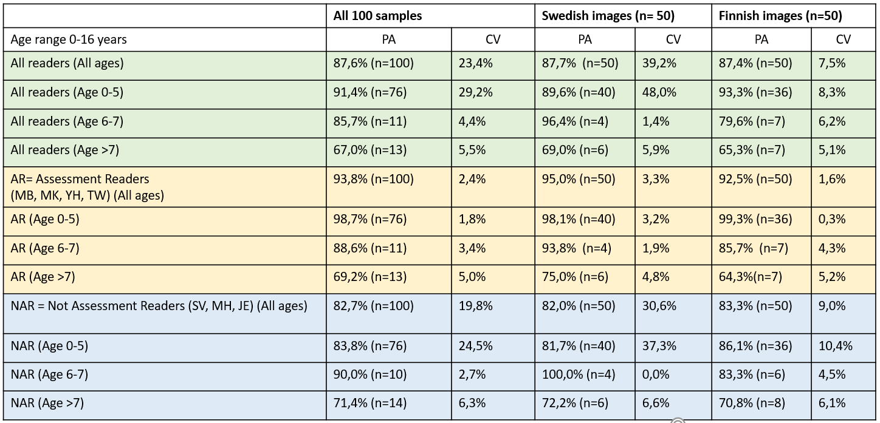

The assessment readers (AR) reached the criteria for PA% for age 0-5 but not for age > 5 (Table 3). The CV for AR were consistently below 5% except for age >7 (Finnish images). The NAR did not reach the PA% criteria except for age 6-7 (Swedish samples). The CV for NAR were approximately threefold higher for the Swedish images age 0-5, than for the Finnish images. For age > 6, the NAR CV were close to the criteria of 5%. To note is that although the PA% for age 0-5 for NAR was similar for Finnish and Swedish images, the CV for the Swedish images was threefold higher than for the Finnish, indicating the importance of other age criteria than PA alone to assess where age issues occur.

The CV plotted against fish length (Fig. 1), illustrates that it is the small, young herrings that is problematic, probably because it is difficult to interpret the scale of the images (i.e. if the otoliths are small or big) and that the quality of the Swedish images were poorer than the Finnish images.
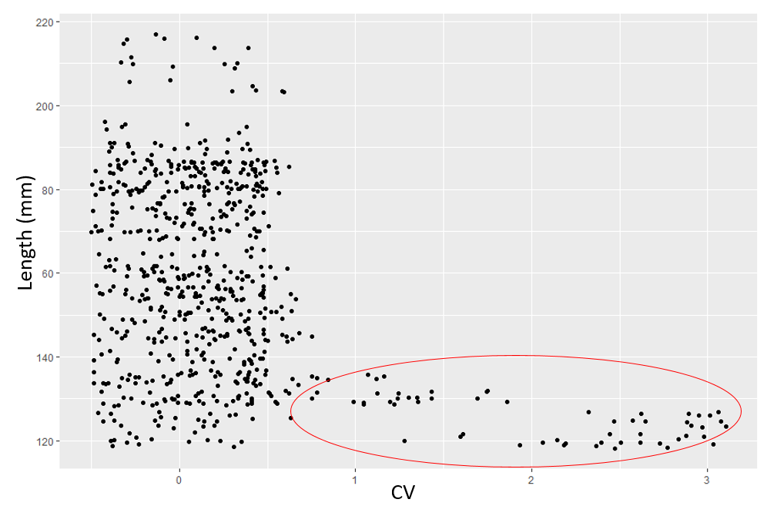
Fig 1. Length plotted against coefficient of variation (CV). Red oval illustrate higher age error for small herring.

The age frequency based on the modal age was similar for Swedish and Finnish samples (Fig. 2).
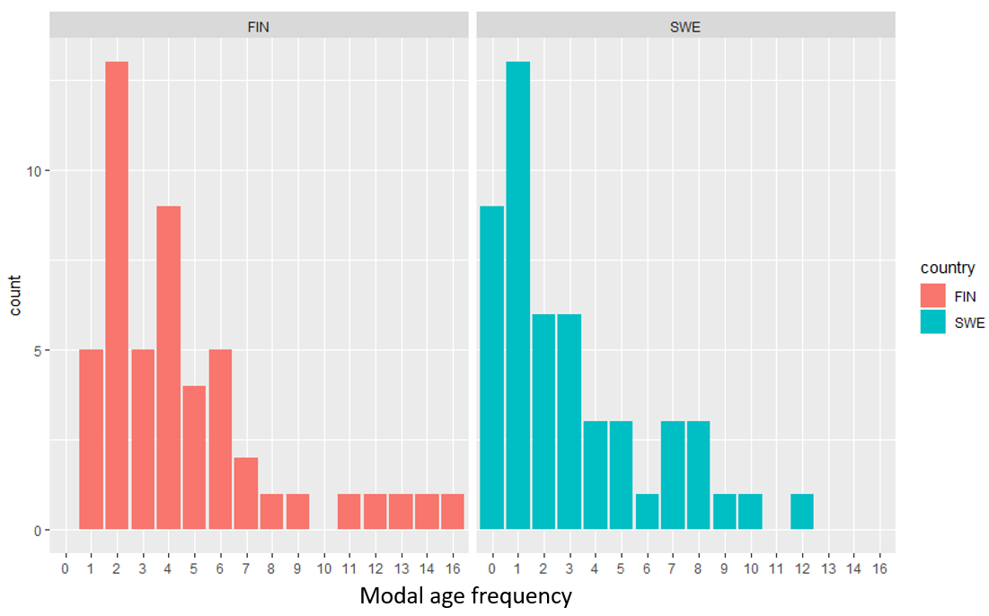
Fig. 2. Modal age frequency for Swedish and Finnish samples.
The standard deviation (STDEV) based on all readers and age classes varied with age, whereas the PA remained overall high > 80% (Fig. 3). The CV for age 0-1 was considerably higher than for older age classes (Fig. 3).
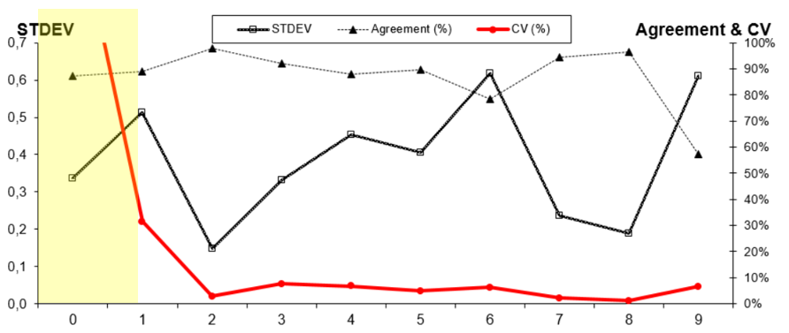
Fig. 3. Age estimation statistics (PA%, CV and STDEV) for all readers and all modal age classes.

The weighted average percentage agreement based on modal ages for all readers is 88 %, with the weighted average CV of 15 %.
Table 4: Coefficient of Variation (CV) table presents the CV per modal age and reader, the CV of all readers combined per modal age and a weighted mean of the CV per reader.
Modal age | R01 FI | R02 SE | R03 SE | R04 SE | R05 FI | R06 FI | R07 FI | all
0 | - | - | - | - | - | - | - | -
1 | 0 % | 0 % | 0 % | 0 % | 0 % | 52 % | 26 % | 42 %
2 | 0 % | 0 % | 0 % | 0 % | 0 % | 17 % | 0 % | 7 %
3 | 0 % | 0 % | 0 % | 0 % | 0 % | 19 % | 0 % | 11 %
4 | 0 % | 0 % | 7 % | 0 % | 11 % | 18 % | 0 % | 11 %
5 | 0 % | 8 % | 8 % | 8 % | 0 % | 17 % | 0 % | 8 %
6 | 13 % | 7 % | 7 % | 0 % | 0 % | 11 % | 13 % | 10 %
7 | 0 % | 8 % | 0 % | 0 % | 0 % | 0 % | 0 % | 3 %
8 | 0 % | 0 % | 0 % | 0 % | 0 % | 6 % | 0 % | 2 %
9 | 7 % | 8 % | 0 % | 7 % | 7 % | 0 % | 0 % | 7 %
10 | - | - | - | - | - | - | - | 15 %
11 | - | - | - | - | - | - | - | 10 %
12 | 6 % | 6 % | 6 % | 6 % | 6 % | 11 % | 6 % | 7 %
13 | - | - | - | - | - | - | - | 11 %
14 | - | - | - | - | - | - | - | 3 %
15 | - | - | - | - | - | - | - | -
16 | - | - | - | - | - | - | - | 3 %
Weighted Mean | 1 % | 2 % | 2 % | 1 % | 2 % | 22 % | 6 % | 15 %
The percentage agreement per reader per modal age tells how large part of the readings that are equal to the modal age. The weighted mean including at the bottom of the table is weighted according to number of age readings. A rank is also assigned to each reader.
Table 5: Percentage agreement (PA) table represents the PA per modal age and reader, the PA of all readers combined per modal age and a weighted mean of the PA per reader.
Modal age | R01 FI | R02 SE | R03 SE | R04 SE | R05 FI | R06 FI | R07 FI | all
0 | 100 % | 89 % | 90 % | 100 % | 70 % | 22 % | 100 % | 82 %
1 | 100 % | 100 % | 100 % | 100 % | 100 % | 47 % | 94 % | 92 %
2 | 100 % | 100 % | 100 % | 100 % | 100 % | 84 % | 100 % | 98 %
3 | 100 % | 100 % | 100 % | 100 % | 100 % | 45 % | 100 % | 92 %
4 | 100 % | 100 % | 92 % | 100 % | 75 % | 50 % | 100 % | 88 %
5 | 100 % | 86 % | 86 % | 86 % | 100 % | 71 % | 100 % | 90 %
6 | 83 % | 83 % | 83 % | 100 % | 100 % | 33 % | 67 % | 79 %
7 | 100 % | 60 % | 100 % | 100 % | 100 % | 100 % | 100 % | 94 %
8 | 100 % | 100 % | 100 % | 100 % | 100 % | 75 % | 100 % | 96 %
9 | 50 % | 50 % | 0 % | 50 % | 50 % | 100 % | 100 % | 57 %
10 | 0 % | 100 % | 0 % | 0 % | 0 % | 0 % | 100 % | 29 %
11 | 100 % | 0 % | 0 % | 100 % | 0 % | 0 % | 100 % | 43 %
12 | 50 % | 50 % | 50 % | 50 % | 50 % | 50 % | 50 % | 50 %
13 | 100 % | - | 0 % | 100 % | 0 % | 100 % | 0 % | 50 %
14 | 100 % | 100 % | 100 % | 100 % | 100 % | 100 % | 0 % | 86 %
15 | - | - | - | - | - | - | - | -
16 | 0 % | 100 % | 0 % | 100 % | 100 % | 100 % | 100 % | 71 %
Weighted Mean | 95 % | 92 % | 89 % | 96 % | 89 % | 59 % | 94 % | 88 %
The relative bias is the difference between the mean age (per modal age per reader) and modal age. As for the previous tables, a combined bias for all readers and weighted means are calculated and finally a rank is assigned to each reader.
Table 6: Relative bias table represents the relative bias per modal age per reader, the relative bias of all readers combined per modal age and a weighted mean of the relative bias per reader. A rank is also assigned to each reader.
Modal age | R01 FI | R02 SE | R03 SE | R04 SE | R05 FI | R06 FI | R07 FI | all
0 | 0.00 | 0.11 | 0.10 | 0.00 | 0.30 | 1.00 | 0.00 | 0.22
1 | 0.00 | 0.00 | 0.00 | 0.00 | 0.00 | 0.82 | -0.06 | 0.11
2 | 0.00 | 0.00 | 0.00 | 0.00 | 0.00 | 0.16 | 0.00 | 0.02
3 | 0.00 | 0.00 | 0.00 | 0.00 | 0.00 | 0.64 | 0.00 | 0.09
4 | 0.00 | 0.00 | 0.08 | 0.00 | 0.25 | 0.75 | 0.00 | 0.15
5 | 0.00 | -0.14 | -0.14 | -0.14 | 0.00 | 0.14 | 0.00 | -0.04
6 | 0.33 | -0.17 | 0.17 | 0.00 | 0.00 | 0.83 | 0.50 | 0.24
7 | 0.00 | -0.40 | 0.00 | 0.00 | 0.00 | 0.00 | 0.00 | -0.06
8 | 0.00 | 0.00 | 0.00 | 0.00 | 0.00 | 0.25 | 0.00 | 0.04
9 | 0.50 | -0.50 | 1.00 | 0.50 | 0.50 | 0.00 | 0.00 | 0.29
10 | 4.00 | 0.00 | 3.00 | 3.00 | 2.00 | 5.00 | 0.00 | 2.43
11 | 0.00 | -2.00 | 1.00 | 0.00 | 1.00 | 1.00 | 0.00 | 0.14
12 | 0.50 | -0.50 | -0.50 | 0.50 | -0.50 | 1.00 | -0.50 | 0.00
13 | 0.00 | - | -2.00 | 0.00 | -1.00 | 0.00 | -3.00 | -
14 | 0.00 | 0.00 | 0.00 | 0.00 | 0.00 | 0.00 | -1.00 | -0.14
15 | - | - | - | - | - | - | - | -
16 | -1.00 | 0.00 | -1.00 | 0.00 | 0.00 | 0.00 | 0.00 | -0.29
Weighted Mean | 0.07 | -0.07 | 0.04 | 0.04 | 0.08 | 0.58 | -0.03 | 0.11
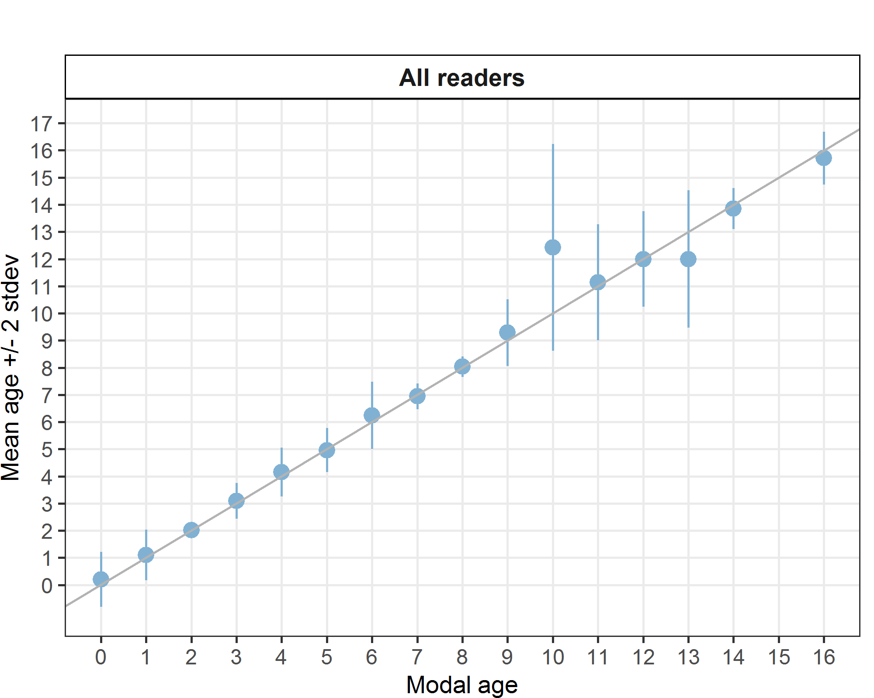
Figure 4: Age bias plot for all readers. Mean age recorded +/- 2 stdev of each reader and all readers combined are plotted against modal age. The estimated mean age corresponds to modal age, if the estimated mean age is on the 1:1 equilibrium line (solid line). Relative bias is the age difference between estimated mean age and modal age.
For each pair that is being compared, the differences between the readings per image are found and the frequency of each occurring difference is obtained. A rank value is calculated for the positive and the negative differences (R+ and R- in the Guus Eltink sheet). The value with the smallest rank is then used to calculate a z-value that determines the level of bias (not clear from Guus Eltink sheet how the equations are defined..).
Table 7: Inter reader bias test. The Inter-reader bias test gives probability of bias between readers and with modal age. - = no sign of bias (p>0.05), * = possibility of bias (0.01<p<0.05), * * = certainty of bias (p<0.01)
Comparison | R01 FI | R02 SE | R03 SE | R04 SE | R05 FI | R06 FI | R07 FI
R01 FI | - | * | - | - | - | ** | -
R02 SE | * | - | * | * | ** | ** | -
R03 SE | - | * | - | - | - | ** | -
R04 SE | - | * | - | - | - | ** | -
R05 FI | - | ** | - | - | - | ** | *
R06 FI | ** | ** | ** | ** | ** | - | **
R07 FI | - | - | - | - | * | ** | -
Modal age | - | * | - | - | - | ** | -

Results by strata
Table 8: Number of age readings per strata for all readers.
Modal age | 27.3.d.30 | total
0 | 68 | 68
1 | 119 | 119
2 | 133 | 133
3 | 77 | 77
4 | 84 | 84
5 | 49 | 49
6 | 42 | 42
7 | 35 | 35
8 | 28 | 28
9 | 14 | 14
10 | 7 | 7
11 | 7 | 7
12 | 14 | 14
13 | 6 | 6
14 | 7 | 7
15 | 0 | 0
16 | 7 | 7
Total | 697 | 697

Table 9: CV per strata.
Modal age | 27.3.d.30 | all
0 | - | -
1 | 42 % | 42 %
2 | 7 % | 7 %
3 | 11 % | 11 %
4 | 11 % | 11 %
5 | 8 % | 8 %
6 | 10 % | 10 %
7 | 3 % | 3 %
8 | 2 % | 2 %
9 | 7 % | 7 %
10 | 15 % | 15 %
11 | 10 % | 10 %
12 | 7 % | 7 %
13 | 11 % | 11 %
14 | 3 % | 3 %
15 | - | -
16 | 3 % | 3 %
Weighted Mean | 15 % | 15 %
Table 10: Percentage Agreement per strata.
Modal age | 27.3.d.30 | all
0 | 82 % | 82 %
1 | 92 % | 92 %
2 | 98 % | 98 %
3 | 92 % | 92 %
4 | 88 % | 88 %
5 | 90 % | 90 %
6 | 79 % | 79 %
7 | 94 % | 94 %
8 | 96 % | 96 %
9 | 57 % | 57 %
10 | 29 % | 29 %
11 | 43 % | 43 %
12 | 50 % | 50 %
13 | 50 % | 50 %
14 | 86 % | 86 %
15 | - | -
16 | 71 % | 71 %
Weighted Mean | 88 % | 88 %
Table 11: Relative Bias per strata.
Modal age | 27.3.d.30 | all
0 | 0.21 | 0.21
1 | 0.11 | 0.11
2 | 0.02 | 0.02
3 | 0.09 | 0.09
4 | 0.15 | 0.15
5 | -0.04 | -0.04
6 | 0.24 | 0.24
7 | -0.06 | -0.06
8 | 0.04 | 0.04
9 | 0.29 | 0.29
10 | 2.43 | 2.43
11 | 0.14 | 0.14
12 | 0.00 | 0.00
13 | -1.00 | -1.00
14 | -0.14 | -0.14
15 | - | -
16 | -0.29 | -0.29
Weighted Mean | 0.10 | 0.10

Advanced readers
All samples included
Table 12: Coefficient of Variation (CV) table presents the CV per modal age and advanced reader, the CV of all advanced readers combined per modal age and a weighted mean of the CV per reader. A rank is also assigned to each reader.
Modal age | R01 FI | R02 SE | R03 SE | R04 SE | all
0 | - | - | - | - | -
1 | 0 % | 0 % | 0 % | 0 % | 0 %
2 | 0 % | 0 % | 0 % | 0 % | 0 %
3 | 0 % | 0 % | 0 % | 0 % | 0 %
4 | 7 % | 0 % | 7 % | 0 % | 5 %
5 | 0 % | 0 % | 0 % | 0 % | 0 %
6 | 13 % | 7 % | 7 % | 0 % | 8 %
7 | 0 % | 8 % | 0 % | 0 % | 4 %
8 | 0 % | 0 % | 0 % | 0 % | 0 %
9 | - | - | - | - | 6 %
10 | - | - | - | - | 10 %
11 | 6 % | 14 % | 6 % | 6 % | 9 %
12 | - | - | - | - | 5 %
13 | 5 % | - | 12 % | 0 % | 11 %
14 | - | - | - | - | 0 %
15 | - | - | - | - | 4 %
Weighted Mean | 2 % | 1 % | 2 % | 0 % | 2 %
Table 13: Percentage agreement (PA) table represents the PA per modal age and reader, advanced the PA of all advanced readers combined per modal age and a weighted mean of the PA per reader. A rank is also assigned to each reader.
Modal age | R01 FI | R02 SE | R03 SE | R04 SE | all
0 | 100 % | 89 % | 90 % | 100 % | 95 %
1 | 100 % | 100 % | 100 % | 100 % | 100 %
2 | 100 % | 100 % | 100 % | 100 % | 100 %
3 | 100 % | 100 % | 100 % | 100 % | 100 %
4 | 92 % | 100 % | 92 % | 100 % | 96 %
5 | 100 % | 100 % | 100 % | 100 % | 100 %
6 | 83 % | 83 % | 83 % | 100 % | 88 %
7 | 100 % | 60 % | 100 % | 100 % | 90 %
8 | 100 % | 100 % | 100 % | 100 % | 100 %
9 | 100 % | 100 % | 0 % | 0 % | 50 %
10 | 100 % | 0 % | 100 % | 0 % | 50 %
11 | 50 % | 50 % | 50 % | 50 % | 50 %
12 | 0 % | 100 % | 100 % | 0 % | 50 %
13 | 50 % | 0 % | 50 % | 100 % | 57 %
14 | 100 % | 100 % | 100 % | 100 % | 100 %
15 | 100 % | 0 % | 100 % | 0 % | 50 %
Weighted Mean | 95 % | 92 % | 94 % | 95 % | 94 %
Table 14: Relative bias table represents the relative bias per modal age and advanced reader, the relative bias of all advanced readers combined per modal age and a weighted mean of the relative bias per reader. A rank is also assigned to each reader.
Modal age | R01 FI | R02 SE | R03 SE | R04 SE | all
0 | 0.00 | 0.11 | 0.10 | 0.00 | 0.05
1 | 0.00 | 0.00 | 0.00 | 0.00 | 0.00
2 | 0.00 | 0.00 | 0.00 | 0.00 | 0.00
3 | 0.00 | 0.00 | 0.00 | 0.00 | 0.00
4 | 0.08 | 0.00 | 0.08 | 0.00 | 0.04
5 | 0.00 | 0.00 | 0.00 | 0.00 | 0.00
6 | 0.33 | -0.17 | 0.17 | 0.00 | 0.08
7 | 0.00 | -0.40 | 0.00 | 0.00 | -0.10
8 | 0.00 | 0.00 | 0.00 | 0.00 | 0.00
9 | 0.00 | 0.00 | 1.00 | 1.00 | 0.50
10 | 0.00 | -2.00 | 0.00 | -1.00 | -0.75
11 | 0.50 | -1.00 | 0.50 | 0.50 | 0.12
12 | 1.00 | 0.00 | 0.00 | 1.00 | 0.50
13 | 0.50 | -3.00 | -1.00 | 0.00 | -0.88
14 | 0.00 | 0.00 | 0.00 | 0.00 | 0.00
15 | 0.00 | 1.00 | 0.00 | 1.00 | 0.50
Weighted Mean | 0.06 | -0.08 | 0.03 | 0.03 | 0.00
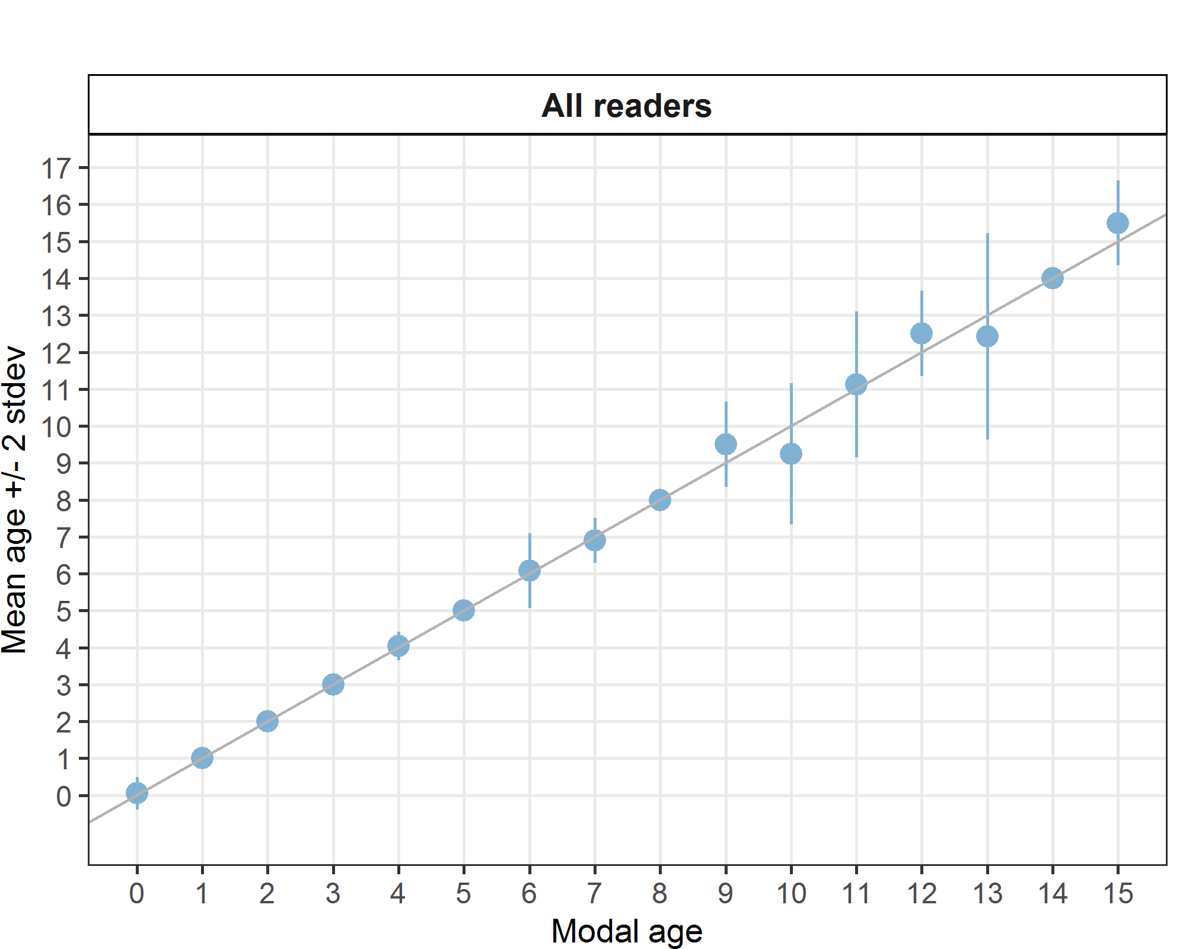
Figure 5: Age bias plot for advanced readers.

Age error matrices are calculated per area and only based on the age readings of the advanced readers.
Table 15: Age error matrix (AEM) for 27.3.d.30. The AEM shows the proportional distribution of age readings for each modal age. Age column should sum to one but due to rounding there might be small deviations in some cases. Only advanced readers are used for calculating the AEM.
strata | Modal age | 0 | 1 | 2 | 3 | 4 | 5 | 6 | 7 | 8 | 9 | 10 | 11 | 12 | 13 | 14 | 15
27.3.d.30 | Age 0 | 0.94872 | - | - | - | - | - | - | - | - | - | - | - | - | - | - | -
27.3.d.30 | Age 1 | 0.05128 | 1 | - | - | - | - | - | - | - | - | - | - | - | - | - | -
27.3.d.30 | Age 2 | - | - | 1 | - | - | - | - | - | - | - | - | - | - | - | - | -
27.3.d.30 | Age 3 | - | - | - | 1 | - | - | - | - | - | - | - | - | - | - | - | -
27.3.d.30 | Age 4 | - | - | - | - | 0.96154 | - | - | - | - | - | - | - | - | - | - | -
27.3.d.30 | Age 5 | - | - | - | - | 0.03846 | 1 | 0.04167 | - | - | - | - | - | - | - | - | -
27.3.d.30 | Age 6 | - | - | - | - | - | - | 0.87500 | 0.1 | - | - | - | - | - | - | - | -
27.3.d.30 | Age 7 | - | - | - | - | - | - | 0.04167 | 0.9 | - | - | - | - | - | - | - | -
27.3.d.30 | Age 8 | - | - | - | - | - | - | 0.04167 | - | 1 | - | 0.25 | - | - | - | - | -
27.3.d.30 | Age 9 | - | - | - | - | - | - | - | - | - | 0.5 | 0.25 | 0.125 | - | - | - | -
27.3.d.30 | Age 10 | - | - | - | - | - | - | - | - | - | 0.5 | 0.50 | - | - | 0.1429 | - | -
27.3.d.30 | Age 11 | - | - | - | - | - | - | - | - | - | - | - | 0.500 | - | 0.1429 | - | -
27.3.d.30 | Age 12 | - | - | - | - | - | - | - | - | - | - | - | 0.375 | 0.5 | - | - | -
27.3.d.30 | Age 13 | - | - | - | - | - | - | - | - | - | - | - | - | 0.5 | 0.5714 | - | -
27.3.d.30 | Age 14 | - | - | - | - | - | - | - | - | - | - | - | - | - | 0.1429 | 1 | -
27.3.d.30 | Age 15 | - | - | - | - | - | - | - | - | - | - | - | - | - | - | - | 0.5
27.3.d.30 | Age 16 | - | - | - | - | - | - | - | - | - | - | - | - | - | - | - | 0.5
Results by strata
Table 16: Number of age readings per strata for all readers.
Modal age | 27.3.d.30 | total
0 | 39 | 39
1 | 68 | 68
2 | 76 | 76
3 | 44 | 44
4 | 52 | 52
5 | 24 | 24
6 | 24 | 24
7 | 20 | 20
8 | 16 | 16
9 | 4 | 4
10 | 4 | 4
11 | 8 | 8
12 | 4 | 4
13 | 7 | 7
14 | 4 | 4
15 | 4 | 4
Total | 398 | 398
Table 17: CV per strata.
Modal age | 27.3.d.30 | all
0 | - | -
1 | 0 % | 0 %
2 | 0 % | 0 %
3 | 0 % | 0 %
4 | 5 % | 5 %
5 | 0 % | 0 %
6 | 8 % | 8 %
7 | 4 % | 4 %
8 | 0 % | 0 %
9 | 6 % | 6 %
10 | 10 % | 10 %
11 | 9 % | 9 %
12 | 5 % | 5 %
13 | 11 % | 11 %
14 | 0 % | 0 %
15 | 4 % | 4 %
Weighted Mean | 2 % | 2 %
Table 18: Percentage Agreement per strata.
Modal age | 27.3.d.30 | all
0 | 95 % | 95 %
1 | 100 % | 100 %
2 | 100 % | 100 %
3 | 100 % | 100 %
4 | 96 % | 96 %
5 | 100 % | 100 %
6 | 88 % | 88 %
7 | 90 % | 90 %
8 | 100 % | 100 %
9 | 50 % | 50 %
10 | 50 % | 50 %
11 | 50 % | 50 %
12 | 50 % | 50 %
13 | 57 % | 57 %
14 | 100 % | 100 %
15 | 50 % | 50 %
Weighted Mean | 94 % | 94 %
Table 19: Relative Bias per strata.
Modal age | 27.3.d.30 | all
0 | 0.05 | 0.05
1 | 0.00 | 0.00
2 | 0.00 | 0.00
3 | 0.00 | 0.00
4 | 0.04 | 0.04
5 | 0.00 | 0.00
6 | 0.08 | 0.08
7 | -0.10 | -0.10
8 | 0.00 | 0.00
9 | 0.50 | 0.50
10 | -0.75 | -0.75
11 | 0.12 | 0.12
12 | 0.50 | 0.50
13 | -0.57 | -0.57
14 | 0.00 | 0.00
15 | 0.50 | 0.50
Weighted Mean | 0.01 | 0.01

Discussion
The PA% and CV were compared to previous years (2017 and 2018) to assess if the new method of using otolith images in SmartDots gave different results compared to the old method of reading from otolith samples (Table 2). The results were similar between years except for CV for age 0-5 for the 2019 age calibration, which were much higher.
Table 20: Age composition by reader gives a summary of number of readings per reader.
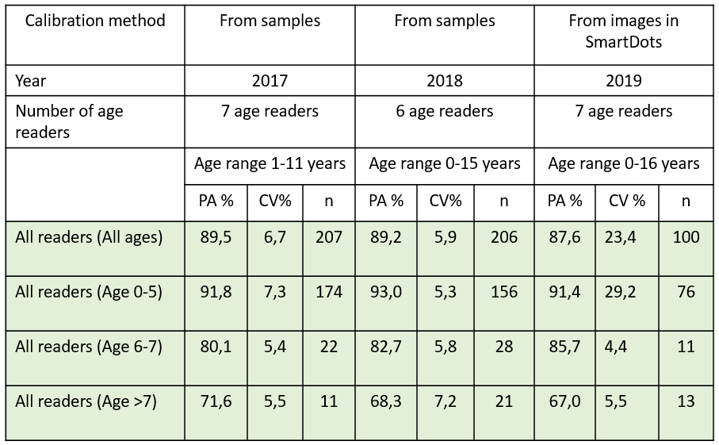
This is the first time we use SmartDots as an age calibration tool and the overall result are similar to the previous years’ calibration results. It seems that it sometimes can be a problem to see on the smaller images if it is a big or small otolith, unless we look at the scale bar or at the length information. There was a scale bar included in each Swedish image, but if the readers are not used to that, it will still not be helpful. The high CV for the Swedish images, aged 0-5, indicated that the scaling interpretation problem occurred specifically for these images, indicating that the quality of the Swedish images were poorer than the Finnish images. To avoid this problem in the future we preferably will use the Finnish method of image acquisition and include an overview image of all otoliths next to each other in the same scale as well as discuss expected annulus width and growth pattern and how to use the scale bar. For age > 6, the CV was close to 5%, which refer to a very low age error and reliable age estimations. The overall PA for all age readers did not reach the expected criteria, but still consider to be high (85.7 – 91.4% for age 0 – 7), indicating a high agreement among readers. For age classes >7, the PA was lower (67%). The assessment readers gave higher agreement and precision than the non-assessment readers.

Conclusion
The results conclude that age calibration with SmartDots is comparable to the traditional way of circulating samples between labs if we use high quality images. For the next calibration it is important to insert a scale-bar on all the otolith images to give the age readers information about the scale and size of the otolith and to solve the high age error for small herring. The magnification for each image should be registered in SmartDots for comparison of the age readers’ annotated distances from the core to the annulus. This will be helpful for identifying structures in the otoliths difficult to interpret. The assessment readers reached the criteria for overall PA% for age 0-5 (98.7%) but not for age 6-7 (88.6%) and >7 (69.2%). The overall CV were consistently below 5%.

References
Campana SE (2001) Accuracy, precision and quality control in age determination, including a review of the use and abuse of age validation methods. J Fish Biol 59:197-242
Cardinale, M., Casini, M., Arrhenius, F., Haakansson, N., 2003. Diel spatial distributionand feeding activity of herring (Clupea harengus) and sprat (Sprattus sprattus) in theBaltic Sea. Aquat. Liv. Res. 16, 283–292
Eltink ATGW (2000) Age reading comparisons. http://www.efan.no
ICES (2018) SmartDots User manual. http://doi.org/10.17895/ices.pub.4602
Parmanne, R., Rechlin, O., Sjöstrand, B. 1994. Status and future of herring and sprat stocks in the Baltic Sea. Dana, vol. 10, pp. 29-59, 1994.
SLU-Aqua (2012). Metodhandbok för åldersbestämning av fisk. Available at: https://www.slu.se/globalassets/ew/org/inst/aqua/externwebb/sotvattenslab/alderslaboratoriet/metodhandbok-alder-20120630.pdf

Annex 3. Additional results

Results all readers
Data Overview
Table 21: Summary of statistics; PA (%), CV (%) and APE (%).
CV | PA | APE
15 % | 88 % | 7 %
Table 22: Data overview including modal age and statistics per sample.
Fish ID | Event ID | Image ID | length | sex | Catch date | ICES area | R01 FI | R02 SE | R03 SE | R04 SE | R05 FI | R06 FI | R07 FI | Modal age | PA % | CV % | APE %
1 | 250 | - | 215 | - | 04/10/2018 00:00:00 | 27.3.d.30 | 12 | 11 | 11 | 12 | 11 | 12 | 12 | 12 | 57 | 5 | 4
10 | 250 | - | 185 | - | 04/10/2018 00:00:00 | 27.3.d.30 | 8 | 8 | 8 | 8 | 8 | 8 | 8 | 8 | 100 | 0 | 0
11 | 250 | - | 185 | - | 04/10/2018 00:00:00 | 27.3.d.30 | 5 | 5 | 5 | 5 | 5 | 5 | 5 | 5 | 100 | 0 | 0
12 | 250 | - | 185 | - | 04/10/2018 00:00:00 | 27.3.d.30 | 5 | 5 | 5 | 5 | 5 | 5 | 5 | 5 | 100 | 0 | 0
13 | 250 | - | 185 | - | 04/10/2018 00:00:00 | 27.3.d.30 | 4 | 4 | 4 | 4 | 4 | 6 | 4 | 4 | 86 | 18 | 11
14 | 250 | - | 185 | - | 04/10/2018 00:00:00 | 27.3.d.30 | 6 | 6 | 6 | 6 | 6 | 6 | 6 | 6 | 100 | 0 | 0
15 | 250 | - | 180 | - | 04/10/2018 00:00:00 | 27.3.d.30 | 4 | 4 | 4 | 4 | 4 | 4 | 4 | 4 | 100 | 0 | 0
16 | 250 | - | 180 | - | 04/10/2018 00:00:00 | 27.3.d.30 | 4 | 4 | 4 | 4 | 4 | 4 | 4 | 4 | 100 | 0 | 0
17 | 250 | - | 180 | - | 04/10/2018 00:00:00 | 27.3.d.30 | 8 | 6 | 7 | 6 | 6 | 8 | 8 | 6 | 43 | 14 | 12
18 | 250 | - | 180 | - | 04/10/2018 00:00:00 | 27.3.d.30 | 4 | 4 | 4 | 4 | 4 | 5 | 4 | 4 | 86 | 9 | 6
19 | 250 | - | 180 | - | 04/10/2018 00:00:00 | 27.3.d.30 | 7 | 7 | 7 | 7 | 7 | 7 | 7 | 7 | 100 | 0 | 0
2 | 250 | - | 210 | - | 04/10/2018 00:00:00 | 27.3.d.30 | 15 | 16 | 15 | 16 | 16 | 16 | 16 | 16 | 71 | 3 | 3
20 | 250 | - | 175 | - | 04/10/2018 00:00:00 | 27.3.d.30 | 4 | 4 | 4 | 4 | 4 | 4 | 4 | 4 | 100 | 0 | 0
21 | 250 | - | 175 | - | 04/10/2018 00:00:00 | 27.3.d.30 | 7 | 6 | 7 | 7 | 7 | 7 | 7 | 7 | 86 | 6 | 4
22 | 250 | - | 175 | - | 04/10/2018 00:00:00 | 27.3.d.30 | 5 | 5 | 5 | 5 | 5 | 5 | 5 | 5 | 100 | 0 | 0
23 | 250 | - | 125 | - | 04/10/2018 00:00:00 | 27.3.d.30 | 1 | 1 | 1 | 1 | 1 | 2 | 1 | 1 | 86 | 33 | 21
24 | 250 | - | 130 | - | 04/10/2018 00:00:00 | 27.3.d.30 | 2 | 2 | 2 | 2 | 2 | 2 | 2 | 2 | 100 | 0 | 0
25 | 250 | - | 130 | - | 04/10/2018 00:00:00 | 27.3.d.30 | 1 | 1 | 1 | 1 | 1 | 2 | 1 | 1 | 86 | 33 | 21
26 | 250 | - | 130 | - | 04/10/2018 00:00:00 | 27.3.d.30 | 2 | 2 | 2 | 2 | 2 | 2 | 2 | 2 | 100 | 0 | 0
27 | 250 | - | 135 | - | 04/10/2018 00:00:00 | 27.3.d.30 | 1 | 1 | 1 | 1 | 1 | 1 | 1 | 1 | 100 | 0 | 0
28 | 250 | - | 140 | - | 04/10/2018 00:00:00 | 27.3.d.30 | 2 | 2 | 2 | 2 | 2 | 2 | 2 | 2 | 100 | 0 | 0
29 | 250 | - | 145 | - | 04/10/2018 00:00:00 | 27.3.d.30 | 2 | 2 | 2 | 2 | 2 | 2 | 2 | 2 | 100 | 0 | 0
3 | 250 | - | 205 | - | 04/10/2018 00:00:00 | 27.3.d.30 | 11 | 9 | 12 | 11 | 12 | 12 | 11 | 11 | 43 | 10 | 7
30 | 250 | - | 145 | - | 04/10/2018 00:00:00 | 27.3.d.30 | 2 | 2 | 2 | 2 | 2 | 3 | 2 | 2 | 86 | 18 | 11
31 | 250 | - | 150 | - | 04/10/2018 00:00:00 | 27.3.d.30 | 2 | 2 | 2 | 2 | 2 | 3 | 2 | 2 | 86 | 18 | 11
32 | 250 | - | 150 | - | 04/10/2018 00:00:00 | 27.3.d.30 | 2 | 2 | 2 | 2 | 2 | 2 | 2 | 2 | 100 | 0 | 0
33 | 250 | - | 155 | - | 04/10/2018 00:00:00 | 27.3.d.30 | 2 | 2 | 2 | 2 | 2 | 2 | 2 | 2 | 100 | 0 | 0
34 | 250 | - | 155 | - | 04/10/2018 00:00:00 | 27.3.d.30 | 4 | 4 | 5 | 4 | 5 | 6 | 4 | 4 | 57 | 17 | 14
35 | 250 | - | 160 | - | 04/10/2018 00:00:00 | 27.3.d.30 | 2 | 2 | 2 | 2 | 2 | 3 | 2 | 2 | 86 | 18 | 11
36 | 250 | - | 165 | - | 04/10/2018 00:00:00 | 27.3.d.30 | 3 | 3 | 3 | 3 | 3 | 3 | 3 | 3 | 100 | 0 | 0
37 | 250 | - | 170 | - | 04/10/2018 00:00:00 | 27.3.d.30 | 3 | 3 | 3 | 3 | 3 | 4 | 3 | 3 | 86 | 12 | 8
38 | 250 | - | 170 | - | 04/10/2018 00:00:00 | 27.3.d.30 | 4 | 4 | 4 | 4 | 4 | 4 | 4 | 4 | 100 | 0 | 0
39 | 250 | - | 170 | - | 04/10/2018 00:00:00 | 27.3.d.30 | 2 | 2 | 2 | 2 | 2 | 2 | 2 | 2 | 100 | 0 | 0
4 | 250 | - | 195 | - | 04/10/2018 00:00:00 | 27.3.d.30 | 9 | 9 | 10 | 10 | 10 | 9 | 9 | 9 | 57 | 6 | 5
40 | 250 | - | 160 | - | 04/10/2018 00:00:00 | 27.3.d.30 | 3 | 3 | 3 | 3 | 3 | 3 | 3 | 3 | 100 | 0 | 0
41 | 250 | - | 160 | - | 04/10/2018 00:00:00 | 27.3.d.30 | 4 | 4 | 4 | 4 | 5 | 5 | 4 | 4 | 71 | 11 | 10
42 | 250 | - | 155 | - | 04/10/2018 00:00:00 | 27.3.d.30 | 3 | 3 | 3 | 3 | 3 | 3 | 3 | 3 | 100 | 0 | 0
43 | 250 | - | 150 | - | 04/10/2018 00:00:00 | 27.3.d.30 | 3 | 3 | 3 | 3 | 3 | 3 | 3 | 3 | 100 | 0 | 0
44 | 250 | - | 145 | - | 04/10/2018 00:00:00 | 27.3.d.30 | 2 | 2 | 2 | 2 | 2 | 2 | 2 | 2 | 100 | 0 | 0
45 | 250 | - | 165 | - | 04/10/2018 00:00:00 | 27.3.d.30 | 5 | 5 | 5 | 5 | 5 | 7 | 5 | 5 | 86 | 14 | 9
46 | 250 | - | 145 | - | 04/10/2018 00:00:00 | 27.3.d.30 | 2 | 2 | 2 | 2 | 2 | 2 | 2 | 2 | 100 | 0 | 0
47 | 250 | - | 135 | - | 04/10/2018 00:00:00 | 27.3.d.30 | 2 | 2 | 2 | 2 | 2 | 2 | 2 | 2 | 100 | 0 | 0
48 | 250 | - | 140 | - | 04/10/2018 00:00:00 | 27.3.d.30 | 1 | 1 | 1 | 1 | 1 | 1 | 1 | 1 | 100 | 0 | 0
49 | 250 | - | 135 | - | 04/10/2018 00:00:00 | 27.3.d.30 | 1 | 1 | 1 | 1 | 1 | 4 | 1 | 1 | 86 | 79 | 51
5 | 250 | - | 190 | - | 04/10/2018 00:00:00 | 27.3.d.30 | 6 | 5 | 6 | 6 | 6 | 7 | 6 | 6 | 71 | 10 | 5
50 | 250 | - | 185 | - | 04/10/2018 00:00:00 | 27.3.d.30 | 14 | 14 | 14 | 14 | 14 | 14 | 13 | 14 | 86 | 3 | 2
6 | 250 | - | 190 | - | 04/10/2018 00:00:00 | 27.3.d.30 | 6 | 6 | 6 | 6 | 6 | 7 | 6 | 6 | 86 | 6 | 4
7 | 250 | - | 190 | - | 04/10/2018 00:00:00 | 27.3.d.30 | 13 | - | 11 | 13 | 12 | 13 | 10 | 13 | 50 | 11 | 8
8 | 250 | - | 185 | - | 04/10/2018 00:00:00 | 27.3.d.30 | 4 | 4 | 4 | 4 | 5 | 6 | 4 | 4 | 71 | 18 | 14
9 | 250 | - | 185 | - | 04/10/2018 00:00:00 | 27.3.d.30 | 6 | 6 | 6 | 6 | 6 | 7 | 7 | 6 | 71 | 8 | 6
Herring BIAS 2018 haul50G7 id50 | 250 | - | 120 | - | 01/10/2018 00:00:00 | 27.3.d.30 | 0 | 0 | 0 | 0 | 0 | 1 | 0 | 0 | 86 | - | -
Herring BIAS 2018 haul50G7 id52 | 250 | - | 120 | - | 01/10/2018 00:00:00 | 27.3.d.30 | 0 | 0 | 0 | 0 | 0 | 0 | 0 | 0 | 100 | - | -
Herring BIAS 2018 haul50G7 id53 | 250 | - | 120 | - | 01/10/2018 00:00:00 | 27.3.d.30 | 0 | 0 | 0 | 0 | 0 | 0 | 0 | 0 | 100 | - | -
Herring BIAS 2018 haul50G7 id54 | 250 | - | 120 | - | 01/10/2018 00:00:00 | 27.3.d.30 | 0 | 0 | 0 | 0 | 1 | 1 | 0 | 0 | 71 | - | -
Herring BIAS 2018 haul50G7 id56 | 250 | - | 120 | - | 01/10/2018 00:00:00 | 27.3.d.30 | 0 | - | 0 | 0 | 0 | 1 | 0 | 0 | 83 | - | -
Herring BIAS 2018 haul50G7 id57 | 250 | - | 125 | - | 01/10/2018 00:00:00 | 27.3.d.30 | 0 | 0 | 0 | 0 | 0 | - | 0 | 0 | 100 | - | -
Herring BIAS 2018 haul50G7 id59 | 250 | - | 125 | - | 01/10/2018 00:00:00 | 27.3.d.30 | 0 | 0 | 0 | 0 | 0 | 1 | 0 | 0 | 86 | - | -
Herring BIAS 2018 haul50G7 id61 | 250 | - | 125 | - | 01/10/2018 00:00:00 | 27.3.d.30 | 1 | 1 | 1 | 1 | 1 | 1 | 1 | 1 | 100 | 0 | 0
Herring BIAS 2018 haul50G7 id64 | 250 | - | 125 | - | 01/10/2018 00:00:00 | 27.3.d.30 | 0 | 0 | 0 | 0 | 0 | 1 | 0 | 0 | 86 | - | -
Herring BIAS 2018 haul50G7 id67_e | 250 | - | 130 | - | 01/10/2018 00:00:00 | 27.3.d.30 | 1 | 1 | 1 | 1 | 1 | 2 | 1 | 1 | 86 | 33 | 21
Herring BIAS 2018 haul50G7 id68_e | 250 | - | 130 | - | 01/10/2018 00:00:00 | 27.3.d.30 | 0 | 1 | 1 | 0 | 1 | 3 | 0 | 0 | 43 | - | -
Herring BIAS 2018 haul50G7 id71 | 250 | - | 130 | - | 01/10/2018 00:00:00 | 27.3.d.30 | 1 | 1 | 1 | 1 | 1 | 1 | 1 | 1 | 100 | 0 | 0
Herring BIAS 2018 haul50G7 id73 | 250 | - | 130 | - | 01/10/2018 00:00:00 | 27.3.d.30 | 1 | 1 | 1 | 1 | 1 | 3 | 0 | 1 | 71 | 79 | 46
Herring BIAS 2018 haul50G7 id74 | 250 | - | 130 | - | 01/10/2018 00:00:00 | 27.3.d.30 | 1 | 1 | 1 | 1 | 1 | 3 | 1 | 1 | 86 | 59 | 38
Herring BIAS 2018 haul50G7 id76 | 250 | - | 130 | - | 01/10/2018 00:00:00 | 27.3.d.30 | 0 | 0 | 0 | 0 | 1 | 1 | 0 | 0 | 71 | - | -
Herring BIAS 2018 haul50G7 id77 | 250 | - | 135 | - | 01/10/2018 00:00:00 | 27.3.d.30 | 1 | 1 | 1 | 1 | 1 | 3 | 1 | 1 | 86 | 59 | 38
Herring BIAS 2018 haul50G7 id78 | 250 | - | 135 | - | 01/10/2018 00:00:00 | 27.3.d.30 | 1 | 1 | 1 | 1 | 1 | 1 | 1 | 1 | 100 | 0 | 0
Herring BIAS 2018 haul50G7 id80 | 250 | - | 135 | - | 01/10/2018 00:00:00 | 27.3.d.30 | 1 | 1 | 1 | 1 | 1 | 1 | 1 | 1 | 100 | 0 | 0
Herring BIAS 2018 haul50G7 id81 | 250 | - | 135 | - | 01/10/2018 00:00:00 | 27.3.d.30 | 2 | 2 | 2 | 2 | 2 | 2 | 2 | 2 | 100 | 0 | 0
Herring BIAS 2018 haul50G7 id83 | 250 | - | 135 | - | 01/10/2018 00:00:00 | 27.3.d.30 | 1 | 1 | 1 | 1 | 1 | 1 | 1 | 1 | 100 | 0 | 0
Herring BIAS 2018 haul52G7-1 id11 | 250 | - | 150 | - | 02/10/2018 00:00:00 | 27.3.d.30 | 4 | 4 | 4 | 4 | 4 | 4 | 4 | 4 | 100 | 0 | 0
Herring BIAS 2018 haul52G7-1 id15 | 250 | - | 150 | - | 02/10/2018 00:00:00 | 27.3.d.30 | 3 | 3 | 3 | 3 | 3 | 4 | 3 | 3 | 86 | 12 | 8
Herring BIAS 2018 haul52G7-1 id17 | 250 | - | 150 | - | 02/10/2018 00:00:00 | 27.3.d.30 | 3 | 3 | 3 | 3 | 3 | 4 | 3 | 3 | 86 | 12 | 8
Herring BIAS 2018 haul52G7-1 id18 | 250 | - | 155 | - | 02/10/2018 00:00:00 | 27.3.d.30 | 3 | 3 | 3 | 3 | 3 | 5 | 3 | 3 | 86 | 23 | 15
Herring BIAS 2018 haul52G7-1 id20 | 250 | - | 155 | - | 02/10/2018 00:00:00 | 27.3.d.30 | 3 | 3 | 3 | 3 | 3 | 3 | 3 | 3 | 100 | 0 | 0
Herring BIAS 2018 haul52G7-1 id22 | 250 | - | 155 | - | 02/10/2018 00:00:00 | 27.3.d.30 | 5 | 5 | 5 | 5 | 5 | 5 | 5 | 5 | 100 | 0 | 0
Herring BIAS 2018 haul52G7-1 id24 | 250 | - | 155 | - | 02/10/2018 00:00:00 | 27.3.d.30 | 4 | 4 | 4 | 4 | 4 | 5 | 4 | 4 | 86 | 9 | 6
Herring BIAS 2018 haul52G7-1 id25 | 250 | - | 155 | - | 02/10/2018 00:00:00 | 27.3.d.30 | 2 | 2 | 2 | 2 | 2 | 2 | 2 | 2 | 100 | 0 | 0
Herring BIAS 2018 haul52G7-1 id28 | 250 | - | 160 | - | 02/10/2018 00:00:00 | 27.3.d.30 | 2 | 2 | 2 | 2 | 2 | 2 | 2 | 2 | 100 | 0 | 0
Herring BIAS 2018 haul52G7-1 id30 | 250 | - | 160 | - | 02/10/2018 00:00:00 | 27.3.d.30 | 2 | 2 | 2 | 2 | 2 | 2 | 2 | 2 | 100 | 0 | 0
Herring BIAS 2018 haul52G7-1 id31 | 250 | - | 160 | - | 02/10/2018 00:00:00 | 27.3.d.30 | 3 | 3 | 3 | 3 | 3 | 4 | 3 | 3 | 86 | 12 | 8
Herring BIAS 2018 haul52G7-1 id34_e | 250 | - | 160 | - | 02/10/2018 00:00:00 | 27.3.d.30 | 8 | 8 | 8 | 8 | 8 | 9 | 8 | 8 | 86 | 5 | 3
Herring BIAS 2018 haul52G7-1 id4 | 250 | - | 140 | - | 02/10/2018 00:00:00 | 27.3.d.30 | 1 | 1 | 1 | 1 | 1 | 1 | 1 | 1 | 100 | 0 | 0
Herring BIAS 2018 haul52G7-1 id5 | 250 | - | 140 | - | 02/10/2018 00:00:00 | 27.3.d.30 | 2 | 2 | 2 | 2 | 2 | 2 | 2 | 2 | 100 | 0 | 0
Herring BIAS 2018 haul52G7-1 id6 | 250 | - | 145 | - | 02/10/2018 00:00:00 | 27.3.d.30 | 2 | 2 | 2 | 2 | 2 | 2 | 2 | 2 | 100 | 0 | 0
Herring BIAS 2018 haul52G7-1 id7 | 250 | - | 145 | - | 02/10/2018 00:00:00 | 27.3.d.30 | 1 | 1 | 1 | 1 | 1 | 2 | 1 | 1 | 86 | 33 | 21
Herring BIAS 2018 haul52G7-1 id8 | 250 | - | 145 | - | 02/10/2018 00:00:00 | 27.3.d.30 | 1 | 1 | 1 | 1 | 1 | 2 | 1 | 1 | 86 | 33 | 21
Herring BIAS 2018 haul55G9-1 id101 | 250 | - | 170 | - | 04/10/2018 00:00:00 | 27.3.d.30 | 6 | 6 | 6 | 6 | 6 | 6 | 6 | 6 | 100 | 0 | 0
Herring BIAS 2018 haul55G9-1 id102_e | 250 | - | 170 | - | 04/10/2018 00:00:00 | 27.3.d.30 | 8 | 8 | 8 | 8 | 8 | 8 | 8 | 8 | 100 | 0 | 0
Herring BIAS 2018 haul55G9-1 id105 | 250 | - | 170 | - | 04/10/2018 00:00:00 | 27.3.d.30 | 7 | 7 | 7 | 7 | 7 | 7 | 7 | 7 | 100 | 0 | 0
Herring BIAS 2018 haul55G9-1 id106 | 250 | - | 175 | - | 04/10/2018 00:00:00 | 27.3.d.30 | 7 | 7 | 7 | 7 | 7 | 7 | 7 | 7 | 100 | 0 | 0
Herring BIAS 2018 haul55G9-1 id107 | 250 | - | 175 | - | 04/10/2018 00:00:00 | 27.3.d.30 | 3 | 3 | 3 | 3 | 3 | 4 | 3 | 3 | 86 | 12 | 8
Herring BIAS 2018 haul55G9-1 id110_e | 250 | - | 175 | - | 04/10/2018 00:00:00 | 27.3.d.30 | 5 | 5 | 5 | 5 | 5 | 4 | 5 | 5 | 86 | 8 | 5
Herring BIAS 2018 haul55G9-1 id116_e | 250 | - | 180 | - | 04/10/2018 00:00:00 | 27.3.d.30 | 5 | 4 | 4 | 4 | 5 | 5 | 5 | 5 | 57 | 12 | 11
Herring BIAS 2018 haul55G9-1 id119_e | 250 | - | 180 | - | 04/10/2018 00:00:00 | 27.3.d.30 | 14 | 10 | 13 | 13 | 12 | 15 | 10 | 10 | 29 | 15 | 12
Herring BIAS 2018 haul55G9-1 id120 | 250 | - | 180 | - | 04/10/2018 00:00:00 | 27.3.d.30 | 4 | 4 | 4 | 4 | 4 | 4 | 4 | 4 | 100 | 0 | 0
Herring BIAS 2018 haul55G9-1 id121_e | 250 | - | 180 | - | 04/10/2018 00:00:00 | 27.3.d.30 | 8 | 8 | 8 | 8 | 8 | 8 | 8 | 8 | 100 | 0 | 0
Herring BIAS 2018 haul55G9-1 id127 | 250 | - | 185 | - | 04/10/2018 00:00:00 | 27.3.d.30 | 10 | 8 | 10 | 9 | 9 | 9 | 9 | 9 | 57 | 8 | 5
Herring BIAS 2018 haul55G9-1 id130 | 250 | - | 185 | - | 04/10/2018 00:00:00 | 27.3.d.30 | 13 | 12 | 12 | 13 | 12 | 14 | 11 | 12 | 43 | 8 | 6
Herring BIAS 2018 haul55G9-1 id133 | 250 | - | 185 | - | 04/10/2018 00:00:00 | 27.3.d.30 | 7 | 6 | 7 | 7 | 7 | 7 | 7 | 7 | 86 | 6 | 4
Table 23: Number of age readings table gives an overview of number of readings per reader and modal age. The total numbers of readings per reader and per modal age are summarized at the end of the table.
Modal age | R01 FI | R02 SE | R03 SE | R04 SE | R05 FI | R06 FI | R07 FI | total
0 | 10 | 9 | 10 | 10 | 10 | 9 | 10 | 68
1 | 17 | 17 | 17 | 17 | 17 | 17 | 17 | 119
2 | 19 | 19 | 19 | 19 | 19 | 19 | 19 | 133
3 | 11 | 11 | 11 | 11 | 11 | 11 | 11 | 77
4 | 12 | 12 | 12 | 12 | 12 | 12 | 12 | 84
5 | 7 | 7 | 7 | 7 | 7 | 7 | 7 | 49
6 | 6 | 6 | 6 | 6 | 6 | 6 | 6 | 42
7 | 5 | 5 | 5 | 5 | 5 | 5 | 5 | 35
8 | 4 | 4 | 4 | 4 | 4 | 4 | 4 | 28
9 | 2 | 2 | 2 | 2 | 2 | 2 | 2 | 14
10 | 1 | 1 | 1 | 1 | 1 | 1 | 1 | 7
11 | 1 | 1 | 1 | 1 | 1 | 1 | 1 | 7
12 | 2 | 2 | 2 | 2 | 2 | 2 | 2 | 14
13 | 1 | 0 | 1 | 1 | 1 | 1 | 1 | 6
14 | 1 | 1 | 1 | 1 | 1 | 1 | 1 | 7
15 | 0 | 0 | 0 | 0 | 0 | 0 | 0 | 0
16 | 1 | 1 | 1 | 1 | 1 | 1 | 1 | 7
Total | 100 | 98 | 100 | 100 | 100 | 99 | 100 | 697
Table 24: Age composition by reader gives a summary of number of readings per reader.
Modal age | R01 FI | R02 SE | R03 SE | R04 SE | R05 FI | R06 FI | R07 FI
0 | 10 | 8 | 9 | 10 | 7 | 2 | 11
1 | 17 | 18 | 18 | 17 | 20 | 14 | 16
2 | 19 | 19 | 19 | 19 | 19 | 21 | 19
3 | 11 | 11 | 11 | 11 | 11 | 12 | 11
4 | 12 | 13 | 12 | 13 | 9 | 13 | 12
5 | 7 | 7 | 7 | 6 | 10 | 9 | 7
6 | 5 | 7 | 5 | 6 | 6 | 5 | 4
7 | 5 | 3 | 6 | 5 | 5 | 9 | 6
8 | 5 | 5 | 4 | 4 | 4 | 4 | 5
9 | 1 | 2 | 0 | 1 | 1 | 3 | 2
10 | 1 | 1 | 2 | 1 | 1 | 0 | 2
11 | 1 | 1 | 2 | 1 | 1 | 0 | 2
12 | 1 | 1 | 2 | 1 | 4 | 2 | 1
13 | 2 | 0 | 1 | 3 | 0 | 1 | 1
14 | 2 | 1 | 1 | 1 | 1 | 2 | 0
15 | 1 | 0 | 1 | 0 | 0 | 1 | 0
16 | 0 | 1 | 0 | 1 | 1 | 1 | 1
Total | 100 | 98 | 100 | 100 | 100 | 99 | 100
Table 25: Mean length at age per reader is calculated per reader and age (not modal age) and for all readers combined per age. A weighted mean is also given.
Age | R01 FI | R02 SE | R03 SE | R04 SE | R05 FI | R06 FI | R07 FI
0 | 124 mm | 123 mm | 123 mm | 124 mm | 122 mm | 120 mm | 124 mm
1 | 134 mm | 134 mm | 134 mm | 134 mm | 133 mm | 130 mm | 134 mm
2 | 147 mm | 147 mm | 147 mm | 147 mm | 147 mm | 144 mm | 147 mm
3 | 159 mm | 159 mm | 159 mm | 159 mm | 159 mm | 147 mm | 159 mm
4 | 171 mm | 172 mm | 173 mm | 172 mm | 173 mm | 165 mm | 171 mm
5 | 174 mm | 176 mm | 171 mm | 173 mm | 172 mm | 170 mm | 174 mm
6 | 184 mm | 181 mm | 184 mm | 183 mm | 183 mm | 176 mm | 184 mm
7 | 177 mm | 175 mm | 178 mm | 177 mm | 177 mm | 179 mm | 178 mm
8 | 175 mm | 176 mm | 174 mm | 174 mm | 174 mm | 179 mm | 175 mm
9 | 195 mm | 200 mm | - | 185 mm | 185 mm | 180 mm | 190 mm
10 | 185 mm | 180 mm | 190 mm | 195 mm | 195 mm | - | 185 mm
11 | 205 mm | 215 mm | 202 mm | 205 mm | 215 mm | - | 195 mm
12 | 215 mm | 185 mm | 195 mm | 215 mm | 190 mm | 210 mm | 215 mm
13 | 188 mm | - | 180 mm | 185 mm | - | 190 mm | 185 mm
14 | 182 mm | 185 mm | 185 mm | 185 mm | 185 mm | 185 mm | -
15 | 210 mm | - | 210 mm | - | - | 180 mm | -
16 | - | 210 mm | - | 210 mm | 210 mm | 210 mm | 210 mm
Weighted Mean | 158 mm | 158 mm | 158 mm | 158 mm | 158 mm | 158 mm | 158 mm
[[1]] 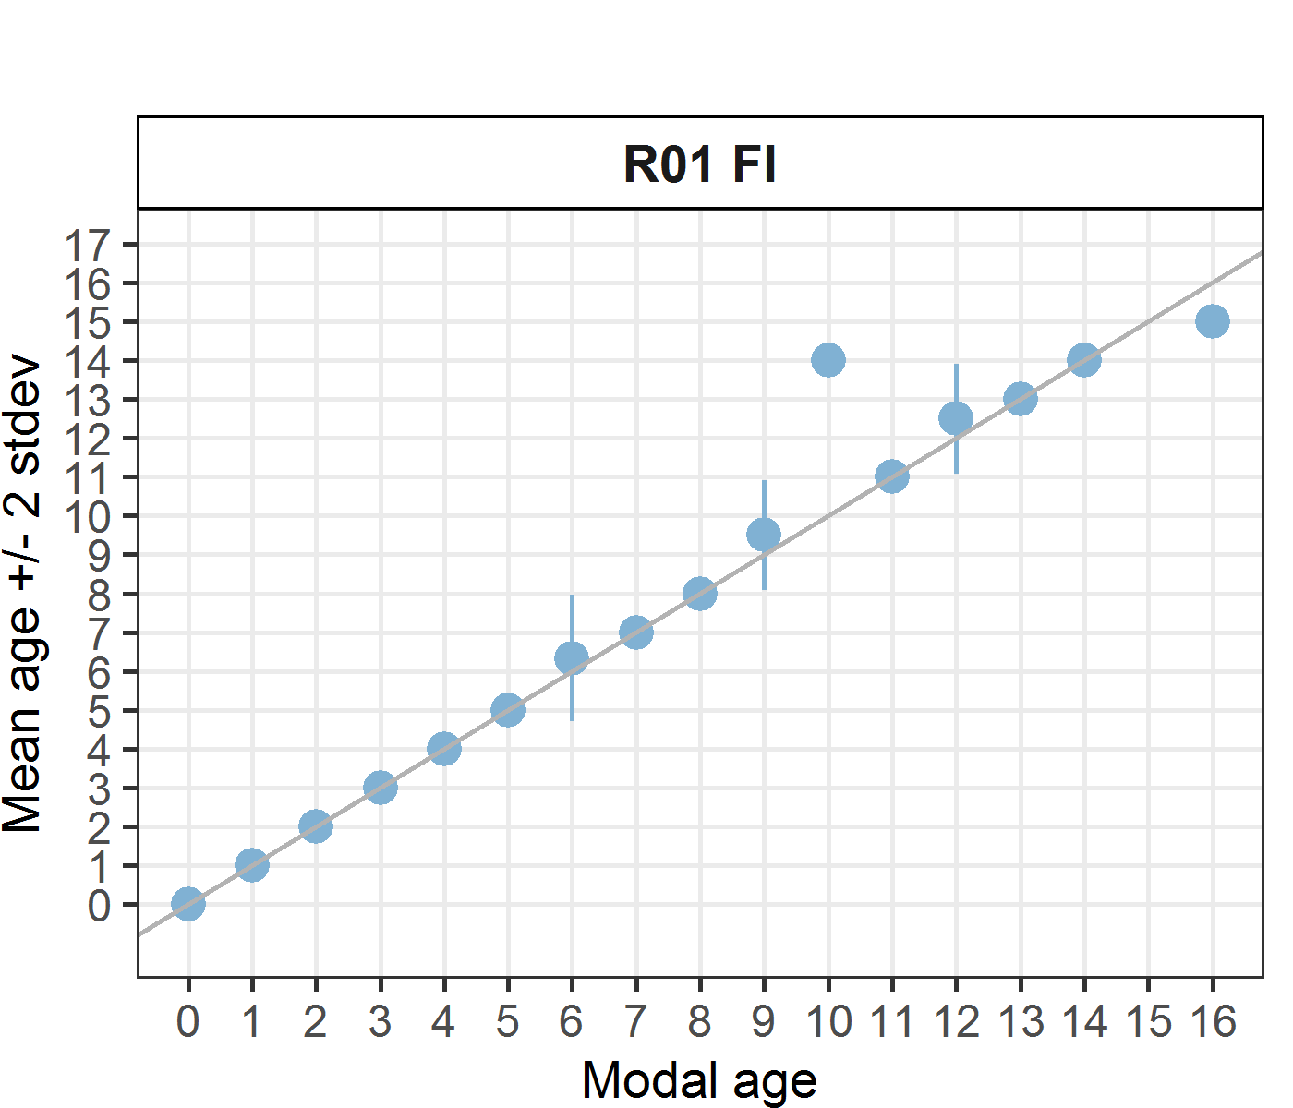 [[2]] 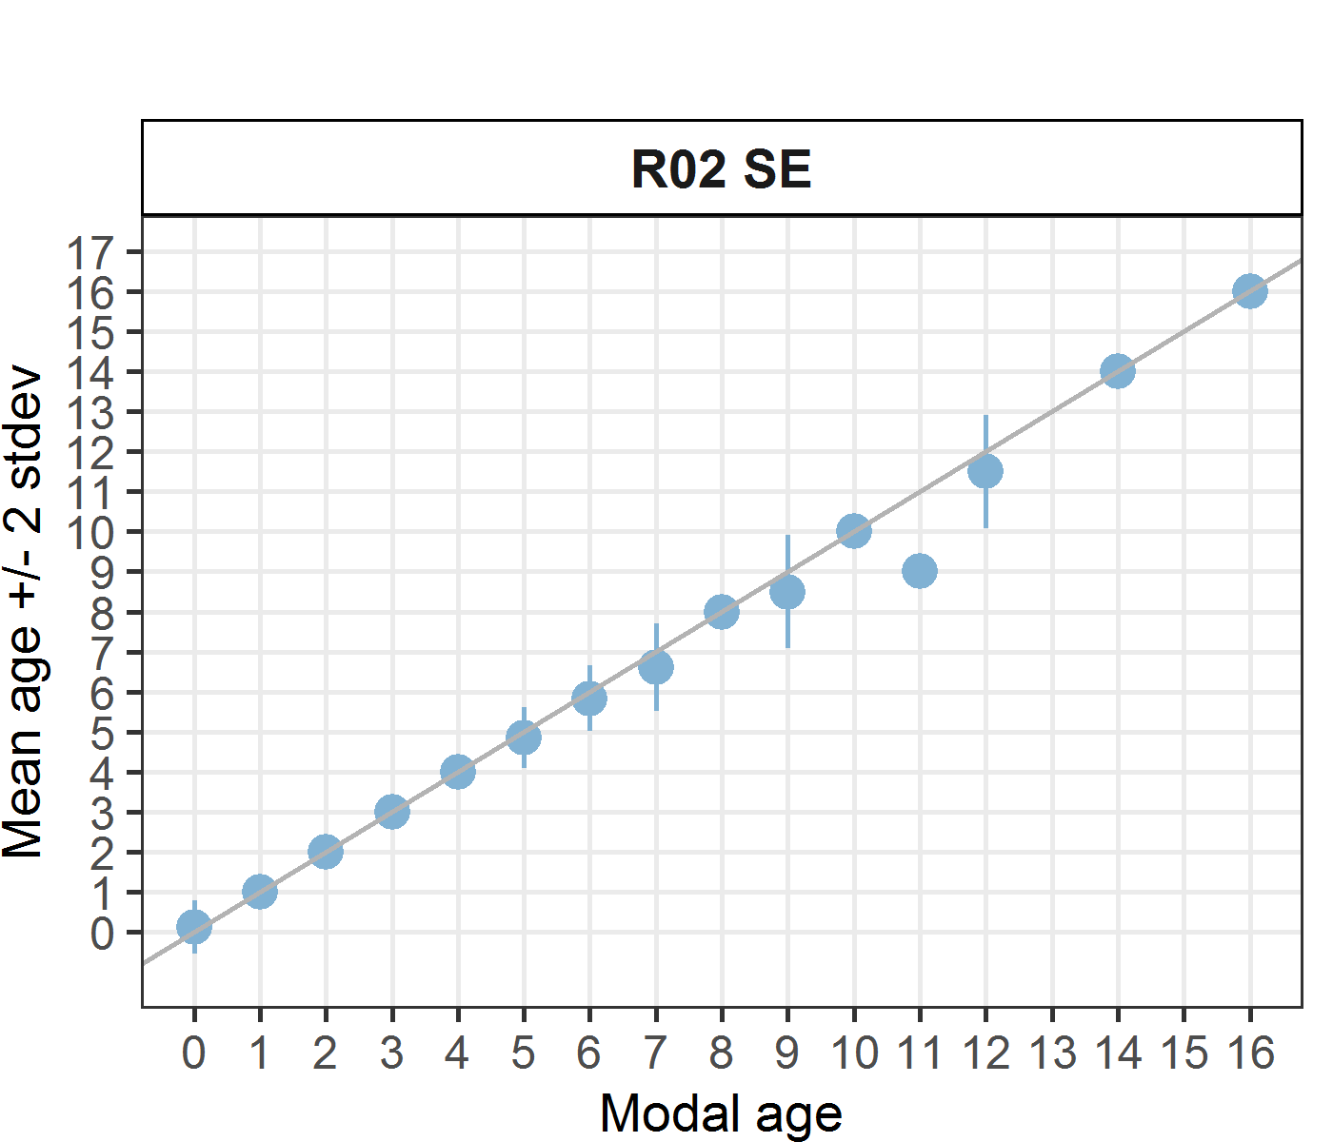 [[3]] 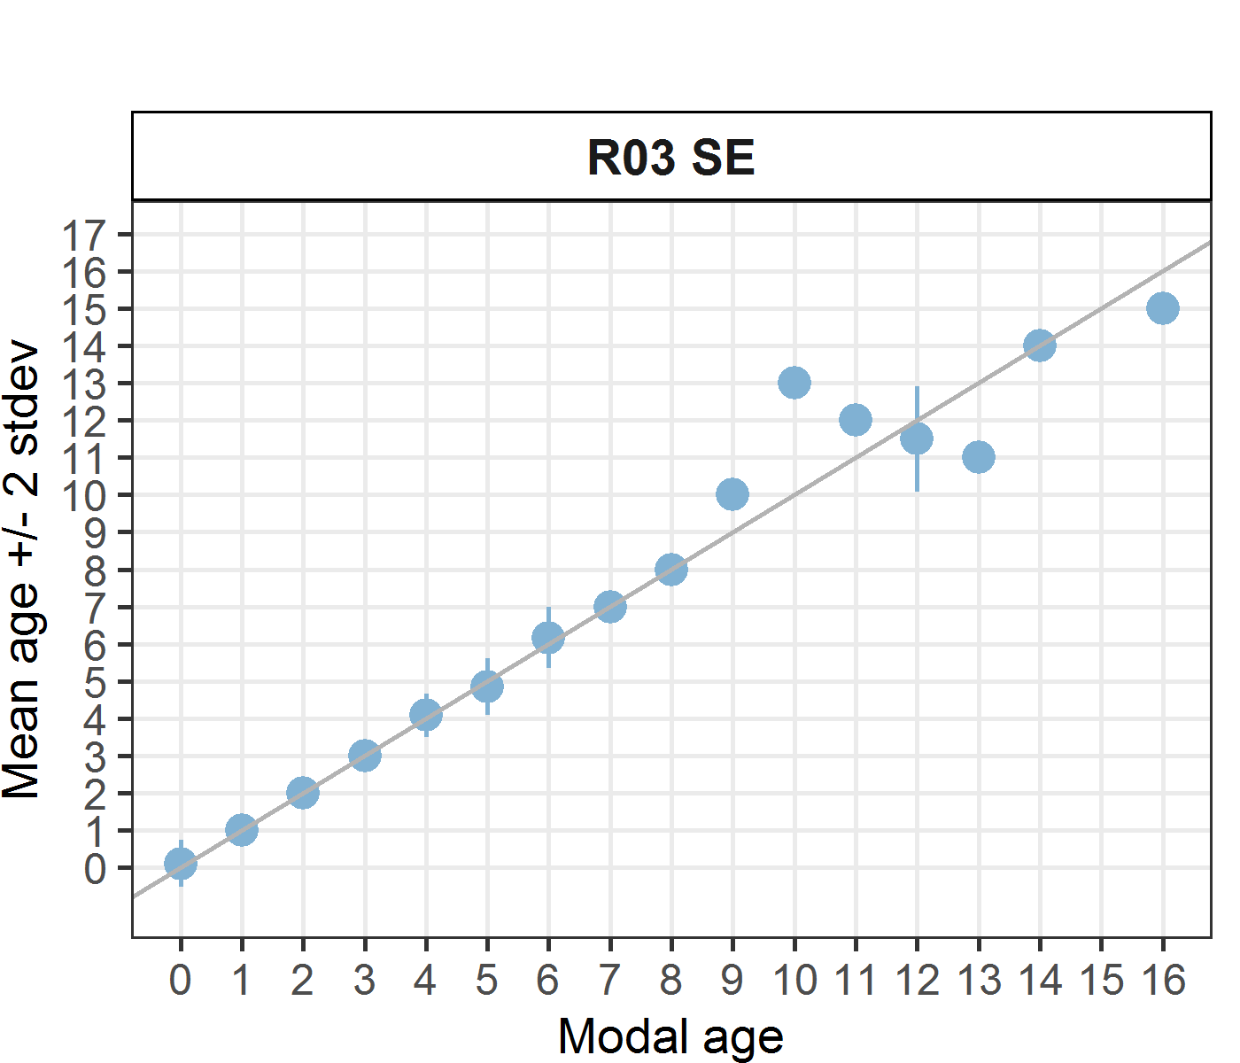 [[4]] 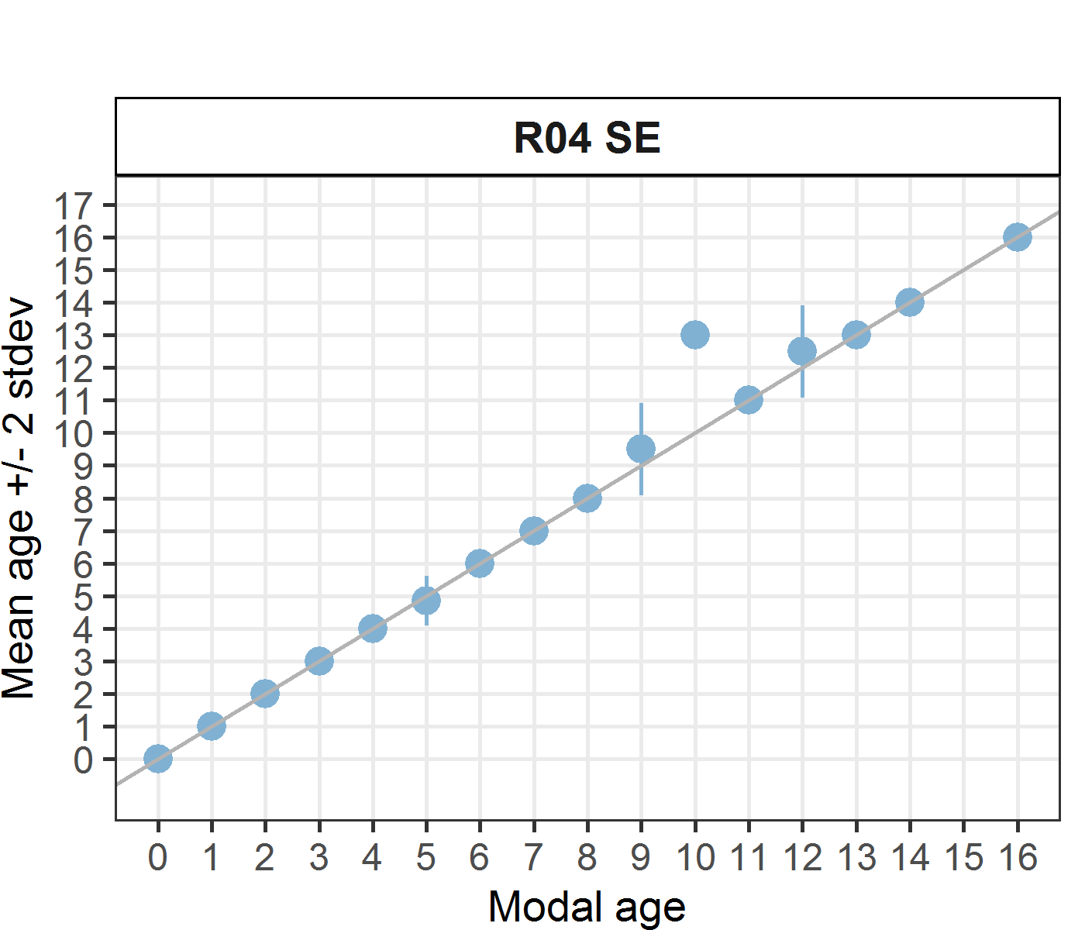 [[5]] 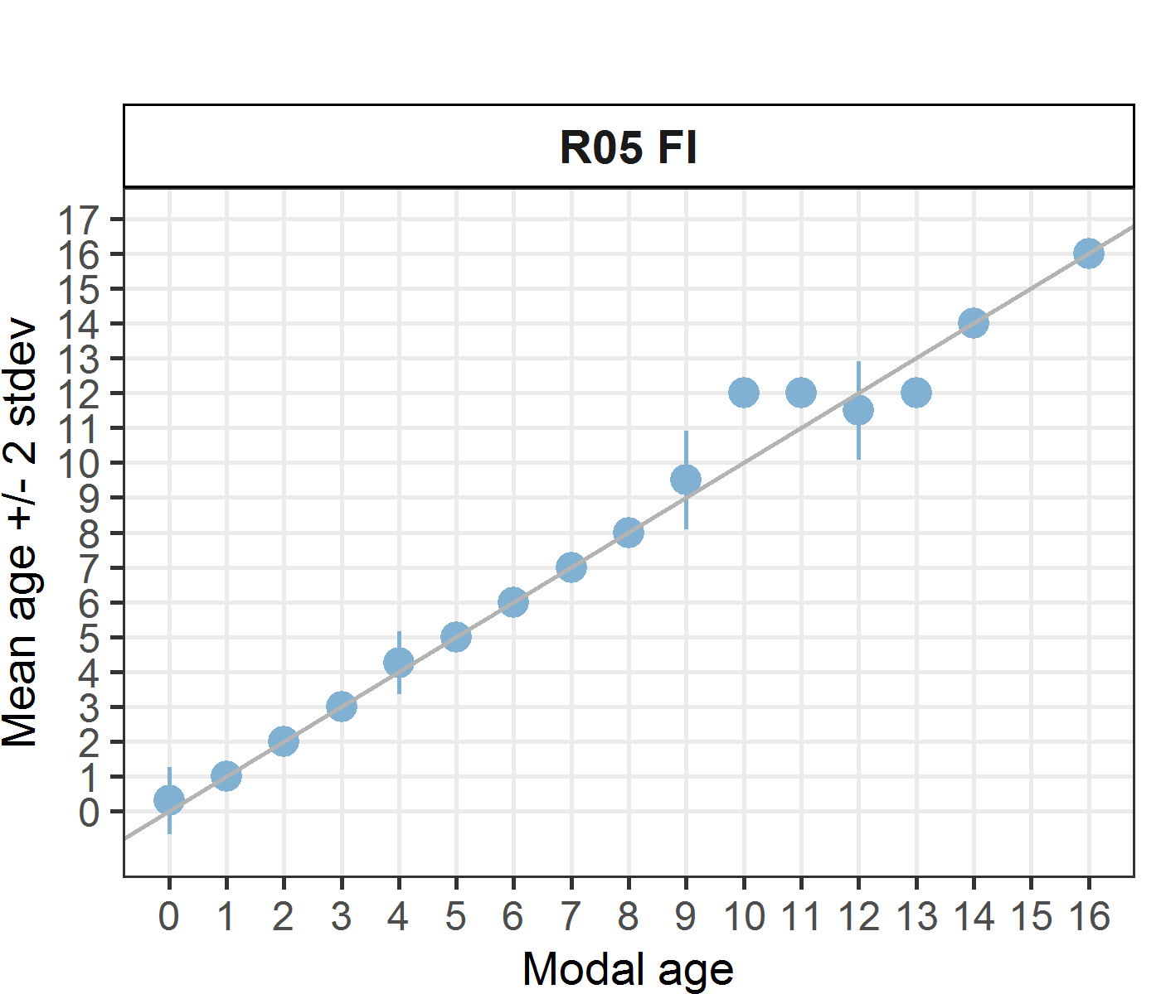 [[6]] 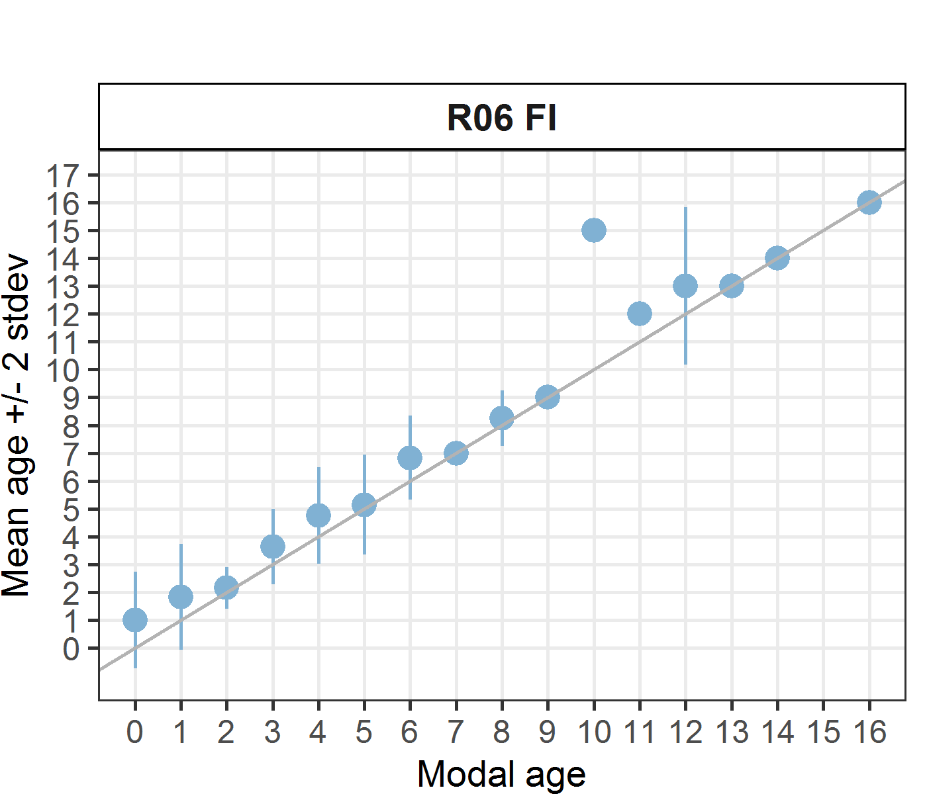 [[7]] 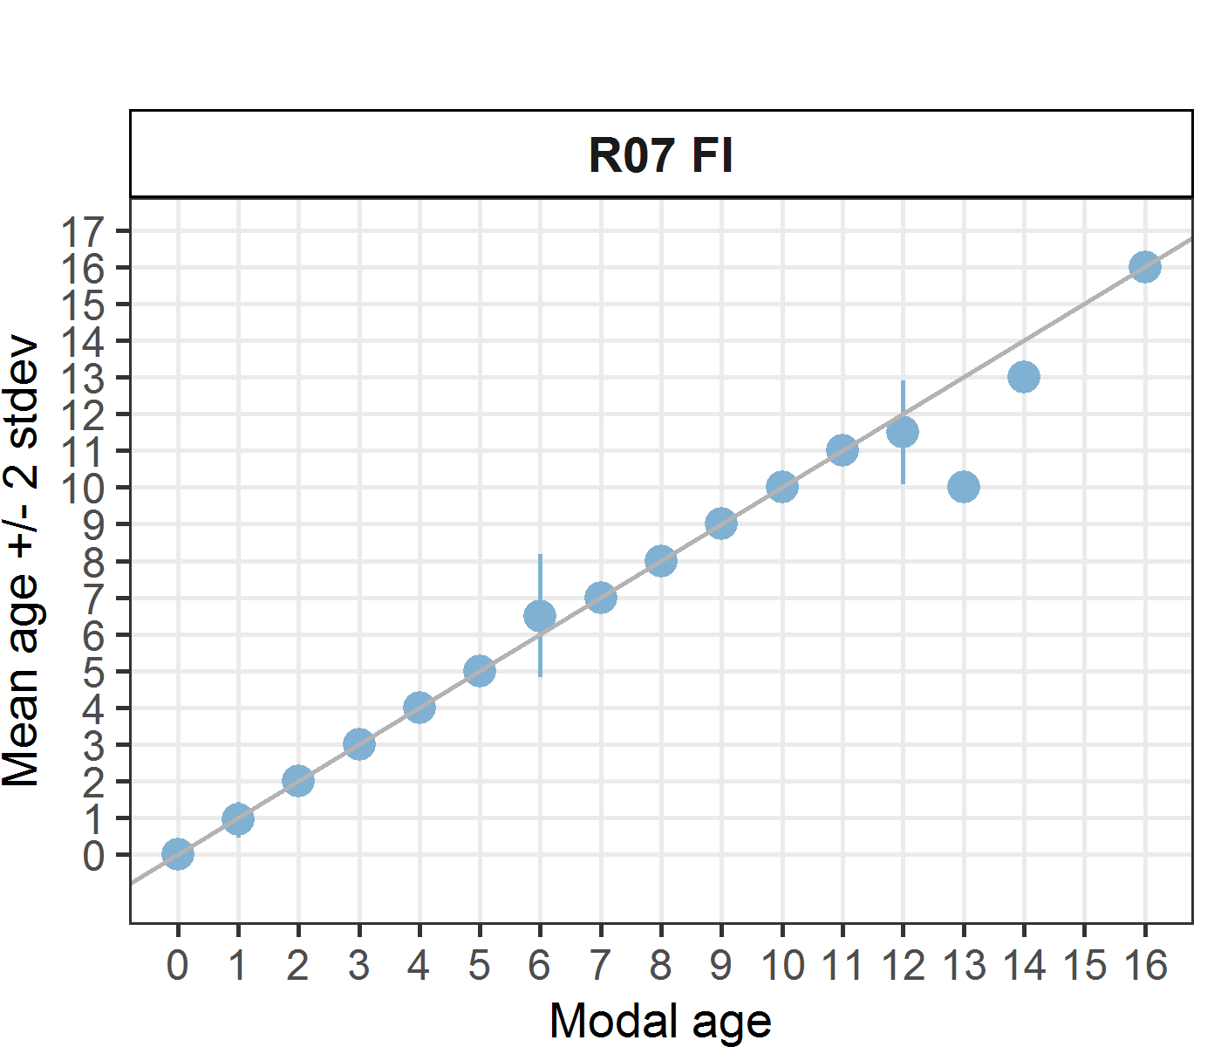
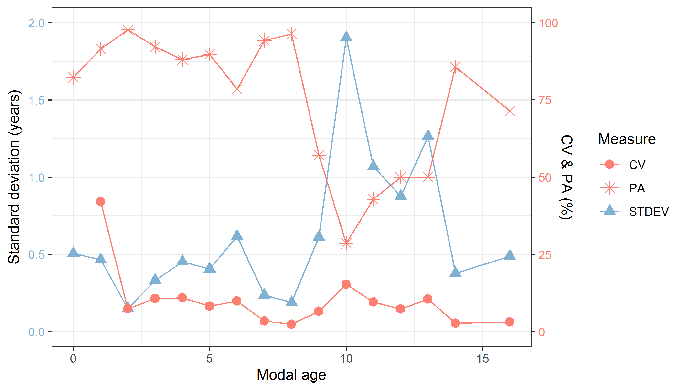
Figure 6: CV, PA and (STDEV (standard deviation) are plotted against modal age
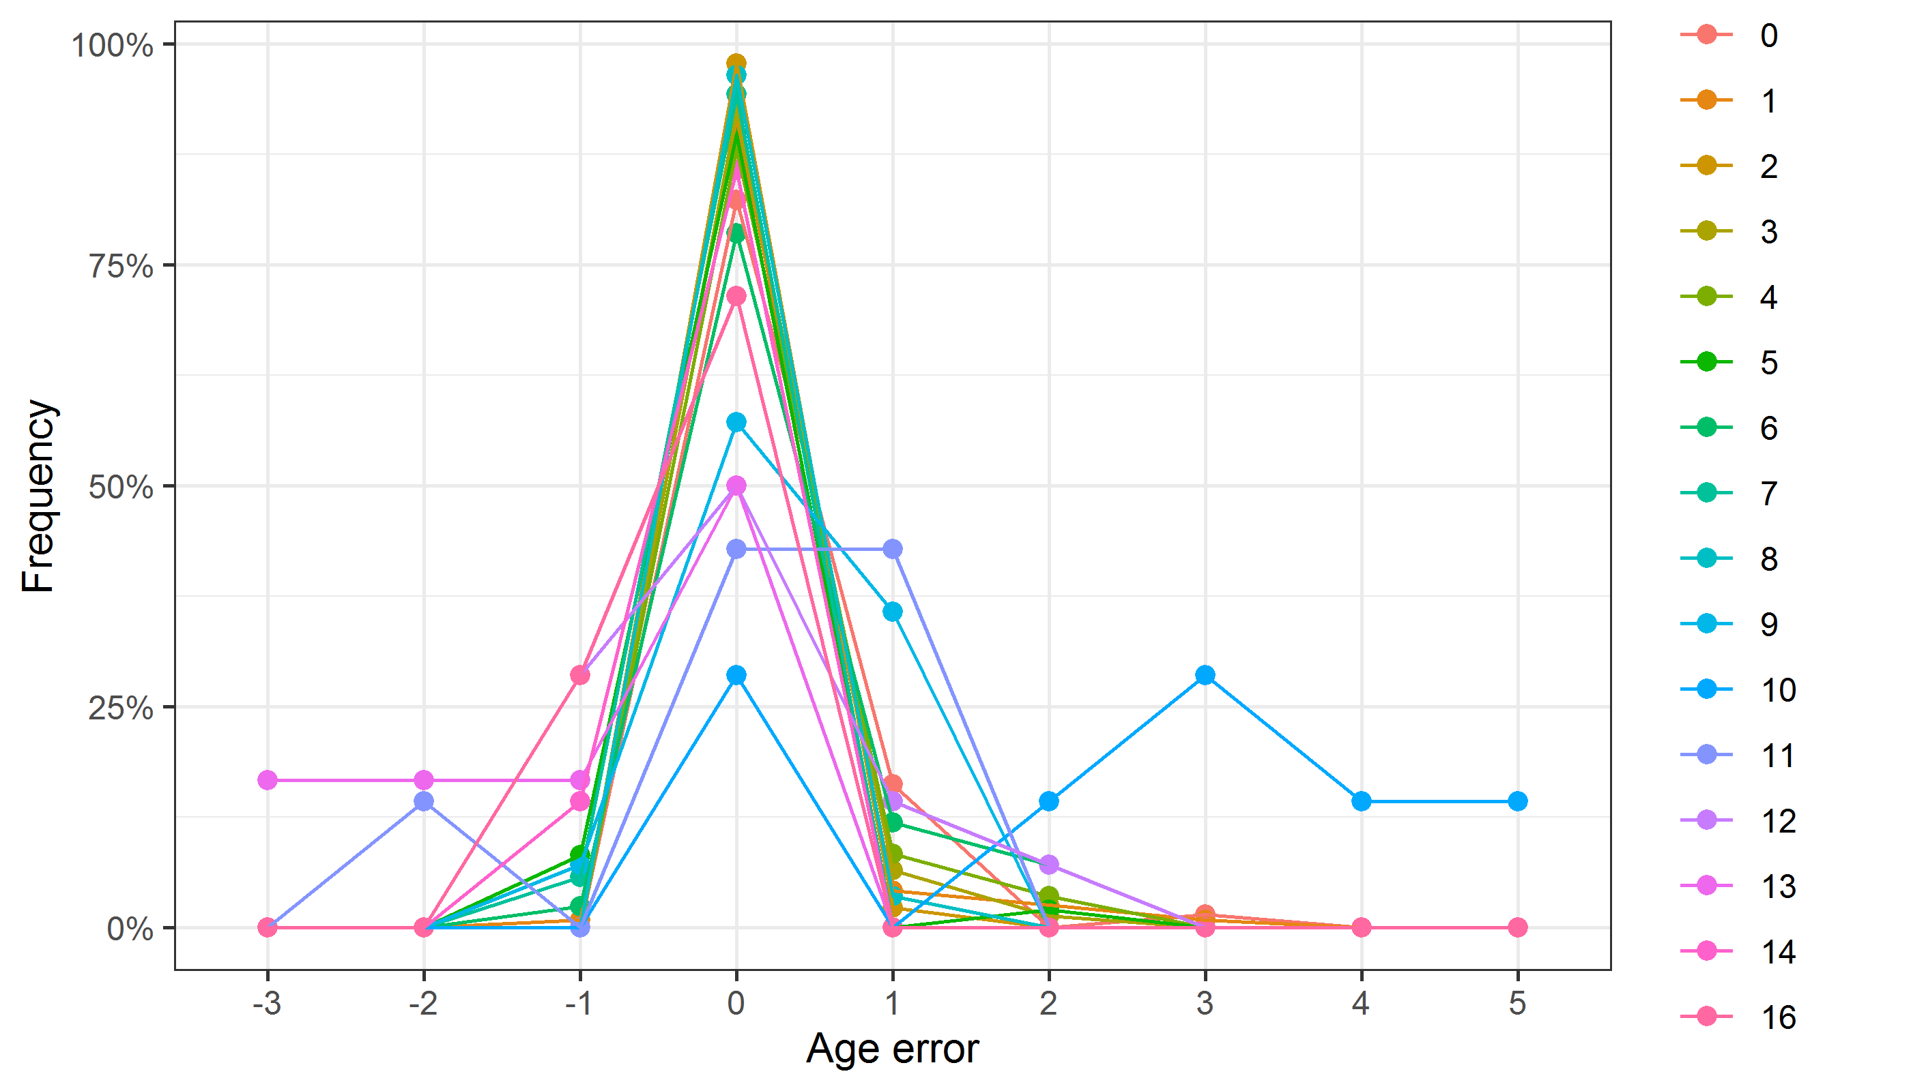
Figure 7: The distribution of the age reading errors in percentage by modal age as observed from the whole group of age readers in an age reading comparison to modal age. The achieved precision in age reading by MODAL age group is shown by the spread of the age readings errors. There appears to be no relative bias, if the age reading errors are normally distributed. The distributions are skewed, if relative bias occurs.
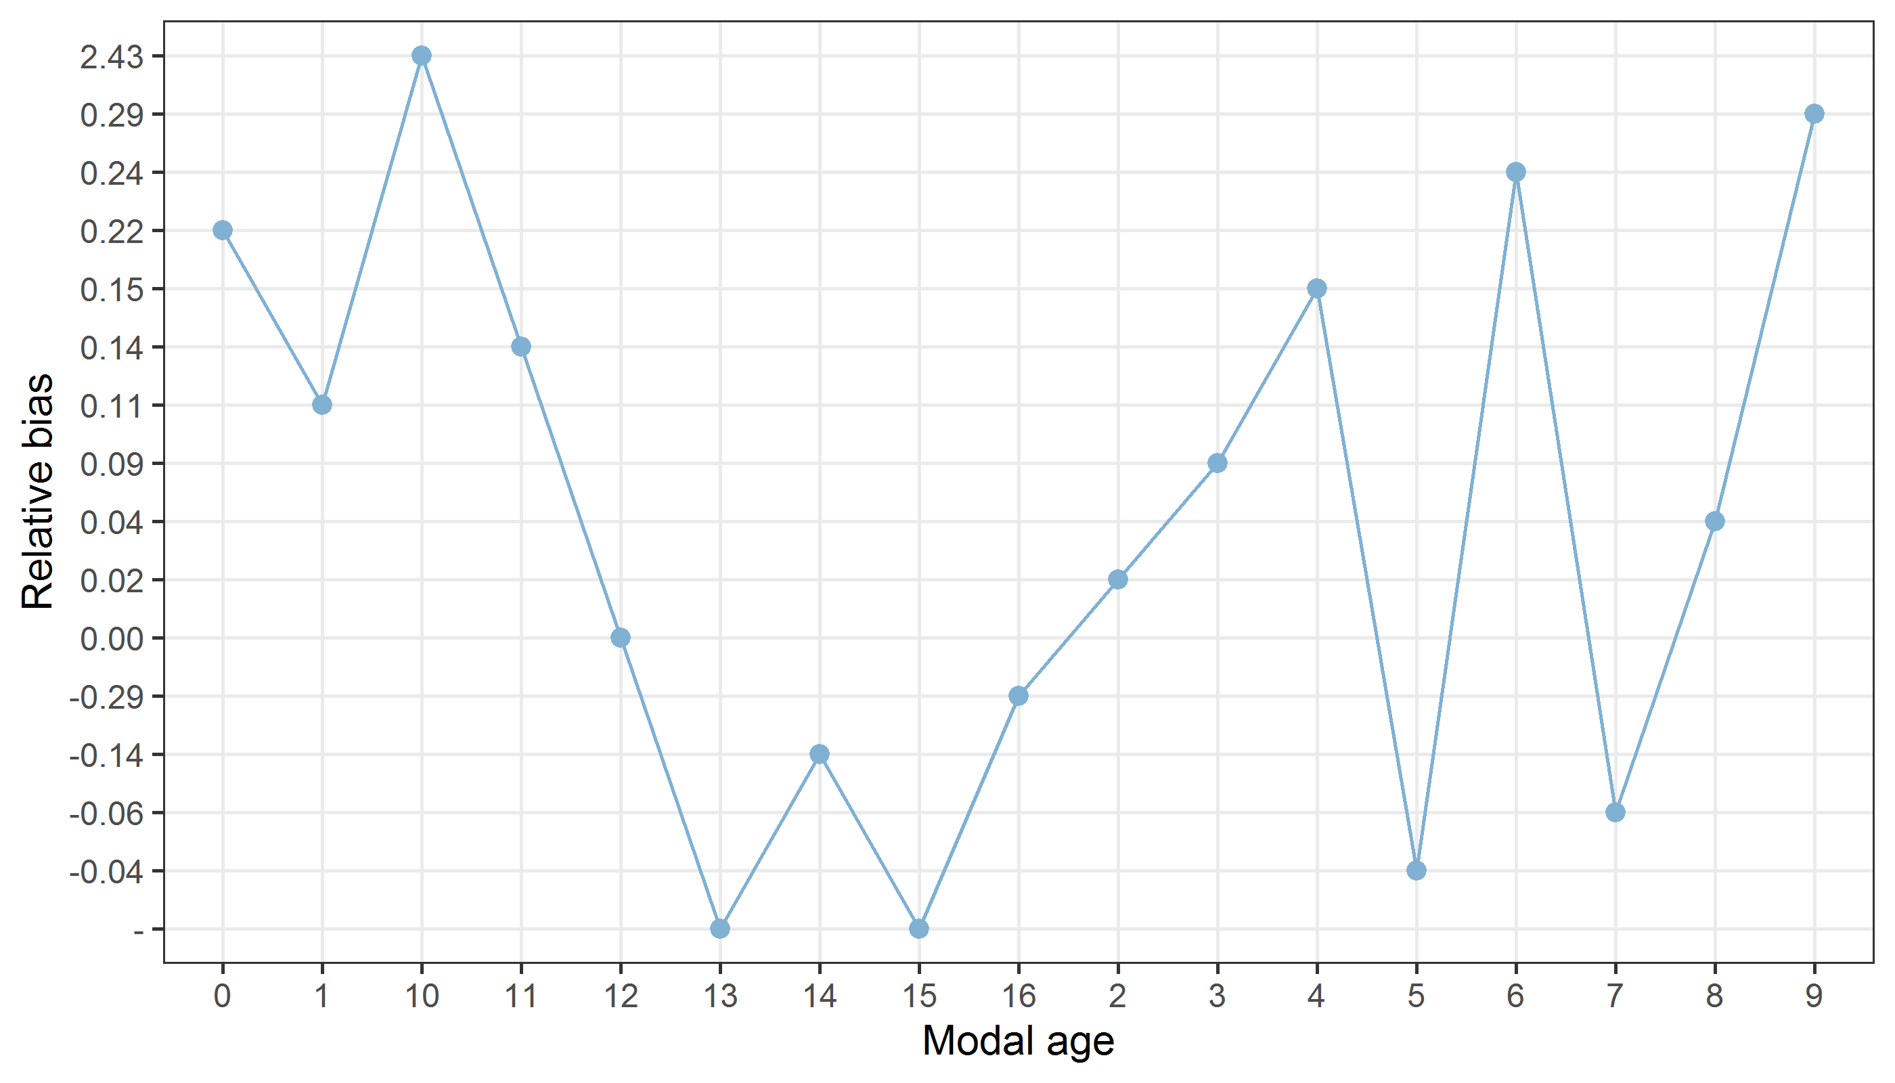
Figure 8: The relative bias by modal age as estimated by all age readers combined.
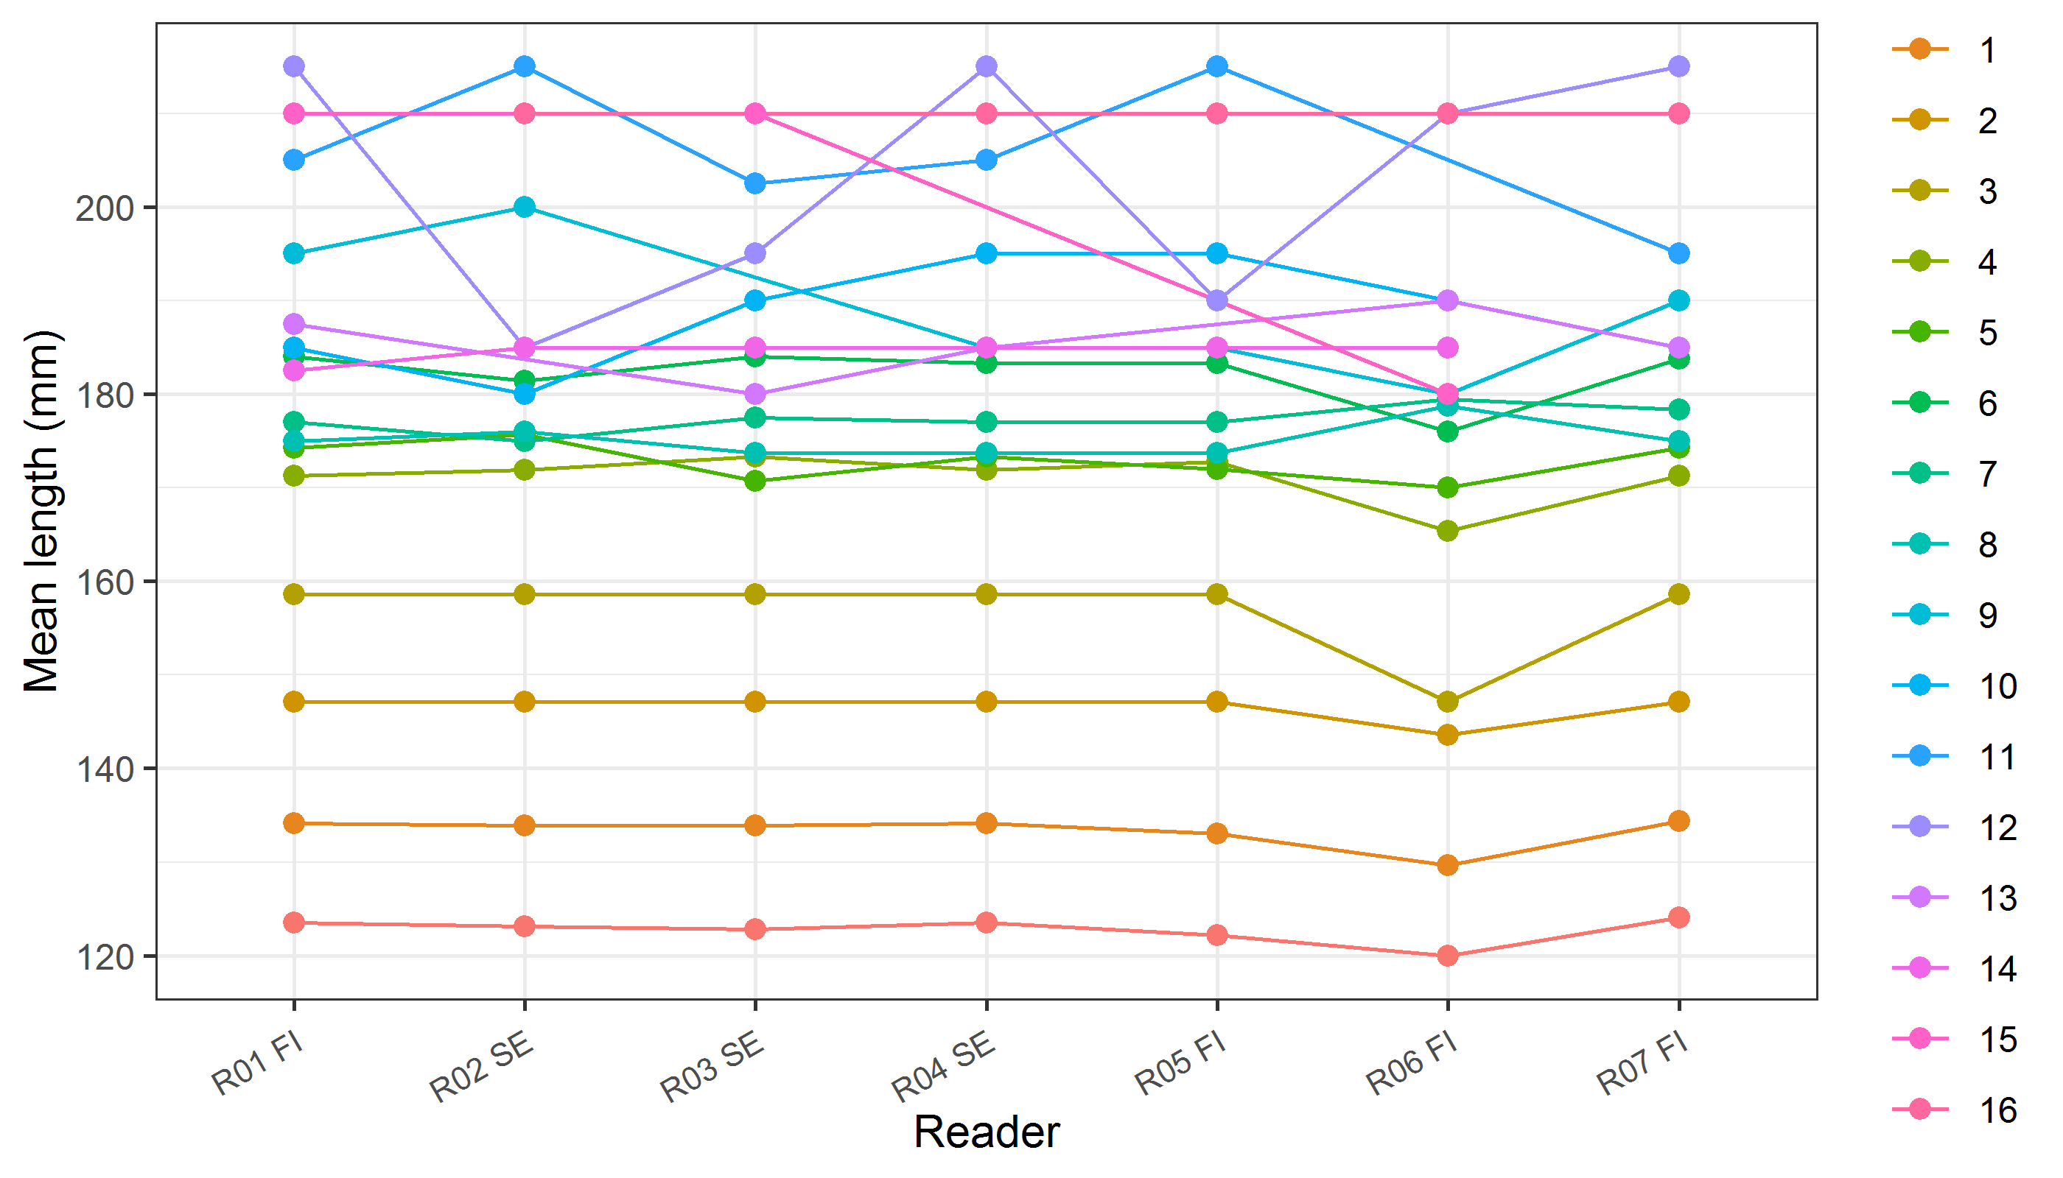
Figure 9: The mean length at age as estimated by each age reader.

Results Advanced readers
All samples included
Data Overview
Table 26: Data overview including modal age and statistics per sample.
Fish ID | Event ID | Image ID | length | sex | Catch date | ICES area | R01 FI | R02 SE | R03 SE | R04 SE | Modal age | PA % | CV % | APE %
1 | 250 | - | 215 | - | 04/10/2018 00:00:00 | 27.3.d.30 | 12 | 11 | 11 | 12 | 11 | 50 | 5 | 4
10 | 250 | - | 185 | - | 04/10/2018 00:00:00 | 27.3.d.30 | 8 | 8 | 8 | 8 | 8 | 100 | 0 | 0
11 | 250 | - | 185 | - | 04/10/2018 00:00:00 | 27.3.d.30 | 5 | 5 | 5 | 5 | 5 | 100 | 0 | 0
12 | 250 | - | 185 | - | 04/10/2018 00:00:00 | 27.3.d.30 | 5 | 5 | 5 | 5 | 5 | 100 | 0 | 0
13 | 250 | - | 185 | - | 04/10/2018 00:00:00 | 27.3.d.30 | 4 | 4 | 4 | 4 | 4 | 100 | 0 | 0
14 | 250 | - | 185 | - | 04/10/2018 00:00:00 | 27.3.d.30 | 6 | 6 | 6 | 6 | 6 | 100 | 0 | 0
15 | 250 | - | 180 | - | 04/10/2018 00:00:00 | 27.3.d.30 | 4 | 4 | 4 | 4 | 4 | 100 | 0 | 0
16 | 250 | - | 180 | - | 04/10/2018 00:00:00 | 27.3.d.30 | 4 | 4 | 4 | 4 | 4 | 100 | 0 | 0
17 | 250 | - | 180 | - | 04/10/2018 00:00:00 | 27.3.d.30 | 8 | 6 | 7 | 6 | 6 | 50 | 14 | 11
18 | 250 | - | 180 | - | 04/10/2018 00:00:00 | 27.3.d.30 | 4 | 4 | 4 | 4 | 4 | 100 | 0 | 0
19 | 250 | - | 180 | - | 04/10/2018 00:00:00 | 27.3.d.30 | 7 | 7 | 7 | 7 | 7 | 100 | 0 | 0
2 | 250 | - | 210 | - | 04/10/2018 00:00:00 | 27.3.d.30 | 15 | 16 | 15 | 16 | 15 | 50 | 4 | 3
20 | 250 | - | 175 | - | 04/10/2018 00:00:00 | 27.3.d.30 | 4 | 4 | 4 | 4 | 4 | 100 | 0 | 0
21 | 250 | - | 175 | - | 04/10/2018 00:00:00 | 27.3.d.30 | 7 | 6 | 7 | 7 | 7 | 75 | 7 | 6
22 | 250 | - | 175 | - | 04/10/2018 00:00:00 | 27.3.d.30 | 5 | 5 | 5 | 5 | 5 | 100 | 0 | 0
23 | 250 | - | 125 | - | 04/10/2018 00:00:00 | 27.3.d.30 | 1 | 1 | 1 | 1 | 1 | 100 | 0 | 0
24 | 250 | - | 130 | - | 04/10/2018 00:00:00 | 27.3.d.30 | 2 | 2 | 2 | 2 | 2 | 100 | 0 | 0
25 | 250 | - | 130 | - | 04/10/2018 00:00:00 | 27.3.d.30 | 1 | 1 | 1 | 1 | 1 | 100 | 0 | 0
26 | 250 | - | 130 | - | 04/10/2018 00:00:00 | 27.3.d.30 | 2 | 2 | 2 | 2 | 2 | 100 | 0 | 0
27 | 250 | - | 135 | - | 04/10/2018 00:00:00 | 27.3.d.30 | 1 | 1 | 1 | 1 | 1 | 100 | 0 | 0
28 | 250 | - | 140 | - | 04/10/2018 00:00:00 | 27.3.d.30 | 2 | 2 | 2 | 2 | 2 | 100 | 0 | 0
29 | 250 | - | 145 | - | 04/10/2018 00:00:00 | 27.3.d.30 | 2 | 2 | 2 | 2 | 2 | 100 | 0 | 0
3 | 250 | - | 205 | - | 04/10/2018 00:00:00 | 27.3.d.30 | 11 | 9 | 12 | 11 | 11 | 50 | 12 | 8
30 | 250 | - | 145 | - | 04/10/2018 00:00:00 | 27.3.d.30 | 2 | 2 | 2 | 2 | 2 | 100 | 0 | 0
31 | 250 | - | 150 | - | 04/10/2018 00:00:00 | 27.3.d.30 | 2 | 2 | 2 | 2 | 2 | 100 | 0 | 0
32 | 250 | - | 150 | - | 04/10/2018 00:00:00 | 27.3.d.30 | 2 | 2 | 2 | 2 | 2 | 100 | 0 | 0
33 | 250 | - | 155 | - | 04/10/2018 00:00:00 | 27.3.d.30 | 2 | 2 | 2 | 2 | 2 | 100 | 0 | 0
34 | 250 | - | 155 | - | 04/10/2018 00:00:00 | 27.3.d.30 | 4 | 4 | 5 | 4 | 4 | 75 | 12 | 9
35 | 250 | - | 160 | - | 04/10/2018 00:00:00 | 27.3.d.30 | 2 | 2 | 2 | 2 | 2 | 100 | 0 | 0
36 | 250 | - | 165 | - | 04/10/2018 00:00:00 | 27.3.d.30 | 3 | 3 | 3 | 3 | 3 | 100 | 0 | 0
37 | 250 | - | 170 | - | 04/10/2018 00:00:00 | 27.3.d.30 | 3 | 3 | 3 | 3 | 3 | 100 | 0 | 0
38 | 250 | - | 170 | - | 04/10/2018 00:00:00 | 27.3.d.30 | 4 | 4 | 4 | 4 | 4 | 100 | 0 | 0
39 | 250 | - | 170 | - | 04/10/2018 00:00:00 | 27.3.d.30 | 2 | 2 | 2 | 2 | 2 | 100 | 0 | 0
4 | 250 | - | 195 | - | 04/10/2018 00:00:00 | 27.3.d.30 | 9 | 9 | 10 | 10 | 9 | 50 | 6 | 5
40 | 250 | - | 160 | - | 04/10/2018 00:00:00 | 27.3.d.30 | 3 | 3 | 3 | 3 | 3 | 100 | 0 | 0
41 | 250 | - | 160 | - | 04/10/2018 00:00:00 | 27.3.d.30 | 4 | 4 | 4 | 4 | 4 | 100 | 0 | 0
42 | 250 | - | 155 | - | 04/10/2018 00:00:00 | 27.3.d.30 | 3 | 3 | 3 | 3 | 3 | 100 | 0 | 0
43 | 250 | - | 150 | - | 04/10/2018 00:00:00 | 27.3.d.30 | 3 | 3 | 3 | 3 | 3 | 100 | 0 | 0
44 | 250 | - | 145 | - | 04/10/2018 00:00:00 | 27.3.d.30 | 2 | 2 | 2 | 2 | 2 | 100 | 0 | 0
45 | 250 | - | 165 | - | 04/10/2018 00:00:00 | 27.3.d.30 | 5 | 5 | 5 | 5 | 5 | 100 | 0 | 0
46 | 250 | - | 145 | - | 04/10/2018 00:00:00 | 27.3.d.30 | 2 | 2 | 2 | 2 | 2 | 100 | 0 | 0
47 | 250 | - | 135 | - | 04/10/2018 00:00:00 | 27.3.d.30 | 2 | 2 | 2 | 2 | 2 | 100 | 0 | 0
48 | 250 | - | 140 | - | 04/10/2018 00:00:00 | 27.3.d.30 | 1 | 1 | 1 | 1 | 1 | 100 | 0 | 0
49 | 250 | - | 135 | - | 04/10/2018 00:00:00 | 27.3.d.30 | 1 | 1 | 1 | 1 | 1 | 100 | 0 | 0
5 | 250 | - | 190 | - | 04/10/2018 00:00:00 | 27.3.d.30 | 6 | 5 | 6 | 6 | 6 | 75 | 9 | 7
50 | 250 | - | 185 | - | 04/10/2018 00:00:00 | 27.3.d.30 | 14 | 14 | 14 | 14 | 14 | 100 | 0 | 0
6 | 250 | - | 190 | - | 04/10/2018 00:00:00 | 27.3.d.30 | 6 | 6 | 6 | 6 | 6 | 100 | 0 | 0
7 | 250 | - | 190 | - | 04/10/2018 00:00:00 | 27.3.d.30 | 13 | - | 11 | 13 | 13 | 67 | 9 | 7
8 | 250 | - | 185 | - | 04/10/2018 00:00:00 | 27.3.d.30 | 4 | 4 | 4 | 4 | 4 | 100 | 0 | 0
9 | 250 | - | 185 | - | 04/10/2018 00:00:00 | 27.3.d.30 | 6 | 6 | 6 | 6 | 6 | 100 | 0 | 0
Herring BIAS 2018 haul50G7 id50 | 250 | - | 120 | - | 01/10/2018 00:00:00 | 27.3.d.30 | 0 | 0 | 0 | 0 | 0 | 100 | - | -
Herring BIAS 2018 haul50G7 id52 | 250 | - | 120 | - | 01/10/2018 00:00:00 | 27.3.d.30 | 0 | 0 | 0 | 0 | 0 | 100 | - | -
Herring BIAS 2018 haul50G7 id53 | 250 | - | 120 | - | 01/10/2018 00:00:00 | 27.3.d.30 | 0 | 0 | 0 | 0 | 0 | 100 | - | -
Herring BIAS 2018 haul50G7 id54 | 250 | - | 120 | - | 01/10/2018 00:00:00 | 27.3.d.30 | 0 | 0 | 0 | 0 | 0 | 100 | - | -
Herring BIAS 2018 haul50G7 id56 | 250 | - | 120 | - | 01/10/2018 00:00:00 | 27.3.d.30 | 0 | - | 0 | 0 | 0 | 100 | - | -
Herring BIAS 2018 haul50G7 id57 | 250 | - | 125 | - | 01/10/2018 00:00:00 | 27.3.d.30 | 0 | 0 | 0 | 0 | 0 | 100 | - | -
Herring BIAS 2018 haul50G7 id59 | 250 | - | 125 | - | 01/10/2018 00:00:00 | 27.3.d.30 | 0 | 0 | 0 | 0 | 0 | 100 | - | -
Herring BIAS 2018 haul50G7 id61 | 250 | - | 125 | - | 01/10/2018 00:00:00 | 27.3.d.30 | 1 | 1 | 1 | 1 | 1 | 100 | 0 | 0
Herring BIAS 2018 haul50G7 id64 | 250 | - | 125 | - | 01/10/2018 00:00:00 | 27.3.d.30 | 0 | 0 | 0 | 0 | 0 | 100 | - | -
Herring BIAS 2018 haul50G7 id67_e | 250 | - | 130 | - | 01/10/2018 00:00:00 | 27.3.d.30 | 1 | 1 | 1 | 1 | 1 | 100 | 0 | 0
Herring BIAS 2018 haul50G7 id68_e | 250 | - | 130 | - | 01/10/2018 00:00:00 | 27.3.d.30 | 0 | 1 | 1 | 0 | 0 | 50 | - | -
Herring BIAS 2018 haul50G7 id71 | 250 | - | 130 | - | 01/10/2018 00:00:00 | 27.3.d.30 | 1 | 1 | 1 | 1 | 1 | 100 | 0 | 0
Herring BIAS 2018 haul50G7 id73 | 250 | - | 130 | - | 01/10/2018 00:00:00 | 27.3.d.30 | 1 | 1 | 1 | 1 | 1 | 100 | 0 | 0
Herring BIAS 2018 haul50G7 id74 | 250 | - | 130 | - | 01/10/2018 00:00:00 | 27.3.d.30 | 1 | 1 | 1 | 1 | 1 | 100 | 0 | 0
Herring BIAS 2018 haul50G7 id76 | 250 | - | 130 | - | 01/10/2018 00:00:00 | 27.3.d.30 | 0 | 0 | 0 | 0 | 0 | 100 | - | -
Herring BIAS 2018 haul50G7 id77 | 250 | - | 135 | - | 01/10/2018 00:00:00 | 27.3.d.30 | 1 | 1 | 1 | 1 | 1 | 100 | 0 | 0
Herring BIAS 2018 haul50G7 id78 | 250 | - | 135 | - | 01/10/2018 00:00:00 | 27.3.d.30 | 1 | 1 | 1 | 1 | 1 | 100 | 0 | 0
Herring BIAS 2018 haul50G7 id80 | 250 | - | 135 | - | 01/10/2018 00:00:00 | 27.3.d.30 | 1 | 1 | 1 | 1 | 1 | 100 | 0 | 0
Herring BIAS 2018 haul50G7 id81 | 250 | - | 135 | - | 01/10/2018 00:00:00 | 27.3.d.30 | 2 | 2 | 2 | 2 | 2 | 100 | 0 | 0
Herring BIAS 2018 haul50G7 id83 | 250 | - | 135 | - | 01/10/2018 00:00:00 | 27.3.d.30 | 1 | 1 | 1 | 1 | 1 | 100 | 0 | 0
Herring BIAS 2018 haul52G7-1 id11 | 250 | - | 150 | - | 02/10/2018 00:00:00 | 27.3.d.30 | 4 | 4 | 4 | 4 | 4 | 100 | 0 | 0
Herring BIAS 2018 haul52G7-1 id15 | 250 | - | 150 | - | 02/10/2018 00:00:00 | 27.3.d.30 | 3 | 3 | 3 | 3 | 3 | 100 | 0 | 0
Herring BIAS 2018 haul52G7-1 id17 | 250 | - | 150 | - | 02/10/2018 00:00:00 | 27.3.d.30 | 3 | 3 | 3 | 3 | 3 | 100 | 0 | 0
Herring BIAS 2018 haul52G7-1 id18 | 250 | - | 155 | - | 02/10/2018 00:00:00 | 27.3.d.30 | 3 | 3 | 3 | 3 | 3 | 100 | 0 | 0
Herring BIAS 2018 haul52G7-1 id20 | 250 | - | 155 | - | 02/10/2018 00:00:00 | 27.3.d.30 | 3 | 3 | 3 | 3 | 3 | 100 | 0 | 0
Herring BIAS 2018 haul52G7-1 id22 | 250 | - | 155 | - | 02/10/2018 00:00:00 | 27.3.d.30 | 5 | 5 | 5 | 5 | 5 | 100 | 0 | 0
Herring BIAS 2018 haul52G7-1 id24 | 250 | - | 155 | - | 02/10/2018 00:00:00 | 27.3.d.30 | 4 | 4 | 4 | 4 | 4 | 100 | 0 | 0
Herring BIAS 2018 haul52G7-1 id25 | 250 | - | 155 | - | 02/10/2018 00:00:00 | 27.3.d.30 | 2 | 2 | 2 | 2 | 2 | 100 | 0 | 0
Herring BIAS 2018 haul52G7-1 id28 | 250 | - | 160 | - | 02/10/2018 00:00:00 | 27.3.d.30 | 2 | 2 | 2 | 2 | 2 | 100 | 0 | 0
Herring BIAS 2018 haul52G7-1 id30 | 250 | - | 160 | - | 02/10/2018 00:00:00 | 27.3.d.30 | 2 | 2 | 2 | 2 | 2 | 100 | 0 | 0
Herring BIAS 2018 haul52G7-1 id31 | 250 | - | 160 | - | 02/10/2018 00:00:00 | 27.3.d.30 | 3 | 3 | 3 | 3 | 3 | 100 | 0 | 0
Herring BIAS 2018 haul52G7-1 id34_e | 250 | - | 160 | - | 02/10/2018 00:00:00 | 27.3.d.30 | 8 | 8 | 8 | 8 | 8 | 100 | 0 | 0
Herring BIAS 2018 haul52G7-1 id4 | 250 | - | 140 | - | 02/10/2018 00:00:00 | 27.3.d.30 | 1 | 1 | 1 | 1 | 1 | 100 | 0 | 0
Herring BIAS 2018 haul52G7-1 id5 | 250 | - | 140 | - | 02/10/2018 00:00:00 | 27.3.d.30 | 2 | 2 | 2 | 2 | 2 | 100 | 0 | 0
Herring BIAS 2018 haul52G7-1 id6 | 250 | - | 145 | - | 02/10/2018 00:00:00 | 27.3.d.30 | 2 | 2 | 2 | 2 | 2 | 100 | 0 | 0
Herring BIAS 2018 haul52G7-1 id7 | 250 | - | 145 | - | 02/10/2018 00:00:00 | 27.3.d.30 | 1 | 1 | 1 | 1 | 1 | 100 | 0 | 0
Herring BIAS 2018 haul52G7-1 id8 | 250 | - | 145 | - | 02/10/2018 00:00:00 | 27.3.d.30 | 1 | 1 | 1 | 1 | 1 | 100 | 0 | 0
Herring BIAS 2018 haul55G9-1 id101 | 250 | - | 170 | - | 04/10/2018 00:00:00 | 27.3.d.30 | 6 | 6 | 6 | 6 | 6 | 100 | 0 | 0
Herring BIAS 2018 haul55G9-1 id102_e | 250 | - | 170 | - | 04/10/2018 00:00:00 | 27.3.d.30 | 8 | 8 | 8 | 8 | 8 | 100 | 0 | 0
Herring BIAS 2018 haul55G9-1 id105 | 250 | - | 170 | - | 04/10/2018 00:00:00 | 27.3.d.30 | 7 | 7 | 7 | 7 | 7 | 100 | 0 | 0
Herring BIAS 2018 haul55G9-1 id106 | 250 | - | 175 | - | 04/10/2018 00:00:00 | 27.3.d.30 | 7 | 7 | 7 | 7 | 7 | 100 | 0 | 0
Herring BIAS 2018 haul55G9-1 id107 | 250 | - | 175 | - | 04/10/2018 00:00:00 | 27.3.d.30 | 3 | 3 | 3 | 3 | 3 | 100 | 0 | 0
Herring BIAS 2018 haul55G9-1 id110_e | 250 | - | 175 | - | 04/10/2018 00:00:00 | 27.3.d.30 | 5 | 5 | 5 | 5 | 5 | 100 | 0 | 0
Herring BIAS 2018 haul55G9-1 id116_e | 250 | - | 180 | - | 04/10/2018 00:00:00 | 27.3.d.30 | 5 | 4 | 4 | 4 | 4 | 75 | 12 | 9
Herring BIAS 2018 haul55G9-1 id119_e | 250 | - | 180 | - | 04/10/2018 00:00:00 | 27.3.d.30 | 14 | 10 | 13 | 13 | 13 | 50 | 14 | 10
Herring BIAS 2018 haul55G9-1 id120 | 250 | - | 180 | - | 04/10/2018 00:00:00 | 27.3.d.30 | 4 | 4 | 4 | 4 | 4 | 100 | 0 | 0
Herring BIAS 2018 haul55G9-1 id121_e | 250 | - | 180 | - | 04/10/2018 00:00:00 | 27.3.d.30 | 8 | 8 | 8 | 8 | 8 | 100 | 0 | 0
Herring BIAS 2018 haul55G9-1 id127 | 250 | - | 185 | - | 04/10/2018 00:00:00 | 27.3.d.30 | 10 | 8 | 10 | 9 | 10 | 50 | 10 | 8
Herring BIAS 2018 haul55G9-1 id130 | 250 | - | 185 | - | 04/10/2018 00:00:00 | 27.3.d.30 | 13 | 12 | 12 | 13 | 12 | 50 | 5 | 4
Herring BIAS 2018 haul55G9-1 id133 | 250 | - | 185 | - | 04/10/2018 00:00:00 | 27.3.d.30 | 7 | 6 | 7 | 7 | 7 | 75 | 7 | 6
Table 27: Number of age readings table gives an overview of number of readings per reader and modal age. The total numbers of readings per reader and per modal age are summarized at the end of the table.
Modal age | R01 FI | R02 SE | R03 SE | R04 SE | total
0 | 10 | 9 | 10 | 10 | 39
1 | 17 | 17 | 17 | 17 | 68
2 | 19 | 19 | 19 | 19 | 76
3 | 11 | 11 | 11 | 11 | 44
4 | 13 | 13 | 13 | 13 | 52
5 | 6 | 6 | 6 | 6 | 24
6 | 6 | 6 | 6 | 6 | 24
7 | 5 | 5 | 5 | 5 | 20
8 | 4 | 4 | 4 | 4 | 16
9 | 1 | 1 | 1 | 1 | 4
10 | 1 | 1 | 1 | 1 | 4
11 | 2 | 2 | 2 | 2 | 8
12 | 1 | 1 | 1 | 1 | 4
13 | 2 | 1 | 2 | 2 | 7
14 | 1 | 1 | 1 | 1 | 4
15 | 1 | 1 | 1 | 1 | 4
Total | 100 | 98 | 100 | 100 | 398
Table 28: Age composition by reader gives a summary of number of readings per reader.
Modal age | R01 FI | R02 SE | R03 SE | R04 SE
0 | 10 | 8 | 9 | 10
1 | 17 | 18 | 18 | 17
2 | 19 | 19 | 19 | 19
3 | 11 | 11 | 11 | 11
4 | 12 | 13 | 12 | 13
5 | 7 | 7 | 7 | 6
6 | 5 | 7 | 5 | 6
7 | 5 | 3 | 6 | 5
8 | 5 | 5 | 4 | 4
9 | 1 | 2 | 0 | 1
10 | 1 | 1 | 2 | 1
11 | 1 | 1 | 2 | 1
12 | 1 | 1 | 2 | 1
13 | 2 | 0 | 1 | 3
14 | 2 | 1 | 1 | 1
15 | 1 | 0 | 1 | 0
16 | 0 | 1 | 0 | 1
Total | 100 | 98 | 100 | 100
Table 29: Mean length at age per reader is calculated per reader and age (not modal age) and for all readers combined per age. A weighted mean is also given.
Age | R01 FI | R02 SE | R03 SE | R04 SE
0 | 124 mm | 123 mm | 123 mm | 124 mm
1 | 134 mm | 134 mm | 134 mm | 134 mm
2 | 147 mm | 147 mm | 147 mm | 147 mm
3 | 159 mm | 159 mm | 159 mm | 159 mm
4 | 171 mm | 172 mm | 173 mm | 172 mm
5 | 174 mm | 176 mm | 171 mm | 173 mm
6 | 184 mm | 181 mm | 184 mm | 183 mm
7 | 177 mm | 175 mm | 178 mm | 177 mm
8 | 175 mm | 176 mm | 174 mm | 174 mm
9 | 195 mm | 200 mm | - | 185 mm
10 | 185 mm | 180 mm | 190 mm | 195 mm
11 | 205 mm | 215 mm | 202 mm | 205 mm
12 | 215 mm | 185 mm | 195 mm | 215 mm
13 | 188 mm | - | 180 mm | 185 mm
14 | 182 mm | 185 mm | 185 mm | 185 mm
15 | 210 mm | - | 210 mm | -
16 | - | 210 mm | - | 210 mm
Weighted Mean | 158 mm | 158 mm | 158 mm | 158 mm
[[1]] 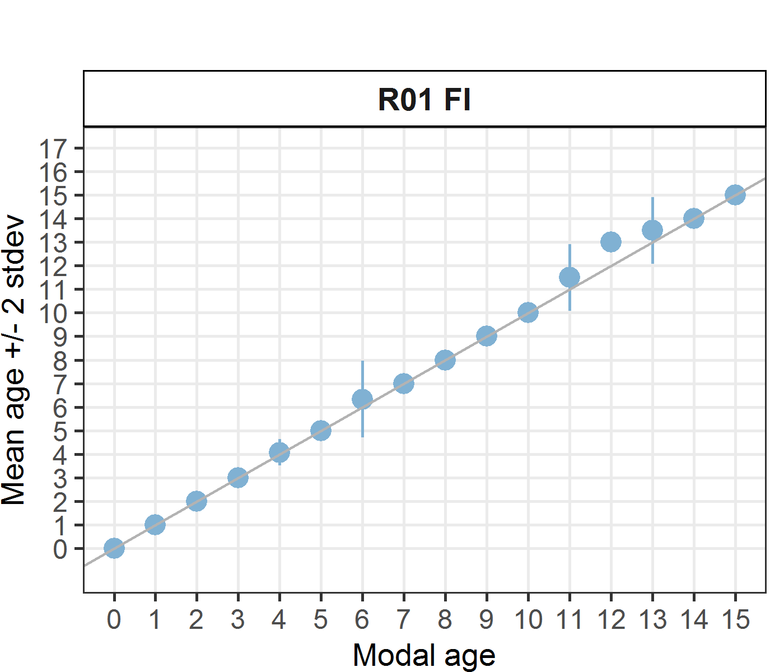 [[2]] 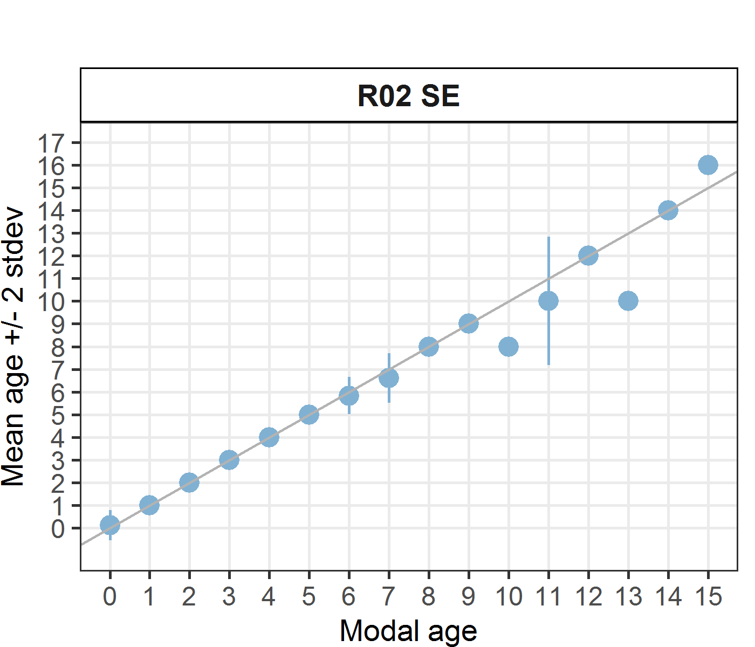 [[3]] 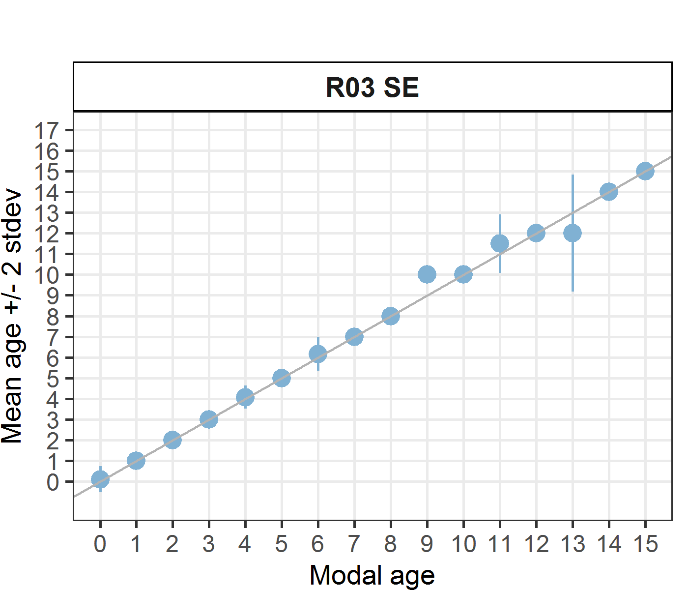 [[4]] 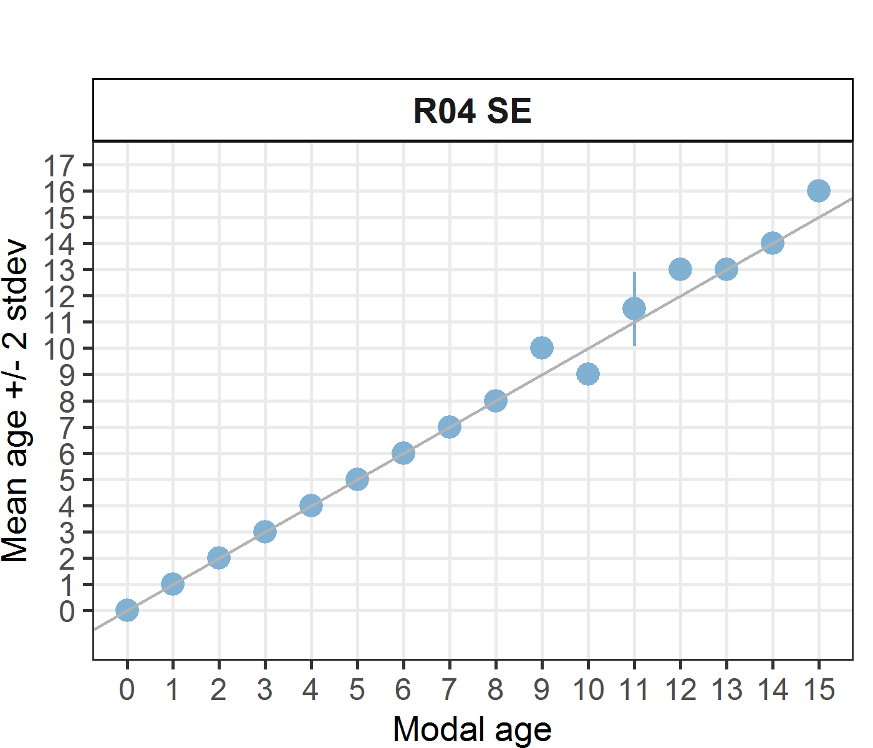
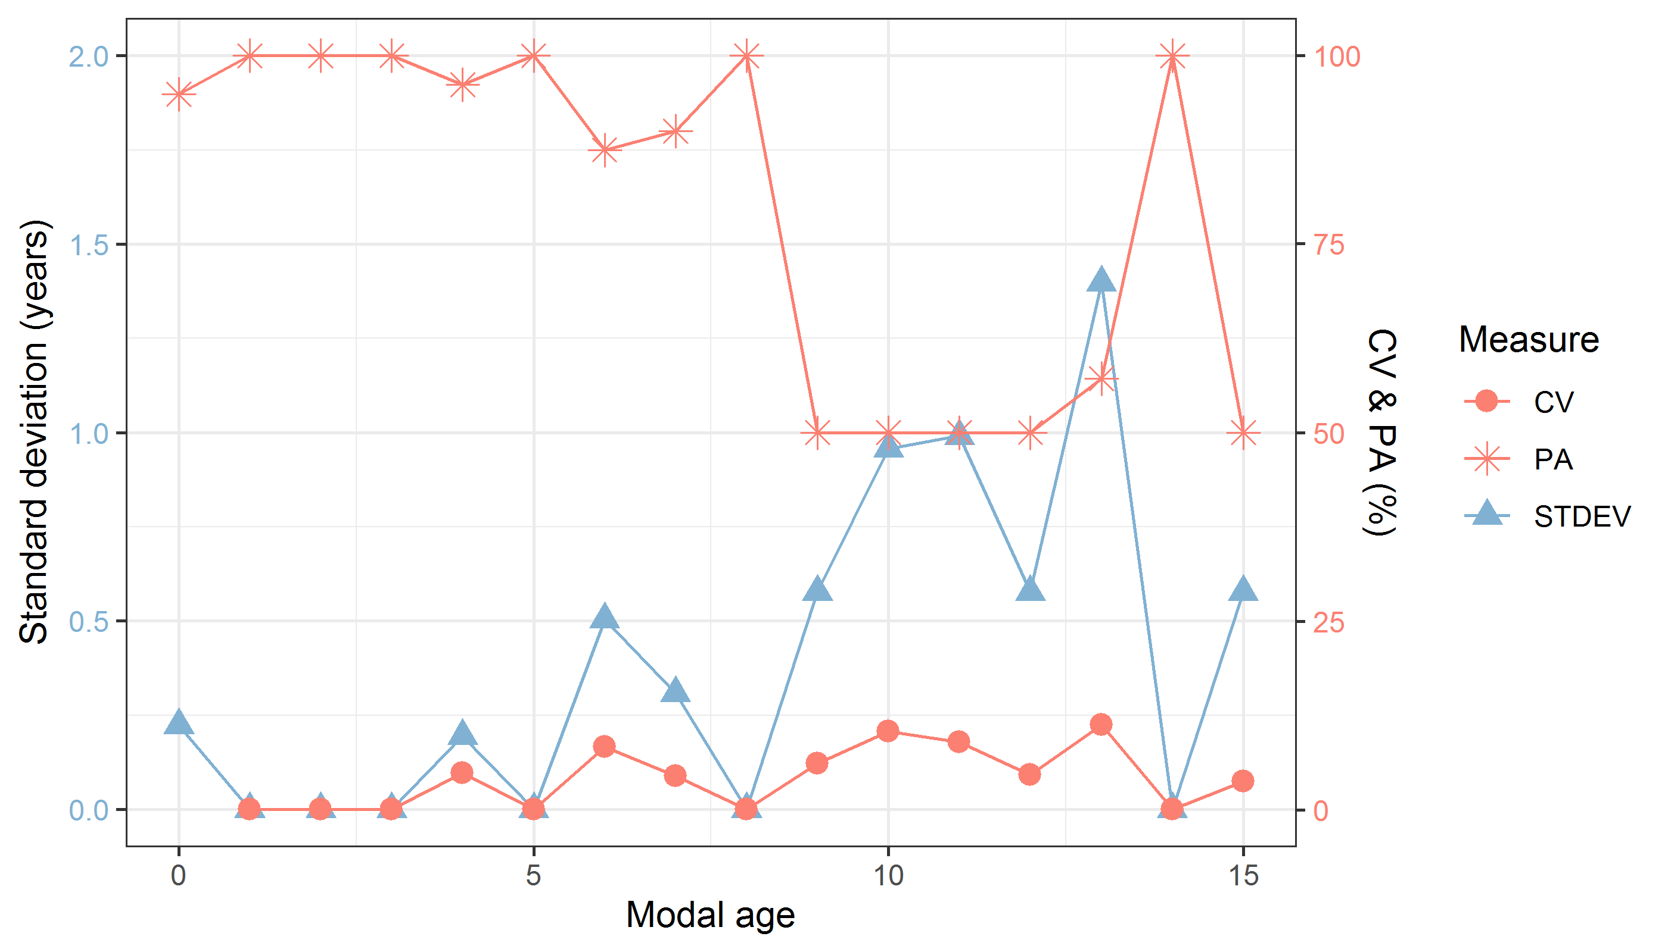
Figure 10: CV, PA and (STDEV (standard deviation) are plotted against modal age
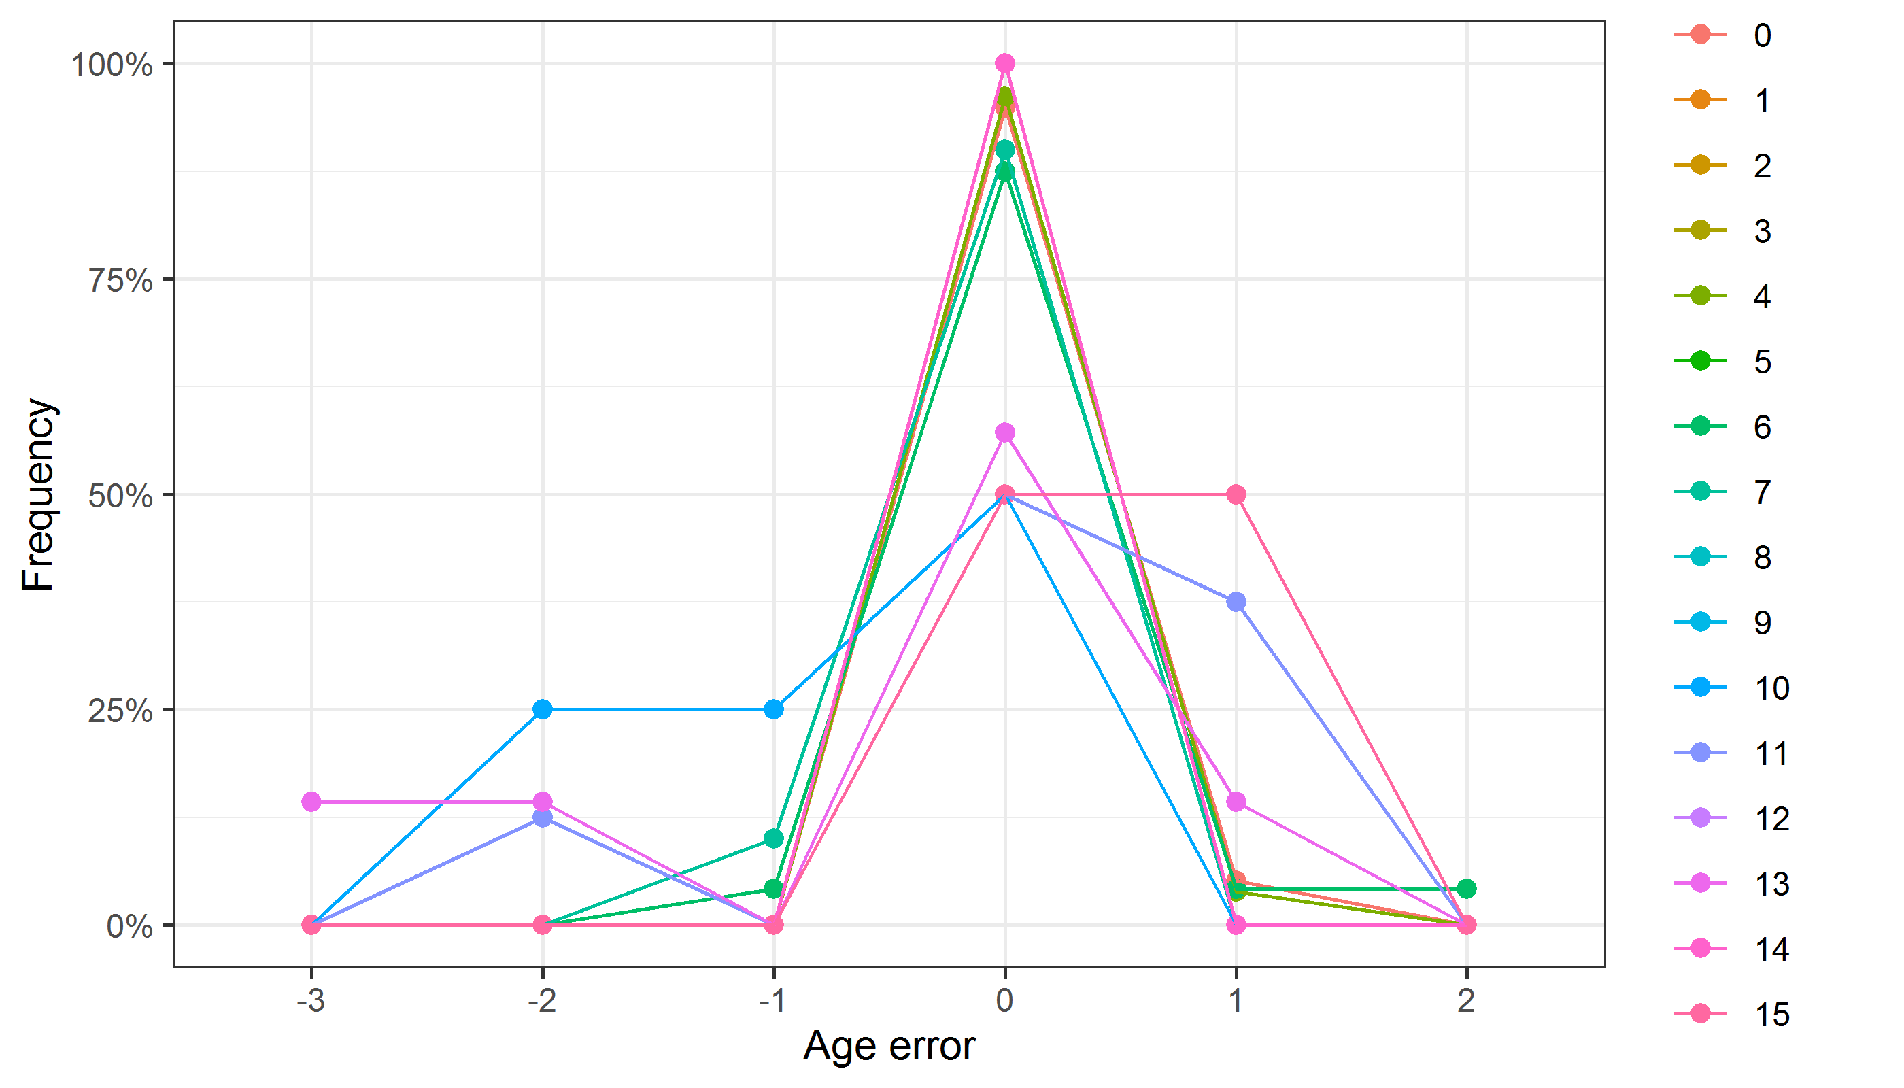
Figure 11: The distribution of the age reading errors in percentage by modal age as observed from the whole group of age readers in an age reading comparison to modal age. The achieved precision in age reading by MODAL age group is shown by the spread of the age readings errors. There appears to be no relative bias, if the age reading errors are normally distributed. The distributions are skewed, if relative bias occurs.
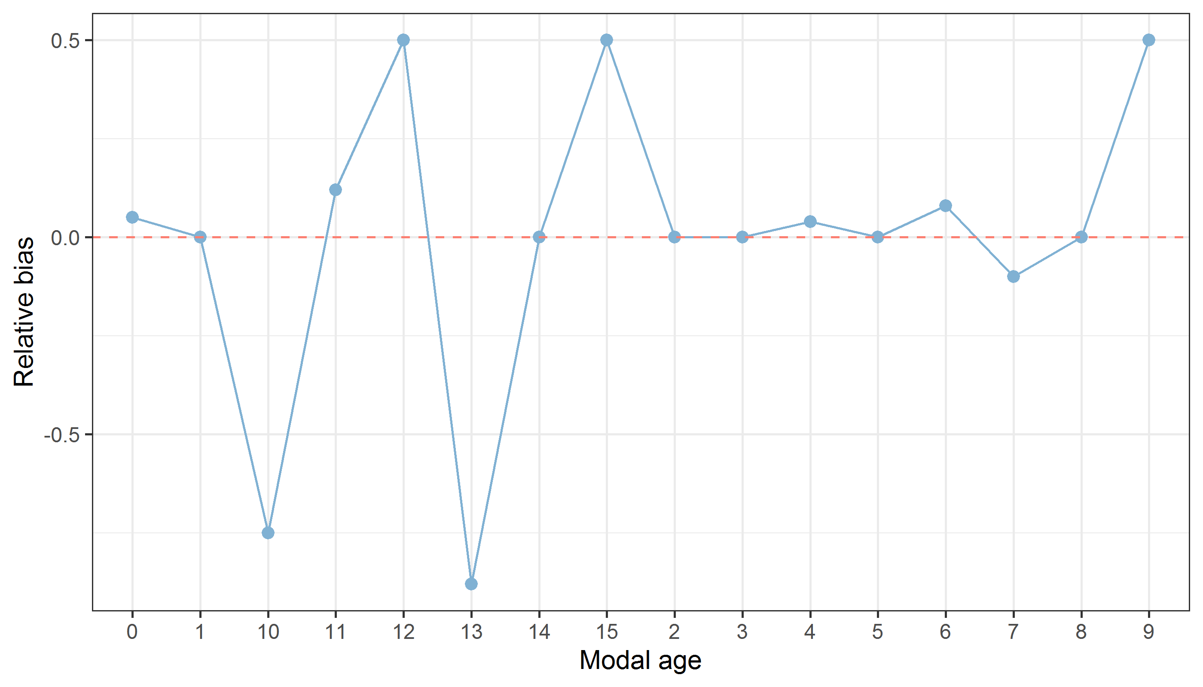
Figure 12: The relative bias by modal age as estimated by all age readers combined.
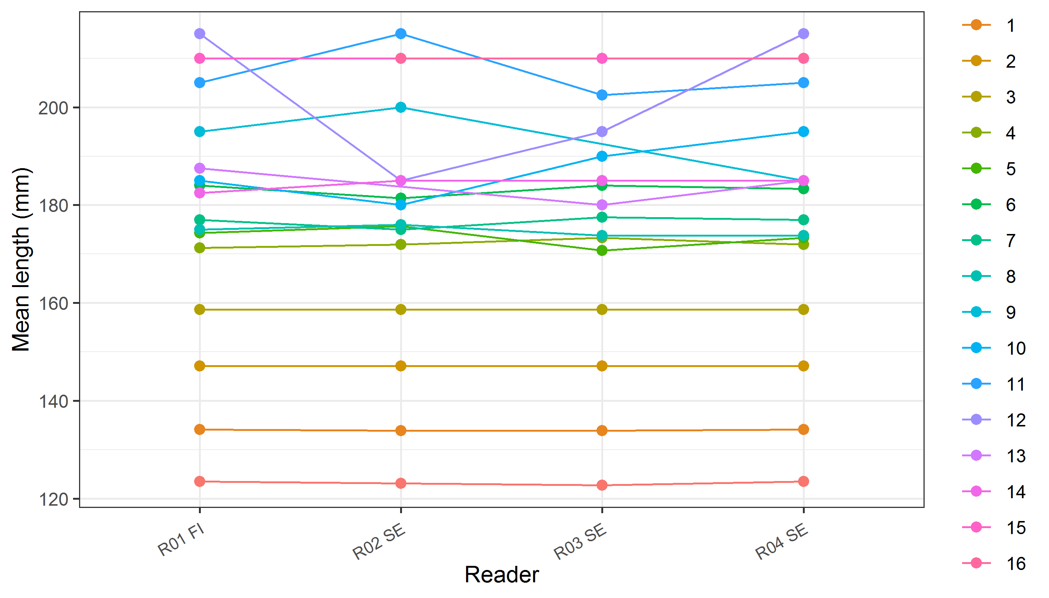
Figure 13: The mean length at age as estimated by each age reader.

Annex 4. ToRs for next meeting

Annex 5. Recommendations
For the next calibration it is important to insert a scale-bar on all the otolith images to give the age readers information about the scale and size of the otolith and to solve the high age error for small herring. The magnification for each image should be registered in SmartDots for comparison of the age readers’ annotated distances from the core to the annulus. This will be helpful for identifying structures in the otoliths difficult to interpret.

