SmartDots Report for event 314:

Otolith Exchange for Sole in 7D

Coordinated by Joanne Smith (Cefas), Valerio Visconti (Cefas) and Karen Bekaert (ILVO)

Participants (in alphabetical order): Brown M., Dimitriadis G., Elleboode R., Fee D., Maertens I., Moerman M., Pellini G., Sabatini L., Visconti V.

January 2021
Table of Contents
1 Introduction 4
2 Methods 5
2.1 Overview of samples and readers 5
2.2 Reading procedure 6
2.3 Statistical Analysis 6
3 Analysis of age calibration exercise 8
3.1 Results 8
3.1.1 All readers 8
3.1.2 Advanced readers 11
3.2 Discussion 15
3.3 Conclusion 16
4 References 17
5 Annex 3. Additional results 18
5.1 Results all readers 18
5.2 Results Advanced readers 31

Introduction
The common sole (Solea solea) is a flatfish from the Order Pleuronectiformes which inhabits the Eastern Atlantic Ocean and the Mediterranean Sea. The species has been historically harvested through highly specialized mixed beam trawl fisheries in shallow waters by most of the ICES-community. Adult sole lives on the sandy or muddy seabed where it often buries itself in the substrate. Length rarely exceeds 60 cm but specimens up to 70 cm have been reported. The oldest specimen observed in Belgian landings was 43 years old (ILVO). Females attain a larger size than males and big soles are invariably females (ICES-Fishmap on sole).
The last sole otolith exchange took place in 2011 in the Bay of Biscay (reaching an average CV of 4.7% and percent agreement to modal age of 88.6%). To our knowledge, this is the first otolith exchange of sole in area 7.d. WGBIOP (October, 2020) identified the need for a sole exchange preceding the sole 7.d stock benchmark foreseen in February 2021. Therefore, this image-only exchange was organized using the SmartDots platform for annotating the images and analysing the results.
The aims of this exchange were:
- To evaluate the accuracy and precision in otolith age reading of sole in division 7.d (Eastern English Channel)
- To identify issues related to age reading of sole in division 7.d
In this report, we present the analysis of the results (precision and accuracy) of the readings by modal age and by age reader. The report highlights the potential bias of age reading for specific readers and allows to identify common issues related to age reading of sole in 7.d.

Methods

Overview of samples and readers
Following WGBIOP Guidelines for Otoliths Exchanges, a set of sole otoliths were selected and uploaded for analysing using the SmartDots application (http://ices.dk/marine-data/tools/Pages/smartdots.aspx).
A total of 116 of sectioned and stained otoliths were used in the exchange. The otoliths all originated from ICES area 7.d and were collected by ILVO. They were stratified by quarter and age up to age 15.
Table 2.1: Overview of samples used for the sole exchange.
Year | ICES area | Strata | Quarter | Number of samples | Modal age range | Length range
2015 | 27.7.d | SS | 2 | 2 | 14 | 310-395 mm
2015 | 27.7.d | SS | 4 | 1 | 15 | 335 mm
2016 | 27.7.d | SS | 2 | 4 | 9-12 | 420-510 mm
2016 | 27.7.d | SS | 3 | 14 | 2-15 | 210-395 mm
2016 | 27.7.d | SS | 4 | 10 | 7-15 | 320-450 mm
2017 | 27.7.d | SS | 1 | 3 | 10-13 | 385-455 mm
2017 | 27.7.d | SS | 2 | 4 | 1-3 | 160-210 mm
2017 | 27.7.d | SS | 3 | 5 | 1-10 | 180-415 mm
2017 | 27.7.d | SS | 4 | 4 | 1-15 | 255-420 mm
2018 | 27.7.d | SS | 1 | 3 | 12-14 | 405-470 mm
2018 | 27.7.d | SS | 2 | 20 | 2-15 | 170-435 mm
2018 | 27.7.d | SS | 3 | 7 | 5-14 | 260-380 mm
2019 | 27.7.d | SS | 1 | 24 | 1-15 | 170-465 mm
2019 | 27.7.d | SS | 4 | 15 | 1-11 | 200-415 mm

A total of 9 participants from 6 different countries and 6 different institutes were involved in the sole otolith exchange. A list of the participants with a summary of their experience in age estimation of sole is shown in Table 2.2. Age estimation of sole is based on sectioned and stained otoliths.
Table 2.2: Reader overview.
Reader code | Expertise | Expertise_rank
R02 GB | Advanced | 2
R04 BE | Advanced | 4
R06 BE | Advanced | 6
R08 FR | Advanced | 8
R10 IE | Advanced | 10
R12 GR | Basic | 12
R14 IT | Basic | 14
R16 IT | Basic | 16
R18 GB | Basic | 18

Reading procedure
Date of birth is conventionally attributed to the 1st of January. One annulus consists of one opaque and one translucent zone. For age estimation, translucent zones are counted. Each reader was asked to annotate all samples in SmartDots, assign an age quality to his reading (from AQ1 to AQ3) and to approve his readings.

Statistical Analysis
This report contains statistical analyses and comparisons of age readings in the form of tables and graphical plots based on Guus Eltink Excel sheet ‘Age Reading Comparisons’ (Eltink, A.T.G.W. 2000) and R scripts specifically developed for SmartDots. For each individual fish the Coefficient of Variation (CV), percentage agreement (PA) and Average Percentage Error (APE) to modal age was calculated.
All statistical analyses were produced for all readers (advanced and basic). In this way, coordinators are able to evaluate the performance of their readers. Furthermore, the statistical analysis (with the age error matrices (AEM)) were performed for advanced age readers only. This information will be provided to the stock coordinator.
Determination of modal age
When summarising the output and reporting the results of the exchange events developed within the SmartDots framework, the modal age (the most common age decided by the age readers for every fish sample) is the most relevant measurement. It is a key statistic by itself, that indicates the most likely age of each sampled fish. It is also fundamental for the estimation of some other relevant statistics to assess the performance of the techniques assessed in the exchange event, e.g. the Percentage Agreement (PA), or input for stock assessments like the Age Error Matrix (AEM) (see below). In this report a multistage approach to select the modal age is used. This multistage approach was based in the different weight given to the age readers based in their experience. Two different weight scores scales were assigned, a weight score decreasing linearly with the experience and another decreasing with a negative exponential shape. The modal age by fish individual is decided following the next approach: 1) If there is a single mode estimated with the “traditional” approach (equal weight for all readers) this value is used as the mode, if not 2) Adding up, by age, the linear weighting score for all the readers that decided each age for that fish. Select as the modal age the age with the highest added score. If there are still multiple ages with the same score: 3) Adding up, by age, the negative exponential weighting score for all the readers that decided each age for that fish. Select as the modal age the age with the highest added score.
During the WGBIOP 2019 meeting it was found that the combination of the modes decided using these three methods (so called “multistage approach”), allows assigning a single modal age to each fish individual.

Percentage Agreement (PA)
The percentage agreement per reader per modal age tells how large the part of readings is that are equal to the modal age. The weighted mean included at the bottom of the table is weighted according to number of age readings. A rank is also assigned to each reader.
$$PA=\frac{number of readings that agree with modal age}{total number of readings by modal age}⋅100\%$$

Co-efficient of Variation (CV)
The table presents the cv per modal age and reader. The cv's are calculated as the ratio between the standard deviation (σ) and mean value (μ) per reader and modal age:
$$CV=\frac{σ}{μ}⋅100\%$$
In the table, also the CV of all readers combined per modal age and a weighted mean of the CV per reader is added.
Average Percentage Error (APE)
APE was calculated based on the method outlined by Beamish & Fournier (1981). This method is not independent of fish age and thus provides a better estimate of precision. As the calculations of both CV and APE pose problems if the mean age is close to 0, all observations for which modal age was 0 were omitted from the CV and APE calculations.
The average percentage error is calculated per image (results in annex 1) as:
$$APE=\frac{100\%}{n}\sum_{i=1}^{n}{|}\frac{a_{i}-\overline{a}}{\overline{a}}|$$
where $a_{i}$ is the age reading of reader $i$ and $\overline{a}$ is the mean of all readings from 1 to $n$.
Age error matricx (AEM)
Age error matrices (AEM) were produced following procedures outlined by WKSABCAL (2014) where the matrix shows the proportion of each modal age mis-aged as other ages. The sum of each row is 1, which equals 100%. The age data was analysed twice, the first time all readers were included and the second time only the “advanced” readers were included. If a reader is “advanced” then they are considered well trained and they provide ages for stock assessment or similar purposes. When the AEM is compiled for assessment purposes it uses only those readers who provide age data for the stock assessment in that specific area.

Analysis of age calibration exercise

Results

All readers
All samples included
In this exchange event, 116 otolith fish individuals were aged. Of those, 7 % were multimodal cases when only the traditional approach was used (all readers equally weighted) to define the mode. For those cases, the multistage approach based on the experience of the readers was used to define the modal age. The percentage of multiple mode cases was then reduced to 0 % (Table 3.1). The complete list of multiple mode cases is presented in table 5.3 in annex 1, where the age readings from each of the readers participating in the exchange event are presented.
Table 3.1: Total number of samples (NSample) and percentage of cases (fish samples) with multiple modes depending on the approach to weight the experience of the reader which will be considered when defining the fish age mode. PercMM_traditional shows the percentage of the total samples for which multiple modes are obtained when all the readers are equally weighted. PercMM_linear_weight shows the percentage of the total samples for which multiple modes are obtained when the weight assigned to the different readers decreases linearly with the experience, while in the PercMM_negexp the weight applied decreases with a negative exponential shape with the experience. The PercMM_multistage shows the percentage of multiple mode cases when a combination of the different methodologies is used, as explained in the material and methods section
NSample | PercMM_traditional | PercMM_linear_weight | PercMM_negexp_weight | PercMM_multistage
116 | 7 % | 0 % | 0 % | 0 %
When all the otolith samples are considered (both single and multimodal cases) the weighted average percentage agreement based on modal ages for all readers is 70 %, with the weighted average CV of 13 % and APE of 8 % (table 3.2).
Table 3.2: Summary of statistics; Total number of samples (NSample), coefficient of variance (CV), percentage of agreement (PA) and average percentage error (APE) for all ages and readers
NSample | CV | PA | APE
116 | 13 % | 70 % | 8 %

Table 3.3: Coefficient of Variation (CV) table presents the CV per modal age and reader, the CV of all readers combined per modal age, and a weighted mean of the CV per reader.
Modal age | R02 GB | R04 BE | R06 BE | R08 FR | R10 IE | R12 GR | R14 IT | R16 IT | R18 GB | all
1 | 0 % | 0 % | 0 % | 0 % | 33 % | 36 % | 106 % | 57 % | 37 % | 41 %
2 | 0 % | 0 % | 0 % | 0 % | 0 % | 17 % | 34 % | 22 % | 22 % | 18 %
3 | 0 % | 0 % | 0 % | 12 % | 0 % | 0 % | 20 % | 11 % | 18 % | 11 %
4 | 0 % | 0 % | 10 % | 0 % | 0 % | 0 % | 16 % | 14 % | 22 % | 11 %
5 | 0 % | 7 % | 7 % | 10 % | 7 % | 7 % | 13 % | 7 % | 13 % | 9 %
6 | 5 % | 6 % | 6 % | 13 % | 6 % | 5 % | 9 % | 8 % | 10 % | 8 %
7 | 5 % | 5 % | 5 % | 11 % | 0 % | 6 % | 8 % | 7 % | 11 % | 7 %
8 | 4 % | 0 % | 0 % | 13 % | 10 % | 6 % | 10 % | 7 % | 11 % | 9 %
9 | 11 % | 19 % | 17 % | 10 % | 12 % | 0 % | 6 % | 11 % | 8 % | 14 %
10 | 8 % | 7 % | 5 % | 15 % | 5 % | 7 % | 12 % | 8 % | 13 % | 11 %
11 | 8 % | 3 % | 0 % | 20 % | 7 % | 5 % | 7 % | 7 % | 10 % | 10 %
12 | 0 % | 3 % | 3 % | 13 % | 11 % | 4 % | 18 % | 14 % | 9 % | 10 %
13 | 6 % | 6 % | 6 % | 7 % | 6 % | 3 % | 8 % | 4 % | 15 % | 10 %
14 | 8 % | 5 % | 4 % | 17 % | 10 % | 7 % | 13 % | 10 % | 20 % | 13 %
15 | 5 % | 0 % | 3 % | 11 % | 12 % | 5 % | 15 % | 13 % | 14 % | 11 %
Weighted Mean | 4 % | 4 % | 4 % | 10 % | 8 % | 7 % | 19 % | 13 % | 15 % | 13 %
The percentage agreement per reader per modal age tells how large is the part of the readings that are equal to the modal age. The weighted mean included at the bottom of the table is weighted according to number of age readings.
Table 3.4: Percentage agreement (PA) table represents the PA per modal age and reader, the PA of all readers combined per modal age, and a weighted mean of the PA per reader.
Modal age | R02 GB | R04 BE | R06 BE | R08 FR | R10 IE | R12 GR | R14 IT | R16 IT | R18 GB | total
1 | 100 % | 100 % | 100 % | 100 % | 86 % | 50 % | 43 % | 50 % | 75 % | 79 %
2 | 100 % | 100 % | 100 % | 100 % | 100 % | 88 % | 62 % | 62 % | 62 % | 86 %
3 | 100 % | 100 % | 100 % | 88 % | 100 % | 100 % | 62 % | 88 % | 75 % | 90 %
4 | 100 % | 100 % | 86 % | 100 % | 100 % | 100 % | 43 % | 71 % | 71 % | 85 %
5 | 100 % | 88 % | 88 % | 75 % | 88 % | 88 % | 62 % | 88 % | 62 % | 82 %
6 | 89 % | 89 % | 89 % | 67 % | 88 % | 89 % | 67 % | 78 % | 67 % | 80 %
7 | 89 % | 89 % | 89 % | 67 % | 100 % | 78 % | 67 % | 78 % | 78 % | 81 %
8 | 88 % | 100 % | 100 % | 25 % | 62 % | 75 % | 29 % | 62 % | 62 % | 68 %
9 | 78 % | 67 % | 67 % | 44 % | 67 % | 100 % | 29 % | 44 % | 56 % | 62 %
10 | 70 % | 80 % | 70 % | 20 % | 70 % | 50 % | 22 % | 60 % | 60 % | 56 %
11 | 71 % | 86 % | 100 % | 29 % | 29 % | 71 % | 43 % | 43 % | 50 % | 58 %
12 | 100 % | 86 % | 86 % | 0 % | 67 % | 80 % | 20 % | 57 % | 43 % | 61 %
13 | 50 % | 71 % | 71 % | 0 % | 71 % | 83 % | 0 % | 71 % | 29 % | 49 %
14 | 40 % | 60 % | 60 % | 40 % | 40 % | 60 % | 20 % | 40 % | 0 % | 40 %
15 | 67 % | 100 % | 83 % | 17 % | 50 % | 60 % | 50 % | 17 % | 33 % | 53 %
Weighted Mean | 84 % | 88 % | 86 % | 53 % | 76 % | 79 % | 43 % | 62 % | 57 % | 70 %

Table 3.5: Average Percentage Error (APE) table represents the APE per modal age and reader and a weighted mean of the APE per reader.
Modal age | R02 GB | R04 BE | R06 BE | R08 FR | R10 IE | R12 GR | R14 IT | R16 IT | R18 GB | all
1 | 0 % | 0 % | 0 % | 0 % | 21 % | 33 % | 86 % | 45 % | 30 % | 26 %
2 | 0 % | 0 % | 0 % | 0 % | 0 % | 10 % | 23 % | 20 % | 20 % | 10 %
3 | 0 % | 0 % | 0 % | 8 % | 0 % | 0 % | 18 % | 7 % | 8 % | 4 %
4 | 0 % | 0 % | 6 % | 0 % | 0 % | 0 % | 14 % | 7 % | 13 % | 5 %
5 | 0 % | 4 % | 4 % | 8 % | 4 % | 4 % | 9 % | 4 % | 9 % | 4 %
6 | 3 % | 3 % | 3 % | 11 % | 4 % | 3 % | 8 % | 4 % | 6 % | 5 %
7 | 3 % | 3 % | 3 % | 9 % | 0 % | 5 % | 7 % | 3 % | 8 % | 4 %
8 | 3 % | 0 % | 0 % | 11 % | 8 % | 5 % | 9 % | 6 % | 8 % | 7 %
9 | 7 % | 15 % | 11 % | 8 % | 9 % | 0 % | 5 % | 8 % | 6 % | 7 %
10 | 7 % | 5 % | 4 % | 11 % | 4 % | 5 % | 8 % | 6 % | 11 % | 7 %
11 | 5 % | 2 % | 0 % | 16 % | 6 % | 3 % | 6 % | 6 % | 8 % | 7 %
12 | 0 % | 2 % | 2 % | 11 % | 8 % | 3 % | 13 % | 10 % | 8 % | 8 %
13 | 4 % | 5 % | 5 % | 5 % | 5 % | 2 % | 7 % | 3 % | 12 % | 8 %
14 | 6 % | 3 % | 3 % | 13 % | 8 % | 5 % | 11 % | 8 % | 17 % | 10 %
15 | 4 % | 0 % | 2 % | 8 % | 9 % | 3 % | 10 % | 11 % | 12 % | 8 %
Weighted Mean | 3 % | 3 % | 3 % | 8 % | 5 % | 6 % | 15 % | 10 % | 11 % | 8 %
The relative bias is the difference between the mean age (per modal age per reader) and modal age. As for the previous tables, a combined bias for all readers and weighted means are calculated.
Table3.6: Relative bias table represents the relative bias per modal age per reader, the relative bias of all readers combined per modal age and a weighted mean of the relative bias per reader. Relative bias is the age difference between estimated mean age and modal age.
Modal age | R02 GB | R04 BE | R06 BE | R08 FR | R10 IE | R12 GR | R14 IT | R16 IT | R18 GB | all
1 | 0.00 | 0.00 | 0.00 | 0.00 | 0.14 | 0.50 | -0.29 | 0.25 | 0.25 | 0.10
2 | 0.00 | 0.00 | 0.00 | 0.00 | 0.00 | 0.12 | -0.12 | 0.38 | 0.38 | 0.08
3 | 0.00 | 0.00 | 0.00 | -0.12 | 0.00 | 0.00 | -0.38 | 0.12 | 0.00 | -0.04
4 | 0.00 | 0.00 | -0.14 | 0.00 | 0.00 | 0.00 | -0.57 | 0.00 | 0.14 | -0.06
5 | 0.00 | -0.12 | -0.12 | -0.25 | -0.12 | 0.12 | -0.12 | 0.12 | 0.12 | -0.04
6 | 0.11 | -0.11 | -0.11 | -0.44 | -0.12 | 0.11 | -0.33 | 0.00 | 0.11 | -0.09
7 | 0.11 | 0.11 | 0.11 | -0.44 | 0.00 | 0.22 | -0.33 | 0.00 | -0.33 | -0.06
8 | 0.12 | 0.00 | 0.00 | -1.25 | -0.50 | 0.25 | -0.43 | -0.38 | -0.25 | -0.27
9 | 0.44 | 1.11 | 0.78 | -0.78 | -0.33 | 0.00 | -0.71 | -0.22 | -0.22 | 0.01
10 | 0.50 | 0.30 | 0.30 | -1.40 | -0.30 | 0.10 | -0.78 | -0.30 | -0.60 | -0.24
11 | 0.14 | 0.14 | 0.00 | -2.00 | -0.43 | 0.00 | -0.71 | -0.29 | -0.83 | -0.44
12 | 0.00 | 0.14 | 0.14 | -1.83 | -0.67 | -0.20 | -1.20 | -1.00 | -1.00 | -0.62
13 | 0.17 | 0.43 | 0.43 | -2.00 | -0.43 | 0.17 | -1.71 | -0.29 | -1.86 | -0.57
14 | -0.40 | 0.00 | 0.40 | -2.00 | -1.20 | -0.60 | -1.80 | -1.20 | -3.20 | -1.11
15 | 0.50 | 0.00 | -0.17 | -2.33 | -1.17 | 0.00 | -0.83 | -0.83 | -1.67 | -0.72
Weighted Mean | 0.13 | 0.15 | 0.11 | -0.91 | -0.30 | 0.08 | -0.63 | -0.20 | -0.49 | -0.23
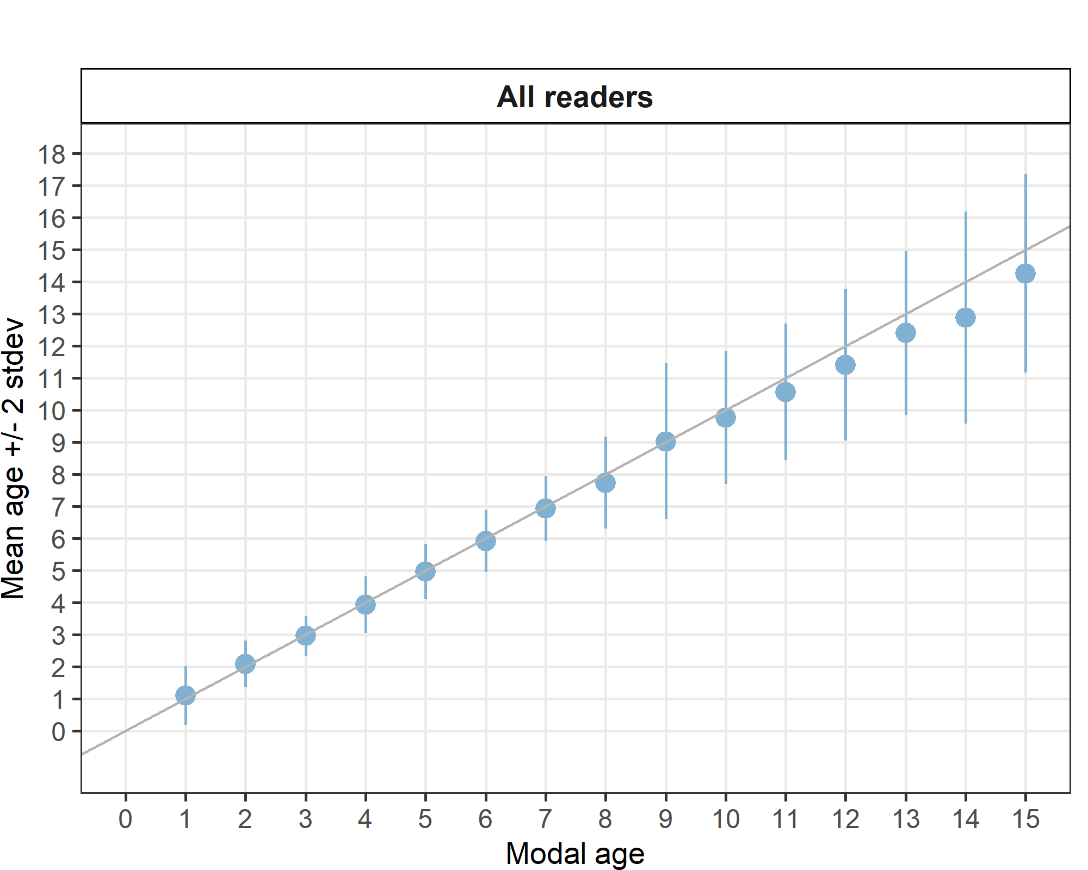
Figure 3.1:: Age bias plot for all readers. Mean age recorded +/- 2 stdev of each reader and all readers combined are plotted against modal age. The estimated mean age corresponds to modal age, if the estimated mean age is on the 1:1 equilibrium line (solid line). Relative bias is the age difference between estimated mean age and modal age.

Table 3.7: Inter reader bias test. The Inter-reader bias test gives probability of bias between readers and with modal age. - = no sign of bias (p>0.05), * = possibility of bias (0.01<p<0.05), * * = certainty of bias (p<0.01)
Comparison | R02 GB | R04 BE | R06 BE | R08 FR | R10 IE | R12 GR | R14 IT | R16 IT | R18 GB
R02 GB | - | - | - | ** | ** | - | ** | ** | **
R04 BE | - | - | - | ** | ** | - | ** | ** | **
R06 BE | - | - | - | ** | ** | - | ** | ** | **
R08 FR | ** | ** | ** | - | ** | ** | * | ** | **
R10 IE | ** | ** | ** | ** | - | ** | ** | - | -
R12 GR | - | - | - | ** | ** | - | ** | ** | **
R14 IT | ** | ** | ** | * | ** | ** | - | ** | -
R16 IT | ** | ** | ** | ** | - | ** | ** | - | **
R18 GB | ** | ** | ** | ** | - | ** | - | ** | -
Modal age | * | * | * | ** | ** | - | ** | * | **

Advanced readers
The weighted average percentage agreement based on modal ages for all readers is 80 %, with the weighted average CV of 8 % and APE of 5 %.
All samples included
Table 3.8: Coefficient of Variation (CV) table presents the CV per modal age and advanced reader, the CV of all advanced readers combined per modal age and a weighted mean of the CV per reader.
Modal age | R02 GB | R04 BE | R06 BE | R08 FR | R10 IE | all
1 | 0 % | 0 % | 0 % | 0 % | 33 % | 16 %
2 | 0 % | 0 % | 0 % | 0 % | 0 % | 0 %
3 | 0 % | 0 % | 0 % | 12 % | 0 % | 5 %
4 | 9 % | 0 % | 9 % | 0 % | 0 % | 6 %
5 | 7 % | 0 % | 0 % | 7 % | 0 % | 5 %
6 | 6 % | 0 % | 0 % | 13 % | 0 % | 7 %
7 | 0 % | 0 % | 0 % | 12 % | 0 % | 5 %
8 | 4 % | 0 % | 0 % | 12 % | 10 % | 9 %
9 | 4 % | 15 % | 5 % | 10 % | 12 % | 11 %
10 | 7 % | 0 % | 3 % | 16 % | 5 % | 10 %
11 | 3 % | 0 % | 0 % | 19 % | 5 % | 10 %
12 | 3 % | 3 % | 5 % | 15 % | 10 % | 10 %
13 | 4 % | 0 % | 3 % | 5 % | 4 % | 8 %
14 | 7 % | 3 % | 5 % | 16 % | 15 % | 13 %
15 | 6 % | 0 % | 2 % | 10 % | 10 % | 9 %
Weighted Mean | 4 % | 1 % | 2 % | 10 % | 7 % | 8 %
Table 3.9: Percentage agreement (PA) table represents the PA per modal age and advanced reader, the PA of all advanced readers combined per modal age and a weighted mean of the PA per reader.
Modal age | R02 GB | R04 BE | R06 BE | R08 FR | R10 IE | total
1 | 100 % | 100 % | 100 % | 100 % | 86 % | 97 %
2 | 100 % | 100 % | 100 % | 100 % | 100 % | 100 %
3 | 100 % | 100 % | 100 % | 88 % | 100 % | 98 %
4 | 86 % | 100 % | 88 % | 100 % | 100 % | 95 %
5 | 88 % | 100 % | 100 % | 88 % | 100 % | 95 %
6 | 88 % | 100 % | 100 % | 75 % | 100 % | 92 %
7 | 100 % | 100 % | 100 % | 62 % | 100 % | 92 %
8 | 89 % | 100 % | 100 % | 22 % | 56 % | 73 %
9 | 88 % | 75 % | 75 % | 38 % | 62 % | 68 %
10 | 88 % | 100 % | 88 % | 12 % | 62 % | 70 %
11 | 86 % | 100 % | 100 % | 29 % | 29 % | 69 %
12 | 89 % | 89 % | 67 % | 11 % | 50 % | 61 %
13 | 75 % | 100 % | 80 % | 0 % | 60 % | 65 %
14 | 50 % | 83 % | 67 % | 17 % | 17 % | 47 %
15 | 62 % | 100 % | 88 % | 12 % | 38 % | 60 %
Weighted Mean | 87 % | 97 % | 91 % | 52 % | 72 % | 80 %

Table 3.10: Average Percentage Error (APE) table represents the APE per modal age and reader and a weighted mean of the APE per reader.
Modal age | R02 GB | R04 BE | R06 BE | R08 FR | R10 IE | all
1 | 0 % | 0 % | 0 % | 0 % | 21 % | 5 %
2 | 0 % | 0 % | 0 % | 0 % | 0 % | 0 %
3 | 0 % | 0 % | 0 % | 8 % | 0 % | 2 %
4 | 6 % | 0 % | 6 % | 0 % | 0 % | 1 %
5 | 4 % | 0 % | 0 % | 4 % | 0 % | 1 %
6 | 4 % | 0 % | 0 % | 10 % | 0 % | 2 %
7 | 0 % | 0 % | 0 % | 10 % | 0 % | 3 %
8 | 2 % | 0 % | 0 % | 10 % | 8 % | 7 %
9 | 2 % | 10 % | 4 % | 8 % | 9 % | 6 %
10 | 4 % | 0 % | 2 % | 12 % | 5 % | 7 %
11 | 2 % | 0 % | 0 % | 15 % | 4 % | 7 %
12 | 2 % | 2 % | 3 % | 13 % | 8 % | 8 %
13 | 3 % | 0 % | 2 % | 5 % | 4 % | 7 %
14 | 6 % | 2 % | 2 % | 12 % | 11 % | 10 %
15 | 4 % | 0 % | 1 % | 8 % | 8 % | 7 %
Weighted Mean | 3 % | 1 % | 1 % | 8 % | 5 % | 5 %
Table 3.11: Relative bias table represents the relative bias per modal age and advanced reader, the relative bias of all advanced readers combined per modal age and a weighted mean of the relative bias per reader.
Modal age | R02 GB | R04 BE | R06 BE | R08 FR | R10 IE | all
1 | 0.00 | 0.00 | 0.00 | 0.00 | 0.14 | 0.03
2 | 0.00 | 0.00 | 0.00 | 0.00 | 0.00 | 0.00
3 | 0.00 | 0.00 | 0.00 | -0.12 | 0.00 | -0.02
4 | 0.14 | 0.00 | -0.12 | 0.00 | 0.00 | 0.00
5 | 0.12 | 0.00 | 0.00 | -0.12 | 0.00 | 0.00
6 | 0.12 | 0.00 | 0.00 | -0.38 | 0.00 | -0.05
7 | 0.00 | 0.00 | 0.00 | -0.50 | 0.00 | -0.10
8 | 0.11 | 0.00 | 0.00 | -1.22 | -0.56 | -0.33
9 | 0.12 | 0.62 | 0.25 | -0.88 | -0.38 | -0.05
10 | 0.25 | 0.00 | 0.12 | -1.62 | -0.38 | -0.32
11 | -0.14 | 0.00 | 0.00 | -1.71 | -0.71 | -0.51
12 | 0.11 | 0.11 | -0.11 | -2.00 | -0.88 | -0.55
13 | -0.25 | 0.00 | 0.20 | -2.50 | -0.40 | -0.59
14 | -0.83 | -0.17 | 0.00 | -3.00 | -2.00 | -1.20
15 | 0.25 | 0.00 | -0.12 | -2.25 | -1.25 | -0.68
Weighted Mean | 0.03 | 0.04 | 0.01 | -1.01 | -0.41 | -0.27

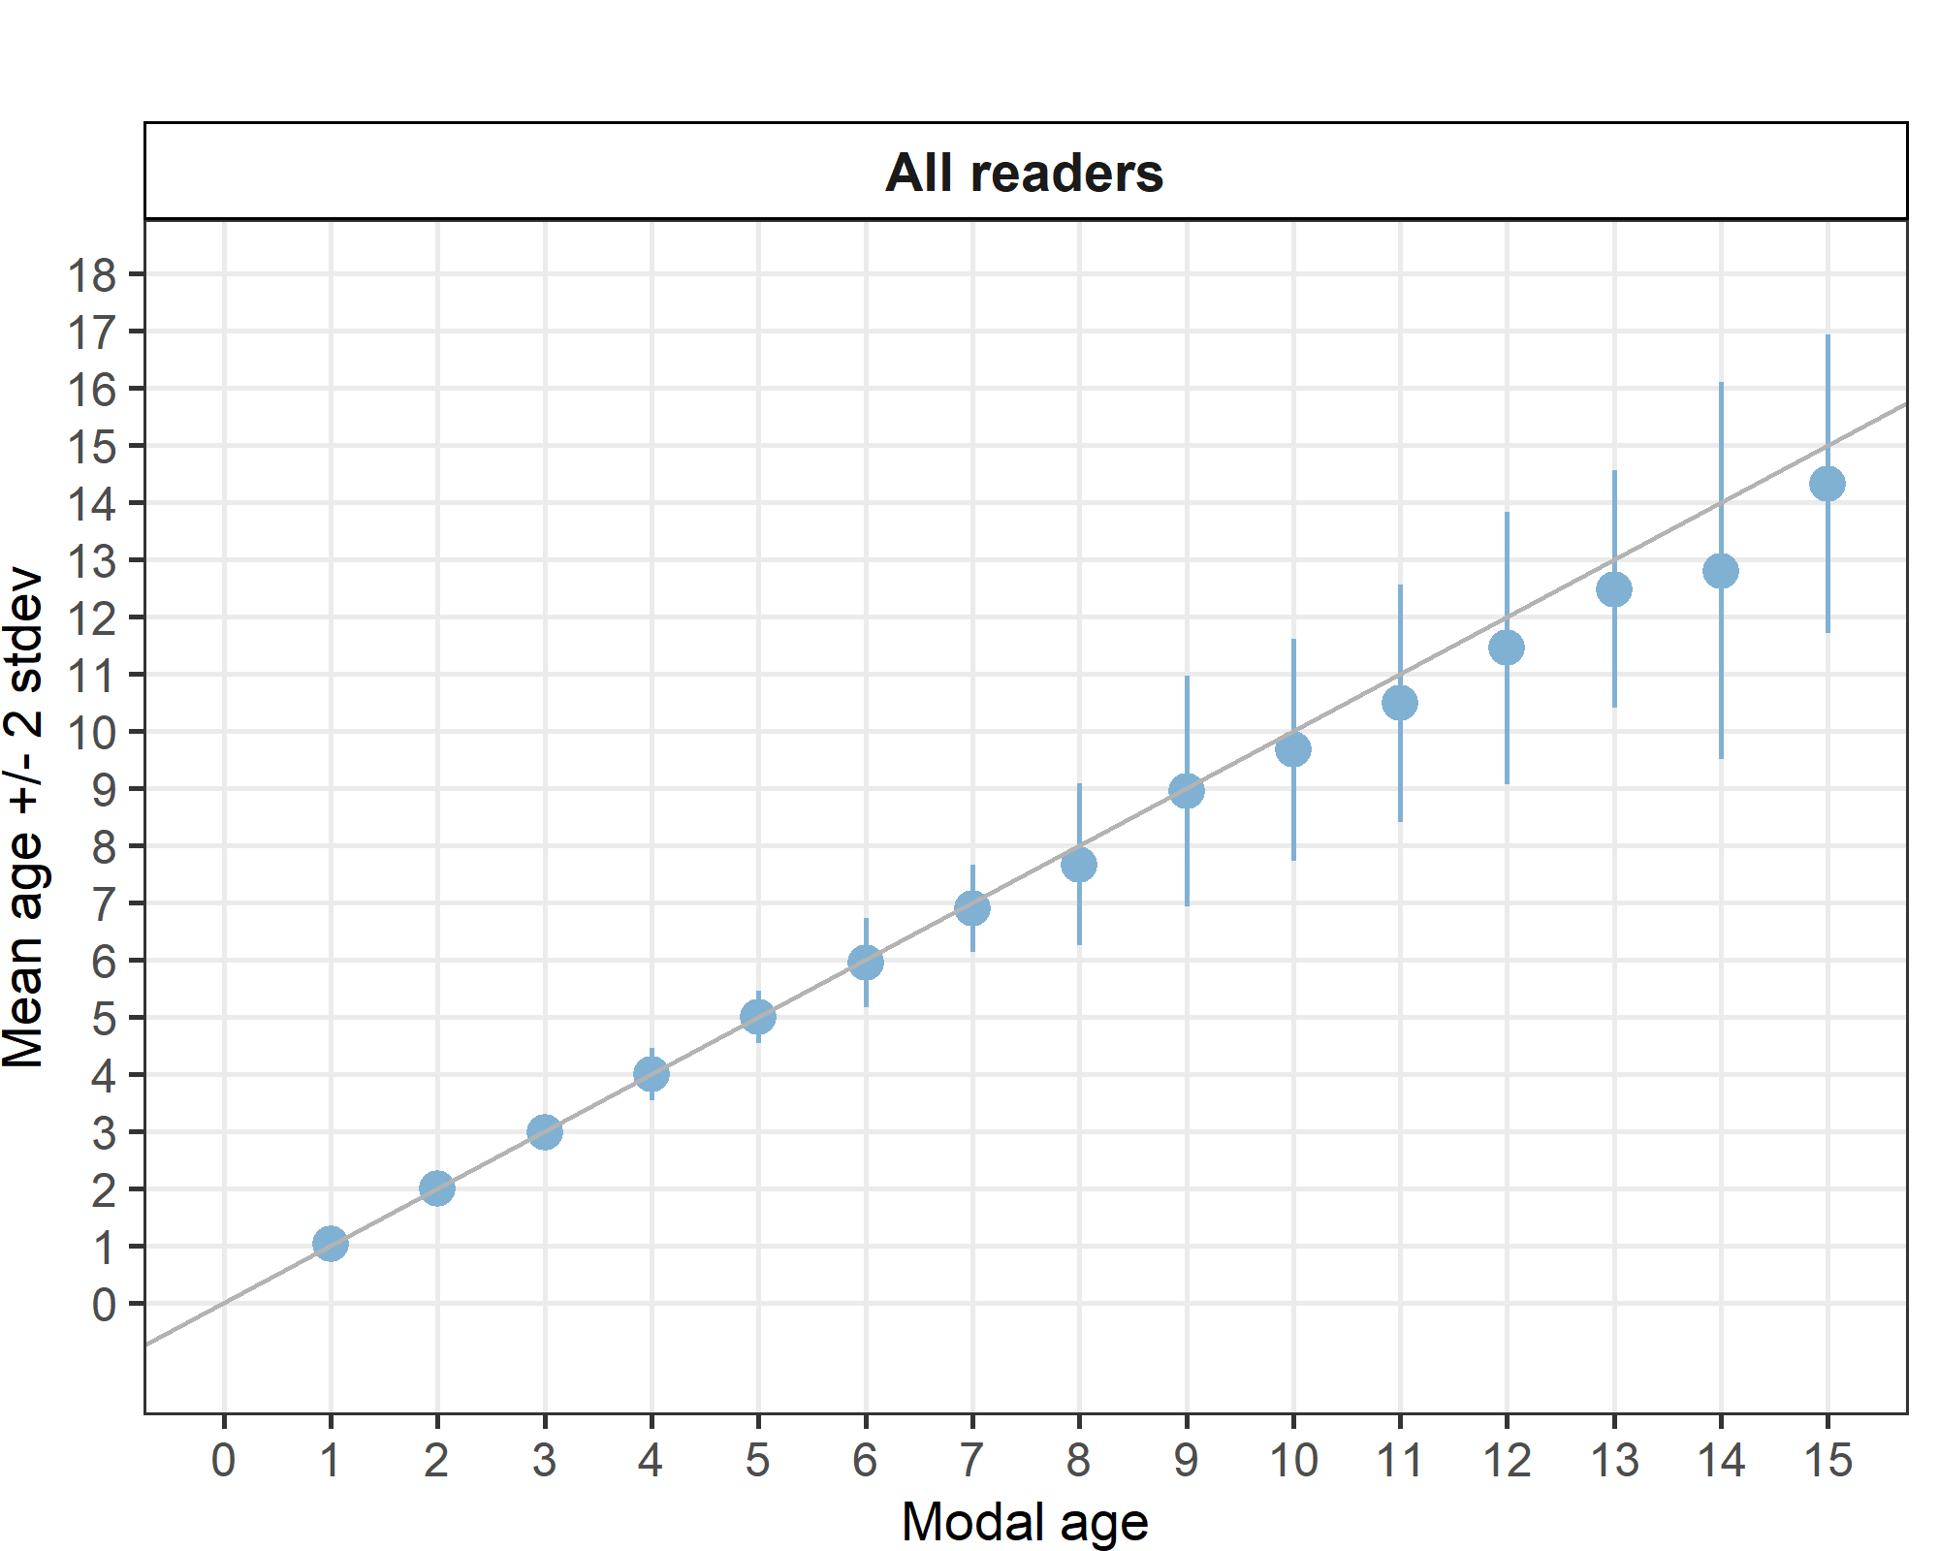
Figure 3.3: Age bias plot for advanced readers.

Age error matrices are calculated per area and only based on the age readings of the advanced readers.
Table 3.12: Age error matrix (AEM) for SS. The AEM shows the proportional distribution of age readings for each modal age. Age column should sum to one but due to rounding there might be small deviations in some cases. Only advanced readers are used for calculating the AEM.
strata | Modal age | 1 | 2 | 3 | 4 | 5 | 6 | 7 | 8 | 9 | 10 | 11 | 12 | 13 | 14 | 15
SS | Age 1 | 0.97436 | - | - | - | - | - | - | - | - | - | - | - | - | - | -
SS | Age 2 | 0.02564 | 1 | 0.025 | - | - | - | - | - | - | - | - | - | - | - | -
SS | Age 3 | - | - | 0.975 | 0.02564 | - | - | - | - | - | - | - | - | - | - | -
SS | Age 4 | - | - | - | 0.94872 | 0.025 | 0.02564 | - | - | - | - | - | - | - | - | -
SS | Age 5 | - | - | - | 0.02564 | 0.950 | 0.02564 | 0.025 | - | - | - | - | - | - | - | -
SS | Age 6 | - | - | - | - | 0.025 | 0.92308 | 0.050 | 0.11111 | - | 0.025 | 0.02857 | - | - | - | -
SS | Age 7 | - | - | - | - | - | 0.02564 | 0.925 | 0.13333 | 0.100 | 0.025 | - | - | - | - | -
SS | Age 8 | - | - | - | - | - | - | - | 0.73333 | 0.075 | 0.025 | 0.02857 | 0.04545 | - | - | -
SS | Age 9 | - | - | - | - | - | - | - | 0.02222 | 0.675 | 0.175 | 0.02857 | 0.06818 | - | 0.06667 | -
SS | Age 10 | - | - | - | - | - | - | - | - | 0.125 | 0.700 | 0.22857 | 0.02273 | 0.08696 | 0.06667 | -
SS | Age 11 | - | - | - | - | - | - | - | - | - | 0.025 | 0.68571 | 0.18182 | 0.08696 | 0.06667 | 0.050
SS | Age 12 | - | - | - | - | - | - | - | - | - | 0.025 | - | 0.61364 | 0.13043 | 0.13333 | 0.075
SS | Age 13 | - | - | - | - | - | - | - | - | 0.025 | - | - | 0.06818 | 0.65217 | 0.16667 | 0.100
SS | Age 14 | - | - | - | - | - | - | - | - | - | - | - | - | 0.04348 | 0.46667 | 0.125
SS | Age 15 | - | - | - | - | - | - | - | - | - | - | - | - | - | 0.03333 | 0.600
SS | Age 16 | - | - | - | - | - | - | - | - | - | - | - | - | - | - | 0.025
SS | Age 17 | - | - | - | - | - | - | - | - | - | - | - | - | - | - | 0.025

Discussion

The statistics representing age reading performance were calculated for all readers combined and for advanced readers only. There were five advanced readers, all of which read using the preparation method of sectioned and stained otoliths. The weighted average percentage agreement based on modal ages for all readers was 70 %, with a weighted average CV of 13 % and APE of 8 %. For advanced readers only, the percentage agreement was 80% with a weighted average CV of 8 % and APE of 5 %. As expected, percentage agreement was higher, and the coefficient of variation and average percentage error was lower for advanced readers compared to all readers.
When looking more in detail, the main problem of bias seems to be the underestimation of older fish for almost all basic readers (R14, R16, R18, see individual results by reader in annex 1). However, this is also the case for the advanced reader R08 and to a lesser extent R10. This means that some readers (mainly those with less experience) are not including all the rings on the outer edge (Figure 3.5). It seems that the identification of the first ring does not pose a problem in this species. Indeed, the percentage agreement is very high for the age class 1. An example of a 100% agreement fish is given in figure 3.4.
Bias is low between three advanced readers (R02, R04, R06) and one basic reader (R12), for those also bias is low with modal age (table 3.7). Three out of five advanced readers reach a CV of 4%. Therefore, training could probably improve the average CV and percentage agreement for this species, especially focusing on the age reading of older fish.
WGBIOP (WGBIOP 2018 Guidelines for Workshops on Age Reading Calibration) recommends that target and threshold statistics are formulated for each species and stock. The statistics refer to the percentage agreement, the CV and the bias. The target value is the value you would like to achieve and know is possible based on exchange and workshop results. The threshold value is the minimum value required before a reader is qualified to supply data to working groups and if necessary can be derived by discussion between expert readers. Usually, a CV of 5% is set as a threshold for sufficient data quality (Campana 2001). Although agreement was not low it would be a recommendation that a workshop for this stock be carried out.

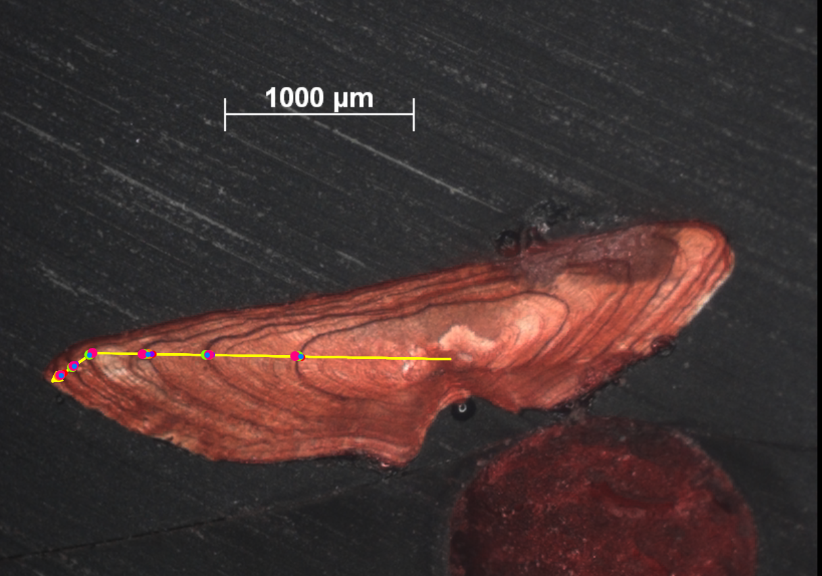Fig 3.4 Example of an otolith showing 100% agreement CDDR06_SOL_7D_L_M_72071 – MA = 6, catch date 01/08/2016
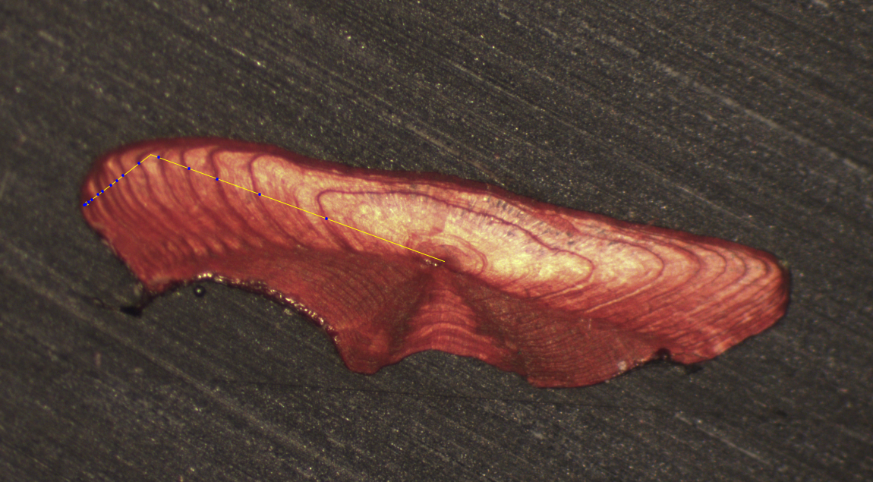
a) reader aged as 15; MA = 15
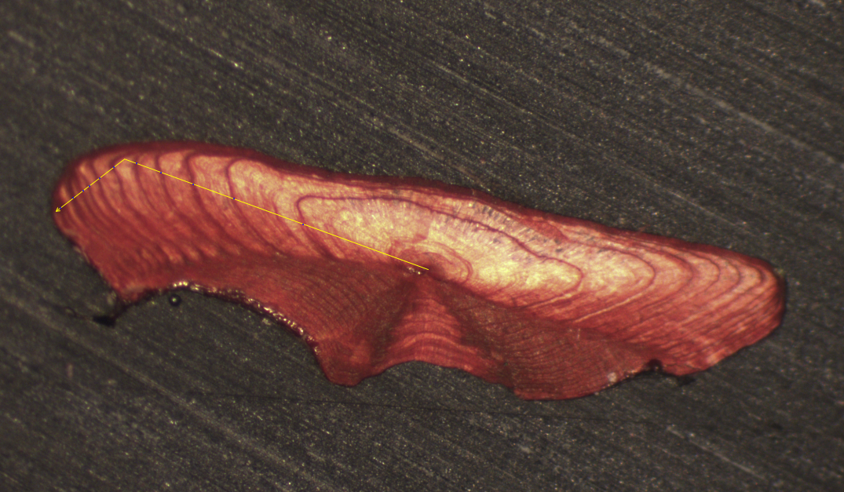
b) Reader aged fish as 11, MA = 15
Fig 3.5 : Image of otolith GNKT01_SOL_7D_L_M_2018011810191

Conclusion
All institutes tend to read this stock using the same preparation method of sectioned and stained. Sectioning is the best method to age sole especially for older specimens as otoliths can change the growth direction and older otoliths tend to get thicker instead of longer and wider. This phenomenon is described as ‘cliff edge effect’ and may cause underestimation of ages in whole otoliths and in particular if there is little or no otolith growth in the horizontal plane.
Percentage agreement between all readers based on modal ages was 70%, with a weighted average CV of 13 % and APE of 8%. For advanced readers only, the percentage agreement is 80% with a weighted average CV of 9 % and APE of 5%. As expected, percentage agreement was higher, and the coefficient of variation was lower for advanced readers compared to all readers.
The percentage agreement was lower in this exchange (80 %) compared to the last sole otolith exchange that took place in 2011 in the Bay of Biscay (88.6%). To our knowledge, this is the first otolith exchange of sole in area 7d.
During this exchange, some readers (particularly trainees) underestimated the older fish, it seemed the smaller rings on the edge of the otolith were not being counted as true rings. Following on from this exchange it would be recommended for a workshop to be carried out to discuss discrepancies in age readings.

References

Beamish R. J. and Fournier D. A. (1981) A method for comparing the precision of a set of age determination. Canadian
Journal of Fisheries and Aquatic Sciences, 38, 982–983

GUIDELINES AND TOOLS FOR AGE READING. Eltink, A.T.G.W., Newton A.W., Morgado C., Santamaria M.T.G and
Modin J. (2000) Guidelines and tools for age Reading. (PDF document version 1.0 October 2000) Internet:
http://www.efan.no

Eltink, A.T.G.W. (2000) Age reading comparisons. (MS Excel workbook version 1.0 October 2000) Internet:
http://www.efan.no

ICES (2014) Report of the Workshop on Statistical Analysis of Biological Calibration Studies (WKSABCAL). ICES CM
2014/ACOM: 3

Annex 1. Additional results

Results all readers
Data Overview
Table 5.1: Summary of statistics; PA (%), CV (%) and APE (%).
NSample | CV | PA | APE
116 | 13 % | 70 % | 8 %
Table 5.2: Data overview including modal age and statistics per sample.
Fish ID | Sample ID | Event ID | Image ID | length | sex | Catch date | ICES area | R02 GB | R04 BE | R06 BE | R08 FR | R10 IE | R12 GR | R14 IT | R16 IT | R18 GB | Modal age | PA % | CV % | APE %
BYDR01_SOL_7D_L_M_2019012410298 | BYDR01_SOL_7D_L_M_2019012410298 | 314 | 37487 | 430 | - | 24/01/2019 00:00:00 | 27.7.d | 8 | 8 | 8 | 7 | 8 | 8 | - | 8 | 8 | 8 | 88 | 4 | 3
BYDR01_SOL_7D_L_M_2019012410343 | BYDR01_SOL_7D_L_M_2019012410343 | 314 | 37488 | 350 | - | 24/01/2019 00:00:00 | 27.7.d | 9 | 10 | 9 | 8 | 10 | 9 | - | 9 | 8 | 9 | 50 | 8 | 6
BYDR03_SOL_7D_L_M_47090 | BYDR03_SOL_7D_L_M_47090 | 314 | 37584 | 395 | - | 05/04/2015 00:00:00 | 27.7.d | 14 | 14 | 15 | 14 | 14 | 13 | 11 | 14 | 13 | 14 | 56 | 8 | 6
BYDR03_SOL_7D_L_M_47129 | BYDR03_SOL_7D_L_M_47129 | 314 | 37585 | 310 | - | 05/04/2015 00:00:00 | 27.7.d | 15 | 15 | 15 | 14 | 14 | 14 | 13 | 14 | 12 | 14 | 44 | 7 | 5
BYDR06_SOL_7D_L_M_2019100810200 | BYDR06_SOL_7D_L_M_2019100810200 | 314 | 37489 | 380 | - | 08/10/2019 00:00:00 | 27.7.d | 11 | 11 | 11 | 10 | 11 | 11 | 10 | 11 | - | 11 | 75 | 4 | 3
BYDR06_SOL_7D_L_M_2019100810201 | BYDR06_SOL_7D_L_M_2019100810201 | 314 | 37490 | 365 | - | 08/10/2019 00:00:00 | 27.7.d | 10 | 10 | 11 | 10 | 10 | 10 | 11 | 11 | 11 | 10 | 56 | 5 | 5
BYDR06_SOL_7D_L_M_2019100810211 | BYDR06_SOL_7D_L_M_2019100810211 | 314 | 37491 | 320 | - | 08/10/2019 00:00:00 | 27.7.d | 5 | 5 | 5 | 5 | 5 | 5 | 6 | 6 | 6 | 5 | 67 | 9 | 8
BYDR06_SOL_7D_L_M_2019100810213 | BYDR06_SOL_7D_L_M_2019100810213 | 314 | 37492 | 315 | - | 08/10/2019 00:00:00 | 27.7.d | 9 | 9 | 9 | 9 | 9 | 9 | 9 | 10 | 10 | 9 | 78 | 5 | 4
BYDR06_SOL_7D_L_M_2019100810215 | BYDR06_SOL_7D_L_M_2019100810215 | 314 | 37493 | 335 | - | 08/10/2019 00:00:00 | 27.7.d | 6 | 6 | 6 | 6 | 6 | 6 | 6 | 7 | 7 | 6 | 78 | 7 | 6
BYDR06_SOL_7D_R_S_2019100810056 | BYDR06_SOL_7D_R_S_2019100810056 | 314 | 37494 | 200 | - | 08/10/2019 00:00:00 | 27.7.d | 2 | 2 | 2 | 2 | 2 | 2 | 2 | 3 | 3 | 2 | 78 | 20 | 16
BYDR06_SOL_7D_R_S_2019100810067 | BYDR06_SOL_7D_R_S_2019100810067 | 314 | 37495 | 200 | - | 08/10/2019 00:00:00 | 27.7.d | 1 | 1 | 1 | 1 | 1 | 2 | 2 | 2 | 2 | 1 | 56 | 36 | 34
BYDR08_SOL_7D_L_M_2017121510154 | BYDR08_SOL_7D_L_M_2017121510154 | 314 | 37496 | 420 | - | 15/12/2017 00:00:00 | 27.7.d | 6 | 6 | 6 | 6 | - | 6 | 6 | 6 | 6 | 6 | 100 | 0 | 0
BYDR08_SOL_7D_L_M_2017121510194 | BYDR08_SOL_7D_L_M_2017121510194 | 314 | 37497 | 255 | - | 15/12/2017 00:00:00 | 27.7.d | 1 | 1 | 1 | 1 | 1 | 1 | 1 | 2 | 2 | 1 | 78 | 36 | 28
BYDR09_SOL_7D_D_M_2019122610207 | BYDR09_SOL_7D_D_M_2019122610207 | 314 | 37498 | 248 | - | 26/12/2019 00:00:00 | 27.7.d | 2 | 2 | 2 | 2 | 2 | 3 | 3 | 3 | 3 | 2 | 56 | 22 | 20
BYDR09_SOL_7D_L_M_2019122610240 | BYDR09_SOL_7D_L_M_2019122610240 | 314 | 37499 | 405 | - | 26/12/2019 00:00:00 | 27.7.d | 4 | 4 | 4 | 4 | 4 | 4 | 4 | 5 | 4 | 4 | 89 | 8 | 5
BYDR09_SOL_7D_L_M_2019122610251 | BYDR09_SOL_7D_L_M_2019122610251 | 314 | 37500 | 399 | - | 26/12/2019 00:00:00 | 27.7.d | 11 | 11 | 11 | 8 | 10 | 11 | 11 | 12 | 10 | 11 | 56 | 11 | 8
BYDR09_SOL_7D_L_M_2019122610253 | BYDR09_SOL_7D_L_M_2019122610253 | 314 | 37501 | 413 | - | 26/12/2019 00:00:00 | 27.7.d | 5 | 5 | 5 | 5 | 5 | 5 | 5 | 5 | 5 | 5 | 100 | 0 | 0
BYDR09_SOL_7D_L_M_2019122610255 | BYDR09_SOL_7D_L_M_2019122610255 | 314 | 37502 | 358 | - | 26/12/2019 00:00:00 | 27.7.d | 10 | 10 | 10 | 6 | 9 | 11 | 9 | 10 | 8 | 10 | 44 | 16 | 12
BYDR09_SOL_7D_L_M_2019122610283 | BYDR09_SOL_7D_L_M_2019122610283 | 314 | 37503 | 258 | - | 26/12/2019 00:00:00 | 27.7.d | 3 | 3 | 3 | 3 | 3 | 3 | 3 | 4 | 3 | 3 | 89 | 11 | 6
BYDR10_SOL_7D_L_M_224293 | BYDR10_SOL_7D_L_M_224293 | 314 | 37504 | 400 | - | 09/12/2016 00:00:00 | 27.7.d | 12 | 12 | 12 | 11 | 11 | 12 | 13 | 12 | 11 | 12 | 56 | 6 | 4
BYDR10_SOL_7D_L_M_224321 | BYDR10_SOL_7D_L_M_224321 | 314 | 37505 | 350 | - | 09/12/2016 00:00:00 | 27.7.d | 16 | 15 | 15 | 13 | 15 | 15 | 15 | 16 | 14 | 15 | 56 | 6 | 4
CDDR01_SOL_7D_L_M_2019021110310 | CDDR01_SOL_7D_L_M_2019021110310 | 314 | 37506 | 355 | - | 11/02/2019 00:00:00 | 27.7.d | 5 | 5 | 5 | 5 | 5 | 5 | 4 | 5 | 4 | 5 | 78 | 9 | 7
CDDR01_SOL_7D_L_M_2019021110315 | CDDR01_SOL_7D_L_M_2019021110315 | 314 | 37507 | 385 | - | 11/02/2019 00:00:00 | 27.7.d | 8 | 8 | 8 | 6 | 7 | 8 | 7 | 7 | 7 | 8 | 44 | 10 | 8
CDDR01_SOL_7D_L_M_2019021110330 | CDDR01_SOL_7D_L_M_2019021110330 | 314 | 37508 | 350 | - | 11/02/2019 00:00:00 | 27.7.d | 7 | 7 | 7 | 7 | 7 | 7 | 6 | 6 | 5 | 7 | 67 | 11 | 9
CDDR01_SOL_7D_L_M_2019021110331 | CDDR01_SOL_7D_L_M_2019021110331 | 314 | 37509 | 310 | - | 11/02/2019 00:00:00 | 27.7.d | 4 | 4 | 3 | 4 | 4 | 4 | 3 | 4 | 3 | 4 | 67 | 14 | 12
CDDR03_SOL_7D_L_M_2018052810319 | CDDR03_SOL_7D_L_M_2018052810319 | 314 | 37510 | 410 | - | 28/05/2018 00:00:00 | 27.7.d | 10 | 10 | 10 | 9 | 9 | 10 | 9 | 9 | 8 | 10 | 44 | 8 | 6
CDDR03_SOL_7D_L_M_2018052810334 | CDDR03_SOL_7D_L_M_2018052810334 | 314 | 37511 | 430 | - | 28/05/2018 00:00:00 | 27.7.d | 11 | 11 | 11 | 10 | 10 | 11 | 10 | 10 | 10 | 10 | 56 | 5 | 5
CDDR03_SOL_7D_R_S_2018052810105 | CDDR03_SOL_7D_R_S_2018052810105 | 314 | 37512 | 170 | - | 28/05/2018 00:00:00 | 27.7.d | 2 | 2 | 2 | 2 | 2 | 2 | 2 | 2 | 2 | 2 | 100 | 0 | 0
CDDR06_SOL_7D_L_M_58794 | CDDR06_SOL_7D_L_M_58794 | 314 | 37586 | 335 | - | 09/10/2015 00:00:00 | 27.7.d | 15 | 15 | 15 | 15 | 15 | 15 | 16 | 16 | 15 | 15 | 78 | 3 | 2
CDDR06_SOL_7D_L_M_72071 | CDDR06_SOL_7D_L_M_72071 | 314 | 37587 | 315 | - | 01/08/2016 00:00:00 | 27.7.d | 6 | 6 | 6 | 6 | 6 | 6 | 6 | 6 | 6 | 6 | 100 | 0 | 0
CDDR06_SOL_7D_L_M_72075 | CDDR06_SOL_7D_L_M_72075 | 314 | 37588 | 315 | - | 01/08/2016 00:00:00 | 27.7.d | 4 | 4 | 4 | 4 | 4 | 4 | 4 | 4 | 4 | 4 | 100 | 0 | 0
CDDR06_SOL_7D_L_M_72083 | CDDR06_SOL_7D_L_M_72083 | 314 | 37589 | 280 | - | 01/08/2016 00:00:00 | 27.7.d | 3 | 3 | 3 | 3 | 3 | 3 | 3 | 3 | 3 | 3 | 100 | 0 | 0
CDDR06_SOL_7D_R_S_71023 | CDDR06_SOL_7D_R_S_71023 | 314 | 37590 | 210 | - | 01/08/2016 00:00:00 | 27.7.d | 2 | 2 | 2 | 2 | 2 | 2 | 2 | 2 | 2 | 2 | 100 | 0 | 0
CDDR07_SOL_7D_L_M_221489 | CDDR07_SOL_7D_L_M_221489 | 314 | 37513 | 360 | - | 25/10/2016 00:00:00 | 27.7.d | 8 | 8 | 8 | 7 | 8 | 9 | 9 | 8 | 8 | 8 | 67 | 7 | 5
CDDR07_SOL_7D_L_M_221490 | CDDR07_SOL_7D_L_M_221490 | 314 | 37514 | 380 | - | 25/10/2016 00:00:00 | 27.7.d | 12 | 12 | 12 | 11 | 12 | 12 | 12 | 12 | 12 | 12 | 89 | 3 | 2
CDDR07_SOL_7D_L_M_221497 | CDDR07_SOL_7D_L_M_221497 | 314 | 37515 | 340 | - | 25/10/2016 00:00:00 | 27.7.d | 7 | 7 | 7 | 7 | 7 | 7 | 7 | 7 | 7 | 7 | 100 | 0 | 0
CDDR08_SOL_7D_L_M_2017112110232 | CDDR08_SOL_7D_L_M_2017112110232 | 314 | 37516 | 380 | - | 21/11/2017 00:00:00 | 27.7.d | 13 | 13 | 13 | 10 | 13 | 13 | 12 | 13 | 11 | 13 | 67 | 9 | 7
CDDR08_SOL_7D_L_M_2017112110241 | CDDR08_SOL_7D_L_M_2017112110241 | 314 | 37517 | 315 | - | 21/11/2017 00:00:00 | 27.7.d | 15 | 15 | 14 | 13 | 15 | - | 15 | 12 | 11 | 15 | 50 | 11 | 10
GNKT01_SOL_7D_L_M_2018011810190 | GNKT01_SOL_7D_L_M_2018011810190 | 314 | 37518 | 405 | - | 18/01/2018 00:00:00 | 27.7.d | 12 | 14 | 14 | 10 | 11 | 14 | 13 | 12 | 9 | 14 | 33 | 15 | 12
GNKT01_SOL_7D_L_M_2018011810191 | GNKT01_SOL_7D_L_M_2018011810191 | 314 | 37519 | 440 | - | 18/01/2018 00:00:00 | 27.7.d | 14 | 15 | 15 | 12 | 13 | - | 11 | 13 | 13 | 13 | 38 | 10 | 8
GNKT01_SOL_7D_L_M_2018011810193 | GNKT01_SOL_7D_L_M_2018011810193 | 314 | 37520 | 470 | - | 18/01/2018 00:00:00 | 27.7.d | 12 | 13 | 13 | 12 | 11 | 13 | 10 | 12 | 11 | 13 | 33 | 9 | 7
GNKT01_SOL_7D_L_M_2019011810440 | GNKT01_SOL_7D_L_M_2019011810440 | 314 | 37521 | 425 | - | 18/01/2019 00:00:00 | 27.7.d | 12 | 12 | 12 | 9 | - | 12 | 8 | 10 | 10 | 12 | 50 | 15 | 13
GNKT01_SOL_7D_L_M_2019011810463 | GNKT01_SOL_7D_L_M_2019011810463 | 314 | 37522 | 285 | - | 18/01/2019 00:00:00 | 27.7.d | 4 | 4 | 4 | 4 | 4 | 4 | 3 | 4 | 4 | 4 | 89 | 9 | 5
GNKT02_SOL_7D_L_M_2019030110184 | GNKT02_SOL_7D_L_M_2019030110184 | 314 | 37523 | 375 | - | 01/03/2019 00:00:00 | 27.7.d | 9 | 9 | 9 | 9 | 9 | 9 | 8 | 8 | 9 | 9 | 78 | 5 | 4
GNKT02_SOL_7D_L_M_2019030110186 | GNKT02_SOL_7D_L_M_2019030110186 | 314 | 37524 | 365 | - | 01/03/2019 00:00:00 | 27.7.d | 11 | 11 | 11 | 11 | 11 | 11 | 10 | 10 | 11 | 11 | 78 | 4 | 3
GNKT02_SOL_7D_L_M_2019030110189 | GNKT02_SOL_7D_L_M_2019030110189 | 314 | 37525 | 370 | - | 01/03/2019 00:00:00 | 27.7.d | 5 | 5 | 5 | 5 | 5 | 5 | 4 | 5 | 5 | 5 | 89 | 7 | 4
GNKT02_SOL_7D_L_M_2019030110195 | GNKT02_SOL_7D_L_M_2019030110195 | 314 | 37526 | 360 | - | 01/03/2019 00:00:00 | 27.7.d | 6 | 6 | 6 | 6 | 6 | 6 | 5 | 6 | 6 | 6 | 89 | 6 | 3
GNKT02_SOL_7D_L_M_2019030110201 | GNKT02_SOL_7D_L_M_2019030110201 | 314 | 37527 | 465 | - | 01/03/2019 00:00:00 | 27.7.d | 10 | 10 | 10 | 9 | 10 | 10 | 9 | 9 | 10 | 10 | 67 | 5 | 5
GNKT02_SOL_7D_L_M_2019030110207 | GNKT02_SOL_7D_L_M_2019030110207 | 314 | 37528 | 420 | - | 01/03/2019 00:00:00 | 27.7.d | 15 | 15 | 15 | 11 | 13 | 14 | 10 | 12 | 11 | 15 | 33 | 15 | 13
GNKT02_SOL_7D_R_S_2019030110072 | GNKT02_SOL_7D_R_S_2019030110072 | 314 | 37529 | 210 | - | 01/03/2019 00:00:00 | 27.7.d | 2 | 2 | 2 | 2 | 2 | 2 | 2 | 2 | 2 | 2 | 100 | 0 | 0
GNKT02_SOL_7D_R_S_2019030110080 | GNKT02_SOL_7D_R_S_2019030110080 | 314 | 37530 | 220 | - | 01/03/2019 00:00:00 | 27.7.d | 3 | 3 | 3 | 3 | 3 | 3 | 2 | 3 | 4 | 3 | 78 | 17 | 7
GNKT05_SOL_7D_L_M_2018071710545 | GNKT05_SOL_7D_L_M_2018071710545 | 314 | 37531 | 335 | - | 17/07/2018 00:00:00 | 27.7.d | 8 | 8 | 8 | 8 | 8 | 9 | 8 | 8 | 9 | 8 | 78 | 5 | 4
GNKT05_SOL_7D_L_M_2018071710552 | GNKT05_SOL_7D_L_M_2018071710552 | 314 | 37532 | 360 | - | 17/07/2018 00:00:00 | 27.7.d | 12 | 13 | 13 | - | 12 | - | 10 | 12 | 12 | 12 | 57 | 8 | 5
GNKT05_SOL_7D_L_M_2018071710559 | GNKT05_SOL_7D_L_M_2018071710559 | 314 | 37533 | 260 | - | 17/07/2018 00:00:00 | 27.7.d | 7 | 7 | 7 | 7 | 7 | 7 | 7 | 7 | 7 | 7 | 100 | 0 | 0
GNKT08_SOL_7D_L_M_224839 | GNKT08_SOL_7D_L_M_224839 | 314 | 37534 | 360 | - | 15/12/2016 00:00:00 | 27.7.d | 12 | 14 | 14 | 9 | 9 | 9 | 9 | 10 | 9 | 9 | 56 | 21 | 18
GNKT08_SOL_7D_L_M_224840 | GNKT08_SOL_7D_L_M_224840 | 314 | 37535 | 450 | - | 15/12/2016 00:00:00 | 27.7.d | 8 | 8 | 8 | 6 | 8 | 8 | 7 | 8 | 8 | 8 | 78 | 9 | 7
GNKT08_SOL_7D_L_M_224847 | GNKT08_SOL_7D_L_M_224847 | 314 | 37536 | 370 | - | 15/12/2016 00:00:00 | 27.7.d | 7 | 7 | 7 | 6 | 7 | 8 | 7 | 8 | 7 | 7 | 67 | 8 | 6
GNKT08_SOL_7D_L_M_224871 | GNKT08_SOL_7D_L_M_224871 | 314 | 37537 | 350 | - | 15/12/2016 00:00:00 | 27.7.d | 9 | 9 | 10 | 7 | 9 | 9 | 8 | 9 | 9 | 9 | 67 | 9 | 6
GNKT08_SOL_7D_L_M_224890 | GNKT08_SOL_7D_L_M_224890 | 314 | 37538 | 320 | - | 15/12/2016 00:00:00 | 27.7.d | 13 | 13 | 13 | 10 | 13 | 13 | 12 | 13 | 13 | 13 | 78 | 8 | 6
PTCT01_SOL_7D_L_M_2017001301 | PTCT01_SOL_7D_L_M_2017001301 | 314 | 37539 | 385 | - | 06/02/2017 00:00:00 | 27.7.d | 13 | 13 | 13 | 11 | 12 | 13 | 10 | 12 | 9 | 13 | 44 | 13 | 10
PTCT01_SOL_7D_L_M_2017001309 | PTCT01_SOL_7D_L_M_2017001309 | 314 | 37540 | 405 | - | 06/02/2017 00:00:00 | 27.7.d | 14 | 14 | 13 | 11 | 13 | 13 | 12 | 13 | 9 | 13 | 44 | 13 | 10
PTCT01_SOL_7D_L_M_2017001323 | PTCT01_SOL_7D_L_M_2017001323 | 314 | 37541 | 455 | - | 06/02/2017 00:00:00 | 27.7.d | 12 | 12 | 11 | 9 | 10 | 11 | 9 | 10 | 10 | 10 | 33 | 11 | 9
PTCT01_SOL_7D_L_M_2019011410246 | PTCT01_SOL_7D_L_M_2019011410246 | 314 | 37542 | 365 | - | 14/01/2019 00:00:00 | 27.7.d | 6 | 6 | 6 | 6 | 6 | 6 | 5 | 5 | 5 | 6 | 67 | 9 | 8
PTCT01_SOL_7D_L_M_2019011410253 | PTCT01_SOL_7D_L_M_2019011410253 | 314 | 37543 | 345 | - | 14/01/2019 00:00:00 | 27.7.d | 7 | 7 | 7 | 6 | 7 | 7 | 6 | 7 | 6 | 7 | 67 | 8 | 7
PTCT01_SOL_7D_L_M_2019011410257 | PTCT01_SOL_7D_L_M_2019011410257 | 314 | 37544 | 430 | - | 14/01/2019 00:00:00 | 27.7.d | 10 | 10 | 10 | 7 | 9 | 9 | 7 | 8 | 7 | 10 | 33 | 16 | 14
PTCT01_SOL_7D_L_M_2019011410258 | PTCT01_SOL_7D_L_M_2019011410258 | 314 | 37545 | 410 | - | 14/01/2019 00:00:00 | 27.7.d | 11 | 11 | 11 | 9 | 10 | 11 | 10 | 10 | 9 | 11 | 44 | 8 | 7
PTCT01_SOL_7D_R_S_2019011410107 | PTCT01_SOL_7D_R_S_2019011410107 | 314 | 37546 | 190 | - | 14/01/2019 00:00:00 | 27.7.d | 2 | 2 | 2 | 2 | 2 | 2 | 1 | 2 | 2 | 2 | 89 | 18 | 10
PTCT01_SOL_7D_R_S_2019011410111 | PTCT01_SOL_7D_R_S_2019011410111 | 314 | 37547 | 200 | - | 14/01/2019 00:00:00 | 27.7.d | 3 | 3 | 3 | 2 | 3 | 3 | 2 | 3 | 2 | 3 | 67 | 19 | 17
PTCT01_SOL_7D_R_S_2019011410138 | PTCT01_SOL_7D_R_S_2019011410138 | 314 | 37548 | 170 | - | 14/01/2019 00:00:00 | 27.7.d | 1 | 1 | 1 | 1 | 2 | 2 | 0 | 0 | 1 | 1 | 56 | 71 | 44
PTCT01_SOL_7D_R_S_2019011410139 | PTCT01_SOL_7D_R_S_2019011410139 | 314 | 37549 | 180 | - | 14/01/2019 00:00:00 | 27.7.d | 1 | 1 | 1 | 1 | 1 | 2 | 0 | 1 | 1 | 1 | 78 | 50 | 22
PTCT03_SOL_7D_L_M_2018040210259 | PTCT03_SOL_7D_L_M_2018040210259 | 314 | 37550 | 430 | - | 02/04/2018 00:00:00 | 27.7.d | 13 | 14 | 14 | 10 | 12 | 12 | 10 | 11 | 8 | 14 | 22 | 17 | 14
PTCT03_SOL_7D_L_M_2018040210260 | PTCT03_SOL_7D_L_M_2018040210260 | 314 | 37551 | 435 | - | 02/04/2018 00:00:00 | 27.7.d | 8 | 8 | 8 | 8 | 8 | 8 | 7 | 8 | 8 | 8 | 89 | 4 | 3
PTCT03_SOL_7D_L_M_2018040210267 | PTCT03_SOL_7D_L_M_2018040210267 | 314 | 37552 | 350 | - | 02/04/2018 00:00:00 | 27.7.d | - | 13 | 14 | 11 | 13 | 14 | 12 | 13 | 12 | 13 | 38 | 8 | 6
PTCT03_SOL_7D_L_M_2018040210270 | PTCT03_SOL_7D_L_M_2018040210270 | 314 | 37553 | 345 | - | 02/04/2018 00:00:00 | 27.7.d | 5 | 5 | 5 | 5 | 5 | 5 | 5 | 5 | 5 | 5 | 100 | 0 | 0
PTCT03_SOL_7D_L_M_2018040210286 | PTCT03_SOL_7D_L_M_2018040210286 | 314 | 37554 | 280 | - | 02/04/2018 00:00:00 | 27.7.d | 7 | 7 | 7 | 7 | 7 | 7 | 6 | 7 | 7 | 7 | 89 | 5 | 3
PTCT03_SOL_7D_L_M_2018040210298 | PTCT03_SOL_7D_L_M_2018040210298 | 314 | 37555 | 250 | - | 02/04/2018 00:00:00 | 27.7.d | 6 | 6 | 6 | 5 | 6 | 6 | 5 | 6 | 6 | 6 | 78 | 8 | 6
PTCT03_SOL_7D_L_M_2019111120105 | PTCT03_SOL_7D_L_M_2019111120105 | 314 | 37556 | 322 | - | 11/11/2019 00:00:00 | 27.7.d | 3 | 3 | 3 | 3 | 3 | 3 | 3 | 3 | 3 | 3 | 100 | 0 | 0
PTCT03_SOL_7D_L_M_2019111120107 | PTCT03_SOL_7D_L_M_2019111120107 | 314 | 37557 | 347 | - | 11/11/2019 00:00:00 | 27.7.d | 4 | 4 | 4 | 4 | 4 | 4 | 4 | 4 | 4 | 4 | 100 | 0 | 0
PTCT03_SOL_7D_L_M_68321 | PTCT03_SOL_7D_L_M_68321 | 314 | 37591 | 510 | - | 04/04/2016 00:00:00 | 27.7.d | 12 | 12 | 12 | 11 | 12 | 12 | 11 | 12 | 12 | 12 | 78 | 4 | 3
PTCT03_SOL_7D_L_M_68323 | PTCT03_SOL_7D_L_M_68323 | 314 | 37592 | 420 | - | 04/04/2016 00:00:00 | 27.7.d | 11 | 11 | 11 | 11 | 10 | 10 | 11 | 11 | 11 | 11 | 78 | 4 | 3
PTCT03_SOL_7D_L_M_68328 | PTCT03_SOL_7D_L_M_68328 | 314 | 37593 | 420 | - | 04/04/2016 00:00:00 | 27.7.d | 9 | 9 | 9 | 9 | 9 | 9 | 8 | 9 | 9 | 9 | 89 | 4 | 2
PTCT03_SOL_7D_L_M_68349 | PTCT03_SOL_7D_L_M_68349 | 314 | 37594 | 460 | - | 04/04/2016 00:00:00 | 27.7.d | 10 | 10 | 10 | 9 | 10 | 10 | 9 | 10 | 10 | 10 | 78 | 5 | 4
PTCT03_SOL_7D_R_S_2017040310127 | PTCT03_SOL_7D_R_S_2017040310127 | 314 | 37558 | 210 | - | 03/04/2017 00:00:00 | 27.7.d | 3 | 3 | 3 | 3 | 3 | 3 | 2 | 3 | 3 | 3 | 89 | 12 | 7
PTCT03_SOL_7D_R_S_2017040310163 | PTCT03_SOL_7D_R_S_2017040310163 | 314 | 37559 | 160 | - | 03/04/2017 00:00:00 | 27.7.d | 1 | 1 | 1 | 1 | - | 1 | 0 | 1 | 1 | 1 | 88 | 40 | 25
PTCT03_SOL_7D_R_S_2018040210117 | PTCT03_SOL_7D_R_S_2018040210117 | 314 | 37560 | 220 | - | 02/04/2018 00:00:00 | 27.7.d | 2 | 2 | 2 | 2 | 2 | 2 | 1 | 2 | 2 | 2 | 89 | 18 | 10
PTCT04_SOL_7D_L_M_2018052110342 | PTCT04_SOL_7D_L_M_2018052110342 | 314 | 37561 | 420 | - | 21/05/2018 00:00:00 | 27.7.d | 8 | 8 | 8 | 7 | 7 | 8 | 7 | 7 | 7 | 7 | 56 | 7 | 7
PTCT04_SOL_7D_L_M_2018052110350 | PTCT04_SOL_7D_L_M_2018052110350 | 314 | 37562 | 355 | - | 21/05/2018 00:00:00 | 27.7.d | 12 | 12 | 12 | 11 | 12 | - | - | 11 | 10 | 12 | 57 | 7 | 6
PTCT04_SOL_7D_L_M_2018052110353 | PTCT04_SOL_7D_L_M_2018052110353 | 314 | 37563 | 430 | - | 21/05/2018 00:00:00 | 27.7.d | 9 | 13 | 10 | 8 | 9 | 9 | 8 | 9 | 9 | 9 | 56 | 16 | 10
PTCT04_SOL_7D_L_M_2018052110362 | PTCT04_SOL_7D_L_M_2018052110362 | 314 | 37564 | 325 | - | 21/05/2018 00:00:00 | 27.7.d | 9 | 9 | 9 | 8 | 7 | 9 | 8 | 8 | 8 | 9 | 44 | 8 | 7
PTCT04_SOL_7D_L_M_2018052110363 | PTCT04_SOL_7D_L_M_2018052110363 | 314 | 37565 | 325 | - | 21/05/2018 00:00:00 | 27.7.d | 4 | 4 | 4 | 4 | 4 | 4 | 3 | 4 | 4 | 4 | 89 | 9 | 5
PTCT04_SOL_7D_L_M_2018052110369 | PTCT04_SOL_7D_L_M_2018052110369 | 314 | 37566 | 340 | - | 21/05/2018 00:00:00 | 27.7.d | 15 | 15 | 15 | 12 | 11 | 15 | 14 | 14 | 15 | 15 | 56 | 11 | 8
PTCT05_SOL_7D_L_M_2018061810274 | PTCT05_SOL_7D_L_M_2018061810274 | 314 | 37567 | 380 | - | 18/06/2018 00:00:00 | 27.7.d | 7 | 6 | 6 | 6 | 6 | 7 | 6 | 6 | 7 | 6 | 67 | 8 | 7
PTCT05_SOL_7D_L_M_2018061810279 | PTCT05_SOL_7D_L_M_2018061810279 | 314 | 37568 | 380 | - | 18/06/2018 00:00:00 | 27.7.d | 7 | 7 | 7 | 7 | 7 | 7 | 7 | 7 | 7 | 7 | 100 | 0 | 0
PTCT05_SOL_7D_L_M_2018061810286 | PTCT05_SOL_7D_L_M_2018061810286 | 314 | 37569 | 345 | - | 18/06/2018 00:00:00 | 27.7.d | 5 | 5 | 5 | 5 | 5 | 6 | 5 | 5 | 6 | 5 | 78 | 8 | 7
PTCT05_SOL_7D_L_M_2018061810300 | PTCT05_SOL_7D_L_M_2018061810300 | 314 | 37570 | 280 | - | 18/06/2018 00:00:00 | 27.7.d | - | 4 | 4 | 4 | 4 | 4 | 3 | 3 | 6 | 4 | 62 | 23 | 12
PTCT05_SOL_7D_L_M_70327 | PTCT05_SOL_7D_L_M_70327 | 314 | 37595 | 365 | - | 18/07/2016 00:00:00 | 27.7.d | 13 | 12 | 11 | 8 | 12 | 12 | 11 | 11 | 11 | 11 | 44 | 12 | 8
PTCT05_SOL_7D_L_M_70328 | PTCT05_SOL_7D_L_M_70328 | 314 | 37596 | 385 | - | 18/07/2016 00:00:00 | 27.7.d | 10 | 11 | 11 | 6 | 10 | 11 | 9 | 10 | 9 | 11 | 33 | 16 | 11
PTCT05_SOL_7D_L_M_70330 | PTCT05_SOL_7D_L_M_70330 | 314 | 37597 | 395 | - | 18/07/2016 00:00:00 | 27.7.d | 17 | 15 | 15 | 12 | 14 | 16 | 15 | 15 | 14 | 15 | 44 | 9 | 7
PTCT05_SOL_7D_L_M_70336 | PTCT05_SOL_7D_L_M_70336 | 314 | 37598 | 355 | - | 18/07/2016 00:00:00 | 27.7.d | 7 | 7 | 7 | 5 | 7 | 7 | 7 | 7 | 7 | 7 | 89 | 10 | 6
PTCT05_SOL_7D_L_M_70341 | PTCT05_SOL_7D_L_M_70341 | 314 | 37599 | 335 | - | 18/07/2016 00:00:00 | 27.7.d | 12 | 10 | 10 | 8 | 10 | 10 | - | 10 | 10 | 10 | 75 | 11 | 5
PTCT05_SOL_7D_L_M_70357 | PTCT05_SOL_7D_L_M_70357 | 314 | 37600 | 330 | - | 18/07/2016 00:00:00 | 27.7.d | 12 | 12 | 12 | 8 | 9 | 11 | - | 8 | 10 | 12 | 38 | 17 | 15
PTCT05_SOL_7D_L_M_70361 | PTCT05_SOL_7D_L_M_70361 | 314 | 37601 | 280 | - | 18/07/2016 00:00:00 | 27.7.d | 5 | 4 | 4 | 4 | 4 | 5 | 5 | 5 | 5 | 5 | 56 | 12 | 11
PTCT05_SOL_7D_L_M_70362 | PTCT05_SOL_7D_L_M_70362 | 314 | 37602 | 285 | - | 18/07/2016 00:00:00 | 27.7.d | 6 | 5 | 5 | 5 | 5 | 6 | 6 | 6 | 6 | 6 | 56 | 9 | 9
PTCT05_SOL_7D_R_S_221451 | PTCT05_SOL_7D_R_S_221451 | 314 | 37571 | 210 | - | 18/07/2016 00:00:00 | 27.7.d | 2 | 2 | 2 | 2 | 2 | 2 | 2 | 3 | 3 | 2 | 78 | 20 | 16
PTCT05_SOL_7D_R_S_221464 | PTCT05_SOL_7D_R_S_221464 | 314 | 37572 | 230 | - | 18/07/2016 00:00:00 | 27.7.d | 3 | 3 | 3 | 3 | 3 | 3 | 3 | 3 | 3 | 3 | 100 | 0 | 0
PTCT06_SOL_7D_L_M_2018072310264 | PTCT06_SOL_7D_L_M_2018072310264 | 314 | 37573 | 370 | - | 23/07/2018 00:00:00 | 27.7.d | 10 | 9 | 9 | 7 | 7 | 9 | - | 7 | 8 | 9 | 38 | 14 | 12
PTCT06_SOL_7D_L_M_2018072310270 | PTCT06_SOL_7D_L_M_2018072310270 | 314 | 37574 | 380 | - | 23/07/2018 00:00:00 | 27.7.d | 14 | 13 | 14 | 12 | 13 | 14 | 14 | 13 | 12 | 14 | 44 | 6 | 5
PTCT06_SOL_7D_L_M_2018072310285 | PTCT06_SOL_7D_L_M_2018072310285 | 314 | 37575 | 305 | - | 23/07/2018 00:00:00 | 27.7.d | 8 | 8 | 8 | 6 | 6 | 8 | 8 | 7 | 6 | 8 | 56 | 13 | 12
PTCT06_SOL_7D_L_M_2018072310288 | PTCT06_SOL_7D_L_M_2018072310288 | 314 | 37576 | 325 | - | 23/07/2018 00:00:00 | 27.7.d | 5 | 5 | 5 | 4 | 5 | 5 | 5 | 5 | 5 | 5 | 89 | 7 | 4
PTCT06_SOL_7D_R_S_2017062610054 | PTCT06_SOL_7D_R_S_2017062610054 | 314 | 37577 | 180 | - | 26/06/2017 00:00:00 | 27.7.d | 1 | 1 | 1 | 1 | 1 | 2 | 1 | 1 | 1 | 1 | 89 | 30 | 18
PTCT06_SOL_7D_R_S_2017062610056 | PTCT06_SOL_7D_R_S_2017062610056 | 314 | 37578 | 210 | - | 26/06/2017 00:00:00 | 27.7.d | 3 | 3 | 3 | 3 | 3 | 3 | 3 | 3 | 3 | 3 | 100 | 0 | 0
PTCT07_SOL_7D_L_M_2017071510298 | PTCT07_SOL_7D_L_M_2017071510298 | 314 | 37579 | 385 | - | 15/07/2017 00:00:00 | 27.7.d | 9 | 8 | 8 | 6 | 7 | 8 | 7 | 7 | 8 | 8 | 44 | 12 | 9
PTCT07_SOL_7D_L_M_2017071510319 | PTCT07_SOL_7D_L_M_2017071510319 | 314 | 37580 | 415 | - | 15/07/2017 00:00:00 | 27.7.d | 10 | 10 | 10 | 9 | 10 | 9 | 10 | 10 | 10 | 10 | 78 | 5 | 4
PTCT07_SOL_7D_L_M_2017071510321 | PTCT07_SOL_7D_L_M_2017071510321 | 314 | 37581 | 340 | - | 15/07/2017 00:00:00 | 27.7.d | 6 | 6 | 6 | 4 | 6 | 6 | 6 | 6 | 6 | 6 | 89 | 12 | 7
PTCT07_SOL_7D_R_S_2017071510138 | PTCT07_SOL_7D_R_S_2017071510138 | 314 | 37582 | 180 | - | 15/07/2017 00:00:00 | 27.7.d | 1 | 1 | 1 | 1 | 1 | 1 | - | 2 | 1 | 1 | 88 | 31 | 19
PTCT07_SOL_7D_R_S_2017071510140 | PTCT07_SOL_7D_R_S_2017071510140 | 314 | 37583 | 180 | - | 15/07/2017 00:00:00 | 27.7.d | 1 | 1 | 1 | 1 | 1 | 1 | 1 | 1 | 1 | 1 | 100 | 0 | 0
Table 5.3: List of cases (sampleID) for which multiple modes where obtained when all readers are considered. The column NModes_trad shows the number of multiple modes for each sampleID when all readers are given the same experience weight.
 | NModes_trad | SampleID
CDDR01_SOL_7D_L_M_2019021110315 | 2 | CDDR01_SOL_7D_L_M_2019021110315
CDDR03_SOL_7D_L_M_2018052810319 | 2 | CDDR03_SOL_7D_L_M_2018052810319
GNKT01_SOL_7D_L_M_2018011810193 | 2 | GNKT01_SOL_7D_L_M_2018011810193
PTCT01_SOL_7D_L_M_2019011410257 | 2 | PTCT01_SOL_7D_L_M_2019011410257
PTCT03_SOL_7D_L_M_2018040210259 | 3 | PTCT03_SOL_7D_L_M_2018040210259
PTCT04_SOL_7D_L_M_2018052110362 | 2 | PTCT04_SOL_7D_L_M_2018052110362
PTCT05_SOL_7D_L_M_70328 | 2 | PTCT05_SOL_7D_L_M_70328
PTCT06_SOL_7D_L_M_2018072310264 | 2 | PTCT06_SOL_7D_L_M_2018072310264
Table 5.4: Number of age readings table gives an overview of number of readings per reader and modal age. The total numbers of readings per reader and per modal age are summarized at the end of the table.
Modal age | R02 GB | R04 BE | R06 BE | R08 FR | R10 IE | R12 GR | R14 IT | R16 IT | R18 GB | total
1 | 8 | 8 | 8 | 8 | 7 | 8 | 7 | 8 | 8 | 70
2 | 8 | 8 | 8 | 8 | 8 | 8 | 8 | 8 | 8 | 72
3 | 8 | 8 | 8 | 8 | 8 | 8 | 8 | 8 | 8 | 72
4 | 6 | 7 | 7 | 7 | 7 | 7 | 7 | 7 | 7 | 62
5 | 8 | 8 | 8 | 8 | 8 | 8 | 8 | 8 | 8 | 72
6 | 9 | 9 | 9 | 9 | 8 | 9 | 9 | 9 | 9 | 80
7 | 9 | 9 | 9 | 9 | 9 | 9 | 9 | 9 | 9 | 81
8 | 8 | 8 | 8 | 8 | 8 | 8 | 7 | 8 | 8 | 71
9 | 9 | 9 | 9 | 9 | 9 | 9 | 7 | 9 | 9 | 79
10 | 10 | 10 | 10 | 10 | 10 | 10 | 9 | 10 | 10 | 89
11 | 7 | 7 | 7 | 7 | 7 | 7 | 7 | 7 | 6 | 62
12 | 7 | 7 | 7 | 6 | 6 | 5 | 5 | 7 | 7 | 57
13 | 6 | 7 | 7 | 7 | 7 | 6 | 7 | 7 | 7 | 61
14 | 5 | 5 | 5 | 5 | 5 | 5 | 5 | 5 | 5 | 45
15 | 6 | 6 | 6 | 6 | 6 | 5 | 6 | 6 | 6 | 53
Total | 114 | 116 | 116 | 115 | 113 | 112 | 109 | 116 | 115 | 1026

Table 5.5: Age composition by reader gives a summary of number of readings per reader.
 | Modal age | R02 GB | R04 BE | R06 BE | R08 FR | R10 IE | R12 GR | R14 IT | R16 IT | R18 GB
0 | 0 | 0 | 0 | 0 | 0 | 0 | 0 | 3 | 1 | 0
1 | 1 | 8 | 8 | 8 | 8 | 6 | 4 | 5 | 4 | 6
2 | 2 | 8 | 8 | 8 | 9 | 9 | 11 | 9 | 8 | 8
3 | 3 | 8 | 8 | 9 | 7 | 8 | 9 | 10 | 11 | 10
4 | 4 | 6 | 8 | 7 | 10 | 8 | 7 | 5 | 6 | 7
5 | 5 | 8 | 8 | 8 | 9 | 8 | 7 | 8 | 9 | 7
6 | 6 | 8 | 8 | 8 | 14 | 8 | 9 | 10 | 9 | 11
7 | 7 | 9 | 8 | 8 | 11 | 13 | 8 | 11 | 12 | 11
8 | 8 | 8 | 9 | 9 | 9 | 5 | 8 | 8 | 10 | 11
9 | 9 | 8 | 6 | 6 | 11 | 10 | 13 | 9 | 6 | 11
10 | 10 | 9 | 9 | 9 | 7 | 12 | 6 | 10 | 12 | 11
11 | 11 | 6 | 7 | 10 | 10 | 6 | 9 | 7 | 6 | 9
12 | 12 | 12 | 8 | 6 | 5 | 7 | 6 | 5 | 10 | 6
13 | 13 | 5 | 8 | 6 | 2 | 7 | 6 | 3 | 6 | 3
14 | 14 | 4 | 5 | 6 | 2 | 3 | 5 | 2 | 3 | 2
15 | 15 | 5 | 8 | 8 | 1 | 3 | 3 | 3 | 1 | 2
16 | 16 | 1 | 0 | 0 | 0 | 0 | 1 | 1 | 2 | 0
17 | 17 | 1 | 0 | 0 | 0 | 0 | 0 | 0 | 0 | 0
19 | Total | 114 | 116 | 116 | 115 | 113 | 112 | 109 | 116 | 115
Table 5.6: Mean length at age per reader is calculated per reader and age (not modal age) and for all readers combined per age. A weighted mean is also given.
 | Age | R02 GB | R04 BE | R06 BE | R08 FR | R10 IE | R12 GR | R14 IT | R16 IT | R18 GB
0 | 0 | - | - | - | - | - | - | 170 mm | 170 mm | -
1 | 1 | 188 mm | 188 mm | 188 mm | 188 mm | 196 mm | 194 mm | 205 mm | 175 mm | 175 mm
2 | 2 | 207 mm | 207 mm | 207 mm | 206 mm | 203 mm | 195 mm | 203 mm | 204 mm | 207 mm
3 | 3 | 241 mm | 241 mm | 249 mm | 247 mm | 241 mm | 242 mm | 275 mm | 237 mm | 248 mm
4 | 4 | 331 mm | 318 mm | 320 mm | 321 mm | 318 mm | 324 mm | 358 mm | 307 mm | 322 mm
5 | 5 | 344 mm | 345 mm | 345 mm | 338 mm | 345 mm | 344 mm | 335 mm | 356 mm | 350 mm
6 | 6 | 334 mm | 346 mm | 346 mm | 368 mm | 331 mm | 335 mm | 337 mm | 336 mm | 324 mm
7 | 7 | 340 mm | 335 mm | 335 mm | 361 mm | 351 mm | 336 mm | 383 mm | 347 mm | 358 mm
8 | 8 | 390 mm | 389 mm | 389 mm | 367 mm | 402 mm | 398 mm | 371 mm | 384 mm | 391 mm
9 | 9 | 369 mm | 359 mm | 359 mm | 410 mm | 378 mm | 372 mm | 396 mm | 404 mm | 387 mm
10 | 10 | 406 mm | 399 mm | 406 mm | 387 mm | 407 mm | 409 mm | 406 mm | 393 mm | 399 mm
11 | 11 | 401 mm | 398 mm | 397 mm | 399 mm | 393 mm | 390 mm | 413 mm | 386 mm | 389 mm
12 | 12 | 399 mm | 402 mm | 400 mm | 405 mm | 398 mm | 418 mm | 367 mm | 404 mm | 382 mm
13 | 13 | 376 mm | 384 mm | 387 mm | 332 mm | 385 mm | 392 mm | 372 mm | 379 mm | 385 mm
14 | 14 | 405 mm | 399 mm | 373 mm | 352 mm | 367 mm | 373 mm | 360 mm | 348 mm | 372 mm
15 | 15 | 344 mm | 363 mm | 373 mm | 335 mm | 333 mm | 342 mm | 353 mm | 395 mm | 338 mm
16 | 16 | 350 mm | - | - | - | - | 395 mm | 335 mm | 342 mm | -
17 | 17 | 395 mm | - | - | - | - | - | - | - | -
19 | Weighted Mean | 337 mm | 337 mm | 337 mm | 337 mm | 337 mm | 336 mm | 337 mm | 337 mm | 336 mm
[[1]] 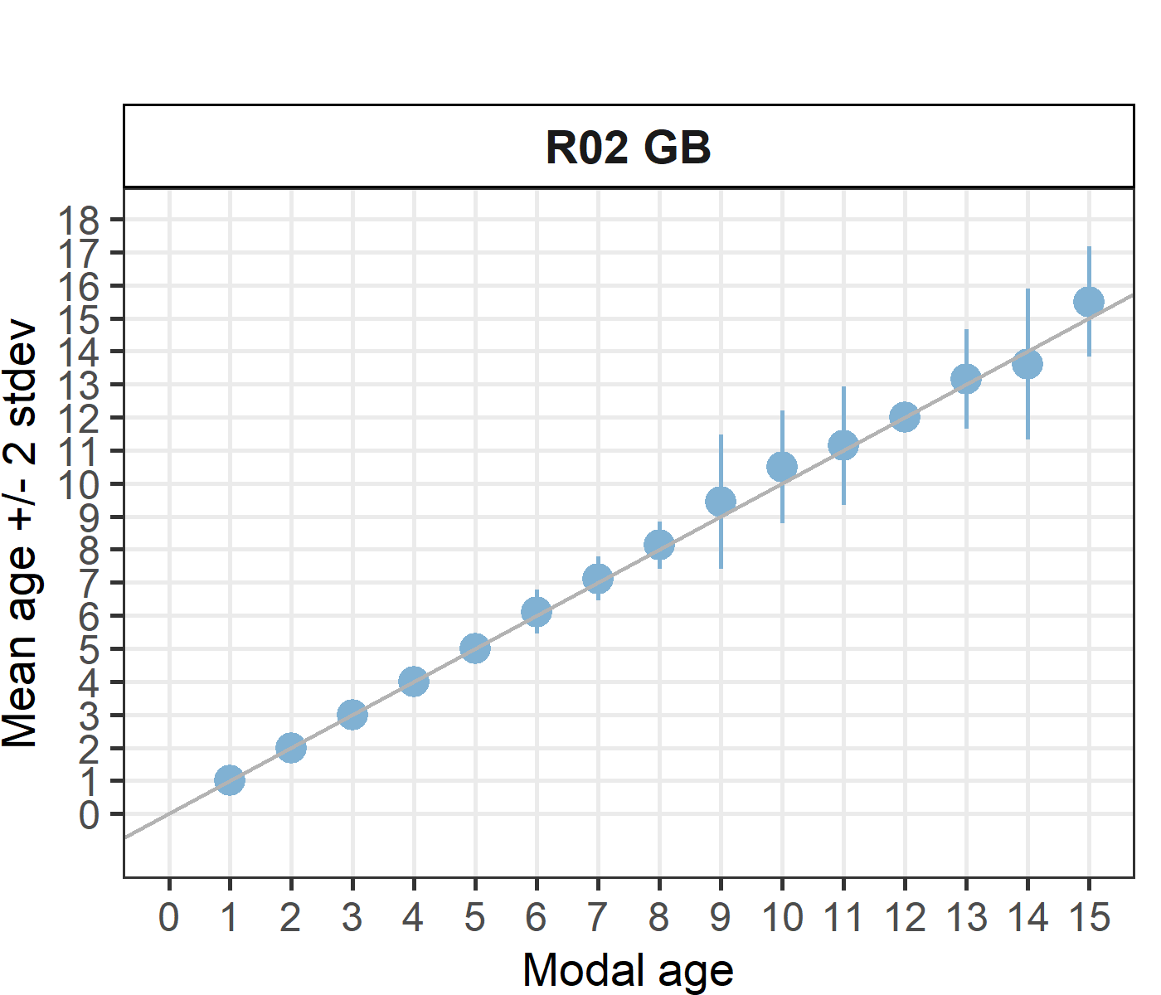
[[2]] 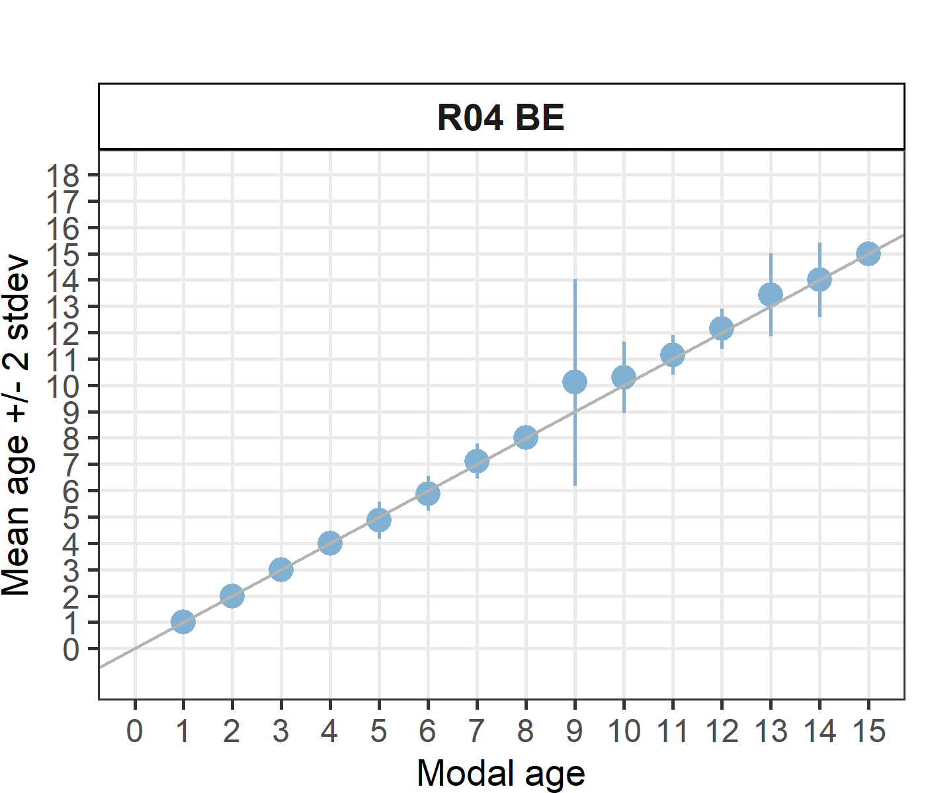
[[3]] 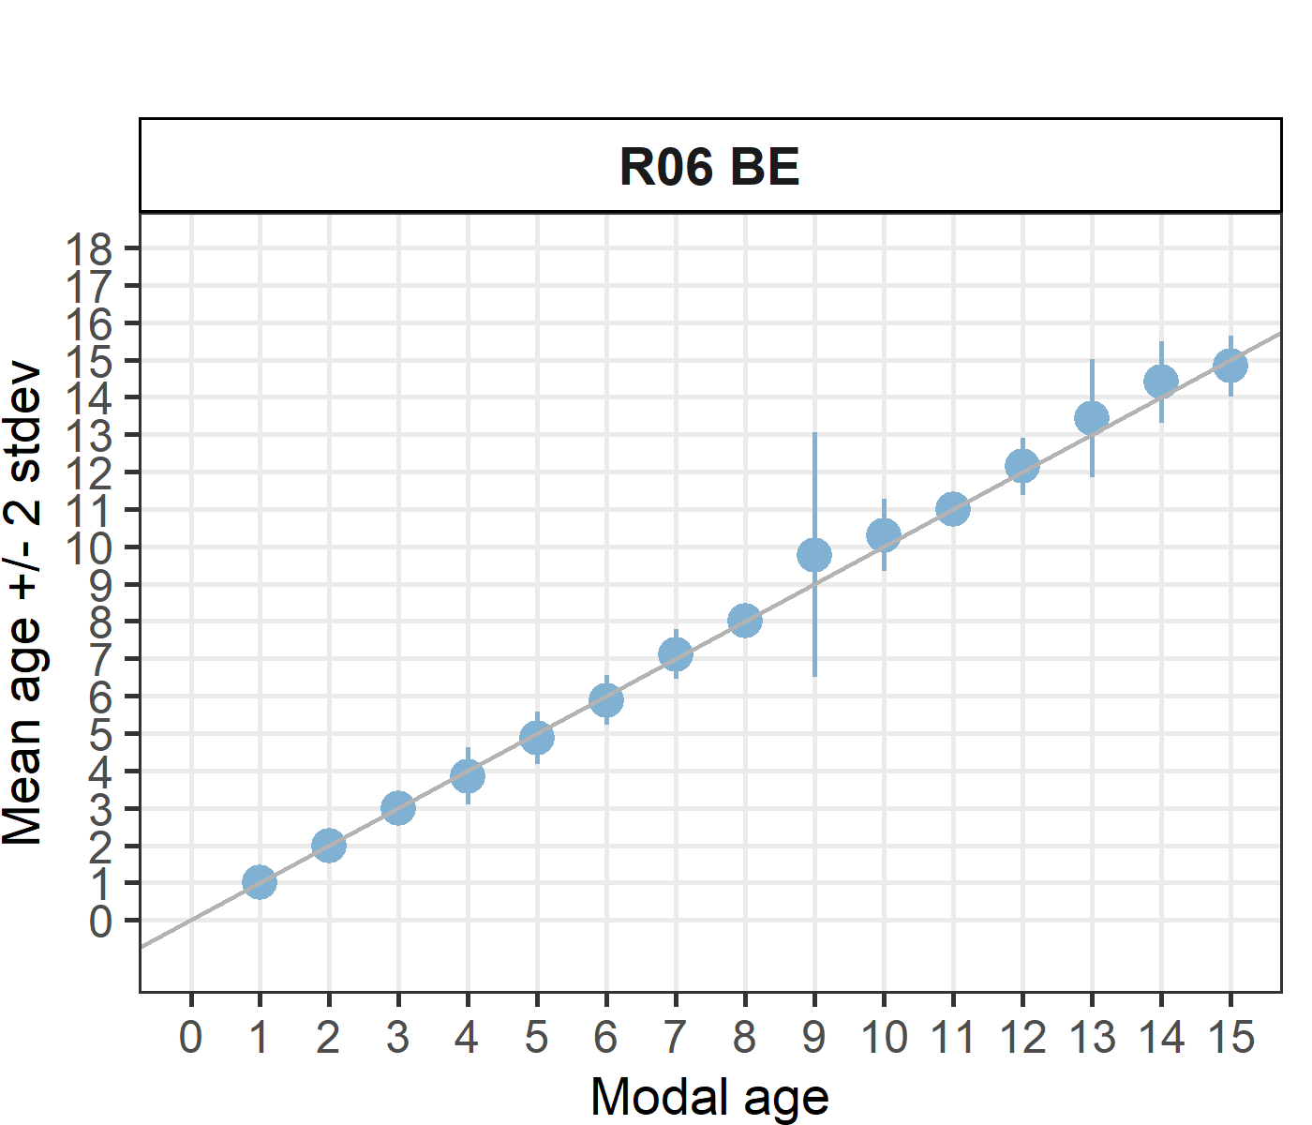
[[4]] 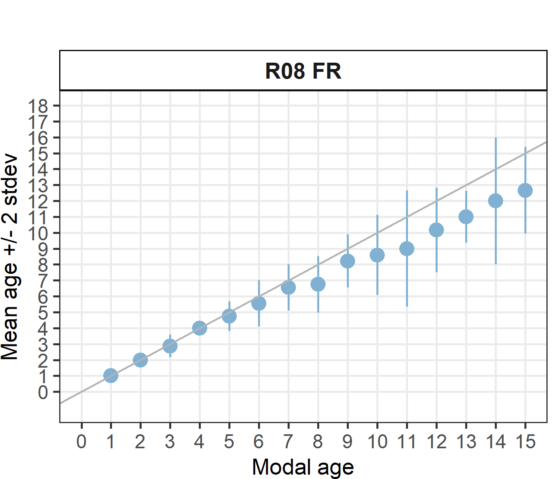
[[5]] 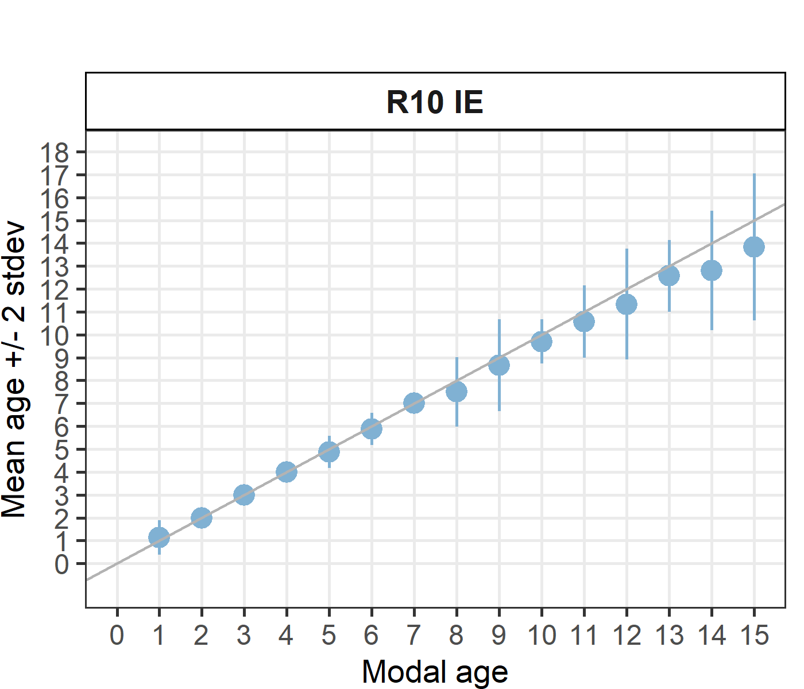
[[6]] 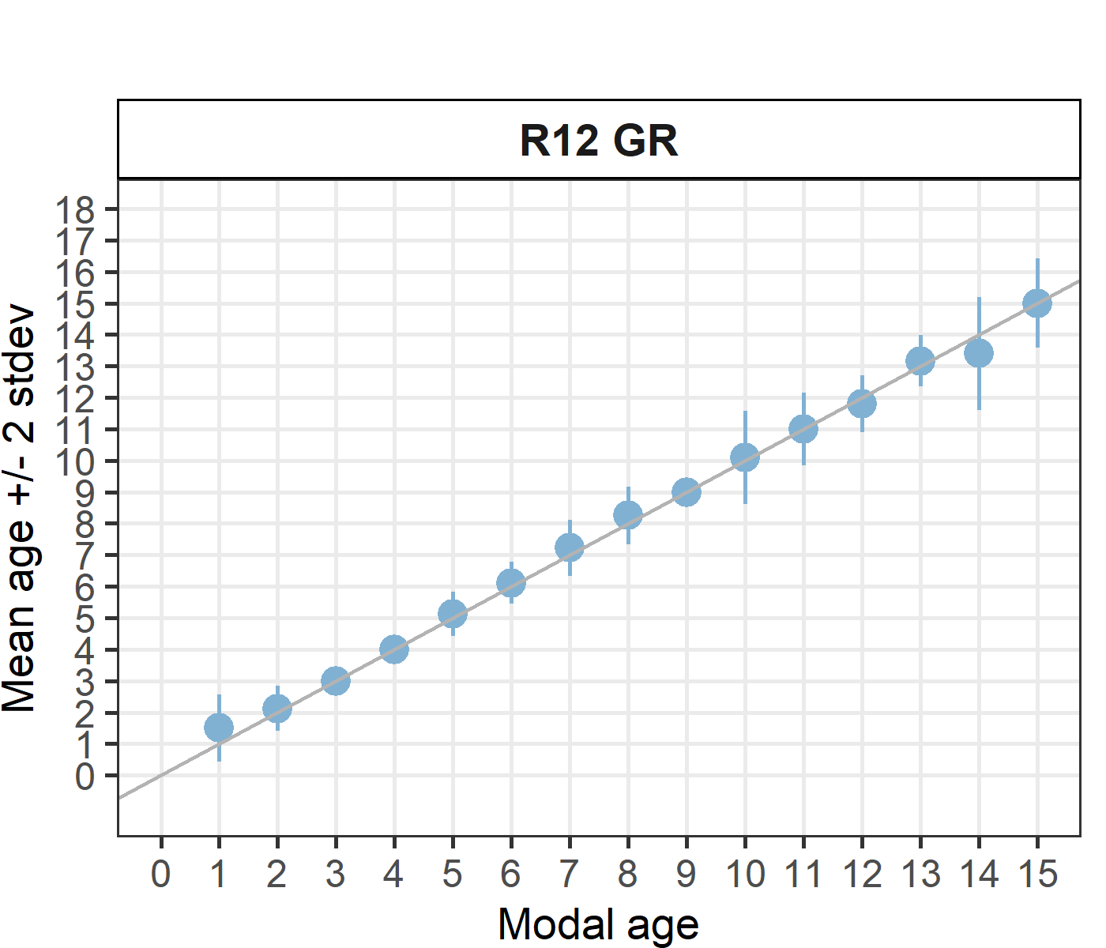
[[7]] 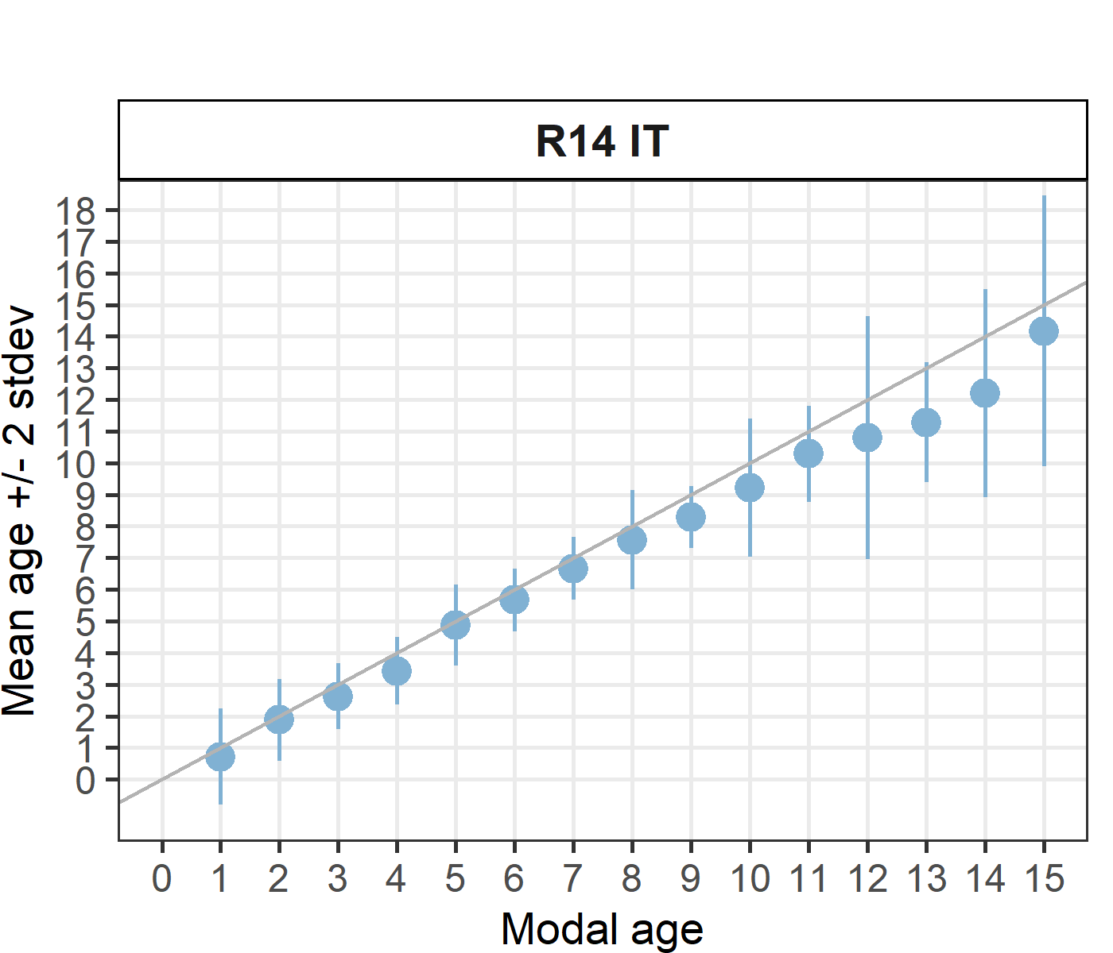
[[8]] 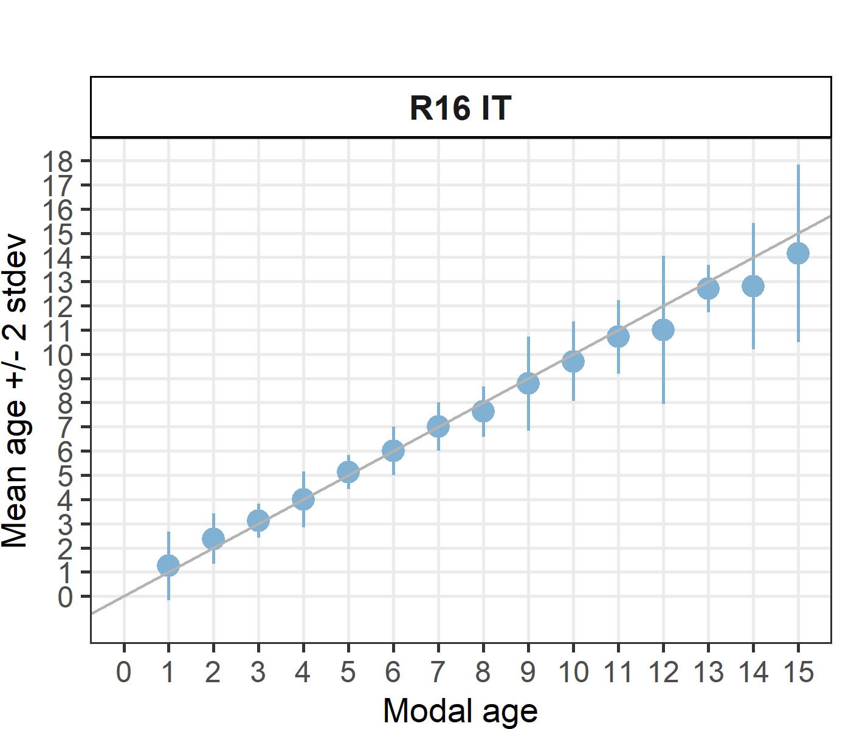
[[9]] 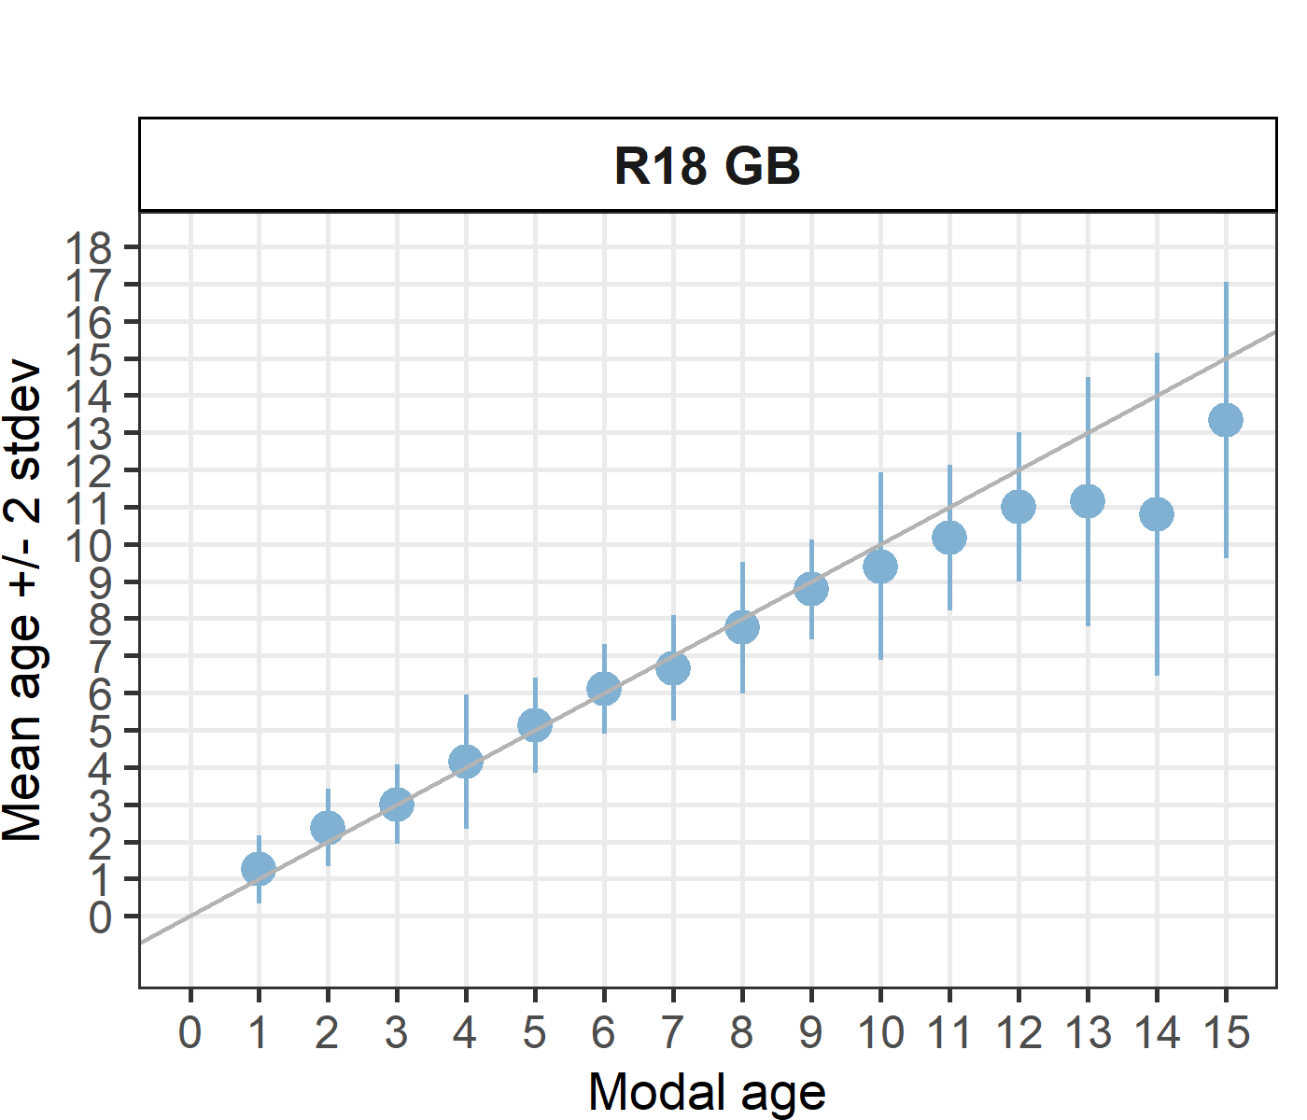
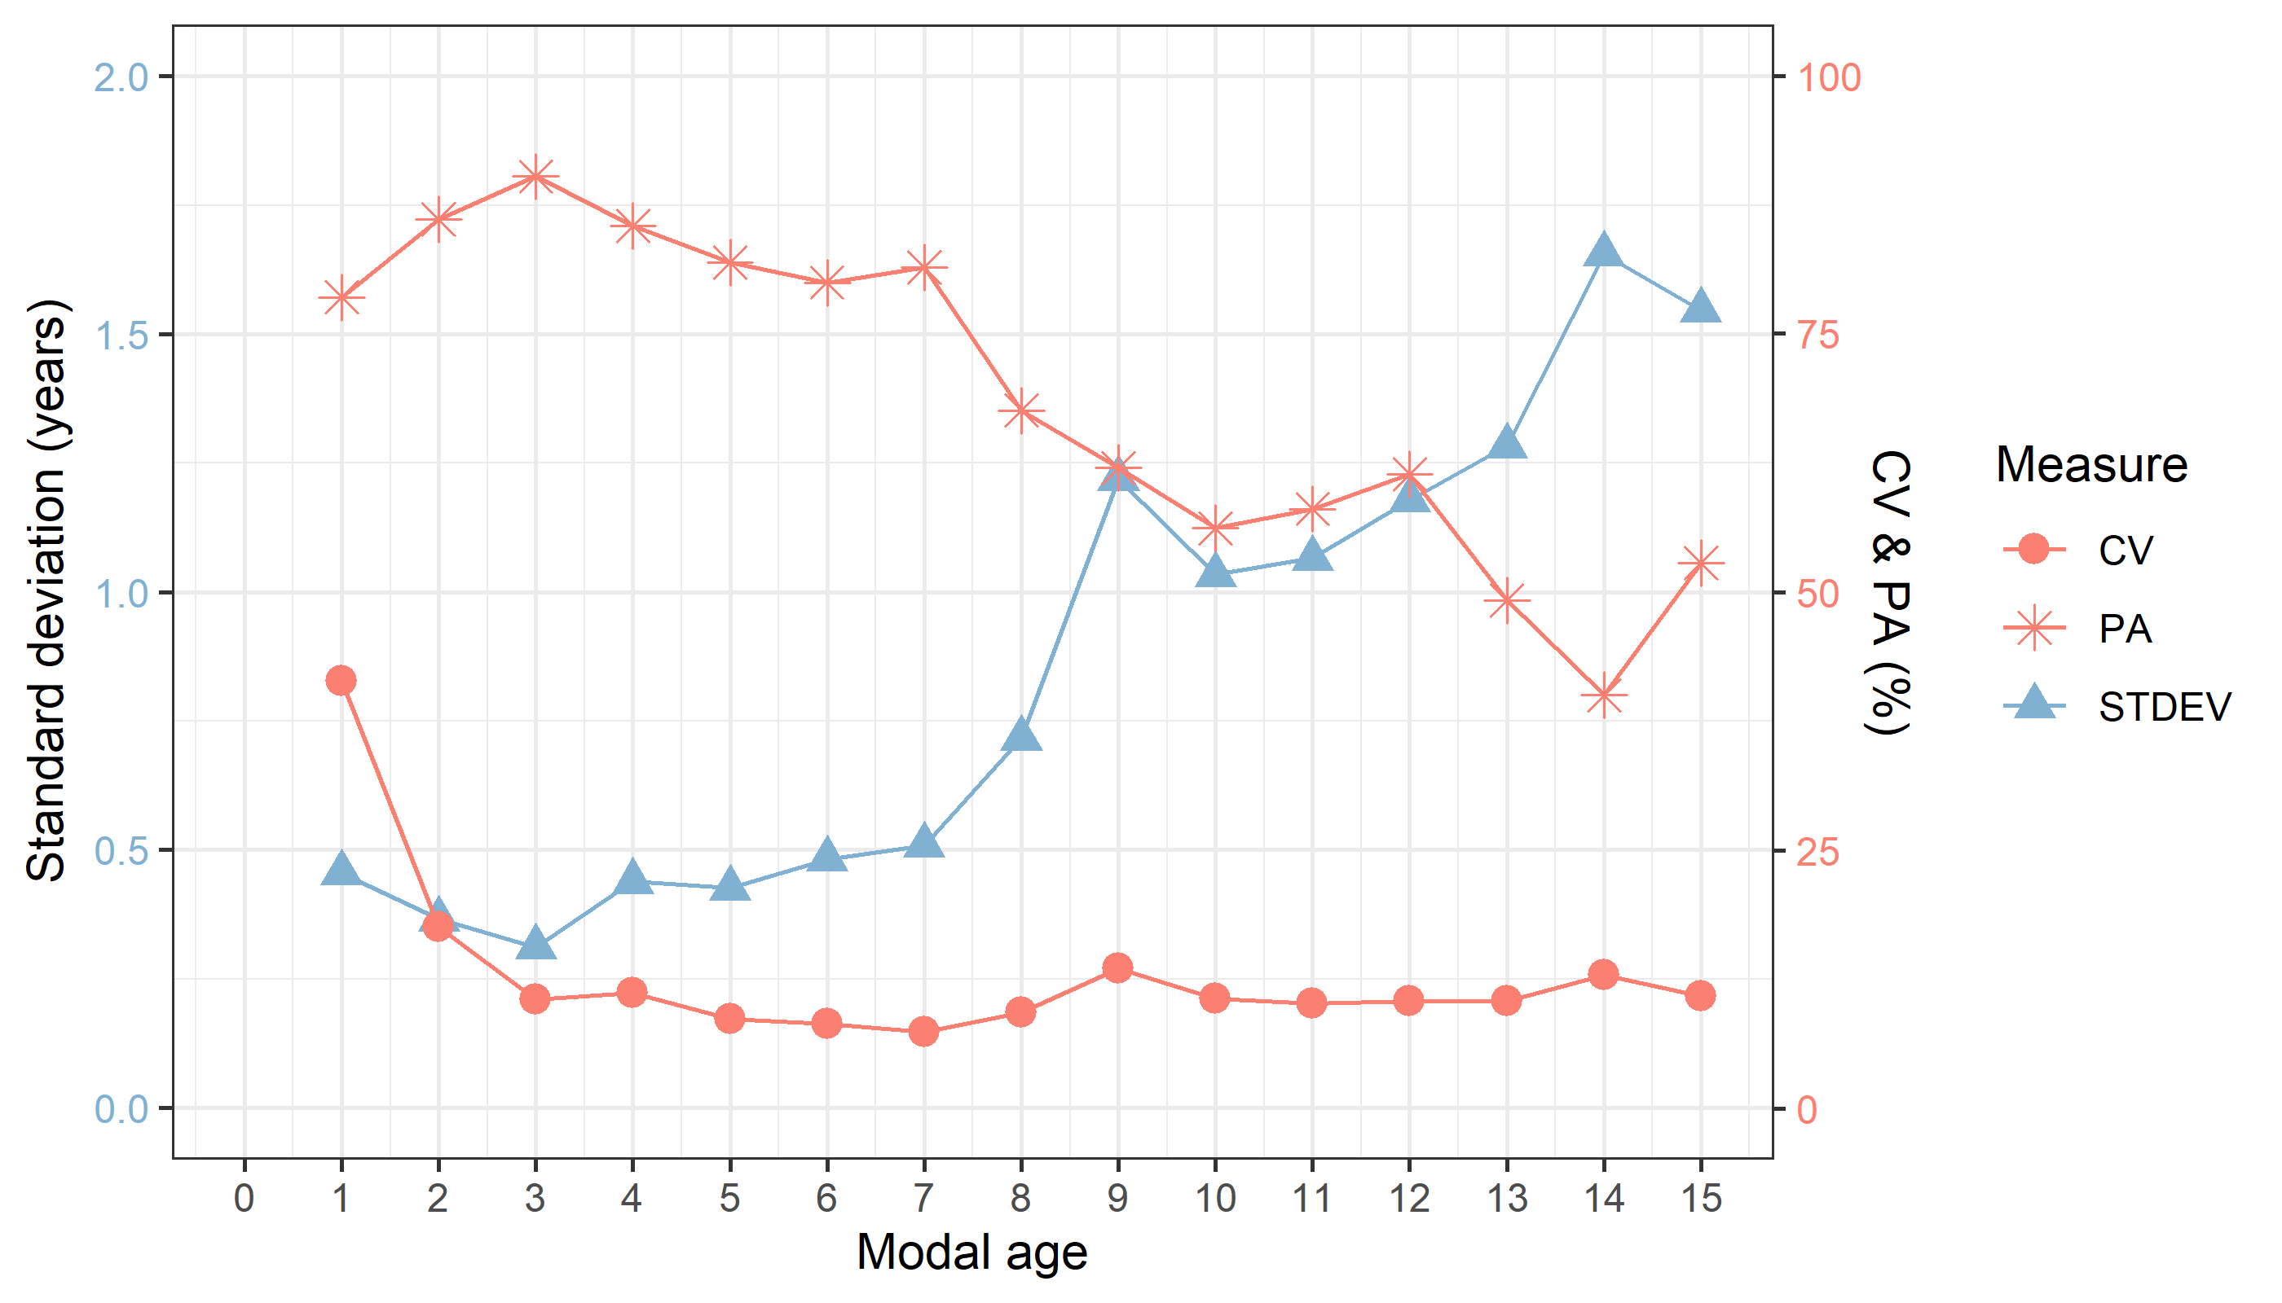
Figure 5.1: CV, PA and (STDEV (standard deviation) are plotted against modal age
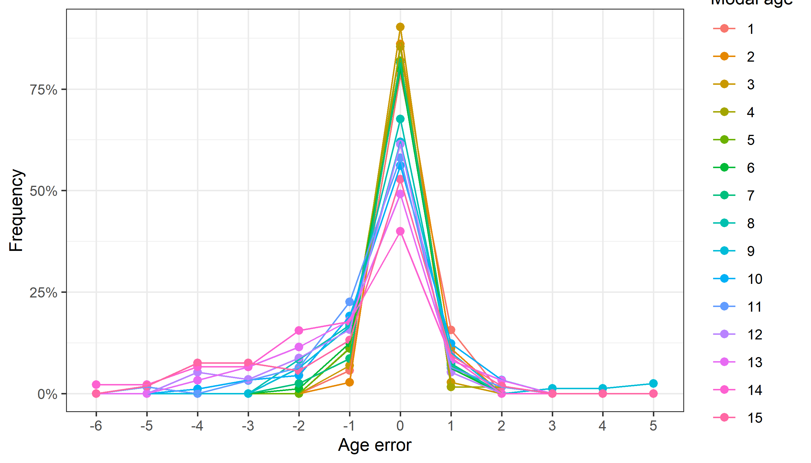Figure 5.2: The distribution of the age reading errors in percentage by modal age as observed from the whole group of age readers in an age reading comparison to modal age. The achieved precision in age reading by MODAL age group is shown by the spread of the age readings errors. There appears to be no relative bias, if the age reading errors are normally distributed. The distributions are skewed, if relative bias occurs.
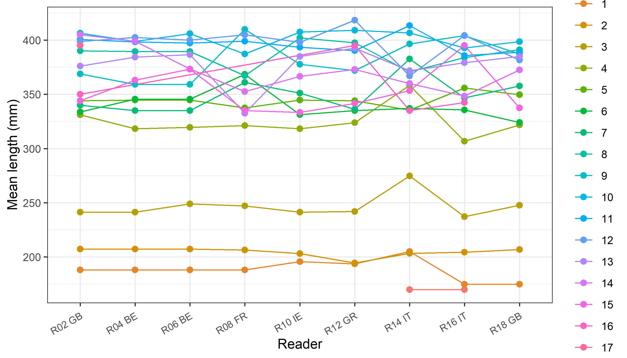
Figure 5.3: The mean length at age as estimated by each age reader.

Results Advanced readers
All samples included
Data Overview
Table 5.7: Summary of statistics; PA (%), CV (%) and APE (%).
NSample | CV | PA | APE
116 | 8 % | 80 % | 5 %
Table 5.8: Data overview including modal age and statistics per sample.
Fish ID | Sample ID | Event ID | Image ID | length | sex | Catch date | ICES area | R02 GB | R04 BE | R06 BE | R08 FR | R10 IE | Modal age | PA % | CV % | APE %
BYDR01_SOL_7D_L_M_2019012410298 | BYDR01_SOL_7D_L_M_2019012410298 | 314 | 37487 | 430 | - | 24/01/2019 00:00:00 | 27.7.d | 8 | 8 | 8 | 7 | 8 | 8 | 80 | 6 | 4
BYDR01_SOL_7D_L_M_2019012410343 | BYDR01_SOL_7D_L_M_2019012410343 | 314 | 37488 | 350 | - | 24/01/2019 00:00:00 | 27.7.d | 9 | 10 | 9 | 8 | 10 | 9 | 40 | 9 | 7
BYDR03_SOL_7D_L_M_47090 | BYDR03_SOL_7D_L_M_47090 | 314 | 37584 | 395 | - | 05/04/2015 00:00:00 | 27.7.d | 14 | 14 | 15 | 14 | 14 | 14 | 80 | 3 | 2
BYDR03_SOL_7D_L_M_47129 | BYDR03_SOL_7D_L_M_47129 | 314 | 37585 | 310 | - | 05/04/2015 00:00:00 | 27.7.d | 15 | 15 | 15 | 14 | 14 | 15 | 60 | 4 | 3
BYDR06_SOL_7D_L_M_2019100810200 | BYDR06_SOL_7D_L_M_2019100810200 | 314 | 37489 | 380 | - | 08/10/2019 00:00:00 | 27.7.d | 11 | 11 | 11 | 10 | 11 | 11 | 80 | 4 | 3
BYDR06_SOL_7D_L_M_2019100810201 | BYDR06_SOL_7D_L_M_2019100810201 | 314 | 37490 | 365 | - | 08/10/2019 00:00:00 | 27.7.d | 10 | 10 | 11 | 10 | 10 | 10 | 80 | 4 | 3
BYDR06_SOL_7D_L_M_2019100810211 | BYDR06_SOL_7D_L_M_2019100810211 | 314 | 37491 | 320 | - | 08/10/2019 00:00:00 | 27.7.d | 5 | 5 | 5 | 5 | 5 | 5 | 100 | 0 | 0
BYDR06_SOL_7D_L_M_2019100810213 | BYDR06_SOL_7D_L_M_2019100810213 | 314 | 37492 | 315 | - | 08/10/2019 00:00:00 | 27.7.d | 9 | 9 | 9 | 9 | 9 | 9 | 100 | 0 | 0
BYDR06_SOL_7D_L_M_2019100810215 | BYDR06_SOL_7D_L_M_2019100810215 | 314 | 37493 | 335 | - | 08/10/2019 00:00:00 | 27.7.d | 6 | 6 | 6 | 6 | 6 | 6 | 100 | 0 | 0
BYDR06_SOL_7D_R_S_2019100810056 | BYDR06_SOL_7D_R_S_2019100810056 | 314 | 37494 | 200 | - | 08/10/2019 00:00:00 | 27.7.d | 2 | 2 | 2 | 2 | 2 | 2 | 100 | 0 | 0
BYDR06_SOL_7D_R_S_2019100810067 | BYDR06_SOL_7D_R_S_2019100810067 | 314 | 37495 | 200 | - | 08/10/2019 00:00:00 | 27.7.d | 1 | 1 | 1 | 1 | 1 | 1 | 100 | 0 | 0
BYDR08_SOL_7D_L_M_2017121510154 | BYDR08_SOL_7D_L_M_2017121510154 | 314 | 37496 | 420 | - | 15/12/2017 00:00:00 | 27.7.d | 6 | 6 | 6 | 6 | - | 6 | 100 | 0 | 0
BYDR08_SOL_7D_L_M_2017121510194 | BYDR08_SOL_7D_L_M_2017121510194 | 314 | 37497 | 255 | - | 15/12/2017 00:00:00 | 27.7.d | 1 | 1 | 1 | 1 | 1 | 1 | 100 | 0 | 0
BYDR09_SOL_7D_D_M_2019122610207 | BYDR09_SOL_7D_D_M_2019122610207 | 314 | 37498 | 248 | - | 26/12/2019 00:00:00 | 27.7.d | 2 | 2 | 2 | 2 | 2 | 2 | 100 | 0 | 0
BYDR09_SOL_7D_L_M_2019122610240 | BYDR09_SOL_7D_L_M_2019122610240 | 314 | 37499 | 405 | - | 26/12/2019 00:00:00 | 27.7.d | 4 | 4 | 4 | 4 | 4 | 4 | 100 | 0 | 0
BYDR09_SOL_7D_L_M_2019122610251 | BYDR09_SOL_7D_L_M_2019122610251 | 314 | 37500 | 399 | - | 26/12/2019 00:00:00 | 27.7.d | 11 | 11 | 11 | 8 | 10 | 11 | 60 | 13 | 9
BYDR09_SOL_7D_L_M_2019122610253 | BYDR09_SOL_7D_L_M_2019122610253 | 314 | 37501 | 413 | - | 26/12/2019 00:00:00 | 27.7.d | 5 | 5 | 5 | 5 | 5 | 5 | 100 | 0 | 0
BYDR09_SOL_7D_L_M_2019122610255 | BYDR09_SOL_7D_L_M_2019122610255 | 314 | 37502 | 358 | - | 26/12/2019 00:00:00 | 27.7.d | 10 | 10 | 10 | 6 | 9 | 10 | 60 | 19 | 13
BYDR09_SOL_7D_L_M_2019122610283 | BYDR09_SOL_7D_L_M_2019122610283 | 314 | 37503 | 258 | - | 26/12/2019 00:00:00 | 27.7.d | 3 | 3 | 3 | 3 | 3 | 3 | 100 | 0 | 0
BYDR10_SOL_7D_L_M_224293 | BYDR10_SOL_7D_L_M_224293 | 314 | 37504 | 400 | - | 09/12/2016 00:00:00 | 27.7.d | 12 | 12 | 12 | 11 | 11 | 12 | 60 | 5 | 4
BYDR10_SOL_7D_L_M_224321 | BYDR10_SOL_7D_L_M_224321 | 314 | 37505 | 350 | - | 09/12/2016 00:00:00 | 27.7.d | 16 | 15 | 15 | 13 | 15 | 15 | 60 | 7 | 5
CDDR01_SOL_7D_L_M_2019021110310 | CDDR01_SOL_7D_L_M_2019021110310 | 314 | 37506 | 355 | - | 11/02/2019 00:00:00 | 27.7.d | 5 | 5 | 5 | 5 | 5 | 5 | 100 | 0 | 0
CDDR01_SOL_7D_L_M_2019021110315 | CDDR01_SOL_7D_L_M_2019021110315 | 314 | 37507 | 385 | - | 11/02/2019 00:00:00 | 27.7.d | 8 | 8 | 8 | 6 | 7 | 8 | 60 | 12 | 10
CDDR01_SOL_7D_L_M_2019021110330 | CDDR01_SOL_7D_L_M_2019021110330 | 314 | 37508 | 350 | - | 11/02/2019 00:00:00 | 27.7.d | 7 | 7 | 7 | 7 | 7 | 7 | 100 | 0 | 0
CDDR01_SOL_7D_L_M_2019021110331 | CDDR01_SOL_7D_L_M_2019021110331 | 314 | 37509 | 310 | - | 11/02/2019 00:00:00 | 27.7.d | 4 | 4 | 3 | 4 | 4 | 4 | 80 | 12 | 8
CDDR03_SOL_7D_L_M_2018052810319 | CDDR03_SOL_7D_L_M_2018052810319 | 314 | 37510 | 410 | - | 28/05/2018 00:00:00 | 27.7.d | 10 | 10 | 10 | 9 | 9 | 10 | 60 | 6 | 5
CDDR03_SOL_7D_L_M_2018052810334 | CDDR03_SOL_7D_L_M_2018052810334 | 314 | 37511 | 430 | - | 28/05/2018 00:00:00 | 27.7.d | 11 | 11 | 11 | 10 | 10 | 11 | 60 | 5 | 5
CDDR03_SOL_7D_R_S_2018052810105 | CDDR03_SOL_7D_R_S_2018052810105 | 314 | 37512 | 170 | - | 28/05/2018 00:00:00 | 27.7.d | 2 | 2 | 2 | 2 | 2 | 2 | 100 | 0 | 0
CDDR06_SOL_7D_L_M_58794 | CDDR06_SOL_7D_L_M_58794 | 314 | 37586 | 335 | - | 09/10/2015 00:00:00 | 27.7.d | 15 | 15 | 15 | 15 | 15 | 15 | 100 | 0 | 0
CDDR06_SOL_7D_L_M_72071 | CDDR06_SOL_7D_L_M_72071 | 314 | 37587 | 315 | - | 01/08/2016 00:00:00 | 27.7.d | 6 | 6 | 6 | 6 | 6 | 6 | 100 | 0 | 0
CDDR06_SOL_7D_L_M_72075 | CDDR06_SOL_7D_L_M_72075 | 314 | 37588 | 315 | - | 01/08/2016 00:00:00 | 27.7.d | 4 | 4 | 4 | 4 | 4 | 4 | 100 | 0 | 0
CDDR06_SOL_7D_L_M_72083 | CDDR06_SOL_7D_L_M_72083 | 314 | 37589 | 280 | - | 01/08/2016 00:00:00 | 27.7.d | 3 | 3 | 3 | 3 | 3 | 3 | 100 | 0 | 0
CDDR06_SOL_7D_R_S_71023 | CDDR06_SOL_7D_R_S_71023 | 314 | 37590 | 210 | - | 01/08/2016 00:00:00 | 27.7.d | 2 | 2 | 2 | 2 | 2 | 2 | 100 | 0 | 0
CDDR07_SOL_7D_L_M_221489 | CDDR07_SOL_7D_L_M_221489 | 314 | 37513 | 360 | - | 25/10/2016 00:00:00 | 27.7.d | 8 | 8 | 8 | 7 | 8 | 8 | 80 | 6 | 4
CDDR07_SOL_7D_L_M_221490 | CDDR07_SOL_7D_L_M_221490 | 314 | 37514 | 380 | - | 25/10/2016 00:00:00 | 27.7.d | 12 | 12 | 12 | 11 | 12 | 12 | 80 | 4 | 3
CDDR07_SOL_7D_L_M_221497 | CDDR07_SOL_7D_L_M_221497 | 314 | 37515 | 340 | - | 25/10/2016 00:00:00 | 27.7.d | 7 | 7 | 7 | 7 | 7 | 7 | 100 | 0 | 0
CDDR08_SOL_7D_L_M_2017112110232 | CDDR08_SOL_7D_L_M_2017112110232 | 314 | 37516 | 380 | - | 21/11/2017 00:00:00 | 27.7.d | 13 | 13 | 13 | 10 | 13 | 13 | 80 | 11 | 8
CDDR08_SOL_7D_L_M_2017112110241 | CDDR08_SOL_7D_L_M_2017112110241 | 314 | 37517 | 315 | - | 21/11/2017 00:00:00 | 27.7.d | 15 | 15 | 14 | 13 | 15 | 15 | 60 | 6 | 5
GNKT01_SOL_7D_L_M_2018011810190 | GNKT01_SOL_7D_L_M_2018011810190 | 314 | 37518 | 405 | - | 18/01/2018 00:00:00 | 27.7.d | 12 | 14 | 14 | 10 | 11 | 14 | 40 | 15 | 12
GNKT01_SOL_7D_L_M_2018011810191 | GNKT01_SOL_7D_L_M_2018011810191 | 314 | 37519 | 440 | - | 18/01/2018 00:00:00 | 27.7.d | 14 | 15 | 15 | 12 | 13 | 15 | 40 | 9 | 8
GNKT01_SOL_7D_L_M_2018011810193 | GNKT01_SOL_7D_L_M_2018011810193 | 314 | 37520 | 470 | - | 18/01/2018 00:00:00 | 27.7.d | 12 | 13 | 13 | 12 | 11 | 12 | 40 | 7 | 5
GNKT01_SOL_7D_L_M_2019011810440 | GNKT01_SOL_7D_L_M_2019011810440 | 314 | 37521 | 425 | - | 18/01/2019 00:00:00 | 27.7.d | 12 | 12 | 12 | 9 | - | 12 | 75 | 13 | 10
GNKT01_SOL_7D_L_M_2019011810463 | GNKT01_SOL_7D_L_M_2019011810463 | 314 | 37522 | 285 | - | 18/01/2019 00:00:00 | 27.7.d | 4 | 4 | 4 | 4 | 4 | 4 | 100 | 0 | 0
GNKT02_SOL_7D_L_M_2019030110184 | GNKT02_SOL_7D_L_M_2019030110184 | 314 | 37523 | 375 | - | 01/03/2019 00:00:00 | 27.7.d | 9 | 9 | 9 | 9 | 9 | 9 | 100 | 0 | 0
GNKT02_SOL_7D_L_M_2019030110186 | GNKT02_SOL_7D_L_M_2019030110186 | 314 | 37524 | 365 | - | 01/03/2019 00:00:00 | 27.7.d | 11 | 11 | 11 | 11 | 11 | 11 | 100 | 0 | 0
GNKT02_SOL_7D_L_M_2019030110189 | GNKT02_SOL_7D_L_M_2019030110189 | 314 | 37525 | 370 | - | 01/03/2019 00:00:00 | 27.7.d | 5 | 5 | 5 | 5 | 5 | 5 | 100 | 0 | 0
GNKT02_SOL_7D_L_M_2019030110195 | GNKT02_SOL_7D_L_M_2019030110195 | 314 | 37526 | 360 | - | 01/03/2019 00:00:00 | 27.7.d | 6 | 6 | 6 | 6 | 6 | 6 | 100 | 0 | 0
GNKT02_SOL_7D_L_M_2019030110201 | GNKT02_SOL_7D_L_M_2019030110201 | 314 | 37527 | 465 | - | 01/03/2019 00:00:00 | 27.7.d | 10 | 10 | 10 | 9 | 10 | 10 | 80 | 5 | 3
GNKT02_SOL_7D_L_M_2019030110207 | GNKT02_SOL_7D_L_M_2019030110207 | 314 | 37528 | 420 | - | 01/03/2019 00:00:00 | 27.7.d | 15 | 15 | 15 | 11 | 13 | 15 | 60 | 13 | 10
GNKT02_SOL_7D_R_S_2019030110072 | GNKT02_SOL_7D_R_S_2019030110072 | 314 | 37529 | 210 | - | 01/03/2019 00:00:00 | 27.7.d | 2 | 2 | 2 | 2 | 2 | 2 | 100 | 0 | 0
GNKT02_SOL_7D_R_S_2019030110080 | GNKT02_SOL_7D_R_S_2019030110080 | 314 | 37530 | 220 | - | 01/03/2019 00:00:00 | 27.7.d | 3 | 3 | 3 | 3 | 3 | 3 | 100 | 0 | 0
GNKT05_SOL_7D_L_M_2018071710545 | GNKT05_SOL_7D_L_M_2018071710545 | 314 | 37531 | 335 | - | 17/07/2018 00:00:00 | 27.7.d | 8 | 8 | 8 | 8 | 8 | 8 | 100 | 0 | 0
GNKT05_SOL_7D_L_M_2018071710552 | GNKT05_SOL_7D_L_M_2018071710552 | 314 | 37532 | 360 | - | 17/07/2018 00:00:00 | 27.7.d | 12 | 13 | 13 | - | 12 | 13 | 50 | 5 | 4
GNKT05_SOL_7D_L_M_2018071710559 | GNKT05_SOL_7D_L_M_2018071710559 | 314 | 37533 | 260 | - | 17/07/2018 00:00:00 | 27.7.d | 7 | 7 | 7 | 7 | 7 | 7 | 100 | 0 | 0
GNKT08_SOL_7D_L_M_224839 | GNKT08_SOL_7D_L_M_224839 | 314 | 37534 | 360 | - | 15/12/2016 00:00:00 | 27.7.d | 12 | 14 | 14 | 9 | 9 | 14 | 40 | 22 | 18
GNKT08_SOL_7D_L_M_224840 | GNKT08_SOL_7D_L_M_224840 | 314 | 37535 | 450 | - | 15/12/2016 00:00:00 | 27.7.d | 8 | 8 | 8 | 6 | 8 | 8 | 80 | 12 | 8
GNKT08_SOL_7D_L_M_224847 | GNKT08_SOL_7D_L_M_224847 | 314 | 37536 | 370 | - | 15/12/2016 00:00:00 | 27.7.d | 7 | 7 | 7 | 6 | 7 | 7 | 80 | 7 | 5
GNKT08_SOL_7D_L_M_224871 | GNKT08_SOL_7D_L_M_224871 | 314 | 37537 | 350 | - | 15/12/2016 00:00:00 | 27.7.d | 9 | 9 | 10 | 7 | 9 | 9 | 60 | 12 | 8
GNKT08_SOL_7D_L_M_224890 | GNKT08_SOL_7D_L_M_224890 | 314 | 37538 | 320 | - | 15/12/2016 00:00:00 | 27.7.d | 13 | 13 | 13 | 10 | 13 | 13 | 80 | 11 | 8
PTCT01_SOL_7D_L_M_2017001301 | PTCT01_SOL_7D_L_M_2017001301 | 314 | 37539 | 385 | - | 06/02/2017 00:00:00 | 27.7.d | 13 | 13 | 13 | 11 | 12 | 13 | 60 | 7 | 6
PTCT01_SOL_7D_L_M_2017001309 | PTCT01_SOL_7D_L_M_2017001309 | 314 | 37540 | 405 | - | 06/02/2017 00:00:00 | 27.7.d | 14 | 14 | 13 | 11 | 13 | 14 | 40 | 9 | 6
PTCT01_SOL_7D_L_M_2017001323 | PTCT01_SOL_7D_L_M_2017001323 | 314 | 37541 | 455 | - | 06/02/2017 00:00:00 | 27.7.d | 12 | 12 | 11 | 9 | 10 | 12 | 40 | 12 | 10
PTCT01_SOL_7D_L_M_2019011410246 | PTCT01_SOL_7D_L_M_2019011410246 | 314 | 37542 | 365 | - | 14/01/2019 00:00:00 | 27.7.d | 6 | 6 | 6 | 6 | 6 | 6 | 100 | 0 | 0
PTCT01_SOL_7D_L_M_2019011410253 | PTCT01_SOL_7D_L_M_2019011410253 | 314 | 37543 | 345 | - | 14/01/2019 00:00:00 | 27.7.d | 7 | 7 | 7 | 6 | 7 | 7 | 80 | 7 | 5
PTCT01_SOL_7D_L_M_2019011410257 | PTCT01_SOL_7D_L_M_2019011410257 | 314 | 37544 | 430 | - | 14/01/2019 00:00:00 | 27.7.d | 10 | 10 | 10 | 7 | 9 | 10 | 60 | 14 | 10
PTCT01_SOL_7D_L_M_2019011410258 | PTCT01_SOL_7D_L_M_2019011410258 | 314 | 37545 | 410 | - | 14/01/2019 00:00:00 | 27.7.d | 11 | 11 | 11 | 9 | 10 | 11 | 60 | 9 | 7
PTCT01_SOL_7D_R_S_2019011410107 | PTCT01_SOL_7D_R_S_2019011410107 | 314 | 37546 | 190 | - | 14/01/2019 00:00:00 | 27.7.d | 2 | 2 | 2 | 2 | 2 | 2 | 100 | 0 | 0
PTCT01_SOL_7D_R_S_2019011410111 | PTCT01_SOL_7D_R_S_2019011410111 | 314 | 37547 | 200 | - | 14/01/2019 00:00:00 | 27.7.d | 3 | 3 | 3 | 2 | 3 | 3 | 80 | 16 | 11
PTCT01_SOL_7D_R_S_2019011410138 | PTCT01_SOL_7D_R_S_2019011410138 | 314 | 37548 | 170 | - | 14/01/2019 00:00:00 | 27.7.d | 1 | 1 | 1 | 1 | 2 | 1 | 80 | 37 | 27
PTCT01_SOL_7D_R_S_2019011410139 | PTCT01_SOL_7D_R_S_2019011410139 | 314 | 37549 | 180 | - | 14/01/2019 00:00:00 | 27.7.d | 1 | 1 | 1 | 1 | 1 | 1 | 100 | 0 | 0
PTCT03_SOL_7D_L_M_2018040210259 | PTCT03_SOL_7D_L_M_2018040210259 | 314 | 37550 | 430 | - | 02/04/2018 00:00:00 | 27.7.d | 13 | 14 | 14 | 10 | 12 | 14 | 40 | 13 | 10
PTCT03_SOL_7D_L_M_2018040210260 | PTCT03_SOL_7D_L_M_2018040210260 | 314 | 37551 | 435 | - | 02/04/2018 00:00:00 | 27.7.d | 8 | 8 | 8 | 8 | 8 | 8 | 100 | 0 | 0
PTCT03_SOL_7D_L_M_2018040210267 | PTCT03_SOL_7D_L_M_2018040210267 | 314 | 37552 | 350 | - | 02/04/2018 00:00:00 | 27.7.d | - | 13 | 14 | 11 | 13 | 13 | 50 | 10 | 7
PTCT03_SOL_7D_L_M_2018040210270 | PTCT03_SOL_7D_L_M_2018040210270 | 314 | 37553 | 345 | - | 02/04/2018 00:00:00 | 27.7.d | 5 | 5 | 5 | 5 | 5 | 5 | 100 | 0 | 0
PTCT03_SOL_7D_L_M_2018040210286 | PTCT03_SOL_7D_L_M_2018040210286 | 314 | 37554 | 280 | - | 02/04/2018 00:00:00 | 27.7.d | 7 | 7 | 7 | 7 | 7 | 7 | 100 | 0 | 0
PTCT03_SOL_7D_L_M_2018040210298 | PTCT03_SOL_7D_L_M_2018040210298 | 314 | 37555 | 250 | - | 02/04/2018 00:00:00 | 27.7.d | 6 | 6 | 6 | 5 | 6 | 6 | 80 | 8 | 6
PTCT03_SOL_7D_L_M_2019111120105 | PTCT03_SOL_7D_L_M_2019111120105 | 314 | 37556 | 322 | - | 11/11/2019 00:00:00 | 27.7.d | 3 | 3 | 3 | 3 | 3 | 3 | 100 | 0 | 0
PTCT03_SOL_7D_L_M_2019111120107 | PTCT03_SOL_7D_L_M_2019111120107 | 314 | 37557 | 347 | - | 11/11/2019 00:00:00 | 27.7.d | 4 | 4 | 4 | 4 | 4 | 4 | 100 | 0 | 0
PTCT03_SOL_7D_L_M_68321 | PTCT03_SOL_7D_L_M_68321 | 314 | 37591 | 510 | - | 04/04/2016 00:00:00 | 27.7.d | 12 | 12 | 12 | 11 | 12 | 12 | 80 | 4 | 3
PTCT03_SOL_7D_L_M_68323 | PTCT03_SOL_7D_L_M_68323 | 314 | 37592 | 420 | - | 04/04/2016 00:00:00 | 27.7.d | 11 | 11 | 11 | 11 | 10 | 11 | 80 | 4 | 3
PTCT03_SOL_7D_L_M_68328 | PTCT03_SOL_7D_L_M_68328 | 314 | 37593 | 420 | - | 04/04/2016 00:00:00 | 27.7.d | 9 | 9 | 9 | 9 | 9 | 9 | 100 | 0 | 0
PTCT03_SOL_7D_L_M_68349 | PTCT03_SOL_7D_L_M_68349 | 314 | 37594 | 460 | - | 04/04/2016 00:00:00 | 27.7.d | 10 | 10 | 10 | 9 | 10 | 10 | 80 | 5 | 3
PTCT03_SOL_7D_R_S_2017040310127 | PTCT03_SOL_7D_R_S_2017040310127 | 314 | 37558 | 210 | - | 03/04/2017 00:00:00 | 27.7.d | 3 | 3 | 3 | 3 | 3 | 3 | 100 | 0 | 0
PTCT03_SOL_7D_R_S_2017040310163 | PTCT03_SOL_7D_R_S_2017040310163 | 314 | 37559 | 160 | - | 03/04/2017 00:00:00 | 27.7.d | 1 | 1 | 1 | 1 | - | 1 | 100 | 0 | 0
PTCT03_SOL_7D_R_S_2018040210117 | PTCT03_SOL_7D_R_S_2018040210117 | 314 | 37560 | 220 | - | 02/04/2018 00:00:00 | 27.7.d | 2 | 2 | 2 | 2 | 2 | 2 | 100 | 0 | 0
PTCT04_SOL_7D_L_M_2018052110342 | PTCT04_SOL_7D_L_M_2018052110342 | 314 | 37561 | 420 | - | 21/05/2018 00:00:00 | 27.7.d | 8 | 8 | 8 | 7 | 7 | 8 | 60 | 7 | 6
PTCT04_SOL_7D_L_M_2018052110350 | PTCT04_SOL_7D_L_M_2018052110350 | 314 | 37562 | 355 | - | 21/05/2018 00:00:00 | 27.7.d | 12 | 12 | 12 | 11 | 12 | 12 | 80 | 4 | 3
PTCT04_SOL_7D_L_M_2018052110353 | PTCT04_SOL_7D_L_M_2018052110353 | 314 | 37563 | 430 | - | 21/05/2018 00:00:00 | 27.7.d | 9 | 13 | 10 | 8 | 9 | 9 | 40 | 20 | 14
PTCT04_SOL_7D_L_M_2018052110362 | PTCT04_SOL_7D_L_M_2018052110362 | 314 | 37564 | 325 | - | 21/05/2018 00:00:00 | 27.7.d | 9 | 9 | 9 | 8 | 7 | 9 | 60 | 11 | 9
PTCT04_SOL_7D_L_M_2018052110363 | PTCT04_SOL_7D_L_M_2018052110363 | 314 | 37565 | 325 | - | 21/05/2018 00:00:00 | 27.7.d | 4 | 4 | 4 | 4 | 4 | 4 | 100 | 0 | 0
PTCT04_SOL_7D_L_M_2018052110369 | PTCT04_SOL_7D_L_M_2018052110369 | 314 | 37566 | 340 | - | 21/05/2018 00:00:00 | 27.7.d | 15 | 15 | 15 | 12 | 11 | 15 | 60 | 14 | 12
PTCT05_SOL_7D_L_M_2018061810274 | PTCT05_SOL_7D_L_M_2018061810274 | 314 | 37567 | 380 | - | 18/06/2018 00:00:00 | 27.7.d | 7 | 6 | 6 | 6 | 6 | 6 | 80 | 7 | 5
PTCT05_SOL_7D_L_M_2018061810279 | PTCT05_SOL_7D_L_M_2018061810279 | 314 | 37568 | 380 | - | 18/06/2018 00:00:00 | 27.7.d | 7 | 7 | 7 | 7 | 7 | 7 | 100 | 0 | 0
PTCT05_SOL_7D_L_M_2018061810286 | PTCT05_SOL_7D_L_M_2018061810286 | 314 | 37569 | 345 | - | 18/06/2018 00:00:00 | 27.7.d | 5 | 5 | 5 | 5 | 5 | 5 | 100 | 0 | 0
PTCT05_SOL_7D_L_M_2018061810300 | PTCT05_SOL_7D_L_M_2018061810300 | 314 | 37570 | 280 | - | 18/06/2018 00:00:00 | 27.7.d | - | 4 | 4 | 4 | 4 | 4 | 100 | 0 | 0
PTCT05_SOL_7D_L_M_70327 | PTCT05_SOL_7D_L_M_70327 | 314 | 37595 | 365 | - | 18/07/2016 00:00:00 | 27.7.d | 13 | 12 | 11 | 8 | 12 | 12 | 40 | 17 | 12
PTCT05_SOL_7D_L_M_70328 | PTCT05_SOL_7D_L_M_70328 | 314 | 37596 | 385 | - | 18/07/2016 00:00:00 | 27.7.d | 10 | 11 | 11 | 6 | 10 | 11 | 40 | 22 | 15
PTCT05_SOL_7D_L_M_70330 | PTCT05_SOL_7D_L_M_70330 | 314 | 37597 | 395 | - | 18/07/2016 00:00:00 | 27.7.d | 17 | 15 | 15 | 12 | 14 | 15 | 40 | 12 | 9
PTCT05_SOL_7D_L_M_70336 | PTCT05_SOL_7D_L_M_70336 | 314 | 37598 | 355 | - | 18/07/2016 00:00:00 | 27.7.d | 7 | 7 | 7 | 5 | 7 | 7 | 80 | 14 | 10
PTCT05_SOL_7D_L_M_70341 | PTCT05_SOL_7D_L_M_70341 | 314 | 37599 | 335 | - | 18/07/2016 00:00:00 | 27.7.d | 12 | 10 | 10 | 8 | 10 | 10 | 60 | 14 | 8
PTCT05_SOL_7D_L_M_70357 | PTCT05_SOL_7D_L_M_70357 | 314 | 37600 | 330 | - | 18/07/2016 00:00:00 | 27.7.d | 12 | 12 | 12 | 8 | 9 | 12 | 60 | 18 | 16
PTCT05_SOL_7D_L_M_70361 | PTCT05_SOL_7D_L_M_70361 | 314 | 37601 | 280 | - | 18/07/2016 00:00:00 | 27.7.d | 5 | 4 | 4 | 4 | 4 | 4 | 80 | 11 | 8
PTCT05_SOL_7D_L_M_70362 | PTCT05_SOL_7D_L_M_70362 | 314 | 37602 | 285 | - | 18/07/2016 00:00:00 | 27.7.d | 6 | 5 | 5 | 5 | 5 | 5 | 80 | 9 | 6
PTCT05_SOL_7D_R_S_221451 | PTCT05_SOL_7D_R_S_221451 | 314 | 37571 | 210 | - | 18/07/2016 00:00:00 | 27.7.d | 2 | 2 | 2 | 2 | 2 | 2 | 100 | 0 | 0
PTCT05_SOL_7D_R_S_221464 | PTCT05_SOL_7D_R_S_221464 | 314 | 37572 | 230 | - | 18/07/2016 00:00:00 | 27.7.d | 3 | 3 | 3 | 3 | 3 | 3 | 100 | 0 | 0
PTCT06_SOL_7D_L_M_2018072310264 | PTCT06_SOL_7D_L_M_2018072310264 | 314 | 37573 | 370 | - | 23/07/2018 00:00:00 | 27.7.d | 10 | 9 | 9 | 7 | 7 | 9 | 40 | 16 | 13
PTCT06_SOL_7D_L_M_2018072310270 | PTCT06_SOL_7D_L_M_2018072310270 | 314 | 37574 | 380 | - | 23/07/2018 00:00:00 | 27.7.d | 14 | 13 | 14 | 12 | 13 | 14 | 40 | 6 | 5
PTCT06_SOL_7D_L_M_2018072310285 | PTCT06_SOL_7D_L_M_2018072310285 | 314 | 37575 | 305 | - | 23/07/2018 00:00:00 | 27.7.d | 8 | 8 | 8 | 6 | 6 | 8 | 60 | 15 | 13
PTCT06_SOL_7D_L_M_2018072310288 | PTCT06_SOL_7D_L_M_2018072310288 | 314 | 37576 | 325 | - | 23/07/2018 00:00:00 | 27.7.d | 5 | 5 | 5 | 4 | 5 | 5 | 80 | 9 | 7
PTCT06_SOL_7D_R_S_2017062610054 | PTCT06_SOL_7D_R_S_2017062610054 | 314 | 37577 | 180 | - | 26/06/2017 00:00:00 | 27.7.d | 1 | 1 | 1 | 1 | 1 | 1 | 100 | 0 | 0
PTCT06_SOL_7D_R_S_2017062610056 | PTCT06_SOL_7D_R_S_2017062610056 | 314 | 37578 | 210 | - | 26/06/2017 00:00:00 | 27.7.d | 3 | 3 | 3 | 3 | 3 | 3 | 100 | 0 | 0
PTCT07_SOL_7D_L_M_2017071510298 | PTCT07_SOL_7D_L_M_2017071510298 | 314 | 37579 | 385 | - | 15/07/2017 00:00:00 | 27.7.d | 9 | 8 | 8 | 6 | 7 | 8 | 40 | 15 | 12
PTCT07_SOL_7D_L_M_2017071510319 | PTCT07_SOL_7D_L_M_2017071510319 | 314 | 37580 | 415 | - | 15/07/2017 00:00:00 | 27.7.d | 10 | 10 | 10 | 9 | 10 | 10 | 80 | 5 | 3
PTCT07_SOL_7D_L_M_2017071510321 | PTCT07_SOL_7D_L_M_2017071510321 | 314 | 37581 | 340 | - | 15/07/2017 00:00:00 | 27.7.d | 6 | 6 | 6 | 4 | 6 | 6 | 80 | 16 | 11
PTCT07_SOL_7D_R_S_2017071510138 | PTCT07_SOL_7D_R_S_2017071510138 | 314 | 37582 | 180 | - | 15/07/2017 00:00:00 | 27.7.d | 1 | 1 | 1 | 1 | 1 | 1 | 100 | 0 | 0
PTCT07_SOL_7D_R_S_2017071510140 | PTCT07_SOL_7D_R_S_2017071510140 | 314 | 37583 | 180 | - | 15/07/2017 00:00:00 | 27.7.d | 1 | 1 | 1 | 1 | 1 | 1 | 100 | 0 | 0

Table 5.9: List of cases (sampleID) for which multiple modes where obtained when all readers are considered. The column NModes_trad shows the number of multiple modes for each sampleID when all readers are given the same experience weight.
 | NModes_trad | SampleID
BYDR01_SOL_7D_L_M_2019012410343 | 2 | BYDR01_SOL_7D_L_M_2019012410343
GNKT01_SOL_7D_L_M_2018011810193 | 2 | GNKT01_SOL_7D_L_M_2018011810193
GNKT05_SOL_7D_L_M_2018071710552 | 2 | GNKT05_SOL_7D_L_M_2018071710552
GNKT08_SOL_7D_L_M_224839 | 2 | GNKT08_SOL_7D_L_M_224839
PTCT01_SOL_7D_L_M_2017001309 | 2 | PTCT01_SOL_7D_L_M_2017001309
PTCT05_SOL_7D_L_M_70328 | 2 | PTCT05_SOL_7D_L_M_70328
PTCT06_SOL_7D_L_M_2018072310264 | 2 | PTCT06_SOL_7D_L_M_2018072310264
PTCT06_SOL_7D_L_M_2018072310270 | 2 | PTCT06_SOL_7D_L_M_2018072310270
Table 5.10: Number of age readings table gives an overview of number of readings per reader and modal age. The total numbers of readings per reader and per modal age are summarized at the end of the table.
Modal age | R02 GB | R04 BE | R06 BE | R08 FR | R10 IE | total
1 | 8 | 8 | 8 | 8 | 7 | 39
2 | 8 | 8 | 8 | 8 | 8 | 40
3 | 8 | 8 | 8 | 8 | 8 | 40
4 | 7 | 8 | 8 | 8 | 8 | 39
5 | 8 | 8 | 8 | 8 | 8 | 40
6 | 8 | 8 | 8 | 8 | 7 | 39
7 | 8 | 8 | 8 | 8 | 8 | 40
8 | 9 | 9 | 9 | 9 | 9 | 45
9 | 8 | 8 | 8 | 8 | 8 | 40
10 | 8 | 8 | 8 | 8 | 8 | 40
11 | 7 | 7 | 7 | 7 | 7 | 35
12 | 9 | 9 | 9 | 9 | 8 | 44
13 | 4 | 5 | 5 | 4 | 5 | 23
14 | 6 | 6 | 6 | 6 | 6 | 30
15 | 8 | 8 | 8 | 8 | 8 | 40
Total | 114 | 116 | 116 | 115 | 113 | 574

Table 5.11: Age composition by reader gives a summary of number of readings per reader.
Modal age | R02 GB | R04 BE | R06 BE | R08 FR | R10 IE
1 | 8 | 8 | 8 | 8 | 6
2 | 8 | 8 | 8 | 9 | 9
3 | 8 | 8 | 9 | 7 | 8
4 | 6 | 8 | 7 | 10 | 8
5 | 8 | 8 | 8 | 9 | 8
6 | 8 | 8 | 8 | 14 | 8
7 | 9 | 8 | 8 | 11 | 13
8 | 8 | 9 | 9 | 9 | 5
9 | 8 | 6 | 6 | 11 | 10
10 | 9 | 9 | 9 | 7 | 12
11 | 6 | 7 | 10 | 10 | 6
12 | 12 | 8 | 6 | 5 | 7
13 | 5 | 8 | 6 | 2 | 7
14 | 4 | 5 | 6 | 2 | 3
15 | 5 | 8 | 8 | 1 | 3
16 | 1 | 0 | 0 | 0 | 0
17 | 1 | 0 | 0 | 0 | 0
Total | 114 | 116 | 116 | 115 | 113
Table 5.12: Mean length at age per reader is calculated per reader and age (not modal age) and for all readers combined per age. A weighted mean is also given.
Age | R02 GB | R04 BE | R06 BE | R08 FR | R10 IE
1 | 188 mm | 188 mm | 188 mm | 188 mm | 196 mm
2 | 207 mm | 207 mm | 207 mm | 206 mm | 203 mm
3 | 241 mm | 241 mm | 249 mm | 247 mm | 241 mm
4 | 331 mm | 318 mm | 320 mm | 321 mm | 318 mm
5 | 344 mm | 345 mm | 345 mm | 338 mm | 345 mm
6 | 334 mm | 346 mm | 346 mm | 368 mm | 331 mm
7 | 340 mm | 335 mm | 335 mm | 361 mm | 351 mm
8 | 390 mm | 389 mm | 389 mm | 367 mm | 402 mm
9 | 369 mm | 359 mm | 359 mm | 410 mm | 378 mm
10 | 406 mm | 399 mm | 406 mm | 387 mm | 407 mm
11 | 401 mm | 398 mm | 397 mm | 399 mm | 393 mm
12 | 399 mm | 402 mm | 400 mm | 405 mm | 398 mm
13 | 376 mm | 384 mm | 387 mm | 332 mm | 385 mm
14 | 405 mm | 399 mm | 373 mm | 352 mm | 367 mm
15 | 344 mm | 363 mm | 373 mm | 335 mm | 333 mm
16 | 350 mm | - | - | - | -
17 | 395 mm | - | - | - | -
Weighted Mean | 337 mm | 337 mm | 337 mm | 337 mm | 337 mm
[[1]] 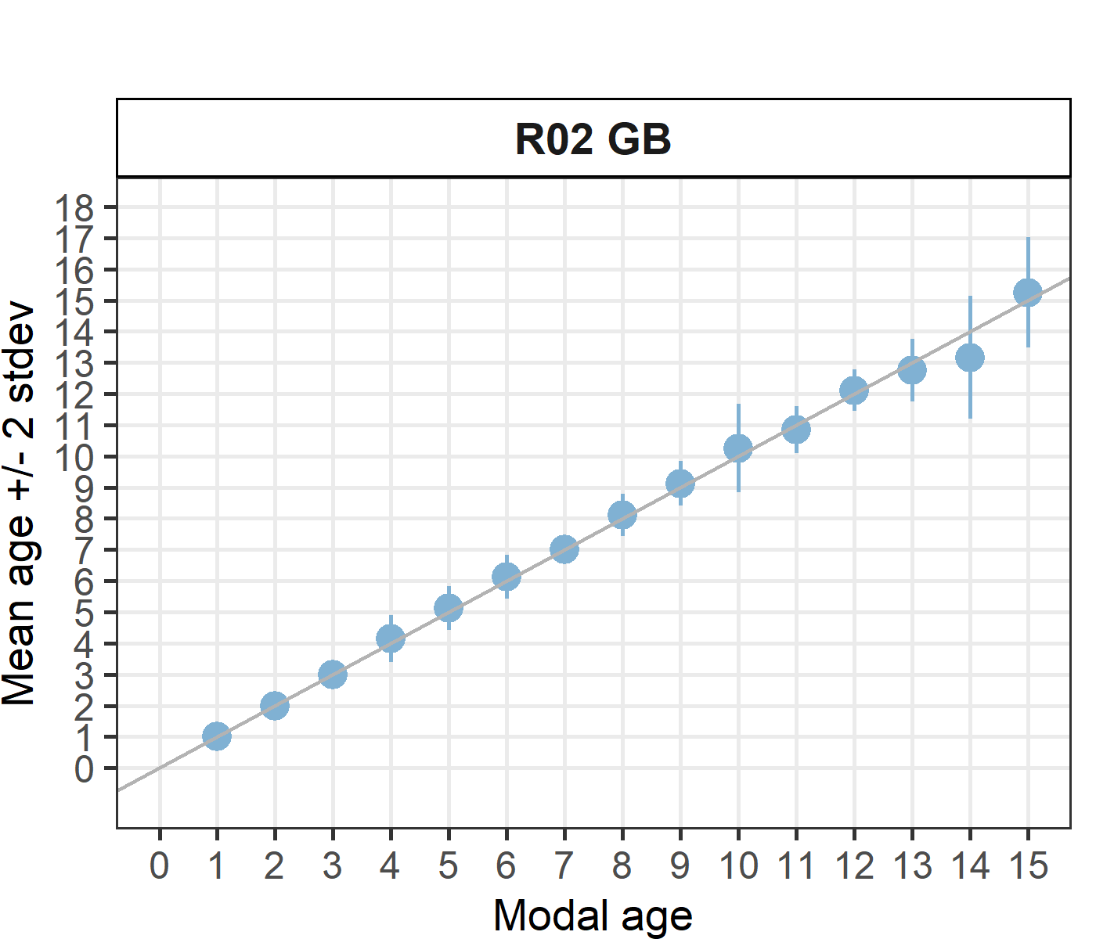
[[2]] 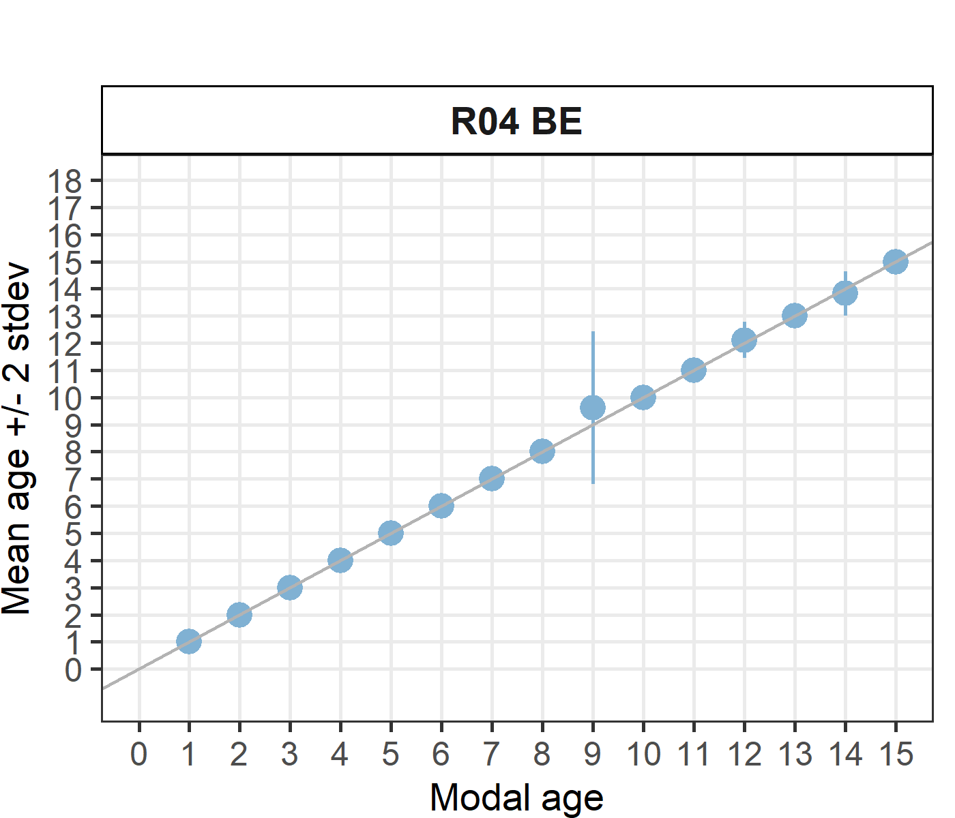
[[3]] 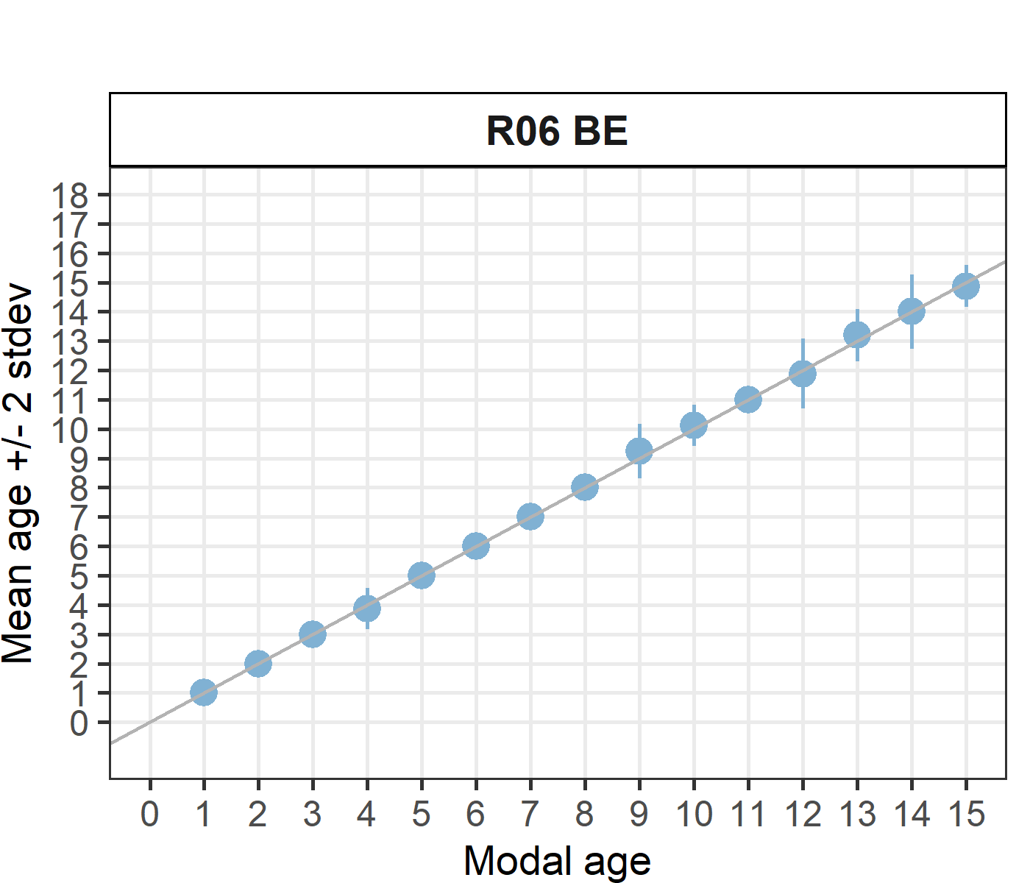
[[4]] 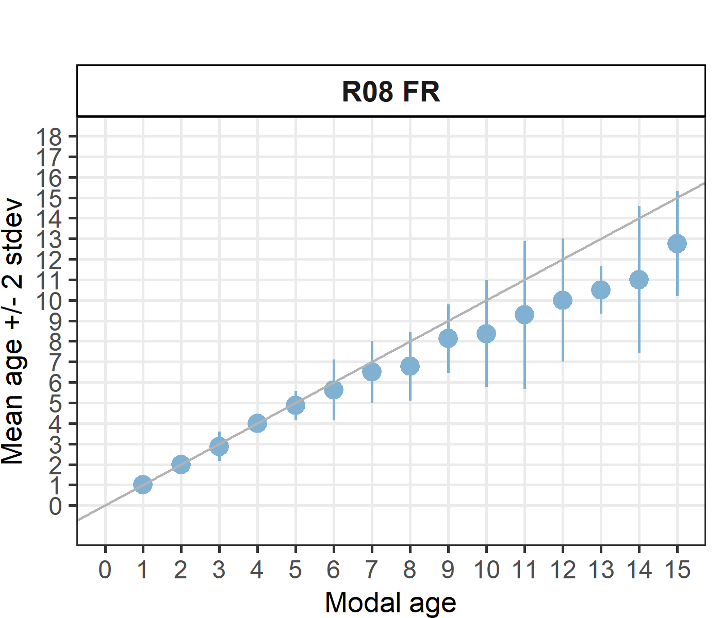
[[5]] 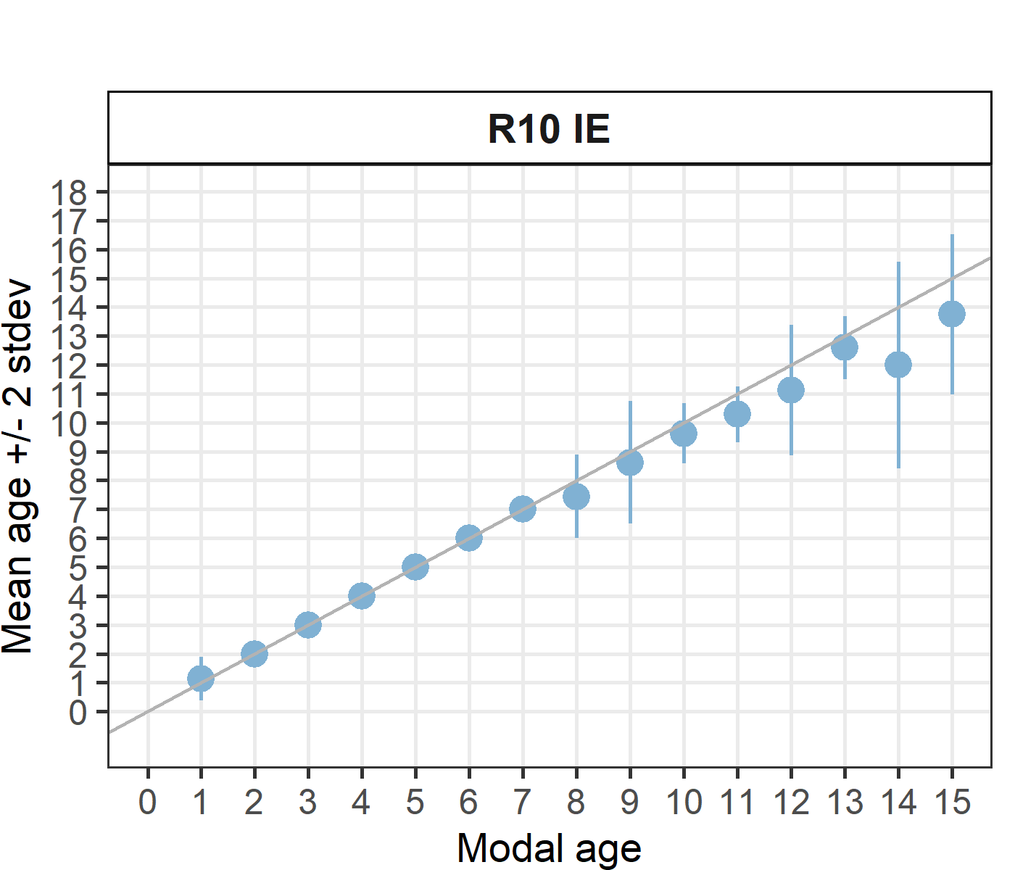
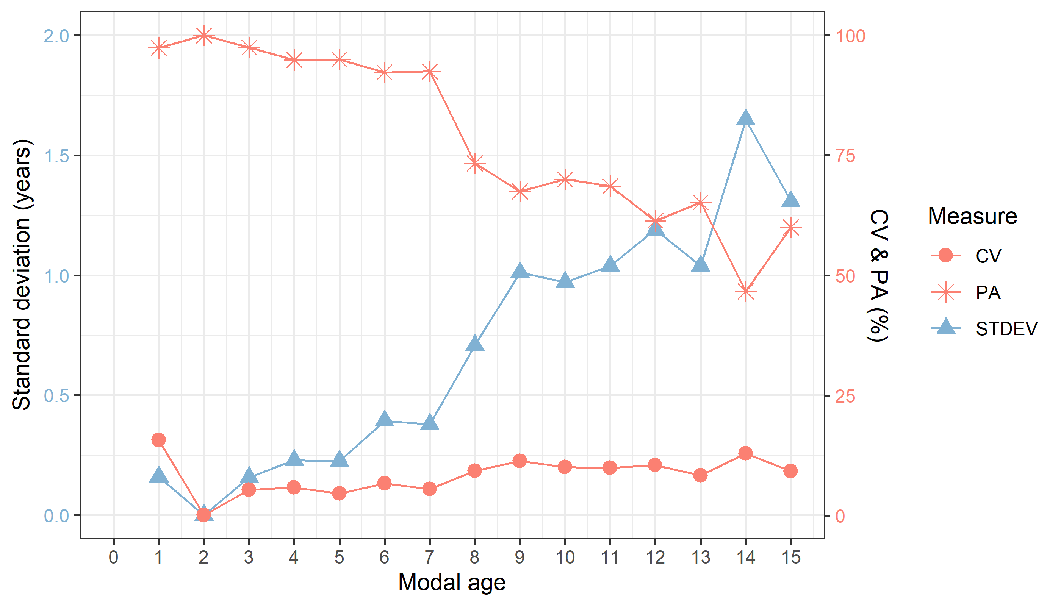
Figure 5.4: CV, PA and (STDEV (standard deviation) are plotted against modal age
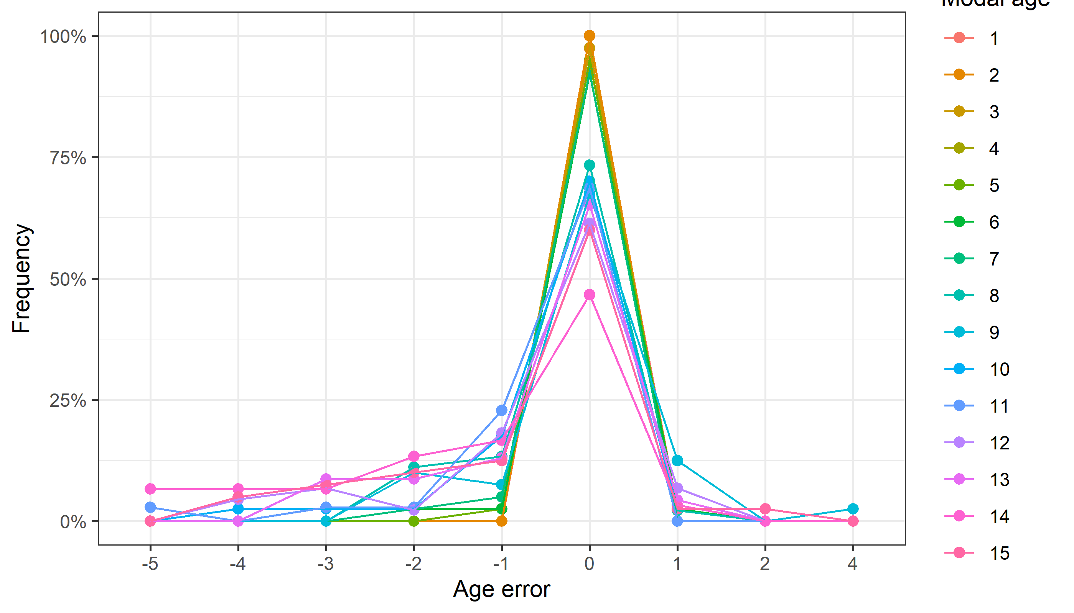
Figure 5.5: The distribution of the age reading errors in percentage by modal age as observed from the whole group of age readers in an age reading comparison to modal age. The achieved precision in age reading by MODAL age group is shown by the spread of the age readings errors. There appears to be no relative bias, if the age reading errors are normally distributed. The distributions are skewed, if relative bias occurs.

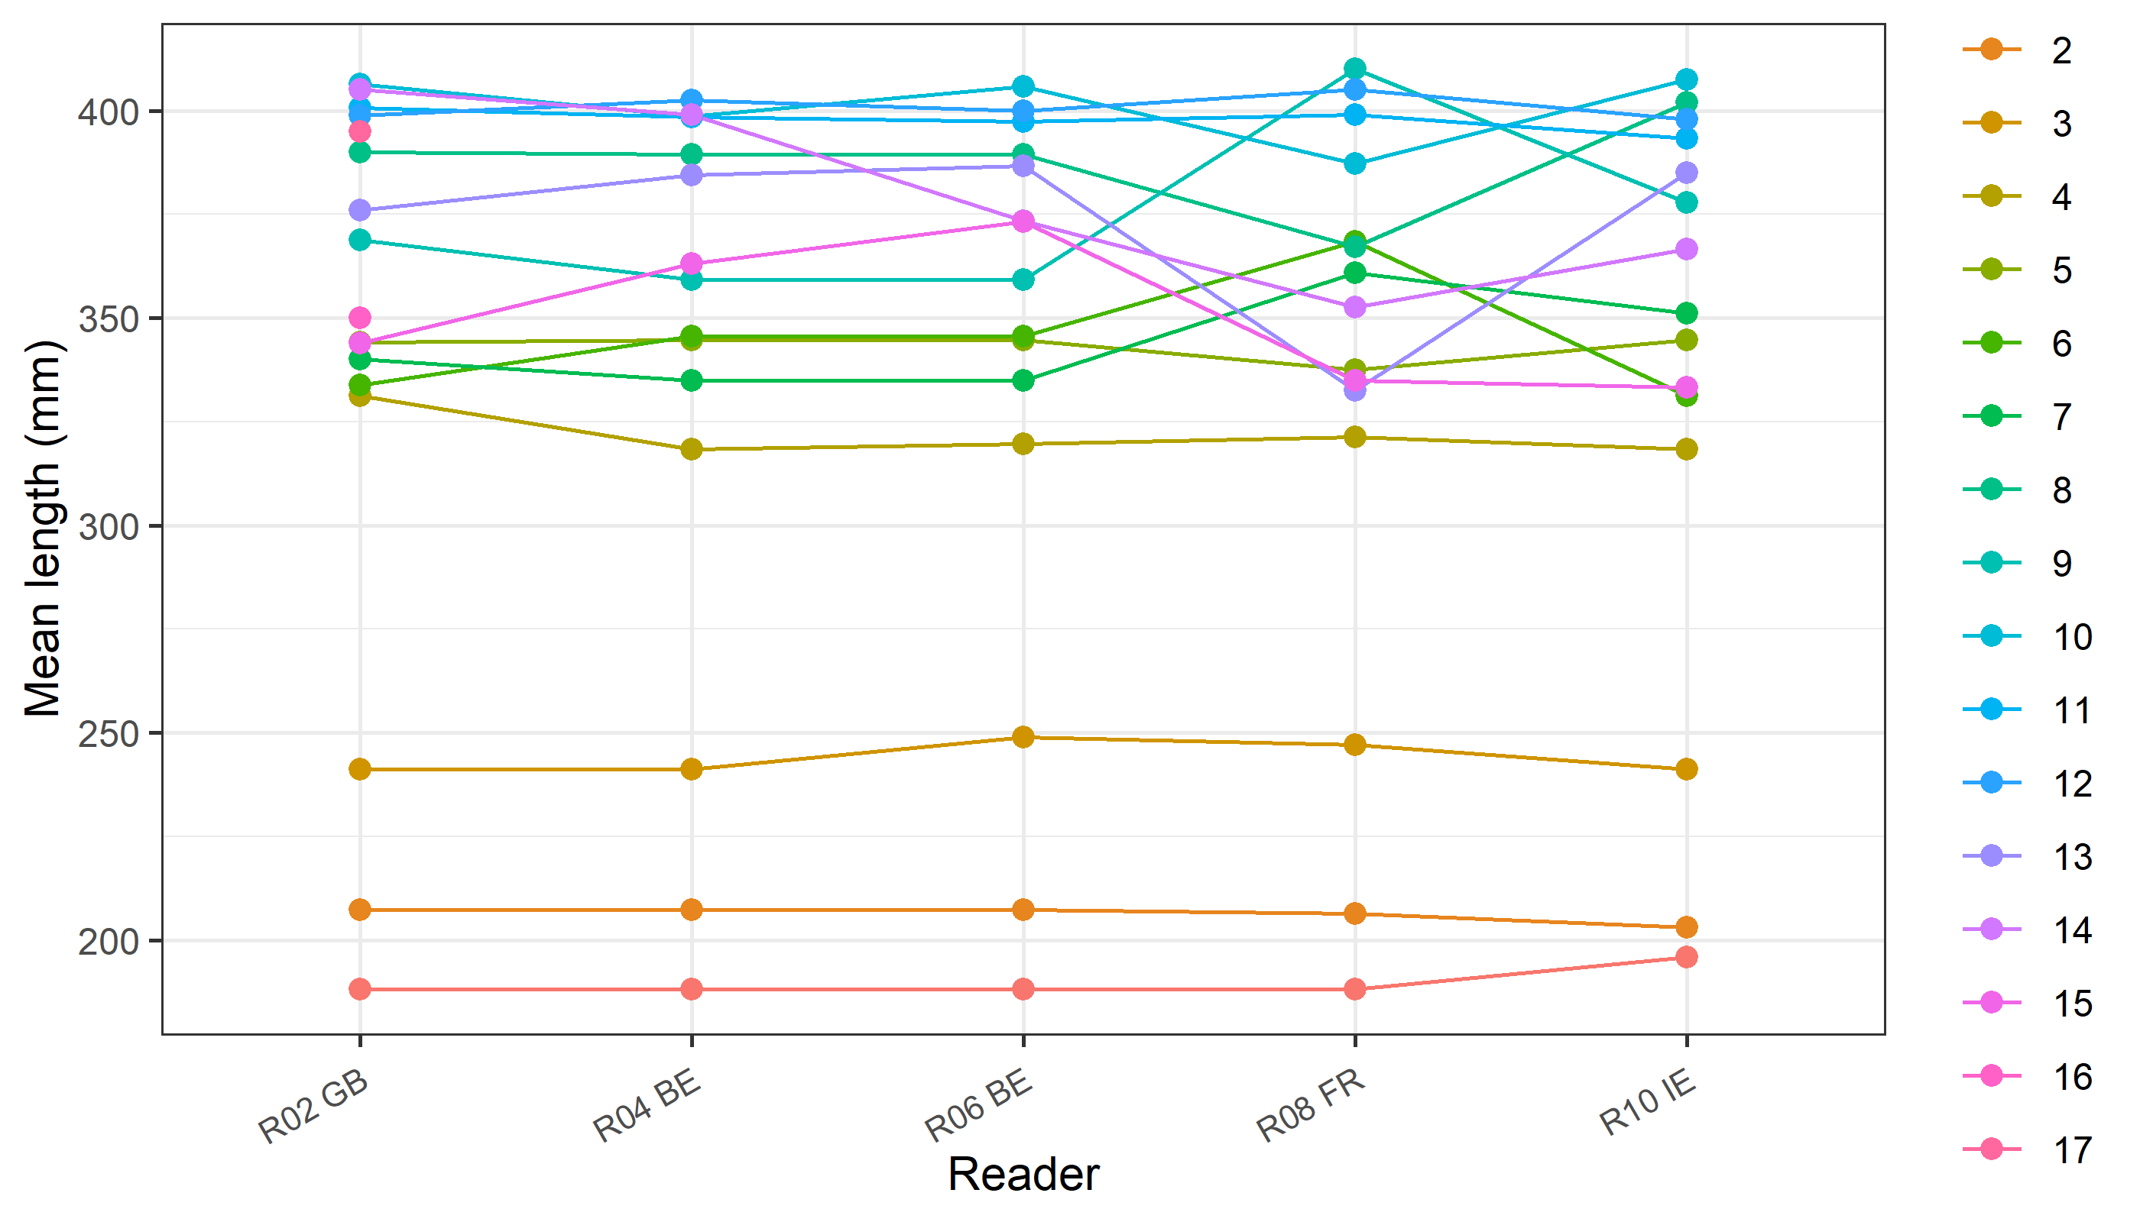
Figure 5.6: The mean length at age as estimated by each age reader.

