SmartDots Report for event 509
Table of Contents
1 Introduction 3
2 Participant list 4
3 Methods 5
4 Analysis of age calibration exercise 7
4.1 Results 8
4.1.1 SmartDot images 13
4.2 Conclusion 15
5 References 16
6 Annex 2. List of participants 17
7 Annex 3. Additional results 18
7.1 Results all readers 19

Introduction
Boarfish (Capros aper, Linnaeus) is a small, long-lived, deep bodied, laterally compressed species distributed from Norway to Senegal, including the Mediterranean, Azores, Canaries, Madeira and Great Meteor Seamount islands (Blanchard & Vandermeirsch 2005). They exhibit sexually dimorphism, with females attaining larger sizes than males, as a result of sex-specific growth and longevity patterns (White et al. 2011). Their maximum age is >30 years and they have an age at maturity and length at maturity of 3.4 years and 9.7cm respectively (Hüssy et al. 2012a). They are batch spawners with indeterminate fecundity that spawn between June and August (Farrell et al. 2016, Blanchard & Vandermeirsch 2005). They are also fast growing (K = 0.145 yr⁻¹ for females and K = 0.181 yr⁻¹ for males). Boarfish primarily inhabit continental shelves and edges, often in large dense shoals at depths of 40-600m (Coad et al. 2014, Egerton et al., 2017). A genetic study conducted in 2013 of samples from the Northeast Atlantic and Mediterranean suggested that boarfish in ICES subareas 4,6,7,8 and the northern part of 9a comprised a single stock (Farrell et al., 2016). Although it’s species distribution is slightly broader than the current EC TAC area (27.6, 7 and 8), only data from these areas were utilized for the ageing exercise.
In 2013, a decision was made not to pursue an active ageing programme. Since then, all boarfish samples, fishery dependent and independent, have been aged using an age length key (ALK) created in 2012. The ALK ranges in length from 5cm – 18 cm and is unimodal with a peak at 12cm, which corresponds to an age of approximately 7 years. In the key, all samples less than 10 cm were estimated from a constructed von Bertalanffy growth curve. In recent years, particularly in 2020 and 2021, there has been a marked increase in recruitment into the fishery and a decline in the number of older fish (15 + group category). To take advantage of the high abundance of young fish available in the fishery and to assess the plus group designation, an ageing exercise was conducted. The aim of the exercise was to carry out boarfish age training using the SmartDots platform https://www.ices.dk/data/tools/Pages/smartdots.aspx, to age samples less than 10 cm, to compile otolith images for future training purposes and to potentially shed light on the possibility of adjusting the plus group designation. The report provides statistical analyses and comparisons from three trained readers ageing 158 boarfish otoliths of varying difficulty.

Participant list

- Julie Coad Davies, DTU Aqua, Denmark
- Edward Farrell, KFO, Ireland
- Roxanne Duncan, MI, Ireland

Methods
Three readers, two from Ireland and one from Denmark, participated in the otolith ageing exercise which took place on the SmartDots platform during November 2022. The otoliths were sourced from both legs of the WESPAS survey (14th June to 24th of July 2022). In total, 158 images were read by all the readers. The fish length distribution of the samples ranged from 55 – 170mm with one third of the samples in the 55-95 mm length range. To image and read the otoliths, the protocol outlined in the boarfish age reading manual, created by DTU Aqua, was followed. The statistical analyses performed on the results are outlined below and their tables and graphical plots can be found in the Results section.
Percentage Agreement
The percentage agreement (PA) measures the interobserver agreement between the readers. The PA is calculated as:
$$\left(\frac{agreements}{agreements+disaggreements}\right)×100\%$$
The percentage agreement per reader per modal age gives the percentage of readings that are equal to the modal age. The weighted mean is weighted according to the number of age readings. A rank is also assigned to each reader.
Co-efficient of Variation (CV)
The coefficient of variation (CV) is calculated per modal age and reader. The CV's is estimated as the ratio between the standard deviation (σ) and mean value (μ) per reader and modal age:
$$CV=\frac{σ}{μ}×100\%$$
Also computed is the CV of all readers combined per modal age, a weighted mean of the CV per reader and a rank value per reader, where the reader with the lowest weighted mean is assigned with a rank and so forth. In the situation of ties between two weighted means, every tied element will be assigned to the lowest rank. This is the procedure for all ties methods when assigning ranks.
Average Percentage Error (APE)
APE is calculated based on the method outlined by Beamish & Fournier (1981). This method is not independent of fish age and thus provides a better estimate of precision. As the calculations of both CV and APE pose problems if the mean age is close to 0, all observations for which modal age was 0 are omitted from the CV and APE calculations.
The average percentage error is calculated per image as:
$$APE=\frac{100\%}{n}\sum_{i=1}^{n}{|}\frac{a_{i}-\overline{a}}{\overline{a}}|$$
where $a_{i}$ is the age reading of reader $i$ and $\overline{a}$ is the mean of all readings from 1 to $n$.

Relative bias
The relative bias is the difference between the mean age (per modal age per reader) and modal age. As for the previous tables, a combined bias for all readers and weighted means is calculated and finally a rank is assigned to each reader.
Inter-reader bias
For each pair that is being compared, the differences between the readings per image are found and the frequency of each occurring difference is obtained. A rank value is calculated for the positive and the negative differences. The value with the smallest rank is then used to calculate a z-value that determines the level of bias.
Age error matrix (AEM)
Age error matrices (AEM) are produced following procedures outlined by WKSABCAL (2014) where the matrix shows the proportion of each modal age misread as other ages. The sum of each column is 1, which equals 100%.
Otolith Growth Analysis
SmartDots provides a measure of distance between the annotations made by the readers and thus provides a measure of growth increment width. This data is used to establish growth curves for each fish and for each reader.

Analysis of age calibration exercise

Overview of samples and readers
Table 4.1: Overview of samples used for the 2022 Boarfish ageing exchange (SmartDots ID 509).
Year | ICES area | Strata | Quarter | Number of samples | Modal age range | Length range
2022 | 27.6.a | a | 3 | 100 | 2-18 | 75-170 mm
2022 | 27.7.j | a | 2 | 58 | 1-12 | 55-160 mm

Table 4.2: Reader overview.
Reader code | Expertise
R02 DK | Basic
R04 IE | Basic
R06 IE | Basic

Results
Firstly, there was excellent participation by all three readers with each providing an age for every otolith except one (Table 4.1). Age 2 was the most read age for the exercise, followed by ages 3 and 4. The coefficient of variation (CV) table shows that as age increased, the overall CV value decreased, beginning at a high of 40% at age 1 and declining to 9% at age 15. This shows that at young ages, there was a wide spread of readings around the modal age which decreased as age increased. The overall weighted mean CV was calculated at 26% with reader R04 readings being weighted slightly higher (Table 4.2). The percentage agreement (PA) per modal age was high between the readers at age 1 (mean = 87%) and consistently decreased to a mean of 50% at age 9. PA reached its lowest at age 12 but increased again to 58% at age 16 (Table 4.3). At the lowest PA, the readers were disagreeing over a range of ages. The average weighted mean PA was calculated at 64% with reader R06 readings being weighted higher at 76%. Relative bias gives an indication of the overestimation and/or underestimation of estimated ages in comparison to the calculated modal age. Mean relative bias was positive at all modal ages, indicating a general tendency for readers to overestimate in comparison to the modal age. This was lowest between modal ages 1-5 (mean = 0.18) and increased to 3.14 by age 12 then decreased to 0.42 at age 16. Readers R04 and R06 had the highest and lowest weighted mean respectively. All readers had a positive bias, indicating that they overestimated their readings in comparison to the modal age (Table 4.4).
Table 4.1: An overview of the number of readings per reader and modal age. The total numbers of readings per reader and per modal age are summarized at the end of the table.
Modal age | R02 DK | R04 IE | R06 IE | total
1 | 10 | 10 | 10 | 30
2 | 38 | 38 | 38 | 114
3 | 35 | 35 | 35 | 105
4 | 22 | 22 | 22 | 66
5 | 3 | 3 | 3 | 9
6 | 5 | 5 | 5 | 15
7 | 4 | 4 | 4 | 12
8 | 6 | 6 | 5 | 17
9 | 2 | 2 | 2 | 6
10 | 6 | 6 | 6 | 18
11 | 4 | 4 | 4 | 12
12 | 7 | 7 | 7 | 21
13 | 4 | 4 | 4 | 12
14 | 3 | 3 | 3 | 9
15 | 4 | 4 | 4 | 12
16 | 4 | 4 | 4 | 12
17 | 0 | 0 | 0 | 0
18 | 1 | 1 | 1 | 3
Total | 158 | 158 | 157 | 473

Table 4.2: Coefficient of Variation (CV) table presents the CV per modal age and reader, the CV of all readers combined per modal age and a weighted mean of the CV per reader.
Modal age | R02 DK | R04 IE | R06 IE | all
1 | 52 % | 0 % | 35 % | 40 %
2 | 28 % | 33 % | 32 % | 31 %
3 | 17 % | 32 % | 27 % | 27 %
4 | 26 % | 31 % | 18 % | 25 %
5 | 0 % | 20 % | 29 % | 18 %
6 | 7 % | 38 % | 9 % | 25 %
7 | 17 % | 27 % | 0 % | 22 %
8 | 5 % | 32 % | 9 % | 28 %
9 | 14 % | 0 % | 0 % | 18 %
10 | 29 % | 21 % | 0 % | 27 %
11 | 4 % | 22 % | 4 % | 19 %
12 | 7 % | 17 % | 0 % | 19 %
13 | 9 % | 19 % | 4 % | 17 %
14 | 8 % | 9 % | 0 % | 9 %
15 | 3 % | 10 % | 0 % | 9 %
16 | 0 % | 20 % | 24 % | 20 %
17 | - | - | - | -
18 | - | - | - | 8 %
Weighted Mean | 21 % | 27 % | 20 % | 26 %

Table 4.3: Percentage agreement (PA) table represents the PA per modal age and reader, the PA of all readers combined per modal age and a weighted mean of the PA per reader.
Modal age | R02 DK | R04 IE | R06 IE | all
1 | 80 % | 100 % | 80 % | 87 %
2 | 82 % | 74 % | 74 % | 76 %
3 | 80 % | 51 % | 69 % | 67 %
4 | 64 % | 55 % | 86 % | 68 %
5 | 100 % | 33 % | 33 % | 56 %
6 | 80 % | 40 % | 60 % | 60 %
7 | 25 % | 50 % | 100 % | 58 %
8 | 83 % | 17 % | 60 % | 53 %
9 | 50 % | 0 % | 100 % | 50 %
10 | 0 % | 17 % | 100 % | 39 %
11 | 0 % | 25 % | 75 % | 33 %
12 | 0 % | 0 % | 100 % | 33 %
13 | 25 % | 25 % | 75 % | 42 %
14 | 33 % | 0 % | 100 % | 44 %
15 | 25 % | 25 % | 100 % | 50 %
16 | 100 % | 50 % | 25 % | 58 %
17 | - | - | - | -
18 | 100 % | 0 % | 0 % | 33 %
Weighted Mean | 65 % | 51 % | 76 % | 64 %

Table 4.4: Relative bias per modal age per reader, the relative bias of all readers combined per modal age and a weighted mean of the relative bias per reader
Modal age | R02 DK | R04 IE | R06 IE | all
1 | 0.30 | 0.00 | 0.20 | 0.17
2 | 0.26 | 0.18 | 0.26 | 0.24
3 | 0.11 | -0.23 | 0.46 | 0.11
4 | 0.18 | 0.36 | 0.27 | 0.27
5 | 0.00 | 0.00 | 0.33 | 0.11
6 | 0.20 | 1.60 | 0.40 | 0.73
7 | 0.50 | 2.00 | 0.00 | 0.83
8 | 0.17 | 3.17 | 0.00 | 1.11
9 | 1.00 | 4.00 | 0.00 | 1.67
10 | 3.00 | 5.17 | 0.00 | 2.72
11 | 4.50 | 4.25 | 0.25 | 3.00
12 | 4.14 | 5.29 | 0.00 | 3.14
13 | 1.25 | 3.50 | -0.25 | 1.50
14 | 1.33 | 2.33 | 0.00 | 1.22
15 | 0.75 | 2.50 | 0.00 | 1.08
16 | 0.00 | 2.75 | -1.50 | 0.42
17 | - | - | - | -
18 | 0.00 | 3.00 | 1.00 | 1.33
Weighted Mean | 0.66 | 1.14 | 0.20 | 0.67

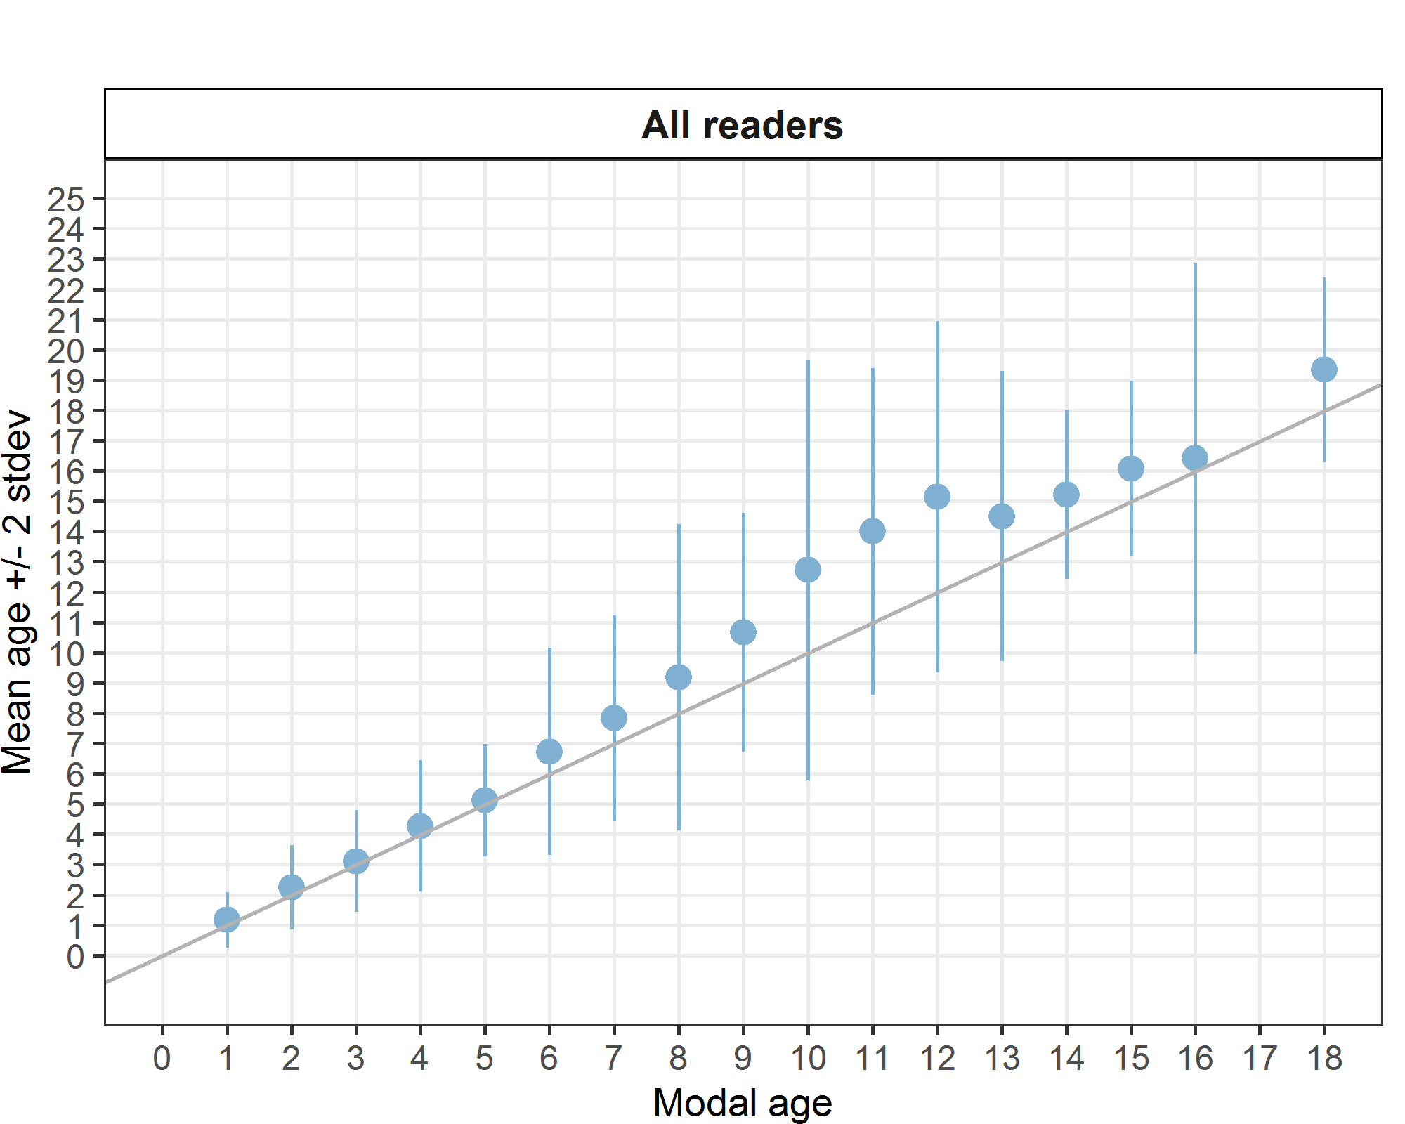
Figure 4.1: Age bias plot for all readers. Mean age recorded +/- 2 SD of each reader and all readers combined are plotted against modal age. The estimated mean age corresponds to modal age, if the estimated mean age is on the 1:1 equilibrium line (solid line). Relative bias is the age difference between estimated mean age and modal age.

Figure 4.1 shows a plot of the overall bias per modal age (and reflect the results in Table 4.4). A sharp increase can be observed from age 6 to 13 with the largest standard deviation at age 10. The plot shows that during this age range, when the estimated age disagreed with the modal age, the readers aged the otoliths higher than the modal age and over a wide range of ages. In the case of age 16, the majority of readings was in agreement with the modal age but when the estimated age disagreed with the modal age, it disagreed over a very wide range of ages.
The box and whisker chart below illustrates the average distance from the centre to the winter rings. Little overlap was observed at modal ages 1-5 indicating that the readers were in agreement as to which structures should be counted as the winter rings. The chart also shows that as age increased, each reader increasingly differed in where they marked the end of the winter rings. This could be a result of the rings being closer together, thus making it difficult to identify which structures were in fact the winter rings (Figure 4.2).
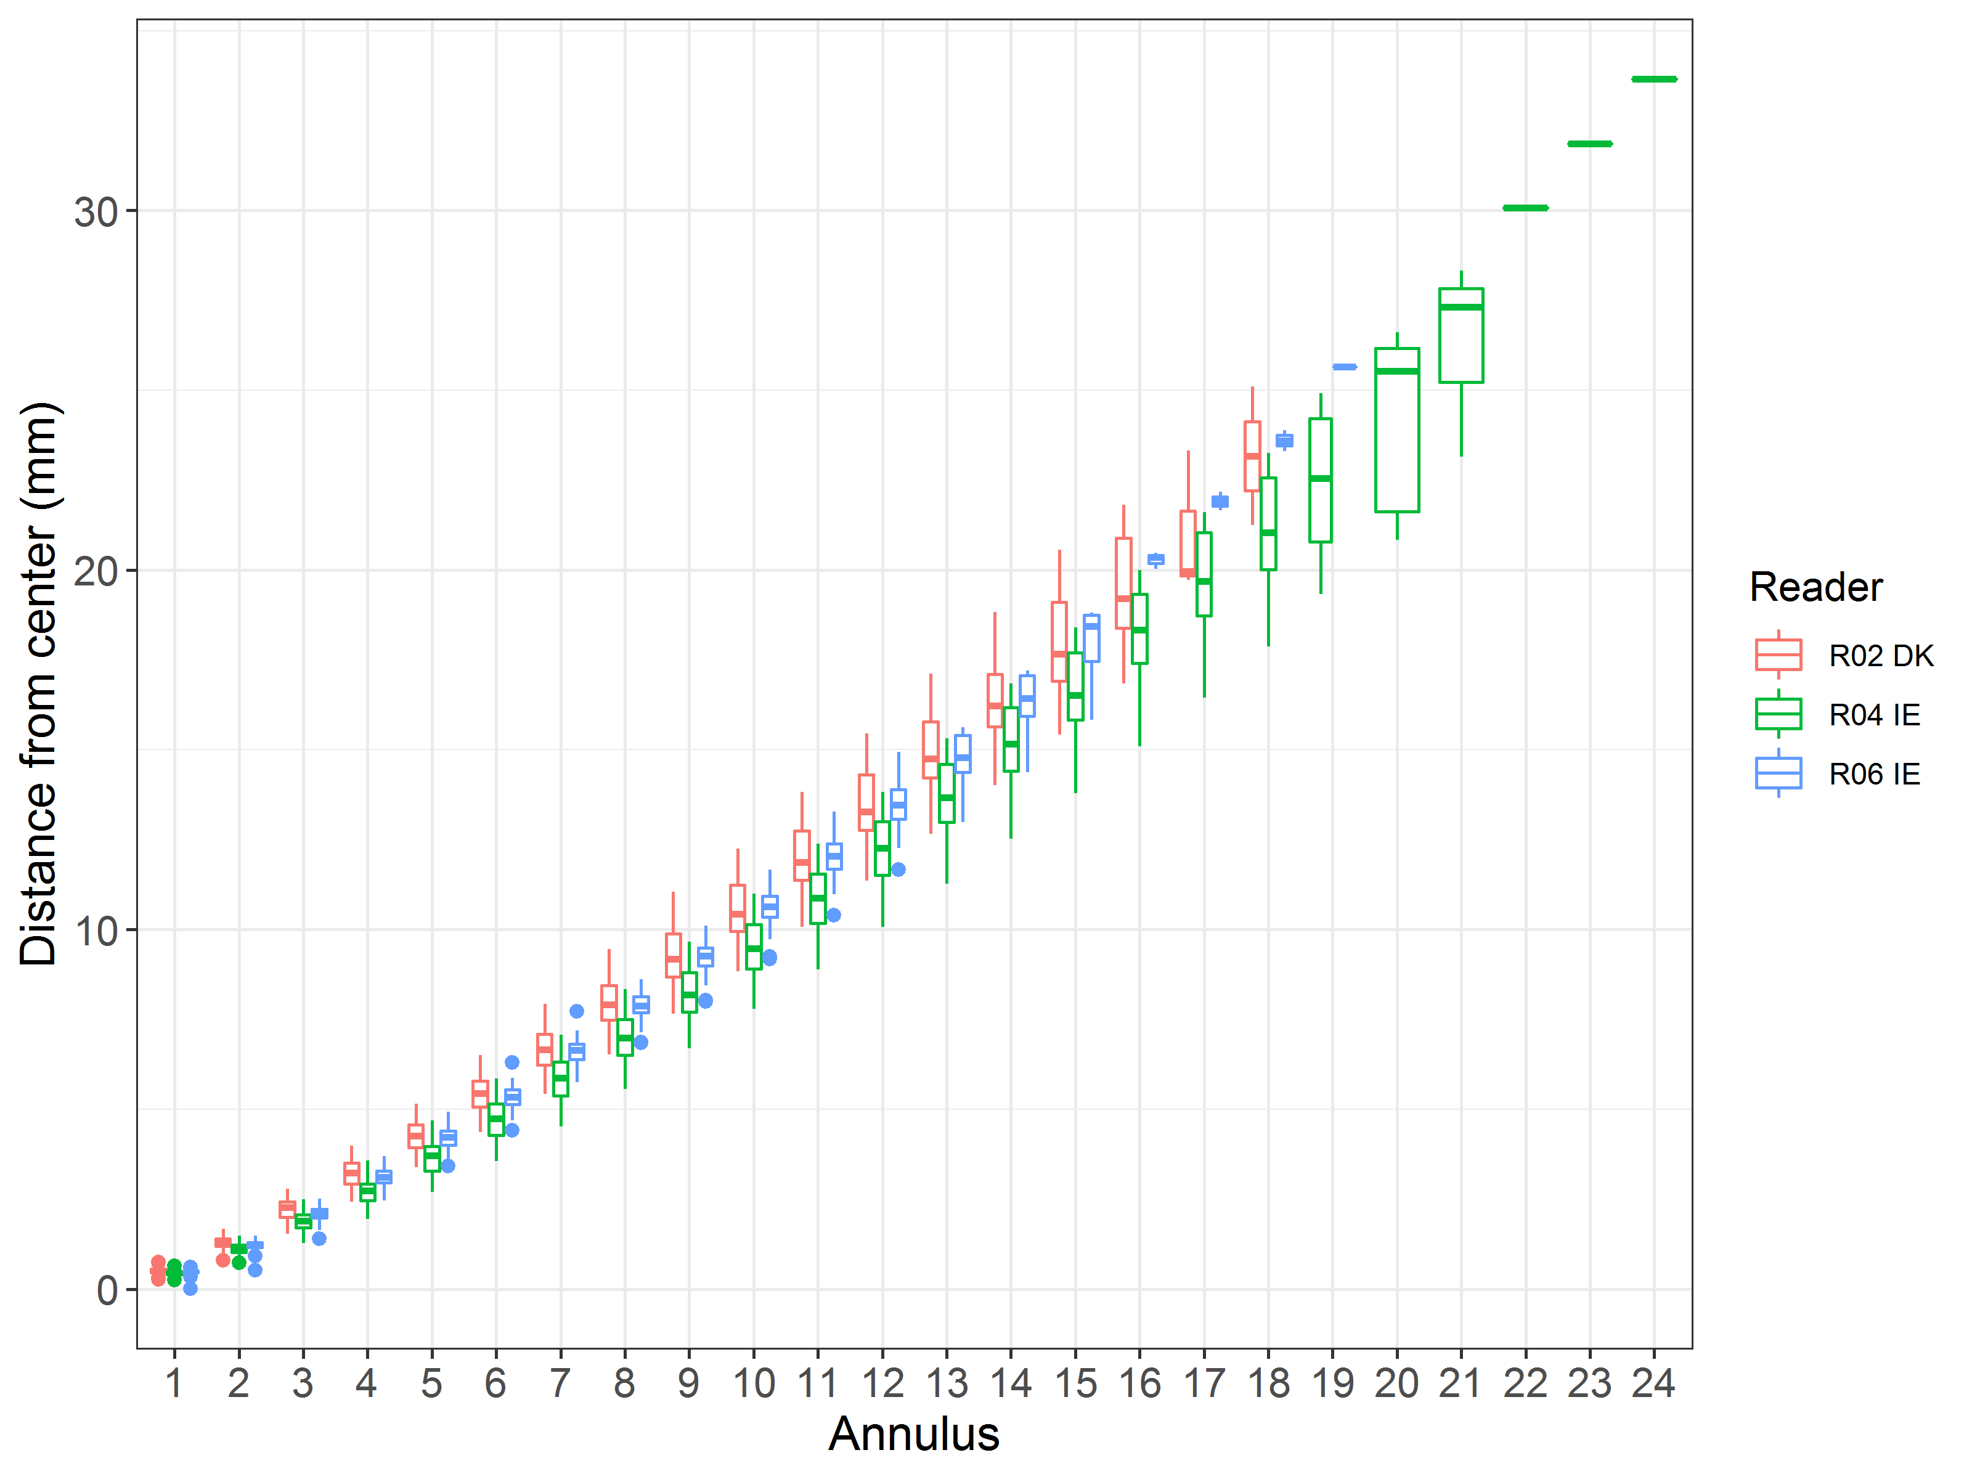

Figure 4.2: Plot of average distance from the centre to the winter rings for readers by preparation method. The boxes represent the median, upper and lower box boundaries of the interquartile range, whiskers represent the minimum and maximum values and the dots represent the outliers.

The age error matrix shows that as age increased, the probability to erroneously assigning an age increased. It also shows that the range of other ages associated with a modal age increased as well. For example, at modal age 1, 86% is correctly assigned with only 13% assigned incorrectly to ages 2 and 3. But at age 10, only 38% is assigned correctly and 56% is assigned inaccurately over a range of 8 ages.
Table 4.5: The age error matrix (AEM) shows the proportional distribution of age readings for each modal age. All readers were used for calculating the AEM.
Modal age | Age 0 | Age 1 | Age 2 | Age 3 | Age 4 | Age 5 | Age 6 | Age 7 | Age 8 | Age 9 | Age 10 | Age 11 | Age 12 | Age 13 | Age 14 | Age 15 | Age 16 | Age 17 | Age 18 | Age 19 | Age 20 | Age 21 | Age 22 | Age 23 | Age 24
0 | - | - | - | - | - | - | - | - | - | - | - | - | - | - | - | - | - | - | - | - | - | - | - | - | -
1 | - | 0.87 | 0.10 | 0.03 | - | - | - | - | - | - | - | - | - | - | - | - | - | - | - | - | - | - | - | - | -
2 | 0.01 | 0.03 | 0.76 | 0.14 | 0.04 | 0.02 | - | - | - | - | - | - | - | - | - | - | - | - | - | - | - | - | - | - | -
3 | - | - | 0.16 | 0.67 | 0.10 | 0.05 | 0.03 | - | - | - | - | - | - | - | - | - | - | - | - | - | - | - | - | - | -
4 | - | - | - | 0.12 | 0.68 | 0.11 | 0.03 | 0.03 | 0.02 | 0.02 | - | - | - | - | - | - | - | - | - | - | - | - | - | - | -
5 | - | - | - | - | 0.22 | 0.56 | 0.11 | 0.11 | - | - | - | - | - | - | - | - | - | - | - | - | - | - | - | - | -
6 | - | - | - | - | - | 0.07 | 0.60 | 0.20 | - | 0.07 | - | - | 0.07 | - | - | - | - | - | - | - | - | - | - | - | -
7 | - | - | - | - | - | - | 0.08 | 0.58 | 0.08 | 0.08 | 0.08 | - | 0.08 | - | - | - | - | - | - | - | - | - | - | - | -
8 | - | - | - | - | - | - | - | 0.12 | 0.53 | 0.12 | - | 0.06 | 0.12 | - | - | - | - | 0.06 | - | - | - | - | - | - | -
9 | - | - | - | - | - | - | - | - | - | 0.5 | - | 0.17 | - | 0.33 | - | - | - | - | - | - | - | - | - | - | -
10 | - | - | - | - | - | - | 0.06 | - | - | - | 0.39 | - | 0.06 | 0.06 | 0.11 | 0.06 | 0.17 | - | 0.05556 | 0.06 | - | - | - | - | -
11 | - | - | - | - | - | - | - | - | - | - | - | 0.33 | 0.08 | - | - | 0.25 | 0.25 | - | - | 0.08 | - | - | - | - | -
12 | - | - | - | - | - | - | - | - | - | - | - | - | 0.33 | 0.05 | 0.05 | 0.10 | 0.14 | 0.14 | 0.05 | 0.05 | 0.05 | 0.05 | - | - | -
13 | - | - | - | - | - | - | - | - | - | - | - | - | 0.08 | 0.42 | 0.17 | 0.08 | 0.08 | - | 0.08 | - | 0.08 | - | - | - | -
14 | - | - | - | - | - | - | - | - | - | - | - | - | - | - | 0.44 | 0.11 | 0.33 | - | 0.11 | - | - | - | - | - | -
15 | - | - | - | - | - | - | - | - | - | - | - | - | - | - | - | 0.5 | 0.25 | - | 0.17 | 0.08 | - | - | - | - | -
16 | - | - | - | - | - | - | - | - | - | - | 0.08 | - | - | - | 0.08 | - | 0.58 | - | 0.08 | 0.08 | - | - | - | - | 0.08
17 | - | - | - | - | - | - | - | - | - | - | - | - | - | - | - | - | - | - | - | - | - | - | - | - | -
18 | - | - | - | - | - | - | - | - | - | - | - | - | - | - | - | - | - | - | 0.33 | 0.33 | - | 0.33 | - | - | -

SmartDots images

WESPAS H17-039 (Age 3) WESPAS H24-046 (Age 6)
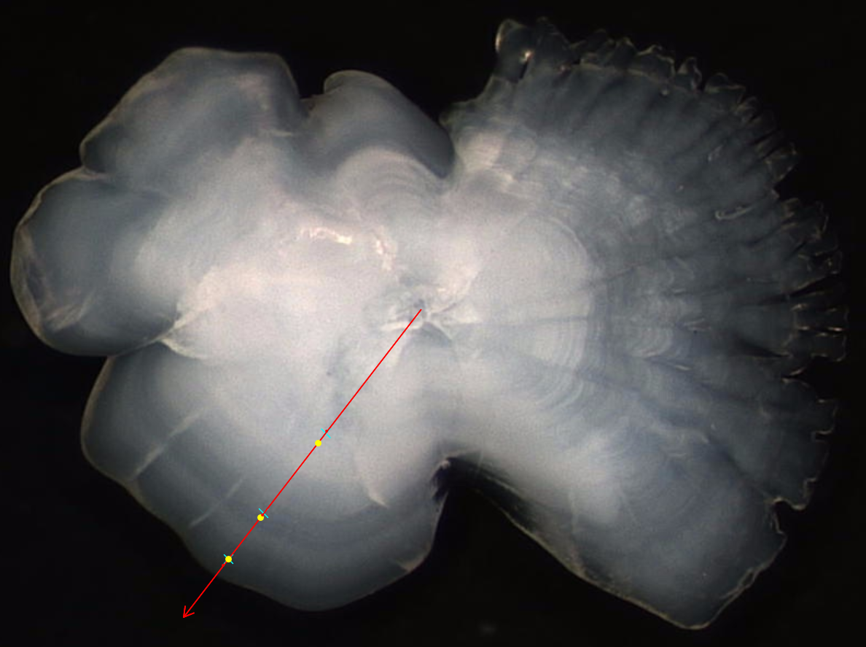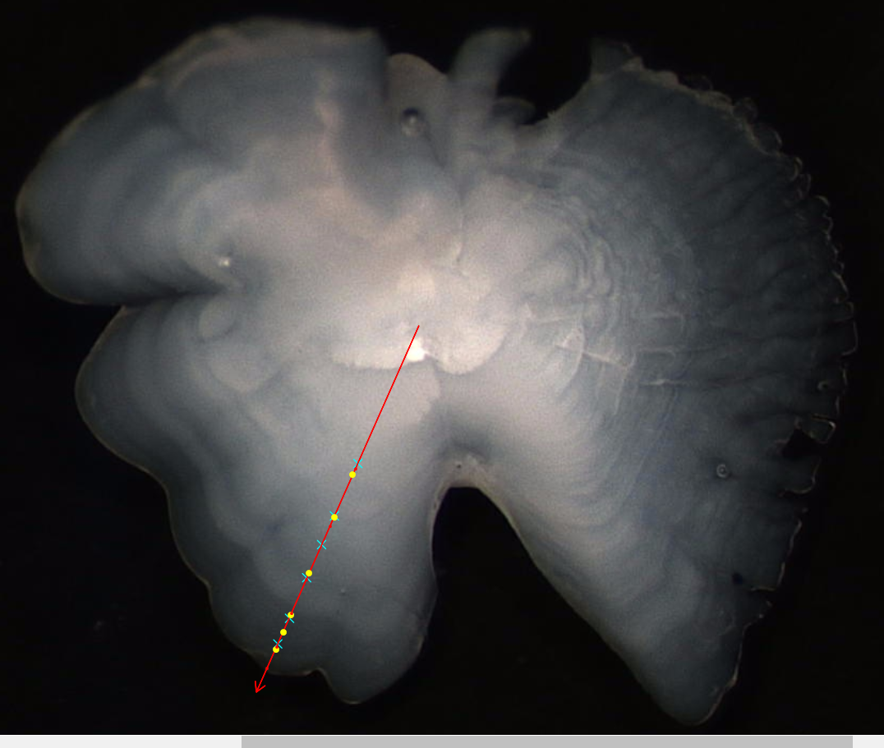
WESPAS H24-041 (Age 15)
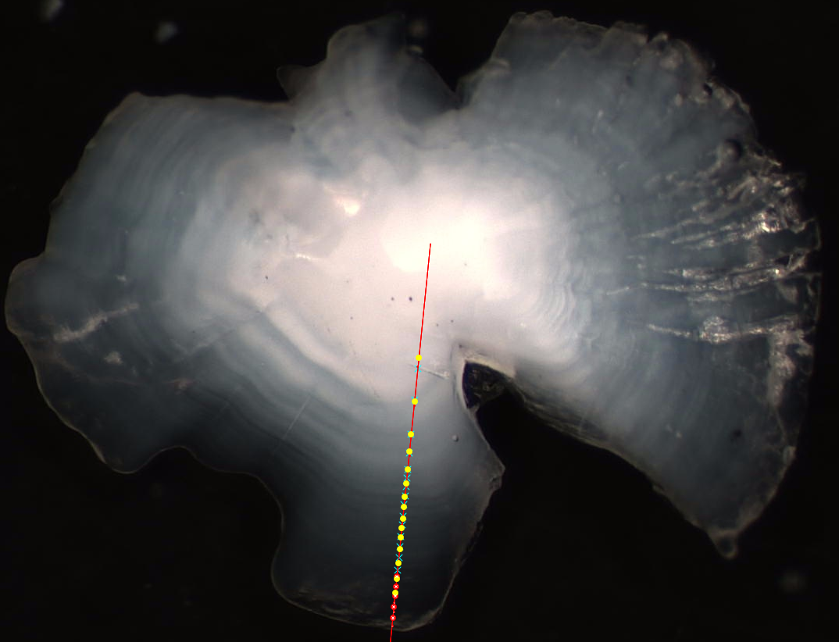
Figure 4.1.1: Examples of high agreement in age reading

WESPAS H31-004 WESPAS H25-033
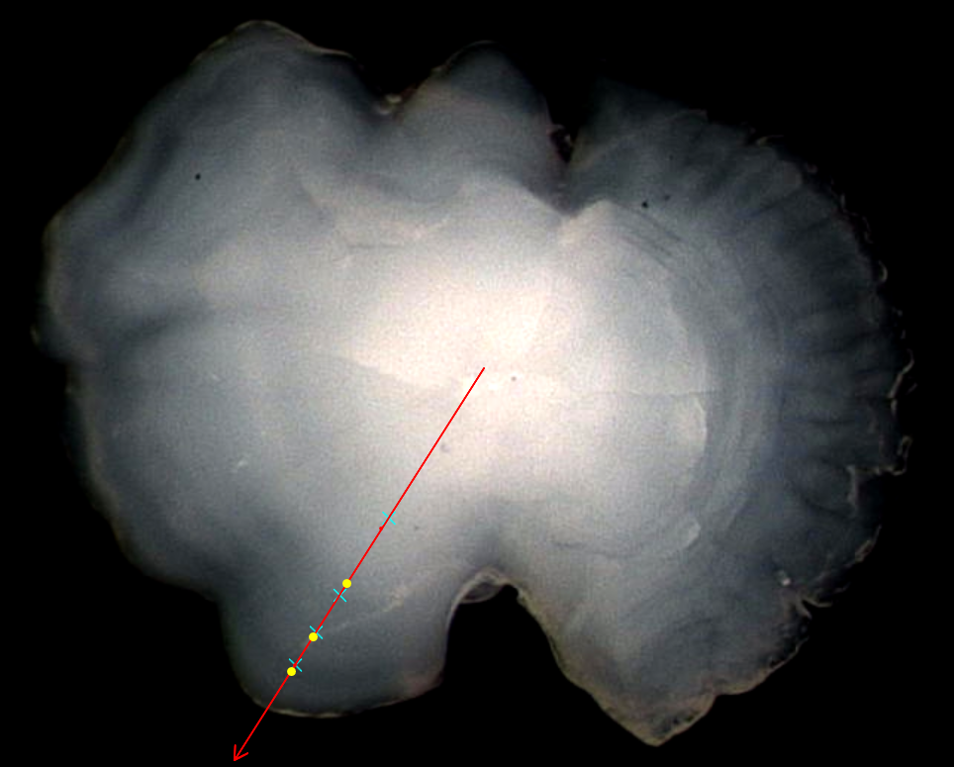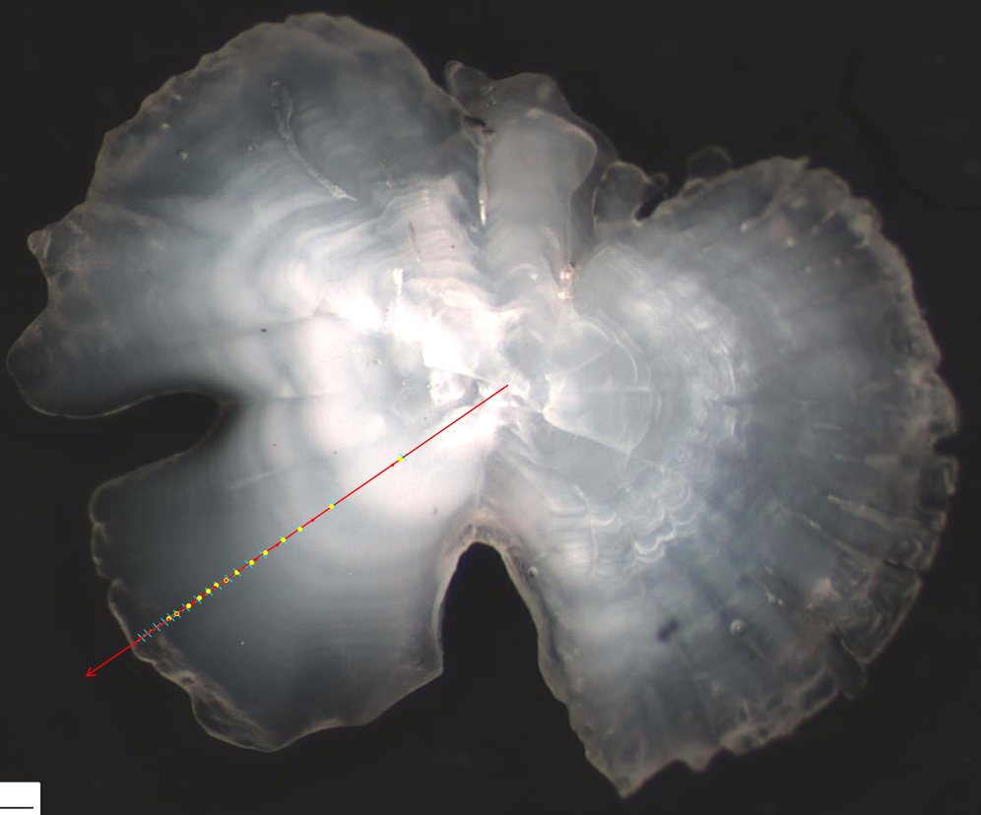
WESPAS H32_032
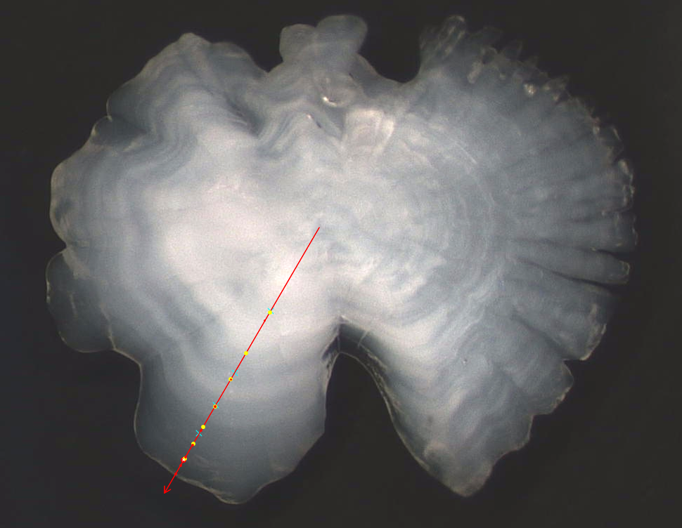

Figure 4.1.2: Examples of high disagreement in age reading

Conclusion
The intention of the age reading exercise was to execute boarfish age training using the SmartDots platform, to age samples less than 10 cm, to compile otolith images for future training purposes and to potentially shed light on the possibility of adjusting the plus group designation. The SmartDots platform proved to be a vital tool to age the otoliths and to promote discussion among readers at the end of the exercise. SmartDots has also shown to be an excellent storage bank for otoliths that can be used in the future for training. Samples with lengths between 5.5 cm and 9.5 cm made up 33% % of the total number of samples (n=53). Boarfish in this length range was aged between 1 and 3 years old. Concerning the plus group designation, this exercise wasn’t able to advise or provide useful information to support or oppose changing to the plus group. Both independent and dependent catch data show that there are less 15+ fish in the stock so there is a need to re-examine the designation; however, this exercise isn’t able to inform on the decision of the age the new grouping should begin.
The modal age represents the age at which the majority of readers agree. If a majority isn’t reached between the readers, the modal age is estimated as the youngest age, which may not be the actual “true” age. In this exercise, the three readers did not agree on an age for 20 samples, which represented 12.6% of the total, therefore an age was assigned to a significant number of samples which may or may have been the true age. In the coefficient of variation (CV) table, a low CV signifies that the readers were estimating close to the modal mean age. On the other hand, a high CV indicates that there is a lot of uncertainty around the modal age. The high CV observed in the exercise might be a characteristic of the difficulty associated with reading boarfish otoliths. Even following the measurement guidelines outlined in the boarfish aging manual, there is still a lot of overlap in distance between the first few growth rings. It is very difficult to state that a specific fish length corresponds to one age.
In the percentage agreement table, the readers agreed on a high percentage of otoliths (75% agreement for the first four years) but when they disagreed, the spread of ages was wide-ranging (Figure 4.3). For example, there were 10 otoliths assigned to age 1 and the readers agreed on 7 of them; however, for age 4, 22 otoliths were assigned to the age but the readers only agreed on 3 and the rest of the samples were aged between 3-9. Also, before the results were collated, all otoliths with an AQ3 score were removed and this could be masking some uncertainty in the results. In the relative bias table and plot, the bias between the readers tended to be low for ages 1-5 and as age increased, the bias estimates increased as the reader’s estimates differed from the modal age. Estimates of age tended to be higher when the readers were not in agreement with the modal age. For the age error matrix (Table 4.5), the spread of the readers’ ages is wide and gets wider as the fish grows. This might be a result of the increased difficulty in identifying and counting the rings as the fish ages. This pattern is also evident in the current age key used for boarfish.

References

Beamish, R. & Fournier, D. 1981. A method for comparing the precision of a set of age determinations. Canadian Journal of Fisheries and Aquatic Sciences, 38, 982-983.
Blanchard, F. & Vandermeirsch, F. 2005. Warming and exponential abundance increase of the subtropical fish Capros aper in the Bay of Biscay (1973–2002). Comptes Rendus Biologies, 328, 505–509.
Coad, J.O., Hüssy, K., Farrell, E.D. & Clarke, M.W. 2014. The recent population expansion of boarfish, Capros aper (linnaeus, 1758): Interactions of climate, growth and recruitment. Journal of Applied Ichthyology, 30, 463–471.
Egerton, S., Culloty, S., Whooley, J., Stanton, C. & Ross, R. 2017. Boarfish (Capros aper): review of a new capture fishery and its valorization potential. ICES Journal of Marine Science, 74, 2059–2068.
Farrell, E.D., Carlsson, J.E.L. & Carlsson, J. 2016. Next gen pop gen: Implementing a high-throughput approach to population genetics in boarfish (Capros aper). Open Science, 3, 160651.
Hüssy, K., Coad, J. O., Farrell, E., Clausen, L. W. & Clarke, M. W. 2012a. Sexual dimorphism in size, age, maturation, and growth characteristics of boarfish (Capros aper) in the Northeast Atlantic. ICES Journal of Marine Science, 69, 1729-1735.
Hüssy, K. & Coad, J. O., 2012b. Age reading manual, Boarfish (Capros aper). Technical University of Denmark, National Institute of Aquatic Resources, Jægersborg Alle 1, 2920 Charlottenlund, Denmark.
White, E., Minto, C., Nolan, C.P., King, E., Mullins, E. & Clarke, M. 2011. First estimates of age, growth, and maturity of boarfish (Capros aper): A species newly exploited in the Northeast Atlantic. ICES Journal of Marine Science, 68, 61–66.
WKSABCAL. 2014. Report of ICES Cooperative Research Report on Age Reading. Chapter 7: Statistical handling of uncertainty in age estimations. In: Report of the Workshop on Statistical Analysis of Biological Calibration Studies (WKSABCAL). 13-18 October 2014, Lisbon, Portugal. Copenhagen (Denmark): International Council for the Exploration of the Sea - ICES; 2014. p. 57-75. JRC93463

Annex 2. List of participants
Table X: Participants list.
Reader code | Expertise
R02 DK | Basic
R04 IE | Basic
R06 IE | Basic

Annex 3. Additional results

Results all readers
Data Overview
Table 7.1: Summary of statistics; PA (%), CV (%) and APE (%).
CV | PA | APE
26 % | 64 % | 18 %
Table X: Data overview including modal age and statistics per sample.
Fish ID | Event ID | Image ID | length | sex | Catch date | ICES area | R02 DK | R04 IE | R06 IE | Modal age | PA % | CV % | APE %
BOF_100 | 509 | - | 105 | M | 30/06/2022 00:00:00 | 27.7.j | 3 | 5 | 4 | 3 | 33 | 25 | 17
BOF_101 | 509 | - | 105 | F | 30/06/2022 00:00:00 | 27.7.j | 4 | 2 | 3 | 2 | 33 | 33 | 22
BOF_102 | 509 | - | 110 | F | 30/06/2022 00:00:00 | 27.7.j | 3 | 2 | 3 | 3 | 67 | 22 | 17
BOF_103 | 509 | - | 95 | F | 30/06/2022 00:00:00 | 27.7.j | 2 | 2 | 0 | 2 | 67 | 87 | 67
BOF_105 | 509 | - | 95 | F | 30/06/2022 00:00:00 | 27.7.j | 2 | 2 | 2 | 2 | 100 | 0 | 0
BOF_106 | 509 | - | 95 | F | 30/06/2022 00:00:00 | 27.7.j | 2 | 3 | 2 | 2 | 67 | 25 | 19
BOF_107 | 509 | - | 110 | M | 30/06/2022 00:00:00 | 27.7.j | 5 | 5 | 4 | 5 | 67 | 12 | 10
BOF_108 | 509 | - | 95 | M | 30/06/2022 00:00:00 | 27.7.j | 3 | 2 | 2 | 2 | 67 | 25 | 19
BOF_109 | 509 | - | 100 | F | 30/06/2022 00:00:00 | 27.7.j | 4 | 7 | 4 | 4 | 67 | 35 | 27
BOF_110 | 509 | - | 100 | F | 30/06/2022 00:00:00 | 27.7.j | 3 | 4 | 3 | 3 | 67 | 17 | 13
BOF_111 | 509 | - | 100 | M | 30/06/2022 00:00:00 | 27.7.j | 3 | 3 | 3 | 3 | 100 | 0 | 0
BOF_112 | 509 | - | 95 | F | 30/06/2022 00:00:00 | 27.7.j | 3 | 2 | 3 | 3 | 67 | 22 | 17
BOF_114 | 509 | - | 95 | F | 30/06/2022 00:00:00 | 27.7.j | 2 | 2 | 2 | 2 | 100 | 0 | 0
BOF_115 | 509 | - | 95 | M | 30/06/2022 00:00:00 | 27.7.j | 2 | 2 | 3 | 2 | 67 | 25 | 19
BOF_116 | 509 | - | 100 | M | 30/06/2022 00:00:00 | 27.7.j | 3 | 3 | 3 | 3 | 100 | 0 | 0
BOF_117 | 509 | - | 95 | M | 30/06/2022 00:00:00 | 27.7.j | 3 | 2 | 3 | 3 | 67 | 22 | 17
BOF_118 | 509 | - | 95 | F | 30/06/2022 00:00:00 | 27.7.j | 5 | 2 | 3 | 2 | 33 | 46 | 33
BOF_119 | 509 | - | 100 | M | 30/06/2022 00:00:00 | 27.7.j | 2 | 3 | 4 | 2 | 33 | 33 | 22
BOF_120 | 509 | - | 115 | M | 12/07/2022 00:00:00 | 27.6.a | 4 | 4 | 4 | 4 | 100 | 0 | 0
BOF_121 | 509 | - | 110 | F | 12/07/2022 00:00:00 | 27.6.a | 3 | 4 | 4 | 4 | 67 | 16 | 12
BOF_122 | 509 | - | 105 | M | 12/07/2022 00:00:00 | 27.6.a | 3 | 2 | 3 | 3 | 67 | 22 | 17
BOF_123 | 509 | - | 100 | M | 12/07/2022 00:00:00 | 27.6.a | 3 | 3 | 3 | 3 | 100 | 0 | 0
BOF_124 | 509 | - | 115 | F | 12/07/2022 00:00:00 | 27.6.a | 4 | 5 | 4 | 4 | 67 | 13 | 10
BOF_125 | 509 | - | 110 | M | 12/07/2022 00:00:00 | 27.6.a | 3 | 2 | 3 | 3 | 67 | 22 | 17
BOF_126 | 509 | - | 110 | F | 12/07/2022 00:00:00 | 27.6.a | 4 | 5 | 4 | 4 | 67 | 13 | 10
BOF_127 | 509 | - | 105 | F | 12/07/2022 00:00:00 | 27.6.a | 3 | 2 | 3 | 3 | 67 | 22 | 17
BOF_128 | 509 | - | 115 | F | 12/07/2022 00:00:00 | 27.6.a | 3 | 4 | 4 | 4 | 67 | 16 | 12
BOF_129 | 509 | - | 110 | F | 12/07/2022 00:00:00 | 27.6.a | 3 | 3 | 4 | 3 | 67 | 17 | 13
BOF_130 | 509 | - | 100 | F | 12/07/2022 00:00:00 | 27.6.a | 3 | 2 | 3 | 3 | 67 | 22 | 17
BOF_131 | 509 | - | 115 | F | 12/07/2022 00:00:00 | 27.6.a | 4 | 3 | 4 | 4 | 67 | 16 | 12
BOF_132 | 509 | - | 105 | F | 12/07/2022 00:00:00 | 27.6.a | 3 | 2 | 3 | 3 | 67 | 22 | 17
BOF_133 | 509 | - | 105 | M | 12/07/2022 00:00:00 | 27.6.a | 3 | 3 | 4 | 3 | 67 | 17 | 13
BOF_134 | 509 | - | 100 | F | 12/07/2022 00:00:00 | 27.6.a | 3 | 3 | 4 | 3 | 67 | 17 | 13
BOF_135 | 509 | - | 115 | F | 12/07/2022 00:00:00 | 27.6.a | 4 | 4 | 4 | 4 | 100 | 0 | 0
BOF_136 | 509 | - | 110 | F | 12/07/2022 00:00:00 | 27.6.a | 3 | 4 | 4 | 4 | 67 | 16 | 12
BOF_137 | 509 | - | 100 | F | 12/07/2022 00:00:00 | 27.6.a | 3 | 2 | 3 | 3 | 67 | 22 | 17
BOF_138 | 509 | - | 105 | F | 12/07/2022 00:00:00 | 27.6.a | 5 | 4 | 4 | 4 | 67 | 13 | 10
BOF_139 | 509 | - | 105 | F | 12/07/2022 00:00:00 | 27.6.a | 3 | 3 | 3 | 3 | 100 | 0 | 0
BOF_140 | 509 | - | 100 | F | 12/07/2022 00:00:00 | 27.6.a | 3 | 2 | 3 | 3 | 67 | 22 | 17
BOF_142 | 509 | - | 150 | F | 12/07/2022 00:00:00 | 27.6.a | 16 | 19 | 10 | 10 | 33 | 31 | 22
BOF_144 | 509 | - | 150 | F | 12/07/2022 00:00:00 | 27.6.a | 14 | 18 | 13 | 13 | 33 | 18 | 13
BOF_145 | 509 | - | 125 | F | 12/07/2022 00:00:00 | 27.6.a | 6 | 4 | 4 | 4 | 67 | 25 | 19
BOF_148 | 509 | - | 125 | M | 12/07/2022 00:00:00 | 27.6.a | 8 | 7 | 7 | 7 | 67 | 8 | 6
BOF_149 | 509 | - | 125 | F | 12/07/2022 00:00:00 | 27.6.a | 6 | 5 | 6 | 6 | 67 | 10 | 8
BOF_150 | 509 | - | 120 | F | 12/07/2022 00:00:00 | 27.6.a | 4 | 4 | 4 | 4 | 100 | 0 | 0
BOF_151 | 509 | - | 120 | F | 12/07/2022 00:00:00 | 27.6.a | 5 | 3 | 6 | 3 | 33 | 33 | 24
BOF_152 | 509 | - | 145 | F | 12/07/2022 00:00:00 | 27.6.a | 16 | 18 | 15 | 15 | 33 | 9 | 7
BOF_153 | 509 | - | 155 | F | 12/07/2022 00:00:00 | 27.6.a | 12 | 16 | 10 | 10 | 33 | 24 | 18
BOF_154 | 509 | - | 150 | F | 12/07/2022 00:00:00 | 27.6.a | 14 | 15 | 13 | 13 | 33 | 7 | 5
BOF_155 | 509 | - | 155 | F | 12/07/2022 00:00:00 | 27.6.a | 16 | 16 | 14 | 16 | 67 | 8 | 6
BOF_156 | 509 | - | 145 | F | 12/07/2022 00:00:00 | 27.6.a | 14 | 16 | 14 | 14 | 67 | 8 | 6
BOF_157 | 509 | - | 145 | F | 12/07/2022 00:00:00 | 27.6.a | 13 | 14 | 10 | 10 | 33 | 17 | 13
BOF_160 | 509 | - | 120 | F | 12/07/2022 00:00:00 | 27.6.a | 5 | 4 | 4 | 4 | 67 | 13 | 10
BOF_161 | 509 | - | 120 | F | 12/07/2022 00:00:00 | 27.6.a | 4 | 3 | 5 | 3 | 33 | 25 | 17
BOF_162 | 509 | - | 120 | F | 12/07/2022 00:00:00 | 27.6.a | 4 | 3 | 5 | 3 | 33 | 25 | 17
BOF_163 | 509 | - | 125 | F | 12/07/2022 00:00:00 | 27.6.a | 4 | 5 | 6 | 4 | 33 | 20 | 13
BOF_165 | 509 | - | 120 | M | 12/07/2022 00:00:00 | 27.6.a | 4 | 3 | 5 | 3 | 33 | 25 | 17
BOF_166 | 509 | - | 145 | F | 12/07/2022 00:00:00 | 27.6.a | 15 | 15 | 15 | 15 | 100 | 0 | 0
BOF_167 | 509 | - | 120 | M | 12/07/2022 00:00:00 | 27.6.a | 4 | 4 | 5 | 4 | 67 | 13 | 10
BOF_168 | 509 | - | 120 | F | 12/07/2022 00:00:00 | 27.6.a | 6 | 6 | 6 | 6 | 100 | 0 | 0
BOF_169 | 509 | - | 155 | F | 12/07/2022 00:00:00 | 27.6.a | 15 | 19 | 12 | 12 | 33 | 23 | 16
BOF_172 | 509 | - | 165 | F | 12/07/2022 00:00:00 | 27.6.a | 15 | 14 | 12 | 12 | 33 | 11 | 8
BOF_176 | 509 | - | 130 | M | 12/07/2022 00:00:00 | 27.6.a | 8 | 12 | 8 | 8 | 67 | 25 | 19
BOF_177 | 509 | - | 155 | F | 12/07/2022 00:00:00 | 27.6.a | 16 | 19 | 15 | 15 | 33 | 12 | 9
BOF_178 | 509 | - | 130 | M | 12/07/2022 00:00:00 | 27.6.a | 5 | 6 | 7 | 5 | 33 | 17 | 11
BOF_180 | 509 | - | 170 | F | 12/07/2022 00:00:00 | 27.6.a | 16 | 24 | 18 | 16 | 33 | 22 | 16
BOF_181 | 509 | - | 160 | F | 12/07/2022 00:00:00 | 27.6.a | 16 | 17 | 12 | 12 | 33 | 18 | 13
BOF_183 | 509 | - | 170 | F | 12/07/2022 00:00:00 | 27.6.a | 18 | 13 | 12 | 12 | 33 | 22 | 17
BOF_184 | 509 | - | 130 | F | 12/07/2022 00:00:00 | 27.6.a | 8 | 11 | 9 | 8 | 33 | 16 | 12
BOF_186 | 509 | - | 165 | F | 12/07/2022 00:00:00 | 27.6.a | 17 | 21 | 12 | 12 | 33 | 27 | 19
BOF_190 | 509 | - | 155 | M | 12/07/2022 00:00:00 | 27.6.a | 16 | 11 | 12 | 11 | 33 | 20 | 15
BOF_191 | 509 | - | 145 | M | 12/07/2022 00:00:00 | 27.6.a | 15 | 14 | 10 | 10 | 33 | 20 | 15
BOF_192 | 509 | - | 145 | F | 12/07/2022 00:00:00 | 27.6.a | 16 | 15 | 14 | 14 | 33 | 7 | 4
BOF_194 | 509 | - | 155 | F | 12/07/2022 00:00:00 | 27.6.a | 16 | 20 | 12 | 12 | 33 | 25 | 17
BOF_195 | 509 | - | 140 | M | 12/07/2022 00:00:00 | 27.6.a | 16 | 16 | 10 | 16 | 67 | 25 | 19
BOF_197 | 509 | - | 140 | M | 12/07/2022 00:00:00 | 27.6.a | 16 | 18 | 14 | 14 | 33 | 12 | 8
BOF_200 | 509 | - | 145 | M | 12/07/2022 00:00:00 | 27.6.a | 8 | 17 | - | 8 | 50 | 51 | 36
BOF_203 | 509 | - | 135 | F | 12/07/2022 00:00:00 | 27.6.a | 9 | 13 | 9 | 9 | 67 | 22 | 17
BOF_204 | 509 | - | 150 | M | 12/07/2022 00:00:00 | 27.6.a | 16 | 18 | 15 | 15 | 33 | 9 | 7
BOF_209 | 509 | - | 150 | M | 12/07/2022 00:00:00 | 27.6.a | 16 | 15 | 11 | 11 | 33 | 19 | 14
BOF_210 | 509 | - | 145 | M | 12/07/2022 00:00:00 | 27.6.a | 16 | 18 | 10 | 10 | 33 | 28 | 21
BOF_211 | 509 | - | 75 | M | 12/07/2022 00:00:00 | 27.6.a | 2 | 1 | 2 | 2 | 67 | 35 | 27
BOF_212 | 509 | - | 135 | M | 12/07/2022 00:00:00 | 27.6.a | 11 | 13 | 9 | 9 | 33 | 18 | 12
BOF_213 | 509 | - | 135 | F | 12/07/2022 00:00:00 | 27.6.a | 6 | 12 | 7 | 6 | 33 | 39 | 29
BOF_214 | 509 | - | 155 | F | 12/07/2022 00:00:00 | 27.6.a | 13 | 13 | 12 | 13 | 67 | 5 | 4
BOF_215 | 509 | - | 160 | F | 12/07/2022 00:00:00 | 27.6.a | 16 | 19 | 16 | 16 | 67 | 10 | 8
BOF_216 | 509 | - | 135 | F | 12/07/2022 00:00:00 | 27.6.a | 9 | 10 | 7 | 7 | 33 | 18 | 13
BOF_217 | 509 | - | 160 | F | 12/07/2022 00:00:00 | 27.6.a | 16 | 20 | 13 | 13 | 33 | 22 | 15
BOF_219 | 509 | - | 85 | M | 12/07/2022 00:00:00 | 27.6.a | 2 | 4 | 3 | 2 | 33 | 33 | 22
BOF_220 | 509 | - | 85 | M | 12/07/2022 00:00:00 | 27.6.a | 2 | 2 | 2 | 2 | 100 | 0 | 0
BOF_221 | 509 | - | 75 | M | 12/07/2022 00:00:00 | 27.6.a | 3 | 2 | 2 | 2 | 67 | 25 | 19
BOF_222 | 509 | - | 90 | U | 12/07/2022 00:00:00 | 27.6.a | 2 | 3 | 3 | 3 | 67 | 22 | 17
BOF_223 | 509 | - | 85 | U | 12/07/2022 00:00:00 | 27.6.a | 2 | 3 | 2 | 2 | 67 | 25 | 19
BOF_224 | 509 | - | 85 | U | 12/07/2022 00:00:00 | 27.6.a | 3 | 2 | 2 | 2 | 67 | 25 | 19
BOF_225 | 509 | - | 80 | M | 12/07/2022 00:00:00 | 27.6.a | 2 | 5 | 3 | 2 | 33 | 46 | 33
BOF_226 | 509 | - | 85 | F | 12/07/2022 00:00:00 | 27.6.a | 2 | 2 | 2 | 2 | 100 | 0 | 0
BOF_227 | 509 | - | 90 | U | 12/07/2022 00:00:00 | 27.6.a | 2 | 2 | 2 | 2 | 100 | 0 | 0
BOF_228 | 509 | - | 90 | F | 12/07/2022 00:00:00 | 27.6.a | 2 | 2 | 3 | 2 | 67 | 25 | 19
BOF_229 | 509 | - | 90 | F | 12/07/2022 00:00:00 | 27.6.a | 2 | 3 | 3 | 3 | 67 | 22 | 17
BOF_230 | 509 | - | 80 | M | 12/07/2022 00:00:00 | 27.6.a | 2 | 2 | 2 | 2 | 100 | 0 | 0
BOF_231 | 509 | - | 90 | F | 12/07/2022 00:00:00 | 27.6.a | 3 | 3 | 3 | 3 | 100 | 0 | 0
BOF_232 | 509 | - | 80 | F | 12/07/2022 00:00:00 | 27.6.a | 3 | 2 | 3 | 3 | 67 | 22 | 17
BOF_233 | 509 | - | 80 | F | 12/07/2022 00:00:00 | 27.6.a | 2 | 2 | 2 | 2 | 100 | 0 | 0
BOF_234 | 509 | - | 125 | F | 12/07/2022 00:00:00 | 27.6.a | 4 | 3 | 4 | 4 | 67 | 16 | 12
BOF_235 | 509 | - | 135 | F | 12/07/2022 00:00:00 | 27.6.a | 9 | 12 | 8 | 8 | 33 | 22 | 16
BOF_236 | 509 | - | 135 | F | 12/07/2022 00:00:00 | 27.6.a | 8 | 7 | 8 | 8 | 67 | 8 | 6
BOF_238 | 509 | - | 125 | M | 12/07/2022 00:00:00 | 27.6.a | 3 | 4 | 4 | 4 | 67 | 16 | 12
BOF_239 | 509 | - | 125 | M | 12/07/2022 00:00:00 | 27.6.a | 4 | 3 | 4 | 4 | 67 | 16 | 12
BOF_240 | 509 | - | 135 | F | 12/07/2022 00:00:00 | 27.6.a | 8 | 4 | 7 | 4 | 33 | 33 | 25
BOF_241 | 509 | - | 125 | F | 12/07/2022 00:00:00 | 27.6.a | 5 | 4 | 5 | 5 | 67 | 12 | 10
BOF_242 | 509 | - | 125 | F | 12/07/2022 00:00:00 | 27.6.a | 3 | 2 | 3 | 3 | 67 | 22 | 17
BOF_243 | 509 | - | 130 | F | 12/07/2022 00:00:00 | 27.6.a | 6 | 9 | 7 | 6 | 33 | 21 | 15
BOF_244 | 509 | - | 130 | M | 12/07/2022 00:00:00 | 27.6.a | 6 | 10 | 10 | 10 | 67 | 27 | 21
BOF_245 | 509 | - | 165 | F | 12/07/2022 00:00:00 | 27.6.a | 18 | 21 | 19 | 18 | 33 | 8 | 6
BOF_246 | 509 | - | 170 | F | 12/07/2022 00:00:00 | 27.6.a | 15 | 19 | 11 | 11 | 33 | 27 | 18
BOF_248 | 509 | - | 130 | F | 12/07/2022 00:00:00 | 27.6.a | 8 | 8 | 7 | 8 | 67 | 8 | 6
BOF_251 | 509 | - | 130 | F | 12/07/2022 00:00:00 | 27.6.a | 7 | 12 | 7 | 7 | 67 | 33 | 26
BOF_252 | 509 | - | 130 | F | 12/07/2022 00:00:00 | 27.6.a | 6 | 7 | 7 | 7 | 67 | 9 | 7
BOF_51 | 509 | - | 90 | F | 30/06/2022 00:00:00 | 27.7.j | 2 | 2 | 2 | 2 | 100 | 0 | 0
BOF_52 | 509 | - | 90 | F | 30/06/2022 00:00:00 | 27.7.j | 3 | 3 | 2 | 3 | 67 | 22 | 17
BOF_53 | 509 | - | 90 | F | 30/06/2022 00:00:00 | 27.7.j | 3 | 6 | 3 | 3 | 67 | 43 | 33
BOF_54 | 509 | - | 80 | F | 30/06/2022 00:00:00 | 27.7.j | 2 | 1 | 2 | 2 | 67 | 35 | 27
BOF_55 | 509 | - | 90 | F | 30/06/2022 00:00:00 | 27.7.j | 2 | 2 | 2 | 2 | 100 | 0 | 0
BOF_56 | 509 | - | 75 | F | 30/06/2022 00:00:00 | 27.7.j | 2 | 2 | 2 | 2 | 100 | 0 | 0
BOF_57 | 509 | - | 90 | F | 30/06/2022 00:00:00 | 27.7.j | 2 | 2 | 2 | 2 | 100 | 0 | 0
BOF_58 | 509 | - | 55 | F | 30/06/2022 00:00:00 | 27.7.j | 1 | 1 | 1 | 1 | 100 | 0 | 0
BOF_59 | 509 | - | 80 | F | 30/06/2022 00:00:00 | 27.7.j | 2 | 2 | 2 | 2 | 100 | 0 | 0
BOF_60 | 509 | - | 75 | F | 30/06/2022 00:00:00 | 27.7.j | 2 | 2 | 2 | 2 | 100 | 0 | 0
BOF_61 | 509 | - | 80 | M | 30/06/2022 00:00:00 | 27.7.j | 2 | 3 | 2 | 2 | 67 | 25 | 19
BOF_62 | 509 | - | 75 | F | 30/06/2022 00:00:00 | 27.7.j | 2 | 1 | 2 | 2 | 67 | 35 | 27
BOF_63 | 509 | - | 80 | M | 30/06/2022 00:00:00 | 27.7.j | 2 | 2 | 2 | 2 | 100 | 0 | 0
BOF_64 | 509 | - | 80 | F | 30/06/2022 00:00:00 | 27.7.j | 2 | 3 | 2 | 2 | 67 | 25 | 19
BOF_65 | 509 | - | 60 | F | 30/06/2022 00:00:00 | 27.7.j | 1 | 1 | 1 | 1 | 100 | 0 | 0
BOF_66 | 509 | - | 70 | F | 30/06/2022 00:00:00 | 27.7.j | 1 | 1 | 1 | 1 | 100 | 0 | 0
BOF_67 | 509 | - | 70 | M | 30/06/2022 00:00:00 | 27.7.j | 1 | 1 | 1 | 1 | 100 | 0 | 0
BOF_68 | 509 | - | 65 | F | 30/06/2022 00:00:00 | 27.7.j | 1 | 1 | 1 | 1 | 100 | 0 | 0
BOF_69 | 509 | - | 85 | F | 30/06/2022 00:00:00 | 27.7.j | 2 | 2 | 2 | 2 | 100 | 0 | 0
BOF_70 | 509 | - | 85 | M | 30/06/2022 00:00:00 | 27.7.j | 3 | 1 | 2 | 1 | 33 | 50 | 33
BOF_71 | 509 | - | 85 | F | 30/06/2022 00:00:00 | 27.7.j | 2 | 2 | 2 | 2 | 100 | 0 | 0
BOF_72 | 509 | - | 85 | F | 30/06/2022 00:00:00 | 27.7.j | 2 | 2 | 2 | 2 | 100 | 0 | 0
BOF_73 | 509 | - | 65 | F | 30/06/2022 00:00:00 | 27.7.j | 1 | 1 | 1 | 1 | 100 | 0 | 0
BOF_75 | 509 | - | 75 | F | 30/06/2022 00:00:00 | 27.7.j | 2 | 2 | 2 | 2 | 100 | 0 | 0
BOF_76 | 509 | - | 85 | M | 30/06/2022 00:00:00 | 27.7.j | 3 | 2 | 3 | 3 | 67 | 22 | 17
BOF_78 | 509 | - | 70 | F | 30/06/2022 00:00:00 | 27.7.j | 1 | 1 | 2 | 1 | 67 | 43 | 33
BOF_79 | 509 | - | 70 | M | 30/06/2022 00:00:00 | 27.7.j | 2 | 1 | 1 | 1 | 67 | 43 | 33
BOF_80 | 509 | - | 75 | F | 30/06/2022 00:00:00 | 27.7.j | 1 | 1 | 1 | 1 | 100 | 0 | 0
BOF_84 | 509 | - | 160 | F | 30/06/2022 00:00:00 | 27.7.j | 15 | 16 | 11 | 11 | 33 | 19 | 14
BOF_87 | 509 | - | 160 | F | 30/06/2022 00:00:00 | 27.7.j | 16 | 17 | 12 | 12 | 33 | 18 | 13
BOF_89 | 509 | - | 160 | F | 30/06/2022 00:00:00 | 27.7.j | 4 | 9 | 4 | 4 | 67 | 51 | 39
BOF_90 | 509 | - | 115 | F | 30/06/2022 00:00:00 | 27.7.j | 4 | 3 | 6 | 3 | 33 | 35 | 26
BOF_91 | 509 | - | 115 | F | 30/06/2022 00:00:00 | 27.7.j | 3 | 2 | 4 | 2 | 33 | 33 | 22
BOF_92 | 509 | - | 110 | F | 30/06/2022 00:00:00 | 27.7.j | 3 | 2 | 3 | 3 | 67 | 22 | 17
BOF_93 | 509 | - | 115 | F | 30/06/2022 00:00:00 | 27.7.j | 4 | 5 | 4 | 4 | 67 | 13 | 10
BOF_94 | 509 | - | 115 | M | 30/06/2022 00:00:00 | 27.7.j | 4 | 3 | 4 | 4 | 67 | 16 | 12
BOF_96 | 509 | - | 110 | F | 30/06/2022 00:00:00 | 27.7.j | 3 | 2 | 4 | 2 | 33 | 33 | 22
BOF_97 | 509 | - | 105 | M | 30/06/2022 00:00:00 | 27.7.j | 3 | 3 | 4 | 3 | 67 | 17 | 13
BOF_98 | 509 | - | 115 | F | 30/06/2022 00:00:00 | 27.7.j | 7 | 6 | 6 | 6 | 67 | 9 | 7
BOF_99 | 509 | - | 105 | F | 30/06/2022 00:00:00 | 27.7.j | 3 | 3 | 3 | 3 | 100 | 0 | 0

Table 7.2: Number of age readings table gives an overview of number of readings per reader and modal age. The total numbers of readings per reader and per modal age are summarized at the end of the table.
Modal age | R02 DK | R04 IE | R06 IE | total
1 | 10 | 10 | 10 | 30
2 | 38 | 38 | 38 | 114
3 | 35 | 35 | 35 | 105
4 | 22 | 22 | 22 | 66
5 | 3 | 3 | 3 | 9
6 | 5 | 5 | 5 | 15
7 | 4 | 4 | 4 | 12
8 | 6 | 6 | 5 | 17
9 | 2 | 2 | 2 | 6
10 | 6 | 6 | 6 | 18
11 | 4 | 4 | 4 | 12
12 | 7 | 7 | 7 | 21
13 | 4 | 4 | 4 | 12
14 | 3 | 3 | 3 | 9
15 | 4 | 4 | 4 | 12
16 | 4 | 4 | 4 | 12
17 | 0 | 0 | 0 | 0
18 | 1 | 1 | 1 | 3
Total | 158 | 158 | 157 | 473
Table 7.3: Age composition by reader gives a summary of number of readings per reader.
Modal age | R02 DK | R04 IE | R06 IE
0 | 0 | 0 | 1
1 | 8 | 13 | 8
2 | 34 | 42 | 31
3 | 38 | 27 | 30
4 | 19 | 15 | 28
5 | 7 | 8 | 5
6 | 7 | 4 | 6
7 | 2 | 4 | 9
8 | 7 | 1 | 3
9 | 3 | 2 | 3
10 | 0 | 2 | 7
11 | 1 | 2 | 3
12 | 1 | 4 | 9
13 | 2 | 4 | 3
14 | 3 | 3 | 4
15 | 6 | 4 | 4
16 | 17 | 5 | 1
17 | 1 | 3 | 0
18 | 2 | 5 | 1
19 | 0 | 5 | 1
20 | 0 | 2 | 0
21 | 0 | 2 | 0
24 | 0 | 1 | 0
Total | 158 | 158 | 157

Table 7.4: Mean length at age per reader is calculated per reader and age (not modal age) and for all readers combined per age. A weighted mean is also given.
Age | R02 DK | R04 IE | R06 IE
0 | - | - | 95 mm
1 | 66 mm | 70 mm | 66 mm
2 | 85 mm | 93 mm | 84 mm
3 | 101 mm | 104 mm | 98 mm
4 | 119 mm | 115 mm | 114 mm
5 | 115 mm | 111 mm | 121 mm
6 | 128 mm | 114 mm | 120 mm
7 | 122 mm | 122 mm | 131 mm
8 | 133 mm | 130 mm | 133 mm
9 | 135 mm | 145 mm | 133 mm
10 | - | 132 mm | 144 mm
11 | 135 mm | 142 mm | 160 mm
12 | 155 mm | 132 mm | 160 mm
13 | 150 mm | 149 mm | 153 mm
14 | 148 mm | 152 mm | 146 mm
15 | 157 mm | 148 mm | 149 mm
16 | 153 mm | 151 mm | 160 mm
17 | 165 mm | 155 mm | -
18 | 168 mm | 146 mm | 170 mm
19 | - | 158 mm | 165 mm
20 | - | 158 mm | -
21 | - | 165 mm | -
24 | - | 170 mm | -
Weighted Mean | 113 mm | 113 mm | 113 mm

Table 7.5: Inter reader bias test. The Inter-reader bias test gives probability of bias between readers and with modal age. - = no sign of bias (p>0.05), * = possibility of bias (0.01<p<0.05), * * = certainty of bias (p<0.01)
Comparison | R02 DK | R04 IE | R06 IE
R02 DK | - | * | **
R04 IE | * | - | **
R06 IE | ** | ** | -
Modal age | ** | ** | **

[[1]] 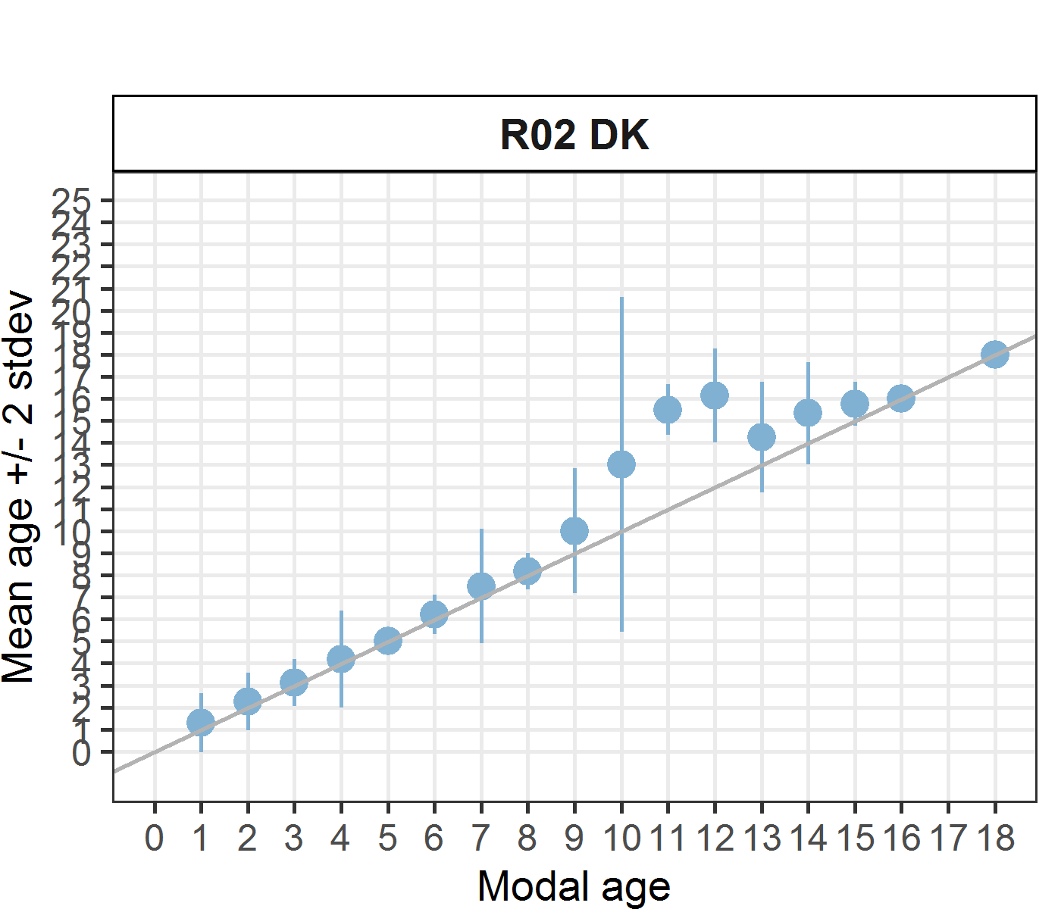 [[2]]
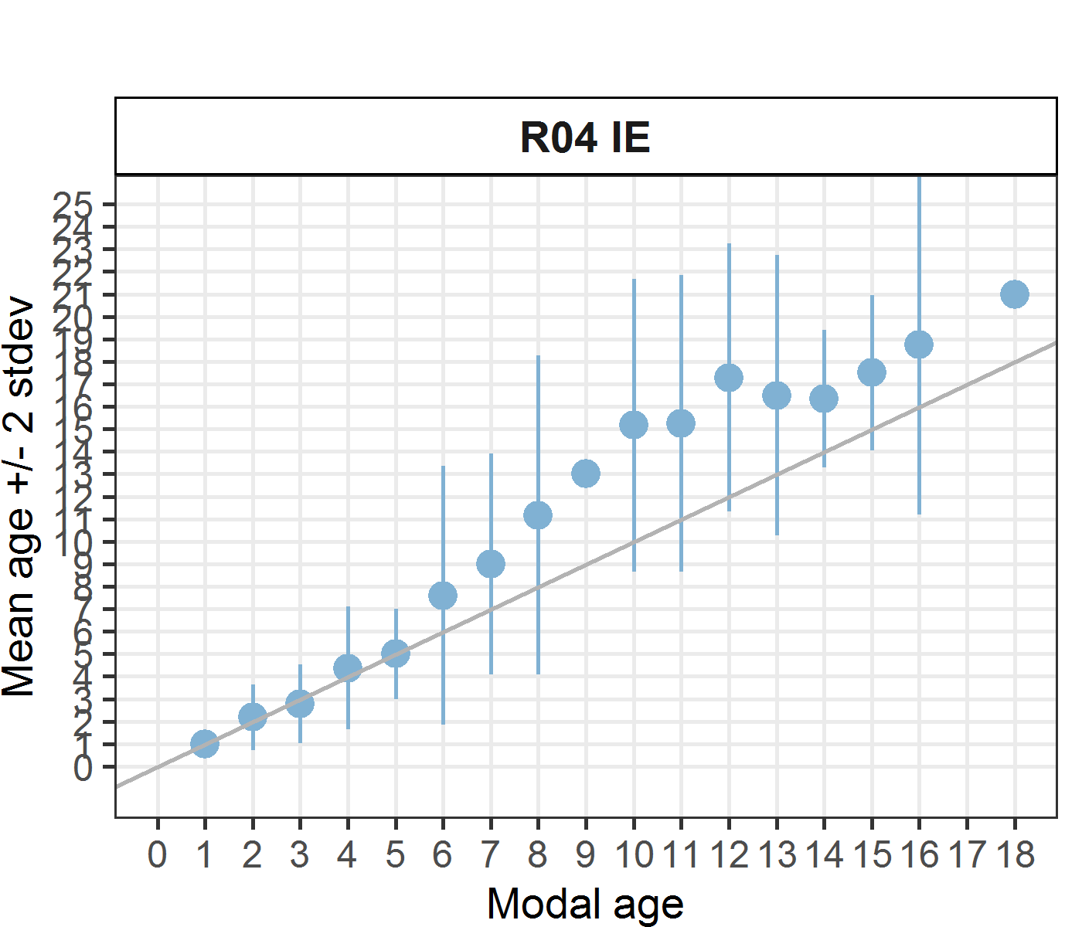 [[3]] 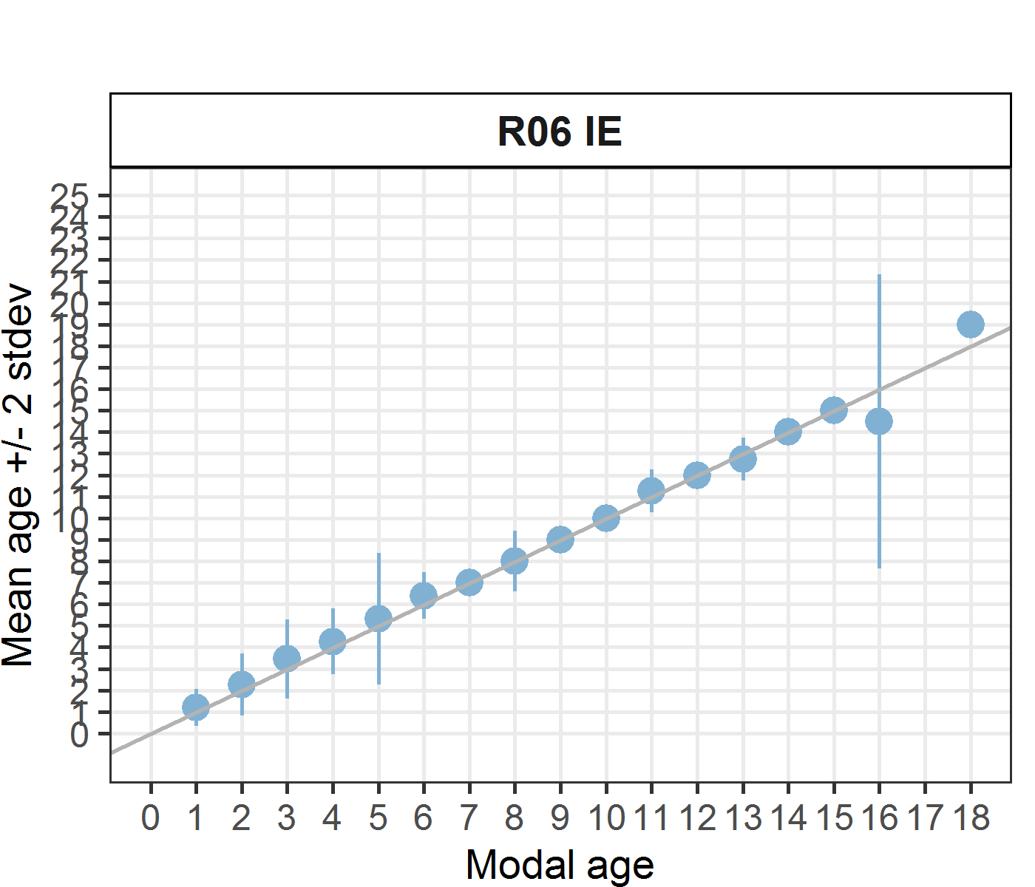
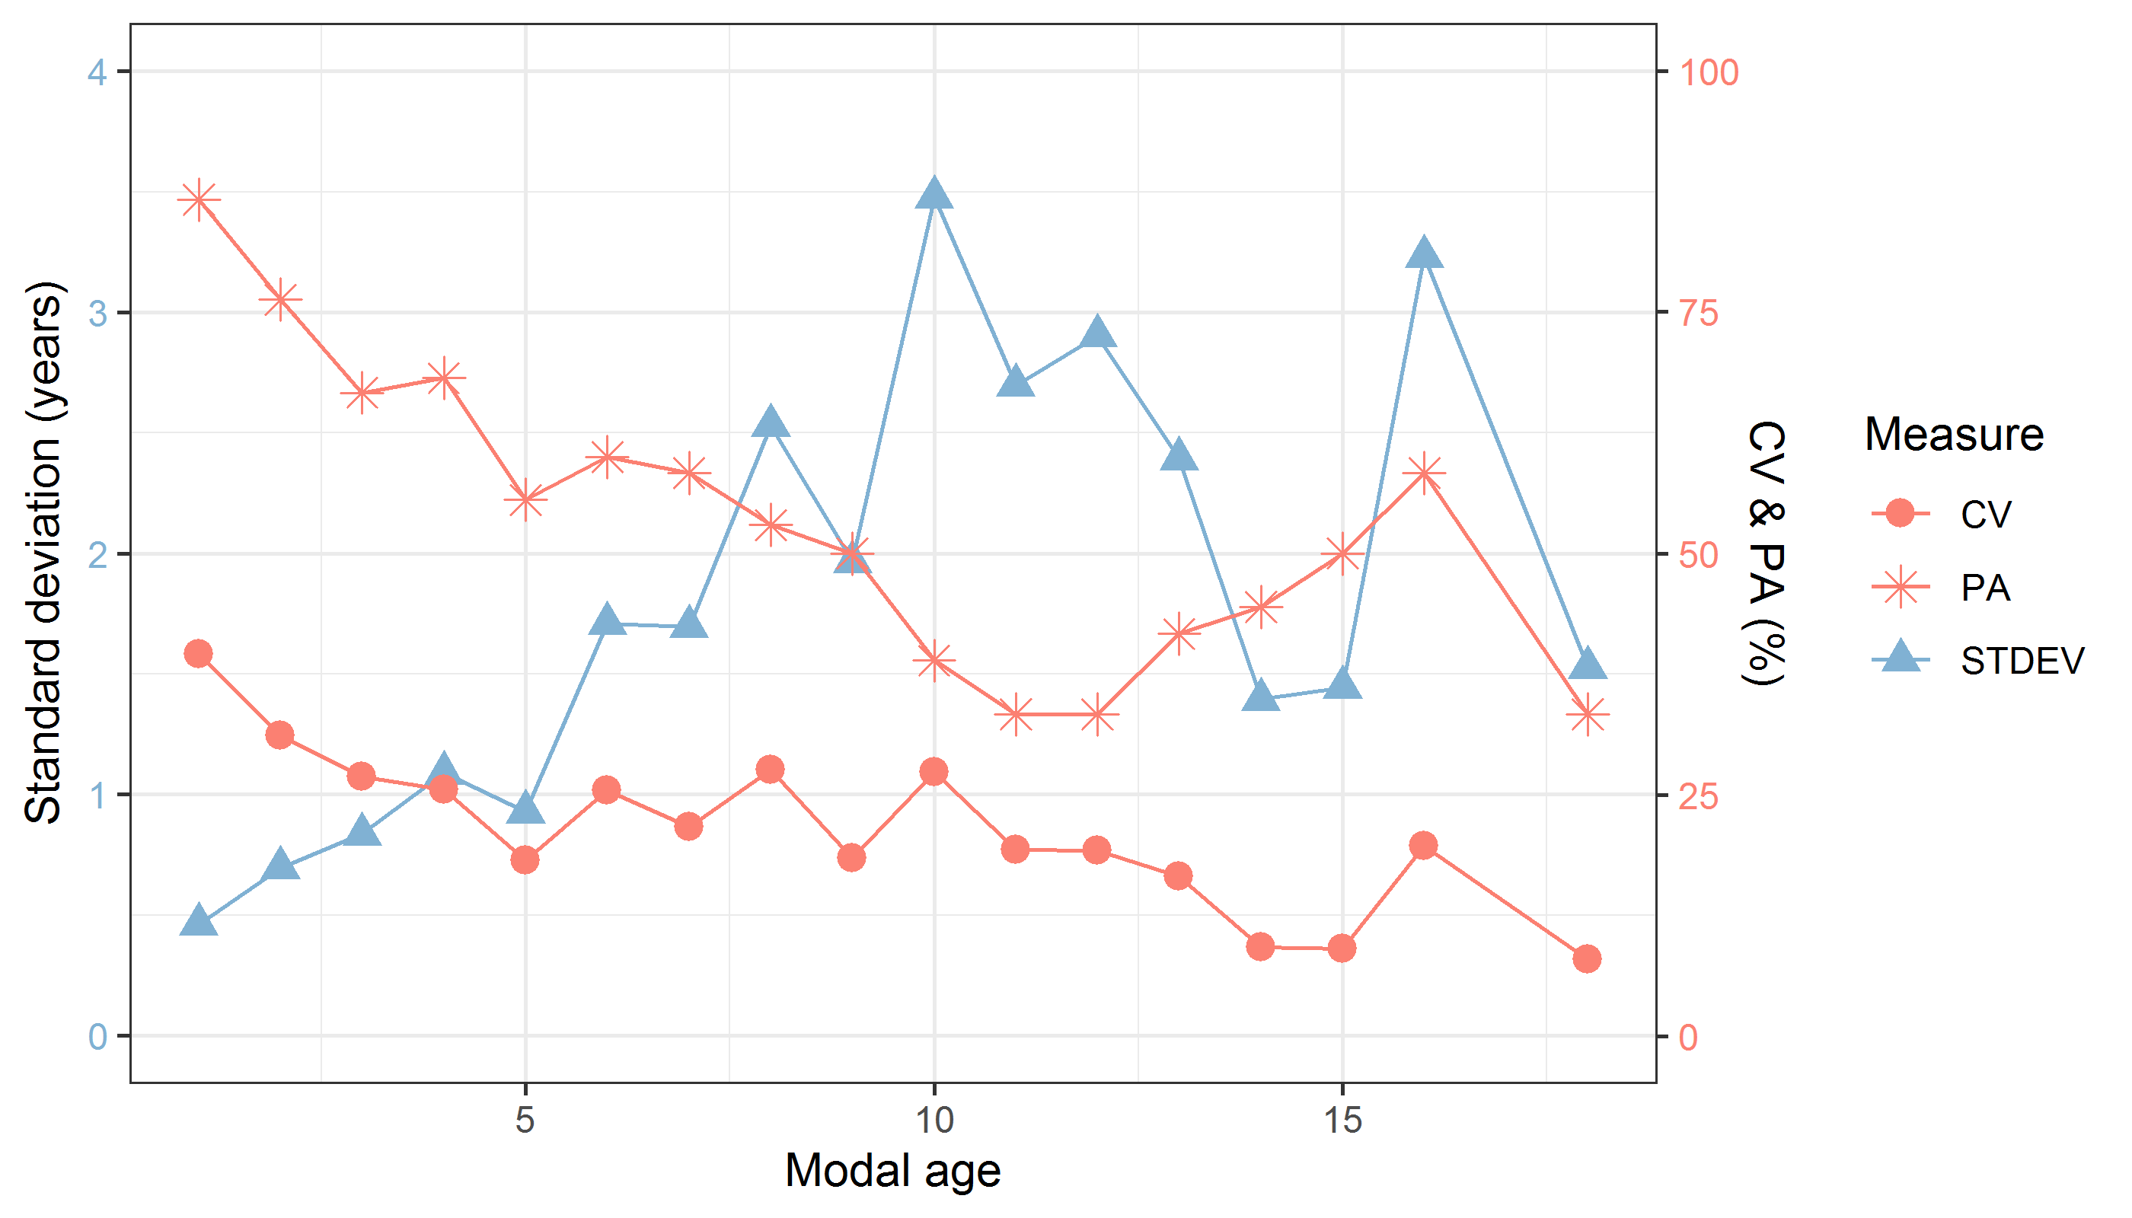
Figure 7.1: CV, PA and (STDEV (standard deviation) are plotted against modal age
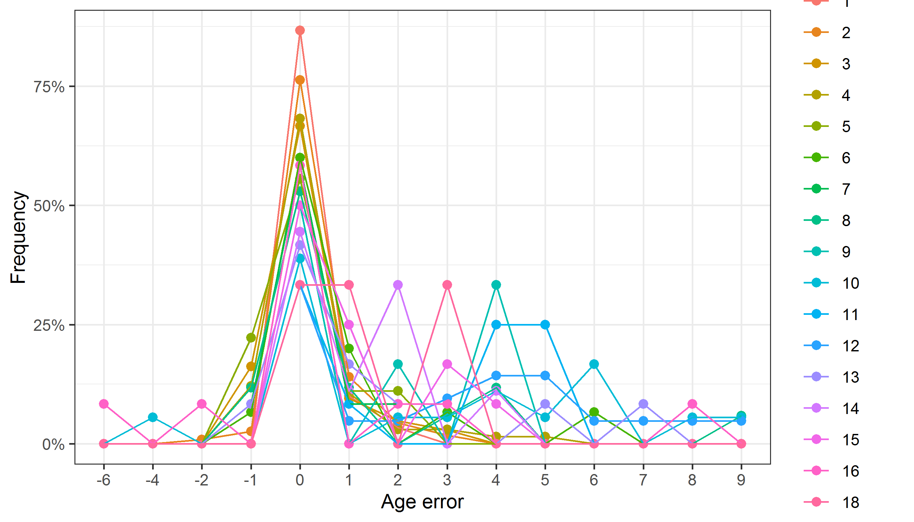
Figure 7.2: The distribution of the age reading errors in percentage by modal age as observed from the whole group of age readers in an age reading comparison to modal age. The achieved precision in age reading by MODAL age group is shown by the spread of the age readings errors. There appears to be no relative bias, if the age reading errors are normally distributed. The distributions are skewed, if relative bias occurs.
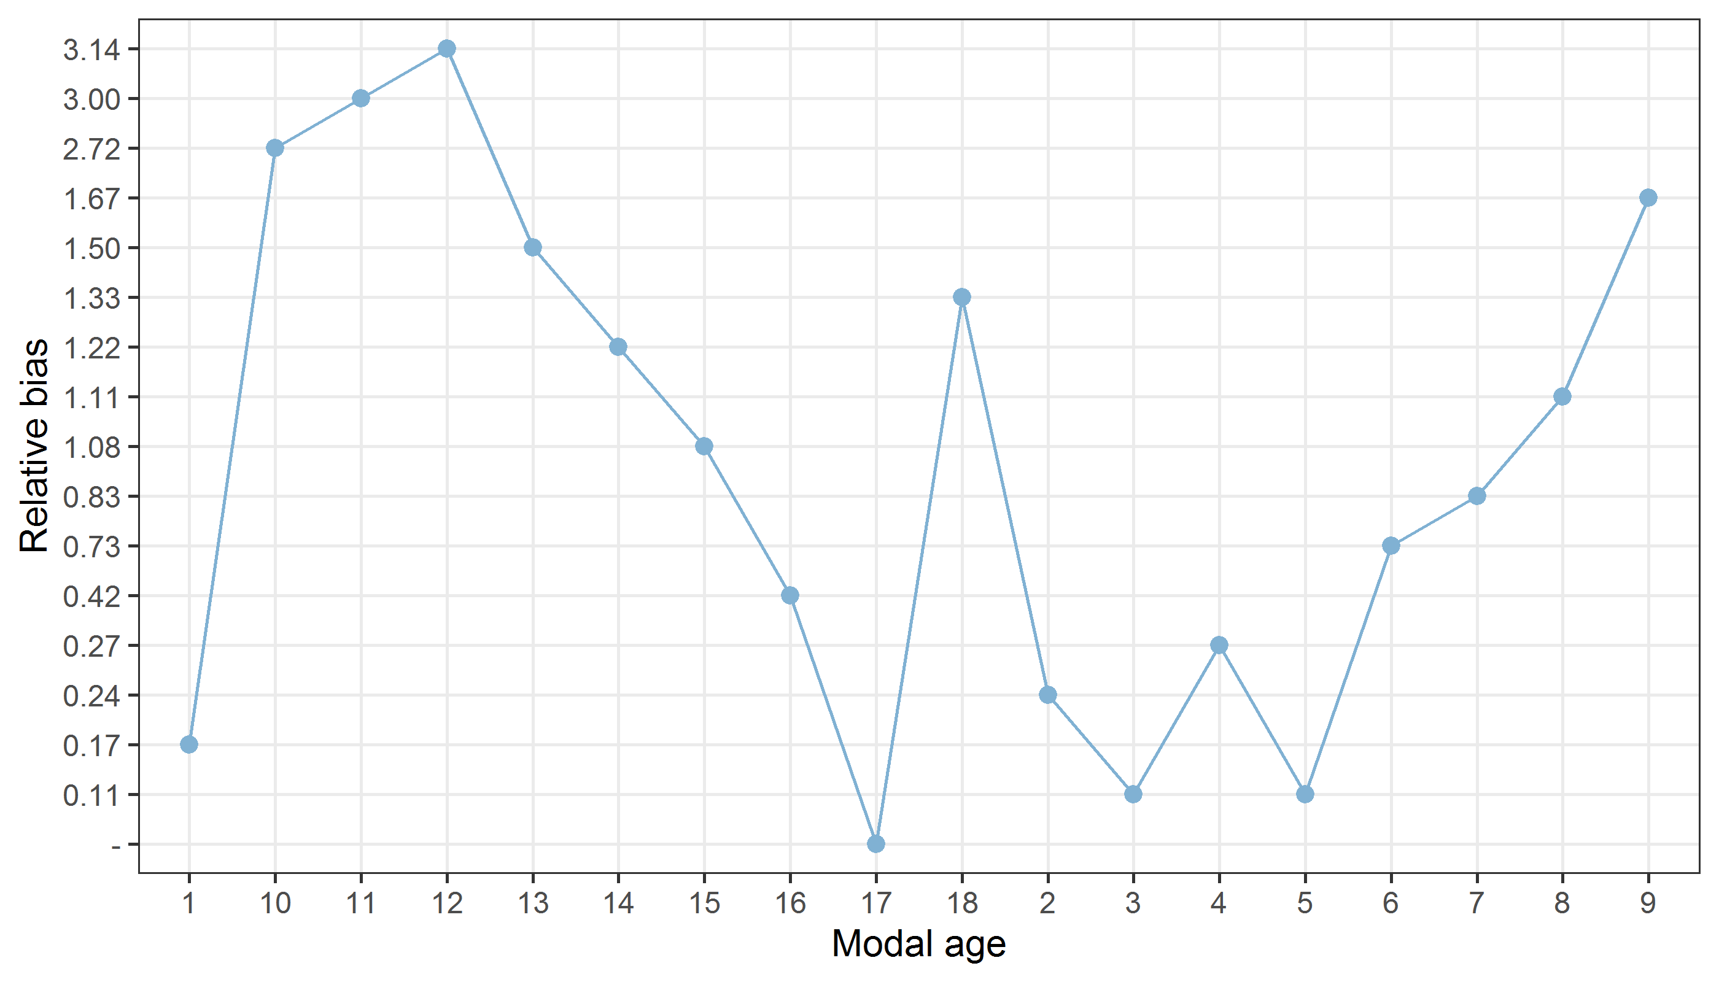
Figure 7.3: The relative bias by modal age as estimated by all age readers combined.
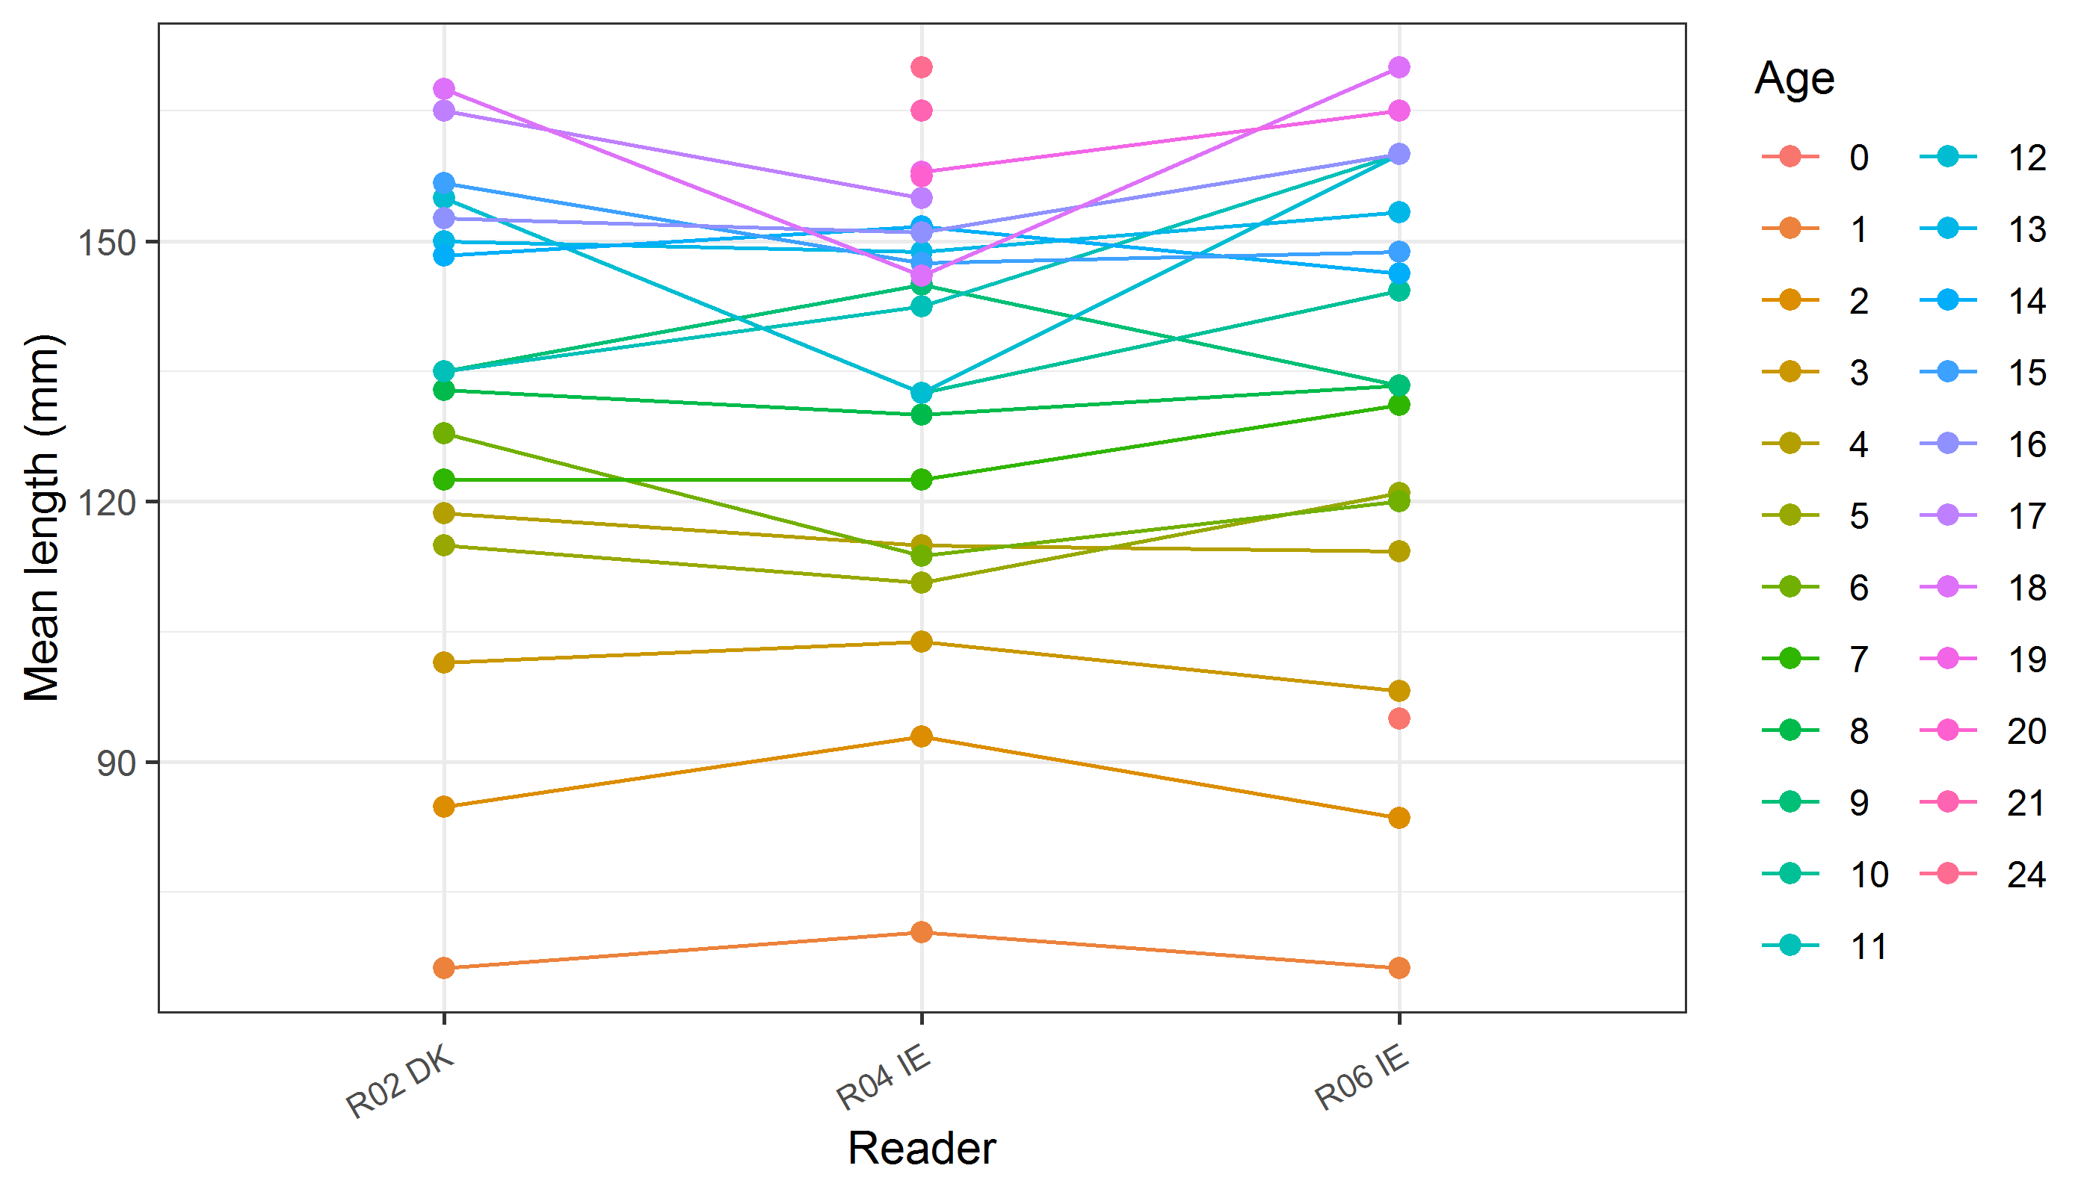
Figure 7.4: The mean length at age as estimated by each age reader.

