SmartDots Report for event 1888

Report of the Exchange of Northeast Atlantic Mackerel (*Scomber scombrus)*

2024 - 2025

(SmartDots event 1888)

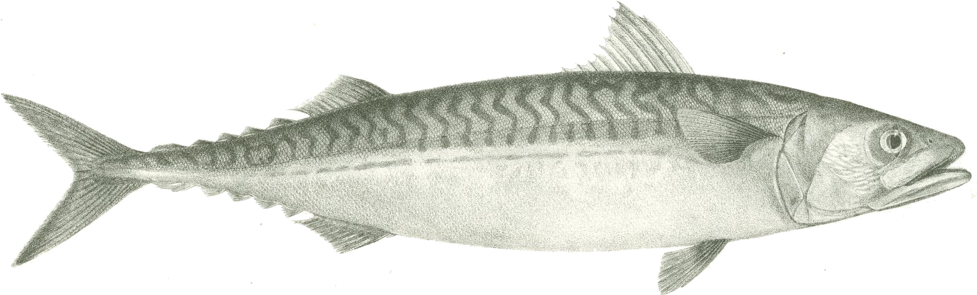

By: Gráinne Ní Chonchúir

The Marine Institute

Éire

Table of Contents

1 Executive summary 3

2 Terms of reference 4

3 Participant list & Expertise 5

4 Introduction 6

5 Methods 8

6 Results 11

7.1 All readers (Advanced and Basic) 11

7.2 Advanced Readers Only 20

6.1 Discussion 37

6.2 Conclusion and Recommendations. 39

7 References 40

8 Annex 3. Additional results 41

8.1 Results all readers 1

8.2 Results Advanced readers 29

# Executive summary

This image only exchange was carried out via SmartDots. A total of 268 otolith images from the main areas of mackerel distribution were included in the exchange. Following the recommendations of WKMACQI (Workshop on Mackerel biological parameter Quality Indicators) (ICES, 2018). Every effort was made to ensure that the spatial and temporal coverage, as well as the length and age range, of the mackerel otoliths used for the exchange correspond with the coverage in the assessment

Results from advanced readers show an overall agreement of 73%, an improvement from 69% when less experienced readers were included and up from 67.8% in the previous exchange in 2021. Agreement is highest at age 0 (96%) and remains strong for ages 1-6 (71-82%), while it is lowest for ages above 10 (37-49%). The coefficient of variation (CV) is highest for ages 1-4 (up to 38%) and stabilizes for ages 6-12 (6-17%), with some increased variability at older ages. The percentage agreement varies by reader, however overall, there is no strong systemic bias, but inconsistencies are notable at specific ages and amongst certain readers.

For basic readers, the overall agreement is lower compared to advanced readers, as expected, indicating greater variability in age readings. Basic readers tend to have higher disagreement, particularly at older ages where precision is more challenging. The coefficient of variation (CV) is also generally higher, reflecting inconsistencies in age estimation. Some readers exhibit noticeable biases, either underestimating or overestimating ages, which impacts overall reliability.

It’s important to note that Basic readers tend to be new to age reading or to reading this particular species and are still training, which are factors that may contribute to the observed discrepancies.

While a marked improvement is observed, when compared with the previous exchange results in 2021, there is still room for improvement across all readers. Specific issues for individual readers to work on, are highlighted in the report.

The exchange findings highlight priorities for future work, i.e. the creation of a Training Reference Collection, active engagement with technological developments around machine learning, through WGBIOP workshops and WGSMART. Additional training and calibration to improve consistency and accuracy in age estimations is also recommended.

# Terms of reference

# Participant list & Expertise

15 Readers from 9 Member States participated in this exchange, consisting of 9 Advanced readers – whose ages are used in the assessments and 6 Basic readers. The list of participants can be found below.

**Table 3.1: Participants List and Expertise**

|  |  |  |  |  |  |
| --- | --- | --- | --- | --- | --- |
| **Reader code** | **Reader** | **Laboratory** | **Country** | **Expertise** | **Readings**  **In**  **Assessment** |
| R02 IS | Guðrún Finnbogadóttir | MFRI | Iceland | Advanced | Yes |
| R04 IE | Selene Hoey | MI | Ireland | Advanced | Yes |
| R06 NL | Tim Huijer | WMR | Netherlands | Advanced | Yes |
| R08 DK | Maria Jarnum | DTU-Aqua | Denmark | Advanced | Yes |
| R10 IE | Eugene Mullins | MI | Ireland | Advanced | Yes |
| R12 ES | Charo Navarro | IEO | Spain | Advanced | Yes |
| R14 FO | Jens Arni Thomassen | FMRI | Faroe Islands | Advanced | Yes |
| R16 FO | Poul Vestergaard | FMRI | Faroe Islands | Advanced | Yes |
| R18 NL | Tomasz Zawadowski | WMR | Netherlands | Advanced | Yes |
| R24 FR | Geoffrey Bled Defruit | IFREMER | France | Basic | No |
| R30 PT | Maria João Ferreira | IPMA | Portugal | Basic | No |
| R32 DK | Rasmus Frydenlund Jensen | DTU-Aqua | Denmark | Basic | No |
| R34 DE | Gitta Hemken | Thünen-Institut | Germany | Basic | No |
| R40 ES | Iñaki Rico | AZTI | Spain | Basic | No |
| R42 ES | Naiara Serrano | AZTI | Spain | Basic | No |

# Introduction

Atlantic mackerel (*Scomber scombrus*) is a pelagic species of high commercial importance in European waters. Living on both sides of the North Atlantic, ICES currently uses the term “Northeast Atlantic (NEA) mackerel” to define the mackerel present in the Northeast Atlantic with a distribution range from the Iberian Peninsula in the South to the Nordic Sea, including Icelandic and Greenland waters and the Western Baltic. Recent ICES stock advice based on an age-based analytical assessment model shows that NEA mackerel is still at a high level but decreasing for a number of years. Age readings on mackerel are important input data for the assessment and carried out by a number of laboratories using international agreed ageing criteria. The first reported workshop on mackerel ageing was held in Lowestoft in 1987, preceded by a first otolith exchange in 1986, and followed by another workshop in 1995 in Spain and one exchange in 2002. A third exchange was performed in 2008, followed by a workshop that was held in 2010 in Lowestoft again, and a small exchange in 2014, which was the first one using images only (via WebGR). All previous workshops and exchanges have had outcome stating the overall agreement to be low but fair but skewed towards having a higher agreement on the younger ages. All workshops discussed and tried to standardize age reading methods by preparing a manual and a reference collection of agreed age otoliths. There was an exchange and workshop held in San Sebastian in 2018, and these were the first mackerel age reading exercise to use the SmartDots platform. Most recently, there was a small-scale exchange completed via SmartDots in 2021.

Northeast Atlantic Mackerel is the subject of a benchmark assessment in 2025, and therefore the results and outputs from this exercise will be forwarded to the Stock Coordinator for consideration at the benchmark meeting in March 2025. In order to expedite the exchange, it was agreed to re - use images from the previous Smartdots exchange (event ID 280). Additional images were provided for areas 4b, 4c and 6a.

This image only exchange was carried out via SmartDots, the web application developed by ICES to facilitate the setup of exchanges, workshops and training events (http://www.ices.dk/marinedata/tools/Pages/smartdots.aspx). A total of 268 otolith images from the main areas of mackerel distribution were included in the exchange. Following the recommendations of WKMACQI (Workshop on Mackerel biological parameter Quality Indicators) (ICES, 2018). Every effort was made to ensure that the spatial and temporal coverage, as well as the length and age range, of the mackerel otoliths used for the exchange correspond with the coverage in the assessment (Table 4.1).

The overall results of the exchange showed an improvement in the agreement between all readers and especially expert readers, when compared with the most recent exchange completed in 2021. However, the agreement between readers for otoliths with older ages continued to be low.

**Table 4.1 Spatial and temporal distribution of samples used in this exchange**



# Methods

This report contains statistical analyses and comparisons of age readings in the form of tables and graphical plots.

First, an overview of participating age readers and the samples are presented.

The first part of the results section includes the tables and plots from the Guus Eltink Excel sheet 'Age Reading Comparisons (Eltink, A.T.G.W. 2000). The order and numbering of tables and plots are the same as in the excel sheet. Tables 6.1 - 6.4 from the 'Age Reading Comparisons' sheet are not outputted since these are merely used to do calculations for the other tables.

**Modal age: a multistage approach to define the modal age by sampled fish**,

In this event, the multistage approach to calculate the modal age has been used. When summarizing the output and reporting the results of the exchange events developed within the SmartDots framework, the modal age (the most common age decided by the age readers for every fish sample) is the most relevant measurement. It is a key statistic by itself, but it is also fundamental for the estimation of some other relevant statistics to assess the performance of the techniques assessed in the exchange event, like the Percentage Agreement (PA), or input for stock assessments like the Age Error Matrix (AEM) (see below). However, the standard approach of calculating the mode (each reader has the same weight=1) the mode is taken as the lowest age of the multiple modal ages. This way renders multiple cases (fish samples) with multiple modal ages (i.e. different ages got the same highest number of readers). Accordingly, this imply a wrong perception of the age by fish individual and introduction of bias in the calculation of the PA and AEM. As a solution, in this report a multistage approach to select the modal age is used. This multistage approach is based in the different weight given to the age readers according to their experience. Two different weight scores scales were assigned, a weight score decreasing linearly with the experience and another decreasing with a negative exponential shape. The modal age by fish individual is decided following the next approach:

1.-If there is a single mode estimated with the standard approach (equal weight for all readers) this value is used as the modal age, if not

2.-Adding up, for each age category, the score assigned with the linear weighting for all the readers that decided that age for that fish. Next, the modal age is selected as the age category that obtains the highest score sum. If, despite this approach, there were still multiple ages with the same score (and hence multiple modes), the next step is applied:

3.-Adding up, for each age category, the score assigned with the negative exponential weighting for all the readers that decided that age for that fish. Select as the modal age the age with the highest score sum.

During the WGBIOP 2019 meeting it was found that the combination of the modes decided using these three methods (so called 'multistage approach'), allows assigning a single modal age to each fish individual.

It is important checking the table that indicates the percentage of multimodal cases (in the results section) and the table with the fishID and sampleID that obtained multiple modes (included in annex 3). ***Samples split by strata***

**Percentage Agreement (PA)**

The percentage agreement per reader per modal age tells how large is the part of readings that are equal to the modal age. The percentage agreement is estimated by modal age and reader as the proportion (as percentage) of times that the lectures of that reader agreed with the resulting modal age. This percentage is estimated as the number of times that a reader agreed with the modal age divided by the total number of otoliths read by a reader for each modal age.

**Coefficient of Variation (CV)**

The table presents the Coefficient of Variation (CV) per modal age and reader. The CV's are calculated as the ratio between the standard deviation (σ) and mean value (μ) per reader and modal age:

To the table is also added the CV of all readers combined per modal age and a weighted mean of the CV per reader.

**Relative bias**

The relative bias is calculated as the difference between the mean and the modal age. This statistic is presented in first place by modal age and reader, but it is also calculated as an average value by modal age for all readers together (or only advanced readers).

**Average Percentage Error (APE)**

The Average Percentage Error (APE) was calculated based on the method outlined by Beamish & Fournier (1981). This method is dependent of fish age and thus provides a better estimate of precision than percentage agreement. As the calculations of both CV and APE pose problems if the mean age is close to 0, all observations for which modal age was 0 were omitted from the CV and APE calculations.

The average percentage error is calculated per image as:

where is the age reading of reader and is the mean of all readings from 1 to .

**Age error matrix (AEM)**

Age error matrices (AEM) were produced following procedures outlined by WKSABCAL (2014) where the matrix shows the proportion of each modal age mis-aged as other ages. The sum of each row is 1, which equals 100%. The age data was analysed twice, the first time all readers were included and the second time only the “advanced” readers were included. If a reader is “advanced” then they are considered well trained and they provide ages for stock assessment or similar purposes. When the AEM is compiled for assessment purposes it uses only those readers who provide age data for the stock assessment in that specific area.

**Otolith Growth Analysis**

SmartDots provides a measure of distance between the annotations made by the readers and thus provides a measure of growth increment width. This data is used to establish growth curves for each otolith (fish) and for each reader.

Overview of Samples

**Table 6.1:** Overview of samples used for the exchange event number 1888

|  |  |  |  |  |  |  |
| --- | --- | --- | --- | --- | --- | --- |
| **Year** | **ICES area** | **Strata** | **Quarter** | **Number of samples** | **Modal age range** | **Length range** |
| 2014 | 27.4.a | Strata_1 | 3 | 2 | 8-14 | 365-415 mm |
| 2014 | 27.4.a | Strata_1 | 4 | 8 | 1-11 | 295-435 mm |
| 2015 | 27.4.a | Strata_1 | 3 | 5 | 0-4 | 225-345 mm |
| 2015 | 27.7.d | Strata_1 | 4 | 5 | 1-4 | 265-355 mm |
| 2016 | 27.4.a | Strata_1 | 1 | 5 | 1-5 | 195-335 mm |
| 2016 | 27.7.c | Strata_1 | 1 | 5 | 5-8 | 345-385 mm |
| 2016 | 27.7.g | Strata_1 | 2 | 5 | 1-6 | 190-335 mm |
| 2018 | 27.7.h | Strata_1 | 4 | 5 | 0-2 | 160-310 mm |
| 2019 | 27.2.a | Strata_1 | 2 | 20 | 1-9 | 160-390 mm |
| 2019 | 27.4.b | Strata_1 | 3 | 14 | 1-6 | 275-355 mm |
| 2019 | 27.5.b | Strata_1 | 1 | 7 | 2-9 | 265-380 mm |
| 2019 | 27.5.b | Strata_1 | 3 | 6 | 5-8 | 360-400 mm |
| 2019 | 27.5.b | Strata_1 | 4 | 7 | 2-9 | 305-380 mm |
| 2019 | 27.6 | Strata_1 | 2 | 3 | 3-7 | 315-370 mm |
| 2019 | 27.6 | Strata_1 | 3 | 7 | 1-5 | 275-370 mm |
| 2019 | 27.7.b | Strata_1 | 2 | 5 | 3-11 | 315-390 mm |
| 2019 | 27.7.f | Strata_1 | 4 | 5 | 0-1 | 215-290 mm |
| 2019 | 27.7.j | Strata_1 | 4 | 5 | 0-3 | 175-335 mm |
| 2019 | 27.8.a | Strata_1 | 4 | 10 | 0-2 | 200-305 mm |
| 2019 | 27.8.c | Strata_1 | 1 | 6 | 2-11 | 330-435 mm |
| 2019 | 27.8.c | Strata_1 | 2 | 4 | 2-5 | 290-355 mm |
| 2019 | 27.8.c | Strata_1 | 3 | 10 | 1-9 | 290-390 mm |
| 2019 | 27.9.a | Strata_1 | 1 | 12 | 2-10 | 265-410 mm |
| 2019 | 27.9.a | Strata_1 | 2 | 7 | 5-12 | 365-420 mm |
| 2019 | 27.9.a | Strata_1 | 3 | 12 | 1-8 | 285-385 mm |
| 2019 | 27.9.a | Strata_1 | 4 | 6 | 0-7 | 210-385 mm |
| 2020 | 27.2.b | Strata_1 | 3 | 20 | 4-18 | 330-420 mm |
| 2020 | 27.4.b | Strata_1 | 1 | 6 | 1-8 | 200-390 mm |
| 2020 | 27.4.c | Strata_1 | 1 | 5 | 1 | 195-240 mm |
| 2020 | 27.5.b | Strata_1 | 1 | 10 | 4-14 | 315-405 mm |
| 2020 | 27.8.b | Strata_1 | 1 | 10 | 3-13 | 320-390 mm |
| 2024 | 27.4.b | Strata_1 | 3 | 2 | 0 | 190 mm |
| 2024 | 27.4.c | Strata_1 | 3 | 7 | 0 | 150-200 mm |
| 2024 | 27.6.a | Strata_1 | 1 | 21 | 4-12 | 350-400 mm |
| 2024 | 27.6.a | Strata_1 | 2 | 1 | 4 | 350 mm |

# Results

### 7.1 All readers (Advanced and Basic)

This analysis looks at the results from all participating age readers and all images, including those with a readability score of AQ3_QA. The AQ Readability Score definitions are given below in Table 7.1.

**Table 7.1:** AQ Readability Score Definitions.

|  |  |
| --- | --- |
| **AQ** [**Code**](javascript:__doPostBack('ctl00$MainContent$myResultControl$tbResults$ct1682$ct1682$ct1682','Sort$Code')) | [**Definition**](javascript:__doPostBack('ctl00$MainContent$myResultControl$tbResults$ct1682$ct1682$ct1682','Sort$Description')) |
| [AQ1](javascript:__doPostBack('ctl00$MainContent$myResultControl$tbResults$ct1682$ct1682$ct1682$ctl02$btCode','')) | Rings can be counted with certainty |
| [AQ2](javascript:__doPostBack('ctl00$MainContent$myResultControl$tbResults$ct1682$ct1682$ct1682$ctl03$btCode','')) | Rings can be counted with difficulty and some doubt |
| [AQ3](javascript:__doPostBack('ctl00$MainContent$myResultControl$tbResults$ct1682$ct1682$ct1682$ctl04$btCode','')) | Rings cannot be counted; the calcified structure is considered unreadable - no age assigned |
| [AQ3_QA](javascript:__doPostBack('ctl00$MainContent$myResultControl$tbResults$ct1682$ct1682$ct1682$ctl05$btCode','')) | Rings cannot be counted; the calcified structure is considered unreadable - age assigned for QA purposes only |

###### Summary statistics for all readers

**Table 7.2:** Summary of statistics; Total number of samples (NSample), coefficient of variance (CV), percentage of agreement (PA) and average percentage error (APE) for all ages and readers

|  |  |  |  |
| --- | --- | --- | --- |
| NSample | CV | PA | APE |
| 268 | 26 % | 69 % | 14 % |

The modal age range of all readers’ analysis was 0-18 for the whole set of otoliths, with more than 10 otoliths of modal ages 0-10, 4 otoliths of modal age 11, 2 otoliths of modal age 12-14 and 1 otolith each of modal ages 16 and 19. The overall agreement for all readers was 69% which shows an increase from the previous exchange in 2021 (64.7%). The best agreement was obtained for otoliths of modal age 0 - 4 (94%, 82%, 78%, 80%, 74% respectively) all of which again show an improvement in % agreement compared with the previous exchange.

Otoliths with modal ages 5 – 6 had a 66% and 63% agreement.

The lowest agreement was obtained for otoliths with modal age >10 (29% - 39%) except for modal age 13, which had a 62% agreement. This doesn’t appear to be a result of superior image quality, as the majority of age 13 images were assigned an AQ2 score and with three readers (interestingly, from the same lab) assigning an AQ3-QA score.

Overall CV was 26%. CV peaked at 48% for modal age 1, and was at its lowest for modal age 17 (11%)

In this exchange event, 268 otolith fish individuals were aged. Of those, 3 % when the traditional approach (all readers equally weighted) is used to define the mode. The percentage of multiple mode cases is reduced to 0 %. The complete list of cases with multiple modes is presented in tables 7.5 and 7.6

###### Coefficient of Variation (CV)

Coefficient of Variation % are given for all readers in Table 7.3 below.

1. HigherVariation in Younger Ages 1 - 4

The percentages at younger ages (1-4) are more widely spread, with values exceeding 30-40% in for individual age readers, and with one reader having a cv of 78% at age 1. This suggests greater variation in modal ages at younger stages.

1. Declining CVs in Older Ages 5+

As age increases, CV generally decreases, especially beyond age 6-7, with fewer values above 20%. This implies that there is a greater consistency amongst readers and doesn’t appear to highlight any major systematic errors in the age reading process.

1. Weighted Mean Trend:

The weighted mean values remain higher in younger age brackets (mostly 20%+) but tend to level off in older ages.

**Table 7.3:** Coefficient of Variation (CV) table presents the CV per modal age and reader, the CV of all readers combined per modal age and a weighted mean of the CV per reader

| Modal age | R02 IS | R04 IE | R06 NL | R08 DK | R10 IE | R12 ES | R14 FO | R16 FO | R18 NL | R24 FR | R30 PT | R32 DK | R34 DE | R40 ES | R42 ES | All |
| --- | --- | --- | --- | --- | --- | --- | --- | --- | --- | --- | --- | --- | --- | --- | --- | --- |
| 0 | - | - | - | - | - | - | - | - | - | - | - | - | - | - | - | - |
| 1 | 16% | 27% | 36% | 30% | 30% | 28% | 34% | 40% | 42% | 15% | 40% | 78% | 22% | 15% | 0% | 48% |
| 2 | 22% | 26% | 14% | 9% | 20% | 10% | 23% | 21% | 35% | 30% | 35% | 39% | 24% | 22% | 20% | 27% |
| 3 | 37% | 18% | 8% | 8% | 41% | 9% | 13% | 19% | 27% | 28% | 39% | 24% | 37% | 33% | 33% | 28% |
| 4 | 34% | 15% | 12% | 13% | 7% | 9% | 22% | 9% | 18% | 22% | 13% | 31% | 37% | 29% | 44% | 25% |
| 5 | 25% | 22% | 7% | 6% | 11% | 10% | 18% | 13% | 18% | 21% | 16% | 19% | 9% | 15% | 19% | 17% |
| 6 | 12% | 19% | 19% | 10% | 15% | 7% | 15% | 8% | 20% | 24% | 16% | 30% | 19% | 6% | 14% | 18% |
| 7 | 6% | 10% | 13% | 10% | 11% | 11% | 7% | 10% | 12% | 16% | 12% | 35% | 8% | 6% | 12% | 15% |
| 8 | 5% | 15% | 11% | 11% | 14% | 11% | 17% | 11% | 13% | 23% | 20% | 33% | 11% | 16% | 11% | 19% |
| 9 | 7% | 11% | 11% | 10% | 11% | 11% | 13% | 9% | 12% | 27% | 18% | 16% | 8% | 8% | 6% | 17% |
| 10 | 12% | 5% | 13% | 13% | 9% | 9% | 9% | 5% | 8% | 21% | 15% | 23% | 7% | 3% | 8% | 15% |
| 11 | 8% | 10% | 19% | 8% | 4% | 5% | 17% | 6% | 20% | 39% | 25% | 23% | 11% | 4% | 5% | 18% |
| 12 | 11% | 6% | 15% | 5% | 10% | 11% | 4% | 10% | 12% | 24% | 12% | 24% | 6% | 12% | 6% | 17% |
| 13 | - | - | - | - | - | - | - | - | - | - | - | - | - | - | - | 18% |
| 14 | 9% | 0% | 18% | 0% | 5% | - | 5% | 9% | 0% | 26% | 7% | 0% | 0% | 5% | 6% | 17% |
| 15 | - | - | - | - | - | - | - | - | - | - | - | - | - | - | - | - |
| 16 | - | - | - | - | - | - | - | - | - | - | - | - | - | - | - | - |
| 17 | - | - | - | - | - | - | - | - | - | - | - | - | - | - | - | 11% |
| 18 | - | - | - | - | - | - | - | - | - | - | - | - | - | - | - | 24% |
| Weighted Mean | 20% | 19% | 16% | 13% | 20% | 13% | 19% | 17% | 24% | 23% | 26% | 37% | 21% | 17% | 17% | 26% |

**Relative Bias**

Relative bias is the difference between the mean age (per modal age per reader) and modal age. As for the previous tables, a combined bias for all readers and weighted means are calculated and presented in Table 7.4

Reader R02 IS exhibits mostly small positive biases, with a slight increase in bias towards older modal ages. The bias fluctuates between positive and zero in the younger ages, but it remains relatively stable or slightly positive through the older ages. Overall, this reader appears to overestimate values slightly but consistently. For example, at modal age 0, the bias is 0.05, and at modal age 18, it is 0.06.

Readers R04 IE & R10 IE show a consistent mixture of small positive and negative biases across different modal ages. The bias fluctuates but doesn't show a strong tendency to overestimate or underestimate overall. Bias is therefore considered relatively balanced, but with more variation especially in the middle-age group. The bias values start out positive, e.g., 0.05 at modal age 0 and drop to negative values (e.g., -0.2 at modal age 5 and -0.62 at modal age 10).

Readers R06 NL & R18 NL generally show a mixture of small positive and negative biases across different ages. The biases tend to oscillate around zero, with small shifts towards overestimation or underestimation at different modal ages. Therefore, bias is relatively stable no strong trends toward overestimation or underestimation overall. For example, at modal age 0, the bias is 0.11, and at modal age 18, it becomes -0.29.

Readers R08 DK & R32 DK show a consistent tendency for small positive biases across most modal ages, although it fluctuates somewhat. This leads to a slight overestimate across all age groups.

Readers R12 ES, R14 ES, R40 ES, R42 ES tend towards small negative biases in the younger and middle modal ages, which increase significantly in older ages. For example, -0.4 at modal age 5, -1.47 at modal age 8, and -9 at modal age 18.

Reader R24 FR exhibits large negative biases that tend to increase as age rises, leading to an underestimation, especially at older ages. For instance, -1.65 at modal age 8, -2.73 at modal age 9, and -3.09 at modal age 10.

Reader R30 PT results show very strong negative biases, across most modal ages, but particularly for older modal ages. This leads to a significant underestimation trend, especially for older ages. For example, -1.17 at modal age 6, -2.41 at modal age 8, and -9 at modal age 18.

Reader R34 DE biases tend to be moderate with a mix of positive and negative values and show less fluctuation compared with other readers. For instance, 0.36 at modal age 0, -0.57 at modal age 8, and 0.64 at modal age 10.

Readers R14 FO & R16 FO show relatively small positive and negative biases, with no major trends. For example, 0.11 at modal age 0 and -0.12 at modal age 7.

**Table 7.4:** Relative Bias table presents the relative bias per modal age and reader, the relative bias of all readers combined per modal age and a weighted mean of the relative bias per reader.

| Modal age | R02 IS | R04 IE | R06 NL | R08 DK | R10 IE | R12 ES | R14 FO | R16 FO | R18 NL | R24 FR | R30 PT | R32 DK | R34 DE | R40 ES | R42 ES | All |
| --- | --- | --- | --- | --- | --- | --- | --- | --- | --- | --- | --- | --- | --- | --- | --- | --- |
| 0 | 0.05 | 0.05 | 0.11 | 0.16 | 0.05 | 0 | 0 | 0.11 | 0.05 | 0 | 0.06 | 0.37 | 0.05 | 0 | 0 | 0.07 |
| 1 | -0.02 | 0.02 | 0.39 | 0.12 | 0.05 | 0.1 | 0.2 | 0.1 | 0.51 | 0.02 | 0.3 | 0.93 | 0 | 0.02 | 0 | 0.18 |
| 2 | -0.12 | -0.19 | 0.09 | 0.03 | 0.03 | -0.04 | 0.12 | 0.06 | -0.03 | -0.38 | 0 | 0.44 | -0.16 | -0.19 | -0.16 | -0.03 |
| 3 | 0.23 | -0.11 | 0 | 0.06 | 0.29 | 0.09 | -0.03 | 0.26 | 0 | -0.23 | -0.57 | 0.26 | 0.29 | 0.14 | 0.17 | 0.06 |
| 4 | 0.36 | -0.05 | -0.14 | 0 | 0.09 | 0.05 | -0.23 | 0.18 | -0.05 | -0.57 | -0.32 | 0.32 | 0.36 | 0.45 | -0.05 | 0.03 |
| 5 | 0.13 | 0.57 | -0.13 | 0 | 0.17 | 0.05 | -0.22 | 0.22 | 0.13 | -0.65 | -0.7 | 0 | 0.13 | 0.22 | 0.04 | 0 |
| 6 | -0.09 | 0.04 | -0.39 | 0 | 0.48 | -0.05 | -0.17 | 0.17 | -0.04 | -1.17 | -1 | 0.43 | 0.13 | 0.17 | -0.39 | -0.13 |
| 7 | 0.06 | 0 | 0.06 | -0.44 | 0.69 | -0.08 | 0 | 0.44 | -0.12 | -1 | -1.47 | -0.12 | 0.44 | -0.06 | -0.33 | -0.13 |
| 8 | -0.05 | 0.23 | -0.23 | -0.18 | 0.77 | -0.4 | 0.14 | 0.5 | -0.29 | -1.65 | -2.41 | -1.18 | 0.62 | 0.18 | -0.55 | -0.3 |
| 9 | 0.45 | 0.27 | -0.55 | -0.55 | 0.73 | -0.4 | 0 | 0.45 | -0.73 | -3.09 | -2.73 | -1.73 | 0.64 | 0.09 | -0.55 | -0.51 |
| 10 | -0.38 | 0.5 | -2 | -0.62 | 0.62 | -0.2 | 0.38 | 0 | -0.57 | -2.29 | -2.86 | -1.75 | 0.5 | 0.12 | -1 | -0.64 |
| 11 | -0.2 | 0.6 | -1.6 | -0.8 | 0.2 | -0.5 | -0.2 | 0 | -1.4 | -3.2 | -2.8 | -2.8 | 0 | -0.2 | -0.6 | -0.9 |
| 12 | 0.5 | 0.67 | -0.67 | 0 | 1 | 0 | -0.33 | 1.5 | -1.5 | -3 | -3.5 | -2.83 | 0.67 | -0.67 | -0.17 | -0.56 |
| 13 | 0 | 0 | -4 | 0 | 2 | - | 0 | 0 | -6 | 0 | - | -3 | 0 | 0 | -1 | - |
| 14 | 1 | 0 | -6 | -1 | -0.5 | -2 | 0.5 | 1 | 0 | -3 | -3.5 | -3 | 1 | 0.5 | -1.5 | -1.1 |
| 15 | - | - | - | - | - | - | - | - | - | - | - | - | - | - | - | - |
| 16 | - | - | - | - | - | - | - | - | - | - | - | - | - | - | - | - |
| 17 | -1 | 0 | -4 | -2 | 0 | -1 | 0 | 0 | -3 | -4 | -5 | -3 | 0 | -2 | -3 | -1.87 |
| 18 | -1 | 0 | -8 | 0 | 0 | - | -3 | 1 | -5 | -9 | -7 | -8 | 0 | -1 | -2 | - |
| Weighted Mean | 0.06 | 0.09 | -0.22 | -0.07 | 0.3 | -0.04 | -0.01 | 0.24 | -0.11 | -0.85 | -0.89 | -0.1 | 0.21 | 0.06 | -0.19 | -0.09 |

**Table 7.5:** Total number of samples (NSample) and percentage of cases (fish samples) with multiple modes depending on the approach to weight the experience of the reader which will be considered when defining the fish age mode. PercMM_traditional shows the percentage of the total samples for which multiple modes are obtained when all the readers are equally weighted. PercMM_linear_weight shows the percentage of the total samples for which multiple modes are obtained when the weight assigned to the different readers decreases linearly with the experience, while in the PercMM_negexp the weight applied decreases with a negative exponential shape with the experience. The PercMM_multistage shows the percentage of multiple mode cases when a combination of the different methodologies is used, as explained in the material and methods section

|  |  |  |  |  |
| --- | --- | --- | --- | --- |
| **NSample** | **PercMM_traditional** | **PercMM_linear_weight** | **PercMM_negexp_weight** | **PercMM_multistage** |
| 268 | 3 % | 0 % | 0 % | 0 % |

**List of multimodal cases**

**Table 7.6:** List of cases for which multiple modes were obtained when all readers are considered. The column NModes_trad shows the number of multiple modes for each FishID or SampleID when all readers are given the same expertise weight.

|  |  |
| --- | --- |
| **NModes_trad** | **SampleID** |
| 3 | Mac_24_1_6A_60071_018 |
| 2 | Mac_24_1_6A_60077_011 |
| 2 | Mac_24_1_6A_60084_012 |
| 2 | MACex2024_305 |
| 2 | MACex2024_306 |
| 2 | MACex2024_326 |
| 2 | MACex2024_350 |
| 2 | MACex2024_353 |
| 2 | MACex2024_363 |
| 2 | MACex2024_388 |
| 2 | MACex2024_391 |
| 2 | MACex2024_396 |
| 2 | MACex2024_409 |
| 2 | MACex2024_417 |
| 2 | MACex2024_429 |
| 2 | MACex2024_434 |
| 2 | MACex2024_440 |
| 2 | MACex2024_496 |
| **3** | **MACex2024_500** |

**Percentage Agreement (PA)**

The percentage agreement per reader per modal age tells how large part of the readings that are equal to the modal age. The weighted mean including at the bottom of the table is weighted according to number of age readings. % agreement results presented for all readers in Table 7.7 show:

1. High Agreement in Early Modal Ages (0-4)

Most readers consistently exhibit strong agreement in identifying modal ages between 0 and 4. For example: Modal age 0 shows PA values ranging from 84% to 100% across all readers, suggesting a consistent ageing criterion amongst readers for younger age groups. However, a small number of age readers did appear to struggle with assigning younger ages.

2. Declining Agreement in Middle Modal Ages (5-12)

There's a noticeable decline in PA as modal ages increase from 5 to 12 for example: Modal age 5 has PA values ranging from 30% to 91%, indicating variability among readers. The reduced agreement may point to challenges or inconsistencies in identifying these modal ages, possibly due to overlapping characteristics with adjacent age groups.

3. Significant Disagreement in Later Modal Ages (13-18)

Low or Absent PA Values can be seen for modal ages 13 and above, many readers have PA values of 0%. For example: Modal age 14 shows PA values of 0% for several readers, with only a few exceptions. This substantial disagreement suggests difficulties in consistently identifying these older modal ages, which could be due to a lack of distinguishing features or insufficient data.

4. Variability Amongst Readers

The weighted mean PA varies across readers, ranging from 40% to 84%. For example: Reader R30 PT has a weighted mean PA of 40%, while R02 IS reaches 84%. Such variability highlights potential areas for further training or calibration.

5. Overall Trend

There's a clear trend of decreasing PA with increasing modal age; for example: The total PA drops from 94% at modal age 0 to 29% at modal age 18. This trend underscores the need for enhanced guidelines when reading older age groups to improve overall agreement.

**Table 7.7:** Percentage agreement (PA) table represents the PA per modal age and reader, the PA of all readers combined per modal age and a weighted mean of the PA per reader.

| Modal age | R02 IS | R04 IE | R06 NL | R08 DK | R10 IE | R12 ES | R14 FO | R16 FO |
| --- | --- | --- | --- | --- | --- | --- | --- | --- |
| 0 | 95 % | 95 % | 89 % | 84 % | 95 % | 100 % | 100 % | 89 % |
| 1 | 98 % | 93 % | 61 % | 88 % | 90 % | 90 % | 80 % | 80 % |
| 2 | 81 % | 75 % | 91 % | 97 % | 84 % | 96 % | 75 % | 81 % |
| 3 | 94 % | 71 % | 94 % | 94 % | 91 % | 91 % | 86 % | 74 % |
| 4 | 91 % | 81 % | 77 % | 86 % | 91 % | 86 % | 59 % | 82 % |
| 5 | 78 % | 52 % | 87 % | 91 % | 78 % | 77 % | 52 % | 65 % |
| 6 | 83 % | 74 % | 78 % | 65 % | 70 % | 85 % | 61 % | 74 % |
| 7 | 81 % | 50 % | 56 % | 62 % | 56 % | 46 % | 75 % | 50 % |
| 8 | 86 % | 59 % | 64 % | 55 % | 59 % | 73 % | 36 % | 73 % |
| 9 | 64 % | 55 % | 64 % | 36 % | 36 % | 60 % | 45 % | 45 % |
| 10 | 62 % | 50 % | 12 % | 38 % | 62 % | 40 % | 50 % | 75 % |
| 11 | 40 % | 20 % | 40 % | 40 % | 80 % | 50 % | 0 % | 60 % |
| 12 | 50 % | 50 % | 50 % | 67 % | 50 % | 67 % | 67 % | 33 % |
| 13 | 100 % | 100 % | 0 % | 100 % | 0 % | - | 100 % | 100 % |
| 14 | 50 % | 100 % | 0 % | 0 % | 50 % | 0 % | 50 % | 50 % |
| 15 | - | - | - | - | - | - | - | - |
| 16 | - | - | - | - | - | - | - | - |
| 17 | 0 % | 100 % | 0 % | 0 % | 100 % | 0 % | 100 % | 100 % |
| 18 | 0 % | 100 % | 0 % | 100 % | 100 % | - | 0 % | 0 % |
| Weighted Mean | **84 %** | **72 %** | **73 %** | **78 %** | **78 %** | **82 %** | **68 %** | 73 % |
| Modal age | **R18 NL** | **R24 FR** | **R30 PT** | **R32 DK** | **R34 DE** | **R40 ES** | **R42 ES** | total |
| 0 | 95 % | 100 % | 94 % | 84 % | 95 % | 100 % | 100 % | 94 % |
| 1 | 34 % | 98 % | 72 % | 56 % | 95 % | 98 % | 100 % | 82 % |
| 2 | 62 % | 62 % | 52 % | 69 % | 78 % | 81 % | 84 % | 78 % |
| 3 | 69 % | 69 % | 40 % | 74 % | 89 % | 80 % | 91 % | 81 % |
| 4 | 64 % | 52 % | 68 % | 55 % | 68 % | 77 % | 68 % | 74 % |
| 5 | 43 % | 48 % | 30 % | 48 % | 78 % | 83 % | 74 % | 66 % |
| 6 | 39 % | 35 % | 26 % | 35 % | 65 % | 83 % | 74 % | 63 % |
| 7 | 56 % | 31 % | 0 % | 31 % | 62 % | 81 % | 47 % | 53 % |
| 8 | 52 % | 25 % | 5 % | 18 % | 52 % | 45 % | 36 % | 49 % |
| 9 | 27 % | 0 % | 0 % | 9 % | 55 % | 55 % | 45 % | 40 % |
| 10 | 57 % | 0 % | 0 % | 38 % | 62 % | 88 % | 25 % | 45 % |
| 11 | 20 % | 0 % | 0 % | 0 % | 40 % | 80 % | 40 % | 34 % |
| 12 | 33 % | 17 % | 0 % | 0 % | 50 % | 0 % | 50 % | 39 % |
| 13 | 0 % | 100 % | - | 0 % | 100 % | 100 % | 0 % | 62 % |
| 14 | 100 % | 0 % | 0 % | 0 % | 0 % | 50 % | 0 % | 31 % |
| 15 | - | - | - | - | - | - | - | - |
| 16 | - | - | - | - | - | - | - | - |
| 17 | 0 % | 0 % | 0 % | 0 % | 100 % | 0 % | 0 % | 33 % |
| 18 | 0 % | 0 % | 0 % | 0 % | 100 % | 0 % | 0 % | 29 % |
| Weighted Mean | 53 % | 55 % | 40 % | 49 % | 75 % | 78 % | 73 % | 69 % |

**Average Percentage Error (APE)**

1. **High Errors in Early Ages (1-2 years old)**

Errors are significantly higher for ages 1-2, with some exceeding 30% (e.g., 54% for R32 DK, 38% for R18 NL, 34% for R06 NL). This suggests greater difficulty for some readers in estimating younger ages accurately.

1. **Gradual Decrease in Errors After Age 2**

Errors start to **decline from age 3 onwards**, generally ranging between **5-15%** for most readers. Some fluctuations exist, but overall accuracy improves with age.

1. **Minimal Errors in Late Teen Years (13-18 years old)**

Errors drop significantly for ages **13-18**, with most values at **0%**.

1. **Variability Amongst Readers**

While the **overall weighted mean error** is **14%**, it does vary significantly across readers. Certain readers consistently show **higher errors** (e.g., **R32 DK weighted mean: 25%**, **R30 PT: 20%**), while others perform better (e.g., **R40 ES: 10%**). This perhaps suggests **methodological differences** in estimation accuracy.

**Table 7.8:** Average Percentage Error (APE) table represents the APE per modal age and reader, the APE of all readers combined per modal age and a weighted mean of the APE per reader.

| Modal age | R02 IS | R04 IE | R06 NL | R08 DK | R10 IE | R12 ES | R14 FO | R16 FO |
| --- | --- | --- | --- | --- | --- | --- | --- | --- |
| 0 | - | - | - | - | - | - | - | - |
| 1 | 5 % | 9 % | 34 % | 19 % | 13 % | 17 % | 26 % | 24 % |
| 2 | 15 % | 20 % | 8 % | 3 % | 9 % | 4 % | 15 % | 11 % |
| 3 | 13 % | 12 % | 2 % | 4 % | 16 % | 5 % | 6 % | 14 % |
| 4 | 15 % | 7 % | 8 % | 5 % | 4 % | 4 % | 15 % | 7 % |
| 5 | 11 % | 15 % | 5 % | 2 % | 7 % | 5 % | 14 % | 9 % |
| 6 | 6 % | 8 % | 13 % | 6 % | 10 % | 3 % | 10 % | 6 % |
| 7 | 3 % | 7 % | 9 % | 8 % | 10 % | 8 % | 4 % | 8 % |
| 8 | 2 % | 9 % | 8 % | 8 % | 10 % | 8 % | 12 % | 9 % |
| 9 | 6 % | 8 % | 8 % | 8 % | 9 % | 9 % | 8 % | 7 % |
| 10 | 8 % | 5 % | 9 % | 9 % | 7 % | 7 % | 7 % | 2 % |
| 11 | 6 % | 8 % | 16 % | 6 % | 3 % | 5 % | 13 % | 4 % |
| 12 | 8 % | 5 % | 11 % | 3 % | 8 % | 6 % | 4 % | 9 % |
| 13 | 0 % | 0 % | 0 % | 0 % | 0 % | - | 0 % | 0 % |
| 14 | 7 % | 0 % | 12 % | 0 % | 4 % | 0 % | 3 % | 7 % |
| 15 | - | - | - | - | - | - | - | - |
| 16 | - | - | - | - | - | - | - | - |
| 17 | 0 % | 0 % | 0 % | 0 % | 0 % | 0 % | 0 % | 0 % |
| 18 | 0 % | 0 % | 0 % | 0 % | 0 % | - | 0 % | 0 % |
| Weighted Mean | **9 %** | **11 %** | **12 %** | **7 %** | **10 %** | **7 %** | **13 %** | 11 % |
| Modal age | **R18 NL** | **R24 FR** | **R30 PT** | **R32 DK** | **R34 DE** | **R40 ES** | **R42 ES** | all |
| 0 | - | - | - | - | - | - | - | - |
| 1 | 38 % | 5 % | 33 % | 54 % | 5 % | 5 % | 0 % | 28 % |
| 2 | 22 % | 29 % | 24 % | 28 % | 17 % | 17 % | 14 % | 13 % |
| 3 | 13 % | 18 % | 32 % | 16 % | 15 % | 15 % | 12 % | 11 % |
| 4 | 11 % | 17 % | 12 % | 21 % | 19 % | 16 % | 18 % | 10 % |
| 5 | 14 % | 18 % | 13 % | 12 % | 6 % | 9 % | 8 % | 9 % |
| 6 | 14 % | 19 % | 10 % | 20 % | 10 % | 5 % | 10 % | 11 % |
| 7 | 8 % | 10 % | 10 % | 22 % | 7 % | 3 % | 10 % | 10 % |
| 8 | 10 % | 18 % | 16 % | 24 % | 8 % | 11 % | 9 % | 13 % |
| 9 | 9 % | 20 % | 13 % | 13 % | 7 % | 5 % | 6 % | 13 % |
| 10 | 7 % | 16 % | 11 % | 18 % | 6 % | 2 % | 6 % | 12 % |
| 11 | 16 % | 34 % | 18 % | 17 % | 7 % | 3 % | 5 % | 12 % |
| 12 | 10 % | 19 % | 10 % | 16 % | 5 % | 10 % | 5 % | 13 % |
| 13 | 0 % | 0 % | - | 0 % | 0 % | 0 % | 0 % | 13 % |
| 14 | 0 % | 18 % | 5 % | 0 % | 0 % | 3 % | 4 % | 13 % |
| 15 | - | - | - | - | - | - | - | - |
| 16 | - | - | - | - | - | - | - | - |
| 17 | 0 % | 0 % | 0 % | 0 % | 0 % | 0 % | 0 % | 10 % |
| 18 | 0 % | 0 % | 0 % | 0 % | 0 % | 0 % | 0 % | 21 % |
| Weighted Mean | 17 % | 17 % | 20 % | 25 % | 10 % | 10 % | 9 % | 14 % |

**Inter-reader bias test**

Systematic biases exist between many readers, suggesting differences in estimation methodology. Some readers (e.g., R04 IE, R24 FR, R30 PT) show strong bias against others, while others (e.g., R10 IE, R42 ES) exhibit more selective bias.

The modal age itself shows significant differences with multiple readers, implying that overall age estimation may be skewed in certain regions. Further investigation is needed to determine whether biases arise from regional factors, methodology differences, or sample variations.

**Table 7.9:** Inter reader bias test. The Inter-reader bias test gives probability of bias between readers and with modal age. - = no sign of bias (p>0.05), * = possibility of bias (0.01<p<0.05), * * = certainty of bias (p<0.01) , / = diagonal of the table (no bias)

|  |  |  |  |  |  |  |  |  |  |  |  |  |  |  |  |
| --- | --- | --- | --- | --- | --- | --- | --- | --- | --- | --- | --- | --- | --- | --- | --- |
| Comparison | R02 IS | R04 IE | R06 NL | R08 DK | R10 IE | R12 ES | R14 FO | R16 FO | R18 NL | R24 FR | R30 PT | R32 DK | R34 DE | R40 ES | R42 ES |
| R02 IS | / | ** | ** | ** | - | ** | ** | - | * | ** | ** | ** | - | ** | - |
| R04 IE | ** | / | ** | ** | ** | ** | ** | ** | ** | ** | ** | ** | ** | ** | - |
| R06 NL | ** | ** | / | ** | - | ** | ** | - | * | ** | ** | ** | * | ** | * |
| R08 DK | ** | ** | ** | / | - | ** | ** | - | * | ** | ** | ** | - | ** | - |
| R10 IE | - | ** | - | - | / | - | - | ** | ** | ** | ** | - | ** | - | ** |
| R12 ES | ** | ** | ** | ** | - | / | ** | - | * | ** | ** | ** | ** | ** | - |
| R14 FO | ** | ** | ** | ** | - | ** | / | ** | * | ** | ** | ** | ** | ** | ** |
| R16 FO | - | ** | - | - | ** | - | ** | / | ** | ** | ** | - | ** | ** | ** |
| R18 NL | * | ** | * | * | ** | * | * | ** | / | ** | ** | ** | ** | * | ** |
| R24 FR | ** | ** | ** | ** | ** | ** | ** | ** | ** | / | ** | ** | ** | ** | ** |
| R30 PT | ** | ** | ** | ** | ** | ** | ** | ** | ** | ** | / | ** | ** | ** | * |
| R32 DK | ** | ** | ** | ** | - | ** | ** | - | ** | ** | ** | / | ** | ** | - |
| R34 DE | - | ** | * | - | ** | ** | ** | ** | ** | ** | ** | ** | / | * | ** |
| R40 ES | ** | ** | ** | ** | - | ** | ** | ** | * | ** | ** | ** | * | / | - |
| R42 ES | - | - | * | - | ** | - | ** | ** | ** | ** | * | - | ** | - | / |
| Modal age | ** | ** | ** | ** | ** | ** | ** | - | * | ** | ** | ** | - | ** | ** |

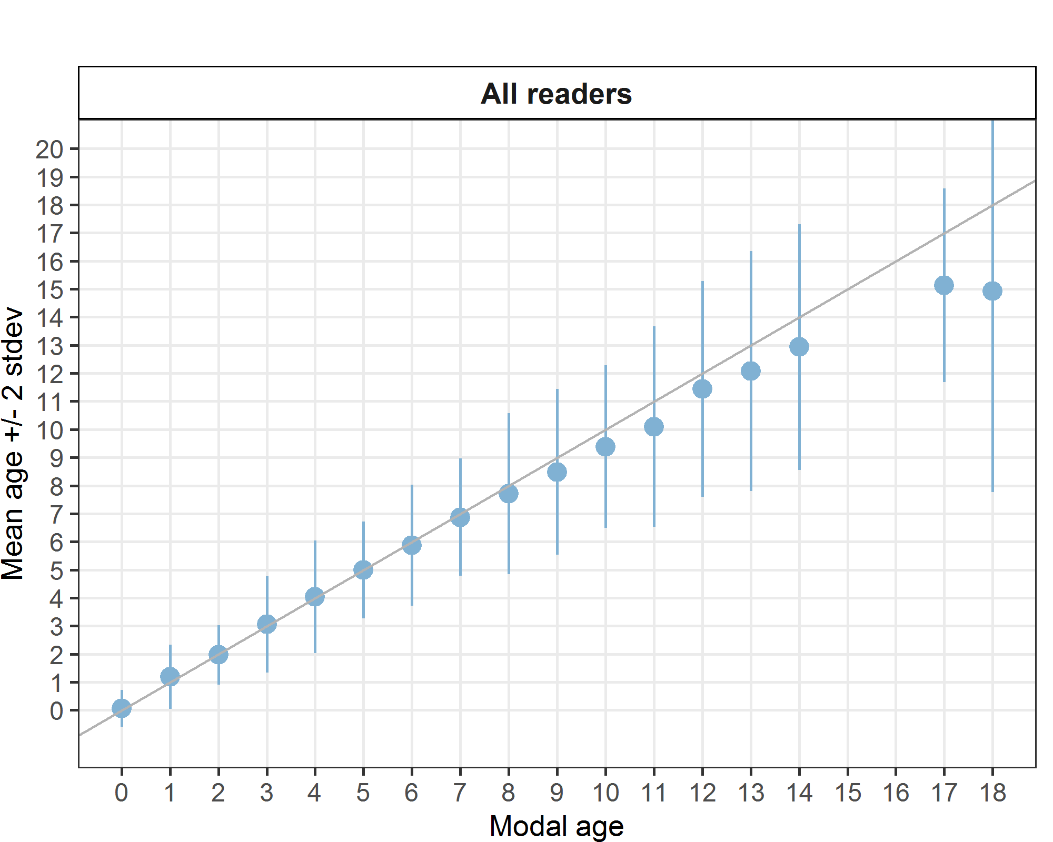

**Figure 7.1:** Strata_1. Age bias plot for all readers. Mean age recorded +/- 2 stdev of each reader and all readers combined are plotted against modal age. The estimated mean age corresponds to modal age, if the estimated mean age is on the 1:1 equilibrium line (solid line). Relative bias is the age difference between estimated mean age and modal age.

### 7.2 Advanced Readers Only

###### Summary statistics for Advanced Readers

**Table 7.9:** Summary of statistics; Total number of samples (NSample), coefficient of variance (CV), percentage of agreement (PA) and average percentage error (APE) for all ages for Advanced Readers only.

|  |  |  |  |
| --- | --- | --- | --- |
| NSample | CV | PA | APE |
| 268 | 21 % | 73 % | 11 % |

The overall agreement increased from 69% to 73% when inexperienced or basic readers were excluded from the analysis. The overall agreement for advanced readers of 73% also shows an increase from the previous exchange in 2021 (67.8%). The highest agreement is at age 0 at 96%, up from 91.1% in the previous exchange. There are consistently high PAs recorded for modal ages 1 to 6 ranging from 71–82% Which again demonstrate an improvement from the 2021 exchange (60 % - 82%)

The lowest agreement was obtained for otoliths with modal age >10 (37% - 49%) except for modal age 13, which had a 62% agreement. This doesn’t appear to be a result of superior image quality, as the majority of age 13 images were assigned an AQ2 score and with three readers (interestingly, from the same lab) assigning an AQ3-QA score.

**All samples included**

###### Multimodal cases

**Table 8.0:** Summary of statistics; Total number of samples (NSample), a percentage of cases (fish samples) with multiple modes depending on the approach to weight the experience of the reader which will be considered when defining the fish age mode. PercMM_traditional shows the percentage of the total samples for which multiple modes are obtained when all the readers are equally weighted. PercMM_linear_weight shows the percentage of the total samples for which multiple modes are obtained when the weight assigned to the different readers decreases linearly with the experience, while in the PercMM_negexp the weight applied decreases with a negative exponential shape with the experience. The PercMM_multistage shows the percentage of multiple mode cases when a combination of the different methodologies is used, as explained in the material and methods section

|  |  |  |  |  |
| --- | --- | --- | --- | --- |
| **NSample** | **PercMM_traditional** | **PercMM_linear_weight** | **PercMM_negexp_weight** | **PercMM_multistage** |
| 268 | 7 % | 1 % | 0 % | 0 % |

In this exchange event, 268 otolith fish individuals were aged. Of those, 7 %when the traditional approach (all readers equally weighted) is used to define the mode. The percentage of multiple mode cases is reduced to 0 %. The complete list of cases with multiple modes is presented in table X in the annex 3 section, where the ageing from each of the readers participating in the exchange event is presented. When all the otolith samples are considered (both single and multimodal cases) the weighted average percentage agreement based on modal ages for all readers is 73 %, with the weighted average CV of 21 % and APE of 11 %.

###### Coefficient of Variation (CV)

Coefficient of Variation % are given for advanced readers in Table 8.1 below. The overall weighted mean CV is 21%, indicating moderate variation across all ages.

1. Higher Variability at Younger Ages (1-4):

The coefficient of variation is highest for modal ages 1-4, especially at age 1 (38% overall), suggesting greater inconsistency for these ages.

Readers: R18 NL (47%) and R06 NL (36%) at age 1, show particularly high variation, indicating significant differences in interpretations.

1. More Consistency for Ages 6-12:

The CV decreases significantly from ages 6-12, with values mostly ranging between 6% and 17%.

This suggests greater agreement amongst readers for these age groups. Age 10 (11% overall) and age 12 (12% overall) show relatively low variability across all readers.

1. Slight Increase in Variability at Older Ages (13-14):

Age 13 has an overall CV of 22%, indicating increased disagreement compared to adjacent ages. Age 14 also shows inconsistencies, with some readers having 0% variation while others are at 18% (R06 NL) and 9% (R02 IS, R16 FO). The overall CV for age 17 is 9%, while age 18 jumps to 19%, indicating some level of disagreement at the highest age recorded.

1. Missing or Low Data for Ages 15-18:

There is no data for ages 15-16, and very limited data for 17-18.

The overall CV for age 17 is 9%, while age 18 jumps to 19%, indicating some level of disagreement at the highest age recorded. R18 NL (24% weighted mean) and R02 IS/R14 FO (20%) have the highest overall variation, whereas R12 ES (14%) and R08 DK (15%) have the lowest variation, suggesting better agreement.

**Table 8.1:** Coefficient of Variation (CV) table presents the CV per modal age and advanced reader, the CV of all advanced readers combined per modal age and a weighted mean of the CV per reader.

| Modal age | R02 IS | R04 IE | R06 NL | R08 DK | R10 IE | R12 ES | R14 FO | R16 FO | R18 NL | all |
| --- | --- | --- | --- | --- | --- | --- | --- | --- | --- | --- |
| 0 | - | - | - | - | - | - | - | - | - | - |
| 1 | 16% | 28% | 36% | 30% | 23% | 31% | 37% | 37% | 47% | 38% |
| 2 | 24% | 27% | 15% | 15% | 19% | 13% | 24% | 19% | 34% | 22% |
| 3 | 38% | 20% | 8% | 18% | 43% | 9% | 14% | 23% | 26% | 26% |
| 4 | 34% | 15% | 12% | 13% | 7% | 9% | 22% | 9% | 18% | 18% |
| 5 | 26% | 22% | 11% | 7% | 11% | 9% | 18% | 12% | 16% | 16% |
| 6 | 6% | 11% | 13% | 11% | 15% | 7% | 14% | 7% | 16% | 12% |
| 7 | 6% | 10% | 13% | 13% | 15% | 11% | 14% | 11% | 12% | 13% |
| 8 | 5% | 16% | 12% | 11% | 13% | 12% | 17% | 11% | 13% | 13% |
| 9 | 7% | 11% | 6% | 11% | 11% | 12% | 11% | 10% | 12% | 12% |
| 10 | 12% | 5% | 15% | 12% | 5% | 6% | 11% | 4% | 8% | 11% |
| 11 | 5% | 9% | 23% | 8% | 4% | 0% | 10% | 12% | 22% | 14% |
| 12 | 10% | 6% | 14% | 6% | 9% | 12% | 4% | 12% | 12% | 12% |
| 13 | - | - | - | - | - | - | - | - | - | 22% |
| 14 | 9% | 0% | 18% | 0% | 5% | - | 5% | 9% | 0% | 17% |
| 15 | - | - | - | - | - | - | - | - | - | - |
| 16 | - | - | - | - | - | - | - | - | - | - |
| 17 | - | - | - | - | - | - | - | - | - | 9% |
| 18 | - | - | - | - | - | - | - | - | - | 19% |
| Weighted Mean | 20% | 19% | 16% | 15% | 19% | 14% | 20% | 17% | 24% | 21% |

###### Relative Bias

Relative bias is the difference between the mean age (per modal age per reader) and modal age. As for the previous table, a combined bias for all advanced readers only and weighted means are calculated and presented in Table 8.2.

1. High Variability at Certain Ages

Age 9 shows the highest positive values (R10 IE: 1.09, R14 FO: 0.55, R16 FO: 0.64), indicating inconsistencies in readings for this age.

Ages 10-12 some significant underestimation is observed at modal ages 10 - 12, particularly for reader R06 NL (-1.57 at age 10, -2.75 at age 11),

Age 14 and 17 again show large negative values in R06 NL (-6 at age 14, -4 at age 17) and R18 NL (-6 at age 13, -3 at age 17), suggesting major inconsistencies.

2. Stability in Some Age Groups

Ages 0-2 show relatively low values across readers, implying better agreement among readers, and ageing at modal ages 6-8 appear more stable with fewer extreme values compared to older ages.

4. Overall Bias Trends

The weighted mean across all advanced readers is close to zero (0.03), highlighting, that while individual readers may show high variability, the age data overall does not exhibit a strong directional bias.

Some ages (9, 10, 11, 14, 17) show high variation, indicating difficulty in consistent readings for those age groups.

Certain readers (R06 NL, R18 NL) show a tendency toward underestimation, while R10 IE tends toward overestimation. Specific observations per advanced reader are given in Table 8.4

Overall, the data does not indicate a strong systemic bias but does show inconsistencies at specific ages and in for certain readers.

**Table 8.3:** Relative Bias table presents the relative bias per modal age and advanced reader, the relative bias of advanced readers combined per modal age and a weighted mean of the relative bias per reader.

|  |  |  |  |  |  |  |  |  |  |  |
| --- | --- | --- | --- | --- | --- | --- | --- | --- | --- | --- |
| Modal age | R02 IS | R04 IE | R06 NL | R08 DK | R10 IE | R12 ES | R14 FO | R16 FO | R18 NL | all |
| 0 | 0 | 0.06 | 0.06 | 0.11 | 0 | 0 | 0 | 0.06 | 0.06 | 0.04 |
| 1 | -0.03 | -0.02 | 0.38 | 0.12 | 0 | 0.05 | 0.15 | 0.05 | 0.45 | 0.13 |
| 2 | -0.15 | -0.21 | 0.03 | -0.03 | 0.03 | -0.07 | 0.06 | 0.03 | -0.06 | -0.04 |
| 3 | 0.16 | -0.16 | 0 | 0.11 | 0.32 | 0.09 | 0 | 0.33 | 0 | 0.09 |
| 4 | 0.36 | -0.05 | -0.14 | 0 | 0.09 | 0.05 | -0.23 | 0.18 | -0.05 | 0.03 |
| 5 | 0.14 | 0.45 | -0.23 | 0.05 | 0.14 | 0 | -0.23 | 0.14 | 0 | 0.05 |
| 6 | -0.05 | 0.27 | -0.23 | -0.14 | 0.45 | -0.05 | -0.09 | 0.23 | 0.18 | 0.07 |
| 7 | 0.06 | 0 | 0 | -0.29 | 0.82 | -0.08 | 0 | 0.35 | -0.18 | 0.08 |
| 8 | 0 | 0.3 | -0.3 | -0.3 | 0.61 | -0.47 | -0.04 | 0.52 | -0.27 | 0 |
| 9 | 0.45 | 0.27 | -0.36 | -0.18 | 1.09 | -0.33 | 0.55 | 0.64 | -0.73 | 0.15 |
| 10 | -0.43 | 0.57 | -1.57 | -0.86 | 0.29 | -0.4 | -0.14 | 0.14 | -0.17 | -0.29 |
| 11 | -0.25 | 0.25 | -2.75 | -1 | 0.25 | 0 | 0 | -0.5 | -1.5 | -0.61 |
| 12 | 0.43 | 0.71 | -0.71 | -0.14 | 0.86 | -0.29 | -0.29 | 1.14 | -1.71 | 0 |
| 13 | 0 | 0 | -4 | 0 | 2 | - | 0 | 0 | -6 | - |
| 14 | 1 | 0 | -6 | -1 | -0.5 | -2 | 0.5 | 1 | 0 | -0.78 |
| 15 | - | - | - | - | - | - | - | - | - | - |
| 16 | - | - | - | - | - | - | - | - | - | - |
| 17 | -1 | 0 | -4 | -2 | 0 | -1 | 0 | 0 | -3 | -1.22 |
| 18 | -1 | 0 | -8 | 0 | 0 | - | -3 | 1 | -5 | - |
| Weighted Mean | 0.06 | 0.08 | -0.23 | -0.08 | 0.29 | -0.07 | -0.01 | 0.24 | -0.11 | 0.03 |

**Table 8.4** Advanced Reader-Specific Observations:

|  |  |  |
| --- | --- | --- |
| Reader | Trend | Key Observations |
| R02 IS | Slight Positive Bias (0.06) | Generally stable, but some variability at ages 4, 5, and 9. |
| R04 IE | Slight Positive Bias (0.08) | Shows higher variation in younger ages (1, 5, 12) but is relatively consistent otherwise. |
| R06 NL | **Strong Negative Bias (-0.23)** | Underestimation is significant, especially at ages 10, 11, 14, and 17. |
| R08 DK | Slight Negative Bias (-0.08) | Mostly stable, but some outliers at ages 9 and 14. |
| R10 IE | **Highest Positive Bias (0.29)** | Tends to overestimate, especially at ages 7-9. |
| R12 ES | Slight Negative Bias (-0.07) | Mostly stable but shows outliers at ages 8 and 9. |
| R14 FO | Neutral (-0.01) | Generally balanced, but inconsistent at ages 9 and 14. |
| R16 FO | Positive Bias (0.24) | More stable, but higher deviations at ages 3, 9, and 12. |
| R18 NL | **Second Highest Negative Bias (-0.11)** | Underestimates strongly at ages 9, 12, and 17. |
| Overall | **Slight Positive Bias (0.03)** | No strong systematic bias, but variation by age and reader. |

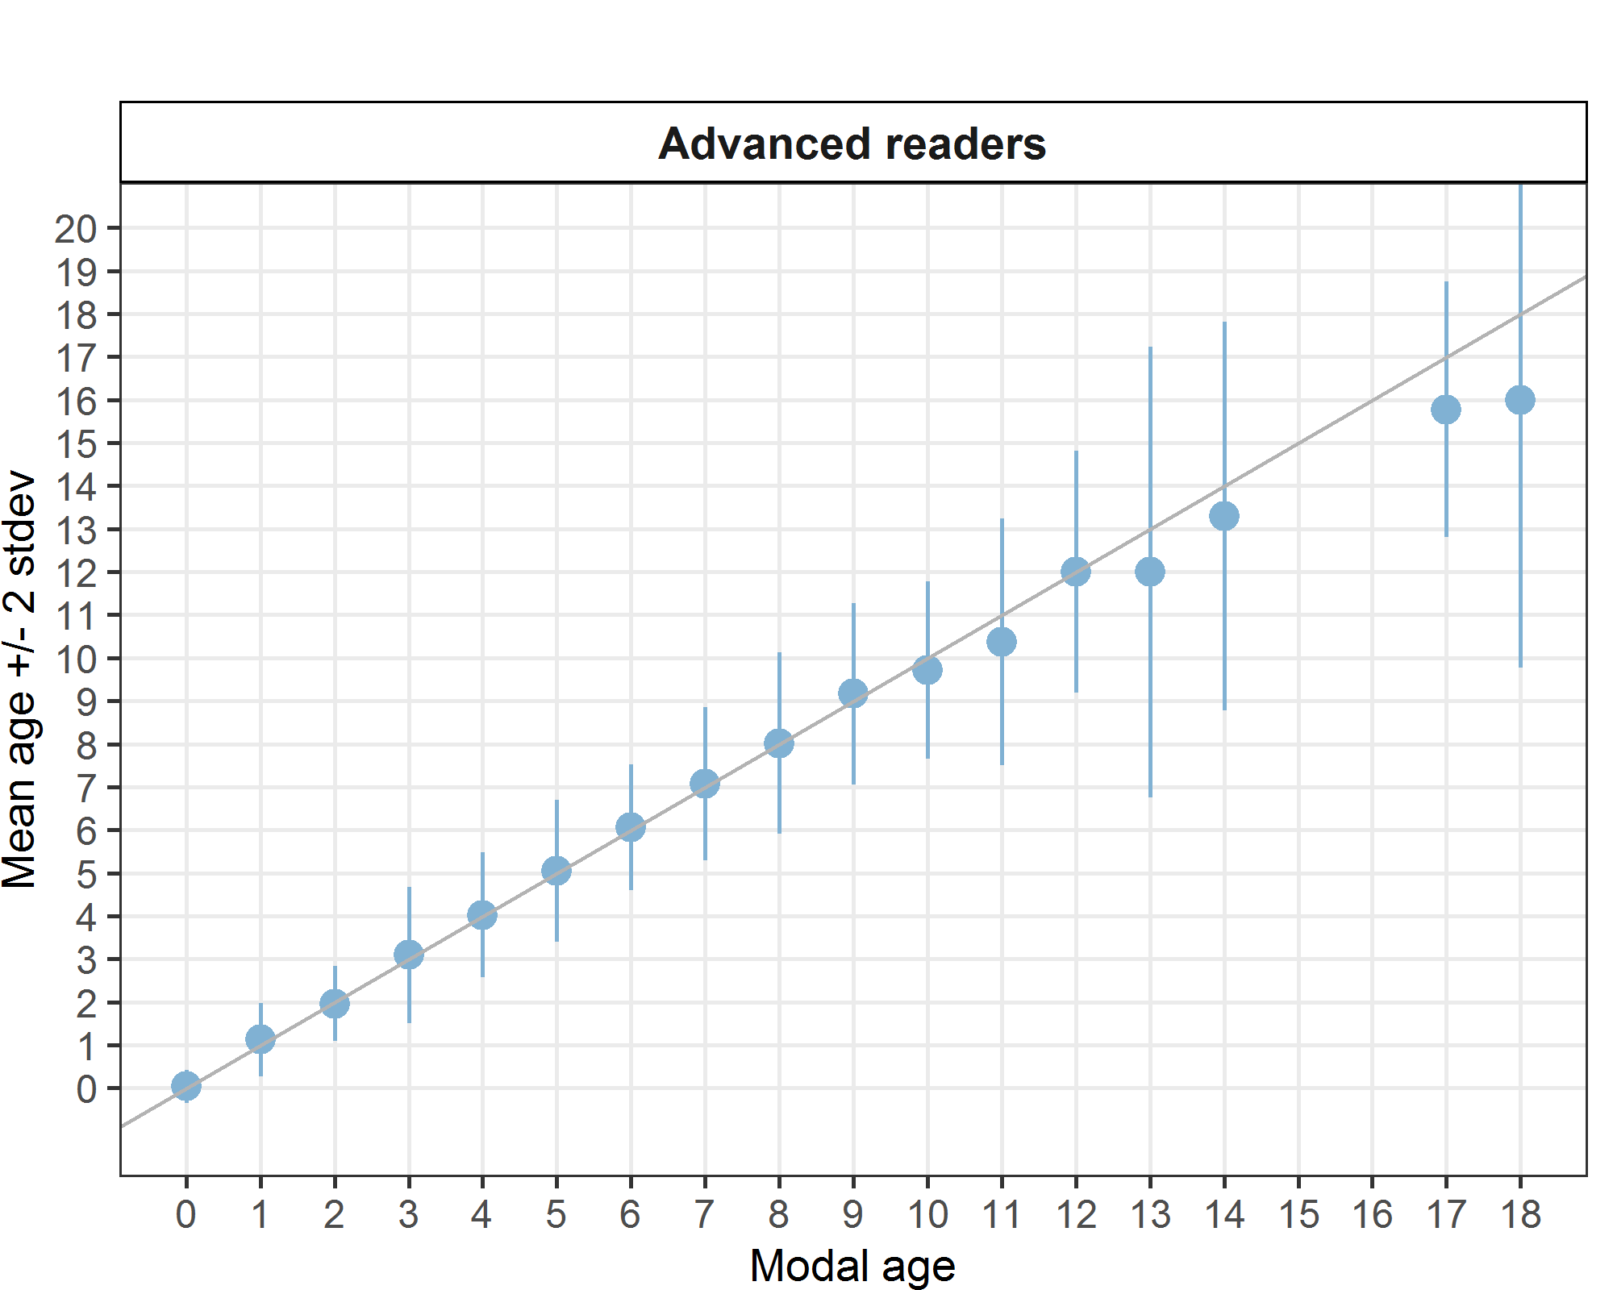

**Figure 7.3:** Age bias plot for advanced readers. Mean age recorded +/- 2 stdev of each reader and all readers combined are plotted against modal age. The estimated mean age corresponds to modal age, if the estimated mean age is on the 1:1 equilibrium line (solid line). Relative bias is the age difference between estimated mean age and modal age.

###### Percentage Agreement (PA)

1. Highest Agreement: R02 IS (85%) and R12 ES (83%) show the most consistent agreement.
2. Lowest Agreement: R18 NL (54%) has the weakest agreement, indicating significant inter-reader variability.

Age-Related Trends:

1. Younger ages (0-4) generally have higher agreement.
2. Lower agreement at ages 7-11, especially for R06 NL, R08 DK, and R18 NL.
3. Very low agreement at ages 13-18, particularly among multiple readers (e.g., R06 NL, R18 NL).

Potential Biases:

Certain readers (R06 NL, R18 NL) appear to struggle with consistency at higher ages.

Readings for several older ages (11, 14, 17, 18) show very wide variations across readers, suggesting age-dependent bias.

**Table 8.5:** Percentage agreement (PA) table represents the PA per modal age and advanced reader, the PA of all advanced readers combined per modal age and a weighted mean of the PA per reader.

| Modal age | R02 IS | R04 IE | R06 NL | R08 DK | R10 IE | R12 ES | R14 FO | R16 FO | R18 NL | total |
| --- | --- | --- | --- | --- | --- | --- | --- | --- | --- | --- |
| 0 | 100% | 94% | 94% | 89% | 100% | 100% | 100% | 94% | 94% | 96% |
| 1 | 97% | 92% | 62% | 88% | 95% | 89% | 80% | 85% | 35% | 80% |
| 2 | 79% | 73% | 91% | 91% | 85% | 93% | 76% | 85% | 67% | 82% |
| 3 | 92% | 68% | 95% | 89% | 86% | 91% | 84% | 72% | 70% | 83% |
| 4 | 91% | 81% | 77% | 86% | 91% | 86% | 59% | 82% | 64% | 80% |
| 5 | 77% | 59% | 82% | 86% | 82% | 81% | 50% | 73% | 50% | 71% |
| 6 | 86% | 82% | 77% | 59% | 73% | 85% | 64% | 77% | 41% | 71% |
| 7 | 82% | 53% | 53% | 59% | 59% | 46% | 71% | 47% | 53% | 58% |
| 8 | 83% | 57% | 61% | 52% | 65% | 71% | 39% | 70% | 55% | 61% |
| 9 | 64% | 55% | 64% | 36% | 36% | 67% | 45% | 36% | 27% | 47% |
| 10 | 86% | 43% | 29% | 43% | 71% | 60% | 43% | 86% | 50% | 57% |
| 11 | 75% | 25% | 25% | 25% | 75% | 100% | 0% | 25% | 0% | 37% |
| 12 | 57% | 43% | 43% | 57% | 57% | 57% | 71% | 29% | 29% | 49% |
| 13 | 100% | 100% | 0% | 100% | 0% | - | 100% | 100% | 0% | 62% |
| 14 | 50% | 100% | 0% | 0% | 50% | 0% | 50% | 50% | 100% | 47% |
| 15 | - | - | - | - | - | - | - | - | - | - |
| 16 | - | - | - | - | - | - | - | - | - | - |
| 17 | 0% | 100% | 0% | 0% | 100% | 0% | 100% | 100% | 0% | 44% |
| 18 | 0% | 100% | 0% | 100% | 100% | - | 0% | 0% | 0% | 38% |
| Weighted Mean | 85% | 72% | 73% | 75% | 80% | 83% | 68% | 73% | 54% | 73% |

**Table 8.6** Advanced Reader-Specific Observations:

|  |  |  |
| --- | --- | --- |
| Reader | Average Agreement (%) | Key Observations |
| R02 IS | **85%** | Consistently high agreement across ages, with a slight dip around ages 5-9. |
| R04 IE | **72%** | Moderate agreement, with lower consistency at ages 5, 7, and 11. |
| R06 NL | **73%** | Generally stable, but extremely low agreement at ages 10, 11, and 14. |
| R08 DK | **75%** | Moderate agreement but with a dip at ages 9 and 14. |
| R10 IE | **80%** | One of the most consistent readers, with higher agreement across most ages. |
| R12 ES | **83%** | Strong agreement overall, except for noticeable dips at ages 7 and 14. |
| R14 FO | **68%** | Lower agreement, especially at ages 5, 8, and 11. |
| R16 FO | **73%** | Moderate agreement, but inconsistencies at ages 7, 9, and 12. |
| R18 NL | **54%** | **Lowest agreement** among all readers, with particularly poor agreement at ages 9, 11, 17, and 18. |
| Overall | **73%** | The overall agreement rate suggests reasonable consistency, but with significant variability by reader and age. |

###### Average Percentage Error (APE)

1. Most Consistent Readers

R12 ES (7%) and R02 IS (9%) have the lowest APE within the advanced reader group.

1. Most Inconsistent Reader

R18 NL (17%) has the highest APE, particularly at ages 1, 6, and 11.

This suggests either a different interpretation of the criteria or a higher error rate.

1. Age-Related Trends

Age 1 has the highest APE across multiple readers (up to 42% for R18 NL).

Ages 3, 5, and 11 also show higher error rates, indicating difficulty in assigning ages. There is minimal disagreement at older ages (17-18) except for a spike at age 18 (16%) overall.

**Table 8.9: Advanced Reader – Specific Observations**

|  |  |  |
| --- | --- | --- |
| Reader | Weighted Mean APE (%) | Key Observations |
| R02 IS | **9%** | One of the lowest disagreement rates, indicating high consistency. |
| R04 IE | **11%** | Moderate disagreement, with some peaks at ages 2 and 3. |
| R06 NL | **11%** | Slightly variable, with **highest error at age 1 (34%)**. |
| R08 DK | **9%** | Relatively stable, but some spikes at ages 1 and 3. |
| R10 IE | **9%** | Consistent, with only minor fluctuations. |
| R12 ES | **7%** | **Lowest disagreement**, suggesting strong reliability. |
| R14 FO | **12%** | Slightly higher disagreement, with peaks at ages 1, 5, and 8. |
| R16 FO | **11%** | Moderate, similar trend to R06 NL and R04 IE. |
| R18 NL | **17%** | **Highest disagreement**, indicating inconsistency in age classifications. |
| Overall | **11%** | General consistency across readers, with notable exceptions. |

**Table 9.0:** Average Percentage Error (APE) table represents the APE per modal age and reader, the APE of all advanced readers combined per modal age and a weighted mean of the APE per reader.

| Modal age | R02 IS | R04 IE | R06 NL | R08 DK | R10 IE | R12 ES | R14 FO | R16 FO | R18 NL | all |
| --- | --- | --- | --- | --- | --- | --- | --- | --- | --- | --- |
| 0 | - | - | - | - | - | - | - | - | - | - |
| 1 | 5% | 10% | 34% | 19% | 5% | 14% | 26% | 19% | 42% | 25% |
| 2 | 17% | 21% | 6% | 6% | 9% | 7% | 14% | 9% | 21% | 11% |
| 3 | 13% | 14% | 2% | 8% | 19% | 5% | 5% | 17% | 13% | 10% |
| 4 | 15% | 7% | 8% | 5% | 4% | 4% | 15% | 7% | 11% | 7% |
| 5 | 12% | 14% | 8% | 3% | 6% | 4% | 14% | 8% | 11% | 8% |
| 6 | 3% | 7% | 8% | 8% | 10% | 3% | 9% | 6% | 13% | 7% |
| 7 | 3% | 7% | 8% | 9% | 12% | 8% | 7% | 9% | 9% | 8% |
| 8 | 2% | 10% | 9% | 8% | 9% | 9% | 12% | 9% | 10% | 7% |
| 9 | 6% | 8% | 5% | 8% | 9% | 9% | 8% | 8% | 9% | 8% |
| 10 | 8% | 5% | 13% | 8% | 4% | 5% | 8% | 2% | 6% | 8% |
| 11 | 3% | 7% | 17% | 5% | 3% | 0% | 9% | 10% | 16% | 11% |
| 12 | 7% | 5% | 10% | 4% | 8% | 8% | 3% | 10% | 10% | 7% |
| 13 | 0% | 0% | 0% | 0% | 0% | - | 0% | 0% | 0% | 17% |
| 14 | 7% | 0% | 12% | 0% | 4% | 0% | 3% | 7% | 0% | 11% |
| 15 | - | - | - | - | - | - | - | - | - | - |
| 16 | - | - | - | - | - | - | - | - | - | - |
| 17 | 0% | 0% | 0% | 0% | 0% | 0% | 0% | 0% | 0% | 8% |
| 18 | 0% | 0% | 0% | 0% | 0% | - | 0% | 0% | 0% | 16% |
| Weighted Mean | 9% | 11% | 11% | 9% | 9% | 7% | 12% | 11% | 17% | 11% |

###### Inter-reader bias test

High inter-reader bias exists, especially among certain readers (R04, R12, R14)., with bias varying by reader pairs rather than being universal. Some readers (R10 IE, R16 FO) exhibit fewer bias issues, indicating more consistency in their age reading.

1. High Certainty of Bias Among Many Readers

The Inter – reader bias test highlights a strong likelihood of bias between many reader pairs.

Readers R04 (IE), R12 (ES), and R14 (FO) exhibit consistent bias with nearly all other readers.

1. Some Readers Show Less Bias

R10 (IE) and R16 (FO) appear to be less biased compared to others.

**Table 9.1:** Inter reader bias test. The Inter-reader bias test gives probability of bias between advanced readers and with modal age. - = no sign of bias (p>0.05), * = possibility of bias (0.01<p<0.05), * * = certainty of bias (p<0.01) , / = diagonal of the table (no bias)

|  |  |  |  |  |  |  |  |  |  |
| --- | --- | --- | --- | --- | --- | --- | --- | --- | --- |
| Comparison | R02 IS | R04 IE | R06 NL | R08 DK | R10 IE | R12 ES | R14 FO | R16 FO | R18 NL |
| R02 IS | / | ** | ** | ** | - | ** | ** | - | * |
| R04 IE | ** | / | ** | ** | ** | ** | ** | ** | ** |
| R06 NL | ** | ** | / | ** | - | ** | ** | - | * |
| R08 DK | ** | ** | ** | / | - | ** | ** | - | * |
| R10 IE | - | ** | - | - | / | - | - | ** | ** |
| R12 ES | ** | ** | ** | ** | - | / | ** | - | * |
| R14 FO | ** | ** | ** | ** | - | ** | / | ** | * |
| R16 FO | - | ** | - | - | ** | - | ** | / | ** |
| R18 NL | * | ** | * | * | ** | * | * | ** | / |
| Modal age | ** | ** | ** | ** | ** | ** | * | - | * |

**Figure 7.4:** Strata 1. Plot of average distance from the centre to the winter rings for advanced readers. The boxes represent the median, upper and lower box boundaries of the interquartile range, whiskers represent the minimum and maximum values, and the dots represent the outliers.

###### General Age Error Matrix (AEM)

**Table 9.2:** General Age error matrix (AEM). The modal age is in rows and the age classifications by the advanced readers in columns.

|  |  |  |  |  |  |  |  |  |  |  |  |  |  |  |  |  |  |  |  |  |  |
| --- | --- | --- | --- | --- | --- | --- | --- | --- | --- | --- | --- | --- | --- | --- | --- | --- | --- | --- | --- | --- | --- |
| **modal_age** | **0** | **1** | **2** | **3** | **4** | **5** | **6** | **7** | **8** | **9** | **10** | **11** | **12** | **13** | **14** | **15** | **16** | **17** | **18** | **19** | **Total** |
| **0** | 0.96 | 0.04 | - | - | - | - | - | - | - | - | - | - | - | - | - | - | - | - | - | - | 1.00 |
| **1** | 0.03 | 0.80 | 0.16 | - | - | - | - | - | - | - | - | - | - | - | - | - | - | - | - | - | 0.99 |
| **2** | - | 0.11 | 0.82 | 0.06 | 0.00 | - | - | - | - | - | - | - | - | - | - | - | - | - | - | - | 0.99 |
| **3** | - | 0.00 | 0.07 | 0.83 | 0.07 | 0.01 | 0.01 | - | - | - | 0.00 | 0.00 | - | - | - | - | - | - | - | - | 0.99 |
| **4** | - | - | 0.01 | 0.10 | 0.80 | 0.08 | 0.02 | - | - | - | - | 0.01 | - | - | - | - | - | - | - | - | 1.02 |
| **5** | - | - | 0.01 | 0.02 | 0.11 | 0.71 | 0.13 | 0.02 | - | - | 0.01 | - | - | - | - | - | - | - | - | - | 1.01 |
| **6** | - | - | - | 0.01 | 0.01 | 0.12 | 0.71 | 0.12 | 0.03 | 0.01 | 0.01 | - | - | - | - | - | - | - | - | - | 1.02 |
| **7** | - | - | - | - | - | 0.02 | 0.18 | 0.58 | 0.15 | 0.05 | 0.01 | 0.01 | - | - | - | - | - | - | - | - | 1.00 |
| **8** | - | - | - | - | - | 0.01 | 0.06 | 0.13 | 0.61 | 0.12 | 0.05 | 0.00 | 0.01 | 0.00 | - | - | - | - | - | - | 0.99 |
| **9** | - | - | - | - | - | - | 0.01 | 0.03 | 0.18 | 0.47 | 0.22 | 0.06 | 0.03 | - | - | - | - | - | - | - | 1.00 |
| **10** | - | - | - | - | - | - | - | 0.07 | 0.05 | 0.15 | 0.57 | 0.17 | - | - | - | - | - | - | - | - | 1.01 |
| **11** | - | - | - | - | - | - | - | 0.09 | 0.03 | 0.09 | 0.23 | 0.37 | 0.20 | - | - | - | - | - | - | - | 1.01 |
| **12** | - | - | - | - | - | - | - | - | 0.02 | 0.03 | 0.08 | 0.13 | 0.49 | 0.13 | 0.06 | 0.06 | - | - | - | - | 1.00 |
| **13** | - | - | - | - | - | - | - | 0.12 | - | 0.12 | - | - | - | 0.62 | - | 0.12 | - | - | - | - | 0.98 |
| **14** | - | - | - | - | - | - | - | 0.06 | - | 0.06 | - | - | 0.06 | 0.18 | 0.47 | 0.06 | 0.12 | - | - | - | 1.01 |
| **17** | - | - | - | - | - | - | - | - | - | - | - | - | - | 0.11 | 0.11 | 0.11 | 0.22 | 0.44 | - | - | 0.99 |
| **18** | - | - | - | - | - | - | - | - | - | - | 0.12 | - | - | 0.12 | - | 0.12 | - | 0.12 | 0.38 | 0.12 | 0.98 |

1. Accuracy is High for Young Ages (0–4)

The diagonal values (e.g., 0.96 at age 0, 0.80 at age 1, etc.) indicate the proportion of times the assigned age matches the true modal age. For ages 0–4, most values are close to 0.80 or higher, meaning most readers correctly assign these ages. However, some misclassification occurs, especially around age 1 and 2, where errors spread to adjacent ages.

2. Increased Error and Spread for Ages 5–12

As age increases, more spread occurs across multiple age categories. At age 5, for example: there is just 0.71 probability of correct assignment. Errors spread into age 4 (0.11) and age 6 (0.13). This trend continues, with growing uncertainty as age increases.

3. Significant Overlap and Misclassification for Ages 13+

At age 13, only 0.62 of assigned age are correct. Some are misclassified as age 7 (0.12) and age 10 (0.12).

At age 14, only 0.47 probability of correct age assignment, with errors distributed across 13, 14, and 17.

At ages 17 and 18, there is substantial misclassification across multiple ages. For example, at age 18, the probability of being classified correctly is just 0.38, with significant misclassification to ages 13, 15, and 17.

4. Possible Causes of Errors

Age Compression: Older individuals (13+) tend to be misclassified as younger.

Adjacent Age Confusion: Errors tend to cluster within ±1-2 years of the modal age.

Smaller Sample Sizes for Older Ages: Fewer observations may lead to noisier data and less reliable ageing.

*AEM by ICES area*

**Table 9.3:** Age error matrix (AEM) for ICES area 27.2.a.

|  |  |  |  |  |  |  |  |  |  |  |  |  |  |  |  |  |  |  |  |  |  |  |
| --- | --- | --- | --- | --- | --- | --- | --- | --- | --- | --- | --- | --- | --- | --- | --- | --- | --- | --- | --- | --- | --- | --- |
| **ices_area** | **modal_age** | **0** | **1** | **2** | **3** | **4** | **5** | **6** | **7** | **8** | **9** | **10** | **11** | **12** | **13** | **14** | **15** | **16** | **17** | **18** | **19** | **Total** |
| **27.2.a** | 1 | 0.22 | 0.72 | 0.06 | - | - | - | - | - | - | - | - | - | - | - | - | - | - | - | - | - | 1.00 |
| **27.2.a** | 2 | - | 0.11 | 0.89 | - | - | - | - | - | - | - | - | - | - | - | - | - | - | - | - | - | 1.00 |
| **27.2.a** | 3 | - | - | 0.08 | 0.92 | - | - | - | - | - | - | - | - | - | - | - | - | - | - | - | - | 1.00 |
| **27.2.a** | 5 | - | - | - | - | 0.17 | 0.61 | 0.17 | 0.06 | - | - | - | - | - | - | - | - | - | - | - | - | 1.01 |
| **27.2.a** | 7 | - | - | - | - | - | - | 0.12 | 0.62 | 0.25 | - | - | - | - | - | - | - | - | - | - | - | 0.99 |
| **27.2.a** | 8 | - | - | - | - | - | - | 0.06 | 0.28 | 0.61 | - | 0.06 | - | - | - | - | - | - | - | - | - | 1.01 |
| **27.2.a** | 9 | - | - | - | - | - | - | - | - | 0.11 | 0.44 | 0.33 | 0.11 | - | - | - | - | - | - | - | - | 0.99 |

**Table 9.4:** Age error matrix (AEM) for ICES area 27.2.b.

|  |  |  |  |  |  |  |  |  |  |  |  |  |  |  |  |  |  |  |  |  |  |  |
| --- | --- | --- | --- | --- | --- | --- | --- | --- | --- | --- | --- | --- | --- | --- | --- | --- | --- | --- | --- | --- | --- | --- |
| **ices_area** | **modal_age** | **0** | **1** | **2** | **3** | **4** | **5** | **6** | **7** | **8** | **9** | **10** | **11** | **12** | **13** | **14** | **15** | **16** | **17** | **18** | **19** | **Total** |
| **27.2.b** | 4 | - | - | - | 0.33 | 0.67 | - | - | - | - | - | - | - | - | - | - | - | - | - | - | - | 1.00 |
| **27.2.b** | 5 | - | - | - | - | - | 0.56 | 0.33 | 0.11 | - | - | - | - | - | - | - | - | - | - | - | - | 1.00 |
| **27.2.b** | 6 | - | - | - | - | - | 0.16 | 0.58 | 0.18 | 0.07 | 0.02 | - | - | - | - | - | - | - | - | - | - | 1.01 |
| **27.2.b** | 8 | - | - | - | - | - | - | 0.11 | 0.17 | 0.50 | 0.17 | 0.06 | - | - | - | - | - | - | - | - | - | 1.01 |
| **27.2.b** | 9 | - | - | - | - | - | - | - | 0.06 | 0.11 | 0.53 | 0.22 | 0.06 | 0.03 | - | - | - | - | - | - | - | 1.01 |
| **27.2.b** | 10 | - | - | - | - | - | - | - | 0.04 | 0.04 | 0.33 | 0.56 | 0.04 | - | - | - | - | - | - | - | - | 1.01 |
| **27.2.b** | 11 | - | - | - | - | - | - | - | - | - | 0.12 | 0.12 | 0.38 | 0.38 | - | - | - | - | - | - | - | 1.00 |
| **27.2.b** | 12 | - | - | - | - | - | - | - | - | - | - | - | 0.11 | 0.56 | 0.11 | - | 0.22 | - | - | - | - | 1.00 |
| **27.2.b** | 17 | - | - | - | - | - | - | - | - | - | - | - | - | - | 0.11 | 0.11 | 0.11 | 0.22 | 0.44 | - | - | 0.99 |
| **27.2.b** | 18 | - | - | - | - | - | - | - | - | - | - | 0.12 | - | - | 0.12 | - | 0.12 | - | 0.12 | 0.38 | 0.12 | 0.98 |

**Table 9.5:** Age error matrix (AEM) for ICES area 27.4.a.

|  |  |  |  |  |  |  |  |  |  |  |  |  |  |  |  |  |  |  |  |  |  |  |
| --- | --- | --- | --- | --- | --- | --- | --- | --- | --- | --- | --- | --- | --- | --- | --- | --- | --- | --- | --- | --- | --- | --- |
| **ices_area** | **modal_age** | **0** | **1** | **2** | **3** | **4** | **5** | **6** | **7** | **8** | **9** | **10** | **11** | **12** | **13** | **14** | **15** | **16** | **17** | **18** | **19** | **Total** |
| **27.4.a** | 1 | 0.14 | 0.78 | 0.08 | - | - | - | - | - | - | - | - | - | - | - | - | - | - | - | - | - | 1.00 |
| **27.4.a** | 2 | - | - | 1.00 | - | - | - | - | - | - | - | - | - | - | - | - | - | - | - | - | - | 1.00 |
| **27.4.a** | 3 | - | - | - | 1.00 | - | - | - | - | - | - | - | - | - | - | - | - | - | - | - | - | 1.00 |
| **27.4.a** | 4 | - | - | - | 0.11 | 0.78 | 0.11 | - | - | - | - | - | - | - | - | - | - | - | - | - | - | 1.00 |
| **27.4.a** | 5 | - | - | - | - | - | 1.00 | - | - | - | - | - | - | - | - | - | - | - | - | - | - | 1.00 |
| **27.4.a** | 6 | - | - | - | - | - | - | 0.78 | 0.11 | 0.11 | - | - | - | - | - | - | - | - | - | - | - | 1.00 |
| **27.4.a** | 7 | - | - | - | - | - | 0.11 | - | 0.67 | 0.22 | - | - | - | - | - | - | - | - | - | - | - | 1.00 |
| **27.4.a** | 8 | - | - | - | - | - | - | 0.06 | 0.22 | 0.56 | 0.11 | 0.06 | - | - | - | - | - | - | - | - | - | 1.01 |
| **27.4.a** | 11 | - | - | - | - | - | - | - | 0.11 | - | - | 0.33 | 0.44 | 0.11 | - | - | - | - | - | - | - | 0.99 |
| **27.4.a** | 14 | - | - | - | - | - | - | - | 0.11 | - | - | - | - | 0.11 | 0.11 | 0.44 | - | 0.22 | - | - | - | 0.99 |

**Table 9.6:** Age error matrix (AEM) for ICES area 27.4.b.

|  |  |  |  |  |  |  |  |  |  |  |  |  |  |  |  |  |  |  |  |  |  |  |
| --- | --- | --- | --- | --- | --- | --- | --- | --- | --- | --- | --- | --- | --- | --- | --- | --- | --- | --- | --- | --- | --- | --- |
| **ices_area** | **modal_age** | **0** | **1** | **2** | **3** | **4** | **5** | **6** | **7** | **8** | **9** | **10** | **11** | **12** | **13** | **14** | **15** | **16** | **17** | **18** | **19** | **Total** |
| **27.4.b** | 0 | 1.00 | - | - | - | - | - | - | - | - | - | - | - | - | - | - | - | - | - | - | - | 1.00 |
| **27.4.b** | 1 | 0.02 | 0.88 | 0.10 | - | - | - | - | - | - | - | - | - | - | - | - | - | - | - | - | - | 1.00 |
| **27.4.b** | 2 | - | 0.05 | 0.84 | 0.12 | - | - | - | - | - | - | - | - | - | - | - | - | - | - | - | - | 1.01 |
| **27.4.b** | 3 | - | - | - | 0.78 | 0.22 | - | - | - | - | - | - | - | - | - | - | - | - | - | - | - | 1.00 |
| **27.4.b** | 6 | - | - | - | - | - | 0.44 | 0.44 | 0.11 | - | - | - | - | - | - | - | - | - | - | - | - | 0.99 |
| **27.4.b** | 8 | - | - | - | - | - | - | 0.14 | 0.14 | 0.57 | - | 0.14 | - | - | - | - | - | - | - | - | - | 0.99 |

**Table 9.7:** Age error matrix (AEM) for ICES area 27.4.c.

|  |  |  |  |  |  |  |  |  |  |  |  |  |  |  |  |  |  |  |  |  |  |  |
| --- | --- | --- | --- | --- | --- | --- | --- | --- | --- | --- | --- | --- | --- | --- | --- | --- | --- | --- | --- | --- | --- | --- |
| **ices_area** | **modal_age** | **0** | **1** | **2** | **3** | **4** | **5** | **6** | **7** | **8** | **9** | **10** | **11** | **12** | **13** | **14** | **15** | **16** | **17** | **18** | **19** | **Total** |
| **27.4.c** | 0 | 0.98 | 0.02 | - | - | - | - | - | - | - | - | - | - | - | - | - | - | - | - | - | - | 1 |
| **27.4.c** | 1 | - | 0.96 | 0.04 | - | - | - | - | - | - | - | - | - | - | - | - | - | - | - | - | - | 1 |

**Table 9.8:** Age error matrix (AEM) for ICES area 27.5.b.

|  |  |  |  |  |  |  |  |  |  |  |  |  |  |  |  |  |  |  |  |  |  |  |
| --- | --- | --- | --- | --- | --- | --- | --- | --- | --- | --- | --- | --- | --- | --- | --- | --- | --- | --- | --- | --- | --- | --- |
| **ices_area** | **modal_age** | **0** | **1** | **2** | **3** | **4** | **5** | **6** | **7** | **8** | **9** | **10** | **11** | **12** | **13** | **14** | **15** | **16** | **17** | **18** | **19** | **Total** |
| **27.5.b** | 2 | - | - | 0.94 | 0.06 | - | - | - | - | - | - | - | - | - | - | - | - | - | - | - | - | 1.00 |
| **27.5.b** | 3 | - | - | - | 1.00 | - | - | - | - | - | - | - | - | - | - | - | - | - | - | - | - | 1.00 |
| **27.5.b** | 4 | - | - | - | 0.19 | 0.81 | - | - | - | - | - | - | - | - | - | - | - | - | - | - | - | 1.00 |
| **27.5.b** | 5 | - | - | - | - | 0.14 | 0.75 | 0.11 | - | - | - | - | - | - | - | - | - | - | - | - | - | 1.00 |
| **27.5.b** | 6 | - | - | - | - | - | - | 0.83 | 0.17 | - | - | - | - | - | - | - | - | - | - | - | - | 1.00 |
| **27.5.b** | 7 | - | - | - | - | - | - | 0.21 | 0.56 | 0.12 | 0.06 | 0.03 | 0.03 | - | - | - | - | - | - | - | - | 1.01 |
| **27.5.b** | 8 | - | - | - | - | - | - | 0.02 | 0.04 | 0.70 | 0.17 | 0.02 | 0.02 | 0.02 | 0.02 | - | - | - | - | - | - | 1.01 |
| **27.5.b** | 9 | - | - | - | - | - | - | 0.06 | 0.06 | 0.28 | 0.61 | - | - | - | - | - | - | - | - | - | - | 1.01 |
| **27.5.b** | 10 | - | - | - | - | - | - | - | - | 0.06 | - | 0.72 | 0.22 | - | - | - | - | - | - | - | - | 1.00 |
| **27.5.b** | 14 | - | - | - | - | - | - | - | - | - | 0.12 | - | - | - | 0.25 | 0.5 | 0.12 | - | - | - | - | 0.99 |

**Table 9.9:** Age error matrix (AEM) for ICES area 27.6.

|  |  |  |  |  |  |  |  |  |  |  |  |  |  |  |  |  |  |  |  |  |  |  |
| --- | --- | --- | --- | --- | --- | --- | --- | --- | --- | --- | --- | --- | --- | --- | --- | --- | --- | --- | --- | --- | --- | --- |
| **ices_area** | **modal_age** | **0** | **1** | **2** | **3** | **4** | **5** | **6** | **7** | **8** | **9** | **10** | **11** | **12** | **13** | **14** | **15** | **16** | **17** | **18** | **19** | **Total** |
| **27.6** | 1 | - | 0.89 | 0.11 | - | - | - | - | - | - | - | - | - | - | - | - | - | - | - | - | - | 1.00 |
| **27.6** | 3 | - | - | 0.12 | 0.71 | 0.06 | - | - | - | - | - | 0.06 | 0.06 | - | - | - | - | - | - | - | - | 1.01 |
| **27.6** | 4 | - | - | - | 0.12 | 0.62 | 0.12 | 0.06 | - | - | - | - | 0.06 | - | - | - | - | - | - | - | - | 0.98 |
| **27.6** | 5 | - | - | - | - | 0.12 | 0.47 | 0.24 | 0.06 | - | - | 0.12 | - | - | - | - | - | - | - | - | - | 1.01 |
| **27.6** | 7 | - | - | - | - | - | - | - | 0.56 | 0.44 | - | - | - | - | - | - | - | - | - | - | - | 1.00 |

**Table 10.0:** Age error matrix (AEM) for ICES area 27.6.a.

|  |  |  |  |  |  |  |  |  |  |  |  |  |  |  |  |  |  |  |  |  |  |  |
| --- | --- | --- | --- | --- | --- | --- | --- | --- | --- | --- | --- | --- | --- | --- | --- | --- | --- | --- | --- | --- | --- | --- |
| **ices_area** | **modal_age** | **0** | **1** | **2** | **3** | **4** | **5** | **6** | **7** | **8** | **9** | **10** | **11** | **12** | **13** | **14** | **15** | **16** | **17** | **18** | **19** | **Total** |
| **27.6.a** | 4 | - | - | - | 0.07 | 0.83 | 0.08 | 0.01 | - | - | - | - | - | - | - | - | - | - | - | - | - | 0.99 |
| **27.6.a** | 5 | - | - | - | - | 0.11 | 0.78 | 0.11 | - | - | - | - | - | - | - | - | - | - | - | - | - | 1.00 |
| **27.6.a** | 6 | - | - | - | - | - | 0.28 | 0.72 | - | - | - | - | - | - | - | - | - | - | - | - | - | 1.00 |
| **27.6.a** | 7 | - | - | - | - | - | - | 0.22 | 0.44 | 0.17 | 0.17 | - | - | - | - | - | - | - | - | - | - | 1.00 |
| **27.6.a** | 8 | - | - | - | - | - | 0.06 | - | 0.17 | 0.50 | 0.17 | 0.06 | - | 0.06 | - | - | - | - | - | - | - | 1.02 |
| **27.6.a** | 12 | - | - | - | - | - | - | - | - | 0.03 | 0.03 | 0.08 | 0.03 | 0.50 | 0.17 | 0.11 | 0.06 | - | - | - | - | 1.01 |

**Table 10.1:** Age error matrix (AEM) for ICES area 27.7.b.

|  |  |  |  |  |  |  |  |  |  |  |  |  |  |  |  |  |  |  |  |  |  |  |
| --- | --- | --- | --- | --- | --- | --- | --- | --- | --- | --- | --- | --- | --- | --- | --- | --- | --- | --- | --- | --- | --- | --- |
| **ices_area** | **modal_age** | **0** | **1** | **2** | **3** | **4** | **5** | **6** | **7** | **8** | **9** | **10** | **11** | **12** | **13** | **14** | **15** | **16** | **17** | **18** | **19** | **Total** |
| **27.7.b** | 3 | - | - | 0.11 | 0.89 | - | - | - | - | - | - | - | - | - | - | - | - | - | - | - | - | 1.00 |
| **27.7.b** | 4 | - | - | - | - | 0.89 | 0.11 | - | - | - | - | - | - | - | - | - | - | - | - | - | - | 1.00 |
| **27.7.b** | 6 | - | - | - | 0.06 | 0.06 | 0.11 | 0.78 | - | - | - | - | - | - | - | - | - | - | - | - | - | 1.01 |
| **27.7.b** | 12 | - | - | - | - | - | - | - | - | - | 0.11 | 0.11 | 0.33 | 0.33 | 0.11 | - | - | - | - | - | - | 0.99 |

**Table 10.2:** Age error matrix (AEM) for ICES area 27.7.c.

|  |  |  |  |  |  |  |  |  |  |  |  |  |  |  |  |  |  |  |  |  |  |  |
| --- | --- | --- | --- | --- | --- | --- | --- | --- | --- | --- | --- | --- | --- | --- | --- | --- | --- | --- | --- | --- | --- | --- |
| **ices_area** | **modal_age** | **0** | **1** | **2** | **3** | **4** | **5** | **6** | **7** | **8** | **9** | **10** | **11** | **12** | **13** | **14** | **15** | **16** | **17** | **18** | **19** | **Total** |
| **27.7.c** | 5 | - | - | - | - | 0.11 | 0.78 | 0.11 | - | - | - | - | - | - | - | - | - | - | - | - | - | 1.00 |
| **27.7.c** | 6 | - | - | - | - | - | - | 1.00 | - | - | - | - | - | - | - | - | - | - | - | - | - | 1.00 |
| **27.7.c** | 7 | - | - | - | - | - | 0.06 | 0.22 | 0.67 | 0.06 | - | - | - | - | - | - | - | - | - | - | - | 1.01 |
| **27.7.c** | 8 | - | - | - | - | - | - | - | 0.22 | 0.78 | - | - | - | - | - | - | - | - | - | - | - | 1.00 |

**Table 10.3:** Age error matrix (AEM) for ICES area 27.7.d.

|  |  |  |  |  |  |  |  |  |  |  |  |  |  |  |  |  |  |  |  |  |  |  |
| --- | --- | --- | --- | --- | --- | --- | --- | --- | --- | --- | --- | --- | --- | --- | --- | --- | --- | --- | --- | --- | --- | --- |
| **ices_area** | **modal_age** | **0** | **1** | **2** | **3** | **4** | **5** | **6** | **7** | **8** | **9** | **10** | **11** | **12** | **13** | **14** | **15** | **16** | **17** | **18** | **19** | **Total** |
| **27.7.d** | 1 | - | 1.00 | - | - | - | - | - | - | - | - | - | - | - | - | - | - | - | - | - | - | 1 |
| **27.7.d** | 2 | - | 0.22 | 0.78 | - | - | - | - | - | - | - | - | - | - | - | - | - | - | - | - | - | 1 |
| **27.7.d** | 3 | - | - | - | 0.94 | - | 0.06 | - | - | - | - | - | - | - | - | - | - | - | - | - | - | 1 |
| **27.7.d** | 4 | - | - | - | - | 1 | - | - | - | - | - | - | - | - | - | - | - | - | - | - | - | 1 |

**Table 10.4:** Age error matrix (AEM) for ICES area 27.7.f.

|  |  |  |  |  |  |  |  |  |  |  |  |  |  |  |  |  |  |  |  |  |  |  |
| --- | --- | --- | --- | --- | --- | --- | --- | --- | --- | --- | --- | --- | --- | --- | --- | --- | --- | --- | --- | --- | --- | --- |
| **ices_area** | **modal_age** | **0** | **1** | **2** | **3** | **4** | **5** | **6** | **7** | **8** | **9** | **10** | **11** | **12** | **13** | **14** | **15** | **16** | **17** | **18** | **19** | **Total** |
| **27.7.f** | 0 | 0.94 | 0.06 | - | - | - | - | - | - | - | - | - | - | - | - | - | - | - | - | - | - | 1 |
| **27.7.f** | 1 | - | 0.81 | 0.19 | - | - | - | - | - | - | - | - | - | - | - | - | - | - | - | - | - | 1 |

**Table 10.5:** Age error matrix (AEM) for ICES area 27.7.g.

|  |  |  |  |  |  |  |  |  |  |  |  |  |  |  |  |  |  |  |  |  |  |  |
| --- | --- | --- | --- | --- | --- | --- | --- | --- | --- | --- | --- | --- | --- | --- | --- | --- | --- | --- | --- | --- | --- | --- |
| **ices_area** | **modal_age** | **0** | **1** | **2** | **3** | **4** | **5** | **6** | **7** | **8** | **9** | **10** | **11** | **12** | **13** | **14** | **15** | **16** | **17** | **18** | **19** | **Total** |
| **27.7.g** | 1 | 0.11 | 0.89 | - | - | - | - | - | - | - | - | - | - | - | - | - | - | - | - | - | - | 1 |
| **27.7.g** | 2 | - | 0.11 | 0.89 | - | - | - | - | - | - | - | - | - | - | - | - | - | - | - | - | - | 1 |
| **27.7.g** | 3 | - | - | 0.22 | 0.78 | - | - | - | - | - | - | - | - | - | - | - | - | - | - | - | - | 1 |
| **27.7.g** | 5 | - | - | - | - | 0.11 | 0.89 | - | - | - | - | - | - | - | - | - | - | - | - | - | - | 1 |
| **27.7.g** | 6 | - | - | - | - | - | 0.11 | 0.89 | - | - | - | - | - | - | - | - | - | - | - | - | - | 1 |

**Table 10.6:** Age error matrix (AEM) for ICES area 27.7.h.

|  |  |  |  |  |  |  |  |  |  |  |  |  |  |  |  |  |  |  |  |  |  |  |
| --- | --- | --- | --- | --- | --- | --- | --- | --- | --- | --- | --- | --- | --- | --- | --- | --- | --- | --- | --- | --- | --- | --- |
| **ices_area** | **modal_age** | **0** | **1** | **2** | **3** | **4** | **5** | **6** | **7** | **8** | **9** | **10** | **11** | **12** | **13** | **14** | **15** | **16** | **17** | **18** | **19** | **Total** |
| **27.7.h** | 0 | 0.96 | 0.04 | - | - | - | - | - | - | - | - | - | - | - | - | - | - | - | - | - | - | 1 |
| **27.7.h** | 1 | - | 0.56 | 0.44 | - | - | - | - | - | - | - | - | - | - | - | - | - | - | - | - | - | 1 |
| **27.7.h** | 2 | - | - | 1.00 | - | - | - | - | - | - | - | - | - | - | - | - | - | - | - | - | - | 1 |

**Table 10.7:** Age error matrix (AEM) for ICES area 27.7.j.

|  |  |  |  |  |  |  |  |  |  |  |  |  |  |  |  |  |  |  |  |  |  |  |
| --- | --- | --- | --- | --- | --- | --- | --- | --- | --- | --- | --- | --- | --- | --- | --- | --- | --- | --- | --- | --- | --- | --- |
| **ices_area** | **modal_age** | **0** | **1** | **2** | **3** | **4** | **5** | **6** | **7** | **8** | **9** | **10** | **11** | **12** | **13** | **14** | **15** | **16** | **17** | **18** | **19** | **Total** |
| **27.7.j** | 0 | 0.88 | 0.12 | - | - | - | - | - | - | - | - | - | - | - | - | - | - | - | - | - | - | 1 |
| **27.7.j** | 1 | - | 0.78 | 0.22 | - | - | - | - | - | - | - | - | - | - | - | - | - | - | - | - | - | 1 |
| **27.7.j** | 2 | - | 0.22 | 0.56 | 0.22 | - | - | - | - | - | - | - | - | - | - | - | - | - | - | - | - | 1 |
| **27.7.j** | 3 | - | - | - | 1.00 | - | - | - | - | - | - | - | - | - | - | - | - | - | - | - | - | 1 |

**Table 10.8:** Age error matrix (AEM) for ICES area 27.8.a.

|  |  |  |  |  |  |  |  |  |  |  |  |  |  |  |  |  |  |  |  |  |  |  |
| --- | --- | --- | --- | --- | --- | --- | --- | --- | --- | --- | --- | --- | --- | --- | --- | --- | --- | --- | --- | --- | --- | --- |
| **ices_area** | **modal_age** | **0** | **1** | **2** | **3** | **4** | **5** | **6** | **7** | **8** | **9** | **10** | **11** | **12** | **13** | **14** | **15** | **16** | **17** | **18** | **19** | **Total** |
| **27.8.a** | 0 | 1 | - | - | - | - | - | - | - | - | - | - | - | - | - | - | - | - | - | - | - | 1 |
| **27.8.a** | 1 | - | 0.64 | 0.36 | - | - | - | - | - | - | - | - | - | - | - | - | - | - | - | - | - | 1 |
| **27.8.a** | 2 | - | 0.16 | 0.60 | 0.2 | 0.04 | - | - | - | - | - | - | - | - | - | - | - | - | - | - | - | 1 |

**Table 10.9:** Age error matrix (AEM) for ICES area 27.8.b.

|  |  |  |  |  |  |  |  |  |  |  |  |  |  |  |  |  |  |  |  |  |  |  |
| --- | --- | --- | --- | --- | --- | --- | --- | --- | --- | --- | --- | --- | --- | --- | --- | --- | --- | --- | --- | --- | --- | --- |
| **ices_area** | **modal_age** | **0** | **1** | **2** | **3** | **4** | **5** | **6** | **7** | **8** | **9** | **10** | **11** | **12** | **13** | **14** | **15** | **16** | **17** | **18** | **19** | **Total** |
| **27.8.b** | 3 | - | - | 0.33 | 0.67 | - | - | - | - | - | - | - | - | - | - | - | - | - | - | - | - | 1.00 |
| **27.8.b** | 5 | - | - | - | 0.11 | - | 0.44 | 0.44 | - | - | - | - | - | - | - | - | - | - | - | - | - | 0.99 |
| **27.8.b** | 6 | - | - | - | - | - | 0.08 | 0.69 | 0.23 | - | - | - | - | - | - | - | - | - | - | - | - | 1.00 |
| **27.8.b** | 7 | - | - | - | - | - | - | - | 0.89 | 0.11 | - | - | - | - | - | - | - | - | - | - | - | 1.00 |
| **27.8.b** | 8 | - | - | - | - | - | 0.12 | 0.12 | - | 0.75 | - | - | - | - | - | - | - | - | - | - | - | 0.99 |
| **27.8.b** | 9 | - | - | - | - | - | - | - | - | 0.24 | 0.29 | 0.24 | 0.12 | 0.12 | - | - | - | - | - | - | - | 1.01 |
| **27.8.b** | 13 | - | - | - | - | - | - | - | 0.12 | - | 0.12 | - | - | - | 0.62 | - | 0.12 | - | - | - | - | 0.98 |

**Table 11.0:** Age error matrix (AEM) for ICES area 27.8.c.

|  |  |  |  |  |  |  |  |  |  |  |  |  |  |  |  |  |  |  |  |  |  |  |
| --- | --- | --- | --- | --- | --- | --- | --- | --- | --- | --- | --- | --- | --- | --- | --- | --- | --- | --- | --- | --- | --- | --- |
| **ices_area** | **modal_age** | **0** | **1** | **2** | **3** | **4** | **5** | **6** | **7** | **8** | **9** | **10** | **11** | **12** | **13** | **14** | **15** | **16** | **17** | **18** | **19** | **Total** |
| **27.8.c** | 1 | - | 0.67 | 0.33 | - | - | - | - | - | - | - | - | - | - | - | - | - | - | - | - | - | 1.00 |
| **27.8.c** | 2 | - | 0.22 | 0.63 | 0.15 | - | - | - | - | - | - | - | - | - | - | - | - | - | - | - | - | 1.00 |
| **27.8.c** | 3 | - | - | 0.08 | 0.67 | 0.22 | 0.03 | - | - | - | - | - | - | - | - | - | - | - | - | - | - | 1.00 |
| **27.8.c** | 4 | - | - | 0.22 | 0.11 | 0.44 | 0.22 | - | - | - | - | - | - | - | - | - | - | - | - | - | - | 0.99 |
| **27.8.c** | 5 | - | - | - | 0.04 | 0.15 | 0.78 | 0.04 | - | - | - | - | - | - | - | - | - | - | - | - | - | 1.01 |
| **27.8.c** | 6 | - | - | - | - | - | 0.12 | 0.65 | 0.12 | 0.06 | - | 0.06 | - | - | - | - | - | - | - | - | - | 1.01 |
| **27.8.c** | 7 | - | - | - | - | - | - | 0.29 | 0.53 | 0.06 | 0.12 | - | - | - | - | - | - | - | - | - | - | 1.00 |
| **27.8.c** | 8 | - | - | - | - | - | - | 0.22 | 0.11 | 0.33 | 0.22 | 0.11 | - | - | - | - | - | - | - | - | - | 0.99 |
| **27.8.c** | 9 | - | - | - | - | - | - | - | - | 0.25 | 0.38 | 0.25 | 0.12 | - | - | - | - | - | - | - | - | 1.00 |
| **27.8.c** | 11 | - | - | - | - | - | - | - | 0.11 | 0.06 | 0.11 | 0.22 | 0.33 | 0.17 | - | - | - | - | - | - | - | 1.00 |

**Table 11.1:** Age error matrix (AEM) for ICES area 27.9.a.

|  |  |  |  |  |  |  |  |  |  |  |  |  |  |  |  |  |  |  |  |  |  |  |
| --- | --- | --- | --- | --- | --- | --- | --- | --- | --- | --- | --- | --- | --- | --- | --- | --- | --- | --- | --- | --- | --- | --- |
| **ices_area** | **modal_age** | **0** | **1** | **2** | **3** | **4** | **5** | **6** | **7** | **8** | **9** | **10** | **11** | **12** | **13** | **14** | **15** | **16** | **17** | **18** | **19** | **Total** |
| **27.9.a** | 0 | 0.78 | 0.22 | - | - | - | - | - | - | - | - | - | - | - | - | - | - | - | - | - | - | 1.00 |
| **27.9.a** | 1 | - | 0.63 | 0.37 | - | - | - | - | - | - | - | - | - | - | - | - | - | - | - | - | - | 1.00 |
| **27.9.a** | 2 | - | 0.17 | 0.79 | 0.03 | - | - | - | - | - | - | - | - | - | - | - | - | - | - | - | - | 0.99 |
| **27.9.a** | 3 | - | 0.01 | 0.08 | 0.78 | 0.07 | 0.01 | 0.05 | - | - | - | - | - | - | - | - | - | - | - | - | - | 1.00 |
| **27.9.a** | 4 | - | - | - | - | 0.89 | 0.06 | 0.06 | - | - | - | - | - | - | - | - | - | - | - | - | - | 1.01 |
| **27.9.a** | 5 | - | - | 0.06 | 0.11 | 0.06 | 0.67 | 0.11 | - | - | - | - | - | - | - | - | - | - | - | - | - | 1.01 |
| **27.9.a** | 7 | - | - | - | - | - | 0.04 | 0.22 | 0.56 | 0.15 | 0.04 | - | - | - | - | - | - | - | - | - | - | 1.01 |
| **27.9.a** | 8 | - | - | - | - | - | - | 0.07 | 0.12 | 0.62 | 0.12 | 0.07 | - | - | - | - | - | - | - | - | - | 1.00 |
| **27.9.a** | 9 | - | - | - | - | - | - | - | - | 0.11 | 0.44 | 0.44 | - | - | - | - | - | - | - | - | - | 0.99 |
| **27.9.a** | 10 | - | - | - | - | - | - | - | 0.20 | 0.07 | - | 0.40 | 0.33 | - | - | - | - | - | - | - | - | 1.00 |
| **27.9.a** | 12 | - | - | - | - | - | - | - | - | - | - | 0.11 | 0.33 | 0.56 | - | - | - | - | - | - | - | 1.00 |

## Discussion

The 2024 otolith exchange event demonstrated an improvement in overall agreement amongst the advanced reader group compared to the previous 2021 exchange. The percentage agreement (PA) increased from 67.8% to 73%, and the coefficient of variation (CV) remained at a moderate 21%, indicating reasonable consistency across age estimates.

Key findings include:

1. **Improved Overall Agreement**
   * The overall agreement increased from **69% to 73%** when only advanced readers were considered.
   * Compared to the 2021 exchange (67.8%), there is a clear improvement.
2. **Reduction in Multiple Mode Cases**
   * When weighting experience, multiple mode cases dropped from **7% (traditional) to 0%** in advanced weighting methods.
   * This indicates stronger consensus amongst experienced readers.
3. **Improved Agreement for Younger Ages**
   * The highest agreement was at **age 0 (96%)**, up from **91.1%** in 2021.
   * Modal ages **1 to 6** had consistently high agreement (71–82%), showing an improvement from 2021 (60–82%).
   * Higher CV values at ages 1–4 suggest some challenges in consistency, with age 1 showing the highest variation (38%).
4. **Lower Variation in Mid-Age Groups (6-12)**
   * CV values dropped significantly for ages **6-12 (6%-17%)**, indicating **better consistency** among readers.
   * Modal ages **10 (11%) and 12 (12%)** had particularly low variability.
5. **Challenges in Older Age Groups**
   * Otoliths with modal ages greater than 10 exhibited significantly lower agreement (37–49%), except for age 13 (62%).
   * Higher relative bias and variability were observed at ages 9, 10, 11, 14, and 17, indicating greater difficulty in consistent age determination.
   * Some readers (e.g., R06 NL and R18 NL) showed a tendency to underestimate ages, particularly for ages 10, 11, 14, and 17.
6. **Impact of Reader Experience on Consistency**
   * When considering weighting methodologies for defining the modal age, multimodal cases were reduced to 0% using the linear, negative exponential, and multistage weighting approaches, highlighting the effectiveness of weighting based on experience.
   * The PA varied significantly among readers, with the highest agreement observed for R02 IS (85%) and R12 ES (83%), while R18 NL exhibited the lowest agreement (54%).
   * R10 IE (80%) and R08 DK (75%) also showed strong consistency.
7. **Overall Trends in Bias and Variability**
   * While no strong systematic bias was observed across all readers (weighted mean relative bias = 0.03), individual readers showed tendencies toward either underestimation (e.g., R06 NL, R18 NL) or overestimation (e.g., R10 IE).
   * Certain age groups (0-2, 6-8) showed **stable and reliable** readings across readers.
   * The highest variation was observed in age groups where bias was also significant (ages 9–12 and 14–18).

## Conclusion and Recommendations.

Overall, the data highlights **improved agreement, reduced variability in key age groups, and minimal systemic bias**, across both Advanced and Basic readers which are all positive outcomes for the accuracy and reliability of mackerel age determination.

Age determination accuracy improved, particularly in younger age groups, but the results also underscore the challenges associated with older age classes. Future efforts should focus on refining methodologies for age determination in older fish, addressing inconsistencies amongst readers.

It is recommended to create a Training Reference Collection (TRC) following the guidelines proposed by WGBIOP in its 2024 Working Group report which will be available: <https://www.ices.dk/community/groups/pages/wgbiop.aspx>

This is a very worthwhile exercise and will be a useful training tool for age readers. It may be possible to use a reference collection already compiled by CEFAS as the basis for this.

It is recommended to actively engage and collaborate with WGBIOP and other Expert Groups e.g. The Working Group on Machine Learning in Marine Science (WGMLEARN) which reviews and identifies machine learning (ML) applications in marine science as well as emerging developments in the field of AI and ML. This group aims to identify key challenges and provide guidance and resources for data sharing (methods, training sets, protocols). Discussions around the fields of computer vision, Near-infrared spectroscopy, multi-dimensional shape analysis and otolith microchemistry and attempts at developing automated methods to estimate individual age & maturity will be of particular interest to age readers. <https://www.ices.dk/community/groups/Pages/WGMLEARN.aspx>

WGBIOP has also developed a draft proposal for a Workshop on Emerging Technologies for the Automated analysis of Calcified structures (WKETAC), possibly for 2025 which will also be of interest and would benefit from the active engagement of age readers.

Another exchange should be completed, after progress has been made on the actions recommended above, in order to ascertain if they have positively impacted age estimation for mackerel.

# References

Beamish R. J. and Fournier D. A. (1981) A method for comparing the precision of a set of age determination. Canadian Journal of Fisheries and Aquatic Sciences, 38, 982–983

GUIDELINES AND TOOLS FOR AGE READING. Eltink, A.T.G.W., Newton A.W., Morgado C., Santamaria M.T.G and Modin J. (2000) Guidelines and tools for age Reading. (PDF document version 1.0 October 2000) Internet: <http://www.efan.no>

Eltink, A.T.G.W. (2000) Age reading comparisons. (MS Excel workbook version 1.0 October 2000) Internet: <http://www.efan.no>

ICES (2014) Report of the Workshop on Statistical Analysis of Biological Calibration Studies (WKSABCAL). ICES CM 2014/ACOM: 35

**Table X:** Participants list.

|  |  |  |  |  |  |
| --- | --- | --- | --- | --- | --- |
| **Country** | **Reader** | **Reader code** | **Expertise** | **Expertise_rank** | **strata** |
| Iceland | Gudrun Finnbogadottir | R02 IS | Advanced | 2 | Strata_1 |
| Ireland | Selene Hoey | R04 IE | Advanced | 4 | Strata_1 |
| Netherlands | Tim Huijer | R06 NL | Advanced | 6 | Strata_1 |
| Denmark | Maria Jarnum | R08 DK | Advanced | 8 | Strata_1 |
| Ireland | Eugene Mullins | R10 IE | Advanced | 10 | Strata_1 |
| Spain | Charo Navarro | R12 ES | Advanced | 12 | Strata_1 |
| Faroe Islands | Jens Arni Thomassen | R14 FO | Advanced | 14 | Strata_1 |
| Faroe Islands | Poul Vestergaard | R16 FO | Advanced | 16 | Strata_1 |
| Netherlands | Tomasz Zawadowski | R18 NL | Advanced | 18 | Strata_1 |
| France | Geoffrey Bled Defruit | R24 FR | Basic | 24 | Strata_1 |
| Portugal | Maria João Ferreira | R30 PT | Basic | 30 | Strata_1 |
| Denmark | Rasmus Frydenlund Jensen | R32 DK | Basic | 32 | Strata_1 |
| Germany | Gitta Hemken | R34 DE | Basic | 34 | Strata_1 |
| Spain | Iñaki Rico | R40 ES | Basic | 40 | Strata_1 |
| Spain | Naiara Serrano | R42 ES | Basic | 42 | Strata_1 |

# Annex 3. Additional results

## Results all readers

*Summary statistics*

**Table X:** Summary of statistics; PA (%), CV (%) and APE (%).

|  |  |  |  |
| --- | --- | --- | --- |
| **NSample** | **CV** | **PA** | **APE** |
| 268 | 26 % | 69 % | 14 % |

*Data Overview*

**Table X:** Data overview including modal age and statistics per sample.

|  |  |  |  |  |  |  |  |  |  |  |  |  |  |  |  |  |  |  |  |  |  |  |  |  |  |  |
| --- | --- | --- | --- | --- | --- | --- | --- | --- | --- | --- | --- | --- | --- | --- | --- | --- | --- | --- | --- | --- | --- | --- | --- | --- | --- | --- |
| **Fish ID** | **Sample ID** | **Event ID** | **Image ID** | **length** | **sex** | **Catch date** | **ICES area** | **R02 IS** | **R04 IE** | **R06 NL** | **R08 DK** | **R10 IE** | **R12 ES** | **R14 FO** | **R16 FO** | **R18 NL** | **R24 FR** | **R30 PT** | **R32 DK** | **R34 DE** | **R40 ES** | **R42 ES** | **Modal age** | **PA %** | **CV %** | **APE %** |
| 300 | Mac_24_1_6A_60071_013 | 1888 | - | 39 |  | 12/02/2024 00:00:00 | 27.6.a | 12 | 12 | 12 | 12 | 13 | 12 | 12 | 12 | 9 | 8 | 8 | 9 | 12 | 10 | 12 | 12 | 60 | 15 | 13 |
| 301 | Mac_24_1_6A_60071_014 | 1888 | - | 34 |  | 12/02/2024 00:00:00 | 27.6.a | 4 | 4 | 4 | 4 | 4 | 4 | 3 | 4 | 4 | 4 | 4 | 4 | 4 | 4 | 4 | 4 | 93 | 7 | 3 |
| 302 | Mac_24_1_6A_60071_015 | 1888 | - | 39 |  | 12/02/2024 00:00:00 | 27.6.a | 12 | 12 | 12 | 13 | 15 | 14 | 12 | 13 | 10 | 12 | 9 | 11 | 13 | 13 | 12 | 12 | 40 | 12 | 9 |
| 303 | Mac_24_1_6A_60071_016 | 1888 | - | 35 |  | 12/02/2024 00:00:00 | 27.6.a | 5 | 6 | 5 | 5 | 5 | 5 | 4 | 4 | 5 | 5 | 4 | 6 | 5 | 5 | 5 | 5 | 67 | 12 | 8 |
| 304 | Mac_24_1_6A_60071_017 | 1888 | - | 36 |  | 12/02/2024 00:00:00 | 27.6.a | 5 | 5 | 5 | 5 | 5 | 5 | 4 | 5 | 5 | 5 | 5 | 5 | 5 | 5 | 5 | 5 | 93 | 5 | 3 |
| 305 | Mac_24_1_6A_60071_018 | 1888 | - | 37 |  | 12/02/2024 00:00:00 | 27.6.a | 7 | 8 | 9 | 7 | 9 | 8 | 8 | 9 | 7 | 7 | 5 | 6 | 7 | 7 | 8 | 7 | 40 | 15 | 12 |
| 306 | Mac_24_1_6A_60071_020 | 1888 | - | 33 |  | 12/02/2024 00:00:00 | 27.6.a | 4 | 4 | 4 | 4 | 4 | 4 | 3 | 4 | 3 | 4 | 3 | 3 | 4 | 4 | 4 | 4 | 73 | 12 | 10 |
| 307 | Mac_24_1_6A_60071_021 | 1888 | - | 39 |  | 12/02/2024 00:00:00 | 27.6.a | 12 | 13 | 13 | 12 | 14 | 12 | 12 | 14 | 12 | 11 | 9 | 10 | 13 | 11 | 13 | 12 | 33 | 11 | 8 |
| 308 | Mac_24_1_6A_60071_022 | 1888 | - | 37 |  | 12/02/2024 00:00:00 | 27.6.a | 8 | 8 | 8 | 7 | 8 | 8 | 7 | 8 | 7 | 7 | 7 | 7 | 8 | 7 | 8 | 8 | 53 | 7 | 7 |
| 309 | Mac_24_1_6A_60077_004 | 1888 | - | 35 |  | 14/02/2024 00:00:00 | 27.6.a | 6 | 6 | 6 | 6 | 6 | 6 | 5 | 6 | 6 | 6 | 6 | 7 | 6 | 6 | 6 | 6 | 87 | 6 | 2 |
| 310 | Mac_24_1_6A_60077_006 | 1888 | - | 35 |  | 14/02/2024 00:00:00 | 27.6.a | 4 | 4 | 4 | 4 | 4 | 4 | 5 | 5 | 4 | 4 | 4 | 4 | 4 | 4 | 3 | 4 | 80 | 11 | 6 |
| 311 | Mac_24_1_6A_60077_007 | 1888 | - | 36 |  | 14/02/2024 00:00:00 | 27.6.a | 5 | 6 | 5 | 5 | 6 | 6 | 5 | 6 | 6 | 5 | 5 | 6 | 5 | 5 | 5 | 5 | 60 | 9 | 9 |
| 312 | Mac_24_1_6A_60077_010 | 1888 | - | 33 |  | 14/02/2024 00:00:00 | 27.6.a | 4 | 4 | 4 | 4 | 4 | 4 | 4 | 4 | 3 | 3 | 4 | 4 | 4 | 4 | 4 | 4 | 87 | 9 | 6 |
| 313 | Mac_24_1_6A_60077_011 | 1888 | - | 37 |  | 14/02/2024 00:00:00 | 27.6.a | 8 | 9 | 8 | 10 | 9 | 5 | 12 | 9 | 8 | 8 | 5 | 4 | 8 | 7 | 7 | 8 | 33 | 26 | 19 |
| 314 | Mac_24_1_6A_60077_012 | 1888 | - | 38 |  | 14/02/2024 00:00:00 | 27.6.a | 5 | 5 | 5 | 5 | 5 | 5 | 6 | 5 | 6 | 5 | 5 | 5 | 5 | 5 | 5 | 5 | 87 | 7 | 5 |
| 315 | Mac_24_1_6A_60084_011 | 1888 | - | 36 |  | 15/02/2024 00:00:00 | 27.6.a | 4 | 4 | 4 | 4 | 4 | 4 | 4 | 4 | 6 | 4 | 4 | 5 | 4 | 4 | 4 | 4 | 87 | 13 | 8 |
| 316 | Mac_24_1_6A_60084_012 | 1888 | - | 40 |  | 15/02/2024 00:00:00 | 27.6.a | 13 | 14 | 8 | 12 | 12 | 10 | 11 | 15 | 10 | 8 | 8 | 5 | 12 | 10 | 12 | 12 | 27 | 25 | 20 |
| 317 | Mac_24_1_6A_60084_013 | 1888 | - | 38 |  | 15/02/2024 00:00:00 | 27.6.a | 6 | 6 | 7 | 6 | 7 | 7 | 7 | 6 | 7 | 6 | 6 | 7 | 7 | 6 | 7 | 7 | 53 | 8 | 8 |
| 318 | Mac_24_1_6A_60084_017 | 1888 | - | 34 |  | 15/02/2024 00:00:00 | 27.6.a | 4 | 4 | 4 | 4 | 5 | 4 | 4 | 4 | 4 | 4 | 4 | 5 | 4 | 4 | 4 | 4 | 87 | 9 | 6 |
| 319 | Mac_24_1_6A_60213_031 | 1888 | - | 35 |  | 05/03/2024 00:00:00 | 27.6.a | 5 | 5 | 5 | 5 | 6 | 5 | 4 | 5 | 5 | 4 | 4 | 5 | 5 | 5 | 5 | 5 | 73 | 11 | 7 |
| 320 | Mac_24_1_6A_60213_034 | 1888 | - | 36 |  | 05/03/2024 00:00:00 | 27.6.a | 4 | 4 | 4 | 4 | 4 | 4 | 3 | 4 | 4 | 3 | 4 | 4 | 5 | 4 | 4 | 4 | 80 | 12 | 6 |
| 321 | Mac_24_1_6A_60614_031 | 1888 | - | 35 |  | 10/04/2024 00:00:00 | 27.6.a | 4 | 4 | 4 | 4 | 4 | 5 | 4 | 5 | 5 | 3 | 4 | 4 | 5 | 4 | 4 | 4 | 67 | 13 | 10 |
| MACex2024_268 | MACex2024_268 | 1888 | - | 270 | M | 09/05/2019 00:00:00 | 27.2.a | 3 | 3 | 3 | 3 | 3 | 3 | 2 | 3 | 2 | 2 | 2 | 3 | 3 | 3 | 3 | 3 | 73 | 17 | 14 |
| MACex2024_269 | MACex2024_269 | 1888 | - | 370 | F | 09/05/2019 00:00:00 | 27.2.a | 11 | 10 | 9 | 10 | 9 | 9 | 10 | 9 | 8 | 5 | 7 | 8 | 11 | 10 | 9 | 9 | 33 | 17 | 12 |
| MACex2024_270 | MACex2024_270 | 1888 | - | 240 | F | 09/05/2019 00:00:00 | 27.2.a | 2 | 2 | 2 | 2 | 2 | 2 | 2 | 2 | 1 | 2 | 1 | 2 | 2 | 2 | 2 | 2 | 87 | 19 | 12 |
| MACex2024_271 | MACex2024_271 | 1888 | - | 280 | F | 09/05/2019 00:00:00 | 27.2.a | 3 | 3 | 3 | 3 | 3 | 3 | 3 | 3 | 2 | 2 | 1 | 3 | 3 | 3 | 3 | 3 | 80 | 22 | 16 |
| MACex2024_272 | MACex2024_272 | 1888 | - | 310 | F | 09/05/2019 00:00:00 | 27.2.a | 3 | 3 | 3 | 3 | 3 | 3 | 3 | 3 | 3 | 3 | 2 | 4 | 3 | 3 | 3 | 3 | 87 | 13 | 4 |
| MACex2024_273 | MACex2024_273 | 1888 | - | 300 | M | 09/05/2019 00:00:00 | 27.2.a | 3 | 3 | 3 | 3 | 3 | 3 | 3 | 3 | 3 | 3 | 1 | 3 | 3 | 3 | 3 | 3 | 93 | 18 | 9 |
| MACex2024_274 | MACex2024_274 | 1888 | - | 230 | M | 09/05/2019 00:00:00 | 27.2.a | 2 | 2 | 2 | 2 | 2 | 2 | 2 | 2 | 1 | 2 | 1 | 2 | 2 | 2 | 2 | 2 | 87 | 19 | 12 |
| MACex2024_275 | MACex2024_275 | 1888 | - | 290 | F | 09/05/2019 00:00:00 | 27.2.a | 3 | 3 | 3 | 3 | 3 | 3 | 3 | 3 | 3 | 3 | 2 | 3 | 3 | 3 | 3 | 3 | 93 | 9 | 4 |
| MACex2024_276 | MACex2024_276 | 1888 | - | 280 | F | 09/05/2019 00:00:00 | 27.2.a | 3 | 3 | 3 | 3 | 3 | 3 | 3 | 3 | 2 | 3 | 1 | 3 | 3 | 3 | 3 | 3 | 87 | 20 | 12 |
| MACex2024_277 | MACex2024_277 | 1888 | - | 250 | F | 09/05/2019 00:00:00 | 27.2.a | 2 | 2 | 2 | 2 | 2 | 2 | 2 | 2 | 1 | 2 | 1 | 2 | 2 | 2 | 2 | 2 | 87 | 19 | 12 |
| MACex2024_278 | MACex2024_278 | 1888 | - | 260 | M | 11/05/2019 00:00:00 | 27.2.a | 2 | 2 | 2 | 2 | 2 | 2 | 2 | 2 | 1 | 2 | 1 | 2 | 2 | 2 | 2 | 2 | 87 | 19 | 12 |
| MACex2024_279 | MACex2024_279 | 1888 | - | 340 | F | 11/05/2019 00:00:00 | 27.2.a | 8 | 8 | 7 | 7 | 8 | 8 | 7 | 8 | 6 | 6 | 4 | 6 | 8 | 6 | 7 | 8 | 40 | 17 | 13 |
| MACex2024_280 | MACex2024_280 | 1888 | - | 360 | M | 11/05/2019 00:00:00 | 27.2.a | 5 | 6 | 5 | 5 | 5 | 5 | 6 | 7 | 6 | 5 | 5 | 6 | 5 | 5 | 6 | 5 | 60 | 12 | 10 |
| MACex2024_281 | MACex2024_281 | 1888 | - | 240 | M | 11/05/2019 00:00:00 | 27.2.a | 2 | 2 | 2 | 2 | 2 | 2 | 2 | 2 | 1 | 2 | 2 | 2 | 2 | 2 | 2 | 2 | 93 | 13 | 6 |
| MACex2024_282 | MACex2024_282 | 1888 | - | 220 | M | 11/05/2019 00:00:00 | 27.2.a | 1 | 0 | 2 | 1 | 1 | 1 | 1 | 1 | 0 | 1 | 1 | 1 | 1 | 1 | 1 | 1 | 80 | 49 | 27 |
| MACex2024_283 | MACex2024_283 | 1888 | - | 280 | M | 11/05/2019 00:00:00 | 27.2.a | 3 | 3 | 3 | 3 | 3 | 3 | 3 | 3 | 2 | 3 | 2 | 3 | 3 | 3 | 3 | 3 | 87 | 12 | 8 |
| MACex2024_284 | MACex2024_284 | 1888 | - | 160 |  | 11/05/2019 00:00:00 | 27.2.a | 1 | 1 | 1 | 1 | 0 | 1 | 1 | 1 | 0 | 1 | 1 | 1 | 0 | 1 | 1 | 1 | 80 | 52 | 40 |
| MACex2024_285 | MACex2024_285 | 1888 | - | 390 | F | 11/05/2019 00:00:00 | 27.2.a | 8 | 8 | 8 | 8 | 8 | 7 | 7 | 8 | 10 | 6 | 5 | 6 | 8 | 7 | 8 | 8 | 53 | 16 | 12 |
| MACex2024_286 | MACex2024_286 | 1888 | - | 360 | M | 11/05/2019 00:00:00 | 27.2.a | 8 | 8 | 7 | 7 | 7 | - | 7 | 7 | 6 | 7 | 6 | 5 | 8 | 7 | - | 7 | 54 | 12 | 8 |
| MACex2024_287 | MACex2024_287 | 1888 | - | 330 | F | 11/05/2019 00:00:00 | 27.2.a | 4 | 5 | 5 | 5 | 5 | 5 | 4 | 5 | 4 | 4 | 3 | 4 | 5 | 4 | 4 | 5 | 47 | 14 | 13 |
| MACex2024_288 | MACex2024_288 | 1888 | - | 177 | F | 29/11/2019 00:00:00 | 27.7.j | 0 | 1 | - | 0 | 0 | 0 | 0 | 0 | 0 | 0 | 0 | 0 | 0 | 0 | 0 | 0 | 93 | - | - |
| MACex2024_289 | MACex2024_289 | 1888 | - | 285 | M | 29/11/2019 00:00:00 | 27.7.j | 1 | 3 | 2 | 2 | 1 | 2 | 2 | 3 | 2 | 1 | 3 | 2 | 1 | 1 | 1 | 2 | 40 | 43 | 36 |
| MACex2024_290 | MACex2024_290 | 1888 | - | 337 | M | 29/11/2019 00:00:00 | 27.7.j | 3 | 3 | 3 | 3 | 3 | 3 | 3 | 3 | 3 | 3 | 3 | 3 | 3 | 3 | 3 | 3 | 100 | 0 | 0 |
| MACex2024_291 | MACex2024_291 | 1888 | - | 274 | M | 29/11/2019 00:00:00 | 27.7.j | 1 | 1 | 1 | 1 | 1 | 1 | 1 | 1 | 2 | 1 | 1 | 1 | 1 | 1 | 1 | 1 | 93 | 24 | 12 |
| MACex2024_292 | MACex2024_292 | 1888 | - | 291 | F | 29/11/2019 00:00:00 | 27.7.j | 1 | 1 | 2 | 2 | 1 | 1 | 1 | 1 | 2 | 1 | 1 | 2 | 1 | 1 | 1 | 1 | 73 | 36 | 31 |
| MACex2024_293 | MACex2024_293 | 1888 | - | 273 | F | 03/12/2019 00:00:00 | 27.7.f | 1 | 1 | 2 | 2 | 1 | 1 | 1 | 1 | 2 | 1 | 2 | 3 | 1 | 1 | 1 | 1 | 67 | 45 | 38 |
| MACex2024_294 | MACex2024_294 | 1888 | - | 260 | F | 03/12/2019 00:00:00 | 27.7.f | 1 | 1 | 1 | 1 | 1 | 1 | 1 | 1 | 2 | 1 | 2 | 2 | 1 | 1 | 1 | 1 | 80 | 35 | 27 |
| MACex2024_295 | MACex2024_295 | 1888 | - | 216 | M | 03/12/2019 00:00:00 | 27.7.f | 0 | 0 | 0 | 0 | 0 | 0 | 0 | 0 | 0 | 0 | 0 | 1 | 0 | 0 | 0 | 0 | 93 | - | - |
| MACex2024_296 | MACex2024_296 | 1888 | - | 236 | F | 03/12/2019 00:00:00 | 27.7.f | 0 | 0 | 0 | 0 | 0 | 0 | 0 | 0 | 1 | 0 | 0 | 0 | 0 | 0 | 0 | 0 | 93 | - | - |
| MACex2024_297 | MACex2024_297 | 1888 | - | 292 | M | 03/12/2019 00:00:00 | 27.7.f | 1 | 1 | 1 | 1 | 1 | 1 | 1 | 1 | 2 | 1 | 2 | 1 | 1 | 1 | 1 | 1 | 87 | 31 | 20 |
| MACex2024_298 | MACex2024_298 | 1888 | - | 309 | M | 10/11/2018 00:00:00 | 27.7.h | 2 | 2 | 2 | 2 | 2 | 2 | 2 | 2 | 2 | 2 | 2 | 3 | 2 | 2 | 2 | 2 | 93 | 12 | 6 |
| MACex2024_299 | MACex2024_299 | 1888 | - | 292 |  | 12/11/2018 00:00:00 | 27.7.h | 1 | 1 | 2 | 2 | 1 | 1 | 2 | 1 | 2 | 1 | 1 | 2 | 2 | 1 | 1 | 1 | 60 | 36 | 34 |
| MACex2024_300 | MACex2024_300 | 1888 | - | 207 | M | 13/11/2018 00:00:00 | 27.7.h | 0 | 0 | 0 | 1 | 0 | 0 | 0 | 0 | 0 | 0 | 1 | 3 | 0 | 0 | 0 | 0 | 80 | - | - |
| MACex2024_301 | MACex2024_301 | 1888 | - | 161 |  | 14/11/2018 00:00:00 | 27.7.h | 0 | 0 | 0 | 0 | 0 | 0 | 0 | 0 | 0 | 0 | 0 | 0 | 0 | 0 | 0 | 0 | 100 | - | - |
| MACex2024_302 | MACex2024_302 | 1888 | - | 170 | M | 14/11/2018 00:00:00 | 27.7.h | 0 | 0 | 0 | 0 | 0 | 0 | 0 | 0 | 0 | 0 | 0 | 0 | 0 | 0 | 0 | 0 | 100 | - | - |
| MACex2024_303 | MACex2024_303 | 1888 | - | 305 |  | 31/10/2019 00:00:00 | 27.8.a | 2 | 1 | 2 | 2 | 2 | - | 3 | 2 | 3 | 1 | 3 | 4 | 1 | 1 | 2 | 2 | 43 | 44 | 33 |
| MACex2024_304 | MACex2024_304 | 1888 | - | 297 | F | 31/10/2019 00:00:00 | 27.8.a | 1 | 1 | 2 | 1 | 1 | 2 | 2 | 1 | 2 | 1 | 2 | 2 | 1 | 1 | 1 | 1 | 60 | 36 | 34 |
| MACex2024_305 | MACex2024_305 | 1888 | - | 239 | M | 31/10/2019 00:00:00 | 27.8.a | 3 | 1 | 2 | 2 | 1 | 2 | 3 | 3 | 4 | 2 | 2 | 3 | 1 | 2 | 2 | 2 | 47 | 39 | 30 |
| MACex2024_306 | MACex2024_306 | 1888 | - | 306 | F | 31/10/2019 00:00:00 | 27.8.a | 1 | 1 | 2 | 1 | 1 | - | 2 | 2 | 2 | 1 | 2 | 1 | 1 | 1 | 1 | 1 | 64 | 37 | 34 |
| MACex2024_307 | MACex2024_307 | 1888 | - | 282 | F | 31/10/2019 00:00:00 | 27.8.a | 2 | 2 | 2 | 2 | 2 | - | 2 | 1 | 2 | 1 | 2 | 1 | 1 | 1 | 1 | 2 | 57 | 33 | 31 |
| MACex2024_308 | MACex2024_308 | 1888 | - | 276 | F | 31/10/2019 00:00:00 | 27.8.a | - | 1 | 2 | 2 | 1 | - | 1 | 1 | 2 | 2 | 2 | 2 | 1 | 1 | 1 | 1 | 54 | 36 | 34 |
| MACex2024_309 | MACex2024_309 | 1888 | - | 249 | F | 31/10/2019 00:00:00 | 27.8.a | 1 | 1 | 1 | 1 | 1 | 1 | 1 | 1 | 2 | 1 | 1 | 1 | 1 | 1 | 1 | 1 | 93 | 24 | 12 |
| MACex2024_310 | MACex2024_310 | 1888 | - | 256 | M | 31/10/2019 00:00:00 | 27.8.a | 1 | 1 | 1 | 1 | 1 | 2 | 2 | 1 | 2 | 1 | 1 | 3 | 1 | 1 | 1 | 1 | 73 | 46 | 37 |
| MACex2024_311 | MACex2024_311 | 1888 | - | 199 |  | 31/10/2019 00:00:00 | 27.8.a | 0 | 0 | 0 | 0 | 0 | 0 | 0 | 0 | 0 | 0 | 0 | 0 | 0 | 0 | 0 | 0 | 100 | - | - |
| MACex2024_312 | MACex2024_312 | 1888 | - | 214 | F | 31/10/2019 00:00:00 | 27.8.a | 0 | 0 | 0 | 0 | 0 | 0 | 0 | 0 | 0 | 0 | 0 | 0 | 0 | 0 | 0 | 0 | 100 | - | - |
| MACex2024_313 | MACex2024_313 | 1888 | - | 277 | M | 11/09/2019 00:00:00 | 27.4.b | 1 | 1 | 1 | 1 | 1 | 1 | 1 | 1 | 2 | 1 | 1 | 1 | 1 | 1 | 1 | 1 | 93 | 24 | 12 |
| MACex2024_314 | MACex2024_314 | 1888 | - | 289 | M | 11/09/2019 00:00:00 | 27.4.b | 1 | 1 | 2 | 1 | 1 | 1 | 1 | 1 | 2 | 1 | 1 | 1 | 1 | 1 | 1 | 1 | 87 | 31 | 20 |
| MACex2024_315 | MACex2024_315 | 1888 | - | 295 | F | 11/09/2019 00:00:00 | 27.4.b | 1 | 1 | 1 | 1 | 1 | 1 | 1 | 1 | 2 | 1 | 1 | 1 | 1 | 1 | 1 | 1 | 93 | 24 | 12 |
| MACex2024_316 | MACex2024_316 | 1888 | - | 296 | F | 11/09/2019 00:00:00 | 27.4.b | 1 | 1 | 2 | 1 | 1 | 1 | 1 | 1 | 2 | 1 | 1 | 1 | 1 | 1 | 1 | 1 | 87 | 31 | 20 |
| MACex2024_317 | MACex2024_317 | 1888 | - | 302 | M | 11/09/2019 00:00:00 | 27.4.b | 1 | 1 | 2 | 1 | 1 | 1 | 1 | 1 | 2 | 1 | 1 | 1 | 1 | 1 | 1 | 1 | 87 | 31 | 20 |
| MACex2024_318 | MACex2024_318 | 1888 | - | 305 | F | 11/09/2019 00:00:00 | 27.4.b | 2 | 2 | 2 | 2 | 2 | - | 2 | 2 | 2 | 1 | 2 | 2 | 2 | 2 | 2 | 2 | 93 | 14 | 7 |
| MACex2024_319 | MACex2024_319 | 1888 | - | 303 | M | 11/09/2019 00:00:00 | 27.4.b | 2 | 2 | 3 | 2 | 2 | 2 | 2 | 3 | 3 | 2 | 1 | 2 | 2 | 2 | 2 | 2 | 73 | 24 | 16 |
| MACex2024_320 | MACex2024_320 | 1888 | - | 304 | M | 11/09/2019 00:00:00 | 27.4.b | 2 | 2 | 2 | 2 | 3 | - | 3 | 1 | 2 | 2 | 3 | 3 | 2 | 2 | 2 | 2 | 64 | 26 | 20 |
| MACex2024_321 | MACex2024_321 | 1888 | - | 310 | M | 11/09/2019 00:00:00 | 27.4.b | 2 | 1 | 2 | 2 | 2 | 2 | 2 | 2 | 2 | 1 | 2 | 2 | 2 | 2 | 2 | 2 | 87 | 19 | 12 |
| MACex2024_322 | MACex2024_322 | 1888 | - | 334 | M | 11/09/2019 00:00:00 | 27.4.b | 3 | 3 | 3 | 3 | 3 | 3 | 3 | 4 | 3 | 3 | 2 | 3 | 3 | 3 | 3 | 3 | 87 | 13 | 4 |
| MACex2024_323 | MACex2024_323 | 1888 | - | 336 | F | 11/09/2019 00:00:00 | 27.4.b | 3 | 4 | 3 | 3 | 4 | 4 | 3 | 3 | 4 | 3 | 3 | 3 | 4 | 3 | 3 | 3 | 67 | 15 | 13 |
| MACex2024_324 | MACex2024_324 | 1888 | - | 333 | M | 11/09/2019 00:00:00 | 27.4.b | 3 | 3 | 3 | 3 | 3 | 3 | 3 | 3 | 3 | 3 | 2 | 3 | 3 | 3 | 3 | 3 | 93 | 9 | 4 |
| MACex2024_325 | MACex2024_325 | 1888 | - | 353 | F | 11/09/2019 00:00:00 | 27.4.b | 3 | 4 | 3 | 3 | 3 | 3 | 3 | 4 | 4 | 3 | 3 | 3 | 3 | 4 | 3 | 3 | 73 | 14 | 12 |
| MACex2024_326 | MACex2024_326 | 1888 | - | 352 | M | 11/09/2019 00:00:00 | 27.4.b | 6 | 6 | 5 | 5 | 6 | 6 | 5 | 7 | 5 | 3 | 3 | 3 | 6 | 6 | 5 | 6 | 40 | 24 | 18 |
| MACex2024_327 | MACex2024_327 | 1888 | - | 204 | M | 21/01/2020 00:00:00 | 27.4.b | 1 | 1 | 1 | 1 | 1 | 1 | 1 | 1 | 1 | 1 | 1 | 1 | 1 | 1 | 1 | 1 | 100 | 0 | 0 |
| MACex2024_328 | MACex2024_328 | 1888 | - | 212 | F | 21/01/2020 00:00:00 | 27.4.b | 1 | 1 | 1 | 1 | 1 | 1 | 1 | 0 | 1 | 1 | 1 | 1 | 1 | 1 | 1 | 1 | 93 | 28 | 13 |
| MACex2024_329 | MACex2024_329 | 1888 | - | 198 | F | 21/01/2020 00:00:00 | 27.4.b | 1 | 1 | 1 | 1 | 1 | 1 | 1 | 0 | 1 | 1 | 1 | 1 | 1 | 1 | 1 | 1 | 93 | 28 | 13 |
| MACex2024_330 | MACex2024_330 | 1888 | - | 211 | M | 30/01/2020 00:00:00 | 27.4.b | 1 | 1 | 1 | 1 | 1 | 1 | 1 | 1 | 1 | 1 | 1 | 1 | 1 | 1 | 1 | 1 | 100 | 0 | 0 |
| MACex2024_331 | MACex2024_331 | 1888 | - | 286 | F | 30/01/2020 00:00:00 | 27.4.b | 2 | 2 | 2 | 2 | 2 | 2 | 2 | 2 | 2 | 2 | 3 | 2 | 2 | 2 | 2 | 2 | 93 | 12 | 6 |
| MACex2024_332 | MACex2024_332 | 1888 | - | 391 | M | 30/01/2020 00:00:00 | 27.4.b | 8 | 8 | 7 | 6 | 8 | - | 8 | 10 | - | 6 | 5 | 2 | 8 | 10 | 8 | 8 | 46 | 29 | 22 |
| MACex2024_333 | MACex2024_333 | 1888 | - | 242 | F | 20/01/2020 00:00:00 | 27.4.c | 1 | 1 | 1 | 1 | 1 | 1 | 1 | 1 | 1 | 1 | - | 1 | 1 | 1 | 1 | 1 | 100 | 0 | 0 |
| MACex2024_334 | MACex2024_334 | 1888 | - | 198 | F | 14/02/2020 00:00:00 | 27.4.c | 1 | 1 | 1 | 1 | 1 | 1 | 1 | 1 | 1 | 1 | 1 | 1 | 1 | 1 | 1 | 1 | 100 | 0 | 0 |
| MACex2024_335 | MACex2024_335 | 1888 | - | 215 | F | 17/02/2020 00:00:00 | 27.4.c | 1 | 1 | 1 | 1 | 1 | 1 | 1 | 1 | 1 | 1 | 1 | 1 | 1 | 1 | 1 | 1 | 100 | 0 | 0 |
| MACex2024_336 | MACex2024_336 | 1888 | - | 195 | M | 17/02/2020 00:00:00 | 27.4.c | 1 | 1 | 1 | 1 | 1 | 1 | 1 | 1 | 1 | 1 | 1 | 1 | 1 | 1 | 1 | 1 | 100 | 0 | 0 |
| MACex2024_337 | MACex2024_337 | 1888 | - | 210 | M | 17/02/2020 00:00:00 | 27.4.c | 1 | 1 | 2 | 1 | 2 | 1 | 1 | 1 | 1 | 1 | 1 | 2 | 1 | 1 | 1 | 1 | 80 | 35 | 27 |
| MACex2024_338 | MACex2024_338 | 1888 | - | 368 | M | 29/04/2019 00:00:00 | 27.6 | 7 | 7 | 8 | 7 | 7 | 8 | 7 | 8 | 8 | 7 | 6 | 6 | 7 | 7 | 7 | 7 | 60 | 9 | 6 |
| MACex2024_339 | MACex2024_339 | 1888 | - | 313 | M | 03/05/2019 00:00:00 | 27.6 | 3 | 2 | 3 | 3 | 3 | 3 | 2 | 3 | 3 | 2 | 2 | 3 | 3 | 3 | 3 | 3 | 73 | 17 | 14 |
| MACex2024_340 | MACex2024_340 | 1888 | - | 358 | M | 03/05/2019 00:00:00 | 27.6 | 4 | 4 | 5 | 4 | 4 | 4 | 4 | 4 | 5 | 3 | 4 | 5 | 4 | 5 | 4 | 4 | 67 | 13 | 10 |
| MACex2024_341 | MACex2024_341 | 1888 | - | 294 | M | 23/07/2019 00:00:00 | 27.6 | 10 | 3 | 3 | 3 | 11 | - | 3 | 4 | 3 | 6 | 5 | 3 | 10 | 8 | 9 | 3 | 43 | 54 | 48 |
| MACex2024_342 | MACex2024_342 | 1888 | - | 323 | F | 23/07/2019 00:00:00 | 27.6 | 10 | 10 | 5 | 6 | 7 | 4 | 5 | 5 | 4 | 6 | 5 | 4 | 4 | 8 | 9 | 5 | 27 | 35 | 29 |
| MACex2024_343 | MACex2024_343 | 1888 | - | 327 | M | 23/07/2019 00:00:00 | 27.6 | 11 | - | 4 | 6 | 4 | - | 3 | 4 | 3 | - | 4 | 2 | 11 | 10 | 11 | 4 | 33 | 59 | 51 |
| MACex2024_344 | MACex2024_344 | 1888 | - | 287 | M | 24/07/2019 00:00:00 | 27.6 | 1 | 1 | 1 | 2 | 1 | 1 | 1 | 1 | 2 | 1 | 1 | 1 | 1 | 1 | 1 | 1 | 87 | 31 | 20 |
| MACex2024_345 | MACex2024_345 | 1888 | - | 370 | M | 24/07/2019 00:00:00 | 27.6 | 6 | 6 | 5 | 5 | 5 | - | 5 | 5 | 6 | 2 | 3 | 2 | 6 | 5 | 5 | 5 | 50 | 29 | 22 |
| MACex2024_346 | MACex2024_346 | 1888 | - | 276 | M | 30/09/2019 00:00:00 | 27.6 | 1 | 1 | 1 | 1 | 1 | 1 | 1 | 1 | 1 | 1 | 2 | 3 | 1 | 1 | 1 | 1 | 87 | 47 | 29 |
| MACex2024_347 | MACex2024_347 | 1888 | - | 274 | F | 30/09/2019 00:00:00 | 27.6 | 1 | 1 | 1 | 1 | 1 | 1 | 1 | 1 | 2 | 1 | 1 | 3 | 1 | 1 | 1 | 1 | 87 | 47 | 29 |
| MACex2024_348 | MACex2024_348 | 1888 | - | 345 | F | 17/05/2019 00:00:00 | 27.7.b | 6 | 6 | 3 | 5 | 6 | 6 | 4 | 6 | 5 | 2 | 5 | 5 | 5 | 6 | 5 | 6 | 40 | 24 | 16 |
| MACex2024_349 | MACex2024_349 | 1888 | - | 340 | F | 17/05/2019 00:00:00 | 27.7.b | 4 | 4 | 4 | 4 | 4 | 5 | 4 | 4 | 4 | 4 | 3 | 4 | 4 | 4 | 4 | 4 | 87 | 9 | 3 |
| MACex2024_350 | MACex2024_350 | 1888 | - | 390 | F | 17/05/2019 00:00:00 | 27.7.b | 12 | 13 | 11 | 11 | 12 | 10 | 12 | 11 | 9 | 10 | 10 | 9 | 12 | 11 | 11 | 11 | 33 | 11 | 8 |
| MACex2024_351 | MACex2024_351 | 1888 | - | 315 | F | 17/05/2019 00:00:00 | 27.7.b | 3 | 2 | 3 | 3 | 3 | 3 | 3 | 3 | 3 | 2 | 3 | 6 | 3 | 3 | 3 | 3 | 80 | 29 | 13 |
| MACex2024_352 | MACex2024_352 | 1888 | - | 365 | F | 17/05/2019 00:00:00 | 27.7.b | 6 | 6 | 6 | 6 | 6 | 6 | 6 | 6 | 6 | 5 | 6 | 6 | 6 | 6 | 6 | 6 | 93 | 4 | 2 |
| MACex2024_353 | MACex2024_353 | 1888 | - | 380 | M | 28/01/2020 00:00:00 | 27.5.b | 10 | 11 | 10 | 10 | 11 | 10 | 8 | 11 | 11 | 5 | 8 | 8 | 11 | 11 | 10 | 11 | 40 | 18 | 13 |
| MACex2024_354 | MACex2024_354 | 1888 | - | 313 | M | 28/01/2020 00:00:00 | 27.5.b | 4 | 4 | 4 | 4 | 4 | 4 | 3 | 4 | 3 | 3 | 3 | 4 | 4 | 4 | 4 | 4 | 73 | 12 | 10 |
| MACex2024_355 | MACex2024_355 | 1888 | - | 330 | F | 28/01/2020 00:00:00 | 27.5.b | 4 | 4 | 4 | 4 | 4 | 4 | 4 | 4 | 4 | 4 | 3 | 4 | 4 | 4 | 4 | 4 | 93 | 7 | 3 |
| MACex2024_356 | MACex2024_356 | 1888 | - | 405 | F | 28/01/2020 00:00:00 | 27.5.b | 14 | 14 | 9 | 13 | 13 | - | 15 | 14 | 14 | 9 | 11 | 11 | 15 | 14 | 13 | 14 | 36 | 16 | 12 |
| MACex2024_357 | MACex2024_357 | 1888 | - | 355 | F | 28/01/2020 00:00:00 | 27.5.b | 6 | 6 | 6 | 6 | 6 | 6 | 6 | 6 | 6 | 6 | 6 | 8 | 6 | 6 | 6 | 6 | 93 | 8 | 4 |
| MACex2024_358 | MACex2024_358 | 1888 | - | 350 | F | 28/01/2020 00:00:00 | 27.5.b | 7 | 6 | 7 | 7 | 7 | 7 | 7 | 7 | 6 | 6 | 6 | 7 | 7 | 7 | 7 | 7 | 73 | 7 | 6 |
| MACex2024_359 | MACex2024_359 | 1888 | - | 330 | M | 28/01/2020 00:00:00 | 27.5.b | 4 | 3 | 3 | 4 | 4 | 4 | 3 | 4 | 4 | 3 | 4 | 4 | 3 | 4 | 3 | 4 | 60 | 14 | 13 |
| MACex2024_360 | MACex2024_360 | 1888 | - | 375 | F | 28/01/2020 00:00:00 | 27.5.b | 6 | 6 | 6 | 6 | 6 | 6 | 6 | 6 | 7 | 5 | 6 | 7 | 6 | 6 | 6 | 6 | 80 | 8 | 4 |
| MACex2024_361 | MACex2024_361 | 1888 | - | 395 | M | 28/01/2020 00:00:00 | 27.5.b | 10 | 10 | 10 | 10 | 10 | 10 | 10 | 10 | 10 | 8 | 9 | 9 | 10 | 10 | 9 | 10 | 73 | 6 | 5 |
| MACex2024_362 | MACex2024_362 | 1888 | - | 355 | M | 28/01/2020 00:00:00 | 27.5.b | 6 | 6 | 6 | 7 | 7 | 6 | 6 | 6 | 6 | 6 | 6 | 6 | 6 | 7 | 6 | 6 | 80 | 7 | 5 |
| MACex2024_363 | MACex2024_363 | 1888 | - | 395 | F | 30/07/2020 00:00:00 | 27.2.b | 11 | 12 | 11 | 10 | 11 | - | 12 | 12 | 9 | 10 | 10 | 5 | 12 | 11 | 10 | 11 | 29 | 18 | 12 |
| MACex2024_364 | MACex2024_364 | 1888 | - | 370 | M | 30/07/2020 00:00:00 | 27.2.b | 6 | 6 | 6 | 6 | 6 | 5 | 6 | 6 | 6 | 4 | 5 | 5 | 6 | 6 | 5 | 6 | 67 | 11 | 10 |
| MACex2024_365 | MACex2024_365 | 1888 | - | 395 | F | 30/07/2020 00:00:00 | 27.2.b | 10 | 11 | 9 | 9 | 10 | 10 | 10 | 10 | 9 | 8 | 8 | 5 | 10 | 10 | 9 | 10 | 47 | 15 | 11 |
| MACex2024_366 | MACex2024_366 | 1888 | - | 370 | M | 30/07/2020 00:00:00 | 27.2.b | 5 | 7 | 5 | 5 | 6 | 6 | 6 | 6 | 7 | 4 | 4 | 5 | 5 | 6 | 5 | 5 | 40 | 17 | 14 |
| MACex2024_367 | MACex2024_367 | 1888 | - | 385 | F | 30/07/2020 00:00:00 | 27.2.b | 9 | 9 | 9 | 8 | 12 | 7 | 10 | 11 | 9 | 6 | 7 | 6 | 10 | 9 | 8 | 9 | 33 | 20 | 15 |
| MACex2024_368 | MACex2024_368 | 1888 | - | 385 | F | 30/07/2020 00:00:00 | 27.2.b | 10 | 9 | 9 | 9 | 10 | 7 | 9 | 10 | 9 | 4 | 8 | 5 | 10 | 9 | 8 | 9 | 40 | 21 | 16 |
| MACex2024_369 | MACex2024_369 | 1888 | - | 385 | F | 30/07/2020 00:00:00 | 27.2.b | 9 | 8 | 8 | 8 | 9 | 8 | 8 | 10 | 9 | 6 | 7 | 7 | 9 | 9 | 8 | 8 | 40 | 12 | 9 |
| MACex2024_370 | MACex2024_370 | 1888 | - | 365 | M | 30/07/2020 00:00:00 | 27.2.b | 6 | 6 | 6 | 5 | 7 | 5 | 6 | 7 | 7 | 5 | 5 | 6 | 7 | 6 | 6 | 6 | 47 | 13 | 9 |
| MACex2024_371 | MACex2024_371 | 1888 | - | 370 | F | 30/07/2020 00:00:00 | 27.2.b | 6 | 7 | 6 | 6 | 8 | 6 | 6 | 7 | 7 | 5 | 5 | 5 | 7 | 6 | 6 | 6 | 47 | 14 | 11 |
| MACex2024_372 | MACex2024_372 | 1888 | - | 410 | F | 30/07/2020 00:00:00 | 27.2.b | 17 | 18 | 10 | 18 | 18 | - | 15 | 19 | 13 | 9 | 11 | 10 | 18 | 17 | 16 | 18 | 29 | 24 | 21 |
| MACex2024_373 | MACex2024_373 | 1888 | - | 380 | M | 30/07/2020 00:00:00 | 27.2.b | 9 | 9 | 9 | 8 | 10 | 9 | 9 | 10 | 10 | 7 | 7 | 8 | 11 | 8 | 8 | 9 | 33 | 13 | 10 |
| MACex2024_374 | MACex2024_374 | 1888 | - | 365 | F | 30/07/2020 00:00:00 | 27.2.b | 6 | 6 | 5 | 5 | 5 | 5 | 5 | 6 | 7 | 3 | 5 | 6 | 6 | 7 | 5 | 5 | 47 | 18 | 14 |
| MACex2024_375 | MACex2024_375 | 1888 | - | 380 | M | 30/07/2020 00:00:00 | 27.2.b | 10 | 10 | 7 | 9 | 10 | 9 | 9 | 10 | 10 | 9 | 7 | 8 | 10 | 10 | 8 | 10 | 47 | 12 | 10 |
| MACex2024_376 | MACex2024_376 | 1888 | - | 330 | M | 30/07/2020 00:00:00 | 27.2.b | 4 | 4 | 3 | 3 | 4 | 3 | 4 | 4 | 4 | 3 | 3 | 3 | 4 | 4 | 3 | 4 | 53 | 15 | 14 |
| MACex2024_377 | MACex2024_377 | 1888 | - | 400 | F | 30/07/2020 00:00:00 | 27.2.b | 6 | 9 | 6 | 5 | 6 | 6 | 8 | 6 | 8 | 3 | 5 | 6 | 7 | 6 | 5 | 6 | 47 | 24 | 16 |
| MACex2024_378 | MACex2024_378 | 1888 | - | 370 | M | 30/07/2020 00:00:00 | 27.2.b | 7 | 8 | 6 | 7 | 8 | 6 | 8 | 8 | 7 | 6 | 6 | 7 | 7 | 7 | 6 | 7 | 40 | 12 | 9 |
| MACex2024_379 | MACex2024_379 | 1888 | - | 415 | M | 31/07/2020 00:00:00 | 27.2.b | 16 | 17 | 13 | 15 | 17 | 16 | 17 | 17 | 14 | 13 | 12 | 14 | 17 | 15 | 14 | 17 | 33 | 11 | 10 |
| MACex2024_380 | MACex2024_380 | 1888 | - | 420 | F | 31/07/2020 00:00:00 | 27.2.b | 15 | 13 | 12 | 11 | 12 | 12 | 12 | 15 | 12 | 9 | 10 | 11 | 14 | 13 | 11 | 12 | 33 | 14 | 10 |
| MACex2024_381 | MACex2024_381 | 1888 | - | 395 | F | 31/07/2020 00:00:00 | 27.2.b | 9 | 9 | 8 | 8 | 11 | 9 | 9 | 10 | 9 | 8 | 7 | 8 | 9 | 10 | 8 | 9 | 40 | 12 | 9 |
| MACex2024_382 | MACex2024_382 | 1888 | - | 385 | F | 31/07/2020 00:00:00 | 27.2.b | 10 | 10 | 8 | 9 | 10 | 9 | 10 | 10 | 9 | 9 | - | 10 | 10 | 10 | 8 | 10 | 57 | 8 | 7 |
| MACex2024_383 | MACex2024_383 | 1888 | - | 299 | M | 08/01/2019 00:00:00 | 27.9.a | 3 | 2 | 3 | 3 | 3 | 3 | 3 | 3 | 3 | 2 | 2 | 1 | 3 | 2 | 3 | 3 | 67 | 24 | 21 |
| MACex2024_384 | MACex2024_384 | 1888 | - | 305 | M | 08/01/2019 00:00:00 | 27.9.a | 3 | 3 | 3 | 3 | 3 | 4 | 3 | 3 | 3 | 3 | 4 | 4 | 3 | 2 | 3 | 3 | 73 | 16 | 11 |
| MACex2024_385 | MACex2024_385 | 1888 | - | 325 | F | 08/01/2019 00:00:00 | 27.9.a | 3 | 3 | 2 | 3 | 3 | 3 | 3 | 3 | 3 | 2 | 2 | 3 | 3 | 1 | 3 | 3 | 73 | 23 | 18 |
| MACex2024_386 | MACex2024_386 | 1888 | - | 266 | M | 17/01/2019 00:00:00 | 27.9.a | 2 | 2 | 2 | 2 | 2 | 2 | 2 | 2 | 2 | 2 | 3 | 2 | 2 | 2 | 2 | 2 | 93 | 12 | 6 |
| MACex2024_387 | MACex2024_387 | 1888 | - | 295 | M | 17/01/2019 00:00:00 | 27.9.a | 3 | 3 | 3 | 3 | 3 | 3 | 3 | 3 | 3 | 3 | 3 | 3 | 3 | 3 | 3 | 3 | 100 | 0 | 0 |
| MACex2024_388 | MACex2024_388 | 1888 | - | 362 | F | 04/02/2019 00:00:00 | 27.9.a | 7 | 7 | 6 | 7 | 7 | 6 | 5 | 6 | 6 | 5 | 6 | 6 | 6 | 7 | 6 | 6 | 53 | 11 | 9 |
| MACex2024_389 | MACex2024_389 | 1888 | - | 392 | M | 04/02/2019 00:00:00 | 27.9.a | 8 | 9 | 8 | 9 | 10 | - | 6 | 10 | 8 | 8 | 8 | 8 | 9 | 10 | 9 | 8 | 43 | 13 | 10 |
| MACex2024_390 | MACex2024_390 | 1888 | - | 410 | F | 04/02/2019 00:00:00 | 27.9.a | 7 | 11 | 8 | 7 | 10 | - | 11 | 10 | 10 | - | 6 | 6 | 11 | 10 | 9 | 10 | 31 | 21 | 18 |
| MACex2024_391 | MACex2024_391 | 1888 | - | 325 | M | 18/01/2019 00:00:00 | 27.9.a | 3 | 2 | 3 | 6 | 6 | - | 4 | 6 | 3 | 4 | 5 | 6 | 2 | 6 | 3 | 6 | 36 | 37 | 33 |
| MACex2024_392 | MACex2024_392 | 1888 | - | 365 | M | 02/04/2019 00:00:00 | 27.9.a | 2 | 3 | 4 | 5 | 5 | 5 | 3 | 5 | 5 | 3 | 4 | 5 | 5 | 5 | 5 | 5 | 60 | 24 | 21 |
| MACex2024_393 | MACex2024_393 | 1888 | - | 378 | F | 02/04/2019 00:00:00 | 27.9.a | 8 | 9 | 8 | 8 | 10 | - | 8 | 8 | 6 | - | 5 | 6 | 9 | 9 | 7 | 8 | 38 | 18 | 14 |
| MACex2024_394 | MACex2024_394 | 1888 | - | 377 | M | 02/04/2019 00:00:00 | 27.9.a | 7 | 7 | 7 | 7 | 8 | 7 | 7 | 7 | 7 | 4 | 6 | 10 | 8 | 8 | 6 | 7 | 53 | 18 | 11 |
| MACex2024_395 | MACex2024_395 | 1888 | - | 387 | M | 02/04/2019 00:00:00 | 27.9.a | 8 | 8 | 8 | 8 | 9 | 8 | 9 | 8 | 8 | 6 | 6 | 6 | 8 | 8 | 8 | 8 | 67 | 12 | 9 |
| MACex2024_396 | MACex2024_396 | 1888 | - | 401 | M | 02/04/2019 00:00:00 | 27.9.a | 10 | 11 | 7 | 10 | 11 | - | 11 | 10 | - | 5 | 7 | 10 | 11 | 11 | 10 | 10 | 38 | 20 | 16 |
| MACex2024_397 | MACex2024_397 | 1888 | - | 365 | F | 11/07/2019 00:00:00 | 27.9.a | 8 | 6 | 8 | 8 | 8 | 8 | 7 | 8 | 7 | 3 | 7 | 7 | 9 | 7 | 6 | 8 | 40 | 20 | 13 |
| MACex2024_398 | MACex2024_398 | 1888 | - | 371 | M | 11/07/2019 00:00:00 | 27.9.a | 4 | 5 | 4 | 4 | 4 | 4 | 6 | 4 | 4 | 3 | 3 | 7 | 5 | 5 | 3 | 4 | 47 | 26 | 19 |
| MACex2024_399 | MACex2024_399 | 1888 | - | 386 | M | 11/07/2019 00:00:00 | 27.9.a | 8 | 8 | 7 | 7 | 8 | - | 7 | 8 | 8 | 4 | 7 | 10 | 8 | 8 | 7 | 8 | 50 | 17 | 11 |
| MACex2024_400 | MACex2024_400 | 1888 | - | 385 | F | 11/07/2019 00:00:00 | 27.9.a | 5 | 6 | 5 | 5 | 5 | 5 | 5 | 6 | 5 | 4 | 4 | 4 | 5 | 5 | 4 | 5 | 60 | 13 | 9 |
| MACex2024_401 | MACex2024_401 | 1888 | - | 312 | F | 04/07/2019 00:00:00 | 27.9.a | 1 | 2 | 3 | 2 | 2 | - | 3 | 3 | 3 | 1 | 2 | 2 | 1 | 2 | 1 | 2 | 43 | 39 | 29 |
| MACex2024_402 | MACex2024_402 | 1888 | - | 316 | F | 25/09/2019 00:00:00 | 27.9.a | 1 | 2 | 1 | 1 | 1 | 1 | 2 | 2 | 2 | 1 | 2 | 5 | 1 | 1 | 1 | 1 | 60 | 66 | 45 |
| MACex2024_403 | MACex2024_403 | 1888 | - | 325 | M | 25/09/2019 00:00:00 | 27.9.a | 2 | 2 | 2 | 2 | 2 | 2 | 2 | 2 | 2 | 2 | 2 | 2 | 2 | 2 | 2 | 2 | 100 | 0 | 0 |
| MACex2024_404 | MACex2024_404 | 1888 | - | 325 | F | 25/09/2019 00:00:00 | 27.9.a | 3 | 3 | 3 | 3 | 3 | 3 | 4 | 3 | 3 | 3 | 3 | 5 | 3 | 3 | 3 | 3 | 87 | 18 | 11 |
| MACex2024_405 | MACex2024_405 | 1888 | - | 332 | M | 25/09/2019 00:00:00 | 27.9.a | 4 | 4 | 4 | 4 | 4 | 4 | 4 | 4 | 4 | 4 | 4 | 4 | 4 | 4 | 4 | 4 | 100 | 0 | 0 |
| MACex2024_406 | MACex2024_406 | 1888 | - | 336 | F | 25/09/2019 00:00:00 | 27.9.a | 2 | 2 | 2 | 2 | 2 | 1 | 3 | 2 | 3 | 1 | 2 | 2 | 2 | 2 | 1 | 2 | 67 | 31 | 19 |
| MACex2024_407 | MACex2024_407 | 1888 | - | 321 | F | 28/10/2019 00:00:00 | 27.9.a | 1 | 2 | 1 | 1 | 2 | 1 | 2 | 2 | 2 | 1 | 3 | 2 | 1 | 1 | 1 | 1 | 53 | 42 | 37 |
| MACex2024_408 | MACex2024_408 | 1888 | - | 332 | F | 28/10/2019 00:00:00 | 27.9.a | 2 | 2 | 2 | 2 | 2 | 2 | 2 | 2 | 2 | 2 | 2 | 2 | 2 | 2 | 2 | 2 | 100 | 0 | 0 |
| MACex2024_409 | MACex2024_409 | 1888 | - | 383 | F | 28/10/2019 00:00:00 | 27.9.a | 7 | 8 | 7 | 6 | 9 | 7 | 6 | 8 | 8 | 6 | 6 | 7 | 8 | 7 | 7 | 7 | 40 | 13 | 10 |
| MACex2024_410 | MACex2024_410 | 1888 | - | 294 | M | 22/01/2019 00:00:00 | 27.5.b | 3 | 3 | 3 | 3 | 3 | 3 | 3 | 3 | 3 | 3 | 1 | 3 | 3 | 3 | 3 | 3 | 93 | 18 | 9 |
| MACex2024_411 | MACex2024_411 | 1888 | - | 382 | F | 22/01/2019 00:00:00 | 27.5.b | 9 | 7 | 8 | 9 | 9 | 9 | 8 | 9 | 8 | 5 | 6 | 8 | 9 | 9 | 8 | 9 | 47 | 15 | 11 |
| MACex2024_412 | MACex2024_412 | 1888 | - | 363 | F | 22/01/2019 00:00:00 | 27.5.b | 7 | 8 | 8 | 8 | 9 | 8 | 9 | 8 | 7 | 4 | 4 | 5 | 8 | 9 | 8 | 8 | 47 | 23 | 18 |
| MACex2024_413 | MACex2024_413 | 1888 | - | 337 | F | 22/01/2019 00:00:00 | 27.5.b | 5 | 5 | 4 | 5 | 5 | 5 | 4 | 5 | 4 | 4 | 4 | 6 | 5 | 5 | 4 | 5 | 53 | 13 | 11 |
| MACex2024_414 | MACex2024_414 | 1888 | - | 339 | F | 22/01/2019 00:00:00 | 27.5.b | 5 | 5 | 5 | 5 | 5 | 5 | 5 | 4 | 5 | 5 | 4 | 5 | 5 | 5 | 5 | 5 | 87 | 7 | 5 |
| MACex2024_415 | MACex2024_415 | 1888 | - | 354 | M | 22/01/2019 00:00:00 | 27.5.b | 6 | 7 | 6 | 7 | 7 | 6 | 6 | 6 | 6 | 4 | 4 | 7 | 6 | 7 | 6 | 6 | 53 | 16 | 10 |
| MACex2024_416 | MACex2024_416 | 1888 | - | 266 | F | 22/01/2019 00:00:00 | 27.5.b | 2 | 2 | 2 | 3 | 2 | 2 | 2 | 2 | 2 | 2 | 2 | 4 | 2 | 2 | 2 | 2 | 87 | 25 | 16 |
| MACex2024_417 | MACex2024_417 | 1888 | - | 398 | F | 05/07/2019 00:00:00 | 27.5.b | 8 | 12 | 10 | 8 | 13 | - | 9 | 11 | 9 | 8 | 6 | 6 | 12 | 12 | 9 | 8 | 21 | 24 | 20 |
| MACex2024_418 | MACex2024_418 | 1888 | - | 371 | F | 05/07/2019 00:00:00 | 27.5.b | 7 | 7 | 6 | 6 | 9 | - | 7 | 8 | 7 | 6 | 6 | 4 | 8 | 7 | 5 | 7 | 36 | 19 | 15 |
| MACex2024_419 | MACex2024_419 | 1888 | - | 366 | F | 05/07/2019 00:00:00 | 27.5.b | 5 | 6 | 5 | 5 | 4 | 5 | 6 | 6 | 5 | 5 | 5 | 5 | 6 | 5 | 5 | 5 | 67 | 11 | 8 |
| MACex2024_420 | MACex2024_420 | 1888 | - | 372 | F | 05/07/2019 00:00:00 | 27.5.b | 7 | 7 | 6 | 7 | 8 | 6 | 7 | 7 | 7 | 4 | 6 | 6 | 8 | 7 | 6 | 7 | 47 | 15 | 11 |
| MACex2024_421 | MACex2024_421 | 1888 | - | 379 | M | 05/07/2019 00:00:00 | 27.5.b | 8 | 9 | 8 | 8 | 8 | 8 | 8 | 9 | 8 | 7 | 6 | 6 | 9 | 8 | 7 | 8 | 53 | 12 | 9 |
| MACex2024_422 | MACex2024_422 | 1888 | - | 361 | M | 05/07/2019 00:00:00 | 27.5.b | 5 | 6 | 5 | 5 | 5 | 5 | 5 | 5 | 5 | 5 | 4 | 5 | 6 | 5 | 5 | 5 | 80 | 9 | 5 |
| MACex2024_423 | MACex2024_423 | 1888 | - | 382 | F | 17/12/2019 00:00:00 | 27.5.b | 8 | 8 | 8 | 8 | 8 | 8 | 6 | 8 | 8 | 6 | 5 | 6 | 8 | 8 | 7 | 8 | 67 | 14 | 12 |
| MACex2024_424 | MACex2024_424 | 1888 | - | 303 | M | 17/12/2019 00:00:00 | 27.5.b | 2 | 2 | 2 | 2 | 2 | 2 | 2 | 2 | 2 | 2 | 2 | 2 | 2 | 2 | 2 | 2 | 100 | 0 | 0 |
| MACex2024_425 | MACex2024_425 | 1888 | - | 318 | F | 17/12/2019 00:00:00 | 27.5.b | 3 | 3 | 3 | 3 | 3 | 3 | 3 | 3 | 3 | 3 | 3 | 3 | 3 | 3 | 3 | 3 | 100 | 0 | 0 |
| MACex2024_426 | MACex2024_426 | 1888 | - | 367 | M | 17/12/2019 00:00:00 | 27.5.b | 8 | 8 | 8 | 8 | 8 | 8 | 8 | 8 | 8 | 7 | 5 | 8 | 9 | 8 | 8 | 8 | 80 | 11 | 6 |
| MACex2024_427 | MACex2024_427 | 1888 | - | 365 | M | 17/12/2019 00:00:00 | 27.5.b | 8 | 9 | 9 | 8 | 9 | 8 | 8 | 8 | 8 | 8 | 6 | 7 | 9 | 8 | 7 | 8 | 53 | 11 | 7 |
| MACex2024_428 | MACex2024_428 | 1888 | - | 350 | M | 17/12/2019 00:00:00 | 27.5.b | 9 | 9 | 8 | 9 | 9 | 9 | 9 | 8 | 6 | 3 | 4 | 9 | 9 | 9 | 8 | 9 | 60 | 25 | 18 |
| MACex2024_429 | MACex2024_429 | 1888 | - | 371 | M | 17/12/2019 00:00:00 | 27.5.b | 7 | 8 | 6 | 9 | 11 | - | 10 | 8 | 7 | 5 | 4 | 4 | - | 8 | 6 | 8 | 23 | 30 | 24 |
| MACex2024_430 | MACex2024_430 | 1888 | - | 295 | M | 15/01/2019 00:00:00 | 27.9.a | 3 | 2 | 3 | 3 | 3 | 3 | 3 | 4 | 3 | 2 | 3 | 4 | 3 | 3 | 3 | 3 | 73 | 18 | 9 |
| MACex2024_431 | MACex2024_431 | 1888 | - | 315 | M | 15/01/2019 00:00:00 | 27.9.a | 3 | 3 | 4 | 3 | 3 | 3 | 3 | 5 | 3 | 3 | 3 | 3 | 3 | 5 | 3 | 3 | 80 | 22 | 16 |
| MACex2024_432 | MACex2024_432 | 1888 | - | 361 | F | 15/01/2019 00:00:00 | 27.9.a | 3 | 3 | 3 | 4 | 3 | 3 | 3 | 3 | 6 | 3 | 4 | 3 | 3 | 4 | 3 | 3 | 73 | 24 | 17 |
| MACex2024_433 | MACex2024_433 | 1888 | - | 420 | F | 23/05/2019 00:00:00 | 27.9.a | 11 | 12 | 11 | 12 | 12 | 12 | 11 | 12 | 10 | 6 | 7 | 9 | 12 | 11 | 11 | 12 | 40 | 18 | 13 |
| MACex2024_434 | MACex2024_434 | 1888 | - | 389 | F | 23/05/2019 00:00:00 | 27.9.a | 9 | 10 | 9 | 9 | 9 | 10 | 10 | 10 | 8 | 8 | 6 | 7 | 9 | 10 | 9 | 9 | 40 | 13 | 10 |
| MACex2024_435 | MACex2024_435 | 1888 | - | 287 | M | 18/07/2019 00:00:00 | 27.9.a | 1 | 1 | 2 | 1 | 1 | 1 | 2 | 2 | 1 | 1 | 2 | 3 | 1 | 1 | 1 | 1 | 67 | 45 | 38 |
| MACex2024_436 | MACex2024_436 | 1888 | - | 293 | M | 18/07/2019 00:00:00 | 27.9.a | 1 | 1 | 2 | 1 | 1 | 1 | 2 | 1 | 2 | 1 | 1 | 3 | 1 | 1 | 1 | 1 | 73 | 46 | 37 |
| MACex2024_437 | MACex2024_437 | 1888 | - | 315 | M | 08/10/2019 00:00:00 | 27.9.a | 1 | 1 | 2 | 2 | 2 | 2 | 2 | 2 | 2 | 1 | 3 | 4 | 1 | 2 | 2 | 2 | 60 | 41 | 26 |
| MACex2024_438 | MACex2024_438 | 1888 | - | 297 | M | 08/10/2019 00:00:00 | 27.9.a | 1 | 1 | 2 | 1 | 2 | 2 | 1 | 2 | 2 | 1 | 1 | 2 | 1 | 2 | 1 | 1 | 53 | 35 | 34 |
| MACex2024_439 | MACex2024_439 | 1888 | - | 208 | F | 08/10/2019 00:00:00 | 27.9.a | 0 | 0 | 1 | 0 | 0 | 0 | 0 | 1 | 0 | 0 | - | 0 | 0 | 0 | 0 | 0 | 86 | - | - |
| MACex2024_440 | MACex2024_440 | 1888 | - | 401 | M | 04/03/2019 00:00:00 | 27.8.c | 11 | 11 | 7 | 10 | 12 | 11 | 10 | 9 | 10 | 6 | 7 | 8 | 12 | 10 | 10 | 10 | 33 | 19 | 15 |
| MACex2024_441 | MACex2024_441 | 1888 | - | 353 | F | 08/04/2019 00:00:00 | 27.8.c | 5 | 5 | 5 | 5 | 5 | 6 | 5 | 5 | 5 | 5 | 6 | 5 | 5 | 5 | 5 | 5 | 87 | 7 | 5 |
| MACex2024_442 | MACex2024_442 | 1888 | - | 340 | M | 08/04/2019 00:00:00 | 27.8.c | 5 | 5 | 5 | 5 | 5 | 5 | 5 | 5 | 4 | 4 | 4 | 5 | 5 | 5 | 5 | 5 | 80 | 9 | 7 |
| MACex2024_443 | MACex2024_443 | 1888 | - | 311 | F | 05/06/2019 00:00:00 | 27.8.c | 3 | 2 | 3 | 4 | 4 | 4 | 3 | 3 | 2 | 3 | 3 | 3 | 3 | 3 | 4 | 3 | 60 | 20 | 15 |
| MACex2024_444 | MACex2024_444 | 1888 | - | 290 | M | 05/06/2019 00:00:00 | 27.8.c | 1 | 1 | 2 | 2 | 2 | 2 | 1 | 2 | 1 | 1 | 1 | 2 | 2 | 1 | 2 | 2 | 53 | 34 | 32 |
| MACex2024_445 | MACex2024_445 | 1888 | - | 390 | M | 25/07/2019 00:00:00 | 27.8.c | 9 | 10 | 6 | 7 | 8 | 8 | 6 | 9 | 8 | 6 | 5 | 6 | 9 | 9 | 9 | 9 | 33 | 20 | 17 |
| MACex2024_446 | MACex2024_446 | 1888 | - | 337 | M | 25/07/2019 00:00:00 | 27.8.c | 4 | 4 | 3 | 3 | 3 | 3 | 4 | 4 | 3 | 3 | 3 | 4 | 4 | 3 | 3 | 3 | 60 | 15 | 14 |
| MACex2024_447 | MACex2024_447 | 1888 | - | 340 | M | 25/07/2019 00:00:00 | 27.8.c | 5 | 5 | 4 | 4 | 5 | 5 | 3 | 5 | 4 | 3 | 4 | 4 | 5 | 5 | 4 | 5 | 47 | 17 | 14 |
| MACex2024_448 | MACex2024_448 | 1888 | - | 379 | M | 25/07/2019 00:00:00 | 27.8.c | 7 | 6 | 7 | 6 | 10 | - | 6 | 6 | 8 | 4 | 4 | 4 | 9 | 7 | 6 | 6 | 36 | 28 | 21 |
| MACex2024_449 | MACex2024_449 | 1888 | - | 318 | F | 25/07/2019 00:00:00 | 27.8.c | 1 | 1 | 2 | 2 | 3 | 2 | 2 | 2 | 2 | 1 | 2 | 3 | 2 | 2 | 1 | 2 | 60 | 34 | 25 |
| MACex2024_450 | MACex2024_450 | 1888 | - | 348 | F | 08/03/2019 00:00:00 | 27.8.c | 6 | 6 | 6 | 6 | 6 | 6 | 5 | 6 | 5 | 4 | 4 | 6 | 6 | 6 | 6 | 6 | 73 | 13 | 10 |
| MACex2024_451 | MACex2024_451 | 1888 | - | 329 | M | 08/03/2019 00:00:00 | 27.8.c | 2 | 2 | 3 | 2 | 3 | 2 | 3 | 2 | 2 | 2 | 2 | 2 | 3 | 2 | 2 | 2 | 73 | 20 | 17 |
| MACex2024_452 | MACex2024_452 | 1888 | - | 365 | M | 08/03/2019 00:00:00 | 27.8.c | 7 | 7 | 9 | 7 | 9 | - | 6 | 8 | 7 | 6 | 4 | 6 | 9 | 7 | 8 | 7 | 36 | 20 | 15 |
| MACex2024_453 | MACex2024_453 | 1888 | - | 435 | M | 08/03/2019 00:00:00 | 27.8.c | 10 | 12 | 8 | 9 | 11 | 11 | 12 | 11 | 7 | 4 | 5 | 9 | 9 | 10 | 11 | 11 | 27 | 26 | 20 |
| MACex2024_454 | MACex2024_454 | 1888 | - | 382 | M | 21/03/2019 00:00:00 | 27.8.c | 10 | 11 | 9 | 8 | 10 | - | 9 | 9 | 8 | 6 | 6 | 7 | 10 | 9 | 9 | 9 | 36 | 17 | 14 |
| MACex2024_455 | MACex2024_455 | 1888 | - | 311 | F | 31/07/2019 00:00:00 | 27.8.c | 3 | 3 | 3 | 3 | 3 | 3 | 3 | 4 | 3 | 3 | 2 | 3 | 3 | 3 | 3 | 3 | 87 | 13 | 4 |
| MACex2024_456 | MACex2024_456 | 1888 | - | 377 | M | 31/07/2019 00:00:00 | 27.8.c | 7 | 6 | 6 | 6 | 7 | 6 | 7 | 7 | 7 | 5 | 5 | 4 | 7 | 7 | 6 | 7 | 47 | 15 | 12 |
| MACex2024_457 | MACex2024_457 | 1888 | - | 339 | M | 31/07/2019 00:00:00 | 27.8.c | 4 | 2 | 3 | 4 | 5 | 4 | 2 | 5 | 4 | 1 | 4 | 3 | 2 | 5 | 1 | 4 | 33 | 42 | 36 |
| MACex2024_458 | MACex2024_458 | 1888 | - | 292 | M | 31/07/2019 00:00:00 | 27.8.c | 1 | 1 | 2 | 1 | 1 | 1 | 1 | 2 | 2 | 1 | 1 | 3 | 1 | 1 | 1 | 1 | 73 | 46 | 37 |
| MACex2024_459 | MACex2024_459 | 1888 | - | 353 | M | 31/07/2019 00:00:00 | 27.8.c | 3 | 2 | 3 | 3 | 3 | 3 | 3 | 5 | 3 | 1 | 2 | 3 | 3 | 3 | 2 | 3 | 67 | 31 | 20 |
| MACex2024_460 | MACex2024_460 | 1888 | - | 245 | F | 14/02/2016 00:00:00 | 27.4.a | 2 | 2 | 2 | 2 | 2 | 2 | 2 | 2 | 2 | 2 | - | 2 | 2 | 2 | 2 | 2 | 100 | 0 | 0 |
| MACex2024_461 | MACex2024_461 | 1888 | - | 295 | F | 18/02/2016 00:00:00 | 27.4.a | 3 | 3 | 3 | 3 | 3 | 3 | 3 | 3 | 3 | 3 | 1 | 3 | 3 | 3 | 3 | 3 | 93 | 18 | 9 |
| MACex2024_462 | MACex2024_462 | 1888 | - | 255 | F | 18/02/2016 00:00:00 | 27.4.a | 2 | 2 | 2 | 2 | 2 | 2 | 2 | 2 | 2 | 2 | - | 2 | 2 | 2 | 2 | 2 | 100 | 0 | 0 |
| MACex2024_463 | MACex2024_463 | 1888 | - | 195 | F | 18/02/2016 00:00:00 | 27.4.a | 0 | 1 | 1 | 1 | 1 | 1 | 1 | 1 | 1 | 1 | 1 | 1 | 1 | 1 | 1 | 1 | 93 | 28 | 13 |
| MACex2024_464 | MACex2024_464 | 1888 | - | 335 | M | 18/02/2016 00:00:00 | 27.4.a | 5 | 5 | 5 | 5 | 5 | 5 | 5 | 5 | 5 | 5 | 4 | 6 | 5 | 5 | 5 | 5 | 87 | 8 | 3 |
| MACex2024_465 | MACex2024_465 | 1888 | - | 345 | M | 01/07/2015 00:00:00 | 27.4.a | 5 | 4 | 4 | 4 | 4 | 4 | 4 | 5 | 4 | 4 | 4 | 6 | 5 | 5 | 4 | 4 | 67 | 14 | 12 |
| MACex2024_466 | MACex2024_466 | 1888 | - | 225 |  | 01/07/2015 00:00:00 | 27.4.a | 1 | 0 | 1 | 1 | 1 | 0 | 0 | 1 | 0 | 0 | 0 | 3 | 1 | 0 | 0 | 0 | 53 | - | - |
| MACex2024_467 | MACex2024_467 | 1888 | - | 415 | M | 16/07/2014 00:00:00 | 27.4.a | 16 | 14 | 7 | 13 | 14 | 12 | 14 | 16 | 14 | 13 | 10 | 11 | 15 | 15 | 12 | 14 | 27 | 18 | 14 |
| MACex2024_468 | MACex2024_468 | 1888 | - | 365 | F | 28/07/2014 00:00:00 | 27.4.a | 8 | 8 | 7 | 7 | 8 | 7 | 10 | 8 | 8 | 8 | 5 | 12 | 8 | 8 | 7 | 8 | 53 | 19 | 11 |
| MACex2024_469 | MACex2024_469 | 1888 | - | 255 | M | 10/08/2015 00:00:00 | 27.4.a | 1 | 1 | 1 | 1 | 1 | 1 | 1 | 1 | 1 | 1 | 1 | 8 | 1 | 1 | 1 | 1 | 93 | 123 | 59 |
| MACex2024_470 | MACex2024_470 | 1888 | - | 325 | M | 10/08/2015 00:00:00 | 27.4.a | 4 | 5 | 3 | 3 | 4 | 4 | 4 | 4 | 3 | 3 | 3 | 4 | 4 | 4 | 3 | 4 | 53 | 17 | 15 |
| MACex2024_471 | MACex2024_471 | 1888 | - | 295 | M | 12/08/2015 00:00:00 | 27.4.a | 2 | 2 | 2 | 2 | 2 | 2 | 2 | 2 | 2 | 1 | 2 | 3 | 2 | 1 | 2 | 2 | 80 | 24 | 13 |
| MACex2024_472 | MACex2024_472 | 1888 | - | 365 | F | 08/11/2014 00:00:00 | 27.4.a | 6 | 6 | 6 | 6 | 6 | 6 | 7 | 6 | 8 | 6 | 5 | 13 | 6 | 6 | 6 | 6 | 73 | 29 | 17 |
| MACex2024_473 | MACex2024_473 | 1888 | - | 435 | F | 08/11/2014 00:00:00 | 27.4.a | 11 | 10 | 7 | 11 | 11 | 11 | 10 | 10 | 12 | 10 | 8 | 10 | 11 | 11 | 10 | 11 | 40 | 12 | 9 |
| MACex2024_474 | MACex2024_474 | 1888 | - | 385 | F | 08/11/2014 00:00:00 | 27.4.a | 7 | 7 | 7 | 5 | 7 | 7 | 7 | 8 | 8 | 7 | 5 | 14 | 7 | 7 | 7 | 7 | 67 | 28 | 15 |
| MACex2024_475 | MACex2024_475 | 1888 | - | 295 | F | 13/11/2014 00:00:00 | 27.4.a | 1 | 1 | 2 | 1 | 1 | 2 | 1 | 1 | 2 | 1 | 2 | 6 | 1 | 1 | 1 | 1 | 67 | 81 | 50 |
| MACex2024_476 | MACex2024_476 | 1888 | - | 305 | F | 13/11/2014 00:00:00 | 27.4.a | 3 | 3 | 3 | 3 | 3 | 3 | 3 | 3 | 3 | 3 | 3 | 3 | 3 | 3 | 3 | 3 | 100 | 0 | 0 |
| MACex2024_477 | MACex2024_477 | 1888 | - | 305 | F | 13/11/2014 00:00:00 | 27.4.a | 2 | 2 | 2 | 2 | 2 | 2 | 2 | 2 | 2 | 2 | 3 | 6 | 2 | 2 | 2 | 2 | 87 | 45 | 25 |
| MACex2024_478 | MACex2024_478 | 1888 | - | 325 | F | 13/11/2014 00:00:00 | 27.4.a | 4 | 4 | 4 | 4 | 4 | 4 | 4 | 4 | 4 | 4 | 4 | 4 | 4 | 4 | 4 | 4 | 100 | 0 | 0 |
| MACex2024_479 | MACex2024_479 | 1888 | - | 345 | M | 16/11/2014 00:00:00 | 27.4.a | 8 | 9 | 8 | 7 | 8 | 8 | 9 | 8 | 6 | 7 | 6 | 11 | 9 | 8 | 7 | 8 | 40 | 16 | 11 |
| MACex2024_480 | MACex2024_480 | 1888 | - | 365 | M | 19/01/2016 00:00:00 | 27.7.c | 5 | 5 | 5 | 5 | 5 | 4 | 5 | 5 | 6 | 5 | 4 | 6 | 5 | 5 | 5 | 5 | 73 | 11 | 5 |
| MACex2024_481 | MACex2024_481 | 1888 | - | 355 | M | 19/01/2016 00:00:00 | 27.7.c | 6 | 6 | 6 | 6 | 6 | 6 | 6 | 6 | 6 | 5 | 5 | 9 | 6 | 6 | 6 | 6 | 80 | 15 | 6 |
| MACex2024_482 | MACex2024_482 | 1888 | - | 355 | M | 19/01/2016 00:00:00 | 27.7.c | 8 | 6 | 7 | 7 | 7 | 6 | 7 | 7 | 6 | 6 | - | 8 | 7 | 7 | 6 | 7 | 50 | 10 | 8 |
| MACex2024_483 | MACex2024_483 | 1888 | - | 345 | F | 19/01/2016 00:00:00 | 27.7.c | 7 | 7 | 7 | 6 | 7 | 7 | 7 | 7 | 5 | 7 | 5 | 7 | 7 | 7 | 7 | 7 | 80 | 11 | 8 |
| MACex2024_484 | MACex2024_484 | 1888 | - | 385 | M | 19/01/2016 00:00:00 | 27.7.c | 8 | 8 | 8 | 7 | 8 | 7 | 8 | 8 | 8 | 7 | 5 | 8 | 8 | 8 | 8 | 8 | 73 | 11 | 8 |
| MACex2024_485 | MACex2024_485 | 1888 | - | 265 | M | 11/12/2015 00:00:00 | 27.7.d | 1 | 1 | 1 | 1 | 1 | 1 | 1 | 1 | 1 | 1 | 1 | 1 | 1 | 1 | 1 | 1 | 100 | 0 | 0 |
| MACex2024_486 | MACex2024_486 | 1888 | - | 295 | M | 11/12/2015 00:00:00 | 27.7.d | 2 | 1 | 2 | 2 | 2 | 2 | 1 | 2 | 2 | 1 | - | 2 | 2 | 1 | 2 | 2 | 71 | 27 | 24 |
| MACex2024_487 | MACex2024_487 | 1888 | - | 335 | M | 11/12/2015 00:00:00 | 27.7.d | 3 | 3 | 3 | 3 | 3 | 3 | 3 | 3 | 3 | 3 | 3 | 4 | 3 | 3 | 3 | 3 | 93 | 8 | 4 |
| MACex2024_488 | MACex2024_488 | 1888 | - | 345 | M | 11/12/2015 00:00:00 | 27.7.d | 4 | 4 | 4 | 4 | 4 | 4 | 4 | 4 | 4 | 4 | 4 | 8 | 4 | 4 | 4 | 4 | 93 | 24 | 12 |
| MACex2024_489 | MACex2024_489 | 1888 | - | 355 | F | 11/12/2015 00:00:00 | 27.7.d | 3 | 3 | 3 | 3 | 3 | 3 | 3 | 3 | 5 | 3 | 3 | 4 | 3 | 3 | 3 | 3 | 87 | 18 | 11 |
| MACex2024_490 | MACex2024_490 | 1888 | - | 291 | F | 11/04/2016 00:00:00 | 27.7.g | 3 | 3 | 3 | 3 | 3 | 3 | 3 | 2 | 2 | 2 | 1 | 3 | 3 | 3 | 3 | 3 | 73 | 23 | 18 |
| MACex2024_491 | MACex2024_491 | 1888 | - | 270 | F | 11/04/2016 00:00:00 | 27.7.g | 2 | 2 | 2 | 2 | 2 | 2 | 2 | 2 | 1 | 2 | 1 | 2 | 2 | 2 | 2 | 2 | 87 | 19 | 12 |
| MACex2024_492 | MACex2024_492 | 1888 | - | 332 | M | 11/04/2016 00:00:00 | 27.7.g | 6 | 6 | 6 | 6 | 6 | 6 | 6 | 6 | 5 | 5 | 4 | 5 | 6 | 6 | 6 | 6 | 73 | 11 | 9 |
| MACex2024_493 | MACex2024_493 | 1888 | - | 333 | M | 11/04/2016 00:00:00 | 27.7.g | 5 | 5 | 5 | 5 | 5 | 5 | 5 | 5 | 4 | 4 | 4 | 5 | 5 | 5 | 5 | 5 | 80 | 9 | 7 |
| MACex2024_494 | MACex2024_494 | 1888 | - | 192 | F | 11/04/2016 00:00:00 | 27.7.g | 1 | 1 | 1 | 1 | 1 | 1 | 1 | 1 | 0 | 1 | 1 | 1 | 1 | 1 | 1 | 1 | 93 | 28 | 13 |
| MACex2024_495 | MACex2024_495 | 1888 | - | 321 | F | 23/03/2020 00:00:00 | 27.8.b | 3 | 2 | 3 | 3 | 3 | 3 | 2 | 3 | 2 | 2 | 2 | 3 | 4 | 3 | 3 | 3 | 60 | 22 | 18 |
| MACex2024_496 | MACex2024_496 | 1888 | - | 335 | F | 23/03/2020 00:00:00 | 27.8.b | 5 | 5 | 3 | 6 | 6 | 6 | 6 | 5 | 5 | 6 | 5 | 7 | 7 | 6 | 4 | 6 | 40 | 19 | 15 |
| MACex2024_497 | MACex2024_497 | 1888 | - | 382 | F | 23/03/2020 00:00:00 | 27.8.b | 10 | 9 | 9 | 8 | 10 | 9 | 10 | 9 | 8 | 7 | 6 | 8 | 9 | 8 | 9 | 9 | 40 | 13 | 10 |
| MACex2024_498 | MACex2024_498 | 1888 | - | 371 | F | 23/03/2020 00:00:00 | 27.8.b | 8 | 5 | 6 | 8 | 8 | - | 8 | 8 | 8 | - | 5 | 8 | 9 | 7 | 7 | 8 | 54 | 17 | 14 |
| MACex2024_499 | MACex2024_499 | 1888 | - | 360 | F | 23/03/2020 00:00:00 | 27.8.b | 6 | 6 | 6 | 6 | 6 | 6 | 6 | 6 | 6 | 6 | 5 | 8 | 6 | 6 | 6 | 6 | 87 | 10 | 4 |
| MACex2024_500 | MACex2024_500 | 1888 | - | 391 | F | 23/03/2020 00:00:00 | 27.8.b | 9 | 10 | 8 | 11 | 12 | - | 12 | 11 | 8 | 9 | 6 | 10 | 10 | 10 | 9 | 10 | 29 | 17 | 13 |
| MACex2024_501 | MACex2024_501 | 1888 | - | 383 | M | 23/03/2020 00:00:00 | 27.8.b | 7 | 7 | 7 | 7 | 7 | 8 | 7 | 7 | 7 | 6 | 5 | 6 | 7 | 6 | 7 | 7 | 67 | 10 | 8 |
| MACex2024_502 | MACex2024_502 | 1888 | - | 374 | F | 23/03/2020 00:00:00 | 27.8.b | 13 | 13 | 9 | 13 | 15 | - | 13 | 13 | 7 | 13 | - | 10 | 13 | 13 | 12 | 13 | 62 | 18 | 13 |
| MACex2024_503 | MACex2024_503 | 1888 | - | 341 | M | 23/03/2020 00:00:00 | 27.8.b | 6 | 6 | 6 | 6 | 7 | 7 | 6 | 7 | 5 | 6 | 5 | 6 | 7 | 6 | 6 | 6 | 60 | 10 | 8 |
| MACex2024_504 | MACex2024_504 | 1888 | - | 357 | M | 23/03/2020 00:00:00 | 27.8.b | 6 | 6 | 6 | 7 | 6 | - | 7 | 7 | 5 | 6 | 5 | 7 | 6 | 6 | 6 | 6 | 57 | 11 | 8 |
| MACex2024_506 | MACex2024_506 | 1888 | - | 190 |  | 31/08/2024 00:00:00 | 27.4.b | 0 | 0 | 0 | 0 | 0 | 0 | 0 | 0 | 0 | 0 | 0 | 0 | 0 | 0 | 0 | 0 | 100 | - | - |
| MACex2024_507 | MACex2024_507 | 1888 | - | 190 |  | 31/08/2024 00:00:00 | 27.4.b | 0 | 0 | 0 | 0 | 0 | 0 | 0 | 0 | 0 | 0 | 0 | 0 | 0 | 0 | 0 | 0 | 100 | - | - |
| MACex2024_509 | MACex2024_509 | 1888 | - | 180 |  | 02/09/2024 00:00:00 | 27.4.c | 0 | 0 | 0 | 0 | 0 | 0 | 0 | 0 | 0 | 0 | 0 | 0 | 0 | 0 | 0 | 0 | 100 | - | - |
| MACex2024_510 | MACex2024_510 | 1888 | - | 170 |  | 02/09/2024 00:00:00 | 27.4.c | 0 | 0 | 0 | 0 | 0 | 0 | 0 | 0 | 0 | 0 | 0 | 0 | 0 | 0 | 0 | 0 | 100 | - | - |
| MACex2024_511 | MACex2024_511 | 1888 | - | 160 |  | 02/09/2024 00:00:00 | 27.4.c | 0 | 0 | 0 | 0 | 0 | 0 | 0 | 0 | 0 | 0 | 0 | 0 | 0 | 0 | 0 | 0 | 100 | - | - |
| MACex2024_513 | MACex2024_513 | 1888 | - | 160 |  | 02/09/2024 00:00:00 | 27.4.c | 0 | 0 | 0 | 0 | 0 | 0 | 0 | 0 | 0 | 0 | 0 | 0 | 0 | 0 | 0 | 0 | 100 | - | - |
| MACex2024_514 | MACex2024_514 | 1888 | - | 170 |  | 02/09/2024 00:00:00 | 27.4.c | 0 | 0 | 0 | 0 | 0 | 0 | 0 | 0 | 0 | 0 | 0 | 0 | 0 | 0 | 0 | 0 | 100 | - | - |
| MACex2024_515 | MACex2024_515 | 1888 | - | 150 |  | 02/09/2024 00:00:00 | 27.4.c | 0 | 0 | 0 | 0 | 0 | 0 | 0 | 0 | 0 | 0 | 0 | 0 | 0 | 0 | 0 | 0 | 100 | - | - |
| MACex2024_516 | MACex2024_516 | 1888 | - | 200 |  | 02/09/2024 00:00:00 | 27.4.c | 0 | 0 | 0 | 1 | 0 | 0 | 0 | 0 | 0 | 0 | 0 | 0 | 0 | 0 | 0 | 0 | 93 | - | - |

*Number of age readings by modal age*

**Table X:** Number of age readings table gives an overview of number of readings per reader and modal age. The total numbers of readings by modal age and by reader are also presented.

|  |  |  |  |  |  |  |  |  |  |  |  |  |  |  |  |  |
| --- | --- | --- | --- | --- | --- | --- | --- | --- | --- | --- | --- | --- | --- | --- | --- | --- |
| **Modal age** | **R02 IS** | **R04 IE** | **R06 NL** | **R08 DK** | **R10 IE** | **R12 ES** | **R14 FO** | **R16 FO** | **R18 NL** | **R24 FR** | **R30 PT** | **R32 DK** | **R34 DE** | **R40 ES** | **R42 ES** | **total** |
| 0 | 19 | 19 | 18 | 19 | 19 | 19 | 19 | 19 | 19 | 19 | 18 | 19 | 19 | 19 | 19 | 283 |
| 1 | 40 | 41 | 41 | 41 | 41 | 39 | 41 | 41 | 41 | 41 | 40 | 41 | 41 | 41 | 41 | 611 |
| 2 | 32 | 32 | 32 | 32 | 32 | 27 | 32 | 32 | 32 | 32 | 29 | 32 | 32 | 32 | 32 | 472 |
| 3 | 35 | 35 | 35 | 35 | 35 | 34 | 35 | 35 | 35 | 35 | 35 | 35 | 35 | 35 | 35 | 524 |
| 4 | 22 | 21 | 22 | 22 | 22 | 21 | 22 | 22 | 22 | 21 | 22 | 22 | 22 | 22 | 22 | 327 |
| 5 | 23 | 23 | 23 | 23 | 23 | 22 | 23 | 23 | 23 | 23 | 23 | 23 | 23 | 23 | 23 | 344 |
| 6 | 23 | 23 | 23 | 23 | 23 | 20 | 23 | 23 | 23 | 23 | 23 | 23 | 23 | 23 | 23 | 342 |
| 7 | 16 | 16 | 16 | 16 | 16 | 13 | 16 | 16 | 16 | 16 | 15 | 16 | 16 | 16 | 15 | 235 |
| 8 | 22 | 22 | 22 | 22 | 22 | 15 | 22 | 22 | 21 | 20 | 22 | 22 | 21 | 22 | 22 | 319 |
| 9 | 11 | 11 | 11 | 11 | 11 | 10 | 11 | 11 | 11 | 11 | 11 | 11 | 11 | 11 | 11 | 164 |
| 10 | 8 | 8 | 8 | 8 | 8 | 5 | 8 | 8 | 7 | 7 | 7 | 8 | 8 | 8 | 8 | 114 |
| 11 | 5 | 5 | 5 | 5 | 5 | 4 | 5 | 5 | 5 | 5 | 5 | 5 | 5 | 5 | 5 | 74 |
| 12 | 6 | 6 | 6 | 6 | 6 | 6 | 6 | 6 | 6 | 6 | 6 | 6 | 6 | 6 | 6 | 90 |
| 13 | 1 | 1 | 1 | 1 | 1 | 0 | 1 | 1 | 1 | 1 | 0 | 1 | 1 | 1 | 1 | 13 |
| 14 | 2 | 2 | 2 | 2 | 2 | 1 | 2 | 2 | 2 | 2 | 2 | 2 | 2 | 2 | 2 | 29 |
| 15 | 0 | 0 | 0 | 0 | 0 | 0 | 0 | 0 | 0 | 0 | 0 | 0 | 0 | 0 | 0 | 0 |
| 16 | 0 | 0 | 0 | 0 | 0 | 0 | 0 | 0 | 0 | 0 | 0 | 0 | 0 | 0 | 0 | 0 |
| 17 | 1 | 1 | 1 | 1 | 1 | 1 | 1 | 1 | 1 | 1 | 1 | 1 | 1 | 1 | 1 | 15 |
| 18 | 1 | 1 | 1 | 1 | 1 | 0 | 1 | 1 | 1 | 1 | 1 | 1 | 1 | 1 | 1 | 14 |
| **Total** | **267** | **267** | **267** | **268** | **268** | **237** | **268** | **268** | **266** | **264** | **260** | **268** | **267** | **268** | **267** | **3970** |

*Number of age readings by age*

**Table X:** Age composition by reader gives a summary of number of readings per reader and age. The total numbers of readings by age and by reader are also presented.

|  |  |  |  |  |  |  |  |  |  |  |  |  |  |  |  |  |
| --- | --- | --- | --- | --- | --- | --- | --- | --- | --- | --- | --- | --- | --- | --- | --- | --- |
| **Age** | **R02 IS** | **R04 IE** | **R06 NL** | **R08 DK** | **R10 IE** | **R12 ES** | **R14 FO** | **R16 FO** | **R18 NL** | **R24 FR** | **R30 PT** | **R32 DK** | **R34 DE** | **R40 ES** | **R42 ES** | **total** |
| 0 | 19 | 19 | 16 | 16 | 19 | 19 | 19 | 19 | 21 | 19 | 17 | 16 | 19 | 19 | 19 | 276 |
| 1 | 45 | 46 | 27 | 39 | 40 | 36 | 35 | 37 | 22 | 54 | 43 | 26 | 46 | 47 | 47 | 590 |
| 2 | 27 | 35 | 46 | 36 | 30 | 30 | 36 | 33 | 51 | 32 | 37 | 33 | 28 | 29 | 28 | 511 |
| 3 | 35 | 28 | 43 | 36 | 35 | 32 | 44 | 30 | 34 | 40 | 32 | 44 | 33 | 28 | 38 | 532 |
| 4 | 22 | 20 | 21 | 22 | 23 | 23 | 22 | 26 | 23 | 29 | 39 | 30 | 19 | 20 | 21 | 360 |
| 5 | 20 | 16 | 22 | 26 | 20 | 22 | 17 | 22 | 21 | 24 | 36 | 26 | 23 | 24 | 22 | 341 |
| 6 | 22 | 30 | 25 | 23 | 19 | 24 | 24 | 23 | 23 | 29 | 27 | 34 | 19 | 23 | 25 | 370 |
| 7 | 18 | 13 | 19 | 22 | 15 | 12 | 19 | 14 | 20 | 12 | 12 | 17 | 15 | 23 | 17 | 248 |
| 8 | 21 | 17 | 23 | 17 | 18 | 15 | 13 | 23 | 24 | 11 | 7 | 17 | 16 | 15 | 18 | 255 |
| 9 | 9 | 13 | 13 | 10 | 13 | 8 | 10 | 9 | 10 | 6 | 3 | 7 | 18 | 9 | 13 | 151 |
| 10 | 12 | 9 | 4 | 7 | 12 | 6 | 11 | 14 | 9 | 3 | 4 | 9 | 9 | 16 | 5 | 130 |
| 11 | 6 | 6 | 3 | 4 | 8 | 3 | 4 | 6 | 1 | 1 | 2 | 5 | 7 | 7 | 5 | 68 |
| 12 | 4 | 6 | 3 | 4 | 7 | 5 | 9 | 3 | 3 | 1 | 1 | 1 | 7 | 1 | 5 | 60 |
| 13 | 2 | 4 | 2 | 4 | 3 | 0 | 1 | 2 | 1 | 3 | 0 | 1 | 3 | 3 | 2 | 31 |
| 14 | 1 | 3 | 0 | 0 | 2 | 1 | 1 | 2 | 3 | 0 | 0 | 2 | 1 | 1 | 1 | 18 |
| 15 | 1 | 0 | 0 | 1 | 2 | 0 | 2 | 2 | 0 | 0 | 0 | 0 | 2 | 2 | 0 | 12 |
| 16 | 2 | 0 | 0 | 0 | 0 | 1 | 0 | 1 | 0 | 0 | 0 | 0 | 0 | 0 | 1 | 5 |
| 17 | 1 | 1 | 0 | 0 | 1 | 0 | 1 | 1 | 0 | 0 | 0 | 0 | 1 | 1 | 0 | 7 |
| 18 | 0 | 1 | 0 | 1 | 1 | 0 | 0 | 0 | 0 | 0 | 0 | 0 | 1 | 0 | 0 | 4 |
| 19 | 0 | 0 | 0 | 0 | 0 | 0 | 0 | 1 | 0 | 0 | 0 | 0 | 0 | 0 | 0 | 1 |
| **Total** | **267** | **267** | **267** | **268** | **268** | **237** | **268** | **268** | **266** | **264** | **260** | **268** | **267** | **268** | **267** | **3970** |

*Separate age bias plots by reader*

[[1]] 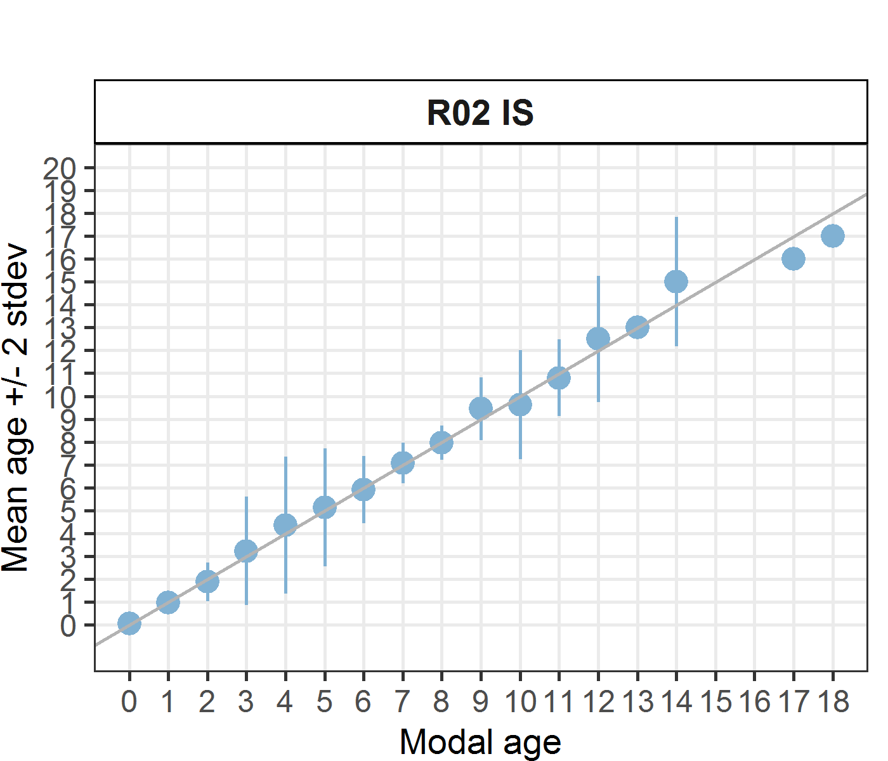 [[2]] 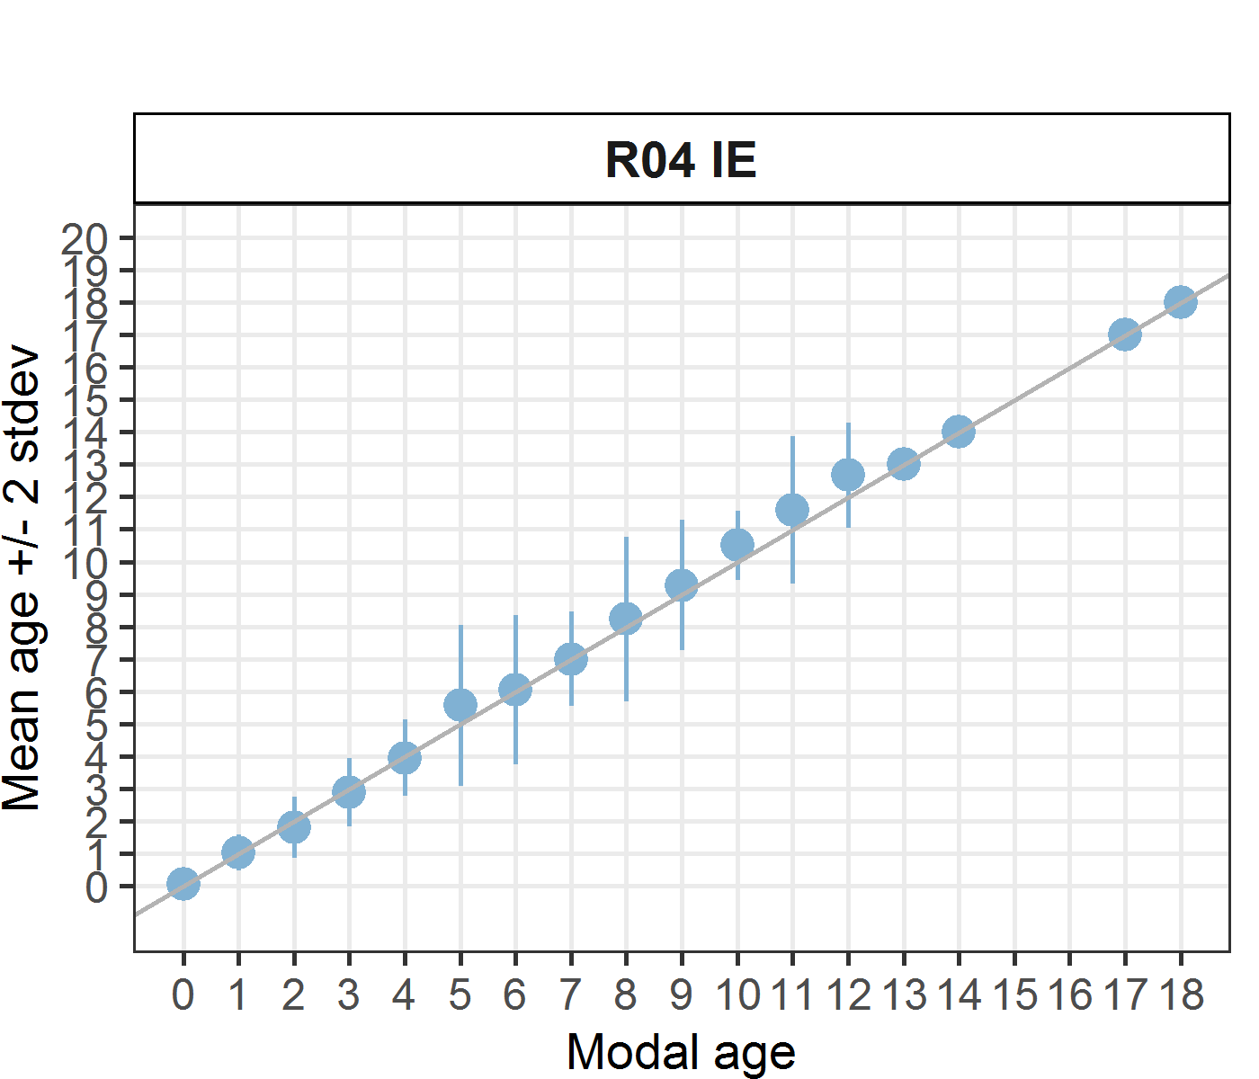 [[3]] 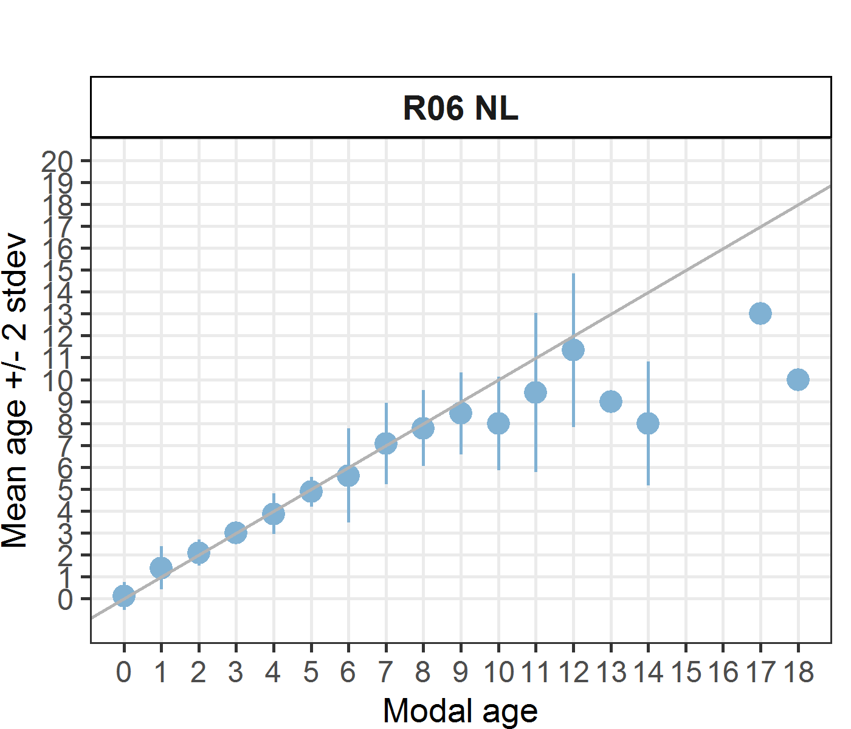 [[4]] 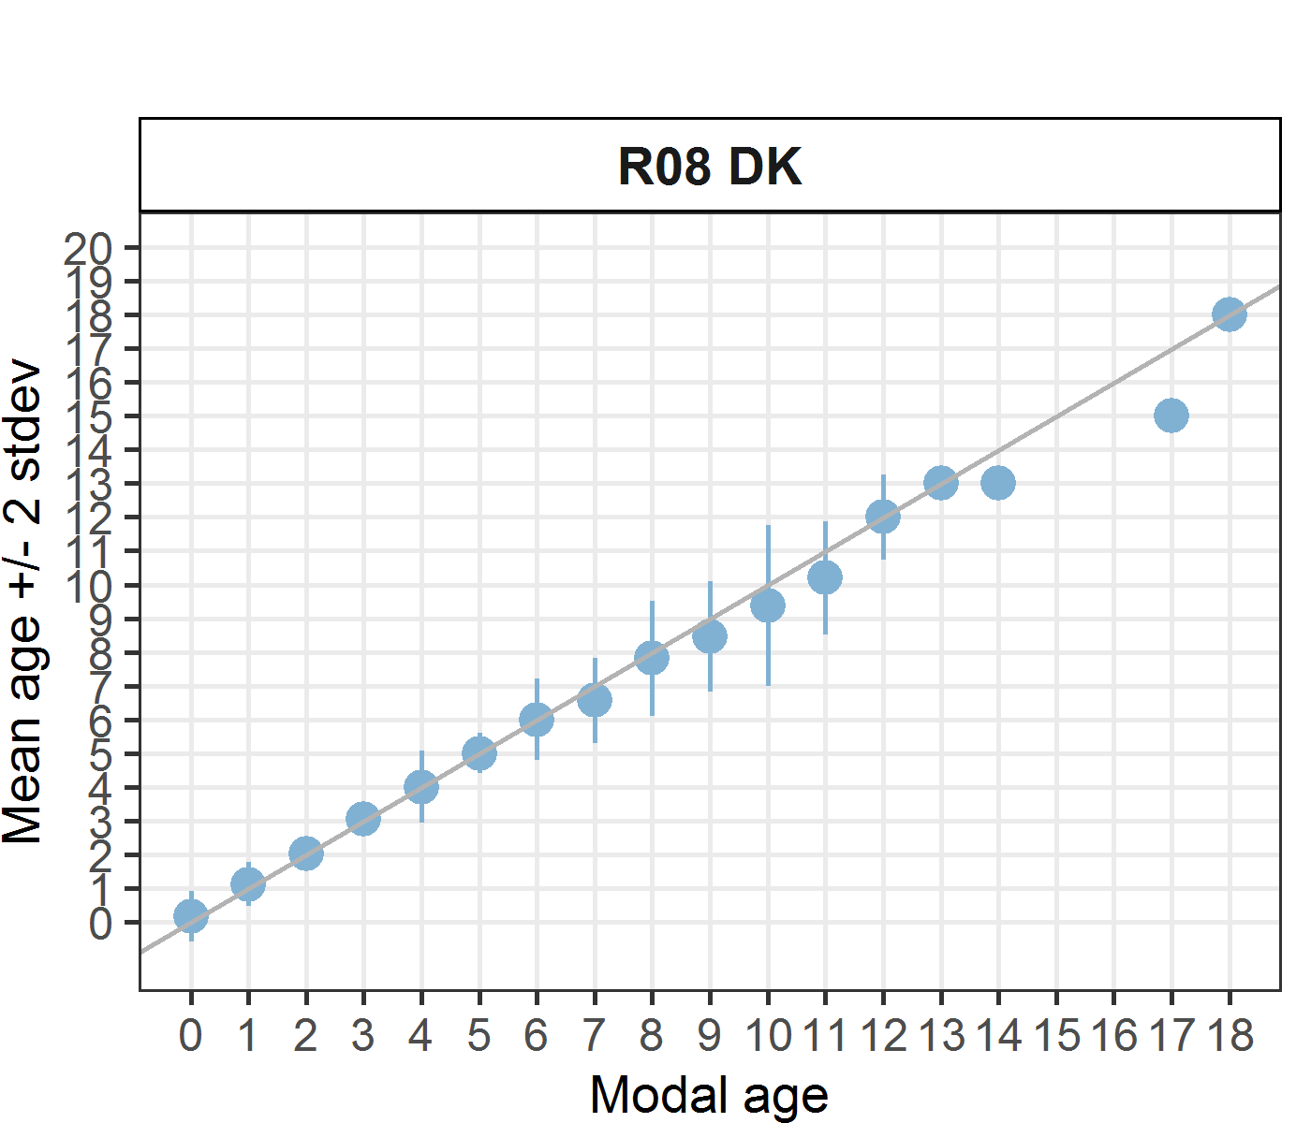 [[5]] 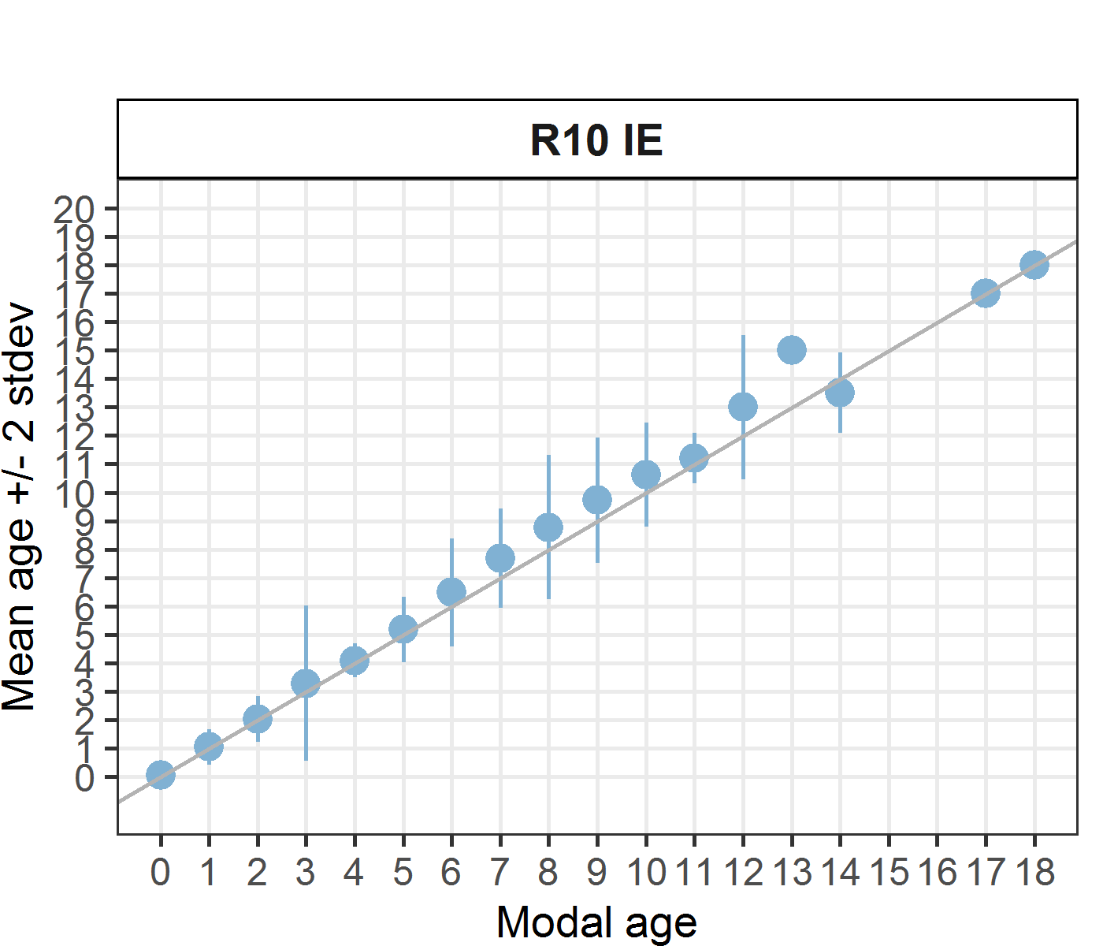 [[6]] 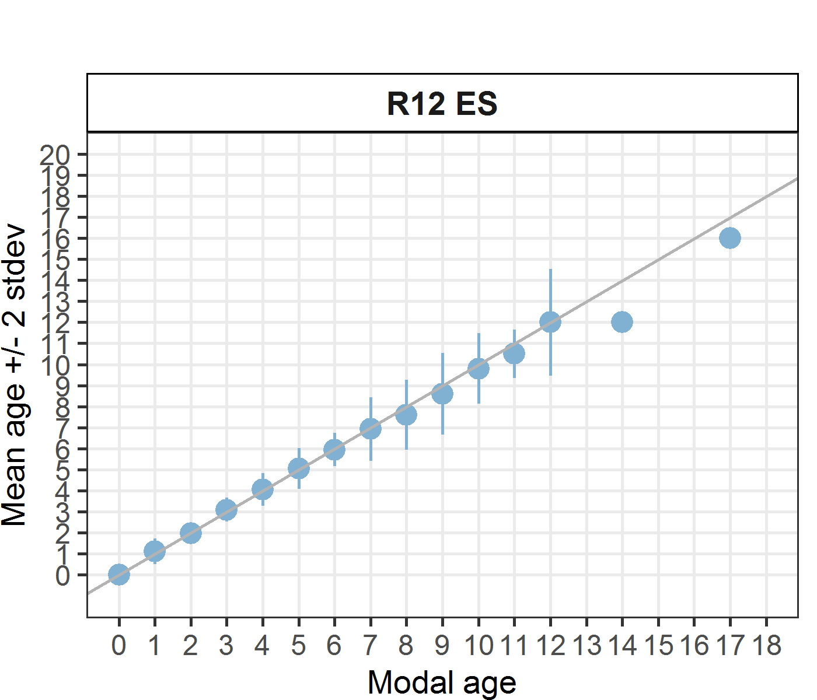 [[7]] 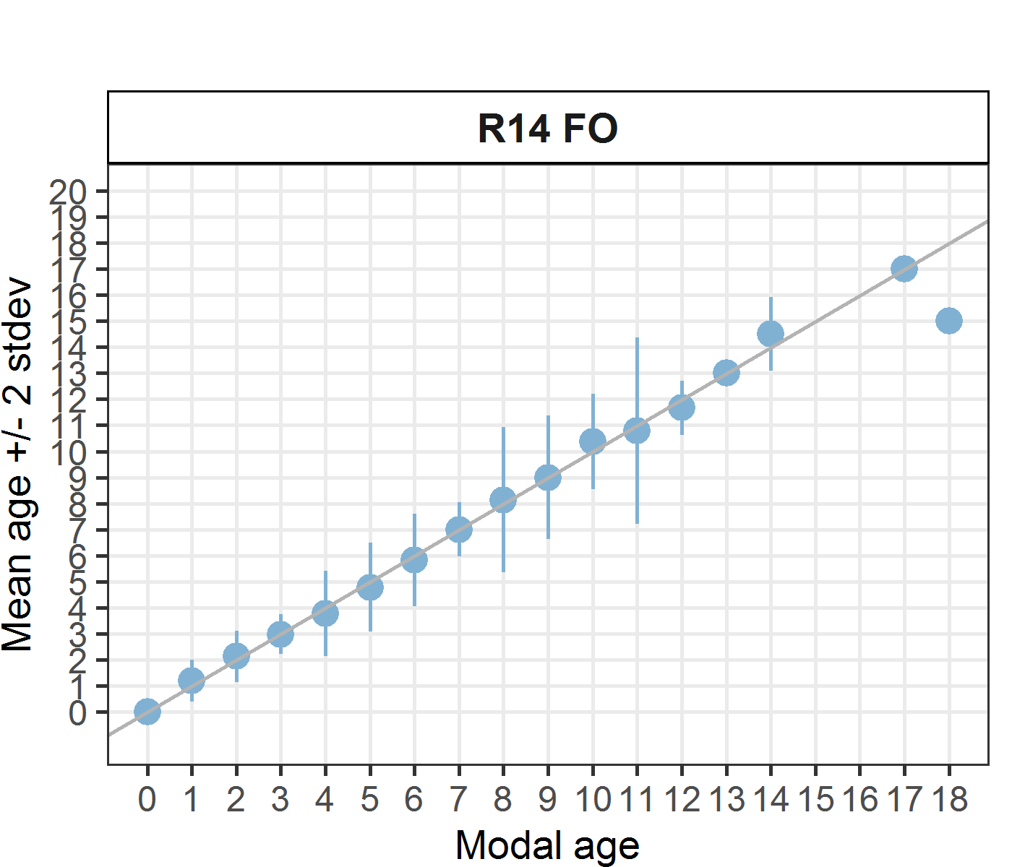 [[8]] 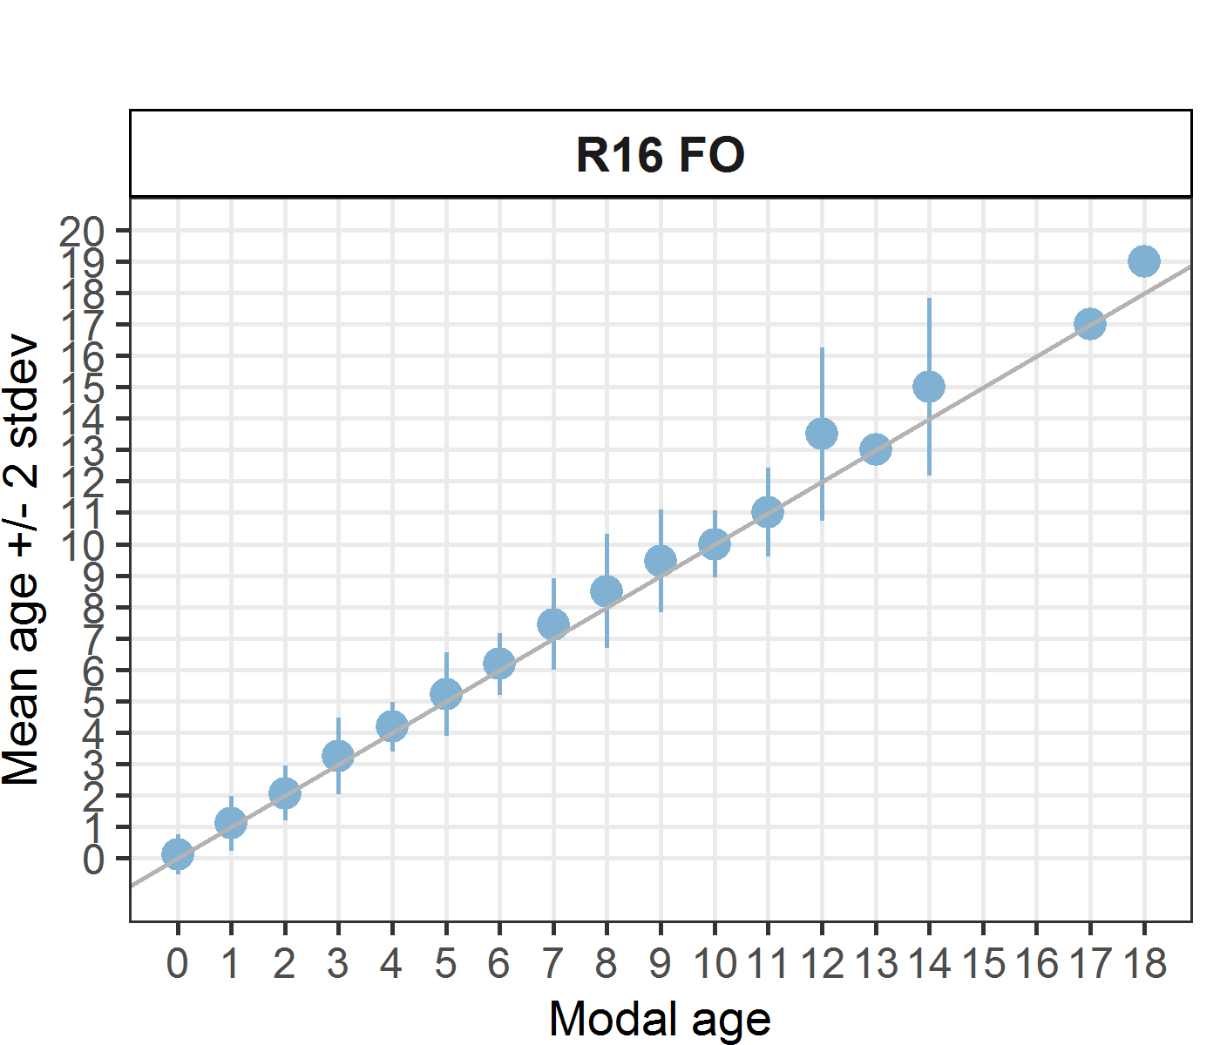 [[9]] 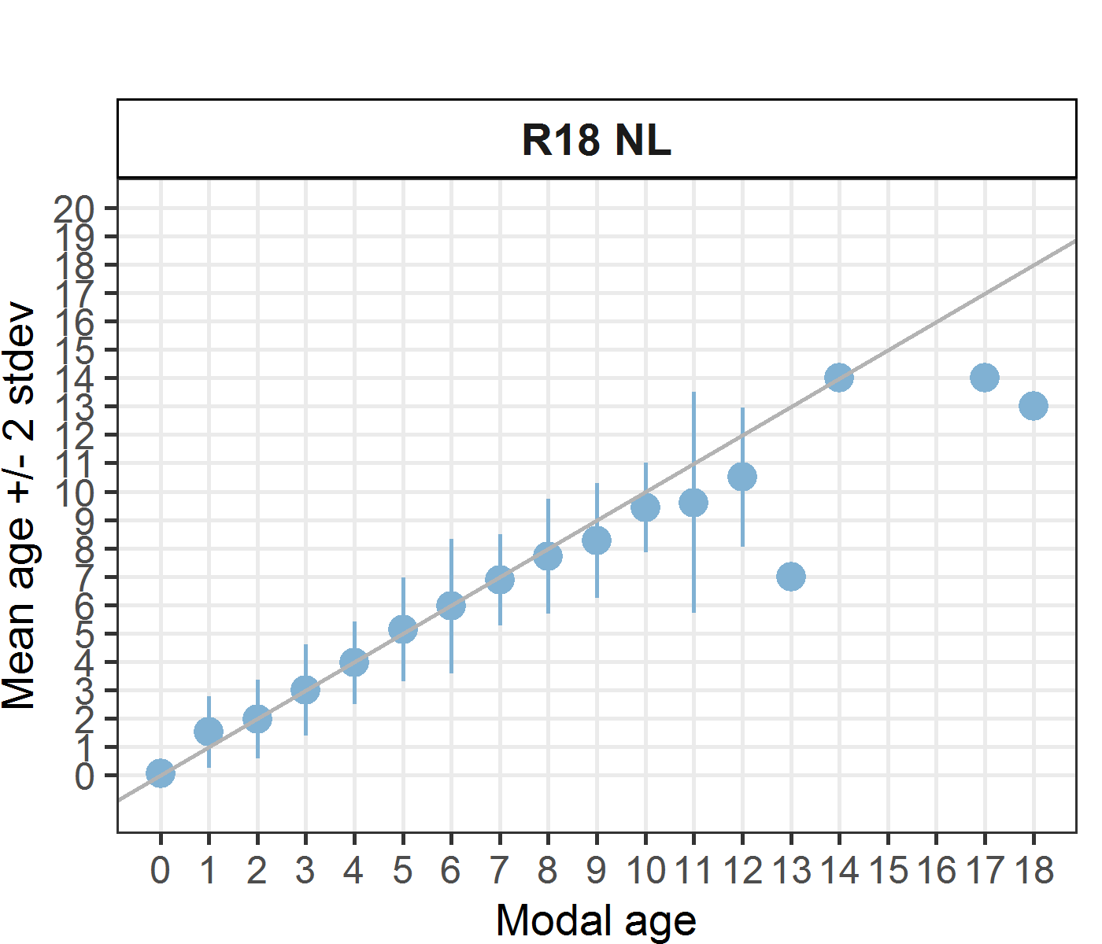 [[10]] 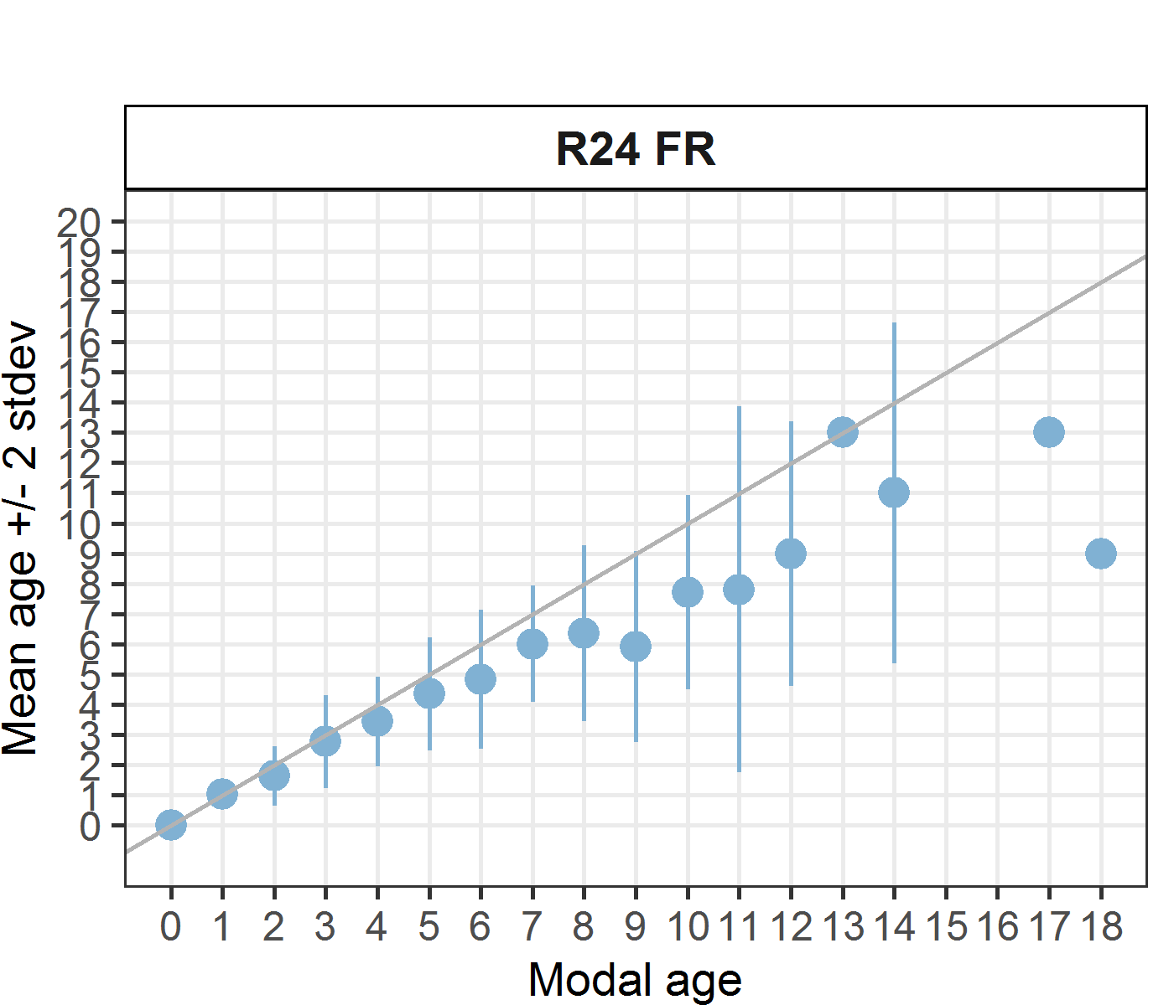 [[11]] 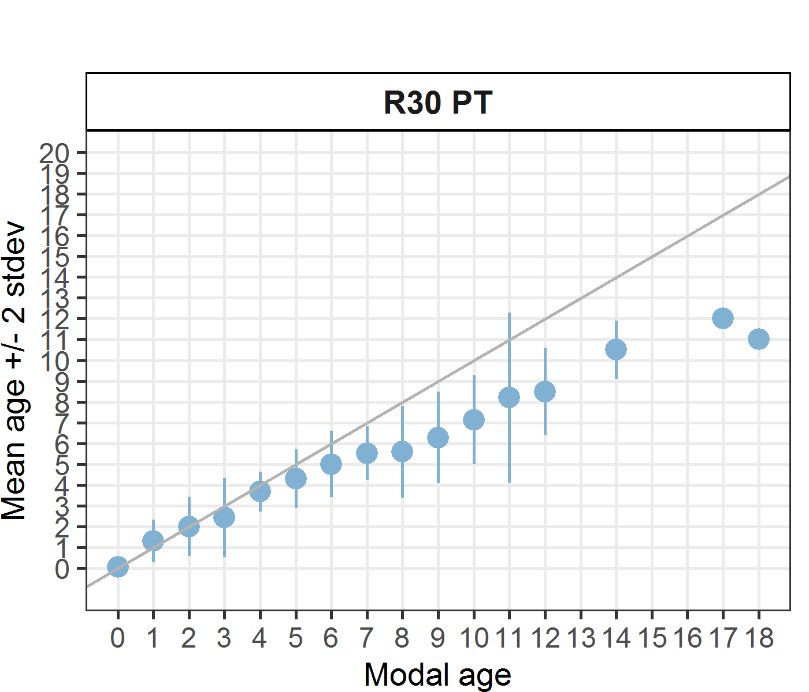 [[12]] 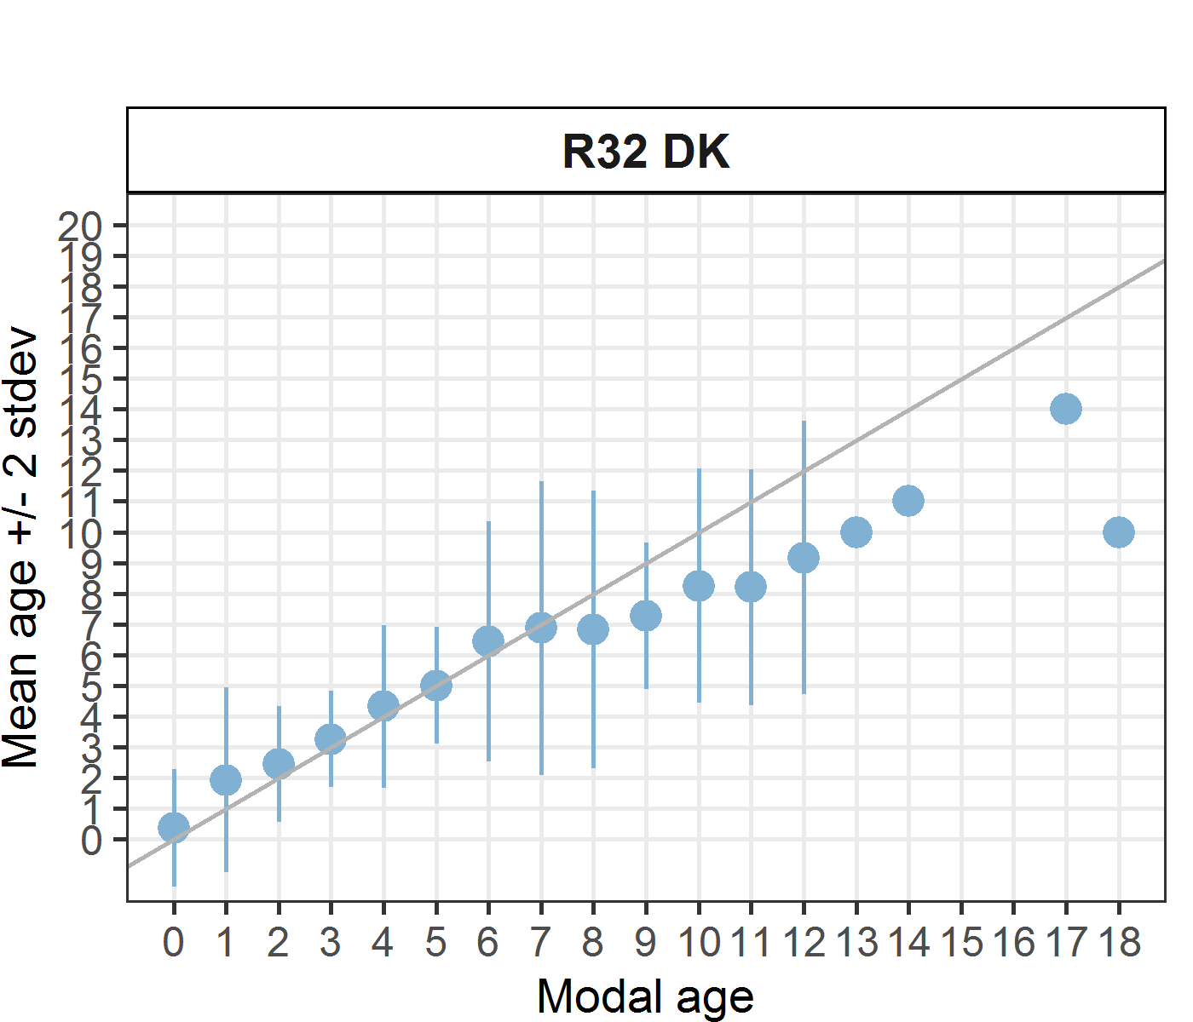 [[13]] 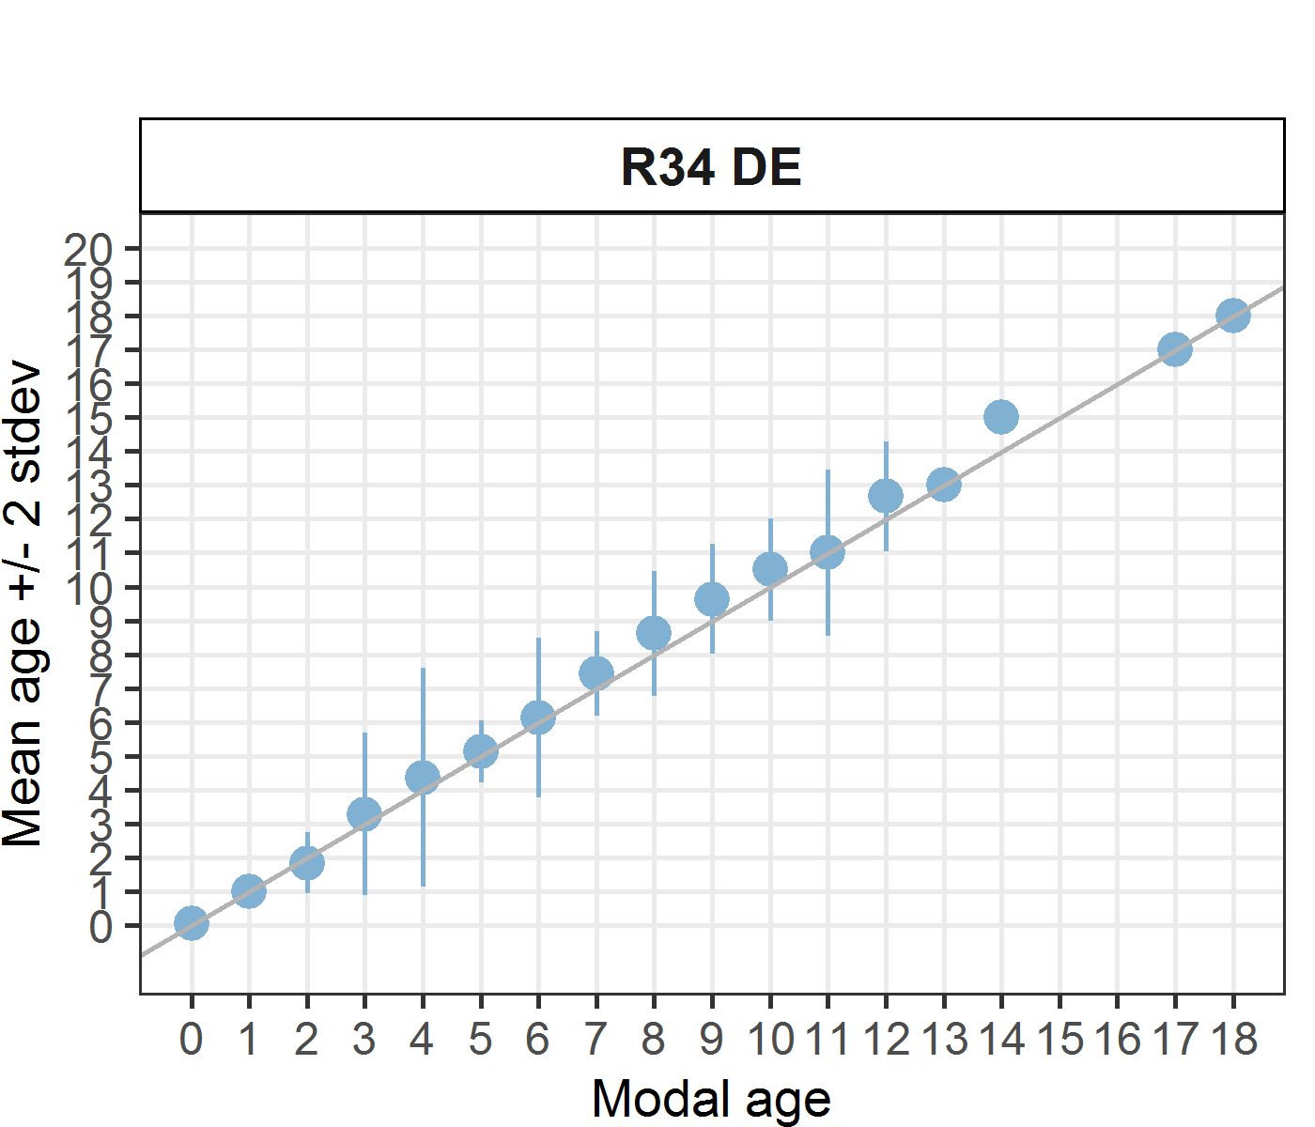 [[14]] 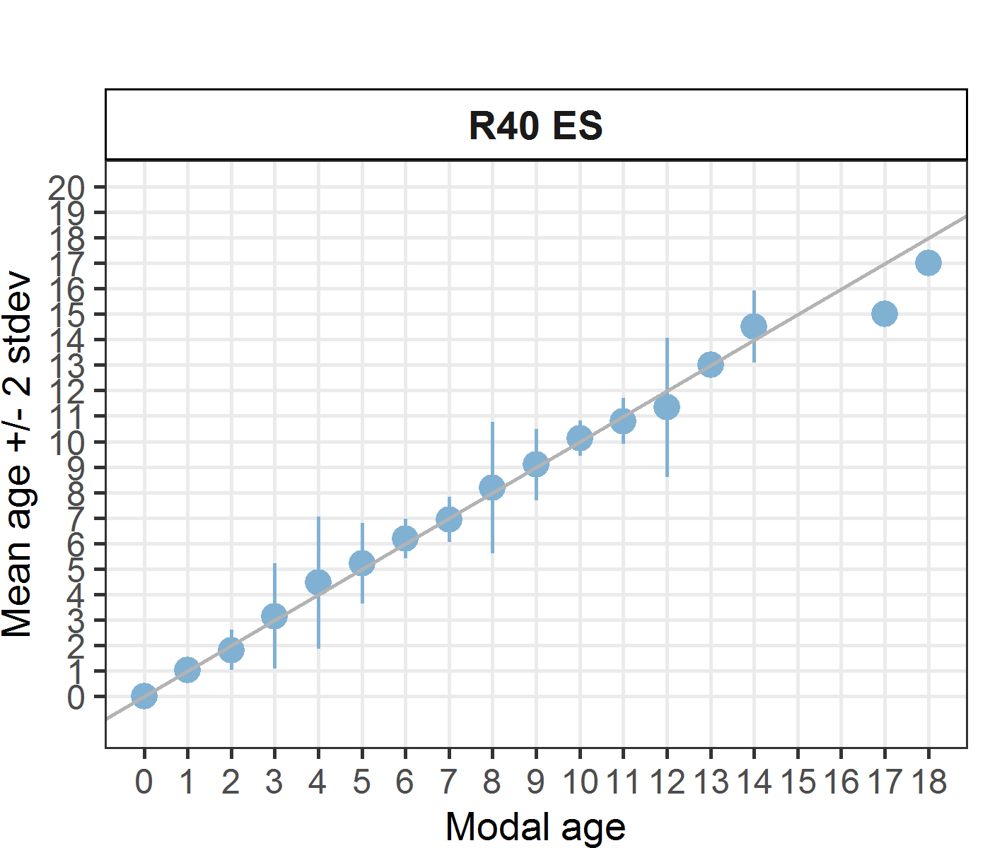 [[15]] 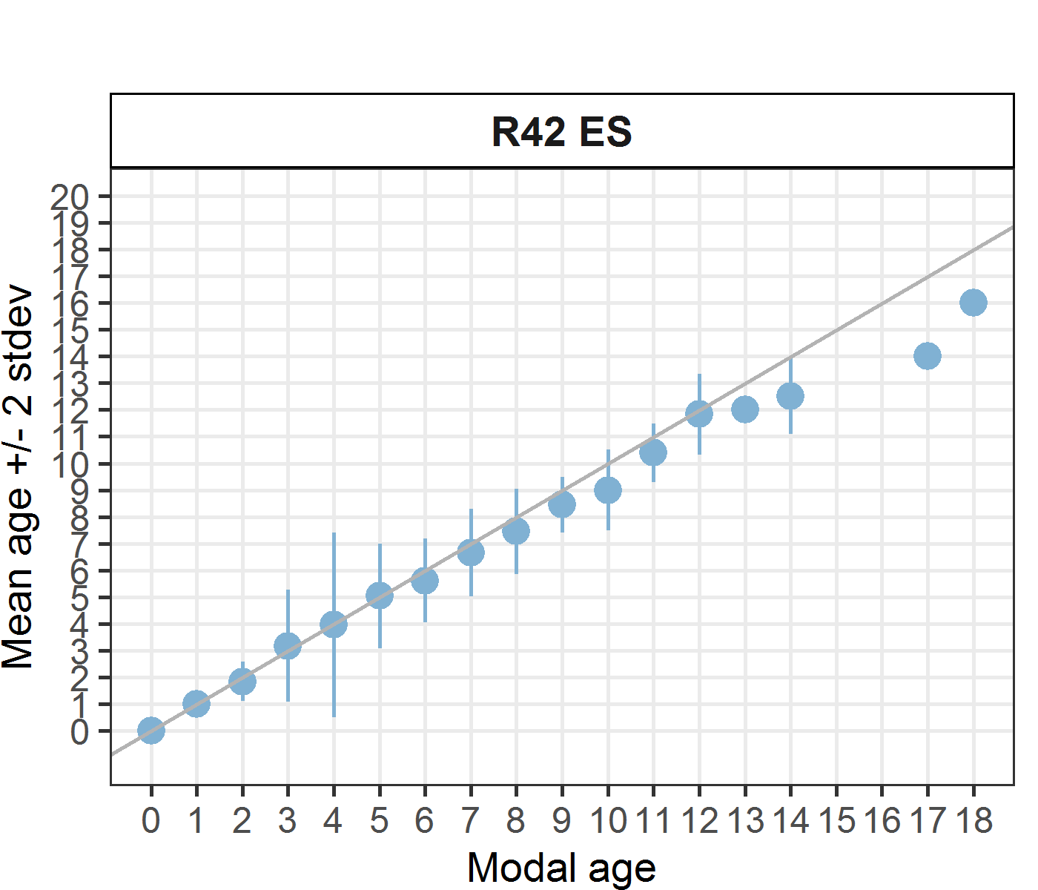

*Statistics by modal age plot (STDEV, CV and PA)*

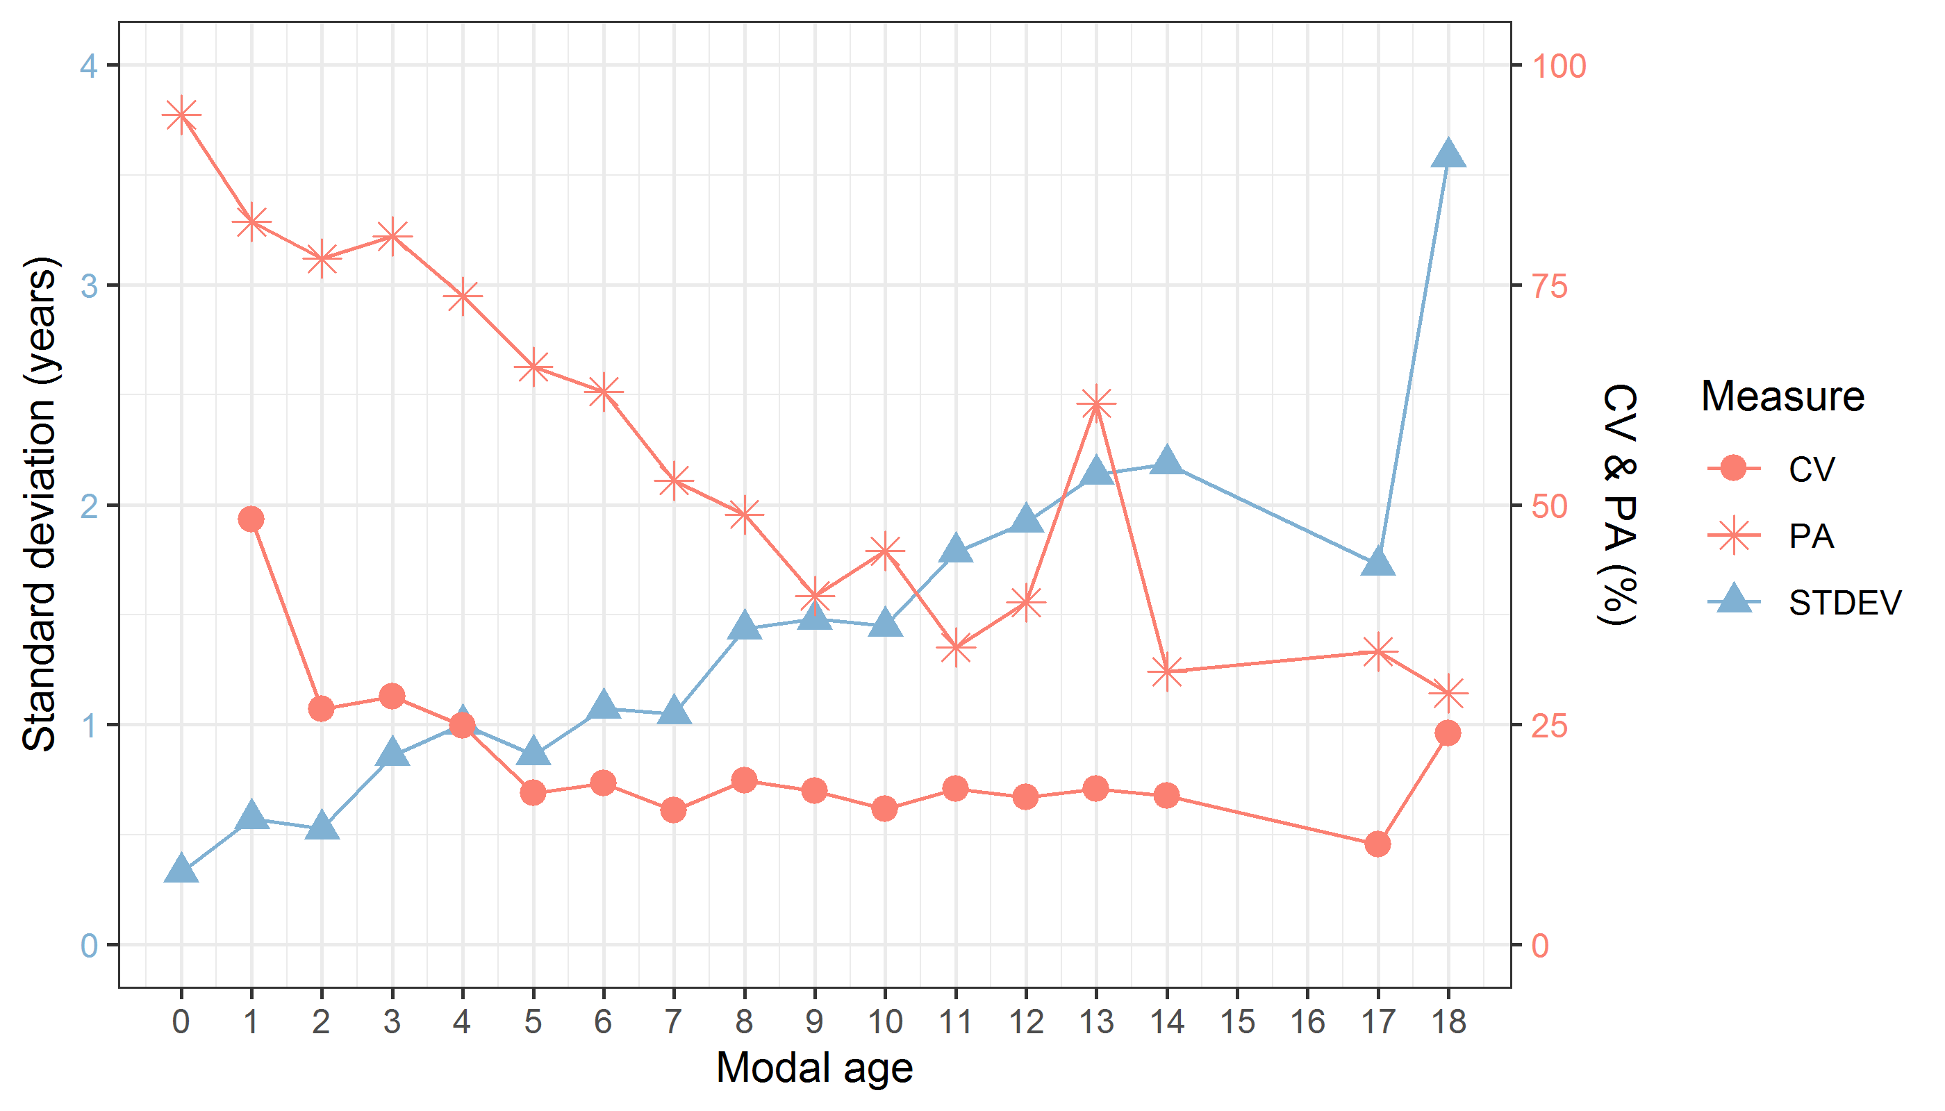

**Figure X:** CV, PA and (STDEV (standard deviation) are plotted against modal age

*Distribution of age reading errors*

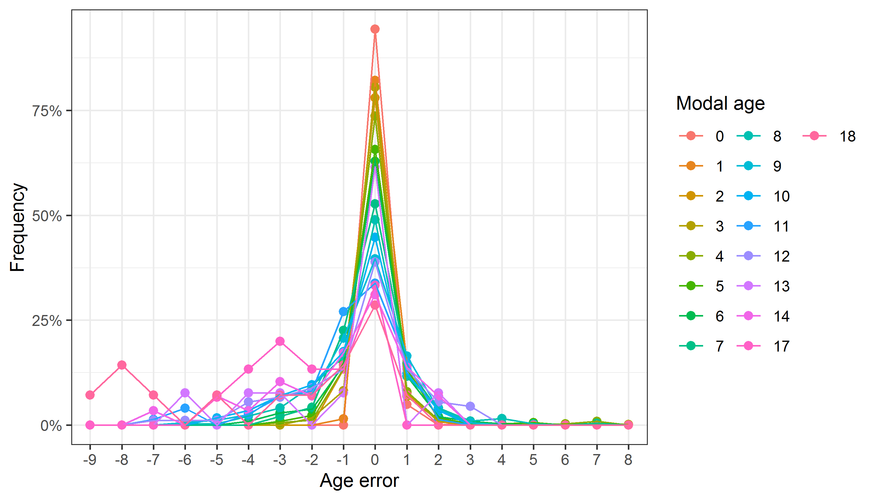

**Figure X:** The distribution of the age reading errors in percentage by modal age as observed from the whole group of age readers in an age reading comparison to modal age. The achieved precision in age reading by MODAL age group is shown by the spread of the age readings errors. There appears to be no relative bias, if the age reading errors are normally distributed. The distributions are skewed, if relative bias occurs.

*Relative bias for all readers*

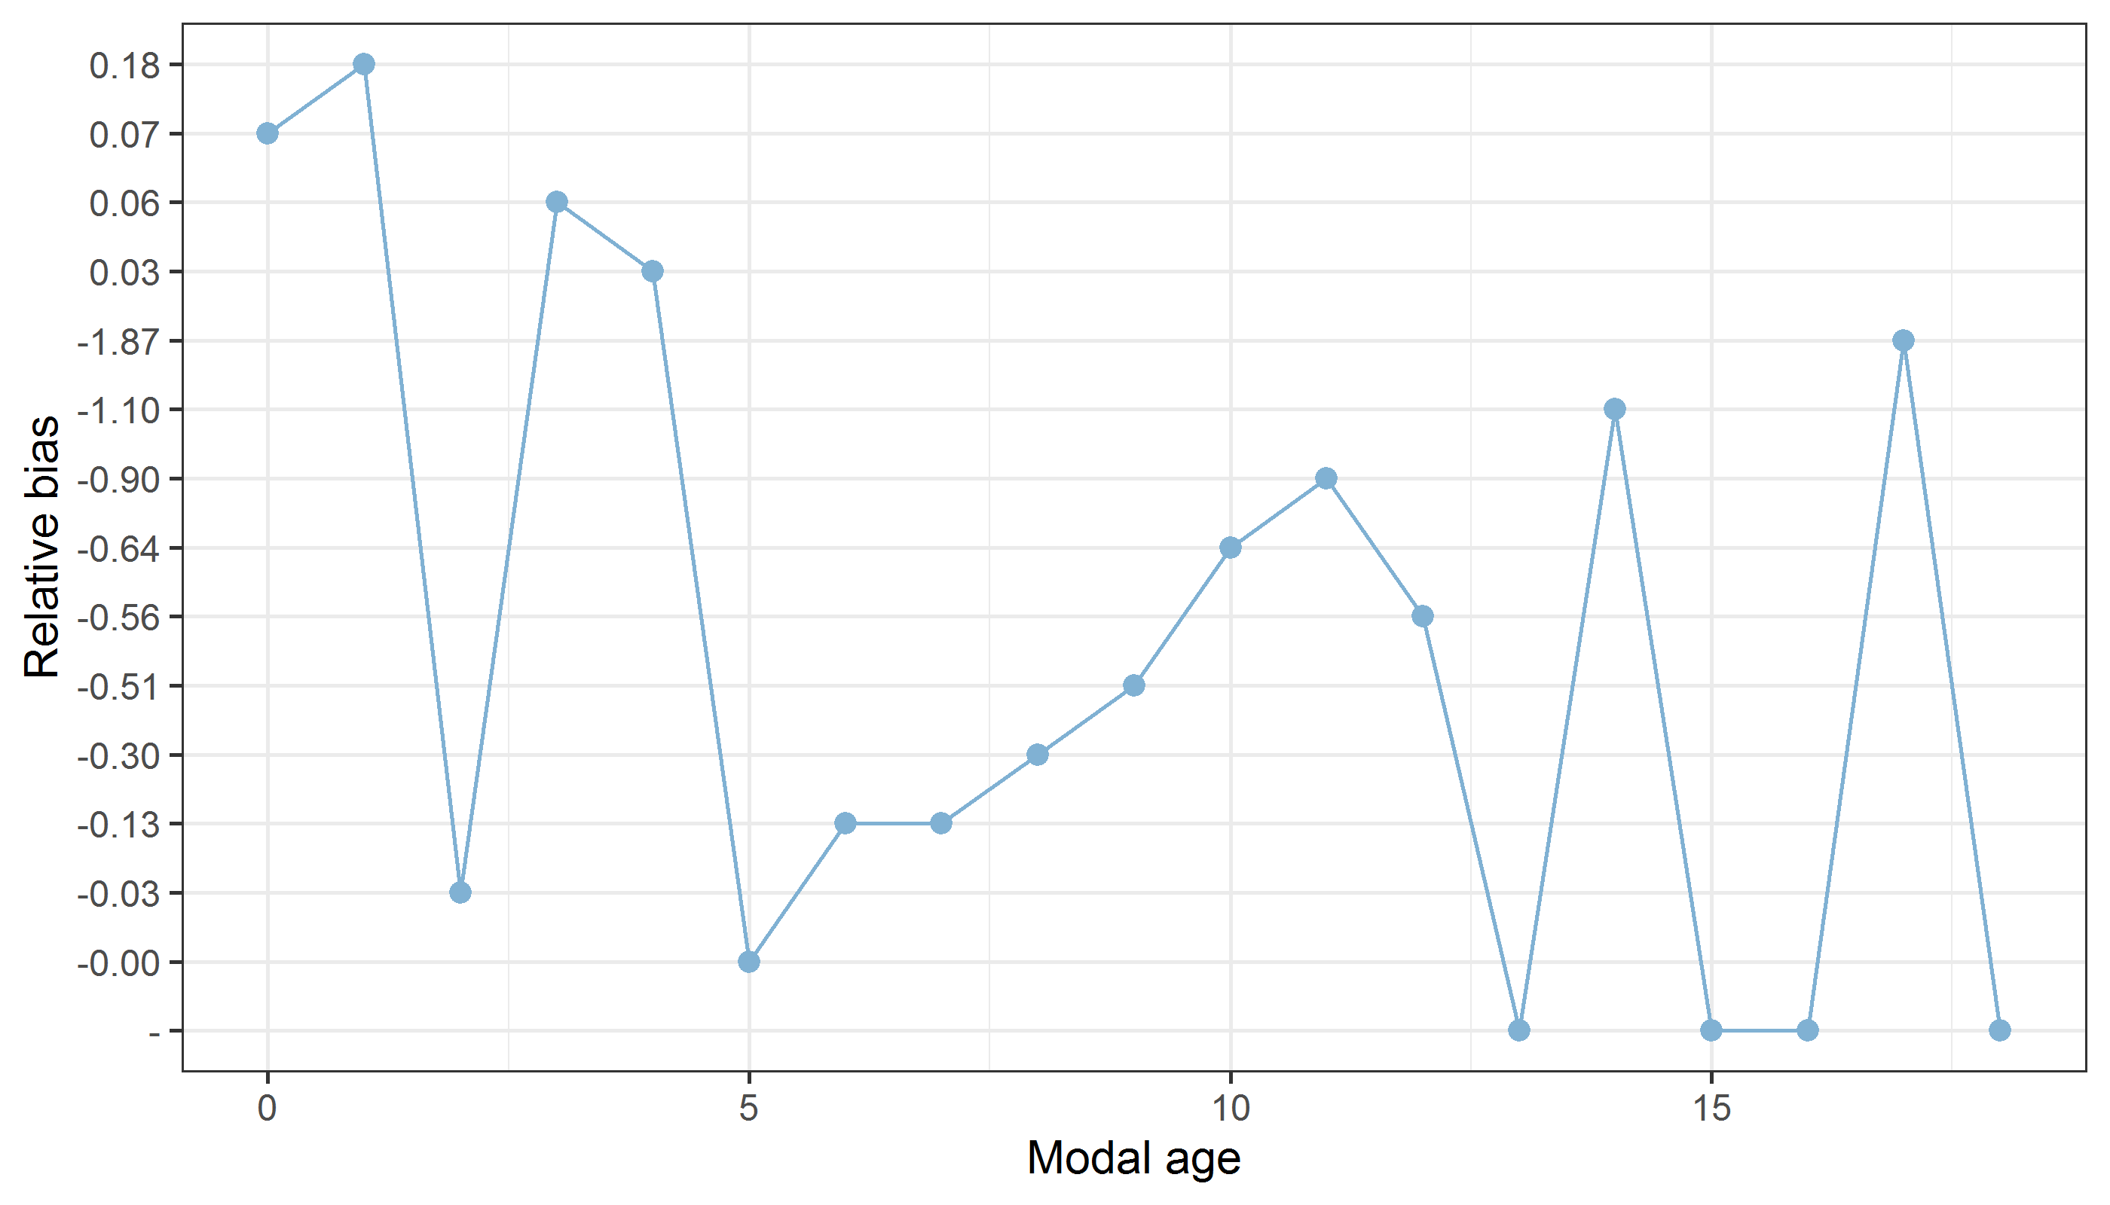

**Figure X:** The relative bias by modal age as estimated by all age readers combined.

*Mean length at age by reader*

**Table X:** Mean fish length at age per reader is calculated per reader and age (not modal age) and for all readers combined per age. A weighted mean is also given.

|  |  |  |  |  |  |  |  |  |  |  |  |  |  |  |  |
| --- | --- | --- | --- | --- | --- | --- | --- | --- | --- | --- | --- | --- | --- | --- | --- |
| **Age** | **R02 IS** | **R04 IE** | **R06 NL** | **R08 DK** | **R10 IE** | **R12 ES** | **R14 FO** | **R16 FO** | **R18 NL** | **R24 FR** | **R30 PT** | **R32 DK** | **R34 DE** | **R40 ES** | **R42 ES** |
| 0 | 187 mm | 191 mm | 186 mm | 184 mm | 185 mm | 189 mm | 189 mm | 187 mm | 187 mm | 189 mm | 186 mm | 183 mm | 185 mm | 189 mm | 189 mm |
| 1 | 265 mm | 261 mm | 243 mm | 253 mm | 260 mm | 257 mm | 253 mm | 255 mm | 235 mm | 272 mm | 255 mm | 245 mm | 264 mm | 264 mm | 266 mm |
| 2 | 289 mm | 296 mm | 285 mm | 288 mm | 285 mm | 284 mm | 289 mm | 291 mm | 291 mm | 289 mm | 300 mm | 291 mm | 289 mm | 288 mm | 287 mm |
| 3 | 312 mm | 311 mm | 316 mm | 312 mm | 314 mm | 314 mm | 296 mm | 308 mm | 298 mm | 307 mm | 313 mm | 295 mm | 313 mm | 311 mm | 309 mm |
| 4 | 226 mm | 216 mm | 222 mm | 228 mm | 245 mm | 243 mm | 240 mm | 251 mm | 281 mm | 290 mm | 276 mm | 273 mm | 238 mm | 214 mm | 237 mm |
| 5 | 272 mm | 286 mm | 281 mm | 296 mm | 288 mm | 266 mm | 296 mm | 274 mm | 291 mm | 310 mm | 320 mm | 283 mm | 255 mm | 286 mm | 285 mm |
| 6 | 331 mm | 317 mm | 351 mm | 329 mm | 306 mm | 333 mm | 351 mm | 319 mm | 302 mm | 344 mm | 348 mm | 333 mm | 342 mm | 330 mm | 349 mm |
| 7 | 354 mm | 370 mm | 362 mm | 337 mm | 337 mm | 344 mm | 333 mm | 362 mm | 324 mm | 314 mm | 359 mm | 308 mm | 321 mm | 324 mm | 329 mm |
| 8 | 342 mm | 335 mm | 337 mm | 380 mm | 355 mm | 326 mm | 353 mm | 356 mm | 366 mm | 292 mm | 295 mm | 368 mm | 333 mm | 366 mm | 342 mm |
| 9 | 383 mm | 352 mm | 355 mm | 386 mm | 322 mm | 378 mm | 376 mm | 307 mm | 355 mm | 398 mm | 158 mm | 341 mm | 379 mm | 378 mm | 378 mm |
| 10 | 378 mm | 384 mm | 396 mm | 340 mm | 387 mm | 332 mm | 388 mm | 394 mm | 317 mm | 407 mm | 405 mm | 355 mm | 377 mm | 346 mm | 402 mm |
| 11 | 391 mm | 395 mm | 402 mm | 409 mm | 388 mm | 424 mm | 318 mm | 396 mm | 380 mm | 39 mm | 408 mm | 325 mm | 386 mm | 351 mm | 398 mm |
| 12 | 127 mm | 288 mm | 166 mm | 134 mm | 350 mm | 267 mm | 243 mm | 285 mm | 298 mm | 39 mm | 415 mm | 365 mm | 298 mm | 398 mm | 181 mm |
| 13 | 207 mm | 306 mm | 227 mm | 308 mm | 281 mm | - | 374 mm | 206 mm | 410 mm | 401 mm | - | 365 mm | 151 mm | 278 mm | 222 mm |
| 14 | 405 mm | 287 mm | - | - | 227 mm | 39 mm | 415 mm | 222 mm | 412 mm | - | - | 400 mm | 420 mm | 405 mm | 415 mm |
| 15 | 420 mm | - | - | 415 mm | 206 mm | - | 408 mm | 230 mm | - | - | - | - | 410 mm | 415 mm | - |
| 16 | 415 mm | - | - | - | - | 415 mm | - | 415 mm | - | - | - | - | - | - | 410 mm |
| 17 | 410 mm | 415 mm | - | - | 415 mm | - | 415 mm | 415 mm | - | - | - | - | 415 mm | 410 mm | - |
| 18 | - | 410 mm | - | 410 mm | 410 mm | - | - | - | - | - | - | - | 410 mm | - | - |
| 19 | - | - | - | - | - | - | - | 410 mm | - | - | - | - | - | - | - |
| **Weighted Mean** | **295 mm** | **295 mm** | **295 mm** | **295 mm** | **295 mm** | **287 mm** | **295 mm** | **295 mm** | **294 mm** | **294 mm** | **295 mm** | **295 mm** | **295 mm** | **295 mm** | **295 mm** |

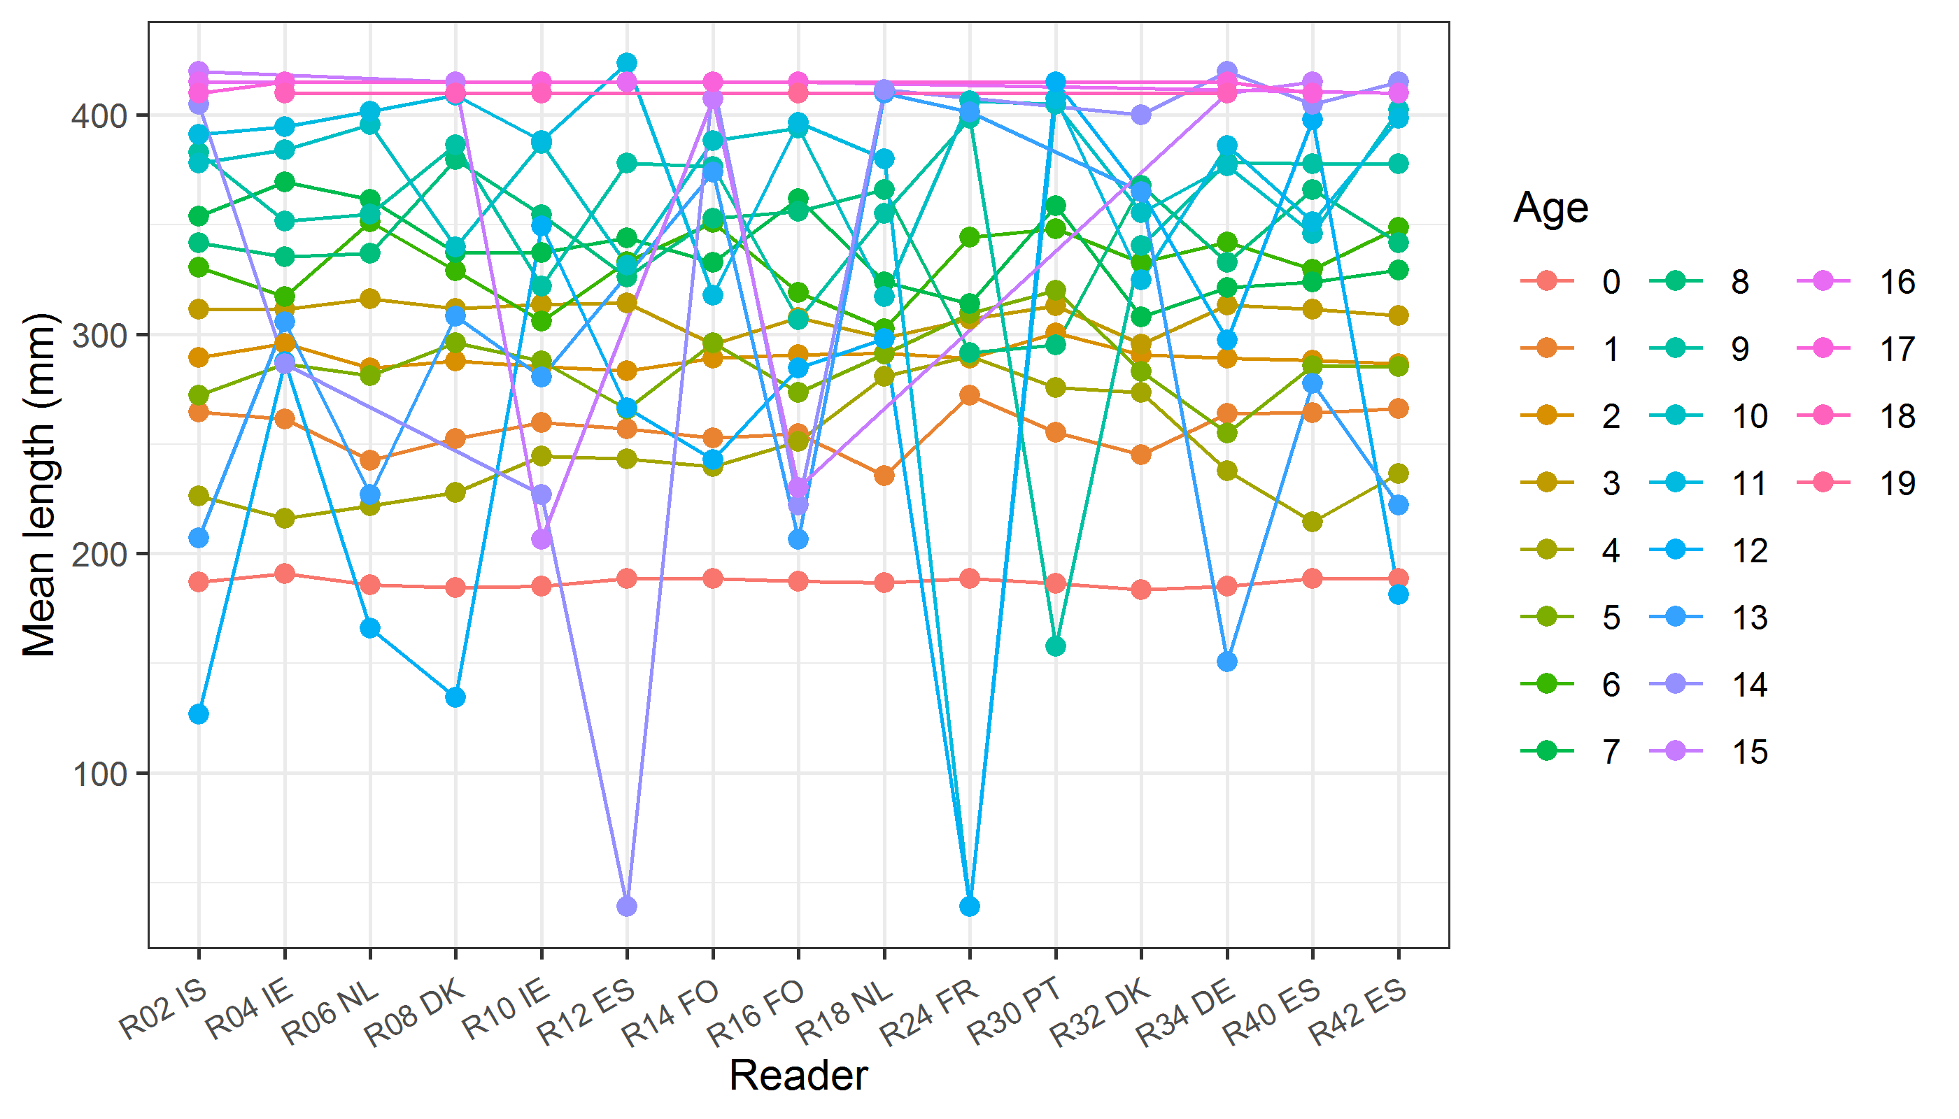

**Figure X:** The mean fish length at age as estimated by each age reader.

## Results Advanced readers

**All samples included**

*Summary statistics*

**Table X:** Summary of statistics; PA (%), CV (%) and APE (%).

|  |  |  |  |
| --- | --- | --- | --- |
| **NSample** | **CV** | **PA** | **APE** |
| 268 | 21 % | 73 % | 11 % |

*Data overview*

**Table X:** Data overview including modal age and statistics per sample.

|  |  |  |  |  |  |  |  |  |  |  |  |  |  |  |  |  |  |  |  |  |
| --- | --- | --- | --- | --- | --- | --- | --- | --- | --- | --- | --- | --- | --- | --- | --- | --- | --- | --- | --- | --- |
| **Fish ID** | **Sample ID** | **Event ID** | **Image ID** | **length** | **sex** | **Catch date** | **ICES area** | **R02 IS** | **R04 IE** | **R06 NL** | **R08 DK** | **R10 IE** | **R12 ES** | **R14 FO** | **R16 FO** | **R18 NL** | **Modal age** | **PA %** | **CV %** | **APE %** |
| 300 | Mac_24_1_6A_60071_013 | 1888 | - | 39 |  | 12/02/2024 00:00:00 | 27.6.a | 12 | 12 | 12 | 12 | 13 | 12 | 12 | 12 | 9 | 12 | 78 | 9 | 5 |
| 301 | Mac_24_1_6A_60071_014 | 1888 | - | 34 |  | 12/02/2024 00:00:00 | 27.6.a | 4 | 4 | 4 | 4 | 4 | 4 | 3 | 4 | 4 | 4 | 89 | 9 | 5 |
| 302 | Mac_24_1_6A_60071_015 | 1888 | - | 39 |  | 12/02/2024 00:00:00 | 27.6.a | 12 | 12 | 12 | 13 | 15 | 14 | 12 | 13 | 10 | 12 | 44 | 11 | 8 |
| 303 | Mac_24_1_6A_60071_016 | 1888 | - | 35 |  | 12/02/2024 00:00:00 | 27.6.a | 5 | 6 | 5 | 5 | 5 | 5 | 4 | 4 | 5 | 5 | 67 | 12 | 8 |
| 304 | Mac_24_1_6A_60071_017 | 1888 | - | 36 |  | 12/02/2024 00:00:00 | 27.6.a | 5 | 5 | 5 | 5 | 5 | 5 | 4 | 5 | 5 | 5 | 89 | 7 | 4 |
| 305 | Mac_24_1_6A_60071_018 | 1888 | - | 37 |  | 12/02/2024 00:00:00 | 27.6.a | 7 | 8 | 9 | 7 | 9 | 8 | 8 | 9 | 7 | 7 | 33 | 11 | 8 |
| 306 | Mac_24_1_6A_60071_020 | 1888 | - | 33 |  | 12/02/2024 00:00:00 | 27.6.a | 4 | 4 | 4 | 4 | 4 | 4 | 3 | 4 | 3 | 4 | 78 | 12 | 9 |
| 307 | Mac_24_1_6A_60071_021 | 1888 | - | 39 |  | 12/02/2024 00:00:00 | 27.6.a | 12 | 13 | 13 | 12 | 14 | 12 | 12 | 14 | 12 | 12 | 56 | 7 | 6 |
| 308 | Mac_24_1_6A_60071_022 | 1888 | - | 37 |  | 12/02/2024 00:00:00 | 27.6.a | 8 | 8 | 8 | 7 | 8 | 8 | 7 | 8 | 7 | 8 | 67 | 7 | 6 |
| 309 | Mac_24_1_6A_60077_004 | 1888 | - | 35 |  | 14/02/2024 00:00:00 | 27.6.a | 6 | 6 | 6 | 6 | 6 | 6 | 5 | 6 | 6 | 6 | 89 | 6 | 3 |
| 310 | Mac_24_1_6A_60077_006 | 1888 | - | 35 |  | 14/02/2024 00:00:00 | 27.6.a | 4 | 4 | 4 | 4 | 4 | 4 | 5 | 5 | 4 | 4 | 78 | 10 | 8 |
| 311 | Mac_24_1_6A_60077_007 | 1888 | - | 36 |  | 14/02/2024 00:00:00 | 27.6.a | 5 | 6 | 5 | 5 | 6 | 6 | 5 | 6 | 6 | 6 | 56 | 9 | 9 |
| 312 | Mac_24_1_6A_60077_010 | 1888 | - | 33 |  | 14/02/2024 00:00:00 | 27.6.a | 4 | 4 | 4 | 4 | 4 | 4 | 4 | 4 | 3 | 4 | 89 | 9 | 5 |
| 313 | Mac_24_1_6A_60077_011 | 1888 | - | 37 |  | 14/02/2024 00:00:00 | 27.6.a | 8 | 9 | 8 | 10 | 9 | 5 | 12 | 9 | 8 | 8 | 33 | 22 | 15 |
| 314 | Mac_24_1_6A_60077_012 | 1888 | - | 38 |  | 14/02/2024 00:00:00 | 27.6.a | 5 | 5 | 5 | 5 | 5 | 5 | 6 | 5 | 6 | 5 | 78 | 8 | 7 |
| 315 | Mac_24_1_6A_60084_011 | 1888 | - | 36 |  | 15/02/2024 00:00:00 | 27.6.a | 4 | 4 | 4 | 4 | 4 | 4 | 4 | 4 | 6 | 4 | 89 | 16 | 9 |
| 316 | Mac_24_1_6A_60084_012 | 1888 | - | 40 |  | 15/02/2024 00:00:00 | 27.6.a | 13 | 14 | 8 | 12 | 12 | 10 | 11 | 15 | 10 | 12 | 22 | 19 | 15 |
| 317 | Mac_24_1_6A_60084_013 | 1888 | - | 38 |  | 15/02/2024 00:00:00 | 27.6.a | 6 | 6 | 7 | 6 | 7 | 7 | 7 | 6 | 7 | 7 | 56 | 8 | 8 |
| 318 | Mac_24_1_6A_60084_017 | 1888 | - | 34 |  | 15/02/2024 00:00:00 | 27.6.a | 4 | 4 | 4 | 4 | 5 | 4 | 4 | 4 | 4 | 4 | 89 | 8 | 5 |
| 319 | Mac_24_1_6A_60213_031 | 1888 | - | 35 |  | 05/03/2024 00:00:00 | 27.6.a | 5 | 5 | 5 | 5 | 6 | 5 | 4 | 5 | 5 | 5 | 78 | 10 | 4 |
| 320 | Mac_24_1_6A_60213_034 | 1888 | - | 36 |  | 05/03/2024 00:00:00 | 27.6.a | 4 | 4 | 4 | 4 | 4 | 4 | 3 | 4 | 4 | 4 | 89 | 9 | 5 |
| 321 | Mac_24_1_6A_60614_031 | 1888 | - | 35 |  | 10/04/2024 00:00:00 | 27.6.a | 4 | 4 | 4 | 4 | 4 | 5 | 4 | 5 | 5 | 4 | 67 | 12 | 10 |
| MACex2024_268 | MACex2024_268 | 1888 | - | 270 | M | 09/05/2019 00:00:00 | 27.2.a | 3 | 3 | 3 | 3 | 3 | 3 | 2 | 3 | 2 | 3 | 78 | 16 | 12 |
| MACex2024_269 | MACex2024_269 | 1888 | - | 370 | F | 09/05/2019 00:00:00 | 27.2.a | 11 | 10 | 9 | 10 | 9 | 9 | 10 | 9 | 8 | 9 | 44 | 9 | 8 |
| MACex2024_270 | MACex2024_270 | 1888 | - | 240 | F | 09/05/2019 00:00:00 | 27.2.a | 2 | 2 | 2 | 2 | 2 | 2 | 2 | 2 | 1 | 2 | 89 | 18 | 10 |
| MACex2024_271 | MACex2024_271 | 1888 | - | 280 | F | 09/05/2019 00:00:00 | 27.2.a | 3 | 3 | 3 | 3 | 3 | 3 | 3 | 3 | 2 | 3 | 89 | 12 | 7 |
| MACex2024_272 | MACex2024_272 | 1888 | - | 310 | F | 09/05/2019 00:00:00 | 27.2.a | 3 | 3 | 3 | 3 | 3 | 3 | 3 | 3 | 3 | 3 | 100 | 0 | 0 |
| MACex2024_273 | MACex2024_273 | 1888 | - | 300 | M | 09/05/2019 00:00:00 | 27.2.a | 3 | 3 | 3 | 3 | 3 | 3 | 3 | 3 | 3 | 3 | 100 | 0 | 0 |
| MACex2024_274 | MACex2024_274 | 1888 | - | 230 | M | 09/05/2019 00:00:00 | 27.2.a | 2 | 2 | 2 | 2 | 2 | 2 | 2 | 2 | 1 | 2 | 89 | 18 | 10 |
| MACex2024_275 | MACex2024_275 | 1888 | - | 290 | F | 09/05/2019 00:00:00 | 27.2.a | 3 | 3 | 3 | 3 | 3 | 3 | 3 | 3 | 3 | 3 | 100 | 0 | 0 |
| MACex2024_276 | MACex2024_276 | 1888 | - | 280 | F | 09/05/2019 00:00:00 | 27.2.a | 3 | 3 | 3 | 3 | 3 | 3 | 3 | 3 | 2 | 3 | 89 | 12 | 7 |
| MACex2024_277 | MACex2024_277 | 1888 | - | 250 | F | 09/05/2019 00:00:00 | 27.2.a | 2 | 2 | 2 | 2 | 2 | 2 | 2 | 2 | 1 | 2 | 89 | 18 | 10 |
| MACex2024_278 | MACex2024_278 | 1888 | - | 260 | M | 11/05/2019 00:00:00 | 27.2.a | 2 | 2 | 2 | 2 | 2 | 2 | 2 | 2 | 1 | 2 | 89 | 18 | 10 |
| MACex2024_279 | MACex2024_279 | 1888 | - | 340 | F | 11/05/2019 00:00:00 | 27.2.a | 8 | 8 | 7 | 7 | 8 | 8 | 7 | 8 | 6 | 8 | 56 | 10 | 8 |
| MACex2024_280 | MACex2024_280 | 1888 | - | 360 | M | 11/05/2019 00:00:00 | 27.2.a | 5 | 6 | 5 | 5 | 5 | 5 | 6 | 7 | 6 | 5 | 56 | 13 | 11 |
| MACex2024_281 | MACex2024_281 | 1888 | - | 240 | M | 11/05/2019 00:00:00 | 27.2.a | 2 | 2 | 2 | 2 | 2 | 2 | 2 | 2 | 1 | 2 | 89 | 18 | 10 |
| MACex2024_282 | MACex2024_282 | 1888 | - | 220 | M | 11/05/2019 00:00:00 | 27.2.a | 1 | 0 | 2 | 1 | 1 | 1 | 1 | 1 | 0 | 1 | 67 | 68 | 44 |
| MACex2024_283 | MACex2024_283 | 1888 | - | 280 | M | 11/05/2019 00:00:00 | 27.2.a | 3 | 3 | 3 | 3 | 3 | 3 | 3 | 3 | 2 | 3 | 89 | 12 | 7 |
| MACex2024_284 | MACex2024_284 | 1888 | - | 160 |  | 11/05/2019 00:00:00 | 27.2.a | 1 | 1 | 1 | 1 | 0 | 1 | 1 | 1 | 0 | 1 | 78 | 57 | 44 |
| MACex2024_285 | MACex2024_285 | 1888 | - | 390 | F | 11/05/2019 00:00:00 | 27.2.a | 8 | 8 | 8 | 8 | 8 | 7 | 7 | 8 | 10 | 8 | 67 | 11 | 6 |
| MACex2024_286 | MACex2024_286 | 1888 | - | 360 | M | 11/05/2019 00:00:00 | 27.2.a | 8 | 8 | 7 | 7 | 7 | - | 7 | 7 | 6 | 7 | 62 | 9 | 6 |
| MACex2024_287 | MACex2024_287 | 1888 | - | 330 | F | 11/05/2019 00:00:00 | 27.2.a | 4 | 5 | 5 | 5 | 5 | 5 | 4 | 5 | 4 | 5 | 67 | 11 | 10 |
| MACex2024_288 | MACex2024_288 | 1888 | - | 177 | F | 29/11/2019 00:00:00 | 27.7.j | 0 | 1 | - | 0 | 0 | 0 | 0 | 0 | 0 | 0 | 88 | - | - |
| MACex2024_289 | MACex2024_289 | 1888 | - | 285 | M | 29/11/2019 00:00:00 | 27.7.j | 1 | 3 | 2 | 2 | 1 | 2 | 2 | 3 | 2 | 2 | 56 | 35 | 22 |
| MACex2024_290 | MACex2024_290 | 1888 | - | 337 | M | 29/11/2019 00:00:00 | 27.7.j | 3 | 3 | 3 | 3 | 3 | 3 | 3 | 3 | 3 | 3 | 100 | 0 | 0 |
| MACex2024_291 | MACex2024_291 | 1888 | - | 274 | M | 29/11/2019 00:00:00 | 27.7.j | 1 | 1 | 1 | 1 | 1 | 1 | 1 | 1 | 2 | 1 | 89 | 30 | 18 |
| MACex2024_292 | MACex2024_292 | 1888 | - | 291 | F | 29/11/2019 00:00:00 | 27.7.j | 1 | 1 | 2 | 2 | 1 | 1 | 1 | 1 | 2 | 1 | 67 | 38 | 33 |
| MACex2024_293 | MACex2024_293 | 1888 | - | 273 | F | 03/12/2019 00:00:00 | 27.7.f | 1 | 1 | 2 | 2 | 1 | 1 | 1 | 1 | 2 | 1 | 67 | 38 | 33 |
| MACex2024_294 | MACex2024_294 | 1888 | - | 260 | F | 03/12/2019 00:00:00 | 27.7.f | 1 | 1 | 1 | 1 | 1 | 1 | 1 | 1 | 2 | 1 | 89 | 30 | 18 |
| MACex2024_295 | MACex2024_295 | 1888 | - | 216 | M | 03/12/2019 00:00:00 | 27.7.f | 0 | 0 | 0 | 0 | 0 | 0 | 0 | 0 | 0 | 0 | 100 | - | - |
| MACex2024_296 | MACex2024_296 | 1888 | - | 236 | F | 03/12/2019 00:00:00 | 27.7.f | 0 | 0 | 0 | 0 | 0 | 0 | 0 | 0 | 1 | 0 | 89 | - | - |
| MACex2024_297 | MACex2024_297 | 1888 | - | 292 | M | 03/12/2019 00:00:00 | 27.7.f | 1 | 1 | 1 | 1 | 1 | 1 | 1 | 1 | 2 | 1 | 89 | 30 | 18 |
| MACex2024_298 | MACex2024_298 | 1888 | - | 309 | M | 10/11/2018 00:00:00 | 27.7.h | 2 | 2 | 2 | 2 | 2 | 2 | 2 | 2 | 2 | 2 | 100 | 0 | 0 |
| MACex2024_299 | MACex2024_299 | 1888 | - | 292 |  | 12/11/2018 00:00:00 | 27.7.h | 1 | 1 | 2 | 2 | 1 | 1 | 2 | 1 | 2 | 1 | 56 | 36 | 34 |
| MACex2024_300 | MACex2024_300 | 1888 | - | 207 | M | 13/11/2018 00:00:00 | 27.7.h | 0 | 0 | 0 | 1 | 0 | 0 | 0 | 0 | 0 | 0 | 89 | - | - |
| MACex2024_301 | MACex2024_301 | 1888 | - | 161 |  | 14/11/2018 00:00:00 | 27.7.h | 0 | 0 | 0 | 0 | 0 | 0 | 0 | 0 | 0 | 0 | 100 | - | - |
| MACex2024_302 | MACex2024_302 | 1888 | - | 170 | M | 14/11/2018 00:00:00 | 27.7.h | 0 | 0 | 0 | 0 | 0 | 0 | 0 | 0 | 0 | 0 | 100 | - | - |
| MACex2024_303 | MACex2024_303 | 1888 | - | 305 |  | 31/10/2019 00:00:00 | 27.8.a | 2 | 1 | 2 | 2 | 2 | - | 3 | 2 | 3 | 2 | 62 | 30 | 21 |
| MACex2024_304 | MACex2024_304 | 1888 | - | 297 | F | 31/10/2019 00:00:00 | 27.8.a | 1 | 1 | 2 | 1 | 1 | 2 | 2 | 1 | 2 | 1 | 56 | 36 | 34 |
| MACex2024_305 | MACex2024_305 | 1888 | - | 239 | M | 31/10/2019 00:00:00 | 27.8.a | 3 | 1 | 2 | 2 | 1 | 2 | 3 | 3 | 4 | 2 | 33 | 43 | 35 |
| MACex2024_306 | MACex2024_306 | 1888 | - | 306 | F | 31/10/2019 00:00:00 | 27.8.a | 1 | 1 | 2 | 1 | 1 | - | 2 | 2 | 2 | 1 | 50 | 36 | 33 |
| MACex2024_307 | MACex2024_307 | 1888 | - | 282 | F | 31/10/2019 00:00:00 | 27.8.a | 2 | 2 | 2 | 2 | 2 | - | 2 | 1 | 2 | 2 | 88 | 19 | 12 |
| MACex2024_308 | MACex2024_308 | 1888 | - | 276 | F | 31/10/2019 00:00:00 | 27.8.a | - | 1 | 2 | 2 | 1 | - | 1 | 1 | 2 | 1 | 57 | 37 | 34 |
| MACex2024_309 | MACex2024_309 | 1888 | - | 249 | F | 31/10/2019 00:00:00 | 27.8.a | 1 | 1 | 1 | 1 | 1 | 1 | 1 | 1 | 2 | 1 | 89 | 30 | 18 |
| MACex2024_310 | MACex2024_310 | 1888 | - | 256 | M | 31/10/2019 00:00:00 | 27.8.a | 1 | 1 | 1 | 1 | 1 | 2 | 2 | 1 | 2 | 1 | 67 | 38 | 33 |
| MACex2024_311 | MACex2024_311 | 1888 | - | 199 |  | 31/10/2019 00:00:00 | 27.8.a | 0 | 0 | 0 | 0 | 0 | 0 | 0 | 0 | 0 | 0 | 100 | - | - |
| MACex2024_312 | MACex2024_312 | 1888 | - | 214 | F | 31/10/2019 00:00:00 | 27.8.a | 0 | 0 | 0 | 0 | 0 | 0 | 0 | 0 | 0 | 0 | 100 | - | - |
| MACex2024_313 | MACex2024_313 | 1888 | - | 277 | M | 11/09/2019 00:00:00 | 27.4.b | 1 | 1 | 1 | 1 | 1 | 1 | 1 | 1 | 2 | 1 | 89 | 30 | 18 |
| MACex2024_314 | MACex2024_314 | 1888 | - | 289 | M | 11/09/2019 00:00:00 | 27.4.b | 1 | 1 | 2 | 1 | 1 | 1 | 1 | 1 | 2 | 1 | 78 | 36 | 28 |
| MACex2024_315 | MACex2024_315 | 1888 | - | 295 | F | 11/09/2019 00:00:00 | 27.4.b | 1 | 1 | 1 | 1 | 1 | 1 | 1 | 1 | 2 | 1 | 89 | 30 | 18 |
| MACex2024_316 | MACex2024_316 | 1888 | - | 296 | F | 11/09/2019 00:00:00 | 27.4.b | 1 | 1 | 2 | 1 | 1 | 1 | 1 | 1 | 2 | 1 | 78 | 36 | 28 |
| MACex2024_317 | MACex2024_317 | 1888 | - | 302 | M | 11/09/2019 00:00:00 | 27.4.b | 1 | 1 | 2 | 1 | 1 | 1 | 1 | 1 | 2 | 1 | 78 | 36 | 28 |
| MACex2024_318 | MACex2024_318 | 1888 | - | 305 | F | 11/09/2019 00:00:00 | 27.4.b | 2 | 2 | 2 | 2 | 2 | - | 2 | 2 | 2 | 2 | 100 | 0 | 0 |
| MACex2024_319 | MACex2024_319 | 1888 | - | 303 | M | 11/09/2019 00:00:00 | 27.4.b | 2 | 2 | 3 | 2 | 2 | 2 | 2 | 3 | 3 | 2 | 67 | 21 | 19 |
| MACex2024_320 | MACex2024_320 | 1888 | - | 304 | M | 11/09/2019 00:00:00 | 27.4.b | 2 | 2 | 2 | 2 | 3 | - | 3 | 1 | 2 | 2 | 62 | 30 | 21 |
| MACex2024_321 | MACex2024_321 | 1888 | - | 310 | M | 11/09/2019 00:00:00 | 27.4.b | 2 | 1 | 2 | 2 | 2 | 2 | 2 | 2 | 2 | 2 | 89 | 18 | 10 |
| MACex2024_322 | MACex2024_322 | 1888 | - | 334 | M | 11/09/2019 00:00:00 | 27.4.b | 3 | 3 | 3 | 3 | 3 | 3 | 3 | 4 | 3 | 3 | 89 | 11 | 6 |
| MACex2024_323 | MACex2024_323 | 1888 | - | 336 | F | 11/09/2019 00:00:00 | 27.4.b | 3 | 4 | 3 | 3 | 4 | 4 | 3 | 3 | 4 | 3 | 56 | 15 | 14 |
| MACex2024_324 | MACex2024_324 | 1888 | - | 333 | M | 11/09/2019 00:00:00 | 27.4.b | 3 | 3 | 3 | 3 | 3 | 3 | 3 | 3 | 3 | 3 | 100 | 0 | 0 |
| MACex2024_325 | MACex2024_325 | 1888 | - | 353 | F | 11/09/2019 00:00:00 | 27.4.b | 3 | 4 | 3 | 3 | 3 | 3 | 3 | 4 | 4 | 3 | 67 | 15 | 13 |
| MACex2024_326 | MACex2024_326 | 1888 | - | 352 | M | 11/09/2019 00:00:00 | 27.4.b | 6 | 6 | 5 | 5 | 6 | 6 | 5 | 7 | 5 | 6 | 44 | 12 | 10 |
| MACex2024_327 | MACex2024_327 | 1888 | - | 204 | M | 21/01/2020 00:00:00 | 27.4.b | 1 | 1 | 1 | 1 | 1 | 1 | 1 | 1 | 1 | 1 | 100 | 0 | 0 |
| MACex2024_328 | MACex2024_328 | 1888 | - | 212 | F | 21/01/2020 00:00:00 | 27.4.b | 1 | 1 | 1 | 1 | 1 | 1 | 1 | 0 | 1 | 1 | 89 | 38 | 22 |
| MACex2024_329 | MACex2024_329 | 1888 | - | 198 | F | 21/01/2020 00:00:00 | 27.4.b | 1 | 1 | 1 | 1 | 1 | 1 | 1 | 0 | 1 | 1 | 89 | 38 | 22 |
| MACex2024_330 | MACex2024_330 | 1888 | - | 211 | M | 30/01/2020 00:00:00 | 27.4.b | 1 | 1 | 1 | 1 | 1 | 1 | 1 | 1 | 1 | 1 | 100 | 0 | 0 |
| MACex2024_331 | MACex2024_331 | 1888 | - | 286 | F | 30/01/2020 00:00:00 | 27.4.b | 2 | 2 | 2 | 2 | 2 | 2 | 2 | 2 | 2 | 2 | 100 | 0 | 0 |
| MACex2024_332 | MACex2024_332 | 1888 | - | 391 | M | 30/01/2020 00:00:00 | 27.4.b | 8 | 8 | 7 | 6 | 8 | - | 8 | 10 | - | 8 | 57 | 15 | 10 |
| MACex2024_333 | MACex2024_333 | 1888 | - | 242 | F | 20/01/2020 00:00:00 | 27.4.c | 1 | 1 | 1 | 1 | 1 | 1 | 1 | 1 | 1 | 1 | 100 | 0 | 0 |
| MACex2024_334 | MACex2024_334 | 1888 | - | 198 | F | 14/02/2020 00:00:00 | 27.4.c | 1 | 1 | 1 | 1 | 1 | 1 | 1 | 1 | 1 | 1 | 100 | 0 | 0 |
| MACex2024_335 | MACex2024_335 | 1888 | - | 215 | F | 17/02/2020 00:00:00 | 27.4.c | 1 | 1 | 1 | 1 | 1 | 1 | 1 | 1 | 1 | 1 | 100 | 0 | 0 |
| MACex2024_336 | MACex2024_336 | 1888 | - | 195 | M | 17/02/2020 00:00:00 | 27.4.c | 1 | 1 | 1 | 1 | 1 | 1 | 1 | 1 | 1 | 1 | 100 | 0 | 0 |
| MACex2024_337 | MACex2024_337 | 1888 | - | 210 | M | 17/02/2020 00:00:00 | 27.4.c | 1 | 1 | 2 | 1 | 2 | 1 | 1 | 1 | 1 | 1 | 78 | 36 | 28 |
| MACex2024_338 | MACex2024_338 | 1888 | - | 368 | M | 29/04/2019 00:00:00 | 27.6 | 7 | 7 | 8 | 7 | 7 | 8 | 7 | 8 | 8 | 7 | 56 | 7 | 7 |
| MACex2024_339 | MACex2024_339 | 1888 | - | 313 | M | 03/05/2019 00:00:00 | 27.6 | 3 | 2 | 3 | 3 | 3 | 3 | 2 | 3 | 3 | 3 | 78 | 16 | 12 |
| MACex2024_340 | MACex2024_340 | 1888 | - | 358 | M | 03/05/2019 00:00:00 | 27.6 | 4 | 4 | 5 | 4 | 4 | 4 | 4 | 4 | 5 | 4 | 78 | 10 | 8 |
| MACex2024_341 | MACex2024_341 | 1888 | - | 294 | M | 23/07/2019 00:00:00 | 27.6 | 10 | 3 | 3 | 3 | 11 | - | 3 | 4 | 3 | 3 | 62 | 68 | 55 |
| MACex2024_342 | MACex2024_342 | 1888 | - | 323 | F | 23/07/2019 00:00:00 | 27.6 | 10 | 10 | 5 | 6 | 7 | 4 | 5 | 5 | 4 | 5 | 33 | 38 | 30 |
| MACex2024_343 | MACex2024_343 | 1888 | - | 327 | M | 23/07/2019 00:00:00 | 27.6 | 11 | - | 4 | 6 | 4 | - | 3 | 4 | 3 | 4 | 43 | 57 | 40 |
| MACex2024_344 | MACex2024_344 | 1888 | - | 287 | M | 24/07/2019 00:00:00 | 27.6 | 1 | 1 | 1 | 2 | 1 | 1 | 1 | 1 | 2 | 1 | 78 | 36 | 28 |
| MACex2024_345 | MACex2024_345 | 1888 | - | 370 | M | 24/07/2019 00:00:00 | 27.6 | 6 | 6 | 5 | 5 | 5 | - | 5 | 5 | 6 | 5 | 62 | 10 | 9 |
| MACex2024_346 | MACex2024_346 | 1888 | - | 276 | M | 30/09/2019 00:00:00 | 27.6 | 1 | 1 | 1 | 1 | 1 | 1 | 1 | 1 | 1 | 1 | 100 | 0 | 0 |
| MACex2024_347 | MACex2024_347 | 1888 | - | 274 | F | 30/09/2019 00:00:00 | 27.6 | 1 | 1 | 1 | 1 | 1 | 1 | 1 | 1 | 2 | 1 | 89 | 30 | 18 |
| MACex2024_348 | MACex2024_348 | 1888 | - | 345 | F | 17/05/2019 00:00:00 | 27.7.b | 6 | 6 | 3 | 5 | 6 | 6 | 4 | 6 | 5 | 6 | 56 | 21 | 17 |
| MACex2024_349 | MACex2024_349 | 1888 | - | 340 | F | 17/05/2019 00:00:00 | 27.7.b | 4 | 4 | 4 | 4 | 4 | 5 | 4 | 4 | 4 | 4 | 89 | 8 | 5 |
| MACex2024_350 | MACex2024_350 | 1888 | - | 390 | F | 17/05/2019 00:00:00 | 27.7.b | 12 | 13 | 11 | 11 | 12 | 10 | 12 | 11 | 9 | 12 | 33 | 11 | 8 |
| MACex2024_351 | MACex2024_351 | 1888 | - | 315 | F | 17/05/2019 00:00:00 | 27.7.b | 3 | 2 | 3 | 3 | 3 | 3 | 3 | 3 | 3 | 3 | 89 | 12 | 7 |
| MACex2024_352 | MACex2024_352 | 1888 | - | 365 | F | 17/05/2019 00:00:00 | 27.7.b | 6 | 6 | 6 | 6 | 6 | 6 | 6 | 6 | 6 | 6 | 100 | 0 | 0 |
| MACex2024_353 | MACex2024_353 | 1888 | - | 380 | M | 28/01/2020 00:00:00 | 27.5.b | 10 | 11 | 10 | 10 | 11 | 10 | 8 | 11 | 11 | 10 | 44 | 10 | 7 |
| MACex2024_354 | MACex2024_354 | 1888 | - | 313 | M | 28/01/2020 00:00:00 | 27.5.b | 4 | 4 | 4 | 4 | 4 | 4 | 3 | 4 | 3 | 4 | 78 | 12 | 9 |
| MACex2024_355 | MACex2024_355 | 1888 | - | 330 | F | 28/01/2020 00:00:00 | 27.5.b | 4 | 4 | 4 | 4 | 4 | 4 | 4 | 4 | 4 | 4 | 100 | 0 | 0 |
| MACex2024_356 | MACex2024_356 | 1888 | - | 405 | F | 28/01/2020 00:00:00 | 27.5.b | 14 | 14 | 9 | 13 | 13 | - | 15 | 14 | 14 | 14 | 50 | 14 | 9 |
| MACex2024_357 | MACex2024_357 | 1888 | - | 355 | F | 28/01/2020 00:00:00 | 27.5.b | 6 | 6 | 6 | 6 | 6 | 6 | 6 | 6 | 6 | 6 | 100 | 0 | 0 |
| MACex2024_358 | MACex2024_358 | 1888 | - | 350 | F | 28/01/2020 00:00:00 | 27.5.b | 7 | 6 | 7 | 7 | 7 | 7 | 7 | 7 | 6 | 7 | 78 | 7 | 5 |
| MACex2024_359 | MACex2024_359 | 1888 | - | 330 | M | 28/01/2020 00:00:00 | 27.5.b | 4 | 3 | 3 | 4 | 4 | 4 | 3 | 4 | 4 | 4 | 67 | 14 | 12 |
| MACex2024_360 | MACex2024_360 | 1888 | - | 375 | F | 28/01/2020 00:00:00 | 27.5.b | 6 | 6 | 6 | 6 | 6 | 6 | 6 | 6 | 7 | 6 | 89 | 5 | 3 |
| MACex2024_361 | MACex2024_361 | 1888 | - | 395 | M | 28/01/2020 00:00:00 | 27.5.b | 10 | 10 | 10 | 10 | 10 | 10 | 10 | 10 | 10 | 10 | 100 | 0 | 0 |
| MACex2024_362 | MACex2024_362 | 1888 | - | 355 | M | 28/01/2020 00:00:00 | 27.5.b | 6 | 6 | 6 | 7 | 7 | 6 | 6 | 6 | 6 | 6 | 78 | 7 | 6 |
| MACex2024_363 | MACex2024_363 | 1888 | - | 395 | F | 30/07/2020 00:00:00 | 27.2.b | 11 | 12 | 11 | 10 | 11 | - | 12 | 12 | 9 | 11 | 38 | 10 | 7 |
| MACex2024_364 | MACex2024_364 | 1888 | - | 370 | M | 30/07/2020 00:00:00 | 27.2.b | 6 | 6 | 6 | 6 | 6 | 5 | 6 | 6 | 6 | 6 | 89 | 6 | 3 |
| MACex2024_365 | MACex2024_365 | 1888 | - | 395 | F | 30/07/2020 00:00:00 | 27.2.b | 10 | 11 | 9 | 9 | 10 | 10 | 10 | 10 | 9 | 10 | 56 | 7 | 5 |
| MACex2024_366 | MACex2024_366 | 1888 | - | 370 | M | 30/07/2020 00:00:00 | 27.2.b | 5 | 7 | 5 | 5 | 6 | 6 | 6 | 6 | 7 | 6 | 44 | 13 | 10 |
| MACex2024_367 | MACex2024_367 | 1888 | - | 385 | F | 30/07/2020 00:00:00 | 27.2.b | 9 | 9 | 9 | 8 | 12 | 7 | 10 | 11 | 9 | 9 | 44 | 16 | 12 |
| MACex2024_368 | MACex2024_368 | 1888 | - | 385 | F | 30/07/2020 00:00:00 | 27.2.b | 10 | 9 | 9 | 9 | 10 | 7 | 9 | 10 | 9 | 9 | 56 | 10 | 7 |
| MACex2024_369 | MACex2024_369 | 1888 | - | 385 | F | 30/07/2020 00:00:00 | 27.2.b | 9 | 8 | 8 | 8 | 9 | 8 | 8 | 10 | 9 | 8 | 56 | 8 | 7 |
| MACex2024_370 | MACex2024_370 | 1888 | - | 365 | M | 30/07/2020 00:00:00 | 27.2.b | 6 | 6 | 6 | 5 | 7 | 5 | 6 | 7 | 7 | 6 | 44 | 13 | 10 |
| MACex2024_371 | MACex2024_371 | 1888 | - | 370 | F | 30/07/2020 00:00:00 | 27.2.b | 6 | 7 | 6 | 6 | 8 | 6 | 6 | 7 | 7 | 6 | 56 | 11 | 9 |
| MACex2024_372 | MACex2024_372 | 1888 | - | 410 | F | 30/07/2020 00:00:00 | 27.2.b | 17 | 18 | 10 | 18 | 18 | - | 15 | 19 | 13 | 18 | 38 | 19 | 16 |
| MACex2024_373 | MACex2024_373 | 1888 | - | 380 | M | 30/07/2020 00:00:00 | 27.2.b | 9 | 9 | 9 | 8 | 10 | 9 | 9 | 10 | 10 | 9 | 56 | 7 | 6 |
| MACex2024_374 | MACex2024_374 | 1888 | - | 365 | F | 30/07/2020 00:00:00 | 27.2.b | 6 | 6 | 5 | 5 | 5 | 5 | 5 | 6 | 7 | 5 | 56 | 13 | 11 |
| MACex2024_375 | MACex2024_375 | 1888 | - | 380 | M | 30/07/2020 00:00:00 | 27.2.b | 10 | 10 | 7 | 9 | 10 | 9 | 9 | 10 | 10 | 10 | 56 | 11 | 8 |
| MACex2024_376 | MACex2024_376 | 1888 | - | 330 | M | 30/07/2020 00:00:00 | 27.2.b | 4 | 4 | 3 | 3 | 4 | 3 | 4 | 4 | 4 | 4 | 67 | 14 | 12 |
| MACex2024_377 | MACex2024_377 | 1888 | - | 400 | F | 30/07/2020 00:00:00 | 27.2.b | 6 | 9 | 6 | 5 | 6 | 6 | 8 | 6 | 8 | 6 | 56 | 20 | 17 |
| MACex2024_378 | MACex2024_378 | 1888 | - | 370 | M | 30/07/2020 00:00:00 | 27.2.b | 7 | 8 | 6 | 7 | 8 | 6 | 8 | 8 | 7 | 8 | 44 | 12 | 10 |
| MACex2024_379 | MACex2024_379 | 1888 | - | 415 | M | 31/07/2020 00:00:00 | 27.2.b | 16 | 17 | 13 | 15 | 17 | 16 | 17 | 17 | 14 | 17 | 44 | 9 | 8 |
| MACex2024_380 | MACex2024_380 | 1888 | - | 420 | F | 31/07/2020 00:00:00 | 27.2.b | 15 | 13 | 12 | 11 | 12 | 12 | 12 | 15 | 12 | 12 | 56 | 11 | 9 |
| MACex2024_381 | MACex2024_381 | 1888 | - | 395 | F | 31/07/2020 00:00:00 | 27.2.b | 9 | 9 | 8 | 8 | 11 | 9 | 9 | 10 | 9 | 9 | 56 | 10 | 7 |
| MACex2024_382 | MACex2024_382 | 1888 | - | 385 | F | 31/07/2020 00:00:00 | 27.2.b | 10 | 10 | 8 | 9 | 10 | 9 | 10 | 10 | 9 | 10 | 56 | 8 | 7 |
| MACex2024_383 | MACex2024_383 | 1888 | - | 299 | M | 08/01/2019 00:00:00 | 27.9.a | 3 | 2 | 3 | 3 | 3 | 3 | 3 | 3 | 3 | 3 | 89 | 12 | 7 |
| MACex2024_384 | MACex2024_384 | 1888 | - | 305 | M | 08/01/2019 00:00:00 | 27.9.a | 3 | 3 | 3 | 3 | 3 | 4 | 3 | 3 | 3 | 3 | 89 | 11 | 6 |
| MACex2024_385 | MACex2024_385 | 1888 | - | 325 | F | 08/01/2019 00:00:00 | 27.9.a | 3 | 3 | 2 | 3 | 3 | 3 | 3 | 3 | 3 | 3 | 89 | 12 | 7 |
| MACex2024_386 | MACex2024_386 | 1888 | - | 266 | M | 17/01/2019 00:00:00 | 27.9.a | 2 | 2 | 2 | 2 | 2 | 2 | 2 | 2 | 2 | 2 | 100 | 0 | 0 |
| MACex2024_387 | MACex2024_387 | 1888 | - | 295 | M | 17/01/2019 00:00:00 | 27.9.a | 3 | 3 | 3 | 3 | 3 | 3 | 3 | 3 | 3 | 3 | 100 | 0 | 0 |
| MACex2024_388 | MACex2024_388 | 1888 | - | 362 | F | 04/02/2019 00:00:00 | 27.9.a | 7 | 7 | 6 | 7 | 7 | 6 | 5 | 6 | 6 | 7 | 44 | 11 | 9 |
| MACex2024_389 | MACex2024_389 | 1888 | - | 392 | M | 04/02/2019 00:00:00 | 27.9.a | 8 | 9 | 8 | 9 | 10 | - | 6 | 10 | 8 | 8 | 38 | 15 | 12 |
| MACex2024_390 | MACex2024_390 | 1888 | - | 410 | F | 04/02/2019 00:00:00 | 27.9.a | 7 | 11 | 8 | 7 | 10 | - | 11 | 10 | 10 | 10 | 38 | 18 | 16 |
| MACex2024_391 | MACex2024_391 | 1888 | - | 325 | M | 18/01/2019 00:00:00 | 27.9.a | 3 | 2 | 3 | 6 | 6 | - | 4 | 6 | 3 | 3 | 38 | 40 | 34 |
| MACex2024_392 | MACex2024_392 | 1888 | - | 365 | M | 02/04/2019 00:00:00 | 27.9.a | 2 | 3 | 4 | 5 | 5 | 5 | 3 | 5 | 5 | 5 | 56 | 28 | 24 |
| MACex2024_393 | MACex2024_393 | 1888 | - | 378 | F | 02/04/2019 00:00:00 | 27.9.a | 8 | 9 | 8 | 8 | 10 | - | 8 | 8 | 6 | 8 | 62 | 14 | 8 |
| MACex2024_394 | MACex2024_394 | 1888 | - | 377 | M | 02/04/2019 00:00:00 | 27.9.a | 7 | 7 | 7 | 7 | 8 | 7 | 7 | 7 | 7 | 7 | 89 | 5 | 3 |
| MACex2024_395 | MACex2024_395 | 1888 | - | 387 | M | 02/04/2019 00:00:00 | 27.9.a | 8 | 8 | 8 | 8 | 9 | 8 | 9 | 8 | 8 | 8 | 78 | 5 | 4 |
| MACex2024_396 | MACex2024_396 | 1888 | - | 401 | M | 02/04/2019 00:00:00 | 27.9.a | 10 | 11 | 7 | 10 | 11 | - | 11 | 10 | - | 10 | 43 | 14 | 9 |
| MACex2024_397 | MACex2024_397 | 1888 | - | 365 | F | 11/07/2019 00:00:00 | 27.9.a | 8 | 6 | 8 | 8 | 8 | 8 | 7 | 8 | 7 | 8 | 67 | 10 | 8 |
| MACex2024_398 | MACex2024_398 | 1888 | - | 371 | M | 11/07/2019 00:00:00 | 27.9.a | 4 | 5 | 4 | 4 | 4 | 4 | 6 | 4 | 4 | 4 | 78 | 16 | 12 |
| MACex2024_399 | MACex2024_399 | 1888 | - | 386 | M | 11/07/2019 00:00:00 | 27.9.a | 8 | 8 | 7 | 7 | 8 | - | 7 | 8 | 8 | 8 | 62 | 7 | 6 |
| MACex2024_400 | MACex2024_400 | 1888 | - | 385 | F | 11/07/2019 00:00:00 | 27.9.a | 5 | 6 | 5 | 5 | 5 | 5 | 5 | 6 | 5 | 5 | 78 | 8 | 7 |
| MACex2024_401 | MACex2024_401 | 1888 | - | 312 | F | 04/07/2019 00:00:00 | 27.9.a | 1 | 2 | 3 | 2 | 2 | - | 3 | 3 | 3 | 3 | 50 | 31 | 26 |
| MACex2024_402 | MACex2024_402 | 1888 | - | 316 | F | 25/09/2019 00:00:00 | 27.9.a | 1 | 2 | 1 | 1 | 1 | 1 | 2 | 2 | 2 | 1 | 56 | 36 | 34 |
| MACex2024_403 | MACex2024_403 | 1888 | - | 325 | M | 25/09/2019 00:00:00 | 27.9.a | 2 | 2 | 2 | 2 | 2 | 2 | 2 | 2 | 2 | 2 | 100 | 0 | 0 |
| MACex2024_404 | MACex2024_404 | 1888 | - | 325 | F | 25/09/2019 00:00:00 | 27.9.a | 3 | 3 | 3 | 3 | 3 | 3 | 4 | 3 | 3 | 3 | 89 | 11 | 6 |
| MACex2024_405 | MACex2024_405 | 1888 | - | 332 | M | 25/09/2019 00:00:00 | 27.9.a | 4 | 4 | 4 | 4 | 4 | 4 | 4 | 4 | 4 | 4 | 100 | 0 | 0 |
| MACex2024_406 | MACex2024_406 | 1888 | - | 336 | F | 25/09/2019 00:00:00 | 27.9.a | 2 | 2 | 2 | 2 | 2 | 1 | 3 | 2 | 3 | 2 | 67 | 28 | 19 |
| MACex2024_407 | MACex2024_407 | 1888 | - | 321 | F | 28/10/2019 00:00:00 | 27.9.a | 1 | 2 | 1 | 1 | 2 | 1 | 2 | 2 | 2 | 2 | 56 | 34 | 32 |
| MACex2024_408 | MACex2024_408 | 1888 | - | 332 | F | 28/10/2019 00:00:00 | 27.9.a | 2 | 2 | 2 | 2 | 2 | 2 | 2 | 2 | 2 | 2 | 100 | 0 | 0 |
| MACex2024_409 | MACex2024_409 | 1888 | - | 383 | F | 28/10/2019 00:00:00 | 27.9.a | 7 | 8 | 7 | 6 | 9 | 7 | 6 | 8 | 8 | 7 | 33 | 14 | 11 |
| MACex2024_410 | MACex2024_410 | 1888 | - | 294 | M | 22/01/2019 00:00:00 | 27.5.b | 3 | 3 | 3 | 3 | 3 | 3 | 3 | 3 | 3 | 3 | 100 | 0 | 0 |
| MACex2024_411 | MACex2024_411 | 1888 | - | 382 | F | 22/01/2019 00:00:00 | 27.5.b | 9 | 7 | 8 | 9 | 9 | 9 | 8 | 9 | 8 | 9 | 56 | 9 | 7 |
| MACex2024_412 | MACex2024_412 | 1888 | - | 363 | F | 22/01/2019 00:00:00 | 27.5.b | 7 | 8 | 8 | 8 | 9 | 8 | 9 | 8 | 7 | 8 | 56 | 9 | 6 |
| MACex2024_413 | MACex2024_413 | 1888 | - | 337 | F | 22/01/2019 00:00:00 | 27.5.b | 5 | 5 | 4 | 5 | 5 | 5 | 4 | 5 | 4 | 5 | 67 | 11 | 10 |
| MACex2024_414 | MACex2024_414 | 1888 | - | 339 | F | 22/01/2019 00:00:00 | 27.5.b | 5 | 5 | 5 | 5 | 5 | 5 | 5 | 4 | 5 | 5 | 89 | 7 | 4 |
| MACex2024_415 | MACex2024_415 | 1888 | - | 354 | M | 22/01/2019 00:00:00 | 27.5.b | 6 | 7 | 6 | 7 | 7 | 6 | 6 | 6 | 6 | 6 | 67 | 8 | 7 |
| MACex2024_416 | MACex2024_416 | 1888 | - | 266 | F | 22/01/2019 00:00:00 | 27.5.b | 2 | 2 | 2 | 3 | 2 | 2 | 2 | 2 | 2 | 2 | 89 | 16 | 9 |
| MACex2024_417 | MACex2024_417 | 1888 | - | 398 | F | 05/07/2019 00:00:00 | 27.5.b | 8 | 12 | 10 | 8 | 13 | - | 9 | 11 | 9 | 8 | 25 | 19 | 15 |
| MACex2024_418 | MACex2024_418 | 1888 | - | 371 | F | 05/07/2019 00:00:00 | 27.5.b | 7 | 7 | 6 | 6 | 9 | - | 7 | 8 | 7 | 7 | 50 | 14 | 10 |
| MACex2024_419 | MACex2024_419 | 1888 | - | 366 | F | 05/07/2019 00:00:00 | 27.5.b | 5 | 6 | 5 | 5 | 4 | 5 | 6 | 6 | 5 | 5 | 56 | 13 | 10 |
| MACex2024_420 | MACex2024_420 | 1888 | - | 372 | F | 05/07/2019 00:00:00 | 27.5.b | 7 | 7 | 6 | 7 | 8 | 6 | 7 | 7 | 7 | 7 | 67 | 9 | 6 |
| MACex2024_421 | MACex2024_421 | 1888 | - | 379 | M | 05/07/2019 00:00:00 | 27.5.b | 8 | 9 | 8 | 8 | 8 | 8 | 8 | 9 | 8 | 8 | 78 | 5 | 4 |
| MACex2024_422 | MACex2024_422 | 1888 | - | 361 | M | 05/07/2019 00:00:00 | 27.5.b | 5 | 6 | 5 | 5 | 5 | 5 | 5 | 5 | 5 | 5 | 89 | 7 | 4 |
| MACex2024_423 | MACex2024_423 | 1888 | - | 382 | F | 17/12/2019 00:00:00 | 27.5.b | 8 | 8 | 8 | 8 | 8 | 8 | 6 | 8 | 8 | 8 | 89 | 9 | 5 |
| MACex2024_424 | MACex2024_424 | 1888 | - | 303 | M | 17/12/2019 00:00:00 | 27.5.b | 2 | 2 | 2 | 2 | 2 | 2 | 2 | 2 | 2 | 2 | 100 | 0 | 0 |
| MACex2024_425 | MACex2024_425 | 1888 | - | 318 | F | 17/12/2019 00:00:00 | 27.5.b | 3 | 3 | 3 | 3 | 3 | 3 | 3 | 3 | 3 | 3 | 100 | 0 | 0 |
| MACex2024_426 | MACex2024_426 | 1888 | - | 367 | M | 17/12/2019 00:00:00 | 27.5.b | 8 | 8 | 8 | 8 | 8 | 8 | 8 | 8 | 8 | 8 | 100 | 0 | 0 |
| MACex2024_427 | MACex2024_427 | 1888 | - | 365 | M | 17/12/2019 00:00:00 | 27.5.b | 8 | 9 | 9 | 8 | 9 | 8 | 8 | 8 | 8 | 8 | 67 | 6 | 5 |
| MACex2024_428 | MACex2024_428 | 1888 | - | 350 | M | 17/12/2019 00:00:00 | 27.5.b | 9 | 9 | 8 | 9 | 9 | 9 | 9 | 8 | 6 | 9 | 67 | 12 | 9 |
| MACex2024_429 | MACex2024_429 | 1888 | - | 371 | M | 17/12/2019 00:00:00 | 27.5.b | 7 | 8 | 6 | 9 | 11 | - | 10 | 8 | 7 | 7 | 25 | 20 | 16 |
| MACex2024_430 | MACex2024_430 | 1888 | - | 295 | M | 15/01/2019 00:00:00 | 27.9.a | 3 | 2 | 3 | 3 | 3 | 3 | 3 | 4 | 3 | 3 | 78 | 17 | 7 |
| MACex2024_431 | MACex2024_431 | 1888 | - | 315 | M | 15/01/2019 00:00:00 | 27.9.a | 3 | 3 | 4 | 3 | 3 | 3 | 3 | 5 | 3 | 3 | 78 | 21 | 16 |
| MACex2024_432 | MACex2024_432 | 1888 | - | 361 | F | 15/01/2019 00:00:00 | 27.9.a | 3 | 3 | 3 | 4 | 3 | 3 | 3 | 3 | 6 | 3 | 78 | 29 | 20 |
| MACex2024_433 | MACex2024_433 | 1888 | - | 420 | F | 23/05/2019 00:00:00 | 27.9.a | 11 | 12 | 11 | 12 | 12 | 12 | 11 | 12 | 10 | 12 | 56 | 6 | 5 |
| MACex2024_434 | MACex2024_434 | 1888 | - | 389 | F | 23/05/2019 00:00:00 | 27.9.a | 9 | 10 | 9 | 9 | 9 | 10 | 10 | 10 | 8 | 9 | 44 | 8 | 6 |
| MACex2024_435 | MACex2024_435 | 1888 | - | 287 | M | 18/07/2019 00:00:00 | 27.9.a | 1 | 1 | 2 | 1 | 1 | 1 | 2 | 2 | 1 | 1 | 67 | 38 | 33 |
| MACex2024_436 | MACex2024_436 | 1888 | - | 293 | M | 18/07/2019 00:00:00 | 27.9.a | 1 | 1 | 2 | 1 | 1 | 1 | 2 | 1 | 2 | 1 | 67 | 38 | 33 |
| MACex2024_437 | MACex2024_437 | 1888 | - | 315 | M | 08/10/2019 00:00:00 | 27.9.a | 1 | 1 | 2 | 2 | 2 | 2 | 2 | 2 | 2 | 2 | 78 | 25 | 19 |
| MACex2024_438 | MACex2024_438 | 1888 | - | 297 | M | 08/10/2019 00:00:00 | 27.9.a | 1 | 1 | 2 | 1 | 2 | 2 | 1 | 2 | 2 | 2 | 56 | 34 | 32 |
| MACex2024_439 | MACex2024_439 | 1888 | - | 208 | F | 08/10/2019 00:00:00 | 27.9.a | 0 | 0 | 1 | 0 | 0 | 0 | 0 | 1 | 0 | 0 | 78 | - | - |
| MACex2024_440 | MACex2024_440 | 1888 | - | 401 | M | 04/03/2019 00:00:00 | 27.8.c | 11 | 11 | 7 | 10 | 12 | 11 | 10 | 9 | 10 | 11 | 33 | 14 | 10 |
| MACex2024_441 | MACex2024_441 | 1888 | - | 353 | F | 08/04/2019 00:00:00 | 27.8.c | 5 | 5 | 5 | 5 | 5 | 6 | 5 | 5 | 5 | 5 | 89 | 7 | 4 |
| MACex2024_442 | MACex2024_442 | 1888 | - | 340 | M | 08/04/2019 00:00:00 | 27.8.c | 5 | 5 | 5 | 5 | 5 | 5 | 5 | 5 | 4 | 5 | 89 | 7 | 4 |
| MACex2024_443 | MACex2024_443 | 1888 | - | 311 | F | 05/06/2019 00:00:00 | 27.8.c | 3 | 2 | 3 | 4 | 4 | 4 | 3 | 3 | 2 | 3 | 44 | 25 | 19 |
| MACex2024_444 | MACex2024_444 | 1888 | - | 290 | M | 05/06/2019 00:00:00 | 27.8.c | 1 | 1 | 2 | 2 | 2 | 2 | 1 | 2 | 1 | 2 | 56 | 34 | 32 |
| MACex2024_445 | MACex2024_445 | 1888 | - | 390 | M | 25/07/2019 00:00:00 | 27.8.c | 9 | 10 | 6 | 7 | 8 | 8 | 6 | 9 | 8 | 8 | 33 | 17 | 13 |
| MACex2024_446 | MACex2024_446 | 1888 | - | 337 | M | 25/07/2019 00:00:00 | 27.8.c | 4 | 4 | 3 | 3 | 3 | 3 | 4 | 4 | 3 | 3 | 56 | 15 | 14 |
| MACex2024_447 | MACex2024_447 | 1888 | - | 340 | M | 25/07/2019 00:00:00 | 27.8.c | 5 | 5 | 4 | 4 | 5 | 5 | 3 | 5 | 4 | 5 | 56 | 16 | 14 |
| MACex2024_448 | MACex2024_448 | 1888 | - | 379 | M | 25/07/2019 00:00:00 | 27.8.c | 7 | 6 | 7 | 6 | 10 | - | 6 | 6 | 8 | 6 | 50 | 20 | 14 |
| MACex2024_449 | MACex2024_449 | 1888 | - | 318 | F | 25/07/2019 00:00:00 | 27.8.c | 1 | 1 | 2 | 2 | 3 | 2 | 2 | 2 | 2 | 2 | 67 | 32 | 21 |
| MACex2024_450 | MACex2024_450 | 1888 | - | 348 | F | 08/03/2019 00:00:00 | 27.8.c | 6 | 6 | 6 | 6 | 6 | 6 | 5 | 6 | 5 | 6 | 78 | 8 | 6 |
| MACex2024_451 | MACex2024_451 | 1888 | - | 329 | M | 08/03/2019 00:00:00 | 27.8.c | 2 | 2 | 3 | 2 | 3 | 2 | 3 | 2 | 2 | 2 | 67 | 21 | 19 |
| MACex2024_452 | MACex2024_452 | 1888 | - | 365 | M | 08/03/2019 00:00:00 | 27.8.c | 7 | 7 | 9 | 7 | 9 | - | 6 | 8 | 7 | 7 | 50 | 14 | 12 |
| MACex2024_453 | MACex2024_453 | 1888 | - | 435 | M | 08/03/2019 00:00:00 | 27.8.c | 10 | 12 | 8 | 9 | 11 | 11 | 12 | 11 | 7 | 11 | 33 | 17 | 14 |
| MACex2024_454 | MACex2024_454 | 1888 | - | 382 | M | 21/03/2019 00:00:00 | 27.8.c | 10 | 11 | 9 | 8 | 10 | - | 9 | 9 | 8 | 9 | 38 | 11 | 9 |
| MACex2024_455 | MACex2024_455 | 1888 | - | 311 | F | 31/07/2019 00:00:00 | 27.8.c | 3 | 3 | 3 | 3 | 3 | 3 | 3 | 4 | 3 | 3 | 89 | 11 | 6 |
| MACex2024_456 | MACex2024_456 | 1888 | - | 377 | M | 31/07/2019 00:00:00 | 27.8.c | 7 | 6 | 6 | 6 | 7 | 6 | 7 | 7 | 7 | 7 | 56 | 8 | 8 |
| MACex2024_457 | MACex2024_457 | 1888 | - | 339 | M | 31/07/2019 00:00:00 | 27.8.c | 4 | 2 | 3 | 4 | 5 | 4 | 2 | 5 | 4 | 4 | 44 | 30 | 24 |
| MACex2024_458 | MACex2024_458 | 1888 | - | 292 | M | 31/07/2019 00:00:00 | 27.8.c | 1 | 1 | 2 | 1 | 1 | 1 | 1 | 2 | 2 | 1 | 67 | 38 | 33 |
| MACex2024_459 | MACex2024_459 | 1888 | - | 353 | M | 31/07/2019 00:00:00 | 27.8.c | 3 | 2 | 3 | 3 | 3 | 3 | 3 | 5 | 3 | 3 | 78 | 25 | 13 |
| MACex2024_460 | MACex2024_460 | 1888 | - | 245 | F | 14/02/2016 00:00:00 | 27.4.a | 2 | 2 | 2 | 2 | 2 | 2 | 2 | 2 | 2 | 2 | 100 | 0 | 0 |
| MACex2024_461 | MACex2024_461 | 1888 | - | 295 | F | 18/02/2016 00:00:00 | 27.4.a | 3 | 3 | 3 | 3 | 3 | 3 | 3 | 3 | 3 | 3 | 100 | 0 | 0 |
| MACex2024_462 | MACex2024_462 | 1888 | - | 255 | F | 18/02/2016 00:00:00 | 27.4.a | 2 | 2 | 2 | 2 | 2 | 2 | 2 | 2 | 2 | 2 | 100 | 0 | 0 |
| MACex2024_463 | MACex2024_463 | 1888 | - | 195 | F | 18/02/2016 00:00:00 | 27.4.a | 0 | 1 | 1 | 1 | 1 | 1 | 1 | 1 | 1 | 1 | 89 | 38 | 22 |
| MACex2024_464 | MACex2024_464 | 1888 | - | 335 | M | 18/02/2016 00:00:00 | 27.4.a | 5 | 5 | 5 | 5 | 5 | 5 | 5 | 5 | 5 | 5 | 100 | 0 | 0 |
| MACex2024_465 | MACex2024_465 | 1888 | - | 345 | M | 01/07/2015 00:00:00 | 27.4.a | 5 | 4 | 4 | 4 | 4 | 4 | 4 | 5 | 4 | 4 | 78 | 10 | 8 |
| MACex2024_466 | MACex2024_466 | 1888 | - | 225 |  | 01/07/2015 00:00:00 | 27.4.a | 1 | 0 | 1 | 1 | 1 | 0 | 0 | 1 | 0 | 1 | 56 | 95 | 89 |
| MACex2024_467 | MACex2024_467 | 1888 | - | 415 | M | 16/07/2014 00:00:00 | 27.4.a | 16 | 14 | 7 | 13 | 14 | 12 | 14 | 16 | 14 | 14 | 44 | 20 | 13 |
| MACex2024_468 | MACex2024_468 | 1888 | - | 365 | F | 28/07/2014 00:00:00 | 27.4.a | 8 | 8 | 7 | 7 | 8 | 7 | 10 | 8 | 8 | 8 | 56 | 12 | 8 |
| MACex2024_469 | MACex2024_469 | 1888 | - | 255 | M | 10/08/2015 00:00:00 | 27.4.a | 1 | 1 | 1 | 1 | 1 | 1 | 1 | 1 | 1 | 1 | 100 | 0 | 0 |
| MACex2024_470 | MACex2024_470 | 1888 | - | 325 | M | 10/08/2015 00:00:00 | 27.4.a | 4 | 5 | 3 | 3 | 4 | 4 | 4 | 4 | 3 | 4 | 56 | 18 | 14 |
| MACex2024_471 | MACex2024_471 | 1888 | - | 295 | M | 12/08/2015 00:00:00 | 27.4.a | 2 | 2 | 2 | 2 | 2 | 2 | 2 | 2 | 2 | 2 | 100 | 0 | 0 |
| MACex2024_472 | MACex2024_472 | 1888 | - | 365 | F | 08/11/2014 00:00:00 | 27.4.a | 6 | 6 | 6 | 6 | 6 | 6 | 7 | 6 | 8 | 6 | 78 | 11 | 8 |
| MACex2024_473 | MACex2024_473 | 1888 | - | 435 | F | 08/11/2014 00:00:00 | 27.4.a | 11 | 10 | 7 | 11 | 11 | 11 | 10 | 10 | 12 | 11 | 44 | 14 | 9 |
| MACex2024_474 | MACex2024_474 | 1888 | - | 385 | F | 08/11/2014 00:00:00 | 27.4.a | 7 | 7 | 7 | 5 | 7 | 7 | 7 | 8 | 8 | 7 | 67 | 12 | 6 |
| MACex2024_475 | MACex2024_475 | 1888 | - | 295 | F | 13/11/2014 00:00:00 | 27.4.a | 1 | 1 | 2 | 1 | 1 | 2 | 1 | 1 | 2 | 1 | 67 | 38 | 33 |
| MACex2024_476 | MACex2024_476 | 1888 | - | 305 | F | 13/11/2014 00:00:00 | 27.4.a | 3 | 3 | 3 | 3 | 3 | 3 | 3 | 3 | 3 | 3 | 100 | 0 | 0 |
| MACex2024_477 | MACex2024_477 | 1888 | - | 305 | F | 13/11/2014 00:00:00 | 27.4.a | 2 | 2 | 2 | 2 | 2 | 2 | 2 | 2 | 2 | 2 | 100 | 0 | 0 |
| MACex2024_478 | MACex2024_478 | 1888 | - | 325 | F | 13/11/2014 00:00:00 | 27.4.a | 4 | 4 | 4 | 4 | 4 | 4 | 4 | 4 | 4 | 4 | 100 | 0 | 0 |
| MACex2024_479 | MACex2024_479 | 1888 | - | 345 | M | 16/11/2014 00:00:00 | 27.4.a | 8 | 9 | 8 | 7 | 8 | 8 | 9 | 8 | 6 | 8 | 56 | 12 | 8 |
| MACex2024_480 | MACex2024_480 | 1888 | - | 365 | M | 19/01/2016 00:00:00 | 27.7.c | 5 | 5 | 5 | 5 | 5 | 4 | 5 | 5 | 6 | 5 | 78 | 10 | 4 |
| MACex2024_481 | MACex2024_481 | 1888 | - | 355 | M | 19/01/2016 00:00:00 | 27.7.c | 6 | 6 | 6 | 6 | 6 | 6 | 6 | 6 | 6 | 6 | 100 | 0 | 0 |
| MACex2024_482 | MACex2024_482 | 1888 | - | 355 | M | 19/01/2016 00:00:00 | 27.7.c | 8 | 6 | 7 | 7 | 7 | 6 | 7 | 7 | 6 | 7 | 56 | 10 | 8 |
| MACex2024_483 | MACex2024_483 | 1888 | - | 345 | F | 19/01/2016 00:00:00 | 27.7.c | 7 | 7 | 7 | 6 | 7 | 7 | 7 | 7 | 5 | 7 | 78 | 11 | 8 |
| MACex2024_484 | MACex2024_484 | 1888 | - | 385 | M | 19/01/2016 00:00:00 | 27.7.c | 8 | 8 | 8 | 7 | 8 | 7 | 8 | 8 | 8 | 8 | 78 | 6 | 4 |
| MACex2024_485 | MACex2024_485 | 1888 | - | 265 | M | 11/12/2015 00:00:00 | 27.7.d | 1 | 1 | 1 | 1 | 1 | 1 | 1 | 1 | 1 | 1 | 100 | 0 | 0 |
| MACex2024_486 | MACex2024_486 | 1888 | - | 295 | M | 11/12/2015 00:00:00 | 27.7.d | 2 | 1 | 2 | 2 | 2 | 2 | 1 | 2 | 2 | 2 | 78 | 25 | 19 |
| MACex2024_487 | MACex2024_487 | 1888 | - | 335 | M | 11/12/2015 00:00:00 | 27.7.d | 3 | 3 | 3 | 3 | 3 | 3 | 3 | 3 | 3 | 3 | 100 | 0 | 0 |
| MACex2024_488 | MACex2024_488 | 1888 | - | 345 | M | 11/12/2015 00:00:00 | 27.7.d | 4 | 4 | 4 | 4 | 4 | 4 | 4 | 4 | 4 | 4 | 100 | 0 | 0 |
| MACex2024_489 | MACex2024_489 | 1888 | - | 355 | F | 11/12/2015 00:00:00 | 27.7.d | 3 | 3 | 3 | 3 | 3 | 3 | 3 | 3 | 5 | 3 | 89 | 21 | 12 |
| MACex2024_490 | MACex2024_490 | 1888 | - | 291 | F | 11/04/2016 00:00:00 | 27.7.g | 3 | 3 | 3 | 3 | 3 | 3 | 3 | 2 | 2 | 3 | 78 | 16 | 12 |
| MACex2024_491 | MACex2024_491 | 1888 | - | 270 | F | 11/04/2016 00:00:00 | 27.7.g | 2 | 2 | 2 | 2 | 2 | 2 | 2 | 2 | 1 | 2 | 89 | 18 | 10 |
| MACex2024_492 | MACex2024_492 | 1888 | - | 332 | M | 11/04/2016 00:00:00 | 27.7.g | 6 | 6 | 6 | 6 | 6 | 6 | 6 | 6 | 5 | 6 | 89 | 6 | 3 |
| MACex2024_493 | MACex2024_493 | 1888 | - | 333 | M | 11/04/2016 00:00:00 | 27.7.g | 5 | 5 | 5 | 5 | 5 | 5 | 5 | 5 | 4 | 5 | 89 | 7 | 4 |
| MACex2024_494 | MACex2024_494 | 1888 | - | 192 | F | 11/04/2016 00:00:00 | 27.7.g | 1 | 1 | 1 | 1 | 1 | 1 | 1 | 1 | 0 | 1 | 89 | 38 | 22 |
| MACex2024_495 | MACex2024_495 | 1888 | - | 321 | F | 23/03/2020 00:00:00 | 27.8.b | 3 | 2 | 3 | 3 | 3 | 3 | 2 | 3 | 2 | 3 | 67 | 19 | 17 |
| MACex2024_496 | MACex2024_496 | 1888 | - | 335 | F | 23/03/2020 00:00:00 | 27.8.b | 5 | 5 | 3 | 6 | 6 | 6 | 6 | 5 | 5 | 5 | 44 | 19 | 13 |
| MACex2024_497 | MACex2024_497 | 1888 | - | 382 | F | 23/03/2020 00:00:00 | 27.8.b | 10 | 9 | 9 | 8 | 10 | 9 | 10 | 9 | 8 | 9 | 44 | 9 | 7 |
| MACex2024_498 | MACex2024_498 | 1888 | - | 371 | F | 23/03/2020 00:00:00 | 27.8.b | 8 | 5 | 6 | 8 | 8 | - | 8 | 8 | 8 | 8 | 75 | 16 | 13 |
| MACex2024_499 | MACex2024_499 | 1888 | - | 360 | F | 23/03/2020 00:00:00 | 27.8.b | 6 | 6 | 6 | 6 | 6 | 6 | 6 | 6 | 6 | 6 | 100 | 0 | 0 |
| MACex2024_500 | MACex2024_500 | 1888 | - | 391 | F | 23/03/2020 00:00:00 | 27.8.b | 9 | 10 | 8 | 11 | 12 | - | 12 | 11 | 8 | 9 | 12 | 16 | 14 |
| MACex2024_501 | MACex2024_501 | 1888 | - | 383 | M | 23/03/2020 00:00:00 | 27.8.b | 7 | 7 | 7 | 7 | 7 | 8 | 7 | 7 | 7 | 7 | 89 | 5 | 3 |
| MACex2024_502 | MACex2024_502 | 1888 | - | 374 | F | 23/03/2020 00:00:00 | 27.8.b | 13 | 13 | 9 | 13 | 15 | - | 13 | 13 | 7 | 13 | 62 | 22 | 17 |
| MACex2024_503 | MACex2024_503 | 1888 | - | 341 | M | 23/03/2020 00:00:00 | 27.8.b | 6 | 6 | 6 | 6 | 7 | 7 | 6 | 7 | 5 | 6 | 56 | 11 | 8 |
| MACex2024_504 | MACex2024_504 | 1888 | - | 357 | M | 23/03/2020 00:00:00 | 27.8.b | 6 | 6 | 6 | 7 | 6 | - | 7 | 7 | 5 | 6 | 50 | 11 | 9 |
| MACex2024_506 | MACex2024_506 | 1888 | - | 190 |  | 31/08/2024 00:00:00 | 27.4.b | 0 | 0 | 0 | 0 | 0 | 0 | 0 | 0 | 0 | 0 | 100 | - | - |
| MACex2024_507 | MACex2024_507 | 1888 | - | 190 |  | 31/08/2024 00:00:00 | 27.4.b | 0 | 0 | 0 | 0 | 0 | 0 | 0 | 0 | 0 | 0 | 100 | - | - |
| MACex2024_509 | MACex2024_509 | 1888 | - | 180 |  | 02/09/2024 00:00:00 | 27.4.c | 0 | 0 | 0 | 0 | 0 | 0 | 0 | 0 | 0 | 0 | 100 | - | - |
| MACex2024_510 | MACex2024_510 | 1888 | - | 170 |  | 02/09/2024 00:00:00 | 27.4.c | 0 | 0 | 0 | 0 | 0 | 0 | 0 | 0 | 0 | 0 | 100 | - | - |
| MACex2024_511 | MACex2024_511 | 1888 | - | 160 |  | 02/09/2024 00:00:00 | 27.4.c | 0 | 0 | 0 | 0 | 0 | 0 | 0 | 0 | 0 | 0 | 100 | - | - |
| MACex2024_513 | MACex2024_513 | 1888 | - | 160 |  | 02/09/2024 00:00:00 | 27.4.c | 0 | 0 | 0 | 0 | 0 | 0 | 0 | 0 | 0 | 0 | 100 | - | - |
| MACex2024_514 | MACex2024_514 | 1888 | - | 170 |  | 02/09/2024 00:00:00 | 27.4.c | 0 | 0 | 0 | 0 | 0 | 0 | 0 | 0 | 0 | 0 | 100 | - | - |
| MACex2024_515 | MACex2024_515 | 1888 | - | 150 |  | 02/09/2024 00:00:00 | 27.4.c | 0 | 0 | 0 | 0 | 0 | 0 | 0 | 0 | 0 | 0 | 100 | - | - |
| MACex2024_516 | MACex2024_516 | 1888 | - | 200 |  | 02/09/2024 00:00:00 | 27.4.c | 0 | 0 | 0 | 1 | 0 | 0 | 0 | 0 | 0 | 0 | 89 | - | - |

*List of multimodal cases*

**Table X:** List of cases for which multiple modes where obtained when all readers are considered. The column NModes_trad shows the number of multiple modes for each FishID or SampleID when all readers are given the same expertise weight.

|  |  |
| --- | --- |
| **NModes_trad** | **SampleID** |
| 3 | Mac_24_1_6A_60071_018 |
| 2 | Mac_24_1_6A_60077_011 |
| 2 | Mac_24_1_6A_60084_012 |
| 2 | MACex2024_305 |
| 2 | MACex2024_306 |
| 2 | MACex2024_326 |
| 2 | MACex2024_350 |
| 2 | MACex2024_353 |
| 2 | MACex2024_363 |
| 2 | MACex2024_388 |
| 2 | MACex2024_391 |
| 2 | MACex2024_396 |
| 2 | MACex2024_409 |
| 2 | MACex2024_417 |
| 2 | MACex2024_429 |
| 2 | MACex2024_434 |
| 2 | MACex2024_440 |
| 2 | MACex2024_496 |
| **3** | **MACex2024_500** |

*Number of age readings by modal age*

**Table X:** Number of age readings table gives an overview of number of readings per reader and modal age. The total numbers of readings by modal age and by reader are also presented.  
*Number of age readings by age*

|  |  |  |  |  |  |  |  |  |  |  |
| --- | --- | --- | --- | --- | --- | --- | --- | --- | --- | --- |
| **Modal age** | **R02 IS** | **R04 IE** | **R06 NL** | **R08 DK** | **R10 IE** | **R12 ES** | **R14 FO** | **R16 FO** | **R18 NL** | **total** |
| 0 | 18 | 18 | 17 | 18 | 18 | 18 | 18 | 18 | 18 | 161 |
| 1 | 39 | 40 | 40 | 40 | 40 | 38 | 40 | 40 | 40 | 357 |
| 2 | 33 | 33 | 33 | 33 | 33 | 29 | 33 | 33 | 33 | 293 |
| 3 | 37 | 37 | 37 | 37 | 37 | 34 | 37 | 37 | 37 | 330 |
| 4 | 22 | 21 | 22 | 22 | 22 | 21 | 22 | 22 | 22 | 196 |
| 5 | 22 | 22 | 22 | 22 | 22 | 21 | 22 | 22 | 22 | 197 |
| 6 | 22 | 22 | 22 | 22 | 22 | 20 | 22 | 22 | 22 | 196 |
| 7 | 17 | 17 | 17 | 17 | 17 | 13 | 17 | 17 | 17 | 149 |
| 8 | 23 | 23 | 23 | 23 | 23 | 17 | 23 | 23 | 22 | 200 |
| 9 | 11 | 11 | 11 | 11 | 11 | 9 | 11 | 11 | 11 | 97 |
| 10 | 7 | 7 | 7 | 7 | 7 | 5 | 7 | 7 | 6 | 60 |
| 11 | 4 | 4 | 4 | 4 | 4 | 3 | 4 | 4 | 4 | 35 |
| 12 | 7 | 7 | 7 | 7 | 7 | 7 | 7 | 7 | 7 | 63 |
| 13 | 1 | 1 | 1 | 1 | 1 | 0 | 1 | 1 | 1 | 8 |
| 14 | 2 | 2 | 2 | 2 | 2 | 1 | 2 | 2 | 2 | 17 |
| 15 | 0 | 0 | 0 | 0 | 0 | 0 | 0 | 0 | 0 | 0 |
| 16 | 0 | 0 | 0 | 0 | 0 | 0 | 0 | 0 | 0 | 0 |
| 17 | 1 | 1 | 1 | 1 | 1 | 1 | 1 | 1 | 1 | 9 |
| 18 | 1 | 1 | 1 | 1 | 1 | 0 | 1 | 1 | 1 | 8 |
| **Total** | **267** | **267** | **267** | **268** | **268** | **237** | **268** | **268** | **266** | **2376** |

**Table X:** Age composition by reader gives a summary of number of readings per reader and age. The total numbers of readings by age and by reader are also presented.

|  |  |  |  |  |  |  |  |  |  |  |
| --- | --- | --- | --- | --- | --- | --- | --- | --- | --- | --- |
| **Age** | **R02 IS** | **R04 IE** | **R06 NL** | **R08 DK** | **R10 IE** | **R12 ES** | **R14 FO** | **R16 FO** | **R18 NL** | **total** |
| 0 | 19 | 19 | 16 | 16 | 19 | 19 | 19 | 19 | 21 | 167 |
| 1 | 45 | 46 | 27 | 39 | 40 | 36 | 35 | 37 | 22 | 327 |
| 2 | 27 | 35 | 46 | 36 | 30 | 30 | 36 | 33 | 51 | 324 |
| 3 | 35 | 28 | 43 | 36 | 35 | 32 | 44 | 30 | 34 | 317 |
| 4 | 22 | 20 | 21 | 22 | 23 | 23 | 22 | 26 | 23 | 202 |
| 5 | 20 | 16 | 22 | 26 | 20 | 22 | 17 | 22 | 21 | 186 |
| 6 | 22 | 30 | 25 | 23 | 19 | 24 | 24 | 23 | 23 | 213 |
| 7 | 18 | 13 | 19 | 22 | 15 | 12 | 19 | 14 | 20 | 152 |
| 8 | 21 | 17 | 23 | 17 | 18 | 15 | 13 | 23 | 24 | 171 |
| 9 | 9 | 13 | 13 | 10 | 13 | 8 | 10 | 9 | 10 | 95 |
| 10 | 12 | 9 | 4 | 7 | 12 | 6 | 11 | 14 | 9 | 84 |
| 11 | 6 | 6 | 3 | 4 | 8 | 3 | 4 | 6 | 1 | 41 |
| 12 | 4 | 6 | 3 | 4 | 7 | 5 | 9 | 3 | 3 | 44 |
| 13 | 2 | 4 | 2 | 4 | 3 | 0 | 1 | 2 | 1 | 19 |
| 14 | 1 | 3 | 0 | 0 | 2 | 1 | 1 | 2 | 3 | 13 |
| 15 | 1 | 0 | 0 | 1 | 2 | 0 | 2 | 2 | 0 | 8 |
| 16 | 2 | 0 | 0 | 0 | 0 | 1 | 0 | 1 | 0 | 4 |
| 17 | 1 | 1 | 0 | 0 | 1 | 0 | 1 | 1 | 0 | 5 |
| 18 | 0 | 1 | 0 | 1 | 1 | 0 | 0 | 0 | 0 | 3 |
| 19 | 0 | 0 | 0 | 0 | 0 | 0 | 0 | 1 | 0 | 1 |
| **Total** | **267** | **267** | **267** | **268** | **268** | **237** | **268** | **268** | **266** | **2376** |

*Separate age bias plots by reader*

[[1]] 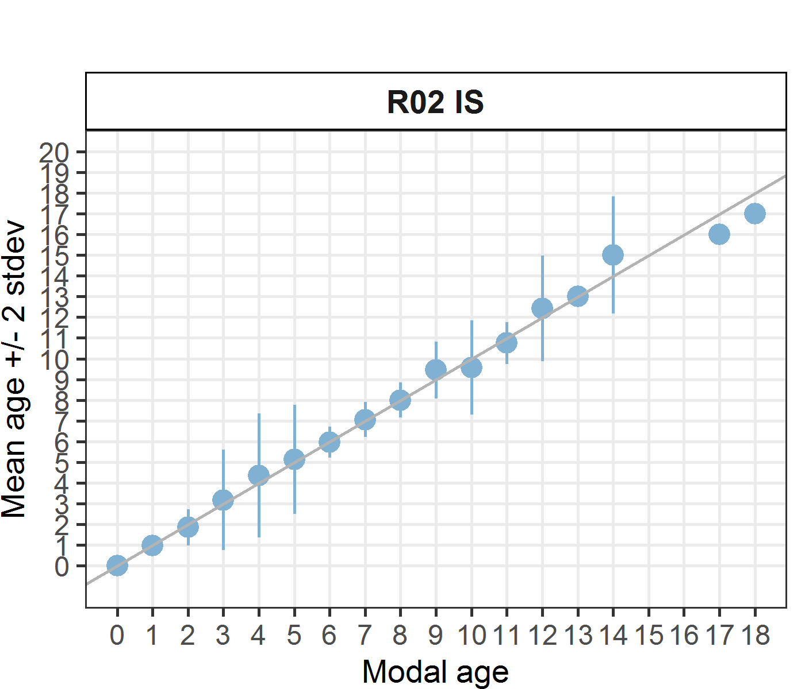 [[2]] 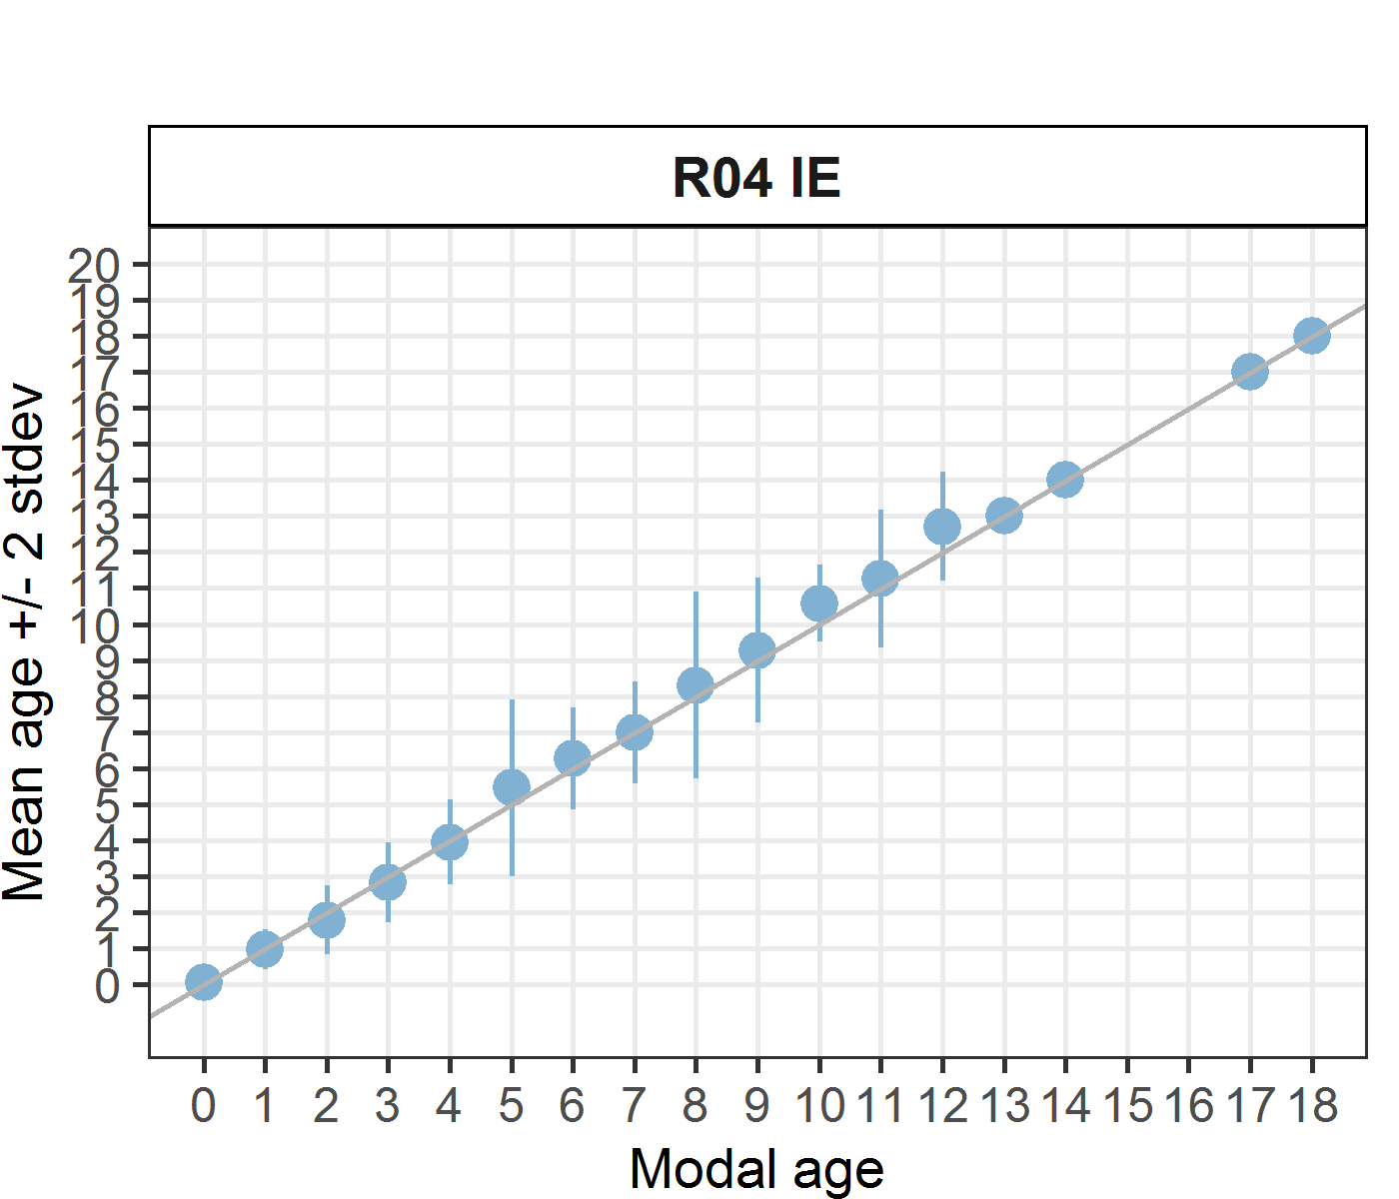 [[3]] 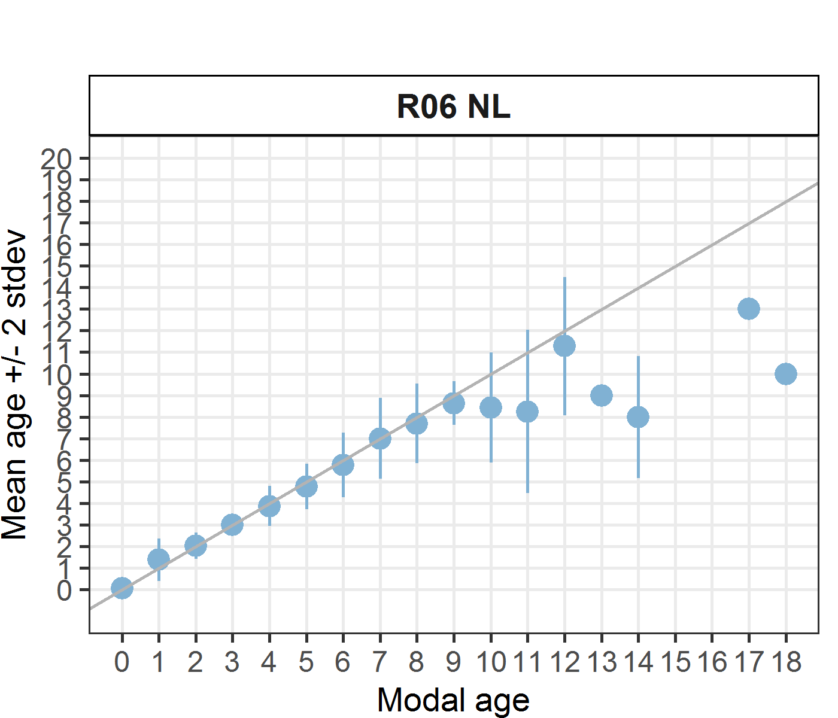 [[4]] 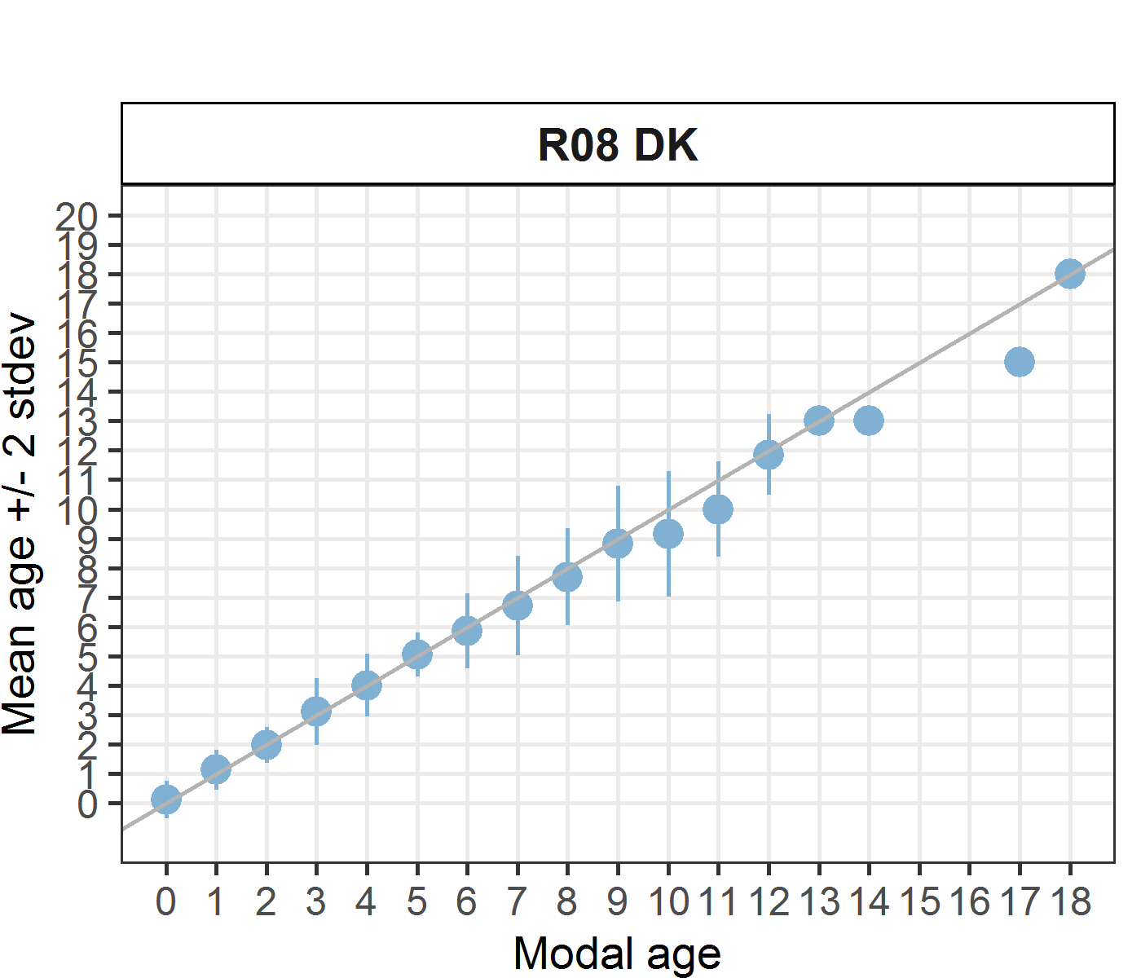 [[5]] 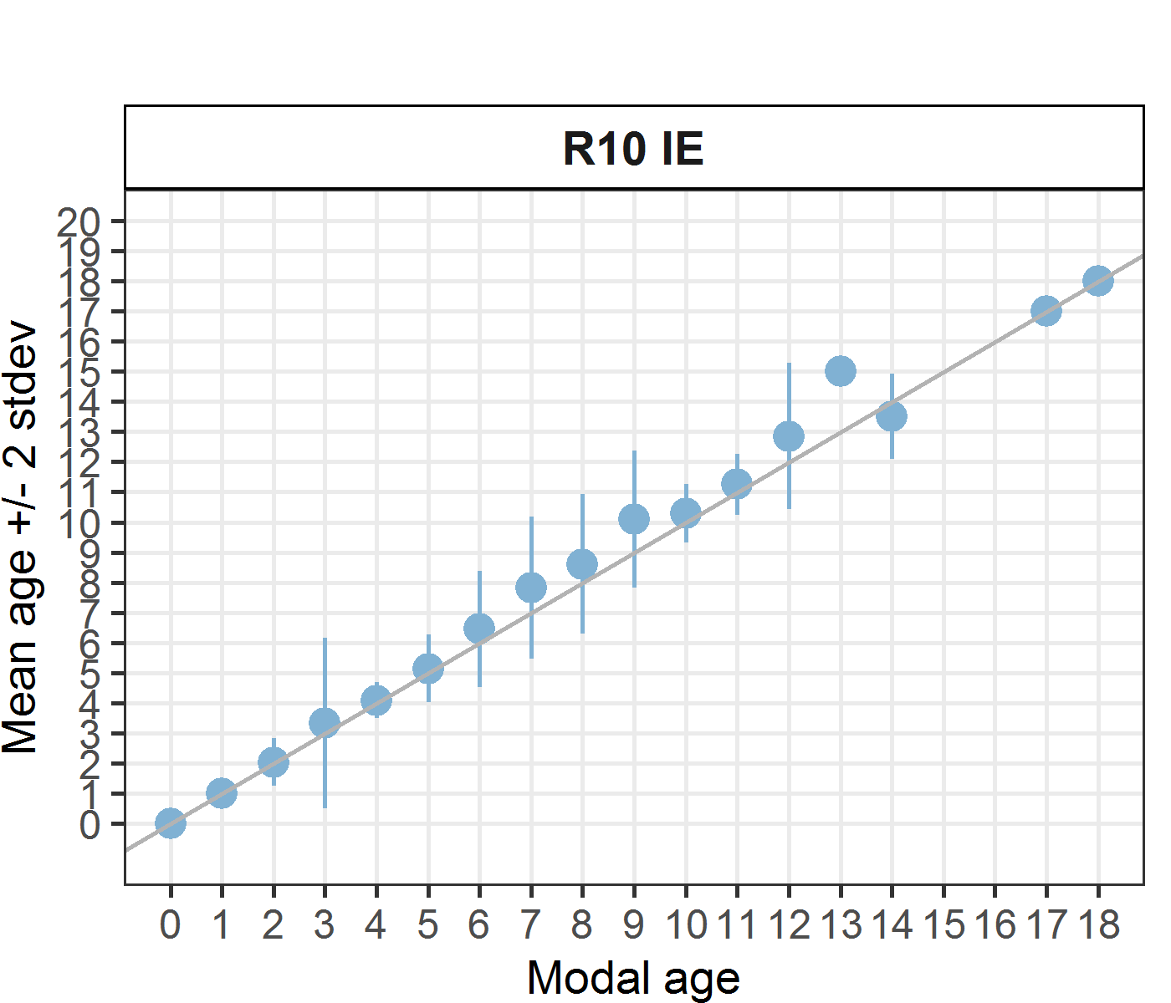 [[6]] 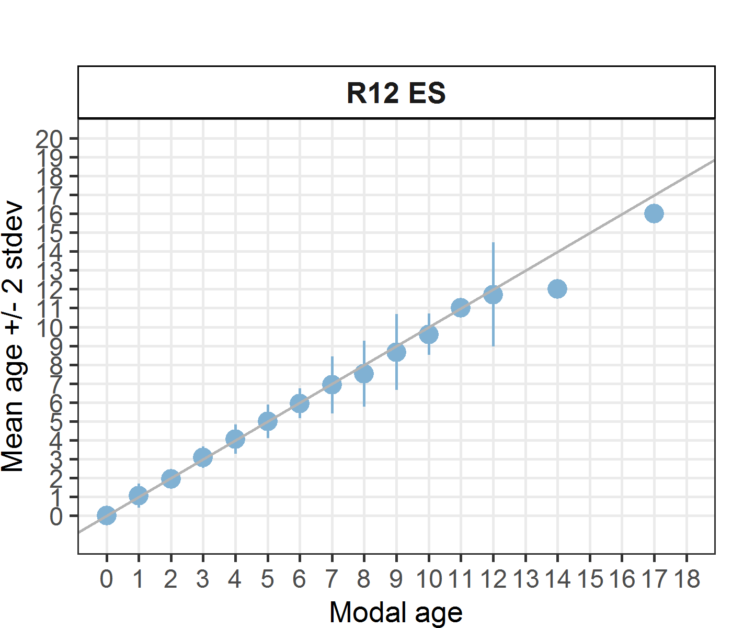 [[7]] 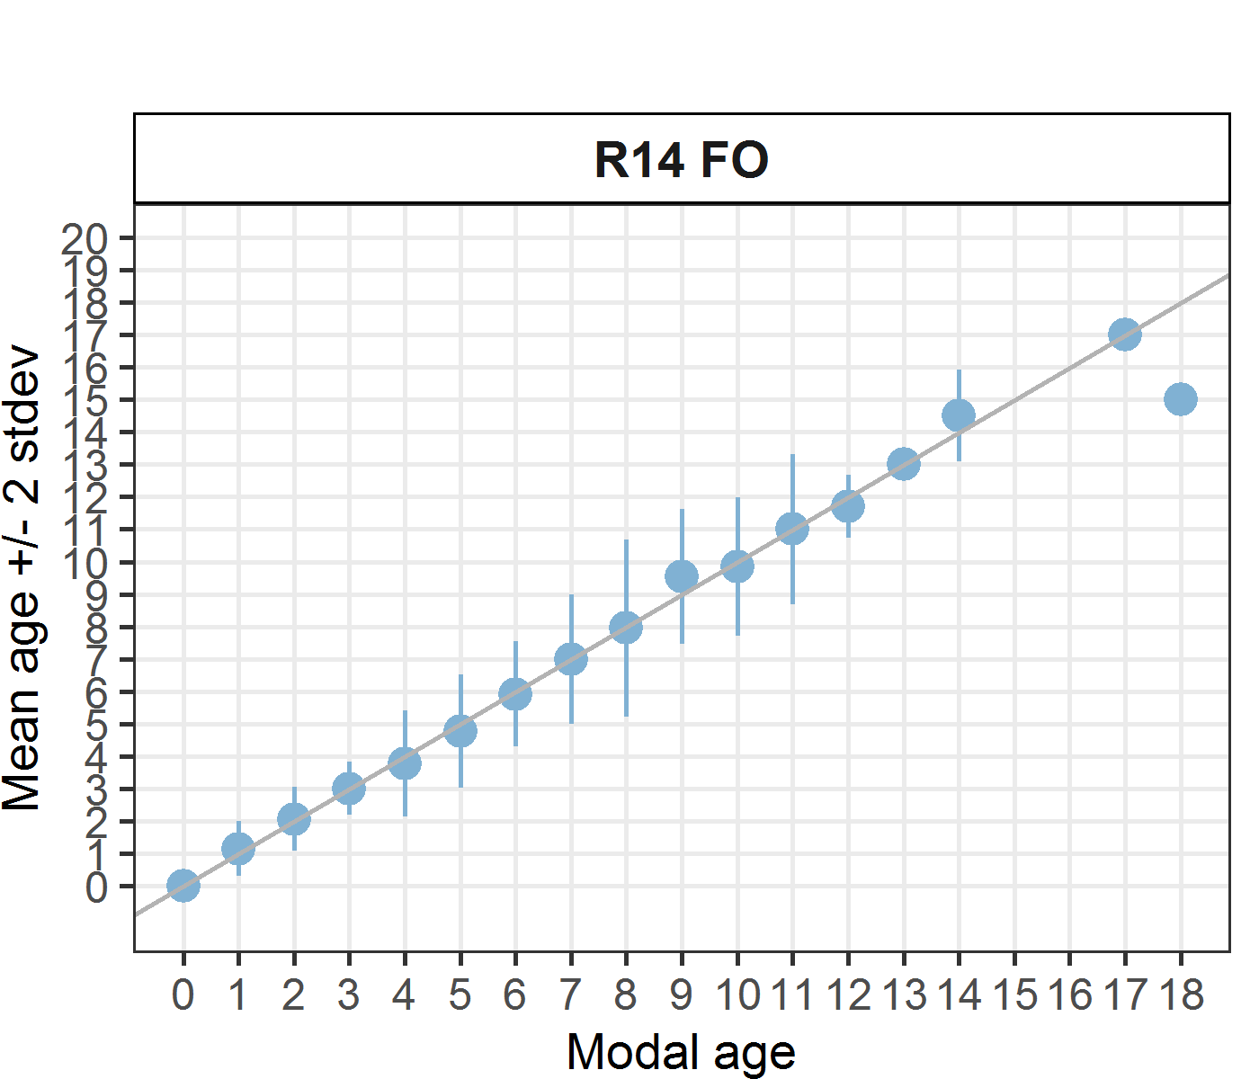 [[8]] 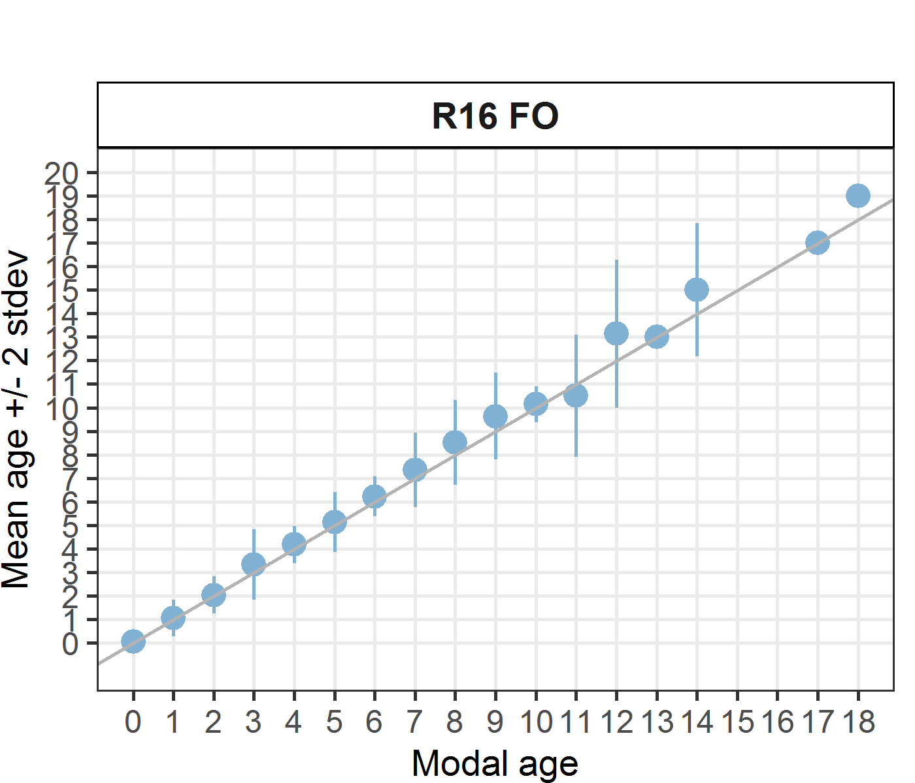 [[9]] 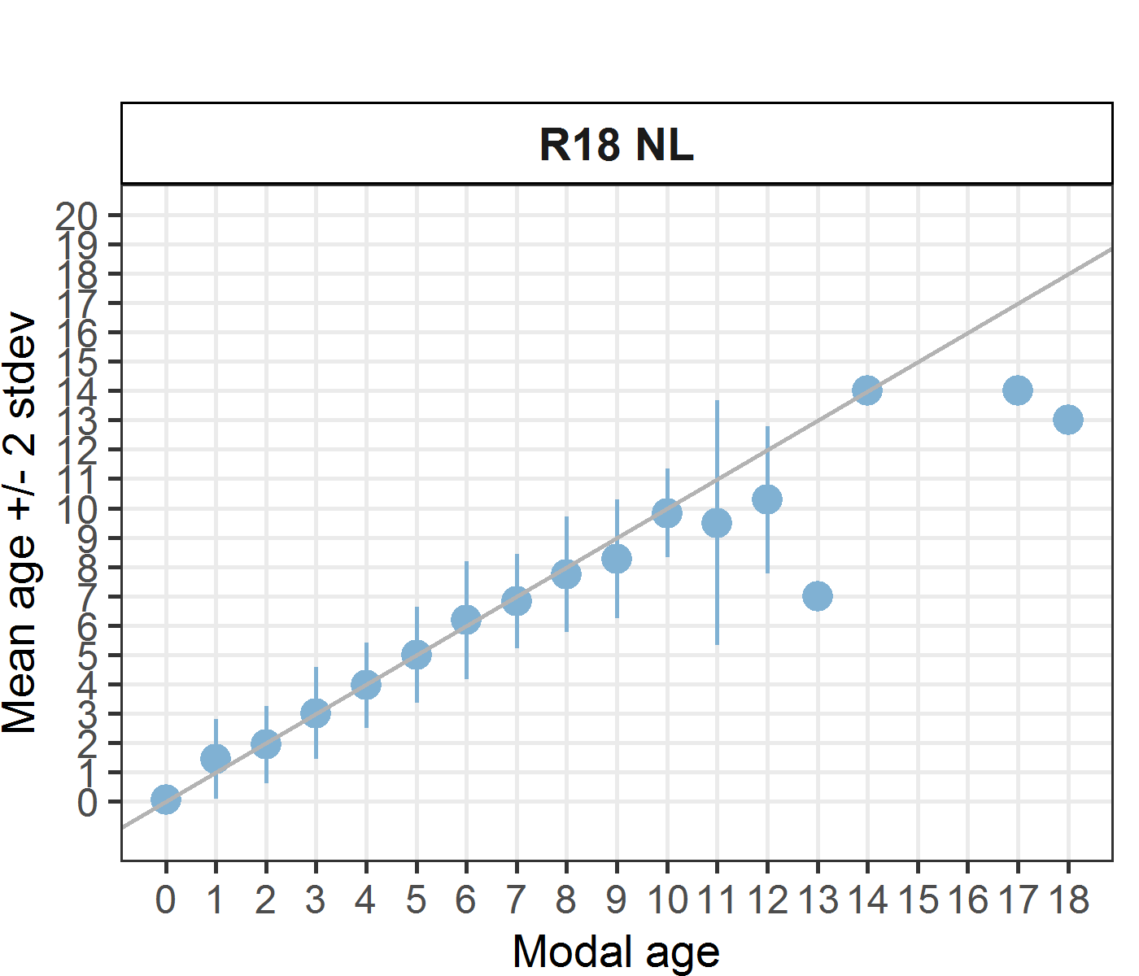

*Statistics by modal age plot (STDEV, CV and PA)*

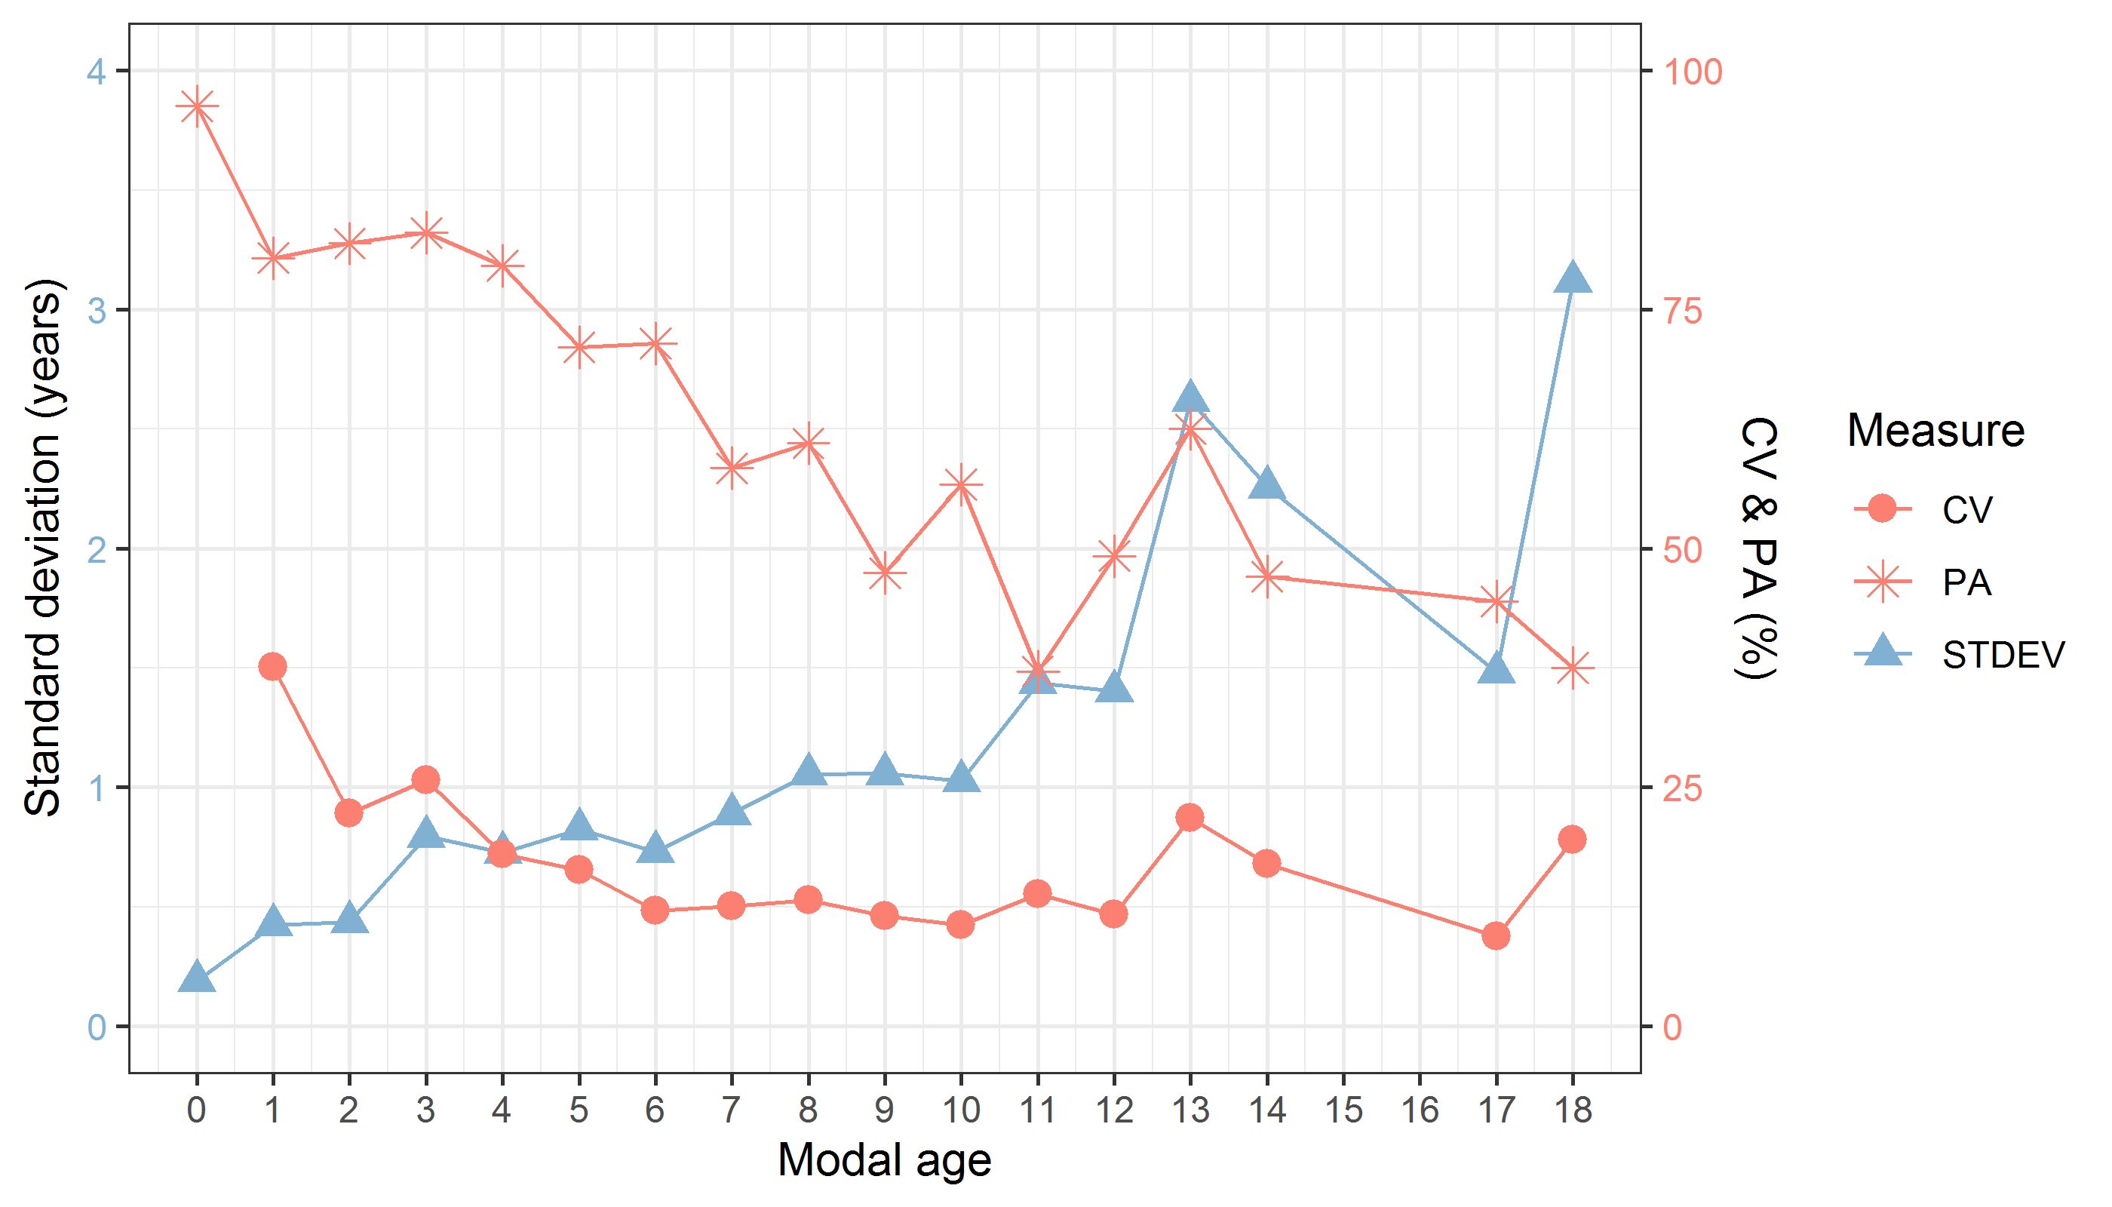

**Figure X:** CV, PA and (STDEV (standard deviation) are plotted against modal age

*Distribution of age reading errors*

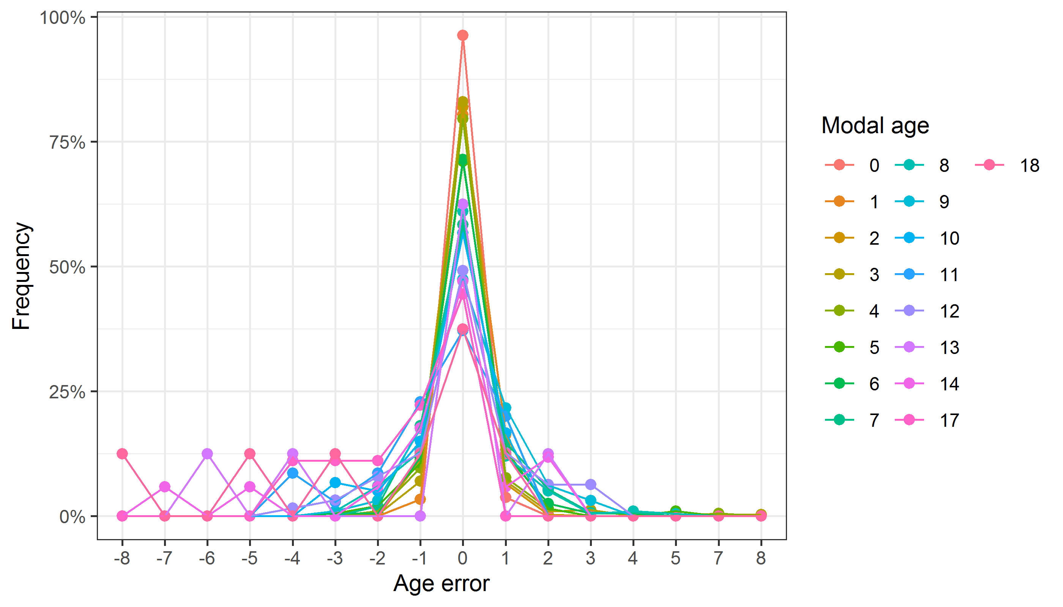

**Figure X:** The distribution of the age reading errors in percentage by modal age as observed from the whole group of age readers in an age reading comparison to modal age. The achieved precision in age reading by MODAL age group is shown by the spread of the age readings errors. There appears to be no relative bias, if the age reading errors are normally distributed. The distributions are skewed, if relative bias occurs.

*Relative bias for all readers*

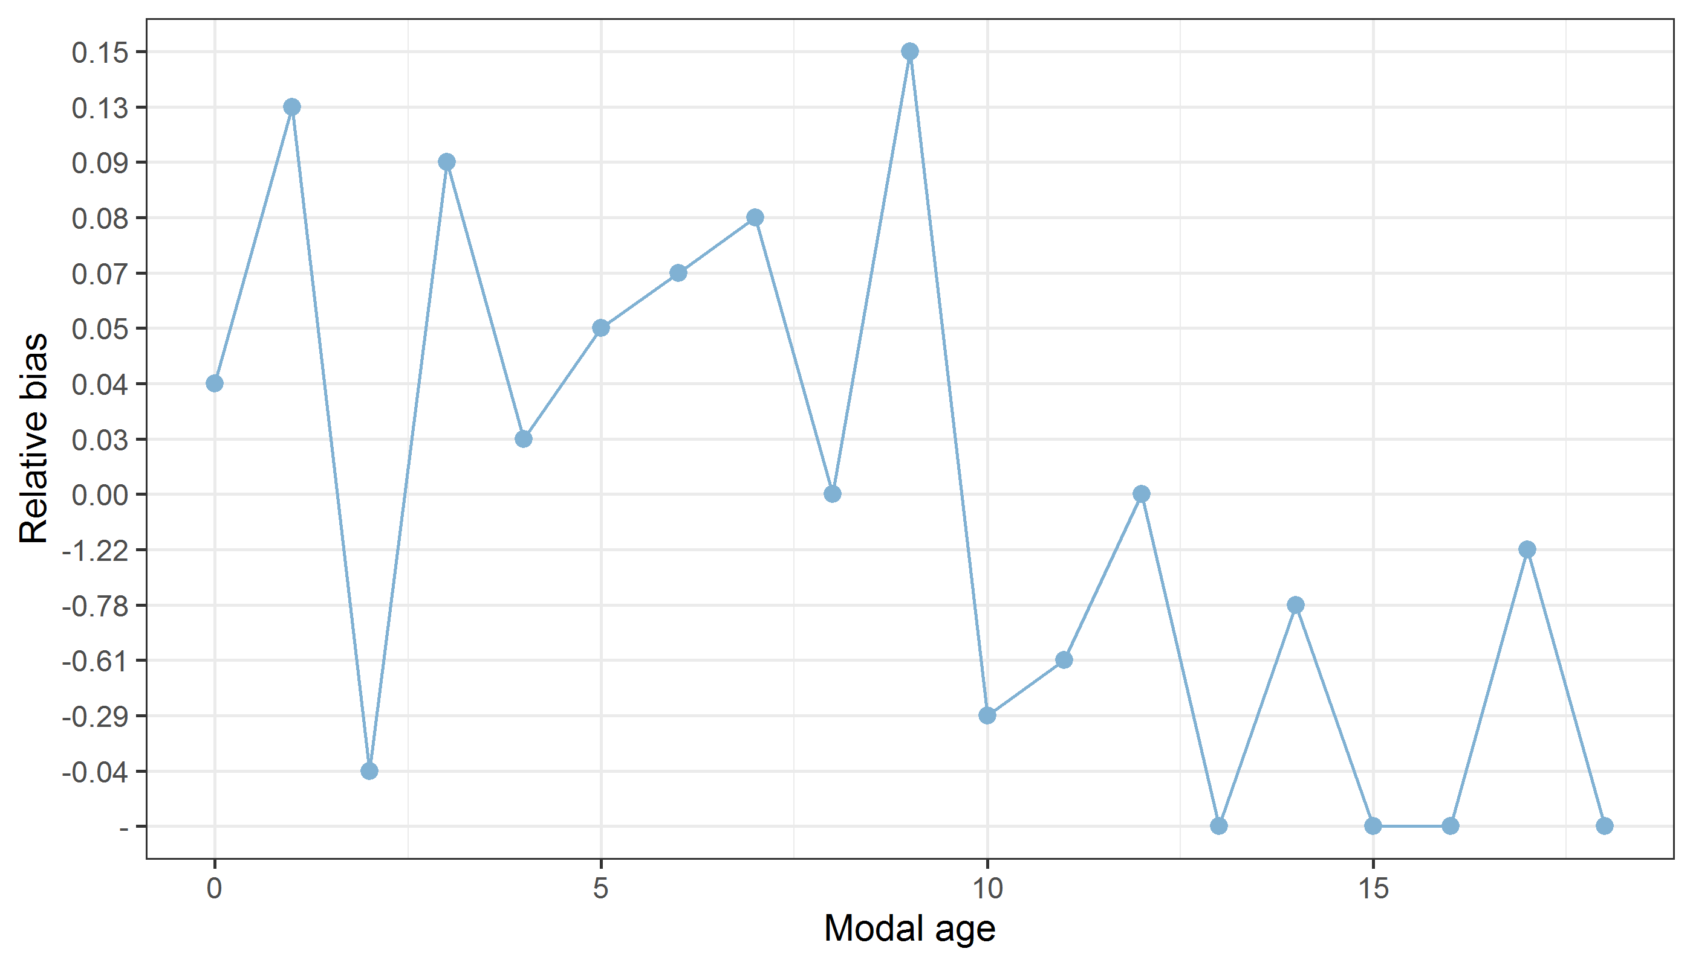

**Figure X:** The relative bias by modal age as estimated by all age readers combined.

*Mean length at age by reader*

**Table X:** Mean fish length at age per reader is calculated per reader and age (not modal age) and for all readers combined per age. A weighted mean is also given.

|  |  |  |  |  |  |  |  |  |  |
| --- | --- | --- | --- | --- | --- | --- | --- | --- | --- |
| **Age** | **R02 IS** | **R04 IE** | **R06 NL** | **R08 DK** | **R10 IE** | **R12 ES** | **R14 FO** | **R16 FO** | **R18 NL** |
| 0 | 187 mm | 191 mm | 186 mm | 184 mm | 185 mm | 189 mm | 189 mm | 187 mm | 187 mm |
| 1 | 265 mm | 261 mm | 243 mm | 253 mm | 260 mm | 257 mm | 253 mm | 255 mm | 235 mm |
| 2 | 289 mm | 296 mm | 285 mm | 288 mm | 285 mm | 284 mm | 289 mm | 291 mm | 291 mm |
| 3 | 312 mm | 311 mm | 316 mm | 312 mm | 314 mm | 314 mm | 296 mm | 308 mm | 298 mm |
| 4 | 226 mm | 216 mm | 222 mm | 228 mm | 245 mm | 243 mm | 240 mm | 251 mm | 281 mm |
| 5 | 272 mm | 286 mm | 281 mm | 296 mm | 288 mm | 266 mm | 296 mm | 274 mm | 291 mm |
| 6 | 331 mm | 317 mm | 351 mm | 329 mm | 306 mm | 333 mm | 351 mm | 319 mm | 302 mm |
| 7 | 354 mm | 370 mm | 362 mm | 337 mm | 337 mm | 344 mm | 333 mm | 362 mm | 324 mm |
| 8 | 342 mm | 335 mm | 337 mm | 380 mm | 355 mm | 326 mm | 353 mm | 356 mm | 366 mm |
| 9 | 383 mm | 352 mm | 355 mm | 386 mm | 322 mm | 378 mm | 376 mm | 307 mm | 355 mm |
| 10 | 378 mm | 384 mm | 396 mm | 340 mm | 387 mm | 332 mm | 388 mm | 394 mm | 317 mm |
| 11 | 391 mm | 395 mm | 402 mm | 409 mm | 388 mm | 424 mm | 318 mm | 396 mm | 380 mm |
| 12 | 127 mm | 288 mm | 166 mm | 134 mm | 350 mm | 267 mm | 243 mm | 285 mm | 298 mm |
| 13 | 207 mm | 306 mm | 227 mm | 308 mm | 281 mm | - | 374 mm | 206 mm | 410 mm |
| 14 | 405 mm | 287 mm | - | - | 227 mm | 39 mm | 415 mm | 222 mm | 412 mm |
| 15 | 420 mm | - | - | 415 mm | 206 mm | - | 408 mm | 230 mm | - |
| 16 | 415 mm | - | - | - | - | 415 mm | - | 415 mm | - |
| 17 | 410 mm | 415 mm | - | - | 415 mm | - | 415 mm | 415 mm | - |
| 18 | - | 410 mm | - | 410 mm | 410 mm | - | - | - | - |
| 19 | - | - | - | - | - | - | - | 410 mm | - |
| **Weighted Mean** | **295 mm** | **295 mm** | **295 mm** | **295 mm** | **295 mm** | **287 mm** | **295 mm** | **295 mm** | **294 mm** |

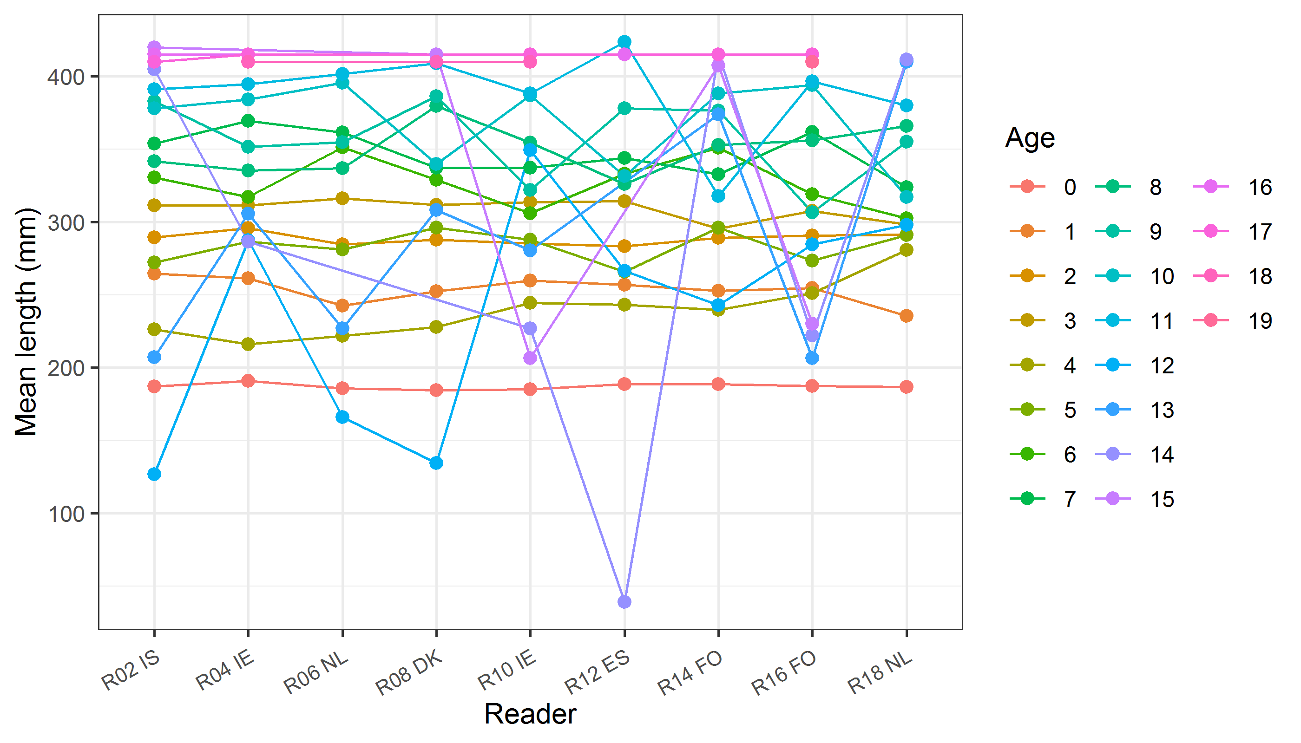

**Figure X:** The mean fish length at age as estimated by each age reader.