SmartDots Report for event 2953
Report of the Exchange of Whiting (Merlangius merlangus) in Area 27.7a: Irish Sea 2025.

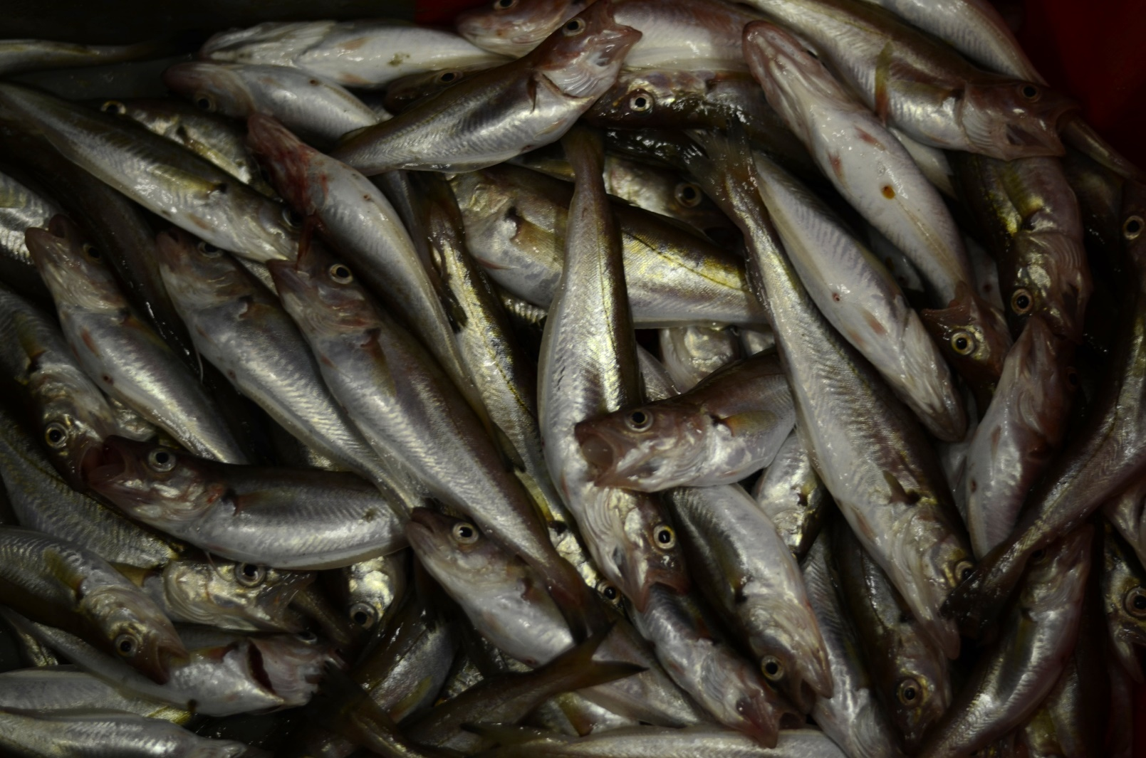

By: Gráinne Ní Chonchúir
Marine Institute
Éire

Table of Contents
1 Executive summary 3
2 Terms of reference 5
3 Agenda and participant list 6
4 Introduction 7
5 Methods 8
6. Age calibration Results All Readers 11
7 Age Calibration Results for Advanced Readers Only 23
8. Discussion 34
9. Conclusion 37
10.References 39
11. Additional results 40

Executive summary
This image only SmartDots exchange (Event 2953) was conducted to respond to a formal request to WGBIOP from WKBNSCS 2025 where it states: “To WGBIOP: Following a mini age calibration exchange between Ireland and Northern Ireland, coupled with recent changes in primary age readers, there is a recommendation for a more formal age reading workshop to be conducted via SMARTDOTS” https://doi.org/10.17895/ices.pub.28715180
The recommendation for an exchange was because of concerns raised about the potential inconsistencies in age determination of whiting (Merlangius merlangus) in the Irish Sea (Division 7.a). Recent assessments indicated anomalies in maturity and weight-at-age trends, suggesting possible misclassification of younger fish ages. The exchange aimed to evaluate reader performance and improve calibration, particularly for ages 1 and 2.
nine readers from five institutes participated, including four advanced readers (providing ages for stock assessments) and five basic readers, one of whom provides ages for stock assessment. A total of 109 otolith images were assessed, covering all quarters and a broad length and age range (modal ages 0–8). The multistage modal age approach was applied to reduce bias and ensure robust comparisons.
Results from all readers combined are Percentage Agreement (PA) = 69%, Coefficient of Variation (CV) = 32%, Average Percentage Error (APE) = 24%.
Results from the advanced readers only are PA = 82%, CV = 19%, APE = 10%—well within acceptable limits.
Agreement is highest at age 0 (83%) and remains strong for ages 1–2 (77–71%), but declines progressively for older ages, reaching its lowest at age 8 (44%). For advanced readers only, agreement is even stronger at ages 0–2 (92–88%) and remains relatively high through age 3 (85%), before dropping sharply at ages 6–7 (56–50%).
The coefficient of variation (CV) is highest for age 1 (51% overall; 28% for advanced readers) and decreases with age, stabilizing between 14–21% for ages 4–6, and reaching its lowest at age 8 (10%). This pattern indicates significant variability in early age interpretation, with improved consistency for mid-age fish.
Percentage agreement varies by reader: most readers achieve >75% overall, but two basic readers (R12 GB-SCT and R16 GB-NIR) show extremely poor agreement (20% and 25%) and strong over-aging bias (+1.51 and +1.04). Advanced readers exhibit minimal bias (weighted mean = +0.05) and high consistency, while basic readers display greater variability and systematic errors, particularly at younger ages.
For basic readers, overall agreement is lower compared to advanced readers (69% vs. 82%) and CV is generally higher (up to 35%), reflecting inconsistencies in age estimation. Some basic readers (e.g., R10 BE) perform exceptionally well (PA = 90%, CV = 7%), but others exhibit noticeable biases, either underestimating or overestimating ages, which impacts overall reliability.
It’s important to note that Basic readers tend to be new to age reading or to reading this particular species and are still training, which are factors that may contribute to the observed discrepancies. This is the case with one exception, where a reader classified as Basic for the purposes of this exchange, does actually contribute ages to the stock assessment.
While the overall results are positive, for both the Advanced and the majority of the Basic Readers, there is still room for improvement across all readers. Specific issues for individual readers, are highlighted in the report. And concerns in relation to the use of age readings in stock assessments from an inexperienced reader are also highlighted.
The exchange findings highlight priorities for future work, i.e. the adoption of a best preparation method for whiting otoliths, the creation of a Training Reference Collection, active engagement with technological developments around machine learning, through WGBIOP workshops and WGSMART. Additional training and calibration to improve consistency and accuracy in age estimations is also recommended.

Terms of reference
This was an image only age reading exchange event using the SmartDots platform. As it was not a workshop, no ToR’s are available.

Agenda and participant list
No agenda is available as this was an exchange and not a workshop.
9 Readers from 5 Institutes participated in this exchange, consisting of 4 Advanced readers (whose ages are used in the assessments) and 5 Basic readers.
It should be noted, that even though participant R16 GB-NIR from AFBI in Northern Ireland contributes age readings to the Stock Assessment, and should therefore, technically be categorised as an ‘Expert’ reader, they are categorised as a ‘Basic’ reader for the purposes of this exchange, due to their minimal training and inexperience.
Of the 9 readers participating in this exchange, 8 read sectioned otoliths under transmitted light, while just one R12 GB-SCT reads broken otoliths.
The list of participants can be found below.
Table 3.1: Participants List and Expertise
Reader Code | Name | Institute/Country | Expertise | Readings in Assessment
R08 IE | Fiona Woods | Marine Institute Ireland | Advanced | Yes
R06 IE | Seán O Connor | Marine Institute Ireland | Advanced | Yes
R04.IE | Imelda Hehir | Marine Institute Ireland | Advanced | Yes
R10 BE | Ilse Maertens | ILVO Belgium | Basic | No
R14 FR | Antoine Dussuel | IFREMER France | Basic | No
R02 FR | Romain Elleboode | IFREMER France | Advanced | Yes
R16 GB-NIR | Jessica Graham | AFBI Northern Ireland | Basic | Yes – See note above.
R12 GB-SCT | Michelle Douglas | Marine lab Scotland | Basic | No
R18 BE | Dante Balliu | ILVO Belgium | Basic | No

Introduction
Stock Definition for Merlangius merlangus in 27.7a shows that whiting spawn in the Irish Sea in Spring, in the eastern Irish Sea and in the coastal waters of the western Irish Sea. Recruitment grounds are in the same general area as the spawning grounds. Historical tagging studies in the 1950s show some seasonal dispersal of larger whiting into the Clyde, eastern Irish Sea and Celtic Sea with evidence of return migrations. The age structure in the eastern Irish Sea is normally broader than in the west. This is possibly due to lower mortality in the east and incomplete mixing. All catches in 7.a, except the 2 ICES rectangles in the very south of 7.a off Dunmore East (33E2 and 33E3) have been considered part of the Irish Sea stock.
The Irish Sea whiting stock is primarily caught by otter trawlers and to a lesser extent, Scottish seines, beam trawls and gillnets. Otter trawlers utilize two main mesh size ranges, 70–89 mm and 100–119 mm. Effort of trawlers utilizing the larger mesh range, traditionally targeting whitefish (cod, haddock, whiting), has seen a large decline since 2003, partially because of effort management restrictions. Effort for trawlers using the smaller range has declined at lower rate. The primary target species at this lower mesh range is Nephrops norvegicus, which has an associated high discard rate of whiting.
A significant change in the maturity ogive for Irish Sea Whiting was observed over the past three years, where the percentage mature at age 2 dropped from 95% mature to less than 60% mature. If fish were maturing later one would expect to see a similar trend in the 1-year-olds, however, this is not the case with an increase in their maturity over the last few years observed instead.
Reviewing the survey weight at age a large decline in weight across most age classes is evident. However, reviewing weight at age for 1-year olds shows that weight at age for this age group has increased significantly in recent years. One possible explanation that fits the data is that there is some confusion around aging the young fish, and more 1-year olds are being aged at 2 and vice versa. Whilst these patterns may be due to fluctuations in stock dynamics, it is important to rule out aging inconsistencies as a cause. One possible explanation that fits the data is that there is some confusion around aging the young fish, and more 1-year olds are being aged at 2 and vice versa.
The objective of this exchange is therefore to attempt to establish if there is indeed an issue with age reading of whiting, particularly, with one- and two-year-old fish.
This image only exchange was carried out via SmartDots, the web application developed by ICES to facilitate the setup of exchanges, workshops and training events (http://www.ices.dk/marinedata/tools/Pages/smartdots.aspx). A total of 109 otolith images focusing on the Irish Sea (Division 7a) were included in the exchange. All images were of sectioned otoliths with transmitted light. Following the recommendations of WKMACQI (Workshop on Mackerel biological parameter Quality Indicators) (ICES, 2018). Every effort was made to ensure that the spatial and temporal coverage, as well as the length and age range, of the whiting otoliths used for the exchange correspond with the coverage in the assessment.

Methods
This report contains statistical analyses and comparisons of age readings in the form of tables and graphical plots.
First, an overview of participating age readers and the samples are presented.
The first part of the results section includes the tables and plots from the Guus Eltink Excel sheet ‘Age Reading Comparisons (Eltink, A.T.G.W. 2000). The order and numbering of tables and plots are the same as in the excel sheet. Tables 6.1 - 6.4 from the ’Age Reading Comparisons’ sheet are not outputted since these are merely used to do calculations for the other tables.
Modal age: a multistage approach to define the modal age by sampled fish,
In this event, the multistage approach to calculate the modal age has been used. When summarizing the output and reporting the results of the exchange events developed within the SmarDots framework, the modal age (the most common age decided by the age readers for every fish sample) is the most relevant measurement. It is a key statistic by itself, but it is also fundamental for the estimation of some other relevant statistics to assess the performance of the techniques assessed in the exchange event, like the Percentage Agreement (PA), or input for stock assessments like the Age Error Matrix (AEM) (see below). However, the standard approach of calculating the mode (each reader has the same weight=1) the mode is taken as the lowest age of the multiple modal ages. This way renders multiple cases (fish samples) with multiple modal ages (i.e. different ages got the same highest number of readers). Accordingly, this imply a wrong perception of the age by fish individual and introduction of bias in the calculation of the PA and AEM. As a solution, in this report a multistage approach to select the modal age is used. This multistage approach is based in the different weight given to the age readers according to their experience. Two different weight scores scales were assigned, a weight score decreasing linearly with the experience and another decreasing with a negative exponential shape. The modal age by fish individual is decided following the next approach:
1.-If there is a single mode estimated with the standard approach (equal weight for all readers) this value is used as the modal age, if not
2.-Adding up, for each age category, the score assigned with the linear weighting for all the readers that decided that age for that fish. Next, the modal age is selected as the age category that obtains the highest score sum. If, despite this approach, there were still multiple ages with the same score (and hence multiple modes), the next step is applied:
3.-Adding up, for each age category, the score assigned with the negative exponential weighting for all the readers that decided that age for that fish. Select as the modal age the age with the highest score sum.
During the WGBIOP 2019 meeting it was found that the combination of the modes decided using these three methods (so called ‘multistage approach’), allows assigning a single modal age to each fish individual.
It is important checking the table that indicates the percentage of multimodal cases (in the results section) and the table with the fishID and sampleID that obtained multiple modes (included in annex 3). Samples split by strata

Percentage Agreement (PA)
The percentage agreement per reader per modal age tells how large is the part of readings that are equal to the modal age. The percentage agreement is estimated by modal age and reader as the proportion (as percentage) of times that the lectures of that reader agreed with the resulting modal age.This percentage is estimated as the number of times that a reader agreed with the modal age divided by the total number of otoliths read by a reader for each modal age.
$$PA=\frac{number of readings that agree with modal age}{total number of readings by modal age}⋅100\%$$
Coefficient of Variation (CV)
The table presents the Coefficient of Variation (CV) per modal age and reader. The CV’s are calculated as the ratio between the standard deviation (σ) and mean value (μ) per reader and modal age:
$$CV=\frac{σ}{μ}⋅100\%$$
To the table is also added the CV of all readers combined per modal age and a weighted mean of the CV per reader.
Relative bias
The relative bias is calculated as the difference between the mean and the modal age. This statistic is presented in first place by modal age and reader, but it is also calculated as an average value by modal age for all readers together (or only advanced readers).
Average Percentage Error (APE)
The Average Percentage Error (APE) was calculated based on the method outlined by Beamish & Fournier (1981). This method is dependent of fish age and thus provides a better estimate of precision than percentage agreement. As the calculations of both CV and APE pose problems if the mean age is close to 0, all observations for which modal age was 0 were omitted from the CV and APE calculations.
The average percentage error is calculated per image as:
$$APE=\frac{100\%}{n}\sum_{i=1}^{n}{|}\frac{a_{i}-\overset{‾}{a}}{\overset{‾}{a}}|$$
where $a_{i}$ is the age reading of reader $i$ and $\overset{‾}{a}$ is the mean of all readings from 1 to $n$.
Age error matrix (AEM)
Age error matrices (AEM) were produced following procedures outlined by WKSABCAL (2014) where the matrix shows the proportion of each modal age mis-aged as other ages. The sum of each row is 1, which equals 100%. The age data was analysed twice, the first time all readers were included and the second time only the “advanced” readers were included. If a reader is “advanced” then they are considered well trained and they provide ages for stock assessment or similar purposes. When the AEM is compiled for assessment purposes it uses only those readers who provide age data for the stock assessment in that specific area.
Otolith Growth Analysis
SmartDots provides a measure of distance between the annotations made by the readers and thus provides a measure of growth increment width. This data is used to establish growth curves for each otolith (fish) and for each reader.

Below is an overview of samples used in this exchange, which spanned all 4 quarters, and the length and age ranges most commonly encountered for this stock.
Table 5.1: Overview of samples used for the exchange event number 2953
Year | ICES area | Strata | Quarter | Number of samples | Modal age range | Length range
2020 | 27.7.a | Strata_1 | 2 | 9 | 2-6 | 310-390 mm
2020 | 27.7.a | Strata_1 | 3 | 12 | 2-5 | 280-440 mm
2021 | 27.7.a | Strata_1 | 1 | 1 | 5 | 400 mm
2021 | 27.7.a | Strata_1 | 2 | 8 | 1-5 | 160-390 mm
2021 | 27.7.a | Strata_1 | 3 | 16 | 0-6 | 120-350 mm
2022 | 27.7.a | Strata_1 | 1 | 14 | 1-7 | 160-380 mm
2022 | 27.7.a | Strata_1 | 2 | 2 | 3-4 | 380-400 mm
2022 | 27.7.a | Strata_1 | 4 | 6 | 2-4 | 310-360 mm
2023 | 27.7.a | Strata_1 | 1 | 3 | 2-4 | 300-360 mm
2023 | 27.7.a | Strata_1 | 2 | 9 | 2-5 | 310-440 mm
2023 | 27.7.a | Strata_1 | 4 | 7 | 1-3 | 190-340 mm
2024 | 27.7.a | Strata_1 | 1 | 5 | 1-5 | 150-360 mm
2024 | 27.7.a | Strata_1 | 3 | 7 | 1-3 | 170-330 mm
2024 | 27.7.a | Strata_1 | 4 | 9 | 0-3 | 140-350 mm
2025 | 27.7.a | Strata_1 | 2 | 1 | 5 | 400 mm

6. Age calibration Results All Readers

6.1 Results for All Readers (Advanced and Basic)
This analysis looks at the results from all participating age readers and all images, including those with a readability score of AQ3_QA. The AQ Readability Score definitions are given below in Table 6.1.
Table 6.1: AQ Readability Score Definitions.
AQ Code | Definition
AQ1 | Rings can be counted with certainty
AQ2 | Rings can be counted with difficulty and some doubt
AQ3 | Rings cannot be counted; the calcified structure is considered unreadable - no age assigned
AQ3_QA | Rings cannot be counted; the calcified structure is considered unreadable - age assigned for QA purposes only

Table 6.2: Summary of statistics; Total number of samples (NSample), coefficient of variance (CV), percentage of agreement (PA) and average percentage error (APE) for all ages and readers

NSample | CV | PA | APE
109 | 32 % | 69 % | 24 %

In this exchange event, 109 otolith fish individuals were aged. Of those, 6 %when the traditional approach (all readers equally weighted) is used to define the mode. The percentage of multiple mode cases is reduced to 0 %. The complete list of cases with multiple modes is presented in tables 6.3 and 6.4, where the ageing from each of the readers participating in the exchange event is presented. When all the otolith samples are considered (both single and multimodal cases) the weighted average percentage agreement based on modal ages for all readers is 69 %, with the weighted average CV of 32 % and APE of 24 %.
The modal age range of all readers’ analysis was 0-8 for the whole set of otoliths. There were 6 otoliths at modal age 0, with a further 27 modal age 1 otoliths and 23 modal age 2 otoliths, in an effort to address the concerns raised by WGCSE. 53 otoliths were spread across modal ages 3 – 7.The overall agreement for all readers was 69%. The best agreement was obtained for otoliths of modal age 0 – 2, with average percentage agreement across all readers being 83%, 77% and 71% respectively.
The lowest agreement was obtained for otoliths with modal age 6 and 8 (53% and 44%)

Multimodal cases
Table 6.3: Total number of samples (NSample) and percentage of cases (fish samples) with multiple modes depending on the approach to weight the experience of the reader which will be considered when defining the fish age mode. PercMM_traditional shows the percentage of the total samples for which multiple modes are obtained when all the readers are equally weighted. PercMM_linear_weight shows the percentage of the total samples for which multiple modes are obtained when the weight assigned to the different readers decreases linearly with the experience, while in the PercMM_negexp the weight applied decreases with a negative exponential shape with the experience. The PercMM_multistage shows the percentage of multiple mode cases when a combination of the different methodologies is used, as explained in the material and methods section
NSample | PercMM_traditional | PercMM_linear_weight | PercMM_negexp_weight | PercMM_multistage
109 | 6 % | 1 % | 0 % | 0 %

List of multimodal cases
Table 6.4: List of cases for which multiple modes were obtained when all readers are considered. The column NModes_trad shows the number of multiple modes for each FishID or SampleID when all readers are given the same expertise weight.
NModes_trad | SampleID
2 | Whg_2020_7a_50514_021
2 | WHG_2020_7a_51067_019
2 | WHG_2020_7a_51067_023
2 | WHG_2021_7a_53414_035
2 | WHG_2022_7a_54652_021
2 | WHG_2022_7a_56805_010
2 | WHG_2022_7a_56805_018
2 | WHG_2022_7a_57272_003
2 | WHG_2023_7a_57571_026
2 | WHG_2023_7a_59489_014
2 | WHG_2023_7a_59626_014
2 | WHG_2023_7a_59643_014
2 | WHG_2023_7a_59643_016
2 | WHG_2024_7a_60356_004
2 | WHG_2024_7a_60606_003
2 | WHG_2024_7a_CHD5_007
2 | WHG_2024_7a_GFS322_005
2 | WHG_2024_7a_GFS322_010
2 | WHG_2025_7a_62655_017

Coefficient of Variation (CV)
Coefficient of Variation % are given for all readers in Table 6.5 below.
Somethings to note from these results are the following:
- The combined CV across all readers is high for younger ages (modal age 1: 51%), indicating poor agreement on age-1 fish.
- CV decreases with age: Age 2: 33%, Age 3: 27%, Age 4–6: 16–21%, Age 8: 10% (best agreement, but fewer readings).
- Weighted mean CV for all readers = 32%, which is relatively high and suggests variability in interpretation.
When looking at expertise levels:
Advanced readers (R02 FR, R04 IE, R06 IE, R08 IE):
Weighted mean CV ranges 15–21%, shows much better consistency.
Basic readers (R10 BE, R12 GB-SCT, R14 FR, R16 GB-NIR, R18 BE):
Weighted mean CV ranges 7–35%. At either end of this range are reader: R12 GB-SCT who has a cv of 35% (indicating the lowest consistency), while reader: R10 BE has a cv of 7% (indicating excellent consistency, especially for a reader classed as basic.)
Age-Specific Issues
- Age 1 is problematic: CV >50% overall, and individual readers show very high variation (up to 54% for R12 GB-SCT).
- Ages 2–3 still show moderate disagreement (20–30% CV).
- Older ages (4–6) have better agreement (mostly <20%).
Implications for Stock Assessment
High CV for younger ages (especially age 1) can significantly affect recruitment estimates and reliance on advanced readers is justified,—basic readers introduce variability. Training and calibration for basic readers, especially GB-SCT, is essential.

Table 6.5: Coefficient of Variation (CV) table presents the CV per modal age and reader, the CV of all readers combined per modal age and a weighted mean of the CV per reader

Modal age | R02 FR | R04 IE | R06 IE | R08 IE | R10 BE | R12 GB-SCT | R14 FR | R16 GB-NIR | R18 BE | All
0 | - | - | - | - | - | - | - | - | - | -
1 | 29% | 32% | 25% | 32% | 0% | 54% | 19% | 32% | 0% | 51%
2 | 0% | 18% | 27% | 16% | 10% | 31% | 20% | 15% | 30% | 33%
3 | 12% | 21% | 19% | 23% | 8% | 25% | 21% | 21% | 19% | 27%
4 | 18% | 14% | 11% | 16% | 6% | 22% | 10% | 18% | 15% | 21%
5 | 14% | 7% | 14% | 11% | 16% | 20% | 15% | 14% | 16% | 21%
6 | 18% | 15% | 10% | 15% | 10% | 8% | 17% | 20% | 18% | 16%
7 | - | - | - | - | - | - | - | - | - | -
8 | - | - | - | - | - | - | - | - | - | 10%
Weighted Mean | 15% | 20% | 20% | 21% | 7% | 35% | 17% | 21% | 15% | 32%

Relative Bias
Relative bias is the difference between the mean age (per modal age per reader) and modal age. As for the previous tables, a combined bias for all readers and weighted means are calculated and presented in Table 6.6 which shows Combined weighted mean across all readers = +0.32 leading to a slight overall tendency to over-age. However, this is mainly driven by two outliers (R12 GB-SCT and R16 GB-NIR).
Advanced Readers (R02 FR, R04 IE, R06 IE, R08 IE)
Overall, Advanced readers are close to neutral, with some small deviations (±0.25). Advanced readers generally have fewer instances of strong significant bias amongst themselves, demonstrating a better alignment and consistency.
R02 FR: Weighted mean = -0.16 → slight under-aging overall.
R04 IE: Weighted mean = +0.25 → slight over-aging.
R06 IE: Weighted mean = -0.01 → almost unbiased.
R08 IE: Weighted mean = +0.23 → slight over-aging.
Basic readers (R10 BE, R12 GB-SCT, R14 FR, R16 GB-NIR, R18 BE):
Two distinct groupings emerge in the Basic Age readers, with two basic readers (R12 GB-SCT and R16 GB-NIR) showing major systematic over-aging, while the remaining Basic readers, illustrate little to no bias in their readings.
R10 BE: Weighted mean = -0.03 → near neutral.
R12 GB-SCT: Weighted mean = +1.51 → strong over-aging bias.
R14 FR: Weighted mean = +0.04 → negligible bias.
R16 GB-NIR: Weighted mean = +1.04 → significant over-aging bias.
R18 BE: Weighted mean = +0.03 → negligible bias.

Age-Specific Trends
Modal age 1–5: Bias increases with age for problematic readers (R12 GB-SCT, R16 GB-NIR).
Modal age 6: Advanced readers under-age strongly (-0.75), while basic readers vary.
Modal age 8: Extreme under-aging for advanced readers (-1 to -2), suggesting difficulty aging older fish consistently.
Significant Bias, particularly at younger ages could distort recruitment estimates. Therefore, training should be prioritised for R12 GB-SCT. Urgent re – training and calibration is required for R16 GB-NIR, if this individuals ages are to continue to be used in the stock assessment.

Table 6.6: The relative bias (as the difference between the mean and modal age) per modal age and reader is presented, as well as the weighted mean relative bias per reader and the relative bias per modal age for all readers combined.
Modal age | R02 FR | R04 IE | R06 IE | R08 IE | R10 BE | R12 GB-SCT | R14 FR | R16 GB-NIR | R18 BE | all
0 | 0 | 0.17 | 0 | 0.17 | 0 | 0.67 | 0 | 0.5 | 0 | 0.17
1 | -0.07 | 0.15 | 0.07 | 0.15 | 0 | 1 | 0.04 | 1.26 | 0 | 0.29
2 | 0 | 0.18 | 0 | 0.14 | 0.05 | 1.5 | 0.09 | 1.41 | 0.18 | 0.39
3 | 0 | 0.29 | 0.12 | 0.24 | -0.06 | 1.82 | 0.29 | 1.18 | 0.12 | 0.44
4 | -0.28 | 0.5 | -0.06 | 0.44 | 0.06 | 1.94 | 0.06 | 0.94 | 0.17 | 0.42
5 | -0.43 | 0.14 | 0 | 0.21 | 0 | 2.43 | -0.29 | 0.57 | -0.14 | 0.28
6 | -0.75 | 0.5 | -0.75 | 0.5 | -0.5 | 0.25 | -0.25 | 0.25 | -0.75 | -0.17
7 | - | - | - | - | - | - | - | - | - | -
8 | -1 | 0 | -1 | 0 | -2 | 0 | 0 | -1 | -1 | -0.67
Weighted Mean | -0.16 | 0.25 | -0.01 | 0.23 | -0.03 | 1.51 | 0.04 | 1.04 | 0.03 | 0.32

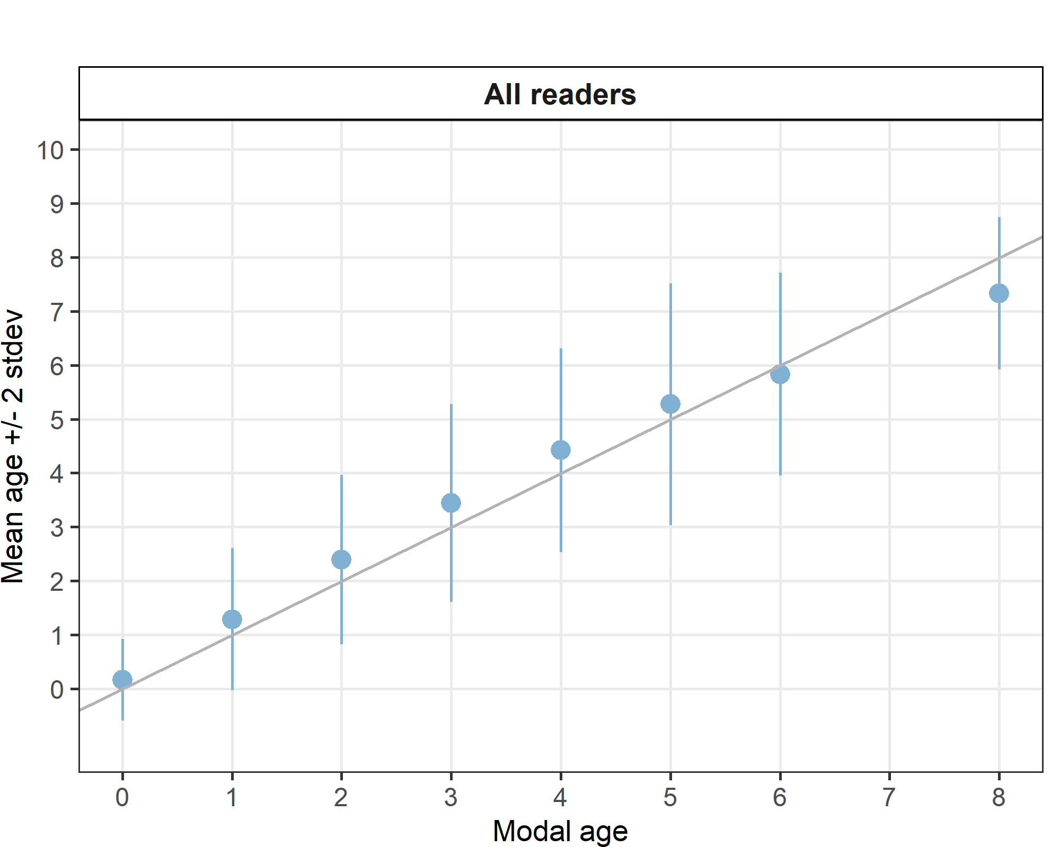
Figure 6.0: Age bias plot for all readers. Mean age recorded +/- 2 stdev of each reader and all readers combined are plotted against modal age. The estimated mean age corresponds to modal age, if the estimated mean age is on the 1:1 equilibrium line (solid line). Relative bias is the age difference between estimated mean age and modal age.

Percentage Agreement (PA)
The percentage agreement per reader per modal age tells what proportion of the readings are equal to the modal age. The weighted mean including at the bottom of the table is weighted according to number of age readings. % agreement results presented for all readers in Table 6.7 show that overall, the combined weighted mean across all readers = 69%, but this is skewed by two poor performers. Most readers are above 75%, except R12 GB-SCT and R16 GB-NIR.

All Readers
The majority of participants (both Advanced and Basic) participating in this exchange have percentage agreements consistently above 75%, confirming the reliability of their ages, as can be seen below:
Advanced and Basic Readers with good PA values.
R02 FR: 83% weighted mean → strong agreement.
R04 IE: 79% → good consistency.
R06 IE: 78% → good consistency.
R08 IE: 78% → good consistency.
R10 BE: 90% → high agreement (surprising for a reader categorised as a Basic – can assume this individual is a very experienced reader of other gadoid species).
R14 FR: 83% → strong consistency.
R18 BE: 84% → strong consistency.

However, two basic readers (R12 GB-SCT and R16 GB-NIR) are major outliers with very low agreement. And will require on – going intensive training. As reader R16 GB-NIR contributes ages to the stock assessment, it is recommended that their ages are excluded or down-weighted in stock assessments until retraining has occurred.
R12 GB-SCT: 20% → extremely poor agreement.
R16 GB-NIR: 25% → very poor agreement.

Age-Specific Trends
Age 0–2: High agreement for most readers except R12 GB-SCT and R16 GB-NIR.
Age 3–5: Agreement drops for some advanced readers (e.g., R06 IE at 57% for age 5).
Age 6: Very low agreement overall (25–75%), indicating difficulty aging older fish.
Age 8: Extreme variability (0% for some, 100% for others), likely due to small sample size.
Older ages (6–8) require improved calibration for all readers.

Table 6.7: Percentage agreement (PA) table represents the PA per modal age and reader, the PA of all readers combined per modal age and a weighted mean of the PA per reader.
Modal age | R02 FR | R04 IE | R06 IE | R08 IE | R10 BE | R12 GB-SCT | R14 FR | R16 GB-NIR | R18 BE | total
0 | 100% | 83% | 100% | 83% | 100% | 33% | 100% | 50% | 100% | 83%
1 | 93% | 85% | 93% | 85% | 100% | 33% | 96% | 11% | 100% | 77%
2 | 100% | 82% | 86% | 86% | 95% | 14% | 82% | 0% | 91% | 71%
3 | 88% | 82% | 65% | 76% | 94% | 12% | 82% | 24% | 82% | 67%
4 | 67% | 56% | 82% | 50% | 94% | 11% | 83% | 39% | 78% | 62%
5 | 64% | 86% | 57% | 86% | 64% | 0% | 64% | 57% | 64% | 60%
6 | 50% | 75% | 25% | 75% | 50% | 75% | 25% | 50% | 50% | 53%
7 | - | - | - | - | - | - | - | - | - | -
8 | 0% | 100% | 0% | 100% | 0% | 100% | 100% | 0% | 0% | 44%
Weighted Mean | 83% | 79% | 78% | 78% | 90% | 20% | 83% | 25% | 84% | 69%

Average Percentage Error (APE)
Excluding Readers R12 GB-SCT and R16 GB-NIR, as their results are significant outliers the following observations can be made for all other readers.
- Highest Errors in Early Ages (1-2 years old)
Errors are higher for ages 1-2, between 0% - 22%. R04 IE and R08 IE are both on 22% for Age 1. Basic readers: R10 BE and R18 BE are very accurate, with APE results between 0–7%. Overall, this suggests greater difficulty for some readers in estimating younger ages accurately.
A Sharp improvement is noted at age 2 with APE for Advanced readers of 0% - 14% (R04 IE with 14% and R08 IE with 11%) and with a range between 4%–15% for Basic readers (again excluding R12 and R16). Early ages are challenging, especially age 1. After age 2, accuracy improves significantly.
- APE Stabilises Ages 3 - 5
Errors start to decline from age 3 onwards, generally ranging between 3-16% for most readers. Some fluctuations exist but . error is moderate and consistent across readers.
- APE Remains Low: Ages 6 - 8
Older ages are generally well-agreed upon, with occasional variability at age 6.
Age 6: APE remains low (7–14% for advanced; 9–14% for basic readers).
Age 8: All readers show 0% (likely due to limited data).
The overall trend shows that APE starts high at age 1, drops sharply by age 2, and stabilizes at moderate levels for ages 3–6. Older ages (8) show near-zero error, likely due to the small sample size rather than true ease of interpretation.
Variability Amongst Readers
While the overall weighted mean error (APE) drops from 24% to ~9% after excluding the two outliers (R12 GB-SCT and R16 GB-NIR), it still varies across readers. Certain readers consistently show higher errors (e.g., R04 IE: 14%, R08 IE: 14%), while others perform better (e.g., R10 BE: 3%, R02 FR: 9%, R18 BE 9% and R06 IE 10% ) . This suggests that while advanced readers generally maintain strong accuracy, some differences remain, and basic readers like R10 BE performed exceptionally well in this calibration event.
Table 6.8: Average Percentage Error (APE) table represents the APE per modal age and reader, the APE of all readers combined per modal age and a weighted mean of the APE per reader.
Modal age | R02 FR | R04 IE | R06 IE | R08 IE | R10 BE | R12 GB-SCT | R14 FR | R16 GB-NIR | R18 BE | All
0 | - | - | - | - | - | - | - | - | - | -
1 | 15% | 22% | 13% | 22% | 0% | 33% | 7% | 25% | 0% | 36%
2 | 0% | 14% | 9% | 11% | 4% | 26% | 12% | 14% | 15% | 25%
3 | 4% | 15% | 13% | 16% | 4% | 19% | 15% | 17% | 10% | 21%
4 | 14% | 12% | 6% | 14% | 3% | 16% | 5% | 15% | 9% | 16%
5 | 12% | 5% | 9% | 7% | 9% | 15% | 12% | 12% | 11% | 15%
6 | 14% | 12% | 7% | 12% | 9% | 6% | 13% | 14% | 14% | 11%
7 | - | - | - | - | - | - | - | - | - | -
8 | 0% | 0% | 0% | 0% | 0% | 0% | 0% | 0% | 0% | 8%
Weighted Mean | 9% | 14% | 10% | 14% | 3% | 25% | 10% | 17% | 9% | 24%

Inter-reader bias test
Systematic biases are evident between many readers, indicating differences in age estimation methodology. Advanced readers (R02 FR, R04 IE, R06 IE, R08 IE) generally align well with each other, showing few strong biases. However, several patterns stand out:
- R12 GB-SCT and R16 GB-NIR exhibit strong bias against nearly all other readers, suggesting major calibration issues and potential methodological differences.
- R06 IE shows frequent strong bias when compared with basic readers, indicating interpretation differences across expertise levels.
- Other readers (e.g., R10 BE, R14 FR, R18 BE) display selective bias, but less consistently.
The modal age row indicates significant differences across multiple readers, implying that overall age estimation may be skewed for certain age classes, particularly younger ages. These patterns suggest that biases may arise from methodological differences, regional practices, or sample variability. Further investigation and targeted calibration are needed to harmonize age reading approaches and reduce systematic discrepancies.
Table 6.9: Inter reader bias test. The Inter-reader bias test gives probability of bias between readers and with modal age. - = no sign of bias (p>0.05), * = possibility of bias (0.01<p<0.05), * * = certainty of bias (p<0.01) , / = diagonal of the table (no bias)
Comparison | R02 FR | R04 IE | R06 IE | R08 IE | R10 BE | R12 GB-SCT | R14 FR | R16 GB-NIR | R18 BE
R02 FR | / | ** | - | ** | - | ** | - | ** | -
R04 IE | ** | / | - | - | * | ** | - | ** | -
R06 IE | - | - | / | - | ** | ** | ** | ** | **
R08 IE | ** | - | - | / | - | ** | - | ** | -
R10 BE | - | * | ** | - | / | ** | ** | ** | **
R12 GB-SCT | ** | ** | ** | ** | ** | / | ** | - | **
R14 FR | - | - | ** | - | ** | ** | / | ** | **
R16 GB-NIR | ** | ** | ** | ** | ** | - | ** | / | **
R18 BE | - | - | ** | - | ** | ** | ** | ** | /
Modal age | - | ** | ** | ** | - | ** | ** | ** | **

Growth Analysis
- Early Annuli (1–3):
  - High variability across readers (wide boxes and long whiskers).
  - Outliers are frequent, especially at annulus 2 and 3.
  - Indicates difficulty in consistently identifying early growth rings.
- Mid Annuli (4–6):
  - Variability decreases slightly, but still noticeable.
  - Median distances cluster around 2.0–2.5 mm.
  - Suggests better agreement among readers as fish age.
- Older Annuli (7–9):
  - Very few data points (boxes are small or absent for some readers).
  - Annulus 9 shows a single large box for one reader (R12 GB-SCT), suggesting inconsistency for this reader.
  - Overall, older rings appear more consistent, but sample size is likely small.
- Reader-Specific Patterns:
  - R12 GB-SCT and R16 GB-NIR show wider spreads and more outliers across several annuli, which is consistent with earlier findings of bias and high APE.
  - Advanced readers (R02 FR, R04 IE, R06 IE, R08 IE) generally show tighter boxes, indicating better precision.
It would appear that early growth interpretation is the most problematic, which can affect age-at-length models and recruitment estimates. It’s clear that further calibration is needed for readers with wide variability (especially R12 GB-SCT and R16 GB-NIR). Older annuli appear more consistent, but limited data may mask true variability.

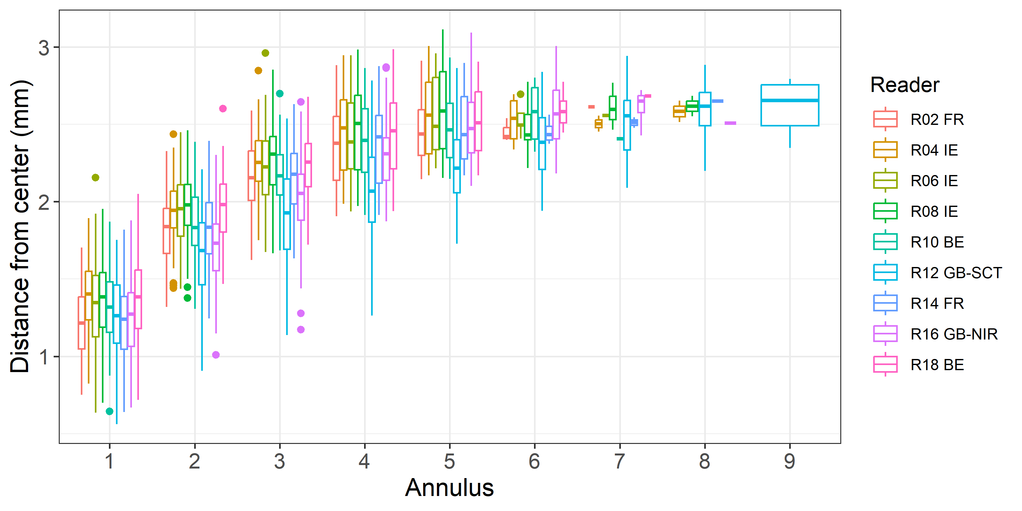
Figure 6.1: Plot of average distance from the centre to the winter rings for all readers. The boxes represent the median, upper and lower box boundaries of the interquartile range, whiskers represent the minimum and maximum values and the dots represent the outliers.

Mean length at age by reader
Overall, good consistency at younger ages 0 – 1 supports reliability in early growth interpretation for most readers Early ages (0–2) show tight ranges (152–160 mm at age 0; 201 – 214mm at age 1; 295–310 mm at age 2), if we exclude readers R12 GB-SCT and R16 GB-NIR - indicating good consistency.
- Mid ages (3–5) remain relatively narrow (334–377 mm).
- Older ages (6 – 7) the length at age ranges increase significantly from age 6 and especially at age 7, the range explodes (310–400 mm), confirming major disagreement among readers for older fish.
- Ages 8 and 9 lack sufficient data for range calculation.
Increasing variability at older ages indicates that some readers may be assigning older ages to larger fish disproportionately.
This pattern aligns with the pattern also observed in the age error matrix, where it is clear that older ages are harder to interpret, leading to potential over-ageing or under-ageing.
Table 7.0: Mean fish length at age per reader is calculated per reader and age (not modal age) and for all readers combined per age. A weighted mean is also given.
Age | R02 FR | R04 IE | R06 IE | R08 IE | R10 BE | R12 GB-SCT | R14 FR | R16 GB-NIR | R18 BE
0 | 160 mm | 152 mm | 155 mm | 152 mm | 155 mm | 150 mm | 155 mm | 140 mm | 155 mm
1 | 213 mm | 201 mm | 211 mm | 201 mm | 210 mm | 168 mm | 214 mm | 165 mm | 210 mm
2 | 309 mm | 295 mm | 307 mm | 297 mm | 310 mm | 231 mm | 301 mm | 207 mm | 309 mm
3 | 340 mm | 338 mm | 353 mm | 341 mm | 334 mm | 291 mm | 339 mm | 282 mm | 340 mm
4 | 377 mm | 360 mm | 354 mm | 360 mm | 370 mm | 333 mm | 374 mm | 330 mm | 361 mm
5 | 372 mm | 372 mm | 372 mm | 368 mm | 366 mm | 331 mm | 355 mm | 372 mm | 374 mm
6 | 330 mm | 357 mm | 370 mm | 370 mm | 355 mm | 344 mm | 370 mm | 365 mm | 352 mm
7 | 360 mm | - | 360 mm | 380 mm | 400 mm | 385 mm | 310 mm | 367 mm | 360 mm
8 | - | 335 mm | - | 335 mm | - | 400 mm | 360 mm | 310 mm | -
9 | - | - | - | - | - | 390 mm | - | - | -
Weighted Mean | 300 mm | 300 mm | 300 mm | 300 mm | 300 mm | 300 mm | 300 mm | 300 mm | 300 mm

Age Calibration Results for Advanced Readers Only
This analysis looks at the results Advanced Readers Only, across all images, including those with a readability score of AQ3_QA. The AQ Readability Score definitions are given below in Table 6.1.
Table 7.1: AQ Readability Score Definitions.
AQ Code | Definition
AQ1 | Rings can be counted with certainty
AQ2 | Rings can be counted with difficulty and some doubt
AQ3 | Rings cannot be counted; the calcified structure is considered unreadable - no age assigned
AQ3_QA | Rings cannot be counted; the calcified structure is considered unreadable - age assigned for QA purposes only

Table 7.2: Summary of statistics; Total number of samples (NSample), coefficient of variance (CV), percentage of agreement (PA) and average percentage error (APE) for all ages and readers
NSample | CV | PA | APE
109 | 19 % | 82 % | 10 %

In this exchange event, 109 otolith fish individuals were aged. Of those, 17 %when the traditional approach (all readers equally weighted) is used to define the mode. The percentage of multiple mode cases is reduced to 0 %. The complete list of cases with multiple modes is presented in tables 7.3 and 7.4, where the ageing from each of the readers participating in the exchange event is presented. When all the otolith samples are considered (both single and multimodal cases) the weighted average percentage agreement based on modal ages for advanced readers is 82 %, with the weighted average CV of 19 % and APE of 10 %.
The modal age range of all readers’ analysis was 0-7 for the whole set of otoliths. There were 6 otoliths at modal age 0, with a further 27 modal age 1 otoliths and 23 modal age 2 otoliths, in an effort to address the concerns raised by WGCSE. 53 otoliths were spread across modal ages 3 – 7.The overall agreement for advanced readers was 82%. The best agreement was obtained for otoliths of modal age 0 – 2 with average percentage agreement across the advanced readers group being 92%, 91% and 88% respectively.
The lowest agreement was obtained for otoliths with modal age 6 and 7 (56% and 50%).

Multimodal cases
Table 7.3: Total number of samples (NSample) and percentage of cases (fish samples) with multiple modes depending on the approach to weight the experience of the reader which will be considered when defining the fish age mode. PercMM_traditional shows the percentage of the total samples for which multiple modes are obtained when all the readers are equally weighted. PercMM_linear_weight shows the percentage of the total samples for which multiple modes are obtained when the weight assigned to the different readers decreases linearly with the experience, while in the PercMM_negexp the weight applied decreases with a negative exponential shape with the experience. The PercMM_multistage shows the percentage of multiple mode cases when a combination of the different methodologies is used, as explained in the material and methods section

NSample | PercMM_traditional | PercMM_linear_weight | PercMM_negexp_weight | PercMM_multistage
109 | 17 % | 1 % | 0 % | 0 %

List of multimodal cases
Table 7.4: List of cases for which multiple modes were obtained when advanced readers are considered. The column NModes_trad shows the number of multiple modes for each FishID or SampleID when all readers are given the same expertise weight.
NModes_trad | SampleID
2 | Whg_2020_7a_50514_021
2 | WHG_2020_7a_51067_019
2 | WHG_2020_7a_51067_023
2 | WHG_2021_7a_53414_035
2 | WHG_2022_7a_54652_021
2 | WHG_2022_7a_56805_010
2 | WHG_2022_7a_56805_018
2 | WHG_2022_7a_57272_003
2 | WHG_2023_7a_57571_026
2 | WHG_2023_7a_59489_014
2 | WHG_2023_7a_59626_014
2 | WHG_2023_7a_59643_014
2 | WHG_2023_7a_59643_016
2 | WHG_2024_7a_60356_004
2 | WHG_2024_7a_60606_003
2 | WHG_2024_7a_CHD5_007
2 | WHG_2024_7a_GFS322_005
2 | WHG_2024_7a_GFS322_010
2 | WHG_2025_7a_62655_017

Coefficient of Variation (CV)
Cv’s for all Advanced Readers are highlighted in Table 7.5 below.
The advanced readers (R02 FR, R04 IE, R06 IE, R08 IE) show consistently low variability, confirming strong agreement in age interpretation. The combined weighted mean CV for all advanced readers is 19%, which is well within acceptable limits for age reading exchanges.
By Modal Age
Age 1: CV is highest (28% overall; individual readers range 19–29%). This indicates early age interpretation remains the most challenging.
Age 2–3: CV drops significantly (15–19%), showing improved consistency after the first winter ring.
Ages 4–6: CV stabilizes at low levels (14–17%), reflecting strong agreement among advanced readers for mid-age fish.
Age 7: Very low CV (8%), suggesting near-perfect alignment, though likely influenced by fewer samples.

By Reader
R02 FR: Weighted mean CV = 16% indicating the best performer amongst the advanced readers.
R06 IE: 17% is slightly better than group average.
R04 IE and R08 IE: 19% and 18% are still strong but with marginally higher variability.
Overall, differences between advanced readers are minor, indicating methodological consistency.
Table 7.5: Coefficient of Variation (CV) table presents the CV per modal age and reader, the CV of advanced readers combined per modal age and a weighted mean of the CV per reader
Modal age | R02 FR | R04 IE | R06 IE | R08 IE | all
0 | - | - | - | - | -
1 | 29% | 29% | 19% | 29% | 28%
2 | 10% | 19% | 26% | 16% | 19%
3 | 0% | 18% | 16% | 18% | 15%
4 | 16% | 16% | 6% | 16% | 15%
5 | 20% | 6% | 16% | 6% | 14%
6 | 18% | 15% | 10% | 14% | 17%
7 | - | - | - | - | 8%
Weighted Mean | 16% | 19% | 17% | 18% | 19%

Relative Bias
Relative bias is the difference between the mean age (per modal age per reader) and modal age. As for the previous tables, a combined bias for all readers and weighted means are calculated and presented in Table 7.6 which shows: The weighted mean bias for all advanced readers combined is very low (0.05), indicating that, on average, advanced readers are well aligned with the modal age and show minimal systematic deviation.
By Individual weighted means
If we look at Individual weighted means we see the following:
R02 FR: -0.18 → slight tendency to under-age.
R04 IE: +0.22 → slight tendency to over-age.
R06 IE: -0.03 → almost neutral.
R08 IE: +0.20 → slight tendency to over-age.
By Modal Age
Age 0–2: Bias values are small (mostly between -0.08 and +0.21), suggesting good consistency for early ages.
Age 3–4: Bias increases slightly for R04 IE and R08 IE (up to +0.38), indicating some over-aging for mid-age fish.
Age 5: R02 FR shows a large negative bias (-0.71), suggesting under-aging at this age, while others remain near neutral.
Age 6–7: Variability spikes: with R02 FR and R06 IE strongly under-ageing (-0.75 and -0.5), while R04 IE and R08 IE strongly over-age(+0.5 and +0.75). Combined bias for age 6 ends up being neutral (0), meaning errors cancel out across readers. Age 7 shows the most divergence (0 vs +1), likely due to very few samples. It would appear that older ages (6–7) are the most problematic, with opposing tendencies amongst readers.
Table 7.6: The relative bias (as the difference between the mean and modal age) per modal age and reader is presented, as well as the weighted mean relative bias per reader and the relative bias per modal age for Advanced Readers only combined.
Modal age | R02 FR | R04 IE | R06 IE | R08 IE | all
0 | 0 | 0.17 | 0 | 0.17 | 0.08
1 | -0.08 | 0.12 | 0.04 | 0.12 | 0.05
2 | -0.04 | 0.21 | 0 | 0.12 | 0.07
3 | 0 | 0.27 | 0.13 | 0.2 | 0.15
4 | -0.12 | 0.38 | -0.06 | 0.38 | 0.14
5 | -0.71 | 0.12 | -0.19 | 0.12 | -0.16
6 | -0.75 | 0.5 | -0.5 | 0.75 | 0
7 | 0 | 1 | 0 | 1 | 0.5
Weighted Mean | -0.18 | 0.22 | -0.03 | 0.2 | 0.05
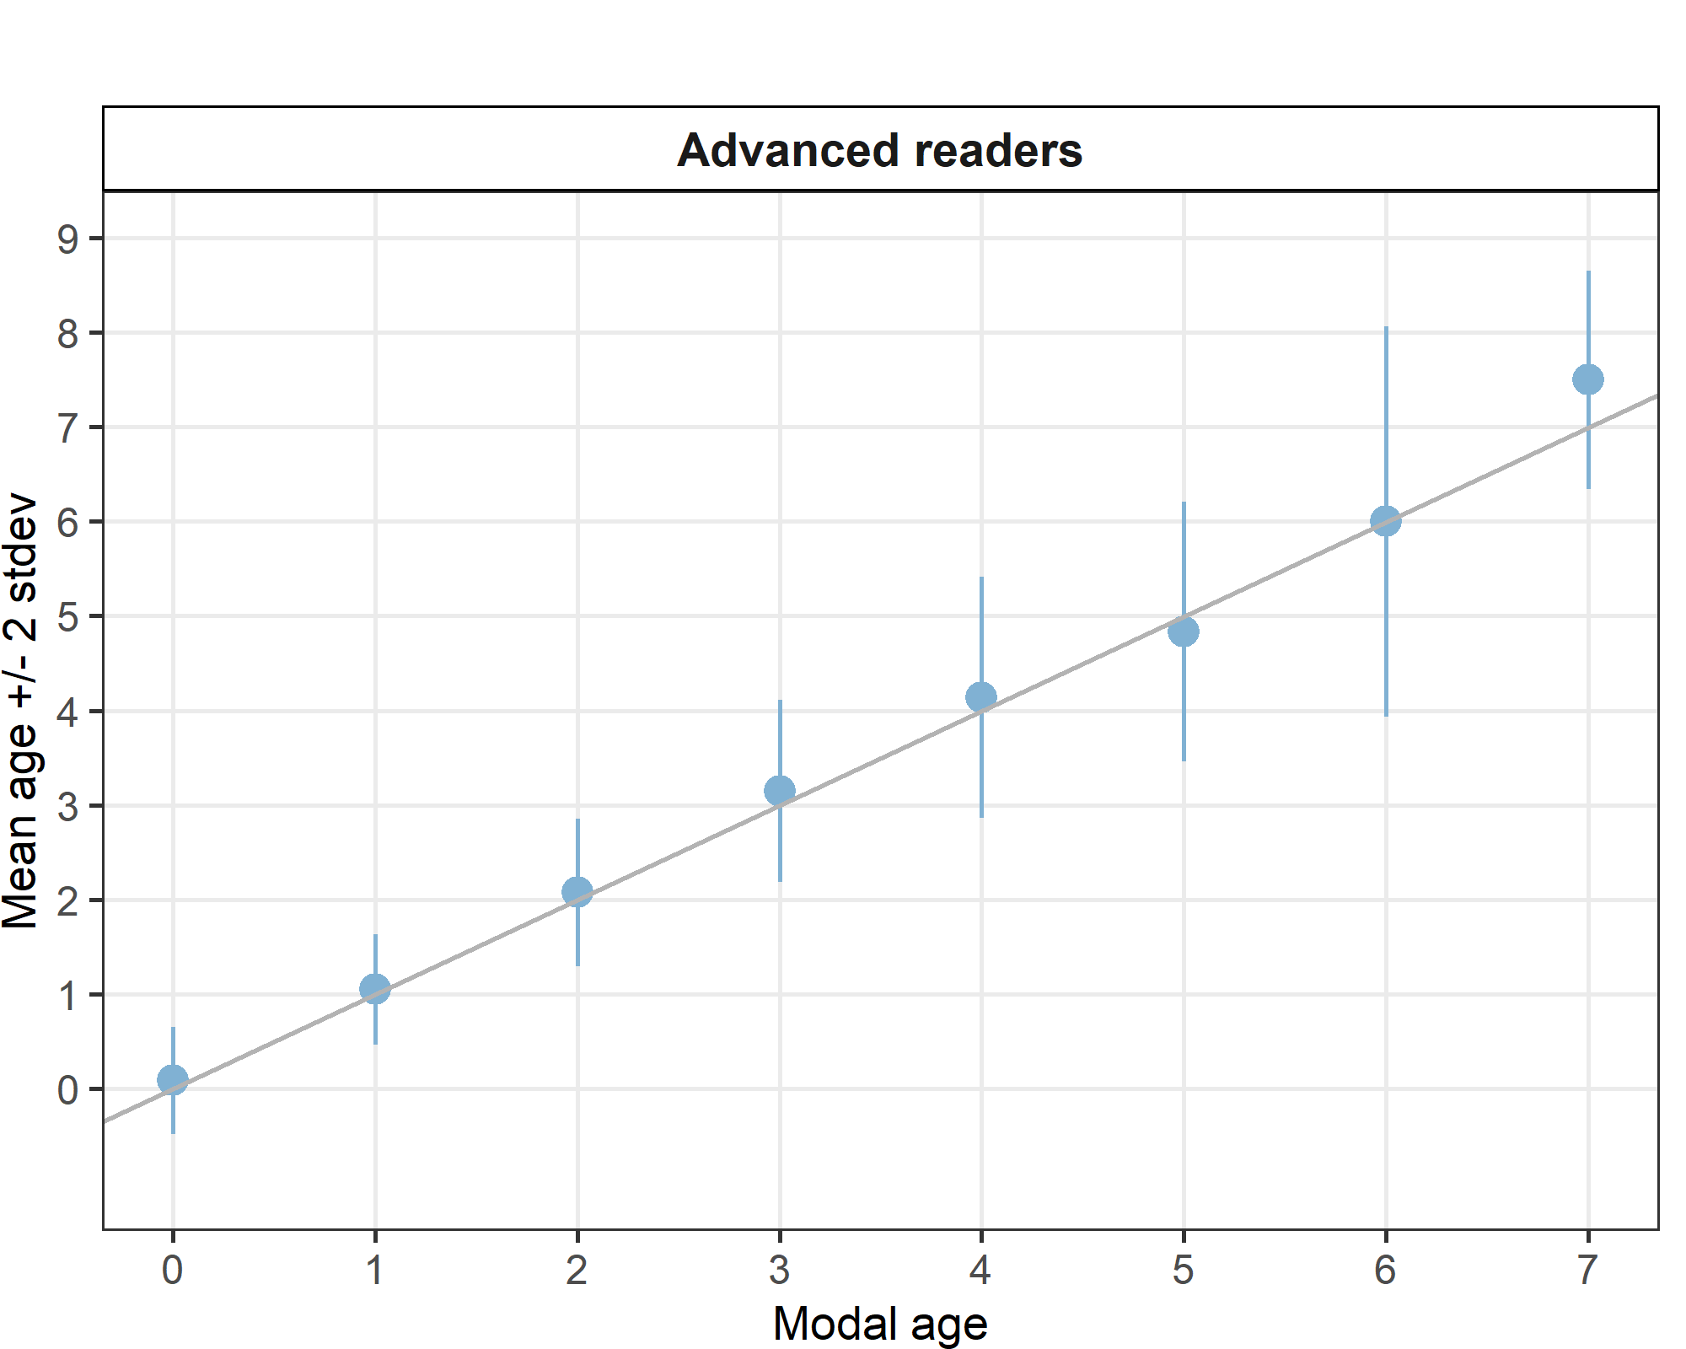
Figure 7: Age bias plot for all readers. Mean age recorded +/- 2 stdev of each reader and advanced readers combined are plotted against modal age. The estimated mean age corresponds to modal age, if the estimated mean age is on the 1:1 equilibrium line (solid line). Relative bias is the age difference between estimated mean age and modal age.

Percentage Agreement (PA)
The percentage agreement per reader per modal age tells what proportion of the readings are equal to the modal age. The weighted mean including at the bottom of the table is weighted according to number of age readings. % agreement results presented for all readers in Table 7.7. The weighted mean PA for advanced readers ranges from 79% to 85%, with an overall average of 82%. This indicates strong consistency amongst advanced readers. Although these results are very good, they do highlight some age-specific challenges as outlined below.
By Modal Age
- Age 0: Very high agreement (92% overall), suggesting strong alignment when identifying the youngest fish.
- Age 1–2: Agreement remains high (91% and 88% overall), confirming reliability for early ages after age 0.
- Age 3: Slight drop to 85%, with R06 IE notably lower at 73%, indicating some variability in mid-age interpretation.
- Age 4–5: Agreement declines further (72% and 73% overall). R04 IE and R08 IE show the lowest scores at 56% for age 4, suggesting difficulty in distinguishing mid-life annuli.
- Age 6: Lowest overall agreement (56%), with all readers struggling (50–75%). This reflects challenges in interpreting older otoliths.
- Age 7: Highly inconsistent (50% overall) due to extreme variation (two readers at 100%, two at 0%), likely caused by very small sample size and/or interpretation uncertainty.
The results show that Advanced Readers are generally reliable, but interpretation becomes more challenging as fish age.
Table 7.7: Percentage agreement (PA) table represents the PA per modal age and reader, the PA of advanced readers combined per modal age and a weighted mean of the PA per reader.
Modal age | R02 FR | R04 IE | R06 IE | R08 IE | total
0 | 100% | 83% | 100% | 83% | 92%
1 | 92% | 88% | 96% | 88% | 91%
2 | 96% | 79% | 88% | 88% | 88%
3 | 100% | 80% | 73% | 87% | 85%
4 | 81% | 56% | 94% | 56% | 72%
5 | 53% | 88% | 62% | 88% | 73%
6 | 50% | 75% | 50% | 50% | 56%
7 | 100% | 0% | 100% | 0% | 50%
Weighted Mean | 85% | 79% | 84% | 81% | 82%

Average Percentage Error (APE)
Weighted mean APE for advanced readers ranges from 8% to 13%, with an overall average of 10%. This confirms high accuracy and consistency amongst advanced readers, well within acceptable limits for age reading exercises.
By Modal Age
- Age 1: Highest error among advanced readers (7–18%, overall, 12%). This reflects the challenge of interpreting the first winter ring.
- Age 2–3: APE drops significantly (overall 9%), indicating improved accuracy after the first annulus.
- Age 4–6: Stable performance (overall 9–10%), showing strong consistency for mid-age fish.
- Age 7: 0% error for all readers (overall 7%, likely due to very few samples or unanimous agreement).
- Age 0: APE cannot be computed for age 0, and it is left blank (“–”) in the table.
By Reader
- R06 IE: Best performer (weighted mean 8%), consistently low error across ages.
- R02 FR: 10%, strong accuracy.
- R04 IE: 13%, slightly higher error, particularly at ages 1 and 4.
- R08 IE: 12%, similar pattern to R04 IE. Overall, differences between advanced readers are minor, confirming methodological alignment.
Table 7.8: Average Percentage Error (APE) table represents the APE per modal age and reader, the APE of advanced readers combined per modal age and a weighted mean of the APE per reader.
Modal age | R02 FR | R04 IE | R06 IE | R08 IE | all
0 | - | - | - | - | -
1 | 15% | 18% | 7% | 18% | 12%
2 | 4% | 15% | 8% | 10% | 9%
3 | 0% | 13% | 11% | 11% | 9%
4 | 9% | 14% | 3% | 14% | 10%
5 | 17% | 4% | 11% | 4% | 9%
6 | 14% | 12% | 9% | 11% | 10%
7 | 0% | 0% | 0% | 0% | 7%
Weighted Mean | 10% | 13% | 8% | 12% | 10%

Age Error Matrix (AEM)
The age error matrix highlights strong agreement at younger ages but reveals increasing misclassification as fish age, particularly from age 4 onward. These results underscore the need for targeted calibration on mid to older age classes where interpretation variability is greatest. If older ages are underestimated, stock assessments may underestimate longevity and spawning potential. Conversely, if younger ages are overestimated, recruitment estimates may be biased.

- High Agreement at Young Ages:
  - Age 0: 92% correct, 8% misclassified as age 1.
  - Age 1: 91% correct, 7% misclassified as age 2.
  - Age 2: 88% correct, small errors to age 1 (3%) and age 3 (8%).
- Increasing Error with Age:
  - Age 3: 85% correct, 10% misclassified as age 4, 3% as age 5.
  - Age 4: Only 72% correct, with 17% misclassified as age 5 and 6% as age 3.
  - Age 5: 73% correct, 10% misclassified as age 4, 9% as age 6.
  - Age 6: 56% correct, major spread (19% to age 5, 12% to age 8).
- Severe Uncertainty at Oldest Ages:
  - Age 7: 50% assigned correctly, 50% misclassified as age 8.
  - Age 8: No row shown (likely very few samples), but age 7 misclassification suggests difficulty distinguishing older annuli.
If looking at the Bias Direction, there appears to be a tendency to over-age at younger ages (e.g., age 0 → age 1), and under-age at older ages (e.g., age 6 → age 5). Ages 4–6 are critical: agreement drops below 75%, with large spreads.

Table 7.9: Age error matrix (AEM). The modal age is in rows and the age classifications by the advanced readers in columns.
modal_age | 0 | 1 | 2 | 3 | 4 | 5 | 6 | 7 | 8 | Total
0 | 0.92 | 0.08 | - | - | - | - | - | - | - | 1.00
1 | 0.02 | 0.91 | 0.07 | - | - | - | - | - | - | 1.00
2 | - | 0.03 | 0.88 | 0.08 | 0.01 | - | - | - | - | 1.00
3 | - | - | 0.02 | 0.85 | 0.10 | 0.03 | - | - | - | 1.00
4 | - | - | 0.02 | 0.06 | 0.72 | 0.17 | 0.03 | - | - | 1.00
5 | - | - | - | 0.07 | 0.10 | 0.73 | 0.09 | - | - | 0.99
6 | - | - | - | - | 0.06 | 0.19 | 0.56 | 0.06 | 0.12 | 0.99
7 | - | - | - | - | - | - | - | 0.50 | 0.50 | 1.00

Inter-reader bias test
The modal age row indicates significant differences across all readers, implying that overall age estimation may be skewed for certain age classes. These patterns suggest that biases may arise from methodological differences, regional practices, or sample variability.
- R04 IE and R08 IE show significant inter - reader bias with R02 FR, demonstrating a systematic difference in age reading interpretation.
- R06 IE: No bias detected and is therefore likely the most consistent reader of the group.
- Modal Age Bias: Significant across all readers. This Indicates systematic differences in assigning modal age, possibly due to interpretation of growth zones or annuli.
It would be useful to harmonize interpretation criteria for older ages (where modal age bias is strongest) for advanced readers.

Table 8.0: Inter reader bias test. The Inter-reader bias test gives probability of bias between readers and with modal age. - = no sign of bias (p>0.05), * = possibility of bias (0.01<p<0.05), * * = certainty of bias (p<0.01) , / = diagonal of the table (no bias)
Comparison | R02 FR | R04 IE | R06 IE | R08 IE
R02 FR | / | ** | - | **
R04 IE | ** | / | - | -
R06 IE | - | - | / | -
R08 IE | ** | - | - | /
Modal age | ** | ** | ** | **

Growth Analysis
Differences in early annuli interpretation appear to be the main source of inter-reader bias. There seems to be a systematic pattern where R02 FR consistently measures smaller increments in early annuli, which could explain why R04 IE and R08 IE show bias against R02 FR (they interpret early growth zones as larger). Later annuli show strong agreement. The Growth pattern observed here is typical for whiting, with rapid early growth (large increments), then tapering after annulus 5. The High variability in early annuli suggests challenges in distinguishing checks vs true annuli.
- Early Growth (Annuli 1–3):
  - R02 FR (red) tends to measure slightly smaller distances than others for annulus 1 and 2.
  - R04 IE (green) and R08 IE (purple) show slightly larger measurements for annulus 2 and 3.
  - Variability is highest in early annuli across all readers (wide whiskers and outliers), indicating difficulty in interpreting the first growth rings.
- Mid Growth (Annuli 4–5):
  - All readers converge more closely, but R04 IE and R08 IE still lean toward slightly larger distances.
  - R06 IE (blue) appears most consistent (narrower boxes), suggesting stable interpretation.
- Late Growth (Annuli 6–8):
  - Distances flatten out (growth slows), and variability decreases significantly.
  - All readers are nearly aligned for annuli 7 and 8, indicating consensus at older ages.

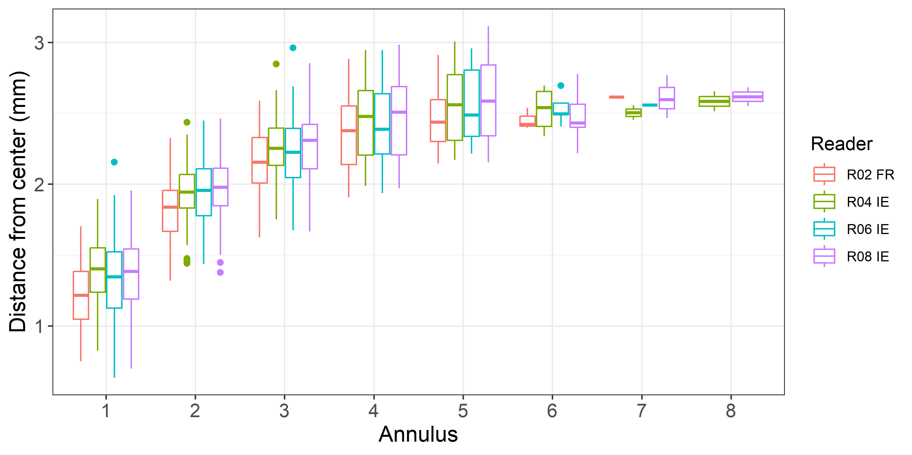
Figure 8: Plot of average distance from the centre to the winter rings for advanced readers. The boxes represent the mean, upper and lower box boundaries of the interquartile range, whiskers represent the minimum and maximum values, and the dots represent the outliers.

Mean length at age by reader
A similar pattern is observed as was seen in the Age Error Matrix data and is highlighted below:
Early Ages (0–2):
Lengths are consistent across readers, indicating strong agreement in interpreting early annuli.
  - Age 0: 152–160 mm
  - Age 1: 201–213 mm
  - Age 2: 295–309 mm
Mid Ages (3–5):
- Age 3: 338–353 mm (slight spread, but still close).
- Age 4: More divergence (354–377 mm), suggesting some variability in assigning age to mid-sized fish.
- Age 5: Perfect alignment (368–372 mm), showing consensus.
Older Ages (6–8):
- Age 6: Larger spread (330 mm for R02 FR vs 370 mm for R06/R08 IE).
- Age 7: R08 IE reports 380 mm vs 360 mm for others.
- Age 8: Only R04 IE and R08 IE report 335 mm, others missing, indicating uncertainty and lack of consistency at older ages.
Table 8.1: Mean fish length at age per reader is calculated per reader and age (not modal age) and for advanced readers combined per age. A weighted mean is also given.
Age | R02 FR | R04 IE | R06 IE | R08 IE
0 | 160 mm | 152 mm | 155 mm | 152 mm
1 | 213 mm | 201 mm | 211 mm | 201 mm
2 | 309 mm | 295 mm | 307 mm | 297 mm
3 | 340 mm | 338 mm | 353 mm | 341 mm
4 | 377 mm | 360 mm | 354 mm | 360 mm
5 | 372 mm | 372 mm | 372 mm | 368 mm
6 | 330 mm | 357 mm | 370 mm | 370 mm
7 | 360 mm | - | 360 mm | 380 mm
8 | - | 335 mm | - | 335 mm
Weighted Mean | 300 mm | 300 mm | 300 mm

8. Discussion
This calibration exchange provides critical insights into the accuracy and consistency of age determination for Irish Sea whiting (Merlangius merlangus), highlighting clear contrasts between advanced and basic readers.
Performance of Advanced Readers
Advanced readers demonstrated strong reliability overall, with a weighted mean percentage agreement (PA) of 82%, low coefficient of variation (CV = 19%), and average percentage error (APE = 10%). These values confirm that advanced readers are well aligned with modal age and exhibit minimal systematic bias. Relative bias across advanced readers was close to neutral (combined mean = +0.05), indicating only minor tendencies toward over- or under-aging. This consistency supports the continued use of their age readings n stock assessments.
However, age-specific challenges remain. Early ages (0–2) showed the highest agreement (88–92%), but age 1 remains problematic, with CV values up to 29% and APE reaching 18% for some readers. Mid-aged fish (ages 4–5) exhibited declining agreement (72–73%) and increased variability, while older ages (6–7) were the most challenging, with PA dropping to 50–56% and opposing tendencies amongst readers (some over-aging, others under-aging). These discrepancies align with the age error matrix, which revealed increasing misclassification beyond age 4 and severe uncertainty at age 7 (50% misclassified as age 8). Such variability can distort estimates of longevity and spawning potential.
Performance of Basic Readers
Basic readers introduced substantial variability into the dataset. While some performed exceptionally well—R10 BE achieved 90% PA and very low APE (3%)—others were significant outliers. R12 GB-SCT and R16 GB-NIR recorded extremely poor agreement (20% and 25% PA) and strong systematic over-aging biases (+1.51 and +1.04 years, respectively). These readers also exhibited the highest CV values (up to 54%) and APE exceeding 25%, confirming that their age estimates are unreliable for assessment purposes. The inclusion of such outliers inflates overall variability (combined CV = 32%) and reduces overall agreement (69%), underscoring the need for targeted retraining and, in the case of Reader R16 GB-NIR – whose ages are currently being used in the stock assessment for Irish Sea Whiting , exclusion or down-weighting of their data in stock assessment. In the case of R12 GB-SCT, this is potentially a result of being new to age reading of whiting in combination with routinely reading broken not sectioned otoliths, as all the other readers do. R16 GB-NIR is also an inexperienced age reader, however the main concern here is that their age readings are currently used in the Irish Sea whiting stock assessment.
Growth and Length-at-Age Patterns
Growth analysis revealed that early annuli interpretation is the primary source of inter-reader bias. R02 FR consistently measured smaller increments in early annuli compared to R04 IE and R08 IE, explaining systematic differences observed in bias tests. Later annuli showed strong convergence, suggesting calibration efforts should prioritize harmonizing interpretation of early growth zones. Length-at-age data corroborates these findings: early ages (0–2) exhibited tight ranges (152–160 mm at age 0; 295–309 mm at age 2), while variability increased markedly at older ages, particularly age 6 (330–370 mm) and age 7 (310–400 mm). This pattern reinforces the need for calibration on older fish.

Analysis of Advanced Reader Results in Relation to WGCSE Concerns
The patterns observed in WGCSE 2025 could possibly be a result of misclassification between ages 1 and 2. A sharp decline in maturity at age 2 (from 95% to <60%) and an increase in maturity at age 1, combined with declining weight-at-age for most ages but increasing weight for age-1 fish, suggested possible misclassification between ages 1 and 2.
Viewing the results of the Advanced Age Readers through this lens highlights the following:

Percentage Agreement (PA) and Coefficient of Variation (CV)
- Advanced readers show high PA for ages 0–2:
  - Age 0: 92%, Age 1: 91%, Age 2: 88%.
- CV for age 1 is highest among advanced readers (28%), indicating variability in interpretation of the first annulus.
- CV drops for age 2 (19%) but remains notable.
These results appear to confirm that age 1 is the most challenging, supporting the hypothesis that confusion between ages 1 and 2 could occur.

Relative Bias
- Advanced readers exhibit minimal overall bias (weighted mean = +0.05), but age-specific trends matter:
  - Age 1: Slight positive bias for some readers (+0.12), suggesting occasional over-aging.
  - Age 2: Bias remains small (+0.07 overall), but individual readers differ (R04 IE up to +0.21).
- This pattern indicates some tendency to classify age-1 fish as age-2, though not significant amongst advanced readers.

Age Error Matrix
- Misclassification between ages 1 and 2 is evident:
  - Age 1: 7% misclassified as age 2.
  - Age 2: 3% misclassified as age 1 and 8% as age 3.
- While agreement is high overall, these error rates confirm some confusion between ages 1 and 2, consistent with WGCSE’s hypothesis.

Growth and Length-at-Age
- Length-at-age data for advanced readers shows:
  - Age 1: ~201–213 mm.
  - Age 2: ~295–309 mm.
- The clear size gap suggests that when misclassification occurs, it is likely due to interpretation of annuli rather than overlapping size ranges. This reinforces that otolith reading challenges, not biological overlap, drive errors.

Conclusion
The advanced reader results partially support the patterns observed at WGCSE 2025:
- There is evidence of potential confusion between ages 1 and 2, as shown by high CV at age 1, moderate misclassification in the age error matrix, and slight positive bias for age 1.
- However, advanced readers maintain strong overall agreement and low error rates compared to basic readers, suggesting that the major issue lies with inexperienced readers (as WGCSE suspected).
- The hypothesis that age-1 fish are sometimes aged as age-2 is valid, but amongst advanced readers, this occurs at a relatively low level and is unlikely to fully explain the maturity ogive shift. The problem is likely amplified when basic readers’ data are included in assessments.

9. Conclusion
This calibration exchange confirms that advanced readers provide reliable and consistent age estimates for Irish Sea whiting, while basic readers introduce significant variability as a group. It’s important to highlight that a number of Basic Readers performed very well in this exchange and the results of the Basic Group as a whole are heavily influenced by the results of two outliers within this group. Advanced readers achieved strong performance metrics—82% percentage agreement, CV of 19%, and APE of 10%—indicating high precision and minimal bias. In contrast, basic readers collectively reduced overall agreement to 69% and increased variability (CV = 32%), with two readers (R12 GB-SCT and R16 GB-NIR) showing extreme bias and poor accuracy. These discrepancies highlight the importance of expertise in age reading and the need for targeted calibration.
Key Findings
- Early Ages (0–2): High agreement amongst advanced readers (88–92%) but persistent challenges at age 1, where CV and APE peak.
- Mid Ages (3–5): Agreement declines slightly, with some variability in interpretation.
- Older Ages (6–7): Most problematic, with PA dropping to 50–56% and opposing tendencies amongst readers (over-aging vs under-aging).
- Basic Readers: Significant outliers (R12 GB-SCT and R16 GB-NIR) exhibit systematic over-aging and poor agreement, requiring urgent intervention.
- Growth and Length-at-Age: Variability in early annuli interpretation drives bias; older ages show widening length ranges, reinforcing calibration needs.

Recommendations for Improvement
- Targeted Retraining for Basic Readers
  - Prioritize intensive training for R12 GB-SCT and R16 GB-NIR before their data are used in assessments.
  - Implement structured calibration exercises using reference otolith sets of agreed age. This could be done online via SmartDots.
- Focus Calibration on Problematic Age Classes
  - Early ages (0–2): Develop clear criteria for identifying the first annulus and distinguishing checks.
  - Mid to older ages (4–7): Harmonize interpretation guidelines to reduce opposing tendencies amongst readers.
- Create a Reference Collection for Irish Sea Whiting
  - Use annotated agreed age reference images to clarify interpretation of early growth zones.
  - Agree on a best method for preparation of otoliths – in this case the recommendation is for all readers to read sectioned otoliths, reading with reflected light.
- Implement Quality Control Measures
  - Exclude or down-weight data from readers with persistent bias until retraining is complete.
  - Regularly monitor PA, CV, and APE metrics to track improvement over time.

In summary, advanced readers (and a number of basic readers) provide a strong foundation for accurate age determination, but variability introduced by some basic readers and challenges at specific age classes must be addressed. Implementing targeted training, harmonized interpretation protocols, and robust quality control will significantly improve the precision and reliability of age data for Irish Sea whiting stock assessments.

10.References
Beamish R. J. and Fournier D. A. (1981) A method for comparing the precision of a set of age determination. Canadian Journal of Fisheries and Aquatic Sciences, 38, 982–983
GUIDELINES AND TOOLS FOR AGE READING. Eltink, A.T.G.W., Newton A.W., Morgado C., Santamaria M.T.G and Modin J. (2000) Guidelines and tools for age Reading. (PDF document version 1.0 October 2000) Internet: http://www.efan.no
Eltink, A.T.G.W. (2000) Age reading comparisons. (MS Excel workbook version 1.0 October 2000) Internet: http://www.efan.no
ICES (2014) Report of the Workshop on Statistical Analysis of Biological Calibration Studies (WKSABCAL). ICES CM 2014/ACOM: 35
Table X: Participants list.
Reader code | Expertise | Expertise_rank | strata
R02 FR | Advanced | 2 | Strata_1
R04 IE | Advanced | 4 | Strata_1
R06 IE | Advanced | 6 | Strata_1
R08 IE | Advanced | 8 | Strata_1
R10 BE | Basic | 10 | Strata_1
R12 GB-SCT | Basic | 12 | Strata_1
R14 FR | Basic | 14 | Strata_1
R16 GB-NIR | Basic | 16 | Strata_1
R18 BE | Basic | 18 | Strata_1

11. Additional results

11.1.Results all readers
Summary statistics
Table X: Summary of statistics; PA (%), CV (%) and APE (%).
NSample | CV | PA | APE
109 | 32 % | 69 % | 24 %

Data Overview
Table X: Data overview including modal age and statistics per sample.
Fish ID | Sample ID | Event ID | Image ID | length | sex | Catch date | ICES area | R02 FR | R04 IE | R06 IE | R08 IE | R10 BE | R12 GB-SCT | R14 FR | R16 GB-NIR | R18 BE | Modal age | PA % | CV % | APE %
WHG_001 | WHG_2024_7a_CTB4_006 | 2953 | 149908 | 150 | U | 22-02-2024 00:00:00 | 27.7.a | 1 | 1 | 1 | 1 | 1 | 1 | 1 | 1 | 1 | 1 | 100 | 0 | 0
WHG_002 | WHG_2024_7a_CTB4_005 | 2953 | 149907 | 170 | U | 22-02-2024 00:00:00 | 27.7.a | 1 | 1 | 1 | 1 | 1 | 1 | 1 | 1 | 1 | 1 | 100 | 0 | 0
WHG_003 | WHG_2024_7a_CHD5_004 | 2953 | 149902 | 190 | U | 21-07-2024 00:00:00 | 27.7.a | 1 | 1 | 1 | 1 | 1 | 1 | 1 | 2 | 1 | 1 | 89 | 30 | 18
WHG_004 | WHG_2024_7a_CHD5_007 | 2953 | 149903 | 210 | U | 21-07-2024 00:00:00 | 27.7.a | 1 | 2 | 1 | 2 | 1 | 3 | 1 | 3 | 1 | 1 | 56 | 52 | 44
WHG_005 | WHG_2024_7a_CHD5_008 | 2953 | 149904 | 210 | U | 21-07-2024 00:00:00 | 27.7.a | 1 | 1 | 1 | 1 | 1 | 1 | 1 | 2 | 1 | 1 | 89 | 30 | 18
WHG_006 | WHG_2024_7a_CHD5_009 | 2953 | 149905 | 170 | U | 21-07-2024 00:00:00 | 27.7.a | 0 | 1 | 1 | 1 | 1 | 2 | 1 | 3 | 1 | 1 | 67 | 68 | 46
WHG_007 | WHG_2024_7a_CHD5_010 | 2953 | 149906 | 180 | U | 21-07-2024 00:00:00 | 27.7.a | 0 | 1 | 1 | 1 | 1 | 1 | 1 | 3 | 1 | 1 | 78 | 70 | 38
WHG_008 | WHG_2021_7a_CHD6_003 | 2953 | 149871 | 160 | U | 28-06-2021 00:00:00 | 27.7.a | 1 | 1 | 1 | 1 | 1 | 1 | 1 | 2 | 1 | 1 | 89 | 30 | 18
WHG_009 | WHG_2021_7a_CHD6_004 | 2953 | 149872 | 180 | U | 28-06-2021 00:00:00 | 27.7.a | 1 | 1 | 1 | 1 | 1 | 2 | 1 | 2 | 1 | 1 | 78 | 36 | 28
WHG_010 | WHG_2021_7a_CHD6_006 | 2953 | 149873 | 170 | U | 28-06-2021 00:00:00 | 27.7.a | 1 | 1 | 1 | 1 | 1 | 1 | 1 | 2 | 1 | 1 | 89 | 30 | 18
WHG_011 | WHG_2023_7a_CHD8_020 | 2953 | 149901 | 190 | U | 12-11-2023 00:00:00 | 27.7.a | 1 | 1 | 1 | 1 | 1 | 2 | 1 | 2 | 1 | 1 | 78 | 36 | 28
WHG_012 | WHG_2021_7a_CHD8_026 | 2953 | 149879 | 250 | U | 28-09-2021 00:00:00 | 27.7.a | 1 | 1 | 1 | 1 | 1 | 5 | 1 | 3 | 1 | 1 | 78 | 85 | 62
WHG_013 | WHG_2021_7a_CHD8_033 | 2953 | 149880 | 190 | U | 28-09-2021 00:00:00 | 27.7.a | 1 | 1 | 1 | 1 | 1 | 2 | 1 | 2 | 1 | 1 | 78 | 36 | 28
WHG_014 | WHG_2021_7a_CHD8_013 | 2953 | 149877 | 140 | U | 28-09-2021 00:00:00 | 27.7.a | 0 | 0 | 0 | 0 | 0 | 0 | 0 | 0 | 0 | 0 | 100 | - | -
WHG_015 | WHG_2021_7a_CHD8_074 | 2953 | 149881 | 120 | U | 28-09-2021 00:00:00 | 27.7.a | 0 | 0 | 0 | 0 | 0 | 1 | 0 | 0 | 0 | 0 | 89 | - | -
WHG_016 | WHG_2024_7a_GFS322_002 | 2953 | 149909 | 260 | U | 25-11-2024 00:00:00 | 27.7.a | 1 | 1 | 1 | 1 | 1 | 5 | 1 | 3 | 1 | 1 | 78 | 85 | 62
WHG_017 | WHG_2024_7a_GFS322_003 | 2953 | 149910 | 280 | U | 25-11-2024 00:00:00 | 27.7.a | 1 | 1 | 1 | 1 | 1 | 2 | 1 | 2 | 1 | 1 | 78 | 36 | 28
WHG_018 | WHG_2024_7a_GFS322_005 | 2953 | 149911 | 170 | U | 25-11-2024 00:00:00 | 27.7.a | 0 | 1 | 0 | 1 | 0 | 1 | 0 | 1 | 0 | 0 | 56 | - | -
WHG_019 | WHG_2024_7a_GFS322_006 | 2953 | 149912 | 140 | U | 25-11-2024 00:00:00 | 27.7.a | 0 | 0 | 0 | 0 | 0 | 1 | 0 | 1 | 0 | 0 | 78 | - | -
WHG_020 | WHG_2024_7a_GFS322_010 | 2953 | 149913 | 230 | U | 25-11-2024 00:00:00 | 27.7.a | 1 | 2 | 1 | 2 | 1 | 2 | 1 | 2 | 1 | 1 | 56 | 36 | 34
WHG_021 | WHG_2024_7a_GFS322_012 | 2953 | 149914 | 270 | U | 25-11-2024 00:00:00 | 27.7.a | 1 | 1 | 2 | 1 | 1 | 2 | 1 | 3 | 1 | 1 | 67 | 50 | 41
WHG_022 | WHG_2024_7a_GFS322_016 | 2953 | 149915 | 200 | U | 25-11-2024 00:00:00 | 27.7.a | 0 | 0 | 0 | 0 | 0 | 1 | 0 | 1 | 0 | 0 | 78 | - | -
WHG_023 | WHG_2024_7a_GFS322_020 | 2953 | 149916 | 280 | U | 25-11-2024 00:00:00 | 27.7.a | 1 | 1 | 1 | 1 | 1 | 2 | 1 | 2 | 1 | 1 | 78 | 36 | 28
WHG_024 | WHG_2022_7a_CHD1_030 | 2953 | 149897 | 230 | U | 19-03-2022 00:00:00 | 27.7.a | 1 | 1 | 1 | 1 | 1 | 2 | 1 | 2 | 1 | 1 | 78 | 36 | 28
WHG_025 | WHG_2022_7a_CHD1_039 | 2953 | 149898 | 250 | U | 19-03-2022 00:00:00 | 27.7.a | 1 | 1 | 1 | 1 | 1 | 2 | 1 | 2 | 1 | 1 | 78 | 36 | 28
WHG_026 | WHG_2022_7a_CHD1_042 | 2953 | 149899 | 200 | U | 19-03-2022 00:00:00 | 27.7.a | 1 | 1 | 1 | 1 | 1 | 2 | 1 | 2 | 1 | 1 | 78 | 36 | 28
WHG_027 | WHG_2022_7a_CHD1_046 | 2953 | 149900 | 160 | U | 19-03-2022 00:00:00 | 27.7.a | 1 | 1 | 1 | 1 | 1 | 1 | 1 | 1 | 1 | 1 | 100 | 0 | 0
WHG_028 | WHG_2021_7a_CHD6_009 | 2953 | 149874 | 160 | U | 28-06-2021 00:00:00 | 27.7.a | 1 | 1 | 1 | 1 | 1 | 1 | 1 | 2 | 1 | 1 | 89 | 30 | 18
WHG_029 | WHG_2021_7a_CHD6_013 | 2953 | 149875 | 180 | U | 28-06-2021 00:00:00 | 27.7.a | 1 | 1 | 1 | 1 | 1 | 2 | 2 | 2 | 1 | 1 | 67 | 38 | 33
WHG_030 | WHG_2021_7a_CHD6_016 | 2953 | 149876 | 170 | U | 28-06-2021 00:00:00 | 27.7.a | 1 | 1 | 1 | 1 | 1 | 2 | 1 | 3 | 1 | 1 | 78 | 53 | 39
WHG_031 | WHG_2021_7a_CHD8_015 | 2953 | 149878 | 160 | U | 28-09-2021 00:00:00 | 27.7.a | 0 | 0 | 0 | 0 | 0 | 0 | 0 | 0 | 0 | 0 | 100 | - | -
WHG_033 | WHG_2023_7a_57571_022 | 2953 | 149941 | 360 | U | 19-01-2023 00:00:00 | 27.7.a | 3 | 3 | 3 | 3 | 3 | 6 | 3 | 4 | 3 | 3 | 78 | 29 | 20
WHG_034 | WHG_2023_7a_57571_026 | 2953 | 149942 | 300 | U | 19-01-2023 00:00:00 | 27.7.a | 4 | 5 | 4 | 5 | 4 | 6 | 4 | 4 | 4 | 4 | 67 | 16 | 13
WHG_035 | WHG_2023_7a_57571_028 | 2953 | 149943 | 310 | U | 19-01-2023 00:00:00 | 27.7.a | 2 | 3 | 2 | 2 | 2 | 3 | 2 | 4 | 3 | 2 | 56 | 28 | 24
WHG_036 | WHG_2024_7a_60062_014 | 2953 | 149959 | 330 | U | 06-07-2024 00:00:00 | 27.7.a | 3 | 5 | 4 | 5 | 3 | 4 | 3 | 5 | 3 | 3 | 44 | 24 | 20
WHG_037 | WHG_2024_7a_60356_003 | 2953 | 149960 | 310 | U | 12-03-2024 00:00:00 | 27.7.a | 3 | 3 | 2 | 3 | 3 | 3 | 3 | 3 | 3 | 3 | 89 | 12 | 7
WHG_038 | WHG_2024_7a_60356_004 | 2953 | 149961 | 360 | U | 12-03-2024 00:00:00 | 27.7.a | 5 | 6 | 5 | 6 | 6 | 6 | 5 | 6 | 5 | 6 | 56 | 9 | 9
WHG_039 | WHG_2024_7a_60606_003 | 2953 | 149962 | 300 | U | 25-03-2024 00:00:00 | 27.7.a | 4 | 5 | 4 | 5 | 5 | 4 | 5 | 5 | 4 | 5 | 56 | 12 | 11
WHG_040 | WHG_2023_7a_58666_015 | 2953 | 149952 | 350 | U | 09-06-2023 00:00:00 | 27.7.a | 4 | 6 | 4 | 5 | 4 | 5 | 5 | 6 | 6 | 4 | 33 | 17 | 13
WHG_041 | WHG_2023_7a_58666_013 | 2953 | 149951 | 330 | U | 09-06-2023 00:00:00 | 27.7.a | 2 | 2 | 1 | 2 | 2 | 2 | 2 | 3 | 2 | 2 | 78 | 25 | 11
WHG_042 | WHG_2023_7a_58666_012 | 2953 | 149950 | 420 | U | 09-06-2023 00:00:00 | 27.7.a | 4 | 5 | 3 | 5 | 4 | 7 | 4 | 6 | 4 | 4 | 44 | 26 | 21
WHG_043 | WHG_2023_7a_58352_002 | 2953 | 149949 | 340 | U | 06-05-2023 00:00:00 | 27.7.a | 3 | 3 | 3 | 3 | 2 | 5 | 3 | 4 | 2 | 3 | 56 | 30 | 20
WHG_044 | WHG_2023_7a_58265_005 | 2953 | 149948 | 440 | U | 11-04-2023 00:00:00 | 27.7.a | 4 | 5 | 5 | 5 | 4 | 8 | 5 | 5 | 5 | 5 | 67 | 23 | 13
WHG_045 | WHG_2023_7a_58265_003 | 2953 | 149947 | 410 | U | 11-04-2023 00:00:00 | 27.7.a | 4 | 4 | 4 | 4 | 4 | 7 | 4 | 5 | 4 | 4 | 78 | 23 | 16
WHG_046 | WHG_2023_7a_58175_005 | 2953 | 149946 | 310 | U | 04-04-2023 00:00:00 | 27.7.a | 3 | 4 | 4 | 4 | 4 | 4 | 5 | 4 | 4 | 4 | 78 | 12 | 6
WHG_047 | WHG_2023_7a_58175_002 | 2953 | 149945 | 390 | U | 04-04-2023 00:00:00 | 27.7.a | 3 | 3 | 3 | 3 | 3 | 4 | 3 | 3 | 3 | 3 | 89 | 11 | 6
WHG_048 | WHG_2023_7a_58172_001 | 2953 | 149944 | 440 | U | 04-04-2023 00:00:00 | 27.7.a | 4 | 5 | 4 | 6 | 5 | 7 | 4 | 4 | 4 | 4 | 56 | 23 | 18
WHG_049 | WHG_2022_7a_55876_007 | 2953 | 149938 | 380 | U | 04-05-2022 00:00:00 | 27.7.a | 3 | 3 | 3 | 3 | 3 | 5 | 3 | 5 | 3 | 3 | 78 | 26 | 20
WHG_050 | WHG_2020_7a_50532_010 | 2953 | 149918 | 310 | U | 16-05-2020 00:00:00 | 27.7.a | 2 | 2 | 2 | 2 | 2 | 3 | 2 | 3 | 2 | 2 | 78 | 20 | 16
WHG_051 | WHG_2020_7a_50532_011 | 2953 | 149919 | 310 | U | 16-05-2020 00:00:00 | 27.7.a | 3 | 3 | 3 | 3 | 3 | 4 | 3 | 3 | 3 | 3 | 89 | 11 | 6
WHG_052 | WHG_2020_7a_50532_012 | 2953 | 149920 | 350 | U | 16-05-2020 00:00:00 | 27.7.a | 6 | 6 | 5 | 6 | 5 | 7 | 6 | 5 | 6 | 6 | 56 | 12 | 9
WHG_053 | WHG_2020_7a_50532_013 | 2953 | 149921 | 340 | U | 16-05-2020 00:00:00 | 27.7.a | 3 | 3 | 3 | 3 | 3 | 4 | 3 | 4 | 3 | 3 | 78 | 14 | 11
WHG_054 | WHG_2020_7a_50532_014 | 2953 | 149922 | 390 | U | 16-05-2020 00:00:00 | 27.7.a | 5 | 5 | 5 | 5 | 6 | 9 | 5 | 6 | 5 | 5 | 67 | 23 | 16
WHG_055 | Whg_2020_7a_50514_021 | 2953 | 149967 | 390 | U | 30-04-2020 00:00:00 | 27.7.a | 4 | 5 | 4 | 5 | 5 | 7 | 4 | 5 | 5 | 5 | 56 | 19 | 12
WHG_056 | Whg_2020_7a_50514_023 | 2953 | 149968 | 380 | U | 30-04-2020 00:00:00 | 27.7.a | 4 | 4 | 3 | 4 | 4 | 6 | 4 | 4 | 4 | 4 | 78 | 19 | 10
WHG_057 | Whg_2020_7a_50514_024 | 2953 | 149969 | 330 | U | 30-04-2020 00:00:00 | 27.7.a | 5 | 4 | 4 | 4 | 4 | 6 | 4 | 4 | 4 | 4 | 78 | 16 | 12
WHG_058 | Whg_2020_7a_50514_025 | 2953 | 149970 | 330 | U | 30-04-2020 00:00:00 | 27.7.a | 2 | 3 | 2 | 2 | 3 | 4 | 3 | 3 | 3 | 3 | 56 | 24 | 19
WHG_059 | WHG_2024_7a_61345_001 | 2953 | 149963 | 300 | U | 19-09-2024 00:00:00 | 27.7.a | 2 | 2 | 2 | 2 | 2 | 3 | 2 | 4 | 2 | 2 | 78 | 30 | 22
WHG_060 | WHG_2021_7a_53415_020 | 2953 | 149936 | 300 | U | 23-09-2021 00:00:00 | 27.7.a | 4 | 6 | 5 | 6 | 5 | 6 | 5 | 6 | 4 | 6 | 44 | 16 | 13
WHG_061 | WHG_2021_7a_53414_035 | 2953 | 149935 | 310 | U | 22-09-2021 00:00:00 | 27.7.a | 6 | 8 | 6 | 8 | 6 | 6 | 7 | 8 | 6 | 6 | 56 | 14 | 13
WHG_062 | WHG_2020_7a_51152_010 | 2953 | 149932 | 400 | U | 15-09-2020 00:00:00 | 27.7.a | 4 | 4 | 4 | 4 | 4 | 5 | 4 | 5 | 4 | 4 | 78 | 10 | 8
WHG_063 | WHG_2020_7a_51152_011 | 2953 | 149933 | 440 | U | 15-09-2020 00:00:00 | 27.7.a | 4 | 5 | 5 | 5 | 4 | 8 | 4 | 5 | 4 | 5 | 44 | 26 | 16
WHG_064 | WHG_2020_7a_51152_012 | 2953 | 149934 | 380 | U | 15-09-2020 00:00:00 | 27.7.a | 5 | 6 | 6 | 7 | 5 | 8 | 5 | 7 | 5 | 5 | 44 | 19 | 15
WHG_065 | WHG_2020_7a_51067_019 | 2953 | 149927 | 390 | U | 30-09-2020 00:00:00 | 27.7.a | 4 | 5 | 4 | 5 | 4 | 6 | 4 | 6 | 4 | 4 | 56 | 19 | 16
WHG_066 | WHG_2020_7a_51067_020 | 2953 | 149928 | 280 | U | 30-09-2020 00:00:00 | 27.7.a | 2 | 2 | 1 | 2 | 3 | 3 | 1 | 4 | 2 | 2 | 44 | 44 | 33
WHG_067 | WHG_2020_7a_51067_021 | 2953 | 149929 | 350 | U | 30-09-2020 00:00:00 | 27.7.a | 2 | 2 | 2 | 2 | 2 | 4 | 2 | 4 | 2 | 2 | 78 | 36 | 28
WHG_068 | WHG_2020_7a_51067_023 | 2953 | 149930 | 390 | U | 30-09-2020 00:00:00 | 27.7.a | 2 | 3 | 2 | 3 | 2 | 5 | 2 | 4 | 2 | 2 | 56 | 39 | 31
WHG_069 | WHG_2020_7a_51067_024 | 2953 | 149931 | 380 | U | 30-09-2020 00:00:00 | 27.7.a | 3 | 5 | 4 | 5 | 4 | 8 | 4 | 5 | 4 | 4 | 44 | 30 | 21
WHG_070 | WHG_2020_7a_50781_002 | 2953 | 149923 | 370 | U | 13-08-2020 00:00:00 | 27.7.a | 3 | 5 | 4 | 5 | 4 | 9 | 3 | 5 | 3 | 5 | 33 | 41 | 28
WHG_071 | WHG_2020_7a_50781_004 | 2953 | 149924 | 330 | U | 13-08-2020 00:00:00 | 27.7.a | 3 | 5 | - | 5 | 4 | 4 | 4 | 6 | 3 | 4 | 38 | 24 | 19
WHG_072 | WHG_2020_7a_50781_005 | 2953 | 149925 | 350 | U | 13-08-2020 00:00:00 | 27.7.a | 3 | 3 | 3 | 3 | 3 | 7 | 3 | 5 | 3 | 3 | 78 | 39 | 28
WHG_073 | WHG_2020_7a_50781_006 | 2953 | 149926 | 310 | U | 13-08-2020 00:00:00 | 27.7.a | 2 | 4 | 4 | 4 | 4 | 5 | 4 | 4 | 4 | 4 | 78 | 20 | 11
WHG_074 | WHG_2022_7a_56805_015 | 2953 | 149939 | 350 | U | 05-10-2022 00:00:00 | 27.7.a | 4 | 5 | 5 | 5 | 4 | 5 | 4 | 4 | 4 | 4 | 56 | 12 | 11
WHG_075 | WHG_2022_7a_56805_018 | 2953 | 149940 | 310 | U | 05-10-2022 00:00:00 | 27.7.a | 3 | 5 | 3 | 5 | 3 | 5 | 3 | 5 | 4 | 3 | 44 | 25 | 22
WHG_076 | WHG_2024_7a_61570_006 | 2953 | 149964 | 350 | U | 30-10-2024 00:00:00 | 27.7.a | 3 | 3 | 3 | 3 | 3 | 7 | 3 | 4 | 3 | 3 | 78 | 38 | 24
WHG_077 | WHG_2023_7a_59489_014 | 2953 | 149953 | 340 | U | 26-10-2023 00:00:00 | 27.7.a | 3 | 4 | 3 | 4 | 3 | 5 | 3 | 4 | 3 | 3 | 56 | 20 | 17
WHG_078 | WHG_2023_7a_59626_014 | 2953 | 149954 | 300 | U | 14-11-2023 00:00:00 | 27.7.a | 2 | 3 | 2 | 3 | 2 | 3 | 2 | 4 | 2 | 2 | 56 | 28 | 24
WHG_079 | WHG_2023_7a_59626_015 | 2953 | 149955 | 310 | U | 14-11-2023 00:00:00 | 27.7.a | 1 | 2 | 2 | 2 | 1 | 3 | 1 | 4 | 1 | 1 | 44 | 56 | 42
WHG_080 | WHG_2023_7a_59626_018 | 2953 | 149956 | 300 | U | 14-11-2023 00:00:00 | 27.7.a | 2 | 2 | 2 | 2 | 2 | 3 | 2 | 3 | 2 | 2 | 78 | 20 | 16
WHG_081 | WHG_2023_7a_59643_014 | 2953 | 149957 | 280 | U | 05-12-2023 00:00:00 | 27.7.a | 1 | 2 | 1 | 2 | 1 | 3 | 1 | 3 | 1 | 1 | 56 | 52 | 44
WHG_082 | WHG_2023_7a_59643_016 | 2953 | 149958 | 320 | U | 05-12-2023 00:00:00 | 27.7.a | 2 | 3 | 2 | 3 | 2 | 5 | 2 | 4 | 5 | 2 | 44 | 41 | 33
WHG_083 | WHG_2022_7a_54560_001 | 2953 | 149882 | 360 | U | 07-03-2022 00:00:00 | 27.7.a | 5 | 5 | 5 | 5 | 5 | 7 | 5 | 7 | 6 | 5 | 67 | 16 | 13
WHG_084 | WHG_2022_7a_54560_002 | 2953 | 149883 | 380 | U | 07-03-2022 00:00:00 | 27.7.a | 5 | 5 | 5 | 5 | 5 | 7 | 5 | 5 | 5 | 5 | 89 | 13 | 8
WHG_085 | WHG_2022_7a_54560_004 | 2953 | 149884 | 320 | U | 07-03-2022 00:00:00 | 27.7.a | 3 | 3 | 3 | 3 | 3 | 5 | 5 | 6 | 5 | 3 | 56 | 31 | 28
WHG_086 | WHG_2022_7a_54560_008 | 2953 | 149885 | 320 | U | 07-03-2022 00:00:00 | 27.7.a | 2 | 2 | 2 | 2 | 2 | 6 | 3 | 3 | 2 | 2 | 67 | 50 | 33
WHG_087 | WHG_2022_7a_54560_009 | 2953 | 149886 | 320 | U | 07-03-2022 00:00:00 | 27.7.a | 2 | 2 | 2 | 2 | 2 | 5 | 3 | 3 | 2 | 2 | 67 | 40 | 29
WHG_088 | WHG_2022_7a_54560_014 | 2953 | 149887 | 350 | U | 07-03-2022 00:00:00 | 27.7.a | 4 | 4 | 4 | 4 | 4 | 6 | 4 | 6 | 4 | 4 | 78 | 20 | 16
WHG_089 | WHG_2022_7a_54652_005 | 2953 | 149888 | 370 | U | 22-03-2022 00:00:00 | 27.7.a | 4 | 4 | 4 | 4 | 4 | 6 | 4 | 5 | 4 | 4 | 78 | 16 | 12
WHG_090 | WHG_2022_7a_54652_021 | 2953 | 149971 | 360 | U | 22-03-2022 00:00:00 | 27.7.a | 7 | 8 | 7 | 8 | 6 | 8 | 8 | 7 | 7 | 8 | 44 | 10 | 8
WHG_091 | WHG_2022_7a_54652_028 | 2953 | 149890 | 320 | U | 22-03-2022 00:00:00 | 27.7.a | 2 | 2 | 2 | 2 | 2 | 4 | 3 | 3 | 2 | 2 | 67 | 30 | 24
WHG_092 | WHG_2022_7a_54652_041 | 2953 | 149891 | 370 | U | 22-03-2022 00:00:00 | 27.7.a | 5 | 5 | 5 | 5 | 5 | 6 | 4 | 5 | 5 | 5 | 78 | 10 | 4
WHG_093 | WHG_2022_7a_55876_024 | 2953 | 149892 | 400 | U | 04-05-2022 00:00:00 | 27.7.a | 4 | 4 | 4 | 4 | 4 | 9 | 4 | 6 | 5 | 4 | 67 | 35 | 24
WHG_094 | WHG_2022_7a_57272_003 | 2953 | 149896 | 360 | U | 02-12-2022 00:00:00 | 27.7.a | 3 | 4 | 4 | 3 | 4 | 5 | 3 | 5 | 5 | 4 | 33 | 22 | 17
WHG_095 | WHG_2021_7a_51819_020 | 2953 | 149859 | 400 | U | 29-01-2021 00:00:00 | 27.7.a | 5 | 5 | 6 | 5 | 5 | 9 | 5 | 6 | 5 | 5 | 67 | 23 | 16
WHG_096 | WHG_2021_7a_53415_002 | 2953 | 149868 | 300 | U | 23-09-2021 00:00:00 | 27.7.a | 2 | 2 | 2 | 2 | 2 | 3 | 2 | 3 | 2 | 2 | 78 | 20 | 16
WHG_097 | WHG_2021_7a_53415_005 | 2953 | 149869 | 280 | U | 23-09-2021 00:00:00 | 27.7.a | 2 | 2 | 2 | 2 | 2 | 2 | 2 | 4 | 2 | 2 | 89 | 30 | 18
WHG_098 | WHG_2021_7a_53415_011 | 2953 | 149870 | 290 | U | 23-09-2021 00:00:00 | 27.7.a | 2 | 2 | 2 | 2 | 2 | 3 | 2 | 3 | 2 | 2 | 78 | 20 | 16
WHG_099 | WHG_2021_7a_52636_015 | 2953 | 149861 | 390 | U | 19-05-2021 00:00:00 | 27.7.a | 5 | 5 | 6 | 5 | 5 | 9 | 6 | 5 | 6 | 5 | 56 | 23 | 15
WHG_100 | WHG_2021_7a_52491_017 | 2953 | 149860 | 260 | U | 22-04-2021 00:00:00 | 27.7.a | 2 | 2 | 2 | 2 | 2 | 2 | 2 | 3 | 2 | 2 | 89 | 16 | 9
WHG_101 | WHG_2021_7a_53202_002 | 2953 | 149862 | 310 | U | 20-08-2021 00:00:00 | 27.7.a | 3 | 3 | 4 | 3 | 3 | 5 | 5 | 4 | 3 | 3 | 56 | 24 | 20
WHG_102 | WHG_2021_7a_53202_006 | 2953 | 149863 | 350 | U | 20-08-2021 00:00:00 | 27.7.a | 2 | 2 | 2 | 2 | 2 | 4 | 2 | 3 | 2 | 2 | 78 | 30 | 22
WHG_103 | WHG_2021_7a_53202_014 | 2953 | 149864 | 290 | U | 20-08-2021 00:00:00 | 27.7.a | 2 | 2 | 2 | 2 | 2 | 3 | 2 | 3 | 2 | 2 | 78 | 20 | 16
WHG_104 | WHG_2021_7a_53414_002 | 2953 | 149865 | 330 | U | 22-09-2021 00:00:00 | 27.7.a | 5 | 5 | 5 | 5 | 5 | 6 | 5 | 6 | 5 | 5 | 78 | 8 | 7
WHG_105 | WHG_2021_7a_53414_050 | 2953 | 149866 | 270 | U | 22-09-2021 00:00:00 | 27.7.a | 2 | 2 | 2 | 2 | 2 | 3 | 2 | 3 | 2 | 2 | 78 | 20 | 16
WHG_106 | WHG_2021_7a_53414_053 | 2953 | 149867 | 270 | U | 22-09-2021 00:00:00 | 27.7.a | 2 | 2 | 2 | 2 | 2 | 3 | 2 | 3 | 2 | 2 | 78 | 20 | 16
WHG_107 | WHG_2025_7a_62655_017 | 2953 | 149917 | 400 | U | 15-04-2025 00:00:00 | 27.7.a | 5 | 6 | 5 | 6 | 7 | 7 | 5 | 6 | 5 | 5 | 44 | 14 | 12
WHG_108 | WHG_2022_7a_56805_010 | 2953 | 149893 | 350 | U | 05-10-2022 00:00:00 | 27.7.a | 4 | 3 | 4 | 3 | 3 | 6 | 4 | 5 | 3 | 3 | 44 | 27 | 20
WHG_109 | WHG_2022_7a_56805_037 | 2953 | 149895 | 320 | U | 05-10-2022 00:00:00 | 27.7.a | 3 | 3 | 4 | 3 | 3 | 3 | 3 | 4 | 3 | 3 | 78 | 14 | 11
WHG_110 | WHG_2022_7a_56805_031 | 2953 | 149894 | 310 | U | 05-10-2022 00:00:00 | 27.7.a | 2 | 2 | 4 | 2 | 2 | 5 | 2 | 4 | 2 | 2 | 67 | 43 | 37
Number of age readings by modal age
Table X: Number of age readings table gives an overview of number of readings per reader and modal age. The total numbers of readings by modal age and by reader are also presented.
Modal age | R02 FR | R04 IE | R06 IE | R08 IE | R10 BE | R12 GB-SCT | R14 FR | R16 GB-NIR | R18 BE | total
0 | 6 | 6 | 6 | 6 | 6 | 6 | 6 | 6 | 6 | 54
1 | 27 | 27 | 27 | 27 | 27 | 27 | 27 | 27 | 27 | 243
2 | 22 | 22 | 22 | 22 | 22 | 22 | 22 | 22 | 22 | 198
3 | 17 | 17 | 17 | 17 | 17 | 17 | 17 | 17 | 17 | 153
4 | 18 | 18 | 17 | 18 | 18 | 18 | 18 | 18 | 18 | 161
5 | 14 | 14 | 14 | 14 | 14 | 14 | 14 | 14 | 14 | 126
6 | 4 | 4 | 4 | 4 | 4 | 4 | 4 | 4 | 4 | 36
7 | 0 | 0 | 0 | 0 | 0 | 0 | 0 | 0 | 0 | 0
8 | 1 | 1 | 1 | 1 | 1 | 1 | 1 | 1 | 1 | 9
Total | 109 | 109 | 108 | 109 | 109 | 109 | 109 | 109 | 109 | 980

Number of age readings by age
Table X: Age composition by reader gives a summary of number of readings per reader and age. The total numbers of readings by age and by reader are also presented.
Age | R02 FR | R04 IE | R06 IE | R08 IE | R10 BE | R12 GB-SCT | R14 FR | R16 GB-NIR | R18 BE | total
0 | 8 | 5 | 6 | 5 | 6 | 2 | 6 | 3 | 6 | 47
1 | 25 | 24 | 27 | 24 | 27 | 13 | 27 | 6 | 27 | 200
2 | 24 | 22 | 23 | 24 | 22 | 16 | 19 | 15 | 21 | 186
3 | 20 | 18 | 13 | 17 | 17 | 16 | 19 | 25 | 17 | 162
4 | 18 | 11 | 22 | 10 | 20 | 11 | 19 | 24 | 18 | 153
5 | 11 | 21 | 12 | 21 | 12 | 17 | 15 | 19 | 14 | 142
6 | 2 | 6 | 4 | 5 | 4 | 14 | 2 | 13 | 5 | 55
7 | 1 | 0 | 1 | 1 | 1 | 10 | 1 | 3 | 1 | 19
8 | 0 | 2 | 0 | 2 | 0 | 5 | 1 | 1 | 0 | 11
9 | 0 | 0 | 0 | 0 | 0 | 5 | 0 | 0 | 0 | 5
Total | 109 | 109 | 108 | 109 | 109 | 109 | 109 | 109 | 109 | 980

Separate age bias plots by reader
[[1]] 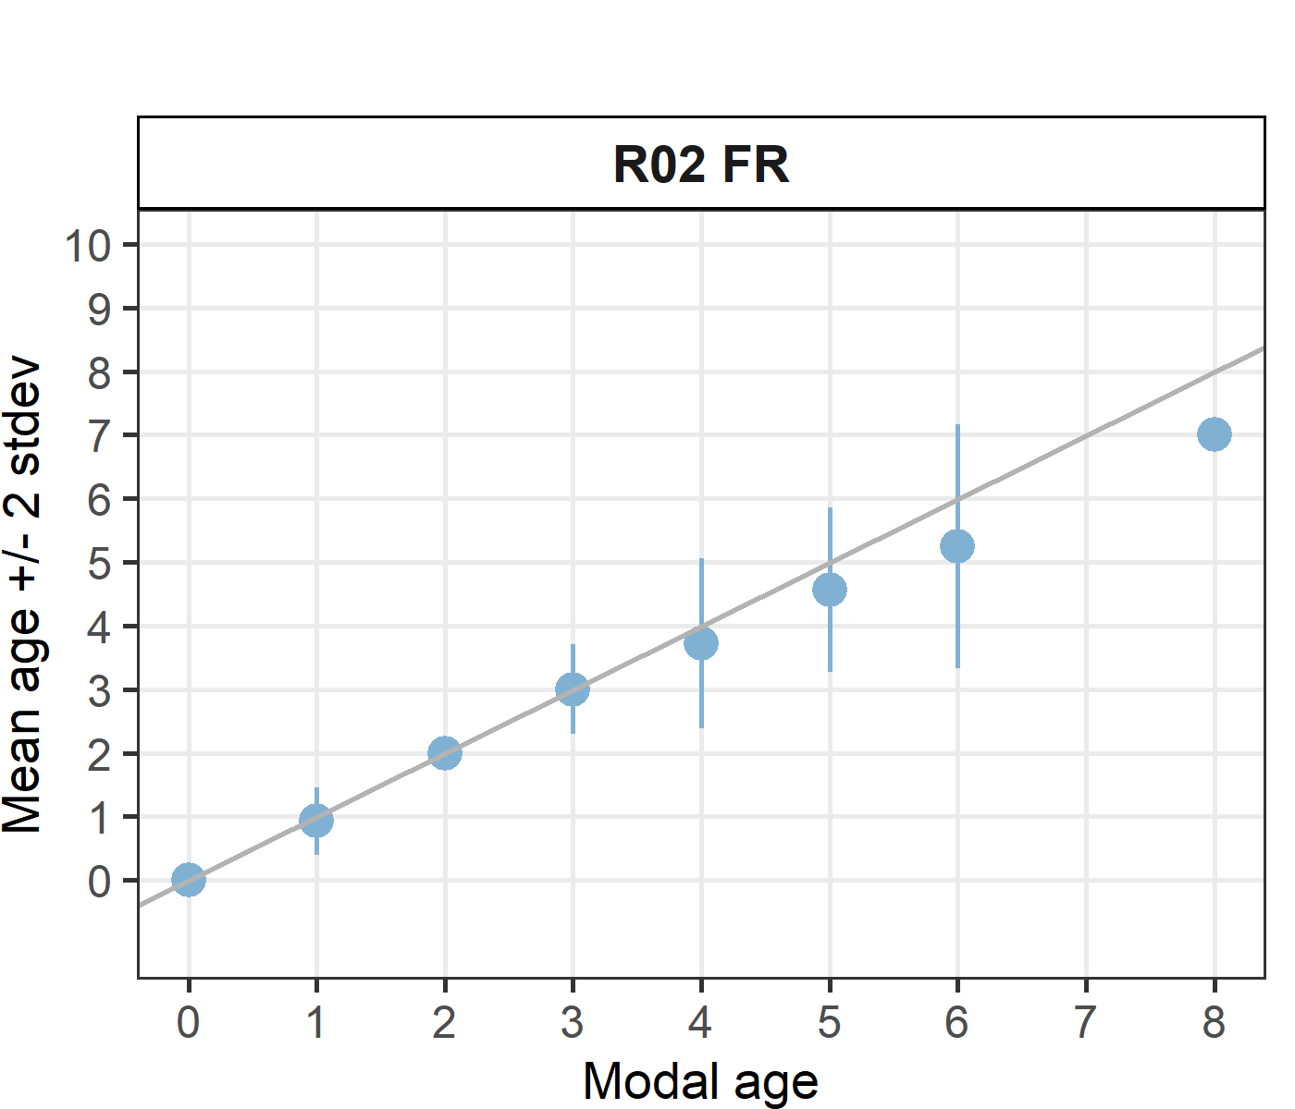 [[2]] 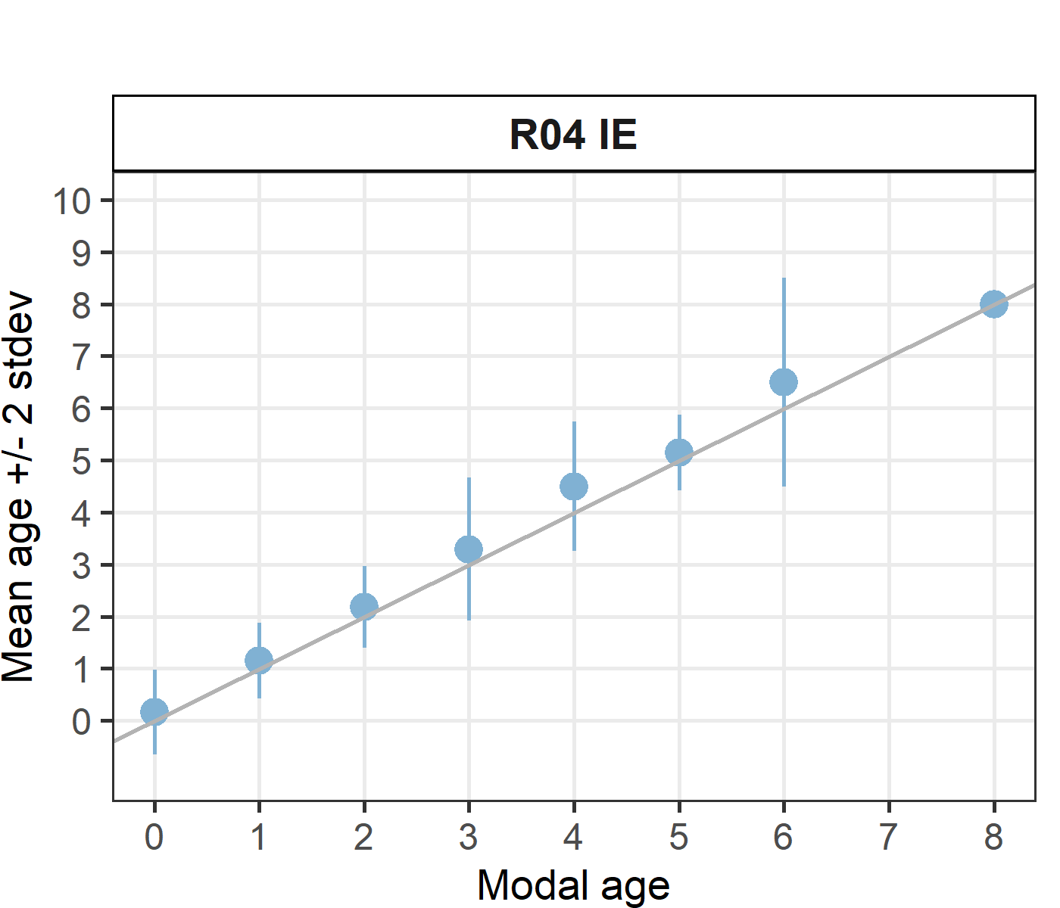 [[3]] 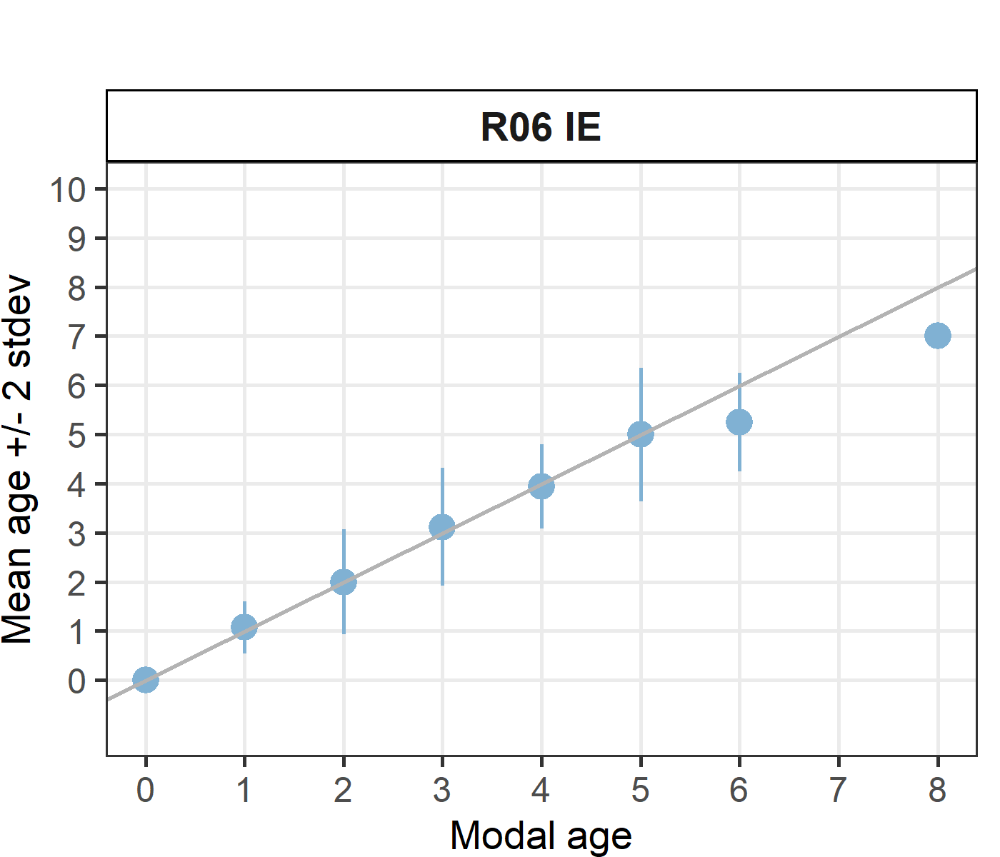 [[4]] 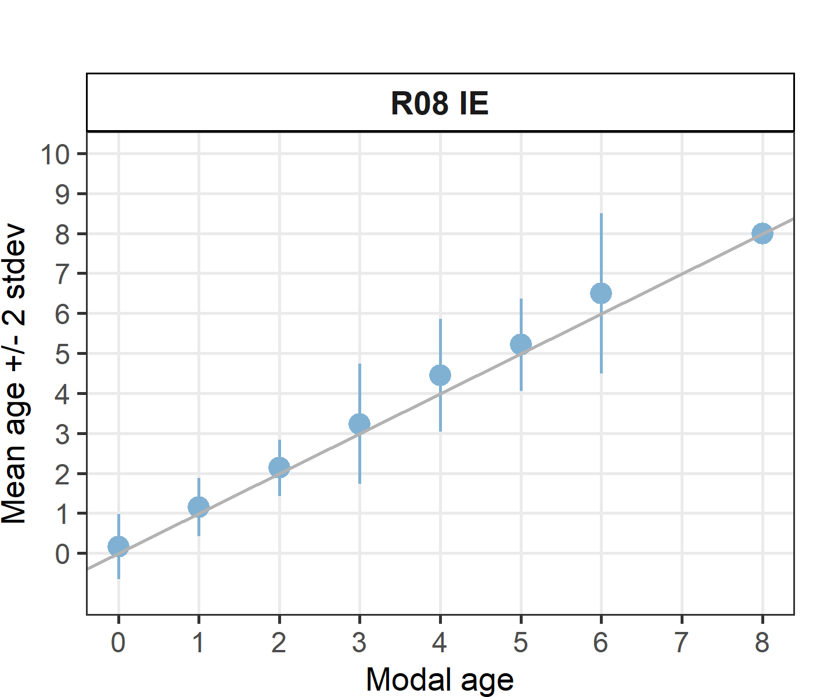 [[5]] 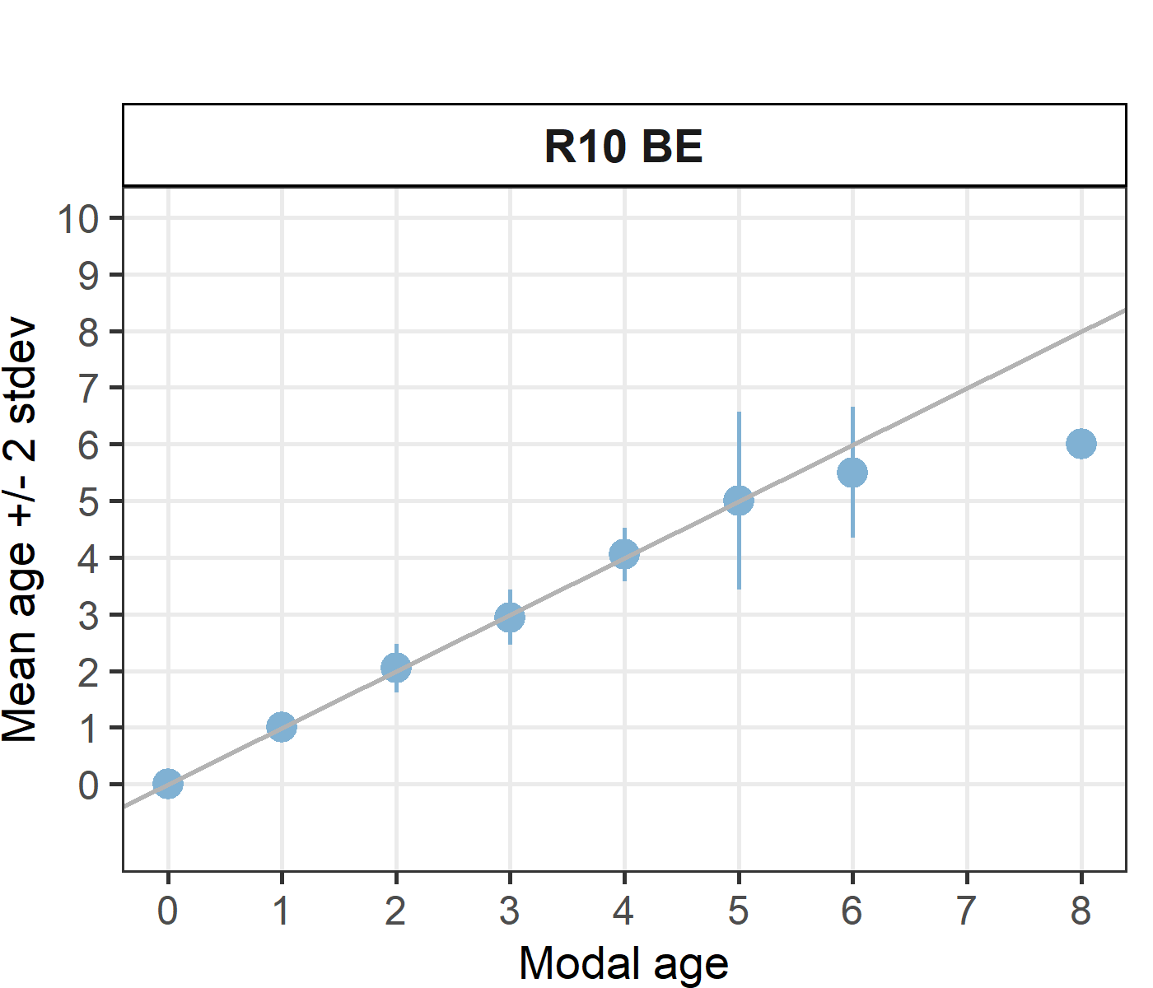 [[6]] 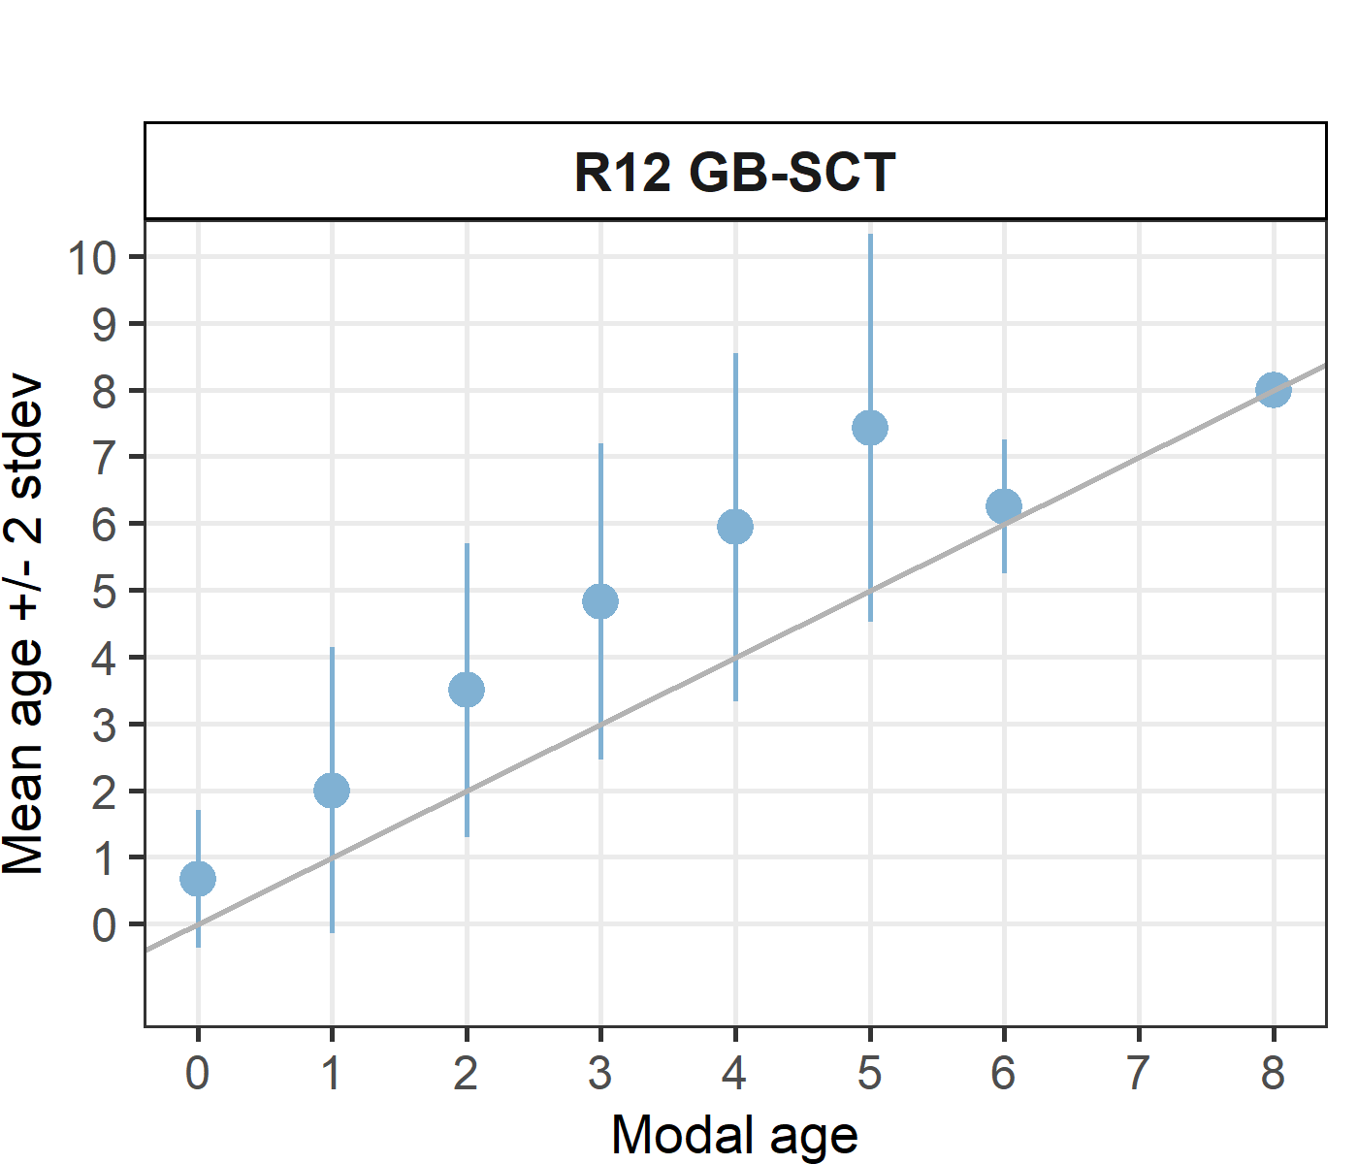 [[7]] 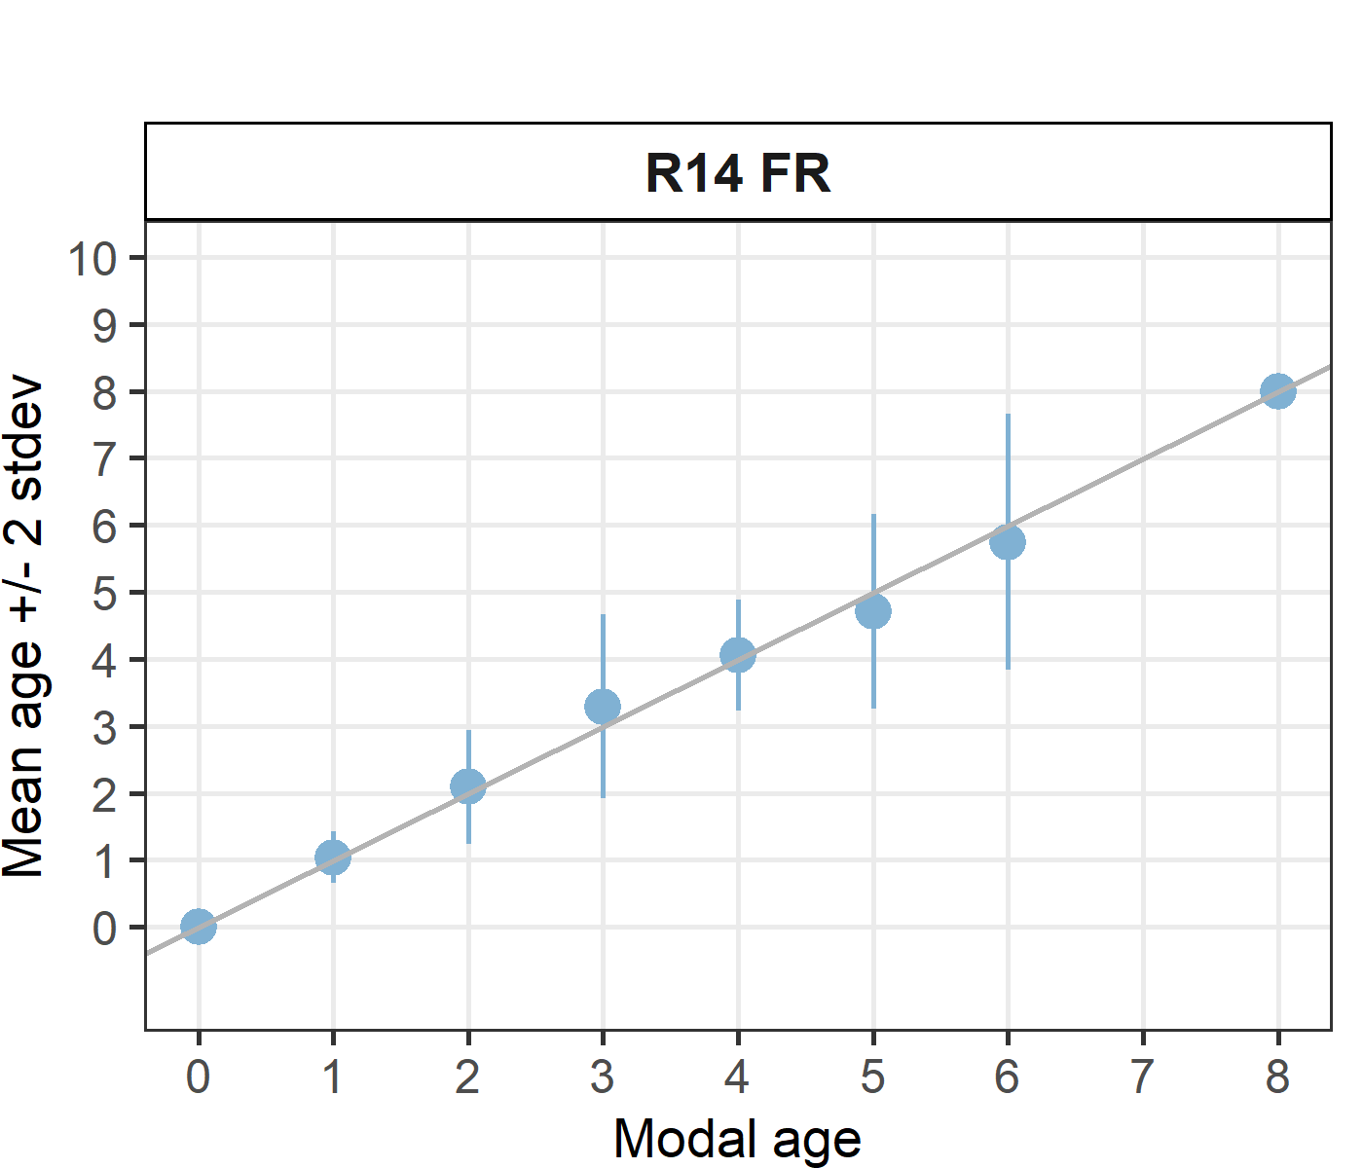 [[8]] 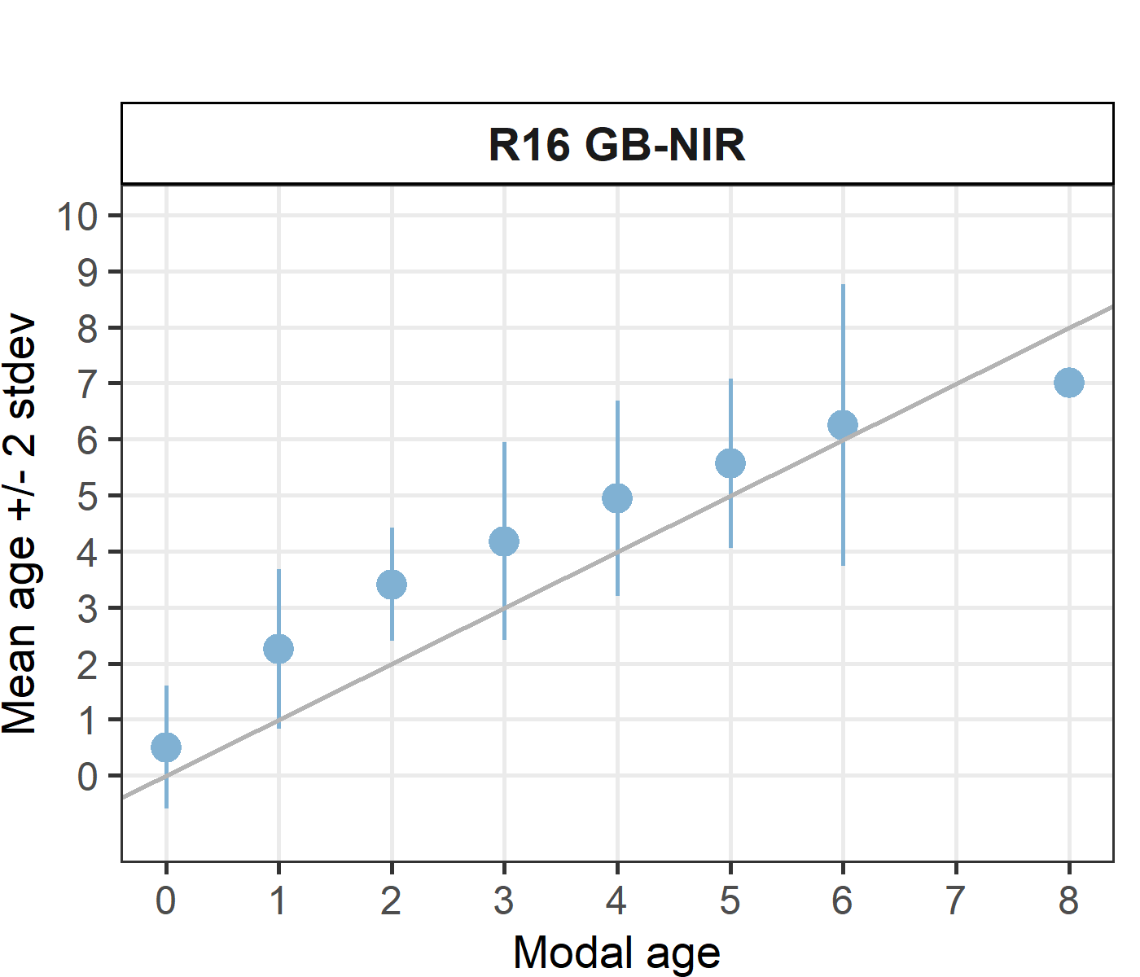 [[9]] 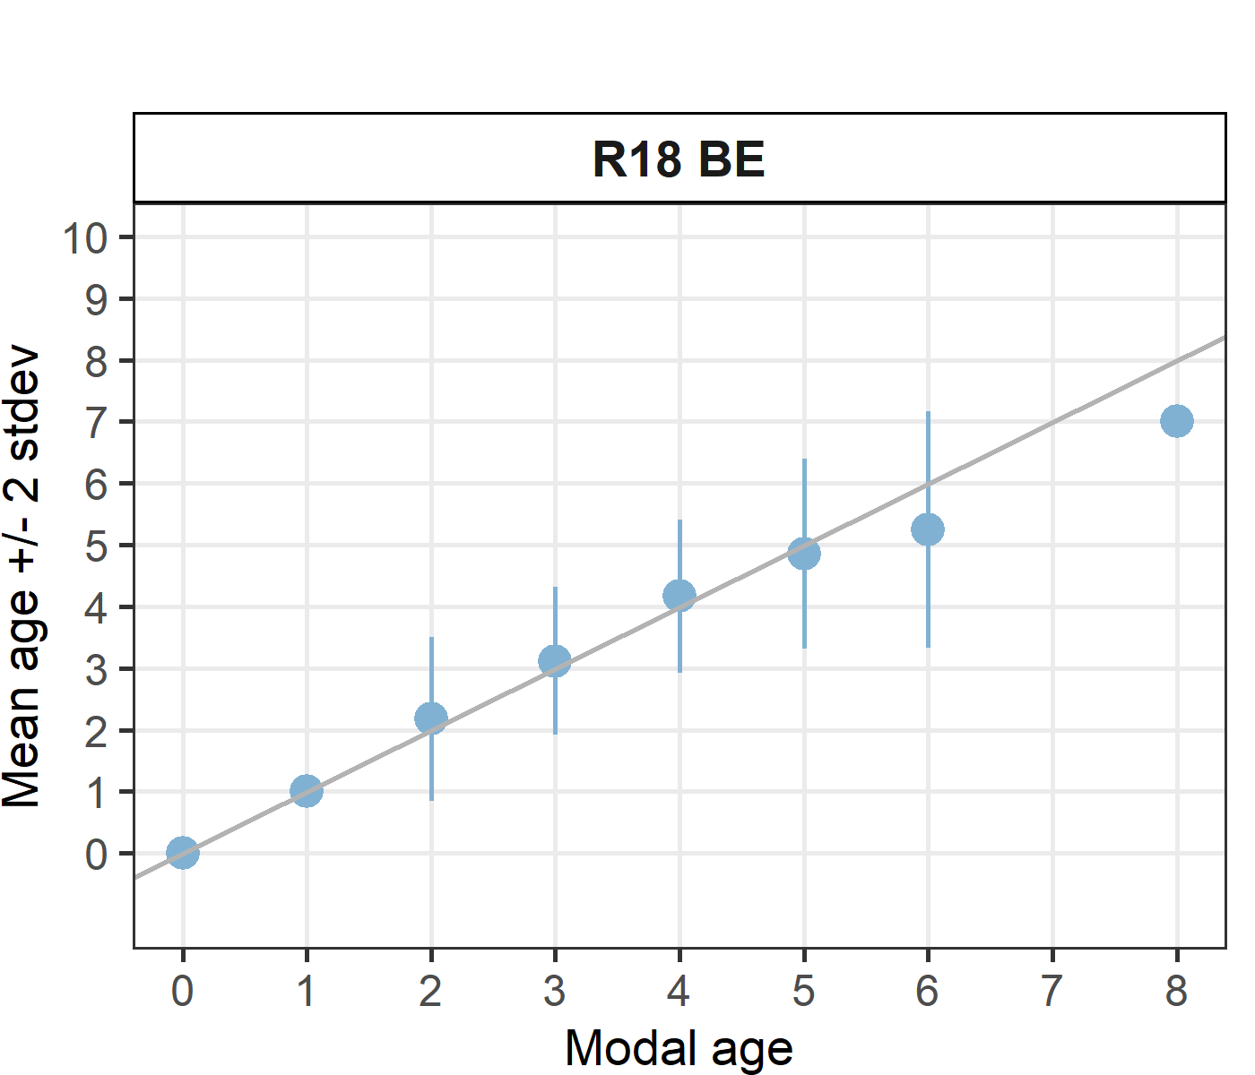

Statistics by modal age plot (STDEV, CV and PA)
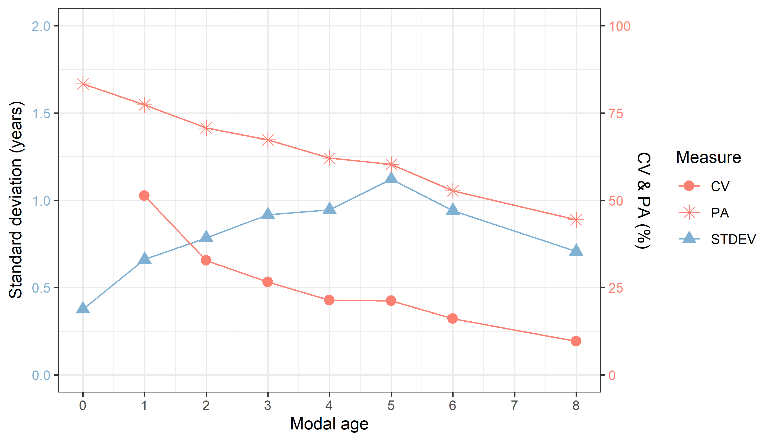
Figure X: CV, PA and (STDEV (standard deviation) are plotted against modal age

Distribution of age reading errors
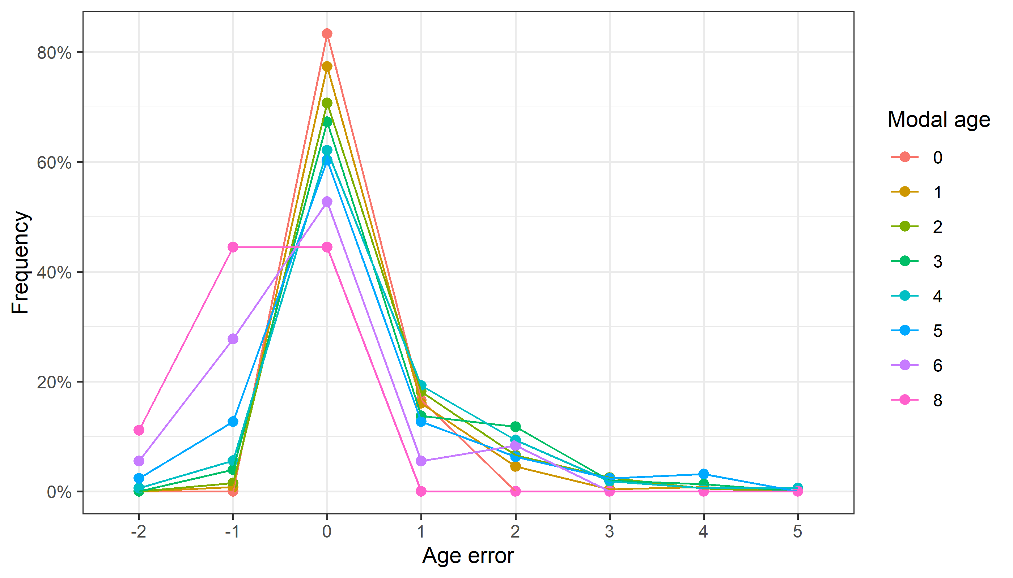
Figure X: The distribution of the age reading errors in percentage by modal age as observed from the whole group of age readers in an age reading comparison to modal age. The achieved precision in age reading by MODAL age group is shown by the spread of the age readings errors. There appears to be no relative bias, if the age reading errors are normally distributed. The distributions are skewed, if relative bias occurs.

Relative bias for all readers
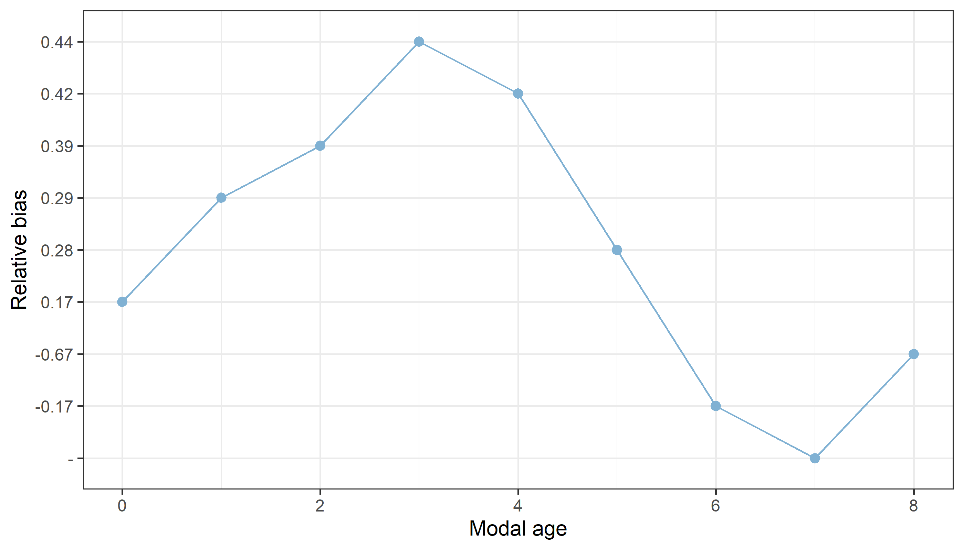
Figure X: The relative bias by modal age as estimated by all age readers combined.

Mean length at age by reader
Table X: Mean fish length at age per reader is calculated per reader and age (not modal age) and for all readers combined per age. A weighted mean is also given.
Age | R02 FR | R04 IE | R06 IE | R08 IE | R10 BE | R12 GB-SCT | R14 FR | R16 GB-NIR | R18 BE
0 | 160 mm | 152 mm | 155 mm | 152 mm | 155 mm | 150 mm | 155 mm | 140 mm | 155 mm
1 | 213 mm | 201 mm | 211 mm | 201 mm | 210 mm | 168 mm | 214 mm | 165 mm | 210 mm
2 | 309 mm | 295 mm | 307 mm | 297 mm | 310 mm | 231 mm | 301 mm | 207 mm | 309 mm
3 | 340 mm | 338 mm | 353 mm | 341 mm | 334 mm | 291 mm | 339 mm | 282 mm | 340 mm
4 | 377 mm | 360 mm | 354 mm | 360 mm | 370 mm | 333 mm | 374 mm | 330 mm | 361 mm
5 | 372 mm | 372 mm | 372 mm | 368 mm | 366 mm | 331 mm | 355 mm | 372 mm | 374 mm
6 | 330 mm | 357 mm | 370 mm | 370 mm | 355 mm | 344 mm | 370 mm | 365 mm | 352 mm
7 | 360 mm | - | 360 mm | 380 mm | 400 mm | 385 mm | 310 mm | 367 mm | 360 mm
8 | - | 335 mm | - | 335 mm | - | 400 mm | 360 mm | 310 mm | -
9 | - | - | - | - | - | 390 mm | - | - | -
Weighted Mean | 300 mm | 300 mm | 300 mm | 300 mm | 300 mm | 300 mm | 300 mm | 300 mm | 300 mm
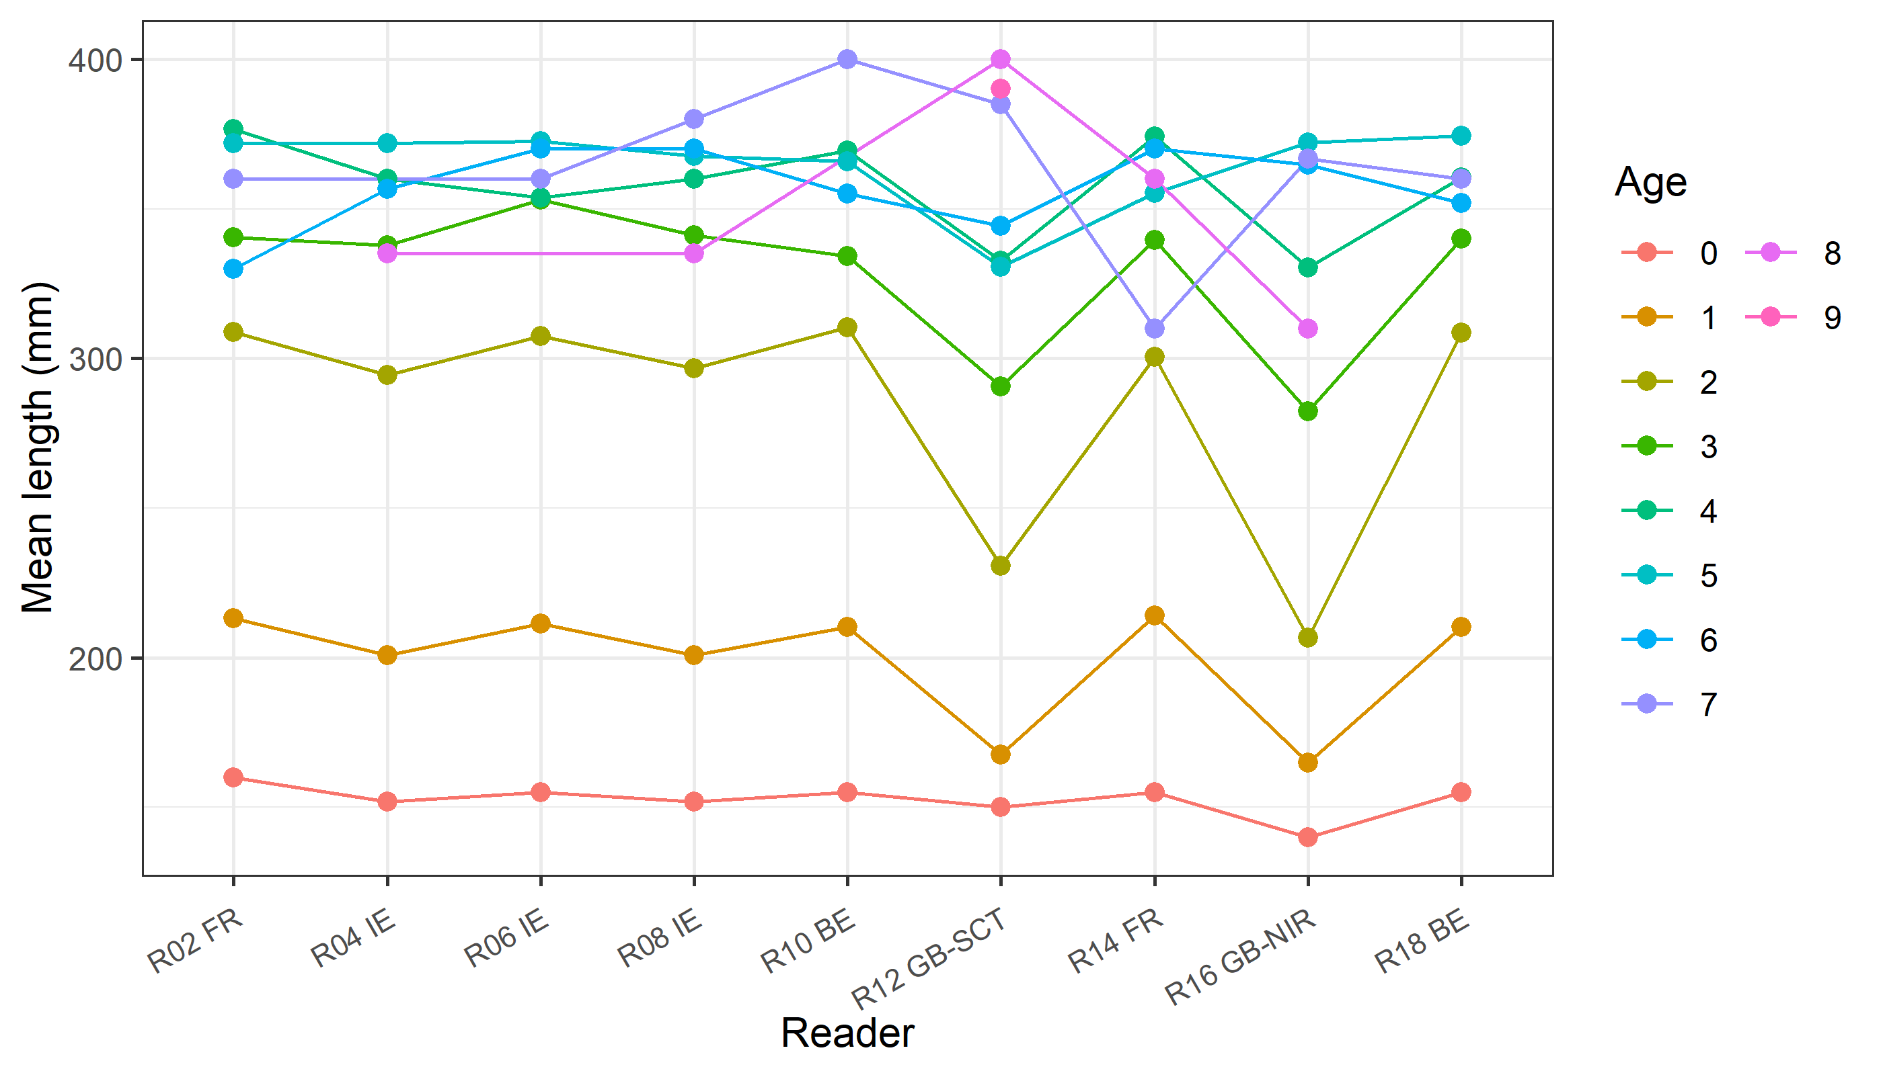
Figure X: The mean fish length at age as estimated by each age reader.

11.2.Results Advanced readers
All samples included
Summary statistics
Table X: Summary of statistics; PA (%), CV (%) and APE (%).
NSample | CV | PA | APE
109 | 19 % | 82 % | 10 %

Data overview
Table X: Data overview including modal age and statistics per sample.
Fish ID | Sample ID | Event ID | Image ID | length | sex | Catch date | ICES area | R02 FR | R04 IE | R06 IE | R08 IE | Modal age | PA % | CV % | APE %
WHG_001 | WHG_2024_7a_CTB4_006 | 2953 | 149908 | 150 | U | 22-02-2024 00:00:00 | 27.7.a | 1 | 1 | 1 | 1 | 1 | 100 | 0 | 0
WHG_002 | WHG_2024_7a_CTB4_005 | 2953 | 149907 | 170 | U | 22-02-2024 00:00:00 | 27.7.a | 1 | 1 | 1 | 1 | 1 | 100 | 0 | 0
WHG_003 | WHG_2024_7a_CHD5_004 | 2953 | 149902 | 190 | U | 21-07-2024 00:00:00 | 27.7.a | 1 | 1 | 1 | 1 | 1 | 100 | 0 | 0
WHG_004 | WHG_2024_7a_CHD5_007 | 2953 | 149903 | 210 | U | 21-07-2024 00:00:00 | 27.7.a | 1 | 2 | 1 | 2 | 1 | 50 | 38 | 33
WHG_005 | WHG_2024_7a_CHD5_008 | 2953 | 149904 | 210 | U | 21-07-2024 00:00:00 | 27.7.a | 1 | 1 | 1 | 1 | 1 | 100 | 0 | 0
WHG_006 | WHG_2024_7a_CHD5_009 | 2953 | 149905 | 170 | U | 21-07-2024 00:00:00 | 27.7.a | 0 | 1 | 1 | 1 | 1 | 75 | 67 | 50
WHG_007 | WHG_2024_7a_CHD5_010 | 2953 | 149906 | 180 | U | 21-07-2024 00:00:00 | 27.7.a | 0 | 1 | 1 | 1 | 1 | 75 | 67 | 50
WHG_008 | WHG_2021_7a_CHD6_003 | 2953 | 149871 | 160 | U | 28-06-2021 00:00:00 | 27.7.a | 1 | 1 | 1 | 1 | 1 | 100 | 0 | 0
WHG_009 | WHG_2021_7a_CHD6_004 | 2953 | 149872 | 180 | U | 28-06-2021 00:00:00 | 27.7.a | 1 | 1 | 1 | 1 | 1 | 100 | 0 | 0
WHG_010 | WHG_2021_7a_CHD6_006 | 2953 | 149873 | 170 | U | 28-06-2021 00:00:00 | 27.7.a | 1 | 1 | 1 | 1 | 1 | 100 | 0 | 0
WHG_011 | WHG_2023_7a_CHD8_020 | 2953 | 149901 | 190 | U | 12-11-2023 00:00:00 | 27.7.a | 1 | 1 | 1 | 1 | 1 | 100 | 0 | 0
WHG_012 | WHG_2021_7a_CHD8_026 | 2953 | 149879 | 250 | U | 28-09-2021 00:00:00 | 27.7.a | 1 | 1 | 1 | 1 | 1 | 100 | 0 | 0
WHG_013 | WHG_2021_7a_CHD8_033 | 2953 | 149880 | 190 | U | 28-09-2021 00:00:00 | 27.7.a | 1 | 1 | 1 | 1 | 1 | 100 | 0 | 0
WHG_014 | WHG_2021_7a_CHD8_013 | 2953 | 149877 | 140 | U | 28-09-2021 00:00:00 | 27.7.a | 0 | 0 | 0 | 0 | 0 | 100 | - | -
WHG_015 | WHG_2021_7a_CHD8_074 | 2953 | 149881 | 120 | U | 28-09-2021 00:00:00 | 27.7.a | 0 | 0 | 0 | 0 | 0 | 100 | - | -
WHG_016 | WHG_2024_7a_GFS322_002 | 2953 | 149909 | 260 | U | 25-11-2024 00:00:00 | 27.7.a | 1 | 1 | 1 | 1 | 1 | 100 | 0 | 0
WHG_017 | WHG_2024_7a_GFS322_003 | 2953 | 149910 | 280 | U | 25-11-2024 00:00:00 | 27.7.a | 1 | 1 | 1 | 1 | 1 | 100 | 0 | 0
WHG_018 | WHG_2024_7a_GFS322_005 | 2953 | 149911 | 170 | U | 25-11-2024 00:00:00 | 27.7.a | 0 | 1 | 0 | 1 | 0 | 50 | - | -
WHG_019 | WHG_2024_7a_GFS322_006 | 2953 | 149912 | 140 | U | 25-11-2024 00:00:00 | 27.7.a | 0 | 0 | 0 | 0 | 0 | 100 | - | -
WHG_020 | WHG_2024_7a_GFS322_010 | 2953 | 149913 | 230 | U | 25-11-2024 00:00:00 | 27.7.a | 1 | 2 | 1 | 2 | 1 | 50 | 38 | 33
WHG_021 | WHG_2024_7a_GFS322_012 | 2953 | 149914 | 270 | U | 25-11-2024 00:00:00 | 27.7.a | 1 | 1 | 2 | 1 | 1 | 75 | 40 | 30
WHG_022 | WHG_2024_7a_GFS322_016 | 2953 | 149915 | 200 | U | 25-11-2024 00:00:00 | 27.7.a | 0 | 0 | 0 | 0 | 0 | 100 | - | -
WHG_023 | WHG_2024_7a_GFS322_020 | 2953 | 149916 | 280 | U | 25-11-2024 00:00:00 | 27.7.a | 1 | 1 | 1 | 1 | 1 | 100 | 0 | 0
WHG_024 | WHG_2022_7a_CHD1_030 | 2953 | 149897 | 230 | U | 19-03-2022 00:00:00 | 27.7.a | 1 | 1 | 1 | 1 | 1 | 100 | 0 | 0
WHG_025 | WHG_2022_7a_CHD1_039 | 2953 | 149898 | 250 | U | 19-03-2022 00:00:00 | 27.7.a | 1 | 1 | 1 | 1 | 1 | 100 | 0 | 0
WHG_026 | WHG_2022_7a_CHD1_042 | 2953 | 149899 | 200 | U | 19-03-2022 00:00:00 | 27.7.a | 1 | 1 | 1 | 1 | 1 | 100 | 0 | 0
WHG_027 | WHG_2022_7a_CHD1_046 | 2953 | 149900 | 160 | U | 19-03-2022 00:00:00 | 27.7.a | 1 | 1 | 1 | 1 | 1 | 100 | 0 | 0
WHG_028 | WHG_2021_7a_CHD6_009 | 2953 | 149874 | 160 | U | 28-06-2021 00:00:00 | 27.7.a | 1 | 1 | 1 | 1 | 1 | 100 | 0 | 0
WHG_029 | WHG_2021_7a_CHD6_013 | 2953 | 149875 | 180 | U | 28-06-2021 00:00:00 | 27.7.a | 1 | 1 | 1 | 1 | 1 | 100 | 0 | 0
WHG_030 | WHG_2021_7a_CHD6_016 | 2953 | 149876 | 170 | U | 28-06-2021 00:00:00 | 27.7.a | 1 | 1 | 1 | 1 | 1 | 100 | 0 | 0
WHG_031 | WHG_2021_7a_CHD8_015 | 2953 | 149878 | 160 | U | 28-09-2021 00:00:00 | 27.7.a | 0 | 0 | 0 | 0 | 0 | 100 | - | -
WHG_033 | WHG_2023_7a_57571_022 | 2953 | 149941 | 360 | U | 19-01-2023 00:00:00 | 27.7.a | 3 | 3 | 3 | 3 | 3 | 100 | 0 | 0
WHG_034 | WHG_2023_7a_57571_026 | 2953 | 149942 | 300 | U | 19-01-2023 00:00:00 | 27.7.a | 4 | 5 | 4 | 5 | 4 | 50 | 13 | 11
WHG_035 | WHG_2023_7a_57571_028 | 2953 | 149943 | 310 | U | 19-01-2023 00:00:00 | 27.7.a | 2 | 3 | 2 | 2 | 2 | 75 | 22 | 17
WHG_036 | WHG_2024_7a_60062_014 | 2953 | 149959 | 330 | U | 06-07-2024 00:00:00 | 27.7.a | 3 | 5 | 4 | 5 | 5 | 50 | 23 | 18
WHG_037 | WHG_2024_7a_60356_003 | 2953 | 149960 | 310 | U | 12-03-2024 00:00:00 | 27.7.a | 3 | 3 | 2 | 3 | 3 | 75 | 18 | 14
WHG_038 | WHG_2024_7a_60356_004 | 2953 | 149961 | 360 | U | 12-03-2024 00:00:00 | 27.7.a | 5 | 6 | 5 | 6 | 5 | 50 | 10 | 9
WHG_039 | WHG_2024_7a_60606_003 | 2953 | 149962 | 300 | U | 25-03-2024 00:00:00 | 27.7.a | 4 | 5 | 4 | 5 | 4 | 50 | 13 | 11
WHG_040 | WHG_2023_7a_58666_015 | 2953 | 149952 | 350 | U | 09-06-2023 00:00:00 | 27.7.a | 4 | 6 | 4 | 5 | 4 | 50 | 20 | 16
WHG_041 | WHG_2023_7a_58666_013 | 2953 | 149951 | 330 | U | 09-06-2023 00:00:00 | 27.7.a | 2 | 2 | 1 | 2 | 2 | 75 | 29 | 21
WHG_042 | WHG_2023_7a_58666_012 | 2953 | 149950 | 420 | U | 09-06-2023 00:00:00 | 27.7.a | 4 | 5 | 3 | 5 | 5 | 50 | 23 | 18
WHG_043 | WHG_2023_7a_58352_002 | 2953 | 149949 | 340 | U | 06-05-2023 00:00:00 | 27.7.a | 3 | 3 | 3 | 3 | 3 | 100 | 0 | 0
WHG_044 | WHG_2023_7a_58265_005 | 2953 | 149948 | 440 | U | 11-04-2023 00:00:00 | 27.7.a | 4 | 5 | 5 | 5 | 5 | 75 | 11 | 8
WHG_045 | WHG_2023_7a_58265_003 | 2953 | 149947 | 410 | U | 11-04-2023 00:00:00 | 27.7.a | 4 | 4 | 4 | 4 | 4 | 100 | 0 | 0
WHG_046 | WHG_2023_7a_58175_005 | 2953 | 149946 | 310 | U | 04-04-2023 00:00:00 | 27.7.a | 3 | 4 | 4 | 4 | 4 | 75 | 13 | 10
WHG_047 | WHG_2023_7a_58175_002 | 2953 | 149945 | 390 | U | 04-04-2023 00:00:00 | 27.7.a | 3 | 3 | 3 | 3 | 3 | 100 | 0 | 0
WHG_048 | WHG_2023_7a_58172_001 | 2953 | 149944 | 440 | U | 04-04-2023 00:00:00 | 27.7.a | 4 | 5 | 4 | 6 | 4 | 50 | 20 | 16
WHG_049 | WHG_2022_7a_55876_007 | 2953 | 149938 | 380 | U | 04-05-2022 00:00:00 | 27.7.a | 3 | 3 | 3 | 3 | 3 | 100 | 0 | 0
WHG_050 | WHG_2020_7a_50532_010 | 2953 | 149918 | 310 | U | 16-05-2020 00:00:00 | 27.7.a | 2 | 2 | 2 | 2 | 2 | 100 | 0 | 0
WHG_051 | WHG_2020_7a_50532_011 | 2953 | 149919 | 310 | U | 16-05-2020 00:00:00 | 27.7.a | 3 | 3 | 3 | 3 | 3 | 100 | 0 | 0
WHG_052 | WHG_2020_7a_50532_012 | 2953 | 149920 | 350 | U | 16-05-2020 00:00:00 | 27.7.a | 6 | 6 | 5 | 6 | 6 | 75 | 9 | 7
WHG_053 | WHG_2020_7a_50532_013 | 2953 | 149921 | 340 | U | 16-05-2020 00:00:00 | 27.7.a | 3 | 3 | 3 | 3 | 3 | 100 | 0 | 0
WHG_054 | WHG_2020_7a_50532_014 | 2953 | 149922 | 390 | U | 16-05-2020 00:00:00 | 27.7.a | 5 | 5 | 5 | 5 | 5 | 100 | 0 | 0
WHG_055 | Whg_2020_7a_50514_021 | 2953 | 149967 | 390 | U | 30-04-2020 00:00:00 | 27.7.a | 4 | 5 | 4 | 5 | 4 | 50 | 13 | 11
WHG_056 | Whg_2020_7a_50514_023 | 2953 | 149968 | 380 | U | 30-04-2020 00:00:00 | 27.7.a | 4 | 4 | 3 | 4 | 4 | 75 | 13 | 10
WHG_057 | Whg_2020_7a_50514_024 | 2953 | 149969 | 330 | U | 30-04-2020 00:00:00 | 27.7.a | 5 | 4 | 4 | 4 | 4 | 75 | 12 | 9
WHG_058 | Whg_2020_7a_50514_025 | 2953 | 149970 | 330 | U | 30-04-2020 00:00:00 | 27.7.a | 2 | 3 | 2 | 2 | 2 | 75 | 22 | 17
WHG_059 | WHG_2024_7a_61345_001 | 2953 | 149963 | 300 | U | 19-09-2024 00:00:00 | 27.7.a | 2 | 2 | 2 | 2 | 2 | 100 | 0 | 0
WHG_060 | WHG_2021_7a_53415_020 | 2953 | 149936 | 300 | U | 23-09-2021 00:00:00 | 27.7.a | 4 | 6 | 5 | 6 | 6 | 50 | 18 | 14
WHG_061 | WHG_2021_7a_53414_035 | 2953 | 149935 | 310 | U | 22-09-2021 00:00:00 | 27.7.a | 6 | 8 | 6 | 8 | 6 | 50 | 16 | 14
WHG_062 | WHG_2020_7a_51152_010 | 2953 | 149932 | 400 | U | 15-09-2020 00:00:00 | 27.7.a | 4 | 4 | 4 | 4 | 4 | 100 | 0 | 0
WHG_063 | WHG_2020_7a_51152_011 | 2953 | 149933 | 440 | U | 15-09-2020 00:00:00 | 27.7.a | 4 | 5 | 5 | 5 | 5 | 75 | 11 | 8
WHG_064 | WHG_2020_7a_51152_012 | 2953 | 149934 | 380 | U | 15-09-2020 00:00:00 | 27.7.a | 5 | 6 | 6 | 7 | 6 | 50 | 14 | 8
WHG_065 | WHG_2020_7a_51067_019 | 2953 | 149927 | 390 | U | 30-09-2020 00:00:00 | 27.7.a | 4 | 5 | 4 | 5 | 4 | 50 | 13 | 11
WHG_066 | WHG_2020_7a_51067_020 | 2953 | 149928 | 280 | U | 30-09-2020 00:00:00 | 27.7.a | 2 | 2 | 1 | 2 | 2 | 75 | 29 | 21
WHG_067 | WHG_2020_7a_51067_021 | 2953 | 149929 | 350 | U | 30-09-2020 00:00:00 | 27.7.a | 2 | 2 | 2 | 2 | 2 | 100 | 0 | 0
WHG_068 | WHG_2020_7a_51067_023 | 2953 | 149930 | 390 | U | 30-09-2020 00:00:00 | 27.7.a | 2 | 3 | 2 | 3 | 2 | 50 | 23 | 20
WHG_069 | WHG_2020_7a_51067_024 | 2953 | 149931 | 380 | U | 30-09-2020 00:00:00 | 27.7.a | 3 | 5 | 4 | 5 | 5 | 50 | 23 | 18
WHG_070 | WHG_2020_7a_50781_002 | 2953 | 149923 | 370 | U | 13-08-2020 00:00:00 | 27.7.a | 3 | 5 | 4 | 5 | 5 | 50 | 23 | 18
WHG_071 | WHG_2020_7a_50781_004 | 2953 | 149924 | 330 | U | 13-08-2020 00:00:00 | 27.7.a | 3 | 5 | - | 5 | 5 | 67 | 27 | 21
WHG_072 | WHG_2020_7a_50781_005 | 2953 | 149925 | 350 | U | 13-08-2020 00:00:00 | 27.7.a | 3 | 3 | 3 | 3 | 3 | 100 | 0 | 0
WHG_073 | WHG_2020_7a_50781_006 | 2953 | 149926 | 310 | U | 13-08-2020 00:00:00 | 27.7.a | 2 | 4 | 4 | 4 | 4 | 75 | 29 | 21
WHG_074 | WHG_2022_7a_56805_015 | 2953 | 149939 | 350 | U | 05-10-2022 00:00:00 | 27.7.a | 4 | 5 | 5 | 5 | 5 | 75 | 11 | 8
WHG_075 | WHG_2022_7a_56805_018 | 2953 | 149940 | 310 | U | 05-10-2022 00:00:00 | 27.7.a | 3 | 5 | 3 | 5 | 3 | 50 | 29 | 25
WHG_076 | WHG_2024_7a_61570_006 | 2953 | 149964 | 350 | U | 30-10-2024 00:00:00 | 27.7.a | 3 | 3 | 3 | 3 | 3 | 100 | 0 | 0
WHG_077 | WHG_2023_7a_59489_014 | 2953 | 149953 | 340 | U | 26-10-2023 00:00:00 | 27.7.a | 3 | 4 | 3 | 4 | 3 | 50 | 16 | 14
WHG_078 | WHG_2023_7a_59626_014 | 2953 | 149954 | 300 | U | 14-11-2023 00:00:00 | 27.7.a | 2 | 3 | 2 | 3 | 2 | 50 | 23 | 20
WHG_079 | WHG_2023_7a_59626_015 | 2953 | 149955 | 310 | U | 14-11-2023 00:00:00 | 27.7.a | 1 | 2 | 2 | 2 | 2 | 75 | 29 | 21
WHG_080 | WHG_2023_7a_59626_018 | 2953 | 149956 | 300 | U | 14-11-2023 00:00:00 | 27.7.a | 2 | 2 | 2 | 2 | 2 | 100 | 0 | 0
WHG_081 | WHG_2023_7a_59643_014 | 2953 | 149957 | 280 | U | 05-12-2023 00:00:00 | 27.7.a | 1 | 2 | 1 | 2 | 1 | 50 | 38 | 33
WHG_082 | WHG_2023_7a_59643_016 | 2953 | 149958 | 320 | U | 05-12-2023 00:00:00 | 27.7.a | 2 | 3 | 2 | 3 | 2 | 50 | 23 | 20
WHG_083 | WHG_2022_7a_54560_001 | 2953 | 149882 | 360 | U | 07-03-2022 00:00:00 | 27.7.a | 5 | 5 | 5 | 5 | 5 | 100 | 0 | 0
WHG_084 | WHG_2022_7a_54560_002 | 2953 | 149883 | 380 | U | 07-03-2022 00:00:00 | 27.7.a | 5 | 5 | 5 | 5 | 5 | 100 | 0 | 0
WHG_085 | WHG_2022_7a_54560_004 | 2953 | 149884 | 320 | U | 07-03-2022 00:00:00 | 27.7.a | 3 | 3 | 3 | 3 | 3 | 100 | 0 | 0
WHG_086 | WHG_2022_7a_54560_008 | 2953 | 149885 | 320 | U | 07-03-2022 00:00:00 | 27.7.a | 2 | 2 | 2 | 2 | 2 | 100 | 0 | 0
WHG_087 | WHG_2022_7a_54560_009 | 2953 | 149886 | 320 | U | 07-03-2022 00:00:00 | 27.7.a | 2 | 2 | 2 | 2 | 2 | 100 | 0 | 0
WHG_088 | WHG_2022_7a_54560_014 | 2953 | 149887 | 350 | U | 07-03-2022 00:00:00 | 27.7.a | 4 | 4 | 4 | 4 | 4 | 100 | 0 | 0
WHG_089 | WHG_2022_7a_54652_005 | 2953 | 149888 | 370 | U | 22-03-2022 00:00:00 | 27.7.a | 4 | 4 | 4 | 4 | 4 | 100 | 0 | 0
WHG_090 | WHG_2022_7a_54652_021 | 2953 | 149971 | 360 | U | 22-03-2022 00:00:00 | 27.7.a | 7 | 8 | 7 | 8 | 7 | 50 | 8 | 7
WHG_091 | WHG_2022_7a_54652_028 | 2953 | 149890 | 320 | U | 22-03-2022 00:00:00 | 27.7.a | 2 | 2 | 2 | 2 | 2 | 100 | 0 | 0
WHG_092 | WHG_2022_7a_54652_041 | 2953 | 149891 | 370 | U | 22-03-2022 00:00:00 | 27.7.a | 5 | 5 | 5 | 5 | 5 | 100 | 0 | 0
WHG_093 | WHG_2022_7a_55876_024 | 2953 | 149892 | 400 | U | 04-05-2022 00:00:00 | 27.7.a | 4 | 4 | 4 | 4 | 4 | 100 | 0 | 0
WHG_094 | WHG_2022_7a_57272_003 | 2953 | 149896 | 360 | U | 02-12-2022 00:00:00 | 27.7.a | 3 | 4 | 4 | 3 | 3 | 50 | 16 | 14
WHG_095 | WHG_2021_7a_51819_020 | 2953 | 149859 | 400 | U | 29-01-2021 00:00:00 | 27.7.a | 5 | 5 | 6 | 5 | 5 | 75 | 10 | 7
WHG_096 | WHG_2021_7a_53415_002 | 2953 | 149868 | 300 | U | 23-09-2021 00:00:00 | 27.7.a | 2 | 2 | 2 | 2 | 2 | 100 | 0 | 0
WHG_097 | WHG_2021_7a_53415_005 | 2953 | 149869 | 280 | U | 23-09-2021 00:00:00 | 27.7.a | 2 | 2 | 2 | 2 | 2 | 100 | 0 | 0
WHG_098 | WHG_2021_7a_53415_011 | 2953 | 149870 | 290 | U | 23-09-2021 00:00:00 | 27.7.a | 2 | 2 | 2 | 2 | 2 | 100 | 0 | 0
WHG_099 | WHG_2021_7a_52636_015 | 2953 | 149861 | 390 | U | 19-05-2021 00:00:00 | 27.7.a | 5 | 5 | 6 | 5 | 5 | 75 | 10 | 7
WHG_100 | WHG_2021_7a_52491_017 | 2953 | 149860 | 260 | U | 22-04-2021 00:00:00 | 27.7.a | 2 | 2 | 2 | 2 | 2 | 100 | 0 | 0
WHG_101 | WHG_2021_7a_53202_002 | 2953 | 149862 | 310 | U | 20-08-2021 00:00:00 | 27.7.a | 3 | 3 | 4 | 3 | 3 | 75 | 15 | 12
WHG_102 | WHG_2021_7a_53202_006 | 2953 | 149863 | 350 | U | 20-08-2021 00:00:00 | 27.7.a | 2 | 2 | 2 | 2 | 2 | 100 | 0 | 0
WHG_103 | WHG_2021_7a_53202_014 | 2953 | 149864 | 290 | U | 20-08-2021 00:00:00 | 27.7.a | 2 | 2 | 2 | 2 | 2 | 100 | 0 | 0
WHG_104 | WHG_2021_7a_53414_002 | 2953 | 149865 | 330 | U | 22-09-2021 00:00:00 | 27.7.a | 5 | 5 | 5 | 5 | 5 | 100 | 0 | 0
WHG_105 | WHG_2021_7a_53414_050 | 2953 | 149866 | 270 | U | 22-09-2021 00:00:00 | 27.7.a | 2 | 2 | 2 | 2 | 2 | 100 | 0 | 0
WHG_106 | WHG_2021_7a_53414_053 | 2953 | 149867 | 270 | U | 22-09-2021 00:00:00 | 27.7.a | 2 | 2 | 2 | 2 | 2 | 100 | 0 | 0
WHG_107 | WHG_2025_7a_62655_017 | 2953 | 149917 | 400 | U | 15-04-2025 00:00:00 | 27.7.a | 5 | 6 | 5 | 6 | 5 | 50 | 10 | 9
WHG_108 | WHG_2022_7a_56805_010 | 2953 | 149893 | 350 | U | 05-10-2022 00:00:00 | 27.7.a | 4 | 3 | 4 | 3 | 4 | 50 | 16 | 14
WHG_109 | WHG_2022_7a_56805_037 | 2953 | 149895 | 320 | U | 05-10-2022 00:00:00 | 27.7.a | 3 | 3 | 4 | 3 | 3 | 75 | 15 | 12
WHG_110 | WHG_2022_7a_56805_031 | 2953 | 149894 | 310 | U | 05-10-2022 00:00:00 | 27.7.a | 2 | 2 | 4 | 2 | 2 | 75 | 40 | 30

List of multimodal cases
Table X: List of cases for which multiple modes where obtained when all readers are considered. The column NModes_trad shows the number of multiple modes for each FishID or SampleID when all readers are given the same expertise weight.
NModes_trad | SampleID
2 | Whg_2020_7a_50514_021
2 | WHG_2020_7a_51067_019
2 | WHG_2020_7a_51067_023
2 | WHG_2021_7a_53414_035
2 | WHG_2022_7a_54652_021
2 | WHG_2022_7a_56805_010
2 | WHG_2022_7a_56805_018
2 | WHG_2022_7a_57272_003
2 | WHG_2023_7a_57571_026
2 | WHG_2023_7a_59489_014
2 | WHG_2023_7a_59626_014
2 | WHG_2023_7a_59643_014
2 | WHG_2023_7a_59643_016
2 | WHG_2024_7a_60356_004
2 | WHG_2024_7a_60606_003
2 | WHG_2024_7a_CHD5_007
2 | WHG_2024_7a_GFS322_005
2 | WHG_2024_7a_GFS322_010
2 | WHG_2025_7a_62655_017

Number of age readings by modal age
Table X: Number of age readings table gives an overview of number of readings per reader and modal age. The total numbers of readings by modal age and by reader are also presented.
Modal age | R02 FR | R04 IE | R06 IE | R08 IE | total
0 | 6 | 6 | 6 | 6 | 24
1 | 26 | 26 | 26 | 26 | 104
2 | 24 | 24 | 24 | 24 | 96
3 | 15 | 15 | 15 | 15 | 60
4 | 16 | 16 | 16 | 16 | 64
5 | 17 | 17 | 16 | 17 | 67
6 | 4 | 4 | 4 | 4 | 16
7 | 1 | 1 | 1 | 1 | 4
Total | 109 | 109 | 108 | 109 | 435
Number of age readings by age
Table X: Age composition by reader gives a summary of number of readings per reader and age. The total numbers of readings by age and by reader are also presented.
Age | R02 FR | R04 IE | R06 IE | R08 IE | total
0 | 8 | 5 | 6 | 5 | 24
1 | 25 | 24 | 27 | 24 | 100
2 | 24 | 22 | 23 | 24 | 93
3 | 20 | 18 | 13 | 17 | 68
4 | 18 | 11 | 22 | 10 | 61
5 | 11 | 21 | 12 | 21 | 65
6 | 2 | 6 | 4 | 5 | 17
7 | 1 | 0 | 1 | 1 | 3
8 | 0 | 2 | 0 | 2 | 4
Total | 109 | 109 | 108 | 109 | 435

Separate age bias plots by reader
[[1]] 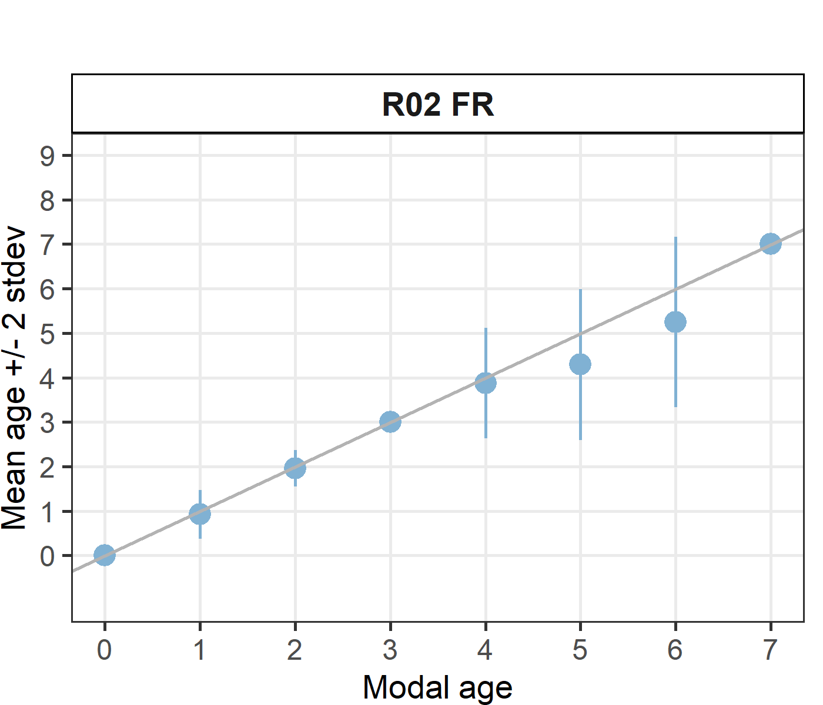 [[2]] 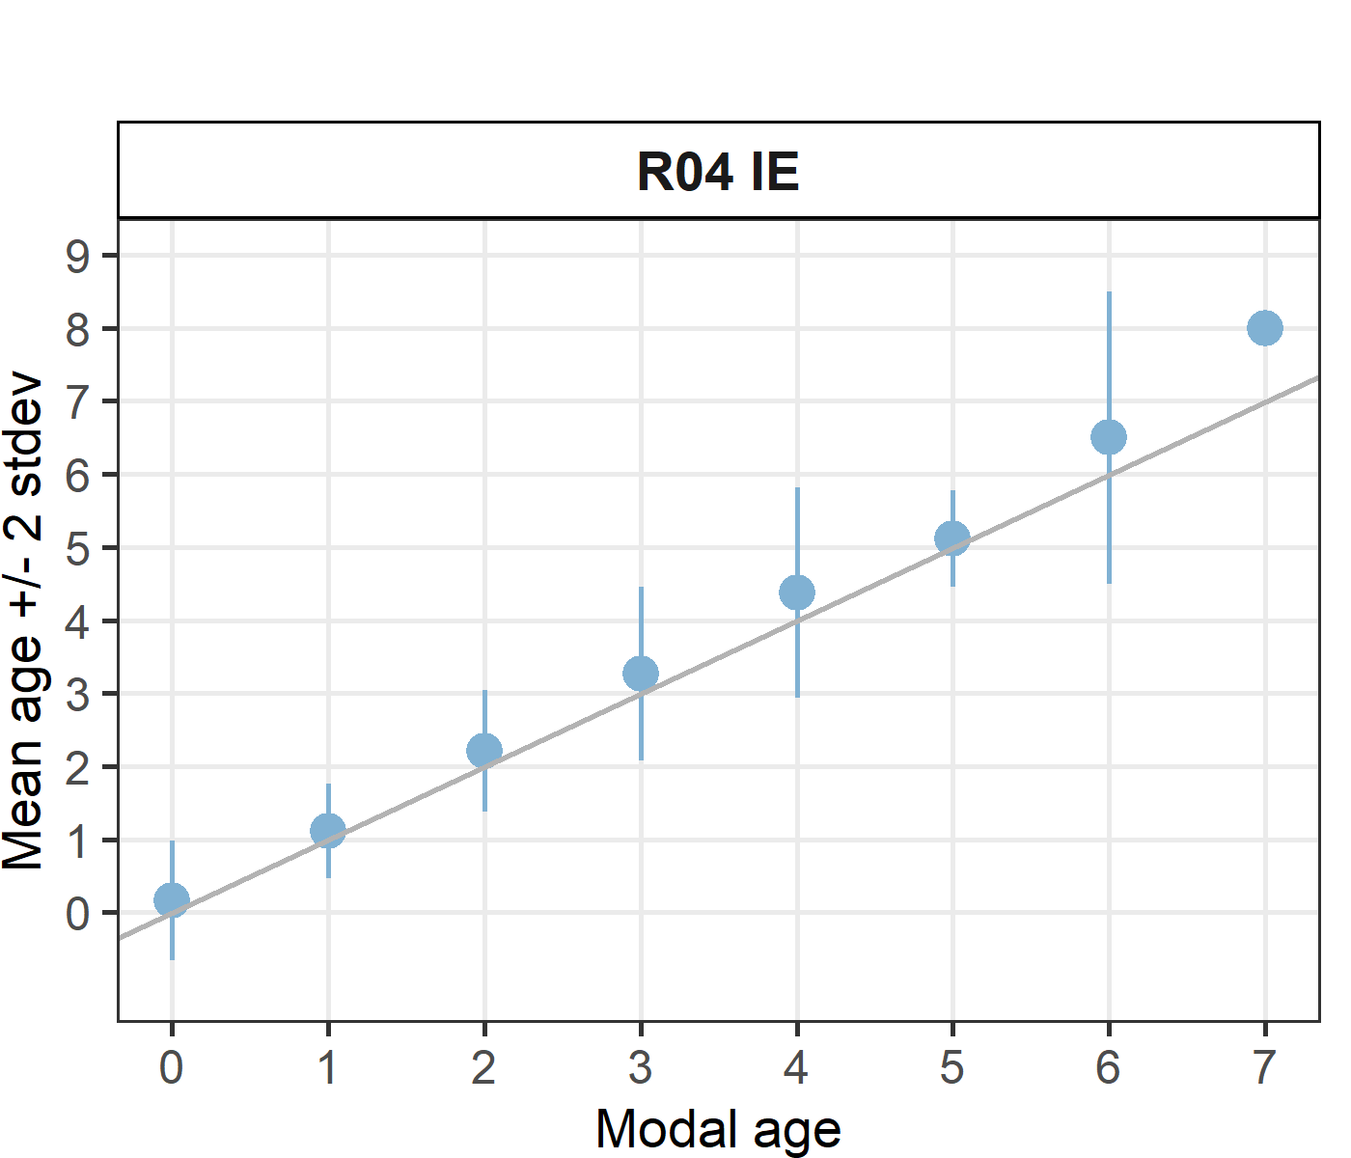 [[3]] 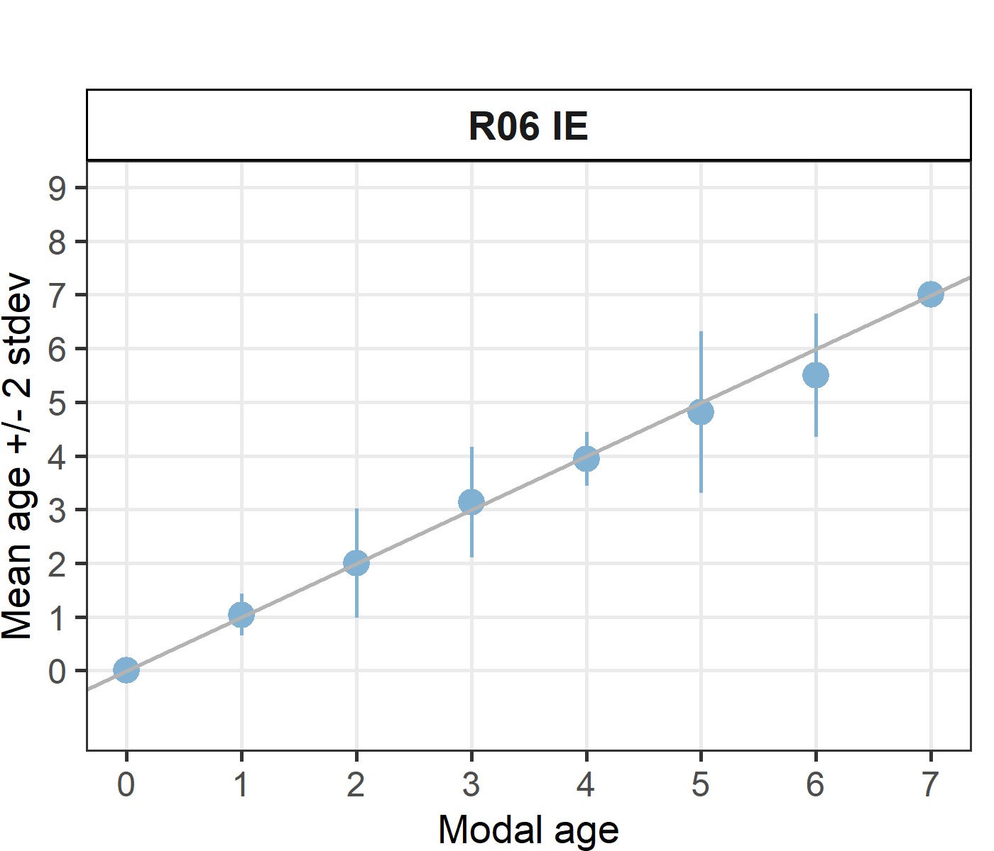 [[4]] 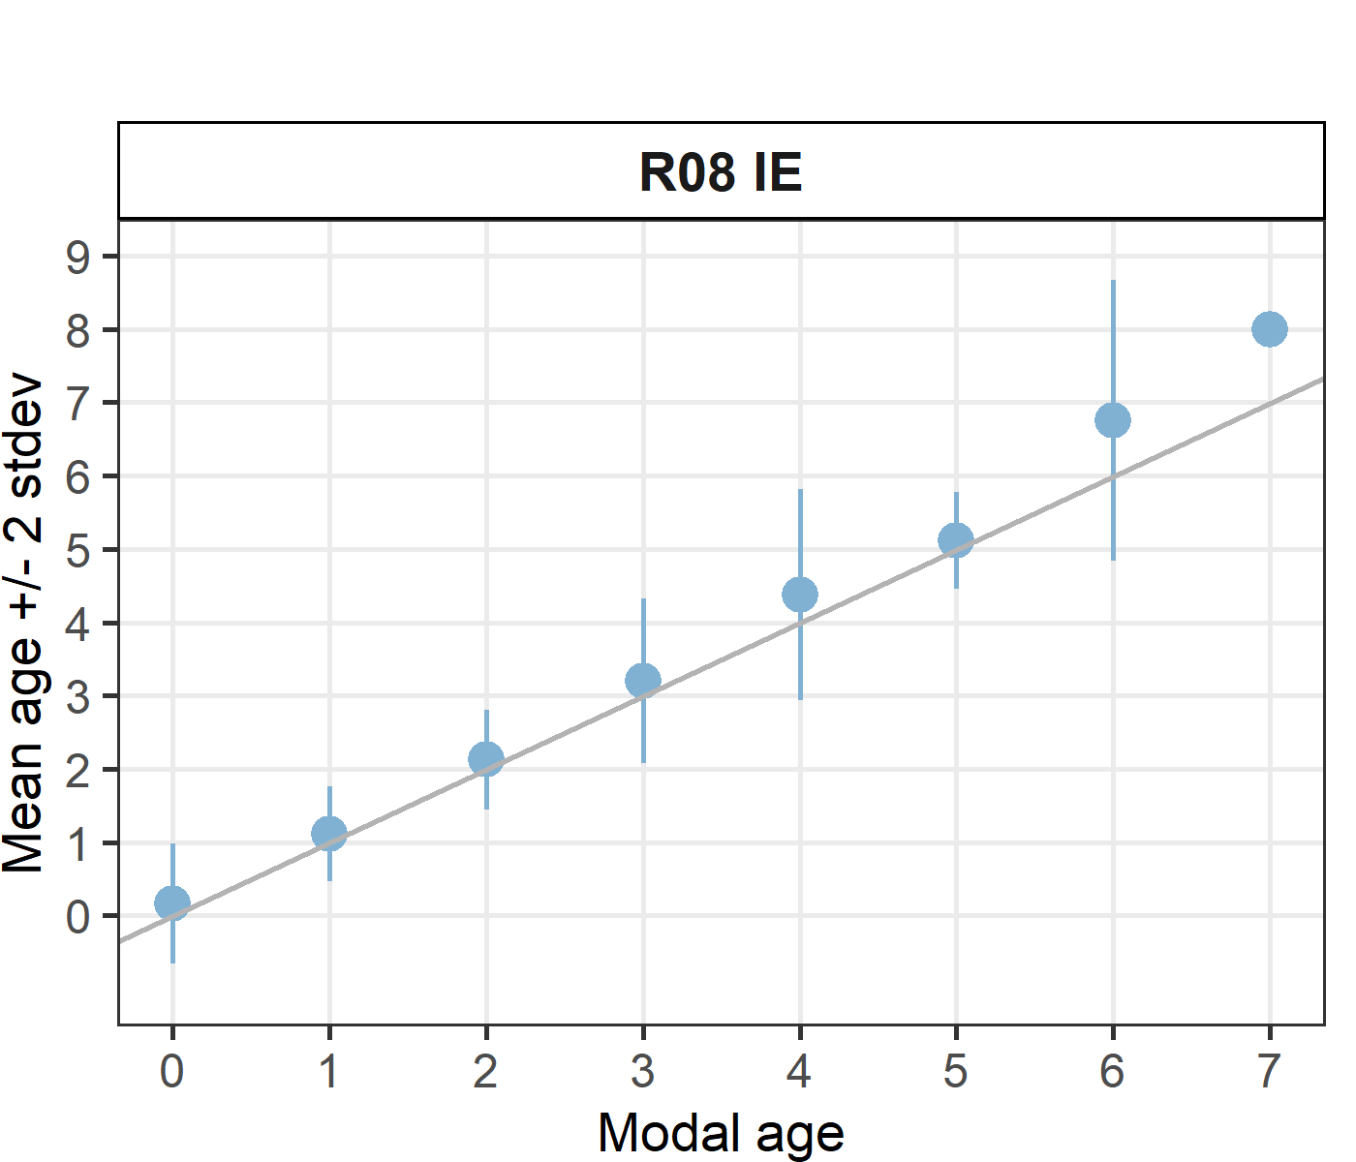

Statistics by modal age plot (STDEV, CV and PA)
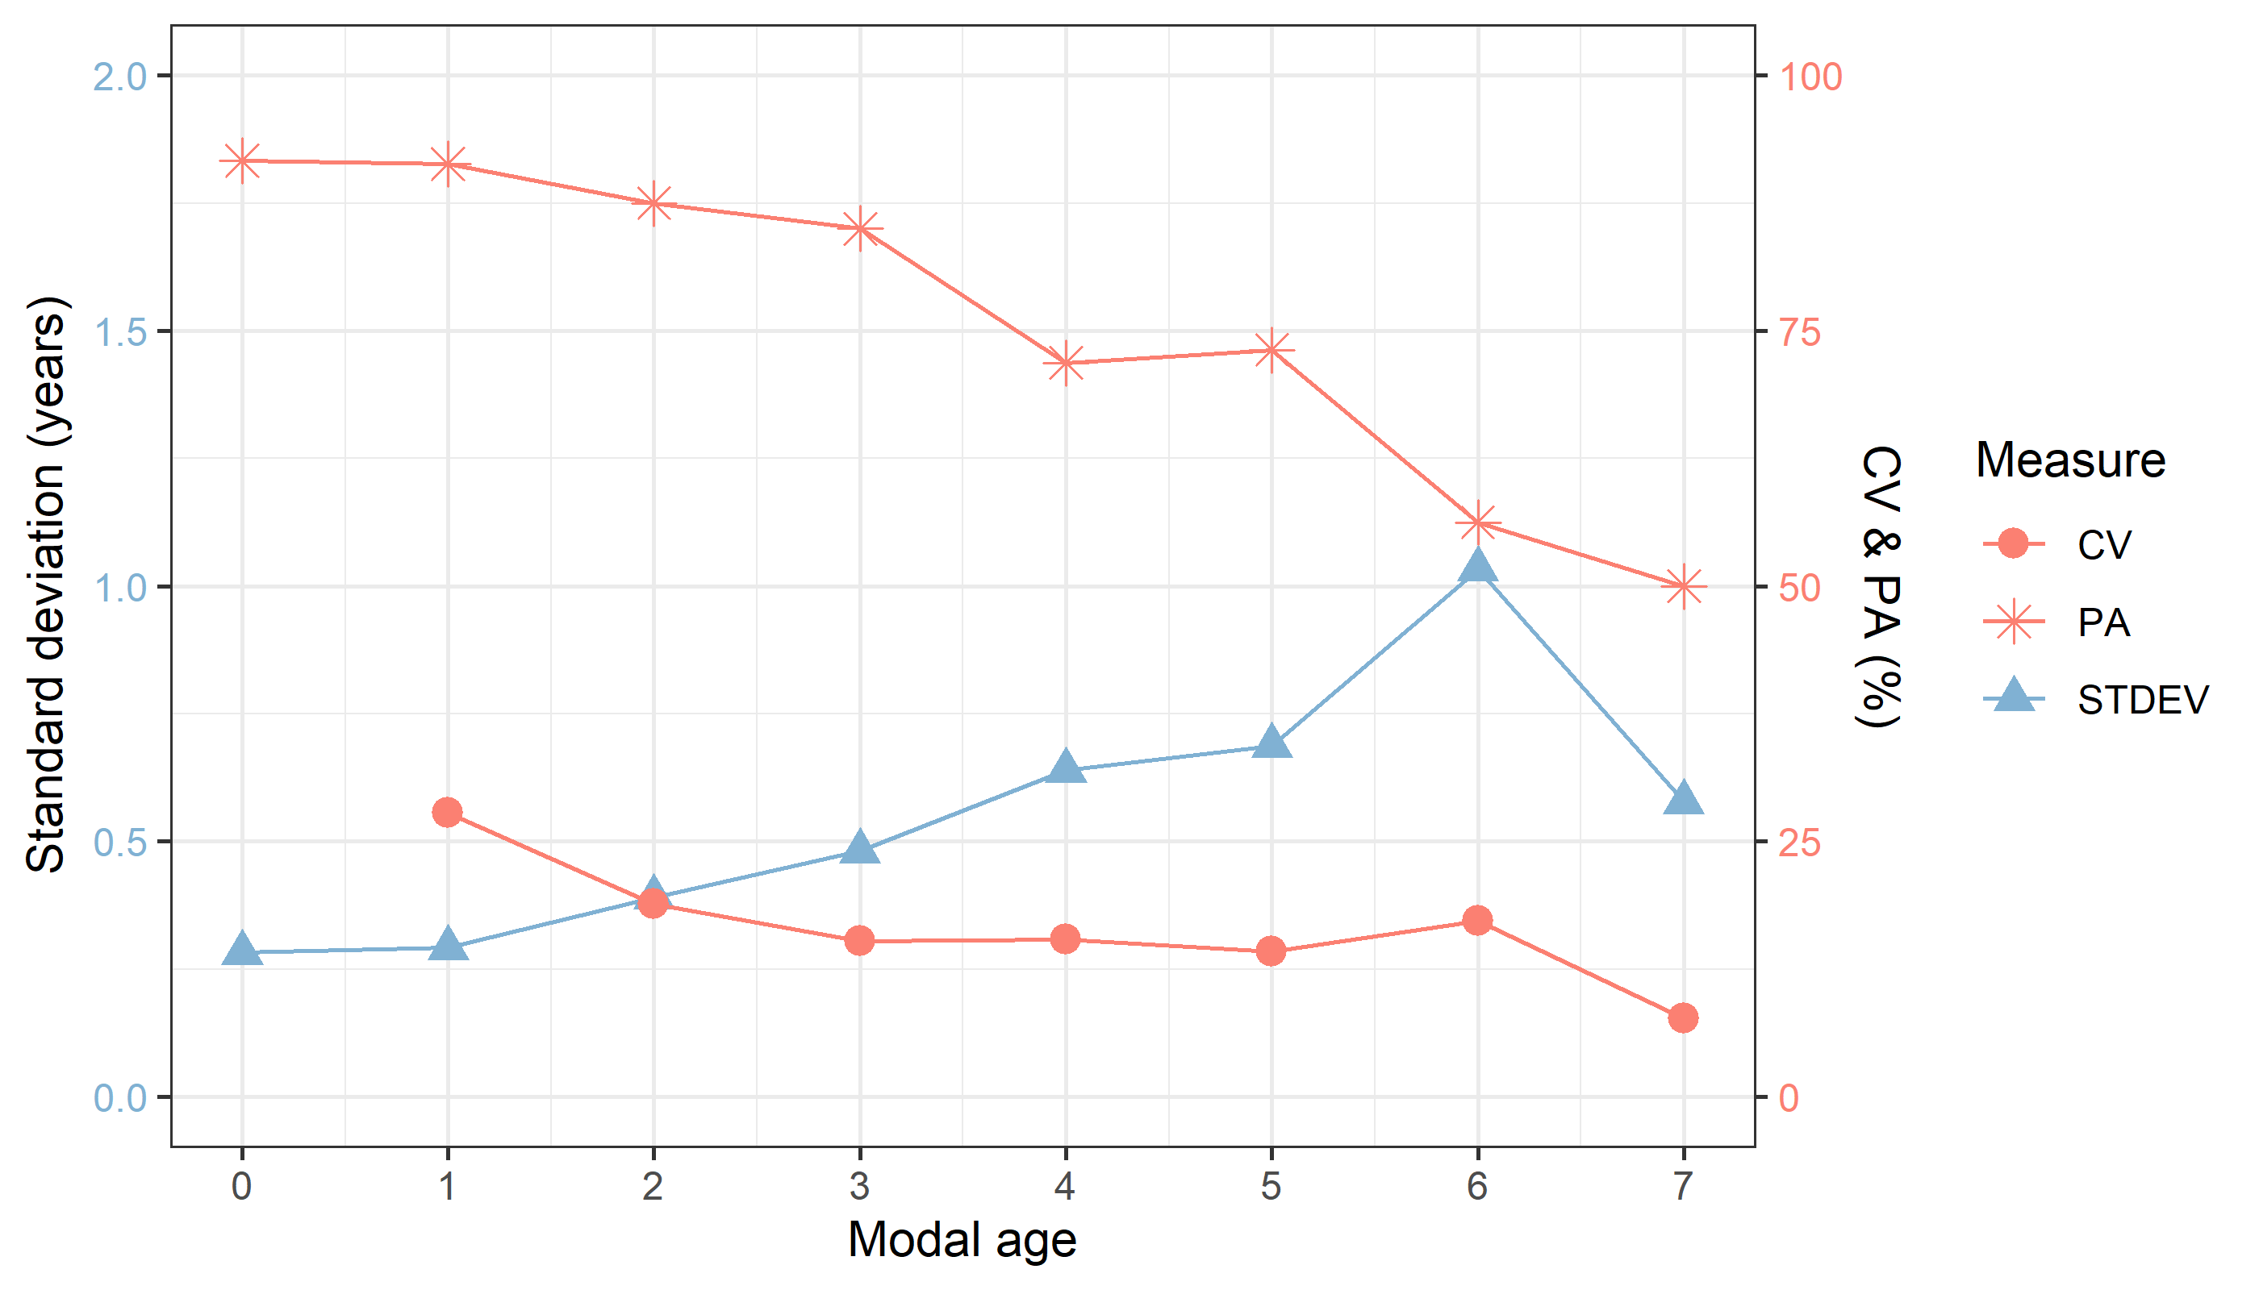
Figure X: CV, PA and (STDEV (standard deviation) are plotted against modal age

Distribution of age reading errors
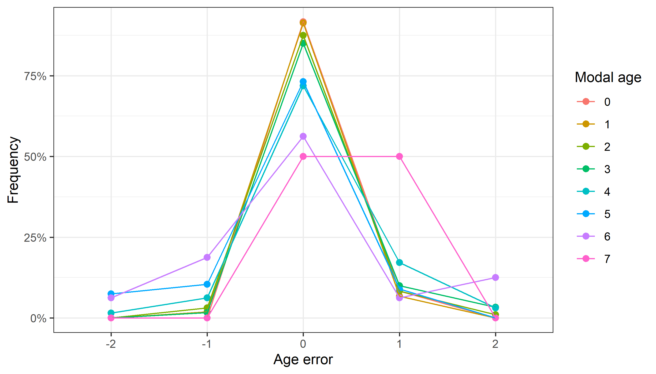
Figure X: The distribution of the age reading errors in percentage by modal age as observed from the whole group of age readers in an age reading comparison to modal age. The achieved precision in age reading by MODAL age group is shown by the spread of the age readings errors. There appears to be no relative bias, if the age reading errors are normally distributed. The distributions are skewed, if relative bias occurs.

Relative bias for all readers
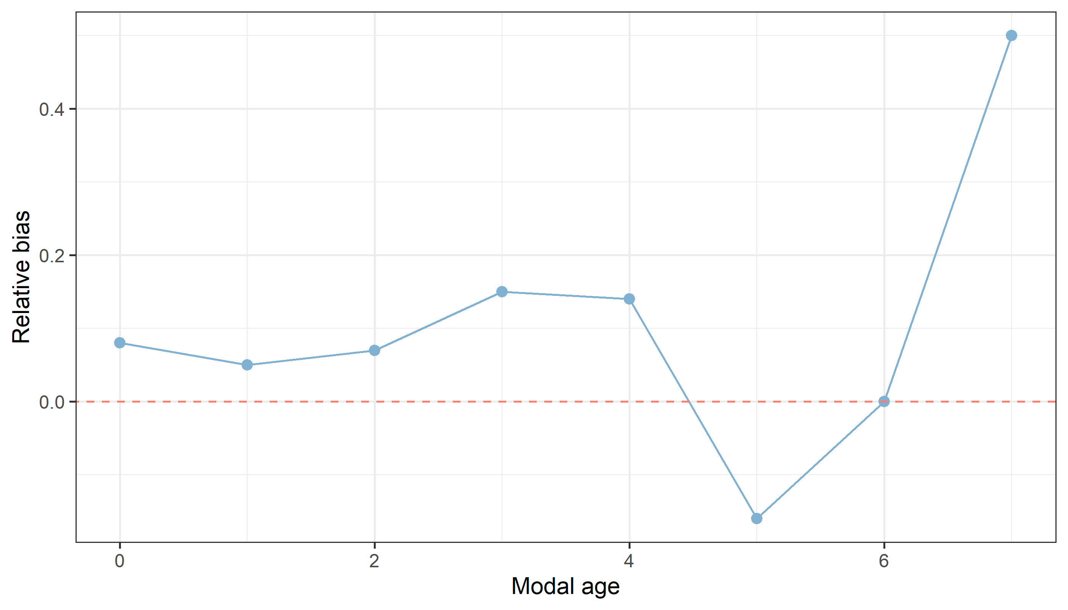
Figure X: The relative bias by modal age as estimated by all age readers combined.

Mean length at age by reader
Table X: Mean fish length at age per reader is calculated per reader and age (not modal age) and for all readers combined per age. A weighted mean is also given.
Age | R02 FR | R04 IE | R06 IE | R08 IE
0 | 160 mm | 152 mm | 155 mm | 152 mm
1 | 213 mm | 201 mm | 211 mm | 201 mm
2 | 309 mm | 295 mm | 307 mm | 297 mm
3 | 340 mm | 338 mm | 353 mm | 341 mm
4 | 377 mm | 360 mm | 354 mm | 360 mm
5 | 372 mm | 372 mm | 372 mm | 368 mm
6 | 330 mm | 357 mm | 370 mm | 370 mm
7 | 360 mm | - | 360 mm | 380 mm
8 | - | 335 mm | - | 335 mm
Weighted Mean | 300 mm | 300 mm | 300 mm | 300 mm
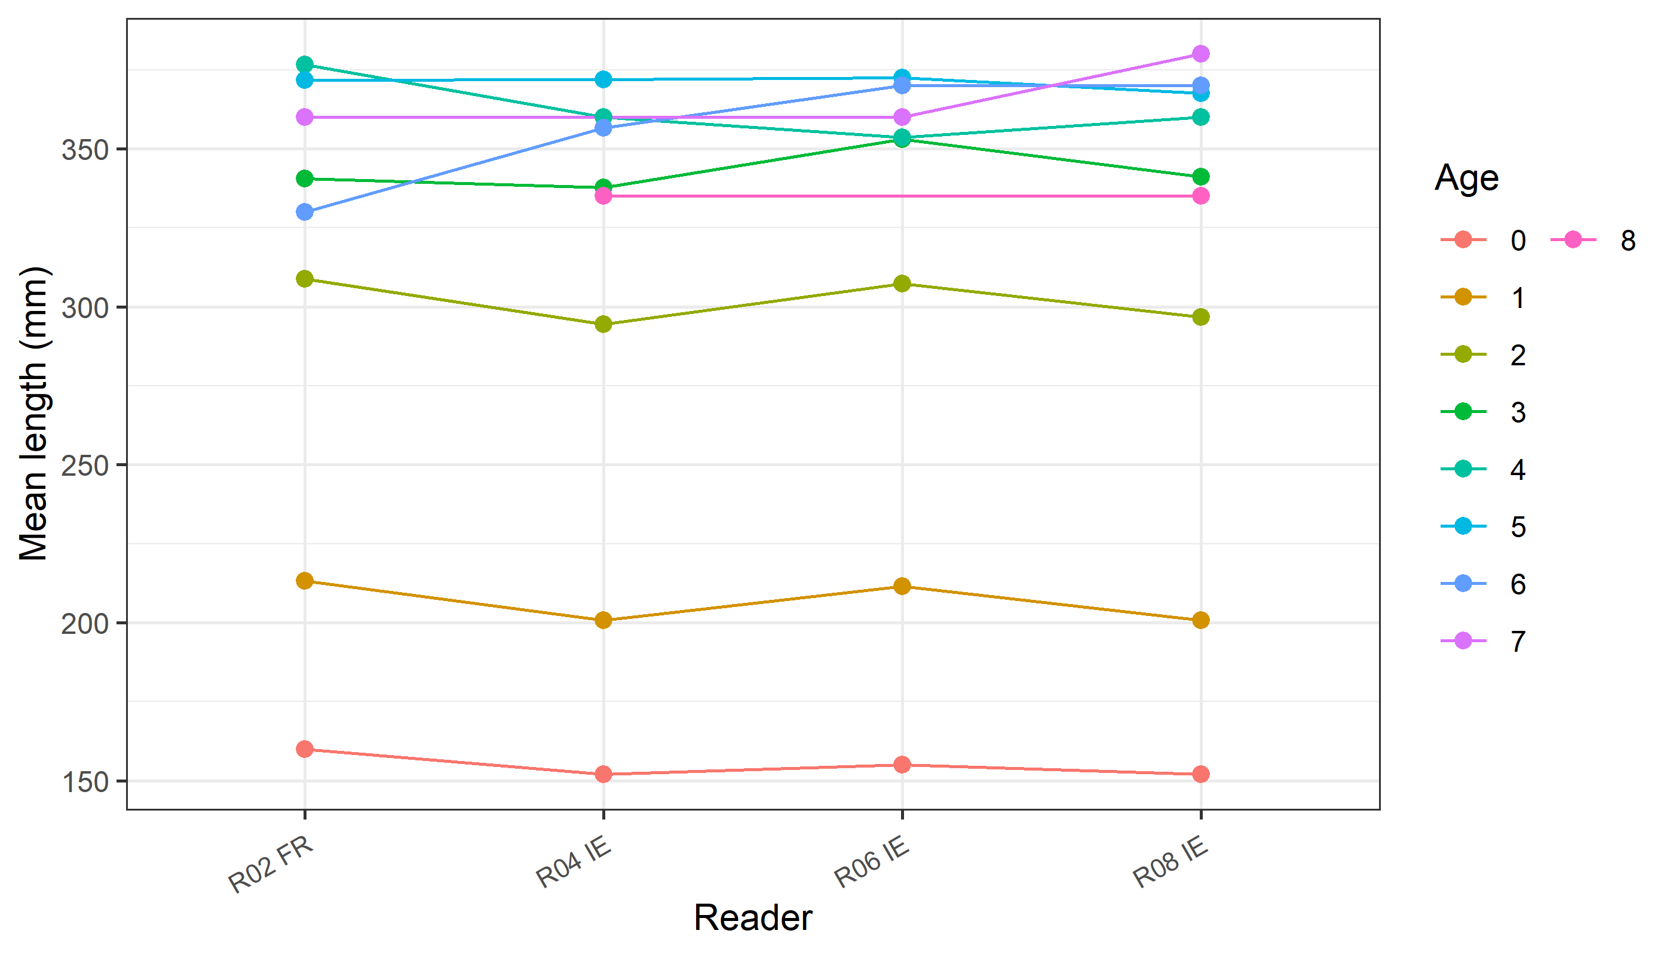
Figure X: The mean fish length at age as estimated by each age reader.

